- PERFORMANCE EVALUATION OF GAA-AKANBI INTERSECTION IN ILORIN, KWARA STATE.
BY
SALMAN ABDULWASIU OKANLAWON
HND/23/CEC/FT/0004

SUBMITTED TO THE DEPARTMENT OF CIVIL ENGINEERING, INSTITUTE OF TECHNOLOGY, KWARA STATE POLYTECHNIC, ILORIN
IN PARTIAL FULFILMENT OF THE REQUIREMENT FOR THE AWARD OF HIGHER NATIONAL DIPLOMA (HND) IN CIVIL ENGINEERING
JUNE 2025.

DECLARATION
I hereby declare that this project work titled PERFORMANCE EVALUATION OF GAA-AKANBI INTERSECTION IN ILORIN, KWARA STATE is a work done by me, SALMAN ABDULWASIU OKANLAWON with matric number, HND/23/CEC/FT/0004 of the Department of Civil Engineering, Institute of Technology, Kwara State Polytechnic, Ilorin.

__________________ ______________
Signature Date

CERTIFICATION
This is to certify that this research study was conducted by SALMAN ABDULWASIU OKANLAWON with matric number, HND/23/CEC/FT/0004 and had been read and approved as meeting the requirement for the award of Higher National Diploma (HND) in the Department of Civil Engineering, Institute of Technology, Kwara State Polytechnic, Ilorin.

_____________________________ ________________________

Engr, A. O. Saadu Date
Project Supervisor

______________________________ _________________________
Engr, A. B. Na’Allah Date
Head of Department

_____________________ _________________
Engr Dr. Mujedu Kasali Adebayo
External Supervisor Date
DEDICATION
This project is dedicated solemnly to Almighty Allah, who is the sole inspiration of all things, without whom there would not be, and neither would this project.
Appreciation goes to my loving parents for their support in the fulfillment of my Higher National Diploma (HND) both orally and financially. May God allow them to eat the fruit of their labor (Amen)

AKNOWLEDGEMENT
I begin by expressing my deepest gratitude to the Almighty God, who has blessed me with the wisdom, strength, and resilience to complete this project.
I extend my sincere appreciation to my project supervisor, Engr. A. O. Saadu for his invaluable guidance, support, and encouragement throughout this journey. His expertise and constructive feedback were instrumental in shaping this project.
To my family, I express my heartfelt gratitude for their unwavering support and love. My Dad, Late Mr Aliyu Salman Alao,and My Mom Mrs Salsman Mariam Bolanle who made me choose this interesting course, thank you for being a constant source of motivation, encouragement and financial support. I appreciate your love.
I also acknowledge the entire staffs of the department of Civil Engineering in the Institute of Polytechnic, Ilorin, for their dedication, enlighten and support towards the success of my academics.
To my friends, guardians and colleagues, I appreciate your encouragement, advice, and camaraderie.
Thank you all for being part of my journey.

ABSTRACT
Having an effective highway traffic management is crucial for ensuring road safety, reducing congestion, and promoting economic activities. This study evaluates the traffic management strategies employed along the Ilorin-Bode Saadu highway in Kwara State, as it serves as a major transportation corridor, linking key urban and rural areas, and is prone to various traffic-related challenges, including congestion, accidents, and inadequate road infrastructure.
Primary data for this research was gathered through structured surveys, direct traffic observations, and interviews with road users, traffic wardens and officials.
Findings reveal significant gaps in the implementation of traffic management systems, with critical issues such as insufficient enforcement, lack of public awareness, and poor road maintenance contributing to persistent challenges. Recommendations include adopting integrated traffic management technologies, improving road infrastructure, enhancing public awareness campaigns, and strengthening collaboration between or among stakeholders.

TABLE OF CONTENTS
1. Title Page ……………………………………… i
2. Declaration …………………………………… ii
3. Certification …………………………………… iii
4. Dedication ……………………………………… iv
5. Acknowledgement …………………………… v
6. Abstract ………………………………………… vi
7. Table of Contents …………………………… vii

8. Chapter One: Introduction
Background of the Study ……………… 1
Problem Statement ……………………… 3
Aim of Study ……………………………… 4
Research Objectives …………………… 4
Justification ………………………………… 5
Scope of the Study ……………………… 6

9. Chapter Two: Literature Review
Traffic Management Strategies ……… 7
Traffic Management in Developing Countries ……………………………… 9
Traffic Management Strategies in Nigeria ………………………………… 10
Research Gaps and Relevance to Ilorin-Bode Saadu Highway ………… 12

10. Chapter Three: Methodology
Brief Description of the Study Area ……………………………………… 14
Methods …………………………………… 15
Data Collection and Site Survey ……… 16
Data Analysis ……………………………… 18

11. Chapter Four: Results and Discussion
Introduction ……………………………… 22
Result and Discussion ………………… 23
12. Chapter Five: Conclusion and Recommendation
Conclusion ………………………………… 27
Recommendation ………………………… 28

13. References ……………………………………… 30

CHAPTER ONE
INTRODUCTION
BACKGROUND OF THE STUDY
Increase in level of urbanization as noticed in all urban centers in the developing world has brought about the upsurge in the various forms of transportation and its influence and pressure on the urban environment. The increasing rate of human population and vehicular traffic has been one of the various problems of African cities (Sule,2016).
Nigerian urban centers are facing similar situation in terms of traffic congestions as a result of the growing rate in population of the cities and the functions provided by urban centers which has exacerbated the current trend in rural-urban migration.
Traffic congestion is a condition on road networks that is characterized by slower speeds, longer trip times, and increased vehicular queuing (Rodrigue et al 2016). According to Downie (2018) traffic congestion occurs when the volume of vehicular traffic is greater than the available road capacity, a point commonly referred to as saturation.
Urban transportation system in most developing countries is faced with increasing pressure due to increase in motor vehicle ownership and use, growing at a faster rate than population, with vehicle ownership annual growth rates of between 15% and 20% (World Bank 2001). More so, the average distance traveled per vehicle has been on the increase in most cities of the world.
This study focuses on Ilorin-Bode Saadu Highway, also known as the A14 highway, it is one of the major roads in Kwara state that connects the city of Ilorin to Bode Saadu and the Neighboring states. This highway plays a critical role in the transportation network of Kwara State, serving as a key route for commuters, traders, and long-distance travelers. Despite its importance, the highway faces significant traffic management challenges, including frequent congestion, high accident rates, and inadequate infrastructure. The study focuses on key traffic management tools deployed along the route, including road signage, manual controls (e.g., traffic wardens and road safety personnel), and physical traffic calming measures such as speed bumps. In addition, the report highlights infrastructural challenges and ongoing rehabilitation efforts that impact the overall efficacy of these systems.
As the population of Ilorin to Bode-Saadu increase, the challenges posed by road traffic congestion is, also expected to aggregate. The matter is made worse given the weak regulatory land use planning regime in the area. To manage road traffic in Ilorin and curb the negative social economic problems associated with it, various traffic management techniques have been put in place. The effectiveness of these techniques in terms of ensuring efficient traffic system needs to be examined hence the present study seeks various traffic management techniques on major roads in Ilorin Municipality.

PROBLEM STATEMENT
To begin with, due to its inter-state networking attribute, Ilorin – bode Saadu high way faces persistent traffic congestions, high accident rate and inadequate road infrastructure along its route.
Furthermore, the rapid increase in population, urbanization, and vehicular density along the Ilorin-Bode Saadu Highway has exacerbated traffic-related issues, creating a pressing need for effective solutions. These challenges not only hinder mobility but also contribute to economic losses and safety concerns for road users.
AIM OF STUDY
The aim of the study is to critically evaluate the existing traffic management system on the Ilorin-Bode Saadu road.

RESEARCH OBJECTIVES
- Identifying the existing and the effectiveness of traffic management strategies (the road signage and markings, periodic road repairs, deployment of road wardens) employed in Ilorin - bode Saadu highway.
- Assess the challenges faced in their implementation which involves analyzing the barriers to the effectiveness of these traffic managements, such as enforcement issues, infrastructure inadequacies, and public compliance problems.
- To propose sustainable solutions to improve traffic flow and safety as well as developing actionable recommendations for enhancing traffic management on the highway, considering technology, infrastructure upgrades, and stakeholder collaboration.
JUSTIFICATION
This study is justified for the economic significance of the highway as it facilitates trade and movement between cities and improving traffic management can reduce delays, enhance productivity and boost local economy.
Analyzing and improving traffic management strategies can help reduce fatalities and injuries as High accident rates on the highway pose serious threats to commuters and other road users. Addressing traffic-related issues can contribute to environmental sustainability by reducing vehicle emissions caused by congestion and improving road efficiency.
SCOPE OF THE STUDY
This research study basically focuses on evaluating traffic management strategies implemented along the Ilorin-Bode Saadu highway in Kwara State. It covers key aspects such as the effectiveness of traffic enforcement, the adequacy of road infrastructure, public awareness of traffic rules, and the role of agencies like KWARTMA and FRSC in managing traffic flow. The scope further includes assessing traffic conditions, identifying challenges, and recommending improvements to enhance road safety, reduce congestion, and ensure efficient transportation along this critical highway route.

CHAPTER TWO
LITERATURE REVIEW
TRAFFIC MANAGEMENT STRATEGIES
Studies highlight the transformative impact of Intelligent Transport Systems (ITS) on traffic management globally. Zhang et al. (2020), in "Predictive Traffic Analytics: A Global Perspective", emphasized the importance of data analytics and real-time monitoring in optimizing traffic flow. Similarly, Smith (2019), in "Intelligent Traffic Systems in Modern Cities", documented the efficacy of automated systems such as adaptive traffic lights and enforcement cameras in reducing urban congestion. These findings underscore the potential benefits of technology-driven solutions in addressing traffic challenges.
TRAFFIC MANAGEMENT IN DEVELOPING COUNTRIES
Developing nations often face unique challenges in implementing advanced traffic solutions due to limited resources and infrastructure. Adekunle and Olumide (2021), in "Traffic Congestion in Developing Economies: A Case for Low-Cost Technological Solutions", highlighted rapid urbanization and insufficient road networks as critical contributors to traffic woes. Their research suggested adopting cost-effective technologies, such as mobile apps for traffic updates, to improve
management efficiency. Meanwhile, Bello (2022), in "Urban Traffic Issues in Sub-Saharan Africa ", emphasized the role of community engagement and policy reforms in mitigating traffic congestion.
TRAFFIC MANAGEMENT STRATEGIES IN NIGERIA
Traffic management in Nigeria is characterized by a blend of traditional methods and evolving strategies. Ajayi (2021), in "Traffic Management in Nigeria: Challenges and Solutions", evaluated the role of agencies like the Lagos Traffic Management Authority (LASTMA) and noted enforcement gaps as a persistent challenge Similarly, Adeyemi (2023), in "Enforcement Gaps in Nigerian Traffic Laws", identified corruption and inadequate personnel as barriers to effective traffic rule enforcement.
In Kwara State, specifically, the reliance on road signage, traffic wardens, and sporadic road maintenance has had limited success. According to the Kwara State Ministry of Transport (2023) Annual Traffic Management Report, issues such as reckless driving and poor road conditions remain prevalent. Moreover, National Bureau of Statistics (2022), in "Traffic Accident Reports in Nigeria", identified narrow roads and insufficient drainage as significant contributors to high accident rates on regional highways, including the Ilorin-Bode Saadu route.

RESEARCH GAPS AND RELEVANCE TO HLORIN-BODE SAADU HIGHWAY
While existing literature provides valuable insights, most studies, such as those by Ajayi (2021) and Adekunle and Olumide (2021), focus on urban centers like Lagos, neglecting rural-urban high ways. The llorin-Bode Saadu Highway faces distinct challenges, including heavy vehicular traffic, minimal ITS integration, and weak enforcement mechanisms. This study addresses these gaps by evaluating the specific traffic management strategies employed on this highway and proposing tailored solutions.

CHAPTER THREE
METHODOLOGY
BRIEF DESCRIPTION OF THE STUDY AREA
Ilorin Bode-Saadu highway is an important transportation route that connects Ilorin, the capital of Kwara state to Bode Saadu, a key junction town that links the highway to and from the major highway that leads to norther Nigeria. The Highway runs approximately from Ilorin (Latitude: 8.4799º N, Longitude: 4.54 18º E) to Bode Saadu (Latitude: 8.83049º N, Longitude: 4.4546º E).
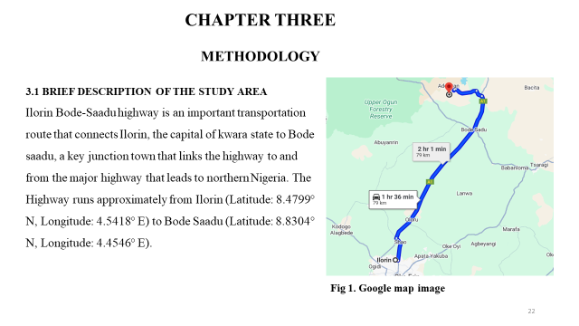

METHODS
DATA COLLECTION AND SITE SURVEY
Data for this analysis was collected through systematic field observations along the route, covering both urban sections and rural segments passing through various villages and towns.
Specific point of interest includes; the types of traffic management systems (Road signage, Manual controls such as the traffic wardens and road safety personnel, speed bumps at village and town intersections).
The Research employs a case study, focusing on the Ilorin-Bode Saadu Highway as a representative example of traffic challenges in Kwara State and Nigeria as a whole.
This approach enables an in-depth evaluation of the current strategies, their implementation, and their impact on road users.
The survey was strategically planned to obtain and assess all the currently employed traffic management strategies such as the road markings, side road signage, speed bumps, traffic wardens and other infrastructures along the llorin-Bode Saadu road.
The study focused on critical points along the road, including villages such as Lumo, Oloru, Kanbi Hausa, Ogunnedun, Aiyekale, Oloko Nla, Gida Bello, Lakanla, and Bode Saadu town.
It further captures significant information most especially from the users and stakeholders of the Ilorin- bode Saadu highway as the road serves as a critical transportation corridor for commuters, traders, long distance travelers and of course the dwellers of the neighborhood.
DATA ANALYSIS
Road Signage and Markings:
- Condition and sufficiency: The study observed that there was no road signage along the most part of the road although this is due to the on-going rehabilitation along the entire route and elsewhere along the road a significant number of signs are in poor condition- faded, damaged, or insufficient in number. This degradation diminishes their effectiveness, leading to driver confusion and reduced compliance with road regulations.
- Road Marking: The painted road markings are visibly deteriorating, with reports of peeling and rip-offs. This deterioration not only compromises lane discipline but also contributes to navigation errors, especially during adverse weather conditions and in areas undergoing road rehabilitation.

Manual Traffic Control:
- Traffic Wardens and Road Safety Personnel: Manual traffic management through traffic wardens is present at some points along the route. However, the limited number of personnel, corruption, unprofessional ethics and over familiarity hinder them from professionally exercising their duties in enforcing traffic law have been noted. This shortfall is particularly evident during peak hours and in segments affected by ongoing rehabilitation.
- Impact on Safety: The reliance on manual control, in the absence of adequate technological support, as well as the inadequacy mentioned above has been linked to lapses in effective traffic regulation. This situation contributes to both increased accident rates and traffic bottlenecks, as manual intervention does not always provide a timely response to emerging hazards or congestion.
SPEED BUMPS:
- Implementation and Condition: Speed bumps are strategically installed at various intervals, especially as the road passes through villages such as Lumo, Oloru, Kanbi Hausa, Odunnedun, Aiyekale, Oloko Nla, Gida Bello, Lakanla, and Bode Saadu town. Field data indicate a mixed performance:
  - In some areas, speed bumps are well-maintained and effectively slow down vehicles even though driver's behavior sometimes compromised the effect.
  - In other areas, the speed bumps are either poorly constructed or inadequately spaced, reducing their effectiveness in enforcing safe driving speeds.
OVERALL IMPACT ON ROAD SAFETY AND TRAFFIC FLOW:
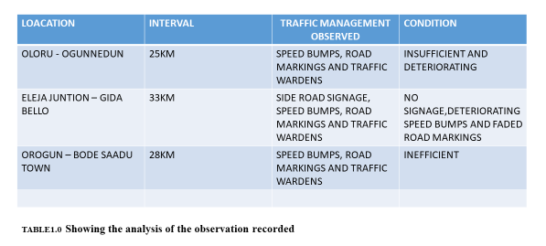
- Accident Rates and Traffic Congestion: The collective inefficiencies of deteriorating signage, insufficient road markings, and inconsistent manual and physical traffic controls have directly impacted road safety. There is a noted correlation between these deficiencies and an increased rate of traffic accidents. Moreover, the ongoing road rehabilitation further complicates traffic management, contributing to periodic congestion and delayed response times in emergency situations.

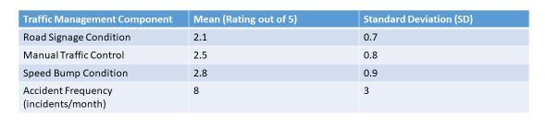

Road Signage vs. Accident Frequency: Correlation Coefficient (1) = -0.48
Manual Traffic Control vs. Accident Frequency: Correlation Coefficient (r) = -0.32
Speed Bump Condition vs. Accident Frequency: Correlation Coefficient (r) = -0.29
A multiple regression was performed with accident frequency as the dependent variable and the three traffic management factors as independent variables.
R²: 0.40
F-Statistic: 10.2, p-value: <0.001
Beta (Coefficient): -0.50, p-value: < 0,001
The analysis indicates that the overall condition of the traffic management systems is poor, with particularly low scores for road signage and moderate scores for manual traffic control and speed bump conditions.
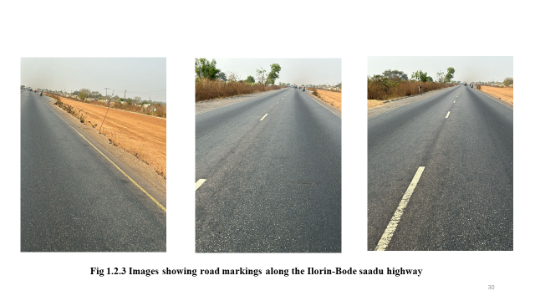

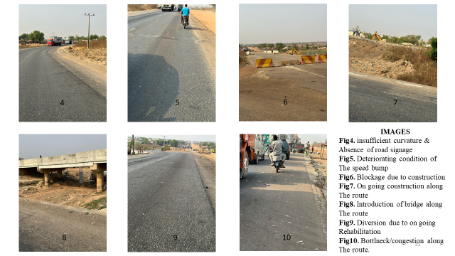
CHAPTER FOUR
INTRODUCTION
The evaluation of traffic management systems along the Ilorin-Bode Saadu road aims to assess the effectiveness of existing measures in ensuring road safety, reducing congestion, and minimizing accidents. The study focuses on key traffic management tools deployed along the route, including road signage, manual controls (e.g., traffic wardens and road safety personnel), and physical traffic calming measures such as speed bumps. In addition, the report highlights infrastructural challenges and ongoing rehabilitation efforts that impact the overall efficacy of these systems.

RESULT AND DISCUSSION
Based on the findings from the manual data analysis and the survey, several recommendations were developed to optimize traffic flow and improve safety along the Ilorin-bode Saadu highway.
The data analysis indicates that while some, if not all of the fundamental components of traffic management along the Ilorin-Bode Saadu road are in place, their current state undermines operational effectiveness. The deteriorated condition of road signage and markings, inadequate coordination of Road Rehabilitation activities with Traffic Management, coupled with insufficient manual controls and inconsistent speed bump installations, directly contribute to higher accident rates and traffic congestion. Addressing these deficiencies through systematic upgrades, better maintenance protocols, and enhanced integration of both manual and automated systems is critical to improving overall road safety and traffic flow.

CHAPTER FIVE
CONCLUSION AND RECOMMENDATION
At the end of this research, it was concluded that the current traffic management system is hindered by poorly maintained and insufficient road signage and markings, inconsistent speed bump conditions, and limited manual control and these deficiencies contribute to higher accident rates and traffic congestion, particularly in areas undergoing rehabilitation and at key junctions.
Therefore, the following recommendations were drawn:
- Upgrade and Maintain Signage and Markings by replacing or refurbishing faded and damaged signs, Repaint and regularly maintain road markings to ensure clear lane guidance.
- Enhance Manual Traffic Control: Increase the number of traffic wardens, especially during peak periods and ensuring professional work ethics, proper orientation and provide targeted training to improve the responsiveness and efficiency of manual controls.
- Improve Speed Bump Implementation Standardize the design and spacing of speed bumps and implementing regular inspections and maintenance to ensure their effectiveness.
- Coordinate Road Rehabilitation with Traffic Management Develop temporary traffic management plans during rehabilitation works and collaborate with relevant authorities to schedule projects during off-peak hours where possible.

REFERENCES
Sule, A., Ajayi, O. (2016). Traffic Management in Nigeria: Challenges and Solutions. Journal of Urban Planning, 12(3), 45-60
Adekunle, A., & Olumide, T. (2021). Traffic Congestion in Developing Economies Case for Low-Cost Technological Solutions. African Journal of Transport, 8(2), 34-50
Adeyemi, L. (2023). Enforcement Gaps in Nigerian Traffic Laws. Nigerian Journal of Road Safety, 10(1), 12-22.
Rodrigue et al 2016). According to Downie (2018) traffic congestion occurs vehicular traffic, 12(4), 44-48.
Zhang et al. (2020). Transformative impact of Intelligent Transport Systems (ITS) traffic management globally.
Bello, S. (2022). Urban Traffic Issues in Sub-Saharan Africa. Journal of Regional Development, 15(4), 78-94.
Kwara State Ministry of` Transport. (2023). Annual Traffic Report. Government Publication
National Bureau of Statistics. (2022).
Road Infrastructure and Traffic Data in Nigeria. Statistical Bulletin. Smith, J. (2019). Intelligent Transport Systems:
Global Applications and Local Impacts International Journal of Transportation Engineering, 14(1), 23-40.
Zhang, Y, Li, W, & Chen, H. (2020), Predictive Analytics for Traffic Management Data-Driven Approach. Transportation Research Journal, 18(2), 110-128
Smith (2019), Intelligent Traffic Systems in Modern Cities
National Bureau of Statistics (2022), Traffic Accident Reports in Nigeria
Federal Road Safety Corps (FRSC). (2023).
Lagos Traffic Management Authority (LASTMA)
World Bank 2001
Kwara State Traffic and Accident Reports. Internal Records.

