Development of Library Management System with Facial Recognition Using Deep Learning

By:
ADEYEMO GBOLAHAN AYOMIDE
HND/23/COM/FT/0016

A Project Submitted to the Department of Computer Science, Institute of Information and Communication Technology, Kwara State Polytechnic, Ilorin.

In Partial Fulfillment of the Requirements for the Award of Higher National Diploma [HND] in Computer Science
July, 2025
CERTIFICATION
This is to certify that this project was carried out by ADEYEMO GBOLAHAN AYOMIDE with matriculation number HND/23/COM/FT/0016 has been read and approved as meeting part of the requirements for the award of Higher National Diploma (HND) in Computer Science.

_________________________ ____________________
Mr. OLAJIDE, A.T DATE
(Project Supervisor)

______________________ _____________________
MR. OYEDEPO, F.S. DATE
(Head of Department)

_______________________ __________________
External Supervisor DATE

DEDICATION
This project is dedicated to the creator of the earth and universe, the Almighty God. It is also dedicated to my parents for their moral and financial support.

ACKNOWLEDGEMENT
All praise due to Almighty God the Lord of the Universe. I praise Him and thank Him for giving me the strength and knowledge to complete my HND programme and also for me continue existence on the earth.
I appreciate the utmost effort of my supervisor, Mr. Olajide A.T., whose patience support and encourages have been the driving force behind the success of this research work. He gave useful corrections, constructive criticisms, comments, recommendations, advice and always ensures that an excellent research is done. My sincere gratitude goes to Head of the Department and other members of staff of the Department of Computer Science, Kwara State Polytechnic, Ilorin, for their constant cooperation, constructive criticisms and encouragements throughout the programme.
Special gratitude to my parents who exhibited immeasurable financial, patience, support, prayers and understanding during the periods in which I was busy tirelessly in my studies. Special thanks go to all my lovely siblings.
My sincere appreciation goes to my friends and classmates.

TABLE OF CONTENTS
Title Page i
Certification ii
Dedication iii
Acknowledgements iv
Abstract v
Table of Content vi

CHAPTER ONE: GENERAL INTRODUCTION
  - Background to the Study
  - Statement of the Problem
  - Aim and Objectives of the Study
  - Significance of the Study
  - Scope of the Study
  - Organization of the Report

CHAPTER TWO: LITERATURE REVIEW
2.1 Review of Related Works
2.2 Review of Related Concept
2.2.1 Overview of Biometric System
2.2.1 Biometric Technologies
2.2.3 Facial Recognition in Libraries
CHAPTER THREE: RESEARCH METHODOLOGY AND ANALYSIS
  - Research Methodology
  - Analysis of the Existing System
  - Problems of the Existing System
  - Description of the Proposed System
  - Advantages of the proposed system

CHAPTER FOUR: DESIGN, IMPLEMENTATION AND DOCUMENTATION OF THE SYSTEM
  - Design of the System
    - Output Design
    - Input Design
    - Database Design
    - Procedure Design
  - Implementation of the System
    - Choice of Programming Language
    - Hardware Support
    - Software Support
  - Documentation of the System
    - Program Documentation
    - Maintaining the System

CHAPTER FIVE: SUMMARY, CONCLUSION AND RECOMMENDATION
  - Summary
  - Conclusion
  - Recommendation
  - References
  - Appendix
- System Flowchart / Program Flowchart of the existing system
- Source Program Listings

ABSTRACT
A library is a place where a huge collection of books and resources are available which can be accessible by the users. It acts as a brain for the institutions. The most common library system, which biometric solutions have in many cases started to replace, is the library card. The card is used to verify identity and keep track of books taken out and books returned. They are a good solution, but over time and under stress, shortcomings start to reveal themselves. One of the fundamental problems with a library card is that processing them at each transaction can be time consuming. At busy times, long queues can form as library staff scan and deal with the cards, or students fumble around in bags to find them. And that’s when students do find them library cards are too often lost or forgotten by their users. Setting up new cards or replacing lost ones is time consuming and a drain on the library’s resources. The other problem that emerges with traditional cards is it’s hard to ensure users are using them properly. Basic library cards can be swapped and passed around between students and the system abused. The way to solve this is to introduce photo ids onto the library cards. The system was designed using C# as the front end and MySQL as the Database System.

CHAPTER ONE

GENERAL INTRODUCTION

BACKGROUND TO THE STUDY
A library is a place where a huge collection of books and resources are available which can be accessible by the users. It acts as a brain for the institutions. It enhances the dissemination of knowledge and spiritual civilization among the students. The tons of books and research works are captivating the students to improvise their knowledge in all perspectives. It guides the students to promote their views differently. This knowledge optimizes the student to achieve a better result in academic as well as personal skill development. Improvisation in technology causes the demand for developing a way to enhance the digital library set up with biometrics (Shanmugam, Ramalakshmi & Sasthri, 2020).
Achintya and Subodh (2019) biometric recognition, or simply biometrics, refers to the automatic recognition of individuals based on their physiological and/or behavioral characteristics. Biometrics can be used to identify the person as person. Tokens, such as smart cards, magnetic stripe cards, photo ID cards, physical keys and so forth, can be lost, stolen, duplicated, or left at home. Passwords can be forgotten, shared, or observed. Moreover, today’s fast-paced electronic world means people are asked to remember a multitude of passwords and personal identification numbers (PINs) for computer accounts, bank ATMs, e-mail accounts, wireless phones, web sites and so forth.
Computer vision for faces can approximate the human approach of identifying the individual users. Face detection identifies the facial region in the input image (locating the face part in image). According to Vijaya, Revathi, Sarveena and Thoshini (2019) face recognition refers to identifying the user corresponding to the image. Face detection can be primarily based on two approaches namely local and global approaches. Local approach uses facial features such as nose, eye and mouth to associate a face with the person. Face recognition can be done previously using geometric models. Several face recognition algorithms have been developed and used, each has its own advantages and efficiency rates. There are several approaches for face recognition namely fisher faces approach, eigen faces approach and there exists several variations in the methods and algorithms for face recognition (Kiran, Chikkamanju & Chandrakanth, 2018).
Librarian need to be aware of theft, mutilation of library materials and other unethical losses. The duty of the librarian is to keep the library buildings, shelves and stacks open and free without losing items to make available or putting individuals at unacceptable risk from the malicious, avaricious and senseless act of others. It is important to provide a safe and secure environment for library staff, library resources and equipment, and library users. In this project one should first identify the user with the help of his/her facial recognition and later on it can be processed for further library transaction part.
Vyavahare and Kataria (2015) asserted that with the advancement of technology, it is imperative to exalt all the systems into a user-friendly manner. The Library Management system (LMS) acts as a tool to transform traditional libraries into secured biometric libraries. In traditional libraries, the students/user has to search for books which are hassle process and there is no proper maintenance of database about issues/fines. The overall progress of work is slow and it is impossible to generate a fast report. The librarians have to work allotted for arranging, sorting books in the book cells. At the same time, they have to check and monitor the lend/borrow book details with its fine. It is a tedious process to work simultaneously in different sectors. LMS will assist the librarians to work easily. The LMS supports the librarians to encounter all the issues concurrently. The users need not stand in a queue for a long period to return/borrow a book from the library. The single PC contains all the data’s in it. The librarians have to assess the system and provide an entry in it. Through LMS the librarian can find the book in the bookshelves.
It is important to provide a safe and secure environment for library staff, library resources, equipment and library users. In this regard, the facial identification system is really useful for the library and information science professional. Therefore this project aimed to develop a library management system using facial recognition.

1.2 STATEMENT OF THE PROBLEM
The most common library system, which biometric solutions have in many cases started to replace, is the library card. The card is used to verify identity and keep track of books taken out and books returned. They are a good solution, but over time and under stress, shortcomings start to reveal themselves. One of the fundamental problems with a library card is that processing them at each transaction can be time consuming. At busy times, long queues can form as library staff scan and deal with the cards, or students fumble around in bags to find them. And that’s when students do find them library cards are too often lost or forgotten by their users. Setting up new cards or replacing lost ones is time consuming and a drain on the library’s resources. The other problem that emerges with traditional cards is it’s hard to ensure users are using them properly. Basic library cards can be swapped and passed around between students and the system abused. The way to solve this is to introduce photo ids onto the library cards. It’s a good solution but again adds extra cost to the library’s operation and slows down staff’s processing of the cards. It can be worth it though for libraries as good identity management of their service can help them run as securely as possible by helping them keep track of their users and valuable resources.

1.3 AIM AND OBJECTIVES OF THE STUDY
The aim of this project is to integrate facial recognition for identity management in library system. However, the objectives are to;
- provide facial recognition as an authourized identity for library management
- design a secured facial authentication system for a library
- evaluate the efficiency of the system using facial recognition.
1.4 SIGNIFICANCE OF THE STUDY
The libraries as a means of easily and rapidly accessing books, archives and images of various types are now widely recognized by commercial interests and public bodies alike. Adopting a biometric system can help libraries balance the books. They are a reasonably priced solution that saves operational costs in the long run. Additionally, re-registration or lost student authentications is no longer a problem. Facial recognition is one of the most commonly used biometric and it is of the most convenient solution available at the moment, they can’t be lost, forgotten or stolen and are literally right at your fingertips.

1.5 SCOPE OF THE STUDY
This project work focus mainly on the integration of facial recognition for identity management in libraries system, however, to access a library materials user need to be authenticate using their face.
1.6 ORGANIZATION OF THE REPORT
This is the overall organizational structure of the work as presented in this project. Chapter one of this project deals with the general introduction to the work in the project. It also entails the aim and objectives of the project, significance of the study, the scope and limitation of the study. Chapter two deals with the literature review, computerization of current state of the art and discussion of related aspect of the project topic relative to computer technology. Chapter three covers the methodology adopted, the methods used for data collection, analysis of the existing system, description of the current procedure, problems of existing system (procedure) itemized, and description of the proposed system and the basic advantages of the proposed decision integration of fingerprint for library management. Chapter four entails design, implementation and documentation of the system. The design involves the system design, output design form, input design form, database structure and the procedure of the system. The implementation involves the implementation techniques used in details, choice of programming language used and the hardware and software support. The documentation of the system involves the operation of the system and the maintenance of the system. Chapter five deals with the summary, conclusion and recommendations.

CHAPTER TWO
LITERATURE REVIEW
2.1 REVIEW OF RELATED WORKS
Vijaya, Revathi, Sarveena and Thoshini (2019) developed a library management system with facial biometric authentication. In this paper the researcher proposed a system that uses the biometric authentication for the users of the Library. It reduces the time taken to gain access into the Library. The system helped in automating the user ledger by automatically recording the in and out time of the users. The system enables the user to pick up the book and leave the library without having to wait in the queue for making the entry in the system.
Vyavahare and Kataria (2015) proposed a library management using real time face recognition system. The paper, an automated system for human face recognition in a real time background world for a large homemade dataset of persons face. The task is very difficult as the real time background subtraction in an image is still a challenge. Addition to this there is a huge variation in human face image in terms of size, pose and expression. The system proposed collapses most of this variance. To detect real time human face Ada Boost with Haar cascade is used and a simple fast PCA and LDA is used to recognize the faces detected. The matched face is then used to mark attendance in the laboratory, in our case. This library management system is real time attendance system based on the human face recognition with a simple and fast algorithms and gaining a high accuracy rate. There two data base one is student data base and other is library data base system.
Yalagi and Mane (2021) implemented a smart library automation using face recognition. The Proposed system uses face recognition for entering and getting the details of an end user. Through this application, the book gets issued to the end-user by identifying the user with the help of face recognition and identifying the book using barcode capture. In our system, we are using dlib face recognition, which is 99.38% accurate. We have provided the validations on the user registration form so that we get the right information. The registration process captures the face of the user and book issue, and the book return process checks the details of the user. End-users of the application will be librarians, students, and teachers. Our project aims at making the tasks of the library easy and to make the book issuing and returning process more interactive and effortless for the user. Also, our system is responsible for preserving the details of book issue and return and paperless report generation.
Uma and Rani (2013) proposed a prototype for secure digital library accessing system using multimodal biometric system. The proposed model secures the sensitive data on Internet. The design on Secure Digital Library Accessing System Using Multimodal Biometric System (SDLAS-MBS) consists of single fingerprint scanner device, webcam and event handler. It supports all the existing services and all other future communication services. To access sensitive data and secure transactions on Internet SDLAS-MBS will be used by the users with the help of fingerprint scanner and webcam devices.
Achintya and Subodh (2009) developed a biometric recognition, novel approach for library patron. The paper discusses a novel patron authentication approach in an automated and modern library based on the biometric recognition. The person working at the entrance or at the circulation desk of the library needs to either confirm or determine the identity of individual requesting services in library. Presently, almost all of the libraries are using identity cards (ID Card) for this purpose including photo-based, smart card based or RFID based etc. With the proposed authentication scheme it is possible to confirm or establish an individual’s identity based on “what one is, or how one behaves”, rather than by “what one possesses” (e.g., an ID card) or “what one remembers” (e.g., a password). The purpose of such authentication system is to ensure that the rendered services are accessed only by a valid user, and not any other else.
Shasha et al, (2010) researched on the library management system to upgrade the management to meet the need of the student demand. Honghai (2011) proposed a system where he represents the wasting of investment in CD which is attached along with the books. To save the cost of the library, he suggested cloud computing for data transfer. Bao (2009) presented a paper on constructing the prediction model for the library. He introduced two models for predicting the process such as the co-efficient of simple determination and t-test. This analysis explains the strong relationship between lending and the number of readers. They mainly concentrate on library lending for designing the construction of the model library.
Eraxiang et al (2016) launched a paper where he highlighted the disadvantage of the traditional library management systems. He provided a solution for the disadvantage by utilizing struts and hibernate framework in MVC architecture. The MVC architecture is also called a multilayer tier where presentation, business, data persistence and database layer are available. These extra features improve the maintainability and reuse of the system.
Zheng (2014) introduced a system based on UML for the Library Management system. Due to the good application prospect of UML, the LMS is designed and model based on this concept. Case diagram and analysis diagram are drawn after the analysis of simple LMS. Hitchense et al (2015), proposed a paper on flexible usage of classes. He suggested the reuse of classes for some similar conditions.
2.2 REVIEW OF RELATED CONCEPTS
2.2.1 Biometric System in Library Perspective
The Biometric System may easily be applicable to Library System Management in three ways:
a) it maintains library patron records very quickly, accurately, orderly;
b) it acts as a helpful management tool for the librarian and other managerial staff of the library; and
c) it may continue for years together without any further adding cost after its installation.
Biometric based patron authentication system can easily be introduced in the library management system, which resulting the full proof security cum automated library system.
2.2.2 Biometric Technologies
Biometrics is the science of measuring physiological or behavioural characteristics that verify a person’s identity. Biometric identification refers to a technology that uses scanned graphical information from many sources for personal identification purposes viz., facial imaging, retinal and iris scans, fingerprint scans, voice patterns, facial recognition, hand geometry identification, etc.
Types of Biometric Technologies
A number of discrete biometric technologies are available on the market today such as signature, fingerprint identification, iris identification, retinal identification, hand geometry, hand, palm, and wrist subcutaneous vein pattern identification, signature identification, voice identification, keystroke dynamics identification, facial feature identification, body salinity (salt) identification, body odor identification, and ear identification.
(a) Iris/Retina (Eye biometrics): The iris is the most accurate and invariable of biometrics, and that their system is the most accurate form of biometric technology as the human eye offers two features with excellent properties for identification. Both the iris (the colored part visible at the front of the eye) and the veins of the retina (the thin film of nerve endings inside the eyeball that capture light and send it back to your brain) provide patterns that can uniquely identify an individual. The pattern of lines and colors on the eye are, as with other biometrics, analyzed, digitized, and compared against a reference sample for verification.
(b) Fingerprint: A highly familiar and well-established biometric science is fingerprinting. The traditional use of fingerprinting, of course, has been as a forensic criminological technique, used to identify perpetrators by the fingerprints they leave behind them at crime scenes. In the context of modern biometrics, these features, called fingerprint minutiae, can be captured, analyzed, and compared electronically, with correlations drawn between a live sample and a reference sample, as with other biometric technologies. Fingerprints offer tremendous invariability, changing only in size with age, are highly resistant to modification or injury, and very difficult to “forge” in any useful way.
(c) Hand Geometry: Perhaps it is the most ubiquitous electronic biometric system. This system requires the subject to place his or her hand (usually the right hand) on a plate where it is photographically captured and measured. Made of 27 bones and a complex web of interconnected joints, muscles, and tendons, the human hand presents a sufficiently peculiar conformation of anatomical features to enable authentication.
(d) Facial Recognition: In the field of biometrics, facial recognition remains one of the more controversial technologies because of its very unobtrusiveness. With good cameras and good lighting, a facial recognition185 system can sample faces from tremendous distances without the subject’s knowledge or consent. The facial recognition technology works by two methods viz., facial geometry or eigenface comparison. Facial geometry analysis works by taking a known reference point (for example, the distance from eye to eye), and measuring the various features of the face in their distance and angles from this reference point. Eigenface comparison uses a palette of about 150 facial abstractions, and compares the captured face with these archetypal abstract faces. This technology may be highly useful for the libraries in security point of view.
2.2.3 Facial Recognitions in Libraries
Application of facial recognition in Library and Information Center can be done in three respective fields.
A. Control access to library premises: This type of application will not allow any unauthorized person to open the door. In this type of application, face of the authorized users will be scanned and stored for verification. This facial recognition is really a secure, convenient, and cost-effective alternative to passwords, badges, swipe cards and PINs. The facial scanner mounts on a wall near the library main door. This face scanners offer various levels of authorization for an individual. This authorization includes a scheduling mechanism for allowing access for individuals based on the time of day. This can avoid unauthorized access from computer room or server. This system increases security levels more than a ID card or ID badge as the face can’t be lost or stolen. It also reduces overall cost in eliminating portable devices and reducing administrative time as well. The system is convenient and there are no more fumbling of keys and ID cards. The member need not worry about misplacing their cards. The premises access devices can be networked together so that the system can be controlled and maintained from a central location.
B. Control access to library network: Now a days, most of the libraries are working on digital environmental where the library is concerned with the local area network, wide area network or intranet of the organization. In a world of cyber crimes, it is the need of the hour for any library to have control over the member access to the library network. Libraries are providing user name and password to the members to make use of the library computer systems and networks. However, too many passwords or inappropriate passwords lead to security lapses in which virtual credentials are lost, forgotten and hacked.
To overcome this problem, advanced biometric solution is available which ensures network authentication and safeguard the library network against unauthorized intrusion. This kind of biometrics system will protect individual PCs and network access. It also reduces the password reset requests from the users. The library administrator can be able to authenticate who is accessing a PC, network, and application with exceptional accuracy. It associates a single facial recognition with as many as passwords or PINs on a system. User can log on automatically without having to type in username or password. It eliminates the security risks of written down passwords and PINs.
C. Control access to library books: Implementation of facial recognition as a library borrower cards will be one of the positive steps to make library a digital environment. Every applicant of library cards will get enrollment of their fingerprint image and get stored in the database. And at the time to borrow book, the person need to scan their face in the facial recognition scanner. If the face is matched with the template in the database, the person can be allowed to borrow the book from the library because fingerprint is unique to every individual. This will release the burden of forgetting, stealing and missing of library cards. Introducing a facial recognition as a library card will reduce the workload of making cards of each and every authorized member.

CHAPTER THREE
RESEARCH METHODOLOGY AND ANALYSIS
3.1 RESEARCH METHODOLOGY
The research methodology for developing a Library Management System with Facial Recognition using Deep Learning follows a structured and systematic approach. It begins with a literature review to explore existing systems, understand the technologies involved, and identify gaps in current solutions. This step helps in establishing the foundation for the project by gaining insights into library management systems and facial recognition technologies, particularly focusing on accuracy, performance, and ethical considerations. Next is the requirement analysis phase, where the needs of stakeholders such as librarians, IT staff, and users are identified. This involves determining the functional requirements of the system, such as facial authentication for user identification and automated book lending, and the non-functional requirements, including scalability, security, and performance.
The development phase entails building the system based on the design specifications. The facial recognition module is developed using deep learning frameworks such as TensorFlow or PyTorch. A library management backend is implemented using a web framework like Django or Flask, and a database is structured to store user information, book details, and transaction logs. The frontend interface is developed to ensure ease of use for users and administrators.

Main Menu
User Registration
Book Lending
Stock
Biodata
Facial Capturing
User Verification

Figure 3.1: Conceptual Framework
The figure 3.1 above shows the conceptual framework of library management system with facial recognition
3.2 ANALYSIS OF THE EXISTING SYSTEM
The most common library system is the library card. The card is used to verify identity and keep track of books taken out and books returned. They are a good solution, but over time and under stress, shortcomings start to reveal themselves. One of the fundamental problems with a library card is that processing them at each transaction can be time consuming. At busy times, long queues can form as library staff scan and deal with the cards, or students fumble around in bags to find them. And that’s when students do find them library cards are too often lost or forgotten by their users. Setting up new cards or replacing lost ones is time consuming and a drain on the library’s resources. The other problem that emerges with traditional cards is it’s hard to ensure users are using them properly. Basic library cards can be swapped and passed around between students and the system abused. The way to solve this is to introduce photo ids onto the library cards. It’s a good solution but again adds extra cost to the library’s operation and slows down staff’s processing of the cards. It can be worth it though for libraries as good identity management of their service can help them run as securely as possible by helping them keep track of their users and valuable resources.
3.3 PROBLEMS OF THE EXISTING PROBLEM
The existing system is the traditional way of identifying people which was the use of library ID cards to identify who are eligible to use the library. This system has the following drawbacks:
- This method is time wastage
- It requires writing records on paper which maybe lost to fire, water, and termites and so on.
- It is also a waste of resources.
3.4 DESCRIPTION OF THE PROPOSED SYSTEM
As a result of the limitations encountered with the use of manual method in documentation, processing and managing records in the library, the need for an alternative system for library management cannot be undermined. The use of facial recognition to authenticate user of a library will go a long way in tracking unauthourized user who is trying to use the library. First and foremost, adopting a fingerprint system can help libraries balance the books. They are a reasonably priced solution that saves operational costs in the long run. Additionally, re-registration or lost student authentications is no longer a problem. Facial recognition is one of the most commonly used biometric. They are the most convenient solution available at the moment they can’t be lost, forgotten or stolen and are literally right at your fingertips.
Facial recognition library management system is great for the efficient running of a library. It’s a system that intrinsically integrates identity management. Staff can process requests faster and with confidence that the library account they are dealing with is that of the user who just scanned their face. Students benefit from a speedy and quick service and the staff benefit from a system that securely keeps track of their valuable library resources.
3.5 ADVANTAGES OF THE PROPOSED SYSTEM
A successful implementation of the fingerprint recognition based library system will greatly increase the efficiency of the librarians and will help to ensure that records are kept and managed properly. Fingerprint based library system has various advantages, they are as follows:
- Reduction of redundancies and inconsistencies.
- Ensure user defined rules to ensure the integrity of data.
- Enables data sharing across all applications.
- Ensures library access authorization.
- Integrity can be improved.

CHAPTER FOUR
DESIGN, IMPLEMENTATION AND DOCUMENTATION OF THE SYSTEM
  - DESIGN OF THE SYSTEM
The proposed system is designed in modules with each modules working together to perform the electronic facial recognition based library management system in order to enhance the performance of the existing system as earlier discussed in chapter three.
The ability to analyze and give focus to the system is explained in the following formats which are output design, input design, database design and procedure design.
    - OUTPUT DESIGN
The output and output to be extracted from the proposed system are as shown below
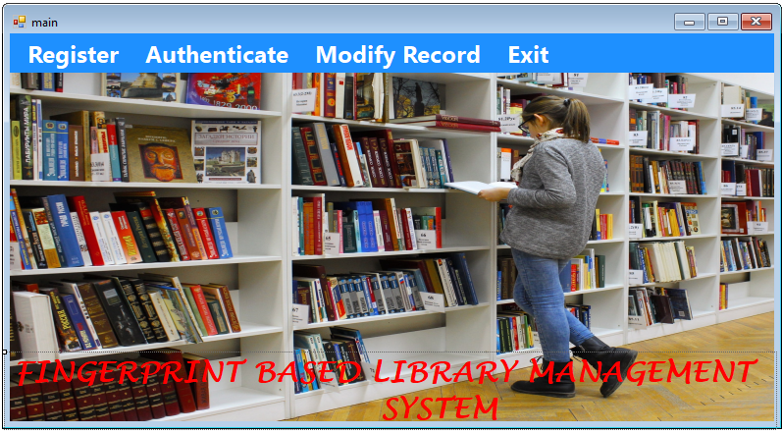
FACIAL RECOGNITION BASED LIBRARY MANAGEMENT SYSTEM
Figure 4.1: Main Page
This interface above is the main menu page that displays some menus which user can click to navigate to other pages
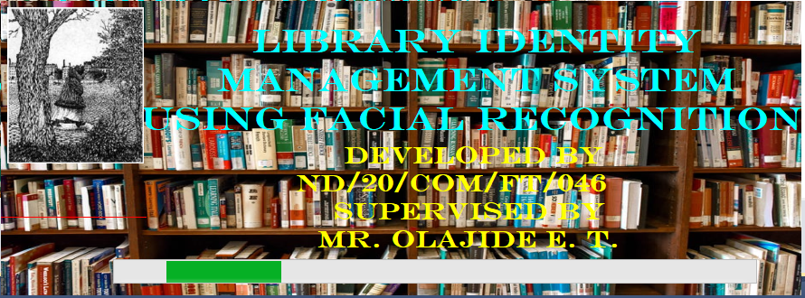
Figure 4.2: Splash Page
This Page is the welcome page that displays the details of the developer as well as the supervisor in charge.

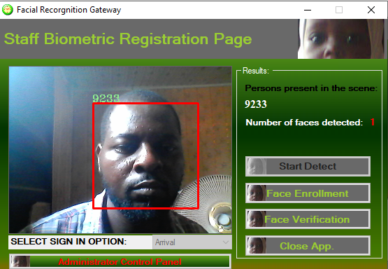


Figure 4.3: Student Face Verification Page
This Page allows the library admin to verify student /user face before he or she can make use of the library.

4.1.2 INPUT DESIGN

It is also necessary to denote that data inputted in the computer for processing determines what the output will be. The inputs are use in collecting information the student through the keyboard. Inputs are necessary information needed for processing so as to produce the expected outputs; which are supplied through the keyboard.
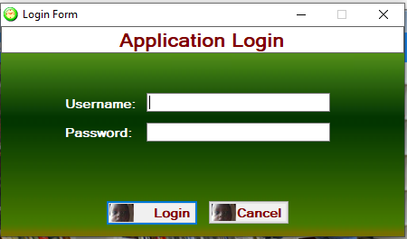
4.4: Login Page
The interface above is the login page where the admin can login to the system.
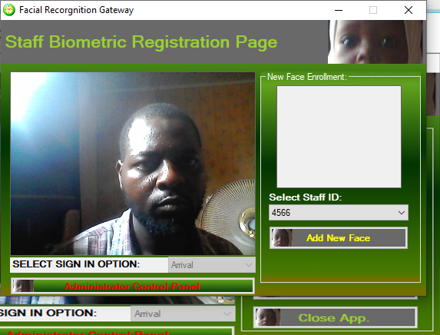 Figure 4.5: Face Enrolment Page
This Page allows the admin to enroll the students using their facial recognition.
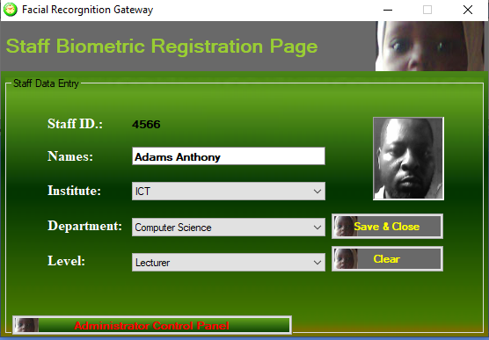
Figure 4.6: Modification Page

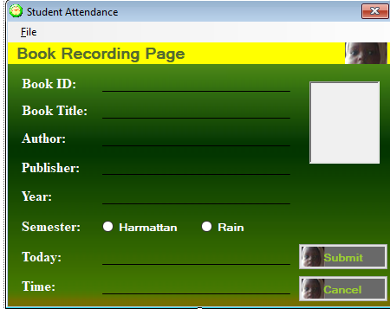
Figure 4.7: Book Registration Page
This Page allows the admin to save new books into the database
4.1.3 DATABASE DESIGN
A database table is used for storing information about the files. The database use for this application is Mysql database. The files and their respective modes of access as well as information they hold are given below;
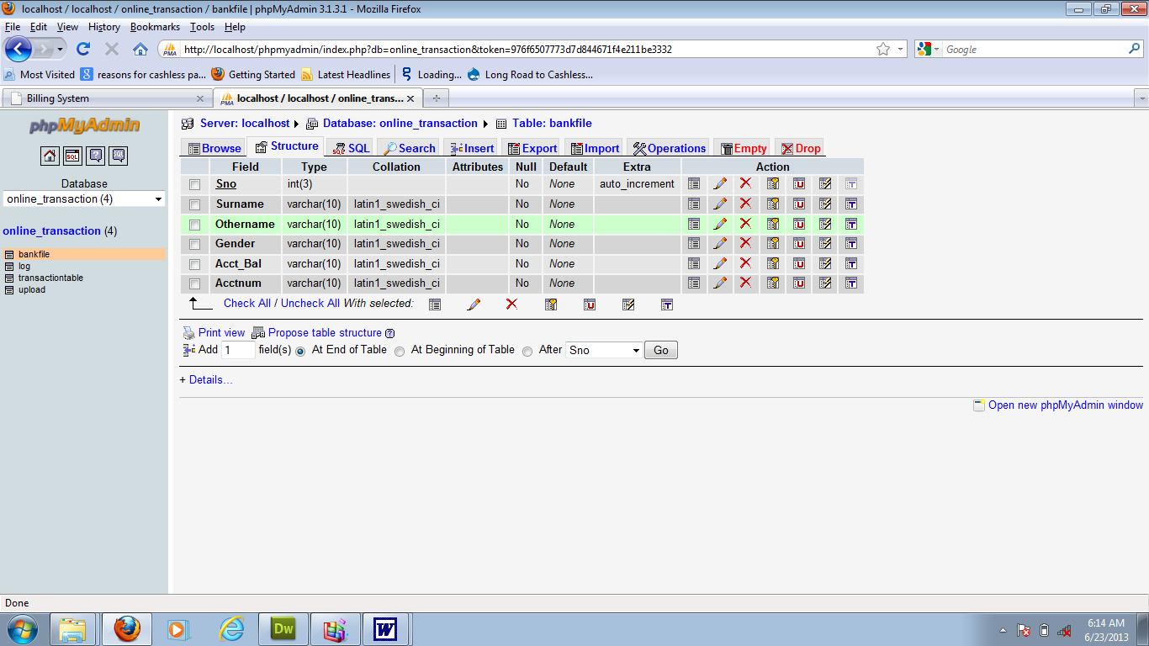
Table 4.1: Student Registration Table

Table 4.2: Admin Login Table structure
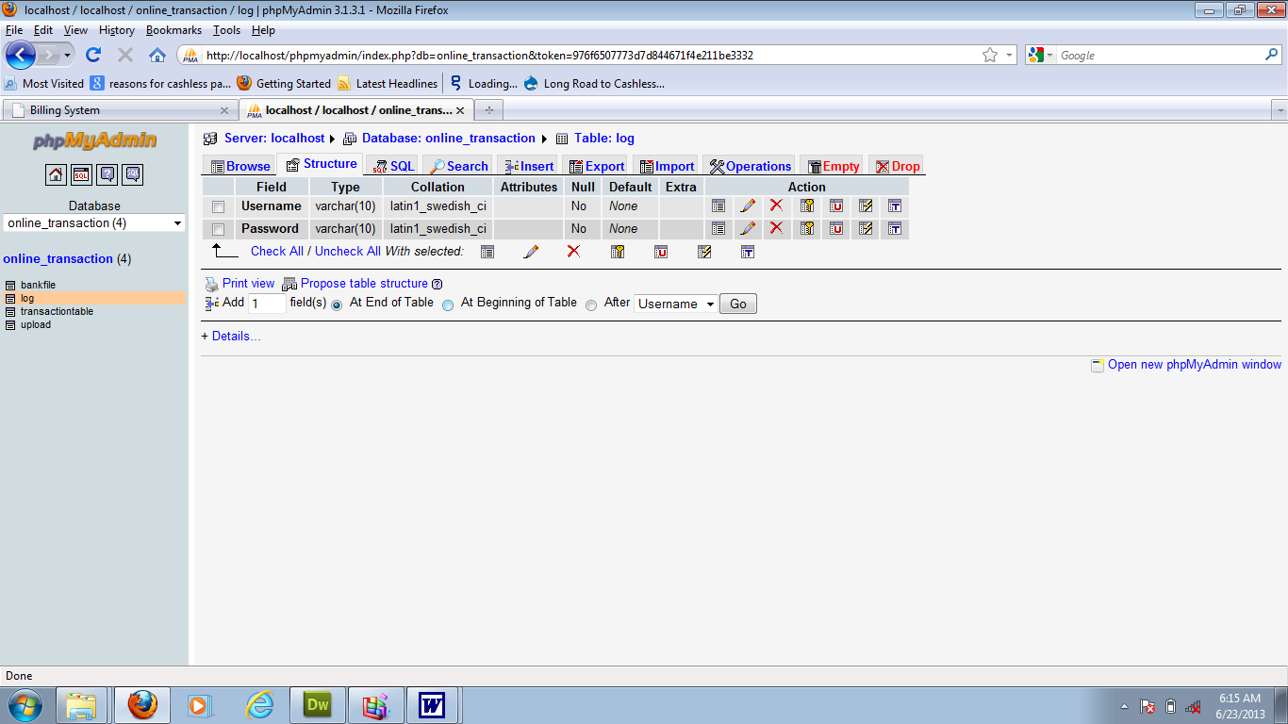

Table 4.3:Face Enrolment Data table
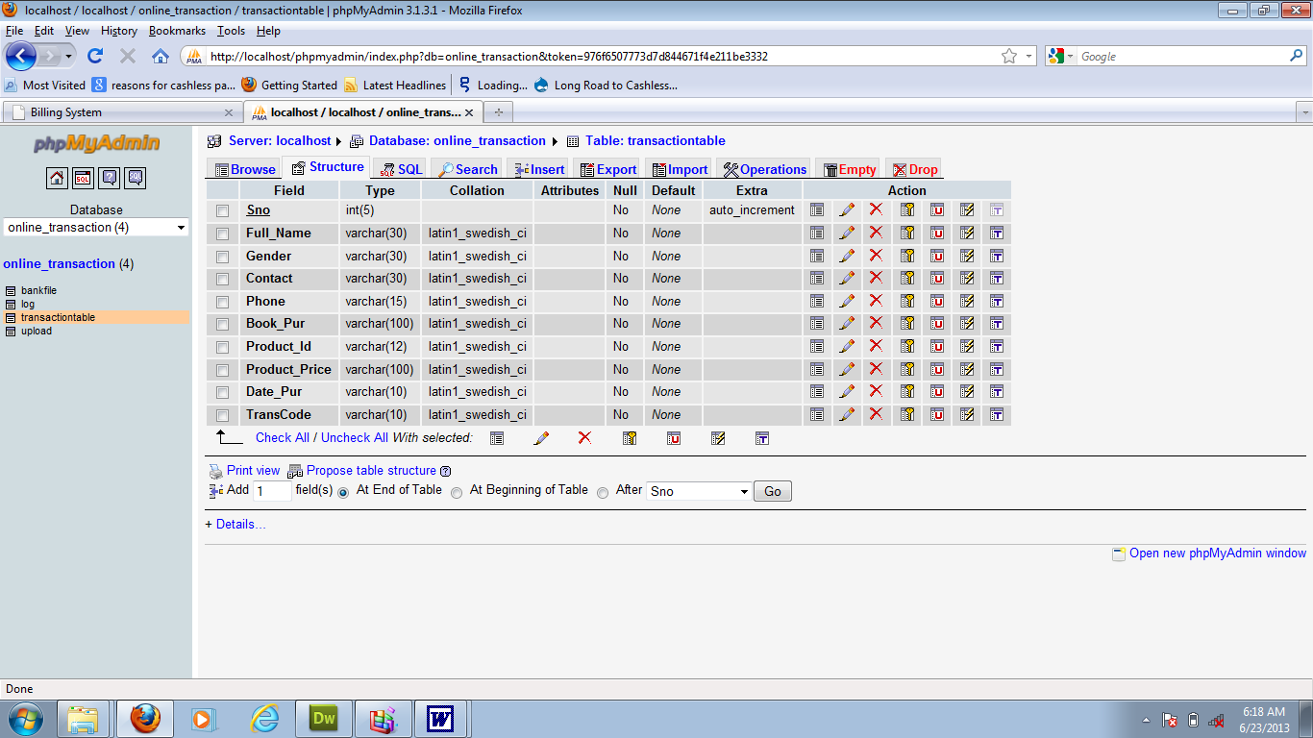
4.1.3 PROCEDURE DESIGN
Procedures are steps which verify the whole process. That is everything put together to produce the desired output. This involves the organization of the source document and end with the output result.
Documents are sent to various departments to be filled by the employees and later returned to the personnel department which are analysed to determine which record goes into the computer.
After selecting the necessary data, this serves as input to the computer system.
4.2 IMPLEMENTATION OF THE SYSTEM
It is always good to develop new ideas, to implement them on a computer and eventually to relish the satisfaction of achieving a successful result. The implementation process involves converting the system design into a complete and tested EDP that is fully operational and that can be used by the system users to meet their business needs. During implementation phase, the hardware and the software must be implemented.
Implementation of a system can be explained in six steps:-
1 Review design specification
2 Code, test and document programs
3 Train users
4 Perform system test
5 Convert to new system
6 Evaluate and maintain the new system
4.2.1 CHOICE OF PROGRAMMING LANGUAGE
The application is designed in Sublime web development package which involves the use of C sharp, MYSQL for database management (with other embedded functionalities) for the page design and layout settings. Hence, the program testing simply involves running it directly from a Personal Computer on local host server provided by Xamp Server 2.0 application.
In preparation for the installation of the new system, the method of changeover is given serious consideration to determine the success of the new system. Suitable changeover technique for this system is pilot changeover. The pilot changeover is operated by applying the new system bit-by-bit until it covers the whole of the operations. The result obtained from using the pilot method on a small portion of the operations would be used in determining the suitability of the need system for the rest of the operations. This method is similar to testing small sample of a distribution, if the test yields a good result then the whole system becomes fully operational and the manual/existing system is eliminated.
4.2.2 HARDWARE SUPPORT
- Minimum of Microcomputer Pentium II- Intel 533 MHZ processor, 128 MB RAM, 3.5GB HDD, 3.5”FDD, 14” VGA Monitor Windows 2000 Enhanced keyboard, mouse and pad.
- Scanner
- Printer
- HP DeskJet 3820c series
4.2.3 SOFTWARE SUPPORT
- Interface Design Language, Microsoft Visual Studio
- ii MY SQL Database Management Software
- iii C Sharp Programming
- Operating system window 07 professional
4.3 PROGRAM DOCUMENTATION
4.3.1 OPERATING THE SYSTEM
Step 1: Boot your computer and click on start button on task bar
Step 2: Launch Xamp server
Step 3: Login to your Application
Step 4: Click on Options
4.1 Click on Dashboard (to view operations)
4.2 Click on verification to verify students
Step 5: Logout
4.3.3 MAINTAINING THE SYSTEM
The use of the term maintenance for software is different from other references to maintenance. Unlike the tires on your car, software does not “wear out”. If this is the case, then why does software maintenance account for such a high percentage of the Total Cost of Ownership for software?
The software maintenance definition refers to changes for defect correction, performance improvements, or adaptations to a changed environment (enhancements). According to this definition, if we build software that is defect-free, performs well, and contains user-controlled parameters to adjust processing rules in response to changing requirements, then most maintenance would not be necessary.
Why does this happen? There are many reasons but the most common reasons are time constraints and lack of experience. Adding validation logic takes time. So, people make assumptions about the quality of in-bound data. Assumptions are also made about the volume of transactions and the impact on performance and the stability of the automated business processes. Finally, it is common for new software to be developed by younger developers who don’t understand the maintenance impacts of their designs.
The reality is that business requirements change and most of these assumptions are flawed. Transaction volumes increase, changing business processes require new transactions or new validation criteria, and software users will use the software incorrectly. The cost of software maintenance and the total cost of ownership can dramatically be reduced, if developers build software that adjusted to changes in transaction volumes; validated all inbound data and provide user-configurable options for logic decision and data validation.
CHAPTER FIVE
SUMMARY, CONCLUSION AND RECOMMENDATIONS
5.1 SUMMARY
The hindrance and issues of the traditional library are identified and new system using facial authentication was developed for easy access for the libraries. In the Library Management system (LMS), the librarian can add/update/remove the student and book details into the database. The students have a Unique ID for accessing any book from the library. Through the ID, the librarian can check the user details and book details. The LMS reduces labor work and makes the system efficient. It is important to provide a safe and secure environment for library staff, library resources and equipment, and library users. In this regard, the facial recognition identification system is really useful for the library and information science professionals.
5.2 CONCLUSION
Facial Identification System are really very useful for Library Management System to ensure better safety and security to the valuable collections which consist of information resource base. One has to first identify the face of students and other library users from the staff i.e. one can recognize it first and later on going towards the library part handling the library transaction such as return the particular book as well as issue the different documents. The main aim is to avoid the tedious library staff effort to handle the library job. The on the whole accomplishment is an effort to understand how Facial Recognition is used as a form of biometric to recognize identities of human beings. It includes all the stages from minutiae extraction from fingerprints to minutiae matching which generates a match gain. Various standard techniques are used in the intermediate stages of processing. The reliability of any regular facial system strongly relies on the precision obtained in the minutia extraction process. The academic libraries can make use of the benefits of the technology to ensure better safety and security to their invaluable information resource base and human resources as well.
5.3 RECOMMENDATIONS
Based on the findings of this research, it is highly recommended that:
i. higher institutions and state libraries should adopt the system, it will go a long way in solving the problems of the existing system.
ii. The system should be generalized and user friendly for the library compatibility and usage
iii. More research should be conducted on this topic as other technologies like facial recognition can also be developed.

REFERENCES
Achintya, K., M. & Subodh, G., N. (2016). Biometric Recognition : Novel Approach for Library Patron Authentication, International Journal of Computer Science & Communications. Vol. 1, Issue: 2. Pp. 4-5.
Gayathri, D. & Uma-Rani, R. (2012). A Prototype for Secure web Access Model Using Multimodal Biometric System based on Fingerprint and Face Recognition, International Journal of Computer Science and Information Technologies, vol.3, Issue: 3. Pp. 33-35.
Gayathri, D. & Uma-Rani, R. (2013). A Prototype for Secure Digital Library Accessing System using Multimodal Biometric System, International Journal of Advanced Research in Computer and Communication Engineering, IJARCCE, vol. 2, Issue 4. Pp. 16-17. www.ijarcce.com.
Kiran, K., G., Chikkamanju, G. & Chandrakanth, B., H. (2018). Automatic Fingerprint Identification System for Management of Library Operations Effectively, International Journal of Information Movement, IFSIJ Impact Factor, vol. 2, Issue: 11. Pp. 78-79.
Mohamad, K., Q. (2011). Biometric Technology: A Review”, International Journal of Computer Science and Communication, Vol. 1, Issue: 2, pp. 5.
Raju, R., Kshetrimayum, N. & Hemachandran, K. (2011). Fingerprint Identification System in library and Information Center, International Journal on Computer Science and Engineering (IJCSE), Vol. 3, Issue: 12. Pp. 56-57.
Rathinasabapathy, G., Mohana, S., & Thiru, L., R. (2008). Biometric Applications in Library and Information Centres: Prospects and Problems, International Caliber. Pp. 6-8.
Shanmugam, P. & Sasthri, G. (2020). Library Management System, Journal of Xi'an University of Architecture & Technology, Vol. 4, Issue: 12. Pp. 66-67. DOI: 10.37896/JXAT12.11/29777.

Appendices: Flowchart
Appendix 1: Main Menu Flowchart
Start
Welcome Screen
Registration

Modification
Exit
Stop
Login
Reports

Verification
Is Login Details Correct?

No

Yes

Appendix 2: Login Flowchart
Start
Login
Is Details Correct?
Stop
Display
Open Database

Close Database

No

Yes
Yes

Appendix 3: Book Access Flowchart
Start
Login
Is Details Correct?
Return
Grant Access
Verify User
Open Database

Is Verification Successful?

No

Yes

No

Yes

Appendix 4: View Records Flowchart
Start
Login
Is Details Correct?
Stop
View Records
Close Database

Open Database

No

Yes
Yes

Appendix 6: User Records Modification Flowchart
Start
Login
Is Details Correct?
Return
Display
Modify User Records
Open Database

Close Database

No

Yes

Appendix 7: Source Code

using System;
using System.Collections.Generic;
using System.ComponentModel;
using System.Data;
using System.Drawing;
using System.Linq;
using System.Text;
using System.Windows.Forms;
using System.IO;
using MySql.Data.MySqlClient;

namespace Fault_detection_in_Cloud
{
public partial class CreateData : Form
{
public void randomareg()
{
String rid = "Rec-001";
MySqlConnection mycon = new MySqlConnection(Class1.connectstring);
mycon.Open();
MySqlCommand cmd = new MySqlCommand("select Count(rid) from recor", mycon);
int i = Convert.ToInt32(cmd.ExecuteScalar());
mycon.Close();
i++;
textBox1.Text = rid + i.ToString();

}
public CreateData()
{
InitializeComponent();
randomareg();
}

private void button4_Click(object sender, EventArgs e)
{
Main_menu mm = new Main_menu();
Hide();
mm.Show();
}

private void timer1_Tick(object sender, EventArgs e)
{
label7.Text = DateTime.Now.ToString("hh:mm:ss tt");
}

private void CreateData_Load(object sender, EventArgs e)
{
timer1.Start();
timer1.Enabled = true;
}

private void button3_Click(object sender, EventArgs e)
{
//To dislay staff's passport

pictureBox1.Visible = true;

try
{
OpenFileDialog opfd = new OpenFileDialog();
opfd.Filter = "All files (*.*)|*.*";

//validate image width and height
if (opfd.ShowDialog() == DialogResult.OK)
{
//textBox13.Enabled = false;
string filepath = opfd.FileName.ToString();
label8.Text = filepath;
pictureBox1.ImageLocation = filepath;

}
}
catch (FormatException) { }
}

private void button2_Click(object sender, EventArgs e)
{
//checking for empty fields............

try
{
if ((textBox1.Text.Trim().Equals("")) || (textBox2.Text.Trim().Equals("")) ||
(textBox4.Text.Trim().Equals("")) ||textBox4.Text.Trim().Equals("") || pictureBox1.Image.Equals(""))
{

MessageBox.Show("ALL FIELDS ARE MANDATORY!", "ALERT!", MessageBoxButtons.RetryCancel, MessageBoxIcon.Error);
textBox1.Focus();
return;

