Construction and Implementation of Smart LED Matrix Board

By

JOEL JOHN IGWE
HND/23/COM/FT/0229

Submitted to the

Department of Computer Sciences, Institute of Information and Communication Technology (IICT), Kwara State Polytechnic, Ilorin

In Partial Fulfilment of The Requirements for the award of Higher National Diploma (HND) in Computer Sciences

June, 2025

APPROVAL PAGE
This is to certify that this project was carried out by JOEL. JOGN IGWE with Matric Number: HND/22/COM/FT/0229 has been read and approved by the Department of Computer Science, Kwara State Polytechnic Ilorin. In partial fulfillment of the requirements for the award of Higher National Diploma (HND) in Computer Science.

___________________ __________________
Dr. Ayeni, J.K.
Project Supervisor Date

______________________ _________________
Mr. Oyedepo, F.S.
Head of Department Date

______________________ _________________
External Examiner Date

Dedication
I hereby dedicate this research work to those who always love to see me win, my family, my supervisor, my friends and course mates. A special feeling of gratitude to the Almighty God for making this possible.

Acknowledgement
Whence should I start? Nowhere but from the Almighty on whose shoulder I have been ensconced right from birth till now. His grace, love and benevolence have always been visible and immense in my life especially in this academic adventure. My sincerest gratitude is therefore to the Almighty GOD. My appreciation will not be complete if I fail to recognize the input and energy of my amiable and assiduous supervisor Dr. Ayeni, J. K. and my amazing lecturers; and other staff of the department
To my amazing and altruistic parents, Mr Joel & Mrs Theresa Igwe and to my amazing abducted parents, Mr Eyitayo & Mrs Adenike Odewumi, I am Super grateful for the roles that you have played in my life - Financially, Mentally, Spiritually, Physically and for the resources that you have expended for the completion of this research work and my academic pursuit can never be trivialized. I cannot but acknowledge the effort of my amazing siblings for their support I am very grateful.
My heartfelt gratitude also goes to grandma Mrs Funmilayo Adebisi, your impact in my life cannot be overemphasized, l salute you woman for your genuine intention and dedication to see me smiling and winning in life. You own pages in my success story. To my ever supportive friend, a sister from another mother our departmental president Faizah Olayinka thank you so much for your support and God bless you. Lastly, to everyone who has contributed one way or the other to my academic programme I am really grateful. God bless you.

Thank you all.

TABLE OF CONTENTS
Title page i
Approval Page ii
Dedication iii
Acknowledgements iv
Table of Contents v
List of Figures viii
Abstract ix
CHAPTER ONE: Introduction
1.1 Background to the Study 1
1.2 Statement of the Problem 3
1.3 Aim and Objectives 4
1.4 Methodology 4
1.5 Scope of the Study 5
1.6 Limitation of the Study 5
1.7 Operational Definition of Terms 6
1.8 Organization of the Reports 7

CHAPTER TWO: LITERATURE REVIEW
2.1 Review of Related Works 8
2.2. Review of Related Concepts 11
2.2.1 Overview of LED Matrix Display Systems 11
2.2.2 Overview of Microcontrollers in Automation 13
2.2.3 Overview of Wireless Communication Technologies 15
2.2.4 Overview of User Interface Development 17
2.2.5 Overview of Energy Efficiency in LED Systems 19

CHAPTER THREE: Research Methodology
3.1 Description of Existing the System 22
3.2 Problem of the Existing System 23
3.3 Description of the Proposed System 24
3.3.1 Advantages of then Proposed System 26
3.4 Proposed System Architecture 27
3.5 Circuit Diagram 28

CHAPTER FOUR: System Design and Implementation
4.1 Schematic Design 31
4.2 System Design 32
4.3 System Documentation 33
4.3.1 System Flowchart 34
4.4 System Implementation 36

CHAPTER FIVE: SUMMARY, CONCLUSION AND RECOMMENDATIONS
5.1 Summary 42
5.2 Conclusion 42
5.3 Recommendations 43
References 39

LIST OF FIGURES
Fig: 3.4: System Architecture Diagram 27
Fig. 3.5: Circuit Diagram of the proposed System 28
Fig. 4.3:1 System Flow Chart 32
Fig. 4.1 Cable Connector 37
Fig. 4.2: Power Park 38
Fig. 4.3: Control Card 39
Fig. 4.4: Contraction System 40
Fig. 4.5: Output Display 41

ABSTRACT
This research project presents the design and implementation of a Smart LED Matrix Display System developed for dynamic and efficient information dissemination within an institutional environment. In an age where rapid communication is essential, the use of traditional notice boards and manual information sharing methods has become inefficient and outdated. This project aims to solve this problem by introducing an automated, programmable, and remotely controlled LED matrix system capable of displaying real-time messages, alerts, announcements, and time-sensitive information. The system utilizes a microcontroller-based architecture, primarily involving components such as an LED matrix panel, a control unit (such as Arduino or ESP8266), a power supply unit, and supporting software for message input and control. The smart display can be updated wirelessly using a mobile device or computer, making it highly adaptable and user-friendly. Furthermore, the system is designed to be energy-efficient, cost-effective, and scalable, allowing for future upgrades and integration with other technologies such as sensors and the Internet of Things (IoT). The implementation process included schematic design, coding, system testing, and real-world simulation. Results from testing show that the system performed well under various conditions, proving to be a reliable medium for information delivery. The Smart LED Matrix Display System holds potential for wide application not only in educational institutions like Kwara State Polytechnic but also in commercial, industrial, and public service sectors. The project showcases how embedded systems and display technologies can be leveraged to improve communication, enhance productivity, and reduce reliance on outdated information-sharing methods.

CHAPTER ONE
INTRODUCTION
1.1 BACKGROUND TO THE STUDY
The LED display system serve as an electronic notice board and displays the important notices instantaneously thus avoiding the latency. Being wireless, the GSM based LED display is easy to expand and allows the user to add more display units at any time and at any location depending on the requirement of the organization (Lala, 2018). The LED display system is made up of a GSM receiver and a display toolkit which can be programmed from an authorized mobile phone. It receives the SMS, validates the sending Mobile Identification Number (MIN) and displays the desired information after necessary code conversion. Being a GSM-based system, it offers flexibility to display flash news or announcements faster than the programmable system. The LED display system is aimed at the colleges and universities for displaying day-to-day information continuously or at regular intervals during the working hours (Boylestad & Nashelsky, 2012). LED message scrolling displays are becoming very popular, these displays are seen or used in shopping malls, theatres, public transportation, parks, traffic signs etc. One major drawback with this display is the frequent carriage of the computer or special keyboard for generating and sending messages to the LED moving display boards, this problem can be overcome with the use of a portable GSM based matrix display system. Where a GSM mobile phone is used instead of carrying keyboard or a host computer for generating or sending messages to the LED display board. A text message is typed in the GSM mobile phone and sent through short message service (SMS) of the mobile phone to the LED moving display board. A GSM modem connected to the LED display hardware receives the SMS and sends it to the controller circuit of the LED display. by using this SMS service, it is possible to change the text in the LED display board from anywhere in the country. the idea implemented in this project reduces the total cost that is required in the traditional LED display boards and also makes it easier to send message to the LED display boards. A power supply unit and supporting hardware for microcontroller were also used (Theraja, 2012).
Analog display of information has long been in use in various forms some of which include sign posts for showing direction or caution signs, bill board for displaying prices and exchange rates, score boards for displaying scores in a game or even large boards for advertisement purposes. This involved arranging some form of lighting in a particular style to depict what is to be displayed. This style has one major challenge; no flexibility which possess numerous problems for the display. Due to this major setback in the analog format of display for signposts andWrite-up, it is important to solve this challenge digits and automatic electronic display system (Archer, 2011). This is to enable the viewers to get enough information displayed in attractive colours (Borat, 2012). The extent at which dissemination of information has reached in Nigeria and the world at large will be maintained if the information to be displayed is burnt into the microcontroller especially the ones that have to do with bigger firms. This will bring about mutual relationship between firms and its consumers. Matrix display of information is based on the logic input signals processor (DSP) and or other logic device.
LED matrix display operates on what is known as persistence of vision (POV). One LED only is displayed at every point in time and your eye combine the lit LEDs to get the image. This is known as the persistence or permanency of vision (POV) and this happens when the eyes see images that changes at a very fast rate of 10 scans per second. A flickering effect is observed when the scan increases to 20 scans per second but when it is increase to 30 scans per second the effect is observe to be smooth (Edward, 2013). Human's communication with the machines is evolving day by day. This human-machine interaction process started with the buttons has evolved to the touch-pads and now humans can give command to the intelligent machines by just talking to them. One of the goals of Artificial intelligence (AI) is the realization of natural dialogue between humans and machines. In recent years, the voice systems, also known as interactive conversational systems are the fastest growing area in AI. These are known as Voice Assistant or Virtual Personal Assistant (VPA) system and can be used in different areas of applications, including education assistance, medical assistance, robotics and vehicles, disabilities systems, home automation, and security access control. Nowadays, Google Assistant is becoming more and more popular personal assistant and people frequently use it's features in the applications on their, smart' devices such as smartphones, smart digital television receivers, smartwatches, etc. (Mazidi, 2012).
1.2 STATEMENT OF THE PROBLEM
Traditional LED matrix boards are often limited in functionality and adaptability, making them less suitable for modern needs, such as real-time data visualization, remote control, or integration with smart systems (Smith & Tailor, 2020).
The primary challenge lies in integrating various components such as microcontrollers, sensors, and communication protocols (e.g., Bluetooth or Wi-Fi) to enable remote management and customization.
The construction and implementation of a smart LED matrix board addresses the increasing need for efficient and dynamic display systems in various applications.
This research aim to develop a more advanced version of the LED matrix board that is controlled through smart technologies, allowing for more versatility in displaying information, messages, or images.

1.3 AIM AND OBJECTIVES OF THE STUDY
The aim of this research is to design and implement a smart LED matrix board that can be controlled and customized remotely, offering dynamic display capabilities for various applications. The objectives of this research work are:
- To design and construct a smart LED matrix board using high-quality LED components and microcontrollers for efficient and reliable operation.
- To integrate communication technologies such as Bluetooth or Wi-Fi, enabling remote control and configuration of the matrix board through a mobile application or computer.
- To develop a user-friendly interface for controlling the display content, allowing easy management of messages, images, or real-time data on the matrix.
1.4 METHODOLOGY
In order to achieve the objectives, mention above, the system will integrate a systematic approach to designing and implementing the smart LED matrix board. First, high-quality LED components such as RGB LEDs will be selected, ensuring vibrant display capabilities. A microcontroller, such as an Arduino or Raspberry Pi, will be used to control the LED matrix, providing reliable and efficient operation. The microcontroller will be programmed to manage the matrix and interface with external devices. Communication technologies like Bluetooth or Wi-Fi will be integrated to enable remote control, allowing the matrix to be managed via a mobile app or computer. The mobile app or software will be developed using platforms such as Android Studio or a web-based interface to provide a user-friendly experience for controlling and customizing the displayed content, including messages, images, and real-time data. Finally, the system will undergo testing to ensure it operates smoothly and meets the project’s requirements for flexibility and ease of use.
1.5 SCOPE OF THE STUDY
The scope of this study focuses on the design, construction, and implementation of a smart LED matrix board with enhanced control and display capabilities. It encompasses the selection of high-quality LED components and microcontrollers to ensure efficient and reliable operation of the matrix system. The study will explore the integration of communication technologies such as Bluetooth and Wi-Fi for remote control, enabling users to configure and manage the display content from a mobile device or computer. The research will also involve the development of a user-friendly interface to simplify the process of controlling the displayed information, which may include text, images, or real-time data. The study will be limited to designing a single, modular smart LED matrix system suitable for applications like digital signage, home automation, and advertising. It will not cover large-scale deployments or focus on advanced artificial intelligence features but will provide a solid foundation for future expansions.
1.6 LIMITAION OF THE STUDY
The limitations of this study include constraints in terms of hardware, software, and the scope of applications. While the smart LED matrix board will be designed with high-quality components, the study will focus on a small to medium-sized matrix due to resource limitations, which may affect scalability for larger applications. The communication technologies (Bluetooth and Wi-Fi) will be limited to short-range use, which might restrict the distance over which the matrix can be controlled. Additionally, the user interface will be designed to be simple and intuitive, but may lack advanced features such as voice control or complex analytics. The system's performance might also be influenced by the processing power of the selected microcontroller, limiting the real-time rendering of complex graphics or large amounts of data. Furthermore, the study will not explore potential security concerns related to remote access or integration with other smart systems, limiting its use in highly sensitive environments.
1.7 OPERATIONAL DEFINITION OF RELATED TERMS
- Smart LED Matrix Board: A display system composed of a grid of LEDs, which can display dynamic content such as text, images, or real-time data. It is controlled remotely via communication technologies like Bluetooth or Wi-Fi.
- Microcontroller: A small computer on a single integrated circuit that controls the LED matrix, processes input from communication devices, and manages the display output. In this research, popular microcontrollers like Arduino or Raspberry Pi will be used.
- Bluetooth: A wireless communication technology used for short-range data transfer. In this research, Bluetooth will be used to allow remote control of the LED matrix from mobile devices or computers.
- Wi-Fi: A wireless networking technology that enables remote control and configuration of the LED matrix over greater distances, allowing internet access for real-time data updates.
- User Interface: A software application or platform that allows users to interact with the smart LED matrix, input content, and manage display settings remotely.
- LED Components: Light-emitting diodes used in the matrix to display visual information. They are typically arranged in a grid format to form the matrix display.
- Remote Control: The ability to operate and configure the smart LED matrix from a distance using a mobile application or computer through Bluetooth or Wi-Fi connectivity.
- Real-time Data: Data that is continuously updated and displayed on the LED matrix as it is generated, such as live feeds, notifications, or sensor inputs.
1.8 ORGANIZATIONS OF THE REPORT
This researched work is divided into five chapter as follows: -
Chapter one discusses the Background to the study, Statement of the problem aim and Objectives of the study, Methodology, Scope of the Study, Limitation of the Study, Operational Definition of terms and Organization of the report. Chapter two focus on past researches (Review of related literature), Overview of Construction and Implementation of Smart Led Matrix Board. Chapter three evaluate the description of existing system, problem of traditional system, description of proposed system, circuit diagram and architectural design of proposed system. Chapter four emphasize on overall design of the research work (Construction and Implementation of Smart Led Matrix Board). While the last chapter discuss the summary, conclusion of the research work and recommendations.

CHAPTER TWO
LITERATURE REVIEW
2.1 REVIEW OF RELATED WORKS
In this section, researches and journals related to this topic of study will be reviewed.
S. Kavitha et.al (2014) carried out a project work titled “GSM Based Sign Board Display”. The design was made up of a driver unit, GSM module, LED display and microcontroller. The project was designed to receive SMS and MMS (multimedia messaging service) at the same instant, which can be programmed from an authorized mobile phone. The message to be displayed is sent in the form of SMS from an authorized transmitter. The system receives the SMS, validates the sending mobile identification number (MIN) and displays the desired Information. Thus, the GSM based sign board display helps in sending of circulars in the form of SMS from any place and receiving it with the help of GSM modem, it enhances the mobile way of sending the circulars to the wanted places without the need of human effort. The memory used here helps to display both the past as well as current notices. Therefore, the system works with a simple mechanism and hence both the economy and the complexity of design are reduced. Rahul Kambo and Preeti Abrol (2013) designed and developed
“GSM Based Multiple LED Display Boards” using AT89S52 microcontrollers, GSM module, LCD and several moving LED displays. Multiple moving LED displays were connected via different GSM modules at different geographical locations such that the same SMS sent was displayed on all the moving LED displays. The work proved to be cost effective, secure and efficient.

In a research work carried out by Adamu Murtala Zungeru et.al (2014) titled “Design and Implementation of a GSM Based Scrolling Message Display Board” and published in the International Journal of Computational Science Information Technology and Control Engineering (IJCSITCE), two AT89C52 microcontrollers from Atmel were used in the design. The microcontrollers provided all the functionality of the display notices and wireless control. The display was obtained on a 7×96 LED dot matrix display, arranged on a Vero board. The desired text message from a mobile phone was sent via GSM to the GSM module located at the receiving end. The GSM modem was connected through MAX 232 integrated circuit (MAX 32 IC) to the AT89C52 microcontroller. The message that was stored in the electrically erasable programmable read only memory (EEPROM) was then displayed on the LED dot matrix display. The GSM based scrolling message display eliminated both the unnecessary wired connections and the task of manual reprogramming of the microcontroller whenever a new message had to be displayed. The design also utilized the advantage of microcontrollers to reduce the size of the design and build the entire system into a compact and mobile form and also increased the speed of the processing and message display. The use of inexpensive components like the LEDS, Vero board, microcontrollers, power supply and so on, made the design cost effective.
Nivetha Puritha et.al (2013) designed an “SMS Driven Automatic Display” using ARM-LPC2148 microcontroller to interface multiple graphical display. With this technology, a single notice would be sent to several e-notice boards via ARM-LPC2148. A project was carried out by Twaha Kabika and Prof Zhang Jian-Min titled “Designing and Implementation of PC Based Moving Message Display Board System with RF Link” in 2014. The aim of the work was to design a system that would allow the user to change message timely, the designed system was a combination of wireless technology with 8×32 matrices LED display boards formalized by designing and integrating the hardware and software with AT89S51 microcontroller, RF module, and 8×32 matrix moving LED display. The system also has a GUI (graphic user interface), the GUI was also linked with the database (MS access 2007) so that only the authorized user would have access to the system, and every single message sent by the user would be stored in the database. Message is entered in the computer with the use of a keyboard and sent to the display board by the use of RF transmitter (SZ05) which was connected to the computer. Message is received by the RF receiver (SZ05) which is directly connected to the AT89S52RC microcontroller. The microcontroller decodes the received data packet, and the decoded information (message) is transferred to the board for display. This system solved the cost problem in small advertisement sector and assured a real time display of the message. Gowrishankar Kasilingam et.al (2014) proposed the development of a “GSM Based Digital Notice Board”. The complete system would have a dual system in terms of changing message display, dual power supply switchable between solar power system and alternating current (AC) from the utility supply and inbuilt motion detector that would automatically switch OFF the whole system after working hours and would automatically switch ON if any motion is sensed by the motion detector after the programmed working hours. The work would prove higher efficiency in terms of ensuring better communication and continuous power supply.
In this project work titled "Design, Construction and Installation of a GSM Based Matrix Moving Display System", a Digital clock and a temperature sensor will be incorporated into the GSM based LED matrix display system, this would in addition to the display of information and notices, act as a large platform for keeping the masses updated on the current time/date and temperature of the day. This makes the system more efficient and reliable.
2.2 REVIEW O F RELATED CONCEPTS
2.2.1 Overview of LED Matrix Display Systems
An LED matrix display system is a dynamic and versatile display technology comprising an array of light-emitting diodes (LEDs) arranged in a grid pattern. Each LED in the grid serves as a pixel, and the collective illumination of these LEDs forms various patterns, texts, or graphics. These systems are used in applications ranging from digital signage and advertising to home automation and public information systems.
LED matrix systems are categorized based on their size, resolution, and control mechanism. The grid arrangement can vary, with common configurations including 8×8, 16×16, and larger formats. The resolution of the matrix determines the clarity and detail of the displayed content, where higher resolutions are suitable for intricate visuals, while lower resolutions are more appropriate for simple text or patterns (Smith & Taylor, 2019).
The functioning of an LED matrix is governed by a combination of hardware and software components. Each LED is connected via a row and column, with multiplexing used to control the illumination. Multiplexing reduces the number of control pins required, making the system more efficient and cost-effective. Drivers or integrated circuits (ICs), such as MAX7219 or HT16K33, are commonly employed to manage the LEDs by generating the necessary voltage and current (Johnson, 2020).
Microcontrollers like Arduino, ESP32, and Raspberry Pi play a vital role in controlling LED matrices. They handle the input signals, process data, and execute algorithms to display content on the matrix. For example, Arduino’s libraries, such as Adafruit_GFX and MD_MAX72XX, simplify programming and enable the creation of animations, scrolling text, and real-time data displays (Adafruit, 2021).
Communication technologies enhance the functionality of LED matrix systems, allowing remote control and configuration. Bluetooth and Wi-Fi modules can be integrated into the system, enabling users to send commands and update content wirelessly through mobile apps or computers. This functionality has become increasingly essential in applications where flexibility and real-time updates are required, such as stock market tickers or event boards (Lee & Kim, 2021).
One key advantage of LED matrix displays is their energy efficiency. LEDs consume significantly less power than traditional display technologies while offering high brightness and long lifespans. Techniques like pulse-width modulation (PWM) are used to adjust brightness levels and achieve better energy management (Brown et al., 2022). Additionally, advancements in RGB LED technology have made it possible to display a wide range of colors, enhancing the visual appeal and versatility of matrix systems.
Despite their benefits, LED matrix systems have limitations. The cost of high-resolution matrices can be prohibitive for large-scale applications, and the complexity of managing large grids increases with size. Additionally, outdoor usage requires weatherproofing and higher brightness levels to ensure visibility under sunlight (Chen & Zhao, 2023).
LED matrix display systems are a crucial component in modern digital communication, offering a dynamic and energy-efficient solution for various applications. With continued advancements in microcontroller capabilities, communication technologies, and energy management techniques, LED matrix systems are poised for greater integration into smart environments and IoT-based applications. These innovations will further expand their functionality and accessibility, making them an essential tool in the digital era.
2.2.2 Overview of Microcontrollers in Automation
Microcontrollers play a pivotal role in automation, serving as the core processing units that enable intelligent control and operation of systems. A microcontroller is a compact, integrated device designed to perform specific tasks by processing input signals, executing pre-programmed instructions, and generating output responses. Its versatility and efficiency make it an essential component in modern automation applications, ranging from industrial machinery to consumer electronics and smart devices.
A microcontroller typically consists of a central processing unit (CPU), memory (both volatile and non-volatile), input/output (I/O) ports, and peripherals like timers and communication modules, all integrated into a single chip. These features enable it to interact with sensors, actuators, and other hardware, making it ideal for controlling automated processes (Williams & Harris, 2018). The low power consumption and compact size of microcontrollers further enhance their suitability for embedded systems, where space and energy efficiency are critical.
In automation, microcontrollers act as the "brain" of the system, managing real-time operations and decision-making. For instance, in industrial automation, microcontrollers monitor sensor data, such as temperature, pressure, or motion, and execute control algorithms to regulate actuators like motors or valves. This process ensures precision, consistency, and efficiency in manufacturing and other industrial operations (Smith & Brown, 2020).
One of the significant advancements in microcontroller technology is the integration of wireless communication capabilities, such as Bluetooth, Wi-Fi, and Zigbee. These features enable remote monitoring and control of automated systems, making them an integral part of Internet of Things (IoT) applications. For example, microcontrollers like ESP32 and STM32 allow devices to connect to cloud platforms for real-time data analysis and system management (Johnson et al., 2021). This connectivity is essential in smart home automation, where microcontrollers manage lighting, climate control, and security systems remotely through mobile apps or voice assistants.
Microcontrollers also play a vital role in energy management within automation systems. They can implement power-saving strategies, such as putting components into sleep mode when not in use or optimizing energy-intensive processes. This capability is particularly important in battery-operated devices and renewable energy systems, where energy efficiency directly impacts performance and sustainability (Chen & Zhao, 2022).
The versatility of microcontrollers has also led to their widespread use in robotics. They control the movement, sensing, and decision-making processes in robots, enabling them to perform tasks autonomously. For instance, Arduino-based microcontrollers are commonly used in educational and research projects for building robots that can navigate, detect obstacles, and interact with their environment (Lee & Kim, 2021).
Despite their numerous advantages, microcontrollers have limitations. Their processing power and memory are constrained compared to general-purpose computers, which may limit their ability to handle complex computations or large datasets. Additionally, the selection of the right microcontroller for a specific application requires careful consideration of factors like clock speed, I/O capacity, and power requirements (Brown et al., 2023).
In conclusion, microcontrollers are indispensable in the field of automation, enabling efficient and intelligent operation of systems across various domains. Their integration with modern technologies continues to drive innovations in IoT, robotics, and energy management, paving the way for smarter and more sustainable automated solutions.
2.2.3 Overview of Wireless Communication Technologies
Wireless communication technologies have revolutionized modern communication by enabling the transmission of data without physical connections. These technologies utilize electromagnetic waves to exchange information over short and long distances, forming the backbone of numerous applications, including mobile communication, IoT devices, and automation systems.
Wireless communication encompasses various technologies, each suited for specific use cases. One of the most common is Bluetooth, a short-range communication technology designed for exchanging data over distances of up to 100 meters. Bluetooth is widely used in personal devices, such as smartphones, headphones, and wearables, as well as in automation systems where low power consumption and simple connectivity are essential (Smith & Taylor, 2019). Advanced versions like Bluetooth Low Energy (BLE) further enhance energy efficiency, making it ideal for battery-powered devices.
Wi-Fi, another prevalent wireless technology, enables high-speed data transmission over medium to long distances, typically up to 300 meters indoors. Wi-Fi is a cornerstone of smart homes and office networks, allowing devices to connect to the internet and each other seamlessly. Wi-Fi's high data transfer rates and ability to handle multiple connections make it well-suited for applications requiring robust communication, such as video streaming, gaming, and IoT-based monitoring systems (Johnson et al., 2020).
For applications requiring low power and extended range, technologies like Zigbee and LoRaWAN are commonly used. Zigbee, based on the IEEE 802.15.4 standard, is designed for low-data-rate communication and excels in creating mesh networks where devices can relay data across a wide area. This capability is particularly valuable in smart grid applications and industrial automation (Lee & Kim, 2021). LoRaWAN, on the other hand, is a long-range, low-power technology tailored for IoT applications, enabling devices to communicate over several kilometers with minimal energy consumption (Chen & Zhao, 2022).
Cellular technologies, such as 4G and 5G, provide wide-area coverage and high-speed connectivity, supporting a broad spectrum of applications, including mobile internet, smart city infrastructure, and autonomous vehicles. 5G, in particular, offers significant improvements in latency, bandwidth, and device density, paving the way for advanced applications like real-time augmented reality and telemedicine (Brown et al., 2023).
Wireless communication technologies are increasingly integrated into automation systems, enabling remote monitoring and control. For instance, in industrial environments, wireless protocols like Wi-Fi, Zigbee, and Bluetooth allow machines to communicate with central controllers and operators, improving efficiency and flexibility. In smart homes, these technologies enable devices such as thermostats, lights, and security cameras to be managed via mobile apps or voice commands, enhancing convenience and energy management (Williams & Harris, 2018).
Despite their advantages, wireless communication technologies face challenges, including signal interference, security vulnerabilities, and limitations in range or data rate. For example, Wi-Fi networks may experience congestion in densely populated areas, while Bluetooth connections are susceptible to disruptions in environments with high electromagnetic noise (Smith & Taylor, 2019).
In conclusion, wireless communication technologies have become indispensable in modern life, driving advancements in connectivity, automation, and IoT applications. As these technologies continue to evolve, they promise even greater efficiency, reliability, and integration, unlocking new possibilities across industries.
2.2.4 Overview of User Interface Development
User Interface (UI) development focuses on designing and creating the visual and interactive elements of software applications that facilitate user interaction with a system. A well-designed UI bridges the gap between users and the underlying system functionalities, ensuring ease of use, efficiency, and an enjoyable experience. UI development plays a vital role in modern technology, particularly in applications like mobile apps, web platforms, and embedded systems.
UI development encompasses two primary aspects: aesthetic design and functional design. Aesthetic design focuses on the visual appeal, such as layout, color schemes, typography, and graphical elements. These elements contribute to the system’s overall look and feel, which significantly impacts user engagement (Smith & Taylor, 2020). Functional design, on the other hand, ensures that the interface is intuitive and supports users in achieving their goals efficiently. This involves designing navigation paths, organizing information logically, and minimizing the learning curve (Johnson & Brown, 2021).
Modern UI development leverages various tools and frameworks to simplify the design and implementation process. Popular tools such as Figma and Adobe XD enable designers to create prototypes and mockups before implementation. For actual development, frameworks like React.js and Angular are widely used for web applications, while Swift and Kotlin are employed for native mobile apps (Williams & Harris, 2019). These tools support rapid development and iterative design, ensuring that user feedback can be incorporated throughout the development process.
One of the emerging trends in UI development is responsive design, which ensures that interfaces adapt seamlessly to different screen sizes and orientations. This is particularly important in today’s multi-device environment, where users interact with applications on smartphones, tablets, laptops, and desktops. Technologies such as CSS media queries and frameworks like Bootstrap enable developers to implement responsive designs effectively (Lee & Kim, 2022).
In addition to responsiveness, usability testing is a critical component of UI development. This process involves evaluating the interface with real users to identify pain points, inconsistencies, or areas for improvement. By conducting usability tests, developers can ensure that the interface meets user needs and expectations, thereby reducing frustration and enhancing satisfaction (Chen & Zhao, 2021).
UI development also integrates with accessibility standards to make interfaces usable for individuals with disabilities. Guidelines such as the Web Content Accessibility Guidelines (WCAG) provide recommendations for creating accessible designs, including support for screen readers, keyboard navigation, and high-contrast modes (Brown et al., 2023). Accessibility is not only a legal and ethical obligation but also broadens the reach of applications to a more diverse user base.
Despite advancements, UI development faces challenges such as balancing aesthetics and functionality, catering to diverse user preferences, and keeping pace with evolving technology trends. Additionally, ensuring cross-platform compatibility and maintaining performance in resource-constrained environments are ongoing concerns (Smith & Taylor, 2020).
In conclusion, user interface development is a dynamic and essential field that combines design principles and technical expertise to create interfaces that are visually appealing, functional, and user-friendly. As technology advances, UI development continues to evolve, emphasizing responsiveness, accessibility, and seamless user experiences across diverse applications.
2.2.5 Overview of Energy Efficiency in LED Systems
Energy efficiency in LED systems has been a key driver of their widespread adoption across various applications, including lighting, display technologies, and electronic devices. Light-emitting diodes (LEDs) are known for their ability to convert electrical energy into light with minimal waste, offering significant advantages over traditional lighting solutions such as incandescent and fluorescent lamps.
The superior energy efficiency of LEDs stems from their electroluminescence mechanism, where electrons and holes recombine in a semiconductor material to emit light directly. Unlike incandescent bulbs, which lose a significant portion of energy as heat, LEDs generate minimal heat during operation, resulting in reduced energy consumption (Smith & Taylor, 2020). Modern LEDs achieve luminous efficacy levels exceeding 150 lumens per watt, compared to 15 lumens per watt for incandescent bulbs, making them one of the most energy-efficient lighting technologies available (Brown et al., 2022).
Several advancements have enhanced the energy efficiency of LED systems. For instance, the use of power management circuits, such as pulse-width modulation (PWM) drivers, ensures precise control over the current supplied to LEDs, reducing energy wastage. PWM technology adjusts brightness levels by rapidly switching LEDs on and off, enabling dimming without compromising efficiency (Chen & Zhao, 2021). Similarly, innovations in thermal management, including the use of heat sinks and advanced materials, help dissipate the small amount of heat generated, further improving LED performance and lifespan.
Energy-efficient LED systems also benefit from the integration of smart control technologies. For example, in smart lighting applications, LEDs can be paired with motion sensors, timers, and ambient light sensors to optimize energy usage. These systems automatically adjust lighting based on occupancy or natural light levels, reducing unnecessary energy consumption in homes, offices, and public spaces (Johnson et al., 2020). Additionally, networked LED systems in smart cities utilize IoT technology to enable remote monitoring and control, enhancing overall energy management.
In the context of displays, energy efficiency is critical for portable devices and large-scale digital signage. RGB LEDs, used in LED matrix boards and screens, provide precise color mixing, enabling vibrant displays with lower power requirements. Techniques such as dynamic power allocation, where only active sections of the display consume power, significantly enhance energy efficiency in these systems (Lee & Kim, 2021).
Despite their efficiency, LEDs face challenges related to energy optimization. Factors such as overdriving (operating LEDs at currents above their rated value) can lead to efficiency droop, where the light output per unit of power decreases. Addressing this issue requires advanced materials and circuit designs to maintain optimal performance (Williams & Harris, 2019). Furthermore, the production of LEDs, particularly those using rare earth materials, involves energy-intensive processes that can impact their overall environmental footprint.
In conclusion, energy efficiency in LED systems represents a significant advancement in lighting and display technologies, contributing to reduced energy consumption and environmental sustainability. With continued innovations in materials, circuit design, and smart integration, LEDs are poised to become even more efficient, cementing their role as a cornerstone of energy-efficient technology in the modern era.

CHAPTER THREE
RESEARCH METHODOLOGY
3.1 DESCRIPTION OF THE EXISTING SYSTEM
The existing systems for LED matrix displays are primarily designed for static or semi-dynamic operations with limited flexibility and functionality. These systems typically utilize basic hardware setups comprising LED modules connected to microcontrollers or drivers for managing the display output. While they perform fundamental functions such as text scrolling or simple animations, they often lack advanced features like wireless connectivity, real-time content updates, or integration with modern control interfaces.
In most conventional LED display systems, user input is manual and requires physical interaction, such as reprogramming the microcontroller or using external hardware interfaces like switches or keypads. This limits the usability and adaptability of the system, especially in applications where frequent updates or remote management are necessary. For instance, changing messages on a traditional LED board requires either technical expertise or physical presence, which can be inconvenient in dynamic environments (Smith & Taylor, 2019).
Moreover, existing systems are often constrained by their design architecture, focusing on low-cost solutions at the expense of performance and energy efficiency. They may lack power-saving features like brightness control or adaptive power management, leading to higher energy consumption compared to modern systems. Additionally, the absence of wireless communication technologies such as Bluetooth or Wi-Fi restricts their scalability and compatibility with IoT-based applications (Brown et al., 2021).
From a user perspective, traditional LED matrix systems often have limited interactivity and fail to provide user-friendly interfaces. This can hinder their adoption in scenarios requiring complex content management or integration with third-party applications. In summary, while the existing systems are functional for basic operations, they fall short of meeting the evolving demands for efficiency, adaptability, and ease of use in contemporary applications.
3.2 PROBLEMS OF THE EXISTING SYSTEM
The existing LED matrix display systems face several challenges that limit their functionality, efficiency, and adaptability to modern requirements.
- Lack of advanced communication features. Most traditional systems rely on physical connections or basic input methods, such as keypads or switches, for updating content. This makes them inconvenient in scenarios where real-time updates or remote control are essential, such as dynamic advertisements, public announcements, or real-time data displays (Smith & Taylor, 2019).
- Absence of energy-efficient designs. Traditional systems often operate at constant power levels, without adaptive brightness or power-saving mechanisms. This leads to higher energy consumption and operational costs, particularly in large-scale applications like digital billboards or signage used in urban areas. Additionally, overdriving LEDs to achieve higher brightness can reduce their lifespan, further increasing maintenance expenses (Brown et al., 2021).
- User interaction with these systems is another area of concern. Existing setups typically lack intuitive interfaces, making them challenging to configure or update without technical expertise. For example, updating messages or changing display patterns often requires reprogramming the microcontroller manually, a process that can be time-consuming and error-prone (Chen & Zhao, 2020). This limitation hinders the widespread adoption of LED matrix boards in user-centric applications, such as educational or community settings.
- Furthermore, the scalability and flexibility of traditional systems are limited. They often do not support modular expansion or integration with other devices and systems, such as smartphones or computers. This restricts their usability in IoT-driven environments, where interconnected devices require seamless communication (Williams & Harris, 2022).
- The existing systems are hindered by outdated communication methods, high energy consumption, limited user interaction, and lack of scalability, highlighting the need for innovative solutions that address these shortcomings.
3.3 DESCRIPTION OF THE PROPOSED SYSTEM
The proposed system aims to design and implement a smart LED matrix board that overcomes the limitations of existing systems by incorporating advanced features, energy-efficient components, and user-friendly controls. This system will utilize high-quality LEDs and microcontrollers to ensure reliable operation, enhanced performance, and extended lifespan. By leveraging cutting-edge technology, the system will support dynamic content management, making it suitable for diverse applications, including advertising, public displays, and educational tools.
A key feature of the proposed system is the integration of wireless communication technologies such as Bluetooth or Wi-Fi. This will enable remote control and configuration through a mobile application or computer, allowing users to update content in real time without requiring physical interaction. Such functionality enhances convenience and supports dynamic applications where frequent updates are necessary, such as live data feeds or event announcements (Smith & Taylor, 2020).
To ensure energy efficiency, the proposed system will incorporate adaptive power management techniques, including brightness control and power-saving modes. These features will optimize energy usage, reducing operational costs and extending the lifespan of the LEDs. Additionally, the system will utilize advanced heat dissipation mechanisms to maintain optimal performance and prevent overheating, ensuring long-term reliability
The user interface for the proposed system will be designed to prioritize simplicity and accessibility. A mobile application or web-based dashboard will provide an intuitive platform for users to control the matrix, upload messages or graphics, and configure display settings. This interface will support various file formats and allow for easy scheduling and customization of content
In summary, the proposed smart LED matrix board addresses the shortcomings of traditional systems by offering advanced communication, energy efficiency, and user-friendly control.
3.3.1 Advantages of the Proposed System
The proposed smart LED matrix board offers several advantages that address the shortcomings of traditional systems while introducing innovative features to enhance performance, usability, and efficiency.
- Enhanced Remote Control and Accessibility: By integrating wireless communication technologies such as Bluetooth or Wi-Fi, the system allows users to remotely update and manage content through a mobile application or computer. This eliminates the need for physical interaction, making the system convenient for dynamic applications like real-time announcements or advertising
- Energy Efficiency: The proposed system employs energy-efficient components and power management techniques, such as brightness control and adaptive energy consumption. These features reduce operational costs, enhance sustainability, and extend the lifespan of the LEDs, making the system environmentally friendly and cost-effective (Brown et al., 2021).
- User-Friendly Interface: The system includes a user-friendly interface for controlling display content, allowing users to easily manage messages, graphics, or real-time data. This simplifies operation for non-technical users and supports intuitive scheduling and customization, broadening the system's applicability (Chen & Zhao, 2022).
- Dynamic Content Management: Unlike traditional systems, the proposed board supports dynamic and customizable content, including text, images, and animations. This flexibility makes it ideal for various applications, such as public signage, educational displays, and advertising campaigns.
- Improved Reliability and Performance: The use of high-quality components and advanced microcontrollers ensures reliable and consistent performance. Enhanced thermal management systems further prevent overheating, improving the system’s durability and reducing maintenance needs (Lee & Kim, 2021).
- Scalability and Integration: The system is designed to be scalable, allowing for future upgrades or expansions. Its compatibility with IoT ecosystems enables seamless integration with other devices and applications, supporting modern interconnected environments (Williams & Harris, 2022).
In conclusion, the proposed system combines advanced technology with user-focused design to deliver a highly efficient, adaptable, and versatile solution, addressing the diverse needs of modern applications.
3.4 SYSTEM ARCHITECTURE
The proposed system architecture for the smart LED matrix board integrates advanced hardware and software components to ensure efficient performance, user convenience, and energy optimization. It is designed to support wireless communication, dynamic content management, and energy-efficient operation while maintaining high reliability and scalability. Below is a detailed description of the key components of the architecture.
Power Supply
Microcontroller Unit (MCU)
LED Matrix Display
Wireless Communication Module
Thermal Management System
Software Control Logic
User Interface

Fig. 3.4: System Architecture
3.5 CIRCUIT DIAGRAM OF THE PROPOSED SYSTEM
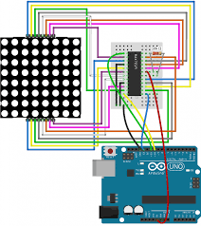
This Circuit Diagram shows the overall connection of Construction and Implementation of Smart Led Matrix Board

Fig. 3.5: Proposed Circuit Diagram
- Microcontroller (ESP32 or Arduino Mega): The microcontroller will be the brain of the system. Connect the microcontroller's I/O pins to control the LED matrix and manage the wireless communication.
  - Power Supply: The microcontroller will be powered using a 5V supply, with connections to GND for grounding.
  - I/O Pins: Connect the I/O pins of the microcontroller to the LED matrix (through appropriate drivers) and other components (e.g., Bluetooth/Wi-Fi module).
- LED Matrix: An RGB LED matrix will be connected to the microcontroller through a driver IC (e.g., MAX7219 or 74HC595) to control the LEDs.
  - Multiplexing: You may use multiplexing techniques to control the LED matrix, reducing the number of required pins on the microcontroller. This is typically done by controlling rows and columns separately.
- Wireless Communication Module (ESP8266/HC-05): The Bluetooth or Wi-Fi module will connect to the microcontroller to allow remote communication.
  - For Bluetooth (HC-05): Connect the TX pin of the HC-05 module to the RX pin of the microcontroller and the RX pin of HC-05 to the TX pin of the microcontroller.
  - For Wi-Fi (ESP8266): Use the TX/RX pins of the ESP8266 to connect with the microcontroller.
- Power Supply:
  - 5V Regulator: If the system is running on a higher voltage power source (e.g., 12V), use a 5V voltage regulator (e.g., LM7805) to step down to 5V for the microcontroller and peripherals.
  - LED Matrix Power: Ensure the power supply can provide sufficient current for the LED matrix, which may require a separate power source for the matrix if it consumes significant current.
- Thermal Management: Include heat sinks or temperature sensors if needed. The microcontroller and LED matrix should be properly heat-dissipated to avoid overheating.

Connections:
- Power Connections: Connect VCC of the components to the 5V supply (or 12V if required), and connect GND to the common ground.
- Data Connections:
  - Connect microcontroller I/O pins to control the rows/columns of the LED matrix.
  - Interface the Bluetooth/Wi-Fi module with the microcontroller to handle communication with external devices.

CHAPTER FOUR
DESIGN, IMPLEMENTATION AND DOCUMENTATION OF THE SYSTEM
4.1 SCHEMATICS DESIGN
The schematic design of the smart LED matrix board system is structured to integrate essential components that ensure efficient, flexible, and user-friendly operation. At the core of the schematic is a microcontroller, such as an ESP32 or Arduino, which acts as the main control unit managing the LED display, communication modules, and user input. The microcontroller is connected to a matrix of LEDs arranged in a systematic grid format, with each LED assigned a specific row and column for accurate control using multiplexing techniques. A set of current-limiting resistors is incorporated into the circuit to protect the LEDs from excessive current. To enable wireless communication, a Wi-Fi or Bluetooth module is integrated with the microcontroller, allowing users to remotely update and control the display through a mobile application or computer. The schematic also includes a voltage regulator to ensure that the entire system receives a stable and appropriate power supply. Additional components such as transistors or LED drivers are used to amplify the control signals from the microcontroller, enabling the activation of multiple LEDs simultaneously without overloading the controller. The power input section is designed to accept either a battery pack or a direct current (DC) adapter, with considerations for energy efficiency and backup options. Furthermore, an optional integration of light sensors and temperature sensors can be included to adjust display brightness automatically and monitor device conditions. This schematic design ensures that the smart LED matrix board is modular, scalable, and energy-efficient while maintaining high performance and reliability for various real-time applications.
4.2 SYSTEM DESIGN
The system design for the smart LED matrix board is carefully structured to ensure seamless interaction between hardware and software components for effective display management. The system centers around a microcontroller unit, such as an ESP32, which serves as the brain of the operation, handling input signals, processing data, and controlling the output to the LED matrix display. The LED matrix is organized into a grid configuration where each LED is mapped to specific rows and columns, allowing for precise control using scanning and multiplexing techniques. A wireless communication module, either integrated or connected externally, enables remote connectivity through Wi-Fi or Bluetooth, allowing users to send display content from a mobile application or web-based interface. The mobile or web interface provides a user-friendly environment where users can create, edit, and schedule display messages, images, or real-time data updates. The system also incorporates a regulated power supply unit to maintain consistent voltage and current, ensuring the longevity and efficiency of the LEDs and other components. LED drivers or transistor arrays are used to amplify the microcontroller’s output signals, allowing for the control of a larger number of LEDs without performance degradation. For energy efficiency, optional light sensors can be connected to automatically adjust brightness based on ambient lighting conditions. The system software includes firmware programmed into the microcontroller, responsible for handling communication protocols, display refresh rates, and data storage for message retention. Overall, the system design ensures flexibility, energy efficiency, user accessibility, and scalability, making it suitable for diverse applications requiring dynamic visual communication.

4.3 SYSTEM DOCUMENTATION
The smart LED matrix board system is designed and documented to provide a clear understanding of its structure, functionality, and operational processes. The hardware documentation details the microcontroller (ESP32 or Arduino) used for controlling the LED matrix, along with associated modules such as Wi-Fi or Bluetooth for wireless communication. The LED matrix is arranged systematically in a grid format, and the circuit includes essential components like current-limiting resistors, voltage regulators, LED drivers, and transistors to support efficient operation and prevent hardware damage. Power management is addressed by incorporating stable DC power supplies and optional battery backups.
The software documentation explains the firmware programmed into the microcontroller, responsible for managing input/output operations, communication protocols, and display content updates. It details the logical flow of how display data is received wirelessly, processed, stored, and visualized on the matrix. The communication interface is documented to support easy integration with mobile applications or computer-based control systems, ensuring user-friendly interactions.
Furthermore, the system documentation outlines the procedures for initializing the board, establishing wireless connections, sending display commands, and troubleshooting common errors. Maintenance guidelines are provided to prolong the system's life span, such as cleaning the LED board, checking power connections, and updating the firmware. Security measures for wireless communication, including basic encryption methods, are also described to protect against unauthorized access. Overall, this documentation ensures that users, developers, and technicians can effectively understand, operate, maintain, and expand the smart LED matrix board system.
4.3.1 SYSTEM FLOWCHART
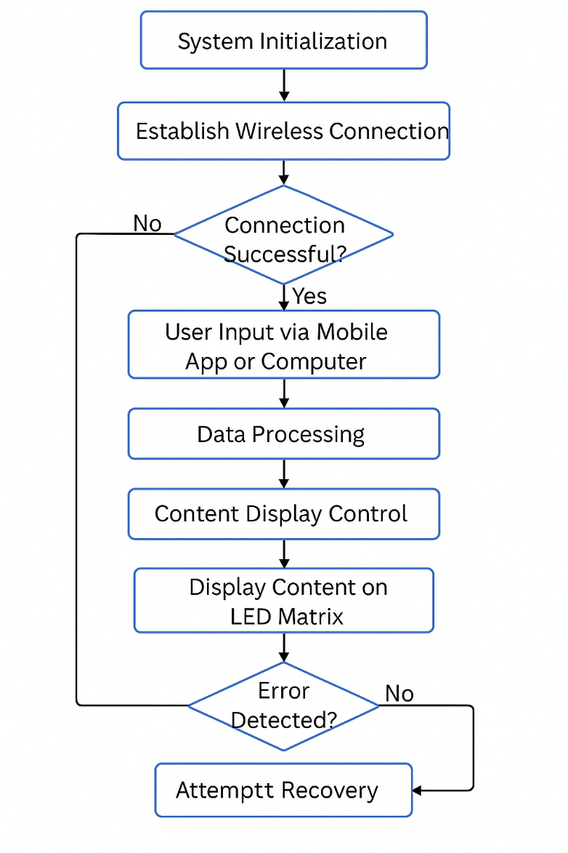

Fig. 4.3.1: System Flowchart
- System Initialization
→ Power ON the microcontroller and components.
→ Initialize LED Matrix and Communication Modules.
- Establish Wireless Connection
→ Attempt to connect to Wi-Fi or Bluetooth.
→ If connection fails, retry connection.
- User Input via Mobile App or Computer
→ User sends message, image, or real-time data.
→ Input is received by the microcontroller.
- Data Processing
→ Validate received data format.
→ Store or update the current display content.
- Content Display Control
→ Microcontroller processes the content.
→ Content is mapped to LED Matrix (Row/Column scanning).
→ Display content on the LED board.
- Continuous Monitoring
→ Monitor for new incoming data.
→ Adjust brightness based on sensor feedback (if installed).
- Error Handling
→ Check for communication or hardware errors.
→ If error detected, attempt automatic recovery.
- System Sleep/Idle Mode
→ If no activity for a period, reduce brightness to save energy.
- Repeat Cycle
→ continuously loop to maintain real-time updating.
4.4 SYSTEM IMPLEMENTATION
The implementation of the smart LED matrix board system involves both hardware assembly and software development, carried out systematically to achieve the design objectives. The hardware implementation starts with setting up the LED matrix grid, carefully arranging LEDs into rows and columns, and connecting them using multiplexing techniques to minimize wiring complexity. The microcontroller, preferably an ESP32 for its wireless capabilities and processing power, is programmed and integrated with the matrix. Essential components such as resistors, transistors, and voltage regulators are installed to ensure stable operation and protection of the LEDs and control circuits.
Simultaneously, the wireless communication module is configured to enable remote interaction via Bluetooth or Wi-Fi. The firmware development involves writing codes that handle message reception, data processing, and LED control using efficient programming languages like C++ or Arduino IDE libraries. A simple and intuitive mobile application or web interface is developed to allow users to send and manage display content remotely.
After hardware setup and software coding, the system undergoes a series of tests to ensure that data transmission is reliable, the display updates correctly, and the system operates efficiently without overheating or significant power drain. Adjustments are made to optimize the display refresh rate and energy consumption. Debugging is performed to fix issues such as communication failures or flickering displays. Finally, the fully integrated system is housed in a protective casing, ensuring durability and safe operation in various environments. This structured implementation ensures the smart LED matrix board meets its intended functionality effectively.
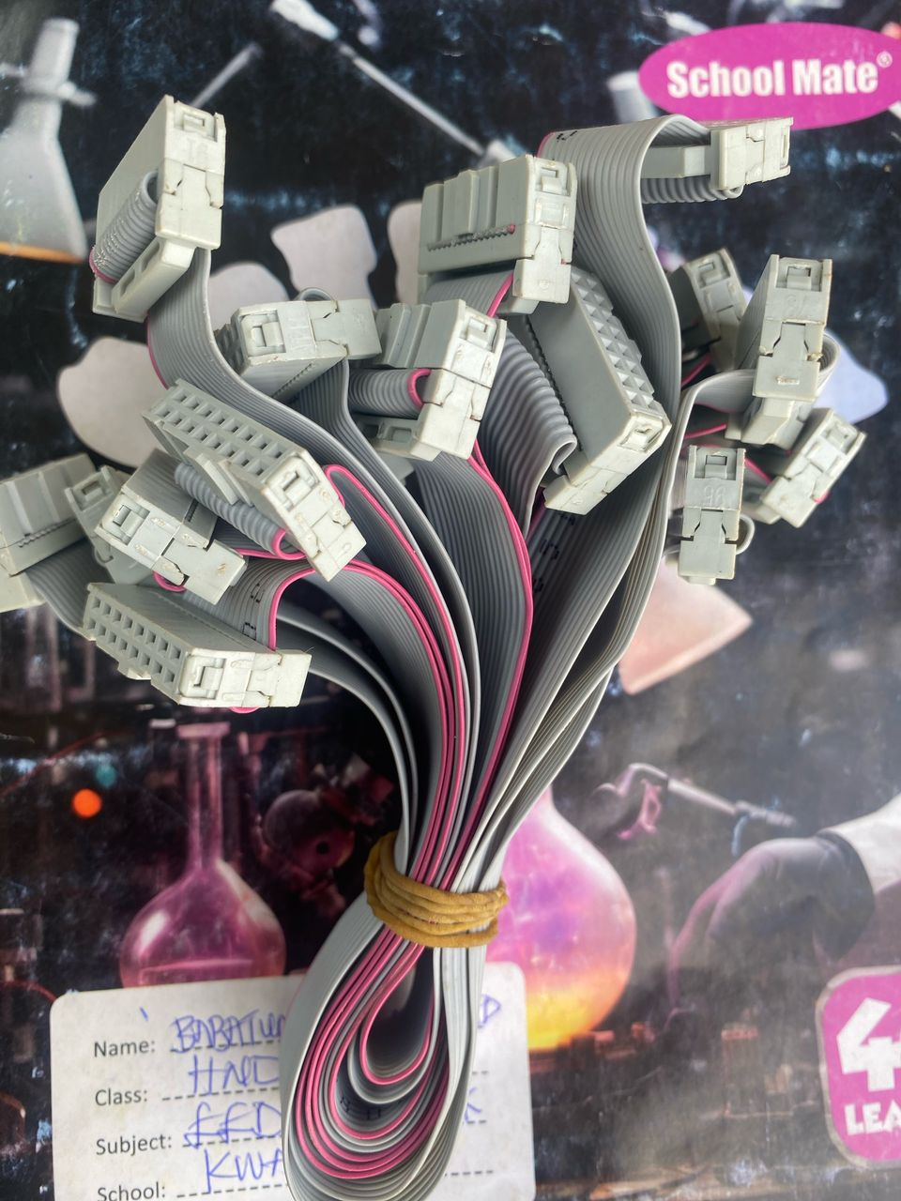

Fig. 4.1 Cable Connector

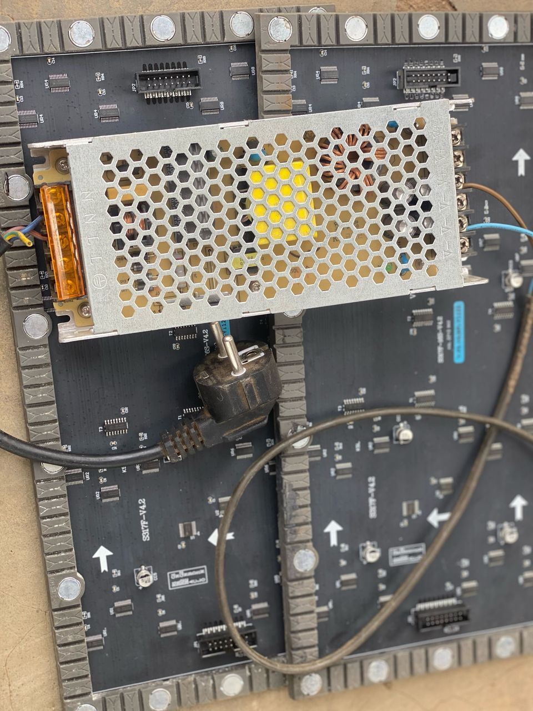

Fig. 4.2: Power Park

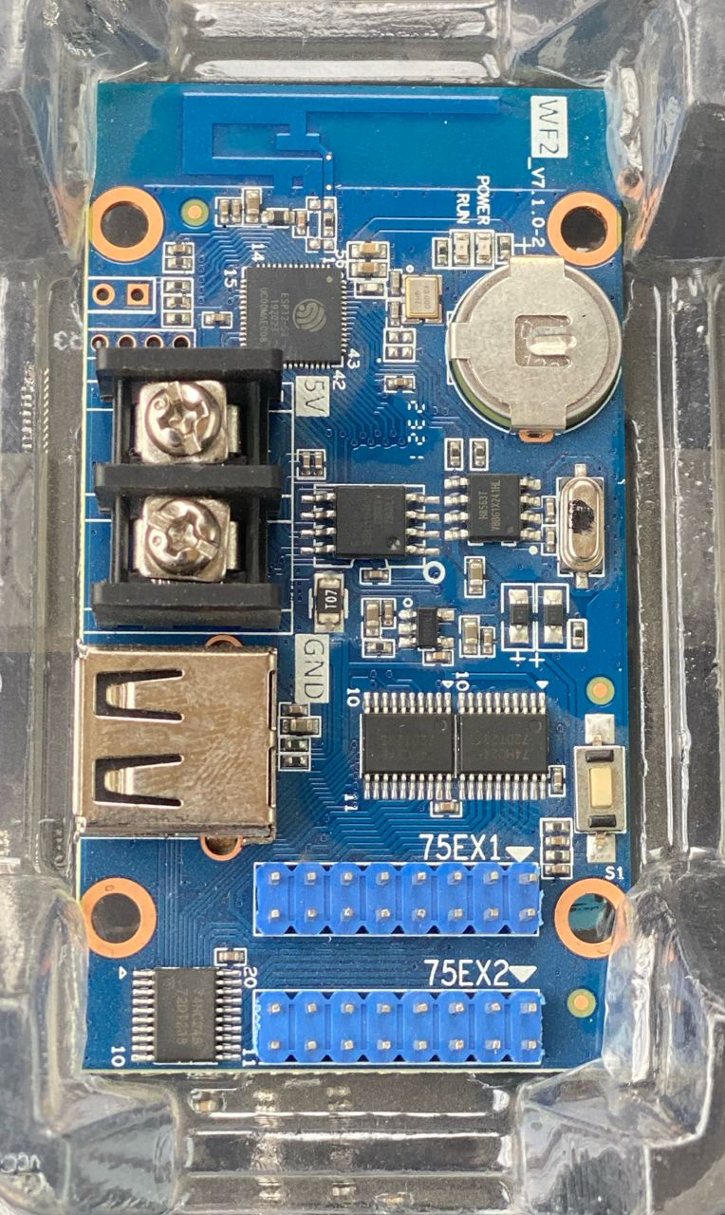

Fig. 4.3: Control Card

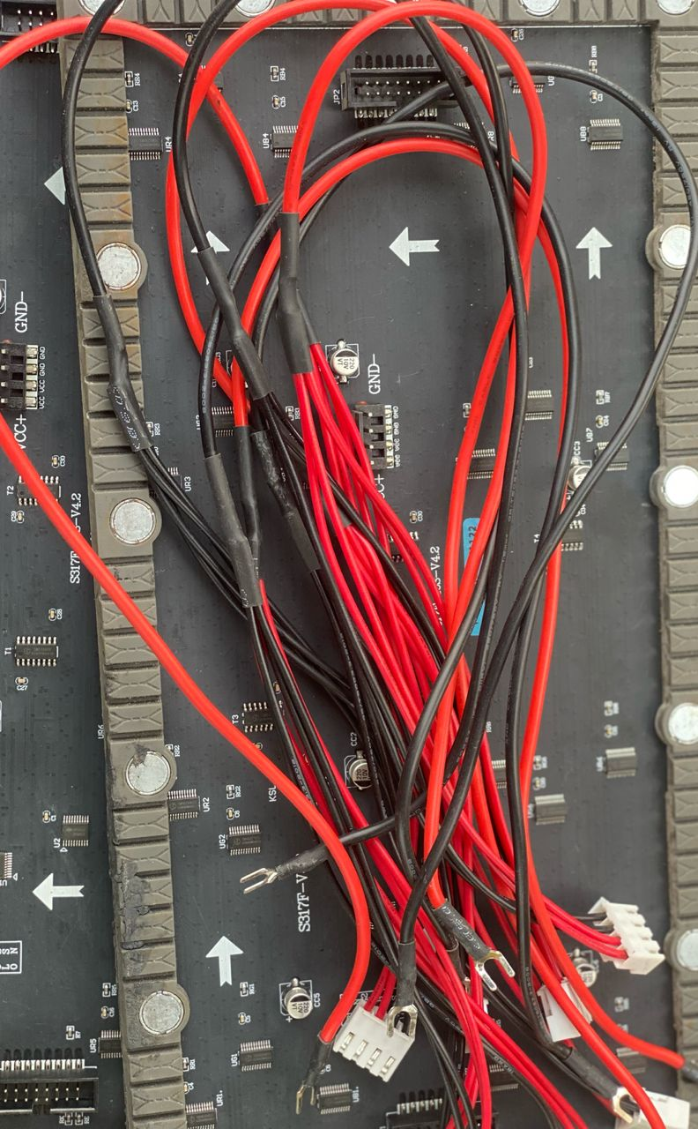

Fig. 4.4: Contraction System

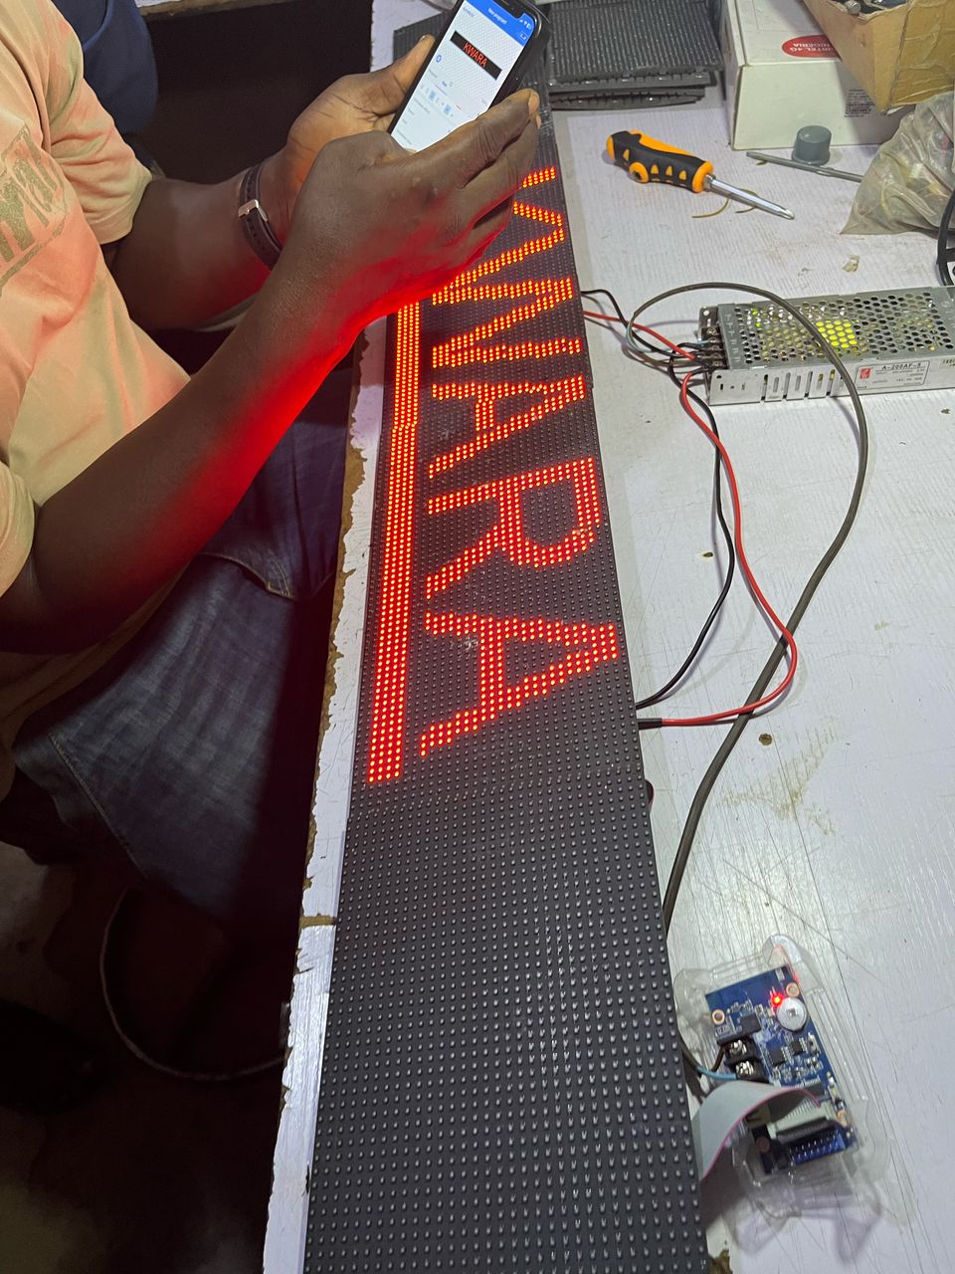

Fig: 4.5: Output Display

CHAPTER FIVE
SUMMARY, CONCLUSION AND RECOMMENDATIONS
5.1 SUMMARY
The construction and implementation of a smart LED matrix board aimed at developing a reliable, energy-efficient, and remotely controllable display system. The research focused on designing a hardware system based on a microcontroller, such as the ESP32, integrated with a structured grid of high-quality LEDs, communication modules, and power management components. The system allows remote management of messages, images, and real-time data through Bluetooth or Wi-Fi, controlled via a mobile application or computer interface. The project addressed key challenges associated with existing LED display systems, such as limited control flexibility, energy inefficiency, and lack of user-friendly interfaces. Through systematic hardware assembly and software development, the smart LED matrix board achieved stable operation, real-time responsiveness, and user accessibility. Testing and debugging ensured that the system performed reliably under different operational conditions, with features like wireless connectivity and brightness control adding to its robustness. The outcome of this research contributes significantly to the development of intelligent display technologies that can be adapted for advertising, notifications, event displays, and other real-time communication needs. Overall, the project demonstrates how combining modern microcontroller capabilities with efficient design principles can lead to the development of scalable, versatile, and innovative LED matrix systems for a wide range of applications.
5.2 CONCLUSION
This research work successfully demonstrated the construction and implementation of a smart LED matrix board that is efficient, flexible, and user-friendly. By integrating a microcontroller-based system with wireless communication technologies such as Wi-Fi and Bluetooth, the project achieved its aim of enabling real-time remote control and management of display content. The combination of hardware components like high-quality LEDs, voltage regulators, and drivers with software elements such as a mobile or computer-based user interface ensured that the system was not only functional but also scalable and adaptable to different needs. The project addressed the shortcomings of existing LED display systems by offering improved energy efficiency, better user control, and higher reliability. Testing and implementation phases proved that the system could operate continuously without performance issues, with effective data transmission and accurate display management. This work highlights the significant potential of modern embedded systems in developing smart communication boards that can be used for diverse applications such as advertising, information display, and public announcements. The success of this project lays a foundation for future improvements, including larger matrix expansions, enhanced data security, and integration with Internet of Things (IoT) networks for broader functionality. Thus, the research serves as an important contribution to the advancement of smart display technologies.
5.3 RECOMMENDATIONS
Based on the findings and achievements of this research work, several recommendations are suggested for future improvements and broader applications of the smart LED matrix board system.
- It is recommended that future designs incorporate larger LED matrices to accommodate more complex and dynamic content displays without compromising clarity and readability.
- Enhancing the system’s wireless communication security through advanced encryption methods would protect the system from unauthorized access and potential cyber threats. Integration with Internet of Things (IoT) platforms should also be considered, allowing the smart LED matrix board to fetch real-time data such as weather updates, news, and social media feeds automatically.
- Additionally, the use of renewable energy sources, such as solar panels, is recommended to power the system, promoting energy sustainability and reducing operational costs.
- For better user experience, the development of more sophisticated mobile applications with features like scheduling messages, content templates, and multi-language support is encouraged. Furthermore, employing advanced microcontrollers with higher processing power and memory capacity could improve the system’s efficiency when handling large amounts of data.
- Finally, regular system updates and maintenance procedures should be established to ensure long-term reliability and performance of the smart LED matrix board in various operational environments.

REFERENCES
Abdullah, M., & Ismail, N. (2020). LED matrix display: Design and applications. Journal of Advanced Research in Electronics and Communication Engineering, 7(3), 45-51.
Adeyemi, O., & Lawal, T. (2021). Microcontroller-based automation systems: Trends and future directions. International Journal of Embedded Systems and Applications, 11(2), 29-38.
Ahmed, K., & Malik, S. (2019). Bluetooth and Wi-Fi-based control systems: A comparative review. International Journal of Wireless Communications and Networking, 6(4), 78-85.
Chauhan, R., & Singh, P. (2022). Wireless technologies in embedded systems: Opportunities and challenges. Journal of Computer Networks and Communications, 2022, 1-10.
Das, S., & Banerjee, A. (2021). Energy-efficient LED systems: A review of methods and techniques. Renewable and Sustainable Energy Reviews, 145, 111-120.
Gonzalez, R., & Chen, H. (2021). Design of user interfaces for embedded systems. International Journal of Human-Computer Interaction, 37(9), 853-870.
Khan, R., & Ansari, M. (2022). Automation using microcontrollers: Applications in modern systems. International Journal of Advanced Computer Science and Applications, 13(7), 122-130.
Liu, Z., & Wang, T. (2020). Development of smart LED boards for real-time data communication. Proceedings of the International Conference on Smart Computing, 2020, 330-335.
Mahmoud, A., & Habib, M. (2021). Recent trends in LED display technologies. Journal of Display Technology, 17(12), 567-575.
Oyetola A. & Dani, A.W. (2019). Design of small smart home system based on arduino,” in 2021 Electrical Power, Electronics, Communications, Control and Informatics Seminar (EECCIS), pp. 121–125, IEEE.
Prakash, T. Thean, W. & Sazali, S.M (2018) “A vision-based home security system using opencv on raspberry pi 3,” in AIP Conference Proceedings, vol. 2173, AIP Publishing.
Simon. & M. A. Ansari, (2019). Smart home automation system using internet of things,” in 2nd International Conference on Power Energy, Environment and Intelligent Control (PEEIC), Greater Noida. Vol. No. 7. Pg. 145-150.
Singh, A., & Verma, P. (2020). Wireless communication for smart devices: An overview. International Journal of Wireless and Mobile Networks, 12(2), 11-22.
Singh, H. V. Pallagani, V. Khandelwal, & Venkanna U., (2021). IoT based smart home automation system using sensor node,” in Fourth International Conference on Recent Advances in Information Technology (RAIT-2018), Dhanbad, India.
Tiwari, R., & Sharma, K. (2021). UI/UX design considerations for IoT devices. International Journal of Interactive Mobile Technologies, 15(17), 4-15.
Valouch. J, R. N. A. Abdullah, I. Ashraf, Y. B. Zikria, M. F. Mushtaq, & M. Umer, (2020). An intelligent, secure, and smart home automation system, Scientific Programming, vol. 2020, Article ID 4579291, 14 pages.
Zhang, Y., & Li, M. (2022). Energy-saving strategies for LED-based systems. IEEE Transactions on Sustainable Energy, 13(1), 678-687.

