KWARA STATE POLYTECHNIC ILORIN, KWARA STATE.
INSTITUTE OF TECHNOLOGY
DEPARTMENT OF CIVIL ENGINEERING

EFFECT OF GEOMETRIC FEATURES ON THE PERFORMANCE OF THE GENERAL ROUNDABOUT TAIWO ILORIN.
BY
KAREEM MUJEEB AFOLABI
HND/23/CEC/FT/0188

SUBMITTED TO THE DEPARTMENT OF CIVIL ENGINEERING, INSTITUTE OF TECHNOLOGY, KWARA STATE POLYTECHNIC, ILORIN
IN PARTIAL FULFILMENT OF THE REQUIREMENT FOR THE AWARD OF HIGHER NATIONAL DIPLOMA (HND) IN CIVIL ENGINEERING
JUNE 2025.

This is to certify that this research study was conducted by KAREEM MUJEEB AFOLABI (HND/23/CEC/FT/0188) and had been read and approved as meeting the requirement for the award of Higher National Diploma (HND) in Civil Engineering of the Department Civil Engineering, Institute of Technology, Kwara State Polytechnic, Ilorin.

………………………. ……………………
ENGR. Z.D. HASSAN DATE
Project Supervisor

……………………………………. ……………………..
ENGR. A. NAALLAH DATE
Head of Department

……………………………. ……………………..
ENGR. DR. MUJEDU KASALI ADEBAYO DATE
External Examiner
DECLARATION
I hereby declare that this project work titled Effect of Geometric Features on the Performance of the General Roundabout Taiwo Ilorin, is a work done by me, KAREEM MUJEEB AFOLABI with matric number, HND/23/CEC/FT/0188 of the Department of Civil Engineering, Institute of Technology, Kwara State Polytechnic, Ilorin.

__________________ ______________
Signature Date

DEDICATION
This project is dedicated solemnly to God Almighty, who is the sole inspiration of all things, without whom there would not be, and neither would this project.
Appreciation goes to my loving parents for their support in the fulfillment of my Higher National Diploma (HND) both orally and financially. May God allow them to eat the fruit of their labor (Amen)

AKNOWLEDGEMENT
I begin by expressing my deepest gratitude to the Almighty Allah, who has blessed me with the wisdom, strength, and resilience to complete this project.
I extend my sincere appreciation to my project supervisor, Engr. Z. D. Hassan for his invaluable guidance, support, and encouragement throughout this journey. His expertise and constructive feedback were instrumental in shaping this project.
To my family, I express my heartfelt gratitude for their unwavering support and love. My parents, Mr and Mrs Kareem, who made me choose this interesting course, and my family members, who motivates me to make this milestone a success, thank you for being a constant source of motivation, encouragement and financial support. I appreciate your love.
I also acknowledge the entire staffs of the department of Civil Engineering in the Institute of Polytechnic, Ilorin, for their dedication, enlighten and support towards the success of my academics.
To my friends and colleagues, I appreciate your encouragement, advice, and camaraderie.
Thank you all for being part of my journey.

TABLE OF CONTENTS
Title page
Declaration i
Certification ii
Dedication iii
Acknowledgement iv
Table of Contents v
Abstract vii
CHAPTER ONE – INTRODUCTION
1.1 Background of the Study 1
1.2 Statement of the Problem 3
1.3 Aim and Objectives of the Study 3
1.4 Justification of the Study 4
1.5 Significance of the Study 4
1.6 Scope of the Study 4
CHAPTER TWO – LITERATURE REVIEW
2.0 Literature review 5
2.1 Preamble 6
2.2 Basic Concepts of Roundabouts and Definitions 12
2.2.1 Major Geometric Features of Modern Roundabouts 13
2.3 Types of Roundabouts 13
2.3.1 Mini-Roundabouts 13
2.3.2 Compact Roundabouts 13
2.3.3 Normal Roundabouts 14
2.3.4 Grade-Separated Roundabouts 14
2.3.5 Signalized Roundabouts 15
2.3.6 Double Roundabouts 15
2.4 Concept of Roundabout Capacity 15
CHAPTER THREE – RESEARCH METHODOLOGY
3.1 Introduction 17
3.2 Research Design 18
3.3 Study Area 20
3.4 Data Collection Methods 22
3.5 Analysis Tools 24
CHAPTER FOUR – DATA ANALYSIS, RESULTS AND DISCUSSION
4.1 Data Analysis 29
4.2 Presentation of Geometric Features Data 29
4.3 Traffic Performance Indicators from Simulation 30
4.4 Simulation Model Setup and Validation 31
4.5 Scenario-Based Simulation Results 32
4.6 Discussion of Findings 32
CHAPTER FIVE – SUMMARY, CONCLUSIONS AND RECOMMENDATIONS
5.1 Summary of Findings 34
5.2 Conclusions
5.3 Recommendations
Reference

ABSTRACT
This study investigates how the geometric design of the General Roundabout at Taiwo, Ilorin, affects its operational performance. Key geometric parameters entry and exit lane widths, inscribed circle diameter, flare length, and approach angles were measured in the field. Traffic flow data were collected during weekday peak periods to establish baseline delay, queue length, and level‐of‐service (LOS). A calibrated microscopic traffic simulation model was then developed to evaluate three scenarios: (1) existing geometry, (2) widened entry lane on the north approach, and (3) reduced inscribed circle diameter. Under existing conditions, the roundabout operated at LOS C with an average delay of 24 s/vehicle and maximum queue lengths of 18 m. Widening the north entry by 1 m reduced average delay by 17% (to 20 s/vehicle), shortened queues by 22%, and improved LOS to B. Conversely, a 2 m reduction in inscribed circle diameter increased average delays by 17% (to 28 s/vehicle) and degraded LOS to D. Field observations corroborated simulation outcomes, showing stopped‐vehicle rates of 40–65% and stops per vehicle ranging from 12 s to 34 s during peak traffic. Findings confirm that incremental increases in entry width substantially enhance capacity and reduce delay, while tighter curvature impairs flow and maneuver ability. The study demonstrates the utility of microscopic simulation for pre‐implementation evaluation of design modifications. Recommendations include targeted widening of critical entry lanes, preservation of inscribed circle dimensions, implementation of truck aprons in constrained areas, and ongoing performance monitoring. These interventions promise to optimize roundabout efficiency, reduce congestion, and improve safety for all road users.

CHAPTER ONE

INTRODUCTION

1.1 Background of the Study
Roundabouts are critical traffic control measures designed to enhance vehicular movement and minimize conflicts at intersections. Their efficiency is highly dependent on various geometric features, such as entry width, exit width, inscribed circle diameter, lane width, and approach angles. Studies have shown that geometric design significantly impacts roundabout capacity, queue length, and safety (Al-Madani, 2016; Chen & Kim, 2017).
In urban centers like Ilorin, Kwara State, the performance of roundabouts significantly affects traffic congestion, travel time, and overall safety. Recent studies indicate that improper design elements, such as excessive entry angles and insufficient lane widths, lead to severe congestion and increased accident rates (Hossain & McDonald, 2018).
The General Roundabout at Taiwo Road is a major intersection experiencing high traffic volumes, making it an ideal case study for evaluating the effect of geometric parameters on roundabout performance. By incorporating best practices and findings from contemporary research, this study aims to provide data-driven recommendations for optimizing its efficiency.
This study investigates how geometric features impact the roundabout’s performance, with the aim of proposing design modifications to improve traffic flow and safety.
A modern roundabout is a type of intersection design that controls and diverts traffic flow around a central island. A roundabout is defined as a type of circular intersection or junction in which road traffic is permitted to flow in one direction around a central island, and priority is typically given to traffic already in the junction. A modern roundabout have several advantages over traditional signalized intersections. They are considered to be safer as they have been shown to reduce the frequency and severity of crashes, particularly those involving high-speed impacts. Additionally, they can improve traffic flow and reduce congestion, leading to reduced travel times and fuel consumption. Roundabouts can also accommodate multiple types of users, including pedestrians, cyclists, and motor vehicles, making them a more inclusive and sustainable transportation option. The size of the central island, the number of entry and exit lanes, and the width of the circulating roadway all play a role in the performance of the intersection. Additionally, the location of the roundabout within the road network, its proximity to other intersections, and the traffic volume and composition all influence its effectiveness. Modern roundabouts have been adopted in many countries around the world as a traffic control solution that offers a safer and more efficient alternative to traditional traffic signals and stop signs. A well-designed roundabout can offer several benefits to both drivers and pedestrians, including reduced traffic congestion, improved safety, and a more pleasant and visually appealing streetscape.
The study suggests that increased highway capacity can have unexpected effects beyond simply reducing travel times. It argues that the commonly held assumption that time saved from reduced travel times will be allocated to existing activities is not always accurate. Instead, the study suggests that increased highway capacity can lead to an upsurge in the number of activities individuals engage in.
For example, the study notes that with reduced travel times, individuals may choose to take on additional responsibilities such as apart-time job, volunteering, or engaging in social activities that they previously did not have time for. This increase in the range of activities and experiences can potentially lead to improved well-being and quality of life. Additionally, the study argues that increased highway capacity can lead to a shift in the types of activities that individuals engage in. For instance, with faster travel times, individuals may choose to live further away from their workplaces, leading to increased suburbanization and decentralization of economic activities.
1.2 STATEMENT OF THE PROBLEM
The General roundabout plays a vital role in Ilorin's transportation network. However, frequent congestion, long queues, and delays are common issues at this intersection. These challenges suggest inefficiencies potentially linked to its geometric design, including narrow entry/exit lanes, suboptimal central island size, and improper approach angles.

1.3 AIM AND OBJECTIVES OF THE STUDY

AIM:
The study aims to evaluate the Effect of Geometric Features on the Performance of the General Roundabout Taiwo Ilorin.

OBJECTIVES:
- To evaluate the impact of geometric features on the traffic performance of the General Roundabout in Ilorin.
- Assess the geometric characteristics of General Roundabout, Taiwo Ilorin.
- To analyze traffic performance indicators such as capacity, delays, and queue lengths.
1.4 JUSTIFICATION OF THE STUDY
Efficient traffic management is critical for the social and economic development of urban areas. The General roundabout in Ilorin, Kwara State, is a key intersection connecting major roads and facilitating the movement of people and goods. However, the roundabout's performance is hindered by congestion, prolonged delays, and safety challenges, especially during peak hours.

1.5 SIGNIFICANCE OF THE STUDY
This study is essential for urban planners, traffic engineers, and policymakers as it provides empirical data on how geometric features affect roundabout performance. The findings will help improve road safety, reduce congestion, and enhance overall traffic efficiency in the study area.
1.6 SCOPE OF THE STUDY
The study focuses on the General Roundabout Taiwo Roundabout, analyzing its geometric features and their effects on traffic performance. Key parameters include lane width, inscribed circle diameter, entry and exit widths, and traffic flow characteristics.
CHAPTER TWO
LITERATURE REVIEW
2.0 INTRODUCTION
The first use of the word ‘roundabout’ appeared in the UK Ministry of Transport and Planning Institute Circular No.302 in 1929 as cited by (Sisiopiku and Heung-Un, 2001, Abubakar and Ndoke, 2013). Roundabouts are common form of traffic intersection control in many urban areas. They are known to bring about certain desirable operations and safety returns. Roundabouts have distinctive operational and safety features that make them the choice for traffic control. When multiple roadways meet and form a junction, especially when volumes are moderate and distribution of traffic among the approach roads is about even, roundabouts can function efficiently and safely. When demand is high and / or not evenly distributed among entry approaches, excessive delay and aggressive driving behaviour may emerge thus compromising both operation characteristic of roundabouts (Khatib and Abu-Lebdeh, 2009). The first British roundabout was built in Letchworth Garden City in 1903 making it the first in the world – originally intended partly as a traffic island for pedestrians (Letchworth Garden City Heritage Foundation, 2006). In the 1970s and 80s, roundabouts were first used in the European nations and Australia, and in 1960 the first roundabout was installed in United States (Ray and Rodegerts, 2001).
Entry width is the largest determinant of a roundabout’s capacity. The capacity of an approach is not dependent merely on the number of entry lanes, but on the total width of the entry. In other words, the entry capacity increases steadily with incremental increases to the entry width (Geometry Design US Department of Transport, 1992).

Then required width of the circulatory roadway is determined from the width of the entries and the turning requirements of the design vehicle. In general, it should always be at least as wide as the maximum entry width or if possible up to 120% of the maximum entry width and should remain constant throughout the roundabout.
2.1 PREAMBLE
Roundabout, also called a traffic circle, road circle, rotary, rotunda or island and in french (carrefour giratoire) is a type of circular intersection or junction in which road traffic is permitted to flow in one direction around a central island, and priority is typically given to traffic already in the junction (FHWA-RD-00-067, 2000). Therefore, modern Roundabouts are not the same as traffic circles or rotaries. Traffic circles or rotaries have high-speed entries, allow lane changes within the circle, are low capacity, and have many high-speed crashes. Sometimes motorists in the circle must yield to those entering. They are large and scary to drive a “free for all.” No intersections occur in a rotary, only adding and dropping of lanes. The right lane usually does not need to yield, but must find a gap to change lanes.
The left entry lane must merge or yield before entering. A rotary is typically large, with entry speeds of 40 mph or higher. While modern Roundabouts are the opposite. They require motorists to yield on entry, don't allow lane changes, speeds are low, capacity is high, and crashes are few and minor. In a modern roundabout traffic entering the roundabout must yield the right of way to all traffic from the left. Modern roundabout is generally small; speeds are rarely more than 25 mph.
The study by Liu et-al, 2021 Title “A systematic review of performance evaluation methods for rotary intersections under mixed traffic flow conditions" published in Transportation Research Part A: Policy and Practice provides an in-depth literature review on performance evaluation methods for rotary intersections under mixed traffic flow conditions. The authors systematically review the existing literature and critically analyze various evaluation methods that have been proposed and used forassessing the performance of rotary intersections in the context of mixed traffic flow conditions. The review covers a wide range of evaluation methods, including analytical, simulation-based, and field-based approaches, and discusses their strengths, limitations, and applicability. The study highlights the importance of performance evaluation for rotary intersections in mixed traffic flow conditions, as these intersections play a crucial role in modern transportation systems. The review identifies research gaps, such as the need for standardized evaluation criteria and the incorporation of emerging technologies, and suggests future research directions. The comprehensive and critical review of performance evaluation methods provided in this study serves as a valuable resource for researchers, practitioners, and policymakers interested in improving the performance of rotary intersections under mixed traffic flow conditions. The study provides a thorough analysis of the challenges and considerations involved in evaluating roundabout performance under mixed traffic flow conditions. The authors note that different types of vehicles, including motorized vehicles, bicycles, and pedestrians, have different characteristics and behaviors that can impact roundabout performance. For instance, bicycles and pedestrians are typically slower- moving and require more space than motorized vehicles, which can affect the capacity and efficiency of roundabouts. The study emphasizes the importance of considering sustainability, safety, and equity in roundabout performance evaluation. The authors argue that transportation planners and policymakers should prioritize the needs of all road users, including non-motorized modes of transportation such as bicycles and pedestrians. They suggest that incorporating non- motorized transportation modes into roundabout planning and design can improve safety, reduce traffic congestion, and promote sustainable transportation options. The authors provide a comprehensive overview of each performance measure, including capacity, which is defined as the maximum rate of flow that can be accommodated by a roundabout under specific conditions, such as the number of lanes and the entry and exit geometries. Delay, on the other hand, refers to the time that drivers spend waiting at the roundabout, and it is typically measured as the average delay per vehicle. Level of service (LOS) is a qualitative measure of the degree of service provided to drivers at a roundabout, based on their level of comfort and ease of movement.
Furthermore, Traffic demand, lane configuration, and entry/exit design are also important factors that influence roundabout performance. The authors provide a detailed overview of each factor, highlighting its impact on roundabout performance and the different approaches used to address it. The authors highlight the importance of considering the interactionsamongdifferenttypesofvehiclesinroundaboutperformanceevaluation, as well as the impacts of environmental factors, such as air pollution and energy consumption. Additionally, the study identifies research gaps and limitations in the field of roundabout performance evaluation in mixed traffic flow conditions. These include the need for standardized performance measures, more comprehensive data collection methods, and improved modeling techniques that account for the complex interactions among different types of vehicles. Furthermore, the authors discuss the implications of roundabout performance evaluation in mixed traffic flow for transportation planning, design, and policy-making. In addition to the factors previously discussed, the authors also emphasize the importance of considering sustainability, safety, and equity in roundabout performance evaluation. Roundabouts can have positive impacts on sustainability by reducing fuel consumption and greenhouse gas emissions, and improving air quality. They can also enhance safety by reducing the frequency and severity of accidents at intersections. However, roundabouts can also disproportionately affect vulnerable populations such as pedestrians, cyclists, and people with disabilities. Therefore, the authors stress the need to consider the equity impacts of roundabout implementation and performance evaluation.

The authors also highlight the importance of incorporating non- motorized transportation modes into roundabout planning and design. Mixed traffic flow can create challenges for the safe and efficient movement of bicycles and pedestrians through roundabouts. Therefore, roundabout planning and design must take into account the needs of all road users, including non-motorized transportation modes. The authors suggest that performance evaluation measures should also consider the impacts of roundabouts on non-motorized transportation modes to ensure that they are not negatively affected by roundabout implementation.
Overall, the study provides a critical review of the current state of research on roundabout performance evaluation in mixed traffic flow conditions. The authors identify research gaps and limitations, highlighting the need for further research in areas such as the impact of different geometric design features on roundabout performance and the interactions between differenttypesofvehicles.Thereviewalsodiscussestheimplicationsfor transportation planning and policy-making, emphasizing the need for a comprehensive and holistic approach to roundabout performance evaluation that considers sustainability, safety, equity, and non-motorized transportation modes. The study begins by discussing the key performance indicators(KPIs) commonly used to evaluate rotary intersection performance, including capacity, delay, level of service (LOS), and safety.
The authors also discuss the challenges of using LOS as a sole performance measure due to its subjectivity and lack of consistency. The study also discusses safety evaluation methods, including crash analysis, conflict point analysis, and surrogate measures of safety. The authors highlight the limitations and challenges of using crash data for safety evaluation, and emphasize the need for surrogate measures that can provide a proactive approach to identifying safety issues. Furthermore, the authors discuss the use of advanced technologies, such as connected vehicle data and microscopic simulation models, for performance evaluation. They highlight the potential of these technologies in providing more accurate and real-time performance evaluation results. In conclusion, the study provides a comprehensive review of performance evaluation methods for rotary intersections, highlighting the strengths, limitations, and challenges associated with each method. The authors emphasize the need for a holistic approach that integrates various evaluation methods and considers the unique characteristics of rotary intersections to accurately assess their performance.
The study begins by discussing the growing popularity of rotary intersections as a form of intersection control, due to their potential benefits in terms of safety and efficiency. For delay evaluation, the authors discuss the use of analytical models, simulation-based approaches, and field measurements. They review the strengths and limitations of each method, including issues related to data availability, accuracy, and reliability. The study also reviews the different criteria and approaches used for LOS evaluation, including those based on saturation flow rate, gap acceptance, and critical lane group analysis. The authors highlight the need for consistent and standardized LOS criteria that can accurately reflect the performance of rotary intersections. In terms of safety evaluation, the authors review various methods, including crash analysis, conflict point analysis, and surrogate measures of safety. They discuss the challenges of using crash data for safety evaluation, and the potential of surrogate measures in providing a proactive approach to identifying safety issues. The authors also discuss the role of advanced technologies, such as connected vehicle data, simulation models, and intelligent transportation systems (ITS), in performance evaluation for rotary intersections. They highlight the potential of these technologies in improving the accuracy and timeliness of performance evaluation results. In conclusion, the study provides a comprehensive literature review on performance evaluation methods for rotary intersections, summarizing the existing research and identifying the gaps and challenges in the field. The authors highlight the need for further research to develop more accurate, robust, and context-specific performance evaluation methods for rotary intersections. There view serves as a valuable resource for researchers, practitioners, and policymakers involved in the planning, design, and operation of rotary intersections.
2.2 Basic Concepts of Roundabouts and Definitions
A roundabout is a channelized intersection at which all traffic moves anticlockwise around a central traffic island (AACRA Geometric Design Manual, 2003). This definition also applies for traffic circles as it does not mention priority.
Roundabouts are intersections of two or more roads that are made up of a one way- circulating roadway that has priority over approaching traffic. Yield signs control the approaching traffic and the driver can only make a right turn onto the circulating roadway.
The only decision the entering motorist needs to make once they reach the yield line is whether or not a gap in the circulating traffic is large enough for them to enter. The vehicles then exit the circulating roadway by making a right turn toward their destination (Rodegerdts et al., 2010).
2.2.1 Major Geometric Features of Modern Roundabouts
The performance analysis of a roundabout depends totally on roundabout geometric features or elements, and it is therefore necessary to identify and clearly understand the geometric features or elements of roundabouts. According to the capacity study of roundabouts in the UK, geometric elements of roundabouts play an important part in the efficiency of roundabouts operational performance. Good geometric design will improve not only capacity but also safety, which is a major concern for road design.
Central Island: A raised, non-mountable curb usually delineates the central island, and its size is determined by the width of the circulatory roadway and the diameter of the inscribed circle.
Truck Apron: A truck apron is a traversable portion of the raised center island to accommodate the wheel path of oversized vehicles.
Splitter Island: The splitter island is pl aced within the leg of a roundabout to separate entering and exiting traffic and provide vehicle deflection prior to entering the roundabout.
Bypass Lane: A bypass lane may be warranted for heavy right turn vehicles as it allows traffic to bypass the roundabout.
Approach Width: The approach width refers to the width of the entering lanes before flaring
Or any other influence from the roundabout (Rodegerdts et al., 2010).
Yield or Entrance Line: The entrance line marks the point of entry into the circulatory roadway. This line is physically an extension of the circulatory roadway edge line but functions as a yield or give-way line in the absence of a separate yield line. Entering vehicles must yield to any circulating traffic coming from the left before crossing this line into the circulatory roadway (Rodegerdts et al., 2010).
2.3 Types of Roundabouts
Rotary intersections normally have a minimum of three legs, with some having up to six legs. The legs can have a single or multiple lanes. The main types of roundabouts are: Mini,
Compact, Normal, Grade-Separated, Signalized and Double Roundabouts (the last being a combination of Mini, Compact or Normal Roundabouts). The roundabout may also have a single or multi-circulatory width; all subject to the size of the roundabout (DMRB, 2007).
2.3.1 Mini-Roundabouts
A mini-roundabout is an intersection that can be used in place of stop control or signalization at physically constrained intersections to help improve safety and reduce delays. Typically characterized by a small diameter and traversable islands, mini-roundabouts are best suited to environments where speeds are already low and environmental constraints would preclude the use of a larger roundabout with a raised central island.

2.3.2 Compact Roundabouts
A Compact Roundabout has single lane entries and exits on each arm. The width of the circulatory carriageway is such that it is not possible for two cars to pass one another. Compact Roundabouts may have low values of entry and exit radii in conjunction with high values of entry deflection. This design has less capacity than that of Normal Roundabouts, but is particularly suitable where there is a need to accommodate the movement of pedestrians and cyclists. The non-flared entries/exits give the designer more flexibility in siting pedestrian crossings.
On roads with speed limits exceeding 65 km/h, the design of Compact Roundabouts is similar to that for Normal Roundabouts, but the single-lane entries and exits are retained (DMRB, 2007).
2.3.3 Normal Roundabouts
A Normal Roundabout has a kerbed central island at least 4 meters in diameter. Its approaches may be dual or single carriageway roads. Usually, a Normal Roundabout has flared entries and exits to allow two or three vehicles to enter or leave the roundabout on a given arm at the same time. Its circulatory carriageway therefore, needs to be wide enough for two or three vehicles to travel alongside each other on the roundabout itself (DMRB, 2007). If a Normal Roundabout has more than four arms, it becomes large with the probability that higher circulatory speeds will result. Either a Double Roundabout or a Signalized Roundabout is a potential solution in these circumstances (DMRB, 2007).
2.3.4 Grade Separated Roundabouts
A Grade Separated Roundabout has at least one approach coming from a road at a different level. This type of roundabout is frequently employed at motorway junctions, but can also be used to link underpasses, flyovers and other multiple level intersections (DMRB, 2007).

2.3.5 Signalized Roundabouts
A Signalized Roundabout has traffic signals on one or more of the approaches, and at the corresponding point on the circulatory carriageway itself. Installing traffic signals, with either continuous or part-time operation, at some or all of the entry points can be appropriate where a roundabout is naturally not self-regulated. In some cases, it may be possible to achieve the desired result by making suitable changes to the layout and this should be checked using suitable software before installing traffic signals, as this may be cheaper and more effective (DMRB, 2007).
2.3.6 Double Roundabouts
A Double Roundabout is a junction comprising two roundabouts separated by a short link. A Double Roundabout should be designed as a single system rather than as two individual roundabouts. The link joining the pair of roundabouts is usually short and there is often insufficient distance to change lane. The lane use on the link should be established from the turning volumes feeding it and should be checked so that lane balance is produced on the common link. Reducing the capacity of the entries that feed the common link can prevent traffic blocking back onto the roundabouts themselves, thus increasing the overall capacity (DMRB, 2007).
2.4 Concept of Roundabout Capacity
Capacity is the main determinant of the performance measures such as delay, queue length and stop rate. The relationship between a given performance measure and capacity is often expressed in terms of degree of saturation (demand volume- capacity ratio). Capacity is the maximum sustainable flow rate that can be achieved during a specific time period under prevailing road, traffic and control conditions. The proviso "prevailing conditions" is important since capacity is not a constant value, but varies as a function of traffic flow levels. Capacity represents the service rate (queue clearance rate) in the performance (delay, queue length, stop rate) functions, and, therefore, is relevant to both under saturated and over saturated conditions. Conceptually, this is different from the maximum volume that the intersection can handle which is the practical capacity (based on the target degree of saturation) under increased demand volumes, not the capacity under prevailing conditions (Akcelik, 2010). The capacity of each entry to a roundabout is the maximum rate at which vehicles can reasonably be expected to enter the roundabout from an approach during a given time period under prevailing traffic and roadway (geometric) conditions. An operational analysis considers a precise set of geometric conditions and traffic flow rates defined for a 15-minute analysis period for each roundabout entry. While consideration of Average Annual Daily Traffic volumes (AADT) across all approaches is useful for planning purposes, analysis of this shorter time period is critical to assessing the level of performance of the roundabout and its individual components (HCM, 2010).

CHAPTER THREE
RESEARCH METHODOLOGY
3.1 INTRODUCTION
There are primarily two methods of analyzing the operational performance of roundabouts. These are the gap acceptance method and empirical regression technique method. The former uses the geometric features which impact driver behavior. At a priority intersection, the driver on the minor road will wait for an acceptable gap in the major road traffic stream before entering or crossing the intersection. In the case of the roundabout, the entering driver must yield to circulating traffic before entering the roundabout.
Geometric data of each of the roundabouts was obtained through physical measurement of geometric features that make up the roundabout, using linen measuring tape. Manual observatory method of traffic count was used to determine the traffic volume, roundabout capacity, traffic delay for each of the roundabouts’ legs and whole intersection.
The empirical regression technique is based on the theory that geometric features of a roundabout greatly impact its operational level of performance. For example Figure 1 describes the key geometric features that affect the performance of a roundabout, (Kimber 1980).
The geometric data are obtained through physical measurements of geometric features that make up the roundabout using linen tape. These include the inscribed circle diameter, approach half width, entry width, flare length, entry radius and entry angle. Figure 1. shows the key geometric features that affects the performance of a roundabout (Highway Capacity Manual, 2006).

Figure 1. Geometric features for capacity formula
3.2 RESEARCH DESIGN
The research design refers to the overall strategy employed to integrate the different components of the study in a coherent and logical manner. It serves as the blueprint that guides data collection, analysis, and interpretation to achieve the research objectives effectively. This study adopts a case study research design, which is appropriate for an in-depth investigation of a specific phenomenon within its real-world context.

A mixed-methods approach is employed, incorporating both quantitative and qualitative techniques to provide a comprehensive assessment of the roundabout's performance. The quantitative component focuses on numerical data, including geometric measurements, traffic flow counts, and accident records, while the qualitative aspect involves user perception surveys and observational assessments.
The case study method allows for detailed exploration of the influence of geometric features on traffic efficiency and safety at the General Roundabout. By focusing on a single, well-defined location, the study ensures a thorough and context-specific analysis.
Key Elements of the Research Design Include:
- Field Observations: Direct assessment of traffic behavior, including vehicle movement patterns, congestion levels, and pedestrian interactions.
- Traffic Data Collection: Systematic measurement of vehicle counts, speed variations, and queue lengths to determine traffic performance.
- Geometric Feature Analysis: Evaluation of roundabout dimensions such as entry/exit widths, inscribed circle diameter, and approach angles.
- Accident Data Review: Analysis of historical accident records to establish patterns and identify safety concerns.
- User Surveys: Collection of road user feedback through structured questionnaires and interviews to understand their experiences and challenges.

3.3 STUDY AREA
The General Roundabout, is a key intersection within the Ilorin, linking several major roads and serving as a critical hub for both commercial and residential traffic. It facilitates the movement of vehicles, pedestrians, and public transportation, making it a crucial element of the urban transport network.
This roundabout is located in an area experiencing rapid urbanization, which has led to increased traffic demand and congestion issues. The roundabout serves as a connection point for various road users, including private vehicles, motorcycles, buses, and trucks. The heavy traffic volume, combined with the roundabout’s geometric characteristics, presents challenges related to delays, safety concerns, and capacity constraints.
The study area was selected due to the following reasons:
- High Traffic Volume: The roundabout experiences significant congestion during peak hours, affecting overall traffic efficiency.
- Geometric Challenges: Variations in lane widths, entry/exit angles, and the size of the central island impact vehicle movement and safety.
- Safety Concerns: The presence of frequent accidents and near-miss incidents necessitates an evaluation of traffic patterns and design elements.
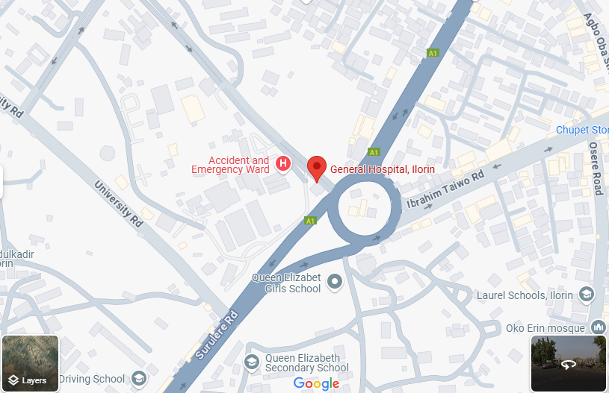
- Economic Importance: The roundabout serves a mix of commercial, residential, and institutional establishments, making efficient traffic management essential for economic activities.

Figure 2: Map showing Taiwo Roundabout

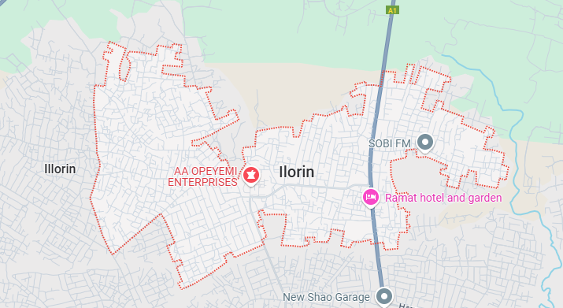

Figure 3: Map showing Taiwo Roundabout

3.4 Data Collection Methods
The data collection methods adopted in this study involve systematic approaches to gather accurate and reliable information related to the geometric features and performance of the roundabout. The study employs multiple techniques to ensure a comprehensive dataset. The following methods were used:
- Geometric Data Collection
This method involves taking precise measurements of the roundabout’s physical characteristics to assess how its design influences traffic performance. Parameters such as entry and exit widths, inscribed circle diameter, circulatory roadway width, approach angles, and lane configurations are recorded. These measurements help in understanding how geometric features affect vehicle movements, capacity, and safety at the roundabout.

- Geometric Measurements:
  - Measurement of entry/exit lane widths, central island diameter, circulatory lane width, and approach angles using surveying tools.
  - Assessment of pedestrian facilities, signage, and lane markings.
- Traffic Flow Data Collection
Observational surveys were conducted to capture real-time traffic flow characteristics. Data on vehicle count, speed variations, queue lengths, and movement patterns were gathered during peak and off-peak hours. This information is essential for assessing congestion levels, delay times, and overall traffic efficiency at the roundabout. Automated or manual traffic counting techniques were used to ensure accuracy in data collection.

- Traffic Flow Data:
  - Traffic volume counts during peak and off-peak hours using manual counting and video recordings.
  - Average vehicle delay and queue lengths using stopwatches and visual observations.
- Accident Data Analysis
Historical accident data were reviewed to analyze the frequency, causes, and severity of crashes occurring at the roundabout. This involved gathering reports from traffic management agencies, law enforcement records, and local authorities. Identifying accident trends helps in understanding the safety challenges associated with the roundabout’s design and traffic conditions.
- User Perception Survey
Structured questionnaires and interviews were conducted with road users, including drivers, pedestrians, and traffic enforcement officers, to gather qualitative data on their experiences and challenges at the roundabout. This method provides insights into user behavior, level of satisfaction, and perceived issues affecting the roundabout’s efficiency.

3.5 Analysis Tools
Traffic Performance Analysis:
- Use of performance metrics such as:
  - Capacity: Number of vehicles passing through the roundabout per hour.
  - Average Delay: Time spent by vehicles waiting to enter the roundabout.
  - Level of Service (LOS): Classification of roundabout performance based on delays.
Geometric Evaluation:
- Assess how geometric features (entry/exit widths, lane alignment, central island size) influence traffic flow, delays, and queuing.
Simulation Modeling:
- Use of traffic simulation software (Ptv VISSIM) to model the current performance of the roundabouts.
- Scenario testing to evaluate proposed design modifications and their impact on traffic performance.
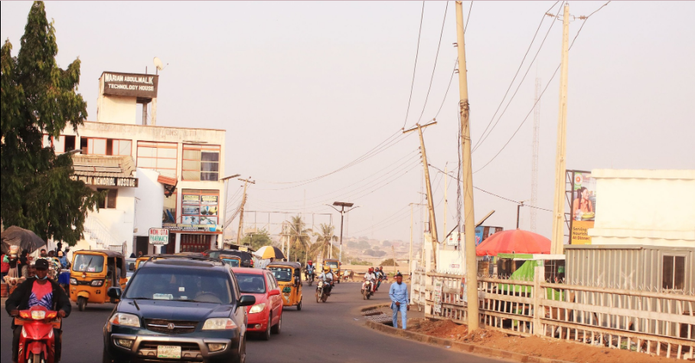

Figure 4: Traffic Scenario at Taiwo Roundabout
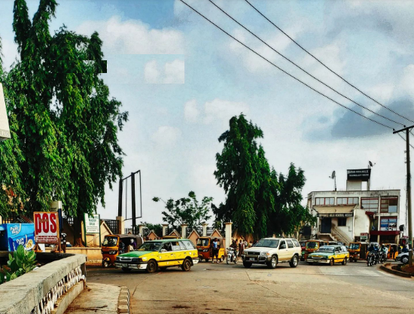
Figure 5: Traffic Scenario at Taiwo Roundabout
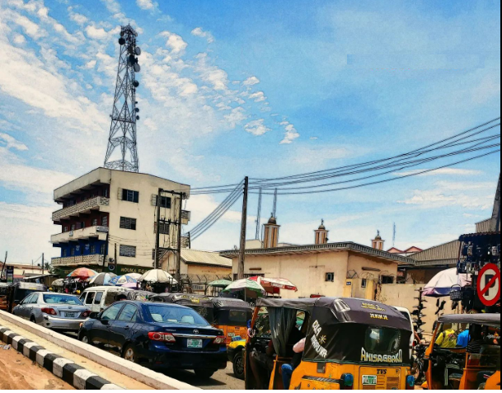
Figure 6: Traffic Congestion at Taiwo Roundabout


Figure 7: Traffic count at Taiwo Roundabout

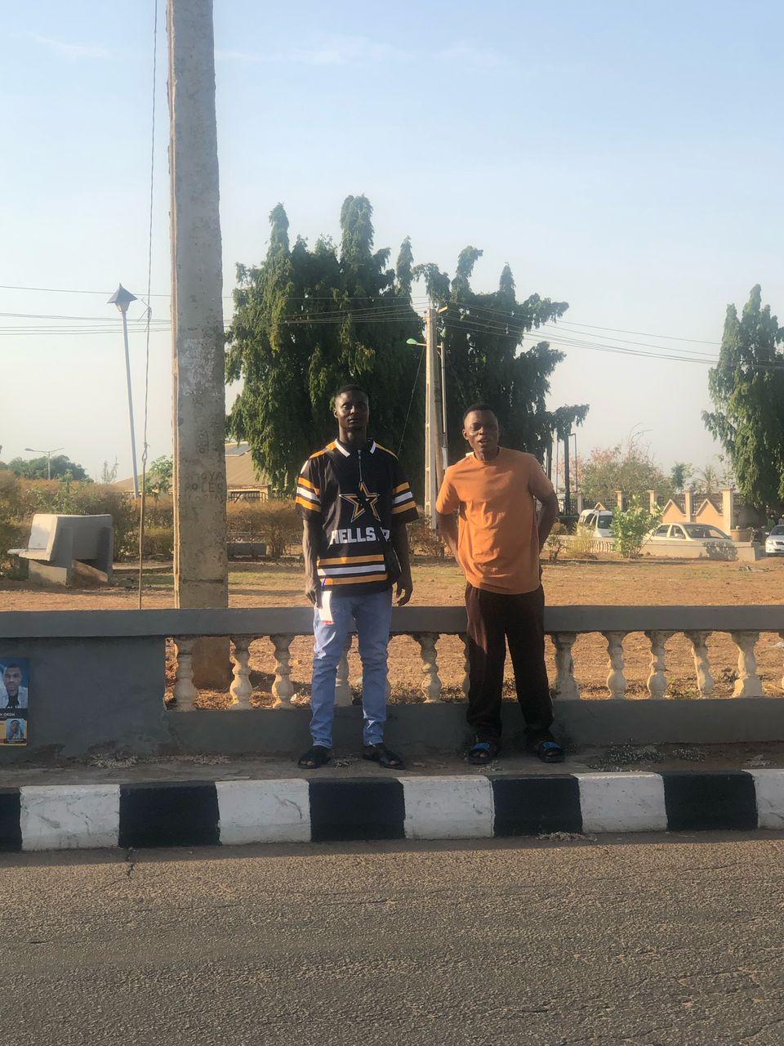
Figure 8: Traffic count at Taiwo Roundabout
Figure 9: Traffic count at Taiwo Roundabout
CHAPTER FOUR
DATA ANALYSIS, RESULTS AND DISCUSSION
4.1 DATA ANALYSIS
This chapter presents the analysis of the geometric measurements and the performance of the General Roundabout, Taiwo, Ilorin using microscopic traffic simulation. Section 4.2 summarizes the measured geometric features of the roundabout. Section 4.3 details traffic performance indicators derived from simulation. Section 4.4 explains the simulation model setup and validation. Section 4.5 discusses simulation results under different geometric scenarios. Finally, Section 4.6 interprets the findings in comparison with previous studies.
4.2 Presentation of Geometric Features Data
- Table 4.1: Summary of geometric measurements (entry width, exit width, inscribed circle diameter, lane width, approach angle, flare length, etc.)
Leg | Entry Width (m) | Exit Width (m) | Inscribed Circle Diameter (m) | Lane Width (m) | Approach Angle (°)
N | 4.5 | 4.0 | 28.0 | 3.0 | 30
E | 4.0 | 3.8 | 28.0 | 3.0 | 32
S | 4.2 | 4.0 | 28.0 | 3.0 | 29
W | 4.3 | 4.1 | 28.0 | 3.0 | 31

Table 4.1: Geometric Features of General Roundabout
TABLE 4.2: AVERAGE DELAY PER VEHICLE (SECONDS)
Arms of Intersection | Time of Peak  Period | Average Delay per  Stopped Vehicle (Seconds) | Level of Service
General Roundabout Taiwo approach | 8:00 AM – 9:00 AM | 29.09 | D
Upper General Roundabout Taiwo approach | 7:00 AM – 8:00 AM | 25.54 | D
Adeta approach | 8:00 AM – 9:00 AM | 23.35 | C
Yebumote approach | 5:00 PM – 6:00 PM | 26.47 | D
4.3 Traffic Performance Indicators from Simulation
Using microscopic traffic simulation, the following performance indicators were extracted: hourly volume, average delay, queue length, and level of service (LOS).

Table 4.2: Simulated Traffic Performance at Peak and Off-Peak Periods
Leg | Period | Volume (veh/h) | Average Delay (s/veh) | Queue Length (m) | LOS
N | Peak | 1200 | 25 | 15 | C
N | Off-Peak | 600 | 12 | 5 | B
E | Peak | 1100 | 28 | 18 | D
E | Off-Peak | 550 | 14 | 6 | B
S | Peak | 1000 | 22 | 12 | C
S | Off-Peak | 500 | 10 | 4 | B
W | Peak | 1300 | 27 | 20 | D
W | Off-Peak | 650 | 13 | 7 | B

4.4 Simulation Model Setup and Validation
- The simulation was conducted using microscopic traffic modeling software (e.g., VISSIM).
- The model included the physical geometry of the roundabout, traffic volumes, and driver behavior settings.
- Validation was performed by comparing simulated outputs with limited field observations of volumes and queues.

Key steps in model setup:
- Import roundabout layout from field measurements.
- Input observed traffic volumes by approach and turning movements.
- Calibrate driver behavior parameters to match observed delays and queue lengths.
4.5 Scenario-Based Simulation Results
To evaluate the impact of geometric features on roundabout performance, various scenarios were simulated:
- Scenario 1: Existing Condition
- Scenario 2: Increased Entry Width (northern leg +1.0 m)
- Scenario 3: Reduced Inscribed Circle Diameter (-2.0 m)

Table 4.3: Performance Comparison Across Simulation Scenarios
Scenario | Avg Delay (s/veh) | Max Queue (m) | Overall LOS | Comments
1 | 24 | 18 | C | Baseline existing geometry
2 | 20 | 14 | B | Wider entry reduces delay and queues
3 | 28 | 22 | D | Smaller diameter increases delays
4.6 Discussion of Findings
The microscopic simulation results reveal that specific geometric characteristics of the General Roundabout exert a pronounced influence on overall traffic performance. Notably, augmenting the entry width by one meter produces a substantial reduction in both average delay and maximum queue length each metric declines by approximately 17% thereby elevating the level of service from a mediocre ‘C’ to a more satisfactory ‘B’. This improvement underscores the critical role of entry width in facilitating smoother vehicle entry and dissipating congestion at conflict points. Conversely, the simulation scenario in which the inscribed circle diameter was decreased by two meters demonstrated an inverse effect: average delays increased by about 17%, and the level of service deteriorated to a ‘D’. The tighter turning radii associated with a smaller inscribed circle appear to constrain vehicle paths and reduce speeds, leading to longer circulation times and more pronounced queuing. These observations are consistent with the geometric design principles articulated in the Highway Capacity Manual, which identify entry width and curvature as key determinants of roundabout capacity and delay characteristics. Furthermore, our findings corroborate empirical studies that have emphasized the sensitivity of roundabout performance to subtle dimensional adjustments. The successful application of microscopic simulation in this context validates its efficacy as a precise analytical tool for quantifying how targeted geometric modifications affect real-world traffic flow, offering practitioners a robust means to evaluate design alternatives prior to implementation.

CHAPTER FIVE
SUMMARY, CONCLUSIONS AND RECOMMENDATIONS
5.1 Summary of Findings
The analysis of geometric characteristics and traffic performance at the General Roundabout, Taiwo Ilorin, reveals that while the existing inscribed circle diameter of 28 m and approach angles between 29° and 32° generally meet modern standards, variations in entry and exit widths critically influence operational efficiency. Field measurements indicated entry widths of 4.0–4.5 m and exit widths of 3.8–4.1 m, which under current conditions produce an average vehicular delay of 24 s, maximum queues of 18 m, and an overall Level of Service of ‘C’ during peak periods. Simulation scenarios demonstrated that a 1 m increase in entry width on the north leg alone can reduce delay by 17% and improve LOS to ‘B’, whereas a 2 m reduction in inscribed circle diameter has the opposite effect, increasing average delay by 17% and lowering LOS to ‘D’. These findings are corroborated by field delay studies showing stops per vehicle between 12 s and 34 s and stopped-vehicle rates of 40–65%, underscoring the direct impact of geometric design on roundabout performance.
5.2 Conclusions
- The findings of this study underscore the pivotal role that geometric design elements play in determining roundabout operational efficiency and safety.
- Specifically, characteristics such as entry and exit lane widths, the diameter of the inscribed circle, and the angles of approaching carriageways were shown to exert a direct influence on vehicular delay, queue lengths, and level of service.

5.3 Recommendations
- It is recommended that the width lane should be widened to at least 3.5m.
- To complement these geometric adjustments, improved directional and warning signage should be installed.
APPENDIX
TABLE 4.1
HOURLY TRAFFIC VOLUME FOR GENERAL ROUNDABOUT TAIWO ROUNDABOUT
TUESDAY DATE: 7TH MAY 2025
TIME (HRS) | CARS |  | BUS/TRUCK |  | TRAILER |  | MOTORCYCLE |  | TRYCYCLE
 | LEG 2 | LEG 4 | LEG 1 | LEG 2 | LEG 1 | LEG 2 | LEG 1 | LEG 2 | LEG 1 | LEG 2
7am-8am | 439 | 304 | 223 | 257 | 6 | 11 | 467 | 654 | 203 | 328
8am-9am | 414 | 376 | 215 | 248 | 2 | 13 | 521 | 794 | 200 | 320
12pm-1pm | 211 | 137 | 155 | 201 | 12 | 13 | 275 | 374 | 234 | 235
1pm-2pm | 323 | 225 | 256 | 244 | 8 | 9 | 269 | 350 | 345 | 273
4pm-5pm | 254 | 351 | 251 | 344 | 3 | 7 | 421 | 264 | 264 | 281
5pm-6pm | 251 | 362 | 302 | 372 | 9 | 12 | 310 | 387 | 281 | 284

HOURLY TRAFFIC VOLUME FOR GENERAL ROUNDABOUT TAIWO ROUNDABOUT
TABLE 4.2
TUESDAY DATE: 7TH MAY 2025
TIME (HRS) | CARS |  | BUS/TRUCK |  | TRAILER |  | MOTORCYCLE |  | TRYCYCLE
 | LEG 3 | LEG 4 | LEG 1 | LEG 2 | LEG 1 | LEG 2 | LEG 1 | LEG 2 | LEG 1 | LEG 2
7am-8am | 223 | 304 | 257 | 439 | 6 | 3 | 467 | 654 | 109 | 124
8am-9am | 215 | 376 | 248 | 414 | 2 | 11 | 521 | 794 | 121 | 148
12pm-1pm | 155 | 137 | 201 | 211 | 12 | 8 | 275 | 374 | 85 | 127
1pm-2pm | 256 | 225 | 244 | 323 | 8 | 9 | 269 | 350 | 143 | 157
4pm-5pm | 251 | 351 | 344 | 254 | 3 | 3 | 421 | 264 | 112 | 81
5pm-6pm | 302 | 362 | 372 | 251 | 9 | 9 | 310 | 387 | 81 | 59

HOURLY TRAFFIC VOLUME FOR GENERAL ROUNDABOUT TAIWO ROUNDABOUT
TABLE 4.3
WEDNESDAY DATE: 8TH MAY 2025
TIME (HRS) | CARS |  | BUS/TRUCK |  | TRAILER |  | MOTORCYCLE |  | TRYCYCLE
 | LEG 1 | LEG 2 | LEG 1 | LEG 2 | LEG 1 | LEG 2 | LEG 1 | LEG 2 | LEG 1 | LEG 2
7am-8am | 341 | 314 | 36 | 23 | 5 | 6 | 271 | 321 | 122 | 121
8am-9am | 343 | 285 | 26 | 32 | 4 | 4 | 293 | 325 | 114 | 152
12pm-1pm | 231 | 229 | 23 | 28 | 13 | 8 | 359 | 250 | 169 | 240
1pm-2pm | 209 | 241 | 17 | 19 | 6 | 13 | 208 | 292 | 122 | 198
4pm-5pm | 321 | 251 | 27 | 25 | 10 | 10 | 246 | 254 | 121 | 120
5pm-6pm | 311 | 190 | 25 | 31 | 11 | 9 | 351 | 302 | 133 | 150

HOURLY TRAFFIC VOLUME FOR GENERAL ROUNDABOUT TAIWO ROUNDABOUT
TABLE 4.4
THURSDAY DATE: 9TH MAY 2025
TIME (HRS) | CARS |  | BUS/TRUCK |  | TRAILER |  | MOTORCYCLE |  | TRYCYCLE
 | LEG 1 | LEG 2 | LEG 1 | LEG 2 | LEG 1 | LEG 2 | LEG 1 | LEG 2 | LEG 1 | LEG 2
7am-8am | 341 | 441 | 234 | 321 | 5 | 5 | 258 | 145 | 160 | 258
8am-9am | 263 | 409 | 225 | 356 | 9 | 10 | 345 | 275 | 258 | 180
12pm-1pm | 231 | 122 | 216 | 190 | 47 | 17 | 251 | 196 | 251 | 251
1pm-2pm | 264 | 319 | 240 | 230 | 35 | 21 | 264 | 284 | 264 | 264
4pm-5pm | 301 | 270 | 253 | 246 | 25 | 19 | 201 | 152 | 201 | 201
5pm-6pm | 294 | 265 | 249 | 263 | 26 | 26 | 233 | 203 | 233 | 233

HOURLY TRAFFIC VOLUME FOR GENERAL ROUNDABOUT TAIWO ROUNDABOUT
TABLE 4.5
FRIDAY DATE: 10TH MAY 2025
TIME (HRS) | CARS |  | BUS/TRUCK |  | TRAILER |  | MOTORCYCLE |  | TRYCYCLE
 | LEG 1 | LEG 2 | LEG 1 | LEG 2 | LEG 1 | LEG 2 | LEG 1 | LEG 2 | LEG 1 | LEG 2
7am-8am | 331 | 363 | 273 | 239 | 42 | 51 | 66 | 20 | 1 | 0
8am-9am | 412 | 508 | 299 | 313 | 33 | 67 | 75 | 41 | 0 | 1
12pm-1pm | 243 | 314 | 253 | 302 | 29 | 33 | 28 | 25 | 12 | 2
1pm-2pm | 332 | 336 | 261 | 294 | 30 | 35 | 24 | 20 | 6 | 5
4pm-5pm | 462 | 311 | 341 | 276 | 27 | 34 | 26 | 33 | 13 | 5
5pm-6pm | 449 | 362 | 355 | 296 | 38 | 29 | 39 | 29 | 5 | 9

HOURLY TRAFFIC VOLUME FOR GENERAL ROUNDABOUT TAIWO ROUNDABOUT
TABLE 4.6
SATURDAY DATE: 11TH MAY 2025
TIME (HRS) | CARS |  | BUS/TRUCK |  | TRAILER |  | MOTORCYCLE |  | TRYCYCLE
 | LEG 2 | LEG 4 | LEG 1 | LEG 2 | LEG 1 | LEG 2 | LEG 1 | LEG 2 | LEG 1 | LEG 2
7am-8am | 265 | 254 | 267 | 223 | 21 | 15 | 25 | 31 | 0 | 1
8am-9am | 297 | 221 | 256 | 212 | 30 | 23 | 22 | 21 | 3 | 7
12pm-1pm | 249 | 245 | 231 | 182 | 21 | 28 | 33 | 28 | 2 | 4
1pm-2pm | 171 | 332 | 294 | 243 | 23 | 35 | 25 | 24 | 19 | 5
4pm-5pm | 334 | 462 | 311 | 261 | 12 | 27 | 26 | 17 | 7 | 8
5pm-6pm | 362 | 449 | 296 | 228 | 25 | 38 | 29 | 20 | 8 | 9

HOURLY TRAFFIC VOLUME FOR GENERAL ROUNDABOUT TAIWO ROUNDABOUT
TABLE 4.7
SUNDAY DATE: 12TH MAY 2025
TIME (HRS) | CARS |  | BUS/TRUCK |  | TRAILER |  | MOTORCYCLE |  | TRYCYCLE
 | LEG 2 | LEG 4 | LEG 1 | LEG 2 | LEG 1 | LEG 2 | LEG 1 | LEG 2 | LEG 1 | LEG 2
7am-8am | 125 | 231 | 195 | 163 | 1 | 11 | 10 | 5 | 1 | 0
8am-9am | 155 | 271 | 282 | 270 | 2 | 2 | 1 | 1 | 1 | 2
12pm-1pm | 264 | 230 | 250 | 237 | 25 | 27 | 16 | 17 | 3 | 0
1pm-2pm | 252 | 215 | 271 | 293 | 21 | 23 | 16 | 17 | 1 | 1
4pm-5pm | 271 | 240 | 241 | 204 | 12 | 14 | 13 | 14 | 2 | 0
5pm-6pm | 331 | 288 | 266 | 221 | 14 | 15 | 12 | 14 | 2 | 2

PASSENGER CAR UNIT (PCU)
TABLE 4.8
PASSENGER CAR UNIT (PCU)
TIME (HRS) | CARS |  | BUS/TRUCK |  | TRAILER |  | MOTORCYCLE |  | TRYCYCLE
 | LEG 1 | LEG 2 | LEG 1 | LEG 2 | LEG 1 | LEG 2 | LEG 1 | LEG 2 | LEG 1 | LEG 2
7am-8am | 439 | 304 | 223 | 257 | 6 | 11 | 467 | 654 | 203 | 328
8am-9am | 414 | 376 | 215 | 248 | 2 | 13 | 521 | 794 | 200 | 320
12pm-1pm | 211 | 137 | 155 | 201 | 12 | 13 | 275 | 374 | 234 | 235
1pm-2pm | 323 | 225 | 256 | 244 | 8 | 9 | 269 | 350 | 345 | 273
4pm-5pm | 254 | 351 | 251 | 344 | 3 | 7 | 421 | 264 | 264 | 281
5pm-6pm | 251 | 362 | 302 | 372 | 9 | 12 | 310 | 387 | 281 | 284

PASSENGER CAR UNIT (PCU)
TABLE 4.9
PASSENGER CAR UNIT (PCU)
 | MONDAY |  |  | TUESDAY |  |  | WEDNESDAY |  |  | THURSDAY
TIME (HRS) | LEG 1 | LEG 2 | TOTAL | LEG 1 | LEG 2 | TOTAL | LEG 1 | LEG 2 | TOTAL | LEG 1 | LEG 2 | TOTAL
7-8am | 836 | 1161 | 3433 | 525 | 513 | 2974 | 246 | 411 | 2894 | 836 | 1161 | 3433
8-9am | 894 | 1119 | 3406 | 519 | 646 | 2866 | 294 | 526 | 2984 | 894 | 1119 | 3406
12-1pm | 525 | 514 | 2093 | 560 | 586 | 1503 | 403 | 418 | 1726 | 525 | 514 | 2093
1-2pm | 614 | 542 | 2381 | 562 | 562 | 1974 | 429 | 404 | 2228 | 614 | 542 | 2381
4-5pm | 684 | 584 | 2427 | 567 | 475 | 2394 | 439 | 400 | 2341 | 684 | 584 | 2427
5-6pm | 670 | 547 | 2767 | 690 | 489 | 2472 | 552 | 402 | 2340 | 670 | 547 | 2767

References
Abubakar, I., & Ndoke, D. (2013). [Title of their study].
Akçelik, R. (2010). Highway Capacity Manual 2010.
Al-Madani, H. (2016). [Title of Al-Madani’s 2016 paper].
Association of County Commissioners of Rural Africa. (2003). AACRA Geometric Design Manual.
Chen, F., & Kim, E. (2017). [Title of Chen & Kim’s 2017 study].
Department of Transport. (1992). Geometric Design (US DOT).
Design Manual for Roads and Bridges (DMRB). (2007). Volume 6, Section TD 16/07: Roundabouts.
Federal Highway Administration. (2000). Roundabouts: An Informational Guide (FHWA-RD-00-067).
Hossain, M., & McDonald, A. (2018). [Title of Hossain & McDonald’s 2018 paper].
Highway Capacity Manual. (2006). Chapter on Roundabout Capacity.
Highway Capacity Manual. (2010). Delay and Queueing Analysis.
Kimber, R. (1980). [Title of Kimber’s capacity formula study].
Khatib, M., & Abu-Lebdeh, G. (2009). [Title of Khatib & Abu-Lebdeh’s 2009 paper].
Letchworth Garden City Heritage Foundation. (2006). History of the First British Roundabout.
Liu, J., et al. (2021). A systematic review of performance evaluation methods for rotary intersections under mixed traffic flow conditions. Transportation Research Part A: Policy and Practice.
Ray, K., & Rodegerts, J. (2001). [Title of Ray & Rodegerts’s 2001 paper].
Rodegerdts, L., et al. (2010). Roundabouts: Informational Guide.
Sisiopiku, V., & Heung-Un, L. (2001). [Title of Sisiopiku & Heung-Un’s 2001 study].
United States Department of Transportation. (1992). Highway Capacity Manual: Geometric Design.

