STUDENT ATTENDANCE MANAGEMNT SYSTEM USING RFID

By
BELLO ARAMIDE ZAINAB
HND/23/COM/FT/0158

A Project Submitted to the Department of Computer Science, Institute of Information and Communication Technology, Kwara State Polytechnic, Ilorin
In Partial Fulfillment of the Requirements for the Award of Higher National Diploma [HND] In Computer Science

July, 2025

CERTIFICATION
This is to certify that this project research was carried out by BELLO, Aramide Zainab with Matriculation Number HND/23/COM/FT/0158, has been read and approved as meeting part of the requirements for the award of Higher National Diploma (HND) in Computer Science.

………………………….. ………………………….
MR. OLAJIDE A.T. Date
Project Supervisor

………………………….. ………………………….
MR. OYEDEPO F. S Date
Head of Department

………………………….. ………………………….
External Examiner Date
DEDICATION
This project is dedicated to the creator of the earth and universe, the almighty God. It is also dedicated to my parents for their moral and financial support.

ACKNOWLEDGEMENT
All praise due to Almighty God the Lord of the Universe. I praise Him and thank Him for giving me the strength and knowledge to complete my HND programme and also for me continue existence on the earth.
I appreciate the utmost effort of my supervisor, Mr. Olajide, A.T., whose patience support and encourages have been the driving force behind the success of this research work. He gave useful corrections, constructive criticisms, comments, recommendations, advice and always ensures that an excellent research is done. My sincere gratitude goes to Head of the Department and other members of staff of the Department of Computer Science, Kwara State Polytechnic, Ilorin, for their constant cooperation, constructive criticisms and encouragements throughout the programme.
Special gratitude to my parents who exhibited immeasurable financial, patience, support, prayers and understanding during the periods in which I was busy tirelessly in my studies. Special thanks go to all my lovely siblings.
My sincere appreciation goes to my friends and classmates.

TABLE OF CONTENTS
Title Page i
Certification ii
Dedication iii
Acknowledgements iv
Abstract v
Table of Contents vi
CHAPTER ONE: GENERAL INTRODUCTION
  - Background to the Study 1
  - Statement of the Problem 3
  - Aim and Objectives of the Study 4
  - Significance of the Study 4
  - Scope of the Study 5
  - Organization of the Report 5
CHAPTER TWO: LITERATURES REVIEW
  - Review of Related Works 7
  - Review of Related Concepts 12
CHAPTER THREE: RESEARCH METHODOLOGY AND ANALYSIS
  - Research Methodology 20
  - Analysis of the Existing System 20
  - Problems of the Existing System 21
  - Description of the Proposed System 21
  - Advantages of the Proposed System 22
CHAPTER FOUR: DESIGN, IMPLEMENTATION AND DOCUMENTATION OF THE SYSTEM
  - Design of the System 24
    - Output Design 24
    - Input Design 29
    - Database Design 33
    - Procedure Design 34
  - Implementation of the System 34
    - Choice of Programming Language 35
    - Hardware Support 35
    - Software Support 36
  - Documentation of the System 36
    - Program Documentation 37
    - Maintaining the System 37
CHAPTER FIVE: SUMMARY, CONCLUSION AND RECOMMENDATION
  - Summary 39
  - Conclusion 40
  - Recommendation 40
References
Flowchart

ABSTRACT
Attendance management is important to every single organization; it can decide whether or not an organization such as educational institutions, public or private sectors will be successful in the future. Institution will have to keep a track of students within the institution such as staffs and students to maximize their performance. Managing student attendance during lecture periods has become a difficult challenge. The ability to compute the attendance percentage becomes a major task as manual computation produces errors, and wastes a lot of time. For the stated reason, an efficient face recognition based attendance system is designed to track student’s activity in the class. Attendance Management System is based on .Net application, which can be implemented on any computer. In This application, C Sharp is the programming language adopted in the system, MySQL is used as back-end design. In compression with other traditional attendance systems, the proposed system provides faster, cheaper and reachable system for student attendance and generate the attendance report automatically.

CHAPTER ONE
GENERAL INTRODUCTION
  - BACKGROUND TO THE STUDY
Nowadays educational institutions are concerned about regularity of student. Even during the pandemic situation attendance is still a major issue in schools and colleges. Mainly there are two conventional methods of marking attendance which are calling out the roll call or by taking student sign on paper. They both were more time consuming and difficult. Hence, there is a requirement of computer-based student attendance management system which will assist the institutions to maintain attendance record automatically (Mrunal, Prasad, Manish, Aniket & Chinmay, 2021).
In contemporary educational settings, the monitoring and management of student attendance remain integral to fostering an environment conducive to learning and academic success. The conventional methods of manual attendance tracking have long been plagued by inefficiencies, inaccuracies, and susceptibility to fraudulent practices. Recognizing these challenges, there has been a growing impetus to explore innovative technological solutions that can revolutionize the attendance monitoring process. Among the myriad of emerging technologies, Radio Frequency Identification (RFID) and Facial Recognition have emerged as promising candidates, offering the potential to automate and enhance the accuracy of student attendance tracking (Maddu & Kumar, 2019).
The attendance management is a significant process that is carry out in every institution to monitor the performance or punctuality of the student. Every institution does this in its own way. Some of these institution use the old paper or file-based system and some have adopted strategies of automated attendance system using some biometric technique. A facial recognition system is a computerized software which is suited for determining or validating a person by performing comparisons on patterns based on their facial appearances, the automated attendance system is the progress that has taken place in the field of automation replacing the attendance marking activity traditionally. Automated attendance systems are generally biometric. These systems are widely used in different organizations. Traditional method of attendance marking is very time consuming and becomes difficult when the strength is high (Revera, 2021).
Facial recognition or face recognition as it is often referred to, analyses characteristics of a person's facial image input through a camera. It measures overall facial structure, distances between eyes, nose, mouth, and jaw edges. These measurements are retained in a database and used as a comparison when a user stands before the camera. One of the strongest positive aspects of facial recognition is that it is non-intrusive. Verification or identification can be accomplished from two feet away or more, without requiring the user to wait for long periods of time or do anything more than look at the camera. Traditionally student’s attendance is taken manually by using attendance sheet, given by the faculty member in class (Katsaggelos, 2020).
In today's educational landscape, the efficient management of student attendance stands as a cornerstone for fostering a conducive learning environment. The traditional methods of manual attendance tracking often prove laborious, time-consuming, and prone to inaccuracies. Consequently, the integration of advanced technologies has emerged as a promising solution to streamline this process. Among these technologies, Radio Frequency Identification (RFID) and Facial Recognition stand out as formidable contenders, offering unparalleled efficiency and accuracy (Eisert & Girod, 2020).

Turk and Pentland, (2017) asserted that, the current attendance marking methods are monotonous and time consuming. Manually recorded attendance can be easily manipulated. Moreover, it is very difficult to verify one by one student in a large classroom environment with distributed branches whether the authenticated students are actually responding or not. Hence this project is proposed to tackle all these issues.
This project delves into the progressive amalgamation of RFID and facial recognition technologies in the development of a sophisticated student attendance system. By leveraging the unique facial features of each student, this system will not only eliminates the need for manual input but also enhances security and minimizes instances of proxy attendance.
1.2 STATEMENT OF THE PROBLEM
The conventional methods of manual attendance recording in educational institutions often prove cumbersome and prone to errors. Faculty members expend valuable time and resources in manually taking attendance, while students may resort to proxy attendance or unauthorized absence, undermining the integrity of the attendance records. Moreover, the lack of real-time monitoring mechanisms renders it difficult for educational administrators to promptly identify and address attendance-related issues. Thus, there exists a pressing need for a more efficient, accurate, and reliable system for student attendance management.
1.3 AIM AND OBJECTIVES
The aim of this project is to develop a robust student attendance system utilizing RFID and facial recognition technologies to automate and enhance the process of attendance tracking in educational institutions. The objectives are to:-
- design and implement a prototype of the student attendance system integrating RFID and facial Recognition technologies;
- implement an automated attendance system based on face recognition
- evaluate the effectiveness, accuracy, and user-friendliness of the developed system through field trials and user feedback.
1.4 SIGNIFICANCE OF THE STUDY
The significance of this project lies in its potential to address the inherent challenges associated with manual attendance tracking in educational institutions. By developing an automated student attendance system leveraging RFID and facial recognition technologies, this research endeavor seeks to streamline the attendance monitoring process, minimize errors, deter fraudulent practices, and enhance the overall efficiency of educational operations. Moreover, the implementation of such a system holds the promise of fostering a culture of accountability, punctuality, and transparency among students and faculty members alike.
1.5 SCOPE OF THE STUDY
This project will focus on the development and implementation of a prototype Student Attendance System using RFID and Facial Recognition technologies. The scope encompasses the design, development, testing, and evaluation phases of the system within the context of educational institutions. The research will primarily target undergraduate and postgraduate students, as well as faculty members and administrative staff involved in attendance management. While the study aims to provide insights and recommendations applicable to a broad range of educational settings, it acknowledges the diverse institutional contexts and operational constraints that may influence the adoption and implementation of the proposed system.
1.6 ORGANISATION OF REPORT
The project write-up is organized into five distinct chapters. Chapter one covers general introduction, which contains introduction to the research topic, statement of the problem, aim and objectives, significance of the study, scope and limitation and organization of the study. Chapter two covers literature review, which contains review of related past works, overview of related concepts. Chapter three explains the project methodology which includes analysis of existing system, problems of the existing system, and the description of the proposed system, advantages of proposed system and design and implementation techniques used. Chapter four explains the design, implementation and documentation of the system which contain system design output design, input design, database design and procedure design, implementation of the system hardware and software support and documentation of the new system installation procedure, operating the system and system maintenance. Lastly, chapter five explains the summary of the research, recommendations and conclusion.

CHAPTER TWO
LITERATURE REVIEW
2.1 REVIEW OF RELATED WORKS
Face recognition is an important research problem spanning numerous fields and disciplines. This is because face recognition, in addition to having numerous practical applications such as bankcard identification, access control,
Mug shots searching, security monitoring, and surveillance system, is a fundamental human behaviour that is essential for effective communications and interactions among people. Below is the review of some journals related to this topic of study.
Silva, (2019) proposed an automated attendance management system based on face recognition algorithm. This system, which is based on face detection and recognition algorithm, automatically detects the student when he enters the class room and mark the attendance by recognition him. This technique is to be use in order to handle the treats like spoofing. The problem with this approach is that it capture only one student image at a time when he enter the classroom thus it is time consuming and may distract the attention of the student.
Katsaggelos (2020) developed a face recognition based attendance system using Raspberry Pi. The study presented the development of a face recognition-based attendance system using Raspberry Pi, a low-cost, credit-card-sized computer. The system utilized OpenCV for face detection and recognition and was designed for use in small-scale educational institutions. The study demonstrated the feasibility of deploying cost-effective face recognition solutions for attendance management, with a focus on simplicity and affordability.
Mrunal (2021) worked on evaluation of face recognition systems for attendance management in educational institutions. The study provided a comparative evaluation of different face recognition systems for attendance management in educational institutions. The researchers conducted experiments using various face recognition algorithms and assessed their performance in terms of accuracy, speed, and scalability. The findings offer valuable insights into the strengths and limitations of different approaches, aiding decision-making in system selection and deployment.
Senthamil et al (2022) proposed a privacy and ethical considerations in face recognition-based attendance systems. The paper examined the privacy and ethical implications associated with the deployment of face recognition-based attendance systems in educational settings. The authors discussed concerns related to data privacy, consent, surveillance, and potential biases in algorithmic decision-making. The study emphasizes the importance of incorporating ethical principles and legal frameworks into the design and implementation of such systems to ensure fairness, transparency, and respect for individual rights.
Mohamed and Raghu (2019) proposed a face recognition based attendance system using deep learning approach. The paper proposed a face recognition-based attendance system employing deep learning techniques. The system leverages convolutional neural networks (CNNs) for feature extraction and classification, achieving high accuracy in identifying and recording attendance. The study highlighted the advantages of deep learning algorithms in handling complex facial variations and robust performance across diverse environmental conditions.
Liu, (2016) proposed attendance system using face recognition system and class monitoring system. Camera is present inside the classroom where the students are seated. The camera capturing the images of students from the video frame. A face recognition system which automatically identifies and verifies the identity of person from video frame from video source. We used Open Cv library that can be formulated as given images are identify or verify all the students seated in front of camera from the stored database of faces.
Schmidt, (2018) in an article titled “The Performance of the Haar Cascade Classifiers Applied to the Face and Eyes Detection”, computer recognition systems authors have consider a system based on real time face recognition which is reliable, secure and fast which needs improvement in different lighting conditions. In the literatures, face recognition problem can be formulated as: given static (still) or video images of a scene, identify or verify one or more persons in the scene by comparing with faces stored in a database. When comparing person verification to face recognition, there are several aspects which differ. First, a client – an authorized user of a personal identification system – is Manuscript received February 22, 2005. Tolba is with the Information Systems Department, Mansoura University, Egypt. EL-Baz is with the Mathematics Department, Damietta Faculty of Science, New Damietta, Egypt, and doing PhD research on pattern recognition EL-Harby is with the Mathematics Department, Damietta Faculty of Science, new Damietta, Egypt, assumed to be co-operative and makes an identity claim.

  - REVIEW OF RELATED CONCEPTS
    - Overview of Biometric System
Biometric System is the technical term for body measurements and calculations. It refers to metrics related to human characteristics. Biometrics authentication (or realistic authentication is used in computer science as a form of identification and access control. It is also used to identify individuals in groups that are under surveillance. Biometric identifiers are the distinctive, measurable characteristics used to label and describe individuals. Biometric identifiers are often categorized as physiological versus behavioral characteristics. Physiological characteristics are related to the shape of the body. Examples include, but are not limited to fingerprint, palm veins, face recognition, deoxyribonucleic acid, sometimes called "the molecule of life (DNA), palm print, hand geometry, iris recognition, retina and odour/scent. Behavioral characteristics are related to the pattern of behavior of a person, including but not limited to typing rhythm, gait, and voice. Some researchers have coined the term behaviometrics to describe the latter class of biometrics.
More traditional means of access control include token-based identification systems, such as a driver's license or passport, and knowledge-based identification systems, such as a password or personal identification number. Since biometric identifiers are unique to individuals, they are more reliable in verifying identity than token and knowledge-based methods; however, the collection of biometric identifiers raises privacy concerns about the ultimate use of this information (Anjola, 2020).
    - Facial Recognition Biometric System
Face Recognition Biometric is a technology capable of identifying or verifying a person from a digital image or a video frame from a video source. There are multiples methods in which facial recognition systems work, but in general, they work by comparing selected facial features from given image with faces within a database. While initially a form of computer application, it has seen wider uses in recent times on mobile platforms and in other forms of technology, such as robotics. It is typically used in security systems and can be compared to other biometrics such as fingerprint or eye iris recognition systems. Recently, it has also become popular as a commercial identification and marketing tool (Selvi, Chitrakala & Jenitha, 2017).
    - Face Recognition Based Attendance Marking System
The face recognition based attendance marking system is based on the identification of face recognition to solve the previous attendance system’s issues. This system uses camera to capture the images of the employee to do face detection and recognition. The captured image is compared one by one with the face database to search for the worker’s face where attendance will be marked when a result is found in the face database. The main advantage of this system is where attendance is marked on the server which is highly secure where no one can mark the attendance of other. Moreover, in this proposed system, the face detection algorithm is improved by using the skin classification technique to increase the accuracy of the detection process. Although more efforts are invested in the accuracy of the face detection algorithm, the system is yet not portable. This system requires a standalone computer which will need a constant power supply that makes it not portable. This type of system is only suitable for marking student’s attendance as they only need to report their presence once a day, unlike students which require to report their attendance at every class on a particular day, it will be inconvenient if the attendance marking system is not portable. Thus, to solve this issue, the whole attendance management system can be developed on a portable module so that it can be work just by executing the python program (Selvi, Chitrakala & Jenitha, 2017).
    - Overview of Radio Frequency Identification (RFID)
Radio Frequency Identification (RFID) technology has emerged as a powerful tool for automatic identification and tracking of objects, assets, and individuals in various industries and applications. At its core, RFID comprises tags, readers, and a backend system, working together to transmit and capture data wirelessly through radio frequency signals. RFID tags, equipped with a unique identifier, can be attached to or embedded within objects or individuals. These tags interact with RFID readers, which emit radio waves to communicate with the tags and capture the data encoded within them. The captured data is then processed and stored in a backend system, allowing for real-time tracking, monitoring, and management of tagged items or individuals.
One of the key advantages of RFID technology lies in its ability to enable automated identification and data capture without requiring line-of-sight or physical contact between the reader and the tag. This feature makes RFID particularly well-suited for applications where traditional barcode or manual identification methods are impractical or inefficient. In industries such as retail, logistics, healthcare, and transportation, RFID systems have revolutionized inventory management, supply chain operations, asset tracking, and access control processes. By providing real-time visibility into the location, status, and movement of tagged items or individuals, RFID enhances operational efficiency, accuracy, and productivity.
RFID technology offers scalability and versatility, accommodating a wide range of deployment scenarios and environments. RFID tags come in various form factors, including passive, active, and semi-passive tags, each tailored to specific use cases and operational requirements. Passive RFID tags, powered by the energy emitted from RFID readers, are cost-effective and suitable for tracking items within short to medium range. Active RFID tags, equipped with their power source, extend the range and enable continuous communication with the reader, making them ideal for tracking high-value assets or monitoring personnel in large-scale environments. Semi-passive RFID tags combine elements of both passive and active tags, offering enhanced battery life and functionality for specific applications (Selvi, Chitrakala & Jenitha, 2017).
    - RFID for Student Facial Attendance Monitoring System
In the context of a Student Facial Attendance Monitoring System, Radio Frequency Identification (RFID) technology plays a crucial role in augmenting the accuracy and reliability of the attendance tracking process. By integrating RFID tags into student identification cards, each student is uniquely identified within the system. When a student presents themselves for attendance verification through facial recognition, the RFID tag embedded within their ID card serves as an additional layer of authentication, ensuring that the correct student's attendance is recorded. This dual authentication mechanism enhances the system's robustness, mitigating the risk of errors or unauthorized attendance.
RFID technology facilitates seamless and efficient data capture during the attendance monitoring process. As students pass through designated checkpoints equipped with RFID readers, their ID cards are automatically scanned, and the unique identifiers encoded within the RFID tags are captured. This process occurs in parallel with facial recognition, enabling rapid and accurate identification of students as they enter or exit the monitored area. By eliminating the need for manual input or verification, RFID enhances the speed and efficiency of attendance recording, minimizing disruptions to academic activities and administrative workflows.
The integration of RFID into the Student Facial Attendance Monitoring System enhances security and accountability within educational institutions. By associating each student's identity with their RFID-tagged ID card, the system creates an auditable trail of attendance records, providing administrators with comprehensive insights into student attendance patterns and behavior. In the event of discrepancies or irregularities, such as instances of proxy attendance or unauthorized access, RFID-enabled monitoring allows for swift detection and remediation, thereby fostering a culture of integrity and responsibility among students and faculty alike (Anjola, 2020).

CHAPTER THREE
RESEARCH METHODOLOGY AND ANALYSIS OF THE EXISTING SYSTEM
3.1 RESEARCH METHODOLOGY
The development of the Students Attendance Management System using RFID involves a structured methodology to ensure its effectiveness and reliability. It begins with requirement analysis, where the needs of stakeholders, such as students, teachers, and administrators, are identified. Key features like attendance tracking, user profiles, course management, and reporting are outlined, and the hardware and software requirements are determined.
In the system design phase, the hardware setup is planned, including the placement of RFID readers at strategic locations like classroom entrances and selecting compatible RFID devices. The software design focuses on creating user-friendly interfaces for login, attendance tracking, and reporting, along with a robust database schema to store student details, attendance logs, and course information. The workflows for attendance logging, report generation, and other functionalities are defined during this stage.
The development phase involves building the front-end user interfaces for students and administrators and implementing back-end logic for processing RFID scans, managing data, and generating reports. A secure and efficient database is integrated to handle real-time data storage and retrieval.
Following development, the integration of hardware and software ensures seamless communication between RFID readers and the database, often using APIs or direct connections. This is followed by rigorous testing to validate the system's functionality. Unit testing checks individual components, integration testing verifies the interaction between hardware and software, and system testing simulates real-world conditions to ensure reliability.
Once testing is complete, the system is deployed by installing RFID readers at designated locations and deploying the software on a server or cloud platform for real-time operation. Training is provided to users to familiarize them with the system.
Finally, maintenance and updates are carried out to ensure the system operates smoothly. Regular feedback is collected to identify improvement opportunities, and updates are implemented to incorporate new features or adapt to technological advancements. This comprehensive methodology ensures the RFID-based attendance management system is efficient, scalable, and user-friendly.
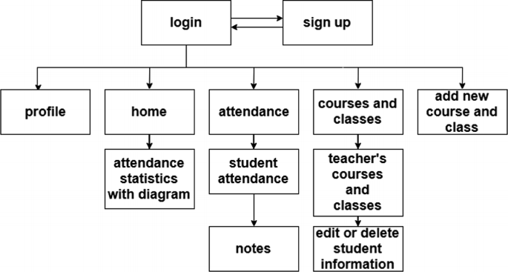
Figure 3.1: Conceptual Framework for Student Attendance Management
The Students Attendance Management System using RFID is an efficient, automated solution for tracking and managing student attendance in educational institutions. The system leverages RFID (Radio-Frequency Identification) technology to record attendance seamlessly when students use their RFID cards.
- Login and Sign Up
  - Provides secure authentication for students and administrators.
  - New users can create accounts with basic details and RFID card registration.
- Profile Management
  - Each user has a dedicated profile displaying their personal information, attendance records, and enrolled courses/classes.
- Home Dashboard
  - Displays a user-friendly overview of attendance statistics, upcoming classes, and important notifications.
- Attendance Tracking
  - Automatically marks attendance when students scan their RFID cards at designated checkpoints.
  - Admins can view detailed reports and monitor attendance trends.
- Courses and Classes Management
  - Students can view their enrolled courses and class schedules.
  - Admins can manage course details, assign teachers, and define class timings.
- Add New Course and Class
  - Admins can create new courses and classes, specifying course codes, instructors, and schedules.

Attendance Management Workflow
- Students scan their RFID cards on the reader at the start of a class or session.
- The RFID reader sends the card's unique ID to the central system.
- The system verifies the ID and logs attendance for the corresponding class.
- Data is updated in real-time and stored in the database for future reference.
Working Process of the Students Attendance Management System Using RFID
The Students Attendance Management System using RFID automates attendance tracking by allowing students to scan their RFID cards at designated checkpoints, with the system verifying their identity, recording attendance in real-time, and updating the database, enabling seamless attendance management, course tracking, and reporting through a centralized dashboard.
3.2 ANALYSIS OF THE EXISTING SYSTEM
The current attendance system in most higher institutions relies on manual methods such as paper-based attendance sheets or electronic systems where students manually sign in using swipe cards or biometric scanners. The analysis of the existing system is analyze below:
- Manual Process: The current system is predominantly manual, requiring instructors to manually take attendance during each class session. This process is time-consuming and prone to errors.
- Limited Accuracy: Manual attendance systems are susceptible to inaccuracies due to human error, such as instructors forgetting to mark attendance or students signing in on behalf of absent classmates (proxy attendance).
- Lack of Real-time Monitoring: With manual systems, there's no real-time monitoring of attendance. Instructors may not know if students are present until after the class session, making it difficult to address attendance issues promptly.
- Administrative Burden: Collating and managing attendance records manually can be administratively burdensome for instructors and administrative staff. It consumes valuable time and resources that could be better utilized for other tasks.
3.3 PROBLEM OF THE EXISTING PROBLEM
The existing system has the following shortcomings:
- Inaccuracies in Attendance Records: Manual attendance processes are prone to errors, leading to inaccuracies in attendance records.
- Proxy Attendance: There's a risk of proxy attendance, where students mark attendance on behalf of absent classmates, leading to inaccurate attendance data.
- Time-Consuming Process: Manual attendance-taking is time-consuming for both instructors and students, reducing valuable instructional time.
- Limited Monitoring: Lack of real-time monitoring makes it challenging for instructors to track attendance patterns and address issues promptly.
- Administrative Challenges: Managing and organizing paper-based attendance records or dealing with electronic systems can pose administrative challenges and increase workload.
3.4 DESCRIPTION OF THE PROPOSED SYSTEM
The proposed student attendance system using face recognition and RFID introduces a cutting-edge solution to streamline the attendance-taking process. At its core, the system utilizes advanced facial recognition technology to automate the identification of students in the lecture rooms. This process begins with the creation of a comprehensive facial database containing images and corresponding identification details of enrolled staffs. Upon activation, the system captures real-time images of students’ faces and applies a sophisticated facial recognition algorithm to match them with the stored database entries. This instantaneous recognition allows for seamless and accurate marking of attendance, eliminating the need for manual roll calls or sign-in sheets. Furthermore, the system operates in real-time, enabling instructors to monitor attendance as staffs enter and leave the office. This ensures timely intervention in cases of discrepancies or unauthorized entries, enhancing overall accountability and security.
Beyond its core functionality, the proposed system offers comprehensive reporting and monitoring capabilities. Admin have access to attendance reports and analytics tools that provide insights into attendance patterns, trends, and student engagement levels. This data-driven approach empowers admin to make informed decisions regarding course delivery and student support.
  - ADVANTAGES OF PROPOSED SYSTEM
The proposed system has the following advantages:
- It is very fast in verification or identification of student face for attendance purpose without taking much time or delay in operation.
- It improved ways of taking the attendance in the class i.e nobody can help another to take his/her attendance because this method uses individual biometric for recognition and verification
- It helps the management to maintain a strong security. Since image is used as a means of authentication it is difficult for someone to mark an attendance on behalf of another person and this creates a strong security measure.
- It saves time and accurate that is, the attendance is taken very fast, correct, exact, and without any mistakes.

CHAPTER FOUR
DESIGN AND IMPLEMENTATION OF THE SYSTEM
4.1 DESIGN OF THE SYSTEM
This is the computation of the particulars of a new system and the determination of what the new system would be and the function it is to perform. This may involve changing from one system to another or modifying the existing system operation.
The most challenging phase of the system life cycle is the change from manual operation to a faster and more accurate one, system design stage covers the technical specifications that will be employed in the implementation of the new system in order to modify the previous system. Some factors are put in consideration. These factors include input design, output design, definitions file and procedure designs and other documentation.
4.1.1 OUTPUT DESIGN
This incorporates the objectives of solving the existing system problems and challenges. This involves the structuring of the desired information and also to enhance efficient and effective attendance system. Things taken into consideration in determining the output are represented below:

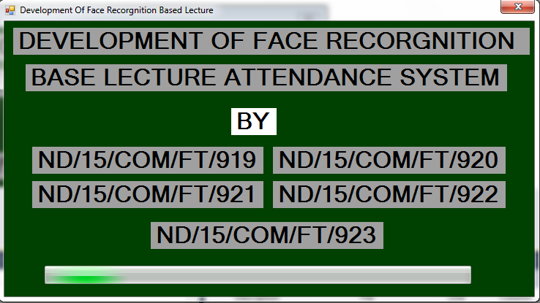
DEVELOPMENT OF STUDENT ATTENDANCE SYSTEM USING RFID AND FACE RECOGNITION
BY
ND/22/COM/FT/

HND/23/COM/FT/

Figure 4.1: Splash Screen
This page tells brief introduction about the project topic as well as the researcher.
4.1.2 INPUT DESIGN
The input to run this software is obtained from lecture attendance system using facial based recognition system. The administrator is expected to safeguard the files and document using facial authentication. The input design describes the input interface for data entry into the program. Data entry interfaces needs to be considered in developing a new system to ensure users’ friendliness. Data entry is done through the use of keyboard, camera, and in some cases selection from the dropdown combos and list boxes are done using mouse selection. The interface descriptions are as shown below:
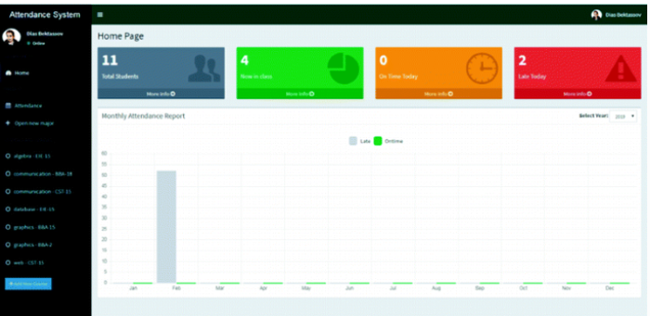
Figure 4.2: Home page
This is the main menu that contains submenus where user can navigate from one page to another within the environment.

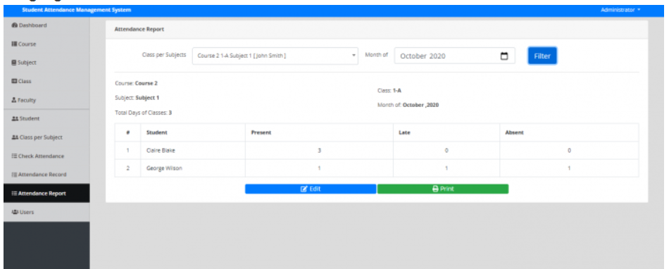
Figure 4.3: Registration form
This page is use by student to supply or enter their information and link the card
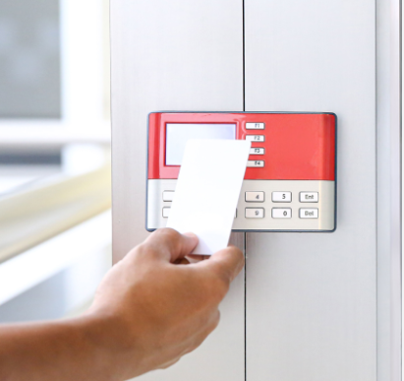
Figure 4.4: Attendace page
This page is use to take the attendance.
4.1.3 DATABASE DESIGN
The structure and organization of records in the tables is a database file is essential to be considered in designing a database driven application. The database files main record where house for keeping data and information relevant for this application.
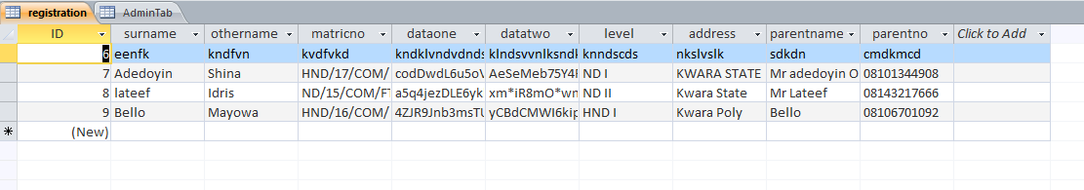
Table 1: Student Table
This table entails all the student details.
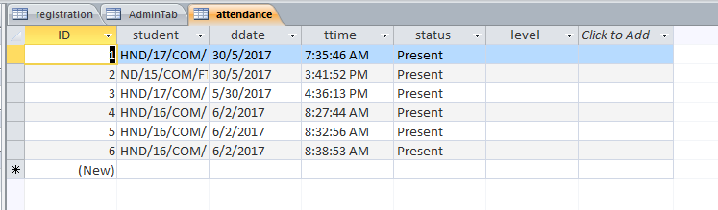
Table 2: Attendance Table
This table entails all the attendance details
4.13 PROCEDURE DESIGN
These are the steps involved in unifying the whole process to produce the desired output. It involves computer procedures which starts from the original input lessons to the output result file. This allows the processing of the information and result to be possible. Menu is provided to aid user in the processing of the output file.
4.2 IMPLEMENTATION OF THE SYSTEM
This entails the choice of the programming language employed to implement the software which should-be suitable for lecture attendance using facial recognition authentication. The software is designed for the use of lecture attendance system which should serve as an assistant for the management in monitoring the attendance system for students.
4.2.1 CHOICE OF PROGRAMMING LANGUAGE
The Application was developed in a .net (dot net) integrated development environment (.net IDE). The Application IDE is chosen following the fact that extracted information needs to be presented in an enhanced pictorial/graphical format and easy communication with the database for program flexibility in windows platform.
4.2.2 HARDWARE REQUIREMENTS
Minimum of Microcomputer Pentium IV- Intel 1.5 GHZ processor, 1.0 GB RAM, 40GB Hard disk, 14” VGA Monitor Windows XP or higher, Enhanced keyboard, mouse and pad.
4.2.3 SOFTWARE REQUIREMENT
i. Windows 7
ii. Microsoft Visual C#.
iii. Webcam
IV. Microsoft Access Database
4.2.4 CHANGE OVER TECHNIQUE
These deals with the processes and steps taking to put the system into use, before the system can be fully employed into the system, some training might have been done by the user of the application if he or she is a computer illiterate, because the user might be a computer illiterate, so also the system might have also been use.
Since the work of an expert cannot be eliminated from the system, the computerized system will have to work hand in hand with the expert in the field.
4.3 DOCUMENTATION OF THE SYSTEM
The documentation for the Student Attendance Management System using RFID provides a comprehensive overview of the system, its purpose, functionality, and operation. This system is designed to automate attendance tracking in educational institutions by leveraging RFID technology. It minimizes manual errors, saves time, and ensures data accuracy, making it an effective solution for managing student attendance.
The system consists of both hardware and software components working together seamlessly. Hardware elements include RFID readers to scan student tags, RFID cards assigned to each student with unique IDs, and a microcontroller like Arduino or Raspberry Pi to process the data. The software side comprises backend programming to handle data processing, a database for storing attendance records, and a frontend interface for administrators and teachers to monitor and generate reports.
The workflow begins with issuing RFID cards to students, linking each card to the student’s profile in the database. When a student scans their RFID card on the reader, the system records the timestamp and stores it in the database. Administrators and teachers can access these records in real time through a user-friendly dashboard, enabling them to monitor attendance, generate summaries, and identify trends.
Installation involves setting up RFID readers at classroom entrances, connecting them to the microcontroller, and integrating the hardware with the software system. On the software side, the backend, database, and user interface are deployed, ensuring smooth data flow and accessibility.
4.3.1 PROGRAM DOCUMENTATION
The program is packaged for use in any system irrespective of either it runs Visual Basic Application or not. After developing a program in Visual Basic, there is a facility provided in Microsoft Visual Studio suite called “Package and Deployment Wizard” that is used in Visual studio application packaging and deployment.
The automated face recognition based lecture attendance system is packaged into an installable setup that can be run from any system.
4.3.2 MAINTAINING THE SYSTEM
Maintaining the Student Attendance Management System using RFID requires consistent attention to both hardware and software components to ensure reliability and accuracy. The hardware, including RFID readers, microcontrollers, and RFID cards, should be regularly inspected for wear and tear, cleaned to prevent dust interference, and tested for functionality. Proper ventilation for microcontrollers and stable power supply maintenance are also crucial to avoid overheating or power-related malfunctions.
On the software side, it is essential to regularly update the system to incorporate security patches and feature enhancements. Database backups should be conducted frequently to prevent data loss, and the database itself should be optimized for performance to handle increasing data loads efficiently. Integrations with other systems, such as Learning Management Systems, must be monitored to ensure smooth operation.
Security is a critical aspect, requiring encrypted data storage, secure user authentication, and periodic system audits to identify and mitigate vulnerabilities. Additionally, user training and technical support play a vital role in maintaining system efficiency, ensuring that both staff and students can operate the system without issues. Feedback mechanisms should be established to allow users to report problems or suggest improvements.

CHAPTER FIVE
SUMMARY, CONCLUSION AND RECOMMENDATIONS
5.1 SUMMARY
The Student Attendance Management System using RFID is an innovative and efficient solution designed to automate the attendance process in educational institutions. It eliminates manual attendance marking, minimizes errors, and provides real-time data for better tracking and management. The system utilizes RFID technology, where each student is assigned a unique RFID card. When scanned by an RFID reader, the system records the student's attendance in a centralized database, which can be accessed through a web or mobile interface. The system enhances productivity, saves time, and ensures data accuracy, making it a valuable tool for modern educational environments.
5.2 CONCLUSION
The implementation of an RFID-based Student Attendance Management System significantly improves the traditional attendance process. It ensures accuracy, reduces administrative workload, and provides a secure and user-friendly method of attendance tracking. By leveraging RFID technology, educational institutions can achieve a seamless and reliable attendance system that enhances operational efficiency. The system is scalable, flexible, and adaptable to various educational setups, making it a sustainable solution for managing attendance.
5.3 RECOMMENDATIONS
Based on the findings of the project, the researcher recommends the following;
- Adoption of the System:
Educational institutions should consider adopting RFID-based attendance systems to improve operational efficiency and student tracking.
- Integration with Existing Systems:
Integrate the RFID system with other institutional systems, such as Learning Management Systems (LMS), for streamlined management.
- Data Security and Privacy:
Ensure robust data encryption and access control to protect student data and maintain confidentiality.
- Periodic Maintenance:
Regularly maintain the RFID hardware and software to ensure system reliability and minimize downtime.
- User Training:
Provide training sessions for staff and students to ensure smooth operation and adoption of the system.
- Scalability and Updates:
Design the system with scalability in mind and incorporate updates based on user feedback and evolving needs.

REFRENCES
Adam, S. & Andrzej, K. (2019). The Performance of the Haar Cascade Classifiers Applied to the Face and Eyes Detection, Computer Recognition Systems Vol. 1, Issue: 2. Pp. 3-4.
Anjola, C., K. (2019). Face Recognition Based Attendance Marking System. Journal of Software Engineering and Simulation Vol. 5. Issue: 2. Pp: 18-29.
Amit, K., Varma, P. K., Perala, S. & Chadha, P. R. (2016): Automatic Attendance System By Visual Programming Language LabVIEW,” in IEEE International Conference On Power Electronics, Intelligent Control and Energy System. Pp. 14-15.
Chintalapati, S. & Raghunadh, V. (2017). Automated Attendance Management System Based on Face Recognition Algorithms. IEEE International Conference on Computational Intelligence and Computing Research.
Eisert, P. & Girod, B. (2020). Analyzing Facial Expressions for Virtual Conferencing, Computer Graphics and Applications. Vol. 18, Issue: 5. Pp. 70-78.
Francisco, S., Victor, F. & Antonio, P. (2018). Automatic Control of Student Attendance in Classroom Using RFID, IEEE International Conference. Pp. 14-15.
Katsaggelos, K. (2020). Automatic Facial Action Recognition in Face Profile Image Expression Recognition Using Facial Animation sequences, in Proceedings IEEE International Conference Multimedia, Parameters and Multi stream HMMs. Pp. 37-40.
Kumar, P. K., Perala, V. & Chadha, P. R. (2016). Automatic Attendance System by Visual Programming Language LabVIEW, in IEEE International Conference on Power Electronics, Intelligent Control and Energy System. Pp. 20-21.
Maddu, K. & Kumar, P. (2019). Wireless Fingerprint Attendance Management System, Fifth International Conference on Image Information Processing (ICIIP), Shimla, India. Pp. 10-11. DOI: 10.1109/ICIIP47207.2019.8985867
Mohammed, S. & Raghu, P. (2019). Automatic Control of Student Attendance in Classroom Using RFID, IEEE International Conference. Vol. 3. Pp. 14-15.
Mrunal A., Prasad L., Manish T., Aniket J., & Chinmay, B. (2021). Attendance Management System using Face-Recognition, International, Journal of Scientific Research in Computer Science, Engineering and Communication Technology. Vol. 7. Pp. 336-341.
Revera, K. (2021). Automatic Facial Action Recognition in Face Profile Image Expression Recognition Using Facial Animation sequences, in Proceedings IEEE International Conference Multimedia, Parameters and Multi stream HMMs. Pp. 37-40.
Selvi, S., Chitrakala, A. & Jenitha, A. (2022). Face Recognition Based Attendance Marking System, IJCSMC. Vol. 3, Issue. 2. Pp. 23-24.
Zhang, Z. & Ma, M. (2019). Design of Face Detection and Tracking System, IEEE 3rd International Congress on Image and Signal Processing. Vol. 2, Issue: 3. Pp. 23-24.

Appendices
Appendix 1: SYSTEM FLOWCHAT
TAKE ATTENDANCE
VIEW STAFF LIST
VIEW ATTENDANCE
REGISTER NEW STAFF

STOP
SPLASH SCREEN

FILE
START
Appendix 2: Student Registration
START
OPEN DATABASE
INCREMENT ID BY 1
ENTER STUDENT DETAILS
SAVE INTO DATABASE
CLOSE DATABASE
MORE RECORD?
RETURN
Yes
No
DISPLAY STAFF
ENTRY FORM
CAPTURE STUDENT FACE

Appendix 3: TAKE ATTENDANCE
OPEN DATABASE
START

CAPTURE STUDENT FACE

VERIFY STUDENT FACE
RETURN
CLOSE DATABASE
ANYMORE ?

Yes

No

Appendix 4: VIEW STUDENT LIST
RETURN
CLOSE DATABASE
OPEN DATABASE
START
DISPLAY ALL
STUDENT DETAILS

ANYMORE TO VIEW?
No
Yes
Appendix 5: VIEW ATTENDANCE
RETURN
CLOSE DATABASE
OPEN DATABASE
START
VIEW ALL STUDENT ATTENDANCE

VIEW MORE?
Yes
No

Appendix 6: SOURCE PROGRAM LISTING

using System;
using System.Collections.Generic;
using System.ComponentModel;
using System.Data;
using System.Drawing;
using System.Linq;
using System.Text;
using System.Windows.Forms;
using System.Data.OleDb;

namespace MultiFaceRec
{
public partial class Form3 : Form
{
private OleDbConnection bookConn;
private OleDbCommand oleDbCmd = new OleDbCommand();
private String connParam = @"Provider=Microsoft.Jet.OLEDB.4.0;Data Source=C:\Users\PROGRAMMER\Desktop\face recornition project\FaceRecProOV\bin\Debug\faceattendance.mdb;Persist Security Info=False";

public Form3()
{
bookConn = new OleDbConnection(connParam);
InitializeComponent();
}

private void nDIToolStripMenuItem1_Click(object sender, EventArgs e)
{

int hh = 1;

dataGridView1.DataSource = null;
dataGridView1.Rows.Clear();
dataGridView1.Refresh();

OleDbDataAdapter dAdapter = new OleDbDataAdapter("select * from StudentDetails WHERE Slevel = 'ND I'", connParam);
OleDbCommandBuilder cBuilder = new OleDbCommandBuilder(dAdapter);

DataTable dataTable = new DataTable();
DataSet ds = new DataSet();
dAdapter.Fill(dataTable);
for (int i = 0; i < dataTable.Rows.Count; i++)
{
dataGridView1.Rows.Add(hh, dataTable.Rows[i][1], dataTable.Rows[i][2], dataTable.Rows[i][3], dataTable.Rows[i][4], dataTable.Rows[i][5]);
hh++;
}

bookConn.Close();

}

{

int hh = 1;

dataGridView1.DataSource = null;
dataGridView1.Rows.Clear();
dataGridView1.Refresh();

OleDbDataAdapter dAdapter = new OleDbDataAdapter("select * from StudentDetails WHERE Slevel = 'HND II'", connParam);
OleDbCommandBuilder cBuilder = new OleDbCommandBuilder(dAdapter);

DataTable dataTable = new DataTable();
DataSet ds = new DataSet();
dAdapter.Fill(dataTable);
for (int i = 0; i < dataTable.Rows.Count; i++)
{
dataGridView1.Rows.Add(hh, dataTable.Rows[i][1], dataTable.Rows[i][2], dataTable.Rows[i][3], dataTable.Rows[i][4], dataTable.Rows[i][5]);
hh++;
}

bookConn.Close();

}

private void Form3_Load(object sender, EventArgs e)
{

}
}
}

