CHAPTER ONE
INTRODUCTION

1.0 BACKGROUND
Time is the ambit within which we operate as such its accuracy is of utmost importance. Hours, Minutes, Seconds are of the same amount of time anywhere on Earth, but the earth is divided into twenty-four (24) time zones. The time zones are such that there exist a one-hour difference between each time zone and the one next to it. Electronic digital displays are basically used to represent visual information. They find their application in virtually all facets of human endeavors and reduce errors in observation and measurement to minimum level.
The Digital clock with Calendar is a portable timepiece that is exceptionally accurate and meets up to certain precision standards. The device shows the time and corresponding date and provides an easy means of viewing it.
This chapter presents the project motivation, aims and objectives, methodology as well as the scope and organization of the project.

1.1 PROJECT MOTIVATION
Analogue timing devices are characterized by being large, heavier and prone to errors in observations and measurements. These errors in observations and measurements can be reduced by the use of digitally based timing devices which provide more portability and ease of viewing. The Digital Clock with Calendar is a portable timepiece that displays time in Hours and Minutes along with the corresponding date through a programme loaded into microcontroller is a suitable device for such an application.

1.2 AIMS AND OBJECTIVES
The project aims at implementing a digital Clock/Calendar using a PIC microcontroller with the respective time and date displayed on an LCD display.

The objectives of the project include:
- Design of power supply unit
- Design of the hardware starter kit
- Programming of the PIC microcontroller
- Interfacing the microcontroller to the display unit

1.3 METHODOLOGY
The project uses a PIC16F84A microcontroller belonging to the RISC architecture. An eighteen pin device which use an XT oscillator to provide the internal clock of the microcontroller. The microcontroller has two ports which are PORTA and PORTB. PORTA has five pins (RA0-RA4) which are used as Set buttons. The pin RA0 allows for the overall set operation, while pin RA1:RA4 are used for the setting of the display parameter (Date, Month, Year, and Day). PORTB has eight pins (RB0-RB7) out of which two pins are used as Control lines and four pins are used as Data lines for the display unit. The operation of the project is based on Timer zero interrupt (TMR0). The timer interrupt is set to generate an interrupt every second, thus the basic timing unit in the project is the Seconds which is generated during the overflow of the TMR0 register. The device is designed to start from a fixed time and date as reference. The microcontroller is interfaced to a Liquid Crystal Display (LCD) which shows the corresponding time and date and a provision is made for a +9V supply out of which +5V is utilized by the microcontroller and other devices that need +5V biasing voltage.

1.4 SCOPE OF AND LIMITATIONS
The digital Clock/Calendar designed and implemented in this project would actually serve satisfactorily its primary function of time keeping. The necessity for accurate time-keeping in public places such as schools, work place, restaurants, shopping malls, and others need not to be overstressed. Among the constraints encountered in the course of implementing the digital Clock/Calendar using PIC16F84A are the following:
- Fewer numbers of ports led to using a single pin to set two parameter which are the Day and Month.
- The Set button is not interrupt driven as such a single parameter cannot be set alone.
- The project does not save the previous value of time on power failure.

1.5 SIGNIFICANCE OF THE PROJECT

The device provides a simple means of viewing time thus ensuring flexibility and suitability for use by lay-men. As a portable device it can be used at various locations for time determination. Similarly the necessity for accurate time-keeping in public places such as schools, work place, restaurants, shopping malls, and others need not to be overstressed.

1.6 ORGANISATION OF THE PROJECT
This project comprises of five (5) chapters. Chapter one serves as an introduction to the work to be done. Chapter two covers the theoretical background and discusses the basic principles upon which the various components used in the project are based.
Chapter three covers the hardware and software design. This chapter describes the components and the physical realization of the overall circuitry. It also discusses the various stages of the software development.
Chapter four deals with the simulation and interfacing of the microcontroller output to the data transmission circuitry and finally chapter five on its own serves to conclude the project by highlighting the problems encountered and the possible recommendations for other relevant works.

CHAPTER TWO
THEORETICAL BACKGROUND

2.1 INTRODUCTION
The primary objectives of this chapter are to give sufficient highlight on the theory and principles upon which the components used in this microcontroller project are based. This would involve a description of the essential units of the PIC16F84A microcontroller and their architecture. A brief outline of the programming environment and the process of the programming the microcontroller chip will be rendered.

2.2 THE PIC16F84A MICROCONTROLLER
A microcontroller is a single chip computer. Micro suggests that the device is small and controller suggests that the device can be used in control applications. Another term used for microcontrollers is embedded controller, since most of the microcontrollers are built into (or embedded in) the devices they control. A microprocessor differs from a microcontroller in many ways. The main difference is that a microprocessor requires several other components for its operation, such as program memory and data memory, I/O devices, and external clock circuit. A microcontroller on the other hand has all the support chips incorporated inside the same chip. All microcontrollers operate on a set of instructions (or the user program) stored in their memory. A microcontroller fetches the instructions from its program memory one by one, decodes these instructions, and then carries out the required operations.
The PIC16F8X families of the devices are CMOS (complementary metal oxide semiconductors) microcontrollers. The most popular PIC micro used to teach new users is the 16F84A. It can be programmed and erased over 1000 times and it is ideal for development work. The device uses a mid range PIC microprocessors with 1024 instructions of ROM (i.e. EEPROM),Program Memory and 68bytes of Random Access Memory(RAM) which are also known as ‘file registers. The program is made up of a serially array of electrically erasable programmable memory (EEPROM) Cells that can be serially programmed by the user.[2]

Internally to the chip, there is a timer, an interrupt controller and 64bytes of EEPROM that can be used for data storage. The chip utilizes a 14 bit instruction word. The chip comes in an 18-pin package with thirteen pins available for digital input and output. PortA and Port B are the physical connections between the microcontroller and the outside world. PortA has five pins and Port B has eight pins. These ports pins can be configured as either input or output pins as dictated by design requirement.

Fig 2.1 The pin configuration of the PIC16f84A

Table 2.1 PIC 16F84A Pin Configuration
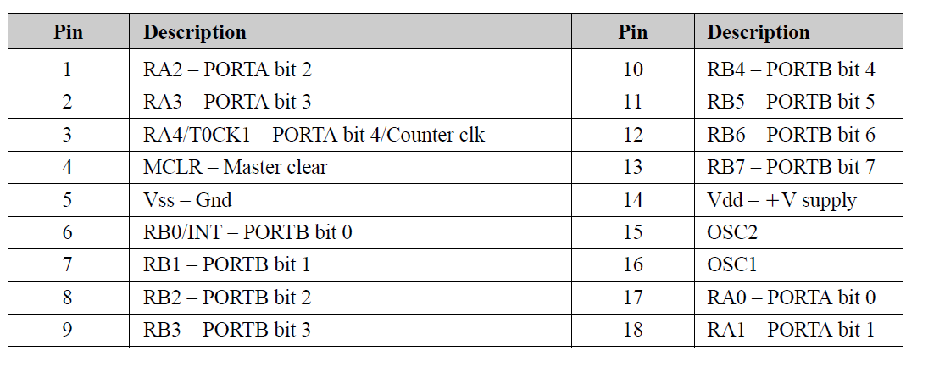
The PIC16F84A also has an eight level stack, an eight bit free run timer/counter with an eight bit software programmable prescaler and an internal or external clock select option with different oscillator configurations. The PIC is available in 18-pin DIP and SOIC packages. The DIP package is used in this project. The remaining five of the eighteen pins are been programmed as V_{ss}, V_{dd}, master clear/reset, OSC1/CLK IN and OSC2/CLKOUT.[2]

2.3 THE PIC 16F84A ARCHITECTURE
The PIC16F84A belongs to a class of 8-bit microcontrollers of RISC architecture. Its general structure showing its blocks is as shown in fig.2.2. Microcontrollers using the RISC architecture (known as the Harvard architecture) have improved bandwidth utilization capabilities as opposed to those using the traditional Von Neumann architecture.

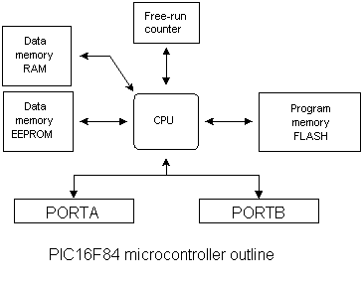

Fig 2.2. The PIC16F84A Microcontroller Outline
The Harvard architecture is as shown in fig 2.3., it results from the need to speed up the work of a microcontroller. This architecture has a separate data memory and program memory which are also addressed through separate buses which are the data memory bus and address memory bus respectively. The separation of the program and data memory further allows instructions to be sized differently than the 8-bit wide data word. The full 14-wide program memory bus fetches a 14-bit instruction in a single clock cycle except for branch instruction which are executed in two cycles.
. 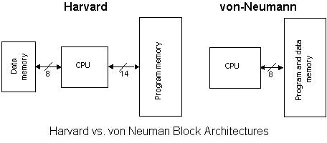

Fig.2.3. Harvard and Von Neumann

Typically, the Harvard or RISC architecture reduces the number of instructions necessary (35 for PIC16F84A) as compared to the Von Neumann or CISC architecture that usually has more instructions.
The use of the RISC architecture in the PIC16F84A results in a 2:1 code compression and 4:1 speed improvement in relation to other 8-bit microcontrollers in its class.[2]

2.4 MEMORY ORGANISATION OF THE PIC16F84A
The memory blocks of the PIC16F84A are divided into programs and data memory. Another features of PIC16F84A is the allocation of separate buses to the blocks.[2]

2.4.1 PROGRAM MEMORY
The program memory is written in flash technology thus enabling a program to be written and rewritten as many times as possible. This memory has 1024 memory locations with 14-bit widen data word. Out of these 1024 locations, location zero (0) and four (4) are reserved for reset and interrupt vector. The program memory of the PIC16F84A has 8K x 14 program memory space of which the first 1K x 14 (0000H-03FFH) are physically implemented. Accessing a location above the physically implemented address will cause a wraparound.[2]

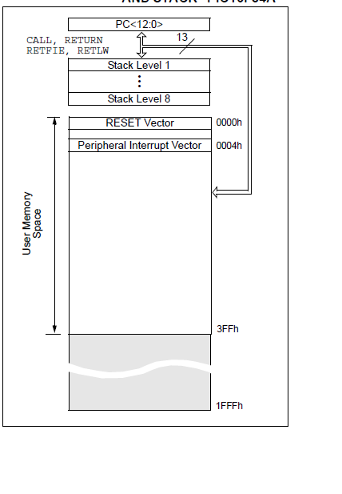

Fig.2.4. Program Memory map and Stack

2.4.2 DATA MEMORY
The data memory is divided into EEPROM and RAM memories. The EEPROM memory is not lost when power supply fails. This memory is not directly addressable but it is addressable indirectly through the FSR (File Select Register). Due to the importance of the parameter stored in this memory, a strict writing procedure must be adhered to. The Ram memory occupies a space in memory map from location 0x0C to 0x4F (68 bytes).
The data memory is divided into two areas, the SFR (Special Function Register) and the GPR (General Purpose Register). The SFR which carries out the main functions of the device is divided into two sets: Core and Peripheral.

The data memory is further divided into two banks for both the SFR and GPR areas. The GPR area is banked to follow more than 116 bytes of general purpose RAM while the banked areas of the SFR are for the registers that control the peripheral functions. Bank selection is done by use of control bits in the STATUS register. [2]
Table 2.5. Register Map for PIC16F84A

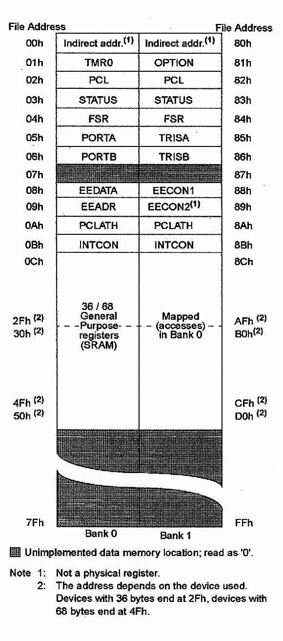

2.5 GENERAL PURPOSE REGISTER
The register file is accessed either directly or indirectly through the File Select Register (FSR).[2]

2.6 SPECIAL FUNCTION REGISTERS
The Special Function Registers (SFR) are registers used by the CPU and peripheral functions to control the operation of the device. They are registers of specialized function assigned with certain blocks of the microcontroller. The special function registers take up the first twelve locations in the banks 0 and 1.[1]

2.6.1 STATUS REGISTER
The Status register is an 8-bit register which contains status bits which are controlled by the arithmetic logic unit, execution of some instructions affects the status bits which depends on the result of arithmetic and logic operations depending on the instruction that is being executed.ALU can affect values of Carry(C), digit Carry (DC) and Zero (Z) bits in the status register.[2]
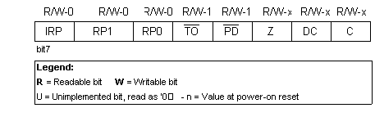

Fig.2.6. Status Register

Bit 7, IRP (Register Bank Select bit): The Bit whose role is to be an eighth bit for purposes of indirect addressing the internal RAM.
1 = bank 2 and 3
0 = bank 0 and 1 (from 00H to FFH)
Bits 6:5, RP1:RP0 (Register Bank Select)
These two bits are upper part of the address for direct addressing. As instructions which address the memory directly have only seven bits, they need one more bit in order to address all 256 bytes which is how many bytes PIC16F84 has. RP1 bit is not used, but is left for some future expansions of this microcontroller.
01 = first bank
00 = zero bank
Bit 4, TO (Time-out; Watchdog overflow)
This bit is set after turning on the supply and execution of CLRWDT and SLEEP instructions. Bit is reset when watchdog gets to the end signaling that overflow took place.
1 = overflow did not occur
0 = overflow did occur
Bit 3, PD (Power-down bit)
This bit is set whenever power supply is brought to a microcontroller, as it starts running, after each regular reset and after execution of instruction CLRWDT. Instruction SLEEP resets it when microcontroller falls into low consumption mode. Its repeated setting is possible via reset or by turning the supply off/on . Setting can be triggered also by a signal on RB0/INT pin, change on RB port, upon writing to internal DATA EEPROM, and by a Watchdog.
1 = after supply has been turned on
0 = executing SLEEP instruction
Bit 2, Z (Zero bit)
This bit is set when the result of an executed arithmetic or logic operation is zero.
1 = result equals zero
0 = result does not equal zero
Bit 1, DC (Digit Carry) DC Transfer
This bit is affected by operations of addition, subtraction. This bit represents transfer from the fourth resulting place. It is set in case of subtracting smaller from greater number and is reset in the other case.
1 = transfer occurred on the fourth bit according to the order of the result
0 = transfer did not occur
The DC bit is affected by ADDWF, ADDLW, SUBLW, SUBWF instructions.

Bit 0, C (Carry) Transfer
This bit is affected by operations of addition, subtraction and shifting.
1 = transfer occurred from the highest resulting bit
0 = transfer did not occur
C bit is affected by ADDWF, ADDLW, SUBLW, SUBWF instructions.[2]
2.6.2 OPTION REGISTER
The prescaler is a name giving to the part of the microcontroller which divides the oscillator clock before it will reaches logic that increases timer status ,the number which divides a clock is defined through the first three bits of the OPTION register. Prescaler can be accorded to timer TMR0, or to the watchdog timer through PSA bit in OPTION register.
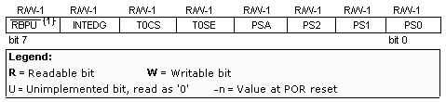

Fig. 2.7. Option Register

The OPTION register is an 8-bit wide register which contains various control bits to configure TMR0 prescaler to watchdog prescaler.[2]
Bit 7, RBPU (PORTB Pull-up Enable bit)
This bit turns internal pull-up resistors on port B on or off.
1 = pull-up resistors turned on
0 = pull-up resistors turned off

Bit 6, INTEDG (Interrupt Edge Select bit)
This bit would determine at what edge interrupt on RB0/INT pin would occur. if the occurrence of interrupts are enable.
1 = rising edge
0 = falling edge

Bit 5, T0CS (TMR0 Clock Source Select bit)
This pin enables a free-run timer to increment its value either from an internal oscillator, i.e. every 1/4 of oscillator clock, or via external impulses on RA4/T0CKI pin.
1 = external impulses
0 = 1/4 internal clock
Bit 4, T0SE (TMR0 Source Edge Select bit)
If trigger TMR0 was enabled with impulses from a RA4/T0CKI pin, this bit would determine whether it would be on the rising or falling edge of a signal.
1 = falling edge
0 = rising edge
Bit 3, PSA (Prescaler Assignment bit)
This is the Bit which assigns prescaler between TMR0 and watchdog timer.
1 = prescaler is assigned to watchdog timer.
0 = prescaler is assigned to free timer TMR0
Bit 0:2 PS0, PS1, PS2 (Prescaler Rate Select bit)
In a case where a 4MHz oscillator is used, one instruction cycle (4 internal clocks) lasts 1µs. Numbers in table 2.6.2. Shows the time period in microseconds (µs) between incrementing TMR or WDT.

Table 2.6.2. Prescalar rate
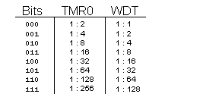

2.6.3 INTCON REGISTER
Intcon register is a control register of an interrupt. Interrupts are a mechanism of a microcontroller which enables it to respond to some events at the moment they occur regardless of what microcontroller is doing at that time. This is a very important part because it provides connection between a microcontroller and environment which surrounds it. Generally, each interrupt changes the program flow, interrupts it and after executing an interrupt sub program (interrupt routine) it continues from that same point on. The register has 8-bits and its located in address 0BH.[2]

The Intcon register can be accessed regardless of the bank selected. Its role is to allow or disallow interrupts and in case they are not allowed, it registers single interrupt requests through its own bits.[2]

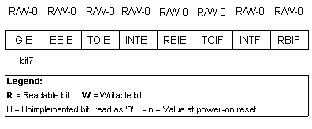
Fig.2.6.3 Intcon Register
Bit7: GIE (Global Interrupt Enable bit)
This bit which enables or disables all interrupts.
1 = all interrupts are enabled
0 = all interrupts are disabled
Bit 6: EEIE (EEPROM Write Complete Interrupt Enable bit)
The bit which enables an interrupt at the end of a writing routine to EEPROM
1 = interrupt enabled
0 = interrupt disabled
Bit 5: T0IE (TMR0 Overflow Interrupt Enable bit)
This bit which enables interrupts during counter TMR0 overflow.
1 = interrupt enabled
0 = interrupt disabled
Bit 4: INTE (INT External Interrupt Enable bit)
The bit enables external interrupt from pin RB0/INT.
1 = external interrupt enabled
0 = external interrupt disabled
Bit3: RBIE (RB port change Interrupt Enable bit)
This enables interrupts to occur at the change of status of pins 4, 5, 6, and 7 of port B.
1 = enables interrupts at the change of status
0 =interrupts disabled at the change of status
Bit 2: T0IF (TMR0 Overflow Interrupt Flag bit)
Overflow of counter TMR0
1 = counter changed its status from FFH to 00H
0 = overflow did not occur
Bit 1: INTF (INT External Interrupt Flag bit)
External interrupt occurred
1 = interrupt occurred
0 = interrupt did not occur
If a rising or falling edge was detected on pin RB0/INT, (which is defined with bit INTEDG in OPTION register), bit INTF is set.
Bit 0: RBIF (RB Port Change Interrupt Flag bit)
The bit which informs about changes on pins 4, 5, 6 and 7 of port B.
1 = at least one pin has changed its status
0 = no change occurred on any of the pins
Bit has to be cleared in an interrupt subroutine to be able to detect further interrupts.[2]

2.7 THE I/O PORTS
A port is a group of pins on the microcontroller that can be accessed simultaneously or in which we can put a desired combination of zeros and ones. It serves as an interface between the PIC16F84A and the outside world. They are used to control or monitor other components or devices. In the case of PIC16F84A microcontroller, there are two ports which are PORTA and PORTB.
In circumstances where one port is multiplexed with an alternate function, selecting one of the functions automatically disables the other.[2]
All port pins can be designated as input or output depending on design specifications. In assigning input or output functions to the pins, the right combination of zeros and ones must be written in the corresponding TRIS register.

2.7.1 PORT A
PORT A is a 5-bit wide latch. RA4 is a dual function PORTA pin, serving either as an I/O pin or as an external input for the free-run timer/counter. The other four PORTA pins (RA0-RA3) are purely bidirectional I/O pins. All PORTA pins have an associated data direction bit (TRIS register) called TRISA, located at address 85H of the data memory. Setting a bit in TRISA register configures the corresponding PORTA pin as input pin and clearing a bit in TRISA register defines the corresponding pin as an output pin. [2]

2.7.2 PORTB
PORTB is an 8-bit wide bidirectional port with a corresponding data direction register called TRISB. A set in any of the particular bit of the TRISB register defines the corresponding PORTB pin as an output pin while a clear defines an input pin
For PORTB pins RB7:RB4 have an interrupt on change feature is recommended for wake-up on key depression operations and where PORTB is only used for the interrupt on change feature as shown.[1]
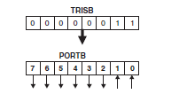

Fig.2.7.2. Port B and TRISB

2.8 THE CPU
This is the most important component of the PIC16F84A or any microcontroller. It is responsible for connecting all parts of the microcontroller into one whole. Its basic function is to decode program instruction.
A written program which is meaningless to the microcontroller needs to be translated into an opcode (a combination of zeros and ones). This translation is done by translators or assemblers as it is possible to have instructions that contain assignments which require different transfers of data from one memory to another or from memory to ports. The CPU must be connected to all the parts of the microcontroller through particular channels.
These channels are called buses (data and address buses). Furthermore, the CPU has features such as oscillation select option, several interrupts, code protection, in-circuit serial programming capabilities and several resets in order to maximize system reliability, minimize cost, provide power saving operation modes (SLEEP) and offer code protection. The CPU of PIC16F84A has a watchdog timer that runs to its own RC oscillator for added reliability which can only be shut off through configuration bits. The CPU is provided with necessary delay on power-up by the OST which keeps the clip in reset until the oscillator stabilizes and the PWRT which provides a fixed nominal delay of 72ms.[2]

2.9 THE OSCILLATOR CIRCUIT
The PIC16F84A can be operated using four oscillator modes namely:
- LP –Low Power Crystal
- XT –Crystal/Resonator
- HS-High Speed Crystal/Resonant
- RC-Resistor/Capacitor

For this project the XT oscillator is employed. In this mode of operation an external crystal and two capacitors are connected to the OSC1 and OSC2 inputs of the microcontroller. Figure 2.9 shows a crystal oscillator with frequency of 4 MHz, two 22 pF capacitors can be used.
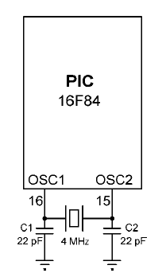

Fig.2.9. Oscillator circuit
The figure above shows the connection of the XT oscillator with PIC16F84. Depending on the oscillator used, in order to get a clock that microcontroller works upon; a clock of the oscillator must be divided by 4.[2]

2.10 OVERVIEW OF LM016L
The LCD is now a common choice of alphanumeric, graphic and video displays. They exist in many forms, but the small monochrome LM016L is used in this project. The reason for choosing this particular LCD is its availability in markets. Here emphasis is laid on the small monochrome alphanumeric type which displays alphabetical, numerical and symbolic characters from the standard ASCII character set. The display is a standard LM016L which displays 2 lines of 16 characters (16x2). Each character is 5x8 pixels making a total of 80x16 pixels overall. The display receives ASCII codes for each character at the data input (D0-D7). The data is presented to the display inputs by the MCU and latched in by pulsing the Enable (E) input. The Read/Write (R/W) line can be tied low (write mode) as the LCD is receiving data only. The figure 2.1.0 below shows the various control and data lines of the LCD (LM016L).

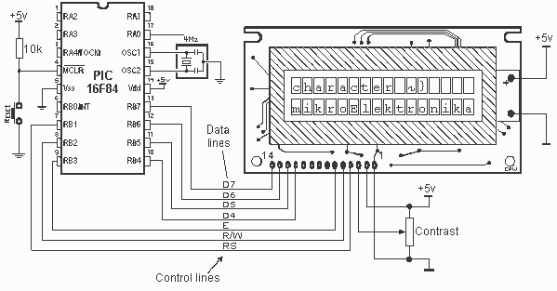

Fig 2.1.0 Connecting LCD to PIC16F84

The RS (Register Select) Input allows commands to be sent to the display RS=0 selects command mode, RS=1 Data mode. The display itself contains a microcontroller the chip in this type of display is the Hitachi HD44780; it must be initialized according to the data and display is options required. Data can be sent in 4-bit mode or 8-bit mode.
The 8-bit code for each ASCII character is sent in two halves high nibbles first then the lower nibbles. To send the data and command the output data is initially masked so that only the higher nibbles are sent. The lower nibbles are cleared during this action.[3] However, the fact that the lower bits are needed to control the display RS and E,they have to be set up after the data has been output in the port high bit. The data is usually saved on I/O pins and allows the LCD to be driven using only 6lines of a single port, while making the software only slightly complex.

CHAPTER THREE
HARDWARE AND SOFTWARE

3.1 INTRODUCTION
In this chapter, the circuit design is discussed in detail. The hardware design here covers the circuitry up to the point where transmission of the digital data begins. It also includes a detailed discussion of the heart of the project work which is the software design and covers the flowchart development and writing of the assembly language program using the PIC16F84A instruction set.

3.2. HARDWARE DESIGN
The hardware part of this project is divided into three units. The three of them were selected based on some technical reasons and design requirements. The three sections designed for are the power supply and pull-up resistor, LCD among others.

3.2.1 POWER SUPPLY
The power supply section of this project uses a +9V battery as the main source of power. An LM7805 was used to regulate this voltage down to a steady +5V for powering the microcontroller, LCD and other discrete components that require +5V for their operation. Despite the fact that the PIC16F84A can operate effectively at voltages less than or greater than 5V by 5%, it requires the voltage to be stable and fixed, as fluctuations between these range will affect its proper operation. This problem called for the use of LM7805 instead of designing a variable power supply or dropping the voltage with a resistor as in Figure 3.1

Fig.3.1. Power Supply Unit

3.2.2 PULL-UP RESISTORS
The pull-up resistor is a type of resistor used to keep a certain line on a logic one(+5V) as a preventive from arrival of a logic zero(0V) accidentally, such a resistor ranges between 5 and 10K. A pull-up resistor is used on microcontrollers to enable normal running, while allowing the programming voltage (about 9V) to be applied without damaging the target system 5 V supply. In the illustration diagram provided in fig. 3.2, Rp is a pull-up resistor. When the switch is open, no current flows through the resistor, so there is no volt drop, and the output voltage remains the same as the supply (+5V). When the switch is closed the output is connected directly to 0 V and the pull-up resistor prevents the supply being shorted to ground.

Fig 3.2 Illustration of a pull-up resistor

V_{o} = 5R_{i}/ (R_{p}+R_{i}) (3.2).

The resistance value of the pull-up resistors used in this project is selected with two considerations – a high value is selected to minimize power loss and at the same time a value much lesser than the input resistance of PIC16F84A. The input resistance of PIC16F8A is about 400KΩ.
With a pull-up resistor of 100k or less, the output voltage (from the equation of fig. 3.2) when the switch is open would be at least 4V (which is a valid digital level). The minimum voltage which will be reliably recognized as logic 1 at the PIC16F84A’s input is 2.0V, and the maximum voltage recognized as logic 0 is 0.8V. In this project, power conservation is not critical; therefore a 10KΩ pull-up resistor worked properly.

3.2.3 LCD SELECTION
The LCD is now a common choice of alphanumeric, graphic and video displays. They exist in many forms, but the small monochrome LM016L is used in this project. The reason for choosing this particular LCD is its availability in markets, low power consumption making suitable for devices powered by Battery and long life span( about 50000 hours) . Here emphasis is laid on the small monochrome alphanumeric type which displays alphabetical, numerical and symbolic characters from the standard ASCII character set.

3.3 THE SOFTWARE
The software actually refers to the program code that is loaded onto the microcontrollers’ program memory. It is the execution of the instructions contained therein that aids the microcontroller in carrying out its primary function of controlling the peripherals devices attached to it. The program is usually written assembly language and then assembled to generate a Hexadecimal code file (machine code). Writing the program and assembling it is made easy by the availability of a group of software known as the MPLAB IDE with an assembler called the MPASM assembler. The process is shown diagrammatically in figure 3.3.
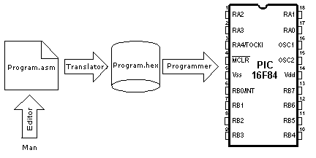

Fig.3.3, Diagram of programming process

3.3.1 MPLAB® IDE Software
The MPLAB IDE (Integrated Development Environment) software brings an ease of software development .it is a windows based application that contains:

- An interface to debugging tools
- Simulator
- programmer (sold separately)
- emulator (sold separately)
- in-circuit debugger (sold separately)
- A full-featured editor
- A project manager
- Customizable toolbar and key mapping
- A status bar and on-line help

The MPLAB IDE allows for editing the source files (either assembly or C) it allows for one touch assemble (or compile) and download to PIC micro emulator and simulator tools (automatically updates all project information) • it also provides a means debug using source files, absolute listing file, machine code. The ability to use MPLAB IDE with multiple debugging tools allows users to easily switch from the cost effective simulator to a full-featured emulator with minimal retraining.

3.3.2 MPLAB® IDE DEVELOPMENT TOOLS
Several tools are incorporated into the MPLAB IDE to provide a complete development environment. They include:

- MPLAB® project Manager
It is used to create a project and work with the specific files related to the project. It allows the source codes to be rebuilt and downloaded to the simulator or emulator easily.

- MPLAB® editor
It is used to create and edit text files such as the sources files, codes and linker script files.
- MPLAB® SIM Simulator
This software moulds the instruction execution and I/O of the PIC microcontroller.
- MPLAB® ICE Emulators
This uses hardware to emulate PIC microcontrollers in real-time either with or without a target system.
- .MPLAB® Assemble/MPLINK ® LINKER/MPLLIB® Library
This assembler allows same code to be assembled without leaving MPLAB® IDE and MPLINK ® creates the final application by linking reloadable modules form MPASM®. MPLIB manages custom libraries for maximum code reuse.
- PROMATE® and PICSTART® plus programmer
These and other programmers are used to program the devices using the MPLAB® IDE.[2]

3.3.3 CODING
The coding process involves the interpretation of the various blocks in the flowchart into the corresponding assembly language. This is achieved using the instruction set available for the PIC16F84A as listed in Appendix two. The code is for the program are typed onto a file with a name ending in.ASM, using Windows Notepad, DOS EDIT, or any other text editor. The program starts with a number of pseudo instructions, commands that give information to the assembler but are not translated into machine codes. These pseudo instructions can be grouped into five:

- HEADER: This involves writing the name of the program at the beginning, what the program does, its version, date it was written, type of microcontroller it is written for as well as the programmer’s name. Such information is preceded with a semicolon so that the assembler recognises them as comments.

- DECLARATION and CONFIGURATION: This involves definition of several microprocessor parameters in order to ensure its proper operation. Among the parameters are type of oscillator used, whether watchdog timer is turned on, whether internal reset circuit is enabled all these are define by the directive below
_CONFIG_CP_OFF_&_WDT_OFF&_PWRTE_ON&_XT_OSC

- LABELS: This is a textual designation (more of an easy- to -read word) for a line in a |program or section of program where the micro can jump to or even begin a set of line of a program. it can be used to execute program branching (e.g. Goto) and the program can have a condition that must be met before the Goto instruction is executed. They usually begin at the first column. An example is cited below[2]
Start
Movlw 0x0F
Movwf TRISA

- PORT INITIALISATION: This involves ensuring that all ports remain as either input or output during the start up of the microcontroller. With respect to the available ports of the microcontroller (PortA and PortB) to program a pin to be an output or an input, we simply send a 0 or a 1 to the relevant bit in the TRISA and TRISB register. These are located at addresses 85h and 86h respectively. Below is a code demonstrating such action
BSF 03h,5 ;Go to Bank 1
MOVLW 06h ;Put 00110 into W
MOVWF 85h ;Move 00110 onto TRISA
BCF 03h,5 ;Come back to Bank0
- SUBROUTINE: A subroutine represents a set of instruction beginning with a label and ending with the instruction Return or Retlw. It is usually a section of code, or program that can be called on the need arises. Subroutines are used during performing the same function more than once, for example creating a delay.

The advantages of using a subroutine are that it will be easier to alter the value once inside a subroutine rather than, say, ten times throughout your program, and also it helps to reduce the amount of memory the program occupies inside the PIC and reduces the overall length of the program.
Consider the subroutine shown below
ROUTINE COUNT equ 255
LABEL decfsz COUNT,1
Goto LABEL
RETURN
The subroutine has to be a given name, (in this case the chosen name ROUTINE). The code that are to be perform are written as normal. In this case, a delay is created in the program. Finally, the subroutine is ended by typing the RETURN instruction. To start the subroutine from anywhere in the program, we simply type the instruction CALL instruction followed by the subroutine name.
When we reach the part of our program that says CALL xxx, where xxx is the name of our subroutine, the program jumps to wherever the subroutine xxx resides. The instructions inside the subroutine are carried out. When the instruction RETURN is reached, the program jumps back to our main program to the instruction immediately following our CALL xxx instruction. For this project the subroutines includes the Set routine in which the incrementation of the various registers used for the timing (Hours, Minutes, Years, Month and Date) is carried out, the Interrupt Service Request (ISR) within which the clock and calendar function is carried out, the LCD routine within which the function for the display of respective date and time is carried out.
- MAIN PROGRAM: This is refers to the beginning of the actual program, it is usually determines the address from which the microcontroller starts following a power supply start-up. This address is (org 0x00) and if an interrupt is to occur the address begins form (0x00) as such the microcontroller is directed to the beginning of the program by using the Goto main instruction. With reference to this project the main program is always in a loop as it always waits for the request for setting via the switch from the Interrupt Service Routine.

3.3.4 IMPLEMENTATION
The implementation of the software program involves assembling a program. A computer “assembles” the assembly-language program into the binary instructions, which for brevity, are actually written in hexadecimal and stored on what is called a .HEX file. Some computers run their own assemblers, but the PIC is far too small for that instead, the program is typed and assembled on a DOS or Windows PC. Then the .HEX file is downloaded into a PIC using a PIC programmer and its associated software. The following figure 3.3.4a shows the interfacing of the chip with the MPLAB for programming the chip.

Fig.3.3.4.a Host PC and Chip

To assemble this program, MPASM is needed, which is the PIC assembler. There is also need for the file P16F84.INC which comes with MPASM and tells the assembler the particulars of the microcontroller 16F84 as opposed to the numerous other varieties of PIC. MPASM is the

Fig.3.3.4 (b) MPLAB PIC environment

Simple way to go. Microchip also gives away a development environment called MPLAB which contains an assembler plus a simulator so you can make your PC pretend to be a PIC and actually see your program run. The figure 3.3.4b above demonstrates how the software part of the program is implemented on the MPLAB.

CHAPTER FOUR

DISCUSSION AND ANALYSIS

4.1. INRODUCTION
This chapters focuses on the simulation, construction and testing of the project.

4.2. SIMULATION
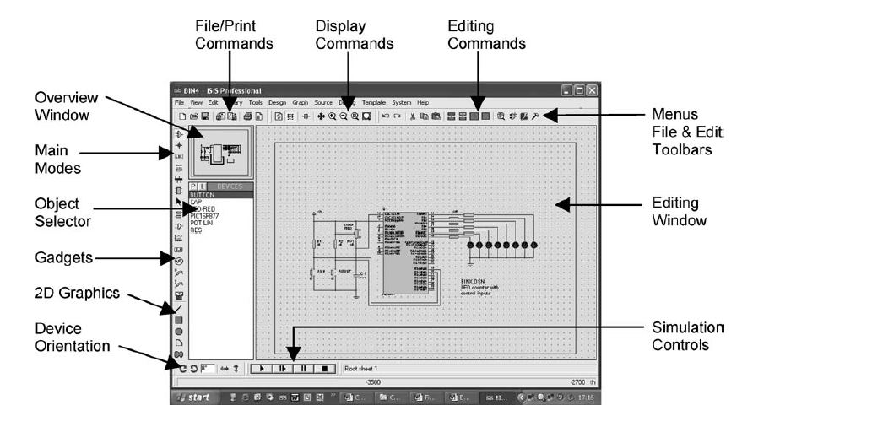
Simulation allows for analysing and designing electronic circuits. The circuit can be drawn and tested on screen, these design tools allows for creating a working system relatively quickly. Proteus© from Labcenter Electronics© which consist of two main parts: ISIS and ARES. ISIS is the schematic capture and interactive simulation software used to create the circuit drawing and to test the circuit prior to building the real hardware. A screenshot of the ISIS schematic capture and interactive simulation environment is shown in Figure 4.2. The main schematic edit window is accompanied by an overview window showing the whole drawing and an object select window, which normally contains a list of components. However, it also shows lists of other available devices for use in the edit window when

Fig.4.2 Screenshot of ISIS

Specific modes are selected. The main editing window includes a sheet outline, which shows the edge of the drawing area within which the components were placed. The component button was selected from the mode toolbar. With this mode selected, components were fetched and placed on the schematic by hitting the P (pick devices) button, and the required category of components was selected. The individual device type was chosen from a list as shown in Figure 4.3. The components were categorised as microprocessors (includes microcontrollers), resistors, capacitors, etc. with variants within each. Subcategories were also selected. Interactive components, such as push buttons grouped in the ACTIVE library were also chosen.

Fig.4.3. Picking of devices

ARES (ARES is a layout package) was used to create a PCB when the circuit has been designed.

Any microcontroller-based simulation will not run without a program attached to the micro-controller chip. When the program was edited and assembled, a hex or machine code file was created. In the MPLAB development system, it was tested with simulated inputs and numerical outputs and was displayed as a Hex or binary numbers. ISIS provides a more user-friendly development environment by providing interactive, on-screen, inputs and outputs, so that the circuit was seen operating in the same way as it will in the real hardware. It also provides debugging features. In this mode, the source code listing was displayed and the programme is stopped, started and single stepped with the execution point shown in the source code window. The problems with the program sequence (logical errors) were resolved easily with the help of the source code debugger. The source code debugging window is shown in Figure 4.4. The execution point in the program listing was highlighted. The buttons at the top of the source code window allowed the program to be stepped, or run between breakpoints. The CPU (special function) registers were also displayed, so that the microcontroller internal changes were tracked. The CPU data memory window showed all the file registers, so that general-purpose register contents were monitored.

4.3. CONSTRUCTION

When building an electronic circuit, it is required to connect the components as outlined in the given circuit diagram. This task can usually be carried out on a Vero board or a printed circuit board (PCB) by soldering the components together. During the development stage of this project electronic circuit, a solderless breadboard was used to assemble the circuit components together to ensure that all components are working as expected. With the expected result obtained, the components were transferred and soldered carefully on the Vero board. The construction began by mounting a +9V battery on a Vero board, out of which +5V is required by the microcontroller and the LCD display. A voltage regulator circuit was used to convert the 9 V battery voltage into 5V; this is independent of the current drawn from the supply. The IC 78L05 a 3-pin device, has one of its pins connected to the positive terminal of the battery in parallel with a 0.33F capacitor. The second pin was connected to the negative terminal of the battery and the third pin provided the +5 V output required and a 0.01F capacitor was connected in parallel with this pin to smoothen any fluctuation in the expected voltage. The microcontroller pins were properly fixed and soldered along the lines of the Vero board in order to obtain the minimum joint. This ensures the reliability of the operation of the microcontroller. Finally the output pins from the microcontroller port were carefully connected to the LCD display (LM016L).

4.4 TESTING

4.4.1 Voltage and Power supply specification
This stage begins with testing the battery supply to ensure that it is providing the required +9V which is to be regulated to produce the required +5V. This is achieved by measuring the battery voltage using a digital multimeter.

4.4.2 PIC Specification
PIC microcontrollers usually operate from a power supply voltage in the range 2 to 6V. However, in this project a +5V supply was used and every output pin is expected to be at +5V the voltages at this pins were measured and found to be as expected.

4.4.3 LCD Display Specification
It was ensured that the +5V supply reaches the LCD display. The display was tested also by writing a program that will print a short string to the screen; it was connected to the microcontroller and viewed to ensure that the programmed strings were displayed as required.

4.4.4 Overall System Test
With the programmed microcontroller mounted on the board and connected properly with the other components. The digital clock/calendar was powered from the +9V battery, all respective nodes were tested to ensure that the required power was as expected. The designed clock/calendar was put on test by pushing the start button that made its begin from the reference value for clock (00:00) and calendar (S 01:01:2000) and was synchronised with a real clock to check for its accuracy. The test results are as shown in table 4.0
Table 4.0 Test results of designed clock
S/N | DESIGNED CLOCK AND CALENDAR |  |  | STOPWATCH
1 | 00:00 | S 01:01:2000 |  | 00:00
2 | 01:00 | S 01:01:2000 |  | 01:00
3 | 02:00 | S 01:01:2000 |  | 02:00
4 | 03:00 | S 01:01:2000 |  | 03:00
5 | 04:00 | S 01:01:2000 |  | 04:00
6 | 05:00 | S 01:01:2000 |  | 05:00
7 | 06:00 | S 01:01:2000 |  | 06:00
8 | 07:00 | S 01:01:2000 |  | 07:00
9 | 08:00 | S 01:01:2000 |  | 08:00
10 | 09:00 | S 01:01:2000 |  | 09:00
11 | 10:00 | S 01:01:2000 |  | 10:00
12 | 11:00 | S 01:01:2000 |  | 11:00
13 | 12:00 | S 01:01:2000 |  | 12:00
14 | 13:00 | S 01:01:2000 |  | 13:00
15 | 14:00 | S 01:01:2000 |  | 14:00
16 | 15:00 | S 01:01:2000 |  | 15:00
17 | 16:00 | S 01:01:2000 |  | 16:00
18 | 17:00 | S 01:01:2000 |  | 17:00
19 | 18:00 | S 01:01:2000 |  | 18:00
20 | 19:00 | S 01:01:2000 |  | 19:00
21 | 20:00 | S 01:01:2000 |  | 20:00
22 | 21:00 | S 01:01:2000 |  | 21:00
23 | 22:00 | S 01:01:2000 |  | 22:00
24 | 23:00 | M 02:01:2000 |  | 23:00

4.4.5 CONCLUSION
There was no noticeable difference between the designed clock and the stopwatch when tested for twenty four hours and the calendar was also changed accordingly.

4.5 OPERATION PRINCIPLE OF THE PROJECT
The calendar/clock designed in this project has a Start button. Pushing the Start button allows power to be supplied to the microcontroller and other components. Before the calendar/clock begins the microcontroller checks the status of the switch S1 (RA0), if it is closed. With switch S1 closed it moves to the Set routine and proceed with operation. If the switch S1 is open it goes into the normal operation mode.
In the normal operation mode, each of the six parameters displayed (Day, Date, Month, Year and Time) on the LCD are updated once every minute. In the Set mode, button B1 increments the Month stepwise from one to twelve (1 to12). After every twelve steps the day is incremented once. Button B2 increments the year also in a stepwise fashion form one to ninety nine (1 to 99). Button B3 increments the hour and button B4 increments the date from one to thirty one (1 to 31)

CHAPTER FIVE
CONCLUSION AND RECOMMENDATION

5.0 CONCLUSION
The major aim of the project which was to implement the 24 hour Clock/Calendar was used with the result been outputted on an LCD display. The digital Clock/Calendar was tested for a period of 24hrs by comparing its operation with a stop-watch. The designed Clock/Calendar was found to be accurate with no noticeable difference. The digital Clock/Calendar was designed using PIC16F84A. The project design includes the hardware and software aspects, the hardware design consist of a power supply unit, hardware starter kit (simulation) for the PIC16F84A, Reset circuits and the LCD display. The software aspect involved writing the assembly program in the text editor which was debugged and assembled using the MPLAB IDE and simulating the project using the Proteus.
5.1 PROBLEM ENCOUNTERED
I had difficulty trying to program the set buttons for setting of the clock. Another problem I encountered was during providing the proper timing of the microcontroller using the oscillator.
5.2 RECOMMENDATION
The digital Clock/Calendar implemented in this project does not fully exploit the uses of the PIC microcontroller. For further work the following features should be incorporated:

An on the hour alarm or buzzer
ii. The Set button should be interrupt driven (implemented by software)
iii. A higher version of the PIC should be used so as to use different pins for setting the parameter.
- A timer or stop-watch feature that could be used for timing tests or exams, bearing in mind that the main clock should continue running normally at the background.

References
- MARTIN BARTES “Interfacing PIC Microcontrollers Embedded Design by Interactive Simulation” Copyright © 2006, Martin Bates. Published by Elsevier 2006
- http://www.mikroe.com/ PIC16F84A Tutorrial.pdf/28/11/2009
- http://www.Microchip.com/ PIC 16F84A Data Sheet.pdf/28/11/2009
- DOGAN IBRAHIM “PIC Basic 30 Projects” Copyright © 2006,Linacre House, Jordan Hill, Oxford OX2 8DP, UK.
- B.L. THERAJA and A.K. THERAJA “ A Textbook of Electrical Technology” Copyright ©2006, S.Chand and Company Ltd.
- MICHEAL A.COVINGTON “ PIC Assembly Language for Complete Beginner” Copyright c 1999, 2004 Michael A. Covington Gernsback Publications, Inc
- RAMAT A. YUSUF “Design and Construction of Digital Clock using PIC16F84A” Copyright © 2006

