
COMPARATIVE EVALUATION OF HARMONY SEARCH ALGORITHM AND TABU SEARCH ALGORITHM ON SHELF SPACE ALLOCATION PROBLEM (A CASE STUDY OF SUPREME SUPERMARKET FATE ROAD, ILORIN)

BY
AMOS PETER
HND /23/COM/FT/0007

BEING A PROJECT SUBMITTED TO THE
DEPARTMENT OF COMPUTER SCIENCE
INSTITUTE OF INFORMATION, COMMUNICATION AND TECHNOLOGY
KWARA STATE POLYTECHNIC ILORIN, KWARA STATE

IN PARTIAL FULFILLMENT OF THE REQUIREMENTS FOR THE AWARD OF HIGHER NATIONAL DIPLOMA (HND) IN COMPUTER SCIENCE
SUPERVISOR: DR. AGBOOLA O.M.

JULY, 2025

CERTIFICATION
This is to certify that this research was conducted by AMOS PETER with the matric number HND/23/COM/FT/0007 and had been read and approved as meeting the requirements for the award of Higher National Diploma (HND) in the Department of Computer Science, Institute of Information Communication Technology (IICT). Kwara State Polytechnic llorin

_________________________________ ________________________________
DR. AGBOOLA, O. M. Date
(Project supervisor)

_________________________________ ________________________________
MR. OYEDEPO, F. S Date
(Head of Department)

_________________________________ ________________________________
EXTERNAL Date

DEDICATION
This research project is dedicated to the Almighty God that preserved me throughout my programme at the Kwara State Polytechnic, Ilorin, for his mercy, favor and unending grace that have always been with me and to my beloved parents who have stood by my side all the time.

ACKNOWLEDGEMENT
Firstly, I acknowledge the Almighty God, who has always been gracious in strengthening me and giving me the inspiration to keep me working and able to complete this research. This report cannot be completed and will be impossible without a thorough supervision and proper guidance. In that regard, I sincerely acknowledge the efforts of my supervisor and my mentor, DR. AGBOOLA, O. M, who, despite his tight schedule as the Director of the IICT and other activities, found time to make sure this research is carried out properly and well documented, and ensure that it makes a brilliant contribution to my academic knowledge.
It is a great pleasure to express my special thanks to my parents, Mr. & Late Mrs. Amos for giving me their spiritual, moral and financial supports. May almighty God grant them long life and prosperity, and to my family at large.
My appreciation also goes to all my lecturers in the great department of Computer Science, for their Contribution towards the success of my programme.
To my project partner and a very close friend Balogun Ayomide Ayoyinka thanks for your contribution and your understanding during the course of this research.
It is also with love and tender heart to remember my colleague at KFC the Managers and the Team members, I pray we will not labor in vain; I thank all my friends and course mates especially Fayomi Olubunmi and Sheu Tijani and those who have support my academic right from the beginning and I appreciate your cooperation towards my success in the polytechnic, may Almighty God reward you abundantly.

TABLE OF CONTENT
TITLE PAGE
DEDICATION
CERTIFICATION
ACKNOWLEDGEMENTS
TABLE OF CONTENTS
ABSTRACT

CHAPTER 1-INTRODUCTION
1.1 Introduction
1.2 Statement of the Problem
1.3 Aim and Objectives
1.4 Significance of the Study
1.5 Scope of the Study
1.6 Organization of report
1.7 Definition of Terms
CHAPTER 2- LITERATURE REVIEW
2.1 Literature Review
CHAPTER 3- RESEARCH METHODOLOGY
3.1 Research Methodology
3.1.1 Harmony Search Algorithm
3.1.2 Tabu Search Algorithm
3.2 Analysis and Problems of the Existing Problem
3.3 Analysis of the Proposed System
CHAPTER 4- IMPLEMENTATION, RESULT AND DISCUSSION
4.1 Introduction
4.2 System Implementation
4.3 System Requirement
4.3.1 Hardware requirement
4.3.2 Software requirement
4.3.3 Choice of Programming Language
4.4 Program Documentation
4.5 Interface Design
4.6 Result and Discussion
CHAPTER 5- SUMMARY, CONCLUSION AND RECOMMMENDATIONS
5.1 Summary
5.2 Conclusion
5.3 Recommendations

References

ABSTRACT
Shelf space allocation remains a critical challenge in the retail industry due to limited space and increasing product variety. The effectiveness of product placement directly impacts sales performance, customer satisfaction, and inventory turnover. This research explores the application of two metaheuristic optimization algorithms Harmony Search and Tabu Search to address the shelf space allocation problem in a retail setting. The proposed shelf space allocation system aim at implementing and evaluating harmony search algorithm and tabu search algorithm with the objective to adapt the shelf space allocation problem to Harmony search and Tabu search algorithm, implement the adapted algorithms and compare the result on the performance of the two algorithms. The study utilized real-world data obtained from a supermarket, capturing product dimensions, weights, and demand percentages. The shelf layout was modeled with 7 shelves and 7 columns per shelf, accommodating 84 different products. The adapted algorithms were implemented using Python programming language, with MySQL as the backend database. The performance of each algorithm was evaluated based on their execution time, and constraint satisfaction, particularly minimizing penalty points associated with soft constraint violations. Results revealed that while both algorithms were capable of producing feasible shelf allocations, the Harmony Search algorithm consistently outperformed Tabu Search in terms of lower penalty points, thereby offering better adherence to soft constraints such as customer demand placement strategies. Although Tabu Search exhibited slightly faster execution in some iterations, it lagged in solution quality. The findings demonstrate the practical relevance of metaheuristic techniques in optimizing complex retail operations. The study concludes that Harmony Search is more suitable for scenarios where constraint satisfaction is prioritized, and that integrating these algorithms into retail management systems can significantly improve decision-making, reduce manual errors, and enhance overall operational efficiency.

Keywords: Allocation, Metaheuristic Algorithms, Harmony Search, Tabu Search, Heuristic Optimization.

CHAPTER ONE
- INTRODUCTION
Shelf Space allocation is a major challenge in retail environment and a valuable scarce asset for retailer. This is an optimization problem that needed to be addressed in order to maximize profit, manage available resources, time management and to create a positive and seamless customer experience.
This is a metaheauristic approach for solving the allocation of items on shelves with consideration of both soft and hard constraints which includes product weight, product demand, product dimension, shelf capacity and availability among others. This approach can be directed towards warehouses, supermarkets, storages and allocation services on the market. Dina Hamad, Alghurair, Hedaya Ghanim Alshammer (2015).
Shelf space allocation is a critical task in the retail environment aimed at placing or arranging products on shelves and with the growing competition in retail operation and supermarkets, optimizing shelf space to enhance customer satisfaction and increase in sales is essential. Traditional shelf allocation approaches often fall short when dealing with large-scale data and constraints, making automated solutions highly desirable.
Various researchers have conducted a research on this areas of shelf space allocation with different approach and methods such as Large Neighborhood Search (LNS), Genetic Algorithm, Tabu search algorithm to mention but few, mostly with the aim to maximize profit and manage shelf space among different products or items by looking for the best possible solution of product placement guided with different constraint based on the number of product to be allocated and shelf layout dimensions.
This research looks for an advanced solution for shelf space allocation by evaluating and comparing two metaheuristics algorithm to see which one is efficient and more effective in solving shelf space allocation problem in terms of solution quality, memory size and computational time.
The two metaheuristic algorithms proposed are Harmony Search Algorithm and Tabu Search Algorithm.

  - STATEMENT OF THE PROBLEM
This paper describes and solve the traditional way of allocating shelves in retail operation, allocating products to shelves in a traditional way can be a major challenge as it is time consuming, prone to error and may not be able to work with constraint.
The goal is to evaluate and compare two metaheuristic algorithms to determine the one with the best quality in terms of solution quality, time and memory size, to improve the traditional way of product placement and shelf arrangement within a reasonable amount of time in order to maximize profit and effective utilization of shelf space, to create an adaptable algorithm bridging the gap of large neighborhood search algorithm which is problem dependent and a system without real-world retail constraints, to also address the scalability of other method or approach such as hybrid genetic algorithm.
Need for more realistic demand estimation, this research fill the gap of existing demand estimate approach by getting realistic data set on product demand and shelf space from a supermarket.
  - AIM AND OBJECTIVES
This research aim at solving the shelf space allocation problem using harmony search algorithm and tabu search algorithm and python programming language for the implementation.
Objectives
- Adaptation of harmony search algorithm and tabu search algorithm to shelf space allocation problem.
- Implementation of harmony search algorithm and tabu search algorithm using python programming language for frontend and backend, and MySQL for the database
- Comparative evaluation of the harmony search algorithm and tabu search algorithm in shelf space allocation.
  - SIGNIFICANCE OF THE STUDY
This study will improve shelf space management by optimizing shelf layouts leading to increased sales, reduced stock outs and better customer satisfaction. It will enhance decision making about product placement, pricing and promotion. Minimize operational costs by using the shelf space efficiently and inventory management. Create potential for developing hybrid or improve version of harmony search and tabu search algorithm in the context of shelf space allocation and will contribute to the field of metaheuristic optimization
  - SCOPE OF THE STUDY
The scope of this study center around a retail supermarket where different products and shelve are available. The finding can be applied in other retail store where different products and shelves are available. But data set used for this particular research is obtained from a retail supermarket.
Shelf space allocation is a useful development in retail operation or stores where there is shelves and products which is to be assigned a space according to some certain conditions (constraint) in order so satisfy customer’s shopping experience and make a positive impact on the sales.
  - THE ORGANIZATION OF THE STUDY
This study is organized into five Chapters
Chapter one: Introduction, Statement of the problem, Aims and Objectives, Significance of the study, Scope of the study, Organization of the study, Definition of terms. Chapter Two: Literature review. Chapter Three: Research Methodology, Analysis of the existing system, , adaptation of the proposed algorithm, Harmony search algorithm, Tabu search algorithm, Comparative evaluation of harmony search algorithm and Tabu search algorithm.
Chapter Four: Implementation, Result and Discussion
Chapter Five: Summary Conclusion and Recommendation
  - DEFINATION OF TERMS
- Heuristic: A mental shortcut or approximate algorithm uses to solve a problem decision or find a solution more efficiently and effectively, often by ignoring some of the details or focusing on the most important aspects.
- Metaheuristic: A high level algorithm framework that is uses heuristics to search for good solutions to complex optimization problems, often by iteratively improving an initial solution.
- Objective function: A mathematical function that is used to evaluate the quality of a solution to an optimization problem.
- Constraint: A limitation, restriction or condition that must be satisfied or adhere to when solving a problem or making a decision.
- Soft constraint: A necessary rules for actions to be taken but if avoided it doesn’t affect the solution so much
- Hard constraint: These are rules that must be satisfied i.e. it cannot be jeopardized
- Stock out: A situation in which a product is not available for a sale due to inventory depletion or stock out.
- Facing: Refers to the number of items a particular product that are placed side by side on a shelf facing customer
- Nesting: Refers to the practice of placing smaller items or products inside or beside larger items or products on a shelf, to maximize shelf space utilization.
- Capping: Refers to the practice of limiting the number of facing (items) of a particular product on a shelf, to prevent overstocking and maintain balanced product mix.

CHAPTER TWO
- LITERATURE REVIEW
Amol C. Adamuthe, Tushar R. Nitave (2018) Adaptive Harmony Search for optimizing constrained Resource allocation problem, In this study, the harmony search algorithm (HSA), a metaheuristic method influenced by process of musical improvisation to address resource allocation issues, particularly the multi-objective virtual machine placement problem and the one-dimensional bin packing problem.
The aim of this research work was to explore the effectiveness of the adaptive harmony search algorithm in solving resource allocation problems, which is to optimize one-dimensional bin packing problems and the multi-objective virtual machine placement problem. With the objective to propose an adaptive harmony search algorithm, introduce an initialization strategy for a partially feasible solution, optimize the one-dimensional bin packing problem, optimize the multi-objective virtual machine placement problem, and evaluate the proposed algorithm’s performance.
The proposed algorithm introduces two modifications to the original harmony search: the adaptive PAR and the partially feasible initialization strategy with real coded solution representation. Experiments were performed to study one-dimensional bin packing problems and multi-objective virtual machine placement problems. The algorithm's performance is tested using 55 instances of the BPP dataset.
The research investigates the effectiveness of the adaptive harmony search algorithm which incorporates two major enhancements to the traditional harmony search algorithm, adaptive pitch adjustment rate (PAR) and partially feasible initialization. These modifications improve the algorithm’s performance in tackling complex optimization problems like the bin packing problem and multi-objective virtual machine placement. The adaptive harmony search algorithm significantly outperforms traditional heuristics e.g. best-fit algorithm in terms of optimality and efficiency for virtual machine placement Adapt harmony search demonstrates a strong ability to maximize profit and minimize wastage, but compromises on load balancing. It performed better than the genetic algorithm in wastage reduction but fell short compared to NSGA-II in exploration and generating a balanced Pareto front. The gaps identified in this research include scalability limitations which means the algorithm struggles with large datasets, Trade-offs in multi-objective optimization, it has weaker exploration capability, it does not address strategies to enhance adaptive harmony search performance on larger instances. This leads to the recommendation to enhance scalability, improve load balancing, hybridize with another algorithm, refine adaptive pitch adjustment rate, and improve multi-objective optimization. This research concluded that the adaptive harmony search algorithm was presented for constrained resource allocation problems which significantly improves upon traditional harmony by incorporating an adaptive pitch adjustment rate and partially feasible initialization which makes it more effective for solving bin packing problems and multi-objective virtual machine placement. It performs significantly well on smaller datasets but struggles with scalability. Future work is encouraged to enhance scalability, improve load balancing, and refine exploration capabilities to handle large and more complex problems. Hybrid approaches and multi-objective optimization improvements will make adaptive harmony search more versatile in real-world applications.
Teresa Bianchi-Aguiar, ElsaSilva, Luis Guimaraes, Maria Antonia Carravilla, Jose F. Oliveira (2018) Allocating products on shelves under merchandising rules: Multi-level product families with display directions. Allocating limited shelf space in a store among the various products that need to be displayed is known as the shelf space allocation problem.
This research aims to develop a novel and realistic mathematical model for the shelf space allocation problem that can help retailers optimize the arrangement of products on store shelves, to maximize profit by optimizing the allocation of shelf space products, while considering realistic constraints such as product families, rectangular shapes and display directions.
The SSAP is modeled using mixed-integer programming, the product sequencing in the MIP formulation is modeled using single commodity flow constraints, the SSAP is solved using mathematical-based heuristics, and a computational experiment to assess the suggested method's effectiveness.
The findings include a novel mathematical model and solution approach for the shelf space allocation problem that considers realistic constraints such as product families, rectangular shapes, and display directions. A mathematical mat-heuristic approach that solves the problem efficiently and effectively, the application and performance of the proposed model and solution approach using real-world benchmark instance.
The research gap is the lack of consideration of realistic constraints such as such as product families, rectangular shapes and display directions in existing shelf space allocation problem models.
The researcher recommended that future research should focus on extending the proposed formulation and solution approach to consider additional realistic constraints, retailers should consider implementing the proposed model and solution approach in their shelf space allocation process, and it should be integrated with retail operations such as inventory management, supply chain management, and category management, Retailer should collect and analyze data on customer behavior.
The shelf space allocation problem with location decisions and a new practical constraint placed on product families is presented in the paper using a novel and realistic mixed integer programming formulation. It is effective and efficient in solving larger-scale instances with practical applicability. It can help the retailer improve their profitability by optimizing shelf space allocation with a flexible approach and adaptability.
Dina Hamad Alghurair, Hedaya Ghanim Alshammar (2015) Shelf space allocation using LNS(Large Neighborhood Search) Solver, this is the problem of solving the allocation of items on shelves, whether this problem is directed towards warehouses, Supermarkets, or any storage and allocation service on the market.
In order to solve the shelf space allocation problem, this research will develop a large neighborhood search algorithm, formulate a mathematical model for the problem, evaluate the performance of the suggested algorithm, and give a graphic depiction of the outcome.
In order to demonstrate how the objective value has changed and how improvements have been made while still fitting all of the objectives within the minimum and maximum limits, it will also display planograms in motion.
The methodology used in this research work includes mathematical modeling, Algorithm development (Large Neighborhood search algorithm) Computational experimentation which can be categorized as the implementation of the algorithm, Generation of planograms, and Analysis of the results using large neighborhood search solver and planogram generation tool.
The findings of the researcher include an effective solution for the shelf space allocation problem which is effective and providing optimal or near-optimal solutions, improved profit maximization, efficient use of shelf space, and scalability i.e. the algorithm performs well on large data and the planograms generated provide clear virtual representation of the shelf space allocation. The gap in this research work is that all larger neighborhood solver methods are problem-dependent; a number of approaches have been proposed by different researchers to generalize the large neighborhood solver and make it problem-independent, which include propagation and explanation-based methods.
This research presented a study for the shelf space allocation problem it suggests a simple model to solve the problem in general and justify its efficiency using the largest neighborhood search-based method. The implementation presented a detailed GUI to watch how shelves are being sorted out. It was able to iterate through hundreds of different solutions and improve profit. The allocation utilizes the maximum space allowed and places products where they yield the best profit.
The upper-bound search strategy finds the best solution faster than the lower-bound strategy, and propagation is based on solutions. This research gives some direction that can be considered in the future such as investigation of other algorithm performance and comparison with the large neighborhood search algorithm, consideration of dynamic factors such as changing customer demand or inventory level, apply the shelf space allocation problem to other industries, Develop a more advance planograms generation tool such as 3D visualization or real-time updates.
Kateryna Czernia Chowska (2021) A genetic algorithm for the retail shelf space allocation problem with virtual segments, shelf space allocation is a problem encountered in allocating products on shelves in retail establishments to increase revenue, boost customer satisfaction, and improve inventory control.
The primary aim of the publication is to propose a practical shelf space allocation model that reflects real-world visual merchandising rules used by retailers. It seeks to develop an efficient algorithm to solve the shelf space allocation problem and provide guidelines for solving the complex problem in a retail context to model the shelf space allocation problem with multiple constraints, incorporating the product facing, capping, and nesting., implementation of the algorithm, real-world application of the model, evaluation, and comparison with CPLEX solver.
The methodology used includes problem modeling, development of the genetic algorithm, Dynamic programming for pallet shelf, and Computational experiments performance comparison with CPLEX.
In a real-world retail setting, the researcher demonstrates that genetic algorithms can offer effective, high-quality solutions to the shelf space allocation problem. Additionally, it implies that a genetic algorithm is a feasible strategy for merchants who want to optimize their shelf space profits while taking into account a number of limitations. It also achieves equilibrium between the quality of the solution and computational efficiency. The horizontal division of shelves into segments and the assignment of these segments to various shelf levels, which results in different product categorization variations and the creation of locations for products the size of which varies on different shelves are regrettably underemphasized in the SSAP literature.
This research takes this gap into account and provides horizontal and vertical levels of shelf location. For convenience, they will be referred to as virtual segments because there is no physical border between them, and their sizes are flexible. The gap also includes a lack of product sequence optimization, limited experimentation with product categories, real-world retail constraints not fully explored, lack of detailed consideration for customer behavior, focus on a genetic algorithm without comparing other metaheuristics, limited analysis of shelf-level variation, real-time adaptability, and scalability.
It is recommended that retailers adopt the proposed genetic algorithm-based approach for shelf space allocation as it offers an efficient solution with a high profit ratio in a reasonable time. Retailers should consider expanding the model by incorporating linear product positioning to further enhance product placement strategies.
This research presents a practical and effective shelf space allocation model utilizing a genetic algorithm to optimize shelf space allocation in retail environments. While this model provides promising results, further refinement in product sequencing and testing in the diverse retail scenario will enhance its applicability and performance, contributing to more profitable merchandising strategies for retailers.

Kateryna Czernia Chowska and Marcin Hernes (2020) A genetic algorithm for shelf space allocation problem with vertical position effects. Getting a competitive edge in the retail industry requires carefully allocating shelf space, one of the most scarce resources in a retail establishment.
This article aims to develop a retail shelf space allocation model that is relevant to practice and propose genetic algorithms that can be applied by category managers to solve it. To develop a model that includes vertical and horizontal category grouping rules that make planograms more attractive to customers, introduce capping and nesting, arrangement of cheaper products on the bottom shelf and expensive and less selling products at the customer's eye level on the top shelves, present constraint according to the following type: shelf constraint, product constraint, multi-shelf constraint, and constraints.
Implementation of genetic algorithm and performance experiments on relevant practical problem size.
The methodology used in this article includes the formation of the mathematical model, algorithm development (Genetic algorithm), Estimation of the quality of the proposed solution using CPLEX solver, computational experimentation which can include implementation of the algorithm, creation of the planograms, and result analysis.
The finding of the researchers shows that considering vertical categories and horizontal price subcategories, as well as product parameters has a significant impact on the gained profit and the experiment also shows that the proposed approach allows a satisfactory solution to be obtained in an acceptable processing time.
The gap in this article is that the shelf space allocation problem incorporates only the facing and this gap is able to be filled by introducing capping and nesting.
In conclusion, this paper contributes to the discussion on efficient shelf space allocation problem modeling to reflect visual merchandising rules used by retailers in stores. The proposed shelf space allocation problem model combines a range of the most useful constraints. The performance of the proposed genetic algorithm was examined by analyzing 25 test cases and the results show that considering vertical and horizontal price subcategories as well as product parameters has a significant in fact on the gained profit, it also shows that the approach creates a satisfactory solution that is obtained in an acceptable processing time.
For more complicated space allocation problems and product sets with widely varying parameters, the researcher suggested using the algorithm.
A. Hande Erol Binguler, Serol Bulkan, Mustafa Agaolu (2015) A Heuristic approach for a shelf space allocation problem. The shelf space allocation problem is a critical issue in retail operations, where the goal is to optimally assign limited shelf space to a variety of products to maximize profitability.
This research aims to develop a practical and effective approach to solving the shelf space allocation problem in retail environments, where limited shelf space needs to be allocated to various products to formulate a model for the shelf space allocation problem that accounts for various constraints like shelf space availability, product dimensions, and demand elasticity factors. To introduce a modified integer programming models that improve the applicability of shelf space allocation problem solutions in real-world retail operations, to propose a simulated annealing algorithm as a solution method for shelf space allocation problem which aims to effectively allocate products to the most suitable shelf spaces while maximizing profit under given constraint., to compare and demonstrate the effectiveness of the proposed heuristic approach in achieving better shelf space allocation decisions for increased profitability in retail settings.
The methodology used includes a modified integer programming model, simulated annealing algorithm, objective function, evaluation and performance, and practical applicability.
The proposed simulated annealing algorithm performs much better than the heuristic algorithm and its average performance is the same as the genetic algorithm of Bisel et al. The suggested simulated annealing algorithm performs better than the genetic algorithm for the optimal (maximum) solution. Thus, the findings indicate that the shelf space allocation problem is better solved by simulated annealing.
The gaps that this paper covers include limited consideration of space elasticity and demand factors; complex operational constraints, computational complexity applicability, and lack of an integrated, scalable solution.
This research concluded by showing that simulated annealing is an effective and efficient heuristic for solving the shelf space allocation problem. The results demonstrate that simulated annealing not only performs better than simpler heuristics but also outperforms more complex approaches in terms of solution quality and computational time. The paper recommends furthering testing with more problem instances exploring other heuristic methods, incorporating additional real-world constraints, and integrating with the retail decision support system.
Jakkyrit Kaewyotha and Wararat Songpan (2021) Multi-objective design of profit volumes and closeness rating using MBHS optimizing based on the prefix span mining approach (PSMA) for product layout in supermarkets.
This research focuses on helping supermarkets design their product layouts better to increase sales and improve the shopping experience the aim of this publication is to improve supermarket product layout by analyzing customer purchase data and optimizing the arrangement of products on shelves.
The objective is to apply the prefix span algorithm to mine sequential purchasing patterns from customer shopping data, and a new multi-objective design.
Used the mutation-based harmony search (MBHS) optimization algorithm to take into account the objective functions of closeness rating and product volumes. To develop a combination of prefix span and multi-objective harmony search. To compare performance and enhance supermarket layout.
Sequential pattern mining (prefixspan algorithm), prefixspan with metaheuristic optimization (MBHS), multi-objective optimization, performance evaluation, implementation, and experimentation are some of the techniques employed.
The researcher found out that the method led to increased profitability, higher total closeness ratings, and more efficient execution times compared with those of the original product layout. Additionally, it was discovered that the suggested approach was more successful than similar ones.
It is also suitable for multi-objective pattern optimization in supermarkets regarding profit, closeness ratio, and consumer time efficiency.
The gap addressed by this publication is the existing shelf space allocation models do not fully account for the complex interactions between different variables e.g. product characteristics, customer preferences, and retailing factors, the neglect of merchandising rules based on product price categories in existing mathematical shelf space allocation problem approaches.
The lack of a comprehensive model that considers both the optimization of shelf space allocation and the incorporation of visual merchandising rules.
The publication recommends using the proposed multi-objective base harmony search technique to optimize shelf space layouts and improve profitability in supermarkets, it also suggests that retailers should incorporate visual merchandising rules, and use sequential pattern mining to analyze customer purchasing behavior.,
The publication suggests that retailers should optimize shelf space allocation to maximize profitability and customer satisfaction and consideration of multiple objectives.
In conclusion, this research proposed the use of a prefix span mining approach in conjunction with a multi-objective base harmony search to identify sequential patterns in customer purchase data the experimental results revealed that the proposed method can rearrange product layout by analyzing customer’s shopping list leading to profitability, higher total closeness rating and more efficient execution times compared with that original layout.
Jiefeng Xu, Evren Gul, Alvin Lim (2020), Maximizing store revenue using tabu search for floor space optimization. This publication focuses on the problem of floor space optimization in retail revenue management. The goal is to maximize store revenue by optimally allocating floor space to different product categories.
This research aims to design and implement a solution approach based on tabu search to solve the optimization problem for each store to determine the optimal assignment of planograms to maximize total revenue subject to certain business constraints. To develop a mathematical model for the floor space optimization problem, to design a tabu search metaheuristic algorithm that exploits the specific neighborhood structure of the floor space optimization problem, to evaluate the performance of the proposed algorithm using computational experiments, to provide a solution approach that optimizes floor space allocation in retail stores to maximize revenue.
The methodology used in this research is a combination of mathematical modeling metaheuristic (tabu search) algorithm design and computational experimentation.
The findings of this research are that the proposed tabu search-based floor space optimization algorithm is highly effective in solving the floor space optimization problem, obtaining optimal or near-optimal solution in a reasonable amount of time, the algorithm also outperforms commercial solver Gurobi in terms of computational time.
The use of multiple neighborhoods in TSFSO allows the algorithm to explore different parts of the solution space; the algorithm can escape local optima solutions with the help of tabu memory. It is computationally efficient, obtaining high-quality solutions in a reasonable amount of time.
The gaps in this publication include inefficient use of floor space allocation, lack of effective solution methods, limited consideration of the space elasticity, and need for a practical and efficient solution approach.
This research recommends that retailers should implement the tabu search floor space optimization algorithm to optimize their floor space and maximize revenue, conduct regular floor space optimization in order to adapt to changing market conditions, consideration of space elasticity, and investigate the application of the tabu search floor space optimization in other industries.
In conclusion, this publication proposed a novel tabu search-based optimization algorithm to solve the floor space optimization problem in retail revenue management. It is shown to be highly effective and efficient in solving large-scale instances of the problem. It outperforms the commercial solver Gurobi. The algorithm’s performance was further improved by incorporating multiple neighborhoods, a candidate list strategy, and a tabu memory mechanism. The result of the publication demonstrates that the tabu search base floor space optimization algorithm can be used in practice to optimize floor space and maximize revenue for retailers.
Kazuki Ishichi, Shunichi Ohmori, Masao Ueda, Kazuho Yoshimoto (2019), Shelf space allocation model with demand learning. The retail industry faces challenges in optimizing shelf space allocation to maximize profitability. Category managers must make strategic decisions on assortment planning and shelf space planning.
This publication aims to propose a method for optimizing shelf-space allocation in retail stores taking into account non-stationary demand with the objective to develop a method for deciding the weekly display space for products with non-stationary demand. To maximize profit by allocating shelf space as efficiently as possible.
To address the gap in the existing research by considering non-stationary demands in shelf space allocation decisions.
The methodology used includes model formulation, three proposed methods for estimating parameters (linear regression, weighted moving average, different sequence) simulation setup, and performance evaluation.
The researchers found out that the conventional linear regression analysis is not suitable and the weighted moving average improved over linear regression while the difference sequence performed the best in all aspects. This research found that dynamic estimation of the parameters was much more effective than static method.
The gaps in this publication include the need for further exploration of different forecasting models, better integration with broader retail operations, handling model errors in the optimization process, and accounting for external factors like customer behavior and economic shifts. Addressing these issues could lead to more practical, robust, and real-world applicable solutions for dynamic shelf space optimization.
The researcher recommends considering other forecasting models, particularly those based on the shelf space approach, integration with assortment planning and inventory replenishment, and incorporating model errors in optimization. Exploring robust error modeling, considering external factors affecting demand, improve computational efficiency for real-time application.
In conclusion, the researchers present a novel approach to optimizing shelf space allocation in retail environments by incorporating dynamic demand learning. Three different methods for estimating the key parameters -∞ and β- were proposed and tested. The results showed that method 3, which uses s difference sequence to account for demand fluctuations, outperforms the other methods in terms of both sales performance and the accuracy of demand estimation.
This method proved particularly effective in responding to fluctuating demand, thus optimizing the display space allocation and improving sales outcomes.
Gwang Kim, IIkyeong Moon (2021), integrated planning for product selection, shelf space allocation, and replenishment decision with elasticity and positioning effects. This paper presents a mathematical model and solution approaches for shelf space allocation in retail operations. The publication aims to develop a mathematical model and solution approach for the shelf space allocation problem in retail operations. The objectives are to develop a mixed integer non-linear programming model that captures the key factors affecting shelf space allocation decisions, to design and develop an efficient algorithm (Hybrid Tabu search and Hybrid genetic algorithm), to evaluate the performance of the proposed algorithms using computational experiments to compare the results obtained by the proposed algorithm with those obtained by the commercial.
The methodology used in this publication includes mathematical modeling, Algorithm development (Hybrid Tabu search algorithm and hybrid genetic algorithm), computational experiment, and comparison with commercial software.
The findings of the publication are both algorithms were able to find high-quality solutions that were close to the optimal solution, the algorithm can solve the problem efficiently, the proposed algorithms outperform LINGO a commercial optimization software, Algorithm 1 outperformed Algorithm 2 in terms of solution quality and computation time for large data sets., Algorithm 1 was able to solve larger instances faster than Algorithm 2, The algorithms were able to handle large data sets with up to 100 products 5 shelves and 3 rows., Displaying too many brands or products can negatively impact sales due to cross-space elasticity effects., Consumer eye-level position is crucial for product display.
The gap of this publication includes limited consideration of uncertainty, no consideration of online stores/retailing, limited scalability, no consideration of dynamic pricing, need for more realistic demand estimation.
The publication recommended that future research should consider incorporating uncertainty in demand and supply, incorporating online retailing, developing more scalable algorithms, and consideration of dynamic pricing. In conclusion, this publication presents a mathematical model and two algorithms for solving the shelf space allocation problem in retail operations. The algorithms are shown to be effective and efficient in solving the problem, and the study provides insights into the importance of considering factors such as product demand, shelf capacity, and replenishment decisions in shelf space allocation decisions.

CHAPTER THREE
- RESEARCH METHODOLOGY
  - Harmony search Algorithm
  - Tabu search Algorithm
3.1.1 Harmony search algorithm.
The Harmony Search Algorithm (HSA) is a population based metaheuristic optimization algorithm which is inspired by the process of musicians improvising harmonies. It was proposed by Zong Woo Geem et al (2001), It is an algorithm that searches near global solutions by using 3 major step to search for it solution which are.
- Harmony memory consideration rate (HMCR) this is use to consider whether to use from the harmony memory. i.e. playing known piece of music
- Pitch adjustment rate (PAR) this control the adjusting of a solution a slight adjustment of the pitch i.e. play something similar to the famous piece of music.
- Random selection this generate randomly i.e. random composition of new note.
3.1.2 Tabu search algorithm.
Tabu search algorithm is a metaheuristic optimization algorithm that escape getting stuck in local optima by using memory to store recently visited solutions. Its focus on promising regions of solution space, exploring different regions of the solution space to avoid getting stuck in a local optimum and uses the tabu list as a short-term memory, preventing the algorithm from revisiting solutions that have already been explored. It was proposed by Fred Glover in 1986 and formalized in 1989.

  - Analysis and Problem of Existing Problem
Existing system for shelf space allocation in Traditional ways of allocating shelves and product which is manual and is time-consuming and tedious process that often-required significant effort and expertise. Additionally, manual allocation is prone to errors, inconsistencies and redundancies, which could lead to allocating conflict of product and inappropriate use of available shelf space. This problem of shelf space allocation is improved by introducing of a set of constraints, which is typically divided into two types: hard and soft constraints.
Hard constraints are those that should be met or satisfied at all times for example cannot be violated, while violations of the soft constraints should be avoided if possible, else there’s penalty for violation. The following shows the hard and soft constraints as stated by the supreme supermarket, Kwara state, Ilorin and gathered online regarding shelf space allocation.
Hard Constraints
H1: All Columns in a shelf must be assigned a product.
H2: A product must not be assigned to two columns.
H3: The weight of product in a column of a shelf must not be more than 25000g and must not be less than 10000g
Soft Constraints
S1: Arrange average demand product on Shelf 1 and 2 in column 1, and 2
S2: Arrange high demand product on Shelf 3, 4 and 5 in column 3, 4 and 5.
S3: Arrange low demand product on shelf 6 and 7 in column 6 and 7.
S4: Arrange product of the same type but difference sizes on the same column.
Penalty for Soft Constraints
Soft constraints should have a smaller penalty to encourage optimal solutions without completely discarding less ideal ones.
1. If an average demand product is placed outside column and shelf 1 and 2, add a penalty point of +1 per misplaced product.
2. If a high-demand product is placed outside column and shelf 3, 4, or 5, add a penalty point of +1 per misplaced product.
3. If an average demand product is placed outside column and shelf 6 and 7, add a penalty point of +1 per misplaced product.
4. If products of the same type but different sizes are placed in separate columns instead of together, add a penalty point of +1 per violation.
For example, if a shelf has two misplaced high- demand products and one misplaced average-demand product, the total penalty would be (1+1) + 1 = 3, the penalty point is = 3
Final Calculation of fitness Values
The final fitness score is computed by calculating total penalty point and find the allocation with the minimum total penalty point and the number of penalty violated. For instance, if a shelf violated three soft constraints (1+1+1) the penalty will be 3 constraints violated with penalty point of 3 point.
This method ensures that solutions remain competitive while still discouraging violations, soft constraint should not be violated but if, there should be a penalty for it. Soft constraint penalties allow some flexibility but still push for better arrangements.
3.3 Analysis of Proposed System
This section entails step by step solutions of the existing problem of shelf scheduling by using the proposed algorithms; the experiment will be carried out by using dataset of the Shelves and beverages products obtain at supreme supermarket along Fate road Ilorin, Kwara State.
STEPS OF HARMONY SEARCH ALGORITHM
STEP 1 Initialize the problem and HSA parameters
1. Input data instance of the allocation problem
2. set the HSA parameters (HMCR, PAR, NI, and HMS).
STEP 2 Initialize the harmony memory
1 Generate Solution of the harmony memory
2. Identify the worst solution in HM
STEP 3 Improvise a new harmony
1. HMCR (Memory Consideration) with probability HMCR, solution is selected from existing harmonies. Ensures good patterns are reused.
2. PAR (Pitch Adjustment) The probability of adjusting the selected solution
3. Random Selection If the value is not chosen from memory (based on HMCR), a completely random solution is generate
STEP 4 Update the harmony memory
1. Is the current solution better than the worst existing one? If yes
2. Include current solution to the HM.
3. Exclude worst solution from HM.
STEP 5 Check the stop criterion
1. Is the number of improvisation complete? If no
2. Repeat STEP3 and STEP4
ADAPTATION OF HARMONY SEARCH ALGORITHM TO SHELF SCHEDULING PROBLEM
THE STEPS IS AS FOLLOWS:
STEP 1: Initialize the problem and HSA parameters
1. State the input data used for the optimization problem, including numbers of shelves, numbers of a column in each shelf and Number of product
-Number of Shelves: 7
-Number of Column in each shelf: 7
-Number of Product: 84
2. Set the HSA parameters such as HMCR (Harmony Memory Consideration Rate), PAR (Pitch Adjustment Rate), NI (Number of Improvisations), and HMS (Harmony Memory Size).
STEP 2: Initialize the harmony memory
1. Create the allocation of the harmony memory, HM = {a1, a2, ……., aHMS}, where each allocation represents a possible solution to the allocation problem.
2. Recognize the worst allocation in HM, worst ∈ {a1, a2, ..., aHMS}, which will be updated if a better solution is found.
STEP 3: Improvise a new harmony
1. Generate a new allocation, a0, representing a potential product allocation solution.
2. For each product in a0, allocate a shelf and a column in a shelf based on the following conditions:
Hard Constraints
H1: All Columns in a shelf must be assigned a product.
H2: A product must not be assigned to two columns.
H3: The weight of product in a column of a shelf must not be more than 25000g and must not be less than 10000g
Soft Constraints
S1: Arrange average demand product on Shelf 1 and 2 in column 1, and 2
S2: Arrange high demand product on Shelf 3, 4 and 5 in column 3, 4 and 5.
S3: Arrange low demand product on shelf 6 and 7 in column 6 and 7.
S4: Arrange product of the same type but difference sizes on the same column.
3. If (U(0,1) ≤ HMCR) then choose shelf allocation based on the memory consideration.
4. If (U(0,1) ≤ PAR) then apply pitch adjustment for shelf scheduling based on the best and worst values in the shelf
5. If If (U(0,1) > HMCR and U(0,1) > PAR) then select a random value for allocating a product to shelf.
6. Repeat steps 2-5 for all product in a0
STEP 4: Update the harmony memory
1. Evaluate the fitness value for the New Harmony solution, a0. i.e summation of the total penalty points
2. If (a0) > (worst) then replace worst with a0 in HM.
STEP 5: Check the stop criterion
1. Repeat Steps 3 and 4 until the termination criterion is met, which is specified by NI (Number of Iteration).
2. Return the best shelf scheduling solution found in the harmony memory
Yes
Start
Initialize the data and HSA Parameter
Initialize Harmony memory
Improvise a new harmony
Update the harmony memory
Is the fitness value of the current greater than the worst solution?
Is the terminating criteria met?
Remove current
Solution from the HM
Output the best allocation
Stop
No
Yes
No

Fig 1.0 Flowchart of the Harmony Search Algorithm
By applying the Harmony Search Algorithm to this shelf space allocation problem, we can systematically generate allocation of products to the available shelves which satisfy both hard and soft constraints.

Harmony Search Algorithm parameter setting
HMCR (Harmony Memory Consideration Rate) = 0.8
PAR (Pitch Adjustment Rate) = 0.4
HM (Harmony Memory Size) = 50
NI (Number of Iteration) = 50

3.1.2 Tabu search algorithm.
STEPS OF TABU SEARCH ALGORITHM
Step 1: Initialize the Problem and TS Parameters
1. Input Data:
2. Define Parameters: Initial Solution: A feasible product allocation that satisfies hard constraints.
Tabu List Size (TSize): Defines how many previous moves are stored.
Max Iterations (NI): Number of iterations to perform.
Aspiration Criteria: Allows overriding the tabu status if a move results in the best solution so far.
Step 2: Generate an Initial Neighboring Solution
Considering the hard and soft constraint.
Step 3: Define Neighborhood Search
1. Generate Neighboring Solutions.
2. Evaluate Each Neighbor Solution
Use a fitness value to evaluate solutions based on constraint satisfaction.
Step 4: Tabu Check
1. Check Tabu List to prevent recently explored moves from being revisited for Tabu Size iterations.
2. Aspiration Criteria: If a move is in the tabu list but results to the best solution so far, it is accepted.
Step 5: Update the Best Solution If a new solution is better than the current best solution, update it. Continue searching until NI (max iterations) is reached.
Step 6: Stopping Criteria the algorithm stops when:
1. Maximum iterations (NI) are reached.
2. No better solution is found after a certain number of iterations.
ADAPTATION OF TABU SEARCH ALGORITHM TO SHELF SPACE ALLOCATION PROBLEM
To adapt shelf space allocation into each of the Tabu search algorithm steps is as follows:
Step 1: Initialize the Data and TS Parameters
1. Input Data:
Number of Shelves: 7
Number of Columns per Shelf: 7
Number of Products: 85
2. Define Parameters: Initial Solution: A feasible product allocation that satisfies hard constraints.
Tabu List Size (TSize): Defines how many previous moves are stored. Max Iterations (NI): Number of iterations to perform.Aspiration Criteria: Allows overriding the tabu status if a move results in the best solution so far.
Step 2: Generate an Initial Neighboring Solution
Allocate a shelf and a column in a based on the following conditions: :
Hard Constraints
H1: All Columns in a shelf must be assigned a product.
H2: A product must not be assigned to two columns.
H3: The weight of product in a column of a shelf must not be more than 25000g and must not be less than 10000g
Soft Constraints
S1: Arrange average demand product on Shelf 1 and 2 in column 1, and 2
S2: Arrange high demand product on Shelf 3, 4 and 5 in column 3, 4 and 5.
S3: Arrange low demand product on shelf 6 and 7 in column 6 and 7.
S4: Arrange product of the same type but difference sizes on the same column.
Step 3: Define Neighborhood Search
1. Generate Neighboring Solutions: Swap products between two columns within the same shelf. Move products between two different shelves while maintaining weight constraints. Shift a product to an empty space if possible.
2. Evaluate Each Neighbor Solution:
Use a fitness value to evaluate solutions based on constraint satisfaction. Prioritize solutions that satisfy more soft constraints while maintaining hard constraints.
Step 4: Apply Tabu Restrictions to Maintain a Tabu List to prevent recently explored moves from being revisited for TSize iterations.
Aspiration Criteria: If a move is in the tabu list but results to the best solution so far, it is accepted.
Step 5: Update the Best Solution If a new solution is better than the current best solution, update it. Continue searching until NI (max iterations) is reached.
Step 6: Stopping Criteria: The algorithm stops when:
1. Maximum iterations (NI) are reached.
2. No better solution is found after a certain number of iterations.
Tabu Search Algorithm Parameters Settings
Output the best allocation
Stop
TSize (Tabu List Size): = 50
NI (Max Iterations): = 50
No better solution is found after = 7 iteration
Aspiration Criterion: = Override tabu restriction if a new solution is better than the best- known solution

Is the terminating criteria met?
Update tabu list
Is the aspiration criteria met?
Remove current solution form the tabu list
Output the best allocation
Stop
Yes
No
No
Yes
No
Start
Initialize the Data and TSA Parameter
Generate an Initial Neighboring Solution
Define Neighborhood Search
Is the fitness value of the current solution greater than the worst solution?
Is the new move in the tabu list?
Evaluation each neighborhood solution
Yes
No
Yes

Fig 1.1 Flowchart of the Tabu Search Algorithm

CHAPTER FOUR
IMPLEMENTATION, RESULT AND DISCUSSION
4.1 Introduction
This chapter provides an overview of the implementation details, present the results obtained, and discuss the findings of the shelf space allocation problem by comparative evaluation of harmony Search (HS) algorithm and Tabu Search (TS) algorithm in python. The system aims at evaluating and implementing harmony search algorithm and tabu search algorithm on shelf space allocation system. These algorithms is use to solve the shelf space allocation problem effectively.
4.2 System Implementation
The implementation of the shelf space allocation carried out using Harmony Search algorithm, Tabu search algorithm and Python within the Django framework, where data is managed through the Product and Shelf Allocation models. The performance of the two algorithms is evaluated and compared based on their ability to minimize a fitness function, which measures constraint violations it involves the steps below:

1. Data Preparation
- The system retrieves product data (including id, name, weight, and demand_percent) from the Product model in the database.
- The demand percentage is converted into a demand value for further processing.
- The shelf layout consists of 7 shelves and 7 columns, with 85 products allocated.
- Parameters are defined for both Harmony Search and Tabu Search algorithms:
Harmony Search:
- Harmony Memory considering Rate (HMCR) = 0.8
- Pitch Adjustment Rate (PAR) = 0.4
- Harmony Memory Size (HMS) = 50
- Number of Iterations (NI) = 50
Tabu Search:
- Tabu list size = 50
- Number of Iterations (NI) = 50

2. Fitness Evaluation and Constraints

The core of the optimization is a fitness function (calculate_fitness), which penalizes allocations that violate any of the following soft constraints:
- High demand products (demand > 70%) should be placed in Shelves 3–5.
- Average demand products (60% ≤ demand ≤ 70%) should be placed in Shelves 1–2.
- Low demand products (demand < 60%) should be placed in Shelves 6–7.
The fitness function returns a penalty score for each allocation, with the aim to minimize this score through the optimization algorithms. A lower fitness score indicates a more optimal allocation.

3. Harmony Search Algorithm (HSA)
The Harmony Search Algorithm (HSA) is used to explore the solution space and generate potential shelf-space allocations. The steps involved in the HSA implementation are as follows:
- Harmony Memory Initialization: A population of random allocations is generated. Each harmony represents a product-to-shelf allocation with random placements of products across shelves and columns.
- For each iteration, a new harmony is generated based on memory and randomization. Specifically:
  - With probability HMCR, a product is placed in a column based on values from the memory (i.e., existing solutions).
  - With probability PAR, pitch adjustment is applied, adjusting the column value slightly to explore local solutions.
  - The new allocation is evaluated using the fitness function, and if it improves upon the worst solution in memory, it replaces it.
- The process is repeated for NI iterations, and the best allocation is selected.
The final allocation, along with its fitness score and constraint violations, is stored in the Shelf Allocation model.

4. Tabu Search Algorithm (TSA)
The Tabu Search Algorithm (TSA) operates as a local search optimization technique, starting with an initial solution (either from HSA or randomly generated). The TSA works as follows:
- Initial Solution: TSA starts with an initial solution and generates neighboring solutions by randomly modifying the product column assignments.
- Tabu List: A list is maintained to track visited solutions. The list prevents revisiting recently explored solutions to avoid cycling.
- If a new solution is not in the tabu list and improves upon the current best solution (lower fitness score), it becomes the new best solution.
- The tabu list is updated dynamically, and old solutions are removed once the list exceeds its maximum size (50).
- This process is repeated for NI iterations.
The final allocation after TSA is also stored in the Shelf Allocation model.
5. Performance Comparison
After running both algorithms, the performance of Harmony Search and Tabu Search is compared based on their respective fitness scores (penalty values). The system logs constraint violations and outputs a detailed analysis of each algorithm’s results. The algorithm with the lower fitness score indicates a better allocation, and this comparison serves as the basis for evaluating the effectiveness of each method.

6. Final Output

The best shelf-space allocation found by each algorithm is saved to the database, and the corresponding fitness scores are logged. Additionally, any constraint violations are printed for further analysis. The system outputs both the final allocation and a summary of how well each algorithm performed in terms of minimizing penalty violations.
4.3 System Requirement
We look at the system requirements from the hardware and software application used for effective implementation of the new design.
4.3.1 Hardware requirement
For effective use of the new system, the minimum requirements for the hardware components are:
Table 1: COMPONENT SPECIFICATION
COMPONENT | SPECIFICATION
Processor speeds | Intel(R) Core(TM) i3-4005U CPU @  1.70GHz
Ram Size | 4.0 GB
Hard Disk | 118 GB

Table 2: Software requirements
SOFTWARE | SPECIFICATION
Operating System | Windows 11 Pro N, 21H2
Code Editor IDE | Visual Studio Code
Programming Language | Python
Database | MySQL

4.3.3 Choice of Programming Language
The system for solving the shelf space allocation problem is developed using Python in the Visual Studio Code (VS Code) environment. Python, a high-level and interpreted language, was chosen for its strong capabilities in optimization, algorithm development, and ease of use. Here are the key reasons why Python is well-suited for this project:
- Simplicity and Readability:
Python’s clean and straightforward syntax makes the code easy to understand, modify, and maintain. This is crucial for managing complex algorithms, such as Harmony Search and Tabu Search, and for ensuring the system remains easily scalable and debuggable.
- Large Standard Library:
Python comes with an extensive standard library that simplifies tasks such as data manipulation, algorithm development, and optimization. These built-in modules save time and help avoid reinventing solutions to common problems, allowing developers to focus on the core functionality of the system.
- Availability of Optimization Libraries:
Python offers a wealth of optimization libraries, such as SciPy, PyGMO and Django which include pre-implemented optimization algorithms. These libraries are directly applicable to the project, providing a solid foundation for the Harmony Search and Tabu Search algorithms used to solve the shelf space allocation problem.
- Extensive Community and Resources:
Python has a large and active community of developers, ensuring that there are abundant resources such as tutorials, forums, and open-source codebases. This extensive support network makes it easy to troubleshoot issues, find solutions to problems, and stay updated on best practices and advancements in algorithm design.
- Rapid Prototyping and Iterative Development:
Python’s interpreted nature allows for quick prototyping, making it easier to test and refine algorithms in real-time. This facilitates an iterative development process, where solutions can be continuously improved based on feedback and results from the optimization algorithms, such as Harmony Search and Tabu Search.
- Integration with Visual Studio Code:
Visual Studio Code offers a lightweight yet powerful development environment for Python. It provides features like intelligent code completion, debugging tools, version control, and extensions for Python, all of which significantly enhance the development experience and increase productivity during algorithm design and implementation.
4.4 Program Documentation
The python program for the Shelf space allocation System to generate near optimal shelf space allocation. The algorithm takes into account both hard constraints, such as the minimum and maximum weight of product to be on a column of a shelf, and soft constraints, such as allocate product of the same type but different sizes on the same column. Here is the python Code for the algorithm below.
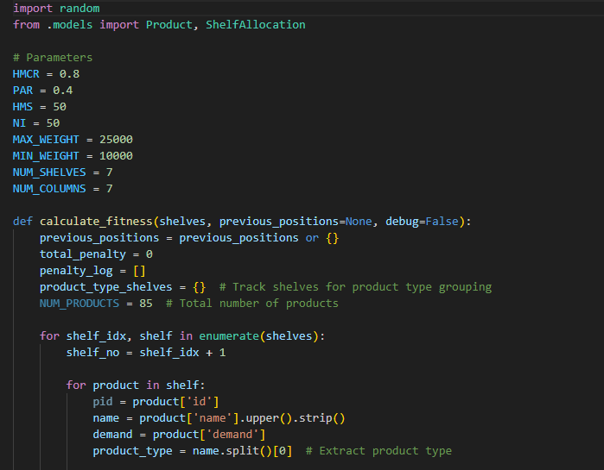

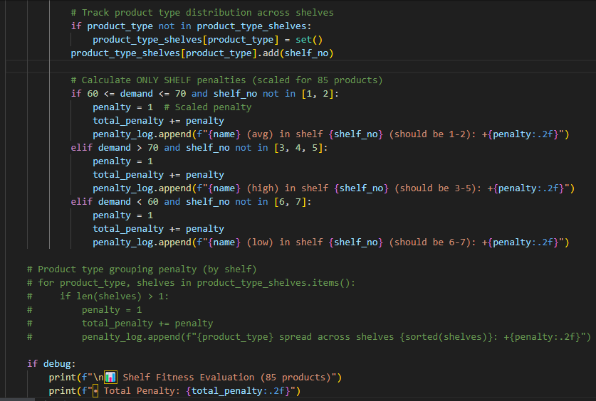
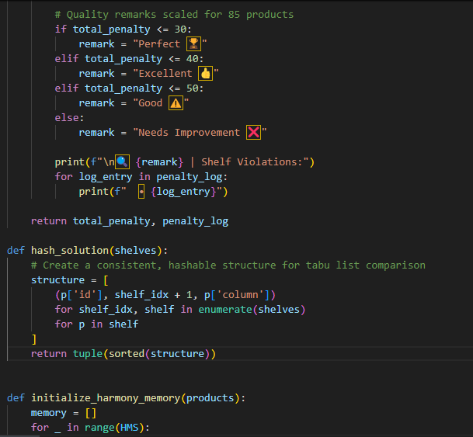
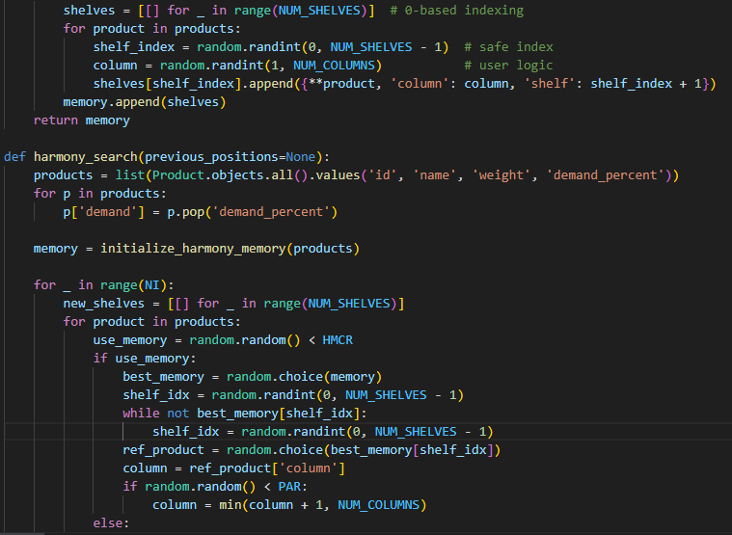

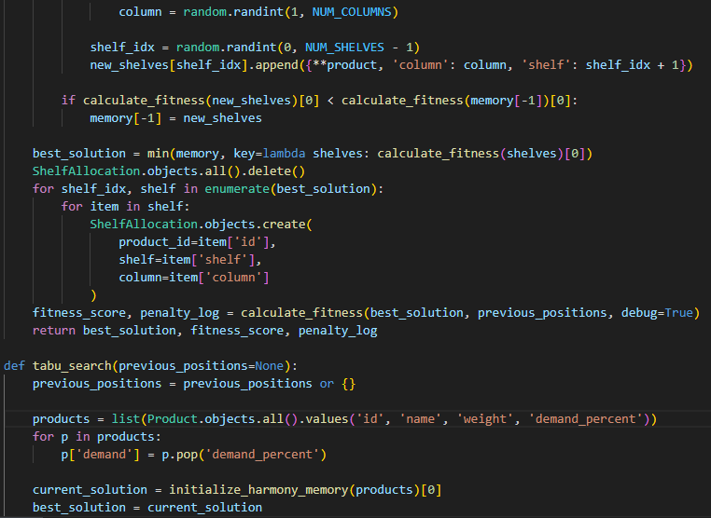

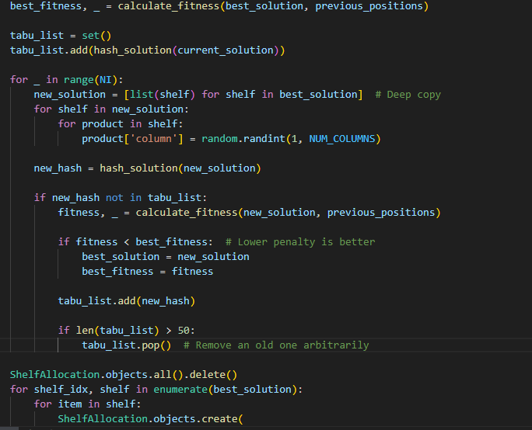

4.5 INTERFACE DESIGN
This section presents the user interface designs developed for the system. Each interface is designed with usability and functionality in mind, ensuring a smooth and intuitive user experience. The layouts aim to support efficient task completion while maintaining a clear visual structure. The images below illustrate the key screens of the system, including navigation elements, input forms, and output displays, highlighting how users interact with the application.

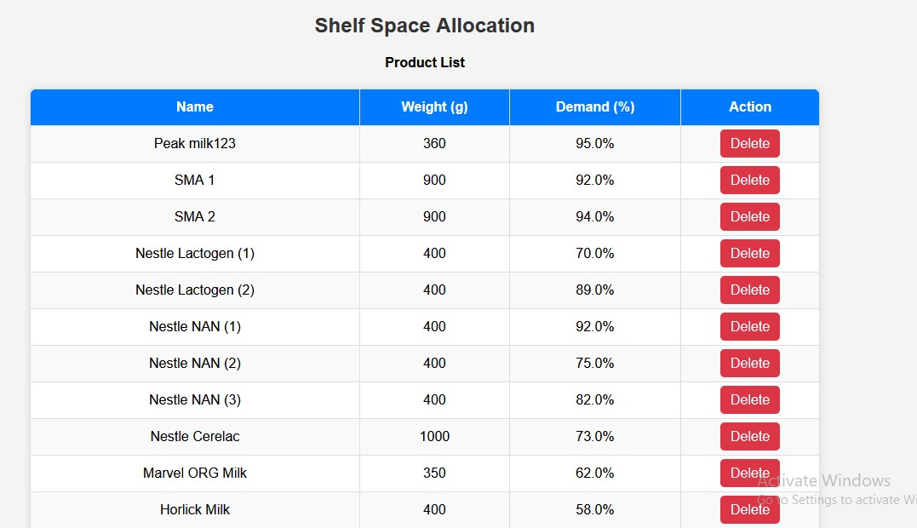
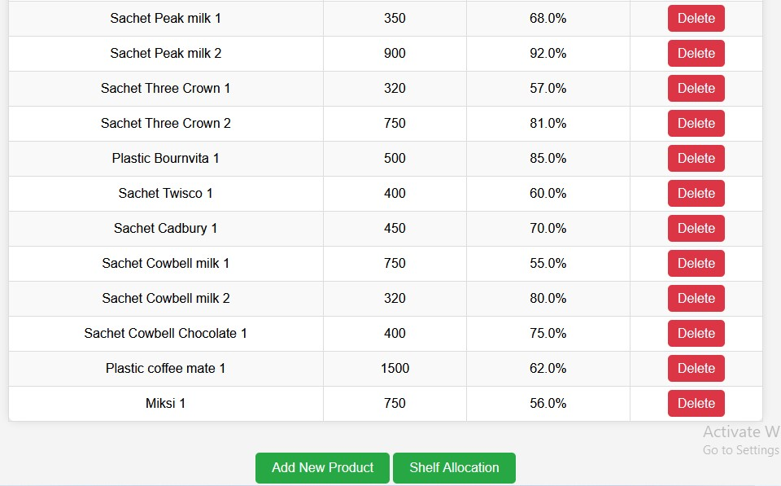
Fig: 2.0 Product list
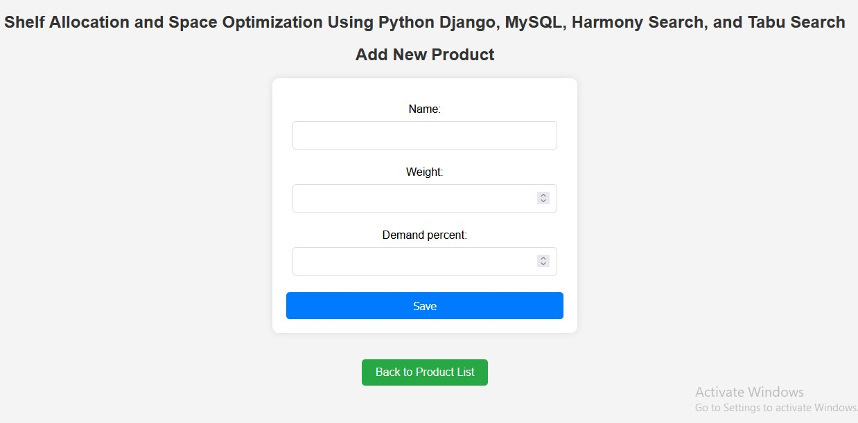
Fig: 2.1 Add products

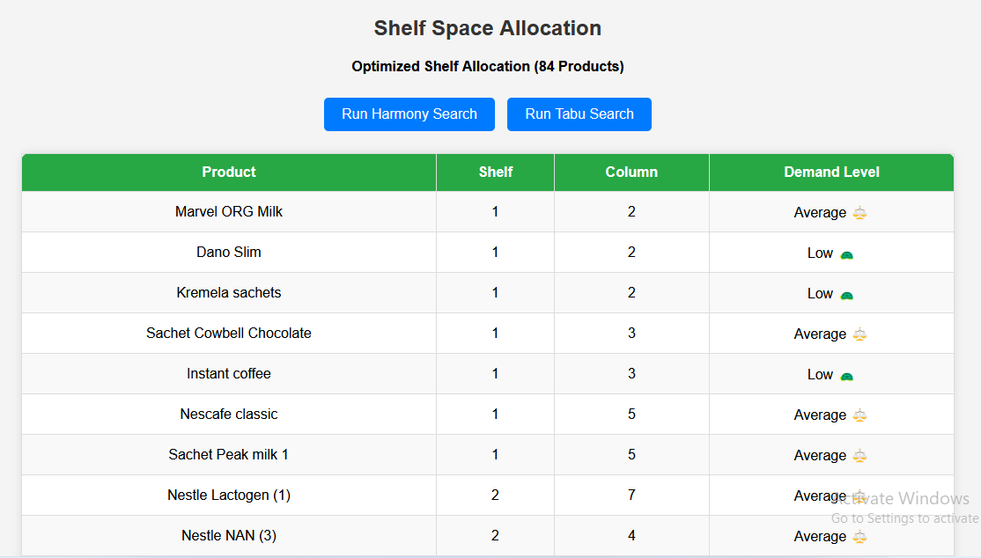
Fig: 2.3 Shelf Allocations

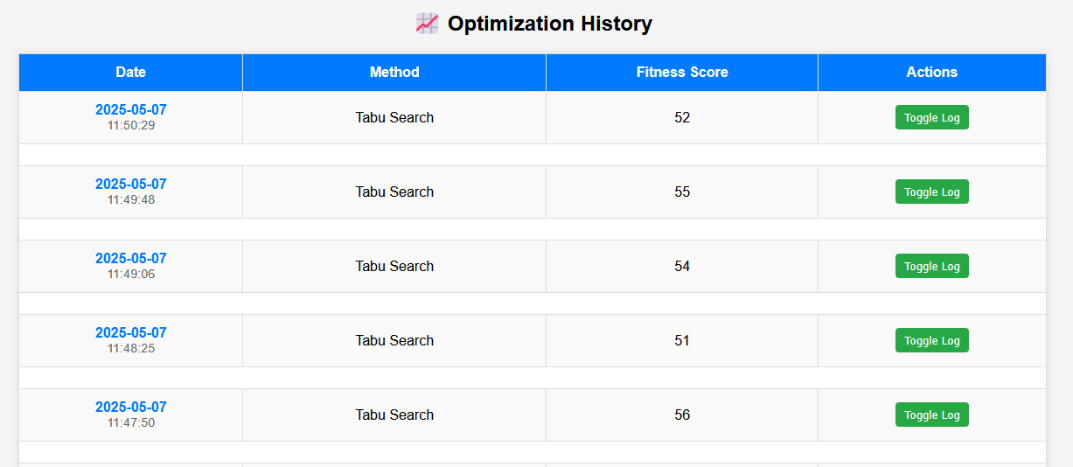
Fig: 2.4 Shelf Allocations

4.6 Results and Discussion
We experimented with random shelf space allocation data to determine how well the Harmony Search algorithm and Tabu search algorithm solved the Shelf space allocation problem. The Shelf space allocation problem is dealt with by utilizing the Harmony Search algorithm and Tabu search algorithm. We take into account both soft and hard constraints, generate new solution iteratively, evaluate their scores, and update the best solution. Printing the result makes it easier to keep track of the algorithm's progress.

Allocation for Harmony Search Algorithm

Table 3: First Iteration
PRODUCT NAME | SHELF | COLUMN
Peak milk123 | 1 | 6
Marvel ORG Milk | 1 | 4
Cebon milk | 1 | 5
Sachet Cowbell milk | 1 | 2
Cebon Café | 1 | 6
Sachet Oluji pure cocoa | 1 | 3
Tin Oluji pure cocoa | 1 | 5
Nestle Cerelac 2 | 1 | 3
Loya milk sachets 1 | 1 | 4
Sachet Peak milk 1 | 1 | 5
Hollandia Evap | 1 | 5
Dano milk | 2 | 6
Dano Cool Cow | 2 | 7
Loya milk sachets | 2 | 5
Tin Peak milk | 2 | 3
Sachet Bournvita | 2 | 2
Sachet Cowbell Chocolate | 2 | 1
Smart Diko | 2 | 6
Nescafe Gold | 2 | 4
Superdelious tin milk | 2 | 7
Dano Cool Cow 2 | 2 | 7
Dano Cool Cow 3 | 2 | 7
Kremela sachets 1 | 2 | 5
Sachet Cowbell milk 1 | 2 | 1
Peak milk456 | 2 | 6
Three crown Evap | 3 | 2
Ovaltine sachets | 3 | 3
Kremela sachets | 3 | 3
Tin Three crown | 3 | 6
Sachet Cadbury | 3 | 1
Bravia | 3 | 3
Nestle Cerelac 1 | 3 | 7
Sachet Three Crown 1 | 3 | 4
Plastic Bournvita 1 | 3 | 2
Sachet Cowbell Chocolate 1 | 3 | 1
Plastic coffee mate 1 | 3 | 2
Miksi 1 | 3 | 3
Nestle Lactogen (2) | 3 | 5
Nestle NAN (2) | 4 | 5
Nestle NAN (3) | 4 | 4
Peak Chocolate sachets | 4 | 6
Tin Cowbell | 4 | 2
Sachet Cowbell Strawberry | 4 | 3
Stock well | 4 | 2
Nescafe classic | 4 | 5
Sachet Three Crown 2 | 4 | 2
Sachet Twisco 1 | 4 | 5
Sachet Cowbell milk 2 | 4 | 6
SMA 1 | 4 | 6
SMA 2 | 5 | 6
Nestle NAN (1) | 5 | 3
Milo sachets | 5 | 5
Dano Cool Cow (Tin) | 5 | 3
Tin Peak Gold | 5 | 5
Sachet Peak milk | 5 | 3
Plastic Bournvita | 5 | 7
Maximus Café | 5 | 6
Miksi | 5 | 7
Ovaltine sachets 1 | 5 | 2
Tin Peak milk 2 | 5 | 2
Sachet Peak milk 2 | 5 | 7
Nestle Lactogen (1) | 5 | 4
Nestle Cerelac | 6 | 7
My Boy 0-12m | 6 | 5
De-hero milk | 6 | 6
Good time milk sachets | 6 | 3
Sachet Three Crown | 6 | 5
Sachet Twisco | 6 | 4
Plastic coffee mate | 6 | 2
Milo sachets 2 | 6 | 4
Hollandia Evap 2 | 6 | 7
Horlick Milk | 6 | 6
Peak Baby 0-12m | 7 | 2
Dano Slim | 7 | 4
Peak milk tin | 7 | 3
Sachet Cowbell Coffee | 7 | 4
Instant coffee | 7 | 6
Brown Gold | 7 | 7
Milo sachets 1 | 7 | 6
Hollandia Evap 1 | 7 | 3
Dano Slim 1 | 7 | 4
Dano Cool Cow 1 | 7 | 3
Tin Peak milk 1 | 7 | 7
Sachet Cadbury 1 | 7 | 4
EXECUTION TIME: 1.38 SECONDS
PENALTY POINT: 40

Table 4: Second Iteration
PRODUCT NAME | SHELF | COLUMN
SMA 2 | 1 | 3
De-hero milk | 1 | 4
Kremela sachets | 1 | 6
Good time milk sachets | 1 | 3
Tin Three crown | 1 | 2
Milo sachets 1 | 1 | 4
Dano Slim 1 | 1 | 1
Loya milk sachets 1 | 1 | 7
Sachet Peak milk 2 | 1 | 2
Sachet Cadbury 1 | 1 | 1
Horlick Milk | 2 | 3
Hollandia Evap | 2 | 4
Dano milk | 2 | 6
Dano Slim | 2 | 6
Dano Cool Cow (Tin) | 2 | 4
Dano Cool Cow | 2 | 3
Instant coffee | 2 | 6
Nescafe Gold | 2 | 4
Superdelious tin milk | 2 | 2
Sachet Three Crown 2 | 2 | 3
Sachet Twisco 1 | 2 | 5
Sachet Cowbell milk 2 | 2 | 7
Peak Baby 0-12m | 3 | 3
Cebon milk | 3 | 4
Peak milk456 | 3 | 3
Ovaltine sachets | 3 | 5
Plastic Bournvita | 3 | 2
Sachet Cowbell Coffee | 3 | 1
Sachet Cowbell Strawberry | 3 | 2
Plastic coffee mate | 3 | 1
Smart Diko | 3 | 6
Cebon Café | 3 | 6
Nestle Cerelac 2 | 3 | 6
Milo sachets 2 | 3 | 6
Dano Cool Cow 1 | 3 | 7
Ovaltine sachets 1 | 3 | 7
Plastic Bournvita 1 | 3 | 1
Sachet Cowbell Chocolate 1 | 3 | 4
Plastic coffee mate 1 | 3 | 1
SMA 1 | 4 | 7
My Boy 0-12m | 4 | 6
Loya milk sachets | 4 | 3
Peak Chocolate sachets | 4 | 7
Sachet Peak milk | 4 | 4
Sachet Bournvita | 4 | 1
Bravia | 4 | 4
Miksi | 4 | 4
Nestle Cerelac 1 | 4 | 1
Hollandia Evap 1 | 4 | 6
Hollandia Evap 2 | 4 | 1
Peak milk123 | 5 | 5
Nestle Lactogen (1) | 5 | 4
Nestle NAN (1) | 5 | 3
Nestle Cerelac | 5 | 4
Marvel ORG Milk | 5 | 1
Milo sachets | 5 | 6
Three crown Evap | 5 | 1
Peak milk tin | 5 | 5
Tin Peak Gold | 5 | 7
Sachet Three Crown | 5 | 1
Sachet Twisco | 5 | 5
Sachet Cadbury | 5 | 2
Sachet Cowbell milk | 5 | 4
Sachet Cowbell Chocolate | 5 | 6
Maximus Café | 5 | 5
Dano Cool Cow 3 | 5 | 2
Tin Peak milk 1 | 5 | 6
Nestle NAN (3) | 6 | 2
Tin Peak milk | 6 | 6
Tin Oluji pure cocoa | 6 | 1
Kremela sachets 1 | 6 | 3
Tin Peak milk 2 | 6 | 5
Sachet Peak milk 1 | 6 | 6
Sachet Three Crown 1 | 6 | 1
Miksi 1 | 6 | 3
Nestle Lactogen (2) | 7 | 7
Nestle NAN (2) | 7 | 5
Tin Cowbell | 7 | 1
Stock well | 7 | 4
Nescafe classic | 7 | 7
Sachet Oluji pure cocoa | 7 | 6
Brown Gold | 7 | 7
Dano Cool Cow 2 | 7 | 6
Sachet Cowbell milk 1 | 7 | 2

EXECUTION TIME: 1.38 SECONDS
PENALTY POINT: 44

3rd Iteration
4th Iteration
5th Iteration
6th Iteration
7th Iteration
8th Iteration
9th Iteration
10th Iteration
….

50th Iteration

Table 5: RESULT SUMMARY OF HARMONY SEARCH ALGORITHM
ITERATION | RESULT (SOFT  CONTRAINT  FITNESS  VIOLATION) | TIME TAKEN  (SEC)
1 | 40 | 1.38
2 | 44 | 1.38
3 | 43 | 1.40
4 | 40 | 1.41
5 | 43 | 1.39
6 | 39 | 1.34
7 | 47 | 1.39
8 | 45 | 1.49
9 | 44 | 1.43
10 | 44 | 1.36

Harmony search result discussion: The first HMS run output starts with iteration 1 and continues to iteration 50, out of which 10 best iterations were recorded each iteration includes the allocation of 84 products to 7 shelves and each shelf contain 7 column. The best allocation as indicted in the table above is iteration 6 with penalty point of 39 and the execution time is 1.34sec

Allocation for Tabu Search algorithm

Table 6: First Iteration
PRODUCT NAME | SHELF | COLUMN
SMA 2 | 1 | 7
Nestle Lactogen (1) | 1 | 5
Nestle Lactogen (2) | 1 | 7
Nestle NAN (2) | 1 | 1
Nestle NAN (3) | 1 | 6
Nestle Cerelac | 1 | 5
Dano Cool Cow (Tin) | 1 | 6
Peak Chocolate sachets | 1 | 4
Tin Peak Gold | 1 | 5
Tin Three crown | 1 | 7
Sachet Cowbell Chocolate | 1 | 3
Instant coffee | 1 | 5
Nescafe classic | 1 | 1
Milo sachets 1 | 1 | 1
Dano Cool Cow 3 | 1 | 1
Sachet Cadbury 1 | 1 | 3
Sachet Peak milk | 2 | 4
Milo sachets 2 | 2 | 4
Dano Cool Cow 2 | 2 | 4
Kremela sachets 1 | 2 | 6
Tin Peak milk 1 | 2 | 2
De-hero milk | 3 | 6
Peak milk456 | 3 | 1
Hollandia Evap | 3 | 1
Loya milk sachets | 3 | 7
Tin Cowbell | 3 | 5
Sachet Cowbell Coffee | 3 | 4
Plastic coffee mate | 3 | 7
Stock well | 3 | 5
Hollandia Evap 1 | 3 | 5
Dano Slim 1 | 3 | 7
Ovaltine sachets 1 | 3 | 1
Sachet Twisco 1 | 3 | 6
Sachet Cowbell milk 1 | 3 | 7
Sachet Cowbell Chocolate 1 | 3 | 7
My Boy 0-12m | 4 | 4
Milo sachets | 4 | 1
Three crown Evap | 4 | 6
Tin Peak milk | 4 | 2
Sachet Bournvita | 4 | 6
Nescafe Gold | 4 | 6
Maximus Café | 4 | 7
Sachet Peak milk 2 | 4 | 4
Sachet Three Crown 2 | 4 | 6
Plastic Bournvita 1 | 4 | 4
Sachet Cowbell milk 2 | 4 | 4
Peak milk123 | 5 | 2
Marvel ORG Milk | 5 | 6
Peak Baby 0-12m | 5 | 3
Cebon milk | 5 | 4
Dano milk | 5 | 3
Dano Slim | 5 | 3
Kremela sachets | 5 | 3
Sachet Three Crown | 5 | 6
Sachet Cowbell Strawberry | 5 | 4
Cebon Café | 5 | 2
Sachet Oluji pure cocoa | 5 | 7
Brown Gold | 5 | 4
Miksi | 5 | 7
Nestle Cerelac 2 | 5 | 2
Plastic coffee mate 1 | 5 | 2
Miksi 1 | 5 | 5
Nestle NAN (1) | 6 | 3
Horlick Milk | 6 | 3
Dano Cool Cow | 6 | 6
Plastic Bournvita | 6 | 7
Sachet Twisco | 6 | 2
Sachet Cadbury | 6 | 3
Sachet Cowbell milk | 6 | 2
Smart Diko | 6 | 7
Tin Oluji pure cocoa | 6 | 1
Superdelious tin milk | 6 | 6
Hollandia Evap 2 | 6 | 3
Dano Cool Cow 1 | 6 | 5
Loya milk sachets 1 | 6 | 2
Tin Peak milk 2 | 6 | 1
Sachet Peak milk 1 | 6 | 6
Sachet Three Crown 1 | 6 | 1
SMA 1 | 7 | 5
Ovaltine sachets | 7 | 2
Good time milk sachets | 7 | 6
Peak milk tin | 7 | 7
Bravia | 7 | 2
Nestle Cerelac 1 | 7 | 3

EXECUTION TIME: 1.30 SECONDS
PENALTY POINT: 53

Table 7: Second Iteration
PRODUCT NAME | SHELF | COLUMN
Horlick Milk | 1 | 7
Tin Peak milk | 1 | 5
Tin Three crown | 1 | 7
Plastic coffee mate | 1 | 1
Nescafe classic | 1 | 6
Miksi | 1 | 5
Sachet Three Crown 2 | 1 | 6
Sachet Twisco 1 | 1 | 4
SMA 2 | 1 | 5
De-hero milk | 2 | 7
Peak milk456 | 2 | 3
Three crown Evap | 2 | 5
Dano milk | 2 | 1
Kremela sachets | 2 | 1
Good time milk sachets | 2 | 1
Tin Peak Gold | 2 | 3
Cebon Café | 2 | 4
Milo sachets 2 | 2 | 4
Sachet Cadbury 1 | 2 | 4
Nestle Lactogen (2) | 2 | 6
Milo sachets | 3 | 2
Sachet Cadbury | 3 | 6
Tin Cowbell | 3 | 1
Sachet Cowbell Coffee | 3 | 1
Sachet Cowbell Strawberry | 3 | 7
Instant coffee | 3 | 5
Hollandia Evap 2 | 3 | 4
Ovaltine sachets 1 | 3 | 7
Loya milk sachets 1 | 3 | 5
SMA 1 | 3 | 5
Peak milk tin | 3 | 7
Sachet Peak milk | 3 | 1
Sachet Three Crown | 3 | 6
Sachet Twisco | 3 | 7
Sachet Oluji pure cocoa | 3 | 7
Tin Oluji pure cocoa | 4 | 4
Brown Gold | 4 | 1
Hollandia Evap 1 | 4 | 6
Dano Cool Cow 3 | 4 | 2
Plastic Bournvita 1 | 4 | 6
Plastic coffee mate 1 | 4 | 6
Nestle NAN (1) | 4 | 7
Marvel ORG Milk | 4 | 4
Dano Slim | 4 | 6
Loya milk sachets | 4 | 4
Peak Chocolate sachets | 4 | 4
Sachet Cowbell Chocolate | 4 | 2
Maximus Café | 5 | 6
Dano Cool Cow 1 | 5 | 3
Dano Cool Cow 2 | 5 | 4
Kremela sachets 1 | 5 | 3
Tin Peak milk 1 | 5 | 3
Tin Peak milk 2 | 5 | 3
Sachet Peak milk 2 | 5 | 6
Sachet Three Crown 1 | 5 | 4
Miksi 1 | 5 | 2
Nestle Lactogen (1) | 5 | 7
Nestle NAN (3) | 5 | 4
Nestle Cerelac | 5 | 7
Cebon milk | 5 | 2
Hollandia Evap | 5 | 2
Ovaltine sachets | 5 | 5
Plastic Bournvita | 6 | 3
Sachet Bournvita | 6 | 3
Sachet Cowbell milk | 6 | 6
Stock well | 6 | 7
Nescafe Gold | 6 | 2
Bravia | 6 | 3
Nestle Cerelac 2 | 6 | 2
Sachet Peak milk 1 | 6 | 7
Sachet Cowbell milk 1 | 6 | 1
Sachet Cowbell milk 2 | 6 | 6
Peak milk123 | 6 | 3
Nestle NAN (2) | 6 | 5
Peak Baby 0-12m | 7 | 2
My Boy 0-12m | 7 | 1
Dano Cool Cow (Tin) | 7 | 6
Dano Cool Cow | 7 | 1
Smart Diko | 7 | 5
Superdelious tin milk | 7 | 2
Nestle Cerelac 1 | 7 | 6
Milo sachets 1 | 7 | 7
Dano Slim 1 | 7 | 2
Sachet Cowbell Chocolate 1 | 7 | 3

EXECUTION TIME: 1.36 SECONDS
PENALTY POINT: 54

3rd Iteration
4th Iteration
5th Iteration
6th Iteration
7th Iteration
8th Iteration
9th Iteration
10th Iteration
….

50th Iteration

Table 8: RESULT SUMMARY FOR TABU SEARCH ALGORITHM
ITERATION | RESULT (SOFT  CONTRAINT  FITNESS  VIOLATION) | TIME TAKEN  (SEC)
1 | 53 | 1.30
2 | 54 | 1.36
3 | 59 | 1.28
4 | 51 | 1.25
5 | 58 | 1.30
6 | 58 | 1.28
7 | 58 | 1.37
8 | 53 | 1.23
9 | 56 | 1.31
10 | 53 | 1.25
Tabu search result discussion: The first TSA run output starts with iteration 1 and continues to iteration 50, out of which 10 best iterations were recorded each iteration includes the allocation of 84 products to 7 shelves and each shelf contain 7 column. The best allocation as indicted in the table above is iteration 4 with penalty point of 51 and the execution time is 1.25sec

Analysis of harmony search result for the best 10 iterations of shelf space allocation, in the first iteration, the algorithm returns a result with a penalty point of 40 and total execution time of 1.38sec. The algorithm proceeds through the iterations, it continues to search for near global solution, aiming to reduce the penalty point and execution time with an objective to satisfy more soft constraint. The Second iteration returns a result with penalty point 44 and total execution time of 1.38sec, the Third (3rd) iteration returns a result with penalty point 43 and total execution time of 1.40sec, the fourth (4th) iteration returns a result with penalty point 40 and total execution time of 1.41sec, the fifth (5th) iteration returns a result with penalty point 43 and total execution time of 1.39sec, the sixth (6th) iteration returns a result with penalty point 39 and total execution time of 1.34sec, the seventh (7th) iteration returns a result with penalty point 47 and total execution time of 1.39sec, the eighth (8th) iteration returns a result with penalty point 45 and total execution time of 1.49sec, the ninth (9th) iteration returns a result with penalty point 44 and total execution time of 1.43sec, while the tenth (10th) iteration returns a result with penalty point 44 and total execution time of 1.36sec. in these 10 iterations it shows that the 6th iteration is the best allocation with a result that has penalty point 39 and total execution time of 1.34sec.

Analysis of Tabu search result for 10 iteration of shelf space allocation, in the first iteration, the algorithm returns a result with a penalty point of 53 and total execution time of 1.30sec. The algorithm proceeds through the iterations, it continues to search for near global solution, aiming to reduce the penalty point and execution time with an objective to satisfy more soft constraint. The Second iteration returns a result with penalty point 54 and total execution time of 1.36sec, the Third (3rd) iteration returns a result with penalty point 59 and total execution time of 1.28sec, the fourth (4th) iteration returns a result with penalty point 51 and total execution time of 1.25sec, the fifth (5th) iteration returns a result with penalty point 58 and total execution time of 1.30sec, the sixth (6th) iteration returns a result with penalty point 58 and total execution time of 1.28sec, the seventh (7th) iteration returns a result with penalty point 58 and total execution time of 1.37sec, the eighth (8th) iteration returns a result with penalty point 53 and total execution time of 1.23sec, the ninth (9th) iteration returns a result with penalty point 56 and total execution time of 1.31sec, while the tenth (10th) iteration returns a result with penalty point 53 and total execution time of 1.25sec. In these 10 iterations it shows that the 4th iteration is the best allocation with a result that has penalty point 51 and total execution time of 1.25sec.

Table 9: COMPARISON OF HARMONY SEARCH ALGORITHM AND TABU SEARCH ALGORITHM
HARMONY SEARCH ALGORITHM | PENALTY POINT (SOFT CONSTRAINT VIOLATION) | EXECUTION TIME  (SEC) | TABU SEARCH ALGORITHM | PENALTY POINT (SOFT CONSTRAINT VIOLATION) | EXECUTION TIME  (SEC)
1 | 40 | 1.38 | 1 | 53 | 1.30
2 | 44 | 1.38 | 2 | 54 | 1.36
3 | 43 | 1.40 | 3 | 59 | 1.28
4 | 40 | 1.41 | 4 | 51 | 1.25
5 | 43 | 1.39 | 5 | 58 | 1.30
6 | 39 | 1.34 | 6 | 58 | 1.28
7 | 47 | 1.39 | 7 | 58 | 1.37
8 | 45 | 1.49 | 8 | 53 | 1.23
9 | 44 | 1.43 | 9 | 56 | 1.31
10 | 44 | 1.36 | 10 | 53 | 1.25

The comparison between the Harmony Search Algorithm and the Tabu Search Algorithm reveals differences in performance based on two key criteria: penalty points for soft constraint violations and execution time. The Harmony Search Algorithm consistently produces lower penalty points compared to the Tabu Search Algorithm, indicating that it is more effective in minimizing violations of soft constraints. The lowest penalty recorded for Harmony Search is 39, whereas for Tabu Search it is 51, and the highest penalty for Harmony Search is 45, while Tabu Search reaches 59. This suggests that Harmony Search is better at finding solutions that adhere more closely to constraints in this work. However, when it comes to execution time, the Tabu Search Algorithm operates slightly faster than the Harmony Search Algorithm. The fastest execution time for Harmony Search is 1.34 seconds, while Tabu Search achieves 1.23 seconds. The worst execution for Harmony Search is 1.49 seconds, compared to 1.37 seconds for Tabu Search. This implies that Tabu Search may be more time-efficient. In conclusion, the Harmony Search Algorithm is preferable when the priority is minimizing constraint violations, while the Tabu Search Algorithm is better suited for applications where speed is a crucial factor.
Table 10: BEST ITERATION SUMMARY
ALGORITHM | BEST ITERATION | PENALTY POINT (SOFT CONSTRAINT VIOLATION) | EXECUTION TIME  (SEC)
Harmony Search Algorithm | 6th | 39 | 1.34
Tabu Search  Algorithm | 4th | 51 | 1.25

PERFORMANCE COMPARISON
Soft Constraint Satisfaction (Penalty Point):
Harmony Search wins: It achieves a lower penalty point (39) compared to Tabu Search (51), meaning it satisfies soft constraints better.
Execution Time:
Tabu Search is slightly faster in its best iteration (1.25 sec) than Harmony Search (1.34 sec), but the difference is minimal (0.09 sec).
No Free Lunch theorem suggests no algorithm is universally best (Wolpert & Macready, 1997). The results of the performance of the algorithms reflect the No Free Lunch (NFL) theorem in the optimization, which states that no algorithm outperforms others across all possible problems. In this case, Harmony search performs better while satisfying soft constraints by achieving a lower penalty point (39 vs. 51), while Tabu search is better in terms of execution time (1.25 sec vs. 1.34 sec). This illustrates that each algorithm has strengths in different aspects, and there is no universally superior method for all evaluation criteria supporting the core idea of the NFL theorem.

CHAPTER 5

SUMMARY, CONCLUSION AND RECOMMENDATION

5.1 Summary
The system begins by collecting input data, including number of shelves and products, product name, weight and demand. To address the shelf space allocation problem, two metaheuristic algorithms Harmony Search and Tabu Search are implemented and compared. Each algorithm independently generates allocation of shelf while attempting to satisfy constraints such as average demand product to Shelf 1 and 2, high demand product to column 3, 4 and 5, and low product to column 6 and 7. The Harmony Search algorithm initializes a set of potential solutions, known as "harmonies," and uses improvisation-inspired operators memory consideration, pitch adjustment, and randomization to explore the solution space. Its strength lies in generating diverse solutions early in the search process, promoting broad exploration. In contrast, the Tabu Search algorithm starts with an initial solution and iteratively improves it by exploring neighboring solutions while avoiding cycles using a tabu list a short-term memory structure that stores recently visited solutions. This algorithm focuses on intensifying the search around promising areas of the solution space and escaping local optima. Both algorithms are evaluated based on solution quality, convergence speed, and their ability to meet the shelf space allocation constraints. The results provide insight into the strengths and weaknesses of each approach in solving complex optimization tasks.
5.2 Conclusion
The comparative analysis of the Harmony Search and Tabu Search algorithms provides valuable insights into optimizing shelf space allocation. By examining the performance, convergence behavior, and solution quality of each method, retailers can identify the most suitable algorithm for aligning product placement with demand patterns and business objectives. Selecting the appropriate approach can lead to more efficient space utilization, increased product visibility, and ultimately, improved sales performance and customer satisfaction.
In the adaptation and implementation of these algorithms, it was observed that the solutions were able to satisfy the specified constraints, which significantly shows the effectiveness of the Harmony Search algorithm and Tabu search algorithm for solving the shelf space allocation problem.
The overall better Algorithm is Harmony Search even though it's marginally slower, its significantly lower penalty point (39 vs 51) means it better satisfies soft constraints, which is usually the main goal in shelf space allocation problems. The algorithm's performance was evaluated based on the result obtained from the 10 iteration of each algorithm and the computational resources utilized.
5.3 Recommendation
Based on the comparative evaluation of harmony search algorithm and tabu search algorithm on shelf space allocation system, the following recommendations can be made:
- Harmony search algorithm Suitability: The Harmony Search algorithm is more suitable for scenarios where the primary objective is achieving higher solution quality through better satisfaction of soft constraints, even if it comes at the cost of slightly increased execution time.
- Tabu search algorithm Suitability: Conversely, Tabu Search is more suitable in scenarios where execution speed is a priority, and near-optimal solutions are acceptable. Its ability to produce reasonable solutions quickly makes it a strong candidate for time-sensitive applications.
- Dynamic Parameter Setting: Dynamic parameter setting refers to the technique of adjusting algorithm control parameters such as the Harmony Memory Considering Rate (HMCR) and Pitch Adjustment Rate (PAR) during the execution of an optimization algorithm, rather than keeping them fixed or relying on randomness. In the context of the Harmony Search algorithm, this approach allows the algorithm to adaptively balance between exploration (searching new areas of the solution space) and exploitation (refining known good solutions).
- Feedback: Collecting detailed feedback from the store regarding the impact of the changes on both sales performance and customer satisfaction is essential. This feedback will provide valuable insights into what is working well and highlight specific areas where further improvements can be made to enhance the overall shopping experience and drive better sales outcomes.
- Directions for Further Study: It is recommended that future research explore the implementation of the Tabu Search algorithm with and without the aspiration criterion. A comparative analysis between the two approaches could provide deeper insights into their impact on solution quality, convergence behavior, and the ability to escape local optima particularly in complex optimization problems such as shelf space allocation. This investigation would help determine whether incorporating the aspiration criterion consistently yields superior performance or if its benefits are problem-dependent.

REFERENCE
Adamuth, A. C., & Nitave, T.R. (2018). Adaptive harmony search for optimizing constrained resource allocation problem. International Journal of Computing, 17(4), 260-269.

Alghurair, D. H., & Alshammar, H. G. (2017). Shelf space allocation problem using LNS solver. International Journal of Science and Research, 6(7), 987-996. Retrieved from [https://doi.org/10.21275/ART20175451](https://doi.org/10.21275/ART20175451)

Bianchi-Aguiar, T., Silva, E., Guimarães, L., Carravilla, M. A., & Oliveira, J. F. (2018). Allocating products on shelves under merchandising rules: Multi-level product families with display directions. Omega, 76, 47-62. Retrieved from [https://doi.org/10.1016/j.omega.2017.04.002](https://doi.org/10.1016/j.omega.2017.04.002)

Bingüler, A. H. E., Bulkan, S., & Ağaoğlu, M. (2016). A heuristic approach for shelf space allocation problem. Journal of Military and Information Science, 4(1), 38–44.

Chananes, A., Pisal, Y., & Paul, R. (2007). PSO – Based Algorithm for home care worker scheduling in the UK. Journal of Computer & Industrial Engineering, 53(4), 559-583.

Czerniachowska, K. (2021). A genetic algorithm for the retail shelf space allocation problem with virtual segments. OPSEARCH. Retrieved from [https://doi.org/10.1007/s12597-021-00551-3](https://doi.org/10.1007/s12597-021-00551-3)

Czerniachowska, K., & Hernes, M. (2020). A genetic algorithm for the shelf-space allocation problem with vertical position effects. Mathematics, 8(11), Article 1881. Retrieved from [https://doi.org/10.3390/math8111881](https://doi.org/10.3390/math8111881)

Ernest, A. T., Jiang, H., Krishnamoorth, M., & Sier, D. (2004). Staff scheduling and rostering: A review of applications, methods and models. European Journal of Operational Research, 153(2), 3-17.

Geem, Z. W., Kim, J. H., & Loganathan, G. (2001). A new heuristic optimization algorithm: Harmony search. Simulation, 76, 60–68.

Ingram, G., & Zhang, T. (2009). Overview of applications and developments in the harmony search algorithm. Music-Inspired Harmony Search Algorithm,* 15–37. *Studies in Computational Intelligence (SCI, volume 191). Springer, Berlin-Heidelberg.

Ishichi, K., Ohmori, S., Ueda, M., & Yoshimoto, K. (2019). Shelf-space allocation model with demand learning. Operations and Supply Chain Management, 12(1), 24-30. Retrieved from [https://doi.org/10.31387/oscm0360219](https://doi.org/10.31387/oscm0360219)

Kaewyotha, J., & Songpan, W. (2021). Multi-objective design of profit volumes and closeness ratings using MBHS optimizing based on the PrefixSpan mining approach (PSMA) for product layout in supermarkets. Applied Sciences, 11(10683). Retrieved from [https://doi.org/10.3390/app112210683](https://doi.org/10.3390/app112210683)

Kim, G., & Moon, I. (2021). Integrated planning for product selection, shelf-space allocation, and replenishment decision with elasticity and positioning effects. Journal of Retailing and Consumer Services, 58,102274. Retrieved from [https://doi.org/10.1016/j.jretconser.2020.102274](https://doi.org/10.1016/j.jretconser.2020.102274)

Lee, K. S., & Geem, Z. W. (2004). A new structural optimization method based on the harmony search algorithm. Comput. Struct., 82, 781–798.

McKay, K., & Buzacott, J. (2000). Application of computerized production control systems in job shop environments. Computers in Industry, 42(2), 79–97.

Ritika xRay Pixy. (2022, May 31). Harmony search algorithm numerical example [Video file]. Retrieved from [https://youtu.be/KO5s1F683Dc?si=OQIX6PP7gnD85hTz](https://youtu.be/KO5s1F683Dc?si=OQIX6PP7gnD85hTz)

Wolper, D. H., & Macready, W. G. (1997). No free lunch theorems for optimization. IEEE Transactions on Evolutionary Computation, 1(1), 67-82. Retrieved from [https://doi.org/10.1109/4235.585893](https://doi.org/10.1109/4235.585893)

Xu, J., Gul, E., & Lim, A. (2020). Maximizing store revenues using Tabu search for floor space optimization. arXiv preprint, arXiv:2011.04422. Retrieved from [https://arxiv.org/abs/2011.04422](https://arxiv.org/abs/2011.04422)

Yang, X. -S., Deb, S., & Fong, S. (2014). Metaheuristic algorithms: optimal balance of intensification and diversification. Appl. Math. Inform. Sci., 8,977.

