DESIGN AND CONSTRUCTION OF SOLAR CHARGE CONTROLLER FOR OPTIMUM EFFICIENCY IN A STAND ALONE PHOTOVOLTAIC SYSTEM

BY

AMOO SIKIRU ADESHINA
HND/23/EEE/FT/0267

SUBMITTED TO
DEPARTMENT OF ELECTRICAL/ELECTRONICS ENGINEERING TECHNOLOGY, KWARA STATE POLYTECHNIC ILORIN.
IN PARTIAL FULFILLMENT OF THE REQUIREMENTS FOR THE AWARD OF HIGHER NATIONAL DIPLOMA (HND) IN ELECTRICAL/ELECTRONICS ENGINEERING TECHNOLOGY

SUPERVISED BY
ENGR. DR. O. A. LAWAL

AUGUST, 2025.

CERTIFICATION
This is to certify that this project was carried out and submitted by Amoo Sikiru Adeshina of matric number HND/23/EEE/FT/0267 and has been read and approved as meeting the requirements for the award of Higher National Diploma in the department of Electrical/Electronics Engineering, Institute of Technology, Kwara State Polytechnic, Ilorin.

_____________________ _____________
ENGR. DR. O. A. LAWAL Date
Project supervisor

_____________________ _____________
ENGR. Z. A. ABDULKADIR Date
Project coordinator

_____________________ _____________
ENGR. DR. O. A. LAWAL Date
Head of department

_____________________ _____________
External examiner Date

DEDICATION
This project is dedicated to Almighty Allah who give life, wisdom, knowledge and understanding to all mankind.

ACKNOWLEDGEMENT
I give all glory and adoration to almighty Allah, the giver of knowledge, strength and ability for sustaining and helping me through my project period, and for his grace and protection over me throughout my higher national diploma program.
My appreciation also goes to my supervisor in person of Engr. Dr. O. A. LAWAL for his total support and fatherly advice during the period of this project. I appreciate you so much Sir. I also acknowledge the support of my amiable project coordinator ENGR. Z. A. ABDULKADIR. Special appreciation to ENGR. A. A. JIMOH and to every other lecturers of the department. I say a big thanks to you all.
My appreciation also goes to my beloved parent MR. AND MRS. AMOO for their moral, financial, and prayer supports, may you live long to reap the fruit of their labour.
I will be an ingrate if I don’t show my appreciation to my amiable Group Leaders HAMMED SHERIF and OWODEYI QUDUS. I also appreciate TEEBABS and all members of my family, colleagues, friends and everyone that has contributed in one way or the other to the success of this project.

TABLE OF CONTENTS
TITLE PAGE i
CERTIFICATION ii
DEDICATION iii
ACKNOWLEDGEMENT iv
TABLE OF CONTENTS v
LIST OF FIGURES vii
LIST OF TABLES viii
ABSTRACT x
CHAPTER ONE 1
1.0 INTRODUCTION 1
1.1 AIM 4
1.2 OBJECTIVES 4
1.3 PROBLEM STATEMENT 4
1.4 SCOPE OF THE PROJECT 4
1.5 CONTRIBUTION 5
1.6 SUMMARY 5
CHAPTER TWO 6
2.0 LITERATURE REVIEW 6
2.1 PULSE WIDTH MODULATION (PWM) 10
2.1.1 ABILITY TO RECOVER LOST BATTERY CAPACITY 12
2.1.2 INCREASE BATTERY CHARGE ACCEPTANCE 12
2.1.3 MAINTAIN HIGH AVERAGE BATTERY CAPACITIES 13
2.1.4 EQUALIZE DRIFTING BATTERY CELLS 14
2.1.5 REDUCE BATTERY HEATING AND GASSING 14
2.1.6 AUTOMATICALLY ADJUST FOR BATTERY AGING 15
2.1.7 SELF-REGULATE FOR VOLTAGE DROPS AND TEMPERATURE EFFECTS 15
2.2 MAXIMUM POWER POINT TRACKER 16
2.2.1 CLASSIFICATION BASED ON CONVERTER 20
2.2.2 CLASSIFICATION BASED ON APPLICATION 24
2.2.3 APPLICATION 24
2.3 GENERAL REVIEW 25
2.3.1 EARLY STAGES (1970S–1980S): 25
2.3.2 DEVELOPMENT OF PWM CONTROLLERS (1990s): 26
2.3.3 INTRODUCTION OF MPPT CONTROLLERS (EARLY 2000s): 26
2.3.4 TECHNOLOGICAL ADVANCES AND INTEGRATION (2010s): 27
2.3.5 RECENT TRENDS (2020s AND BEYOND): 27
2.3.6 Comparative Analysis of Cost: PWM vs. MPPT 29
CHAPTER THREE 31
3.0 METHODOLOGY 31
3.1 PWM CIRCUITRY 31
3.1.2 Steps Involved in PWM Solar Charge Controller Operation: 33
3.2 MPPT CIRCUITRY 33
3.2.1 Steps Involved in MPPT Operation 35
3.3 SYSTEM CONFIGURATION 36
3.3.1 SOLAR PANEL 37
3.3.2 MPPT SOLAR CHARGE CONTROLLER 39
3.3.3 PWM SOLAR CHARGE CONTROLLER 40
3.3.4 LOCAL MADE PWM CHARGE CONTROLLER 42
3.3.5 KNIFE SWITCH CHANGE OVER 48
3.3.6 LITHIUM BATTERY 49
3.3.7 INVERTER 50
3.3.8 AC LOAD 51
3.3.9 13A SOCKET OUTLET 52
3.3.10 LAMPHOLDER 52
3.3.11 LED BULB 53
3.3.12 DC CABLE 53
3.3.13 AC CABLE 54
3.4 SUMMARY 55
CHAPTER FOUR 57
4.0 TEST AND RESULTS 57
4.1 CHARGING AND DISCHARGING OF THE BATTERY 61
4.2 EFFICIENCY OF THE INVERTER 63
4.3 OVERALL EFFICIENCY OF THE SOLAR SYSTEM 64
4.4 SUMMARY 65
CHAPTER FIVE 66
5.0 CONCLUSION 66
5.1 RECOMMENDATION 66
APPENDIX I 68
APPENDIX II 69
APPENDIX III 70
REFERENCES 71

LIST OF FIGURES
Figure 1: Concept of an inverter. 10
Figure 2 : Schematic diagram of PWM solar charge controller 35
Figure 3: Schematic diagram of MPPT solar charge controller . 37
Figure 4: Schematic diagram of MPPT solar charge controller. 40
Figure 5: Solar panel 42
Figure 6: MPPT solar charge controller. 43
Figure 7: PWM charge controller. 45
Figure 8: Locally made PWM charge controller circuit diagram. 45
Figure 9: Inner view of the locally made charge controller 50
Figure 10: Outer view of the locally made charge controller 50
Figure 11: knife switch changeover 51

LIST OF TABLES
Table 1 : Cost comparison between PWM and MPPT solar charge controller 39
Table 2: Description of the solar panel used 48
Table 3: Description of MPPT charge controller used 50
Table 4: Description of the PWM charge controller used. 51
Table 5: The results of voltage, current and power of the 100w solar panel 67
Table 6: The results of voltage, current, input power and output power of the MPPT solar charge controller with time. 68
Table 7: The results of voltage, current, power input, power output and efficiency of the foreign PWM solar charge controller 69
Table 8: The results of voltage, current, input power, output power and efficiency of the local PWM solar charge controller with time. 70

ABSTRACT
The growing demand for clean and reliable energy in off-grid and rural areas has made solar photovoltaic (PV) systems a promising alternative to conventional power sources. However, maximizing the efficiency of these systems remains a significant challenge, particularly in developing regions where cost constraints and component reliability are major concerns. This study focuses on the design and construction of a Pulse Width Modulation (PWM) solar charge controller to optimize energy conversion in a stand-alone PV system, and to evaluate its performance in comparison with foreign PWM and Maximum Power Point Tracking (MPPT) charge controllers. Previous studies have shown that MPPT-based controllers significantly outperform PWM controllers, especially under variable irradiance conditions, by ensuring operation close to the maximum power point of the solar module. While MPPT controllers offer higher efficiency, PWM controllers remain widely used due to their simpler design and lower cost. In this work, a locally constructed PWM charge controller was built and tested alongside a foreign PWM and an MPPT controller. Experimental analysis revealed that the MPPT controller achieved the highest efficiency, ranging from 45% to 77.6%, whereas both the local and foreign PWM controllers recorded efficiency values between 43% and 66%. Furthermore, the inverter used in the system achieved an efficiency of up to 89.7%. The overall system efficiency was calculated as 39.7% using the MPPT controller, and 28.4% using either the local or foreign PWM controllers. These results underscore the superior performance of MPPT technology in maximizing solar energy utilization. However, the study also demonstrates that a well-designed local PWM controller can serve as a functional and economically viable solution for basic off-grid applications. The findings provide valuable insights for future design improvements and policy recommendations in renewable energy deployment in resource-limited settings.

CHAPTER ONE

1.0 INTRODUCTION
Arsad et al(2025) reported that in the past decade, the industrialization of the world has led to the depletion of fossil fuel and non-renewable reserves, posing serious threats to human survival. The majority of the current power generation is primarily based on fossil fuels, such as coal, rather than biofuels. The transition from fossil fuels to renewable energy (RE) is gaining momentum as more nations, towns, and companies set sustainability and zero-emission goals. Renewable energy sources (RES) are energy sources that are naturally replenished and can be used to generate electricity and heat, such as biomass, hydropower, wind, solar energy, geothermal energy, and nuclear energy, within a limited time frame (Ang et al., 2022). One of the primary sources of renewable energy is biofuels, a sustainable alternative produced from organic materials. Biofuels are extracted from certain crops planted for the production of energy and fuel. These plants are referred to as energy crops, including seaweeds, algae, and microalgae. However, the sustainability of biofuel as a generation source is problematic due to its limited resources. Consequently, global research efforts were directed towards exploring sustainable energy alternatives such as tidal, wind, solar, etc. Solar energy-based photovoltaic (PV) is a potential renewable energy source since it is constantly available, free, environmentally friendly, and low-maintenance. Serano et al. (2019) highlight solar photovoltaic energy as a prominent method of electricity generation, as it captures solar radiation. This technology enables electricity access in rural areas where conventional power delivery is not feasible.
PV systems provide a viable means of power generation for applications like powering residential appliances, electrification of villages in rural areas, telecommunications, refrigeration, and water pumping (Parida et al., 2011).
Lokesh Reddy et al. (2017) in their study, they advised the use of solar energy in all countries of the world due to the excessive energy crisis and environmental pollution is considered vigorously. Photovoltaic systems, which convert solar energy to electricity, are now one of the most common sources of electrical energy. They can be used in grid-connected mode to support the network or in a stand-alone mode to supply some remote areas.
In a stand-alone mode, the PV independently cannot be enough for supplying loads because weather conditions (such as cloud and fog) have a significant impact on the solar energy received by a PV array; therefore, there is a need for energy storage systems like batteries (K & Vijayaraj, 2020a; LokeshReddy et al., 2017). The energy produced by the solar panel varies with the incident sunlight. During the day, the energy from the solar panel increases to the peak level and decreases to zero from morning till evening.
There are several important issues in a stand-alone PV battery system such as efficiency controllability, charge capability, proper protection scheme, system weight, battery lifespan, battery charge and discharge pattern, system ON and OFF mode, system cost, output voltage quality etc. these features are affected by the type and configuration of DC to DC converter, size of batteries and PV arrays, control strategy, MPPT algorithm and energy management system. Therefore, proper selection and adjustment of the parameters is the most vital task of the photovoltaic system design. This variation in solar energy, depending on the sunlight, requires a controller that controls the charging of the battery backup (K & Vijayaraj, 2020b).
Solar charge controller is one of the most influential elements on the quality and lifespan of the photovoltaic solar system due to its function of protecting the battery from overcharging and deep discharging. This ensures the battery charges efficiently and does not get overcharged, undercharged, or damaged due to fluctuations in current or voltage. Modern charge controllers often include built-in monitoring systems to display parameters like battery voltages, charging current, and system status. They also protect against reverse current flow from the battery to the solar panel at night, short circuit and overcurrent conditions, and temperature extremes that could affect charging. Some advanced charge controllers offer equalization, a process that balances the charge among the cells of a battery bank to enhance performance and life span.
The charge controller exists mainly in pulse width modulation (PWM) and maximum power point tracker (MPPT) technologies for both foreign and locally manufactured products.
PWM charge controller is a widely used type of solar charge controller with an efficiency of 60-80%, designed to regulate the power sent from solar panels to a battery. Its primary purpose is to ensure the battery is charged efficiently while preventing overcharging, undercharging, and damage to the battery. This controller uses PWM technology to adjust the charging rate of the battery by rapidly switching the connection between the solar panel and the battery ON and OFF. It also modulates the width (duration) of the pulse of current sent to the battery depending on the battery’s charge level. The PWM controllers usually employ a three-stage charging process, such as bulk charging, absorption charging, and float charging.
An MPPT charge controller is an advanced type of charge controller designed to maximize the energy harvested from solar panels by operating them at their maximum power point (MPP). This capability makes the MPPT charge controller highly efficient (85-95%), particularly in large or high voltage power systems. The MPPT controller continuously adjusts its input voltage and current to ensure the solar panels operate at their maximum power point, which is the point on the solar panel’s voltage curve. Current (V-I) curve where power output is maximized. It is efficient in cold or variable conditions and suitable for medium to large solar power systems, making them ideal for homes, businesses, and individual applications. The DC-to-DC conversion of the MPPT minimizes energy loss compared to PWM controllers, especially in a system with mismatched panel and battery voltages. The main goal of this project is to design and construct a locally made PWM charge controller and determine the most efficient among the locally made PWM, foreign PWM, and foreign MPPT charge controllers.

1.1 AIM
This project aims to design and construct a locally made charge controller for optimum efficiency in a stand-alone photovoltaic system.

1.2 OBJECTIVES
The objectives of this study are to:
- Determine the efficiency of local and foreign (MPPT and PWM) charge controllers.
- Design, construct, and install a prototype stand-alone solar photovoltaic system.
- Determine the efficiency of each stage of the stand-alone solar photovoltaic system.
- Determine the overall efficiency of the stand-alone photovoltaic system.

1.3 PROBLEM STATEMENT
The efficiency of stand-alone PV systems depends largely on the performance of the charge controllers. Despite the availability of PWM and MPPT controllers, many solar photovoltaic systems still operate below optimal efficiency due to suboptimal charge management (Singh et al., 2023).

1.4 SCOPE OF THE PROJECT
The project covers the following:
- Design and construction of a locally-made PWM charge controller.
- Purchase of a foreign-made PWM and MPPT charge controller
- Installation of a prototype stand-alone solar PV system.
- Determination of the efficiencies for charge controllers (local PWM, foreign PWM and foreign MPPT), solar panels.

1.5 CONTRIBUTION
- Enhancing the performance of PV systems for optimal battery charging.
- Reduction in the overall size of the control circuit used for PV system control.
- Proposal for a cost-effective solar PV system installation.

1.6 SUMMARY
Renewable energy sources (RES) are naturally replenishing resources used to generate electricity and heat. Photovoltaic systems, which convert solar energy to electricity, are now one of the most common sources of electrical energy. Due to issues like weather variations, stand-alone PV systems often require energy storage systems like batteries, as they cannot always generate sufficient power independently. These systems use a DC to DC converter (solar charge controllers) to connect the PV array and batteries. The charge controller plays a critical role in managing these factors by ensuring the batteries are neither overcharged nor undercharged. There are two main types of charge controllers: PWM and MPPT. PWM controllers, which are widely used, regulate battery charging through a three-stage process and operate with efficiencies of 60-80%. MPPT controllers are more advanced, optimizing the energy harvested from solar panels and operating at efficiencies of 85-95%. MPPT is especially effective in larger systems or under variable environmental conditions.
This project aims to design, construct, and simulate a locally made PWM charge controller and compare its efficiency with foreign-made PWM and MPPT controllers in a stand-alone solar photovoltaic system.

CHAPTER TWO

2.0 LITERATURE REVIEW
Today, it is estimated that approximately one-third of the world′s population (i.e., around two billion people) has no access to electric power, potentially leading to recurrent cycles of poverty and deprivation (Abdul-Ganiyu et al., 2021). A power inverter, or inverter, is an electronic device or circuitry that is essential in converting DC to AC power, and they are widely used in renewable energy systems, uninterruptible power supplies (UPS), and industrial applications. With the increased adoption of PV systems, electric vehicles (EVs), and off-grid power solutions, the demand for efficient and reliable inverters has surged (Morey et al., 2023). Figure 1 describes the concept of an inverter, showing how inverter works by converting direct (DC) source into alternating (AC) sources.
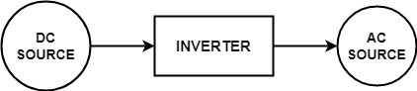
Figure 1: Concept of an inverter.
The efficiency, performance, and suitability of inverters are largely determined by their operating frequency, which can be classified into two broad categories: high-frequency inverters and low-frequency inverters. These two types of inverters differ in their design, operation, and application areas, making them each suitable for distinct scenarios. The fundamental distinction between these two lies in their switching frequency, transformer design, efficiency characteristics, size and weight, electromagnetic interference (EMI), and load suitability. High-frequency inverters typically operate at higher switching frequencies, enabling them to achieve smaller, lighter, and more efficient designs. The advantages of high-frequency operation include better control over the output waveform and improved efficiency, particularly in applications requiring compact size and quick response times, such as in portable devices or high-precision systems. However, their performance can be affected by challenges like electromagnetic interference and switching losses at higher frequencies (Robles et al., 2021).
Technological advancements in inverter design over recent decades have profoundly reshaped the landscape of power conversion systems, driving marked improvements in efficiency, compactness, reliability, and cost-effectiveness. These innovations have expanded the role of inverters beyond traditional applications such as power grid stabilization and renewable energy integration into cutting-edge domains like electric mobility, grid-scale energy storage, and compact consumer electronics. By leveraging breakthroughs in semiconductor materials, advanced control algorithms, and thermal management techniques, modern inverters now deliver superior performance under dynamic operating conditions while enabling lighter, more scalable solutions. This evolution underscores their growing versatility in bridging the gap between sustainable energy generation, storage, and next-generation electrification demands (Y. Liu et al., 2020; Petri et al., 2022).
In recent years, inverter technology has undergone transformative advancements driven by the escalating demands of modern power systems and the integration of renewable energy sources. These improvements can be broadly classified into several key areas:
The evolution of inverters is closely linked to breakthroughs in power semiconductor devices. Traditional silicon-based semiconductors are increasingly being supplanted by wide-bandgap (WBG) materials such as silicon carbide (SiC) and gallium nitride (GaN). These materials offer significant advantages, including superior thermal performance, faster switching speeds, and enhanced efficiency. As a result, SiC and GaN devices enable the design of inverters that are not only more compact and robust but also capable of operating at higher temperatures and frequencies. These characteristics are particularly beneficial for high-performance applications such as electric vehicles and large-scale RES (Zhao et al., 2012).
A pivotal development in inverter design is the ability to operate at high switching frequencies. High frequency switching reduces the size and weight of passive components such as inductors and capacitors, thereby allowing for more compact inverter designs. Moreover, elevated switching frequencies contribute to a more agile dynamic response, which is crucial for applications like PV systems, where space constraints and rapid control adjustments are critical (Chen & Xu, 2022)
Modern inverter control has benefited immensely from advances in digital signal processing and microcontroller technologies. Inverters now routinely implement sophisticated control algorithms such as PWM, vector control, and model predictive control (MPC) to optimize power conversion. These algorithms improve system performance by adapting to fluctuating load conditions and reducing harmonic distortion. Adaptive control techniques further refine inverter responsiveness, ensuring optimal performance across a range of operating scenarios (Bhatt et al., 2020).
As renewable energy becomes increasingly prevalent, inverters are evolving to integrate seamlessly with sources such as solar panels and wind turbines. New grid-tied and off-grid inverter designs feature advanced MPPT algorithms that maximize power extraction under variable environmental conditions. Additionally, these inverters are designed to support bidirectional power flow and enhance grid synchronization, which are essential for energy storage integration and overall grid stability.
Inverters are now a critical component in energy storage systems, facilitating bidirectional power flow that allows for efficient energy charging and discharging. The synergy between modern inverters and battery management systems (BMS) is key to maintaining energy balance in micro-grids and residential solar applications, thereby enhancing system reliability and extending battery life. Advances in inverter technology have led to more compact and modular designs that simplify installation and maintenance. Modular inverters allow for scalable system configurations, enabling users to expand their energy capacity as needed without significant redesign. This modularity not only reduces costs but also improves system flexibility in both residential and industrial settings. The advent of smart grid technologies and the Internet of Things (IoT) has spurred the development of smart inverters. These devices provide real-time communication and remote monitoring capabilities, allowing for enhanced grid management through demand response, frequency regulation, and voltage stabilization. Moreover, smart inverters facilitate predictive maintenance and continuous performance optimization, contributing to overall grid resilience.
Improvements in materials, design, and control algorithms have culminated in inverters that achieve efficiencies exceeding 98%. Modern thermal management techniques, such as advanced cooling systems and optimized ventilation, further enhance inverter reliability and longevity even under extreme operating conditions. Inverters now play an active role in supporting grid operations by providing functions such as reactive power compensation, voltage regulation, and fault detection. Enhanced filtering and harmonic suppression capabilities ensure high-quality power output, which is crucial for applications that require stringent power quality standards, such as healthcare and data centres.
Finally, advances in manufacturing processes, economies of scale, and improved component integration have driven down the cost of inverters. These cost reductions have made high-performance inverters more accessible for a broad spectrum of applications, ranging from small-scale residential solar systems to large industrial installations. The future of inverters lies in continued improvements in efficiency, integration with renewable energy systems, and the development of smart, interconnected devices that optimize energy use. High-frequency inverters will likely continue to dominate in applications requiring compactness and precision, while low-frequency inverters will remain central to large-scale industrial systems.
Solar charge controllers are essential components in PV systems, particularly for off-grid applications, where they regulate the flow of energy between solar panels, batteries, and the load. They ensure the safe and efficient operation of the solar energy storage system by preventing overcharging, deep discharge, and improving the overall system performance. However, like any technology, solar charge controllers have their advantages and limitations. This critical review highlights both the strengths and the challenges of solar charge controllers. Solar charge controllers exist in two types:

2.1 PULSE WIDTH MODULATION (PWM)
The technology for solar photovoltaic battery charge controllers has advanced dramatically over the past five years. The most exciting new technology, PWM charging, has become very popular. PWM is the most effective means to achieve constant voltage battery charging by switching the solar system controller's power devices. When in PWM regulation, the current from the solar array tapers according to the battery's condition and recharging needs. When a battery voltage reaches the regulation set point, the PWM algorithm slowly reduces the charging current to avoid heating and gassing of the battery, yet charging continues to return the maximum amount of energy to the battery in the shortest time (Acharya & Aithal, 2020). Charging a battery with a solar system is a unique and difficult challenge. In the old days, simple on-off regulators were used to limit battery outgassing when a solar panel produced excess energy. However, as solar systems advanced, it became clear how much these simple devices interfered with the charging process. The history of on-off regulators has been early battery failures, increasing load disconnects, and growing user dissatisfaction. PWM has recently surfaced as the first significant advance in solar battery charging.
PWM solar chargers use technology similar to other modern high-quality battery chargers. When a battery voltage reaches the regulation set point, the PWM algorithm slowly reduces the charging current to avoid heating and gassing of the battery, yet the charging continues to return the maximum amount of energy to the battery in the shortest time. The result is a higher charging efficiency, rapid recharging, and a healthy battery at full capacity.
In addition, this new method of solar battery charging promises some very interesting and unique benefits from the PWM pulsing. These include:
- Ability to recover lost battery capacity and desulfate a battery.
- Dramatically increasing the charge acceptance of the battery.
- Maintaining high average battery capacities (90% to 95%) compared to on-off regulated state-of-charge levels that are typically 55% to 60%.
- Balancing battery cells with varying charge levels.
- Reducing battery heating and gassing.
- Automatically adjusting for battery aging.
- Self-regulation for voltage drops and temperature effects in solar systems.
The benefits noted above are technology-driven. The more important question is how the PWM technology benefits the solar system user.
Jumping from a 1970s technology into the new millennium offers:
- Longer battery life:
  - Reducing the costs of the solar system
  - Reducing battery disposal problems
- More battery reserve capacity:
  - Increasing the reliability of the solar system
  - Minimizing load disconnections.
  - Opportunity to reduce battery size to lower the system cost
- Greater use of the solar array energy:
  - Get 20% to 30% more energy from your solar panels for charging
  - Stop wasting solar energy when the battery is only 50% charged
  - Opportunity to reduce the size of the solar array to save costs
- Greater user satisfaction: get more power when you need it for less money!!

2.1.1 ABILITY TO RECOVER LOST BATTERY CAPACITY
The Battery Council International reports that sulfation is responsible for 84% of all lead-acid battery failures. This issue is even more prevalent in solar systems, where opportunity charging is quite different from conventional battery charging. The prolonged periods of undercharging are typical in solar systems, leading to grid corrosion, causing sulfate crystals to accumulate on the battery's positive plates. PWM pulse charging can prevent the formation of sulfate deposits, reduce the resistive barrier on the surface of the grids, and break through the corrosion at the interface. Besides enhancing charge acceptance and efficiency, there is substantial evidence that this charging method can restore capacity that has been lost in a solar battery over time.(Singh et al., 2023).
A 1994 paper by CSIRO, a leading battery research group in Australia, notes that pulsed-current charging can recover the capacity of cycled cells. The sulfate crystallization process is slowed, and the inner corrosion layer becomes thinner and is divided into islands. The electrical resistance is reduced and capacity is improved. The paper’s conclusion is that pulse charging a cycled battery can evoke a recovery in battery capacity.

2.1.2 INCREASE BATTERY CHARGE ACCEPTANCE
Charge acceptance is a term often used to describe the efficiency of recharging the battery. Since solar batteries are constantly recharging with a limited energy source (e.g. opportunity charging with available sunlight), a high charge acceptance is critical for required battery reserve capacity and system performance.
Solar PV systems have a history of problems due to poor battery charge acceptance. For example, a study of four National Forest Service lighting systems using on-off shunt controllers clearly demonstrated the problems caused by low charge acceptance. The batteries remained at low charge states and went into LVD every night, but the battery typically accepted only about one-half the available solar energy the next day during charging. One system only accepted 10% of the energy available from the array between 11:00 AM and 3:00 PM.
After extensive study, it was determined that the problem is in control strategy, not in the battery. Further, the battery was capable of accepting that charge, but it wasn’t being charged. Later a system similar in all aspects except using a constant voltage charge controller was studied. In this case, the battery is being maintained in an excellent state of charge (Acharya & Aithal, 2020).

2.1.3 MAINTAIN HIGH AVERAGE BATTERY CAPACITIES
A high battery state-of-charge (SOC) is important for battery health and for maintaining the reserve storage capacity so critical for solar system reliability. An FSEC Test Report noted that the life of a lead-acid battery is proportional to the average SOC, and that a battery maintained above 90% SOC can provide two or three times more charge/discharge cycles than a battery allowed to reach 50% SOC before recharging.
However, as noted in the previous section, many solar controllers interfere with the recharging of the battery. The FSEC study noted at the end of the report that the most significant conclusion is that some controllers did not maintain the battery SOC at a high level, even when loads were disconnected.
In addition, a comprehensive 23-month study of SOC factors was reported by Sandia in 1994. It was learned that the regulation set point has little effect on long-term SOC levels, but the reconnect voltage is strongly correlated to SOC. Five on-off regulators and two quasi constant voltage regulators were tested. A summary of the SOC results follows:
- 3 on-off regulators with typical hysteresis averaged between 55% and 60% SOC over the 23-month period
- 2 on-off regulators with tighter hysteresis (risking global instability) averaged about 70% SOC
- The 2 constant voltage controllers with hysteresis of 0.3 and 0.1 volts averaged close to 90% SOC.
Sandia concluded that the number of times a system cycles off and on during a day in regulation has a much stronger impact on battery state-of-charge than other factors within any one cycle.

2.1.4 EQUALIZE DRIFTING BATTERY CELLS
Individual battery cells may increasingly vary in charge resistance over time. An uneven acceptance of charge can lead to significant capacity deterioration in weaker cells. Equalization is a process to overcome such unbalanced cells. The increased charge acceptance and capacity recovery capabilities of PWM pulse charging will also occur at lower charging voltages.

2.1.5 REDUCE BATTERY HEATING AND GASSING
Clearly battery heating/gassing and charge efficiency go hand in hand. A reduction in transient gassing is a characteristic of pulse charging. PWM will complete the recharging job more quickly and more efficiently, thereby minimizing heating and gassing. The ionic transport in the battery electrolyte is more efficient with PWM. After a charge pulse, some areas at the plates become nearly depleted of ions, whereas other areas are at a surplus. During the off-time between charge pulses, the ionic diffusion continues to equalize the concentration for the next charge pulse. In addition, because the pulse is so short, there is less time for a gas bubble to build up. The gassing is even less likely to occur with the down pulse, since this pulse apparently helps to break up the precursor to a gas bubble which is likely a cluster of ions.

2.1.6 AUTOMATICALLY ADJUST FOR BATTERY AGING
As batteries cycle and get older, they become more resistant to recharging. This is primarily due to the sulfate crystals that make the plates less conductive and slow the electro-chemical conversion. However, age does not affect PWM constant voltage charging. The PWM constant voltage charging will always adjust in regulation to the battery’s needs. The battery will optimize the current tapering according to its internal resistance, recharging needs, and age. The only net effect of age with PWM charging is that gassing may begin earlier.

2.1.7 SELF-REGULATE FOR VOLTAGE DROPS AND TEMPERATURE EFFECTS
With PWM constant voltage charging, the critical finishing charge will taper per the equation:
$I = Ae-t$…………………… (1)
This provides a self-regulating final charge that follows the general shape of this equation. As such, external system factors such as voltage drops in the system wires will not distort the critical final charging stage. The voltage drop with tapered charging current will be small fractions of a volt. In contrast, an on-off regulator will turn on full current with the full voltage drop throughout the recharging cycle (one reason for the very poor charge efficiency common to on-off regulators).

2.2 MAXIMUM POWER POINT TRACKER
The MPPT system can be classified based on the algorithms used; power converter in the system and application of the system (Standalone or grid interconnection).
Many methods to track the Maximum Power Point (MPP) for photovoltaic (PV) arrays have been discussed by Trishan Esram et al (2007). This work comprehensively outlines all the techniques applied in the field of MPPT and reveals that at least 19 distinct methods have been introduced. These methods differ in terms of complexity, efficiency, and implementation.
In addition, a high-frequency photovoltaic pulse charger (PV-PC) for lead-acid batteries (LAB) guided by a power-increment-aided incremental-conductance maximum power point tracking (PIINCMPPT) technique was proposed by Hung-I Hsieh et al. The PV-PC, implemented using a boost current converter (BCC), aims to eliminate sulphating crystallization on the electrode plates of LABs and thus extend battery life. The BCC is modeled in conjunction with the PV module to ensure maximum energy transfer to the battery. A duty-control mechanism guided by the PI-INC MPPT is designed to operate the BCC at MPP even under random insolation conditions.
A practical design example involving a PV-PC system for a four-in-series LAB battery (48 VDC) was examined. The system’s charging behavior was compared to that of a traditional CC-CV charger. In this context, four different solar insolation change scenarios were analyzed to evaluate the tracking behavior of PI-INC MPPT in the PV-BC system. The results were also compared with those obtained using the conventional INC MPPT algorithm.
K.H. Hussein et al. (1995) developed a new Maximum Power Tracking (MPT) algorithm to locate the Maximum Power Operating Point (MPOP) by comparing the incremental and instantaneous conductance of the PV array. This study revealed the drawbacks of the widely used Perturb and Observe (P&O) method and showed that the Incremental Conductance algorithm could track the MPOP effectively, even under rapidly changing atmospheric conditions. The conclusions were drawn through both simulation and graphical analysis.
On the contrary, Zheng Shicheng et al. proposed a simpler MPPT method called Constant Voltage Tracking (CVT), based on an analysis of the PV array’s characteristic curve and operational theory (Xue, 2017). A lower-power PV system was designed using this method, which was validated using a PV charging setup. The charger controller applied successfully tracked the MPP of the PV array, proving the efficacy of the CVT technique.
In addition, Noppadol Khaehintung et al. (2025) presented an adjustable Self-Organizing Fuzzy Logic Controller (SOFLC) for a Solar-powered Traffic Light Equipment (SPTLE), integrated with an MPPT system. This system used a boost converter controlled by a PIC16F876A RISC microcontroller. Simulation results in MATLAB/SIMULINK indicated that the fuzzy-based P&O MPPT offered better performance and produced more power from the solar panel compared to conventional methods.
Similarly, Panom Petchjatuporn et al. introduced a neural network-based MPPT algorithm for a solar battery charging system (Arsad et al., 2025). This tracking algorithm, implemented on a low-cost PIC16F876 RISC microcontroller without external sensors, showed superior tracking speed and reduced output power fluctuation during steady-state operations. The experimental outcomes using a commercial solar array confirmed an efficiency of over 90%.
S. Yuvarajan et al. (2003) proposed a fast and accurate MPPT algorithm that utilizes the open-circuit voltage and short-circuit current of the PV panel. The algorithm incorporates the nonlinear V-I characteristics of the PV panel and was validated using MATLAB simulations. The maximum power deviation was less than 1.5% under typical illumination and temperature conditions, proving it to be both faster and more accurate than P&O and other approximation-based methods.
Prof. Dr. Ilhami Colak et al. (2016) developed a real-time MATLAB Simulink model of three solar farms, each providing 15 kW of power. Energy conversion in each farm was managed using P&O-based MPPT algorithms. The generated DC power was collected using parallel converter connections via inter-phase transformers and converted to 3-phase AC through a full-bridge inverter controlled by sinusoidal pulse width modulation (SPWM).
Furthermore, S.G. Tesfahunegn et al. designed a solar/battery charge controller integrating both MPPT and over-voltage control into a single function (Arsad et al., 2025). A small-signal model of the lead-acid battery was developed to design the dual-loop controller. Simulation studies in SIMULINK/SIMPOWER confirmed its superior transient response with minimal voltage overshoot.
In a similar context, Yuncong Jiang et al. introduced an analog MPPT controller that uses load current to maximize solar panel output. This method, compared to traditional designs that require voltage-current multiplication, reduced both the size and cost of the controller (Yuvarajan & Xu, 2003). Simulation results confirmed the effectiveness of this low-cost design.
Arash Shafie et al. (2020) proposed a novel MPPT algorithm aimed at constant voltage-type battery charging applications. The strategy focused on maximizing output current, offering the benefits of a simple current controller and independence from specific circuit topologies. A new hybrid PV model was introduced for simulation, validating the algorithm’s reliability and high efficiency.
Solar PV systems have attracted significant research interest over the years to enhance module efficiency. The inherent non-linear nature of the IV curve necessitates techniques to determine the MPP, which justifies the widespread adoption of MPPT techniques.
According to Murtaza et al. (2012), despite the development of numerous MPPT techniques, the P&O method remains popular due to its simplicity, low cost, and ease of implementation. However, it suffers from slow response under rapidly changing irradiance and tends to oscillate around the MPP.
To mitigate these issues, Ali F. Murtaza et al. introduced a hybrid MPPT method combining P&O and Fractional Open Circuit Voltage (FOCV) techniques. This hybrid method showed enhanced robustness and reduced oscillations under variable irradiance conditions. Simulation in MATLAB/SIMULINK confirmed its superior performance compared to conventional P&O.
On the contrary, Weidong Xiao et al. (2007) studied the performance of PV modules under non-ideal conditions such as shading. Their findings showed that even minor shading drastically reduces module power output and impacts non-shaded modules in series. To address this, they proposed two topologies based on parallel module connections and compared various DC-DC converter technologies in terms of dynamic response, frequency characteristics, and cost.
Jun Pan et al. (2009) proposed an MPPT strategy based on the output current of a DC/DC converter using a variable duty cycle step. This modified P&O method simplified system structure while enhancing tracking speed and accuracy. In terms of battery charging, an optimal control strategy combining MPPT and intermittent current charging was employed. This prevented overcharging, improved state of charge, and extended battery life.
In standalone DC systems, (Singh et al., 2023) reported that excess power fed into a battery under high state-of-charge and low load conditions reduces battery lifespan. Although output voltage controllers were traditionally used, this study showed that such controllers could lead to system instability.
To resolve this, Sandeep Anand et al. proposed a novel charge controller scheme ensuring that battery voltage remains below its gassing voltage. This design optimizes PV and battery utilization while protecting battery health. Simulations and laboratory prototype experiments validated its performance.
Lastly, Mohamed Azab introduced an MPPT algorithm that uses computed maximum power as a reference for an ON/OFF controller with hysteresis. Unlike conventional MPPT methods, this algorithm directly controls power extraction, offering high convergence speed and independence from PV characteristics. Testing under various conditions confirmed its ability to track MPP even with sudden irradiance changes.
Ashish Pandey et al. critiqued the P&O method for its limitations under rapidly changing conditions. They proposed a variable step-length algorithm that evaluates the overall trend in the power-voltage curve, effectively reducing the drift and improving accuracy.

2.2.1 CLASSIFICATION BASED ON CONVERTER
Eftichios Koutroulis et al(2001) introduced a new MPPT system that uses a Buck-type DC/DC converter, which is controlled by a microcontroller. In this method, the output power of the PV array is directly used to control the DC/DC converter. This method has high efficiency, lower cost, and can be easily modified to handle more energy sources. A new MPPT system has been developed by Eftichios Koutroulis et al, consisting of a buck-type DC/dc converter, which was controlled by a microcontroller-based unit. The main difference between the methods used in the proposed MPPT system and other techniques used in the past was that the PV array output power was used to directly control the DC/DC converter, thus reducing the complexity of the system. The resulting system has high efficiency, lower cost and can be easily modified to handle more energy sources (e.g., wind-generators). The experimental results show that the use of the proposed MPPT control increases the PV output power by as much as 15% compared to the case where the DC/DC converter duty cycle was set such that the PV array produces the maximum power at 1 kW/m² and 25 °C.
A system with an alternative source of energy supply from a photovoltaic energy system that operates in case of utility power failure has been discussed by C. Thulasiyammal (2009). The proposed PV system is composed of a conventional novel single-axis tracking system and a PV system with a DC-DC boost converter and PWM voltage source inverter. The PV panel voltage is taken as an input parameter to maximize the output power. PWM techniques to regulate the output power of the boost converter at its maximum possible value and simultaneously control the charging process of the battery were proposed by D.V.N. Ananth (2012). Analysis of the boost converter was demonstrated using a MATLAB/Simulink model. Chamnan Ratsame (2015) presented an intelligent control method for the maximum power point tracking (MPPT) of a photovoltaic-powered water pump system for long long-tailed boat in Thailand by using a DC-DC boost converter as a switching charger. This system consisted of a solar array, a switching battery charger based on a boost DC-DC converter, a battery, and a small water pump. The solar array had a specification of 75 watts of output power, 14-18 volts of output DC voltage, and 3A of output DC. The output power of the solar array was the input power for the boost DC-DC converters and the switching charger. To control the boost converter, the pulse width modulation (PWM) was applied. The water pump was controlled by a microcontroller PIC 186627. When the water amount reaches the specified level, a sensor will send a signal to the microcontroller to control a relay to drive a motor in the water pump. To verify the proposed pump system, a prototype of a water pump for a small boat was built to experimentation. From the results, to stabilize the output voltage of the boost DCDC charger at 25.6 volts, the duty ratio was controlled at 35-50% with a 100 kHz switching frequency. The battery, having a rated voltage of 24 volts and a rated current of 7 amps per hour, was used in the system. A novel cost-effective, more accurate, and efficient microcontroller-based MPPT system for a solar voltaic system to ensure fast tracking of MPOP at all fast-changing environmental conditions has been proposed by Siwakoti et al (2017). It uses a PWM technique to regulate the power output of the boost DC/DC converter at its maximum possible value and simultaneously controls the charging process of the battery. The Incremental Conductance algorithm is implemented here. The incremental conductance method implemented is based on the principle that at the maximum power point
$$\frac{dP}{dv}= 0 …………………… (2)$$
Since
$P=IV$ $…………………… (3)$
It yields:
$\frac{dV}{dI}= \frac{I}{V}$ …………………… (4)
Where P, V, and I are the PV array output power, voltage, and current, respectively.
B.R. Sanjeeva Reddy et al proposed PWM techniques to regulate the output power of the boost converter at its maximum possible value and simultaneously control the charging process of the battery. Parameter extraction, model evaluation, and analysis of the boost converter were demonstrated using a MATLAB/Simulink model. A battery-integrated boost converter for module-based series-connected PV systems has been analyzed by Yang Du et al (2010). Each PV module has its battery and DC/DC converter. The converter achieves MPPT and battery charging. The application of the proposed converter to a module-based series-connected PV system can maintain string voltage and save an additional voltage amplification stage. Steady-state analysis of the converter to determine the power flow equations was presented. Three advantages compared with the conventional series-connected boost converter were reported. Simulation and experimental results of a laboratory prototype were presented. For conventional parallel PV sources, the current ripple at the load side increases when the ripples are added up from each converter, which also reduces the lifetime of the battery storage. Even though the ripple was able to be reduced by increasing switching frequency, the extra switching losses must be taken into account. In this paper, a switching technique was proposed based on paralleled multiple-input sources with boost converters. Since the current ripple of the battery charging current can be minimized without the restrictions of source voltages, currents, and duty cycles, the MPPT algorithm was also able to be implemented with the proposed technique for integrating renewables into the smart grid. The proposed technique was validated through detailed numerical analysis, simulation, and experimental results.
The modelling and control design of the PV charger system using a Buck-Boost converter was presented by B. SreeManju et al (2011). The controller was designed to balance the power flow from the PV module to the battery and the load, such that PV power was utilized effectively and the battery was charged in three charging steps. The past technology was based on Centralized Inverters, present on String Inverters, and the future on AC-Modules and AC-Cells. Yun-Pam Lee et al focused on a DC to AC Inverter, power switching system; the ability to generate the drive voltage and switch the power supply between the city electrical system and the solar power system. The main aim is to construct a stable, completed, and low-cost solar energy conversion system. A novel photovoltaic converter system was proposed by J. H. R. Enslinan (2018), implementing a new maximum power point tracking technique. The three functions, battery regulation, inverting, and maximum-power-point tracking, needed for photovoltaic systems with battery back-up, were integrated in a single cost-effective converter. This converter charges the battery, operates close to the MPP of the photovoltaic array, and forms a DC to AC inverter for a complex power load. The step-down charger allows the combination of high-voltage PV arrays with low-voltage batteries. A full description of the circuit and practical measured results with efficiencies was presented.

2.2.2 CLASSIFICATION BASED ON APPLICATION
The control strategies in photovoltaic charge control, including MPPT, were presented by V. Salas et al (2011). It has been integrated into a Photovoltaic standalone system and has been simulated. Roger Gules et al presented the analysis, design, and implementation of a parallel connected MPPT system for stand-alone photovoltaic power generation. The parallel connection of the MPPT system reduces the negative influence of power converter losses on the overall efficiency because only a part of the power generated is processed by the MPPT system. Furthermore, all control algorithms used in the classical series-connected MPPT can be applied to the parallel system. A simple bidirectional DC–DC power converter was proposed for the MPPT implementation and presents the functions of a battery charger and step-up converter. The operation characteristics of the proposed circuit were analyzed with the implementation of a prototype in a practical application by S. Ozdemir et al (2012). The proposed voltage source was operated in current-controlled mode and a PI current controller was used for the production of the switching pattern. The Phase Locked Loop method was used to operate the proposed inverter in parallel with the grid.

2.2.3 APPLICATION
L. Schuch, et al. (2021)proposed an autonomous street lighting system based on solar energy as the primary source, batteries as the secondary source, and lighting emitting diodes (LEDs) as the lighting source. This system is being presented as an alternative for remote localities, like roads and crossroads. Besides, it presents high efficiency, because all power stages were implemented in DC. The design of the LEDs fixture, in order to replace a 70W high-pressure sodium (HPS) lamp, was performed. This design takes into account the human eye response in isotopic conditions. Experimental results were presented with the LED driver and battery charger. The battery charger presents three control modes: MPPT mode, constant current mode, and constant voltage mode. The control mode depends on the battery state (charged/discharged) and solar irradiance level. The battery charger input impedance was analyzed in order to ensure that the MPPT was obtained for any solar irradiance and panel temperature. Yi-Hwa Liu (2005) proposed a MPPT battery charger. The MPP of a PV power generation system depends on the array temperature and solar insolation. Therefore, a digital controller was required to implement the MPPT algorithm. In this paper, the MPP algorithm was implemented based on a PIC16F877 microcontroller. In addition to the MPPT algorithm, a PV mathematical model was presented in this paper. A detailed description of the design and implementation of the proposed battery charger was also discussed. Simulation and experimental results demonstrate the effectiveness and validity of the proposed system.

2.3 GENERAL REVIEW
A chronological general review of solar charge controllers traces their evolution over the years, from the early days of solar power systems to the advanced, intelligent charge management systems used today. Here’s an overview of the development:

2.3.1 EARLY STAGES (1970S–1980S):
- Basic Solar Power Systems: Early solar power systems were simple, with basic charge regulation needed for the battery banks. These systems primarily used diode-based charge controllers to prevent reverse current flow at night, which could discharge the batteries.
- Shunt Regulators: One of the first types of charge controllers was the shunt regulator, which connected a transistor or relay in parallel with the battery. It would divert excess current when the battery was fully charged, preventing overcharging.
- Limited Technology: These controllers had minimal sophistication and lacked the ability to optimize performance or monitor battery health in a detailed manner (Koutroulis et al., 2001).

2.3.2 DEVELOPMENT OF PWM CONTROLLERS (1990s):
- Introduction of PWM Technology: With the growth of solar energy applications in off-grid and rural areas, more advanced charge controllers were developed. PWM charge controllers began to be introduced, which used a pulsing mechanism to control the charging current and voltage more effectively than previous designs.
- Improved Efficiency: PWM controllers were more efficient than older controllers because they used a process of gradually reducing the charging current as the battery approached its full charge, rather than cutting off the charge completely.
- Cost-Effective: These systems were affordable and widely adopted for off-grid solar applications, where the focus was on improving battery life and charging efficiency.

2.3.3 INTRODUCTION OF MPPT CONTROLLERS (EARLY 2000s):
- MPPT Technology: The most significant technological advancement in charge controllers came with the introduction of MPPT technology. MPPT charge controllers allow the system to track and extract the maximum available power from the solar panel, even when environmental conditions (such as sunlight) fluctuate.
- Better Utilization of Solar Energy: MPPT controllers could adapt to varying sunlight conditions by continuously adjusting the operating point of the solar panels to match the maximum power point, significantly improving the efficiency of the system.
- High Efficiency: MPPT technology improved energy conversion by up to 30% compared to PWM controllers, particularly in situations where sunlight intensity was low or when battery voltages varied.

2.3.4 TECHNOLOGICAL ADVANCES AND INTEGRATION (2010s):
- Smart and Digital Controllers: During the 2010s, solar charge controllers became increasingly smart. Many models integrated features such as battery temperature compensation, advanced charge algorithms, and real-time monitoring. These developments helped optimize battery performance and extend their lifespan.
- User Interface and Communication: Modern charge controllers came with digital displays and communication ports (e.g., USB, Bluetooth, or Wi-Fi) that allowed users to monitor system performance remotely via apps or computer interfaces.
- Hybrid Systems: Many controllers began integrating features for managing solar + wind energy systems or even incorporating grid-tied capabilities for hybrid setups. This flexibility made the controllers adaptable to various renewable energy setups.
- Advanced MPPT Algorithms: More advanced MPPT algorithms were introduced, including multi-point tracking, dynamic MPPT, and adaptive tracking methods that further improved efficiency in challenging conditions, like partial shading.

2.3.5 RECENT TRENDS (2020s AND BEYOND):
- Integration with Energy Storage: Modern solar charge controllers are now integrated into the broader energy storage systems (ESS). These controllers manage not only the solar charging of batteries but also the distribution of power across different energy storage mediums.
- Artificial Intelligence (AI) and Machine Learning: Some of the latest controllers incorporate AI and machine learning algorithms to predict energy generation and consumption patterns, optimize charging schedules, and ensure more efficient battery management.
- Grid Services: With the growth of smart grids and demand-response services, solar charge controllers are evolving to interact with the grid to send excess power or manage the charging based on grid needs and tariffs.
- Enhanced Communication & IoT: Modern controllers integrate with IoT (Internet of Things) for full system integration, enabling automatic adjustments and remote troubleshooting. Cloud-based monitoring is becoming more common, allowing system performance to be tracked on a global scale, improving system reliability and reducing maintenance costs.
The cost of solar charge controllers is an important consideration when designing and implementing solar power systems, particularly for off-grid applications. The cost varies depending on factors such as type (PWM vs. MPPT), features, power capacity, and brand. This review discusses the costs associated with solar charge controllers, offering insights into the differences between types of controllers, their applications, and the key factors influencing cost.

2.3.6 Comparative Analysis of Cost: PWM vs. MPPT
Table 1 : Cost comparison between PWM and MPPT solar charge controller (LokeshReddy et al., 2017)
Feature | PWM Controllers | MPPT Controllers
Cost Range | 30,000 – 300,000 | 150,000 – 1,800,000+
Efficiency | Lower (90%-95%) | Higher (95%-99%)
Best for | Small, low-power systems | Larger, high-power, and complex systems
Applications | Off-grid homes, small solar projects | Off-grid homes, commercial systems, hybrid systems
Energy Savings | Moderate (lower in larger systems) | Significant (20-30% more efficient)
Features | Basic functionality, limited features | Advanced features, remote monitoring, adaptive charging
Maintenance | Simple and easy to maintain | More complex, may require professional maintenance
System Size | Up to 100W-500W systems | 500W systems and above

SUMMARY
This chapter provides a detailed review of the solar photovoltaic system components, such as: inverter, solar charge controllers. It begins with a background on the inverter system and the charge controllers, followed by a general and chronological review of solar charge controllers. Furthermore, it explores the cost review, performance evaluation metrics, and data challenges, and identifies gaps in current research to guide future studies.

CHAPTER THREE

3.0 METHODOLOGY
This section outlines the research approach used in this study to investigate the effectiveness of solar charge controllers in off-grid applications. The study utilizes a mixed-methods approach combining both qualitative and quantitative data to ensure a comprehensive understanding of the topic.

3.1 PWM CIRCUITRY
PWM is a technique used to control the amount of power delivered to a load by adjusting the width of the pulses in a signal. PWM is widely used in applications like motor control, light dimming, and power regulation in circuits such as solar charge controllers, DC-DC converters, and more. Below, we will explain the basic working principle, circuitry, and steps involved in generating PWM signals.
Figure 2 describes the schematic diagram of a PWM solar charge controller consists of several key blocks, including a microcontroller or control circuitry, a MOSFET for switching, a battery voltage sensing circuit, and a solar panel input interface.

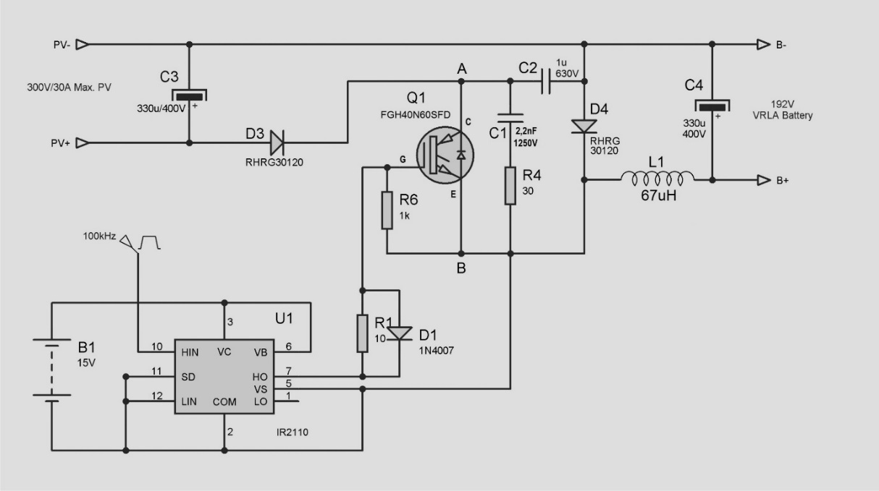
Figure 2 : Schematic diagram of PWM solar charge controller (Acharya & Aithal, 2020)

3.1.1 Basic Components:
- Solar Panel Input: Provides DC power (typically 12V or 24V, depending on the system design).
- Battery: Stores the energy from the solar panel.
- PWM Controller (Microcontroller/IC): Controls the duty cycle to regulate power delivery to the battery.
- MOSFET: Acts as a switch to regulate the connection between the solar panel and the battery.
- Voltage Sensing Circuit: Monitors the battery voltage to adjust the PWM signal accordingly.
- Current Sense Circuit: Measures the current to ensure proper charging.
- Protection Circuit: Includes features like over-voltage, under-voltage, and over-temperature protection.

3.1.2 Steps Involved in PWM Solar Charge Controller Operation:

Solar Panel Provides Power

Voltage and Current Sensing

PWM Control and Duty Cycle Adjustment

Mosfet Switching

Battery Charging Regulation

3.2 MPPT CIRCUITRY
MPPT is a technique used in solar charge controllers to maximize the power output from solar panels. Unlike a PWM controller, which simply regulates the voltage to prevent overcharging, an MPPT controller dynamically adjusts the operating point of the solar panel to extract the maximum power available. MPPT algorithms track the maximum power point (MPP) of the solar panel, which varies with temperature, light intensity, and panel characteristics, and then adjust the load to match this point for optimal power transfer.
Figure 3 describes the schematic diagram of an MPPT solar charge controller consists of several key blocks, including a microcontroller or control circuitry, a MOSFET for switching, a battery voltage sensing circuit, and a solar panel input interface.

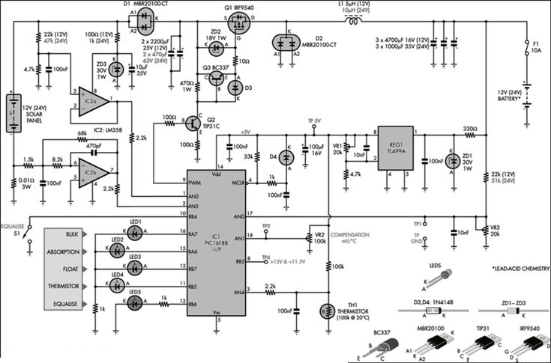
Figure 3: Schematic diagram of MPPT solar charge controller (Y.-H. Liu et al., 2005) (Acharya & Aithal, 2020).
MPPT-based charge controllers typically consist of the following components:
- Solar Panel Input: A PV array that generates power.
- MPPT Algorithm (Control Circuit): A microcontroller or specialized IC that runs the MPPT algorithm to compute the optimal power point.
- DC-DC Converter: A step-up (boost) or step-down (buck) converter, typically using a switching transistor (MOSFET), to adjust the voltage and current to match the battery charging requirements.
- Battery Storage: The battery or battery bank that stores the energy harvested from the solar panel.
- Voltage and Current Sensing: Measurement circuits that monitor the battery voltage, solar panel voltage, and current to optimize the system’s operation.
- Feedback Loop: A system that continuously monitors the solar panel’s performance and adjusts the operation of the DC-DC converter to ensure maximum power transfer.

3.2.1 Steps Involved in MPPT Operation

3.2.1.1 Solar Panel Voltage and Current Measurement
- The MPPT controller continuously monitors both the voltage (V) and current (I) of the solar panel.
- These measurements are used to calculate the power (P) being generated by the panel at any given time. Power is calculated as: P=V×I, P =IV

3.2.1.2 Determining the Maximum Power Point (MPP)
- The MPPT algorithm tracks the point at which the solar panel produces the maximum power. This point is often referred to as the maximum power point (MPP) and is the combination of voltage and current where the panel is most efficient.
Two common MPPT algorithms are:
  - Perturb and Observe (P&O): This method perturbs (slightly changes) the operating voltage and observes the resulting change in power. If power increases, it continues in that direction; if it decreases, it switches direction.
  - Incremental Conductance (IncCond): This algorithm compares the incremental changes in voltage and current to find the point where the derivative of power with respect to voltage is zero (indicating maximum power).
- The MPP is dynamic and changes based on environmental conditions such as sunlight intensity and temperature.

Adjusting the Operating Point Using a DC-DC Converter
- The MPPT controller uses the determined MPP (voltage and current values) to adjust the voltage at which the solar panel operates.
- The DC-DC converter adjusts the output from the solar panel to match the optimal voltage required by the battery. This can involve:
  - Step-down (buck) converters if the panel voltage is higher than the battery voltage.
  - Step-up (boost) converters if the panel voltage is lower than the battery voltage.
- The converter typically uses a MOSFET (Metal-Oxide-Semiconductor Field-Effect Transistor) as a switch, controlled by the MPPT algorithm.

Charging the Battery
- The DC-DC converter's output is used to charge the battery. The MPPT controller ensures that the battery receives the right voltage and current for efficient and safe charging.
- The charging process may consist of different stages:
  - Bulk Charge: High current charging until the battery reaches a certain voltage.
  - Absorption Charge: The current is reduced as the battery reaches its full charge voltage.
  - Float Charge: A low current is used to maintain the battery charge without overcharging.

3.3 SYSTEM CONFIGURATION
The basic block diagram in figure 4 consists of a PV cell, charge controllers, change over switch, battery, inverter, and load.
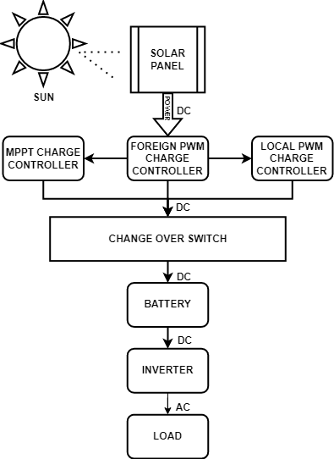
Figure 4: Schematic diagram of MPPT solar charge controller (Y.-H. Liu et al., 2005) (Acharya & Aithal, 2020).

3.3.1 SOLAR PANEL
Solar panels, also known as PV panels, are devices that convert sunlight directly into electricity through a process called the photovoltaic effect. These panels are a cornerstone of renewable energy technology, providing a clean, sustainable source of power for homes, businesses, and even large-scale power plants.
Solar panels consist of multiple solar cells made from semiconductor materials, typically silicon. When sunlight hits these cells, it excites electrons in the material, causing them to move and generate an electric current. This current is then captured and used as electricity.

3.3.1.1 Types of Solar Panels:
There are three main types of solar panels:
- Mono-crystalline Solar Panels: Made from a single continuous crystal structure. These are highly efficient and long-lasting but are generally more expensive.
- Polycrystalline Solar Panels: Made from silicon crystals that are melted together. These are slightly less efficient than mono-crystalline but more affordable.
- Thin-Film Solar Panels: Made from layers of photovoltaic material. These are flexible, lightweight, and can be used in a variety of applications, though they are generally less efficient than crystalline panels.
The table below shows the description of the solar panel used in the system configuration:
Table 2: Description of the solar panel used
Parameters | Value
Manufacturer | Sunshine solar
MODEL | POLYCRYSTALLINE
AM | 1.5
E | 1000w/m²
TC | 25⁰C
MAXIMUM POWER (PMAX) | 100W
OUTPUT TOLERANCE | $±$5%
CURRENT AT PMAX (IMP) | 5.15A
VOLTAGE AT PMAX (VMP) | 19.43V
SHORT CIRCUIT CURRENT (ISC) | 5.51A
OPEN CIRCUIT VOLTAGE (VOC) | 23.3V
MAXIMUM SYSTEM VOLTAGE | DC 1500V
MAXIMUM SERIES FUSE RATING | 20A

Figure 5 describes the pictorial view of 100W solar panel used in system configuration.
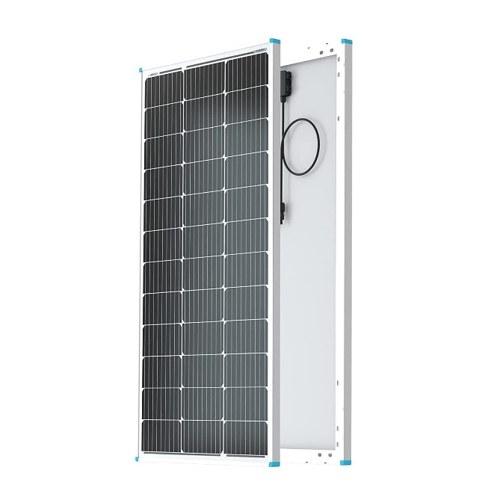
Figure 5: Solar panel (Belkaid et al., 2016)

3.3.2 MPPT SOLAR CHARGE CONTROLLER
A MPPT charge controller is an advanced type of solar charge controller that optimizes the power output from solar panels to charge a battery efficiently. It does this by constantly adjusting the voltage and current to find the maximum power point (MPP), where the combination of voltage and current delivers the most energy to the battery. MPPT technology maximizes the efficiency of the system, improving the charging speed and making better use of the available solar energy.
Table 3 shows the description of the MPPT charge controller used:
Table 3: Description of MPPT charge controller used
Parameters | Value
Rated voltage | 12V/24V
Rated current | 40A
Maximum PV voltage | 100V
Maximum PV input power | 520W(12V), 1040W(24V)

Figure 6 describes the pictorial view of a 40A MPPT controller used in the system configuration.

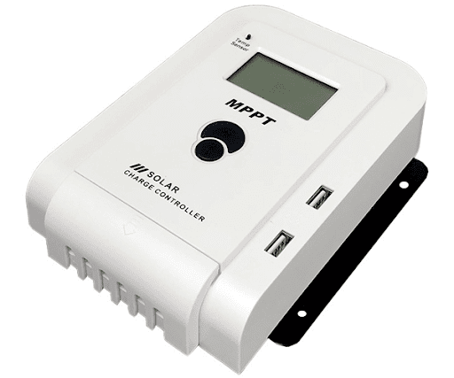
Figure 6: MPPT solar charge controller.

3.3.3 PWM SOLAR CHARGE CONTROLLER
A PWM Charge Controller is a crucial component in solar power systems, especially for managing the charging of batteries. It regulates the voltage and current from solar panels to the battery, ensuring optimal charging performance, safety, and longevity of the battery.
A PWM charge controller works by switching the connection between the solar panel and the battery on and off at a high frequency, thus controlling the amount of power going into the battery. The key here is the pulse width, the amount of time the controller is “on” (allowing power to pass to the battery) compared to when it is “off.”
- Pulse Width: The “on” time of the controller determines how much power is delivered to the battery. As the battery charges and its voltage rises, the controller adjusts the pulse width to lower the charge rate, ensuring that the battery is charged efficiently without being overcharged.
- Voltage Regulation: The controller ensures that the battery doesn’t receive too much voltage (which could damage it) by controlling the amount of energy that goes through based on the battery’s state of charge.
Table 4: Description of the PWM charge controller used.
Parameters | Value
Model | W88-B
Rated voltage | 12v/24v
Rated current | 30A
Maximum PV voltage | 50v
Maximum PV input power | 260W(12v)520W(24v)

Figure 7 describes the pictorial view of the 30A PWM solar charge controller used in the system configuration.

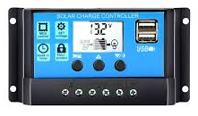
Figure 7: PWM charge controller.

3.3.4 LOCAL MADE PWM CHARGE CONTROLLER
Figure 8 describes the circuit diagram of a local made PWM solar charge controller consists of several key blocks, including a microcontroller or control circuitry, a MOSFET for switching, a battery voltage sensing circuit, and a solar panel input interface.

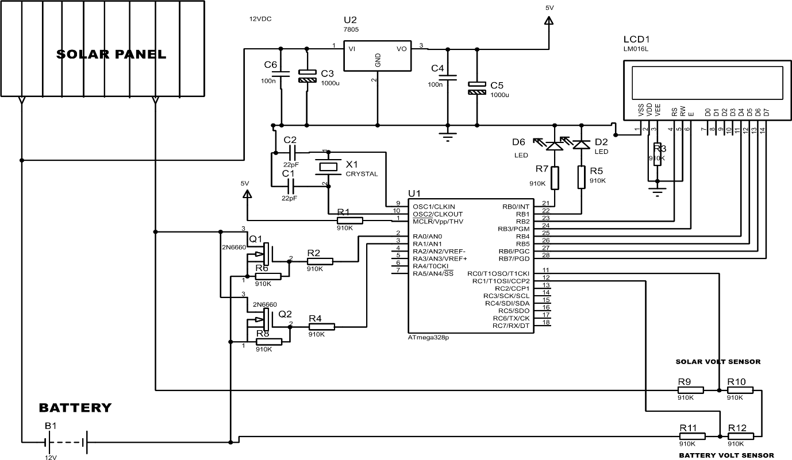
Figure 8: Locally made PWM charge controller circuit diagram.

Below is a detailed explanation of all the components in the schematic diagram and their functions:

Power Components

Solar Panel Input
- Function: Converts sunlight into DC electricity.
- Voltage Output: Typically 12V.
- Connection: Provides power to both the battery and the circuit.

Battery (B1 – 12V) Input
- Function: Stores energy from the solar panel.
- Usage: Supplies power when sunlight is unavailable.
- Connection: Powers the microcontroller and other circuit components through a voltage regulator.

Voltage Regulator (U2 – 7805)
- Function: Converts 12V DC from the solar panel/battery down to a stable 5V DC.
- Connections:
  - Input (Vin): Connected to 12V from the battery/solar panel.
  - Ground (GND): Common ground.
  - Output (Vout): Supplies 5V DC to the microcontroller and other low-voltage components.
- Capacitors (C3, C4, C5, C6):
  - C3 (10µF): Smooths input voltage.
  - C4 (0.1µF): Reduces noise.
  - C5 (100µF): Stabilizes output voltage.
  - C6 (100µF): Additional filtering.

Microcontroller Section

Microcontroller (U1 – Atmega328P)
- Function: The brain of the system. It processes voltage readings and displays them on the LCD.
- Key Pins:
  - VCC & GND: Power supply (5V).
  - Oscillator Pins (XTAL1, XTAL2): Connected to a 16MHz crystal oscillator (X1) for timing.
  - Analog Pins (ADC0, ADC1, etc.): Used to read voltages from sensors.
  - Digital Pins: Control LCD and LED indicators.

Crystal Oscillator (X1 – 16MHz)
- Function: Provides a stable clock signal for microcontroller operation.
- Capacitors (C1, C2 – 22pF): Used for frequency stability.

Sensor Section

a. Voltage Sensors (Resistor Dividers)
Used to measure voltages from the solar panel and battery.
- Solar Voltage Sensor (R9, R10):
  - Scales down the solar panel voltage for safe microcontroller input.
  - Example: If solar panel voltage is 12V, the divider reduces it to a range suitable for ADC (e.g., 0-5V).
- Battery Voltage Sensor (R11, R12):
  - Similar function for battery voltage monitoring.

Display Section

LCD Display (LCD1 – 16x2)
- Function: Displays real-time battery and solar voltage data.
- Connection:
  - Data Pins (D4-D7): Receive data from the microcontroller.
  - Control Pins (RS, EN): Used for LCD operation.
  - Power (VCC, GND): 5V supply.

LED Indicators

LED (D6, D2)
- Function: Status indicators.
- Current Limiting Resistor (R7 – 330Ω): Limits current to LEDs.

Transistor Circuit

Transistors (Q1, Q2 – 2N3904)
- Function: Likely used as electronic switches to control power flow or load connection.
- Resistors (R1, R2, R3, R4 – 1KΩ):
  - Used as pull-down or base resistors for transistors.

Working Principle Summary
- Power Flow:
  - The solar panel charges the battery.
  - The voltage regulator (7805) converts 12V to 5V.
  - The microcontroller and LCD operate at 5V.
- Voltage Sensing:
  - Voltage dividers reduce solar panel and battery voltage for safe ADC input.
  - The microcontroller reads the values.
- Data Display:
  - The LCD shows real-time voltage readings.
  - LEDs indicate system status.
- Transistor Switching:
  - Used for battery protection or load control.
Figure 9 and figure 10 describes the inner and outer view of the local made PWM solar charge controller, showing the main components and soldering processes involved.
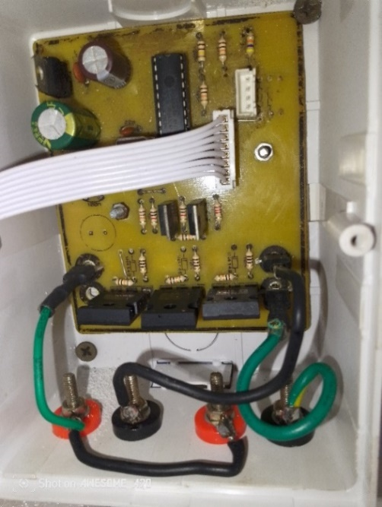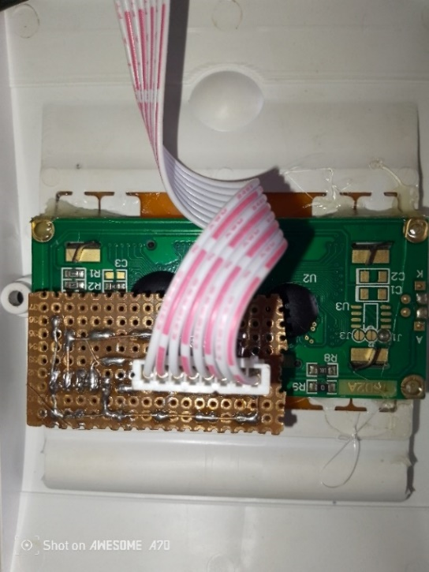
Figure 9: Inner view of the locally made charge controller.
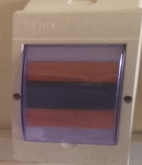
Figure 10: Outer view of the locally made charge controller

3.3.5 KNIFE SWITCH CHANGE OVER
A knife switch change-over is a manually operated electrical switch used to transfer power between two different sources or circuits. It consists of a metal blade (the “knife”) that pivots into or out of contact with stationary terminals to make or break a connection. This type of switch is commonly used in power distribution systems, laboratories, and industrial settings for isolating and switching circuits.
The knife switch change over allows switching between two power sources (such as a main supply and a generator) by manually shifting the blade between two sets of terminals. When the blade is in one position, power flows from the corresponding source. Moving it to the other position transfers power to the second source. In the situation of this project, an 100A knife switch change-over was used to switch power between the foreign MPPT, foreign PWM and locally made PWM charge controllers which would be supplied to the battery.
The figure 11 describes the pictorial view of 100A knife switch change over, showing the switching operations from one source to another.

Figure 11: knife switch changeover (Amrouche et al., 2000)

3.3.6 LITHIUM BATTERY
A lithium-ion (Li-ion) battery is a type of rechargeable battery that uses lithium ions to store and transfer energy. It is widely used in consumer electronics, electric vehicles, renewable energy systems, and industrial applications due to its high energy density, long lifespan, and lightweight design. A lithium-ion battery consists of three main components:
- Anode (Negative Electrode): Usually made of graphite, it stores lithium ions when the battery is charged.
- Cathode (Positive Electrode): Typically made of lithium metal oxides (like lithium cobalt oxide or lithium iron phosphate), it releases lithium ions during discharge.
- Electrolyte: A liquid or solid substance that allows lithium ions to move between the anode and cathode.
During charging, lithium ions move from the cathode to the anode through the electrolyte, storing energy.
During discharging, the ions move back to the cathode, releasing stored energy to power devices.

Types of Lithium Batteries
- Lithium Cobalt Oxide (LiCoO₂) – Used in smartphones, laptops, and cameras.
- Lithium Iron Phosphate (LiFePO₄) – Safer, with a longer lifespan, used in power tools and electric vehicles.
- Lithium Manganese Oxide (LiMn₂O₄) – Common in medical devices and power tools.
- Lithium Nickel Manganese Cobalt Oxide (LiNiMnCoO₂ or NMC) – Popular in EVs and energy storage.
- Lithium Titanate (Li₄Ti₅O₁₂ or LTO) – Ultra-fast charging and long lifespan, used in specialized applications.
In this project, a lithium cobalt oxide type of lithium ion battery was used. Each battery rated at 3.7v, 650maH. Three pieces of the battery were connected in series to produce a voltage rating of 11.1v and current per hour of 650maH. Having two of the three pieces of the series connection being connected parallel to each other in other to produce a voltage rating of 11.1v and current per hour rating of 1300maH.
Figure 12 describes the pictorial view of a 3.7v, 650maH lithium ion battery used in the system configuration.

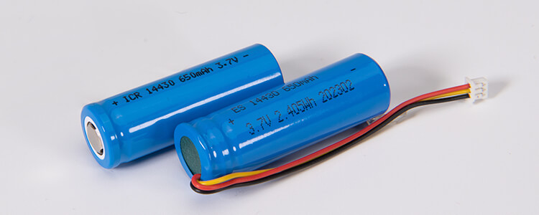
Figure 12: lithium batteries (Singh et al., 2023).

3.3.7 INVERTER
An inverter is an electrical device that converts direct current (DC) power into alternating current (AC) power. It is widely used in various applications, including home power backup systems, solar energy systems, and automotive power supplies. Since most household appliances and electronic devices operate on AC power, inverters play a crucial role in ensuring an uninterrupted power supply during outages or in off-grid locations. A 500W inverter is a power conversion device that transforms DC (Direct Current) power from a battery (such as a car or solar battery) into AC (Alternating Current) power, which is commonly used to run household or electronic devices. It is a compact and efficient solution for powering small appliances, tools, and electronic gadgets in areas where direct AC power is unavailable.
The inverter takes DC input from a 12V or 24V battery and converts it into standard 110V or 220V AC output, depending on the region and device requirements. It does this through electronic circuits that modify the voltage and frequency of the output current.
Figure 13 describes the pictorial view of 500W, inverter used in the system configuration.

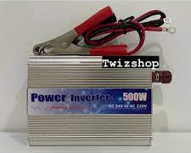
Figure 13: 500W power inverter (Petri et al., 2022).

3.3.8 AC LOAD
An AC load refers to any electrical device or appliance that operates on Alternating Current (AC) power. AC loads are commonly found in homes, industries, and commercial buildings since the standard electricity supply from power grids is in the form of AC. These loads consume electrical energy and convert it into useful work such as lighting, heating, cooling, or mechanical motion.

3.3.9 13A SOCKET OUTLET
A 13A socket outlet is a standard electrical power outlet designed to provide 13 amperes (A) of current at a specific voltage (typically 230V AC in the UK and many other countries). It is widely used in homes, offices, and commercial buildings to power a variety of electrical appliances and devices.
Figure 14 describes the pictorial view of the 13A socket outlet used in the system configuration.

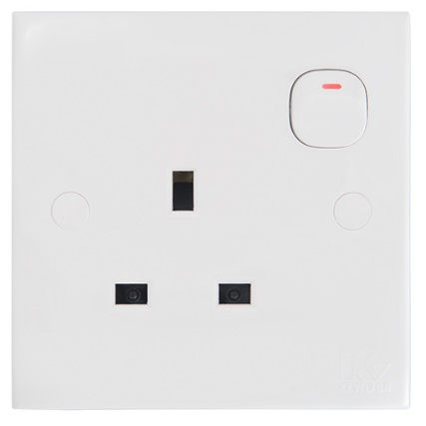
Figure 14: 13A socket outlet (Kim et al., 2020).

3.3.10 LAMPHOLDER
A lampholder is an electrical device designed to securely hold and connect a light bulb to an electrical circuit. It provides both mechanical support and electrical contact to allow the bulb to function properly. Lampholders are widely used in homes, offices, industries, and outdoor lighting applications.
Figure 15 describes the pictorial view of the lampholder used in the system configuration.

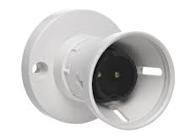
Figure 15: lampholder (Kim et al., 2020).

3.3.11 LED BULB
An LED (Light Emitting Diode) bulb is an energy-efficient lighting solution that uses semiconductor technology to produce light. Unlike traditional incandescent or CFL bulbs, LED bulbs consume less power, have a longer lifespan, and provide brighter illumination. They are widely used in residential, commercial, and industrial lighting applications due to their efficiency and durability.
Figure 16 describes the pictorial view of the 5W LED bulb used in the system configuration.

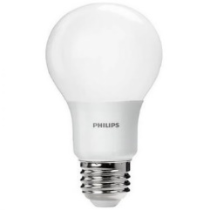
Figure 16: led bulb (Kim et al., 2020).

3.3.12 DC CABLE
A DC cable is an electrical cable designed to carry direct current (DC) power between components in a circuit. DC cables are commonly used in solar power systems, battery connections, automotive wiring, telecommunications, and industrial applications where direct current is required.
Figure 17 describes the pictorial view of the DC cable used in the system configuration.

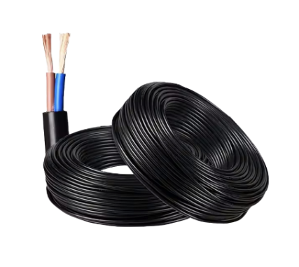
Figure 17: 6mm DC cable (Bruzek et al., 2015).

3.3.13 AC CABLE
An AC (Alternating Current) cable is an electrical cable designed to transmit alternating current (AC) power from a power source to electrical devices or systems. AC cables are widely used in household wiring, industrial power distribution, commercial buildings, and power transmission networks due to the global reliance on AC power systems.
Figure 18 describes the pictorial view of the AC cable used in the system configuration, showing the conductor strand and the insulation around the stranded conductor.

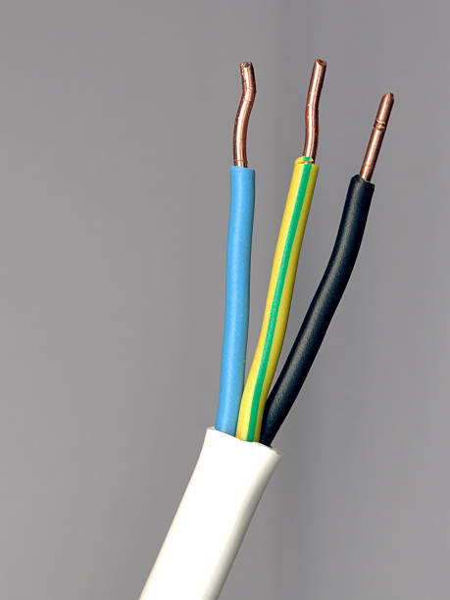
Figure 18: Ac cable (Amrouche et al., 2000).

Figure 19 describes the system installations and workability:
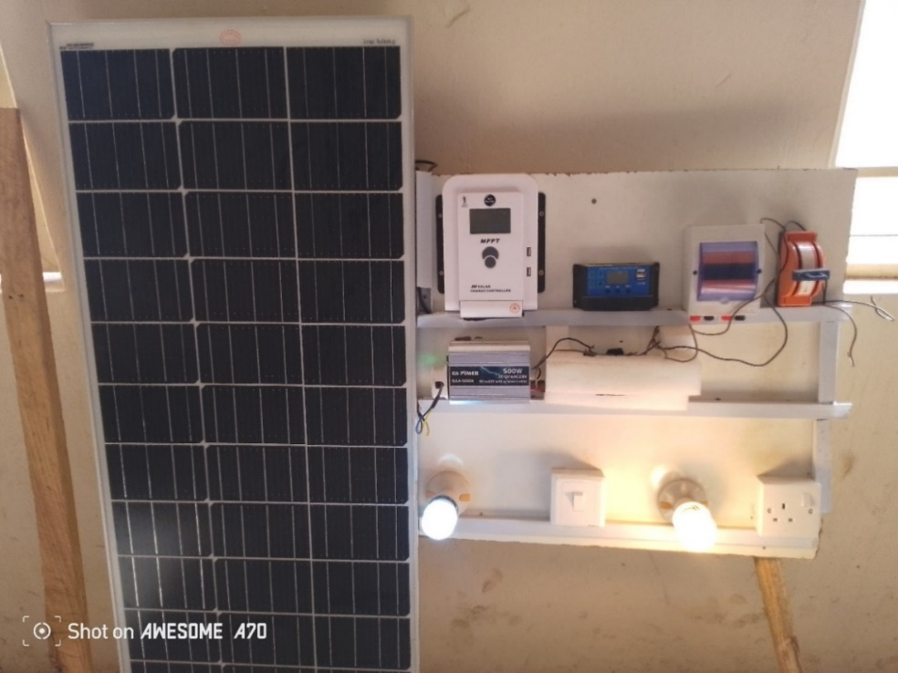
Figure 19: System installation and workability.

3.4 SUMMARY
This section consist of the method and materials used in design, construction, simulation and installation of a prototype stand-alone PV solar system. The system configuration consists of an 100W solar panel, 40A MPPT solar charge controller, 30A foreign PWM solar charge controller, 30A locally made PWM solar charge controller, 100A knife switch change over, 12volts lithium ion batteries, 500W power inverter, 13A socket outlet, lamp holders and led bulb. The solar panel convert electricity from the sun into electricity and passes through the charge controller for regulation before getting to the battery bank which then powers the inverter to supply the Ac load.

CHAPTER FOUR

4.0 TEST AND RESULTS
This section outlines the experimental setup, methodologies, and procedures used to evaluate the efficiencies of the charge controllers. The results are analyzed to address the hypotheses posed in the introduction.
The experimental data shown in the tables below represent the experimental data of voltage, current, and power for the solar panel, foreign MPPT charge controller, foreign PWM charge controller, and locally made PWM charge controller. From this tested value, the overall efficiency of these parameters was determined.
Table 5: The results of voltage, current and power of the 100w solar panel
Time (hrs) | Voltage (V) | Current (A) | Output power (W)
10:45am | 14.5 | 2.08 | 30.16
11.45am | 15.0 | 2.26 | 33.9
12:45pm | 15.8 | 2.95 | 46.61
1:45pm | 16.3 | 3.59 | 58.517
2:45pm | 16.1 | 3.02 | 48.622
3:45pm | 15.6 | 2.92 | 45.552
4:45pm | 14.9 | 2.35 | 35.015
Choosing a constant value of the power of the solar panel at its peak value of 58.517 in order to calculate the efficiency of the solar panel at 1000w/m² . The results obtained is shown below:
$$Efficiency \left(\%\right)=\frac{Power output}{irradiance×area}×100$$
Where:
Power input = 100w
Area = 0.7432m²
$Efficiency \left(\%\right)=\frac{58.517}{1000×0.7432}×10$0
Efficiency (%) of the solar panel = 7.87% at the maximum irradiance of 1000W/m².
Table 6: The results of voltage, current, input power and output power of the MPPT solar charge controller with time.
Time | Voltage  (V) | Current (A) | Power input  (W) | Power output  (W) | Efficiency  (%)
10:45am | 12.2 | 1.13 | 30.16 | 13.786 | 45.7
11.45am | 13.0 | 1.56 | 33.9 | 20.28 | 61.3
12:45pm | 13.3 | 2.5 | 46.61 | 33.25 | 71.3
1:45pm | 14.2 | 3.2 | 58.517 | 45.44 | 77.6
2:45pm | 13.6 | 2.8 | 48.622 | 38.08 | 65.0
3:45pm | 13.2 | 2.2 | 45.552 | 29.04 | 49.6
4:45pm | 13.0 | 1.6 | 35.015 | 20.8 | 35.6

$$Efficiency \left(\%\right) of the MPPT=\frac{Power output}{power input}×100$$
Efficiency of MPPT controller ranges from (45-77.6)%
Figure 20 describes the graph representation of the power input, power output and efficiency of the MPPT solar charge controller.

Figure 20: The graph showing the power input, power output, and efficiency of the MPPT controller with time.

Table 7: The results of voltage, current, power input, power output and efficiency of the foreign PWM solar charge controller
Time | Voltage  (V) | Current (A) | Power input  (W) | Power output  (W) | Efficiency  (%)
10:45 am | 12.0 | 1.06 | 30.16 | 12.72 | 42.1
11.45 am | 12.6 | 1.32 | 33.9 | 16.63 | 49.06
12:45 pm | 13.0 | 1.9 | 46.61 | 24.7 | 52.9
1:45 pm | 13.2 | 1.8 | 58.517 | 23.76 | 40.6
2:45 pm | 13.5 | 1.5 | 48.622 | 20.25 | 41.64
3:45 pm | 12.9 | 21.7 | 45.552 | 21.93 | 37.4
4:45 pm | 12.4 | 1.2 | 35.015 | 14.88 | 25.3
$$Efficiency \left(\%\right)=\frac{Power output}{power input}×100$$
Efficiency of foreign PWM controller ranges from (42-55)%
Figure 21 describes the graph representation of the power input, power output and efficiency of the foreign PWM solar charge controller.

Figure 21: The graph showing the power input, power output and efficiency of the foreign PWM controller with time.

Table 8: The results of voltage, current, input power, output power and efficiency of the local PWM solar charge controller with time.
Time | Voltage  (V) | Current (A) | Power input  (W) | Power output  (W) | Efficiency  (%)
10:45 am | 12.0 | 1.08 | 30.16 | 12.96 | 42.9
11. 45am | 12.6 | 1.33 | 33.9 | 16.758 | 49.43
12:45 pm | 13.0 | 1.9 | 46.61 | 25.08 | 53.8
1:45 pm | 13.2 | 1.8 | 58.517 | 23.76 | 40.6
2:45 pm | 13.5 | 1.5 | 48.622 | 20.25 | 41.64
3:45 pm | 12.9 | 1.7 | 45.552 | 21.93 | 37.4
4:45 pm | 12.4 | 1.2 | 35.015 | 14.88 | 25.3

$$Efficiency \left(\%\right)=\frac{Power output}{power input}×100$$
Efficiency of local PWM controller ranges from (43-55)%
Figure 21 below shows the graph representation of the power input, power output and efficiency of the local PWM solar charge controller.

Figure 22: The graph showing the power input, power output and efficiency of the local PWM controller with time.

4.1 CHARGING AND DISCHARGING OF THE BATTERY
First of all, the charging current for 1300mAh battery was calculated. As we know that charging current should be 10% of the Ah rating of battery.
Therefore,
Charging current for 1300mAh Battery I $=1300mAh×({10}/{100})$
$I=0.13Amps$.
But due to some losses, 0.13 – 0.15 Amperes for batteries charging purpose instead of 0.13Amps was considered.
Battery Charging Time:
Taking 0.13 Amp for charging purpose,
Then,$$Charging time for 1300mAh battery =\frac{1300mAh}{0.13}=10hours$$
Practically, it has been noted that 40% of losses occurs in case of battery charging.
Then:
$1300mAh×\left({40}/{100}\right)$= 0.52mAh
Therefore, 1300+ 0.52 = 1300.52mAh (1300mAh + Losses)
Now Charging Time of battery = Ah ÷ Charging Current
Putting the values;
1300.52mAh ÷ 0.13 = 10.004hrs
Therefore, the 1300mAh battery would take 10 Hours to fully charge in case of the required 0.13A charging current.

Calculating Discharge Time:
Formula:
$Discharge time\left(hours\right)=battery capacity$÷$current drawn$.
A 1300mAh battery with an 800mAh load:
$$discharge time(hours) =\frac{1300mAh}{800mAh}=1.625hrs$$
Calculating Depth of Discharge (DoD):
$$DoD (\%) =\frac{discharge capacity}{total capacity}×100$$
1300mAh battery discharges 800mAh:
$$DoD (\%) =\frac{800mAh}{1300mAh}×100$$
$DoD \left(\%\right)=61.54$
DoD is a percentage indicating how much of the battery’s capacity has been used.

4.2 EFFICIENCY OF THE INVERTER
Experimental data shown below shows the experimented data of the inverter, from this tested value, the efficiency of the inverter was determined.
In determining the efficiency of the inverter:
$$\text{Watt-hour (Wh) of the battery =}\frac{\text{mAh×Voltage (V)}}{1000}\text{​}$$
$$\text{Watt-hour (Wh) of the battery =}\frac{\text{1300×12}}{1000}\text{​}$$
$\text{Watt-hour (Wh) of the battery}$ $\text{=}$ 15.6Wh
Energy Supplied to Load
The load of 28W was powered for 30 minutes = 0.5 hours, so:
Energy Supplied=28W×0.5h=14Wh
$$Efficiency \left(\%\right)=\frac{ Power output}{ power input }×100$$
$Efficiency \left(\%\right)=\frac{14Wh}{15.6wh}×10$0
Efficiency (%) of the inverter = 89.7%.
Figure 23 and figure 24 describes the waveform quality of the high frequency inverter and low frequency inverter, showing the frequency, volt per division and other parameters.

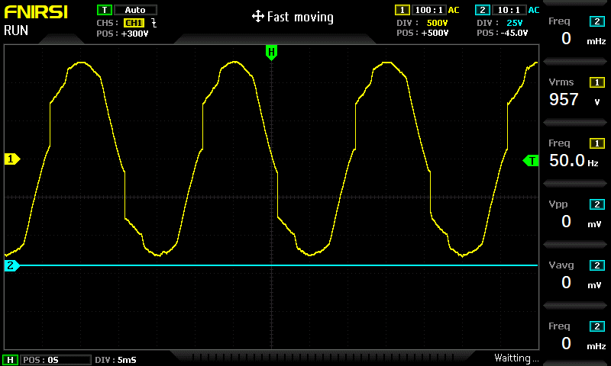
Figure 23: Waveform quality of the high frequency inverter.

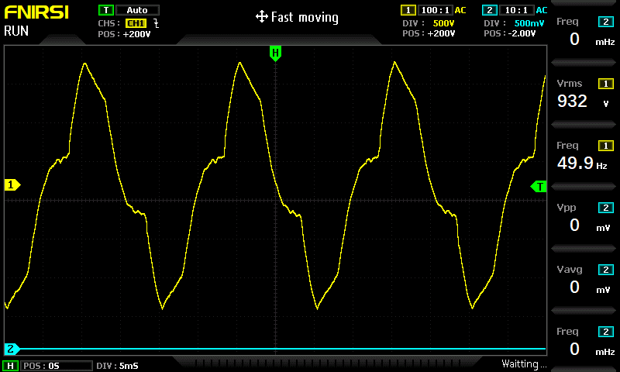
Figure 24: Waveform quality of the low frequency inverter.

4.3 OVERALL EFFICIENCY OF THE SOLAR SYSTEM
$$\text{Efficiency of the system with the MPPT controller}$$
$Efficiency \left(\%\right)=0.58×0.77×$ 0.89
Efficiency (%) = 39.7%.
Efficiency of the system with the foreign PWM controller
$Efficiency \left(\%\right)=0.58×0.55×$ 0.89
Efficiency (%) = 28.4%.
Efficiency of the system with the local PWM controller
$Efficiency \left(\%\right)=0.58×0.55×$ 0.89
Efficiency (%) = 28.4%.

4.4 SUMMARY
This section outlines the test carried out and the results obtained through the installation. The voltage and current of each device was measured carefully and was used to calculate the power and efficiency. The efficiency of the MPPT solar charge controller ranging from (25-78%), while the efficiency of the PWM solar charge controller ranging from (24-53%) both foreign and locally made. The charging hours for the 1300mAh battery under a charging current of 0.13A is estimated to be 10hrs while the battery discharges in 1.6hrs, making the depth of discharge (DoD) to be approximately 61.54%. The efficiency of the inverter used achieved 89.7% making it efficient in powering AC loads.

CHAPTER FIVE

5.0 CONCLUSION
In this project, a simple and efficient PWM solar charge controller is designed and installed for a PV system. The design uses pulse width modulation technology to adjust the charging rate of the battery by rapidly switching the connection between the solar panel and the battery ON and OFF. It also modulates the width (duration) of the pulse of current sent to the battery depending on the battery’s charge level. The PWM controllers employ a three-stage charging process, such as bulk charging, absorption charging, and float charging. The model is installed, connecting different parts such as the PV system, changeover switch, battery, inverter, and load. The designed PWM solar charge controller was put to the test in efficiency with the other two solar charge controllers. During the test conducted, it was noticed that the MPPT solar charge controller is more efficient and works more than the PWM due to the fact that it charges and delivers current at a faster rate. However, the PWM was also noticed to be efficient but at a lesser rate compared to the MPPT controller and also works more as a controller due to the fact that it regulates power more efficiently than the MPPT solar charge controller.

5.1 RECOMMENDATION
Based on the analysis and experimental results of the PWM and MPPT solar charge controllers, the following recommendations are proposed for optimal solar charge controller selection and future improvements:
- Use PWM controllers for small scale or budget constrained system
- MPPT controllers is preferable for high power or variable conditions
- Future designs could integrate adaptive PWM/MPPT switching to balance cost and efficiency based on real time conditions.
- Research into low cost MPPT algorithms (e.g; perthub & observe optimization) could make MPPT more accessible.
- Implementing temperature compensation in PWM designs to enhance battery charging accuracy.
- Implementation of more than one solar panel in the installation setup.

APPENDIX I
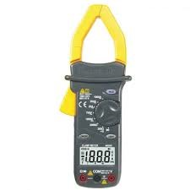
DIGITAL MULTIMETER
PLIER

CUTTER

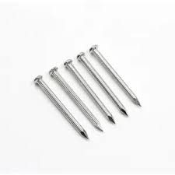
PVC TRUNKING PIPE

TORNADO NAIL

MEASURING TAPE

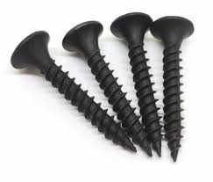
SCREW DRIVER

BLACK SCREW

APPENDIX II
BILL OF ENGINEERING AND MEASUREMENT EVALUATION (BEME)
S/N | MATERIAL | UNIT | COST/UNIT(#) | AMOUNT (#)
1 | 100WATT SOLAR PANEL | 1 | 80,000 | 80,000
2 | 40A MPPT SOLAR CHARGE CONTROLLER | 1 | 75,000 | 75,000
3 | 30A PWM SOLAR CHARGE CONTROLLER | 1 | 70,000 | 70,000
4 | 40A LOCAL MADE PWM SOLAR CHARGE CONTROLLER | 1 | 90,000 | 90,000
5 | 100A KNIFE SWITCH CHANGE OVER | 1 | 5,000 | 5,000
6 | LITHIUM ION BATTERIES | 4 | 10,000 | 40,000
7 | 500 WATTS INVERTER | 1 | 120,000 | 120,000
8 | 13A SOCKET OUTLET | 1 | 5,000 | 5,000
9 | 3 BY 3 PATRESS | 1 | 1,000 | 1,000
10 | LAMPHOLDER | 2 | 500 | 1,000
11 | 5W LED BULB | 2 | 1,000 | 2,000
12 | 4MM DC CABLE | 4 length | 500 | 2,000
13 | 2.5MM AC CABLE | 5 length | 500 | 2,500
14 | 1.5MM AC CABLE | 6 length | 300 | 1,800
15 | TRUNK PIPE | 1 | 2,000 | 2,000
16 | AC PLUG | 1 | 500 | 500
17 | BLACK SCREW | 1 packet | 500 | 500
 | TOTAL AMOUNT | - | - | 498, 300

APPENDIX III
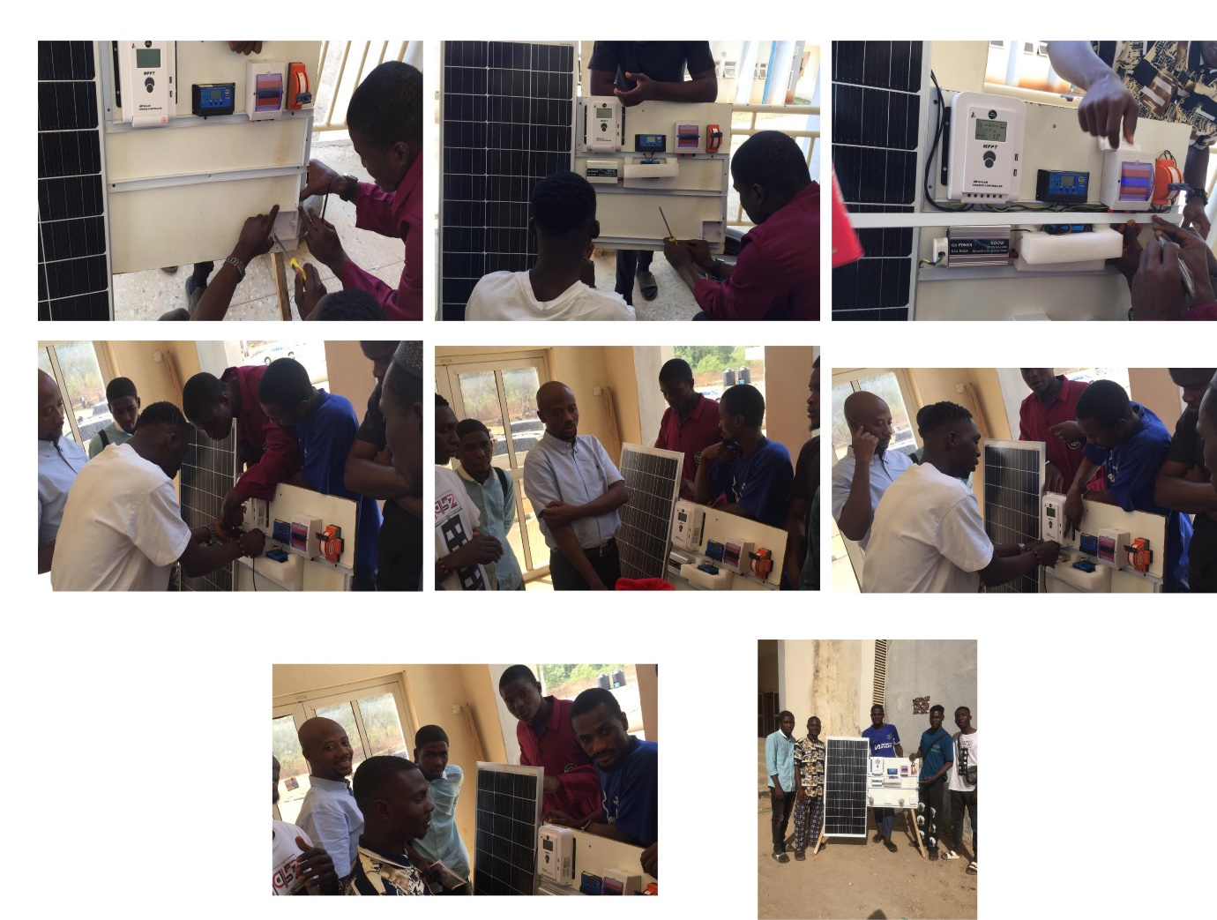

REFERENCES
Abdul-Ganiyu, S., Quansah, D. A., Ramde, E. W., Seidu, R., & Adaramola, M. S. (2021). Techno-economic analysis of solar photovoltaic (PV) and solar photovoltaic thermal (PVT) systems using exergy analysis. Sustainable Energy Technologies and Assessments, 47, 101520. https://doi.org/10.1016/j.seta.2021.101520
Acharya, P. S., & Aithal, P. S. (2020). A Comparative Study of MPPT and PWM Solar Charge Controllers and their Integrated System. Journal of Physics: Conference Series, 1712(1), 012023. https://doi.org/10.1088/1742-6596/1712/1/012023
Amrouche, S. O., Belhamel, M., Malek, A., & Maafi, A. (2000). Chapter 164—DC/AC Solar Inverter for Solar Applications. In A. A. M. Sayigh (Ed.), World Renewable Energy Congress VI (pp. 821–824). Pergamon. https://doi.org/10.1016/B978-008043865-8/50164-1
Ang, T.-Z., Salem, M., Kamarol, M., Das, H. S., Nazari, M. A., & Prabaharan, N. (2022). A comprehensive study of renewable energy sources: Classifications, challenges and suggestions. Energy Strategy Reviews, 43, 100939. https://doi.org/10.1016/j.esr.2022.100939
Arsad, A. Z., Zuhdi, A. W. M., Azhar, A. D., Chau, C. F., & Ghazali, A. (2025). Advancements in maximum power point tracking for solar charge controllers. Renewable and Sustainable Energy Reviews, 210, 115208. https://doi.org/10.1016/j.rser.2024.115208
Belkaid, A., Colak, I., & Isik, O. (2016). Photovoltaic maximum power point tracking under fast varying of solar radiation. Applied Energy, 179, 523–530.
Bhatt, R., Kravchenko, I., & Gupta, M. (2020). High-efficiency solar thermophotovoltaic system using a nanostructure-based selective emitter. Solar Energy, 197, 538–545. https://doi.org/10.1016/j.solener.2020.01.029
Bruzek, C. E., Allais, A., Dickson, D., Lallouet, N., Allweins, K., & Marzahn, E. (2015). 7 - Superconducting DC cables to improve the efficiency of electricity transmission and distribution networks: An overview. In J.-L. Bessède (Ed.), Eco-Friendly Innovation in Electricity Transmission and Distribution Networks (pp. 135–167). Woodhead Publishing. https://doi.org/10.1016/B978-1-78242-010-1.00007-0
Chen, Y., & Xu, D. (2022). Review of Soft-Switching Topologies for Single-Phase Photovoltaic Inverters. IEEE Transactions on Power Electronics, 37(2), 1926–1944. IEEE Transactions on Power Electronics. https://doi.org/10.1109/TPEL.2021.3106258
Du, Y., & Lu, D. D.-C. (2010). Analysis of a battery-integrated boost converter for module-based series connected photovoltaic system. The 2010 International Power Electronics Conference - ECCE ASIA -, 694–698. https://doi.org/10.1109/IPEC.2010.5543655
Esram, T., & Chapman, P. L. (2007). Comparison of Photovoltaic Array Maximum Power Point Tracking Techniques. IEEE Transactions on Energy Conversion, 22(2), 439–449. IEEE Transactions on Energy Conversion. https://doi.org/10.1109/TEC.2006.874230
Hussein, K. H. (1995). Maximum photovoltaic power tracking: An algorithm for rapidly changing atmospheric conditions. IEE Proceedings - Generation, Transmission and Distribution, 142(1), 59. https://doi.org/10.1049/ip-gtd:19951577
auMaAxP6Iy14l1tWa1Mc4in1LJnlGHrrWWkqY4AnniLOyjEuuwYg__&Key-Pair-Id=APKAJLOHF5GGSLRBV4ZA
K, P., & Vijayaraj, D. S. (2020a). An Overview of Battery Charging Methods, Charge Controllers, and Design of MPPT Controller based on Adruino Nano for Solar Renewable Storage Energy System. International Journal of Engineering Research & Technology, 9(11). https://doi.org/10.17577/IJERTV9IS110214
K, P., & Vijayaraj, D. S. (2020b). An Overview of Battery Charging Methods, Charge Controllers, and Design of MPPT Controller based on Adruino Nano for Solar Renewable Storage Energy System. International Journal of Engineering Research & Technology, 9(11). https://doi.org/10.17577/IJERTV9IS110214
Kantibhai, G. S., & Kumar, S. (2020). PERFORMANCE ANALYSIS OF INC BASED MPPT FOR PV SYSTEM. International Journal of Technical Research & Science, Special(Issue2), 17–24. https://doi.org/10.30780/specialissue-electricalsystem/003
Kim, K. C., Kim, D. H., Kim, S. C., & Kim, J. H. (2020). Analysis of Thermal Characteristics and Insulation Resistance Based on the Installation Year and Accelerated Test by Electrical Socket Outlets. Safety and Health at Work, 11(4), 405–417. https://doi.org/10.1016/j.shaw.2020.06.004
Koutroulis, E., Kalaitzakis, K., & Voulgaris, N. C. (2001). Development of a microcontroller-based, photovoltaic maximum power point tracking control system. IEEE Transactions on Power Electronics, 16(1), 46–54. https://doi.org/10.1109/63.903988
Liu, Y., Tolbert, L. M., Kritprajun, P., Dong, J., Zhu, L., Hambrick, J., Schneider, K. P., & Prabakar, K. (2020). Aging Effect Analysis of PV Inverter Semiconductors for Ancillary Services Support. IEEE Open Journal of Industry Applications, 1, 157–170. IEEE Open Journal of Industry Applications. https://doi.org/10.1109/OJIA.2020.3028647
Liu, Y.-H., Leou, R.-C., & Cheng, J.-S. (2005). Design and implementation of a maximum power point tracking battery charging system for photovoltaic applications. 2005 IEEE Russia Power Tech, 1–5. https://doi.org/10.1109/PTC.2005.4524349
LokeshReddy, M., Kumar, P. J. R. P., Chandra, S. A. M., Babu, T. S., & Rajasekar, N. (2017). Comparative study on charge controller techniques for solar PV system. Energy Procedia, 117, 1070–1077. https://doi.org/10.1016/j.egypro.2017.05.230
Martins, M. L. D. S. (2018). Series-Connected Partial-Power Converters Applied to PV Systems: A Design Approach Based on Step-Up/Down Voltage Regulation Range. IEEE Transactions on Power Electronics. https://www.academia.edu/89220270/Series_Connected_Partial_Power_Converters_Applied_to_PV_Systems_A_Design_Approach_Based_on_Step_Up_Down_Voltage_Regulation_Range
MKDas. (2021, March 31). PWM Solar Charge Controller with PIC12F675. Lab Projects BD. https://labprojectsbd.com/2021/03/31/pwm-solar-charge-controller-with-pic12f675/
Morey, M., Gupta, N., Garg, M. M., & Kumar, A. (2023). A comprehensive review of grid-connected solar photovoltaic system: Architecture, control, and ancillary services. Renewable Energy Focus, 45, 307–330. https://doi.org/10.1016/j.ref.2023.04.009
Murtaza, A. F., Sher, H. A., Chiaberge, M., Boero, D., Giuseppe, M. D., & Addoweesh, K. E. (2012). A novel hybrid MPPT technique for solar PV applications using perturb & observe and Fractional Open Circuit Voltage techniques. Proceedings of 15th International Conference MECHATRONIKA, 1–8. https://ieeexplore.ieee.org/document/6415078
Nixon, J. D., Bhargava, K., Halford, A., & Gaura, E. (2021). Analysis of standalone solar streetlights for improved energy access in displaced settlements. Renewable Energy, 177, 895–914. https://doi.org/10.1016/j.renene.2021.05.105
Ozdemir, S., Altin, N., & Sefa, I. (2012). Single stage three-level MPPT inverter for solar supplied systems. International Symposium on Power Electronics Power Electronics, Electrical Drives, Automation and Motion, 103–108. 2012 International Symposium on Power Electronics, Electrical Drives, Automation and Motion (SPEEDAM 2012). https://doi.org/10.1109/SPEEDAM.2012.6264559
Pan, J., Wang, C., & Hong, F. (2009). Research of photovoltaic charging system with maximum power point tracking. 2009 9th International Conference on Electronic Measurement & Instruments, 4-478-4–481. https://doi.org/10.1109/ICEMI.2009.5274013
Parida, B., Iniyan, S., & Goic, R. (2011). A review of solar photovoltaic technologies. Renewable and Sustainable Energy Reviews, 15(3), 1625–1636. https://doi.org/10.1016/j.rser.2010.11.032
Petri, T., Keller, M., & Parspour, N. (2022). The Insulation Resilience of Inverter-Fed Low Voltage Traction Machines: Review, Challenges, and Opportunities. IEEE Access, 10, 104023–104049. IEEE Access. https://doi.org/10.1109/ACCESS.2022.3210348
Robles, E., Fernandez, M., Andreu, J., Ibarra, E., & Ugalde, U. (2021). Advanced power inverter topologies and modulation techniques for common-mode voltage elimination in electric motor drive systems. Renewable and Sustainable Energy Reviews, 140, 110746. https://doi.org/10.1016/j.rser.2021.110746
School of Electrical Engineering, KIIT University, Bhubaneshwar-751024, Odisha, India, Pradhan, A., Dr S.M Ali, D. S. M. A., & Dash, R. (2011). A Comparative Study of Perturb-Observance Method and Incremental Conductance Method. Indian Journal of Applied Research, 3(5), 206–208. https://doi.org/10.15373/2249555X/MAY2013/62
Serrano, M. A. L.-, Paipa, E. A. L., Márquez, L. F. B.-, & Mora, S. B. S.-. (2019). Performance comparison between PWM and MPPT charge controllers. Scientia Et Technica, 24(1), 6–11.
Sharma, M., Sharma, S., Sharma, G., & Mehta, S. (2015). A Neuro-Fuzzy Approach based MPPT for Mutli- Junction Photo-Voltaic Arrays. 3.
Singh, A., Pal, K., & Vishwakarma, C. B. (2023). State of charge estimation techniques of Li-ion battery of electric vehicles. E-Prime - Advances in Electrical Engineering, Electronics and Energy, 6, 100328. https://doi.org/10.1016/j.prime.2023.100328
Wang, C., Chen, W., Shao, S., Chen, Z., Zhu, B., & Li, H. (2011). Energy Management of Stand-Alone Hybrid PV System. Energy Procedia, 12, 471–479. https://doi.org/10.1016/j.egypro.2011.10.063
Xiao, W., Ozog, N., & Dunford, W. G. (2007). Topology Study of Photovoltaic Interface for Maximum Power Point Tracking. IEEE Transactions on Industrial Electronics, 54(3), 1696–1704. IEEE Transactions on Industrial Electronics. https://doi.org/10.1109/TIE.2007.894732
Xue, J. (2017). Photovoltaic agriculture—New opportunity for photovoltaic applications in China. Renewable and Sustainable Energy Reviews, 73, 1–9. https://doi.org/10.1016/j.rser.2017.01.098
Yuvarajan, S., & Xu, S. (2003). Photo-voltaic power converter with a simple maximum-power-point-tracker. 2003 IEEE International Symposium on Circuits and Systems (ISCAS), 3, III–III. https://doi.org/10.1109/ISCAS.2003.1205040
Zhao, Z., Xu, M., Chen, Q., Lai, J.-S., & Cho, Y. (2012). Derivation, Analysis, and Implementation of a Boost–Buck Converter-Based High-Efficiency PV Inverter. IEEE Transactions on Power Electronics, 27(3), 1304–1313. IEEE Transactions on Power Electronics. https://doi.org/10.1109/TPEL.2011.2163805

