DEVELOPMENT OF AI BASED DIET AND EXERCISE APPLICATION

BY
OLADIGBO JAMES DAMILARE
HND/23/COM/FT/0450

A Project Submitted to the Department of Computer Science, Institute of Information and Communication Technology, Kwara State Polytechnic, Ilorin

In Partial Fulfillment of the Requirements for the Award of Higher National Diploma (HND) in Computer Science

July, 2025
CERTIFICATION
This is to certify that this project was carried out by OLADIGBO, James Damilare with matric number HND/23/COM/FT/0450, has part of the requirements for the award of Higher National Diploma (HND) in Computer Science.

………………………………. ……………………………….
Mr. Saka T.O. Date
(Project Supervisor)

………………………………. ……………………………….
Mr. Oyedepo, F. S. Date
(Head of Department)

………………………………. ……………………………….
External Examiner Date

DEDICATION
This project is dedicated to the creator of the earth and universe, the Almighty God. It is also dedicated to my parents for their moral and financial support.

ACKNOWLEDGEMENT
All praise is due to the Almighty God the Lord of the universe. I praise Him and thank Him for giving me the strength and knowledge to complete my HND programme and also for my continue existence on the earth.
I appreciate the utmost effort of my supervisor, Mr. Saka T.O, whose patience support and encouragement have been the driving force behind the success of this research work. He gave useful corrections, constructive criticisms, comments, recommendations, advice and always ensures that an excellent research is done. My sincere gratitude goes to the Head of the Department and other members of staff of the Department of Computer Science, Kwara State Polytechnic, Ilorin, for their constant cooperation, constructive criticisms and encouragements throughout the programme.
Special gratitude to my parents who exhibited immeasurable financial, patience, support, prayers and understanding during the periods in which I was busy tirelessly in my studies. Special thanks go to all my lovely siblings.
My sincere appreciation goes to my friends and classmates.

TABLE OF CONTENTS
Title Page i
Certification ii
Dedication iii
Acknowledgements iv
Abstract v
Table of Contents vi
CHAPTER ONE: GENERAL INTRODUCTION
  - Background to the Study 1
  - Aim and Objectives of the Study 3
  - Statement of the Problem 3
  - Significance of the Study 4
  - Scope of the Study 4
  - Organization of the Report 5
CHAPTER TWO: LITERATURE REVIEW
2.1 Review of Related Works 7
2.2 Overview of an Exercise 11
2.3 Overview of Diet 11
2.4 Artificial Intelligence 12
2.5 Machine Learning Overview 12
2.6 Artificial Intelligence in Diet and Exercise Application 13

CHAPTER THREE: RESEARCH METHODOLOGY AND ANALYSIS OF THE EXISTING SYSTEM
  - Research Methodology 14
  - Analysis of the Existing System 15
  - Problems of the Existing System 15
  - Description of the Proposed System 16
  - Advantages of the proposed system 16
CHAPTER FOUR: DESIGN, IMPLEMENTATION AND DOCUMENTATION OF THE SYSTEM
  - Design of the System 18
    - Output Design 18
    - Input Design 21
    - Procedure Design 24
  - Implementation of the System 25
    - Hardware Support 25
    - Software Support 26
  - Documentation of the System 26
    - Maintaining the System 27
CHAPTER FIVE: SUMMARY, CONCLUSION AND RECOMMENDATIONS
  - Summary 28
  - Conclusion 28
  - Recommendations 29
References 30
Appendices

ABSTRACT
In the era of technological advancements, the integration of Artificial Intelligence (AI) in various aspects of daily life has become increasingly prevalent. This project presents the development and implementation of an AI-based diet and exercise application aimed at promoting personalized health and wellness management. The application utilizes machine learning algorithms to analyze user data, including dietary preferences, health conditions, fitness goals, and activity levels, to generate tailored diet plans and exercise routines. The development process involves several stages, beginning with data collection through user input and integration with wearable devices to gather real-time health metrics. Subsequently, the collected data undergoes analysis using AI algorithms, including natural language processing and predictive modeling, to provide personalized recommendations. These recommendations encompass dietary suggestions, meal plans, calorie tracking, and exercise regimens tailored to individual needs and preferences. The efficacy of the AI-based diet and exercise application is evaluated through user feedback, engagement metrics, and health outcomes over time. Preliminary results demonstrate promising outcomes in improving adherence to healthy lifestyle practices, enhancing user motivation, and facilitating sustainable behavior change. The development of this AI-based diet and exercise application represents a significant advancement in leveraging technology to promote personalized health and wellness management.
CHAPTER ONE
GENERAL INTRODUCTION
  - BACKROUND TO THE STUDY
Technologies such as digital wearables enhanced with Artificial Intelligence (AI) are well suited for the fitness industry. Some of these products and solutions have become more widely adopted, while others are just beginning to penetrate consumer awareness. Finally, artificial intelligence will fully enter the fitness-related field. Advances in artificial intelligence make more responsive, customizable, and immersive digital fitness assistants available every year. For example, the emotion between people, this is the reason why coaching services cannot be replaced. AI can make computationally precise decisions, but it cannot meet educators' trust needs in a human-like way. While advances in AI may fuel critical personalization techniques, achieving a spiritual and family-friendly experience is a short-lived challenge. This goal is supported by the human motivation hypothesis (Zhu & Sun., 2022).
The AI-based diet and exercise consultant application eliminate the need for real-world dieticians and provide a handy and efficient diet plan and physical challenges for every day. Nutrients are chemical substances required by all lives to produce energy, and humans acquire necessary nutrients through nutrition, or food intake. The consumption of a healthy diet on a regular basis can provide numerous benefits, including protection against heart disease and diabetes, support of muscle and bones, and improvement of the immune system. Incorporating healthy diets into one’s lifestyle can help prevent and fight off chronic diseases, as well. On the other hand, consumption of an unbalanced diet can lead to a myriad of problems, such as type 2 diabetes, obesity, hypertension and cardiovascular disease, or certain types of cancers (Sharmar & Patel, 2020).
Cohen, Valde-Mas and Elinav, (2023) stated that, a poor diet can directly lead to obesity, which is a risk factor for many other diseases. From 2011, the percentage of adults aged 18 years and older who have obesity in California has increased from 23.8 to 30.3 in 2020, and one of the explanations behind this increase is diet. The main causes of obesity is a high intake of sugar and fat, processed and fast food, and a low amount of exercise, so the energy consumed will be stored in the body as fat. As a result of obesity, one will have a higher risk of adopting other diseases, such as heart disease, respiratory diseases (asthma and sleep apnea), skeletal issues (osteoarthritis), gallstones, and a variety of thirteen cancers.
In relationship with heart diseases, a diet that affects the functioning of the heart or elevates the blood pressure within the body can be problematic. Consumption that is high in saturated fats, trans-fat, and cholesterol can increase the risk of heart conditions, such as atherosclerosis, particularly referring to the buildup (plague) of fats and cholesterol in the artery walls; this causes arteries to narrow and restrict proper blood flow. A high consumption of sodium can cause an increase in blood pressure, thus disrupting the homeostasis of the body and causing improper regulation of cardiac output. Lastly, diets play an essential role in the contribution or cause of Type 2 Diabetes. Unlike Type 1 Diabetes that is caused by an autoimmune response of the body, Type 2 Diabetes is closely associated with lifestyle, such as obesity or eating too much sugar and fat. Therefore, the treatment of Type 2 Diabetes also involves diet regulation: to consume lower levels of fat and higher levels of fiber (Datta, et al., 2020)
It is a fresh tackle the way to get active while exercising. It fuses physical activity with interactive exercises. Anyone can find a Artificial intelligence (AI) which will motivate them to exercise and have a fun doing. This AI has you employ already existing landmarks as the simplest way to unravel the story of the Enlightened versus the Resistance. Walking or running from place to place is great motivation. Just place your device in front of you and also the AI translates your body movements into game controls on your screen. Ready to make a choice from an ever-expanding variety for all humans of exercises to play alone and you're able to share your score together with your friends or relations. AI is great for integration with fitness (Sutar et al., 2022).
In today's world, people are facing various health issues due to unhealthy eating habits and a lack of physical exercise. To address this issue, an AI-based diet and exercise application is being developed to help individuals lead a healthy lifestyle.
1.2 STATEMENTS OF THE PROBLEM
The prevalence of obesity, cardiovascular diseases, and other lifestyle-related ailments underscores the urgent need for effective interventions to promote healthier behaviors. Traditional approaches to diet and exercise management often lack personalization and fail to address individual preferences and constraints. Furthermore, adherence to conventional programs is often challenging, leading to suboptimal outcomes. Consequently, there is a pressing need for innovative solutions that leverage emerging technologies, such as artificial intelligence, to deliver personalized and engaging interventions for diet and exercise management. This project aim to develop an AI based diet and exercise application for human use.
  - AIM AND OBJECTIVES OF THE STUDY
The aim of this project is to develop an AI-based diet and exercise application that offers personalized recommendations to users, thereby facilitating adherence to healthier dietary choices and exercise routines. The objectives of the project are to:
- integrate machine learning algorithms into the application for generating tailored diet plans and exercise routines based on individual profiles;
- design interactive interfaces and features that enhance user engagement and facilitate behavior change;
- collect and analyze user data, including dietary preferences, health conditions, and fitness goals, to inform personalized recommendations; and
- evaluate the efficacy of the AI-based application in promoting adherence to healthier habits and improving health outcomes.
  - SIGNIFICANCE OF THE STUDY
This project holds significant implications for public health and wellness, offering a novel approach to addressing the growing epidemic of lifestyle-related diseases. By harnessing the power of artificial intelligence, the developed application has the potential to revolutionize the way individuals manage their diet and exercise routines, leading to improved health outcomes and quality of life. Furthermore, the findings of this study can inform the development of future interventions and policies aimed at promoting healthier behaviors on a larger scale.
  - SCOPE OF THE STUDY
The scope of this project encompasses the development and evaluation of an AI-based diet and exercise application tailored to individual user profiles. It involves the collection and analysis of user data, the integration of machine learning algorithms, and the design of interactive interfaces. However, the study does not extend to the deployment and long-term monitoring of the application in real-world settings, which would require further research and collaboration with stakeholders. Additionally, while the application targets general health and wellness goals, it may not address specific medical conditions or dietary restrictions beyond a certain scope.
  - ORGANIZATION OF THE REPORT
This is the overall organizational structure of the work as presented in this project. Chapter one of this project deals with the general introduction to the work in the project. It also entails the aim and objectives of this project, the significance of the study, the scope and limitation of the study. Chapter two presents a review of literature. It discussed the past works that are related to this project, overview of diet system, exercise technologies, overview of machine learning and other related concepts. Chapter three covers the methodology, analysis of the existing system, description of the current procedure, problems of existing system (procedure) itemized, and description of the proposed system and the basic advantages of the proposed AI based diet and exercise application. Chapter four contains design, implementation and documentation of the system. The design involves the system design, output design form, input design form, database structure and the procedure of the system. The implementation involves the implementation techniques used in details, choice of programming language used and the hardware and software support. The documentation of the system involves the operation of the system and the maintenance of the system. Chapter five deal with summary, conclusion, recommendation and references.

CHAPTER TWO
LITERATURE REVIEW
2.1 REVIEW OF RELATED WORKS
In this section, some past journals/articles related to this topic of study were reviewed.
Datta, (2020) developed an AI-based diet and exercise application. An AI-based diet and exercise consultant application is being developed that can provide personalized daily diet plans and physical activities. The main objective of the application is to help individuals achieve and maintain their fittest life by providing an efficient and handy diet plan, eliminating the need for real-world dieticians. A balanced diet is crucial as it provided proper nutrition for the body to work effectively, reducing the risk of disease, infection, and fatigue. Additionally, a good diet can help individuals manipulate their calorie intake based on their needs. The AI based diet and exercise consultant application can help individuals overcome their unhealthy eating habits and lead healthy lifestyles. The research paper investigated the effectiveness of an AI-based diet and exercise consultant application in helping individuals achieve their fitness goals and lead healthy lifestyles.
Sutar, (2022) proposed a future of fitness app with artificial intelligence. The researchers proposed in their project as future of fitness with AI to keep track of everyone’s health. By encouraging users to make positive lifestyle changes, we hope to assist them in pursuing a healthy lifestyle. Several applications are available on the play store, such as Cult Fit, Abs workout, Total Fitness, Calorie Counter and others. However, none of these applications provide a free subscription. Regular exercise strengthens our muscles and bones. Improves breathing, cardiovascular and general health. Exercise prevents many chronic conditions like heart disease, high blood pressure, and other chronic diseases. In order to maintain a healthy weight, lose excess weight, or maintain a successful weight loss, diet and physical activity are both crucial. The number of calories consumed through food and drink you consume is greater than the number of calories you burn through exercise. It’s necessary to balance calories.
Oh, (2022) worked on comparative effectiveness of artificial intelligence-based interactive home exercise applications in adolescents with obesity. The researchers developed an artificial intelligence (AI)-based gesture recognition game application called Super Kids Adventure (SUKIA, Funrehab, Daejeon, Korea), which provided inexpensive and motivational game applications. The research was designed to assess the effects of SUKIA and Nintendo Switch (NINS) on calorie consumption, VO2 max, 6-minute walking test (6MWT) as well as body mass index (BMI), and the Borg rating of perceived exertion scale (RPE) in adolescents with obesity. A convenience sample of 24 adolescents with obesity were randomized into either the NINS or SUKIA groups 5 days/week for 3 weeks. Analysis of variance (ANOVA) and independent t-tests were presented with significant level at p < 0.05, and the analysis indicated that SUKIA showed superior effects on calorie consumption, VO2 max, and RPE compared to NINS. Their results provided evidence that SUKIA can more effectively improve cardiopulmonary function and calorie consumption than NINS in adolescents with obesity during COVID-19.
Adegoke, (2020) designed AI digital fitness trainer and meal guide. The software the researcher developed was called ‘Trainensor’. It is an application designed to help people improve their body posture by detecting their workout attitude and counting the repetitions they complete. People who don't have access to a gym but still want to stay active may use this AI- based Workout Assistant and Fitness Guide to help them stay in shape at home. In order to ensure that they are doing the exercises correctly and avoid long-term and short-term injuries, personalized health and nutrition plans, as well as a daily workout calorie count, are all included. There were two main goals: to offer a bottom-up strategy for real-time segmentation and estimation of the user's posture, and to build a single-shot approach that is effective. The goal of AI is to create algorithms that allow computers to think like humans. Expert systems, pattern recognition, natural language comprehension, automatic computation results provision, and automatic programming are examples of these. Robotics, game theory, intelligent decision support systems, and artificial neural networks are also examples. Because of this, AI is focused on certain applications. As artificial intelligence (AI) advances, so do the training possibilities.
Zing, (2019) implemented an application of AI in nutrition. The paper provided an overview of the current state of AI applications in healthcare with a focus on the utilization of AI-driven recommender systems in nutrition. It discussed the positive outcomes and challenges that arise when AI is used in this field. This paper addressed the challenges to develop AI recommender systems in healthcare, providing a well-rounded perspective on the complexities. Real-world examples and research findings are presented to underscore the tangible and significant impact AI recommender systems have in the field of healthcare, particularly in nutrition. The ongoing efforts of applying AI in nutrition lay the groundwork for a future where personalized recommendations play a pivotal role in guiding individuals toward healthier lifestyles.
Zhu and Sun, (2022) proposed an intelligent mobile application to assist diet control using artificial intelligence and computer vision. They implemented a deep learning model into the application that can make predictions when given an image and analyze the nutrients for that food item. The sum of daily nutritional information is displayed to users on the dashboard, as well as a letter grade to help visualize their progress on healthy eating. Every past diet log is saved locally on Shared Preferences for the users to pull up as needed. The users have full control over how to use the application, and it is designed to raise awareness of how much nutrients are suggested daily in comparison to each individual consumption. We evaluated the effectiveness of the application with an experiment to test out its accuracy, and the results supported the application’s potential as well as inspired ideas for future improvements.
Salinari et al., (2023) worked on the application of digital technologies and artificial intelligence in healthcare: an overview on nutrition assessment. The main aim of the paper was to briefly describe the evolution of AI and its applications in healthcare, particularly in nutrition and clinical biochemistry. Indeed, AI is revealing itself to be an important tool in clinical nutrition by using telematic means to self-monitor various health metrics, including blood glucose levels, body weight, heart rate, fat percentage, blood pressure, activity tracking and calorie intake trackers. In particular, the application of the most common digital technologies used in the field of nutrition as well as the employment of AI in the management of diabetes and obesity, two of the most common nutrition-related pathologies worldwide was presented.
Sharma and Patel, (2020) proposed a recent advances in AI based automated personalized nutrition system: future need of healthcare. In the research paper, the researchers has provided compressive overview of different emerging innovations in the field of food classification and energy expenditure calculations. Comparative analysis of each method is provided in tabular form to get more insight to each application. The paper was concluded with findings and future challenges in the field of food computing and energy expenditure calculations. It is the future need to shape this area by overcoming challenges to provide economical and personalized nutrition system to the society.
Cohen, Valdés-Mas and Elinav, (2023) worked on the role of artificial intelligence in deciphering diet–disease relationships. In this paper, the researchers highlighted selected examples of case studies at the intersection between diet–disease research and artificial intelligence. They discussed their potential and challenges and offer an outlook toward the transformation of dietary sciences into individualized clinical translation. Large clinical cohorts with artificial intelligence analytics have introduced new precision and personalized nutrition concepts that enable one to successfully bridge these gaps in a real-life setting.
Lee, Kim, Kim, Lim, and Jung (2021) developed a challenges of diet planning for children using artificial intelligence. The study presented the results of the evaluation of the utility of AI-generated diets for children and provides related implications. The researchers developed two AI solutions for children aged 3–5 years using a generative adversarial network (GAN) model and a reinforcement learning (RL) framework. After training these solutions to produce daily diet plans, experts evaluated the human- and AI-generated diets in 2 steps. RESULTS: In the evaluation of adequacy of nutrition, where experts were provided only with nutrient information and no food names, the proportion of strong positive responses to RL generated diets was higher than that of the human- and GAN-generated diets (P < 0.001). In contrast, in terms of diet composition, the experts’ responses to human-designed diets were more positive when experts were provided with food name information (i.e., composition information). To the best of their knowledge, this is the first study to demonstrate the development and evaluation of AI to support dietary planning for children. This study demonstrates the possibility of developing AI-assisted diet planning methods for children and highlights the importance of composition compliance in diet planning. Further integrative cooperation in the fields of nutrition, engineering, and medicine is needed to improve the suitability of the proposed AI solutions and benefit children’s well-being.
2.2 REVIEW OF RELATED CONCEPTS
2.2.1 Overview of an Exercise
An exercise is a physical activity performed to improve health, fitness, or skill. It encompasses a wide range of activities, from structured workouts in a gym to everyday movements like walking or climbing stairs. The primary purpose of exercise is to enhance physical well-being by strengthening muscles, improving cardiovascular health, increasing flexibility, and boosting overall endurance. However, exercise goes beyond just physical benefits; it also positively impacts mental health by reducing stress, anxiety, and depression through the release of endorphins, often referred to as the "feel-good" hormones.
Engaging in regular exercise has numerous physiological effects on the body. It stimulates the heart and lungs, improving their efficiency and increasing overall cardiovascular health. Muscles become stronger and more toned through resistance training, while flexibility exercises enhance joint mobility and reduce the risk of injury. Additionally, exercise promotes better circulation, leading to improved oxygen and nutrient delivery to tissues and organs throughout the body. Over time, these physiological adaptations result in increased energy levels, better posture, and a reduced risk of chronic diseases such as heart disease, diabetes, and obesity.
Beyond physical health benefits, exercise plays a crucial role in mental and emotional well-being. It serves as a natural mood enhancer, releasing endorphins that help alleviate stress, anxiety, and depression. Regular physical activity can also improve cognitive function, memory, and overall brain health by increasing blood flow and promoting the growth of new neurons. Furthermore, exercise provides opportunities for social interaction and connection, whether through group fitness classes, sports teams, or outdoor activities, fostering a sense of community and belonging. Exercise is a multifaceted activity with far-reaching benefits for both the body and mind. It improves physical health by strengthening muscles, enhancing cardiovascular function, and increasing flexibility. Additionally, exercise positively impacts mental well-being by reducing stress, anxiety, and depression while promoting better cognitive function and social connection. Incorporating regular exercise into daily life is essential for maintaining overall health and vitality, making it a cornerstone of a balanced and fulfilling lifestyle (Sharma & Patel, 2020).
2.2.2 Overview of Diet
Diet refers to the types and quantities of food and beverages consumed by an individual or a population. It plays a fundamental role in maintaining overall health and well-being, influencing not only physical but also mental and emotional health. A balanced diet provides essential nutrients such as carbohydrates, proteins, fats, vitamins, and minerals, which are necessary for proper growth, development, and optimal functioning of the body's systems. A healthy diet should be diverse, incorporating a variety of foods from different food groups to ensure adequate intake of nutrients while minimizing the risk of deficiencies or excesses.
The composition of a healthy diet varies based on factors such as age, sex, activity level, and specific health needs or goals. However, some general guidelines apply universally. These include prioritizing whole, minimally processed foods such as fruits, vegetables, whole grains, lean proteins, and healthy fats while limiting intake of highly processed or sugary foods and beverages. Adequate hydration is also essential for maintaining proper bodily functions, and water should be the primary beverage choice throughout the day. In addition to providing essential nutrients, a balanced diet plays a crucial role in preventing and managing various health conditions. For example, consuming a diet rich in fruits, vegetables, and whole grains can reduce the risk of chronic diseases such as heart disease, diabetes, and certain types of cancer. Likewise, maintaining a healthy weight through portion control and mindful eating can help prevent obesity and its associated health complications. Moreover, certain dietary patterns, such as the Mediterranean diet or the DASH (Dietary Approaches to Stop Hypertension) diet, have been shown to have particular health benefits and are often recommended for promoting overall well-being.
Diet is a cornerstone of health promotion and disease prevention. By making informed food choices and adopting a balanced eating pattern, individuals can support their physical, mental, and emotional health throughout life. However, it's essential to approach diet with flexibility and moderation, recognizing that enjoyment and satisfaction are also important aspects of a healthy relationship with food. Consulting with a registered dietitian or healthcare provider can provide personalized guidance and support in achieving dietary goals and optimizing health outcomes (Sharma & Patel, 2020).
2.2.3Artificial Intelligence
Artificial intelligence (AI) is a branch of computer science that aims to create intelligent machines capable of simulating human-like cognitive functions such as learning, reasoning, problem-solving, perception, and language understanding. At its core, AI seeks to develop algorithms and systems that can analyze large amounts of data, extract meaningful insights, and make decisions or predictions autonomously. This field encompasses a wide range of subfields and techniques, including machine learning, natural language processing, computer vision, robotics, and expert systems, among others.
Machine learning, a subset of AI, focuses on developing algorithms that enable computers to learn from data and improve their performance over time without being explicitly programmed. By training models on large datasets, machine learning algorithms can identify patterns, correlations, and trends within the data, allowing them to make accurate predictions or decisions in new and unseen situations. Deep learning, a specialized form of machine learning inspired by the structure and function of the human brain, has emerged as a powerful tool for solving complex problems in various domains, such as image recognition, speech recognition, and natural language processing.
Natural language processing (NLP) is another critical area of AI that deals with the interaction between computers and human language. NLP techniques enable computers to understand, interpret, and generate human language in a way that is meaningful and contextually relevant. This has led to the development of applications such as chatbots, virtual assistants, language translation systems, and sentiment analysis tools, which facilitate communication and interaction between humans and machines. AI has a wide range of applications across various industries and domains, including healthcare, finance, transportation, manufacturing, entertainment, and more. In healthcare, AI is used for medical image analysis, drug discovery, personalized medicine, and patient diagnosis. In finance, AI powers algorithmic trading, fraud detection, credit scoring, and risk management. In transportation, AI enables autonomous vehicles, traffic management systems, and route optimization algorithms. As AI technologies continue to advance and mature, they have the potential to revolutionize industries, drive innovation, and solve some of the world's most pressing challenges. However, ethical considerations, privacy concerns, and societal implications must be carefully addressed to ensure that AI is developed and deployed responsibly for the benefit of humanity (Sutar et al., 2022).
2.2.4 Machine Learning
Machine learning is a subfield of artificial intelligence (AI) that focuses on developing algorithms and models that enable computers to learn from data and make predictions or decisions without being explicitly programmed. At its core, machine learning is about building systems that can automatically learn and improve from experience. This is achieved through the use of various techniques and algorithms that analyze data, identify patterns, and make informed decisions or predictions based on the information available.
One of the key concepts in machine learning is the idea of training a model using labeled data. Labeled data consists of input-output pairs, where the input represents the features or attributes of the data, and the output represents the corresponding label or prediction. During the training process, the model learns to map inputs to outputs by adjusting its internal parameters through optimization techniques such as gradient descent. The goal is to minimize the error between the model's predictions and the actual labels in the training data, thereby improving its performance over time.
Machine learning algorithms can be broadly categorized into three main types: supervised learning, unsupervised learning, and reinforcement learning. In supervised learning, the algorithm learns from labeled data, making predictions or decisions based on examples provided during training. Unsupervised learning, on the other hand, involves training the model on unlabeled data and discovering patterns or structures within the data without explicit guidance. Reinforcement learning focuses on training agents to interact with an environment, learning to take actions that maximize a cumulative reward signal over time.
The applications of machine learning are vast and diverse, spanning across various industries and domains. In healthcare, machine learning is used for diagnosing diseases, predicting patient outcomes, and personalizing treatment plans. In finance, it's employed for fraud detection, algorithmic trading, and risk assessment. In marketing, machine learning powers recommendation systems, customer segmentation, and predictive analytics. From self-driving cars to virtual assistants, machine learning is driving innovation and revolutionizing how we interact with technology in our daily lives. As the field continues to advance, the potential for leveraging machine learning to solve complex problems and make data-driven decisions is only expected to grow (Sutar et al., 2022).
2.2.5 Artificial Intelligence in Diet and Exercise Application
Artificial Intelligence (AI) has made significant strides in revolutionizing diet and exercise applications, offering personalized and adaptive solutions to individuals striving for better health and fitness. In the realm of diet, AI-powered applications analyze users' dietary habits, preferences, and health goals to provide tailored meal plans, recipe recommendations, and nutritional advice. These platforms leverage machine learning algorithms to process vast amounts of data, including nutritional information, ingredient lists, and user feedback, to offer personalized dietary guidance that aligns with users' unique needs and preferences.
Similarly, AI plays a pivotal role in optimizing exercise routines and fitness programs. Through the use of wearable devices, such as fitness trackers and smartwatches, AI algorithms can monitor users' activity levels, track their progress, and provide real-time feedback and coaching. By analyzing biometric data, including heart rate, sleep patterns, and exercise intensity, AI-powered fitness apps can generate personalized workout plans, suggest appropriate exercises, and adjust training loads to help individuals achieve their fitness goals safely and effectively. Moreover, AI enables the integration of diet and exercise data to offer comprehensive health management solutions. By combining nutritional insights with exercise metrics, AI-driven platforms can provide holistic recommendations that take into account both dietary intake and physical activity levels. These integrated solutions offer users a complete picture of their health and wellness, empowering them to make informed decisions about their lifestyle habits and achieve optimal results in their fitness journey.
AI facilitates continuous learning and adaptation in diet and exercise applications, allowing them to evolve and improve over time. By analyzing user behavior, preferences, and outcomes, AI algorithms can refine their recommendations and strategies to better meet the needs of individual users. This iterative process of optimization enables diet and exercise applications to provide increasingly personalized and effective solutions, ultimately empowering users to lead healthier, more active lifestyles (Adegoke, 2020).

CHAPTER THREE
RESEARCH METHODOLOGY AND ANALYSIS OF THE EXISTING SYSTEM
3.1 RESEARCH METHODOLOGY
The application uses the Google Fit API to synchronize and display various health metrics such as Steps, Heart Rate, Blood Pressure, Oxygen Saturation, Blood Glucose, and Body Temperature. The step data will be used to send notifications to the user to walk more, and reminders to stay hydrated. The system will be developed using HTML, CSS, Media-Query for the frontend while MySQL a relational database management system will be used for the backend system together with the Google Fit API. Below is the architectural diagram of the proposed system.
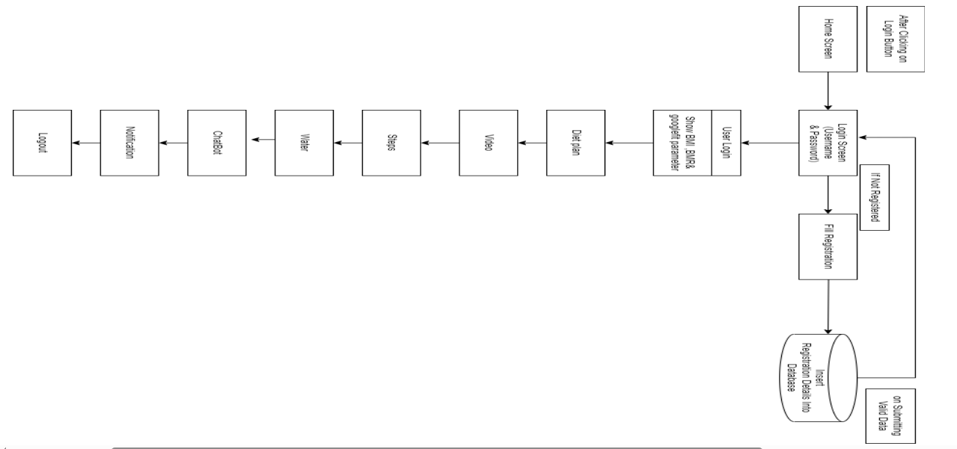
Figure 3.1: Architectural Diagram of the Proposed System
3.2 ANALYSIS OF THE EXISTING SYSTEM
The existing system for diet and exercise applications typically involves manual tracking of food intake and physical activities. Users rely on pen-and-paper logs or generic mobile apps that offer limited functionality and lack personalized recommendations. These applications often lack intelligent analysis capabilities and fail to adapt to individual preferences, goals, and health conditions. Moreover, they may not integrate seamlessly with wearable devices or provide real-time feedback. These systems typically lack the sophistication needed to provide personalized recommendations and intelligent analysis. Users are left to navigate through generic interfaces that fail to adapt to their individual preferences, dietary restrictions, or health conditions. Moreover, the manual nature of tracking food intake and physical activities is prone to inaccuracies, resulting in ineffective monitoring of progress. Integration with wearable devices and other health tracking technologies is often limited, hindering the seamless synchronization of data and real-time feedback.
3.3 PROBLEMS OF THE EXISTING PROBLEM
The primary problems with the existing system stem from its lack of personalization and inefficient tracking methods. Users face challenges in adhering to their fitness goals due to the generic nature of recommendations and the cumbersome process of manually logging information. Furthermore, the limited feedback provided by these systems fails to adequately motivate users and drive meaningful progress. Integration issues exacerbate these challenges, preventing users from leveraging the full potential of wearable devices and other health tracking technologies to monitor their health and fitness effectively.
3.4 DESCRIPTION OF THE PROPOSED SYSTEM
The proposed AI-based diet and exercise application aims to revolutionize the way users approach their fitness journey. By harnessing the power of machine learning algorithms, the system offers personalized recommendations tailored to individual needs and preferences. Whether it's creating custom meal plans or devising exercise routines, the application analyzes user data to deliver tailored guidance that maximizes effectiveness and adherence. Through advanced image recognition and natural language processing capabilities, tracking food intake and physical activities becomes effortless, enhancing the accuracy of data collection and analysis.
One of the standout features of the proposed system is its ability to provide real-time feedback to users. By continuously monitoring progress and performance, the application offers timely insights, motivational messages, and adjustments to meal plans and exercise routines. This real-time feedback mechanism not only keeps users engaged and motivated but also ensures that they stay on track towards achieving their fitness goals. Seamless integration with wearable devices further enhances the user experience, enabling automatic synchronization of data and comprehensive monitoring of health and fitness metrics.
3.5 ADVANTAGES OF THE PROPOSED SYSTEM
The proposed system will possess the following advantages:
- By providing tailored recommendations, the proposed system ensures that users receive guidance that aligns with their individual needs and preferences.
- Leveraging AI technology, the system improves the accuracy of tracking food intake and exercise, leading to more reliable data for analysis and evaluation.
- Real-time feedback and personalized recommendations help to keep users motivated and engaged, increasing adherence to their fitness goals.
- Seamless integration with wearable devices and other health tracking technologies enhances user experience and enables comprehensive monitoring of health and fitness metrics.
CHAPTER FOUR
DESIGN, IMPLEMENTATION AND DOCUMENTATION OF THE SYSTEM
4.1 DESIGN OF THE SYSTEM
This is the computation of the particulars of a new system and the determination of what the new system would be and the function it is to perform. This may involve changing from one system to another or modifying the existing system operation.
The most challenging phase of the system life cycle is the change from manual operation to a faster and more accurate one; system design stage covers the technical specifications that will be employed in the implementation of the new system in order to modify the previous system. Some factors are put in consideration. These factors include input design, output design, definitions file and procedure designs and other documentation.
4.1.1 OUTPUT DESIGN
This incorporates the objectives of solving the existing system problems and challenges. This involves the structuring of the desired information and also to enhance efficient and effective AI based Diet. Things taken into consideration in determining the output are represented below:


Figure 4.1: Main Menu
This page allow user to navigate from one page to another
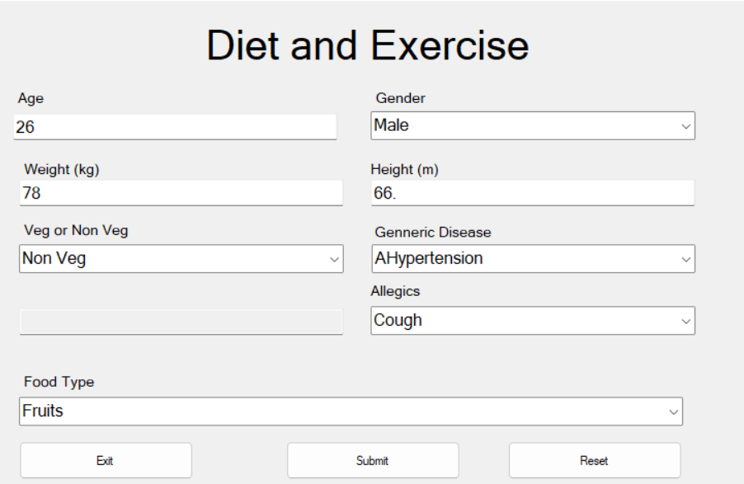
Figure 4.2: Diet Page
This is a page where user enter its details for diet purpose
4.1.2 INPUT DESIGN
The input to run this software is obtained from AI based diet administrator. The administrator is expected to register any User information. He can achieve this by typing via the keyboard. The input required from the Users is their personal data and answer?
To the questions set by the administrator. It can serve as the various input layouts from the various modules first from the collection of data and module then from the assessment module and input from User respectively.
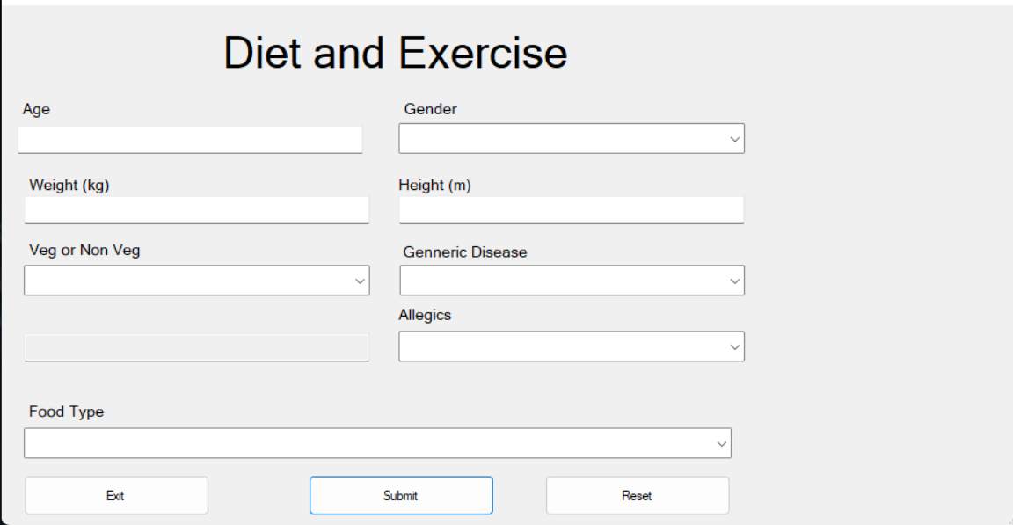
Figure 4.3: diet information interface
This is a page where user supply/enter diet details.
4.1.3 DATABASE DESIGN
Database design is the process of creating a detailed data model of a database. It involves defining the structure of the database, including tables, columns, relationships, constraints, and other relevant elements. A well-designed database is crucial for efficient data storage, retrieval, and manipulation, as well as ensuring data integrity and security.

Table 4.1: Patient table
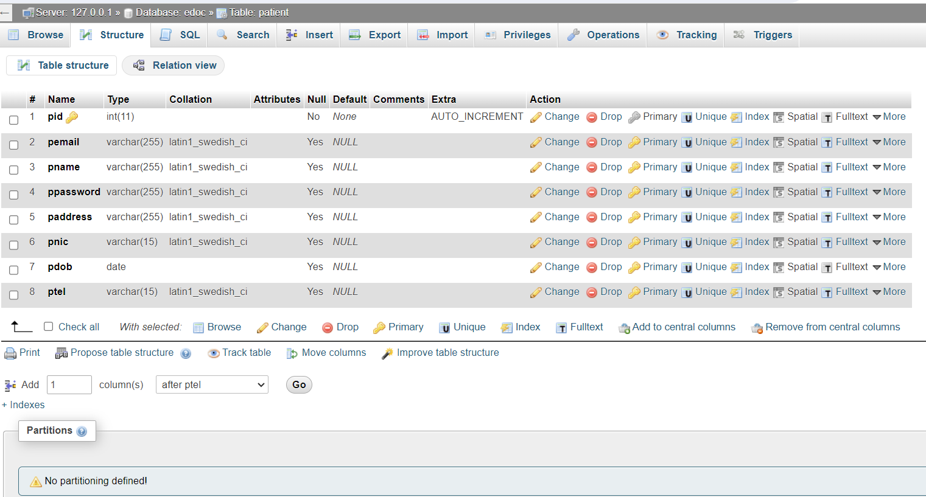
Table 4.2: Admin table


4.1.4 PROCEDURE DESIGN
These are the steps involved in unifying the whole process to produce the desired output. It involves computer procedures which start from the original input lessons to the output result file. This allows the processing of User information and result to be possible. Menu is provided to aid User in the processing of the output file.
4.2 IMPLEMENTATION OF THE SYSTEM
This entails the choice of the programming language employed to implement the software which should-be suitable for AI based diet. The software is designed for the use of AI based diet which should serve as an assistant. It is also expected to be used in conjunction with the User. The AI based diet admin will prepare data base while the admin will provide personal data about the User.
4.2.1 CHOICE OF PROGRAMMING LANGUAGE
The Application was developed in a .net (dot net) integrated development environment (.net IDE). The Application IDE is chosen following the fact that extracted information needs to be presented in an enhanced pictorial/graphical format and easy communication with the database for program flexibility in windows platform.
4.2.2 HARDWARE REQUIREMENT
i. 500 Hz minimum with CD ROM drive etc.
ii. Hard disk of capacity 10GB Minimum
iii. 126-512 megabyte of RAM
iv. An Uninterrupted power supply (UPS)
v. A voltage stabilizer
vi. A power generating set etc.
4.2.3 SOFTWARE REQUIREMENT
i. Windows operating system such as Windows 7 etc
ii. Dream Weaver
iii. Server Query Language (SQL).
4.3 DOCUMENTATION OF THE SYSTEM
4.3.1 PROGRAM DOCUMENTATION
The program is packaged for use in any system irrespective of either it runs visual studio application or not. After developing a program in Visual studio, there is a facility provided in Microsoft Visual Studio suite called “Package and Deployment Wizard” that is used in Visual studio application packaging and deployment.
The AI based diet is packaged into an installable setup that can be run from any system.
4.3.2 MAINTAINING OF THE SYSTEM
The system maintenance refers to making modification to an already existing application/program without necessarily re-writing everything from start. Program maintenance of a program includes modification of the program to meet-up with certain requirements of the Users. In this course, additional features can be added, errors corrected, ambiguous interfaces redesigned to eliminate confusions and unnecessary features removed.
Maintaining this program can be done in a Visual studio environment. Any future modification can be by re-running the program source code in a visual studio environment making necessary changes and updates and recompile the application into an upgrade version of the existing version of the mini word processing application. Further versions of this program can be named following their year of release or it can be given a different version number.

CHAPTER FIVE
SUMMARY, CONCLUSION AND RECOMMENDATIONS
5.1 SUMMARY
The development of an AI-based diet and exercise application marks a significant advancement in the realm of health and wellness technology. This application leverages artificial intelligence algorithms to personalize diet plans and exercise routines according to individual needs, preferences, and health goals. Users can input their dietary preferences, medical history, fitness levels, and goals into the application, which then generates tailored recommendations to optimize their health journey. The AI component continuously learns and adapts based on user feedback and real-time data, ensuring ongoing relevance and effectiveness. By harnessing the power of AI, this application revolutionizes the way individuals approach nutrition and fitness, empowering them to make informed choices and achieve sustainable lifestyle changes. This system adopted the Google Fit API and was developed using the web technologies such as HTML, CSS, Media Query and MySQL.
5.2 CONCLUSION
The development of an AI-based diet and exercise application holds immense promise in promoting healthier lifestyles and combating the growing global burden of chronic diseases related to diet and physical inactivity. By offering personalized recommendations, constant support, and data-driven insights, this application has the potential to significantly improve user adherence to healthy habits and enhance overall well-being. However, it is crucial to acknowledge the limitations and challenges associated with AI technology, such as data privacy concerns, algorithm biases, and the need for ongoing validation and refinement. Moving forward, continued research, collaboration between healthcare professionals and technologists, and user-centered design principles will be essential to realize the full potential of AI in optimizing nutrition and fitness outcomes.
  - RECOMMENDATIONS
Based on the findings of this research, it is highly recommended that:
- comprehensive educational resources should be provided within the application to help users understand the principles of nutrition, exercise physiology, and behavior change, empowering them to make informed decisions.
- mechanisms for collecting user feedback and monitoring outcomes to refine the AI algorithms continuously should be implemented, ensuring that recommendations remain accurate, relevant, and personalized.
- collaboration with healthcare professionals to ensure alignment with evidence-based guidelines and to facilitate seamless integration with existing healthcare systems, enabling holistic patient care.
- robust data protection measures to safeguard user privacy and confidentiality should be prioritize, adhering to relevant regulations.

REFERENCES
Adegoke, T. (2020). AI Digital Fitness Trainer and Meal Guide (Trainensor). International Journal of Modern Engineering Technologies. Vol. 3, Issue: 3. Pp. 39-40.
Agarwal, V., Sharma, K. & Rajpoot, A. K. (2022). AI Based Yoga Trainer-Simplifying Home Yoga using Mediapipe and Video Streaming. In 2022 3rd International Conference for Emerging Technology (INCET). Pp. 1-5.
Ashrafian, A., Shokri, F., Amiri, M.J.T., Yaseen, Z.M. & Rezaie-Balf, M. (2020). Compressive Strength of Foamed Cellular Lightweight Concrete Simulation: New Development of Hybrid Artificial Intelligence Model. Construction and Building Materials. Vol. 23. Pp. 1170-1171.
Aslani, S., Kermani, B. & Alibeigi, S. (2016). The Articial Intelligence of Health Sector: How to Advance based on Math and Science, International Journal of Modern Engineering Technologies. Vol. 2. Issue: 2. Pp.23-24.
Yotam Cohen,1,∗ Rafael Valdés-Mas,1,∗ and Eran Elina (2023). The Role of Artificial Intelligence in Deciphering Diet–Disease Relationships: Case Studies, Annual Review of Nutrition. Pp. 23-24.
Datta, P. R., Jayendra, M., Prajwal, D., Rakesh, K., Jayendra, M. & Kumar, R. R. (2020). Development of AI-Based Diet and Exercise Application, International Journal of Medical Information. Vol. 4, Issue: 3. Pp. 29-31.
Caballero-Ruiz, E., García-Sáez, G., Rigla, M., Villaplana, M., B., Hernando, M. E. (2019) A Web-Based Clinical Decision Support System for Gestational Diabetes: Automatic Diet Prescription and Detection of Insulin Needs. European Journal of Clinical Nutrition. Vol. 8, Issue: 3. Pp. 112-113.
Oh, W., An, Y. Min, S. & Park, C. (2022) Comparative Effectiveness of Artificial Intelligence-Based Interactive Home Exercise Applications in Adolescents with Obesity, International Journal of Medical Information. Vol. 2, Issue: 1. Pp. 9-10.
Ramakrishnan, R., Xing, T., Chen, C., Lee, M. & Gao, J. (2019). Application of AI in Nutrition, Journal of Advances in Information Science and Technology. Vol. 1, Issue: 1. Pp. 7-11.
Salinari, A., Machì, M., Armas, Y. D., Cianciosi, D., Qi, N., Yang, B., Cotorruelo, M., Villar G., Lopez, L., A., Battino, M. & Giampieri, F. (2023). The Application of Digital Technologies and Artificial Intelligence in Healthcare: An Overview on Nutrition Assessment, European Journal of Clinical Nutrition. Vol. 2, Issue: 1. Pp. 12-13.
Sharma, D. & Patel, S. (2020). Recent Advances in AI based Automated Personalized Nutrition System: Future Need of Healthcare, International Journal of Advanced Trends in Computer Science and Engineering. Vol. 9, Issue: 5. Pp. 789-790.
Sutar, G. Chougule, A. Pandhare, M. Shinde, V. & Kadam, C. (2022). Future of Fitness App with Artificial Intelligence, Grenze International Journal of Engineering and Technology. Vol. 5, Issue: 8. Pp. 114-116.
Tran, T. T., Choi, J. W., Van-Dang, C., Su-Park, G., Baek, J. Y. & Kim, J. W. (2018). Recommender system with Artificial Intelligence for Fitness Assistance System. In 2018 15th International Conference on Ubiquitous Robots (UR). Pp. 489-492.
Yong, B., Xu, Z., Wang, X., Cheng, L., Li, X., Wu, X. & Zhou, Q. (2018). IoT-Based Intelligent Fitness System, Journal of Parallel and Distributed Computing. Vol. 1, Issue: 8. Pp. 14-16.
Zhu, W. & Sun, Y. (2022). Smart Diet: An Intelligent Mobile Application to Assist Diet Control Using Artificial Intelligence and Computer Vision, European Journal of Clinical Nutrition. Vol. 3, Issue: 3. Pp. 42-44.

