BOOK LENDING VERIFICATION SYSTEM USING BIOMETRIC AUTHENTICATION (A CASE STUDY OF KWARA STATE POLYTECHNIC LIBRARY)

By:

AJOSE TAOFEEK AREMU
HND/23/COM/FT/0354

A Project Submitted to the Department of Computer Science, Institute of Information and Communication Technology, Kwara State Polytechnic, Ilorin

In Partial Fulfillment of the Requirements for the Award of Higher National Diploma (HND) in Computer Science

July, 2025
CERTIFICATION
This is to certify that this project was carried out by AJOSE Taofeek Aremu with matric number HND/23/COM/FT/0354, has part of the requirements for the award of Higher National Diploma (HND) in Computer Science.

………………………………. ……………………………….
Mr. Saka T.O Date
(Project Supervisor)

………………………….. ………………………….
Mr. Oyedepo F. S. Date
(Head of Department)

………………………….. ………………………….
External Examiner Date

DEDICATION
This project is dedicated to the creator of the earth and universe, the Almighty God. It is also dedicated to my parents for their moral and financial support.

ACKNOWLEDGEMENT
All praise due to Almighty God, the Lord of the Universe. I praise Him and thank Him for giving me the strength and knowledge to complete my HND programme and also for my continue existence on the earth.
I appreciate the utmost effort of my supervisor, Mr. Saka T.O., whose patience support and encouragement have been the driving force behind the success of this research work. He gave useful corrections, constructive criticisms, comments, recommendations, advice and always ensures that an excellent research is done. My sincere gratitude goes to Head of the Department and other members of staff of the Department of Computer Science, Kwara State Polytechnic, Ilorin, for their constant cooperation, constructive criticisms and encouragements throughout the programme.
Special gratitude to my parents who exhibited immeasurable financial, patience, support, prayers and understanding during the periods in which I was busy tirelessly in my studies. Special thanks go to all my lovely siblings.

TABLE OF CONTENTS
Title Page i
Certification ii
Dedication iii
Acknowledgements iv
Abstract v
Table of Contents vi
CHAPTER ONE: GENERAL INTRODUCTION
  - Background to the Study 1
  - Statement of the Problem 3
  - Aim and Objectives of the Study 4
  - Significance of the Study 4
  - Scope of the Study 5
  - Organization of the Report 5
CHAPTER TWO: LITERATURE REVIEW
2.1 Review of Related Works 6
2.2 Overview of Biometric System 9
2.2.1 Biometric Technologies 9
2.2.1.1 Types of Biometric Technologies 9
2.2.2 Biometric System in Library Perspective 11
2.2.3 Fingerprint Applications in Libraries 12
CHAPTER THREE: RESEARCH METHODOLOGY AND ANALYSIS
  - Research Methodology 13
  - Analysis of the Existing System 15
  - Problems of the Existing System 15
  - Description of the Proposed System 16
  - Advantages of the proposed system 16
CHAPTER FOUR: DESIGN, IMPLEMENTATION AND DOCUMENTATION OF THE SYSTEM
  - Design of the System 17
    - Output Design 17
    - Input Design 19
    - Database Design 21
    - Procedure Design 23
  - Implementation of the System 24
    - Choice of Programming Language 24
    - Hardware Support 24
    - Software Support 24
  - Documentation of the System 25
    - Program Documentation 25
    - Maintaining the System 25
CHAPTER FIVE: SUMMARY, CONCLUSION AND RECOMMENDATION
  - Summary 26
  - Conclusion 26
  - Recommendation 27
References 28
Appendices

ABSTRACT
A library is a place where a huge collection of books and resources are available which can be accessible by the users. It acts as a brain for the institutions. The most common library system, which biometric solutions have in many cases started to replace, is the library card. The card is used to verify identity and keep track of books taken out and books returned. They are a good solution, but over time and under stress, shortcomings start to reveal themselves. One of the fundamental problems with a library card is that processing them at each transaction can be time consuming. At busy times, long queues can be formed as library staff scan and deal with the cards, or students fumble around in bags to find them. Library cards are too often lost or forgotten by their users. Setting up new cards or replacing lost ones is time consuming and a drain on the library’s resources. The other problem that emerges with traditional cards is that it is hard to ensure users are using them properly. Basic library cards can be swapped and passed around between students and the system abused. The way to solve this is to introduce photo ids onto the library cards. The system was designed using C# as the front end and MySQL as the Database System.

CHAPTER ONE
GENERAL INTRODUCTION
  - BACKGROUND TO THE STUDY
Book lending is the process of giving a particular book in a library to someone to use temporarily, on condition that it or its equivalent will be returned. A library is a place where a huge collection of books and resources are available which can be accessible by the users. It acts as a brain for the institutions. It enhances the dissemination of knowledge and enhance civilization among the students. The tons of books and research works are captivating the students to improvise their knowledge in all perspectives. It guides the students to promote their views differently. This knowledge optimizes the student to achieve a better result in academic as well as personal skill development. Improvisation in technology causes the demand for developing a way to enhance book lending in library set up with biometrics (Shanmugam, et al., 2020).
Achintya and Subodh (2019) define biometric verification, or simply biometrics, as the “automatic recognition of individuals based on their physiological and/or behavioral characteristics”. Biometrics can be used to identify the person. Tokens, such as smart cards, magnetic stripe cards, photo ID cards and so forth which can be lost, stolen or duplicated. An English dictionary (2021) defines fingerprint as “the unique natural pattern of ridges on the tips of the fingers. It is the unique identification for public key in asymmetric cryptosystem.” Fingerprint Recognition /verification are one of the leading and best biometric technologies that are to be widely used nowadays. One can implement the Fingerprint recognition System for book lending purpose. Book lending in a library system include issuing and returning of books. Library plays an important role in the development of an institutes and society. Library is not always safe and secure place. Books are often found on the library shelves with pages torn from the spine. Sometimes books are damaged beyond repair and almost all academic libraries are suffering from book or document theft by its member.
Librarian need to be aware of theft, mutilation of library materials and other unethical losses. The duty of the librarian is to keep the library buildings, shelves and stacks open and free without losing items to make available or putting individuals at unacceptable risk from the malicious, avaricious and senseless act of others. It is important to provide a safe and secure environment for library staff, library resources and equipment, and library users. In this project one should first identify the borrower with the help of fingerprint verification and later on it can be processed for further library transaction part (Kiran, et al., 2018).
Gayathri and Uma (2019) assert that with the advancement of technology, it is imperative to exalt all the systems into a user-friendly manner. The Library system (LS) acts as a tool to transform traditional libraries into secured biometric libraries. In traditional libraries, the students or borrower of a book has to search for books which are hassle process and go to the library staff which manually registers him or her on paper (record book). There is no proper maintenance of database about issues/fines, the overall progress of lending and returning book is slow and it is impossible to generate a fast report. The librarians have to check and monitor the lend/borrow books details with its fine; it is a tedious process to work simultaneously in different sectors. Book lending using fingerprint verification will assist the librarians to work easily and helps the librarians to solve all the issues concurrently. The borrowers need not stand in a queue for a long period to return/borrow a book from the library as a single PC contains all the data’s in it. It is important to provide a safe and secure environment for library staff, library resources and equipment, and library users. In this regard, the fingerprint verification system is really useful for the library and information science professional (Anil and Atul, 2020).
This system is specially proposed for book borrowing in a library the system will have borrower name, address., e-mail, photo, phone number fingerprint and reference mobile number stored in the library database.
  - STATEMENTS OF THE PROBLEM
The most common book lending system is in a library, which biometric solutions have in many cases started to replace, especially the use of library Identity Card (ID Card). The ID card is used to verify identities of members that had registered with the library and keep track of books taken out and books returned. They are a good solution, but over time and under stress, shortcomings start to reveal themselves. One of the fundamental problems with a library member Identity Card (ID) card is that verifying them at each transaction can be time consuming. At busy times, long queues can form as library staff scan and deal with the ID cards, or students fumble around in bags to find them, and that’s when students often realize they have lost or forgotten the ID at home. Issuing new ID for registered member or students is time consuming and a drain on the library’s resources. The other problem that emerges with traditional ID cards is it’s hard to verify as identity cards can be easily duplicated nowadays. The way to solve this is to introduce a fingerprint authentication where anyone who which to borrow any library material will have to register and a fingerprint is captured at the point of registration. It will worth it for libraries as good identity management of their users and can help them run as securely as possible by helping them keep track of their users and valuable resources.

  - AIM AND OBJECTIVES OF THE STUDY
The aim of this project is to integrate fingerprint verification into book lending in the library system for identity management. However, the objectives are to;
- Provide fingerprint as an authourized identity for library management
- Design a secured fingerprint authentication system for borrowing books
- Implement the design above in Visual C Sharp Programming Language.
  - SIGNIFICANCE OF THE STUDY

The libraries as a means of easily and rapidly accessing books, archives and images of various types are now widely recognized by commercial interests and public bodies. Adopting a biometric system can help libraries balance the books. They are a reasonably priced solution that saves operational costs in the long run. Additionally, re-registration or lost student authentications is no longer a problem. Fingerprints are the most commonly used biometric and they are the most convenient solution available at the moment, they can’t be lost, forgotten or stolen and are literally right at your fingertips anytime a book is to be borrowed or returned.
  - SCOPE OF THE STUDY
The scope of this project is to develop a book lending verification system using fingerprint that will eliminate how unregistered individuals are gaining access into a library to borrow books. This is done by using fingerprint as a form authentication for proof of a registered member of that particular library. The system will be a window based application that will be developed using Microsoft Visual C#.net as the preferred programming language for building the user interface and Microsoft SQL Server for database design. It does not cover other aspects of biometric.

  - ORGANIZATION OF THE REPORT
This is the overall organizational structure of the work as presented in this project. Chapter one of this project deals with the general introduction to the work in the project. It also entails the aim and objectives of this project, the significance of the study, the scope and limitation of the study. Chapter two presents a review of literature. It discussed the past works that are related to this project, overview of biometric system, biometric technologies, biometric system in library perspective and fingerprint applications in libraries. Chapter three covers the methodology, analysis of the existing system, description of the current procedure, problems of existing system (procedure) itemized, and description of the proposed system and the basic advantages of the proposed fingerprint authentication for book lending in a library. Chapter four contains design, implementation and documentation of the system. The design involves the system design, output design form, input design form, database structure and the procedure of the system. The implementation involves the implementation techniques used in details, choice of programming language used and the hardware and software support. The documentation of the system involves the operation of the system and the maintenance of the system. Chapter five deal with summary, conclusion, recommendation and references.

CHAPTER TWO
LITERATURE REVIEW
2.1 REVIEW OF RELATED WORKS
Uma and Rani (2019) proposed a prototype for secure digital library accessing system using multimodal biometric system. The proposed model secures the sensitive data on Internet. The design on Secure Digital Library Accessing System Using Multimodal Biometric System (SDLAS-MBS) consists of single fingerprint scanner device, webcam and event handler. It supports all the existing services and all other future communication services. To access sensitive data and secure transactions on Internet SDLAS-MBS will be used by the users with the help of fingerprint scanner and webcam devices.
Achintya and Subodh (2019) developed a biometric recognition, novel approach for library patron. The paper discussed a novel patron authentication approach in an automated and modern library based on the biometric recognition. The person working at the entrance or at the circulation desk of the library needs to either confirm or determine the identity of individual requesting services in library. Presently, almost all of the libraries are using identity cards (ID Card) for this purpose including photo-based, smart card based or RFID based and so on. With the proposed authentication scheme it is possible to confirm or establish an individual’s identity based on “what one is, or how one behaves”, rather than by “what one possesses” (e.g., an ID card) or “what one remembers” (e.g., a password). The purpose of such authentication system is to ensure that the rendered services are accessed only by a valid user, and not any other else.
Shasha et al, (2019) researched on the library management system to upgrade the management to meet the need of the student demand. Honghai (2018) proposed a system where he represents the wasting of investment in CD which is attached along with the books. To save the cost of the library, he suggested cloud computing for data transfer. Bao (2019) presented a paper on constructing the prediction model for the library. He introduced two models for predicting the process such as the co-efficient of simple determination and t-test. This analysis explains the strong relationship between lending and the number of readers. They mainly concentrate on library lending for designing the construction of the model library.
Eraxiang et al (2016) launched a paper where he highlighted the disadvantage of the traditional library management systems. He provided a solution for the disadvantage by utilizing struts and hibernate framework in MVC architecture. The MVC architecture is also called a multilayer tier where presentation, business, data persistence and database layer are available. These extra features improve the maintainability and reuse of the system.
Zheng (2019) introduces a system based on UML for the Library Management system. Due to the good application prospect of UML, the LMS is designed and model based on this concept. Case diagram and analysis diagram are drawn after the analysis of simple LMS. Hitchense et al (2015), proposed a paper on flexible usage of classes. He suggested the reuse of classes for some similar conditions.
Yang et al (2017) explained a tedious work on the manual process of the librarians. So he introduced an LMS through VB. Bretthauer et al (2017) exposed information about the open-source software for libraries. He also explained the drawback of the open-source software. Brave (2010) presented the various open-source software such as LMS, digital library software content, citation and knowledge, and journal management software, etc. He examined the staff satisfaction and attitude towards the open-source library. Singh (2017) proposes a paper where comparison takes place between expectations and experience of the open-source library.

2.2 OVERVIEW OF BIOMETRIC SYSTEM
Biometric system generally refers to the use of technology to identify people based on some aspect of their biological traits. There are two fundamental applications for securing biometric technology: access control and key management. In access control, the system modulates access through inspection of a candidate user's biometric. In key management, the system’s objective is to extract a stable encryption key from the user's biometric (Dastbaz & Wright, 2013).
2.2.1 Biometric Technologies
Biometrics is the science of measuring physiological or behavioural characteristics that verify a person’s identity. Biometric identification refers to a technology that uses scanned graphical information from many sources for personal identification purposes viz., facial imaging, retinal and iris scans, fingerprint scans, voice patterns, facial recognition, hand geometry identification, etc.
2.2.1.1 Types of Biometric Technologies
A number of discrete biometric technologies are available on the market today such as signature, fingerprint identification, iris identification, retinal identification, hand geometry, hand, palm, and wrist subcutaneous vein pattern identification, signature identification, voice identification, keystroke dynamics identification, facial feature identification, body salinity (salt) identification, body odor identification, and ear identification.
(a) Iris/Retina (Eye biometrics): The iris is the most accurate and invariable of biometrics, and that their system is the most accurate form of biometric technology as the human eye offers two features with excellent properties for identification. Both the iris (the colored part visible at the front of the eye) and the veins of the retina (the thin film of nerve endings inside the eyeball that capture light and send it back to your brain) provide patterns that can uniquely identify an individual. The pattern of lines and colors on the eye are, as with other biometrics, analyzed, digitized, and compared against a reference sample for verification (Singh, 2017).
(b) Fingerprint: A highly familiar and well-established biometric science is fingerprinting. The traditional use of fingerprinting, of course, has been as a forensic criminological technique, used to identify perpetrators by the fingerprints they leave behind them at crime scenes. In the context of modern biometrics, these features, called fingerprint minutiae, can be captured, analyzed, and compared electronically, with correlations drawn between a live sample and a reference sample, as with other biometric technologies. Fingerprints offer tremendous invariability, changing only in size with age, are highly resistant to modification or injury, and very difficult to “forge” in any useful way (Zheng, 2019).
(c) Hand Geometry: Perhaps it is the most ubiquitous electronic biometric system. This system requires the subject to place his or her hand (usually the right hand) on a plate where it is photographically captured and measured. Made of 27 bones and a complex web of interconnected joints, muscles, and tendons, the human hand presents a sufficiently peculiar conformation of anatomical features to enable authentication (Zheng , 2019).
(d) Facial Recognition: In the field of biometrics, facial recognition remains one of the more controversial technologies because of its very unobtrusiveness. With good cameras and good lighting, a facial recognition185 system can sample faces from tremendous distances without the subject’s knowledge or consent. The facial recognition technology works by two methods viz., facial geometry or eigenface comparison. Facial geometry analysis works by taking a known reference point (for example, the distance from eye to eye), and measuring the various features of the face in their distance and angles from this reference point. Eigenface comparison uses a palette of about 150 facial abstractions, and compares the captured face with these archetypal abstract faces. This technology may be highly useful for the libraries in security point of view (Walia, 2018).
2.2.2 Book Lending Verification
Book lending verification is a crucial process within libraries to ensure the proper management of library materials and the accountability of patrons borrowing those materials. Traditionally, book lending verification has relied on manual methods such as presenting library cards or signing out books, which can be prone to errors and misuse. However, with advancements in technology, libraries are increasingly adopting automated verification systems, including barcode scanning, RFID tagging, and biometric authentication, to streamline the lending process and enhance security.
One of the most common methods of book lending verification is barcode scanning, where each library item is assigned a unique barcode that is scanned at the point of checkout and check-in. This method enables efficient tracking of borrowed items and helps prevent unauthorized borrowing or theft. Similarly, RFID tagging allows for wireless identification and tracking of library materials, enabling faster and more convenient lending transactions. RFID tags embedded in library items can be scanned using RFID readers, eliminating the need for manual barcode scanning and enabling self-service checkout kiosks for patrons.
Biometric authentication is emerging as a promising approach to book lending verification, offering heightened security and convenience. By using biometric identifiers such as fingerprints or iris scans, libraries can uniquely authenticate patrons and link them to their borrowing history, reducing the risk of identity theft and unauthorized borrowing. Biometric authentication also facilitates faster and more seamless lending transactions, as patrons can simply scan their biometric data to verify their identity and borrow books without the need for physical library cards or passwords. Overall, book lending verification systems play a vital role in ensuring the efficient and secure management of library collections, and the adoption of automated verification technologies can greatly enhance the lending experience for both patrons and library staff (Singh, 2017).

2.2.3 Biometric System in Library Perspective
The Biometric System may easily be applicable to Library System Management in three ways which are; it maintains library patron records very quickly, accurately, orderly, it acts as a helpful management tool for the librarian and other managerial staff of the library, and it may continue for years together without any further adding cost after its installation. Biometric based patron authentication system can easily be introduced in the library management system, which resulting the full proof security cum automated library system.
In the context of libraries, the implementation of a biometric system introduces a modern and efficient method for managing patron access and transactions. By utilizing biometric identifiers such as fingerprints or iris scans, libraries can streamline the process of user authentication, eliminating the need for physical library cards or manual entry of credentials. This not only enhances security by reducing the risk of identity theft or unauthorized access but also improves the overall user experience by providing a convenient and frictionless way for patrons to access library resources and services. Additionally, biometric systems offer libraries valuable insights into patron usage patterns and preferences, allowing for more personalized services and targeted resource allocation.
The adoption of biometric systems in libraries aligns with broader trends in digital transformation and technological innovation within the library sector. As libraries increasingly embrace digital technologies to modernize their operations and services, biometric systems offer a cutting-edge solution for improving efficiency and enhancing user engagement. By leveraging biometric authentication, libraries can enhance the efficiency of tasks such as checking out materials, accessing restricted areas, or tracking attendance at events and programs. Furthermore, biometric systems can help libraries stay ahead of evolving security threats and compliance requirements, ensuring the protection of patron privacy and sensitive information. Overall, the integration of biometric systems in libraries represents a significant step towards a more secure, efficient, and user-centric library experience (Singh, 2017).
2.2.4 Fingerprint Applications in Libraries (AFIS)
Application of AFIS in Library and Information Center can be done in three respective fields.
A. Control access to library premises: This type of application will not allow any unauthorized person to open the door. In this type of application, fingerprints of the authorized users will be scanned and stored for verification. This fingerprint identification is really a secure, convenient, and cost-effective alternative to passwords, badges, swipe cards and PINs. The fingerprint reader mounts on a wall near the library main door. This fingerprint scanners offer various levels of authorization for an individual. This authorization includes a scheduling mechanism for allowing access for individuals based on the time of day. This can avoid unauthorized access from computer room or server. This system increases security levels more than a Identity Card (ID) card or ID badge as the fingerprint can’t be lost or stolen. It also reduces overall cost in eliminating portable devices and reducing administrative time as well. The system is convenient and there are no more fumbling of keys and ID cards. The member need not worry about misplacing their cards. The premises access devices can be networked together so that the system can be controlled and maintained from a central location.
B. Control access to library network: Nowadays, most of the libraries are working on digital environment where the library is concerned with the local area network, wide area network or intranet of the organization. In a world of cybercrimes, it is the need of the hour for any library to have control over the member access to the library network. Libraries are providing user name and password to the members to make use of the library computer systems and networks. However, too many passwords or inappropriate passwords lead to security lapses in which virtual credentials are lost, forgotten and hacked.
To overcome this problem, advanced biometric solution is available which ensures network authentication and safeguard the library network against unauthorized intrusion. This kind of biometrics system will protect individual PCs and network access. It also reduces the password reset requests from the users. The library administrator can be able to authenticate who is accessing a PC, network, and application with exceptional accuracy. It associates a single fingerprint with as many as passwords or Personal Identification Numbers (PINs) on a system. User can log on automatically without having to type in username or password. It eliminates the security risks of written down passwords and PINs (Singh, 2017).
C. Control access to library books: Implementation of fingerprint as a library borrower cards will be one of the positive steps to make library a digital environment. Every applicant of library cards will get enrollment of their fingerprint image and get stored in the database. And at the time to borrow book, the person need to scan their fingerprint in the fingerprint scanner. If the fingerprint is matched with the template in the database, the person can be allowed to borrow the book from the library because fingerprint is unique to every individual. This will release the burden of forgetting, stealing and missing of library cards. Introducing a fingerprint as a library card will reduce the workload of making cards of each and every authorized member (Walia, 2018).

CHAPTER THREE
RESEARCH METHODOLOGY AND ANALYSIS OF THE EXISTING SYSTEM
3.1 RESEARCH METHODOLOGY
The proposed system demonstrated a three-tier architectural structure. The verification system which centered on the enrolment, enhancement, feature extraction and matching of fingerprints. The backend database system that serves as store of the templates of all account holders’ pre-registered fingerprints. Fingerprint verification is to verify the authenticity of one person by his fingerprint, Fingerprint identification is by matching the information of user such as the fingerprint matching. A complete Fingerprint base library system can be explain in two phases: a. Enrolment Phase b. Authentication/Verification phase.
- Enrolment Phase: In the fingerprint application, a finger will be enrolled. This enables the system to set high security threshold and still be able to cope with everyday real life issue. Biometric reference data is collected and stored in database.
Biometric information scanner
Feature Extraction stored
Register
Figure 3.2: Enrolment Phase Source: (Singh, 2017)
The Enrolment is crucial because the once recorded reference data will normally be used over the active lifetime of user or his/her biometric hardware device.
- Authentication Phase: In this phase, users can access the library to borrow books by using their fingers. The user can place finger on the Biometric scanner and user’s finger scan can be matched through database, where all authenticated user’s fingerprints are stored. If a user wants to carry wants to make use of borrow or return books to the library he/she will simply place his/her finger on the biometric scanner and get access in a moment. If user’s fingerprint cannot be verified by database then the user will not be given access to borrow book.
Place finger on Scanner

Start
Does fingerprint match?

No

Yes
Give Access to Library Materials

End

Figure 3.3: Authentication Phase Source: (Singh, 2017)
In the design of this project, high level programming was used in order to achieve a good end. Before design, the front and backend of a design must be known, therefore C# is the programming language used for the scripting of the design and MYSQL database was use for the database in the implementation.
3.2 ANALYSIS OF THE EXISTING SYSTEM
The most common way of verifying somebody before borrowing a book at Kwara State Polytechnic library is the library identity card. The ID card is used to verify identity and keep track of books taken out and books returned by the students or users. They are a good solution, but over time and under stress, shortcomings start to reveal themselves. One of the fundamental problems with a library ID card is that checking/verifying them at each transaction can be time consuming. At busy times, long queues can form as library staffs scan to confirm the authenticity of the ID. Sometimes lost or forgot these cards at home. Replacing lost ID is time consuming and a drain on the library’s resources. The other problem that emerges with the existing ID cards is, it’s hard to verify its originality sometimes. The way to solve this is to introduce a fingerprint authentication where anyone who which to borrow any library material will have to register and a fingerprint is captured at the point of registration. It will worth it for Kwara State Polytechnic libraries as good identity management of their users and can help them run as securely as possible by helping them keep track of their users and valuable resources.
3.3 PROBLEMS OF THE EXISTING SYSTEM
The Kwara State polytechnic library uses the traditional way of identifying people who are eligible to borrow library books which has the following drawbacks according to the library staff:
- Lack of electricity: The library is facing electrical power issues which do affect the operations of the library
- Inadequate working devices: a lot of devices such as laptops, networking devices in the library are not working properly,
- The traditional method is time wastage: Due to the numerous numbers of users using the using identification card takes a lot of time because the library workers will have to check each of the users ID before they can have access to the library materials.
- It requires writing records on paper which maybe lost to fire, water, and termites and so on: All records of registered library user are saved on files which is not safe.
- It is also a waste of resources: Using manual records in library operations waste a lot of resources like paper and other stationary materials.
- Using ID card is not 100% safe: Some people do use fake ID card to have access to the library materials since ID card cannot authourized by just looking at it.
3.4 DESCRIPTION OF THE PROPOSED SYSTEM
The proposed system is the use of fingerprint for the authentication of Kwara State polytechnic library users. As a result of the limitations encountered with the use of manual method in borrowing books in the library, the need for an advance alternative system cannot be undermined. The use of fingerprint to authenticate user of the library will go a long way in tracking un-authourized user who is trying to use or borrow the library materials. On the system any user that want to have access to the library will first register on the system and enroll his/her fingerprint on the system, anytime the registered user want to use the library he will verify his identity by placing his finger on the fingerprint scanner for authentication. If the finger matched with the one on the system then access is granted to that particular user.
3.5 ADVANTAGES OF THE PROPOSED SYSTEM
A successful implementation of the fingerprint verification based book lending system will greatly increase the efficiency of Kwara State polytechnic librarians and will help to ensure that records are kept and managed properly. Fingerprint based book lending system has various advantages, they are as follows:
- Reduction of redundancies and inconsistencies: This system reduced data inconsistent and the redundancy.
- Ensure user defined rules to ensure the integrity of data: The system developed ensures data integrity.
- Enables data sharing across all applications: This system allows the sharing of data among other library applications.
- Ensures library access authorization: The system developed ensures those only authourized users are given access to the library materials.
- Integrity can be improved: Data integrity will be improved if the system is adopted in any library.

CHAPTER FOUR
DESIGN, IMPLEMENTATION AND DOCUMENTATION OF THE SYSTEM
  - DESIGN OF THE SYSTEM
The proposed system is designed in modules with each modules working together to perform the fingerprint electronic library system in order to enhance the performance of the existing system as earlier discussed in chapter three.
The ability to analyze and give focus to the system is explained in the following formats which are output design, input design, database design and procedure design.
    - OUTPUT DESIGN
The outputs to be extracted from the proposed system are as shown below
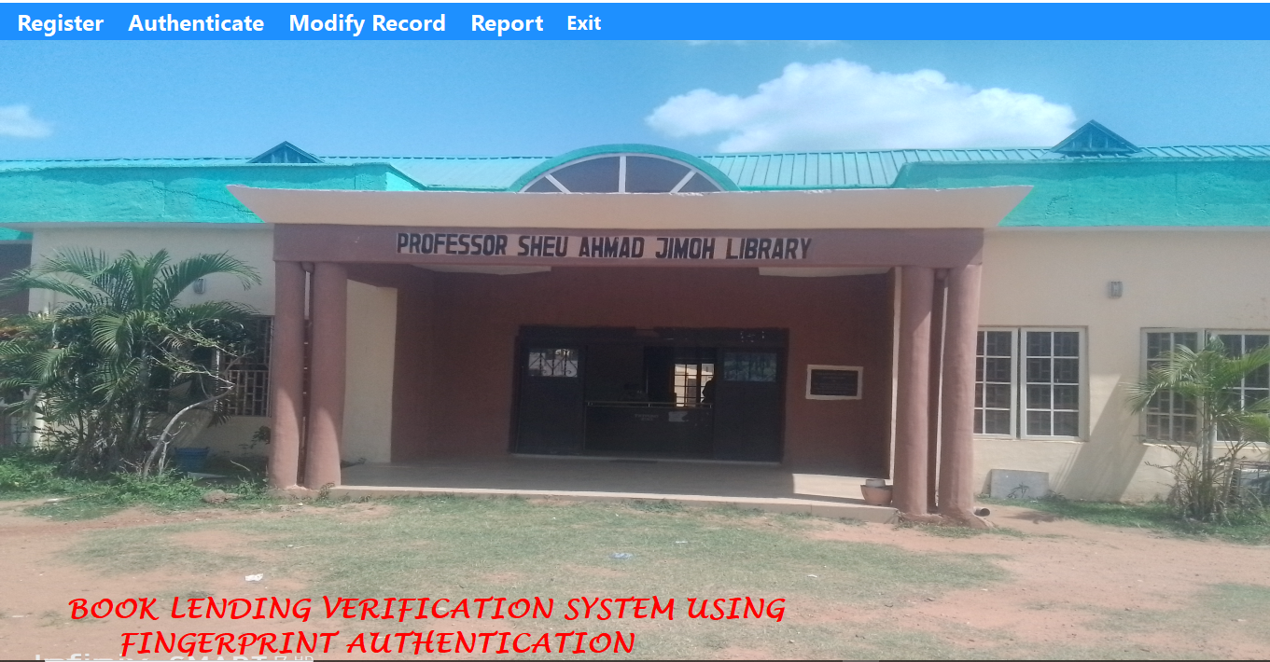
Figure 4.1: Main Page
This is the main menu of the system which shows some menus which can be clicked to navigate to other pages, these include the registration, Verification, modification and so on.
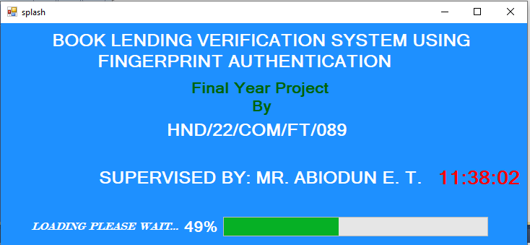

Figure 4.2: Splash Page
This Page is the welcome page that display the topic of the project as well as the details of the researcher.
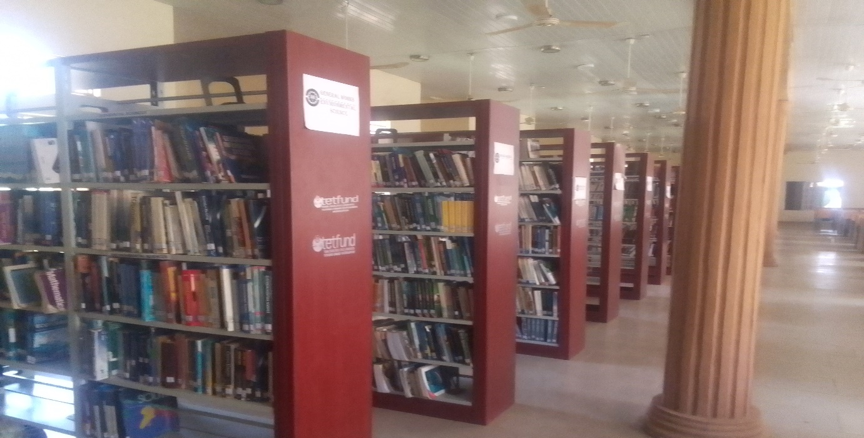
HOME BOOKS CONTACT
Figure 4.3: List of Books Dashboard Page
This Page Display all operations books available on the system this system.

4.1.2 INPUT DESIGN

It is also necessary to denote that data inputted in the computer for processing determines what the output will be. The inputs are use in collecting information of the student through the keyboard. Inputs are necessary information needed for processing so as to produce the expected outputs; which are supplied through the keyboard.

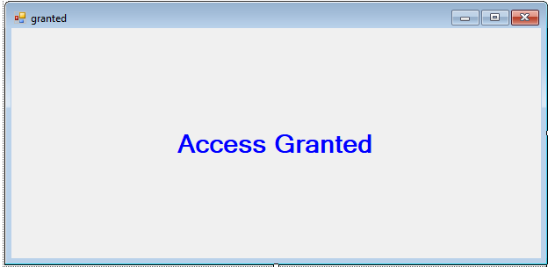

Figure 4.4: User Access Granted Page

This allows student or user to borrow books from the system.

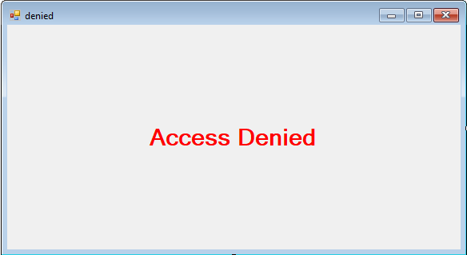

Figure 4.5: User Access Denied Page

This page shows a user denied the access to library materials.

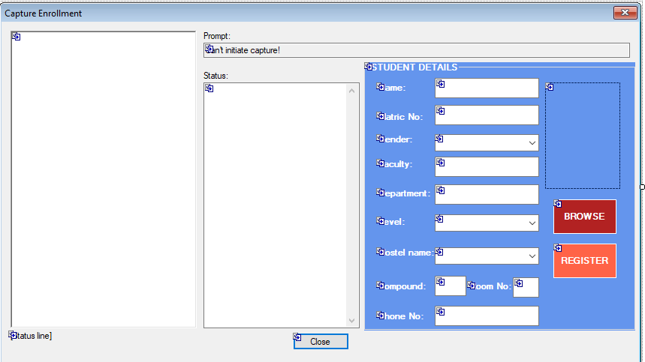

Figure 4.6: User Verification Page
This Page allows student /user to enter their details and gain access to the system.
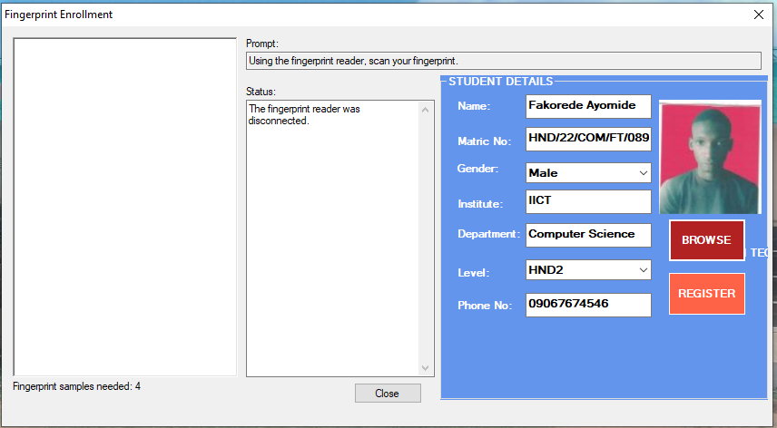
Figure 4.7: Enrolment Page
This Page allow user to Register in order to have access to library materials.
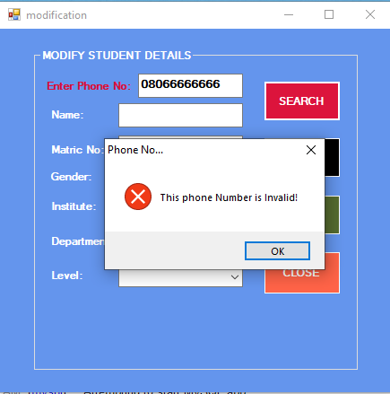
Figure 4.8: Modification Page
This Page allows the admin to modify user’s record.
4.1.3 DATABASE DESIGN
A database table is used for storing information about the files. The database use for this application is MySQL database. The files and their respective modes of access as well as information they hold are given below;
Table 4.1: Registration Structure
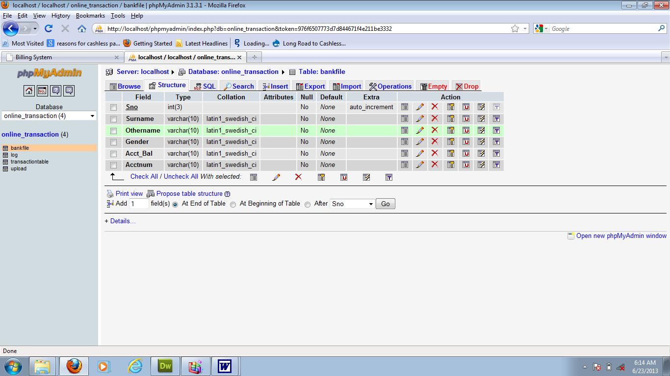

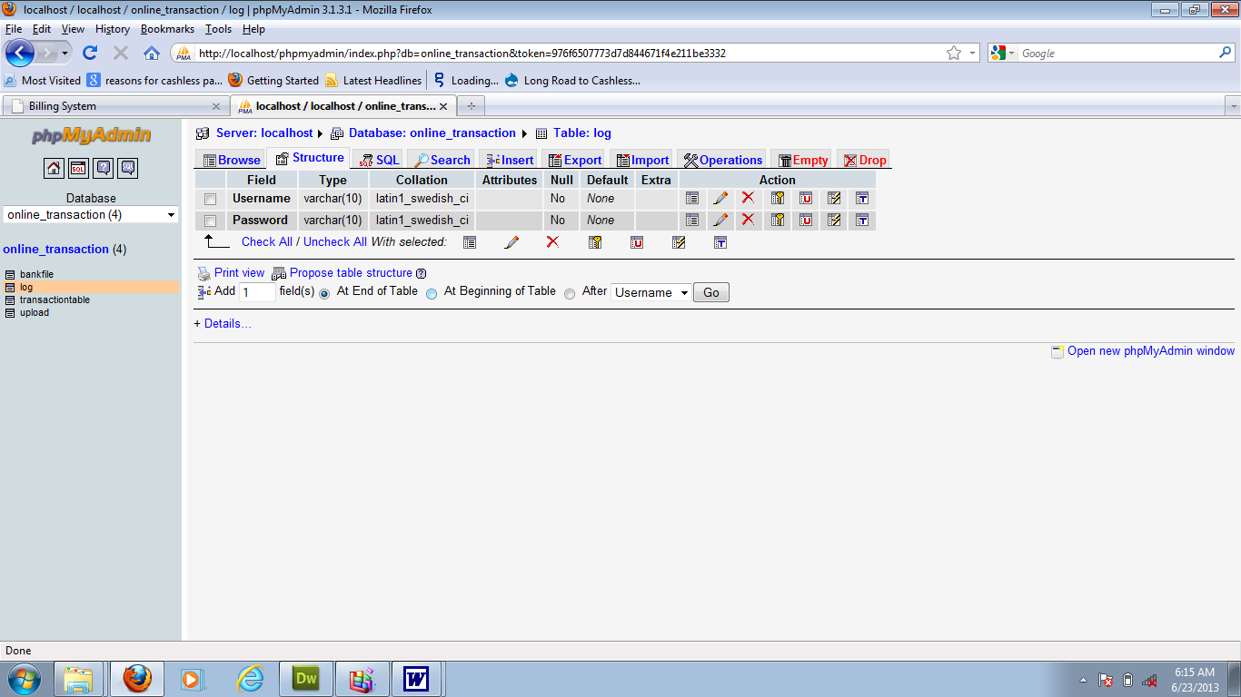
Table 4.2: Admin Login Table Structure

Table 4.3: User Personal Data table
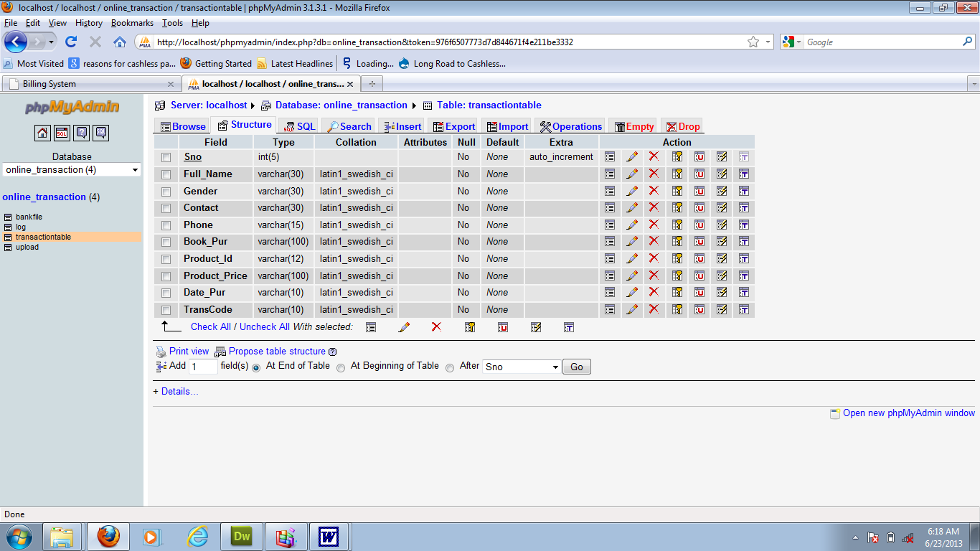
4.1.3 PROCEDURE DESIGN
Procedures are steps which verify the whole process. That is everything put together to produce the desired output. This involves the organization of the source document and end with the output result. Documents are sent to various departments to be filled by the employees and later returned to the personnel department which are analyzed to determine which record goes into the computer.
After selecting the necessary data, this serves as input to the computer system.
4.2 IMPLEMENTATION OF THE SYSTEM
It is always good to develop new ideas, to implement them on a computer and eventually to relish the satisfaction of achieving a successful result. The implementation process involves converting the system design into a complete and tested system that is fully operational and that can be used by the system users to meet their business needs. During implementation phase, the hardware and the software must be implemented.
Implementation of a system can be explained in six steps:-
  - Review design specification
  - Code, test and document programs
  - Train users
  - Perform system test
  - Convert to new system
  - Evaluate and maintain the new system
4.2.1 CHOICE OF PROGRAMMING LANGUAGE
The application is designed in Sublime web development package which involves the use of C# programming language, MYSQL for database management and Visual Studio (with other embedded functionalities) for the page design and layout settings. Hence, the program testing simply involves running it directly from a Microsoft Visual Studio on local host server provided by .Net application.
In preparation for the installation of the new system, the method of changeover is given serious consideration to determine the success of the new system. Suitable changeover technique for this system is pilot changeover. The pilot changeover is operated by applying the new system bit-by-bit until it covers the whole of the operations. The result obtained from using the pilot method on a small portion of the operations would be used in determining the suitability of the need system for the rest of the operations. This method is similar to testing small sample of a distribution, if the test yields a good result then the whole system becomes fully operational and the manual/existing system is eliminated.
4.2.2 HARDWARE SUPPORT
- Minimum of Microcomputer Pentium II- Intel 533 MHZ processor, 128 MB RAM, 3.5GB HDD, 3.5”FDD, 14” VGA Monitor Windows 2000 Enhanced keyboard, mouse and pad.
- Scanner
- Printer
- HP DeskJet 3820c series
    - SOFTWARE SUPPORT
- C Sharp
- MY SQL Database Management Software
- Operating system window 07 professional
- Microsoft Visual Studio
- Scanner software, Mira scan
4.3 PROGRAM DOCUMENTATION
4.3.1 OPERATING THE SYSTEM
Step 1: Boot your computer and click on start button on task bar
Step 2: Launch Microsoft Visual C#
Step 3: Login to your Application
Step 4: Click on Options
4.1 Click on Dashboard (to view operations)
4.2 Click on Borrow Books
4.3 Verify User
Step 5: Logout
4.3.3 MAINTAINING THE SYSTEM
The use of the term maintenance for software is different from other references to maintenance. Unlike the tires on your car, software does not “wear out”. If this is the case, then why does software maintenance account for such a high percentage of the Total Cost of Ownership for software?
The software maintenance definition refers to changes for defect correction, performance improvements, or adaptations to a changed environment (enhancements). According to this definition, if we build software that is defect-free, performs well, and contains user-controlled parameters to adjust processing rules in response to changing requirements, then most maintenance would not be necessary.
Why does this happen? There are many reasons but the most common reasons are time constraints and lack of experience. Adding validation logic takes time. So, people make assumptions about the quality of in-bound data. Assumptions are also made about the volume of transactions and the impact on performance and the stability of the automated business processes. Finally, it is common for new software to be developed by younger developers who don’t understand the maintenance impacts of their designs.
The reality is that business requirements change and most of these assumptions are flawed. Transaction volumes increase, changing business processes require new transactions or new validation criteria, and software users will use the software incorrectly. The cost of software maintenance and the total cost of ownership can dramatically be reduced, if developers build software that adjusted to changes in transaction volumes; validated all inbound data and provide user-configurable options for logic decision and data validation.

CHAPTER FIVE
SUMMARY, CONCLUSION AND RECOMMENDATION
5.1 SUMMARY
The hindrance and issues of the traditional way of borrowing books in Kwara State polytechnic library are identified and new system using fingerprint authentication was developed for easy access to the school libraries books. In the system designed, the Kwara poly librarian can add/update/remove the student and book details into the database. The users/students have a unique ID for borrowing any book from the library. Through the ID, the librarian can check the user details and book lend details. The system reduces labor work of the staffs and makes the system efficient. The proposed system demonstrated a three-tier architectural structure. The verification system which centered on the enrolment, enhancement, feature extraction and matching of fingerprints. The backend database system that serves as store of the templates of all account holders’ pre-registered fingerprints. Fingerprint verification was used to verify the authenticity of one person by his fingerprint, Fingerprint identification is by matching the information of user such as the fingerprint matching. It is important to provide a safe and secure environment for Kwara State Polytechnic library staffs, library resources and equipment, and library users. In this regard, the fingerprint identification system was successfully implemented and the testing was satisfactory.
5.2 CONCLUSION
Fingerprint identification System are really very useful for Library and Information Science professionals to ensure better safety and security to the valuable collections which consist of information resource base. One has to first identify the finger from the user i.e. one can recognize it first and later on going towards the library part handling the library transaction such as return the particular book as well as issue the different documents. The main aim is to avoid the tedious Kwara poly library staff effort in verifying user during book lending and return. The whole accomplishment is an effort to understand how Fingerprint recognition is used as a form of biometric to recognize identities of human beings. It includes all the stages from minutiae extraction from fingerprints to minutiae matching which generates a match gain. Various standard techniques are used in the intermediate stages of processing. The reliability of any regular fingerprint system strongly relies on the precision obtained in the minutia extraction process. The academic libraries can make use of the benefits of the technology to ensure better safety and security to their invaluable information resource base and human resources as well.
5.3 RECOMMENDATION
Based on the findings of this research, it is highly recommended that Kwara state library, other higher institutions and state libraries should adopt the system, it will go a long way in solving the problems of the existing system (not returning book borrowed from the library), The system should be generalized and user friendly for the library compatibility and usage and more research should be conducted on this topic as other technologies like facial recognition can also be developed.

REFERENCES
Achintya, K., M. & Subodh, G., N. (2019). Biometric Recognition: Novel Approach for Library Patron Authentication, International Journal of Computer Science & Communications. Pp. 4.
Anil, D. & Atul, R. (2020). A Prototype for Secure web Access Model Using Multimodal Biometric System based on Fingerprint and Face Recognition, International Journal of Computer Science and Information Technologies, vol.3, Issue: 3. Pp. 33-35.
English Dictionaries. (2021). (version 1.1.2). [mobile application software]. Retrieved from https://play.google.com
Gayathri, D. & Uma-Rani, R. (2016). A Prototype for Secure Digital Library Accessing System using Multimodal Biometric System, International Journal of Advanced Research in Computer and Communication Engineering, IJARCCE, vol. 2, Issue 4, pp. 16. www.ijarcce.com.
Kiran, K., G., Chikkamanju, G. & Chandrakanth, B., H. (2018). Automatic Fingerprint Identification System for Management of Library Operations Effectively, International Journal of Information Movement, IFSIJ Impact Factor, vol. 2, Issue: 11, pp. 78-83 78.
Mohamad, K., Q. (2011). Biometric Technology: A Review”, International Journal of Computer Science and Communication, vol. 1, Issue: 2, pp. 5.
Raju, R., Kshetrimayum, N. & Hemachandran, K. (2011). Fingerprint Identification System in library and Information Center, International Journal on Computer Science and Engineering (IJCSE). Vol. 3, Issue: 12. Pp. 56-57.
Shasha, G., Mohana, S., Thiru, L., R., Hitchense, D., & Bao, K. (2019). Biometric Applications in Library and Information Centres: Prospects and Problems International Caliber. Pp. 6-8.
Singh (2017). Automatic fingerprint recognition system using pattern recognition techniques: A survey. International journal of computer applications, Vol. 5. Pp. 4-5.
Yang, G., Dabama, T., Shoewu, O., & Anithri, P., O. (2016). Development of Fingerprint Biometrics Verification and Vetting Management System, International journal of u- & e- service and technology. Vol. 2. Pp. 16-13.
Zheng , P. (2014). Library Management System, Journal of Xi'an University of Architecture & Technology. Vol. 4, Issue: 12. Pp. 66. DOI: 10.37896/JXAT12.11/29777.

Appendices: System Flowchart
Appendix 1: Main Menu flowchart
Start
Main Menu
Modify User Record
User Authentication
Stop
Report
List of Books

Exit

User Registration

Appendix 2: User Registration Flowchart
Start
Is Record OK?
Close DB
Another Record?
Return
Yes
Open Database

Accept User Record

No
Save Record to DB

No
Yes

Appendix 3: User Authentication Flowchart
Start
Is Request OK?
Close DB
More Book Request?
Return
Yes
Open Database

Request for Book

No
Verify User

No
Yes

Appendix 4: Modification Flowchart
Start
Display Record
Return
Open Database
Accept User ID
Is Record Found?
Modify Another Record?
Close Database
Display Record Not Found
No
Yes
No
Search User record
Edit/Delete Record

Yes
Update Database
RECORD

Appendix 5: View User Report Flowchart

Start
Open Database
Search

View User Report
RECORD

Close Database
Exit to Main Menu
Is It EoF?
Yes
No

Appendix 6: List of Books Flowchart
Start
Open Database
Search

Select Books List
RECORD

No
List Found?
Yes
Display
RECORD

Close Database
Exit to Main Menu

Appendix 7: Source Code

using System;
using System.Collections.Generic;
using System.ComponentModel;
using System.Data;
using System.Drawing;
using System.Linq;
using System.Text;
using System.Windows.Forms;
using System.IO;
using MySql.Data.MySqlClient;

namespace Mechanic_Location_Finder
{
public partial class CreateData : Form
{
public void randomareg()
{
String rid = "Rec-001";
MySqlConnection mycon = new MySqlConnection(Class1.connectstring);
mycon.Open();
MySqlCommand cmd = new MySqlCommand("select Count(rid) from recor", mycon);
int i = Convert.ToInt32(cmd.ExecuteScalar());
mycon.Close();
i++;
textBox1.Text = rid + i.ToString();

}
public CreateData()
{
InitializeComponent();
randomareg();
}

private void button4_Click(object sender, EventArgs e)

