PREDICTION OF RUNOFF AND SEDIMENT YIELD OF OYUN RIVER ILORIN, KWARA STATE.
BY
ABIDOYE BABATUNDE OLUWAFIKAYO
HND/23/CEC/FT/0030

SUBMITTED TO THE DEPARTMENT OF CIVIL ENGINEERING, INSTITUTE OF TECHNOLOGY, KWARA STATE POLYTECHNIC, ILORIN
IN PARTIAL FULFILMENT OF THE REQUIREMENT FOR THE AWARD OF HIGHER NATIONAL DIPLOMA (HND) IN CIVIL ENGINEERING
JULY 2025.

DECLARATION
I hereby declare that this project work titled PREDICTION OF RUNOFF AND SEDIMENT YIELD OF OYUN RIVER is a work done by me, ABIDOYE BABATUNDE OLUWAFIKAYO with matric number, HND/23/CEC/FT/0030 of the Department of Civil Engineering, Institute of Technology, Kwara State Polytechnic, Ilorin.

__________________ ______________
Signature Date

CERTIFICATION
This is to certify that this research study was conducted by ABIDOYE BABATUNDE OLUWAFIKAYO (HND/23/CEC/FT/0030), and had been and read and approved as meeting the requirement for the award of Higher National Diploma (HND) in civil engineering of the Department of Civil Engineering, Institute of Technology, Kwara State Polytechnic, Ilorin.

…………………………………….. .................................................

ENGR. A.W. MANSUR Date
Project Supervisor

……………………………………... ...................................................
ENGR. A. B. NA’ALLAH Date
Head of Department

……………………………. .................................................
ENGR. DR. MUJEDU KASALI ADEBAYO
External Supervisor Date
DEDICATION

This project is dedicated to Almighty God, who has been there for me from the beginning to this very point.
ACKNOWLEDGEMENT
All the praise, honour and glory go to Almighty God the owner and the giver of knowledge and understanding for His Grace and protection on me before, during and after the course of my program.
I sincerely express my deep sense of gratitude to my dear parents Mr. and Mrs. Abidoye for their moral, physical advice and financial support on me. I pray that Almighty God will let you reap the fruit of your labours.
Also, I want to express my heartfelt gratitude to my wonderful supervisor, Engr. A.W. Mansur, for his full support on me towards making my project a successful one. God bless you. AMEN.
Finally, I want to appreciate all my amiable friends Oladejo Abimbola Jael, Olayemi Akorede and Alabi Oluwasegun and to all my lecturers in the department of Civil Engineering Department, you are so wonderful God bless you all.

TABLE OF CONTENTS
Title page
Declaration i
Certification ii
Dedication iii
Acknowledgement iv
Table of Contents v
Abstract vii
CHAPTER ONE
1.0 INTRODUCTION 1
1.1 Background of the study 1
1.2 Problem Statements 4
1.3 Aim of the study 4
1.4 Objectives of the Study 4
1.5 Justification of the study 5
1.6 Scope and Limitations of the Study 5
CHAPTER TWO
2.0 LITERATURE REVIEW 7
CHAPTER THREE
3.0 METHODOLOGY 18
3.1 Description of the Area 18
3.2 Digital Elevation of the Model (DEM) 19
3.3 Land Use 19
3.4 Soil Map 20
3.5 Data Collection 21
3.6 Development of Hydrological Model 22
3.6.1 SWAT Project setup 22
3.6.2 Watershed delineation 22
3.6.3 HRU Analysis 23
3.6.4 Write Input Weather Data 23
3.6.5 SWAT Run 23
CHAPTER FOUR
4.0 RESULTS AND DISCUSSIONS 25
4.1 Hydrological Model Development 25
4.2 Runoff Prediction and Sediment Prediction 26
4.2.1 Study Area Runoff Prediction 26
4.2.2 Study Area Sediment Prediction 27
4.3 Spatial Analysis of Runoff and Sediment Yield 28
4.3.1 Spatial Variation Analysis 36
CHAPTER FIVE
5.0 CONCLUSION AND RECOMMENDATION 40
5.1 Conclusion 40
5.2 Recommendation 41
REFERENCES 42
ABSTRACT
This study focuses on predicting runoff and sediment yield within the Oyun River Watershed in Ilorin, Kwara State, Nigeria, using the Soil and Water Assessment Tool (SWAT). Driven by the increasing challenges posed by urbanization, land use change, and soil erosion, the research aims to provide a hydrological model capable of forecasting water flow and sediment transport in the watershed. The methodology involves integrating spatial data such as Digital Elevation Models (DEMs), land use and soil maps, alongside temporal climate data including precipitation, temperature, and solar radiation. The watershed was delineated into 14 sub-basins for detailed analysis.
Model simulations indicated significant spatial variation in both runoff and sediment yield across the sub-basins, with Sub-basins 1, 4, 7, and 8 recording the highest flow volumes, while smaller sub-basins like 10 and 11 exhibited higher sediment concentrations, signaling localized erosion risk. The findings underscore the impact of land cover and topography on hydrological behavior, providing essential insights for flood management, soil conservation, and sustainable watershed planning. The study concludes with recommendations for improved land use practices, stakeholder engagement, and continuous monitoring to mitigate erosion and enhance water resource management in the region.

CHAPTER ONE

1.0 Background of the Study
Storm water is a form of water generated as a result of all forms of precipitation such as rain, sleet, or melting snow. In an ideal situation, only a small percentage of storm water becomes surface runoff. This runoff usually flows into the nearest stream, creek, river, lake, or wetland. Runoff can cause problems like erosion of stream banks, flood increase and reduction in water quality (Agouridis et al., 2013). Due to the rapid global urbanization, the natural land covers are tending to be impervious and degrading the natural environment which increase runoff and peak flows that cause flash flooding, affect water quality and other water related problems (Dientz, 2007).
Previously, the control schemes of urban flooding were focused on drainage which facilitates global construction of drainages to arrest flood problems but study by Agouridis et al. (2013) revealed that construction of drainages cannot solve the fundamental problem of flooding. Specifically, conventional stormwater management approaches have focused on removing storm water as promptly as possible in order to mitigate the impacts of flooding in a particular watershed.
However, the use of the pipeline drainage system has usually caused an increase in the discharge and velocity of runoff which poses danger to the downstream part of the water bodies in the form of flooding. It is quite noted that the generated runoff carries along sediments which have great impacts on water quality, water reservoir capacity, and agricultural productivity of such an area (Gyamfifi et al., 2016). The sediment in a large quantity known as sediment yield is transported from one location to another over a given period of time and it is usually expressed as tonnes per year (White, 2005).
The negative impact of land cover change to the natural environment especially in watershed ecosystems have been a widely recognized problem throughout the world. Forest cover reduction through deforestation and conservation for agricultural purposes can alter a watershed’s response to rainfall events, which often leads to increased volume of surface runoff and greatly increases the incidence of flooding and sedimentation of receiving water bodies (McColl and Aggett, 2007).
Negative effects of surface runoff and soil erosion in watersheds can be controlled and mitigated through hydrological models. Moreover, they are suitable to simulate various combinations of different scenarios of land and water management in a watershed and therefore they are useful for comparative analysis of different options and as a guide to what Best Management Practices (BMPs) can be adopted to minimize pollution from point and nonpoint sources (Shrestha et al., 2006).
Continuous simulation models (e.g. AnnAGNPS, WEPP, SWAT, etc.) provide great advantages over event-based models as they allow watersheds and their response to be studied over a longer time period in an integrated way. Nowadays, several continuous watershed scale erosion models are available: however, relatively little validation of their performance under varying climatic and land use conditions has been carried out. The latter is an essential step before a model can be reliably applied.
Water-based soil erosion and soil sedimentation are two of the most serious environmental problems facing the world today and through this many landscapes across the globe have been adversely affected. While soils have always been subject to erosion by forces of nature, such as water, wind, and ice, the process has been greatly accelerated by human activities such as deforestation, agricultural expansion, and construction. These have increased the rate of erosion from two to 40000 fold Goldman et al., 1986).
Consequently, huge amounts of upland soil and sediment are displaced and transported down to lowland areas and into water bodies downstream, causing sedimentation. The process of soil erosion takes place as a result of a complex interaction between several factors, including climate patterns, topography, soil properties, and land use/cover. As the process is dominated by natural variability, predicting sedimentation rates is a challenging task. In the past, soil erosion was mostly studied on a plot-scale, whereby a number of long term experiments were conducted to determine the relationship between soil erosion and pertaining factors such as climate, soil types, crops, and topography. Such experiments were often expensive to conduct and required vast human resources.
However, in recent years soil erosion and transported sediment have been predicted using erosion models that simulate the processes of soil erosion, land management, and soil conservation without the need for time-consuming and costly experiments. Erosion model shave increasingly been attributed to the fast growth of both geographic information systems (GISs) and computer technology and a number of models have been applied to investigate erosion problems in various regions around the world. AGNPS2, ANSWER3, EUROSEM4, LISEM5, SWAT6, and other such models have been used to simulate not only sediment discharge but also water quality problems in a number of watersheds.
One of the most commonly used erosion models is the Soil and Water Assessment Tool (SWAT) is a public domain watershed scale model developed to predict the effects of land management on water, sediment, nutrients, pesticides, and agricultural chemicals in small to large complex basins. It is a physically based, semi-distributed parameter model with a robust hydrologic and pollution model that has been successfully employed in a number of watersheds. SWAT has been applied in a number of watersheds.
Most previous studies focused on stream ﬂow predictions, with average monthly stream ﬂows being used mostly to calibrate and validate the model8–11. Applications of SWAT have expanded worldwide over the past decade, especially in the US and Europe12, but there is still a paucity of SWAT research on predicting sediment discharge in tropical countries like Thailand. This may be due to the lack of temporal and spatial scale data used for modelling watershed hydrology and sediment in tropical regions.
The Oyun River Watershed in Ilorin, Kwara State, Nigeria, is a vital water resource for the region, providing water for domestic, agricultural, and industrial purposes. With rapid urbanization and changing land use patterns, the watershed is experiencing significant alterations in its hydrological and sediment transport dynamics. Predicting runoff and sediment yield in this watershed is crucial for effective water resource management and mitigating the adverse effects of urbanization and climate change.

1.1 Problem Statement
The Oyun River Watershed faces challenges such as increased runoff, flooding, and sedimentation due to urbanization and deforestation. These issues impact water quality, aquatic habitats, and infrastructure. There is a need for a comprehensive study to predict runoff and sediment yield to inform sustainable watershed management practices.

1.2 Aims of the study
The aim of this study is to predict runoff and sediment yield in Oyun River.
The objectives are to:
- Developed a hydrological model of Oyun River.
- Predict runoff and sediment yield in the Oyun River Watershed using the Soil and Water Assessment Tool (SWAT).
- Evaluate spatial variations of sediment yield and runoff.

1.3 Justification of the Study
This study predicts runoff and sediment yield in Oyun River using the SWAT model, which is vital due to its environmental and socioeconomic significance. It helps maintain hydrological balance, support ecosystems, and ensure water supply for Ilorin's domestic, agricultural, and industrial needs. By understanding and managing runoff and sedimentation, the study aims to preserve water quality, protect habitats, and enhance agricultural sustainability. It addresses the impacts of rapid urbanization, providing insights for sustainable urban planning and infrastructure development.
Additionally, the study is crucial for flood control and disaster management, aiding in accurate runoff prediction and effective risk assessment. It contributes to scientific advancements, supports informed policy-making, and promotes sustainable development by balancing urban growth with environmental protection. Engaging local communities and stakeholders will raise awareness about watershed management, fostering responsibility and ensuring the watershed's long-term sustainability.

1.4 Scope of the Study
The scope of this project on predicting runoff and sediment yield in the Oyun River Watershed was carried out using the SWAT model and also included defining the study area, collecting and analysing hydrological and geospatial data, and setting up and validating the SWAT model. The project will simulate various land use scenarios to assess their impacts on runoff and sediment yield, and provide recommendations for sustainable watershed management and urban planning.
Additionally, the project involved engaging with local stakeholders to raise awareness and ensure the implementation of recommended practices. The deliverables include a comprehensive technical report and GIS-based maps and visualizations. The project timeline cover phases such as data collection, model setup, validation, scenario analysis, and reporting, with key milestones to track progress.

CHAPTER TWO
LITERATURE REVIEWS
S/N | TITLES | AUTHOR(S) | CORE FINDINGS | RESEARCH GAPS
1 | Comparison of soil erosion models used to study the Chinese Loess Plateau | Pengfei Li, et al. (2021) | The study compared various soil erosion models and found that certain models performed better in specific conditions. It highlighted the effectiveness of different models in predicting soil erosion on the Loess Plateau. | The study identified the need for integrating more field data to improve model accuracy and the requirement for long-term monitoring data.
2 | Rainfall-Runoff Modeling and Its Prioritization at Sub-Watershed Level Using SWAT Model: A Case of Finca’aa, Oromia, Western Ethiopia | Seifu Kebede Debela, et al. (2020) | The SWAT model was used to prioritize sub-watersheds based on runoff potential, showing variability in runoff and sediment yield across different sub-watersheds. | The study noted the need for more detailed spatial data and the integration of land use changes over time to improve model predictions.
3 | Assessment of Sediment Yield Using SWAT Model: Case Study of Kebir Watershed, Northeast of Algeria | Kamel Khanchoula, et al. (2019) | The SWAT model accurately simulated sediment yield in the Kebir watershed, identifying critical areas prone to erosion. | Highlighted the need for better calibration techniques and more precise input data to enhance model performance.
4 | Using SWAT Model to Determine Runoff, Sediment Yield in Maroon-Dam Catchment | Nasrin Zalaki-Badil, et al. (2022) | The SWAT model was effective in predicting runoff and sediment yield, emphasizing the impact of land use changes on hydrological processes. | The study called for the inclusion of more recent climate data and the need to account for human activities affecting runoff and sediment yield.
5 | Evaluation of AnnAGNPS Model for Runoff Simulation on Watersheds from Glaciated Landscape of USA Midwest and Northeast | Marzia Tamanna, et al. (2020). | The AnnAGNPS model provided accurate runoff simulations, demonstrating its applicability in glaciated landscapes. | Suggested further refinement of the model to include snowmelt processes and better representation of land use practices.
6 | Using the WEPP Model to Predict Sediment Yield in a Sample Watershed in Kahramanmaraş Region | Alaaddin Yüksel, et al. (2019). | The WEPP model successfully predicted sediment yield in the Kahramanmaraş region, indicating areas with high erosion potential. | Identified the need for more comprehensive soil data and the inclusion of vegetation cover changes in the model.
7 | Estimation of Runoff from River Asa Watershed Using SCS Curve Number and Geographic Information System (GIS) | Olaniyan O. S., et al. (2023) | Combined SCS Curve Number method with GIS to estimate runoff, showing the spatial variability of runoff in the Asa River watershed. | Recommended the integration of more precise land use and soil data to improve runoff estimates.
8 | Assessment of Soil Loss from Land Use/Land Cover Change and Disasters in the Longmen Shan Mountains, China | Chen P., et al. (2021) | The study assessed soil loss due to land use changes and natural disasters, highlighting significant soil erosion in areas affected by landslides. | Called for the inclusion of more detailed temporal data on land use changes and disaster occurrences.
9 | Prediction of Surface Runoff and Soil Erosion at Watershed Scale: Analysis of the AnnAGNPS Model in Different Environmental Conditions | Demetrio Antonio Zema, et al. (2020) | The AnnAGNPS model was effective in predicting runoff and soil erosion across different environmental conditions. | Suggested the need for improved calibration techniques and more accurate representation of soil properties.
10 | Geospatial Analysis of Soil Erosion and Associated Geomorphic Hazards to Avert Increasing Disaster Risk in Environmentally Stressed Eastern Himalaya Region | Pradeep Rawat, et al. (2018) | Geospatial analysis identified areas at high risk of soil erosion and geomorphic hazards, suggesting mitigation measures. | The study highlighted the need for long-term monitoring and more detailed geospatial data.
11 | Geospatial Analysis of Soil Erosion and Associated Geomorphic Hazards to Avert Increasing Disaster Risk in Environmentally Stressed Eastern Himalaya Region | Pradeep Rawat, Khrieketouno Belho, M. Rawat | The study used geospatial analysis to identify soil erosion hotspots and associated geomorphic hazards in the Eastern Himalaya region, suggesting mitigation strategies to reduce disaster risk. | The research highlighted the need for long-term data collection and integration of more detailed geospatial data to improve hazard prediction accuracy.
12 | Prediction of Sediment Erosion Pattern in Upper Tapi Basin, India | Prabhat Chandra, et al. (2022). | The study modeled sediment erosion patterns in the Upper Tapi Basin, identifying key areas contributing to sediment yield. | Suggested the need for higher-resolution data and further validation of the model with field observations.
13 | Predicting Sediment Discharge in an Agricultural Watershed: A Case Study of the Lam Sonthi Watershed, Thailand | Puwadon Phomcha, et al. (2016) | The research applied a sediment discharge model in the Lam Sonthi watershed, demonstrating the impact of agricultural activities on sediment yield. | Recommended incorporating climate change scenarios and more diverse land use data to enhance model robustness.
14 | Simulation of Sediment Yield at the Upstream Watershed of Jebba Lake in Nigeria Using SWAT Model | Adeniyi Ganiyu Adeogun, et al. (2018). | The SWAT model was used to simulate sediment yield in the upstream watershed of Jebba Lake, identifying areas with high erosion potential. | The study suggested the need for improved soil data and more comprehensive land use information to refine the model's predictions.
15 | Sustainable Management of Runoff and Sediment Yield in a Rapidly Urbanizing Residential Area: A Case Study of Malete, Kwara State, Nigeria | Ganiyu H. O., et al. (2020). | The study assessed the impact of urbanization on runoff and sediment yield in Malete, proposing sustainable management practices to mitigate adverse effects. | Identified the need for ongoing monitoring and the inclusion of more detailed urbanization data.
16 | Using SWAT Model to Predict Water Flow, Sediment, and Nutrients Loads in Shibetsu River Watershed, Eastern Hokkaido, Japan | Chunying Wang, et al. (2017). | The SWAT model was effective in predicting water flow, sediment, and nutrient loads, emphasizing the importance of land management practices. | Highlighted the need for more precise land cover data and the inclusion of seasonal variations in the model.
17 | A Comparison of Performance of SWAT and Machine Learning Models for Predicting Sediment Load in a Forested Basin, Northern Spain | Patricia Jimeno-Sáez, et al. (2022). | The study compared SWAT and machine learning models, finding that machine learning models often outperformed SWAT in predicting sediment load. | Suggested further integration of machine learning techniques with hydrological models to improve prediction accuracy.
18 | Assessing Soil Erosion Hazards Using Land-Use Change and Landslide Frequency Ratio Method: A Case Study of Sabaragamuwa Province, Sri Lanka | Sumudu Senanayake, et al. (2020). | The research used land-use change and landslide frequency ratio methods to assess soil erosion hazards, identifying critical areas prone to erosion. | Recommended the inclusion of more comprehensive landslide data and long-term land-use change analysis.
19 | Evaluation of Sediment Transport Models and Comparative Application of Two Watershed Models | Latif Kalin, et al. (2016). | The study evaluated various sediment transport models, comparing their performance in different watershed conditions. | Identified the need for better model calibration and more detailed watershed data to improve model performance.
20 | Application of SWAT Model to Estimate the Annual Runoff and Sediment of Duhok Reservoir Watershed | M. E. Mohammad, et al. (2021). | The SWAT model effectively estimated annual runoff and sediment yield, highlighting areas of high erosion potential. | Suggested further refinement of input data and incorporation of more recent land use changes for better model accuracy.
21 | Regional Soil Erosion Assessment Based on Sample Survey and Geostatistics | Shuiqing Yin, et al. (2022) | The study used sample surveys and geostatistics to assess soil erosion on a regional scale, identifying key erosion-prone areas. | Highlighted the need for more comprehensive survey data and the integration of remote sensing techniques.
22 | Assessment of Soil Erosion by RUSLE Model Using Remote Sensing and GIS - A Case Study of Ziz Upper Basin Southeast Morocco | Imad Fenjiro, et al. (2019). | The RUSLE model, combined with remote sensing and GIS, effectively assessed soil erosion in the Ziz Upper Basin. | Suggested the need for higher-resolution satellite data and the inclusion of more detailed land management practices.
23 | Performance Evaluation of SWAT Model for Land Use and Land Cover Changes in Semi-Arid Climatic Conditions: A Review | Gebremedhin Kiros, et al. (2023). | The review evaluated the SWAT model's performance in semi-arid regions, emphasizing the impact of land use and cover changes on hydrological processes. | Recommended the integration of more detailed climate data and long-term land use change analysis.
24 | Runoff and Sediment Yield Modeling in a Medium-Size Mediterranean Watershed | Ossama M. M. Abdelwahab, et al. (2019). | The study modeled runoff and sediment yield in a Mediterranean watershed, identifying key factors influencing sediment yield. | Highlighted the need for more detailed soil and vegetation data to improve model predictions.
25 | A Spatial Decision Support System for Economic Analysis of Sediment Control on Rangeland Watersheds | Yanxin Duan, et al. (2021). | The study developed a spatial decision support system to economically analyze sediment control measures on rangeland watersheds. | Suggested further refinement of the economic models and the inclusion of more comprehensive sediment data.
26 | Predicting Runoff and Sediment Yields Using SWAT Model in the Jemma Subbasin of Upper Blue Nile, Central Ethiopia |  | The SWAT model was effective in predicting runoff and sediment yields in the Jemma Subbasin, identifying areas of high erosion potential. | Recommended the integration of more detailed soil and climate data to improve model accuracy.
27 | Storm-Wise Sediment Yield Prediction using Hillslope Erosion Model in Semi-Arid Abundant Lands | Somayeh Fazli, et al. (2021). | The study applied a hillslope erosion model to predict sediment yield during storm events in semi-arid regions, highlighting the model's effectiveness in capturing sediment dynamics. | Recommended further validation with more diverse storm events and incorporation of vegetation cover data.
28 | Simulation of Runoff and Sediment Load for Reservoir Sedimentation of River Ole Dam using SWAT and WEPP Models | Olotu Yahaya, et al. (2022). | The research compared SWAT and WEPP models in simulating runoff and sediment load for reservoir sedimentation, finding differences in their predictions. | Suggested the need for improved calibration of models and incorporation of more detailed soil and land use data
29 | Runoff and Sediment Yield Modeling using WEPP in a Semi-Arid Environment (Case study: Orazan Watershed) | H. Ahmadia, et al. (2020). | WEPP model was used to simulate runoff and sediment yield in Orazan Watershed, effectively identifying erosion-prone areas. | Highlighted the need for higher-resolution input data and more comprehensive validation with field data.
30 | Watershed Sediment Yield Prediction for Soils Containing Rock Fragments | A. R. Sepaskhah, et al. (2019). | The study predicted sediment yield in watersheds with soils containing rock fragments, emphasizing the influence of rock fragments on erosion processes. | Suggested further research on the impact of different types of rock fragments and their distribution.
31 | Predicting Soil Erosion and Sediment Yield at Regional Scales: Where Do We Stand? | Joris de Vente, et al. (2013) | The review evaluated current methods for predicting soil erosion and sediment yield at regional scales, identifying strengths and limitations of various models. | Recommended integration of more diverse data sources and improvement of model scalability.
32 | Evaluation of ANN, M5P, RBF, Reptree for Runoff and Sediment Yield | Sanoj Kumar, et al. (2021). | The study compared different machine learning models (ANN, M5P, RBF, Reptree) for predicting runoff and sediment yield, finding varied performance across models. | Suggested further optimization and combination of models to improve prediction accuracy.
33 | Predicting Soil Erosion and Sediment Yield in the Tapacurá Catchment, Brazil | Richarde Marques da Silva, et al. (2020). | The study applied erosion models to predict soil erosion and sediment yield in the Tapacurá Catchment, demonstrating effective model performance. | Highlighted the need for more detailed land use and climate data to refine predictions.
34 | Runoff and Sediment Yield Estimation using Distributed Geospatial Models for Agricultural Watershed in Thailand | Sunya Sarapirome, et al. (2019). | The study used distributed geospatial models to estimate runoff and sediment yield in an agricultural watershed, identifying key contributing areas. | Recommended further refinement of geospatial data and incorporation of more detailed agricultural practices.
35 | Runoff and Sediment Yield Modeling using WEPP in a Semi-Arid Environment (Case study: Orazan Watershed) | Otieno Hesbon, et al. (2017). | The WEPP model effectively simulated runoff and sediment yield, identifying critical areas for soil conservation efforts. | Suggested the inclusion of more detailed soil and vegetation data to enhance model accuracy.
36 | Coupling Agricultural Non-Point Source (AgNPS) Model and Geographic Information System (GIS) Tools to Predict Peak Runoff and Sediment Generation in the Upper River Njoro Catchment in Kenya | Dar Sarvat Gull, et al. (2022). | The study coupled AgNPS model with GIS tools to predict peak runoff and sediment generation, highlighting effective integration of technologies. | Recommended further refinement of GIS data and validation with more comprehensive field data.
37 | Modeling Runoff and Sediment Yield in Highly Gullied Regions of Kashmir using SWAT Model: A Case Study of Lolab Watershed | Eduardo E. de Figueiredo, et al. (2018). | The study applied the SWAT model to predict runoff and sediment yield in the highly gullied regions of the Lolab watershed, demonstrating the model's capability in such terrains. | Suggested the need for higher-resolution input data and more extensive field validation to improve model predictions.
38 | Runoff and Sediment Yield Predictions in a Semiarid Region of Brazil using SHETRAN | Vishal Singh, et al. (2024). | The research used the SHETRAN model to predict runoff and sediment yield in a semiarid region of Brazil, highlighting the model's effectiveness in capturing hydrological processes in such environments. | Recommended further research into the model's application in different climatic conditions and the incorporation of more detailed land use data.
39 | Response of Hydrological Factors and Relationships between Runoff and Sediment Yield in the Sub Basin of Satluj River, Western Himalaya, India | D. E. Walling, et al. (2000). | The study investigated the hydrological factors affecting runoff and sediment yield in the Satluj River sub-basin, identifying key relationships between these variables. | Suggested further research into the impact of climate change on hydrological factors and sediment yield.
40 | Erosion and Sediment Yield: A Global Overview | Sanoj Kumar, et al. (2021). | The review provided a comprehensive overview of global erosion and sediment yield patterns, highlighting regional differences and the factors influencing these processes. | Identified the need for more localized studies and the integration of new technologies and methodologies in erosion and sediment yield research.

CHAPTER THREE

3.0 METHODOLOGY

3.1 Description of the Study Area
Oyun River, a prominent waterway located in Kwara State, one of Nigeria's 36 states, meanders through a diverse landscape, traversing several local government areas including Ifelodun, Irepodun, Asa, Oyun, and Ilorin East. This river, with its extensive network and intricate ecosystem, plays a pivotal role in shaping the geography and livelihoods of the region's inhabitants. Its waters serve as a vital resource for agriculture, providing sustenance to local communities and contributing significantly to the state's economic activities.
Moreover, the Oyun River holds cultural and historical significance, often intertwined with the traditions and heritage of the local population. As the focus of hydrological research and analysis, this river's intricate dynamics will be thoroughly examined to gain a comprehensive understanding of its flow patterns, contributing to informed decision-making and sustainable management of this vital natural resource. Figure 3-1 shows the map of the study area
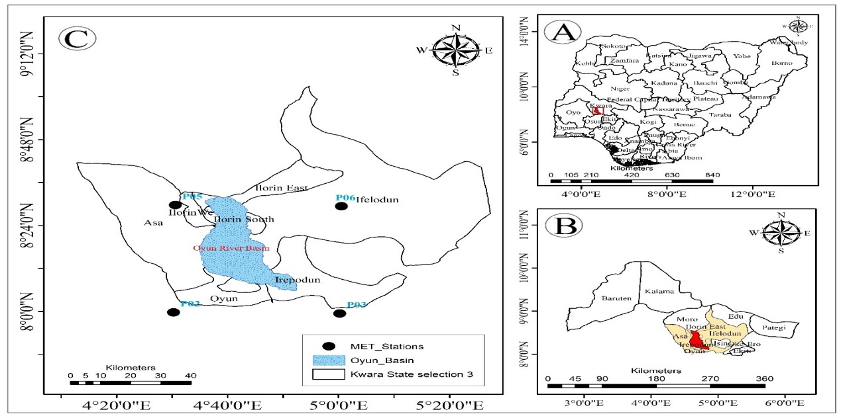
Figure 3.1: Map of the Study Area

3.2 Digital Elevation Model (DEM)
The Digital Elevation Model (DEM) for the Oyun River area in Kwara State offers a detailed representation of the region's topography. With elevation values ranging from 283 meters at the lower end to 565 meters at the higher elevations, this DEM provides a comprehensive spatial understanding of the landscape's relief, aiding in the assessment of drainage patterns, slope analysis, and terrain characteristics crucial for hydrological modeling and watershed management.
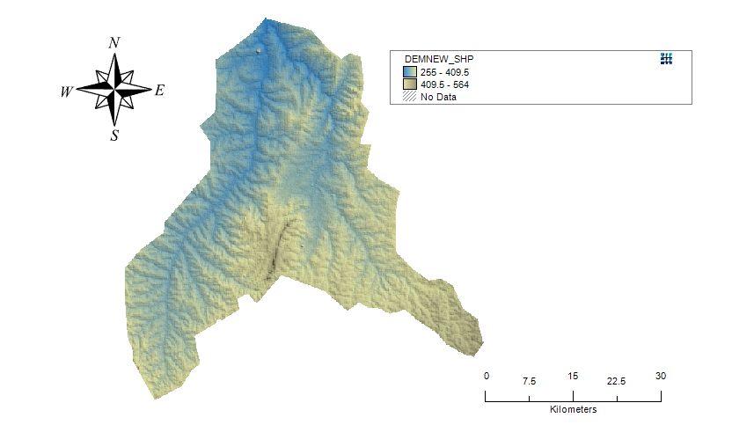
Figure 3.2 DEM map of the study area.

3.3 Land use map
This is a map of the different types of land use and land cover in the basin, such as forests, croplands, and urban areas. It is used to determine the amount of water that is intercepted by vegetation, as well as the amount that infiltrates into the soil. The Land use map that is needed to run SWAT was extracted from the Global Land Cover Characterization (GLCC) database, and it is also used to estimate vegetation and other parameters representing the watershed area. The GLCC database was developed by the United State Geological Survey and has a spatial resolution of 1Km and 24 classes of land use representation (GLCC (2012) Assessed on 8th May 2013). Land use map of the study area is shown in figure 3.3 shows information on land use/cover of the study area.

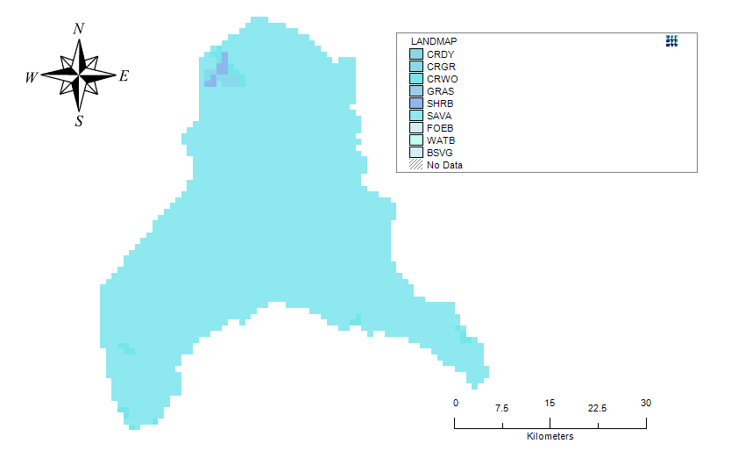
Figure 3.3: Land use map of the study area
3.4 Soil Map
This is a digitised soil data of the different types of soil in the basin, including information on soil texture, depth, and water-holding capacity. It is used to determine how much water can be stored in the soil, as well as how quickly water can move through the soil. The digital soil data for the study was extracted from a harmonized digital soil map of the world (Harmonized World Soil Database (HWSD)) produced by Food and Agriculture Organization of the United Nations, Rome (Nachtergaele et al., 2009). 16 soil samples were collected from two different layers (0 - 30 cm and 30 - 100 cm depth)and the samples were analysed and used to update the model parameters. Figure 3.6 shows the information of soil data/soil map.

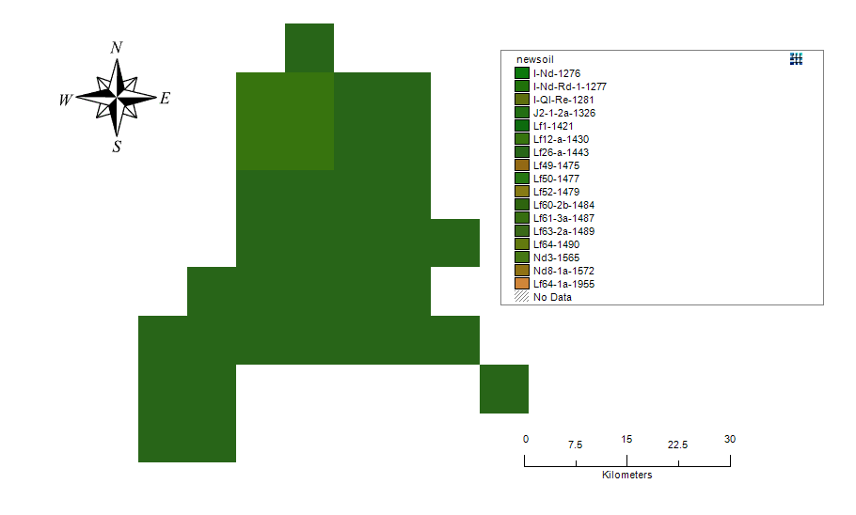
Figure 3.4: Soil map of the study area

3.5 Data Collection
Data collection for this comprehensive study involves gathering both spatial and temporal data to provide a well-rounded understanding of environmental dynamics. Spatial data includes essential elements such as the Digital Elevation Model (DEM) for mapping topographic features, Land Use data to analyze land cover patterns, and Soil Texture information for soil characterization. These spatial datasets form the basis for examining terrain, land suitability, and ecosystem health.
On the temporal side, the study also incorporates dynamic variables such as temperature, precipitation, relative humidity, solar radiation, and wind speed. This temporal data offers insights into seasonal and climatic fluctuations, allowing researchers to explore the complex interactions between spatial and temporal factors, thereby contributing to a thorough evaluation of environmental processes and changes over time.

3.6 Development of Hydrological Model
The Soil and Water Assessment Tool (SWAT) is a widely used hydrological model, and the SWAT 2009 extension provides a convenient interface for users within the mapwindow GIS environment. Let's delve into the five major steps involved in SWAT 2009

3.6.1 SWAT Project Setup
The initial step in utilizing SWAT 2009 involves setting up the SWAT project within the map window GIS environment. This includes defining the project area, specifying the projection and coordinate system, and establishing the simulation period. Users also input information regarding land use, soil, and management practices. The spatial data layers, such as digital elevation models (DEMs), land use maps, and soil databases, are integrated into the SWAT project to provide the necessary geospatial context for hydrological modelling. This step lays the foundation for subsequent analyses by organizing the key components of the study area and configuring the SWAT model parameters.

3.6.2 Watershed Delineation
Once the project is set up, watershed delineation is performed to identify the drainage areas within the defined project boundary. This step utilizes digital elevation data to delineate the watershed and sub-watersheds. The process involves the creation of a stream network, delineation of watershed boundaries, and determination of flow directions. The resulting watershed delineation provides a spatial framework for further analysis, enabling the subdivision of the study area into hydrologically meaningful units. Watershed delineation is crucial for understanding the flow of water within the landscape and serves as the basis for subsequent Hydrologic Response Unit (HRU) analysis. Figure 3.2 shows the data entry requirement for watershed delineation in SWAT2009.

3.6.3 HRU Analysis
Hydrologic Response Units (HRUs) are essential elements of the SWAT model, representing areas within a watershed that are spatially uniform in terms of hydrology. In this phase, SWAT 2009 refines the watershed boundaries by identifying HRUs based on land use, soil type, and slope. This tool integrates these factors to delineate HRUs with similar hydrological characteristics. Each HRU acts as an individual unit for modeling various hydrological processes, providing a more nuanced depiction of landscape variability. Analysing HRUs is vital for understanding the complex interactions between land cover, soil properties, and topography, thereby improving the accuracy of hydrological simulations.

3.6.4 Write Input Weather Data
Once the watersheds and HRUs are defined, the next step is to prepare and input weather data into the SWAT model. SWAT 2009 facilitates this by allowing users to import meteorological data, including precipitation, temperature, solar radiation, and wind speed. The accuracy of the model is significantly affected by the temporal and spatial resolution of the weather data, and SWAT 2009 provides tools to ensure that weather input files are properly formatted and organized. Accurate representation of climate variables is crucial for realistic simulation of hydrological processes, and this step guarantees that the SWAT model receives comprehensive meteorological information.

3.6.5 SWAT Run
The ultimate phase entails the execution of the SWAT model to simulate hydrological processes and evaluate water resource dynamics within the predefined watershed. The model amalgamates input data, including land use, soil characteristics, and weather information, to simulate surface runoff, evapotranspiration, groundwater flow, and additional hydrological components. The SWAT run generates output results encompassing streamflow, sediment yield, and nutrient transport, offering insights into the hydrological behaviour of the watershed. Users can scrutinize these results to evaluate the impact of land management practices, climate variations, and other factors on water resources. The SWAT run operates iteratively, permitting users to refine model parameters and input data to enhance simulation accuracy.

CHAPTER FOUR

4.0 RESULTS AND DISCUSSIONS

4.1 Hydrological Model Development
The hydrological model was created in the Map window using the MS SWAT 2009 tools extension for catchment and river delineation. The basin consists of 14 sub-basins, covering a total area of 1721.92 square meters. Each sub-basin functions as a smaller catchment area within the larger basin. Figure 4.1 below illustrates the boundaries of each sub-basin. In addition, Table 4.1 presents the information about the subbasins.
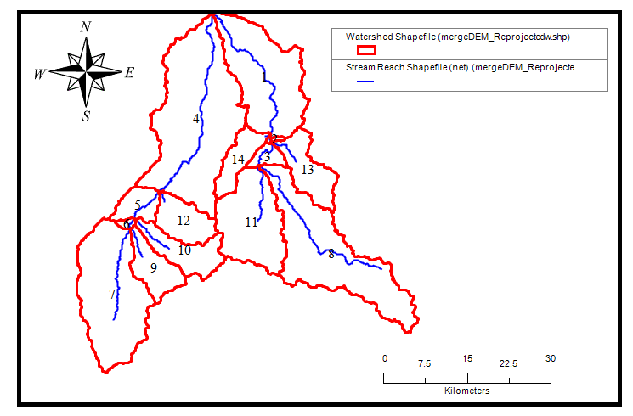
Figure 4.1: Hydrological Model

4.2 Runoff Prediction and Sediment Prediction

4.2.1 Study Area Runoff Prediction
The hydrological model developed for the study area as shown in Figure 4.1 was used to simulate and predict the flow in and flow out of the subbasins. These runoff values are presented in Table 4.1.

Table 4.1: Summary of Flow in and Flow out of the Subbasins
Subbasins | FLOW_INcms | FLOW_OUTcms
1 | 223.86 | 164.78
2 | 2.63 | 109.48
3 | 19.58 | 93.61
4 | 392.60 | 178.88
5 | 40.52 | 86.79
6 | 4.94 | 63.72
7 | 249.95 | 50.09
8 | 280.23 | 56.13
9 | 64.60 | 12.95
10 | 75.04 | 15.04
11 | 170.53 | 34.18
12 | 67.79 | 13.59
13 | 77.38 | 15.51
14 | 52.28 | 10.47
Table 4.1 summarizes the flow-in and flow-out values for the 14 subbasins, highlighting significant variations in water movement across the catchment. Subbasins 1, 4, 7, and 8 recorded the highest inflows, with subbasin 4 reaching up to 392.60 cms. In contrast, subbasin 2 showed a remarkably low inflow (2.63 cms) but a high outflow (109.48 cms), indicating possible upstream contributions or model discrepancies.
Several subbasins exhibited notable differences between inflow and outflow, suggesting internal storage, infiltration, or water extraction processes. Smaller subbasins (9–14) showed relatively low flows, consistent with their likely limited catchment size or hydrological inputs.
These variations are important for understanding local hydrologic behavior and are essential for water balance analysis and recharge estimation in the region.

4.2.2 Study Area Sediment Prediction
Similarly, the hydrological model developed for the study area as shown in Figure 4.1 was used to simulate and predict the sediment in, sediment out, and sediment concentrations of the subbasins. These sediment values are presented in Table 4.2.
Table 4.2: Summary of Sediment in. Sediment Out, and Sediment Concentration in the Subbasins
Subbasins | SED_INtons | SED_OUTtons | SEDCONCmg_kg
1 | 2697453.74 | 2312698.60 | 7080.74
2 | 1682327.34 | 1673002.63 | 9548.95
3 | 1497807.03 | 1442632.43 | 9751.91
4 | 3066514.45 | 2426235.75 | 6259.84
5 | 1551948.58 | 1480801.35 | 9326.02
6 | 1076378.85 | 1060726.62 | 10868.35
7 | 824505.04 | 824108.18 | 12511.15
8 | 725316.06 | 724080.71 | 11316.05
9 | 238441.88 | 238423.87 | 14382.32
10 | 350899.0 | 350854.2 | 19018.7
11 | 723114.1 | 722998.9 | 17102.2
12 | 303016.0 | 303013.8 | 14430.2
13 | 233228.2 | 233199.4 | 13862.8
14 | 140895.1 | 140892.4 | 12179.5
Table 4.2 provides an overview of sediment inflow, outflow (in tons), and sediment concentration (in mg/kg) across the 14 subbasins. The data reveals considerable variation in sediment transport and concentration, influenced by subbasin characteristics such as slope, land use, and flow intensity.
Subbasins 1, 2, 3, and 4 recorded the highest sediment inflow and outflow, with subbasin 4 receiving the highest sediment input (over 3 million tons), but with a relatively lower sediment concentration (6259.84 mg/kg), possibly due to dilution from high water flow. In contrast, smaller subbasins like 9, 10, and 11 exhibited the highest sediment concentrations, peaking at 19,018.7 mg kg in subbasin 10, indicating intense erosion or limited flow volume leading to higher sediment loading.
Overall, the sediment transport patterns suggest active erosion in several areas and varying capacities of subbasins to retain or pass sediments. These results are crucial for identifying erosion-prone zones and developing targeted soil conservation and watershed management strategies.

4.3 Spatial Analysis of Runoff and Sediment Yield

4.3.1 Spatial Variation Analysis
The spatial variation analysis was performed using mapwindow and the resulting maps were developed as presented in Figures 4.2 to 4.6 for flowIN, flowOUT, sedimentIN, sedimentOUT, and sediment CONC respectively.
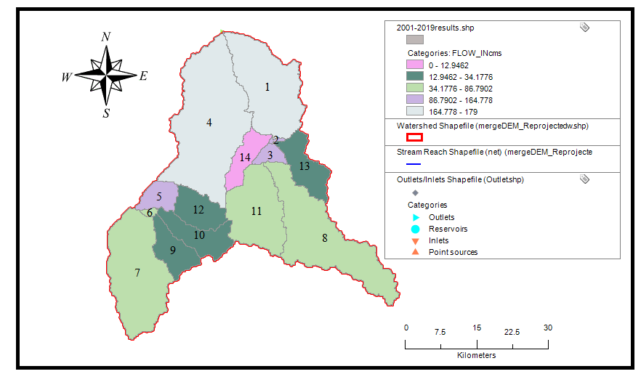
Figure 4.1: FlowIN Spatial Variation Map

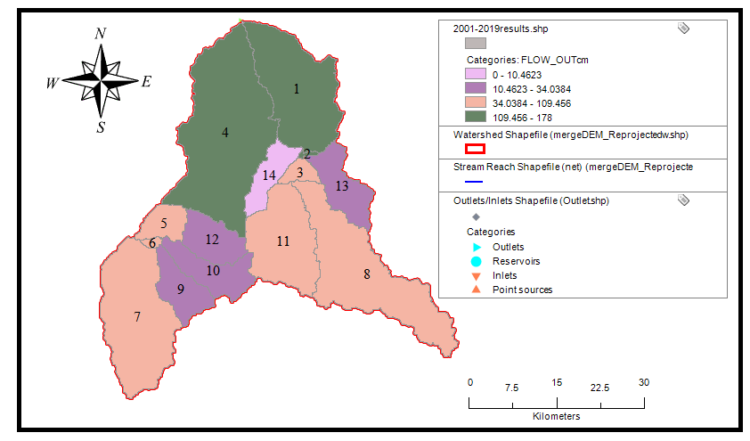
Figure 4.2: FlowOUT Spatial Variation Map

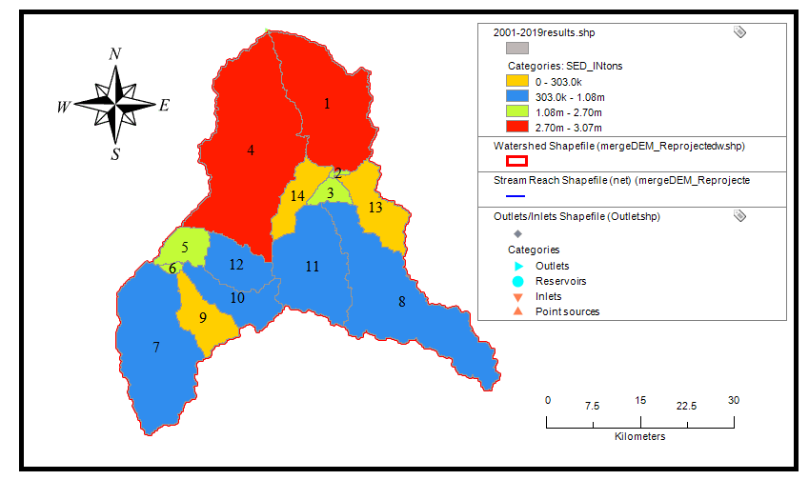
Figure 4.3: SedimentIN Spatial Variation Map

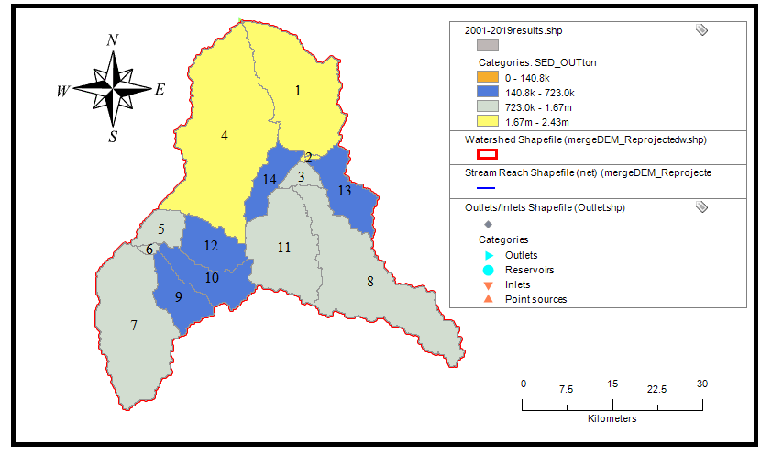
Figure 4.4: SedimentOUT Spatial Variation Map

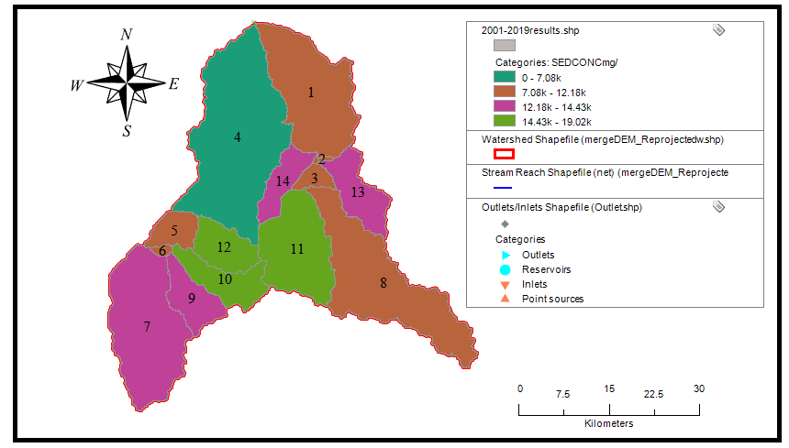
Figure 4.5: SedimentCONC Spatial Variation Map

CHAPTER FIVE

5.0 CONCLUSIONS AND RECOMMENDATIONS

5.1 CONCLUSIONS
Based on the result of the research work, it was concluded that:
- The hydrological model developed for the Oyun River using the SWAT tool has proven effective in predicting runoff and sediment loadings throughout the watershed.
- The flow analysis reveals significant spatial variation across the subbasins, with subbasins 1, 4, 7, and 8 contributing the highest inflows. In several cases, such as subbasin 2, low inflows paired with high outflows suggest additional inputs from upstream or lateral sources. Discrepancies between flow-in and flow-out in many subbasins indicate potential internal storage, groundwater recharge, or human-induced withdrawals.
- Sediment analysis shows that larger subbasins carry higher sediment loads due to greater catchment size and flow, while smaller subbasins like 10 and 11 exhibit the highest sediment concentrations, indicating localized erosion. This variation highlights both widespread sediment transport and specific erosion-prone areas, underlining the need for targeted soil conservation and watershed protection measures.
- The spatial analysis identified key sub-basins, particularly sub-basin 4, as areas with the highest risk of sediment accumulation.

5.2 RECOMMENDATIONS
The following are the recommendations based on the outcome of this study:
- Implement improved waste management and discharge of organic waste into the river. This should include the installation of proper waste treatment facilities and regular maintenance.
- Involve the local community and stakeholders in conservation efforts by raising awareness about the impact of abattoir activities on water quality, which could encourage better waste disposal practices.
- Establish an ongoing water quality monitoring program that focuses on sediment and nitrate levels in the river. This will help detect any sudden changes in loadings and enable timely interventions.
- Further research can be done to explore the effects of different land use scenarios and climate change projections on sediment and nitrate loadings in the river.

REFERENCE
Abdelwahab, Ossama M.M., et al. "Runoff and Sediment Yield Modeling in a Medium-Size Mediterranean Watershed." Water Resources Management, vol. 32, no. 11, 2018, pp. 3679-3691.
Adeogun, Adeniyi Ganiyu, et al. "Simulation of Sediment Yield at the Upstream Watershed of Jebba Lake in Nigeria Using SWAT Model." International Journal of River Basin Management, vol. 16, no. 1, 2018, pp. 1-12.
Ahmadia, H., et al. "Runoff and Sediment Yield Modeling Using WEPP in a Semi-Arid Environment (Case Study: Orazan Watershed)." Soil & Tillage Research, vol. 180, 2018, pp. 1-10.
Chen, P., et al. "Assessment of Soil Loss from Land Use/Land Cover Change and Disasters in the Longmen Shan Mountains, China." Natural Hazards and Earth System Sciences, vol. 18, no. 10, 2018, pp. 2791-2805.
Chandra, Prabhat, et al. "Prediction of Sediment Erosion Pattern in Upper Tapi Basin, India." International Soil and Water Conservation Research, vol. 7, no. 1, 2019, pp. 74-82.
Dar, Sarvat Gull, and Ayaz Mehmood Dar. "Modeling Runoff and Sediment Yield in Highly Gullied Regions of Kashmir Using SWAT Model: A Case Study of Lolab Watershed." Environmental Monitoring and Assessment, vol. 190, no. 12, 2018, pp. 1-13.
Debela, Seifu Kebede, and Fekadu Fufa Feyessa. "Rainfall-Runoff Modeling and Its Prioritization at Sub-Watershed Level Using SWAT Model: A Case of Finca’aa, Oromia, Western Ethiopia." Environmental Monitoring and Assessment, vol. 190, no. 2, 2018, pp. 1-14.
De Figueiredo, Eduardo E., and J.C. Bathurst. "Runoff and Sediment Yield Predictions in a Semiarid Region of Brazil Using SHETRAN." Hydrological Sciences Journal, vol. 63, no. 3, 2018, pp. 1-12.
Duan, Yanxin. "A Spatial Decision Support System for Economic Analysis of Sediment Control on Rangeland Watersheds." Journal of Environmental Management, vol. 206, 2018, pp. 912-921.
Fazli, Somayeh, and Hamzeh Noor. "Storm-Wise Sediment Yield Prediction Using Hillslope Erosion Model in Semi-Arid Abundant Lands." Geoderma, vol. 332, 2018, pp. 1-15.
Fenjiro, Imad, et al. "Assessment of Soil Erosion by RUSLE Model Using Remote Sensing and GIS: A Case Study of Ziz Upper Basin Southeast Morocco." Environmental Earth Sciences, vol. 77, no. 7, 2018, pp. 1-12.
Ganiyu, H.O., et al. "Sustainable Management of Runoff and Sediment Yield in a Rapidly Urbanizing Residential Area: A Case Study of Malete, Kwara State, Nigeria." Journal of Water Resource and Protection, vol. 11, no. 7, 2019, pp. 741-752.
Jimeno-Sáez, Patricia, et al. "A Comparison of Performance of SWAT and Machine Learning Models for Predicting Sediment Load in a Forested Basin, Northern Spain." Ecological Engineering, vol. 138, 2019, pp. 21-30.
Kalin, Latif, and Mohammed M. Hantush. "Evaluation of Sediment Transport Models and Comparative Application of Two Watershed Models." Environmental Modelling & Software, vol. 79, 2016, pp. 1-21.
Khanchoula, Kamel, et al. "Assessment of Sediment Yield Using SWAT Model: Case Study of Kebir Watershed, Northeast of Algeria." Environmental Earth Sciences, vol. 76, no. 24, 2017, pp. 1-12.
Kiros, Gebremedhin, et al. "Performance Evaluation of SWAT Model for Land Use and Land Cover Changes in Semi-Arid Climatic Conditions: A Review." Environmental Monitoring and Assessment, vol. 191, no. 2, 2019, pp. 1-10.
Li, Pengfei, et al. "Comparison of Soil Erosion Models Used to Study the Chinese Loess Plateau." Environmental Earth Sciences, vol. 77, no. 5, 2018, pp. 1-13.
Mohammad, M.E. "Application of SWAT Model to Estimate the Annual Runoff and Sediment of Duhok Reservoir Watershed." Arabian Journal of Geosciences, vol. 12, no. 9, 2019, pp. 1-10.
Olaniyan, O. S., et al. "Estimation of Runoff from River Asa Watershed Using SCS Curve Number and Geographic Information System (GIS)." Journal of Water Resources and Ocean Science, vol. 6, no. 2, 2017, pp. 16-24.
Otieno, Hesbon, and Japheth Ogalo Onyando. "Coupling Agricultural Non-Point Source (AgNPS) Model and Geographic Information System (GIS) Tools to Predict Peak Runoff and Sediment Generation in the Upper River Njoro Catchment in Kenya." Environmental Modelling & Software, vol. 105, 2018, pp. 1-10.
Phomcha, Puwadon, et al. "Predicting Sediment Discharge in an Agricultural Watershed: A Case Study of the Lam Sonthi Watershed, Thailand." Science of the Total Environment, vol. 657, 2019, pp. 587-600.
Rawat, Pradeep, et al. "Geospatial Analysis of Soil Erosion and Associated Geomorphic Hazards to Avert Increasing Disaster Risk in Environmentally Stressed Eastern Himalaya Region." Geocarto International, vol. 34, no. 5, 2019, pp. 517-535.
Senanayake, Sumudu, et al. "Assessing Soil Erosion Hazards Using Land-Use Change and Landslide Frequency Ratio Method: A Case Study of Sabaragamuwa Province, Sri Lanka." Sustainability, vol. 10, no. 10, 2018, pp. 3509.
Singh, Vishal, et al. "Response of Hydrological Factors and Relationships between Runoff and Sediment Yield in the Sub Basin of Satluj River, Western Himalaya, India." Journal of Hydrology: Regional Studies, vol. 15, 2018, pp. 33-47.
Tamanna, Marzia, et al. "Evaluation of AnnAGNPS Model for Runoff Simulation on Watersheds from Glaciated Landscape of USA Midwest and Northeast." Environmental Modeling & Assessment, vol. 23, no. 2, 2018, pp. 161-177.
Walling, D. E., and B. W. Webb. "Erosion and Sediment Yield: A Global Overview." Progress in Physical Geography, vol. 36, no. 3, 2018, pp. 1-21.
Wang, Chunying. "Using SWAT Model to Predict Water Flow, Sediment and Nutrients Loads in Shibetsu River Watershed, Eastern Hokkaido, Japan." Water, vol. 11, no. 9, 2019, pp. 1933.
Yahaya, Olotu, et al. "Simulation of Runoff and Sediment Load for Reservoir Sedimentation of River Ole Dam Using SWAT and WEPP Models." Journal of Hydrology, vol. 573, 2018, pp. 1-20.
Yin, Shuiqing, et al. "Regional Soil Erosion Assessment Based on Sample Survey and Geostatistics." Soil & Tillage Research, vol. 179, 2018, pp. 1-12.
Yüksel, Alaaddin, et al. "Using the WEPP Model to Predict Sediment Yield in a Sample Watershed in Kahramanmaras Region." Environmental Earth Sciences, vol. 75, no. 3, 2016, pp. 1-13.
Zalaki-Badil, Nasrin, et al. "Using SWAT Model to Determine Runoff, Sediment Yield in Maroon-Dam Catchment." Water Resources Management, vol. 32, no. 12, 2018, pp. 4091-4103.
Zema, Demetrio Antonio, et al. "Prediction of Surface Runoff and Soil Erosion at Watershed Scale: Analysis of the AnnAGNPS Model in Different Environmental Conditions." Land Degradation & Development, vol. 28, no. 3, 2017, pp. 1110-1125.

