

KWARA STATE POLYTECHNIC, ILORIN
INSTITUTIONOF INFORMATION COMMUNICATION TECHNOLOGY
DEPARTMENT OF COMPUTER SCIENCE

DEVELOPMENT OF A PACKET FILTERING TECHNIQUE FOR NETWORK SECURITY

BY
ADEBIYI TUNJI OLUWATAYO
ND/23/COM/PT/0075

A PROJECT REPORT SUBMITTED TO THE
DEPARTMENT OF COMPUTER SCIENCE
INSTITUTE OF INFORMATION AND COMMUNICATION TECHNOLOGY, KWARA STATE POLYTECHNIC ILORIN

IN PARTIAL FULFILLMENT OF THE REQUIREMENT FOR THE AWARD OF NATIONAL DIPLOMA (ND) IN COMPUTER SCIENCE
2025
CERTIFICATION
This is to certify that this project was carried out by ADEBIYI TUNJI OLUWATAYO with Matriculation Number ND/23/COM/PT/0075 in the department of Computer Science, Institute of Information and Communication Technology, Kwara State Polytechnic, Ilorin.

------------------------------------- ----------------------
MR. ISIAKA, O.S. Date
(Project Supervisor)

--------------------------------- ----------------------
MR. OYEDEPO, F.S. Date
(Head of Department)

----------------------------------- ---------------------
External Supervisor Date

DEDICATION
I dedicated this project to almighty God, whose support and encouragement were invaluable throughout this endeavor. May this work contribute to a more secure future.

ACKNOWLEDGMENT
I would like to express my sincere gratitude to my project supervisor, Mr. Isiaka O.S., for his invaluable guidance, support, and mentorship throughout the course of this project.
His insightful feedback, expert advice, and encouragement have been instrumental in shaping the development of the packet filtering technique for network security. I deeply appreciate his dedication and patience, which motivated me to overcome challenges and strive for excellence in my work.
This project would not have been possible without his unwavering support. Thank you, Mr. Isiaka O.S., for your mentorship and encouragement.

TABLE OF CONTENTS
Title page i
Certification ii
Dedication iii
Acknowledgements iv
Table of content v
Abstract vii
CHAPTER ONE: GENERAL INTRODUCTION
  - Introduction 1
  - Statement of the problem 3
  - Aims and objectives of the study 3
  - Significance of the study 3
  - Scope and limitation of the study 3
  - Organization of report 3
CHAPTER TWO: LITERATURE REVIEW
2.1 Review of related works 5
2.2 How does a Packet Filter Wrok 7
2.3 Packet Filtering Gateway and Authentication Server 7
2.4 Strategies of Packet Filtering 8
CHAPTER THREE: RESEARCH METHODOLOGY AND ANALYSIS
  - Research methodology 10
  - Analysis of the existing system 10
  - Problems of the existing system 10
  - Description of the proposed system 10
  - Advantages of the proposed system 12
CHAPTER FOUR: DESIGN, IMPLEMENTATION AND DOCUMENTATION
  - Design of the system 13
    - Output Design 13
    - Input Design 15
    - Database Design 16
    - Procedure Design 16
  - Implementation of the System 17
    - Choice of programming language 17
    - Hardware Support 17
    - Software support 17
  - Documentation of the system 17
    - Program Documentation 17
    - Maintaining the system 18
CHAPTER FIVE: SUMMARY, CONCLUSION AND RECOMMENDATION
  - Summary 19
  - Conclusion 19
  - Recommendations 19
References, System Flowchart / Program Flowchart 21
Flowcharts 22
Source Program listings 26
ABSTRACT
As the number of computers and network systems increases in today's world, so does the need for increased and strong computer and network security. Internet Protocol security (IPSec) is a protocol, not a service, that encrypts, validates, and authenticates IP-based network traffic. Because IPSec provides server-to-server protection, you can use it to defend against internal network threats such as eavesdropping, tampering, man-in-the-middle attacks, IP spoofing, and other password-based attacks. Since encryption, integrity, and authentication services are implemented at the transport level, IPSec is completely transparent to applications. TCP and UDP ports are still used by applications to communicate with one another. As the internet evolves and computer networks grow in size, there are individuals who have developed sophisticated skills and know how to infiltrate a user's privacy in a variety of ways. Because hacker tools have become more sophisticated, network security has naturally become one of the most important factors for businesses to consider. This application will be built with HTML5, CSS, Java Script, PHP as the front end and MYSQL as the backend.

CHAPTER ONE
GENERAL INTRODUCTION
1.1 INTRODUCTION
Packet filtering is a useful tool for the security-conscious network administrator, but its effective use necessitates a thorough understanding of its capabilities and limitations, as well as the quirks of the specific protocols to which filters are applied. There is no time when security does not matter in this age of universal electronic connectivity, viruses and hackers, electronic eavesdropping and electronic fraud. The explosive growth of computer systems and their interconnection via networks has increased both organizations' and individuals' reliance on the information stored and communicated using these systems. As a result, there is a greater awareness of the need to protect data and resources from disclosure, to ensure data authenticity, and to protect systems from network-based attacks. A firewall is a security guard that is installed at the point of entry between a private network and the Internet, requiring all incoming and outgoing packets to pass through it (Divya & Ritu, 2015).
The most important aspect of a network is security. There are numerous network security concepts. One of the most important concepts in network security is the firewall (Tharaka et al., 2016). A packet must pass through various network nodes as it travels from its origin to its destination. Each of these nodes has a router, which determines which path a packet should take to reach its destination security (Tharaka et al., 2016). The Internet has experienced rapid growth in recent years as a result of the ever-increasing demand for connectivity and inter-human communication. Although it began as a way to connect institutions using expensive circuit switching methods, subsequent advances in networking protocols and physical technologies meant that Internet connectivity became widely available, even to home users. Computer interconnections have enabled us to communicate quickly and share information in a variety of ways. These benefits, however, are not without drawbacks.
As the number of computers and network systems increases in today's world, so does the need for increased network security. The growth of the computer network system has exposed many networks to various types of internet threats, and as a result of this exposure, it is clear that increased network security is critical in every organization. Identification, authentication, and authorization, as well as surveillance cameras, may be used to protect the integrity, availability, accountability, and authenticity of computer hardware or network equipment. There is no set procedure for creating a secure network. Network security must be tailored to the needs of a single organization's network and not to those of others. A small law firm, for example, would allow authorized users on the outside of the network to access case information while ensuring that full internet access is always available to staff on the inside of the network, in other cases to access a case file from the office or on the road. A good network security system protects a network in a way that is consistent with its purpose, and care must be taken when selecting a network provider for an organization, particularly one as large as a law firm (Lin, Tsudik & Wang, 2011).
The IP Security feature allows you to create custom traffic filters, specify the source and destination addresses, the protocol and service, inspect both inbound and outbound traffic, and encrypt data streams using IPSEC. The original intent of Windows 2000's IP Security feature was to provide secure communications between hosts and services via IPSEC. An IP Security policy includes various filters and filter actions, as well as, if desired, an authentication and encryption scheme. IP Security filters can also create a 'tunnel' between two specified endpoints. In order to protect their private data, organizations' individual networks must be protected from public access. In general, packet filtering is a low-cost technology to implement. It should be noted, however, that a packet filtering device does not provide the same level of security as an application or proxy firewall. Except for the most basic IP networks, all IP networks are made up of IP subnets and contain routers (Divya & Ritu, 2015).
1.2 STATEMEMT OF THE PROBLEM
Packet filtering can be used to enhance overall network security. This feature is becoming more common in IP routers. If administrators use packet filtering correctly, it can be a very secure and useful tool. Currently, a number of challenges exist in the design and implementation of packet filtering firewalls in order to make them secure and efficient. Some of the issues that must be addressed are incorrect classification, variable header length, and fragment packet.
1.3 AIM AND OBJECTIVES OF THE STUDY
The aim of this research is to develop a packet filtering technique for network security. The study's objectives are as follows:
- Ensure the security of application traffic between a client and a server.
- Use IP filtering to provide end-to-end security from client-to-server, server-to-server, and client-to-client.
- Keep systems safe from network-based attacks.
1.4 SIGNIFICANCE OF THE STUDY
This study is intended to provide network security, protect your online identity, prevent identity theft, and ensure the security of any information transmitted over the internet. Secure hosting protects your Internet from hackers and unscrupulous individuals looking to steal your information. You can ensure that any information, data, or documents transmitted over the Internet are sent over a secure connection by using a secured server.
1.5 SCOPE OF THE STUDY
This study focuses on packet filtering techniques for network security in order to protect users' information from unscrupulous individuals. As a result, the study will only be applicable to the application of packet security, which employs a packet filtering technique for validation or authentication.
1.6 ORGANIZATION OF THE REPORT
The project report is divided into five chapters. The first chapter contains a general introduction, which includes an introduction to the research topic, a statement of the problem, the aim and objectives of the study, the significance of the study, the scope, the organization of the report, and the definition of technical terms used. The second chapter is a review of the literature, which includes a review of general texts as well as discussions of issues related to this research. The third chapter explains the project methodology, which includes data collection methods, an analysis of the existing system, problems with the existing system, a description of the proposed system, and the benefits of the proposed system. Chapter four discusses system design, implementation, and documentation, which includes system design – output design, input design, database design, and procedure design, system implementation – hardware and software support, and system documentation – installation procedure, operating the system, and system maintenance. Finally, chapter five discusses the research summary, recommendations, and conclusion.

CHAPTER TWO
LITERATURE REVIEW
2.1 REVIEW OF RELATED PAST WORKS
According to Divya & Ritu (2015), the rapid growth of the internet has connected millions of computers worldwide; therefore, in order for businesses to communicate with the outside world, they must connect to the internet. Individual organizations' private networks, known as Intranets, must be connected to the public network, i.e. the Internet. In order to protect their private data, organizations' individual networks must be protected from public access. In general, packet filtering is a low-cost technology to implement. It should be noted, however, that a packet filtering device does not provide the same level of security as an application or proxy firewall. Except for the most basic IP networks, all IP networks are made up of IP subnets and contain routers.
According to Tharaka et al. (2016), a common network security issue (Employees) that most organizations face has to do with the company's employees and the various errors they make. According to Dr. Michael E. Whitman, CISM, CISSP (2011), author of the textbook "Principles of Information Security," "Humans make mistakes; sometimes due to inexperience or inadequate training, and sometimes due to an incorrect assumption." However, regardless of the reason and the absence of malicious intent, something as simple as a keyboarding error has the potential to cause a worldwide Internet outage, and quick information access on the Internet has become increasingly important for growing businesses. As companies begin to outsource various business functions to the public network, precautions must be taken to ensure that their network is not tampered with or falls into the hands of unauthorized parties. If a network is accessed by a hacker or a disgruntled employee, it can wreak havoc on the organization's proprietary data, reduce productivity, and impede the company's ability to compete with other businesses. Unauthorized network access can also jeopardize a company's relationships with customers and business partners, who may doubt the company's ability to protect their confidential information.
According to Sarri et al. (2017), technological advancements in computer networks are increasing the demand for security on systems built. Security necessitates adaptability, efficiency, and effectiveness. The exchange of information via an internet connection is now commonplace. However, this method may result in data theft or cybercrime, resulting in losses for both parties. The use of a wireless network is increasing the rate of data theft. There are no signal restrictions that can be intercepted in the wireless system. Filtering is a method of limiting incoming internet access. Its goal is to keep intruders or people who want to steal data at bay. If not foreseen, this can be fatal. Filtering for Internet protocol (IP) and media access control (MAC) is a method of preventing unauthorized use and abuse of wireless networks. This technique is extremely useful for securing data on a computer when it connects to a public network. By registering IP and MAC addresses on a router, the information will be kept unused and stolen. This system only includes a few computers that can connect to a wireless hotspot using the IP and MAC addresses listed.
Filtering for Internet protocol (IP) and media access control (MAC) is a method of preventing unauthorized use of wireless networks. This technique is very useful for securing data on a computer if it connects to a public network. By registering IP and MAC addresses on a router, you can keep the information from being used and stolen. This system contains only a few computers that can connect to a wireless hotspot using the IP and MAC addresses listed.

2.2 HOW DOES A PACKET FILTER WORK?
In general, all packet filters work in the same way. Every packet entering the TCP/IP protocol stack is examined as it enters the network layer and transport layer. The network and transport headers are thoroughly examined for the following information.
i. Protocol (IP header, network layer) – Byte 9 (remember, the byte count starts with zero) in the IP header identifies the packet's protocol. Most filter devices can tell the difference between TCP, UPD, and ICMP.
ii. Source address (IP header, network layer) – The source address is the 32-bit IP address of the host that sent the packet.
iii. Destination address (IP header, network layer) – The destination address is the 32-bit IP address of the host for which the packet is intended.
iv. Source port (TCP or UDP header, transport layer) – A port is assigned to each end of a TCP or UDP network connection. TCP ports are distinguished from UDP ports. Ports with numbers less than 1024 are reserved and have a specific purpose. Ephemeral ports are those with a port number greater than 1024 (inclusive). They can be used however the vendor sees fit. RFP1700 contains a list of "well-known" ports. The source port is an ephemeral port number that is pseudo-randomly assigned. As a result, filtering on the source port is frequently ineffective.
v. Destination port (TCP or UDP header, transport layer) – The destination port number identifies the port to which the packet is being sent. Every service on the destination host listens to a different port. Ports such as 20/TCP and 21/TCP -ftp connection/data, 23/TCP -telnet, 80/TCP -http, and 53/TCP -DNS zone transfers are examples of well-known ports that may be filtered.
vi. Connection status (TCP header, transport layer) – The connection status indicates whether or not the packet is the first of the network session. If this is the first packet in the session, the ACK bit in the TCP header is set to "false" or 0. It is simple to prevent a host from connecting by rejecting or discarding any packets with the ACK bit set to "false" or 0.
2.3 PACKET FILTERING GATEWAY AND AUTHENTICATION SERVER
To secure an internet connection, several sites employ a combination of a packet filtering gateway and an authentication server. To limit the number of hosts exposed to the Internet, the MITRE Corporation employs a Cisco router. Telnet, rlogin, and ftp have been modified to use the Secure ID smartcard system. A challenge/response system is used to validate Internet connections.
2.4 STRATEGIES OF PACKET FILTERING
The primary benefits of packet filtering are the ability to reduce unwanted packet traffic and to protect against malicious and unwanted use of network sources. Packet filtering can be implemented using a variety of strategies. Among them are:
i. ROUTING TABLE SOLUTIONS: The routing table lookup is used to determine whether to route or drop the packet in this scheme. The routing table entries determine which destinations packets should and should not be routed to. When static routes are used, this solution comes in handy. Routing protocols such as RIP are used, but they are insecure. Routers can select which sources to accept RIP information from, which aids in preventing incorrect information from being provided inadvertently.
ii. INPUT AND OUTPUT FILTERING: In this scheme, filtering is performed on a network's external interface in both the input and output directions. By doing so, network security is achieved without slowing down internal network routing.
iii. SOURCE ADDRESS FILTERING: Internal network connections will use one authentication scheme, while external network connections will use another. Internal connections are those that exist within an organization's address space. If a filter is applied to the external interface, it will reject packets that claim to be from within but are actually from outside the network, i.e. the source and destination addresses are in the internal address space but the packet arrives from outside the network.
iv. PROTOCOL PORT FILTERING: The destination port is examined in this scheme to determine which set of destination ports can be accessed from the external network by applying a filter restricting the services that can be accessed from the external network. TCP services such as SMTP, nntp, ftp-data, ftp, finger, telnet, login, and shell, for example, can be denied access to external networks.
v. ADVANCED FILTERING STRATEGIES: Other commercial vendors, such as Novell, use Static Packet Filtering and advanced features such as TCP ACK bit filtering, Dynamic Packet Filtering, and Fragmented Packet Filtering in their Border Manager 3.7.
vi. STATIC PACKET FILTERING: Each packet that crosses the border between the internal network (intranet) and the external network (internet) is examined in Static Packet Filtering. The static packet filter examines each packet's header information to identify parameters such as Protocol ID, source and destination IP addresses and port numbers, and router interface for incoming and outgoing packets. These parameters are examined, and the decision to forward or drop the packet is made based on a predefined set of inbound and outbound rules.
vii. TCP ACK BIT FILTERING: Only packets with the TCP ACK bit set are allowed into the network when TCP ACK bit filtering is enabled. TCP ACK filtering prevents all external hosts from initiating unauthenticated TCP connections to internal hosts.
viii. DYNAMIC PACKET FILTERING: Dynamic packet filtering, also known as stateful packet filtering, keeps track of the outgoing packets that it has allowed to pass and allows only those packets to return. When a packet is sent to the public network, a return filter is dynamically created to allow the response packet. This scheme is compatible with both connection less and connection-oriented protocols.
ix. FRAGMENTED PACKET FILTERING: Packets are divided into small chunks called fragments; the first fragment contains all of the header information; previously, only the first packet was dropped assuming that the subsequent packets could not be reassembled without the header information; however, these subsequent packets can be used to flood the network, consuming bandwidth; to avoid this, the filtering discards the first packet as well as all subsequent packets if they have the same source and destination addresses.

CHAPTER THREE
RESEARCH METHODOLOGY AND ANALYSIS OF THE SYSTEM
3.1 RESEARCH METHODOLOGY
All packet filters work in the same general way. Every packet that enters the TCP/IP protocol stack is examined at the network and transport layers. The network and transport headers are carefully examined for the following information. The method used in this study is Routing Table Solutions; in this scheme, the decision to route or drop a packet is based on a routing table lookup. The routing table entries determine which destinations packets may and may not be routed to. When static routes are used, this solution comes in handy. Routing protocols such as RIP are used, but they are insecure. Routers can select which sources to accept RIP information from, which aids in preventing incorrect information from being provided inadvertently.
3.2 ANALYSIS OF THE EXISTING SYSTEM
The current system is a physical server, which is the traditional method of protecting computer networks with firewalls and software encryption. Because of its open medium dynamic changing topology, monitoring and management point not centralized, clear line not well defended, and cooperative algorithms, the wireless ad-hoc network is vulnerable to physical attack or harm.
3.3 PROBLEMS OF THE EXISTING SYSTEM
The problem of existing system are listed below
- The network is not secure because anyone can connect to it.
- It does not increase overall network security.
- Once the source IP address is spoof, a packet filter may incorrectly classify the packet.
- Some packet filters simply discard the first fragment, assuming that the remaining fragments are useless to the receiver.
3.4 DESCRIPTION OF THE PROPOSED SYSTEM
A packet filtering device can be used as the first line of defense in a network, preventing inbound packets of specific types from ever reaching the protected network. It can also provide data privacy, integrity, authenticity, and anti-replay protection for network traffic, as well as end-to-end security from client-to-server, server-to-server, and client-to-client using packet filtering techniques.
- Click Network > Packet Filters on the Main tab to open the Packet Filters screen.
- Select Enabled from the Packet Filtering list.
- Select Accept from the list of Unhand led Packet Actions.
- For the Options setting, leave the default value alone or check the appropriate check boxes.
- For the Protocols setting, leave the default value alone or clear the check boxes as necessary.
- Specify a value from the MAC Addresses list:
Value | Description
None | When you choose this option, all MAC addresses are exempt from packet filter evaluation.
Always Accept | When you select this option, the BIG-IP Configuration utility displays additional settings and allows you to specify which MAC addresses are exempt from packet filter evaluation.

1. If you instructed the MAC Addresses setting to always accept specific MAC addresses, provide the following information:
  - Enter a MAC address in the Add field and click Add. In the MAC Address List field, the MAC address is displayed.
  - Repeat this step for each MAC address that you want the system to ignore when evaluating packet filters.
2. Select a value from the IP Addresses list:
Value | Description
None | When this option is selected, all IP addresses are exempt from packet filter evaluation.
Always Accept | When you select this option, you can specify which IP addresses are not subject to packet filter evaluation. Additional settings are displayed by the BIG-IP Configuration utility.

3. If you set the IP Addresses setting to always accept specific IP addresses, enter the following information:
  - In the Add field, enter an IP address and click Add. The IP address is displayed in the IP Address List field.
  - Repeat this step for each IP address that you want the system to exclude from packet filter evaluation.
4. Choose a value from the VLANs list:
Value | Description
None | When this option is selected, all VLANs are exempt from packet filter evaluation.
Always Accept | When you choose this option, you can specify which VLANs are exempt from packet filter evaluation. Additional settings are displayed by the BIG-IP Configuration utility.

- Use the Move button to move one or more VLAN names from the Available list to the selected list if you configured the VLANs setting to always accept specific VLANs.
6. Click Update.
3.5 ADVANTAGES OF THE PROPOSED SYSTEM
- Packet filtering is quick, adaptable, and transparent (no Changes are required at the client)
- To prevent the use of private address space from leaking into the global Internet.
- To keep unauthorized users from accessing the server's information.
- Scalability of the packet filter
- Packet filters do not necessitate any special configuration of client computers.
CHAPTER FOUR
DESIGN, IMPLEMENTATION AND DOCUMENTATION OF THE SYSTEM
4.1 DESIGN OF THE SYSTEM
This is the computation of the specifics of a new system, as well as the determination of what the new system will be and what function it will perform. This may entail switching from one system to another or modifying the current system's operation. The transition from manual to faster and more accurate operation is the most difficult phase of the system life cycle; the system design stage covers the technical specifications that will be used in the implementation of the new system in order to modify the previous system. Some factors are considered, such as input design, output design, definitions, file and procedure designs, and other documentation.
4.1.1 OUTPUT DESIGN
This includes the objectives of resolving existing system issues and challenges. This includes structuring the desired information as well as improving the efficiency and effectiveness of the Server Security System. The following factors were considered in determining the output:
PACKET FILTERING TECHNIQUE FOR NETWORK SECURITY
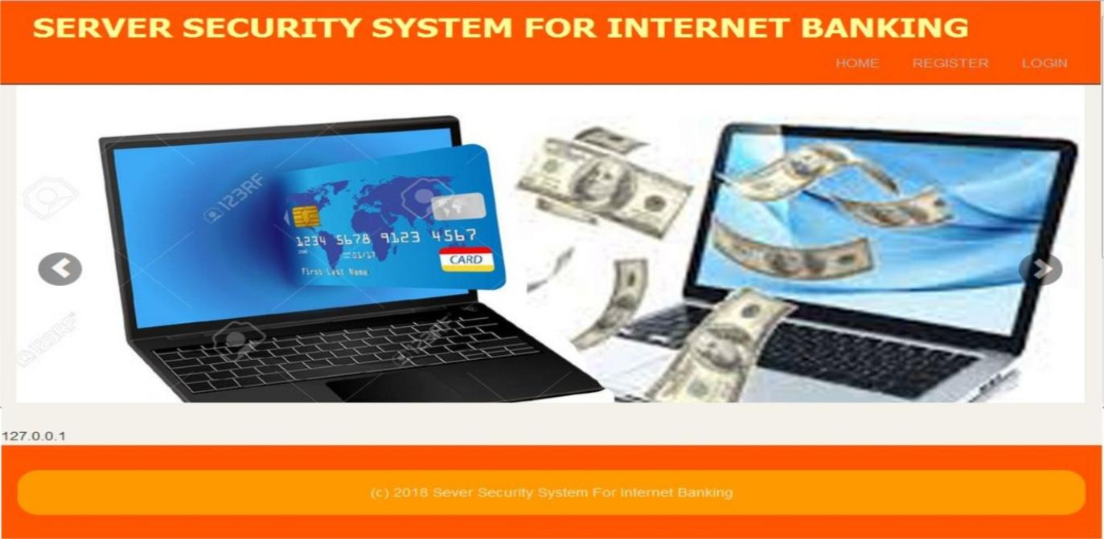

Figure 4.1: The main menu interface. This is a main menu diagram with submenus.
PACKET FILTERING TECHNIQUE FOR NETWORK SECURITY
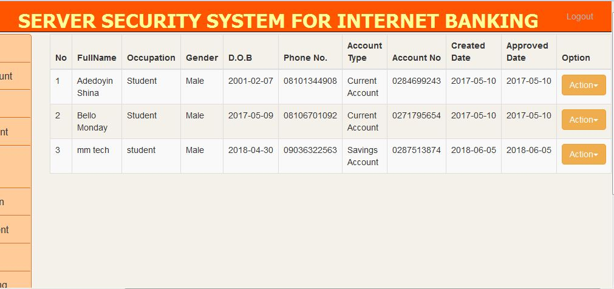

Figure 4.2: View Activated Account interface. This interface U78888displays all the Activated account
PACKET FILTERING TECHNIQUE FOR NETWORK SECURITY
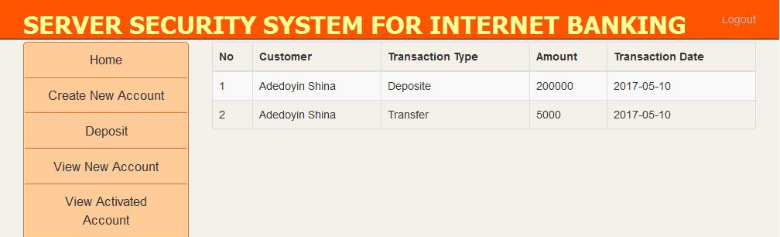
Figure 4.3: View Transaction Interface. This interface displays all the Transaction made.
PACKET FILTERING TECHNIQUE FOR NETWORK SECURITY
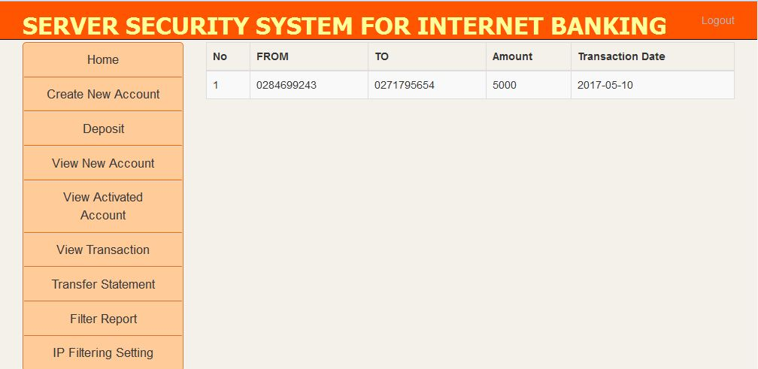

Figure 4.4: Transfer Statement Interface. This interface displays all Transfer made
4.1.2 INPUT DESIGN
The Server Security System administrator provides the input required to run this web. He can accomplish this by typing on the keyboard. Users' personal data and answers are required as input. In response to the administrator's questions. It can serve as the various input layouts from the various modules, starting with the data collection and module, then moving on to the assessment module and user input.
PACKET FILTERING TECHNIQUE FOR NETWORK SECURITY
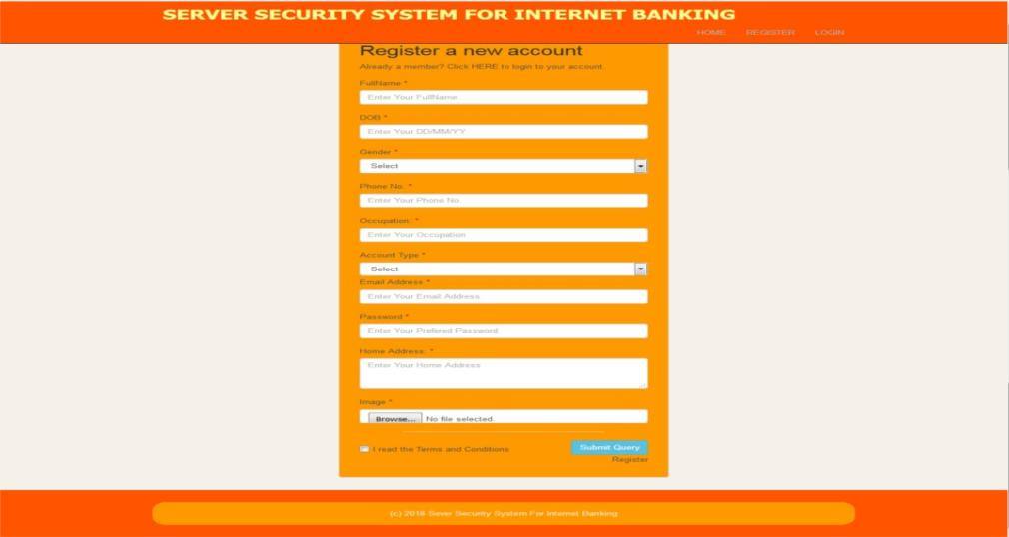
Figure 4.5: Registration Interface. This interface is the interface where the users register their information
PACKET FILTERING TECHNIQUE FOR NETWORK SECURITY
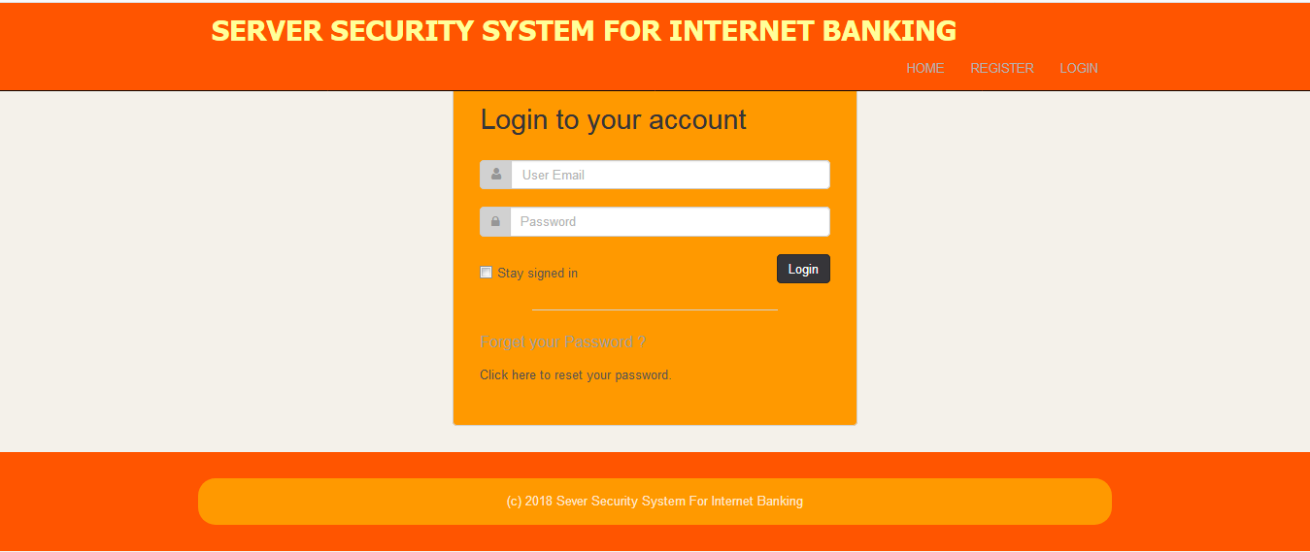

Figure 4.6: Login Interface. This interface is where the users input Email and Password to Login
PACKET FILTERING TECHNIQUE FOR NETWORK SECURITY
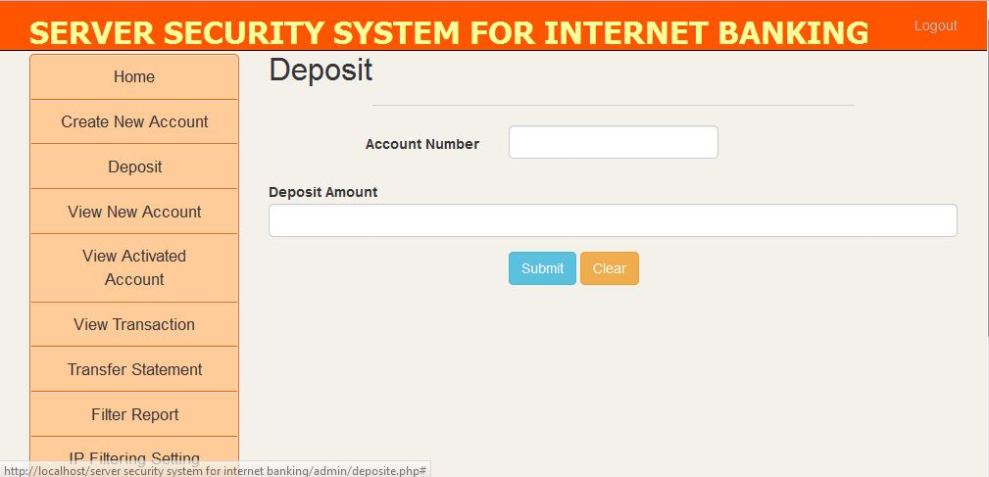

Figure 4.7: Deposit Interface. This interface is where the user enter account number and deposit account

4.1.3 DATABASE DESIGN
The input file is processed against the output file to generate the required output, and the "various file layout (designs)" have already been provided in the various pages, under the input design and the output design for the various modules, respectively. The following file design requirements must be met:
Storage media: That is the method of storing the 'file,' which can be auxiliary storage or diskettes. It can be done or printed on hard copy if necessary.
Method of organization: To avoid ambiguity, the file will be organized serially or in chronological order.
File security: Files must be protected to prevent unauthorized access to the file, particularly in the result module, which must be accessed only by the administrator.
Record layout: As previously stated, the records should be in order and easy to read.
4.1.4 PROCEDURE DESIGN
These are the steps involved in bringing the entire process together to produce the desired result. It entails computer procedures that begin with the original input lessons and end with the output result file. This enables the processing of User information and the generation of results. A menu is provided to assist the user in processing the output file.
4.2 IMPLEMENTATION OF THE SYSTEM
This includes selecting the programming language to be used to implement the web, which should be compatible with the Server Security System. The web is intended for use with a Server Security System, which should act as a supplement. It is also anticipated that it will be used in conjunction with the User. The Server Security System administrator will prepare the data base, while the administrator will provide personal information about the User.
4.2.1 CHOICE OF PROGRAMMING LANGUAGE
The application was created using an integrated development environment called.net (dot net) (.net IDE). The Application IDE was chosen because extracted information needs to be presented in an enhanced pictorial/graphical format, as well as easy communication with the database for program flexibility on the Windows platform.
4.2.2 HARDWARE REQUIREMENT
i. 500 Hz minimum with CD ROM drive etc.
ii. Hard disk of capacity 10GB Minimum
iii. 126-512 megabyte of RAM
iv. An Uninterrupted power supply (UPS)
v. A voltage stabilizer
vi. A power generating set etc.
4.2.3 WEB REQUIREMENT
i. Window Operated system such Window 7
ii. Mozilla Firefox
iii. Server Query Language (SQL).
4.3 DOCUMENTATION OF THE SYSTEM
4.3.1 PROGRAM DOCUMENTATION
The program is packaged for use in any system, regardless of whether it supports the Visual Studio application or not. Following the development of a program in Visual Studio, a facility called "Package and Deployment Wizard" is provided in the Microsoft Visual Studio suite and is used in Visual Studio application packaging and deployment. The Server Security System comes in the form of an installable setup that can be run from any system.
4.3.2 MAINTAINING THE SYSTEM
System maintenance refers to making changes to an existing application or program without having to rewrite everything from scratch. A program's maintenance includes modifying the program to meet the needs of the users. Additional features can be added, errors fixed, ambiguous interfaces redesigned to eliminate confusions, and unnecessary features removed during this course. This program can be maintained in a Visual Studio environment. Any future changes can be made by re-running the program source code in a VISUAL STUDIO environment, making the necessary changes and updates, and recompiling the application into an upgrade version of the existing mini word processing application. Further versions of this program can be named after the year they were released, or they can be given a different version number.

CHAPTER FIVE
SUMMARY AND CONCLUSION
5.1 SUMMARY
To thrive in today's economy, service providers should provide open and easily accessible communications services that allow their end users to communicate with anyone in the world. The same open and freely scalable communication architecture provides limitless communication services to end users while also creating a very appealing target for hackers who would exploit that open communication access for their own financial gain. An organization's security implementation, regardless of size, should consider all forms of access and intrusion on network hardware, both physically and remotely. Because security is a long-term issue, service providers require a security strategy as well as staff who are well-versed in that strategy. To that end, this thesis discussed the tools and practices that network operators must employ in order to protect their networks from denial of service attacks and other common security threats. Finally, service providers can turn those critical security safeguards into profitable managed security services for their enterprise clients.
5.2 CONLUSION
Service providers must develop a security strategy because security is a long-term issue. A good place to start is by educating employees on best practices. When implementing a security plan, it is critical to start with the most obvious protections and by deploying equipment capable of the most advanced protections, such as deploying equipment capable of providing privileged authentication and a higher level of scalability than line-level, protecting servers and routers by using one-time passwords and allowing only authorized users to access routers, and deploying authorization systems. Administrators can also put in place a mechanism to manage incoming traffic, which can include attacks on router control processors. In general, operators should turn off unused and unnecessary services, even if this means turning off server features. Finally, the growing importance of physical infrastructure in an organization has necessitated the need to physically protect the systems themselves, not only from cyber-attacks, but also from physical attacks that can be perpetrated against them.

5.3 RECOMMENDATIONS
Based on the researcher findings it is strongly recommended that
i. When implementing security policy, keep in mind that mechanisms such as intrusion detection and prevention techniques, which are critical to securing network infrastructure, can be turned into managed security services and sold to enterprise customers.
ii. All network devices should have an ACL (Access Control List) that restricts access to the device to network management workstations only.
iii. To help prevent man-in-the-middle attacks that use ARP spoofing tactics, administrators should use the port security feature and hard coded MAC addresses on switches and routers.
Finally, network administrators should always be aware of the most recent forms of threat and attack, test their network security design to see if it is vulnerable to the new threats and attacks, and then review the security design or policy for further modification.

REFERENCES
Brent C., Elizabet D. & Zwicky (2000) Building Internet Firewalls
Rai T.D & Verma R. (2015) ”Packet Filtering Technique for Network Security”, International Journal of Engineering Research & Technology (IJERT), page 1-4
Ji-Seon F. (2014). Overview of IP address Filtering Techniques, International Journal of Computer Science & Information Technology, Vol. 3, page 600-625.
Sarri D.S., Suplyandi, siahaan A.P.U & Muttaqin M. (2017), A Review of IP and MAC Address Filtering in Wireless Network Security, International Journal Science Research and Technology (IJSRST), Volume 3, Issue 6.
Robert G., Cornelia G., George P. & Radu L., (2019) Network Security Using Firewalls, Department of Computer Science, Faculty of Electrotehnics and Informatics.
Tharaka S.C., Silva R.L.C., Sharmila S., Silva S.U.I., Liyanage K.L.D.N., Amarasinghe A.A.T.K.K. & Dhammearatch D. (2016) “High Security Firewall: Prevent Unauthorized Access Using FirewallTechnologies”, International Journal of Scientific and Research Publications, Volume 6, Issue 4.
MAIN MENU

START
MAIN MENU
FILE
ABOUT
HELP
STOP

PACKET FILTERING

ABOUT

START
RETURN
DISPLAY ABOUT MENU
HELP
START
RETURN
DISPLAY HELP MENU

SOURCE PROGRAM LISTINGS
<?php session_start(); ?>
<?php
if(!isset($_SESSION['email'])){
echo "<script> window.location = 'index.php';</script>";
}

?>
<!-- === BEGIN HEADER === -->
<!DOCTYPE html>
<!--[if IE 8]> <html lang="en" class="ie8"> <![endif]-->
<!--[if IE 9]> <html lang="en" class="ie9"> <![endif]-->
<!--[if !IE]><!--> <html lang="en"> <!--<![endif]-->
<head>
<!-- Title -->
<title>Campus Online Help Desk</title>
<!-- Meta -->
<!--
CODE TO REFRESH A PAGE
-->
<!--<meta http-equiv="refresh" content="30" > -->
<?php include("fusioncharts/php/fusioncharts.php"); ?>
<meta http-equiv="content-type" content="text/html; charset=utf-8" />
<meta name="description" content="">
<meta name="author" content="">
<meta name="viewport" content="width=device-width, initial-scale=1, maximum-scale=1"/>
<!-- Favicon -->
<link href="favicon.html" rel="shortcut icon">
<!-- Bootstrap Core CSS -->
<link rel="stylesheet" href="assets/css/bootstrap.css" rel="stylesheet">
<!-- Template CSS -->
<link rel="stylesheet" href="assets/css/animate.css" rel="stylesheet">

<link rel="stylesheet" href="assets/css/font-awesome.css" rel="stylesheet">
<link rel="stylesheet" href="assets/css/nexus.css" rel="stylesheet">
<link rel="stylesheet" href="assets/css/responsive.css" rel="stylesheet">
<link rel="stylesheet" href="assets/css/custom.css" rel="stylesheet">
<!-- Google Fonts-->
<link href="assets/js/dataTables/dataTables.bootstrap.css" rel="stylesheet" />
<script type="text/javascript" src="ipmapper.js"></script>

<script type="text/javascript" src="fusioncharts/js/fusioncharts.js"></script>
<script type="text/javascript" src="fusioncharts/js/fusioncharts.charts.js"></script>
<script type="text/javascript" src="fusioncharts/js/themes/fusioncharts.theme.fint.js"></script>
<?php
session_start();
require ("connectme.php");

?>
<!DOCTYPE html PUBLIC "-//W3C//DTD XHTML 1.0 Transitional//EN" "http://www.w3.org/TR/xhtml1/DTD/xhtml1-transitional.dtd">
<html xmlns="http://www.w3.org/1999/xhtml">
<head>
<meta http-equiv="Content-Type" content="text/html; charset=utf-8" />
<title>Server Security</title>
<link href="yusufishola.css" rel="stylesheet" type="text/css"/>
<link href="../yusufishola.css" rel="stylesheet" type="text/css"/>
<style type="text/css">
<!--
body {
background-color: #BFF9CB;
}
-->
</style>
</head>

<body>
<table width="1000" border="1" align="center" cellspacing="0">
<tr>
<td height="77"><img name="banner" src="image/banner.jpg" width="1000" height="180" border="0" id="banner" alt="" /></td>
</tr>
<tr bgcolor="#FFFFFF">
<td height="178">
<br/>
<a href="admin/viewresult2.php"><font size='5' color="green">View Result</font></a>

<form action="loginproccess.php" method="post" name="form1" id="form1">
<p>&nbsp;</p>
<table width="326" border="0" align="center" cellpadding="2" cellspacing="0" bgcolor="#4FD06B">
<tr>
<td width="76">Username</td>
<td width="242"><label for="username"></label>
<input type="text" name="username" id="username" required/></td>
</tr>
<tr>
<td>Password</td>
<td><label for="password"></label>
<input type="password" name="password" id="password" required/></td>
</tr>
<tr>
<td>&nbsp;</td>
<td><input type="submit" name="submit" name="button2" id="button2" value="Submit" />
<input type="reset" name="Reset" id="button" value="Reset" />
</td>

</tr>
</table>
<p>&nbsp;</p>
<p>&nbsp;</p>
<p>&nbsp;</p>
</form></td>
</tr>

<tr>
<td><img src="image/bar.jpg" width="1000" height="20" /></td>
</tr>
</table>
</body>
</html>
<?php session_start(); ?>
<!DOCTYPE html PUBLIC "-//W3C//DTD XHTML 1.0 Transitional//EN" "http://www.w3.org/TR/xhtml1/DTD/xhtml1-transitional.dtd">
<html xmlns="http://www.w3.org/1999/xhtml">
<head>
<meta http-equiv="Content-Type" content="text/html; charset=utf-8" />
<title>Server Security</title>
<link href="yusufishola.css" rel="stylesheet" type="text/css"/>
<link href="../yusufishola.css" rel="stylesheet" type="text/css"/>
<style type="text/css">
<!--
body {
background-color: #BFF9CB;
}
-->
</style>
</head>

<body><table width="1000" border="1" align="center" cellspacing="0">
<tr>
<td height="77"><img name="banner" src="image/banner.jpg" width="1000" height="180" border="0" id="banner" alt="" /></td>
</tr>
<tr bgcolor="#FFFFFF">
<td height="178" valign="top"><form id="form1" name="form1" method="post" action="voters_process.php">
<table align="center">
<?php require ("connectme.php");

// holds the distinct number of positions
$vstatus = @$_SESSION['status'];

if($vstatus == 1 ){
// already vote
echo '<tr><td colspan="3">';

echo "You have Already voted For your candidates click <a href='logout.php'>here</a> to log out";

echo'</td></tr><br><br><br>';
}else{

$gotten = mysql_query("SELECT DISTINCT post FROM Server") or die (mysql_error());
$_SESSION['num'] = mysql_num_rows($gotten);
while ($rowss = mysql_fetch_array($gotten)){
$post = $rowss['post'];
$posttest = 0;
$get1 = mysql_query("SELECT cont_id, photo, name FROM Server WHERE post = '$post'") or die (mysql_error());
while ($row = mysql_fetch_array($get1)){
$get2 = mysql_query("SELECT postname FROM post WHERE id = '$post'") or die(mysql_error());
while ($row2 = mysql_fetch_array($get2)){
if ($posttest != $post){
echo "<tr><td align =center><h1><b>".$postname = strtoupper($row2['postname'])."</b></h1></td></tr>";
}
$cont_id = $row['cont_id'];
$photo = $row['photo'];
echo "<tr><td>".$name = $row['name']."</td>";
echo "<td><input type='radio' name='$post' id='radio' value='$cont_id' /></td>";
echo '<td><img src="passport/'.$photo.'.jpg"." width=100 border=1></td></tr>';
$posttest = $post;
}
}
}
?>

