IMPLEMENTATION OF A SYSTEM FOR SIGNATURE AUTHENTICATION AND RECOGNITION

BY

ISSA ABDULWAHEED
HND/23/COM/FT/0289

A PROJECT REPORT SUBMITTED TO THE
DEPARTMENT OF COMPUTER SCIENCE
INSTITUTE OF INFORMATION AND COMMUNICATION TECHNOLOGY, KWARA STATE POLYTECHNIC ILORIN

IN PARTIAL FULFILLMENT OF THE REQUIREMENT FOR THE AWARD OF HIGHER NATIONAL DIPLOMA (HND) IN COMPUTER SCIENCE

2025
CERTIFICATION
This is to certify that this project is written by Issa Abdulwaheed with matriculation number HND/23/COM/FT/0289 in Computer Science Department, Institute of Information and Communication Technology, Kwara State Polytechnic, Ilorin.

------------------------------------- ----------------------
MR. ISIAKA, O.S. Date
(Project Supervisor)

--------------------------------- ----------------------
MR. OYEDEPO, F.S. Date
(Head of Department)

----------------------------------- ---------------------
External Supervisor Date

DEDICATION
I dedicate this project to Almighty God, for His unfailing grace, wisdom, and strength that sustained me throughout this journey.

ACKNOWLEDGEMENT
I sincerely thank my project supervisor, [MR. ISIAKA], for his valuable guidance and support throughout this project. I also extend my gratitude to the Computer Science Department at Institute of Information and Communication Technologies (IICT-BAS)for providing the resources and knowledge that made this work possible.
Finally, I appreciate the encouragement and support from my family and friends during this journey.

TABLE OF CONTENTS
PAGE
Title page i
Certification ii
Dedication iii
Acknowledgement iv
Table of content v
Abstract vii
CHAPTER ONE: INTRODUCTION
  - Introduction 1
  - Statement of the Problems 3
  - Aim and Objectives 3
  - Significance of the Study 3
  - Scope of the Study 4
  - Organization of the Report 4
CHAPTER TWO: LITERATURE REVIEW
2.1 Review of Related Literature 5
2.2 Review of Past work 7
2.3 Off-Line Signature Recognition 8
2.4 Review of Related Theory 9
2.4.1 How the Human Brain Works 9
CHAPTER THREE: METHODOLOGY AND ANALYSIS OF THE SYSTEM
3.1 Research Methodology 12
3.2 Analysis of the Existing System 12
3.3 Problems of the Existing System 13
3.4 Description of the Proposed System 13
3.5 Advantages of the Proposed System 14

CHAPTER FOUR: DESIGN AND IMPLEMENTATION AND OF THE SYSTEM
4.1 Design of the New System 15
4.1.1 Output Design 15
4.1.2 Input Design 16
4.1.3 Database Design 16
4.1.4 Procedure Design 17
4.2 System Implementation 17
4.2.1 Choice of Programming Language 17
4.2.2 Hardware Support 18
4.2.3 Software Support 18
4.2.3 Changeover Techniques 18
4.3 Documentation of the System 18
4.3.1 Program Documentation 18
4.3.2 Operating the System 19
4.3.3 Maintaining the System 19
CHAPTER FIVE: SUMMARY, CONCLUSION AND RECOMMENDATION
5.1 Summary 20
5.2 Conclusion 20
5.3 Recommendation 21
References 22
Flow chart 24
Source Code 29

ABSTRACT
The Implementation of a System for Signature Authentication and Recognition aims to address the growing need for secure and reliable identity verification in digital and physical transactions. This system leverages advanced image processing and machine learning algorithms to analyze, verify, and recognize signatures with high accuracy. The process involves extracting unique features from signatures and comparing them against pre-stored templates to ensure authenticity. By integrating techniques such as feature extraction, pattern matching, and neural network classification, the system ensures robustness against forgeries and variations in signature styles. Designed to be user-friendly and scalable, the system can be applied in various domains, including banking, legal documentation, and access control. This research highlights the architecture, development, and evaluation of the system, demonstrating its potential for enhancing security and efficiency in signature-based authentication processes.. The research objectives are to design a system that recognizes and verifies signatures against what is already in the database, to ensure document security, and to completely eliminate cases of signature forgery using Visual Basic 6.0 as the implementing language.

CHAPTER ONE

GENERAL INTRODUCTION
  - INTRODUCTION
Signature verification seeks to confirm a person's identity by using his or her chosen signature. Signature is thought to be a behavioral biometric that encodes the signer's ballistic movements; as such, it is difficult to imitate. When compared to physical characteristics such as fingerprints, iris, or face, a signature typically exhibits greater intra-class and time variability. In addition, as with passwords, a user can select a simple signature that is easy to forge. The signature, on the other hand, is an intriguing biometric due to its widespread acceptance by the general public and niche applications (validating paper documents and use in banking applications).
At the moment, there are several methods for verifying the authenticity of one's personal data, ranging from a signature to a fingerprint. A signature is a symbol of a person's name written by hand and by the person himself as a personal marker. Signatures are frequently used in data verification in schools, banks, corporations, hospitals, government, and other settings. Because of the importance of the signature function, many parties wish to manipulate the signatures of others. Duplicate signatures can be harmful and fall into the criminal realm. Signature identification can be accomplished both online and offline. Online signature recognition is accomplished by placing a signature on a pen tablet, whereas offline signature recognition is accomplished by scanning (Suryani, Irwansyah, & Chindra, 2017).
A handwritten signature is one of the most widely accepted personal attributes for confirming a person's identity. Based on the implicit assumption that a person's normal signature changes slowly and is very difficult to erase, alter, or forge without detection, the written signature is regarded as the primary means of identifying the signer of a written document. In comparison to other electronic identification methods such as fingerprint scanning and retinal vascular pattern screening, the handwritten signature is one method for authorizing transactions and authenticating human identity. It is easier for people to transition from the popular pen-and-paper signature to one in which the handwritten signature is captured and verified electronically (Choudhary, Patil, Bhadade, & Chaudhari, 2013).
The signature recognition task is divided into two sections. The first approach necessitates the gathering of information and the recognition of signatures as the system's output, and it is observed that signatures must be made within a certain time interval. This system represents the signing person, whereas another approach is to treat a signature as a static two-dimensional image that contains no time-related information (Pacut, Czajka, 2001). In a nutshell, signature recognition can be divided into two categories. Both online and offline.
The online signature recognition, in which signatures are obtained while writing with a special instrument, such as a pen tablet. In fact, in the case of online signature recognition, there is always dynamic information available, such as velocity, acceleration, and pen pressure. So far, many widely used methods for online signature recognition have been developed, such as Artificial Neural Networks (ANN), dynamic time warping (DTW), and hidden Markov models (HMM) (Wu, Jou, & Lee, 2007).
Off-line recognition only works with signature images captured with a scanner or digital camera. Offline signature recognition and verification is a difficult problem in general. Unlike the on-line signature, which captures dynamic aspects of the signing action directly as the handwriting trajectory, the dynamic information contained in the off-line signature is severely degraded. Handwriting features such as handwriting order, variation in writing speed, and skillfulness must be recovered from grey-level pixels.
Signature recognition is the process of verifying the identity of the writer by comparing the signature to samples stored in a database. The outcome of this process is typically between 0 and 1, representing a fit ratio (1 for match and 0 for mismatch). The term "signature recognition" refers to a computer's ability to convert human-written text into text. This can be accomplished in one of two ways: scanning written text (offline method) or writing directly on peripheral input devices. The first of these recognition techniques, known as optical character recognition (OCR), is the most widely used. Most scanning software provides the same type of O C R, allowing users to scan handwritten documents and have them translated into basic text documents. Some archivists use OCR to convert massive amounts of handwritten historical documents into searchable, easily accessible digital forms (Cath, 2010).
1.2 STATEMENT OF THE PROBLEM
Handwritten signatures have historically been a popular method of authentication. Though such signatures are never the same for the same person at different times, it appears that there is no practical problem for humans to distinguish the real signature from the forged one visually. It will be extremely beneficial when an electronic device can demonstrate at least the same level of virtuosity. For decades, researchers have been working on computer-aided handwritten signature verification systems. To address the problem of handwritten signature recognition, various approaches have been developed.
Recognizing signatures ignoring the variation such as
- Variation due to different pens
- Variation arising out of the fact that “No two signature of the same person are exactly - same”
- Any marks on the paper or any such element.
Overcoming the above variation and establishing the authenticity of signature.
1.3 AIMS AND OBJECTIVES
The aim of this study is to design a system that capable of recognizing and verifying signature. The basic objectives of this study are as follow:
- To design a system that recognizes and verifies signature against what already exist in data base
- To ensure security of document
- To reduce completely cases of signature forgery
- To ensure that business transaction are carried out faster and more conveniently
1.4 SIGNIFICANCE OF THE STUDY
The proposed system will help to overcome the short coming of the existing system such as forgery in accuracy time wasting and it’s unreliable. So the new system will precede the following features. It will be significance to banking system for slip withdrawal for signature verification and eliminate the use of human being for identification of signature. It will also have vital impact to play academically as it will effectively contribute to both knowledge of the researcher and academy in general. It will contribute to literature which will serve as reference point.
1.5 SCOPE OF THE STUDY
The scope of this project work is to design a system that not only recognizes an individual signature but also verifies subsequent copies of the same signature to avoid cases of forgery as much as possible. SRVS (Signature Recognition and Verification System) is often categorized in two major classes: On-line SRVS and Off-line SRVS, this study is limited to the offline method of signature recognition and verification. The problem signature recognition verification is in theory a pattern recognition task used to discriminate two classes: Original and forgery signature. Even after many efforts in order to develop new verification techniques for offline signature recognition, the influence of forgery types has not been extensively studied.
1.6 ORGANIZATION OF THE REPORT
Majority of this project will contain all the necessary information needed to carry out the proposed task. Chapter one contains general introduction, aim and objective, significance of the study, scope and limitation, organization of the report and definition of technical / operation terms. Chapter two deals with the literature review, it reviews related topic to the project, discussion of related aspect of the project topic relative to computer technology. Chapter three deals with methodology and analysis of the system which include the data collection method employed, the description of the existing system and its problems and the description of the proposed system and possible advantages it will provide the will solve problems encountered in the existing manual system. While chapter four deals with the design, implementation and the description of the proposed system. It covers description of the output design, input design, database design and procedure design. The implementation techniques used, the programming language used in developing the new system and system requirements for running the system. And also talks about the program documentation as well user documentation. Lastly chapter five presents a brief summary of the work done, experience gained and problems encountered in the course of the project, conclusion and recommendation. Other appendices included after the references used are; algorithm, system flowchart, program flowchart, program source listing and generated computer output.

CHAPTER TWO
LITERATURE REVIEW
2.1 REVIEW OF RELATED WORK
According to Hemant (2014) review on “Off-Line Signature Recognition Systems” Handwritten signature is one of the most widely used biometric traits for authentication of person as well as document. In this paper he discuss issues regarding off-line signature recognitions and review existing techniques, their performance and method for feature extraction. The system designed using cluster based global features which is a multi algorithmic offline signature recognition system and special consideration is given to the analysis of Static Signature Recognition Systems (SRS). The performance metrics of typical systems are compared along with their feature extraction mechanisms. it is concluded that the system is has reported accuracy of 95.08% (CCR), which is higher than individual performance metrics.
Mustafa (2015) probe on “offline signature verification with user-based and global classifiers of local features” The signature is divided into zones using both fixed size rectangular or polar grids, where HOG and LBP features are calculated. For either of the representations, features obtained from grid zones are concatenated to form the final feature vector. Two different types of SVM classifiers are trained, namely global and user-dependent SVMs, to perform verification. He also experiment with the fusion of classifiers, and show that the combination improves overall verification performance. Feature-level fusion is possible but we prefer to train classifiers to be experts for each feature type. Score-level fusion helps the classification process with an additional information on how to combine different feature classifiers by deciding on combination weights, separately. In conclusion, obtained results are comparable or better compared to those reported in the literature for the GPDS database. Considering that using skilled forgeries brings a potentially significant advantage in accuracy, the results should be deemed comparable and possibly better than state-of-the-art results. On the other hand, the fact that the proposed system does not require skilled forgeries of the enrolling user, is attractive for real life applications.
Maged (2010) analyze on “Online handwritten signature verification system based on DWT features extraction and neural network classification” Online handwritten signature verification system based on extracting sub-bands that represent intrapersonal features of signature from DWT representations of that signature is presented in this paper. Both extracted pen position and derived pen-movement angle parameters of handwritten signature data were decomposed into sub-band signals by DWT. Low frequency (approximations) and high frequency (details) subband signals were extracted for these parameters. Low frequency sub-band signals (approximation) are found consistent as features to enhance the difference between a genuine signature and its forgery. This is at least when using it in the recognition process with the signature database used in this research. The signature database consists of 20 genuine signatures for each of five users as well as 20 skilled forgeries for each user. A multi matcher (recognizer) consisting of six neural networks is used to recognize online handwritten signature.
Pascual-Gaspar, Carde-noso-Payo & Vivaracho-Pascual (2009) review on “Practical On-Line Signature Verification” DTW-based on-line signature verification system specially designed to be used in practical scenarios. It does not need special hardware features to get good performance results, just geometric coordinates and, optionally, pen pressure. The system needs only a reduced number of signatures from the user to bring excellent verification results. Depending on the security requirements, different feature sets could be selectively chosen. Benchmark experiments carried out over four popular on-line signature databases (MCYT, SVC2004, BIOMET and MYIDEA) prove that our system provides excellent results in terms of EER, specially for the skilled forgery scenario, where the system clearly outperforms other up-to-date systems in the literature under similar testing conditions.
A review by Radhikaa & Gopika (2014) on “Online and Offline Signature Verification: A Combined Approach” An approach that combines online and offline signature verification methods has been proposed. The online approach deals with the videos of signing process and the pen track is used for forming the feature vector. Whereas offline signature verification deals with the scanned images of the signatures and uses the gradient and projection features for forming the feature vector. Both online and offline approach verifies a signature based on comparison with a previously set threshold value. Finally the results of testing done in these approaches are combined and used by SVM for final verification. The performance of online, offline and combined approaches have been evaluated and the proposed approach works fairly well.
2.2 REVIEW OF GENERAL TEXT
On-line signature recognition considers the dynamic characteristics of signatures. In Jain & Greiss (2012) have used critical points, speed curvature angle as features and they have reported FRR 2.8% and FAR 1.6 %. They used common as well as writer dependent thresholds but it was observed that the writer dependent thresholds give better accuracy.
Considering another approach Lei, Palla & Govindarajalu (2005) have proposed a technique for finding correlation between two signature sequences for online recognition, they mapped the occurrence of different critical points on signature and the time scale and the correlation between these sequences was evaluated using a new parameter called Extended Regression Square (ER2) coefficient the results were compared with an existing technique based on Dynamic Time Wrapping (DTW). They reported Equal Error rate (EER) 7.2% where the EER reported by DTW was 20.9 % with user dependent thresholds. Abdullah and Shoshan (2006) used Image invariant and dynamic features for On-Line signature recognition, they used the Fourier descriptors for invariance and writing speed was used as dynamic feature. Multi-layer perceptron neural network was used for classification.
In Rhee & Cho (2003) used Model guided segmentation approach for segment–to–segment comparison to obtain consistent segmentation. They used discriminative feature selection for skilled as well as random forgeries. They reported EER 3.4 %. Nalwa used a moment and torque base approach for on-line signature recognition. His work is based parameterizing each online curve over its normalized arc-length. These parameters are then represented along the length of the curve, in a moving coordinate frame. The measures of the curve within a sliding window that are analogous to the position of the center of mass, the torque exerted by a force, and the moments of inertia of a mass distribution about its center of mass. Further, He suggested the weighted and biased harmonic mean as a graceful mechanism of combining errors from multiple models of which at least one model is applicable but not necessarily more than one model is applicable. He recommended that each signature be represented by multiple models, these models, perhaps, local and global, shape based and dynamics based. The reported FRR was 7% and FAR was 1%.
Keit, Palanjppan used a pen pressure based method for online mode in (2001) They designed a system which used a specialized pen capable of sensing writing pressure of the person and then used the pressure signal for identification purpose. They have obtained FRR 2.13% and FAR 3.14%. Shafiei & Rabiee [44] have proposed a method based on variable length segmentation & Hidden Markov Model (HMM). A new proposed a neural network based prototype for dynamic signature recognition, the system used method of verification by the Conjugate Gradient Neural Network (NN), and the FRR achieved was 1.6%. This was a brief review of the on-line signature recognition. Next we consider the off-line approach for signature recognition.
2.3 OFF-LINE SIGNATURE RECOGNITION
A lot of research has been done in the field of Off-line signature recognition. This is a convenient approach and various optimization techniques are applied to address the problem. The used granulometric size distributions for the definition of local shape descriptors in an attempt to characterize the amount of signal activity exciting each retina on the focus of an superimposed grid. He then used a nearest neighbor and threshold-based classifier to detect random forgeries. A total error rate of 0.02% and 1.0% was reported for the respective classifiers. A database of 800 genuine signatures from 20 writers is used.
Our first step is to remove connected components consisting of a few pixels (such as less than 20) that are not expected to happen in all signatures of a specific user. This kind of connected components rather contribute as noise and does not provide any useful information. Next, a bounding box should be established which provides a rectangular workspace. Initially, bounding box is determined as the rectangular box with minimum and maximum horizontal and vertical coordinates of signature pixels.
Example results of first two preprocessing steps are shown in Figure 2.2 along with the original signature. Initial bounding box is subject to further modifications, as explained in following steps.
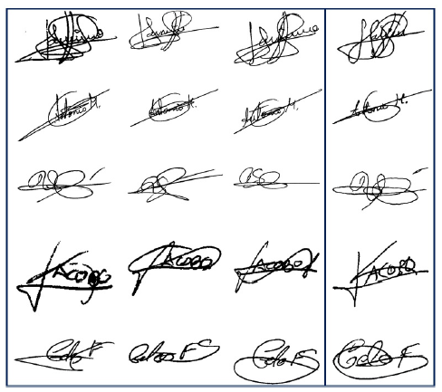
Figure 2.1: Sample genuine (first three columns) and their corresponding skilled forgery (last column) signatures from GPDS-160 database. It shows that using manual method it is possible 80% possible to grant an entry for one of the signed signature of the forgery for genuine one which can lead to fraud or other related issues.
2.4 REVIEW OF RELATED THEORY
The project created a challenge of creating a project with the ability to recognized hand written signature and verify its authenticity. The posed a problem with method of solution that goes outside the convention of writing algorithmic process. The challenge involves making computer solve the problem using a series of new steps. After a lengthy research, the only feasible solution required using a concept of the neuron in human brain familiar with medical practitioners (Stolkes, 2010).
2.4.1 HOW THE HUMAN BRAIN WORKS
The working of the neuron of the human brain remains incomplete till date. But from what we understand so far about the human brain, a system with similar properties can be developed. In the human brain, a typical neuron collect signals from others through a host of fine structure called dendrites. The neuron send out spikes of electrical activity through a long, thin stand known as an axon, which split into thousand of branches. At each end of each branch a structure called a synapse convert the activity from the axon into electrical effects that inhibit or excite activity on the connected neurons. When a neuron receives excitatory input, its sends a spike of electrical activity down its axon. Learning occurs by charging the effectiveness of the synapse so that the influence of one on another changes.
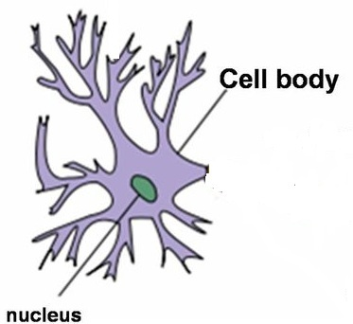
Fig 2.1 Brain Neuron

Artificial Neuron
An artificial neuron designed to simulate the brain neuron under limiting conditions such as a smaller processing power than the human brain can also be optimized to have similar properties which are:
- Training- Which utilizes several input to create an output
- Utilization- Which is uses an already created output to a solar problem
For each of these stages a general rule governs the operation. This rule can be called the firing rule.
The rule accounts flexibility of neural network. It simply defines how a neuron should optimize for an input irrespective of whether it has been previously trained for that input or not. A firing rule based on the hamming distance principle is stated below:
Take a collection of training patterns for a node, some of which cause it to fire (the 1-thught set of patterns) and other which prevent it from doing so (the 0-thught set). Then the patterns not in the collection cause the node to fire IF, on comparison they have more input element in common with the nearest pattern in the 1-thught set than with the nearest pattern in the 0-taught set. If there is a tie, then the pattern remain in the undefined state.
For example a 3-input neuron is taught to output 1 when the input (X₁,X₂ and X₃) is 111 or 101 and to input 0 when the input is 000 or 001. Then, before applying the firing rule, the truth table is
Table 2.1 (Neural Networks by Christos and Dimitrios Siganos)
X₁: | 0 | 0 | 0 | 0 | 1 | 1 | 1
X₂: | 0 | 0 | 1 | 1 | 0 | 1 | 1
X₃: | 0 | 1 | 0 | 1 | 1 | 0 | 1
OUT: | 0 | 0 | 0/1 | 0/1 | 1 | 0/1 | 1

As an example of the way the firing rule is applied take the pattern 0/0. It differ from 000 in 1 element, from 1001 in 2 element, from 101 in 3 element and from 111 in 2 element therefore, the nearest pattern is 000 which belong in the 0-taught set. Thus the firing rule requires that the neuron should not fire when the input is 001. On the other hand, 011 is equally distant from two taught patterns that have different output thus the output stays undefined (0/1). By applying the firing in every column the following truth table is obtained;
Table 2:2 (NEURAL NETWORK by Christos Sergiou and Dimitrrious Siganous)
X₁: | 0 | 0 | 0 | 0 | 1 | 1 | 1 | 1
X₂: | 0 | 0 | 1 | 1 | 0 | 0 | 1 | 1
X₃: | 0 | 1 | 0 | 1 | 0 | 1 | 0 | 1
OUT: | 0 | 0 | 0 | 0/1 | 0/1 | 1 | 1 | 1

The different between the two truth table is called the generalization of the neuron. Therefore the firing rule give the neuron a sense of similarity and enable it to respond ‘sensibly’ to patterns not seen during training.
Back propagation Artificial Neural Network there are several algorithms that can be used to create an artificial neural network, but the bank propagation was chosen because is probably the easiest to implement, while preserving efficiency of the network.
CHAPTER THREE
ANALYSIS OF THE CURRENT SYSTEM
3.1 RESEARCH METHODOLOGY
There are different methods used in collection of data during the research made on this project work for the benefit of the research. Two major methods used in collection of data during this project work such as internet and Library.
1) INTERVIEW: - Some Banks staffs as well as students were interviewed to really understand the existing method so as to come up with software that will eliminate most if not all of the problem inherent in the early method of signatory verification.
2) LITERATURE REVIEW: - Gathering information about the tutorial software through the reading of textbook and surfing the internet, which gave a broad knowledge on the project.
3) OBSERVATION: - Most of the information used to design this project would be gotten using this approach.
3.2 ANALYSIS OF THE EXISTING DESIGN
It is important to have knowledge and understanding of the existing system before a new and improved system is designed. The existing system of signature recognition and verification has to do with manually comparing signature with the human e.t.c. the process is time consuming and due to the inconsistency of the human nature, very prone to dangerous errors. In the existing system in bank for example, the banker takes the presented cheque or any other banking instrument signed by a customer, compares it using his/her eyes the signature on the instrument against the already existing copy of the signature in the bank database. One of the major problems with this verification is that vital parts of the signature may be missed and even if the signature was forged, it can be passed as original and thereby causing great chaos. There are times that the human signature is irregular due to sickness or other factors, when such signature is presented, it could be pass as forged and the instrument will not be honored; cases like the require the presence of the signatory and this process is really time consuming and stressful.
In the manual system of signature recognition and verification, there are situation where the signature is verified several times by several people and because our eyes are different, what Mr. A passes as original as forged by Mr. B also, training for signature is extremely time consuming. Basically, people are trained to recognized specific features in the signature but a skilled forgery can get away with theft. When the original signatory of a document is not reachable and a case of forgery is suspected, that transaction is suspected until the signatory is reached to make amends. Basically, when there is an urgent need to have a document verified, this system is unreliable because some important but tiny details may be overlooked.
3.3 PROBLEMS OF THE EXISTING SYSTEM
Like every other manual system, the problems are the same but a few are mentioned below.
- Time consumption: this system is really slow and time-consuming because the time it takes for the signature to be verified and passed on for further confirmation could be used for other productive tasks.
- Inefficiency: the waste of time, energy and money in this system is high and you don’t always get the desired result because the verifier is trying by all means to avoid mistake he waste time and energy confirming one document.
- Unreliability: the system is unreliable and prone to errors. The issue to signature verification is a very sensitive one because usually documents carrying signature have to do with money or other sensitive issues so using the human eye verify such signature could be very risky because a seemingly little mistake could have dire consequences.

3.4 DESCRIPTION OF THE PROPOSED SYSTEM
The existing system has major fall-outs and so the need for the proposed system. The use of computers to make life easier has improved the way things are done worldwide. This ease has also spread into the area of signature recognition and verification thereby saving more time and increasing reliability. Signature recognition and verification involves two separates but strongly related tasks: one of them is the identification of the signature owner and the other is the decision about whether the signature is genuine or forged (verification).
In this study, the purpose is to authenticate a signature that is, to verify that the signature is not counterfeit and it really belongs to the person who is claimed to be the signatory. Usually there is training and testing phase for the signature. In the training phase, the training data set is obtained from 8 original signatures provided by the real owner. The signatures are then loaded one at a time and used in training and testing. First the signature image is captured using a camera or scanner, then through several image processing operation, it is converted to binary and normalized. The offline signature recognition and verification system (SRVS) has made signature confirmation easier and more reliable. In the banking sector for example, all you need is to have the signature in the database, you load the signature, train it and subsequently just verify and in minutes, the transaction is completed.
3.5 ADVANTAGES OF THE PROPOSED SYSTEM
The proposed system is definitely an improvement on the manual system. Among others, the main advantage of the propose system are;
- Time saving: this system is faster than the manual system signature recognition and verification. It also saves more time thereby making it possible to attend to other needs.
- Reliability: this system is also more reliable than the manual system less prime to errors than the manual system.
CHAPTER FOUR
DESIGN AND IMPLEMENTATION OF THE SYSTEM
4.1 DESIGN OF THE SYSTEM
The existing system of image comparison is due to human recognition method which is been carried out by man’s intelligent. But this system has been design in a computerized way to make the system effective, efficient and user friendly application the system design has been categories into four, which is base on the operation they perform, they are;
4.1.1 OUTPUT DESIGN
The input of the system mainly based on the input of the name, address and phone number which is just to identify the user of the system in order to store their information into the database. Each input is the recall during the verification.
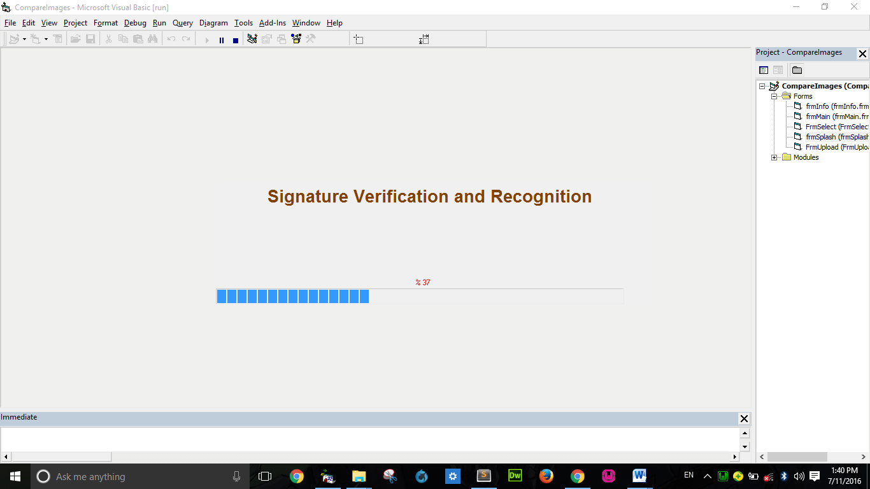
Fig. 4.1: Signature Comparison Splash Screen
This is the first screen that will be displayed to show what the project is about.
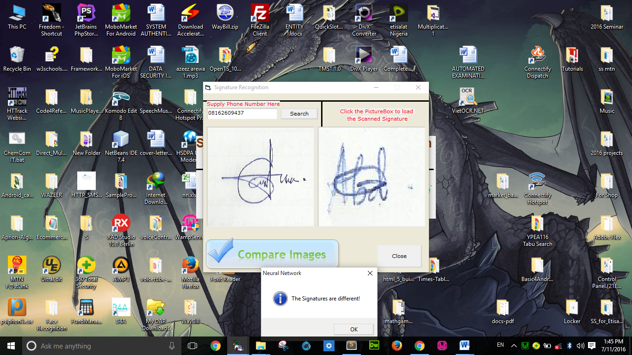
Fig. 4.2: Signature uploads for Verification
This is where new signature are added to the system.
4.1.2 INPUT DESIGN
The output form and file of the system is base on the input of the user of the system. The user of the system supply there name through the require input which later give an output of all the users of the system on a list. The output form is also generated through the input search by the user to produce an output of image comparison which the user need, so also the system produced an output which display true or false.
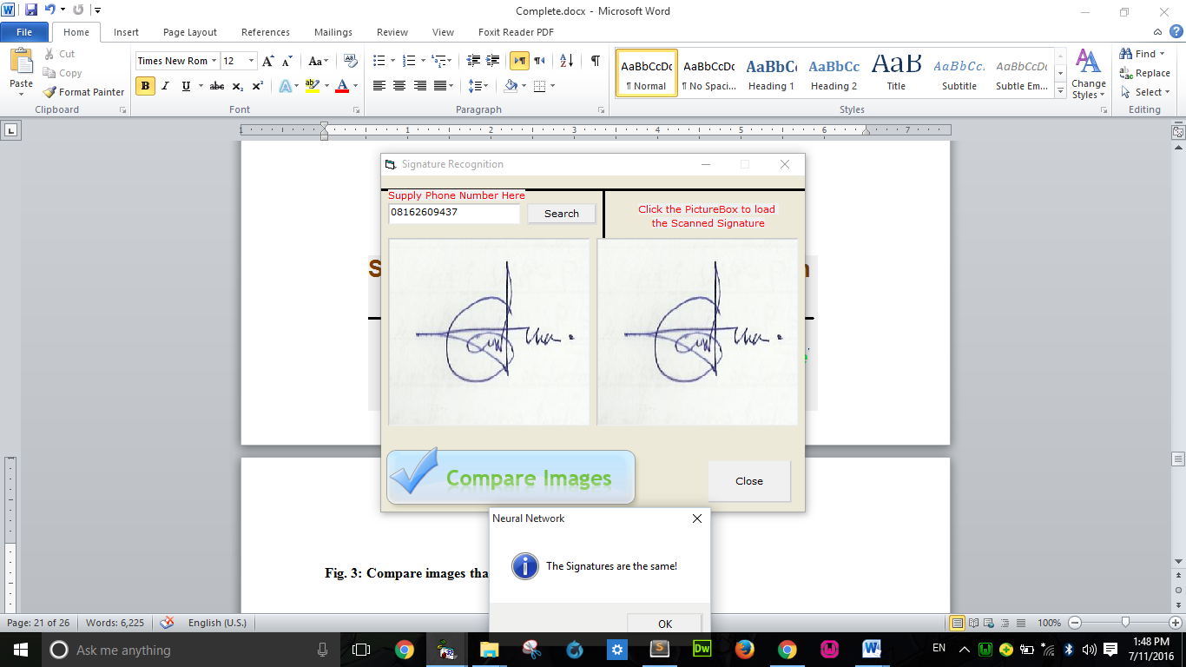
Fig. 4.3: Compare images that are the same.
This is the module where the signature are compared
4.1.3 DATABASE DESIGN
This stage describes the data that are used in the system for various operations, either for the input of data or for the generation of report.
The input designs are majorly the input of name which is used to know total number of people that have used the system.
The design is has follow
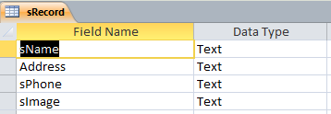
This file is design in Microsoft access, which is also use as the database in the program.
Table 1: The database that save the uploaded Images.
This saves the signature the entire registered signature
4.1.4 PROCEDURE DESIGN
This application is design in a way to make it user friendly in many directions, taking the color animation, the user click effect, the menus provided, etc. The menu of the program is divided into four difference module, which are
- Upload Image: this is where signature are saved for signature vefication.
- Compare Image: this is the module where the signatures are compared
- Search Images: this is where a parameter are entered to check whether it is there or NOT
- Close Application: Actual termination of the app
4.2 IMPLEMENTATION OF THE SYSTEM
4.2.1 CHOICE OF PROGRAMMING LANGUAGE
In the designing of this system visual basic programming language was use in the implementation of all the modules due to the tools or feature incorporate on visual basic that make it easy for the implementation of a user friendly, effectiveness and efficiency programme language, writing of the program has been made easy.
Microsoft access was used for the designing of the table and also serves as our database design, which was linked to visual basic for effective data management.
4.2.2 HARDWARE SUPPORT
The project has been program in a way to make it possible for the usage of low required hardware device support. Due to the portability of the software, some hardware requirements are also been consider in order to have an efficient and effective system.
The hardware support to the system are been listed below
- Hard disk of size as low as 5gb or more
- CD drive as low as 15x
- A monitor of either LCD or CRT
- Keyboard either USD or serial port
- An uninterrupted power supply. (UPS)
- A processor speed of at least 20mg
- A memory of size 64mb
4.2.3 SOFTWARE SUPPORT
The software requirement for the application of the program, is been design in a way to meet the standard of the generation we are in today
The support are listed below
I. Window XP upward in order to meet the graphic design
II. Microsoft office for some data processing
4.2.4 CHANGEOVER TECHNIQUES
The technique used is waterfall model. In this model, existing system works hand in hand with the proposed system.
4.3 DOCUMENTATION OF THE SYSTEM
4.3.1 PROGRAM DOCUMENTATION
Program documentation describe all section of the program, it lay more emphasis on the function of each modules and there required input or output in these program, the section is been splitted into three section which are explain below
File Section: - These handle the name of all members that have used in the system, all the names of the users are been save in to a data for reference and record keeping purpose.
Upload Signature: - This section is used in handling the major work of the system which is analyzing various uploaded images based on the picture box by the user
Compare Signature: - This section gives information on the major issue on each result of the compare images by giving information status of the images.
4.3.2 SYSTEM DOCUMENTATION
After the program has been well tested with input that the output has already been known, the next is to install the software in to the computer system for use.
The process of installing are been stated below
i. Insert the CD into the system through the CD-ROM after the computer is switch on
ii. Locate the CD drive directory in my computer and click it to open
iii. After open, locate setup.exe, and then click to install the program by following the necessary step in installing the program.
iv. Ensure full installing of the software for effective operation of the system.
After the program has been fully install. The next thing is to locate the package install to put it into operation, to locate the package for expiration purpose the following step are to be taking .
i. Click on start menu from task bar. Then select all programs
ii. From the display sub option, select by locating the software installed named Image Comparison check to load the software.
    - MAINTAINING THE SYSTEM
Built-in procedure is designed in the system to enable the system to recover from shutdown.

CHAPTER FIVE
SUMMARY, CONCLUSION AND RECOMMENDATION
5.1 SUMMARY OF FINDINGS
The new system (offline signature recognition and verification) has been discussed in this study, it has also been successfully designed and tested to deal with major problems of the existing system. During verification, when an input image and ID are received, the first step is to verify that the account exists by checking for the existence of the directory with the name ID. If it exists, verification proceeds. If it doesn’t, a message is generated for the user, and verification stops. For the verification, a training of the single image is first done, and then the results are compared with the stored in the training file, during the main training process. The resulting level of accuracy is based on the degree of difference between the error level of those two processes. However the acceptance or rejection of a particular input is based on the accepted level of accuracy which can be defined in the ‘application setting” menu of the program. This study aims to reduce to a minimum the case of forgery in business transaction. The new system has been analyzed, tested designed and document in this study.
5.2 CONCLUSION
In this study, we presented off-line signature recognition and verification system which is based on signa processing, moment invariants, some global properties and neural networks. Both system used a three-step process. In the first step, the signature is separated from its image background. Second step performs normalization and digitization of the original signature. Moment invariants and some global properties which are used as input features for the neural networks (NN) are obtained the third step. Our recognition system exhibited 100% success rate by identifying correctly all the signature that it was trained for. However, it exhibited poor performance when it was presented with signatures that it was not trained for earlier. We did not consider this a ‘high risk” case because recognition steps is always followed by verification step and these kinds of false positive can be easily caught by the verification system generally the failure to recognize and high similarity between 2 signatures. Recognition and verification ability of the system can be increased by using addition feature in the input data set.
5.2 RECOMMENDATIONS
The importance of avoiding forged signature is very crucial and this is the aim of the study. After careful study and comprise between the new system and the manual system, we can recommend that the new system of signature recognition and verification be adopted by banks, insurance companies and other business houses where intensified research should be carried out for perfect results.

REFERENCES
Bonsor, K. (2008). "How Fingerprint Recognition Systems Work". http://computer.howstuffworks.com/facial-recognition.htm.
Brunelli R. and Poggio, T. (1993). "Face Recognition: Features versus Templates", IEEE Trans. on PAMI.
Brunelli, R. (2009). Template Matching Techniques in Computer Vision: Theory and Practice, Wiley, ISBN 978-0-470-51706-2, TM book.
Choudhary N. Y., Patil R., Bhadade U., & Chaudhari B. M., (2013), Signature Recognition & Verification System Using Back Propagation Neural Network, International Journal of IT, Engineering and Applied Sciences Research (IJIEASR) ISSN: 2319-4413, Volume 2, No. 1, Nadurbar, India
Crawford, M. (2011). "Facial recognition progress report". SPIE Newsroom. http://spie.org/ x57306.xml.
Greene, L. (2001). "Face scans match few suspects" (SHTML). St. Petersburg Times. http://www.sptimes.com/News/021/TampaBay/Face_scan_match.htm.
Joel, G. (2012). "Verifying Signature". Center for Democracy & Technology. http://www.cdt.org/blogs/harley/facial-recognition-and-privacy.
House, D. (2007). "Facial recognition at DMV". Oregon Department of Transportation. http://www.oregon.gov/ODOT/DMV/cards_facialrec.shtml.
Kimmel, R. (2005) "Three-dimensional face recognition". http://www.cs.technion.ac.il /~ron/PAPERS/BroBroKimIJCV05.pdf.
Krause, M. (2002). "Is face recognition just high-tech snake oil?". Enter Stage Right. ISSN 1488-1756. http://www.enterstageright.com/archive/ articles/0102facerecog.htm.
Meek, J. (2002). "Robo cop". London: UK Guardian newspaper. http://www.guardian.co.uk/Archive/Article/0,4273,4432506,00.htm.
Pacut A., Czajka A, (2001) “Recognition of Human Signatures”, pp. 1560-1564, 2001.
Wu Q., Jou I, & Lee S., (2007), “On-Line Signature Verification Using LPC Cepstrumand Neural Networks”, IEEE Transactions on Systems, Man, and Cybernetics—Part B: Cybernetics, 27(1):148-153.
Schultz, Z. (2007). "Facial Recognition Technology Helps DMV Prevent Identity Theft". WMTV News, Gray Television. http://www.nbc15.com/news/headlines/2684991.html.
Smith, K. (2008) "Face Recognition" (PDF). http://www.biometrics.gov/Documents/FaceRec.pdf.
Suryani D., Irwansyah E., Chindra R., (2017),Offline Signature Recognition and Verification System using Efficient Fuzzy Kohonen Clustering Network (EFKCN) Algorithm, International Conference on Computer Science and Computational Intelligence, ICCSCI, Bali, Indonesia
Williams, M. (2008). "Better Face-Recognition Software". http://www.technologyreview.com /Infotech/18796/?a=f.
West, R. (2010). "Airport anti-terror systems flub tests; Face-recognition technology fails to flag 'suspects'". USA Today.

PROGRAM FLOWCHART
Start
Home Page
Register

Verify

About
Stop

HOMEPAGE FLOWCHART
Start
Register
Select Option

Option
Register

Option
Verify
Option
About
Stop
Verify
About
Yes

Yes

Yes

No

No

No

REGISTER
Start
Open Database
Enter Registration Information
Save To Database
Any More Process?
Return
Close Database
Yes
No

VERIFY SIGNATURE
Start
Open Database
Is signature
Match ?
Return
Any more Process?
Input verification detail
Yes
No
No
Yes
Close database
Display
information

ABOUT
Start
return
Display about

SOURCE CODE
Private Sub Form_Load()
Init_List
CheckMenu
Call PKencrypt(Ekey)
Ekey = strConData
End Sub

Private Sub lvwList_DblClick()
If Me.lvwList.ListItems.Count <> 0 Then
Call PopupMenu(mnupopup)
Me.ToolBar.Buttons(6).Enabled = False
End If
End Sub

Private Sub lvwList_ItemClick(ByVal Item As MSComctlLib.ListItem)
cd.FileName = Empty
strFile = Me.lvwList.SelectedItem
lblSource.Caption = Me.lvwList.SelectedItem
strSourceFile = Me.lvwList.SelectedItem.Text
Me.lblFileName.Caption = Me.lvwList.SelectedItem.SubItems(1)
Me.lblBytes.Caption = Format(FileLen(strFile), "###,###,###,###") & " Bytes"
Me.lblConversionTime.Caption = "Estimated Conversion Time"
GetConvertionTime

intIndex = Me.lvwList.SelectedItem.Index
SetIcon
Me.ToolBar.Buttons(8).Enabled = True
Me.ToolBar.Buttons(6).Enabled = False
End Sub

Private Sub mnuDecrypt_Click()
dCrypto
End Sub

Private Sub mnuRemove_Click()
RMList
End Sub

Private Sub ToolBar_ButtonClick(ByVal Button As MSComctlLib.Button)
Select Case Button.Index
Case 2
GetFile
frm_Thesis.xp_Prog.Value = 0
Case 4
frm_Key.Show 1
Case 6
Crypto
Case 8
dCrypto
Case 10
frm_SetPassword.Show 1
Case 12
Unload Me

End Select
End Sub

Private Sub GetFile()
On Error GoTo err:
Dim cSec As Integer
Dim cMin As Integer

cd.ShowOpen

strSourceFile = cd.FileName
strFile = cd.FileTitle
If strFile <> "" Then

Me.lblFileName.Caption = strFile
strByte = Format(FileLen(strFile), "###,###,###,###")
Me.lblBytes.Caption = strByte & " Bytes"
Me.lblConversionTime.Caption = "Estimated Conversion Time"

'Me.lvwList.ListItems.Clear
'Me.lvwList.ListItems.Add , , strSourceFile
'Me.lvwList.ListItems(Me.lvwList.ListItems.Count).SubItems(1) = strFile
'Me.lvwList.ListItems(Me.lvwList.ListItems.Count).SubItems(2) = Format(FileLen(strFile), "###,###,###,##0") & " Bytes"
GetConvertionTime

SetIcon
Me.ToolBar.Buttons(6).Enabled = True
End If
Exit Sub
err:
If FileLen(strFile) > 75000000 Then
tmplen = FileLen(strFile) / 20
cSec = tmplen / cRate
Else
cSec = FileLen(strFile) / cRate
End If
cMin = Int(cSec / 60)
cSec = Int(cSec - (cMin * 60))
If cSec = 0 Then cSec = 1
lblTime.Caption = "min: " & Trim(Str(cMin)) & " sec: " & Trim(Str(cSec))
'Me.lvwList.ListItems(Me.lvwList.ListItems.Count).SubItems(3) = "min: " & Trim(Str(cMin)) & " sec: " & Trim(Str(cSec))
End Sub

Private Sub Crypto()

If MsgBox("Are you sure you want to Encrypt the data of this File?", vbQuestion + vbYesNo, "System Information") = vbYes Then
strSourceFile = cd.FileName
LookUp = True
Call EncFile(strSourceFile, strSourceFile)
strSourceFile = ""
cd.FileName = Empty
Else
Exit Sub
End If
Me.ToolBar.Buttons(6).Enabled = False
End Sub

'If strSourceFile = cd.FileName Then
'MsgBox "You browse the file." & vbCrLf & "If the file is in the List of Encrypted file, please remove it manually.", vbInformation, "Information"
'strSourceFile = ""
'cd.FileName = Empty
'Exit Sub

