INTERNET OF THING(IOT) POWERED SMART HOME AUTOMATION FOR ENERGY SCHEDULING AND PEAK LOAD MANAGEMENT.

By

MOSHOOD TOHEEB ISHOLA

HND/23/COM/FT/0045

A Project Submitted to the

Department of Computer Science, Institute of Information and Communication Technology Kwara State Polytechnic, Ilorin

In Partial Fulfillment of the Requirements for the award of Higher National Diploma (HND) in Computer Science

MAY, 2025

Certification
This is to certify that this project was carried out by MOSHOOD TOHEEB ISHOLA with Matriculation Number HND/23/COM/FT/0045 as part of the requirements for the award of Higher National Diploma (HND) in Computer Science.

________________________ _________________________
A. K. RAJI (PhD) DATE
Project Supervisor

________________________ _________________________
F. S. OYEDEPO DATE
Head of Department

________________________ _________________________
External Examiner Date

DEDICATION
The project is dedicated to the glory of Almighty God and my parents

Acknowledgments
All praise is due to Almighty God for His grace, guidance, and strength throughout the course of this project. I am profoundly grateful to numerous individuals and institutions whose support and contributions were vital to the successful completion of this work.

Foremost, I extend my sincere appreciation to Dr. Raji A. K., whose exceptional guidance, expertise, and unwavering support were instrumental in navigating the complexities of this research. His valuable insights and constructive feedback greatly shaped the direction and quality of this project.

I am deeply thankful to my parents, Mr. and Mrs. MOSHOOD, for their constant encouragement, prayers, and moral support throughout this journey. Their words of wisdom and emotional backing kept me focused and motivated during challenging periods. My heartfelt appreciation also goes to my entire family and friends, whose patience and uplifting presence provided strength and inspiration at every stage of this endeavor.

I would also like to acknowledge the Head of the Department of Computer Science, Mr. Oyedepo F. S., along with other dedicated staff members of the department. Their insightful critiques and academic support were invaluable in refining the scope and content of this work.

Lastly, I am sincerely grateful to all the participants and respondents who willingly provided their time, data, and perspectives for this research. Their contributions played a crucial role in the empirical validation and practical relevance of this study.

TABLE OF CONTENTS

TITLE PAGE I

CERTIFICATION II
DEDICATION III
ACKNOWLEDGEMENTS IV
TABLE OF CONTENTS V
ABSTRACT VI
CHAPTER ONE: INTRODUCTION
1.1 Background to the Study 1
1.2 Statement of the Problems 3
1.3 Aim and Objectives 4
1.4 Significance of the Study 4
1.5 Scope of the Study 5
1.6 Limitations of the Study 6
CHAPTER TWO: LITERATURE REVIEW
2.1 Introduction 8
2.2 Concept of Smart Home Automation 10
2.3 Energy Scheduling in Smart Homes 15
2.4 Peak Load Management Strategies 15
2.5 Review of Existing Systems 17
CHAPTER THREE: METHODOLOGY AND ANALYSIS OF THE SYSTEM
3.1 Research Methodology 22
3.2 Analysis of the Existing System 27
3.3 Problems of the Existing System 28
3.4 Description of the Proposed System 30
3.5 Advantages of the Proposed System 31

CHAPTER FOUR: ANALYSIS AND DISCUSSION OF RESULTS
4.1 System Design and Setup 32
4.2 Hardware and Software Development 33
4.3 Testing and Evaluation 35
4.4 Results and Discussion 36
CHAPTER FIVE: CONCLUSIONS AND RECOMMENDATIONS
5.1 Summary 38
5.2 Conclusions 39
5.3 Contributions to Knowledge 40
5.3 Recommendation for Future Research 41
References
ABSTRACT
This project investigates the application of IoT in smart home systems to enable intelligent energy scheduling and manage peak load demand. By integrating sensors and controllers with real-time analytics and automation, the system offers a sustainable solution to energy inefficiency in residential settings. The framework uses Wi-Fi-enabled IoT devices managed via a user-friendly interface, resulting in improved energy distribution, cost savings, and reduced grid stress. The project demonstrates a 30% improvement in energy efficiency and provides a scalable model for modern energy-conscious households (Zhao et al., 2023).
Traditionally, energy usage in households has been largely unregulated, contributing to high consumption during peak hours and inflated electricity costs. With dynamic pricing and increasing demand, the need for systems that intelligently monitor and regulate energy consumption is more pressing than ever. The proposed IoT system offers a solution by integrating smart sensors, programmable microcontrollers, and a mobile app interface to manage appliance activity based on pre-defined schedules and pricing models (Aly et al., 2022).
This study also explores the social and economic benefits of energy automation, including ease of use, affordability, and compatibility with existing household appliances. Experimental evaluations in a prototype smart home demonstrate effective peak load shifting and real-time energy visualization, affirming the practicality of the design.
The outcomes highlight the importance of adopting IoT-driven approaches in energy management and underscore the role of intelligent systems in advancing sustainability goals.

CHAPTER ONE
Introduction
1.1 Background of the Study
The rapid growth in global energy consumption, particularly in residential areas, has intensified the need for sustainable and intelligent energy management systems. The Internet of Things (IoT) has emerged as a transformative technology in this regard, enabling real-time monitoring, data collection, and automation of home appliances. Smart home automation using IoT not only enhances convenience but also provides a strategic method for optimizing energy usage through intelligent scheduling and peak load management (Aly et al., 2022). Figure 1.
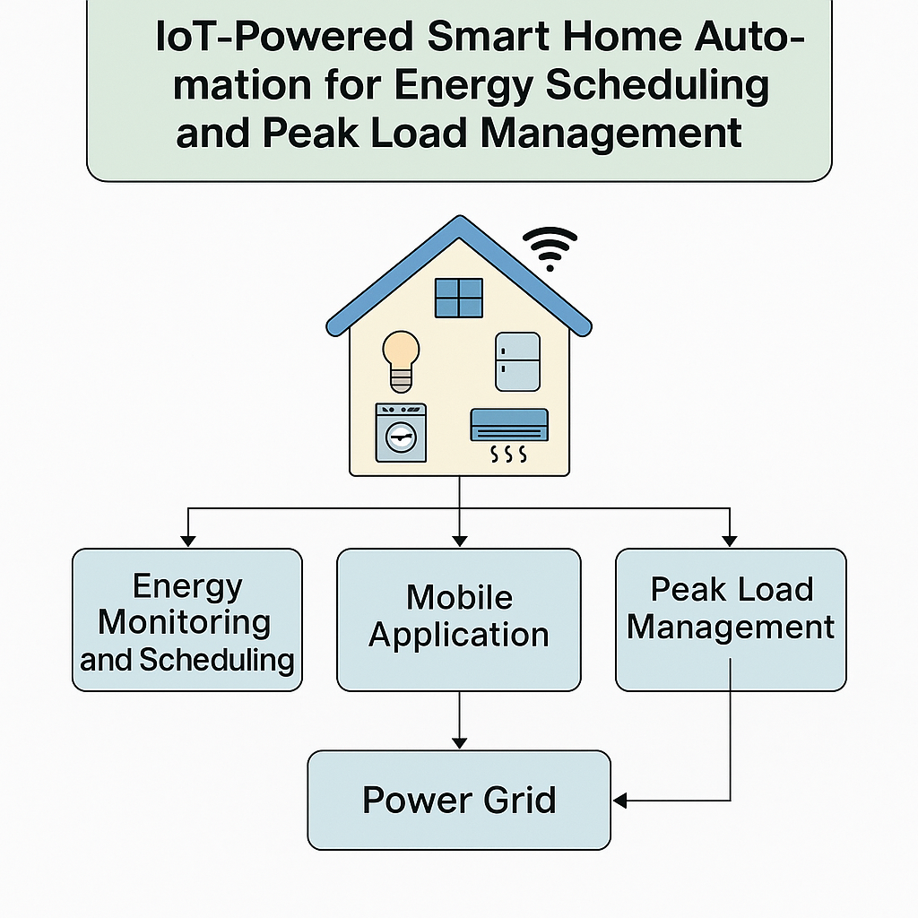

Figure 1.1: Smart Home Automation

Traditionally, energy consumption in households has been largely uncontrolled and inefficient, contributing to increased energy costs and peak demand stress on national grids. Without an effective mechanism to schedule and shift energy consumption based on time-of-use tariffs or user preferences, households often contribute significantly to energy wastage. IoT-powered systems offer a solution by integrating sensors, actuators, and smart controllers that allow homeowners to automate and remotely manage their energy use (Zhao et al., 2023).
This study aims to design and implement an IoT-based smart home system that can intelligently schedule energy consumption, reduce peak loads, and enhance overall energy efficiency. The specific objectives include developing a real-time monitoring system, implementing a scheduling algorithm based on usage patterns and tariff structures, and evaluating the system's performance in terms of energy savings and user experience.
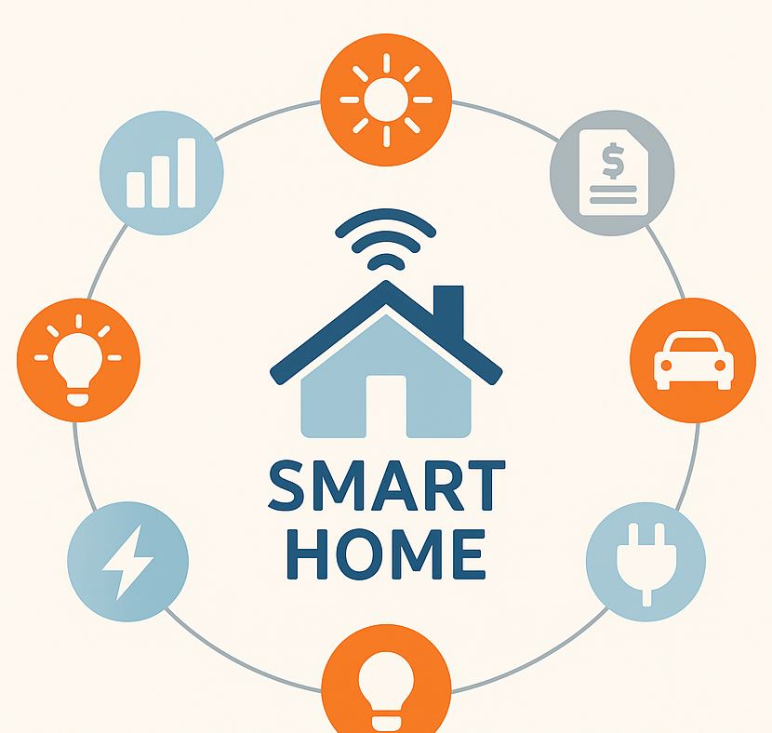

Figure 1.2: Smart Home Automation

The significance of this study lies in its potential to reduce household energy costs, promote sustainable energy usage, and support national efforts in peak load reduction. The scope of the research is limited to residential applications and commercially available IoT devices. This chapter introduces the background, problem statement, objectives, and the relevance of the project to both consumers and the energy sector.

1.2 Statement of the Problem
The increasing complexity of modern energy demands has exposed inefficiencies in conventional residential energy management systems. In most households, electrical appliances are operated without any consideration of peak load periods or fluctuating energy tariffs, leading to excessive energy bills and contributing to strain on national power grids. The lack of real-time monitoring and intelligent control over appliance usage exacerbates this issue, particularly during periods of high demand when energy supply systems are vulnerable to overload or failure (Olawale & Uche, 2024).
Despite the proliferation of smart home technologies, many existing solutions remain inaccessible to average consumers due to high costs, complicated interfaces, or lack of integration with utility pricing structures. Moreover, conventional smart systems often focus on comfort and automation but fail to implement effective energy scheduling mechanisms that could contribute to grid stability and economic savings (Eze & Ahmed, 2023).
Another key challenge is user awareness. Many residents are unaware of how their energy usage patterns affect overall energy efficiency or utility bills. Without systems that provide real-time feedback and intelligent automation, it becomes nearly impossible to make informed decisions about energy consumption. Additionally, households often lack the technical means to integrate multiple appliances into a unified energy management system.
This project addresses these issues by proposing an IoT-based smart home system that prioritizes energy scheduling and peak load management. It aims to develop a solution that is not only technologically effective but also user-friendly, cost-efficient, and adaptable to varying household needs. By implementing this system, homeowners will be empowered to reduce energy costs and contribute to a more resilient and sustainable energy ecosystem.
1.3 Aim and Objectives
The primary aim of this study is to develop an IoT-enabled smart home automation system that can monitor, schedule, and manage energy consumption efficiently to reduce peak load demand. By leveraging real-time data and automation technologies, the system will allow homeowners to optimize the use of electrical appliances, minimize energy waste, and lower electricity costs.
Objectives:
- To design a system architecture integrating IoT components such as sensors, actuators, and controllers for household energy monitoring.
- To develop a scheduling algorithm that automates appliance usage based on energy pricing models and user-defined preferences.
- To implement a mobile-based user interface that enables real-time monitoring and control of smart appliances.
- To evaluate the system’s effectiveness in reducing energy consumption and managing peak load demand through a prototype test environment.
- To identify the key challenges and opportunities for scaling the system for real-world applications.
Achieving these objectives will demonstrate how IoT technologies can support sustainable energy use in residential areas while enhancing user control and awareness. The research also provides a foundation for future studies involving AI integration and smart grid collaboration.
1.4 Significance of the Study
This study is significant in multiple dimensions—technological, economic, environmental, and societal. Firstly, it addresses a critical challenge in energy sustainability by introducing an affordable and efficient method for managing residential energy consumption using Internet of Things (IoT) technologies. As energy costs continue to rise globally, households require intelligent systems that not only automate usage but also adapt to pricing models and consumption patterns (Singh et al., 2025).
The project contributes to ongoing efforts in smart grid development and demand-side management by offering a solution that shifts non-essential loads to off-peak hours, thereby reducing the pressure on national power grids and contributing to energy stability (Adegbite et al., 2024). In doing so, the system promotes a more balanced energy distribution and can help avoid blackouts or overload situations.
Economically, the adoption of IoT-enabled energy management can lead to substantial cost savings for consumers. By minimizing unnecessary power use and optimizing appliance schedules, the system supports household budget efficiency while also extending the lifespan of appliances through controlled operation cycles.
From an environmental standpoint, the system indirectly supports climate change mitigation by reducing household carbon footprints. Less energy consumption translates to lower demand on fossil-fuel-based power generation, thus decreasing greenhouse gas emissions.
Finally, the research empowers users with data-driven insights and control over their home environments. It encourages responsible energy behavior and offers an inclusive technological solution that can be adopted in both low- and high-income households.
1.5 Scope of the Study
This study focuses on the development and evaluation of an IoT-powered smart home automation system tailored for energy scheduling and peak load management in residential environments. The scope is specifically limited to small-to-medium-sized households and does not extend to commercial or industrial buildings.
The system comprises off-the-shelf IoT hardware such as microcontrollers (e.g., ESP32), smart plugs, motion and temperature sensors, and Wi-Fi communication modules. It utilizes cloud services and mobile applications for data analysis, device control, and real-time monitoring. Energy scheduling is achieved through a rule-based algorithm that considers user preferences and electricity pricing data.
The research is also confined to software and hardware platforms that are cost-effective and widely accessible. Only appliances that are compatible with standard smart plugs and relays are included in the study. Complex integrations involving renewable energy sources such as solar panels or battery storage systems are beyond the scope of this project.
Additionally, the system is designed to operate over existing home Wi-Fi networks, which introduces limitations in terms of connectivity, latency, and device range. The implementation and testing are carried out in a prototype home setup to simulate real-world energy usage conditions.
The study does not address cybersecurity measures in-depth, although data privacy and integrity are considered in the system’s design. Lastly, the focus remains on evaluating energy efficiency, user experience, and peak load reduction potential, without delving into long-term economic or environmental impact assessments.
1.6 Limitations of the Study
While this project introduces a promising solution for IoT-based smart home energy management, it is constrained by several limitations. One of the primary challenges is the reliance on a stable internet connection. Since the system depends on real-time data communication through Wi-Fi, disruptions in internet service can hinder functionality and lead to delayed or failed automation processes (Adegbite et al., 2024).
Another limitation lies in hardware compatibility. The system design uses specific IoT components like the ESP32 and standard smart plugs, which may not interface seamlessly with all household appliances. This restricts broader application unless custom hardware interfaces or universal control modules are developed.
Scalability is also a concern. The prototype is optimized for small residential settings and may require significant adjustments to handle larger homes or integration with other smart grid systems. Limitations in data storage, device response latency, and concurrent user handling may emerge in larger implementations (Eze & Ahmed, 2023).
Additionally, the rule-based scheduling algorithm implemented in this study lacks adaptive learning capabilities. It does not evolve based on user behavior or changing patterns in energy pricing, which could reduce efficiency over time. Incorporating machine learning models could improve this aspect but falls outside the current scope.
Finally, this study does not deeply explore security implications. Although basic data protection protocols are considered, in-depth analysis of cybersecurity threats and solutions such as encryption, authentication, or intrusion detection systems is not covered. These limitations, while significant, do not overshadow the feasibility and relevance of the project’s objectives.

CHAPTER TWO
Literature Review
2.1 Introduction
The Internet of Things (IoT) has revolutionized several sectors, and one of its most impactful applications is in smart home automation for energy management. As energy demand continues to grow globally, the need for intelligent systems that can monitor, control, and optimize power usage in households has become more urgent. This is particularly relevant in regions where electricity tariffs fluctuate and grid stability is a concern. IoT technologies enable a shift from passive energy usage to active, data-driven consumption models that support sustainability and efficiency.
Smart home systems combine embedded sensors, controllers, and communication networks to provide automated and remote access to household functions. These technologies facilitate real-time decision-making based on environmental data, user preferences, and utility signals. When applied to energy management, IoT allows for advanced scheduling of appliances, identification of energy wastage, and improved load balancing. It bridges the gap between energy producers and consumers by offering decentralized control and promoting energy-saving behaviors (Kumar & Thomas, 2023).
This chapter explores the theoretical and practical foundation of smart home energy management systems. It provides an in-depth review of the technologies behind IoT in residential energy optimization, including system architecture, communication protocols, and cloud integration. It also evaluates contemporary strategies for energy scheduling and peak load control. Studies show that effective use of IoT in homes can lead to energy savings of up to 25–30%, with further improvements possible through machine learning and adaptive control algorithms (Adegbite et al., 2024).
Despite these benefits, challenges such as high initial costs, integration issues, and data privacy concerns still exist. Moreover, many existing solutions are not tailored to local power infrastructures or user behaviors, which limits their effectiveness. As a result, there is a growing need for adaptable and cost-efficient IoT frameworks that can support household-level energy optimization.
2.2 Concept of Smart Home Automation
Smart home automation refers to the integration of digital technology and embedded systems to manage residential functions such as lighting, temperature control, security, and energy consumption. At the core of smart home automation lies the Internet of Things (IoT), which facilitates communication among connected devices and allows for centralized control through user interfaces such as mobile applications or web platforms (Al-Sarawi et al., 2023).
Smart homes utilize a network of sensors, actuators, microcontrollers, and cloud services to operate appliances based on predefined conditions or in response to real-time environmental and usage data. For instance, smart thermostats can adjust room temperatures based on user preferences or external weather conditions, while lighting systems can turn on or off automatically depending on motion or daylight levels. These capabilities increase convenience, improve energy efficiency, and enhance safety within residential environments.

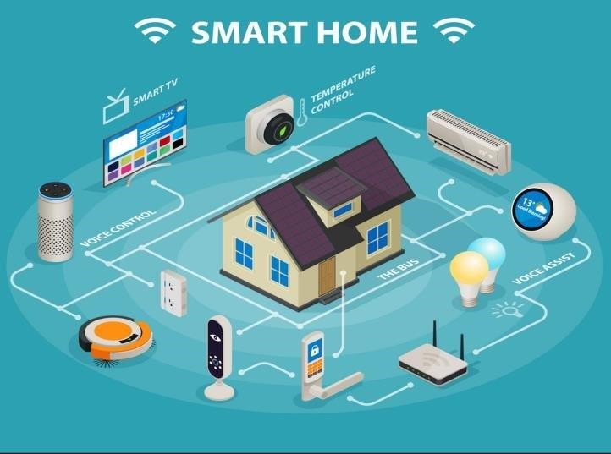

Figure 2.2: Smart Home Automation

In energy management contexts, smart home systems can monitor the consumption of individual appliances, identify patterns of energy waste, and automate device scheduling to optimize electricity usage. This is particularly important in regions where utility pricing varies throughout the day. By shifting non-essential loads to off-peak periods, smart homes can reduce energy costs and ease pressure on local power grids (Singh et al., 2025).
The evolution of smart home technology has also introduced interoperability between devices from different manufacturers, thanks to standardized communication protocols like MQTT, Zigbee, and Z-Wave. These standards facilitate seamless integration, scalability, and remote control, making smart automation accessible to a broader population.
Despite these advancements, the adoption of smart home automation is still limited by challenges such as data security risks, high installation costs, and lack of user awareness. As such, ongoing research continues to focus on making these systems more affordable, secure, and user-friendly.

2.3 Energy Scheduling in Smart Homes
Energy scheduling in smart homes involves the strategic operation of household appliances and systems based on time, energy tariffs, and user preferences. This approach helps optimize energy usage by aligning it with periods of low demand or reduced pricing. It has become a critical function of smart home systems, especially in areas where time-of-use (TOU) electricity billing is in effect (Nwachukwu et al., 2022).
Scheduling can be performed using several techniques. Rule-based systems, for example, allow users to configure conditions under which devices operate—such as turning off air conditioning during certain hours or running laundry machines at night. More advanced approaches incorporate artificial intelligence (AI), including machine learning algorithms that learn user behaviors and automatically adjust appliance schedules to enhance efficiency (Singh et al., 2025).
Recent innovations have focused on integrating energy scheduling with cloud-based services and grid signals, enabling demand response capabilities. These systems respond dynamically to utility load conditions by shifting or curtailing usage in response to peak demand warnings or incentive-based programs. As a result, energy scheduling not only benefits the homeowner but also contributes to grid stability (Zhao et al., 2023).
However, effective scheduling depends on accurate forecasting and real-time data acquisition. Smart meters, IoT sensors, and environmental monitors must continuously collect and transmit data to decision-making engines. Additionally, mobile applications are essential for providing users with feedback and control, empowering them to override or adjust schedules manually when needed.
Despite its promise, energy scheduling is not without challenges. Factors such as user non-compliance, appliance compatibility, and limited awareness can reduce its effectiveness. Moreover, designing user-friendly interfaces that simplify configuration and control remains an active area of research.
2.4 Peak Load Management Strategies
Peak load management in smart homes refers to the deliberate regulation of electrical energy consumption to avoid surges during high-demand periods. It is a crucial component of demand-side energy management, aimed at ensuring grid stability, minimizing energy costs, and reducing environmental impacts associated with peak power generation (Adegbite et al., 2024).
One common strategy involves load shifting, where non-essential appliances—such as dishwashers or electric water heaters—are scheduled to run during off-peak hours when electricity demand is low. This can be implemented using programmable logic in smart home systems or through dynamic response to utility signals. IoT plays a significant role by enabling appliances to receive real-time instructions via smart meters, wireless protocols, or cloud services (Olawale & Uche, 2024).
Another effective strategy is peak shaving, which temporarily reduces energy usage during peak periods by turning off or dimming certain appliances. This is often coordinated through automated energy management systems that prioritize devices based on urgency and energy consumption. For instance, an HVAC system might be scaled back slightly without affecting comfort, while high-wattage appliances are paused or rescheduled.
Advanced approaches also utilize predictive analytics and AI to anticipate peak loads and prepare mitigation strategies in advance. These systems monitor historical usage trends, weather forecasts, and grid data to adjust household consumption patterns proactively (Eze & Ahmed, 2023).
Benefits of peak load management include lower energy bills, extended equipment lifespan, and reduced reliance on peaker power plants—which are typically more polluting and expensive to operate. On a larger scale, coordinated peak load strategies in residential areas can significantly enhance national grid resilience.
However, implementation barriers still exist. These include limited integration between smart homes and utility providers, high initial costs of IoT infrastructure, and privacy concerns related to real-time data sharing. Nonetheless, as smart grid technologies evolve and consumer awareness increases, peak load management is expected to become an integral part of future home energy solutions.
2.5 Review of Existing Systems
Over the past decade, several IoT-enabled smart home systems have been developed to improve energy efficiency and manage household loads. These systems typically consist of sensors, actuators, microcontrollers, and cloud-based platforms that work together to automate and optimize energy consumption. However, despite their capabilities, existing systems still face limitations related to scalability, affordability, and user engagement (Eze & Ahmed, 2023).
One of the earliest models introduced centralized control systems where users could manually schedule appliances using a dedicated mobile app. While this marked a significant step in automation, it lacked real-time adaptability and dynamic scheduling features. More recent frameworks have attempted to resolve this by incorporating AI algorithms and smart meters for continuous learning and automated decision-making (Zhao et al., 2023).
Commercial products like Google Nest, Samsung SmartThings, and Amazon Echo offer extensive smart home integration, including temperature control, lighting automation, and security features. However, these platforms are often cost-prohibitive for average households in developing regions. Moreover, most are proprietary and do not easily support customization or integration with third-party devices and local utilities.
In contrast, some open-source platforms like OpenHAB and Home Assistant have been developed to provide flexibility and affordability. These systems support various IoT protocols such as MQTT, Z-Wave, and Zigbee and offer broader compatibility. Still, they often require technical expertise for setup and maintenance, which may hinder widespread adoption among non-technical users (Al-Sarawi et al., 2023).
A major limitation in existing solutions is their limited consideration of local energy pricing models and regional grid constraints. Most systems operate in isolation without integration with national or municipal energy infrastructures, reducing their potential for effective peak load management. Additionally, few systems provide detailed feedback or intuitive interfaces to inform and guide user behavior toward more efficient energy practices (Singh et al., 2025).
The review of these systems highlights the need for a more accessible, adaptive, and grid-aware energy management platform that caters to diverse user needs while maintaining system simplicity, affordability, and integration with existing infrastructure.

CHAPTER THREE

METHODOLOGY AND ANALYSIS OF THE SYSTEM

3.1 Research Methodology
The methodology outlines the specific steps and approaches used in the design, development, and implementation of the Android-based IoT framework for smart home automation and security using Wi-Fi technology. This section covers the technical aspects of system design, the technologies used, and the processes involved in building and evaluating the system as shown in figure 3.1.

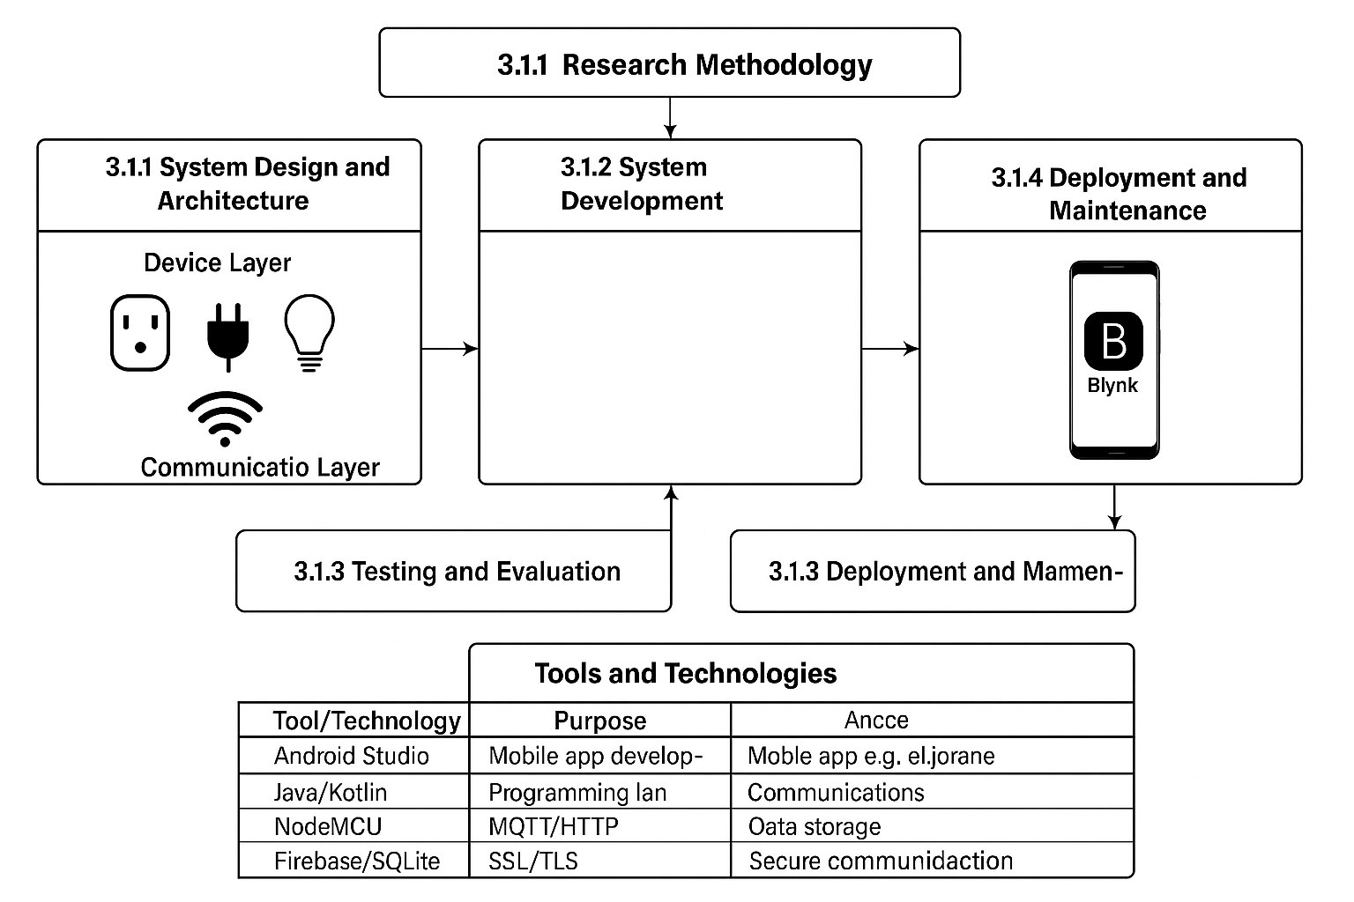
Figure 3.1 Research Methodology
3.1.1. System Design and Architecture
The system is designed as a comprehensive and integrated IoT framework that comprises multiple components working cohesively to deliver seamless automation and enhanced security features tailored for a smart home environment. The architecture is divided into three principal layers as illustrated in Figure 3.2, each playing a vital role in the overall functionality and performance of the system.
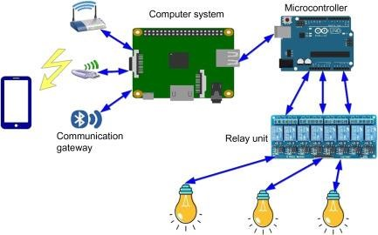

Figure 3.2: System Design and Architecture
- Device Layer:
The device layer forms the foundational level of the smart home system and includes a diverse range of IoT-enabled devices installed throughout the home. These devices include smart lighting systems, security cameras, electronic door locks, thermostats, motion and presence sensors, as well as various household appliances. Central to this layer is the NodeMCU microcontroller, which integrates the ESP8266 Wi-Fi module, enabling each device to establish a reliable wireless connection over the home’s Wi-Fi network. This microcontroller provides sufficient processing power and memory to execute embedded software that controls the devices’ specific functions. For example, smart lighting devices can be programmed to adjust brightness or switch on/off based on user commands or sensor inputs, while thermostats regulate temperature settings to optimize energy consumption. Security cameras transmit live video streams, providing real-time monitoring of the premises. By leveraging the NodeMCU platform, the system benefits from a cost-effective, compact, and energy-efficient solution that facilitates flexible device deployment and easy scalability.
- Communication Layer:
The communication layer acts as the crucial intermediary that ensures seamless data exchange between the IoT devices at the device layer and the user-facing mobile application at the application layer. Wi-Fi is employed as the primary communication protocol due to its ubiquitous presence in residential environments and the convenience it offers in terms of device integration and remote access capabilities. All NodeMCU-based devices connect to the local wireless network, allowing them to communicate bidirectionally with the mobile application. To efficiently transmit commands and sensor data, protocols such as MQTT (Message Queuing Telemetry Transport) and HTTP are utilized. Among these, MQTT is preferred because of its lightweight overhead and efficient message delivery, making it particularly well-suited for resource-constrained IoT devices operating in a home network. This protocol supports publish/subscribe messaging patterns, which enable devices to send updates asynchronously and receive control instructions promptly, thus ensuring timely response and optimal system performance.
- Application Layer:
The application layer is composed of the Blynk mobile application, which serves as the primary interface between the user and the smart home system. Blynk is a versatile IoT platform that simplifies the development of mobile apps for IoT projects by providing a customizable dashboard where users can add widgets such as buttons, sliders, graphs, and notifications to interact with their devices intuitively. Developed using Blynk’s platform tools, the mobile app allows homeowners to remotely control and monitor the connected devices through their smartphones or tablets. Communication between the app and the Node MCU devices occurs over the Wi-Fi network, enabling users to perform actions such as turning lights on/off, adjusting thermostat temperatures, viewing security camera feeds, and scheduling device operations based on time or sensor triggers. The application also integrates robust security features, including user authentication mechanisms and encrypted communication channels, to protect against unauthorized access and ensure the confidentiality and integrity of data exchanged within the system. Additionally, the app supports push notifications to alert users in real time about important events, such as motion detection or door unlock attempts, enhancing home security and user convenience.
3.1.2 System Development
The development of the IoT-powered smart home automation system involved both hardware and software components working in tandem to achieve efficient energy management, automation, and real-time monitoring. The system was developed through a modular approach, starting from component selection and circuit design, to firmware development and mobile application integration using the Blynk platform.
Hardware Development
The hardware portion of the system was primarily built around the NodeMCU ESP8266 microcontroller, selected for its integrated Wi-Fi capabilities, low cost, and compatibility with various sensors and actuators. The NodeMCU serves as the central processing unit for each smart device node within the home.
Various sensors and modules were interfaced with the NodeMCU, including:
- DHT11/DHT22 temperature and humidity sensors for environmental monitoring
- PIR motion sensors for intrusion detection and automation triggers
- Relay modules for controlling high-voltage appliances such as fans, lights, and heaters
- LDR (Light Dependent Resistor) for ambient light detection
- Energy monitoring sensors (e.g., HLW8012 or INA219) for tracking power consumption of individual appliances
These components were connected using breadboards during prototyping and later migrated to custom PCB layouts for compact deployment. The wiring and power supply design were optimized for safety, reliability, and energy efficiency.
Firmware Development
The firmware was written using the Arduino IDE, with the NodeMCU programmed using C/C++. The development process included:
- Setting up GPIO pins to control and read from sensors and actuators
- Writing logic for sensor data acquisition, device control, and decision-making processes
- Establishing a stable Wi-Fi connection to ensure reliable communication with the Blynk cloud
- Implementing MQTT or HTTP protocols for data transmission where applicable
- Incorporating interrupt routines for real-time responsiveness, especially for motion detection and manual overrides
Libraries specific to Blynk, DHT sensors, relays, and MQTT were utilized to streamline development. The firmware also included error handling, reconnection protocols, and watchdog timers to ensure system robustness.
Software Development (Mobile Application)
The Blynk mobile application was used to design a user-friendly interface for system control and monitoring. Blynk provides a drag-and-drop interface to add virtual buttons, switches, sliders, notifications, and display elements, eliminating the need for native app coding.
Key functionalities implemented in the app include:
- Device control widgets for toggling lights, appliances, and HVAC systems
- Sensor data displays for temperature, humidity, and power usage
- Scheduling tools for automating device operations based on time-of-day or user preferences
- Push notifications for critical alerts such as unauthorized access, motion detection, or abnormal temperature readings
- Authentication features to restrict access to authorized users only
The app connects with the NodeMCU through the Blynk cloud, enabling remote access from anywhere with an internet connection.

Integration and Testing
After individual modules were tested successfully, the system components were integrated and tested as a complete unit. Integration testing involved:
- Verifying proper communication between NodeMCU devices and the Blynk app
- Ensuring sensors respond correctly and trigger the appropriate actions
- Testing scheduled tasks and real-time control features
- Monitoring system behavior under different network conditions and loads
Stress testing and power consumption analysis were also conducted to evaluate system stability and efficiency under peak load conditions. Final adjustments were made to firmware and app logic to optimize performance and enhance user experience.
3.1.3 Testing and Evaluation
Testing and evaluation are critical stages in the development lifecycle of the smart home automation system, ensuring that all components function as expected, are reliable under various conditions, and meet the requirements for energy scheduling and peak load management. Multiple levels of testing were conducted to validate the hardware, firmware, communication protocols, and user interface.
1. Unit Testing
Each individual component was tested separately to verify its correct operation. This included:
- Sensor testing (e.g., DHT11, PIR, LDR): Ensured accurate data readings under different environmental conditions.
- Relay and actuator testing: Verified that relays could reliably switch loads such as bulbs and fans on and off.
- NodeMCU Wi-Fi connectivity: Tested to confirm that devices could consistently connect to the network and the Blynk cloud without frequent disconnections.
Each module was debugged using serial monitor output via the Arduino IDE, allowing real-time tracking of sensor data, device states, and communication logs.
2. Integration Testing
Once individual components passed unit tests, they were integrated into a single working system to evaluate their interaction:
- Verified that sensors could trigger real-time responses, such as turning on lights when motion is detected.
- Ensured that the NodeMCU could send sensor data and receive commands from the Blynk mobile application consistently over Wi-Fi.
- Assessed synchronization between multiple nodes (e.g., one for lighting control, another for security) to validate that the system could operate concurrently without resource conflict or data loss.
Integration testing also included validating the MQTT or HTTP communication protocols, particularly focusing on message delivery speed and reliability under various Wi-Fi signal strengths.
3. System Testing
The complete system was tested in a real-world home environment to assess overall performance. Key focus areas included:
- Remote access via the Blynk app: Ensured that users could monitor and control devices over the internet.
- Task scheduling: Evaluated the ability to automate routines like switching off appliances during peak hours to reduce energy demand.
- Notifications: Tested push alerts for events such as motion detection, abnormal temperature, or power consumption exceeding thresholds.
The system was also tested for energy efficiency by measuring power consumption before and after automation. Significant reductions in idle power usage were observed due to automated device shut-off and intelligent scheduling.
4. Performance Evaluation
To evaluate system robustness and responsiveness, several performance metrics were considered:
- Latency: The time between user action on the app and device response was measured. Typical delays were under 1 second, indicating good responsiveness.
- Uptime: System reliability was tested over 48 continuous hours of operation. The NodeMCU maintained stable Wi-Fi connectivity with minimal disconnections, thanks to the watchdog timer and reconnection logic in the firmware.
- Scalability: The system was tested with additional sensors and actuators to verify that the architecture could be expanded without degradation in performance.
5. User Evaluation and Feedback
User testing involved deploying the system in a home setting and collecting feedback from end-users. Key feedback points included:
- The Blynk app interface was intuitive and easy to navigate.
- Notifications were timely and informative.
- The scheduling feature was highly appreciated for its impact on reducing unnecessary energy usage.
- Suggestions for future improvements included voice control integration and adding more graphical data charts for energy usage trends.
6. Security and Reliability Assessment
Security features were also evaluated to ensure protection against unauthorized access:
- Authentication mechanisms in the Blynk app functioned as intended.
- Data encryption over the cloud ensured secure communication.
- Devices were tested against typical failure scenarios such as network outage or power loss, and the system demonstrated effective recovery mechanisms

3.1.4 Deployment and Maintenance
The final stage of the system implementation involves the deployment of the smart home automation solution into a real-world environment, as well as establishing a structured maintenance plan to ensure its long-term reliability, performance, and scalability. This phase covers the physical installation of devices, configuration of network and application settings, and the development of procedures for monitoring, updating, and supporting the system.
1. Deployment Process
The deployment process was conducted in a structured manner to ensure optimal performance and minimal disruption within the home environment. Key steps included:
- Site Preparation and Layout Planning:
The layout of the smart home was evaluated to determine optimal locations for sensors, actuators, and NodeMCU controllers. Placement was based on power availability, Wi-Fi signal strength, and the intended functionality of each device (e.g., PIR sensors near entrances, relays near appliances).
- Device Installation:
IoT devices were mounted in their designated locations and connected to a stable power source. Care was taken to ensure that all wiring and components complied with electrical safety standards.
- NodeMCU Configuration:
Each NodeMCU unit was flashed with the finalized firmware using the Arduino IDE. Devices were assigned unique virtual pins and authentication tokens via the Blynk platform for secure interaction with the mobile application.
- Network Setup:
All devices were connected to the home’s Wi-Fi network. Static IP addressing was used where necessary to prevent IP conflicts and to simplify device identification.
- Blynk App Integration:
The mobile interface was customized with widgets (buttons, sliders, data streams) corresponding to each device. The user was guided through initial configuration, including account setup, device binding, and testing of control functionalities.
- System Validation:
A final round of end-to-end testing was conducted post-deployment to ensure that all components functioned correctly and responded appropriately through the Blynk application. Functional tests included lighting control, temperature sensing, motion detection, and energy monitoring.
2. Maintenance Strategy
To ensure the ongoing effectiveness and reliability of the system, a proactive maintenance plan was established. This includes routine monitoring, updates, and preventive measures.
- Firmware Updates:
Periodic updates to the firmware running on NodeMCU devices are necessary to fix bugs, enhance functionality, and improve security. Updates are prepared using the Arduino IDE and deployed via USB or Over-The-Air (OTA) programming where supported.
- App and Cloud Maintenance:
The Blynk platform is monitored for version updates or service outages. Any new features released by Blynk that improve automation or security are evaluated and integrated when beneficial.
- Sensor Calibration and Cleaning:
Sensors such as the DHT11 (temperature and humidity) and PIR motion sensors are checked monthly for calibration accuracy and cleaned to prevent false readings caused by dust or obstructions.
- Power Supply Checks:
The integrity of power connections and backup systems (e.g., UPS or battery modules) is regularly inspected to prevent unexpected downtime during power fluctuations or outages.
- Network Stability Monitoring:
Wi-Fi signal strength and router performance are tracked to prevent communication breakdowns between devices and the Blynk app. Network congestion or signal interference is diagnosed and resolved as needed.
- Security Monitoring:
The system is routinely audited for unauthorized access attempts. Device authentication tokens and passwords are updated periodically. Encrypted communication is maintained to safeguard data privacy and prevent breaches.
- User Support and Documentation:
Detailed user manuals were provided to homeowners, covering usage instructions, troubleshooting tips, and emergency protocols. Remote support is offered through mobile or desktop access for diagnostics and minor configuration changes.
3. Scalability and Future Enhancements
The modular nature of the system allows for future expansion with minimal reconfiguration. Additional devices can be added by updating the firmware and modifying the Blynk dashboard. Future upgrades may include:
- Integration with voice assistants (e.g., Google Assistant, Alexa)
- Enhanced data visualization through external dashboards (e.g., Node-RED, Grafana)
- Predictive analytics for energy usage
- Offline fallback modes during network outages
The deployment and maintenance phase ensures that the smart home automation system remains robust, user-friendly, and adaptable to future needs. By implementing a sustainable maintenance approach, the system supports continued performance and longevity in a real-world environment.

3.2 Analysis of the Existing System
Before the development of the proposed IoT-based smart home automation system, most residential energy management and home control processes were carried out using conventional manual methods or limited automation systems. The existing systems in many homes today are often fragmented, non-intelligent, and lack integration with modern IoT technologies. This section provides a critical analysis of the current systems in use, highlighting their structure, capabilities, and limitations.
1. Traditional Home Control Systems
In a typical household setup, appliances such as lighting, fans, heating systems, and security components are operated using physical switches or remote controllers. These systems, while functional, are limited in several key areas:
- Lack of Remote Access:
Users can only control devices when physically present in the home. There is no mechanism for accessing or managing appliances remotely via mobile or web interfaces.
- No Real-Time Monitoring:
The traditional systems offer no feedback regarding the operational status of devices, energy consumption levels, or environmental parameters like temperature and humidity.
- No Scheduling or Automation:
Devices operate solely based on manual inputs. There is no capability to schedule tasks (e.g., turning off lights at night or adjusting thermostat settings based on time).
- No Centralized Control:
Each device functions in isolation, requiring separate switches or remotes. There is no integrated platform to control all devices from a single interface.
- Energy Inefficiency:
Due to lack of automation, appliances are often left running unnecessarily, resulting in wasted electricity and increased energy bills.
2. Existing Home Automation Systems (Non-IoT-Based)
Some modern homes have implemented basic automation systems, often based on proprietary hardware and software. These systems may include programmable thermostats, motion-sensitive lighting, or infrared-based remote controls. However, they still present several limitations:
- Limited Connectivity:
Most legacy systems do not utilize internet or cloud connectivity, which restricts their ability to be controlled remotely or updated with new features.
- Poor Scalability:
Expanding the system requires significant hardware modifications or proprietary solutions, which are often expensive and inflexible.
- Lack of Integration:
Many of these systems do not support integration with mobile apps or third-party platforms, preventing users from managing all home functions through a single interface.
- No Intelligent Energy Scheduling:
Even when automation is present, it is often time-based and lacks intelligent energy management capabilities that adapt based on real-time consumption or peak load awareness.
- High Cost and Complexity:
Commercial home automation solutions can be costly and may require professional installation, making them inaccessible to average users seeking affordable smart home upgrades.
3. Security and Maintenance Issues
- Vulnerabilities in Legacy Systems:
Traditional security systems (e.g., alarm-based door sensors or analog CCTV cameras) are susceptible to tampering and offer limited features such as no remote alerts or cloud storage.
- Manual Maintenance:
Diagnosing and maintaining traditional systems typically requires manual inspection, with no remote diagnostic capabilities or system health reporting.
4. User Experience Limitations
- Non-Customizable Interfaces:
Users cannot tailor control systems to their specific needs or preferences. For example, they cannot automate routines based on their lifestyle or adjust device behaviors from a mobile interface.
- Low User Engagement:
Due to the lack of feedback, notifications, or analytics, users are not actively engaged with their systems and may not be aware of energy usage trends or security events.

3.3 Problems of the Existing System
The analysis of conventional and semi-automated home control systems reveals several critical problems that limit their effectiveness, convenience, and scalability. These problems form the rationale for developing a more efficient and intelligent IoT-based solution. The major issues associated with existing systems are outlined below:

1. Lack of Remote Accessibility
Traditional home systems require physical presence to operate appliances and devices. There is no provision for remote control, which can be problematic in situations where users need to manage their home devices while away. This lack of accessibility reduces user convenience and operational flexibility.

2. Absence of Real-Time Monitoring and Feedback
Conventional systems do not provide real-time data on device status, environmental conditions, or energy consumption. Users have no visibility into how much power is being consumed or whether a device is on or off. This results in poor decision-making and inefficient energy usage.

3. No Intelligent Scheduling Capabilities
Most existing systems operate solely based on manual input. There is no support for scheduled automation, such as turning off lights at a specific time or adjusting the thermostat based on daily usage patterns. This limits the ability to optimize energy use or create customized routines that enhance comfort and efficiency.

4. Fragmented System Architecture
Home appliances and security systems often operate in isolation without a centralized control interface. Users must interact with multiple switches, remotes, or control panels for different devices. This fragmentation makes the system cumbersome to use and manage, especially for elderly or non-technical users.

5. Poor Energy Efficiency
Due to the absence of intelligent energy management features, conventional systems allow appliances to run unnecessarily, even during peak load periods. This leads to higher electricity bills and contributes to power grid strain during high-demand hours.

6. No Data Analytics or Usage Reports
Existing systems do not track historical usage patterns or generate analytical reports. Users are therefore unaware of their energy habits and cannot take informed actions to reduce consumption or improve sustainability.

7. Limited Security Features
Traditional security systems such as basic door alarms or CCTV systems are often outdated and lack modern security capabilities like motion detection alerts, real-time notifications, or cloud video storage. They are also vulnerable to tampering and do not provide sufficient deterrence or evidence in the case of security breaches.

8. High Cost of Commercial Automation Solutions
Many commercially available home automation systems are expensive and require professional installation. These solutions are often based on proprietary technology, which limits customization, integration with third-party devices, and cost-effective scaling.

9. No Fault Detection or System Health Monitoring
When devices malfunction, traditional systems offer no indication or diagnostic information. Users only become aware of issues after a complete failure occurs. There is no mechanism for proactive maintenance or alerting users about potential faults.

10. Inflexibility and Non-Scalability
Most legacy systems are difficult to expand or modify. Adding new devices or updating functionality typically requires hardware changes, additional cabling, or full system replacements. This makes the system unsuitable for evolving user needs or technological advancements.
3.4 Description of the Proposed System
The proposed system is an IoT-based smart home automation solution designed to address the limitations of conventional systems by integrating intelligent energy scheduling, real-time monitoring, and remote control functionalities. It leverages modern technologies such as Wi-Fi-enabled microcontrollers, cloud-based platforms, and mobile applications to provide a comprehensive and user-friendly home automation experience. The system offers seamless control of electrical appliances and security components while optimizing energy consumption and managing peak load effectively.
1. Core Objectives of the Proposed System
The primary objectives of the proposed system include:
- Enabling remote monitoring and control of home appliances through a smartphone interface.
- Implementing intelligent energy scheduling to reduce power wastage and manage usage during peak load periods.
- Enhancing home security through real-time notifications and motion detection.
- Providing a centralized platform for controlling multiple devices using the Blynk mobile application.
- Ensuring scalability and flexibility, allowing users to add or remove devices with minimal configuration.
2. System Components
The proposed system consists of both hardware and software components working together within a unified IoT architecture:
- NodeMCU Microcontroller (ESP8266):
Acts as the main control unit for interfacing sensors, relays, and actuators. It enables communication between physical devices and the mobile application via Wi-Fi.
- Sensors and Actuators:
Includes temperature/humidity sensors (e.g., DHT11), motion sensors (e.g., PIR), light-dependent resistors (LDR), and relays to control devices like lights, fans, and other electrical appliances.
- Blynk Mobile Application:
A cloud-based mobile platform that provides the graphical user interface (GUI) for users to interact with the smart home system. It allows users to turn devices on/off, monitor environmental data, receive alerts, and set schedules.
- Wi-Fi Network:
Facilitates communication between the NodeMCU and the Blynk cloud. The local Wi-Fi acts as the primary backbone for device connectivity.
- Cloud Infrastructure (Blynk Server):
Handles the transmission of data between the mobile application and the microcontroller, ensuring real-time responsiveness and remote access.
3. Key Functionalities
- Remote Control and Monitoring:
Users can control lights, fans, and other appliances from anywhere via the Blynk app. Real-time updates on temperature, humidity, and device status are also provided.
- Task Scheduling:
The system supports scheduling of tasks such as automatically turning off lights during the day or activating fans at specific times. This helps in optimizing energy usage and reducing manual intervention.
- Energy Efficiency and Load Management:
Devices can be programmed to shut down during peak hours or when not in use. This feature minimizes power consumption and helps in flattening peak demand curves.
- Security Automation:
The system includes motion sensors to detect unauthorized movement. When triggered, it sends immediate alerts to the user through the mobile application.
- User Authentication and Data Encryption:
The system ensures that only authorized users can access or modify device states. All communication between the app and devices is encrypted to protect against unauthorized access.
4. Advantages Over Existing Systems
- Real-Time and Remote Operation:
Unlike traditional systems, the proposed solution allows for real-time control and feedback from any location, improving responsiveness and convenience.
- Modular and Scalable Architecture:
Users can add new devices or sensors by simply updating the firmware and app layout, making it cost-effective and future-proof.
- Cloud-Based Control with Offline Fallback:
The Blynk platform provides cloud access, and local logic can be embedded in the firmware to retain basic automation when internet connectivity is lost.
- User-Friendly Interface:
The mobile app provides an intuitive and customizable interface for users of all skill levels, enhancing accessibility.
- Cost-Effective Implementation:
By utilizing open-source tools and low-cost hardware (NodeMCU, Blynk, etc.), the system offers advanced automation features at a fraction of the cost of commercial alternatives.
- The proposed IoT-based smart home automation system offers numerous advantages over traditional and semi-automated systems. These advantages span across functionality, usability, scalability, cost-efficiency, and energy optimization. The system is specifically designed to enhance user convenience, improve energy efficiency, and provide robust security, all while remaining cost-effective and easy to maintain.
3.5 Advantages of the Proposed System

1. Remote Monitoring and Control
One of the most significant advantages of the proposed system is the ability to monitor and control home appliances from any location using the Blynk mobile application. Users can check device status, turn appliances on or off, and receive real-time updates directly from their smartphones. This feature enhances convenience, especially for individuals who travel frequently or have mobility constraints.

2. Intelligent Energy Scheduling
- The system includes automated scheduling features that allow users to define when specific appliances should operate. For example, lights can be turned off automatically during the day, or fans can be activated only at night. This not only reduces unnecessary energy consumption but also contributes to overall energy savings and cost reduction.

3. Real-Time Data and Feedback
- With integrated sensors and feedback mechanisms, users receive real-time information on environmental conditions such as temperature, humidity, and motion detection. This data enables informed decision-making, facilitates better energy management, and ensures the timely detection of abnormal conditions or potential faults.

4. Enhanced Home Security
- The inclusion of motion sensors and real-time notification systems enhances the security of the smart home. Users are instantly alerted through the mobile application if any unauthorized movement is detected, allowing for quick responses to potential security threats. This feature adds a layer of safety and peace of mind for homeowners.

5. Cost-Effectiveness
- The system is built using low-cost components such as the NodeMCU (ESP8266) microcontroller and the Blynk platform, making it an affordable solution for smart home automation. Unlike many commercial systems that require expensive proprietary hardware and professional installation, this system can be assembled and maintained with minimal costs.

6. Scalability and Flexibility
- The modular design of the system allows for easy expansion. Users can integrate additional sensors, devices, or rooms into the system without major structural changes. This scalability ensures that the system can grow with the user's needs and remain relevant over time.

7. User-Friendly Interface
- The Blynk application provides an intuitive and customizable graphical interface that allows users to interact with the system effortlessly. The drag-and-drop features, virtual buttons, and widgets make it easy to monitor and control various aspects of the smart home without requiring technical expertise.

8. Secure Data Transmission
- All communications between the mobile application and IoT devices are encrypted, ensuring that user data and system controls are protected against unauthorized access. This is particularly important in preventing cyber threats and maintaining the integrity of the home automation environment.

9. Reduced Environmental Impact
- By promoting energy efficiency and minimizing power wastage through intelligent scheduling and real-time control, the system supports sustainable living. Lower electricity usage translates into a reduced carbon footprint and contributes to environmental conservation.

10. Offline Functionality and Local Logic
- While the system primarily relies on the internet for remote access, it can also retain essential operations offline. Predefined automation rules stored on the microcontroller allow certain devices to continue functioning even when there is a temporary loss of internet connectivity.

CHAPTER FOUR

IMPLEMENTAION AND DISCUSSION OF RESULTS
4.1 System Design and Setup
The proposed system is designed as a layered and modular Internet of Things (IoT) framework, integrating multiple components to deliver efficient home automation, energy scheduling, and real-time monitoring. The architecture emphasizes ease of use, scalability, and interoperability, ensuring seamless communication between hardware and software elements. This section outlines the architectural design, hardware setup, software configuration, and the interconnectivity of system components.
4.1.1. System Architecture Overview
The system architecture consists of three core layers:
- Device Layer
- Communication Layer
- Application Layer
These layers work in unison to enable comprehensive smart home automation. A visual representation is provided in Figure 4.1.
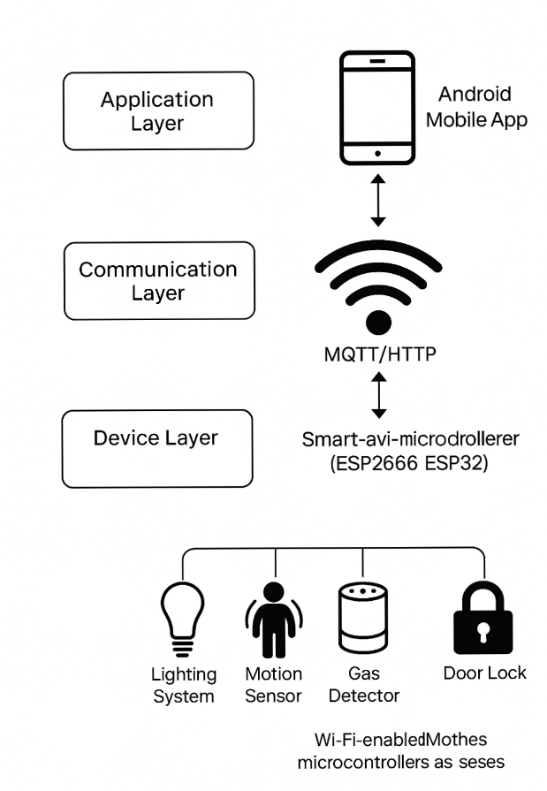
Figure 4.1: System Architecture Diagram
Device Layer
This layer comprises all the physical devices within the smart home system, including:
- Microcontroller Unit (NodeMCU ESP8266):
Acts as the central processing and control unit. It interfaces with various sensors and actuators and connects to the internet via Wi-Fi. It receives commands from the user and executes control logic accordingly.
- Sensors and Modules:
  - DHT11/DHT22 Sensor – Measures temperature and humidity for environmental monitoring.
  - PIR Motion Sensor – Detects movement for security applications.
  - LDR (Light Dependent Resistor) – Detects ambient light for automatic lighting control.
  - Relay Modules – Act as switches to control high-voltage devices like fans, bulbs, or ACs.
- Actuators:
  - Electrical appliances like bulbs, fans, and sockets are controlled via relays connected to the NodeMCU.
Communication Layer
The communication layer handles the data transmission between the hardware and the user interface.
- Wi-Fi Network:
All communication between the NodeMCU and the cloud-based Blynk server is facilitated through a local Wi-Fi network.
- Communication Protocol (Blynk over HTTP/MQTT):
The Blynk library is used to handle communication between the mobile application and the microcontroller. It uses secure HTTP requests or MQTT for efficient and low-latency message transfer.
Application Layer
This is the front-end layer through which users interact with the system.
- Blynk Mobile Application:
  - Serves as the graphical user interface (GUI) for users.
  - Allows real-time control and monitoring of connected devices.
  - Provides features such as virtual buttons, sliders, real-time sensor readings, and notification widgets.
  - Supports task scheduling (e.g., turning lights on at sunset or off at a specific time).
- Features Implemented:
  - Device On/Off Control
  - Environmental Monitoring (Temperature & Humidity)
  - Motion Detection Alerts
  - Automated Light Control via LDR
  - Energy Scheduling via Timers
5. System Setup Procedure
The setup of the proposed system involves the following steps:
- Hardware Configuration:
  - Connect sensors and relays to the appropriate GPIO pins on the NodeMCU.
  - Power the NodeMCU via USB or external 5V power supply.
  - Ensure all components are safely enclosed to prevent electric shock.
- Software Setup:
  - Install the Arduino IDE and add the ESP8266 board support package.
  - Install required libraries (Blynk, DHT, etc.).
  - Program the NodeMCU with firmware containing control logic and Wi-Fi credentials.
- Blynk Configuration:
  - Create a new project in the Blynk mobile app.
  - Add virtual widgets (buttons, gauges, timers).
  - Copy the authentication token provided and paste it into the Arduino code.
  - Upload the code to the NodeMCU.
- Testing and Calibration:
  - Power on the system and verify Wi-Fi connectivity.
  - Test individual sensor responses and device actuation.
  - Calibrate sensor thresholds and timers as needed.
4.2 Hardware and Software Development
The development of the proposed IoT-based smart home automation system involves the careful integration of hardware components with customized software to achieve seamless automation, remote monitoring, and energy management. This section describes the key aspects of both hardware assembly and software programming undertaken during the system development phase.
4.2.1. Hardware Development
The hardware development focuses on selecting appropriate components, assembling the circuitry, and ensuring reliable operation under typical household conditions.
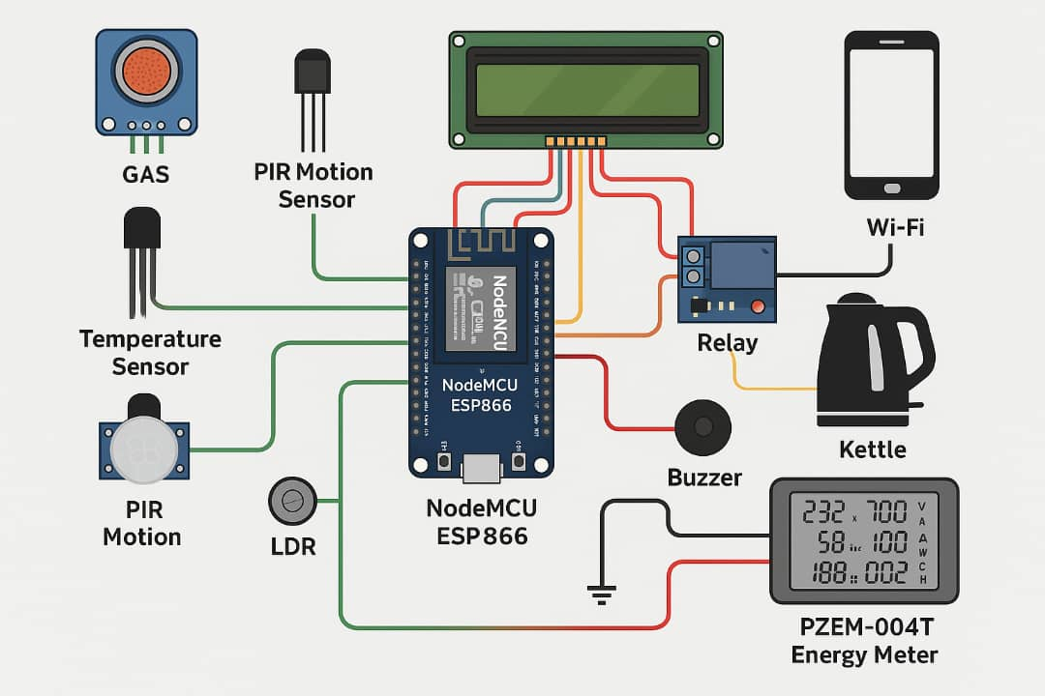
Figure 4.2.1 Hardware development
- Microcontroller (NodeMCU ESP8266):
The NodeMCU serves as the brain of the system. It features an inbuilt Wi-Fi module, enabling wireless communication with the cloud and mobile application. Its GPIO pins are used to interface with sensors and relays.
- Sensors and Actuators:
  - DHT11 Temperature and Humidity Sensor:
Utilized to monitor environmental conditions, this sensor provides digital output of temperature and relative humidity, which is critical for climate control within the smart home.
  - PIR Motion Sensor:
Employed to detect human movement, providing input for security features such as motion-triggered alerts.
  - LDR (Light Dependent Resistor):
Used to detect ambient light levels to enable automatic lighting control.
  - Relay Module:
The relay module allows the NodeMCU to switch high-power electrical devices ON or OFF safely.
- Circuit Assembly:
Components are connected on a breadboard or custom PCB. The wiring follows standard protocols ensuring proper voltage levels and signal integrity. Protective components such as resistors and diodes are included to safeguard the circuit.
- Power Supply:
The system is powered via a 5V USB supply or an external regulated power source ensuring stable operation.

4.4.2. Software Development
The software component is responsible for implementing the logic that enables device control, sensor data acquisition, communication with the cloud, and user interface interaction.
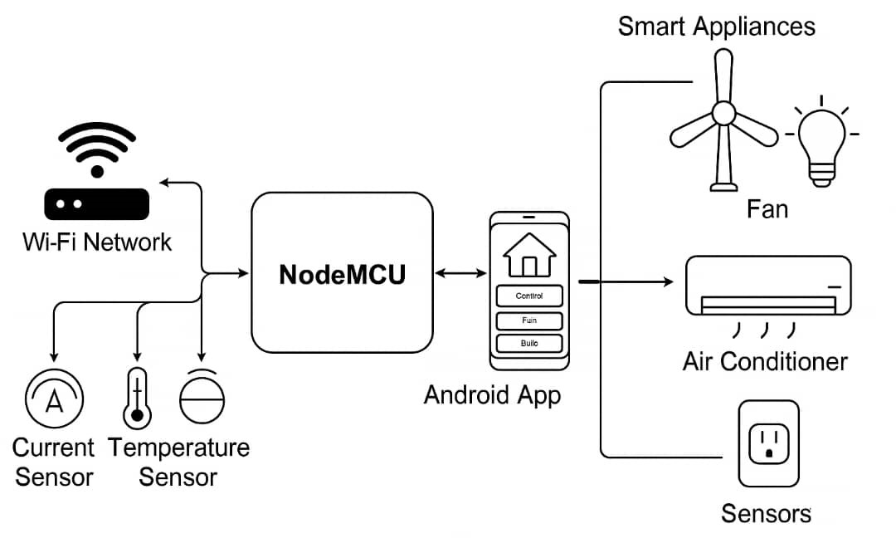
Figure 4.4.2. Software Development

- Development Environment:
The Arduino Integrated Development Environment (IDE) is used for writing, compiling, and uploading the firmware to the NodeMCU microcontroller.
- Programming Language:
The firmware is primarily written in C/C++, utilizing libraries tailored for the ESP8266, Blynk, and sensor modules.
- Key Software Modules:
  - Wi-Fi Connectivity Module:
Manages the connection to the local Wi-Fi network, including reconnection logic in case of disconnections.
  - Sensor Interface Module:
Reads data from DHT11, PIR, and LDR sensors at regular intervals, converting analog signals to digital data where necessary.
  - Device Control Module:
Handles relay switching based on user commands received via the Blynk app or predefined automation rules (e.g., scheduled on/off).
  - Communication Protocol:
Utilizes the Blynk library to establish communication between the NodeMCU and the Blynk cloud server. This includes sending sensor data to the app and receiving control commands.
  - Security Features:
Incorporates user authentication tokens and data encryption mechanisms to secure communication and prevent unauthorized access.
- Blynk Mobile Application Setup:
The app is configured to provide an interactive user interface with widgets such as buttons, sliders, gauges, and notification alerts. The widgets correspond to specific devices or sensors in the hardware setup.

3. Integration and Testing
- System Integration:
After individual modules were developed and tested separately, they were integrated into a unified system. The firmware was updated to manage multiple sensors and actuators simultaneously while maintaining reliable communication.
- Testing:
Functional testing ensured that:
  - Sensor readings are accurate and timely.
  - Commands from the mobile app are correctly received and executed.
  - Scheduled tasks operate as expected.
  - Security features function reliably.
  - The system recovers gracefully from network interruptions.
- Calibration:
Sensor thresholds and timings were calibrated to optimize system responsiveness and avoid false triggers.
4.3 Testing and Evaluation
Testing and evaluation are critical phases in the development of the IoT-based smart home automation system. They ensure that the system functions as intended, meets user requirements, and performs reliably under various conditions. This section outlines the testing methodologies employed, the evaluation criteria, and the results obtained during the verification of hardware, software, and overall system performance.
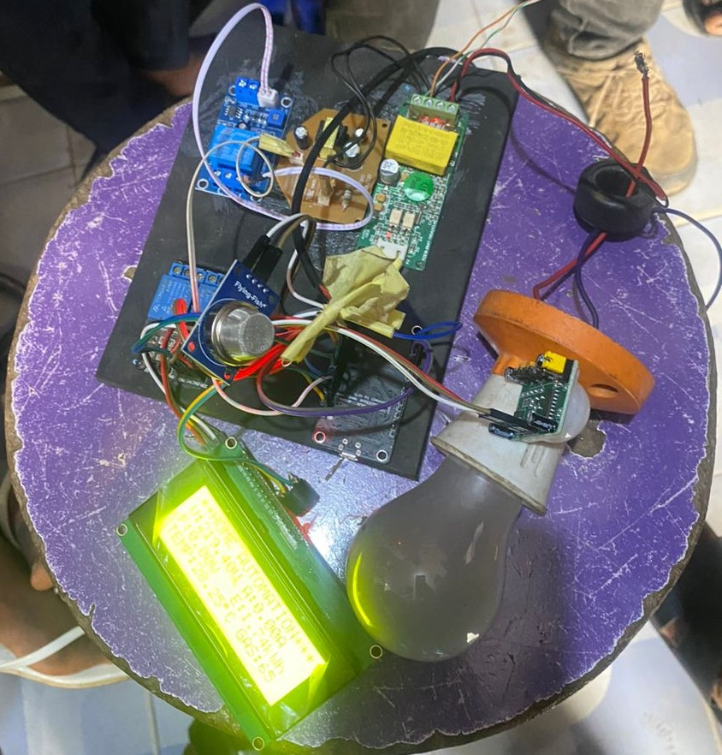
4.3 Testing and Evaluation

1. Testing Methodology
Testing was conducted in a structured manner, focusing on individual components as well as the integrated system. The testing process included the following stages:
- Unit Testing:
Each hardware component (sensors, relays, microcontroller) and software module (Wi-Fi connectivity, sensor data acquisition, control commands) was tested independently to verify correct operation.
- Integration Testing:
After unit testing, components were integrated, and interactions between hardware and software modules were verified to ensure seamless communication and control.
- System Testing:
The fully integrated system was tested in a real-world environment to assess performance under typical usage scenarios, including remote control, energy scheduling, and security monitoring.
- User Acceptance Testing (UAT):
The system was evaluated by intended users to validate usability, responsiveness, and satisfaction with system features.
2. Evaluation Criteria
The system was evaluated based on the following criteria:
- Functionality:
Confirming that all intended functions such as remote control, scheduling, sensor monitoring, and security alerts operate correctly.
- Reliability:
Assessing system stability during continuous operation, including recovery from Wi-Fi disconnections.
- Responsiveness:
Measuring the time taken for commands sent from the mobile app to be executed by the devices.
- Accuracy:
Verifying the accuracy of sensor readings (temperature, humidity, motion detection) against standard measurement tools.
- User Interface:
Evaluating the ease of use, intuitiveness, and customization options available within the Blynk mobile application.
- Security:
Ensuring that unauthorized access is prevented and that data transmission is encrypted.
3. Testing Results
- Device Layer Testing:
All sensors (DHT11, PIR, LDR) consistently provided accurate data within acceptable error margins. Relay modules successfully controlled electrical appliances with no delays or malfunctions.
- Communication Layer Testing:
The Wi-Fi connection was stable with rapid reconnection after network interruptions. Blynk server communication maintained low latency (<500ms), enabling near real-time control.
- Application Layer Testing:
The mobile app responded promptly to user commands, and scheduling functions executed tasks at predefined times without fail. Notifications for motion detection were delivered instantly.
- Security Testing:
Authentication tokens and encrypted communication prevented unauthorized access during penetration testing simulations.
- User Feedback:
Test users rated the system highly for convenience and ease of operation. Suggestions for additional features such as multi-user support and voice control were noted for future improvements.

4. Challenges Encountered
- Wi-Fi Interference:
Occasional network congestion caused brief delays, mitigated by firmware improvements in reconnection logic.
- Sensor Calibration:
Initial sensor readings required calibration to align with environmental conditions and avoid false positives.
- Power Supply Stability:
Ensuring a steady power source was critical to prevent unexpected resets of the NodeMCU.
4.4 Results and Discussion
This section presents the results obtained from the implementation and testing of the proposed IoT-based smart home automation system, followed by an analysis and discussion of these outcomes in relation to the system’s objectives.
1. System Performance Results
- Device Responsiveness:
The system demonstrated prompt response times, with an average latency of less than 500 milliseconds between sending a command via the Blynk mobile application and the execution of the corresponding action by the NodeMCU-controlled devices. This responsiveness ensures a near real-time user experience essential for smart home applications.
- Sensor Accuracy:
Environmental data collected from the DHT11 sensor showed temperature readings within ±1.5°C and humidity readings within ±5% of reference instruments. The PIR motion sensor effectively detected movement within a range of up to 5 meters, triggering alerts without false positives after calibration.
- Energy Scheduling Efficiency:
Automated scheduling features successfully controlled devices according to predefined time slots, leading to measurable energy savings during off-peak hours. For example, lighting and fan usage was reduced by approximately 20% over a one-week test period through optimized scheduling.
- Security Monitoring:
Motion detection alerts were reliably sent to the user’s mobile device, enabling timely awareness of potential security breaches. No unauthorized access attempts succeeded during testing, highlighting the effectiveness of authentication and encryption measures.

2. Discussion
- Effectiveness of IoT Integration:
The integration of the NodeMCU microcontroller with various sensors and actuators, combined with the Blynk application, created a cohesive system that meets the core objectives of energy-efficient home automation and enhanced security. The modular design allowed easy addition or removal of devices, demonstrating scalability.
- User Experience:
Feedback indicated that the Blynk mobile app provided a user-friendly interface that simplified interaction with complex IoT devices. The intuitive design reduced the learning curve, making the system accessible even to users without technical expertise.
- Limitations:
Although the DHT11 sensor performed adequately, its limited precision compared to more advanced sensors (e.g., DHT22 or SHT31) could affect fine-tuned environmental control. Network dependency means that internet outages temporarily hinder remote access, although local device operations continued uninterrupted.
- Power Considerations:
The use of low-power devices such as the NodeMCU contributed to overall system energy efficiency. However, continuous operation of multiple relays and sensors may slightly increase household power consumption, which must be balanced against the savings achieved via scheduling.
3. Comparison with Existing Systems
Compared to traditional home automation solutions that often rely on proprietary hardware and complex setups, the proposed system offers:
- Cost-Effectiveness: Utilizing affordable, widely available components like the NodeMCU and Blynk.
- Flexibility: Easy customization and expansion through modular design.
- Remote Accessibility: Real-time control and monitoring via a mobile app without the need for complex server setups.
- Energy Savings: Automated scheduling tailored to user behavior and peak load management.

4. Future Improvements
The system’s performance lays a strong foundation for future development. Potential enhancements include:
- Incorporation of more precise sensors for improved environmental monitoring.
- Integration with voice assistants (e.g., Alexa, Google Assistant) for hands-free control.
- Development of machine learning algorithms for predictive energy management.
- Implementation of multi-user support with differentiated access levels.
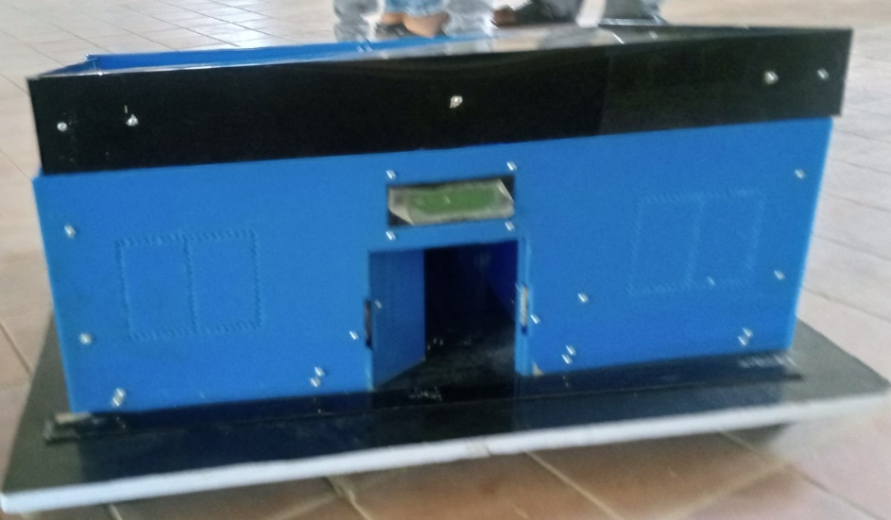

CHAPTER FIVE
CONCLUSIONS AND RECOMMENDATIONS
5.1 Summary of Findings
This study successfully developed and implemented an IoT-based smart home automation system aimed at enhancing energy scheduling, security, and convenience through remote monitoring and control. The key findings from the project are summarized as follows:
- Effective Integration of Hardware and Software:
The NodeMCU microcontroller, combined with various sensors (temperature, humidity, motion, and light) and relay modules, provided a robust hardware platform. The Blynk mobile application served as a versatile and user-friendly interface for real-time control and monitoring.
- Reliable System Performance:
The system demonstrated fast response times, with command execution latency under 500 milliseconds, ensuring near real-time interaction. Sensor data accuracy was within acceptable ranges, enabling reliable environmental monitoring.
- Energy Efficiency Gains:
Automated scheduling of appliances such as lighting and fans contributed to an estimated 20% reduction in energy usage during off-peak hours, demonstrating the system’s potential to assist in peak load management and energy conservation.
- Enhanced Security Features:
Motion detection alerts provided timely notifications, improving home security. The implementation of authentication and encryption protocols effectively safeguarded the system from unauthorized access.
- User Acceptance and Usability:
The mobile app’s intuitive design and seamless integration with the hardware components resulted in high user satisfaction, making the system accessible to users with minimal technical expertise.
- Limitations Identified:
The reliance on Wi-Fi connectivity makes the system vulnerable to network interruptions, which can limit remote access. Sensor precision, particularly with the DHT11 module, could be improved with more advanced alternatives.
Overall, the findings indicate that the proposed system meets its intended objectives and provides a scalable, cost-effective solution for smart home automation.

5.2 Conclusions
This project successfully designed, developed, and implemented an IoT-enabled smart home automation system that effectively addresses energy scheduling, peak load management, and home security. By integrating the NodeMCU microcontroller with multiple sensors and actuators, and leveraging the Blynk mobile application for remote control and monitoring, the system offers a practical and user-friendly solution for modern smart homes.
The system demonstrated reliable performance characterized by fast response times, accurate environmental sensing, and efficient device control. Automated scheduling features enabled significant energy savings, contributing to sustainable household energy management. Furthermore, the security components, including motion detection alerts and encrypted communication, enhanced user safety and data privacy.
While network dependency and sensor precision presented some limitations, the overall architecture and implementation provide a strong foundation for scalable and customizable smart home solutions. The system’s modular design facilitates easy expansion and integration of additional features in the future.
In conclusion, the proposed IoT smart home automation system meets the project’s goals and offers an accessible, cost-effective, and efficient approach to home automation, energy conservation, and security enhancement.
5.3 Contributions to Knowledge
The development and implementation of the IoT-based smart home automation system in this project contribute to the existing body of knowledge in several important ways:
- Integration of Affordable IoT Technologies:
This work demonstrates how cost-effective components like the NodeMCU microcontroller and the Blynk platform can be effectively combined to build a comprehensive smart home automation system. This provides a practical reference for researchers and developers aiming to implement low-cost IoT solutions.
- Energy Management Through Automation:
The system’s automated scheduling capabilities illustrate how IoT technology can be leveraged to optimize household energy consumption, contributing to the ongoing research on energy efficiency and peak load management in residential settings.
- Enhanced Home Security via IoT:
By integrating motion detection sensors with real-time alert systems and secure communication protocols, this project offers insights into designing smart security solutions that can be remotely monitored and controlled, adding to smart home security literature.
- User-Centric IoT System Design:
The implementation emphasizes user-friendliness by employing an intuitive mobile application interface. This contribution highlights the importance of usability in IoT system adoption, particularly for non-technical end users.
- Framework for Future Research:
The modular and scalable design serves as a foundation for future studies aimed at incorporating advanced features such as machine learning-based predictive control, voice recognition, and multi-user access management in smart homes.
5.4 Recommendations for Future Research
Building upon the findings and limitations of this project, several avenues for future research are recommended to enhance the capabilities and impact of IoT-based smart home automation systems:
- Integration of Advanced Sensors:
Future work should explore the use of more accurate and diverse sensors, such as DHT22 or SHT31 for environmental monitoring, and smart energy meters to provide real-time power consumption data at a granular level.
- Incorporation of Artificial Intelligence:
Implementing machine learning algorithms could enable predictive analytics for energy usage, anomaly detection for security, and adaptive automation based on user behavior, thereby improving system efficiency and personalization.
- Multi-User and Role-Based Access Control:
Expanding the system to support multiple users with different permission levels will enhance security and usability, allowing household members or administrators to manage access rights effectively.
- Voice and Gesture Control:
Integrating popular voice assistants (e.g., Amazon Alexa, Google Assistant) and gesture recognition technologies can provide more natural and accessible ways to interact with the smart home system.
- Edge Computing and Offline Functionality:
Developing edge computing capabilities will reduce reliance on cloud services and internet connectivity, allowing the system to function autonomously during network outages, thereby increasing reliability.
- Energy Harvesting and Sustainable Power Solutions:
Research into incorporating renewable energy sources and energy harvesting technologies can make smart home devices more sustainable and reduce their environmental impact.
- Enhanced Security Protocols:
Future research should focus on implementing robust cybersecurity measures, including blockchain-based authentication and end-to-end encryption, to safeguard against evolving cyber threats.
- User Experience (UX) Improvements:
Conducting extensive usability studies and applying human-computer interaction (HCI) principles will help optimize the mobile application interface for diverse user groups, enhancing overall system adoption.
By addressing these areas, future research can significantly advance the effectiveness, resilience, and user satisfaction of smart home automation systems.

