A COMPREHENSSIVE COMPARATIVE STUDY ON THE STRENGTH ASSESSMENT OF NO-FINE CONCRETE AND CONVENTIONAL CONCRETE
BY
OLAYEMI AKOREDE OLUWASEUN
HND/23/CEC/FT/0088

SUBMITED TO

DEPARTMENT OF CIVIL ENGINEERING
INSTITUTE OF TECHNOLOGY
KWARA STATE POLYTECHNIC, ILORIN

IN PARTIAL FULFILMENT OF THE REQUIREMENTS FOR THE AWARD OF HIGHER NATIONAL DIPLOMA (HND) IN CIVIL ENGINEERING

AUGUST, 2025

CERTIFICATION
This is to certify that this research study was conducted by OLAYEMI, Akorede Oluwaseun (HND/23/CEC/FT/0088) and had been read and approved as meeting the requirement for the award of Higher National Diploma (HND) in Civil Engineering of the Department of Civil Engineering, Institute of Technology, Kwara State Polytechnic, Ilorin.

_________________ _________
ENGR. M. GARUBA DATE
Project Supervisor

_________________ ________
ENGR. A. NAALLAH DATE
Head Of Department

_________________ _______
ENGR. DR. MUJEDU KASALI ADEBAYO DATE
External Examiner

DEDICATION
This project is dedicated to Almighty God, who has been there for me from the beginning to this very point.

ACKNOWLEDGEMENT
All the praise, honor and glory goes to Almighty God, the owner and the giver of knowledge and understanding for His grace and protection on me before, during and after the course of my program.
I sincerely express my deep sense of gratitude to my dear parents, Mr and Mrs Olayemi for their moral, physical advice and financial support on me. I pray that Almighty God will let you reap the fruit of your labors.
Also, I want to express my heartfelt gratitude to my wonderful supervisor, Engr. M. Garuba, for his full support on me towards making my project a successful one. God bless you. AMEN.
Moreso, I want to appreciate all my lecturers in the department of Civil Engineering Department, you are so amazing.
Lastly, I can’t do without appreciating all my father’s e.g. Prophet Onipinla, Pastor Jenyo Esu Pofo, Evan, and my amity Abidoye Oluwafikayo, Alabi Oluwasegun, Oladejo Abimbola, you are so wonderful to me, God bless you all.

ABSTRACT
This project presents the comprehensive study on the strength assessment of No-fine concrete and conventional concrete to determine the performance characteristics of concrete made without fine aggregate and conventional concrete. Single sized coarse aggregate fraction 10mm from a quarry in Ilorin, Ordinary Portland Cement and water/cement ratio 0.5 were used in the experiments. Concrete mix ration of 1:3, 1:6 and 1:2:4 was prepared to find the optimum mix yielding the highest strength. The influence of the above factors on the density, compressive strength was studied experimentally. It was found that the strength of no-fine concrete is higher than that of conventional concrete, and sufficient enough for structural use. Due to its high ratio of continuous voids, this concrete has high water permeability. The suggested mixtures can be used for cast in-situ walls in low-rise, low-cost housing (later plastered externally to reduce air and water permeability).

TABLE OF CONTENTS
Title Page i
Certification ii
Dedication iii
Acknowledgement iv
Abstract v
Table of content vi
List of Table viii
List of figures ix
CHAPTER ONE 1-7
- Introduction
1.1 Aim and Objective of The Study
  - Problem Statement
  - Justification
  - Scope of Study
CHAPTER TWO 8-17
2.0 Literature Review
2.1 Types of Light Weight Concrete
2.2 Advantage and Disadvantage of Lightweight Concrete
2.3 Application of Lightweight Concrete
2.4 Improving the Mechanical Properties of No Fine Concrete
2.5 laboratory Investigation of no Fine Concrete
2.6 Coarse Aggregate
CHAPTER THREE 18-25
3.0 Materials and Methods
3.1 Methodology
3.2 Selection of Materials
3.3 Sieve Analysis Test
CHAPTER FOUR 26-29
4.0 Result and Discussion
4.1 Discussion of Results
CHAPTER FIVE 30-46
5.0 Conclusion
5.1 Recommendation
5.2 References

LIST OF TABLES
• Table 2.1 Advantage Disadvantage of light weight concrete
• Table 3.1 Materials used for the control experiment (1:3,1:6)
• Table 3.2 Material for the experiment (mix ratio 1:3,1:6)
• Table 4.1 Determination of Quantity of Materials
• Table 4.2 Crushing strength of concrete made of mix ratio 1:2:4,1:3 and1;6
• Table 4.3 Compressive strength of hardened of no-fine concrete after 7,14, and 28days of curing for the Mix Ratio of 1:3
• Table 4.4 Compressive strength of hardened of NO-FINE concrete after 7,14, and 28days of curing for the Mix Ratio of 1:6
• Table 4.5 Compressive strength of hardened conventional concrete after 7,14, and 28daycuring for the Mix Ratio of 1:3

CHAPTER ONE
1.O INTRODUCTION
A composite material that consists of essentially of a binding medium, such as a mixture of Portland cement and water, within which are embedded particles or fragments of aggregate, usually a combination of fine and coarse aggregate.
Concrete is by far the most versatile and most widely used construction materials worldwide.it can be engineered to satisfy a widely range of performance specifications, unlike other building materials, such as natural stone and steel, which generally have to be used as they are. Because the tensile strength of cement is much lower than its compressive strength, it is typically reinforced with steel bars, in which case it is known as reinforced concrete.
Materials: A composite materials is made up of various constituents. The properties and the characteristics of the composite are functions of the constituent materials properties as well as the various mix proportions. Before discussing the properties of the composite, it is necessary to discuss those of the individual constituent as well the effect of the mix proportional and method of production.
Cement: There are many different kinds of cements. I concrete, the most commonly used is Portland cement, a hydraulic cement which sets and harden by chemical reaction with water and is capable of doing so under water. Cement is the “glue” that binds the concrete ingredient and is instrumental for the strength of the composite. Although cement and concrete have been around for thousands of years, modern Portland cement was invested in 1824 by joseph Aspin of Leeds, England.
The name derives from its resemblance of the natural building stone quarried in Portland, England.
Portland cement is made up primarily of four mineral components (tricalcium silicate, dicalcium silicate, tricalcium aluminate, and tetra calcium luminometries), each of which has its own hydration characteristics. By changing the relative proportions of these components, cement manufacturers can be controlling the properties of the product.
The primary product of the cement hydration is a complex and poorly crystalline calcium silicate hydration gel (or CSH). A secondary product of hydration is calcium hydroxide, a highly crystalline material. A category of siliceous materials known as pozzolans have little or no cementitious value, but in finely divided form and in the presence of moisture will react chemically with calcium hydroxide to form additional CSH. This secondary hydration process has a generally beneficial effect on the final concrete properties. Examples of pozzolans are fly ash, ground granulated blast furnace slag, and micro silica or silica fume.
The American society for Testing and Materials (ASTM) define five types of cement, specifying for each the mineral composition and chemical and physical characteristics such as fineness. The most common cement is Type I. Type III cement is used if more rapid strength development is required. The other types are characterized by either lower heat of hydration or better sulfate resistance than that of Type I cement.
Aggregate: The aggregate is a granular material, such as sand, gravel, crushed stone or iron_ blast furnace slag. It is graded by passing it through a set of sieves with progressively smaller mesh sizes. All materials that pass-through sieve #4 {0.187 in (4.75mm) opening is conventional referred to as
fine aggregate or sand, while all materials that is retained on the #4 sieve is referred to as coarse aggregate, gravel, or stone. By carefully grading the material and selecting an optima particle size distribution, a maximum packing density can be achieved, where the smaller particles fill the void space between the large particles. Such dense packing minimizes the amount of cement paste needed and generally leads to improved mechanical and durability properties of the cement.
The aggregate constitutes typically 75% of the concrete volume, or more, and therefore its properties largely determine the properties of the concrete. For concrete to be of good quality, the aggregate has to be strong and durable and free of silts, organic matters, oils, and sugars. Otherwise, it should be washed prior to use, because any of these impurities may slow or prevent the cement from hydrating or reduce the bond between the concrete paste and the aggregate particles.
Admixture: While aggregate, cement, and water are the main ingredient of concrete, there are large number of minerals and chemical admixture that may be added to the concrete. The four most common admixture will be discussed.
- Air-entraining agent are chemicals that are added to the concrete to improve its freeze-thaw resistance. Concrete typically contains a large number of pores of different sizes, which may be partially filled with water. If the concrete is subjected to freezing temperatures, this water expands when forming ice crystals and can easily fracture the cement matrix, causing damage that increases with each freeze-thaw cycle. If the air void created by the air-entraining agent are of the size and average spacing, they give the freezing water enough space to expand, thereby avoiding the damaging internal stresses.
- Water-reducing admixture, also known as super plasticizer are chemically that lower the viscosity of concrete in its liquid state,
- typically, by creating electrostatic surface charge on the cement and very fine aggregate particles. This causes the particles to repel each other, thereby increasing the mix flow ability, which allows the use of less water in mix design and result in increased strength and durability of the concrete. See FLOW OF SOLIDS.
- Retarding admixture delay the setting time, which may be necessary in situation where delays in placement of concrete can be expected. Accelerators shorten the period needed to initiate hydration-for example, in emergency repair situations that call for the very rapid development of strength or rigidity
- Color pigments in powder or liquid form may be added to the concrete mix to produce colored concrete. These are usually used with white Portland cement to attain their full coloring potential.
The drive for optimum safety with the strength of the concrete in the mind of engineers has to led to the modification of concrete production in construction industry. There are various ways by which concrete has been modified for various purpose without compromising in strength of concrete, such as coarse aggregate combination, partial replacement of either fine aggregate or coarse aggregate in their research on the comparative analysis of the combination of coarse aggregate size fractions on the compressive strength of the concrete concluded that, third test of the combine 25N/mm. Concrete production can be modified provide the minimum required strength is reached and served the intended purpose. The challenge which is very common in Nigeria construction industry is the coarse nature of 1:2:4 conventional mix ratio of green concrete. Most often in Nigeria construction industry, 1:2:4 conventional mix ratio is often been rationalized and batch to obtain
1:3:6 mix ratio so as to have a workable green concrete. The research was undertaken to compare the compressive strength of concrete made conventional mix ratio was (1:2:4) and concrete made of non-conventional mix ratio was investigated. 12mm size of coarse aggregate was use to cast concrete made of 1:2:4 mix ratio and 1:3:6 mix ratio. There is no significant difference between concrete made of 1:2:4 mix ratio and the one made from 1:3:6 mix ratio keywords: Coarse Aggregates, Compressive Strength, Concrete, Aggregate Sizes, Fineness Modulus (FM), conventional mix ratio, non-conventional mix ratio and Statistical Test (ANOVA).
1.1 AIM AND OBJECTIVE OF THE STUDY
The aim of this research work is ta comprehensive comparative study on the strength assessment of no-fine concrete and conventional concrete, with the following objectives.
I. To determine the strength properties of no fine concrete and conventional concrete.
ii. To compare the strength of concrete made from no fine and conventional concrete.
1.2 PROBLEM STATEMENT
Due to the incessant collapse of structure which has resulted to loss of lives and properties in the recent time called for the need to check the compressive strength of no fine concrete and that of conventional which may enhance local economy, if find out, it has higher strength as compared to conventional.

1.3 JUSTIFICATION
The basis of this report was the need to develop a high performing previous concrete.
1.4 SCOPE OF STUDY
The scope of the study is based on the comprehensive comparative study on the strength assessment of no fine concrete and conventional concrete.
The ratio adopted for no fine concrete is 1:3 and 1:6 respectively. The ratio adopted for no for conventional concrete is 1:2:4.
Materials used: Cement, fine aggregate and coarse aggregate size of the aggregate is 20mm, 10mm passing and 12mm. Testing of specimen at the age of 7,14,28 days for comprehensive strength.

CHAPTER TWO
2.0 LITERATURE REVIEW
An experience study on durability and water absorption properties of pervious concrete. This investigation shows that; 18.75 mm size gravel with 1:10mix proportion made with OPC has more water absorption percentage values (1.08%) compared to other and similarly 9.375 mm size gravel with 1:10mix proportion made with OPC has more water absorption percentage (0.68%) compared to others. 18.75mm size gravel with 1:6 proportion made with OPC is more durable (0.34%) compared to other and similarly 9.375 mm size gravel with 1:6mix proportion made with OPC is more durable (0.36%) compared to other, such as, water absorption and durability bare inversely proportional to each other means that, concrete made by 1:6mix proportion has more durability and less water absorption and concrete made by 1:10 mix proportion has more water absorption and less durability (Darshan et al.,2014). Study and comparison of mechanical properties, durability and permeability of M15, M20, M25 grades of previous concrete with conventional concrete: the investigation shows that: previous concrete has less strength than traditional concrete by using 18.2% for M15, 14.5% for M20 and for M25.In addition, the tensile and flexural electricity values are also comparatively decreases than the conventional concrete by means of 30%. Though the previous concrete has low compressive, tensile and flexural strength it has high coefficient of permeability hence the following conclusion are drawn based on the permeability, environment effects and economical aspects. It as fact from the project that no fines concrete has more coefficient of permeability. Hence, it is capable of capturing storm water and recharging the ground water. As a
result, it can be ideally used at parking areas and at residential areas where the movement of vehicle is very moderate. Further, no fines concrete is an eco-friendly solution support sustainable construction. In this project, fine aggregate as an ingredient has not been used. Presently, there is an acute shortage of natural sand all around. By making use of FA in concrete indirectly we may have been creating environmental problem. Elimination of fines correspondingly decreases environment related problems. In many cities diversion of runoff by proper means is complex task. Use of this concrete can effectively control the run off as well as saving the finances invested on the construction of drainage system. Hence, it can be traditional that no fines concrete is very cost effective apart from being efficient (Sai et ai, 2015)
Experimental study on properties of no-fine concrete: This study investigated that the slump of No-fine concrete is found to be zero irrespectively of aggregate size and addition of fine aggregate. The porosity of no-fine concrete is largely affected by size of coarse aggregate used in concrete mix. Concrete mix counting 20mm size aggregate shows higher porosity in comparison to concrete mix containing 10mm size aggregate.
The addition of fine aggregate to concrete mix lowers the porosity because this fills the void spaces between the aggregate resulting in decreased porosity. The compressive strength of No-fine concrete largely depends upon the size of coarse aggregate used in the concrete mix and the percentage of fine aggregate used in the mix. However, the conclusion of fine aggregate result in comparatively good strength (Abid et al, 2015). The relationship between compressive strength (αck) and porosity (P) are given by the following empirical equation: For 10mm aggregate No-fine concrete: For 20mm aggregate No-fine concrete: For all-in aggregate No-fine concrete
For 10mm aggregate No-fine concrete: αck ꓿ 23.31e-045P
For 20mm aggregate No-fine concrete: αck ꓿ 18.89e-0.033P
For all-in aggregate No-fine concrete: αck 17.41e-0.031P
2.1 TYPES OF LIGHTWEIGHT CONCRETE
Lightweight concrete can be prepared by injecting air in its composition or it can be achieved by omitting the final size of the aggregate or even replacing them by a hollow, cellular or porous aggregate. Popularity. lightweight concrete can be categorized into three groups:
• No-fine concrete
• Lightweight aggregate concrete
• Aerated/foamed concrete

2.1.1 NO-Fines Concrete
No-fine concrete can be defined as a lightweight concrete composed of cement and coarse aggregate. Uniformly distributed voids are formed throughout its mass. The main characteristics of this type of light weight is it maintains its large voids and not forming laitance layer or cement film when placed on the wall. Figure 2 shows one example of No-fines concrete (Nevile, 2012).
No-fine concrete usually used for both load bearing and non-load bearing for external walls and partitions. The strength of non-fines concrete increase as the cement is increased. However, it is sensitive to the water composition. Insufficient water can cause lack of cohesion between the particular and therefore, subsequent loss in strength of the concrete. Likewise, too much water can cause cement film to run off the aggregate
to form laitance layers, leaving the bulk of the concrete deficient in cement and thus weakens the strength. (Shan, 2012).
2.1.2 Lightweight Aggregate Concrete
Porous lightweight aggregate of low specific gravity is used in this lightweight concrete instead of ordinary concrete. The light weight aggregate can be natural aggregate such as pumice, scoria and all of those of volcanic origin and artificial aggregate such as expanded blast-furnace slag, vermiculite and clinker aggregate. The main characteristic of this lightweight aggregate is its high porosity which result in a low specific gravity (Shan, 2014).
The lightweight aggregate concrete can be divided into two types according to its application. One is partially compacted lightweight aggregate concrete and the other is the structural lightweight aggregate concrete. The partially compacted lightweight aggregate concrete is mainly used for two purposes that is for precast concrete blocks or panel and cast in-situ roofs and walls. The main requirement for this type of concrete is that it should have adequate strength and a low density to obtain the best thermal insulated and a low drying shrinkage to avoid cracking (Nevile, 2013).
Structurally lightweight aggregate concrete is fully compacted similar to that of the normal reinforced concrete of dense aggregate. It can be used with steel reinforcement as to have a good bond between the steel and the concrete. The concrete should provide adequate protection against the corrosion of the steel. The shape and the texture of the aggregate particles and the coarse nature of the fine aggregate tend to produce harsh concrete mixes. Only the denser varieties of lightweight aggregate are suitable for use in structure concrete.
2.1.3 Aerated Concrete
Aerated concrete does not contain coarse aggregate, and can be regarded as an aerated mortar. Typically, aerated concrete is made by introducing air or other gas into a cement slurry and fine Sand. In commercial practice, the sand is replaced by pulverized fuel ash or other siliceous material, and lime maybe used instead of cement (Mat, 2013).
There are two methods to prepare the aerated concrete. The first method is to inject the gas into the mixing during its plastic condition by means of a chemical reaction. The second method, air is introduced either by mixing-in stable foam or by whipping-in air, using an air-entraining agent. The first method is usually used in precast concrete with a reasonable high strength and low drying shrinkage. The second method is mainly used for in-situ concrete, suitable for insulted roof screeds or pipe lagging.

2.2 ADVANTAGES AND DISADVANTAGES OF LIGHTWEIGHT CONCRETE
Table 2.1 shows the advantages and disadvantages of using light weight concrete as structure (Nevile 2013).
1 Table 2.1: Advantages and Disadvantages of Lightweight concrete
ADVANTAGES | DISADVANTAGES
Rapid and relatively simple construction | Very sensitive with water content in the  Mixture
Economical in terms of transportation as  well as reduction in man power | Difficult to place and finish because of  the porosity and angularity of the  aggregate. In some mixes the cement  mortar may separate the aggregate and  float towards the surface
Significant reduction of overall weight  result in saving structural frames, footing  or piles. | Mixing time is longer than conventional  Concrete to assure proper mixing
Most of lightweight concrete have better
nailing and saving properties than
heavier and stronger conventional concrete

2.3 APPLICATION OF LGHTWEIGHT CONCRET
Lightweight concrete has been used since the eighteen centuries by the Romans. The application on the "The Pantheon' where it uses pumice aggregate in the construction of cast in-situ concrete is a proof of its usage. In USA and England in the late nineteen century, clinker was used in their construction for example the ‘British Museum’ and other low-cost housing. The lightweight concrete was also used in construction during the first world war. The United States used mainly for shipbuilding and concrete blocks. The foamed blast furnace slag and pumice aggregate for blocks making were introduced in England and Sweden around 1930s.
Nowadays with the advancement of technology, lightweight concrete expands its uses. For example, in the form of perlite with its outstanding insulating characteristics. It is widely used as loose-fill insulation in masonry construction where it enhances fire ratings, reduces noise transmission, does not rot and termite resistant. It is also used for vessels, roof deck and other applications. (Samidi, 2010).
2.4 IMPROVING THE MECHANICAL PROPERTIES OF NO FINE CONCRETE
The investigation shows that; No-fine concrete is, as the name indicates, concrete consisting of coarse mixture, cement and water-fine being left out absolutely. The addition of polypropylene fibers enables to maximize the intrinsic power of the concrete. Polypropylene fibers without a doubt assist inhibit the formation of crack due to both plastics’ shrinkage and dry shrinkage.
Polypropylene fibers used in concrete to improve blend concord and reduced bleeding of water. Mechanical residences of no-fines concrete are feature of the combination: cement ratio and water-cement ratio. The density and energy house of the investigated no-fines concrete are decrease than that of regular weight concrete, however enough sufficient for structural use (Ammar, 2013).
2.5 LABORATORY INVESTIGATION OF NO-FINE CONCRETE
The investigation shows that: No fines concrete has excessive water permeability due to the presence of interconnected air voids. The presence of high porosity relative to traditional concrete makes the pervious concrete with limited compressive, pervious concrete has been substantially popular for some a long time because of its capability to lessen the incidence of flooding, and to assist in recharging the flooding water level. The porosity of the pervious concrete was 0.24, in comparison to 0.08 for traditional concrete. The porosity of pervious concrete changed into no longer notably prompted with the aid of age. The compressive energy of the pervious concrete on air drying was twice larger than that for traditional concrete. No-fine concrete, presents an acceptable alternative when used in low volume and occasional impact area (ICCESD-2014).

2.6 COARSE AGGREGATE
This project work was based on crushed granite coarse aggregate of 10mm minimum size having a specific gravity of 2.5; free from impurities such as dust clay, particles and organic matter, etc. The granite was source from a quarry in Ilorin, Kwara State Nigeria.

CHAPTER THREE
3.0 MATERIAL AND METHOD
3.1 METHODOLOGY
In order to study the behavior of light weight concrete, normal concrete hosting was done determine the materials and instruction properties of each type of light weight concrete and how will these properties differ according to a different types of mix ratio, (1:3 and 1:6) for no-fine concrete and 1:2:4 for conventional concrete. Once concrete has hardened it can be subjected to a wide range of tests to prove its ability to perform or to discover its characteristics. Fore new concrete this usually involve casting specimen from fresh concrete and testing them for various properties as the concrete matures.
3.1 SELECTION OF MATERIALS
Materials in terms of engineering refer to selecting the correct materials for the application in which the engineered part is being used. The selection process including chosen the material, paying attention to its specific type of grade based on the required properties. The materials used for this project work (No-fine concrete and conventional concrete) also known as light weight concrete made up of only coarse aggregate granite), cement (Portland) and water by omitting the fine aggregate (sand) from the conventional concrete.

3.2.1 COARSE AGGREGATE
Coarse aggregates this are the irregular broken stone or naturally occurring rounded gravel used making concrete. Material which are large to be retained on 4.7mm sieve size are called coarse aggregate, and its maximum size can be up to 63mm. inches in diameter. Gravels constitute the majority of coarse aggregate used with crushed stone making up remainder. Typically, the most in common size of aggregate used in construction is 20mm. This project work based on the crushed granite coarse aggregate of 10mm minimum size having as specific gravity of 2.5; from impurities such as dust, clay particles and organic matter, etc. The granite was sourced from a quarry in Ilorin Kwara State Nigeria.
3.2.2 PORTLAN DCEMENT
Portland cement is the most common type of cement in general use around the world as a basic ingredient of concrete, mortar, stucco and non-specialty grout. It was developed from other types of hydraulic lime in England in the early 19th century by Joseph Aspdin and usually originates from limestone.it is a fine powder, produced by heating limestone and clay materials in a kiln to form clicker, grinding the clicker and adding2 to 3 percent of gypsum. Several types of Portland cement are available. The most common, called ordinary Portland cement (OPC), is grey, but white Portland cement is also available. Locally available Portland-Limestone Cement, by Dangote group of company, CEM II/B-L, Grade 42.5, company CEM II$/$B-L Grade 42.5 (purchased in Ilorin, Nigeria), manufactured in conformity to Nigeria Industrial Standard (NIS) 444-1[8], which is equivalent to BS EN 19-1[9] was used as a binder for this project work.
3.2.3 WATER RATIO
The water-ratio is the ratio of the weight of water to the weight of cement used in a concrete mix. A lower ratio leads to higher strength and durability, but may make the mix difficult to work with the form. Workability can be resolve with the use of plasticizers or super-plasticizers. The notion of water-cement ratio was first developed by Duff A. Abrams and publish in 1918.Refer to concrete slump test. The 1997 uniform building code specifies a maximum of 0.5 ratio when concrete is exposed to freezing and thawing in a severe or a very severe sulfate condition. However, a mix with ratio of 3.5 may not mix through, and may not allow well enough to be placed. More water is therefore used than is technically necessary to react with cement. Water-cement ratio of 0.45 to 0.60 are more typically used. For higher-strength concrete, lower ratio is used in the preparation of concrete cubes. Plasticizer to increase flow ability. Treated water supplied by the polytechnic was used in the preparation of concrete cubes.
3.3 SIEVE ANALYSIS TEST
The sieve analysis, commonly known as the graduation test, is a basic essential test for all aggregate technicians. The sieve analysis determines the graduation. (The distribution of aggregate particles, by size, within a given sample) in order to determine compliance with design, production control requirement and, verification specifications. The gradation data may be used to calculate relationships between various aggregate or aggregate blends, to check compliance with such blends, and to predict trends during production by plotting gradation curves graphically, to name just a few uses. Used in conjunction with other tests, the sieve analysis is a very good quality control and quantity acceptance tool.
Apparatus:
• Stack of sieve
• Weighting balance
• Pan
Procedure: Talking a representative sample of coarse aggregate weight and record it down, determine the mass of the sample accurately, make sure the sieve is clean and prepare of stack of sieve. Sieves braving larger opening sizes (i.e., lower number) are placed above the one having the smaller opening sizes (i.e., higher number). Weigh all the sieve and the pan separately pour the coarse aggregate sample into the stack of sieve from the top and place the cover, put the stack in the sieve shaker and the fix the clamps, adjust the time on 10 to 15 minute and get the shaker going, stop the sieve shaker and measure the mass of such sieve plus retained aggregate.
Commercially available Dangote ordinarily Portland cement was used for this project work. The cement has a specific gravity of 3.15. 12mm seizes of coarse aggregate were used. It was free from clay materials and organic matter. The fine aggregate is normal sand obtained from burrow pit. The water used was suitable for drinking. It was obtained from the borehole at Kwara state polytechnic, institute of technology, Kwara State, Nigeria. This conforms to British standard (BS3148, 1990) specification. To mix ratios was used for this research work which are; 1:2:4 (cement, fine the coarse aggregate) and 1:3:6 (cement, and coarse aggregate). With water cement ratio of 0.5. The mix composition was done was done using the absolute volume method shown in equation. (1) Mix ratio ꓿1:2:4, 1:3:6 water cement ratio ꓿0.5
$$\frac{Fa}{1000sg}+\frac{Ca}{1000sg}+\frac{C}{1000sg}+0.02 =1m^{3}of concrete$$
Where 0.02 ꓿entrapped air
W꓿0.5C
Where W ꓿ weight of water
C ꓿ Weight of cement

$$\frac{Fa}{C}+\frac{Ratio ×Density of fine aggregate}{Densiy of water}∙∙∙∙∙∙∙∙∙∙∙∙∙∙∙∙∙∙∙∙∙∙∙\left(2\right)$$

Fa ꓿ $\frac{Ratio ×Density of fine aggregte}{Density of cement}C∙∙∙∙∙∙∙∙∙∙∙∙∙∙∙∙∙∙∙∙(3)$

Ca = ($\frac{Ratio ×Density of Coarse Aggregate}{density of cement}C∙∙∙∙∙∙∙∙∙∙∙∙∙∙∙∙∙∙∙∙∙∙∙∙.∙∙∙∙∙∙∙∙∙(4)$
Where Fa ꓿ Fine aggregate
Ca ꓿ Coarse aggregate
Table 1: Material used for the control experiment (mix ratio 1:2:4)
MATERIALS | CEMENT
MATERIALS | WATER
MATERIALS | SAND
MATERIALS | GRANITE  (12mm)

Table 2: Material for the experiment (mix ratio 1:3, 1:6)
MATERIAL | CEMENT  WATER  GRANITE  (12mm)

The fine aggregate (sand) and the binder (cement) and coarse aggregate for the control was poured were mixed thoroughly using a concrete mixer, The specified amount of Water was then poured into the mixer bucket. It was then, mixed thoroughly to ensure suitable consistency for the proportioned coarse aggregate replacement. Water of specified weight was poured and mix thoroughly to obtain an even consistent mix. This was done for two mix ratios to be use in this research work. The concrete mix was then poured into each mold of 150mm×150mm×150 size for 1:2:4 mix ratio and 1:3, 1:6 mix ratio. The green concrete was then poured in to the molded layer by layer to allow proper compaction to prevent void on the concrete. The green concrete in the mold was left for 24 hours before it was demolded and placed in the curing tank. For each mix ratios (i.e., 1 2:3 and 1:3:6) concrete cube were cast and cured for 7days, 4days and 28days respectively [1,2]
A research hypothesis for the research was poured as follow;
• Null hypothesis, (Ho): there was no significant difference in the compressive strength of the concrete made of 1:2:4 mix ratio to compressive strength of concrete made 1:3, 1:6 mix ratio.
• Alternative hypothesis, (H1): there was a significant difference in the compressive strength of the concrete made of 1:2:4 mix ratio to compressive strength of concrete made of 1:3, 1:6 mix ratio. [7]

CHAPTER FOUR 4
4.0 RESULT AND DISCUSSION
Table 4.1: Determination of Quantity of Materials
MATERIALS | DENSITY (Kg/m³)
Water | 1000
Cement | 3150
Coarse Aggregate | 2600
Sand | 2500
Water- cement ratio is | 0.5

MIX DESIGN FOR NO-FINE CONCRETE 1:3
Water ratio 0.5
Normal mix ratio = 1:3
Relative density of cement=3.18kg
Relative density of coarse aggregate = 2.60kg
Density of water 1000kg/m³
Density of cement=3.15 x 1000=3180kg/m³
Density of coarse aggregate 2.6 x 1000-2600kg/m³
1m³ = volume of all material

$$C= \frac{Mw}{ew}+\frac{Mc}{ee}+\frac{MCa}{cc}$$
i.e., MW =0.5, Mc 1, Мса3
$$\frac{0.5c}{1000}+\frac{1 c}{3180}+\frac{3c}{2600}$$
0.005c+0.00318c+0.00115=1
0.001968= 1
C =$\frac{1}{0.001968}$
C=508.130kg/m³
WEIGHT OF MATERIALS
Weight of cement (C) = 508.180kg/m³
Weight of water (W) = 0.5 X 508.180
=284.0.65kg/m³
Weight of coarse aggregate = 3 x 508.180 = 1524.89 kg/m³
Volume of mold = 180mm by 180mm by 180mm
= 0003875mm
SHRINKAGE VALUE=1.3
Volume x Shrinkage value = 1.3 x 0.003375-0.0043875 m²
No of mould-9
Weight of Cement for 9 mould = 9 x 0.0043875 x 808.180
= 20.0648kg
Weight of coarse aggregate for 9 mould = 9 x 0.0043875 x 1524.81
= 60.1943kg
Weight of water for 9 mould= 9 x 0.0043875 x 284.065
= 10.0323kg
Total weight of material needed
Weight of Cement = 20.064 x 3
= 60.192kg
Weight of coarse aggregate= 60.1943 x 3
= 180.882kg
Weight of water =10.0323 x 3
=30.0969 kg
For 1:6
$$\frac{0.5c}{1000}+\frac{1c}{3180}+\frac{6c}{2600}=1m³$$
0.0005 + 0.000318c+ 0.002308c =1
C =0.003126=1
C$=\frac{1}{0.003126}$
C=319.8977 kg/m²
WEIGHT OF MATERIALS
Weight of Cement = 319.8977 kg/m³
Weight of water (w) = 0.5 X 319.8977 kg/m² = 159.94885kg/m³
Weight of coarse aggregate = 6 x 319.8977-1919.386
Volume of mould = 0.003378m³
Volume of shrinkage = 1.3 x 0.003375
= 0.0043575m³
FOR CONVENTIONAL CONCRETE
Ratio 1:2:4
Density of water = 1000kg/m²
Density of cement=3150 kg/m²
Density of fine aggregate=2500kg/m²
Density of coarse aggregate = 2600kg/m²
Vw + Vc + Vfc + Vca = 1
$\frac{0.5c}{1000}+\frac{1xc}{3180}+\frac{2c}{2500}+\frac{2c}{2600}=$1m³
0.0005C + 0.000317C + 0.0008C. + 0.00154C =1m³
0.003157C =1m³
C = 316.76
Weight of Cement=316.76kg/m³
Weight of water (w) = 0.5 X 316.76kg/m³ = 158.38kg/m³
Weight of coarse aggregate = 4 x 316.76 = 1267.04
Weight of fine aggregate = 4 x 316.76 = 1267.04
Volume of mould = 180mm by 150mm by 180man
=0.003375m
SHRINKAGE VALUE =1.3
Value x shrinkage value 1.3 x 0.003375 =0.043878m³
No of mould =9
Volume of concrete for 9 cubes
9 x 0.003375
=0.0304
Shrinkage and waste 1.5 x 0.0304 =0.0486m³
Weight of cement needed 316.76 x 0.0486
=14.44kg
Weight of fine aggregate = 4 x 316.76 x 0.0456 =28.889kg
Weight of coarse aggregate 4x316.76 x 0.0456 =57.777kg
Weight of water needed =$\frac{1}{2}$ weight of cement $\frac{14.44}{2}$ = 7.22

The results of the sieve analysis test on the aggregate are shown in figure below.
The fineness modulus (FM) got shows that, the FM gotten is within the FM range 22.1 to 3.1 as specified in American Society of Testing and Materials (ASTM)
C33. Therefore, the fine aggregate is suitable for construction work.
The value of specific gravity of the aggregate are from 2.58 to 2.75
Fitness Modulus (FM) $=\frac{0.32+2.10+7.40+9.00+9.32}{100}=\frac{294.14}{100}=2.94$

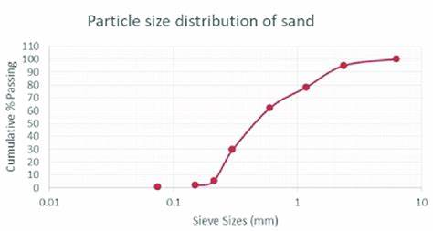

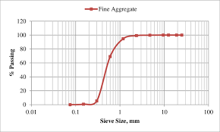

Table 4.2 Crushing strength of concrete made of mix ratio 1:2:4, 1:3 and 1:6
Age of curing | Mix ratio (1:2:4) Average crushing strength FCu (N/mm²) | Mix ratio (1:3) Average crushing strength FCu (N/mm²) | Mix ratio (1:6) Average crushing strength FCu (N/mm²)
7 | 8 | 21 | 18
14 | 9 | 12 | 21
28 | 13 | 19 | 26

Compressive strength test 7, 14 and days of curing for the mixed ratio 1:3
Special  No | Area of the cubes  (Mm²) | Weight (kg) | Density (kg/m³) | Average density | Failure load (KN) | Compressive strength (N/mm²) | Average compressive strength (N/mm²)
1  2  3 | 22500 | 7.100  6.935  7.000 | 2103.70  2054.81  2074.07 | 2077.53 | 250  150  200 | 11.11  6.67  8.88 | 8.87
1  2  3 | 22500 | 7.465  7.510  7.356 | 2211.85  2225.15  2179.56 | 2205.53 | 270  300  260 | 12.00  13.33  11.56 | 12.30
1  2  3 | 22500 | 8.130  8.200  8.256 | 2408.89  2429.63  2446.22 | 2428.24 | 410  415  430 | 18.22  18.44  19.11 | 18.59

Density= $\frac{mass}{volume}$ $=\frac{7.100}{0.003375}$ 2103.70kg/m³
Volume of cube =0.15×0.15 x0.15 =0.003375m³
Compressive Strength $(N/mm)=$ $\frac{failure load}{area}=\frac{250×1000}{22500}=\frac{250,000}{22500}$=11.11
Area of cube =150mm× 150mm× 150mm =22500mm²
Average compressive strength for 7days
ACS = 11.11 + 6.67 +8.88 /3 =26.66/3
= 20.74 N/mm²
Average compressive strength for 14days
ACS =12.00+ 13.33+ 11.56/3 =36.89/3
=12.30 N/mm²
Average compressive strength for 28days
ACS =18.22+18.44+ 19.11/3 =55.77/3
=18.59N/mm²

Table 4.4 Compressive strength of Harding of NO-FINE concrete after 7,14
and 28days of curing for the mix Ratio of 1.6
Age of cube | Specimen  No | Area of the cube (mm) | Weight  (kg) | Density (kg/m³) | Average  Density | Failure Load  (KN) | Compressive  Strength (N/mm²) | Average  Compressive  Strength (N/mm)
7days | 1  2  3 | 22500 | 8.129  8.200  8.220 | 2408.59  2429.63  2435.56 | 2424.59 | 400  412  425 | 17.78  18.31  18.89 | 18.33
14days | 1  2  3 | 22500 | 8.730  8.910  8.529 | 2586.67  2640.00  2527.11 | 2584.59 | 457  500  487 | 20.31  22.22  21.6 | 21.39
28day | 1  2  3 | 22500 | 9.313  9.721  9.370 | 2759.40  2880.29  2776.27 | 2805.33 | 520  650  590 | 23.11  28.89  26.22 | 26.06
Density =mass/volume$\frac{mass}{volume}=\frac{ 8.129}{0.003375}$ = 2408.59kg/m³
Volume of cube = 0.15×0.15×0.15 = 0.003375m³
Compressive strength (N/mm²) = $\frac{failure load}{area}=\frac{400×1000}{22500}$ = 17.78
Area of cube = 150mm×150mm×150mm = 22500mm²
Average compressive strength for 7days
ACS =$\frac{ 17.78+18.31+18.89}{3}$ = 18.33 N/mm²
Average compressive strength for 14days
ACS = $\frac{20.31+22.22+21.64 }{3}$ =21.39 N/mm²
Average compressive strength for 28days
ACS=$\frac{23.11+28.89+26.22 }{3}$ = 26.07N/mm²

Table 4.5: Compressive strength of Harding of Conventional concrete after 7.14 and 28days of curing for the Mix Ratio of 1:2:4
Ages of cubes | Specimen  No | Area of the cube  (mm²) | Weight  (kg) | Density  (kg/mm³) | Average  density | Failure  Load  (KN) | Compressive Strength  (N/mm²) | Average  Compressive  Strength (N/mm²
7days | 1  2  3 | 22500 | 9.238  8.679  8.526 | 2737.19  2571.56  2526.22 | 2611.67 | 165  160  205 | 7.33  7.11  9.11 | 7.85
14days | 1  2  3 | 22500 | 8.822  8.595  8.626 | 2613.93  2546.67  2555.85 | 2571.15 | 181  209  215 | 8.04  9.29  9.56 | 8.96
28days | 1  2  3 | 22500 | 8.594  8.497  8.595 | 2546.37  2517.63  2546.67 | 2536.89 | 298  274  299 | 13.24  12.18  13.29 | 12.90
Density=$\frac{mass}{volume}=\frac{9.238}{0.003375}$ =2737.19kg/m³
Volume of cube= 0.15 x 0.15 x 0.15 =0.003375m³
Compressive strength (N/mm²) =$\frac{failure load}{area}$ =$\frac{165 x1000}{ 22500 }$= $\frac{165,000}{22500}$=7.33
Area of cube 150mm 150mm×150mm =22500mm²
Average compressive strength for 7days
ACS =7.33+ 7.11 +9.11/3 =$\frac{23.55}{3}$=7.85 N/mm²
Average compressive strength for 14days
ACS = 8.04 + 9.28 +$\frac{9.56}{3}$ = 26.89/3=8.96 N/mm²
Average compressive strength for 28days
ACS-13.24+12.18+13.29 3 38.71 12.90N/mm²
DISCUSSION OF RESULTS
Compressive strength test was carried out to evaluate the strength progress of concrete, comprising different mix ratio of 1:3 and 1:6 for no fine concrete while 1:2:4 was used for conventional concrete at the age of 7, 14, 28days respectively. As shown in table (4.5 & 4.6) that the mix ratio gives different result when carrying out the test. From the 28 days testing results of no fine concrete and conventional concrete, the cement aggregate and water cement ratio of 1:3 and 0.5 was chosen as the most suitable mix since it produced the highest compressive strength. Compared to conventional concrete with the mix ratio of (1:2:4). Due to the results acquired, it shows that the conventional concrete has more strength and density than the NO-FINE concrete.
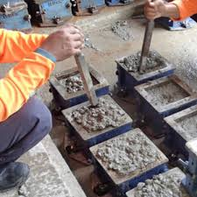 CUBE CASSTING STAGE
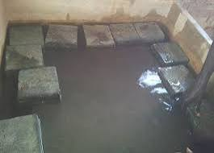 CUBE CURING STAGE
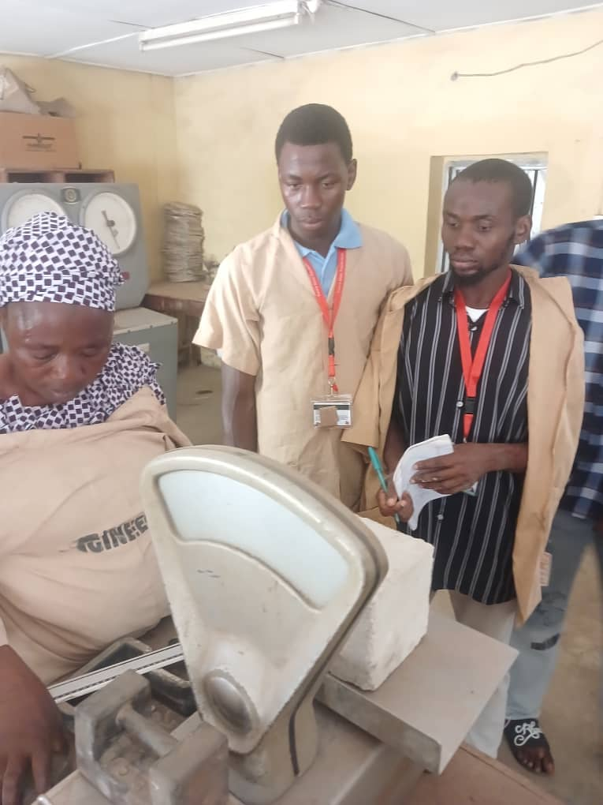
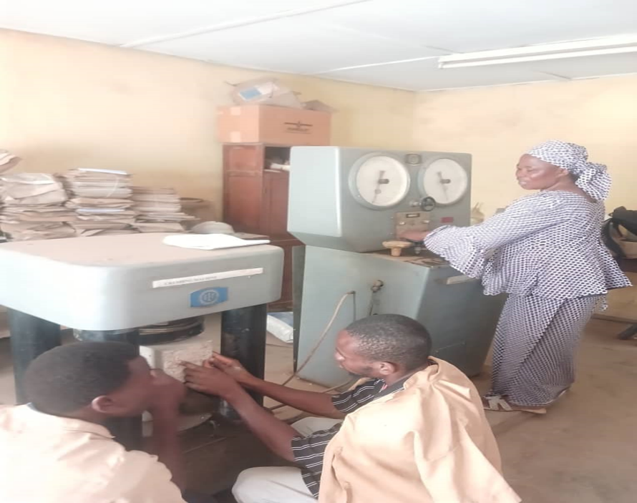

CHAPTER FIVE
5.0 CONCLUSION
Based on the result of the research carried out, the following conclusions may be drawn;
• Mix ratio is a factor to be considered when determining the compressive strength of a concrete.
• From the result of the average compressive strength of concrete for seven days of curing (8kN/mm2), for both concrete made of 1:2:4 mix ratio and 1-3:6 mix ratio, we can deduce that, the concrete strength met the minimum required standard for seven days of curing which is 65% of (15N/mm2 the minimum standard 28days of curing strength).
• From the result of the average compressive strength of concrete for fourteen days of curing (14N/mm2), for both concrete made of 1:2:4 mix ratio and 1:3:6 mix ratio, we can deduce that, the concrete strength met the required standard for fourteen days of curing which is 90% of (15N/mm2 the minimum standard 28days of curing strength).
•From the result of the average compressive strength of concrete for twenty-eight days of curing (17N/mm2), for both concrete made of 1:2:4 mix ratio and 1:3:6 mix ratio, we can deduce that, the concrete strength met the minimum required standard for twenty-eight days of curing which is (12N/mm2).
•With the average compressive strength of concrete at 28 days of curing (13N/mm2), for 1:2:4 mix ratio, we can deduce that 1:2:4 mix ratio can be adopted as a conventional mix design.

4.2 RECOMMENDATION
From the analysis of result and conclusion above, the following are my recommendation
• Strength properties of investigated no-fines concrete are found to be lower than that of conventional concrete but are sufficient enough for structural use.
• For the construction of pervious concrete structure, coarse aggregate of larger sizes should be used.
• The effect of water-cement ratio has greater impact over the strength of no fine concrete, strength of no fine concrete increases with increase in water cement ratio.

REFERENCES
1.Neville, A. M., & Brooks, J. J. (2020). Concrete Technology. Pearson Education.
2.Pope, C. D., et al. (2022). "Investigation of Groundwater for Concrete Use." Journal of Environmental Studies.
3.Mehta, P. K., & Monteiro, P. J. M. (2017). Concrete: Microstructure, Properties, and Materials. McGraw-Hill Education.
4.Obla, K. H., et al. (2023). "Permeable Concrete Properties and Applications." ACI Journal.
5.Abid et al, (2015). On experimental study on Durability Water Absorption Properties of parlous concrete.
6 Assessment of the Flexural Strength of No-Fines Recycled Aggregate Concrete Prisms Patel, D. Jobanputra, and P. Patel Engineering, Technology & Applied Science Research, 2021.
7. A. A. Yasin. Innovation and Research on Investigation of Mechanical and Physical Properties of No-Fines 2015.
8. K. P. Verian, W. Ashraf, and Y. Cao (2018) Properties of Recycled Concrete Aggregate and Their Influence in New Concrete Production.
9. International Journal of Advance Research in Science and Engineering, 2017
A. R. Kalyane et al. Compressive Strength of No-Fines Concrete Compared to Conventional Concrete for Road Pavements.
10. Z. A. Tunio et al. (2019) Effect of Coarse Aggregate Gradation and Water-Cement Ratio on Unit Weight and Compressive Strength of No-Fines Concrete. Engineering, Technology & Applied Science Research, DOI: 10.48084/etasr.2509
11.Influence of Coarse Aggregate Gradation on the Mechanical Properties of Concrete, Part II: No-Fines Vs. Ordinary Concrete
12.A. S. Buller, Z. A. Tunio, F. U. R. Abro, T. Ali, K. A. Jamali. Journal: Engineering, Technology & Applied Science Research, 2019
13 Compressive Strength of No-Fines Concrete.A. R. Kalyane, A. Gujar, A. Jadhav, G. Agrawal, G. Mandora, R. Mahajan.Journal: International Journal of Advance Research in Science and Engineering, 2017
14. A. Malik. Journal: Imperial Journal of Interdisciplinary Research, (2016) An Experimental Study on Properties of No-Fines Concrete
15. M. A. Alam, S. Naz. Journal: International Journal of Informative and Futuristic Research, 2015 Experimental Study on Properties of No-Fine Concrete
16. M. A. B. Kabir, Kh. Md. S. Islam. Conference: 3rd International Conference on Civil Engineering for Sustainable Development, 2016 Performance Study on No-Fines Concrete
17. P. Mounika, K. Srinivas. Journal: International Journal of Engineering and Techniques, (2018) Mechanical Properties of No-Fines Concrete for Pathways
18. S. Ali, S. Kacha. Journal: Engineering, Technology & Applied Science Research, (2021) DOI: 10.48084/etasr.4349: Quality of Recycled Aggregates and Compressive Strength of No-Fines Recycled-Aggregate Concrete.

19. Tensile Behavior of Green Concrete Made of Fine/Coarse Recycled Glass and Recycled Concrete Aggregates. Authors: Sabry Fayed, Ceyhun Aksoylu, Ali Serdar Ecemiş, Emrah Madenci, Yasin Onuralp Özkılıç: Journal: Buildings, 2024: DOI: 10.3390/buildings14092969.

20. International Journal of Civil Engineering and Technology (IJCIET), 2019

