KWARA STATE POLYTECHNIC, ILORIN
INSTITUTE OF TECHNOLOGY
DEPARTMENT CIVIL ENGINEERING

ASSESSMENT OF THE EFFECTS OF SOLID WASTE DUMP SITES ON GROUNDWATER QUALITY IN GANMO/AMOYO TOWN

BY
ALABI SARAH OPEYEMI
HND/23/CEC/FT/0114

SUBMITTED TO:
DEPARTMENT OF CIVIL ENGINEERING,
INSTITUTE OF TECHNOLOGY,
KWARA STATE POLYTECHNIC, ILORIN

IN PARTIAL FULFILMENT OF THE REQUIREMENTS FOR THE AWARD OF HIGHER NATIONAL DIPLOMA (HND) IN CIVIL ENGINEERING

JULY, 2025

CERTIFICATION
This is to certify that this research study was conducted by Alabi Sarah Opeyemi (HND/23/CEC/FT/0114) and had been read and approved as meeting the requirements for the award of Higher National Diploma (HND) in Civil Engineering of the Department of Civil Engineering, Institute of Technology, Kwara State Polytechnic, Ilorin.

______________________________ ______________________
ENGR. DR, E.O IBlWOYE DATE
Project Supervisor

______________________________ ______________________
ENGR. A. NAALLAH DATE
Head of Department

______________________________ ______________________
ENGR. DR. MUJEDU KASALI ADEBAYO DATE
External Examiner

DEDICATION
This project is dedicated to the loving memory of my late parent, whose valves, prayers, and sacrifices laid the foundation for my success.
‌ I also wholeheartedly dedicate it to Barrister Yusuf Taofik Adeniyi who support, guidance and encouragement have played a significant role in my academic journey, your impact will always be remembered

ACKNOWLEDGEMENTS
Frist and foremost, my heartfelt appreciation goes to almighty God for the strength, wisdom and guidance throughout the duration of this work,
I am deeply grateful to my supervisor ENGR. DR, E.O IBlWOYE for his invaluable support, constructive feedback and encouragement throughout every stage of the project. my heartfelt appreciation goes to my late parent, whose, valves, prayer and sacrifices laid the foundation for my success. l would like to express my heartfelt gratitude to my wonderful siblings your constant support, encouragement and sacrifices meant so much to me throughout this journey, your beliefs in me gave me the strength to keep going even when things got tough,
Lastly, my gratitude goes to my amiable lecturer, Engr A.O Saadu, ENGR A Sanni, and everyone who contributed in one way or another, may almighty God reward you all abundantly.

ABSTRACT
This project was executed in order to research and study the sources that contributes to Solid Waste Management in Ilorin West, Nigeria, to access existing waste management practices in Ilorin and also identify the sources that contributes to solid waste, while finding an approach or technology that can help eradicate or manage it and envisage the promotion of a clean & healthy environment in Ilorin West, Nigeria. The method used in the execution of this project is a research design (questionnaire) adopted to collect data from respondents on assessment of solid waste practices in Ilorin metropolis. The instruments (tools) used to analyze, examine and process the data obtained from the various households include; frequency & percentage which was represented by pie-chart. The results of the study show that the solid waste practices in the study area have been observed to be lacking by many households and provision of adequate funds should be made to solve the problem of solid waste management in the metropolis, and it was also discovered that most residents do not have easy access to KWEPA waste bin in their residential areas. It is recommended that Kwara Environmental Protection Agency (KWEPA) should train more people on environmental sanitation and procure more equipment needed to enhance an effective and clean environment.

TABLE OF CONTENTS
TITLE PAGE i

CHAPTER ONE

INTRODUCTION

1.1 Background of the Study
Solid wastes are unwanted or useless solid materials generated from human activities in residential, industrial or commercial areas. Solid wastes also mean any garbage, refuse, sludge from a wastewater treatment plant, or air pollution control facility and other discarded materials including solid, liquid, semi-solid, or contained gaseous material, resulting from industrial, commercial, mining and agricultural operations (Vergara and Tchobanoglous, 2012). Solid waste is any discarded or abandoned material. Solid wastes can be solid, liquid, semi-solid or containerized gaseous material.
Underground water being that part of precipitation that infiltrates through the soil down to the water table. Underground water is mostly contained in aquifers which are water bearing rock made of layers of permeable rock, sand, or gravel through which groundwater flows, containing enough water to supply wells and springs (Greenburg 2005). When rain falls to the ground, some waters flow along the earth's surface to the streams or lakes, while some are used by plants, some are returned back to the atmosphere through leaves of plants via transpiration, some evaporate and return to the atmosphere while some infiltrate into the ground. Underground water is found in the cracks and spaces in the soil, sand and rock. It moves slowly through layers of soil, sand and rock also known as aquifers. According to Edwards (2013), aquifers typically are made of a conglomeration of gravel, sand, stone or fractured rock, like limestone. The speed at which the groundwater flows depends on the size of spaces in the soil or rock and how well the spaces are connected. Saturation zone is the zone at which water completely fills the aquifer. The water table is located above the saturation zone, the water table depth varies due to many factors, it may also rise and fall depending on many factors, heavy rainfall may cause the water table to rise while heavy pumping of the groundwater supplies may cause the water table to fall.
Ravenscroft (2007) has suggested that underground water is polluted by human activities, in areas where material above the aquifer is permeable, pollutants can be easily sunk into the groundwater. Of the global quantity of available freshwater, more than 98% is groundwater stored in pore spaces and fractures of rock strata (Smith 2016). Dumping of refuse affects the groundwater in that biodegradable solids are decomposed and leaches into the soil to reach the groundwater. This is faster when rain falls and wash down the decomposed materials down into the groundwater, although the water gets cleaner as it percolates down the earth surface into various strata of soil, but there are some dissolved solids, metals and salts which will not be removed from the water and thereby reaches the groundwater, and reduces the quality of the groundwater fit for drinking.
Many houses these days do not have proper means of solid waste disposal, it is common in the area of study that people living in the area use open dumping and burning as their means of solid waste disposal. Many landlords face the need to provide a source of water for their homes as water is needed in human being’s daily activities which make some dig wells or boreholes to reach the groundwater without considering certain distances between the well and their dumping sites. Drinking contaminated groundwater causes several diseases, therefore, this study is done to analyze certain samples of water taken from wells near dumping sites and deduce meaningful conclusions on the potability of the water samples analyzed.

1.2 Statement of the Problem
Generation, collection and proper management of solid waste from household, industries, markets, abattoir and shops result in improving the standard of living of the inhabitants. The location of dumpsites closest to the wells and groundwater recharge areas easily release pollutants to these water bodies. With gradual accumulation, pollutants can become harmful to the end users. Therefore, assessment of water quality is an important aspect of water evaluation and the standard of living of the people.

1.3 Aim and Objectives
The aim of this work is to determine the impacts of solid waste on ground water quality used for domestic purposes.
The specific objectives of this work are to:
- Identify wells close to dump sites in Ganmo/Amayo Town
- Determine the physico-chemical characteristics of the water samples taken from the selected wells in the areas of study and compare it WHO and NSDWQ standard
- Determine the correlation between levels of pollutants in selected wells with distances from the dumping site.
- Evaluate the engineering features of the selected wells.
- Recommend best practices for preventing pollution of wells.

1.4 Justification for the Study
Wells located very close to a refuse dumping site are harmful to human health because of the increased level of pollutants and contaminants, which are caused by the solid wastes. Subsequently, there is a need for a better and safer source of water for drinking purposes and other domestic purposes. Accordingly, if the groundwater sources are located at an acceptable distance from the dumping site, it will hugely reduce the health hazards caused by water in the body systems of the people using the water.

1.5 Scope of the Study
The scope of this study covers laboratory analysis and assessment of different wells in relation to municipal solid wastes at Ganmo/Amayo community in Ilorin. The analysis was carried out to examine the characteristics of solid wastes, physico-chemical characteristics of soil at the dumpsites and physicochemical characteristics of the wells within the proximity of the dumpsites.
This study will test for the effects of solid wastes on the quality of groundwater samples using various tests such as tests for chlorides, test for hardness in water, turbidity test, acidity test, alkalinity test, test for suspended solids, test for total solids etc.

1.6 Limitation of the Study
The study determined the effects of dumpsite leachate on the groundwater and surface in the study area. This study is limited to only this particular community (Ganmo and Amoyo) and seven samples (7) as the representative of the community and the parameters measured were limited by financial constraints and time hence the results are limited in revealing the trends over time.

CHAPTER TWO

LITERATURE REVIEW

2.1 Waste
These are unwanted or unusable items, remains, or byproducts, or household garbage, chemical waste, the undigested remainder of food expelled from the body as excrement, used or contaminated water from domestic, industrial, or mining applications.

2.2 Sources of Waste
Sources of waste can be broadly classified into four types: Industrial, Commercial, Domestic, and Agricultural.

2.2.1 Industrial waste
These are the wastes produced by industrial activity which includes any material that is rendered useless during a manufacturing process such as that of factories, industries, mills, and mining operations. Most of the toxic industrial wastes are dumped on waste lands for slow and gradual decomposition. Some industries dump their effluents on barren land, road sides creating a very unhygienic environment for the local population. Some of the effluents have heavy metals which pollute the groundwater through seepage during the monsoon season (US EPA OAR, 2015). Some heavy metals have been found slowly accumulating on land soils. One such most toxic heavy metal is cadmium which is present in traces in some fertilizers. Examples are plastic, glass, etc.

2.2.2 Institutional waste
These are wastes produced from institutions such as schools, hospitals, or prisons. These include wastes not typically found in the households but hazardous waste in circumstances.

2.2.3 Commercial waste
Commercial waste can be defined as any waste generated as a result of carrying out a business, including associated lawn and garden clippings from normal maintenance of the business premises. It also includes rubbish produced by customers i.e., food wrappers and containers. Example: plastic, paper, etc.

2.2.4 Domestic waste
The different household wastes which are collected during household activities like cooking, cleaning, etc. are known as domestic wastes. Examples are leaves, vegetable peels, excreta, etc.

2.2.5 Agricultural waste
Various wastes produced in the agricultural field are known as agricultural wastes. Chemical fertilizers increase soil fertility and give better crop yield in lesser time. Shortly, the land becomes saline, acidic or alkaline and loses fertility. Pesticides and Biocides are toxic chemicals used in crop fields which are not eco-friendly. They enter into crops and then into primary and secondary consumers. Even human beings are affected due to biomagnification. In underdeveloped and developing countries, the poor sanitary conditions aggravate soil pollution (Tietz and Jeff, 2006). The excreta of man and animals, digested sewage sludge used as manure pollute the soil. Several germs present in such wastes contaminate soil, vegetables, and water bodies causing severe health hazards. Examples are cattle waste, weed, husk, etc.

2.2.6 Municipal solid wastes
These are solid wastes from home, offices, stores, schools, hospitals, hotels etc. These domestic solid wastes one usually thrown in municipal garbage collecting cans or on road side open waste lands (Kumar et al, 2016). They are collected by municipality vehicles to certain garbage disposal sites. They are dumped over a large area of land which becomes the breeding ground of flies and rats. Usually, they are not burnt to reduce the volume because burning would cause air pollution which is still more dangerous.

2.2.7 Mining solid wastes
They include mine dust, rock tailing, slack and slag. Open cast mining completely spoils the surrounding soil. Toxic chemicals and metals present in the mining wastes destroy vegetation and produce many deformities in animals and human beings.

2.2.8 Electronic wastes
The latest solid waste that has appeared in the last twenty years commonly known as e-wastes is no less harmful. Irreparable computer and electronic goods. Frequently, more efficient and user-friendly electronic items appear in the market thus discarding the old generation equipment which simply become garbage or solid wastes. Over half of the e-wastes generated in developed countries are exported to developing countries where they ultimately increase the e-garbage proportions (Blau, 2006).

2.2.9 Hospital wastes
Hospitals generate hazardous wastes that contain disinfectants, other harmful chemicals and pathogenic microorganisms. Such wastes require careful treatment and disposal. The use of incinerators is crucial for disposal of hospital wastes.

2.3 Types of Wastes
Common waste is classified into two types: Biodegradable and Non-biodegradable waste. These two kinds of wastes are explained below:

2.3.1 Biodegradable waste
These are the wastes that come from our kitchen and it includes food remains, garden waste, etc. Biodegradable waste is also known as moist waste. This can be composted to obtain manure.
Biodegradable wastes decompose themselves over a period of time depending on the material.

2.3.2 Non-biodegradable waste
These are the wastes which include old newspaper, broken glass pieces, plastics, etc. Nonbiodegradable waste is known as dry waste. Dry wastes can be recycled and can be reused. Nonbiodegradable wastes do not decompose by themselves and hence are major pollutants.

2.4 Solid Waste
Solid waste means any garbage, refuse, sludge from a wastewater treatment plant, water supply treatment plant, or air pollution control facility and other discarded materials including solid, liquid, semi-solid, or contained gaseous material, resulting from industrial, commercial, mining and agricultural operations, and from community activities, but does not include solid or dissolved materials in domestic sewage, or solid or dissolved materials in irrigation return flows or industrial discharges that are point sources from manufacturing plants (Kumar et al, 2016). Examples of solid waste include: waste tires, septage, scrap metal, latex paints, furniture and toys, garbage, appliances and vehicles, oil and antifreeze, empty aerosol cans, paint cans and compressed gas cylinders, construction and demolition debris, asbestos.

2.4.1 Classes of solid wastes
- Household waste is generally classified as municipal waste,
- Industrial waste as hazardous waste, and
- Biomedical waste or hospital waste as infectious waste.
- Hazardous waste
Industrial and hospital waste is considered hazardous as they may contain toxic substances. Certain types of household waste are also hazardous. Hazardous wastes could be highly toxic to humans, animals, and plants; are corrosive, highly inflammable, or explosive; and react when exposed to certain things e.g., gases (Horinko et al, 2016). Household waste that can be categorized as hazardous waste include old batteries, shoe polish, paint tins, old medicines, and medicine bottles. Hospital waste contaminated by chemicals used in hospitals is considered hazardous. These chemicals include formaldehyde and phenols, which are used as disinfectants, and mercury, which is used in thermometers or equipment that measure blood pressure. Hospital waste is generated during the diagnosis, treatment, or immunization of human beings or animals or in research activities in these fields or in the production or testing of biologicals. It may include wastes like sharps, soiled waste, disposables, anatomical waste, cultures, discarded medicines, chemical wastes, etc. These are in the form of disposable syringes, swabs, bandages, body fluids, human excreta, etc. This waste is highly infectious and can be a serious threat to human health if not managed in a scientific and discriminate manner.
- Non-hazardous waste
All waste materials not specifically deemed hazardous under federal law are considered nonhazardous wastes. It includes paper, wood, plastics, glass, metals, and chemicals, as well as other materials generated by industrial, commercial, agricultural, and residential sources. Even though these wastes are not defined as hazardous, improper management of them poses significant risks to the environment and human health (Horinko and Courtin, 2016). Therefore, the handling, transport, and disposal of nonhazardous wastes is regulated by the government, largely at the state and local level. The extent to which a particular waste is deemed non-hazardous depends on both its physical and chemical nature and the source from which it comes.
Some of the types of nonhazardous waste known are the following;
- Agricultural waste: Non-Hazardous components include animal manure, urine, and bedding materials.
- Batteries: These contain heavy metals such as mercury, lead, cadmium, and nickel, that contaminates the environment if batteries are improperly disposed of.
- Construction & demolition debris: Materials generated during the construction, renovation, and demolition of buildings, roads, and bridges.
- Industrial waste: Non-Hazardous waste produced by industries in the country.
- Medical waste: Solid waste generated in the diagnosis, treatment, or immunization of human beings or animals.
- Municipal solid waste Trash or garbage generated by households and commercial institutions consisting of everyday items such as product packaging, grass clippings, furniture, clothing, bottles, food scraps, newspapers, appliances, paint and batteries.
- Scrap tires: Used automotive tires that are destined for disposal.
- Special wastes: Industrial wastes deemed non-hazardous by the Environmental Protection Agency (EPA) pending further study are cement kiln dust, crude oil and natural gas wastes, fossil fuel combustion wastes, and certain mineral processing and mining wastes.

2.5 Effects of Municipal Solid Waste on the Environment
Uncontrolled strong waste dumping exposes urban inhabitants to potential dangers from polluted water especially those living adjoining to dumpsites, unhealthy food sources, air, land, and vegetation contamination. Poor solid waste disposal and handling of wastes leads to environmental degradation, ecosystem destruction and high risks to public health. Such accumulations of solid wastes are a health hazard not only to urban residents but threaten the environment (UNEP, 2005). Environmental problems associated with solid waste range from health hazards, water pollution and soil, offensive odor and repulsive sight. The outcome of this all is degradation of our environmental quality (AbdusSalam et al.,2011).
Most dumpsites are sited within the vicinity of living communities and wetlands. The dumpsites are often not technologically sited for adsorption of toxic substances. Therefore, makes them responsive to discharge pollutants to nearby water bodies and to the air through leachates or dumpsite gases respectively (Kulikowska and Klimiuk, 2008). Many water resources have been earmarked as being hazardous to man as well as other living systems (Moh, 2012).
The highest numbers of the uncontrolled dumping sites are many years old with unmanaged waste disposal techniques. Such dumping sites have significant environmental impacts. Solid waste poses significant life-threatening potential health of the terrestrial, aquatic and aerial environments (Odukoya et al., 2000).

2.6 Challenges of urban solid waste management
Attitudes towards waste management about dumping sites greatly affect the municipal solid waste management system. Municipal solid waste management starting from household waste storage, to waste segregation, recycling, collection frequency, willingness to pay for waste management services, and opposition to sitting of waste treatment and disposal facilities depend on public awareness and participation. Awareness and involvement in the management of the dumping sites has equal significance to the proper solid waste management for health and well-being of the people. This restricts use of community and societal approaches in the management of solid waste management services (Zurbrugg, 2003).

2.7 Impacts of Solid Waste Management
Leachate is toxic to the surface and to groundwater. Contamination of these water sources is detrimental to health. Many communities in less-developed regions rely on untreated surface water and well-water for drinking and other domestic purposes. The potentials of land and water contamination as a result of improper solid waste management concerns many researchers. Despite natures rejuvenating capacity solid wastes lack dilution to absorb or reduce the impact of residues, in waterways and on land. More coordinated effort is needed to protect. Preventive and environmental control is necessary for sustainable solid waste management practice.

2.7.1 Waste Depth
Concentration of constituents in leachate is found in lower parts in the landfills. Surface rocks and the geology of the dumping site determine the solid waste saturation. This is in respect to the breakdown and distribution that take place in the process of waste decomposition. Water seepage from landfills carries chemical toxicants from disintegrating waste material. Waste age and waste depth increases leachate toxicity (Ahmed et al., 2012).

2.7.2 Landfill Age
The duration of time for solid dumping determines waste decomposition in the landfills. The leachate forms in layers and becomes toxic with time (Asadi, 2008). Leachate of recent landfill contains high COD and BOD with gradual subsequent reduction in the lower layers. (Asadi, 2008). Carboncontaining compounds decompose faster than inorganic compounds with age. (Chiang, Chang & Chung, 2001). Inorganic compounds are not so toxic as they are removed through infiltration by rainfall (Chiang et al., 2001). Sulphate reduced to sulphide through infiltration precipitates heavy metals (Adhikari, Khanal & Manandhar, 2013). Leachate quality in the landfills becomes toxic as organic matter therein undergoes stabilization (Adhikari et al., 2013).

2.7.3 Leachate Formation
Municipal solid waste disposal sites have been associated with surface and groundwater pollution. The gradual decomposition of organic substances at the dumping sites needs to be addressed (Zouboulis, 2002). Depositing of solid wastes from any source’s forms leachate within the dump and landfills. This is a resultant of the Physical, chemical and biological processes (Kjeldsenet al., 2002). Physicochemical characteristics of leachate depend on the source of the solid waste materials and volume. The geology, compaction and moisture content play a role in the retention of the contaminants. Water flow and climatic conditions determine leachate toxicity (WHO, 2006). Researchers, such as Kjeldsen et al. (2002) in their research of groundwater contamination ascertain that availability of water is crucial in solid waste decomposition.

2.7.4 Leachate Composition
Municipal leachate is a composite of organic and inorganic components. This is a result of the diverse origin of the deposited solid wastes. In most developing countries with low technology for managing solid waste generation and management the management of solid wastes is still underdeveloped (Tatsi and Zouboulis, 2002). Underdeveloped solid waste management practices pose a threat to the quality and sustainability of soil and water resources. Leachate’s pollution in the municipality is a major limitation to municipal waste management.

2.7.5 Ions
Most municipal solid waste contain cations: Ca²⁺, Mg²⁺, Na⁺, K⁺, Fe²⁺, Mn²⁺ and NH₄⁺ and anions:
HCO₃⁻, Cl⁻ and SO₄² the distribution of ions in leachate toxicity are varied (Christensen et al., 2001)

2.7.6 Trace Elements
Organic and inorganic elements have been detected in solid waste leachates. Mainly are from solid wastes indiscriminately deposited. Typically reported trace elements include Cd, Cr, Cu, Ni, Pb, and Zn; most of them are regulated by water quality standards due to toxicity and half-life (Jorstad, 2006).

2.7.7 Heavy Metals
Many studies have confirmed that the concentrations of heavy metals in leachates are usually very low. However, they may constitute a significant environmental threat, even when very low concentrations (µg/l) are leached into surface water or groundwater resources (Ehring, 1983). Their relative abundance in leachate differs greatly between different dumps and landfills. The typically reported heavy metals in leachates include: Cd, Pb, Zn, Ni, Cr, and Cu.
Although significant quantities of heavy metals are found in solid wastes only a small fraction is leached to the underground water aquifers with time. Their solubility in leachates is influenced by factors such as: Ph, redox potential and ion exchange capacity in the waste mass (Christensen et al., 2001).

2.7.8 Dissolved Organic Matter
Dissolved organic covers a variety of organic products. These range from nonvolatile acids to refractory fulvic and humic-like compounds (Kjeldsen & Christophesen, 2001). Concentrations for this study were phsico-chemical and biological parameters. (Jorstad, 2006). Their concentrations are described by parameters such; Total Dissolved Substances (TDS), Total Suspended Substances (TSS) and Total counts in coliforms (Jorstad, 2006).

2.8 Solid Waste Management
Human and animal activities generate different kinds of wastes. These wastes are generally in solid form, and may cause pollution of land, water, and air unless treated and disposed of (Herbert and Lewis, 2007). The process of collection, transportation, treatment, and disposal can be grouped under solid waste management.
The main sources for solid wastes are domestic, commercial, industrial, municipal, and agricultural wastes. The increase in the quantity of solid waste is due to overpopulation, affluence, and technological advancement.

2.8.1 Components of solid waste management
The municipal solid waste industry has four components: recycling, composting, disposal, and wasteto-energy via incineration. The Waste Management Hierarchy is made up of four levels ordered from most preferred to least preferred methods based on their environmental soundness: Source reduction and reuse; recycling or composting; energy recovery; treatment and disposal. The following steps are involved in solid waste management.

2.8.2 Collection of solid waste
The functional element of collection includes not only the gathering of solid waste and recyclable materials, but also the transport of these materials, after collection, to the location where the collection vehicle is emptied. The collected waste is then separated into hazardous and non-hazardous materials. There are a number of waste separation technologies available such as air stripping, stream stripping, carbon absorption, and precipitation. This location may be a materials processing facility, a transfer station or a landfill disposal site. Collection of solid waste is subdivided into the following;
i) Waste handling and separation, storage and processing at the source
Waste handling and separation involves activities associated with waste management until the waste is placed in storage containers for collection. Handling also encompasses the movement of loaded containers to the point of collection. Separating different types of waste components is an important step in the handling and storage of solid waste at the source of collection.
ii) Segregation and processing and transformation of solid wastes
The types of means and facilities that are now used for the recovery of waste materials that have been separated at the source include curbside collection, drop-off and buy-back centers. The separation and processing of wastes that have been separated at the source and the separation of commingled wastes usually occur at a materials recovery facility, transfer stations, combustion facilities and treatment plants.
iii) Transfer and transport
This element involves two main steps. First, the waste is transferred from a smaller collection vehicle to larger transport equipment. The waste is then transported, usually over long distances, to a processing or disposal site.

2.8.3 Disposal
Today, the disposal of wastes by landfilling or land spreading is the ultimate fate of all solid wastes, whether they are residential wastes collected and transported directly to a landfill site, residual materials from materials recovery facilities (MRFs), residue from the combustion of solid waste, compost, or other substances from various solid waste processing facilities. According to Davidson and Gary (2011), a modern sanitary landfill is not a dump; it is an engineered facility used for disposing of solid wastes on land without creating nuisances or hazards to the public health or safety, such as the problems of insects and the contamination of groundwater. Before the final disposal of the solid wastes, it is processed to recover the usable resources and to improve the efficiency of the solid waste disposal system. The main processing technologies are compaction, incineration, and manual separation. The appropriate solid waste disposal method has to be selected, keeping in view the following objectives: – should be economically viable
- should not create a health hazard
- should not cause adverse environmental effects
- should not result in unpleasant sight, odor, and noise.

2.8.4 Reusing
In recent years, some environmental organizations (for example jiji.com, efritin.com, olx.com), have been gaining popularity for their online reuse networks (Sheftalovich and Zoya, 2016). These networks provide a worldwide online registry of unwanted items that would otherwise be thrown away, for individuals and nonprofits to reuse or recycle. Therefore, this free internet-based service reduces landfill pollution and promotes the gift economy.
The solid wastes can be properly utilized or reused to reap the benefits such as:
- conservation of natural resources
- economic development
- generate many useful products
- employment opportunities
- control of air pollution.

2.8.5 Landfills
Landfills are created by land dumping. Land dumping methods vary, most commonly it involves the mass dumping of waste into a designated area, usually a hole or sidehill. After the waste is dumped, it is then compacted by large machines. When the dumping cell is full, it is then "sealed" with a plastic sheet and covered in several feet of dirt. This is because landfills pose the threat of pollution and can intoxicate ground water. The signs of pollution are effectively masked by disposal companies and it is often hard to see any evidence. Usually, landfills are surrounded by large walls or fences hiding the mounds of debris. Large amounts of chemical odor eliminating agents are sprayed in the air surrounding landfills to hide the evidence of the rotting waste inside the plant (Horinko and Courtin, 2016).

2.8.6 Energy generation
Municipal solid waste (MSW) can be used to generate energy. Several technologies have been developed that make the processing of MSW for energy generation cleaner and more economical than ever before, including landfill gas capture, combustion, pyrolysis, gasification, and plasma arc gasification. While older waste incineration plants emitted a lot of pollutants, recent regulatory changes and new technologies have significantly reduced this concern. The Environmental Protection Agency (EPA) noted these improvements in the year 2003, citing waste-to-energy as a power source "with less environmental impact than almost any other source of electricity".

2.9 Waste Recycling
Recycling of waste products is very important as this process helps in processing waste or used products into useful or new products. Recycling helps in controlling air, water, and land pollution. It also uses less energy. There are a number of items that can be recycled like paper, plastic, glass, etc. Recycling helps in conserving natural resources and also helps in conserving energy. Recycling helps in protecting the environment as it helps in reducing air, water, and soil pollution.

2.10 Sources of Surface Water
Natural springs: In the olden days, one could just drink from a spring but in this modern age, the water must be tested to be sure it is free of chemical toxins and purified of biological organisms. To purify the water without adding anything, ozone is used. Ozone reduces to ordinary oxygen, which is normally suspended in water or released into the atmosphere. It is then bottled to make bottled spring water. If the water is naturally carbonated, then it is sparkling water.
Lakes and rivers: In recent times, these are quite polluted, but they are the source of tap water. Tap water is purified and disinfected, usually with chlorine sometimes fluoride is added.
The ocean: Salty Ocean water can be made drinkable through desalination, filtration or chemically decontamination. This is how many campers get drinkable water when camping. Drinking water from streams without decontaminating it risks giardia and other illnesses. Although ocean water makes up nearly 97 percent of all water on earth, it is not a viable source of potable water unless salt and other impurities are removed. Desalination, the process by which salt is removed from water, is a rapidly growing practice. While salt and other microscopic particles can be removed from water in a variety of ways, the most promising method is through reverse osmosis. This process forces saltwater through filters with microscopic pores that remove salt and other microbes. Reverse osmosis requires large amounts of energy, making it a very expensive process.
Wells: Wells can be either near the surface or they can draw up water from very deep. They need to be tested for purity. But some wells offer pure, drinkable water (bore hole).
Rainwater: Rainwater is usually pure, it may get dirty and contaminated by the roof, gutters or pipes, surface where it is caught and sometimes the storage in which the water is stored contaminates the rainwater.
Ice caps and glacial melting: Of the 3 percent of earth's water considered freshwater, 70 percent of that small amount is currently locked in glaciers and ice caps. In theory, frozen glacial and ice cap water could be melted and used, but the amount of energy needed to melt and transport vast quantities of ice make it economically impractical. Glaciers and ice caps also play vitally important roles in the regulation of earth's climates and global temperatures, making their preservation very important.

2.11 Properties of Water
Water (H₂O) is a polar inorganic compound that at room temperature, it is a tasteless and odorless liquid, which is nearly colorless apart from an inherent hint of blue. It is by far the most studied chemical compound and is described as the "universal solvent" and the "solvent of life". It is the most abundant substance on Earth and the only common substance to exist as a solid, liquid, and gas on the Earth's surface. It is also the third most abundant molecule in the universe. Water molecules form hydrogen bonds with each other and are strongly polar. This polarity allows it to dissociate ions in salts and bond to other polar substances such as alcohols and acids, thus dissolving them. Its hydrogen bonding causes its many unique properties, such as having a solid form less dense than its liquid form, a relatively high boiling point of 100 °C for its molar mass, and a high heat capacity .Water is amphoteric, meaning that it can exhibit properties of an acid. Water is the chemical substance with chemical formula H₂O; one molecule of water has two hydrogen atoms covalently bonded to a single oxygen atom. Water is a tasteless, odorless liquid at ambient temperature and pressure. According to (Braun et al, 1993), liquid water has weak absorption bands at wavelengths of around 750 nm which cause it to appear to have a blue color. This can easily be observed in a water-filled bath or wash-basin whose lining is white. Large ice crystals, as in glaciers, also appear blue.
Unlike other analogous hydrides of the oxygen family, water is primarily a liquid under standard conditions due to hydrogen bonding. The molecules of water are constantly moving in relation to each other, and the hydrogen bonds are continually breaking and reforming at timescales faster than 200 femtoseconds (2×10⁻¹³ seconds) (Richardson et al, 2016). However, these bonds are strong enough to create many of the peculiar properties of water, some of which make it integral to life.
The following are the physical properties of water:
Water, ice, and vapor
Within the Earth's atmosphere and surface, the liquid phase is the most common and is the form that is generally denoted by the word "water". The solid phase of water is known as ice and commonly takes the structure of hard, amalgamated crystals, such as ice cubes, or loosely accumulated granular crystals, like snow. The gaseous phase of water is known as water vapor (or steam). Visible steam and clouds are formed from minute droplets of water suspended in the air.
Water also forms a supercritical fluid. The critical temperature is 647 K and the critical pressure is 22.064 MPa. A likely example of naturally occurring supercritical water is in the hottest parts of deep water hydrothermal vents, in which water is heated to the critical temperature by volcanic plumes and the critical pressure is caused by the weight of the ocean at the extreme depths where the vents are located. This pressure is reached at a depth of about 2200 meters: much less than the mean depth of the ocean (3800 meters). The following are the properties of water in the three possible existing forms (water, vapor, ice).

2.12 Groundwater Supplies
Groundwater exists within the pore spaces and breaks in rocks and dregs underneath the Earth’s surface.
It starts as precipitation or snow. It permeates through the soil profile into the groundwater framework. With time the boring of wells makes its way back to surface streams, oceans, or lakes. Utilized broadly for household, industrial and agrarian purposes, groundwater resources constitute an imperative component of water supply frameworks in many parts of the world. The water source has wide conveyance, inexpensiveness, dependability, and has less chemical and microbial quality than surface water, and requires little or no treatment before use (Morris, 2003).
About half of the populaces of the world’s population rely almost on groundwater for potable water supplies (UNEP, 2010). In Africa, almost 75% of the population depends on groundwater for water supply. In other nations that get minimal precipitation such as Libya, Tunisia, Namibia, and Botswana, groundwater is the single source of potable water (WWAP, 2012)

2.13 Water Quality Standards and Guidelines
Water Quality Standards and Guidelines are primarily aimed at protecting public health and aquatic life. The standards and guidelines are established case wise by each country to regulate the levels of contaminants permitted in their various water sources (Onemano and Otum, 2003). They consist of the water quality criteria to protect users, determine if they are being attained, water body’s designated uses, and anti-degradation policies to protect high-quality water bodies. Water quality degradation has attracted the attention of many organizations such as WHO in efforts to promote a worldwide response to water quality deterioration.
The WHO Guidelines for Drinking-Water Quality (GDWQ) covers the Physical, chemical and microbiological aspects of water quality (WHO, 2006). The guidelines are regularly updated based on scientific research and consultations with various stakeholders and professionals which leads to the periodic release of revised documents (WHO, 2011). The third and fourth editions of the guidelines were published in 2004-2008 and 2011 respectively.
The WHO recommended Guidelines for Drinking-Water Quality are not mandatory limits, although they are intended to form a basis for individual countries to formulate and regulate their national water quality standards and guidelines in the context of local or national environmental, social, economic and cultural conditions. Proper implementation of the WHO guidelines will ensure the safety of drinking water supplies by elimination or reduction to a minimum acceptable concentration of constituents of water known to be hazardous to health (WHO, 2011).
The Guidelines for Drinking-Water Quality are generic and are aimed to protect worldwide public health. The most important stage of implementation of these standards is the conversion and adaptation of the underlying Philosophy, guidance and given numeric values to quality standards defined per country. Unlike in developed countries that have attained higher standards in addressing water quality issues, the situation in Nigeria remains uncertain. However, Nigeria is making efforts to follow the global trends of reducing standard concentration levels through the NEBS and NEMA that have localized the international standards for the Nigerian case.

2.14 Pollution of Groundwater and Surface Water
The vulnerability of groundwater to pollution indicates combinations of geological and hydrological parameters give risks associated with groundwater pollution than other combinations (Dimitriou, 2008). Groundwater aquifers are hydraulically connected to the overlying land surface through interwoven pore fringes. The vulnerability of an aquifer to contamination depends on this. Groundwater that gets water and contamination from the land surface is considered more helpless than groundwater that gets water and contaminants more gradually and in lower quantities.
The quality of groundwater depends on the relative number of contaminants that reach the aquifer, the travel time of contaminants, and the topographical system contaminants-attenuation capacity. The degree of attenuations occurs depends on soil and rock type and type of contaminant and the related action (WHO, 2006).
Any effort to control or prevent surface and groundwater pollution in any area requires adequate proper understanding of such natural intrinsic characteristics of any targeted aquifer in terms of vulnerability to contamination and the background information of the activities in the area in question.

2.15 Potential Health Effects of contaminated surface water flow and groundwater
Land filling is a common globally though, it’s a controlled method of disposing solid wastes on land with the purposes of eliminating public health, environmental hazards and minimizing nuisances without contaminating surface or subsurface water resources. Despite this, many dumping sites are inadequate of lining and precautions in the construction leading to seepage of leachate from the decomposition of the organic wastes (Butt and Ghaffar, 2012: Longe and Balogun, 2010). In such dumping sites, the leachate continues to percolate into the ground and may contaminate groundwater sources (USEPA, 2003: Mor, Ravindra, Dahiya, and Chandra, 2006). Gradual contamination of groundwater resources has a potential risk to the natural environment and to the health of users especially children and elderly people (Mor et al., 2006).
Many water borne diseases such as diarrhoea, typhoid, cholera, paratyphoid, hepatitis, enteric fever, dermatitis, blue baby syndrome can be caused by drinking water that has high nitrates. Benzene, a known component of gasoline, is a human carcinogen (Butt & Iqbal, 2007). The serious health effects of lead such as learning disabilities in children; kidney, nerve, liver problems; and pregnancy risks. The best way to reduce the health risks associated with poor drinking water quality is by preventing contaminants from reaching the ground water is (Butt & Iqbal, 2007).

2.16 Effects of Water Pollutants on Health
Water naturally contains small amounts of broken up substances such as zinc, calcium, magnesium, and indeed pollution like residue, sand, and microbial substances under typical circumstances. These quantities are considered safe for human use; however, when they exceed threshold limits, then the water is polluted (Christensen et al., 2001). Metal ions and their complex exhibit a wide range of toxicity to organisms ranging from sub-lethal to lethal depending upon the time of exposure and the ambient temperature. For example, the heavy metals; Pb, Zn, Mn, Cd, As, Ni and Hg are highly toxic even in low concentrations (Sangarika et al., 2010). Cadmium and lead are significantly hazardous to human health; long term exposure to lead may cause severe disruption of biosynthesis of hemoglobin and/or anemia, damage of kidneys, high blood pressure, brain damage, miscarriages, disruption of nervous system and sperm damage in males. Mercury can be responsive to brain and kidney damage and interference with the nervous system and regeneration of hemoglobin (GSADH, 2005). When these pollutants are indiscriminately dumped in the landfills, the resulting leachate finds ways into the groundwater or is washed into surface water and streams causing water pollution. Zn reaches the water bodies through artificial pathways like by-products of steel production or coal-fired power stations, as well as burning of waste materials (Damodharan, 2013). To a small extent Zn is found through effluents from commercial industries, mining leaching, from fertilizers, and smelting activities. Measured pH values in samples are mere indicators of acidity but not measure of potential activity levels of actual hydrogen ions (H⁺). The pH measurements scale run from 0-14 with 7.0 considered neutral. pH below 7.0 is considered acidic while those above 7.0 considered bases. pH levels are indicators of the health implications of a water source as organisms thrive based on acidity at a given range. Water acidity at any levels when comes into contact with any chemical or metal makes them more noxious (Moh, 2012).
Pathogens and nutrients also contribute to water quality. Pathogens like coliforms are the result of untreated sewage. The coliform bacteria group that originates from the intestinal tract of warm-blooded animals and is an indicator of the bacteriological noxious contamination of domestic water supply. The presence of E. coli in potable water has been attributed to many diseases. On the other hand, Total coliforms may not necessarily be harmful to humans though according to the Environmental Protection Agency (EPA) they are indicators of pathogens that need regular investigation. Coliform level symptoms under the category of gastroenteritis may not be serious for healthy people. However, they can lead to serious complications to people having weak immune systems (Butt & Iqbal, 2007). Escherichia coliforms in drinking water are often reflected through biological indicators of the total coliforms. The Escherichia coliform is an indicator of the presence of pathogens in water. Their presence in drinking water is of concern because of the various diseases they may cause to human beings. Similarly, coliforms have nitrogen carrying capacity of red cells in infants and can cause a condition referred to as methemoglobinemia or blue baby syndrome (Osu and Okoro, 2011).

2.17 Important Terms Relating to Water

2.17.1 Color
The term “color” is used here to mean true color, that is, the color of water from which turbidity has been removed. The term “apparent color” includes not only color due to substances in solution, but also that due to suspended matter. Apparent color is determined on the original sample without filtration or centrifugation. In some highly colored industrial wastewaters color is contributed principally by colloidal or suspended material. In such cases both true color and apparent color should be determined. Color in water may result from the presence of naturally occurring metallic ions (iron and manganese), humus and peat materials, plankton, weeds, and industrial wastes (Davis et al, 2011). Color is removed to make a water suitable for general and industrial applications. Colored industrial wastewaters may require color removal before discharge into watercourses.

2.17.2 Turbidity
Turbidity is a measure of the degree to which the water loses its transparency due to the presence of suspended particulates. The more total suspended solids in the water, the murkier it seems and the higher the turbidity (Bas Wijnen et al, 2014). The measurement of turbidity is a key test of water quality. Turbidity in open water may be caused by growth of microorganisms. Human activities that disturb land, such as construction, mining and agriculture, can lead to high sediment levels entering water bodies during rain storms due to storm water runoff. Areas prone to high bank erosion rates as well as urbanized areas also contribute large amounts of turbidity to nearby waters, through storm water pollution from paved surfaces such as roads, bridges and parking lots. Some industries such as quarrying, mining and coal recovery can generate very high levels of turbidity from colloidal rock particles.
In drinking water, the higher the turbidity level, the higher the risk that people may develop gastrointestinal diseases (Mann et al ,2017). This is especially problematic for immune compromised people, because contaminants like viruses or bacteria can become attached to the suspended solids the suspended solids interfere with water disinfection with chlorine because the particles act as shields for the virus and bacteria. Similarly, suspended solids can protect bacteria from ultraviolet (UV) sterilization of water.

2.17.3 Total solids
The term "total solids" refers to matter suspended or dissolved in water or wastewater, and is related to both specific conductance and turbidity. Total solids (also referred to as total residue) is the term used for material left in a container after evaporation and drying of a water sample. Total Solids includes both total suspended solid, the portion of total solids retained by a filter and total dissolved solids, the portion that passes through a filter (American Public Health Association, 1998).
Total solids can be measured by evaporating a water sample in a weighted dish, and then drying the residue in an oven at 103°C to 105° C. The increase in weight of the dish represents the total solids. Instead of total solids, laboratories often measure total suspended solids and/or total dissolved solids.

2.17.4 Total suspended solids (TSS)
Total Suspended Solids (TSS) are solids in water that can be trapped by a filter. TSS can include a wide variety of material, such as silt, decaying plant or animal matter, industrial wastes, and sewage. High concentrations of suspended solids can cause many problems for stream health and aquatic life. High TSS can block light from reaching submerged vegetation and as the amount of light passing through the water is reduced, photosynthesis slows down. Moreover, reduced rates of photosynthesis cause less dissolved oxygen to be released into the water by plants, if light is completely blocked from bottom dwelling plants, the plants will stop producing oxygen and will die. Decomposition of plants will cause bacteria to use up even more oxygen from the water, low dissolved oxygen can lead to fish kill, high TSS can also cause an increase in surface water temperature, because the suspended particles absorb heat from sunlight. This can cause dissolved oxygen levels to fall even further (because warmer waters can hold less dissolved oxygen), and can harm aquatic life in many other ways, as discussed in the temperature section.
The decrease in water clarity caused by TSS can affect the ability of fish to see and catch food. Suspended sediment can also clog fish gills, reduce growth rates, decrease resistance to disease, and prevent egg and larval development. When suspended solids settle to the bottom of a water body, they can smother the eggs of fish and aquatic insects, as well as suffocate newly hatched insect larvae. Settling sediments can fill in spaces between rocks which could have been used by aquatic organisms for homes (Mitchell and Stapp, 1992).
High TSS in a water body can often mean higher concentrations of bacteria, nutrients, pesticides, and metals in the water. These pollutants may attach to sediment particles on the land and be carried into water bodies with storm water. In the water, the pollutants may be released from the sediment or travel farther downstream (Federal Interagency Stream Restoration Working Group, 1998).
High TSS can cause problems for industrial use, because the solids may clog or scour pipes and machinery.
Factors affecting total suspended solids
- High flow rates
The flow rate of the water body is a primary factor in TSS concentrations. Fast running water can carry more particles and larger-sized sediment. Heavy rains can pick up sand, silt, clay, and organic particles (such as leaves, soil, tire particles) from the land and carry it to surface water. A change in flow rate can also affect TSS; if the speed or direction of the water current increases, particulate matter from bottom sediments may be suspended once more.
(Watershed’s website).
- Soil erosion
Soil erosion is caused by disturbance of a land surface. Soil erosion can be caused by Building and Road Construction, Forest Fires, Logging, and Mining. The eroded soil particles can be carried by storm water to surface water. This will increase the TSS of the water body.

- Urban runoff
During storm events, soil particles and debris from streets and industrial, commercial, and residential areas can be washed into streams. Because of the large amount of pavement in urban areas, infiltration is decreased, velocity increases, and natural settling areas have been removed.
Sediment is carried through storm drains directly to creeks and rivers.
- Wastewater and septic system effluent
The effluent from Wastewater Treatment Plants (WWTPs) can add suspended solids to a stream. The wastewater from our houses contains food residue, human waste, and other solid material that we put down our drains. Most of the solids are removed from the water at the WWTPs before being discharged to the stream, but treatment cannot eliminate everything.
- Decaying plants and animals
As plants and animals’ decay, suspended organic particles are released and can contribute to the TSS concentration.
- Bottom-feeding fish
Bottom-feeding fish (such as carp) can stir up sediments as they remove vegetation. These sediments can contribute to TSS.

2.17.5 Total dissolved solids (TDS)
Total Dissolved Solids (TDS) are solids in water that can pass through a filter (usually with a pore size of 0.45 micrometers). TDS is a measure of the amount of material dissolved in water. This material can include carbonate, bicarbonate, chloride, sulfate, phosphate, nitrate, calcium, magnesium, sodium, organic ions, and other ions. A certain level of these ions in water is necessary for aquatic life. Changes in TDS concentrations can be harmful because the density of the water determines the flow of water into and out of an organism's cells (Mitchell and Stapp, 1992). However, if TDS concentrations are too high or too low, the growth of many aquatic lives can be limited, and death may occur.
Similar to TSS, high concentrations of TDS may also reduce water clarity, contribute to a decrease in photosynthesis, combine with toxic compounds and heavy metals, and lead to an increase in water temperature.
TDS is used to estimate the quality of drinking water, because it represents the number of ions in the water. Water with high TDS often has a bad taste and/or high-water hardness, and could result in a laxative effect.
Factors affecting total dissolved solids
- Geology and soil in the watershed
Some rock and soil release ions very easily when water flows over them; for example, if acidic water flows over rocks containing calcite (CaCO₃), such as calcareous shales, calcium (Ca²⁺) and carbonate (CO₃²⁻) ions will dissolve into the water. Therefore, TDS will increase. However, some rocks, such as quartz-rich granite, are very resistant to dissolution, and don’t dissolve easily when water flows over them. TDS of waters draining areas where the geology only consists of granite or other resistant rocks will be low (unless other factors are involved).
- Urban runoff
During storm events, pollutants such as salts from streets, fertilizers from lawns, and other material can be washed into streams and rivers. Because of the large amount of pavement in urban areas, natural settling areas have been removed, and dissolved solids are carried through storm drains to creeks and rivers.
- Fertilizer runoff
Fertilizer can dissolve in storm water and be carried to surface water during storms, and contribute to TDS.
- Wastewater and septic system effluent
The effluent from Wastewater Treatment Plants (WWTPs) adds dissolved solids to a stream. The wastewater from our houses contains both suspended and dissolved solids that we put down our drain. Most of the suspended solids are removed from the water at the WWTPs before being discharged to the stream, but WWTPs only remove some of the TDS. Important components of the TDS load from WWTPs include phosphorus, nitrogen, and organic matter.
- Soil erosion
Soil erosion is caused by disturbance of a land surface. Soil erosion can be caused by Building and Road Construction, Forest Fires, Logging, and Mining. The eroded soil particles may contain soluble components that can dissolve and be carried by storm water to surface water.
This will increase the TDS of the water body.
- Decaying plants and animals
As plants and animals’ decay, dissolved organic particles are released and can contribute to the TDS concentration.

2.17.6 Dissolved Oxygen
Dissolved oxygen (DO) is a relative measure of the amount of oxygen (O₂) dissolved in water. Oxygen gets into the water by diffusion from the atmosphere, aeration of the water as it tumbles over rocks and waterfalls, and as a product of photosynthesis. The oxygen content of water will decrease when there is an increase in nutrients and organic materials from industrial wastewater, sewage discharges, and runoff from the land (Whitney King, 2011). Excessive plant and algae growth and decay in response to increasing nutrients in waterways can significantly affect the amount of dissolved oxygen available (Chiya and Izum, 1995). Dissolved oxygen (DO) is one of the most important indicators of water quality. It is essential for the survival of fish and other aquatic organisms. Oxygen dissolves in surface water due to the aerating action of winds. Oxygen is also introduced into the water as a byproduct of aquatic plant photosynthesis. Dissolved oxygen refers to the level of free, non-compound oxygen present in water or other liquids. It is an important parameter in assessing water quality because of its influence on the organisms living within a body of water. In limnology (the study of lakes), dissolved oxygen is an essential factor second only to water itself. A dissolved oxygen level that is too high or too low can harm aquatic life and affect water quality.

CHAPTER THREE

MATERIAL AND METHODS

3.1 Study Area

3.1.1 Location of the Study Area
This research work was carried out at Ganmo/Amayo community in the Ifelodun Local Government Area of Kwara state, Nigeria. Ganmo/Amayo which is located on latitude 7°26’ 39’’ N and longitude 3° 54’ 57’’ E is one of the largest communities in Ifelodun.
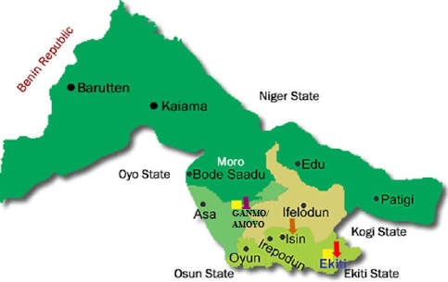
Figure 3.1: Map Showing Ganmo/Amayo in Ifelodun Local Government Area

3.1.2 Climatic Condition of the Study Area
Ilorin has a tropical and dry climate with a lengthy wet season and relatively constant temperatures throughout the course of the year. The climate of the study areas is tropically wet and dry, with the wet season from mid-March to October and dry period from November to March through August sees somewhat of a lull in precipitation. This lull nearly divides the wet season into two different seasons. During the dry period, Ilorin experiences the typical West African harmattan. The mean total rainfall for Ilorin is 1420.06mm falling in approximately 109 days. Rainfall peaks in June and September. The mean maximum temperature is 26.46 C and the relative humidity is 74.55%.

3.1.3 Soil and Drainage Pattern
The common type of drainage available in Ganmo/Amayo area is open channel, the residents of Ganmo/Amayo dispose their waste inside the drainage when it is raining which often leads to incessant erosion and flooding. Some dispose of their waste in stream course

3.1.4 Population
Ganmo/Amayo community is experiencing rapid population growth and expansion of urban Physical infrastructure. The community is located in Ifelodun Local Government. Ifelodun has a population of 306,795, (NBS, 2006) making it densely populated and having the highest residents in the state. According to Planning Authority of Ifelodun Local Government (2015), Google Earth (2017) and ground truthing (2017) the total number of residential buildings in the study area at the period of carrying out this research was 20,915. The community is largely occupied by students and staff of the University of Ilorin and The Polytechnic Ilorin as well as other local occupants.

3.1.5 Economic and Environmental Activities
Ganmo/Amayo is manifesting some of the indicators of environmental poverty such as housing congestion, traffic congestion, poor drainage and sewage system, indiscriminate discharge of liquid and solid waste, environmental pollution, inadequate social facilities and over-utilization of existing infrastructural facilities. There has been a lot of informal physical development in Ganmo/Amayo; some houses that were hitherto residential have been converted to commercial uses, places that were originally earmarked as setback are used for shops and stores.
The major economic activity of this area is trading which include road side trading, selling of wares in shops, transport services, boarding for students etc.

3.1.6 Sources of Waste Generation in Ganmo/Amayo
The percentage of solid waste generated from residential area is about 33.73%, commercial 30.77%, industrial, 1.77%, religion and institutional accounted for 13.02% and 20.71% respectively The types of solid waste generated by the institution in Ganmo/Amayo are basically paper, nylon of pure water and biscuit while the industrial waste in include; paper, nylon, metal, plastic and the like. The level of waste being generated in Ganmo/Amayo is a challenge because of the lack of waste management policy and governance.
There are various modes of waste storage/disposal in Ganmo/Amayo, among these are metal bin which accounted for 46.15%, the plastic bin is about 31.96%, basket and carton takes 10.65% and 3.55% respectively. Others modes include burning waste in the ground which takes about 7.69% of the total. One of the reasons why plastic bin and metal dustbin take the largest percentage of solid waste storage in Ganmo/Amayo, this is because it serves as a convenient means of storing waste before disposal, it is pollution free and enhances the clean environment
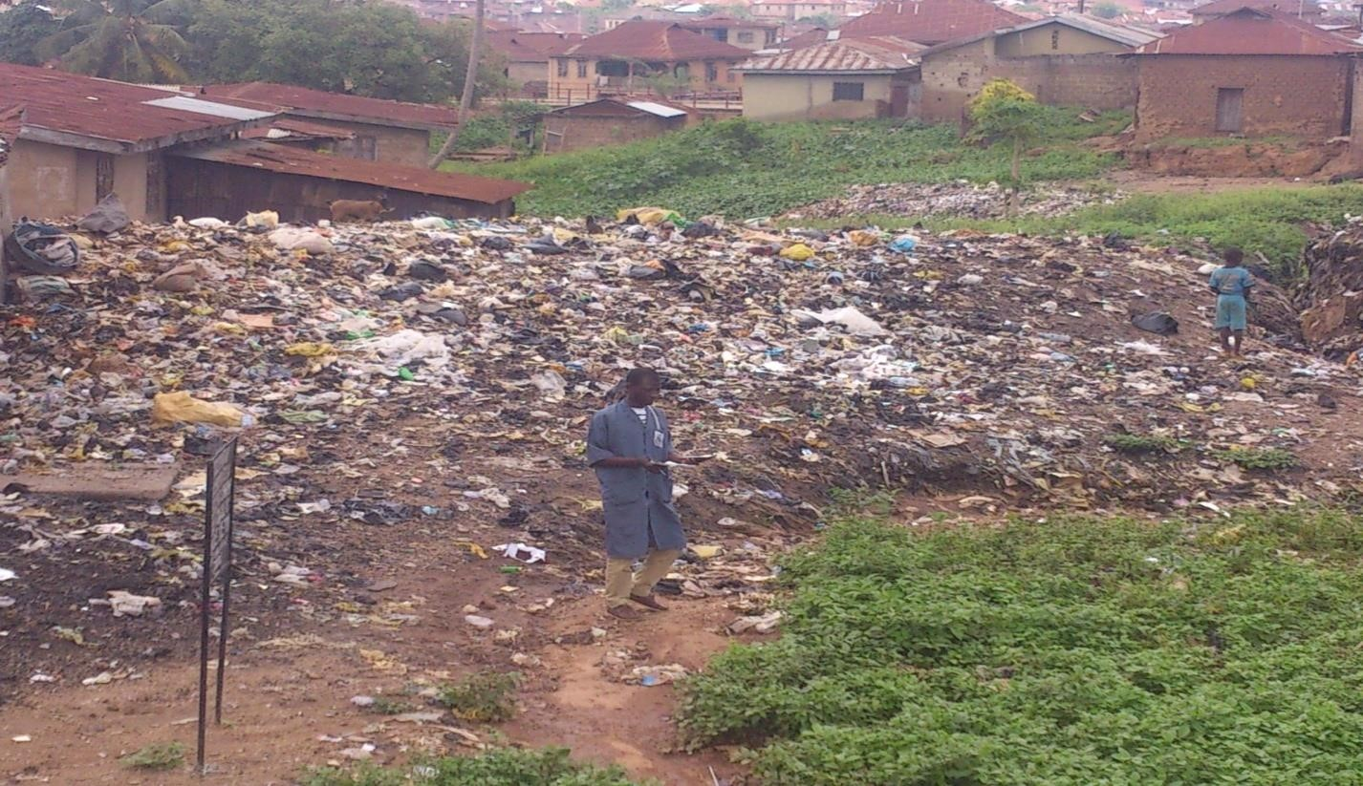
Plate 3.2: Elewure Dumpsite at Ganmo primary school

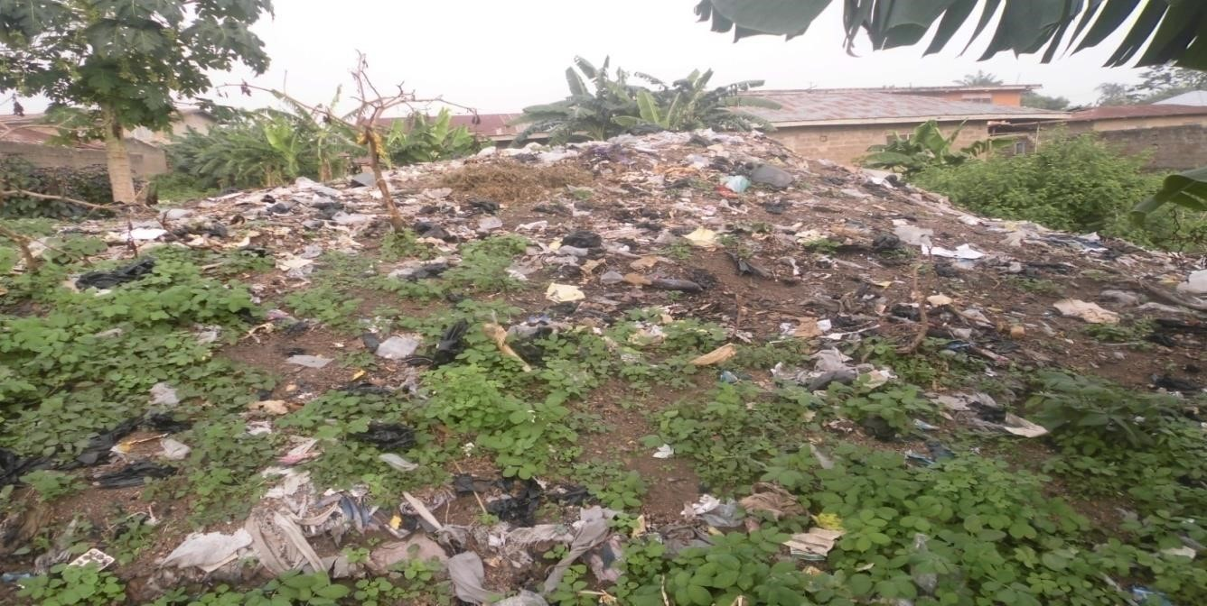
Plate 3.3: Dumpsite at Winners chapel church in Amoyo
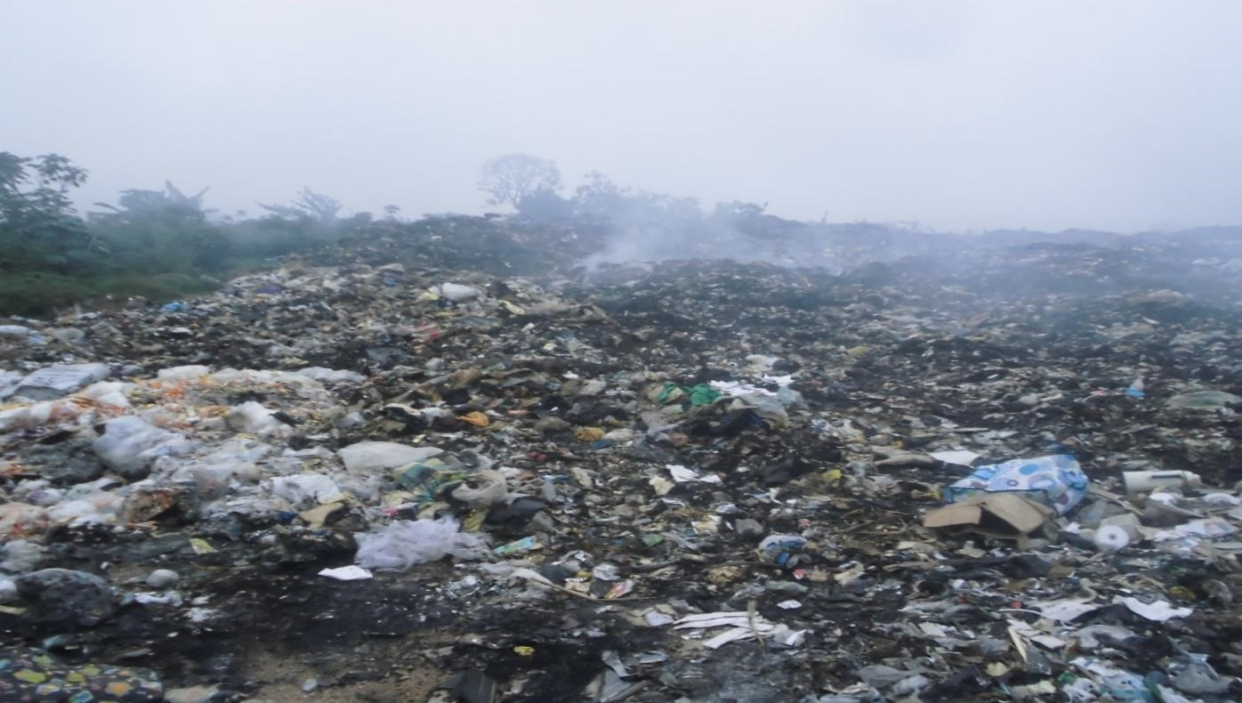
Plate 3.4: Ganmo last bus-stop in Kwara State.
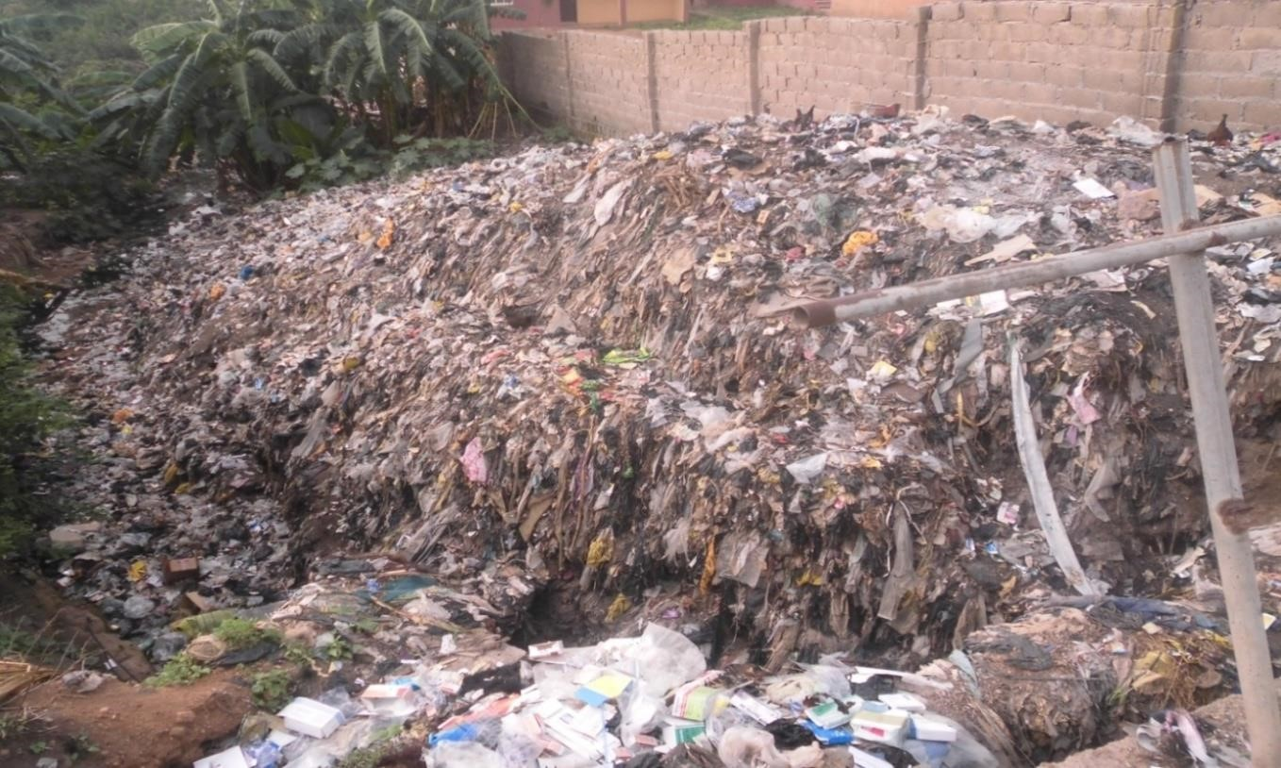
Plate 3.5: Dumpsite at Redemption Road opposite Amoyo Primary School

3.1.7 Geology and Hydrology
The main lithology of the rock unit includes the amphibolites, migmatite gneisses, granites and pegmatites. Other important rock units are the schists, made up of biotite schist, quartzite schist talktremolite schist, and the muscovite schists. The topography of the Ilorin is characterized by undulating terrain with general elevation between 180 m and 210 m above sea level, and is drained by rivers Omi, among others. Occurrence of groundwater is dependent on the extent of weathered units and development of secondary porosity, e.g. fractures, faults, joints.
Consequently, the weathered aquifers are generally discontinuous, with groundwater occurrences in localized disconnected phreatic weathered regolith aquifers, essentially under unconfined to semi-confined conditions.

3.2 Research Design
This study used a Descriptive Research Design. Descriptive research design is used to investigate the background of a research problem and get the required information needed to carry out further research. It is used in multiple ways by different organizations, and especially when getting the required information about their target audience. Descriptive research design is cheap, easy and effective to conduct (Creswell (2002). The descriptive research design enables the experimenter to gather information, epitomize and interpret them for the purposes of clarification (Orodho, 2004).

3.3 Sampling Procedure and Size
Initial reconnaissance survey was conducted within the study area. Two (2) dumping sites were found with a total of sixteen (16) wells and one (1) stream where wastes are being dumped. The wells close to the dumping site and the stream were purposely selected both upstream and downstream. The stream was equally sampled alongside with the wells. This sampling method was selected because of its flexibility and so as to get different samples with respect to their distance to the dumping site. The area so selected was chosen due to regular use of these water sources for domestic purposes.
A total of six (6) wells and one (1) borehole were selected (with the borehole being the control point) at equidistance both upstream and downstream (Figure 2). The water sample were collected at an average depth of 3.7m.
The choices of the sampling points were determined by the direction of flow and their proximity by the dumping site and the dumping stream and nearness to the surface leachate flow from the dumping site. The samples were collected from the wells in the morning and the evening time because some of the parameters of water changes with respect to time of the day.
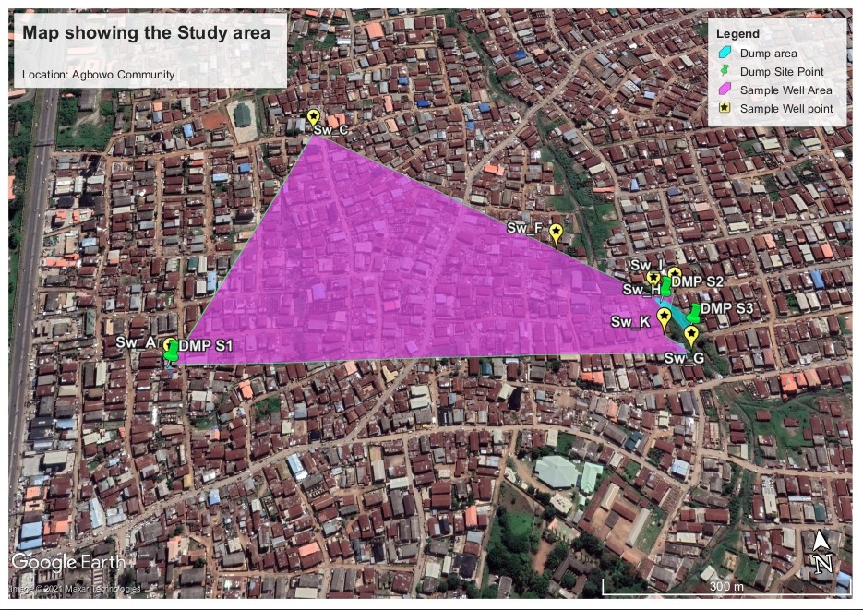
Figure 3.2: Map showing the Sampling wells and the dumpsite

3.4 Sampling Methods and Procedure
The sampled water was collected in 1-liter plastic water bottles. The accuracy of the microbiological, physical and chemical characteristics of water samples is affected to some extent by the method of sampling and storage. In collecting samples for chemical and physical tests, sample bottles were rinsed several times with distilled water and then rinsed with the sampled water at the sites. Each sample were immediately close, air tightened and then put in a container for transfer to department of Public Health laboratory in UCH for analysis.
The wells and dumping site locations were determined using iPhone GPS locator. A tape rule was used in measuring the distances between the dump site and wells in conjunction with a smart measuring device. Graduated tape with an attached weight was used to measure the depth of the wells.
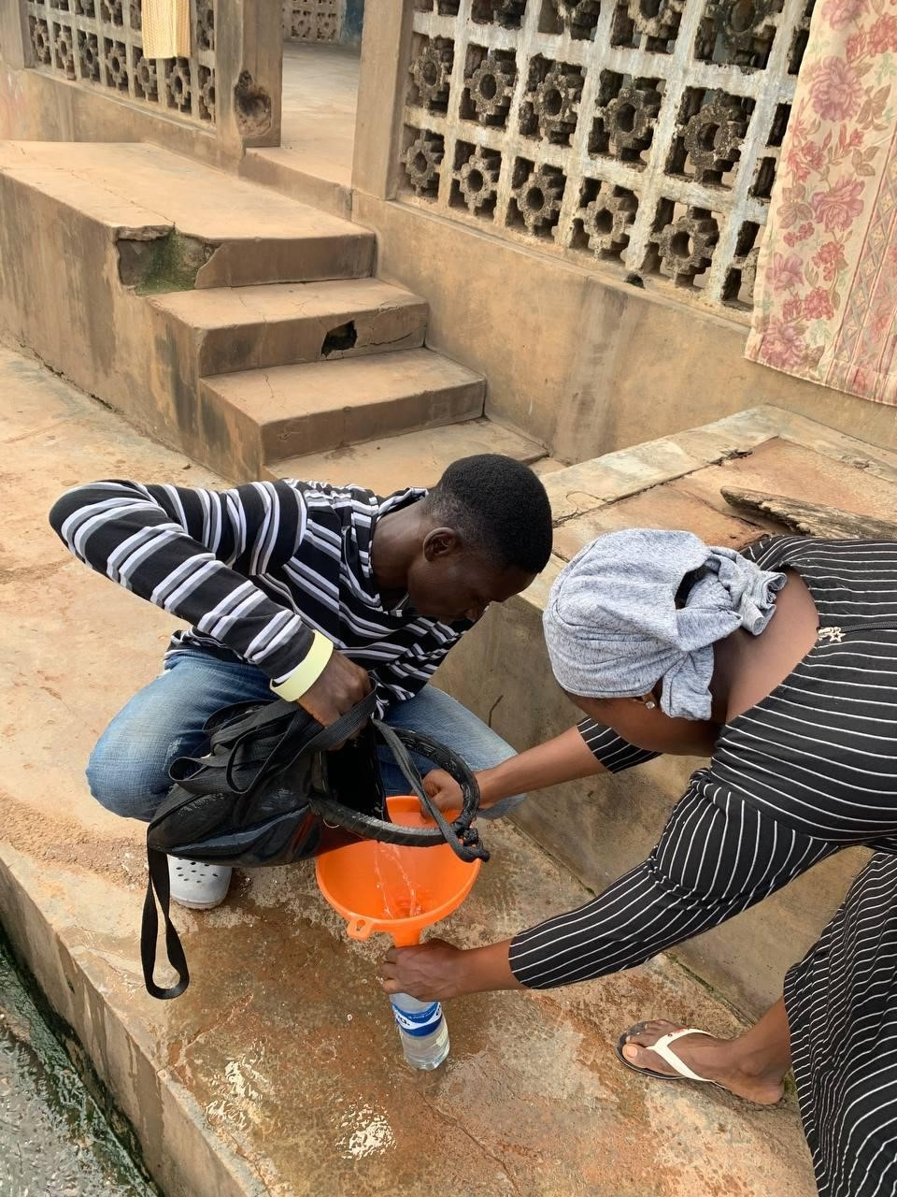
Plate 3.2: Collection of Sample

3.5 Method of Analysis
The following tests were carried out to determine the initial and final concentrations of various water quality parameters. The tests include; PH test, Turbidity test, Conductivity test, Total Dissolves Solids test, Total alkalinity test, Total Hardness test, Calcium Hardness test, test for Chloride, test for Nitrate, test for Iron, test for Lead, Total Coliform test, E.Coli test present in the water sample.

3.6 Data Analysis and Presentation Method
Data on the level of pollutants in the wells was analyzed using descriptive statistics to obtain means. Correlation analysis was performed through cross- tabulations to determine the relationship between the level of pollutants in wells as compared to the materials used in construction of the well, the depth of well and the distances between the wells and the dumping sites. The Data was analyzed using Statistical Package for Social Sciences (SPSS) computer software version 16, PSPP and Microsoft Excel Package

CHAPTER FOUR

RESULTS AND DISCUSSION

4.1 Preamble
The study investigated the effects of solid waste dump sites on groundwater quality in Ganmo/Amoyo town. This chapter present the results of the physical, chemical and bacteriological tests on well water samples carried out in this project research. This chapter contains three sections. The first section describes the levels of pollutants in the wells and compares them to the recommended standards by WHO and NSDWQ. The second section is on the results of correlations analyses between levels of pollutants and distance from the dumpsite and the final section is on the results of correlations analyses between levels of pollutants and depth of the well.

4.2 Levels of pollutants in the wells and stream water as compared to guidelines provided by KEBS for portable water

4.2.1 Appearance
All the samples collected from each well location are clear with no despicable appearance. There is no milky or cloudy appearance which could be as a result of colloids and fine clay.

4.2.2 pH
The ground water pH was measured as shown in Table 4.1. The results in Table 4.2 shows that the pH in well water ranged from 6.51 to 7.45 having a mean of 6.99. Four Samples were acidic while three samples were alkaline. The mean pH during the study was within the guidelines and in acceptable range as NSDWQ and WHO (6.5 – 8.5).

Table 4.1: Descriptive Statistics of the pH showing mean pH and Standard deviation of measured values
 | N | Mean | Std Dev | Minimum | Maximum
PH | 7 | 6.99 | .35 | 6.51 | 7.45
Valid (N) | 9

Table 4.2: Results of Physical, Chemical, Bacteriological and Soil Analysis of Sample
Parameters | Ganmo | Amoyo | NSDWQ | WHO
PHYSICAL PARAMETERS
PH | 6.36 | 6.53 | 6.5 – 8.5 | 6.5 – 8.5
Turbidity (NTU) | 6.5 | 7.5 | 5 | 5
Electrical Conductivity (μs/cm) | 946 | 1711 | 1000 | 1000
Appearance | Clear | Clear | Clear | Clear
Total Dissolved Solids
(mg/l) | 264.0 | 276.0 | 500 | 500
CHEMICAL
PARAMETERS
Total Alkalinity (mg/l) | 82 | 91 | 200 | 200
Total hardness (mg/l) | 140 | 124 | 150 | 200
Calcium Hardness
(mg/l) | 119 | 93 | 75 | 100
Chloride (mg/l) | 61 | 68 | 250 | 250
Nitrate (mg/l) | 2.96 | 3.18 | 50 | 50
Iron (Fe) (mg/l) | 0.003 | 0.002 | 0.3 | 0.3
Lead (Pb) (mg/l) | 0.00 | 0.00 | 0.01 | 0.01
BACTERIOLOGICAL
ANALYSIS
Total Coliform (MPN) | 952 | 720 | 10 | 10
E.Coli (MPN) | 723 | 509 | 0 | 0
SOIL ANALYSIS | Ganmo | Amoyo | EPA | EPA
Aluminium (mg/kg) | 56.5 | 62.0 | 10,000 to 300,000 | 10,000 to 300,000 mg Al kg-1
Lead (mg/kg) | 68.0 | 73.0 | 400 ppm | 400 ppm
Arsenic (mg/kg) | 0.00 | 0.00 | 40 | 40
Copper (mg/kg) | 64.5 | 62.0 | 2 – 50 mg | 2 – 50 mg
Chromium (mg/kg) | 72.0 | 68.0 | 50 µg/L | 50 µg/L
Zinc (mg/kg) | 15.0 | 18.0 | 10-300 mg/kg | 10-300 mg/kg
Mercury (mg/kg) | 0.00 | 0.00 | 72 ppm | 72 ppm
Cobalt (mg/kg) | 28.0 | 32.0 | 750 mg/kg | 750 mg/kg
Iron (mg/kg) | 76.5 | 80.0 | 20,000 to 550,000 mg/kg | 20,000 to 550,000 mg/kg
Manganese (mg/kg) | 41.5 | 32.0 | 20 to 40 ppm (mg/kg) | 20 to 40 ppm (mg/kg)
Other Parameters
Distance to Dump Site
(m) | 4.21 | 13.32
Depth of Well (m) | 8.19 | 7.36
Covered | Yes | Yes | Yes | Yes
Wall Lining | Unlined | Lined | Lined | Lined

4.2.3 Electrical Conductivity of Water
Conductivity measures the water’s ability to conduct electricity. It is the opposite of resistance. Pure, distilled water is a poor conductor of electricity. When salts and other inorganic chemicals dissolve in water, they break into tiny, electrically charged particles called ions. Ions increase the water’s ability to conduct electricity. Common ions in water that conduct electrical current include sodium, chloride, calcium, and magnesium The electrical conductivity of the well sample as compared to NSDWQ and WHO guidelines is presented in the table 4.2. The results in Table 4.2 indicate that Ganmo and Amoyo is within NSDWQ and WHO Standard. Amoyo Sampling points had relatively high electrical conductivity than the permissible level. This is likely because Amoyo was located at dry dump site implying less inorganic dissolved solids like nitrate, sulphate and phosphate anions or cations like sodium, magnesium and iron.

4.2.4 Turbidity
The turbidity of the well samples depend on the amount of suspended solid matters. The result in the Table 4.2 below indicate that the turbidity values for the water samples fall within NSDWQ and WHO standard. The maximum limit of 5 NTU by NSDWQ was satisfied by all the samples. This is due to minimal contamination by clay, silt, organic matter and planktons.

4.2.4 Total Dissolved Solids
Total dissolved solids (TDS) is due to the inorganic salts and small amounts of organic matter present in solution in water. The principal constituents are usually calcium, magnesium, sodium, and potassium cations and carbonate, hydrogencarbonate, chloride, sulfate, and nitrate anions.
The range of total dissolved solids of the water samples is between 264mg/l and 276mg/l. The two samples location meet NSDWQ and WHO standard of 500mg/l. The presence of dissolved solids in water may affect its taste but the two samples has a good taste because theyfall within the NSDWQ and WHO standard.

4.2.5 Total Alkalinity
The Alkalinity in the water will help keep the water's pH stabilized. The result for the total Alkalinity is shown in the Table 4.2 shown above. The range of the well samples is 63 – 102mg/l. All the well samples meet the standard of 200mg/l by NSDWQ and WHO.

4.2.6 Total Hardness
Total hardness is the sum of the calcium and magnesium concentrations in water sample. The range of values for the water sample is 140 for Ganmo and 124 for Amoyo all falls within NSDWQ (150mg/l) and WHO (200mg/l) NSDWQ and WHO standard.

4.2.7 Calcium Hardness
Drinking water with high calcium hardness is not known to have any adverse health effects. In fact, there are health benefits associated with hard water, as both calcium and magnesium are important dietary requirements. Calcium also improves the taste of the water. The limit set by WHO (100mg/l) is based on water aesthetics and not a health guideline. All the samples fall short of WHO and NSDWQ standards of 100mg/l and 75mg/l respectively. Calcium mostly get into the water by leachate action of the dumpsite.

4.2.8 Chloride
Chloride concentrations in well water range from 45mg/l to 82mg/l , hence satisfying WHO and NSDWQ limits of 250mg/l for potable water.

4.2.9 Dissolved Nitrates
The results in table 4.2 show that all the sampling points of the well recorded lower dissolved nitrate levels (ranging from 2.32 – 5.1mg/L) of dissolved nitrates than the recommended NSDWQ and WHO guidelines of 50mg/l

4.2.10 Iron (Fe)
The WHO and NSDWQ permissible level of iron (0.3 mg/l) is not exceeded in all wells. Iron levels range from 0.002 to 0.015mg/l in the sampled wells.

4.2.11 Lead (Pb)
No lead concentration was detected in the water sample. This shows that the sample is from any lead poisoning.

4.2.12 Total Coliform
The results of bacteriological analysis of well water from the Agbowo community showed that all the wells were contaminated with coliform sand other bacteria as indicated in Table 4.2. The levels of Total coliforms counts in sampled wells were very high all exceeding 350mg/l as compared to the NSDWQ guidelines of 10/100ml.
These high counts might have arisen due to the poor level of hygiene and sanitation observed in this community. Wells in this area are constantly exposed to contamination from human activities. Also, the layout of the houses is not well planned such that the distances between wells and septic tanks and even refuse dumps are very minimal. These high parameters are of great concern to public health since the water from these wells is consumed by people without treatment (Adekunle et al., 2007). The presence of coliform in water is an indication of feacal contamination and has been associated with waterborne epidemic (Mackenzie et al., 1995). Any water source used for drinking or cleaning purposes should not contain any organism of fecal origin (Akeredolu, 1991).

4.2.12 E.coli Count in the Sampled Wells
The levels of E.Coli in sampled wells were very high all exceeding 150mg/l as compared to the NSDWQ guidelines of nil/100ml as indicated in Figure 4.12. This is very dangerous to human health. Therefore residents may be at risk of suffering from water borne illnesses after consumption of this water without treatment

4.3 The Correlation between Levels of Pollutants in Sampled Wells with respect to Distances between the Wells and the Dumpsite

4.3.1 Correlation between Physical Parameters in Sampled well and Distance from Dumpsite
The session investigated whether the levels of pollutants in wells differed with respect to the distance from the dumping site. Correlation analyses were done to ascertain whether significant relationships existed between the levels of pollutants and distance from the dumpsite.
Table 4.3 summarizes the Pearson’s correlations between the Physical parameters in the sample wells and the distances of the sampling points from the dumpsite. The results show that there is a strong positive correlation between pH and the distance to the dumpsite (r= .653. P = .112), there is a weak positive correlation between Turbidity and the distance to the dumpsite (r= .271. P = .557), there is a very weak positive correlation between Conductivity and the distance to the dumpsite (r= .051. P = .914), and a strong correlation between TSD and the distance to the dumpsite (r= .453, P = .308).
This implies that as the distance to the dumpsite increases, these parameters also increases.

Table 4.3: The Correlation between Physical Parameters in Sampled Wells with respect to Distances between the Wells and the Dumpsite
 |  | Distance to Dump Site (m)
PH | Pearson Correlation | .653
PH | Sig. (2-tailed) | .112
Turbidity (NTU) | Pearson Correlation | .271
Turbidity (NTU) | Sig. (2-tailed) | .557
Conductivity(μs/cm) | Pearson Correlation | .051
Conductivity(μs/cm) | Sig. (2-tailed) | .914
Total Dissolved Solids (mg/l) | Pearson Correlation | .452
Total Dissolved Solids (mg/l) | Sig. (2-tailed) | .308

4.3.2 Correlation between Chemical Parameters in Sampled wells and Distance from Dumpsite
Table 4.4 summarizes the Pearson’s correlations between the chemical parameters in the sample wells and the distances of the sampling points from the dumpsite. The results show that there is a strong negative correlation between total alkalinity and the distance to the dumpsite (r= -.333. P = .466), there is a small negative correlation between total hardness and the distance to the dumpsite (r= -.214. P = .645), there is a negative correlation between Calcium hardness and the distance to the dumpsite (r= .424 P = .343), there is a positive correlation between chloride and the distance to the dumpsite (r= .151 P = .756), there is a strong positive correlation between dissolved nitrates and the distance to the dumpsite (r= .634 P = .126), and a strong correlation between Iron and the distance to the dumpsite (r= .718, P = .069). Negative correlations implies that as the distance from the sample well to the dumpsite increases, the parameter measured decreases. Likewise, positive correlations implies that as the distance from the sample well to the dumpsite increases, the parameter measured increases.
Table 4.4: The Correlation between Chemical Parameters in Sampled Wells with respect to Distances between the Wells and the Dumpsite
 |  | Distance to Dump Site (m)
Total Alkalinity (mg/l) | Pearson Correlation | -.333
Total Alkalinity (mg/l) | Sig. (2-tailed) | .466
Total hardness (mg/l) | Pearson Correlation | -.214
Total hardness (mg/l) | Sig. (2-tailed) | .645
Calcium Hardness (mg/l) | Pearson Correlation | -.424
Calcium Hardness (mg/l) | Sig. (2-tailed) | .343
Chloride (mg/l) | Pearson Correlation | .151
Chloride (mg/l) | Sig. (2-tailed) | .746
Nitrate (mg/l) | Pearson Correlation | .634
Nitrate (mg/l) | Sig. (2-tailed) | .126
Iron (mg/l) | Pearson Correlation | .718
Iron (mg/l) | Sig. (2-tailed) | .069

4.3.3 Correlation between Bacteriological Parameters in Sampled wells and Distance from Dumpsite
Table 4.5 summarizes the Pearson’s correlations between the bacteriological parameters in the sample wells and the distances of the sampling points from the dumpsite. The results show that there is a strong negative correlation between total coliform and the distance to the dumpsite (r= -.695. P = .083), and there is a strong negative correlation between E. Coli and the distance to the dumpsite (r= -.816. P = .025). As the distance to the dumpsite increases, the total coliforms and E. Coli reduces.
Table 4.5: The Correlation between Bacteriological Parameters in Sampled Wells with respect to Distances between the Wells and the Dumpsite
 |  | Distance to Dump Site (m)
Total Coliform MPN | Pearson Correlation | -.695
E. Coli_MPN | Pearson Correlation | -.816

4.4 The Correlation between Levels of Pollutants in Sampled Wells with respect to the depth of the wells

4.4.1 Correlation between Physical Parameters in Sample Water and depth of the wells
The session investigated whether the levels of pollutants in wells differed with respect to the depth of the wells. Correlation analyses were done to ascertain whether significant relationships existed between the levels of pollutants and depth of the wells
Table 4.6 summarizes the Pearson’s correlations between the Physical parameters in the sample wells and the depth of the sampled wells. The results show that there is a strong positive correlation between pH and the depth of the sampled well(r= .554. P = .197), there is a small positive correlation between Turbidity and the depth of the wells(r= .143. P = .760), there is a very weak negative correlation between Conductivity and depth of the sampled well (r= -.125. P = .789), and a strong correlation between TSD and the depth of the sampled well (r= .529, P = .222).

Table 4.6: The Correlation between Physical Parameters in Sampled Wells with respect to the depth of the wells
 |  | Distance to Dump Site (m)
PH | Pearson Correlation | .554
PH | Sig. (2-tailed) | .197
Turbidity (NTU) | Pearson Correlation | .143
Turbidity (NTU) | Sig. (2-tailed) | .760
Conductivity(μs/cm) | Pearson Correlation | -.125
Conductivity(μs/cm) | Sig. (2-tailed) | .789
Total Dissolved Solids (mg/l) | Pearson Correlation | .529
Total Dissolved Solids (mg/l) | Sig. (2-tailed) | .222

4.4.2 Correlation between chemical parameters in Sample Water and depth of the wells
Table 4.7 summarizes the Pearson’s correlations between the chemical parameters in the sample wells and the depth of the sampled wells. The results show that there is a negative correlation between total alkalinity and the depth of the sampled well(r= -.234. P = .613), there is a negative correlation between total hardness and the depth of the wells(r= -.275. P = .551, there is a very moderately negative correlation between calcium hardness and depth of the sampled well (r= -.456. P = .304), there is a very strong positive correlation between dissolved nitrates and depth of the sampled well (r= .514. P = .238), there is a very weak positive correlation between chloride and depth of the sampled well (r= .049. P = .918), and a strong correlation between Iron and the depth of the sampled well (r= .676, P = .095).

Table 4.7: The Correlation between Chemical Parameters in Sampled Wells with respect to the depth of the wells
 |  | Depth_of_Well
Total_Alkalinity | Pearson Correlation | -.234
Total_Alkalinity | Sig. (2-tailed) | .613
Total_hardness | Pearson Correlation | -.275
Total_hardness | Sig. (2-tailed) | .551
Calcium_Hardness | Pearson Correlation | -.456
Calcium_Hardness | Sig. (2-tailed) | .304
Chloride | Pearson Correlation | .049
Chloride | Sig. (2-tailed) | .918
Nitrate | Pearson Correlation | .514
Nitrate | Sig. (2-tailed) | .238
Iron_Fe | Pearson Correlation | .676
Iron_Fe | Sig. (2-tailed) | .095

4.4.3 Correlation between Bacteriological Parameters in Sampled wells and the depth of Well Samples
Table 4.8 summarizes the Pearson’s correlations between the bacteriological parameters in the sample wells and the depth of the sampled well. The results show that there is a strong negative correlation between total coliform and the depth of well sample(r= -.697. P = .082), and there is a strong negative correlation between E. Coli and the depth of the sampled well (r= -.807. P = .028). As the depth of the sampled well increases, the total coliforms and E. Coli reduces.

Table 4.8: The Correlation between Bacteriological Parameters in Sampled Wells with respect to the depth of the wells
 |  | Depth_of_Well_m
Total_Coliform_MPN | Pearson Correlation | -.697
Total_Coliform_MPN | Sig. (2-tailed) | .082
Coli_MPN | Pearson Correlation | -.807
Coli_MPN | Sig. (2-tailed) | .028

CHAPTER FIVE

CONCLUSION AND RECOMMENDATIONS

5.1 Conclusion
In this study, various statistical techniques were used to evaluate quality and variation in physical, chemical and microbial parameters of well-water (underground water) in Ganmo and Amayo in relation to their proximity to solid waste dump site. The results have shown that leachates from Solid waste dumpsite owing to proximity to well-water impact on physico-chemical properties such as nitrate, Ammonia, chloride, Sodium, Magnesium, Electrical Conductivitiy, Total dissolved solids, Salinity, water hardness, and microbial qualities of the well-water. Precipitation also contributes significantly to the migration of coliforms from various sources to the underground water.
The Physical parameters measured show that other than the pH and turbidity, all other concentration values exceeded the NSDWQ guidelines for drinking water. The presence of high load of bacteria in well samples mean that leachate is altering the water quality of water in the vicinity of the dumpsite. Bacteriological concentration of water from all sampling points exceeded the NSDWQ standards. Hence the water in the vicinity of the dumpsite presents significant threat to public health. Any use of this water especially for domestic purposes should be disallowed as its use will lead to waterborne diseases such as cholera and typhoid.
There is therefore a need for biogeochemistry assessment of hydrologic environment before considering siting a well in any location. The results suggest that the minimum standard distance between solid waste dumpsite and well water will vary with different hydrologic environments

5.2 Recommendations
The following recommendations are made at the end of the study;
    - To maintain and sustain portable water which is free from bacteriological and chemical contaminants, there is need to consider solid waste disposal and management, in term of sorting of waste, disposal method used and siting of disposal site.
    - Formulation of policies and guidelines by ministry of water resources on digging of wells for domestic use in areas of high aquifer levels, boreholes should be an alternative for the provision of potable water in such areas.
    - Further research on the safe distance between the dumping site and the sources of portable water should be done so as to reduce leachate pollution from the dumping site
    - To reduce waste, reuse, waste avoidance and waste recovery, public awareness campaigns and sensitisation should be done.
    - Nigeria ministry of water resources should come up with mechanism to improve the quantity and quality of the water supply to reduce direct reliance on the surface water source and wells.

REFERENCES
Abdus-Salam, N., Ibrahim, M. S. & Fatoyinbo, F. T. (2011). Dumpsites In Lokoja, Nigeria: A Silent Pollution Zone For Underground Water. Waste Management and Bio resource Technology, 1, 21-30.
Adhikari, B., Khanal, S. N., & Manandhar, D. R. (2013). Study of landfill leachate and waste composition of different landfill of Nepal. Journal of Science Engineering and Technology, 9(11), 1521.
Ahmed, F. N., Lan, C. Q. (2012). Treatment of landfill leachate using membrane bioreactors: a review. Desalination, 287, 41-54
Akan, J.C., Abdulrahman, F.I., Sodipo, O.A., Ochanya.A.E and Askira, Y.K (2010): Heavy metals in sediments from river Ngada, Maiduguri Metropolis, Borno state, Nigeria. Journal of Environmental Chemistry and Ecotoxicology Vol. 2((9), pp.131-140
Allen, A.R. (2001) Containment landfills: The myth of sustainability. J. Eng. Geol., 60, 3-19
Al-Weher, M. (2008). Levels of heavy metal Cd, Cu and Zn in three fish species collected from the Northern Jordan Valley. Jordan Journal of Biological Sciences; 1: 41-46.
Asadi, M. (2008). Investigation of heavy metals concentration in landfill leachate and reduction of different coagulants. The 7th international conference on Environmental Engineering (pp. 484488). Vilnius: Faculty of Environmental Engineering, Vilnius Gediminas Technical University.
APHA.(1992). Standard Methods for the Examination of Water and Wastewater. American Public Health Association, USA
Barcelona,M.J., Gibb,J.P., Helfrich,J.A., & Garske,E.E. (1985). Practical Guide for Ground-Water Sampling. Illinois State Water Survey.
Barrett, A., Lawlor, J. (1995). The Economics of Waste Management in Ireland. Economic and Social Research Institute, Dublin. 129pp
Borosova, D.; Mocak, J.; Beinrohr, E. and Miskovic, P. (2002). Validation and quality assurance of arsenic determination in urine by GFAAS after toluene extraction. Polish Journal of Environmental Studies; 11: 617-623.
Butt, I., & Ghaffar, A. (2012). Ground Water Quality Assessment near Mehmood Boti Dumping site, Lahore, Pakistan. Asian Journal of Social Sciences & Humanities, 1(2), 13-24.
Butt, I., &Iqbal, A. (2007). Solid waste management and associated environmental issues in Lahore. Pakistan geographical review. Azian Journal of social science and humanities, 62(1), 45-50.
Calvo,F.,Moreno,B.,Zamorano,M., & Szanto,M. (2005). Environmental Diagnosis Methodology for Municipal Waste Dumping sites. Waste Management, 25, 768- 779.
Chiang, L., Chang, J, C. (2001). Electrochemical oxidation combined with Physical- chemical pretreatment processes for the treatment of refectory landfill leachate. Environ EngSci, 18 (6), 369-378.
Christensen, T.h., Kjeldsen, P., Bjerg,P.L.,Jensen, D.L., Christensen, J.B., Baun, A., Albrechtsen,H-J., & Heron, G. (2001). Biogeochemistry of dumping site leachate plumes. Applied Geochemistry, 16, 659-718.
Creswell J.W. (2002). Research Design: Qualitative, Quantitative and Mixed Research Methods Approaches. 2nd ed. Thousand Oaks, C.A: Sage.
Damodharan, U (2013). Bioaccumulation of heavy metals in contaminated river water - Uppanar, Cuddalore South East Coast of India. htt//.dx.doi.org/10.5772/5334.
Dimitriou, E. (2008). Groundwater risk assessment at a heavily industrialized catchment and the associated impacts on a peri-urban wetland. Journal of Environmental Management, 88 (2008) 526-538.
Douglas, T. (1992). Patterns of land, water and air pollution by waste. In: Newson, M. (Ed.) Managing the Human Impact on the Natural Environment John Wiley & Sons, 150-171
Fahmy, G.H and Fathi, A.A (2011). Limnological studies on the Wetlnad Lake, Al-Asfar, with special references to heavy metal accumulation by fish. American Journal of Environmental sciences 7(6): 515-524
Gakungu N. K, Gitau A. N. (2012). Solid Waste Management In Kenya: A Case Study Of Public Technical Training Institutions ICASTOR. Journal of Engineering Vol. 5, No. 3, Nairobi GSADH, Government of South Australia, Department of Health, Wastewater Management section. (2005). Reed bed Systems. St. Adelide, South Australia 5000.
Jorstad, L. B. (2006). Analyses of variation in inorganic contaminant concentration and distribution in a landfill leachate plume: Astrolabe Park, Sydney, Australia. Unpublished PHD thesis. University of New South Wales, Australia.
Henry, R. K., Yongsheng, Z. and Jun, D. (2006). Municipal solid waste management challenges in developing countries - Kenyan case study. Waste Management, (26): 92-100.
Khateeb, M.A. (2013). Landfill leachate impact on groundwater quality report. Institute of water and environmental science solid and hazardous waste management.
Kjeldsen, P. and ChristoPhersen, M. (2001). Composition of leachate from old landfills in Denmark. Waste Manage. Res., 19, 249-256.
Kulikowska, D., & Klimiuk, E. (2008). The effect of dumping site age on municipal leachate composition. Bioresource Technology, 99(13), 5981-5985.
Martin, M. (2000). Globalization, Development, and Municipal Solid Waste Management in Third World Cities, Mexico.
Meenakshi, P. (2005). Elements of Environmental Science and Engineering, Prentice Hall of India Private limited, India.
Moh, S. (2012). Field Investigation of Groundwater Contamination from Solid Waste Dumping site in Malang, Indonesia. International Journal of Civil & Environmental Engineering, 12(02), 74-81.
Mohammed, S. (2011). Effect of refuse dumps on ground water quality. Advances in Applied Science Research, 2(6), 595-599.
Mor, S., Ravindra K., Dahiya, R.P. & Chandra, A. (2006). Leachate characterization and assessment of groundwater pollution near municipal solid waste dumping site. Environmental Monitoring and Assessment, 118(1-3), 435-456.
Morris, B.L. (2003). Groundwater and its susceptibility to degradation: a global assessment of the problem and options for management. Early warning and assessment report series, RS. 03-3. Kenya, UNEP.
Mugenda, A.G. (2003). Research Methods: Quantitative and qualitative approaches. African Centre of Technology, Nairobi.
Muiruri, J.M., Nyambaka, H.N. and Nawiri, M.P. (2013). Heavy metals in water and tilapia fish from Athi -Galana-Sabaki tributaries, Kenya. International Food Research Journal,20(2): 891 - 896
Mwamburi, J. (2009). Trace metal concentration in water and sediments of satellite lakes within Lake Victoria (Kenya) basin. Lakes and Reservoirs: Research and Management 2009 14: 203-219
Nyandwaro, E. O. (2017). The Impacts Of Solid Waste On Ground And Surface Water Quality In Kisii Municipality, Kenya
Ochieng, E.Z., Lalah, J.O and Wandiga, S.O. (2007). Analysis of heavy metals in water and surface sediments in five Rift Valley lakes in Kenya for Assessment of recent increase in anthropogenic activities. Bull. Environ. Contam. Toxicol. (2007) 79: 570 -576
Ochieng, E.Z., Lalah, J.O and Wandiga, S.O. (2008). Water quality and trace metal distribution in a pristine lake in the lake Basin in Kenya. Bull. Environ. Contam. Toxicol. (2008) 80: 362 - 366
Odukoya, O.O., Bamgbose, O. & Arowolo, T.A. (2000). Heavy metals in topsoil of Abeokuta dumpsites. Global Journal of Pure Apllied Sciences,7, 467-472
Ohwoghere-Asuma, O. and Aweto, K.E. (2013). Leachate Characterization and Assessment of Groundwater and Surface Water Qualities near Municipal Solid Waste Dump Site in Effurun, Delta State, Nigeria. Journal of Environment and Earth Science, 3(9).
Olatunji, O.S and Osibanjo, O. (2012). Determination of selected heavy metals in inlandfresh water of lower River Niger drainage in North Central Nigeria. African Journal of Environmental Science and Technology 6(10): 403 - 408
Onemano, J.I. and Otun, J.A. (2003). Problems on water quality standards and monitoring in Nigeria: Towards the millennium development goals. 29th WEDC International Conference, Abuja, Nigeria.
Orodho, A.J. and Kombo D.K. (2002).Research Methods.Nairobi : Kenyatta University, Institute of Open Learning.
Orodho J.A. (2004). Techniques of Writing research proposals and Reports in Education and Social Sciences. Masola Publishers, Nairobi.
Osu, C. and Okoro, I. A. (2011). Comperative Evaluation of Physical and Chemical Parameters of Sewage from selected areas in Port-Harcourt Metropolis, Riverd State Nigeria. Continental Journal. Water, Air and Soil Pollution 2(1): 1-14.
Oyekunle, J. A. O., Ogunfowokan, A. O., Olutona, G. O., Atoyebi, A. O. & Lawal, A. (2013). Speciation Study of Heavy Metals in Water and Sediments from Asunle River of the Obafemi Awolowo University, Ile-Ife, Nigeria. International Journal of Environmental Protection, 3(3), 6-16.
Radojovenic, M. and Bashkin, V. (2006). Practical environmental analysis. Cambridge, UK: The Royal Society of Chemistry. Pp 254.
Sangarika, N., Debyani, S., Rajani, K. S. (2010) heavy metal Pollution in a Tropical Lagoon Chilika Lake, Orissa, India. Continental J. Water, Air and Soil Pollution. 1:6-12
Schubeler Peter, (1996). Conceptual Framework for Municipal Solid Waste Management in LowIncome Countries. Urban Management Program Working Paper No. 9,Nairobi Kenya.
Sharma, R. and Pervez, S. (2003). Enrichment and exposure of particulate lead in a traffic environment in India. Environ. Geochem.Health, 25: 297 - 306
Smith, K. (2010). What is Solid Waste Management? Retrieved from (http://www.wisegreek.com/ what-issolid-waste-managment.htm)
Tatsi, A. and Zouboulis, A. (2002). A field investigation of the quantity and quality of leachate from a municipal solid waste landfill in a Mediterranean climate (Thessaloniki, Greece). Advances in Environmental Research, 6(3): 207-219
UNEP. (2002). African Environment Outlook. Past, Present and Future Perspectives, UNEP, United Kingdom
UNEP. (2005). Solid Waste Management, United Nations Environment Programme -Division of Technology, Industry, and Economics
USEPA, (2003).Community water and wastewater treatment.Office of research and development, Washington, DC, USEPA.
Ustohalova,V., Ricken,T., & Widmann, R. (2006). Estimation of dumping site emission lifespan using process oriented modeling. Waste Management, 26(4), 442-450, page 12-31.
WWAP (World Water Assessment Programme). (2012). The United Nations World Water Development Report 4: Managing Water under Uncertainty and Risk. Paris, UNESCO.
Yamane, T. (1987). Statistics: An introductory analysis. Taro Yamane Harper and Row, New York,247254.
WHO. (2006). Protecting Groundwater for Health: Managing the Quality of Drinking- water Sources. Edited by O. Schmoll, G. Howard, J. Chilton and I. Chorus. ISBN:1843390795. Published by IWA Publishing, London, UK.
WHO. (2011). Guidelines for drinking water quality. 4th ed. WHO Press Geneva, Switzerland.541p.Available at www.who.int/ ater_sanitation_health/ publications.
WWAP (World Water Assessment Programme). (2012). The United Nations World Water Development Report 4: Managing Water under Uncertainty and Risk. Paris, UNESCO.
Zerbock, O. (2003). Urban Solid Waste Management: Waste Reduction in Developing Nations: for the Requirements of Field Engineering, in the Developing World School of Forest.
Zaporozec, A. (2002). Groundwater contamination inventory: a methodological guide. IHP-VI Series on groundwater. No 2. UNESCO. Paris
Zurbrug, C. (2003). Solid Waste Management in Developing Countries. Retrieved fromhttp://www.eawag.ch/organisation/abteilungen/sandec/publikationens-swm/downloadss-wm/basicsofSWM.pdf

