PREVENTION AND MANAGEMENT OF MALARIA IN UNDER-FIVE CHILDREN
(A CASE STUDY OF ILORIN METROPOLIS, KWARA STATE)

BY

ND/23/STA/FT/0016
JIMOH IQMAT OYINDAMOLA

A RESEARCH PROJECT SUBMITTED TO THE DEPARTMENT OF STATISTICS
INSTITUTE OF APPLIED SCIENCES (IAS) KWARA STATE POLYTECHNIC, ILORIN.
IN PARTIAL FULFILLMENT OF THE REQUIREMENT FOR THE AWARD OF NATIONAL DIPLOMA (ND) IN STATISTICS

JUNE, 2025

CERTIFICATION
This project work has been read, supervised and approved as meeting the requirement for the award of the National Diploma (ND) in Statistics Department, Institute of Applied Science (IAS), Kwara state polytechnic, Ilorin, Kwara state.

-------------------------- ----------------------------
Mr. Safihi F.G Date
Project supervisor

---------------------------- ------------------------------
Mrs. Elepo T.A Date
Head of Department

------------------------------ ------------------------------
External Examiner Date

DEDICATION
This project is dedicated to the Almighty God and to my parent (Mr. and Mrs. Jimoh)

ACKNOWLEDGEMENT
I give praise and adoration to the creator of heaven and earth; the Alpha and Omega for His blessings and grace bestow upon me. And for the wisdom, knowledge and understanding given to me to be able to accomplish this task.

My profound gratitude goes to my supervisor, the person of Mr. Safihi F.G for his assistance and guidance during this research work, and also to our able head of department Mrs. Elepo T.A.

My special gratitude goes to my parent (Mr. and Mrs. Jimoh) who has been there for me throughout the process of everything in my life.

And to every one of my lecturers that taught me everything I know in statistics and all, Dr. A.B Aiyelabegan, Dr. D.O, Beki, Mr. K.N Yusuf, Mr. Suleiman S., Pastor Kuranga, L.J, Dr. N.A Alao, Mrs. G.A Yusuf, Mrs. Ajiboye R.A, Mr. Yusuf Saad, Mrs. F.B Abdulrahman, Mr. Salami O.O, Mr. Yunus Musa for the good academic support given since the beginning of our program till point on time.

My appreciation also goes Mr. Yinka Jimoh for his support and my siblings, my friends (Fathia Laide, Joy Oyinkansola, Adejoke Faridah, Fathia Gbemisola, Modupe and Comrade Yusuf (Fabulous) and all my along the way friends. You all are awesome.

TABLE OF CONTENTS
Title page i
Certification ii
Dedication iii
Acknowledgement iv
Table of contents v
Abstract vi

CHAPTER ONE: Introduction
1.1 Background of the study 1
1.2 Statement of the Problem 3
1.3 Aim and Objectives of the study 3
1.4 Significance of the Study 4
1.5 Scope and Limitation of the Study 4
1.6 Definition of Terms 5

CHAPTER TWO: Literature Review
2.1 Introduction 6
2.2 Review of Related Literature 6

CHAPTER THREE: Research Methodology
3.1 Introduction 11
3.2 Statistics Techniques 11
3.3 Source of Data 14
3.4 Data Presentation 14

CHAPTER FOUR: Analysis of Data
4.1 Introduction 15
4.2 Analysis of Data 15

CHAPTER FIVE: Summary of Finding, Conclusion and Recommendation
5.1 Summary of Findings 22
5.2 Conclusion 23
5.3 Recommendation 23
REFERENCES 25

ABSTRACT
This study statistically analyzed the prevention and management of malaria in under-five children within Ilorin Metropolis. Malaria remains one of the leading causes of morbidity and mortality in Nigerian children, especially those under five years old. Using a structured questionnaire administered to 50 caregivers, the research employed descriptive statistics, bar and pie charts, and Chi-Square tests to evaluate prevention practices, treatment adherence, and caregiver awareness. Key findings revealed that although 98% of households owned insecticide-treated nets (ITNs) and used mosquito control methods, 50% of children with fever symptoms did not receive any treatment, and another 50% of those treated failed to complete their medication. A significant relationship was found between whether a child was tested and the type of treatment given (χ² = 43.160, p = 0.000), indicating that testing improves treatment accuracy. However, there was no significant relationship between ITN ownership and fever incidence (p = 0.332) or between treatment type and caregiver perception of malaria seriousness (p = 0.377). The study concludes that while preventive tools are available, adherence to treatment protocols is inadequate. It recommends expanded health education, better access to testing, and strengthened follow-up programs to ensure correct malaria treatment and reduce avoidable child deaths.

Keywords: Malaria, Under-Five Children, Prevention, Treatment, Chi-Square, ITN, Fever, Ilorin Metropolis, ACT, Health Behavior

CHAPTER ONE

INTRODUCTION

1.1 Background to the Study
Malaria remains one of the most life-threatening infectious diseases in the world, particularly in sub-Saharan Africa, where climatic and socio-environmental conditions promote the breeding of Anopheles mosquitoes, the vector responsible for transmitting the disease. According to the World Health Organization (WHO), over 247 million cases of malaria were reported globally in 2021, with the African region accounting for 95% of these cases and 96% of malaria deaths. Among the most vulnerable to this deadly disease are children under the age of five, who are estimated to account for approximately 80% of all malaria deaths in the African region.
In Nigeria, malaria is endemic and poses a significant burden on public health, with the country contributing to more than 25% of the global malaria burden. The disease has remained a major cause of mortality and morbidity, especially among under-five children and pregnant women. The Nigerian National Malaria Elimination Programme (NMEP) has over the years implemented various strategies aimed at reducing the incidence and mortality caused by malaria. These include the distribution of insecticide-treated nets (ITNs), indoor residual spraying (IRS), the use of artemisinin-based combination therapies (ACTs), seasonal malaria chemoprevention, and the promotion of environmental sanitation practices.
Ilorin Metropolis, which serves as the capital of Kwara State in North-Central Nigeria, is not exempted from this health crisis. The city is characterized by a mix of urban and peri-urban settlements, with varying degrees of access to healthcare services, clean water, and improved sanitation. These disparities, combined with high rainfall and poor drainage systems, provide ideal conditions for the breeding of mosquitoes and sustained malaria transmission. In addition, the lack of adequate healthcare infrastructure in some areas, limited awareness on malaria prevention, and socio-economic factors have further compounded the vulnerability of under-five children to malaria in this region.
Children under five years of age are particularly susceptible to malaria due to their immature immune systems. The disease can progress rapidly in children, leading to severe illness and death if not promptly treated. Common symptoms in children include fever, vomiting, weakness, convulsions, and anemia. In severe cases, cerebral malaria, organ failure, and even death can occur. The health burden imposed by malaria on this age group significantly hampers childhood development and contributes to increased healthcare costs and loss of productivity for caregivers.
In addition to ITNs, other prevention strategies include indoor residual spraying (IRS), environmental management (e.g., clearing bushes and draining stagnant water), and community health education. Early diagnosis and prompt treatment are essential to the effective management of malaria. The introduction of rapid diagnostic tests (RDTs) has improved the accuracy and speed of malaria diagnosis, while artemisinin-based combination therapies (ACTs) have become the standard treatment for uncomplicated malaria. Unfortunately, access to these interventions is still limited in many parts of Ilorin Metropolis due to logistical, financial, and infrastructural barriers.
Efforts by governmental agencies, international partners such as WHO and UNICEF, and local non-governmental organizations have led to modest improvements in malaria prevention and control in Nigeria. Mass campaigns for ITN distribution, public health education programs, and the deployment of trained community health workers are examples of strategies used to mitigate malaria transmission. Despite these efforts, however, malaria remains a persistent health issue in Ilorin, particularly among the most vulnerable populations like children under five.
This study, therefore, aims to conduct a statistical analysis of the prevention and management of malaria among under-five children in Ilorin Metropolis. It will assess the prevalence of malaria, explore the use and effectiveness of preventive measures, evaluate treatment-seeking behaviors, and identify demographic and socio-economic factors that influence malaria outcomes. By employing statistical tools and techniques, this research intends to generate data-driven evidence that can inform policy, guide interventions, and ultimately contribute to reducing the malaria burden in Ilorin.
In conclusion, malaria continues to be a public health menace in Nigeria and Ilorin Metropolis in particular. Despite the implementation of numerous preventive and treatment strategies, under-five children remain at high risk of infection and its complications. The need for a detailed, data-oriented approach to understanding the dynamics of malaria prevention and management in this age group is urgent. Through statistical analysis, this study seeks to contribute to the body of knowledge and support ongoing efforts to achieve the goal of malaria elimination in Nigeria.

1.2 Statement of the Problem
Despite continuous public health efforts, malaria remains endemic in Ilorin, with under-five children experiencing repeated episodes of infection. The major concern is whether the existing preventive and management strategies are being effectively implemented and whether they are producing the desired health outcomes. Many caregivers may not fully utilize preventive tools, while others delay seeking treatment due to lack of awareness or access to healthcare services. This study investigates these issues through statistical analysis to identify gaps in malaria control efforts and recommend improvements.

1.3 Aim and Objectives of the Study
The main aim of this study is to statistically analyze the prevention and management of malaria in under-five children in Ilorin Metropolis. Specific objectives include:
- To determine the prevalence rate of malaria among under-five children.
- To identify the common malaria prevention measures employed by caregivers.
- To assess the treatment and management approaches used during malaria episodes.
- To evaluate the effectiveness of prevention and management strategies using statistical tools.

1.4 Significance of the Study
This study is significant for several reasons:
- It provides empirical data on the prevalence and management of malaria among under-five children in Ilorin.
- It offers insight into the effectiveness of current prevention strategies.
- It aids policymakers and healthcare practitioners in developing targeted interventions.
- It contributes to the academic body of knowledge on malaria prevention and control in Nigeria.

1.5 Scope and Limitations of the Study
The study is focused on under-five children in Ilorin Metropolis, Kwara State. It examines malaria prevention practices and treatment strategies based on data collected from caregivers and healthcare providers in selected health centers. Limitations may include limited access to medical records, caregiver recall bias, and the scope being restricted to a single metropolitan area.

1.6 Definition of Terms
To ensure clarity and proper understanding of the key concepts used in this study, the following terms are defined:
- Malaria: A life-threatening disease caused by parasites (Plasmodium species) that are transmitted to humans through the bites of infected female Anopheles mosquitoes.
- Under-Five Children: Children who are below the age of five years. They are considered the most vulnerable population group to infectious diseases like malaria.
- Prevention: Measures taken to reduce the likelihood of malaria infection, including the use of insecticide-treated nets, indoor spraying, environmental sanitation, and prophylactic medication.
- Management: The process of diagnosing, treating, and controlling malaria cases. It involves early diagnosis, appropriate drug therapy, and follow-up care to prevent complications or death.
- Insecticide-Treated Nets (ITNs): Mosquito nets that have been treated with insecticides to kill or repel mosquitoes, offering a protective barrier especially during sleeping hours.
- Caregiver: A person who provides daily care to a child, especially in a home setting. In this study, it primarily refers to mothers or guardians of under-five children.
- Ilorin Metropolis: The capital city of Kwara State, Nigeria, comprising Ilorin East, West, and South Local Government Areas.
- Statistical Analysis: The process of collecting, organizing, and interpreting numerical data to identify patterns, relationships, and trends relevant to the research questions.

CHAPTER TWO

LITERATURE REVIEW

2.1 Introduction
Malaria remains a major public health challenge in many developing countries, particularly in sub-Saharan Africa. The disease disproportionately affects vulnerable populations, with children under the age of five being the most at risk of severe illness and death. Numerous studies have been conducted globally, regionally, and locally to understand the epidemiology of malaria, its transmission patterns, prevention strategies, and treatment modalities. This chapter presents a critical review of literature related to the prevention and management of malaria in under-five children, with an emphasis on statistical findings and implications. The review draws from both empirical studies and theoretical perspectives to provide a strong foundation for the current research. The themes covered include the prevalence of malaria in under-five children, effectiveness of preventive strategies, treatment and healthcare-seeking behavior, socio-economic determinants, and public health interventions.

2.2 Review of Related Literature

Prevalence of Malaria among Under-Five Children in Nigeria
Numerous studies have documented the high prevalence of malaria among children under five in Nigeria, with some regional variations due to climatic, ecological, and socio-economic differences. According to the 2018 Nigeria Demographic and Health Survey (NDHS), about 23% of children under five had a fever in the two weeks preceding the survey, a proxy often used for malaria prevalence. In Ilorin and other parts of North-Central Nigeria, the prevalence is influenced by both urban and rural dynamics, including water storage habits, proximity to bushes and stagnant water, and sanitation levels.
For instance, Adekeye et al. (2021) carried out a cross-sectional study on malaria prevalence in under-five children in Kwara State and found that over 45% of the children surveyed had experienced at least one episode of malaria in the previous year. The study identified poor use of mosquito nets and limited awareness among caregivers as contributing factors. The results also indicated a seasonal pattern, with higher incidences during the rainy season.
The high prevalence in this age group can be attributed to weak immunity, poor access to healthcare, and delayed diagnosis and treatment. Malaria remains both a cause and a consequence of poverty, creating a vicious cycle that further endangers children's health. Therefore, understanding its prevalence provides a basis for targeted interventions, resource allocation, and policy development. The use of statistical analysis in tracking prevalence rates over time helps public health professionals make evidence-based decisions and monitor the effectiveness of ongoing malaria control programs.

Effectiveness of Insecticide-Treated Nets (ITNs) in Malaria Prevention
Insecticide-treated nets (ITNs) have been consistently proven to be one of the most effective malaria prevention tools, especially for children under five who often sleep close to their mothers or siblings. ITNs act as both a physical and chemical barrier against mosquito bites and have significantly reduced malaria transmission in endemic regions. The WHO estimates that ITNs account for nearly 50% of all malaria cases averted since 2000.
A study by Olaleye et al. (2019) in southwestern Nigeria revealed that households that consistently used ITNs had significantly fewer malaria cases among children under five compared to those that did not. The study employed logistic regression analysis to compare malaria incidence with ITN usage, revealing a statistically significant inverse relationship. The protective effectiveness was further enhanced when ITNs were used properly and regularly.
However, usage remains inconsistent across Nigeria. Factors such as heat discomfort, lack of awareness, improper net installation, and beliefs about side effects reduce usage rates. In Kwara State, studies have shown that although many households receive ITNs during mass distribution campaigns, only about 60–70% report consistent use. This gap highlights the need for continuous public health education and behavioral change communication.
In summary, while ITNs are a cornerstone of malaria prevention, their full potential is only realized when supported by adequate knowledge dissemination, accessibility, and monitoring of usage patterns. Statistical evaluation of ITN distribution and usage provides valuable insights for policymakers and health organizations aiming to scale up malaria prevention.

Role of Environmental Management in Malaria Control
Environmental management is another critical aspect of malaria prevention, particularly in urban and semi-urban areas like Ilorin Metropolis. Strategies such as proper waste disposal, elimination of stagnant water, drainage of breeding sites, and urban planning help reduce mosquito habitats, thereby minimizing transmission.
Studies such as that by Musa et al. (2020) in Abuja have shown a strong correlation between poor environmental conditions and high malaria incidence. The researchers utilized multivariate analysis to examine environmental variables (e.g., presence of open drains, refuse dumps, water storage practices) and malaria cases in under-five children. The study concluded that children living in environments with poor sanitation were nearly twice as likely to suffer repeated malaria episodes.
In Ilorin, several residential areas lack proper drainage systems, especially during the rainy season, leading to water stagnation and an upsurge in mosquito populations. Awareness about environmental management practices remains low among some caregivers, necessitating targeted community interventions.
Statistically evaluating the impact of environmental sanitation on malaria incidence provides evidence for the development of integrated vector management strategies. This includes combining chemical control methods with environmental approaches for sustainable malaria control in under-five children.

Treatment-Seeking Behavior and Prompt Management of Malaria
The effectiveness of malaria management largely depends on how quickly caregivers recognize symptoms and seek appropriate treatment. Delays in diagnosis and treatment can result in severe complications, particularly in young children. Treatment-seeking behavior is influenced by multiple factors, including caregiver education, household income, access to healthcare facilities, and cultural beliefs.
A study conducted by Ibrahim and Adebayo (2021) in Northern Nigeria found that only 54% of caregivers sought treatment within 24 hours of noticing symptoms in their children. The study used chi-square analysis to explore the relationship between treatment timing and outcomes, revealing that early treatment significantly reduced hospitalization rates and severity.
In Ilorin Metropolis, access to public health centers is relatively better than in rural areas, yet challenges persist, such as overcrowding, stock-outs of antimalarial drugs, and reliance on traditional healers. Some caregivers self-medicate or use herbal remedies, delaying appropriate care.
Statistical analysis of treatment patterns provides valuable insights into healthcare gaps and helps develop strategies to improve early diagnosis and effective case management. Encouraging prompt treatment through education and accessibility to health services is critical in reducing malaria-related morbidity and mortality in under-five children.

Socio-Economic Determinants of Malaria Prevention and Management
Socio-economic status (SES) plays a crucial role in the ability of households to prevent and manage malaria. Income level, parental education, occupation, and household size affect access to preventive tools, treatment, and information. Children in low-income households are more vulnerable due to overcrowded living conditions, poor sanitation, and limited access to health facilities.
An analysis by Ojo et al. (2020) in Lagos found a significant correlation between household wealth index and malaria incidence among children under five. The logistic regression model revealed that children from the lowest SES quintile were 2.3 times more likely to experience malaria than those from wealthier households.
In Ilorin, similar patterns have been observed, where families with limited resources often delay treatment or lack access to quality healthcare. Moreover, education level of caregivers has been linked to awareness and utilization of malaria prevention strategies. Parents with higher education levels are more likely to adopt preventive behaviors and seek prompt treatment.
Understanding the socio-economic dimensions of malaria control through statistical means enables more equitable and targeted interventions. It also supports the integration of malaria control programs into broader poverty alleviation and educational initiatives.

Impact of Public Health Interventions on Malaria Reduction
Public health interventions, including mass ITN distribution, health campaigns, free treatment programs, and malaria education, have significantly contributed to malaria control in Nigeria. However, the sustainability and effectiveness of these interventions require continuous monitoring and evaluation.
A longitudinal study by Yusuf and Bello (2022) assessed the impact of a three-year community-based malaria intervention program in Kwara State. Using time series analysis, the study found a 30% reduction in malaria cases among under-five children in communities with sustained intervention, compared to a 12% reduction in control areas. Components such as community mobilization, school health education, and regular monitoring contributed to success.

CHAPTER THREE

RESEARCH METHODOLOGY

3.1 Introduction
This chapter outlines the research methods adopted for the statistical analysis of malaria prevention and management among under-five children in Ilorin Metropolis. It covers the research design, population, sampling techniques, data collection methods, and statistical tools used for analysis. The methodology ensures that the data collected are reliable, valid, and suitable for the objectives of the study. Through a combination of descriptive and inferential statistical techniques, this study provides a clear and accurate picture of malaria-related challenges and interventions in the study area

3.2 Statistical Techniques
This study applies both descriptive and inferential statistical techniques to examine the prevention and management of malaria in under-five children in Ilorin Metropolis. The integration of these techniques ensures a comprehensive analysis of trends, patterns, and associations within the data collected, facilitating evidence-based conclusions in line with the research objectives. Specifically, this analysis seeks to determine malaria prevalence, assess the influence of preventive measures, and evaluate relationships between socio-demographic factors and malaria incidence.

Descriptive Statistics
Descriptive statistics are employed to summarize and describe the essential features of the dataset in a simplified manner. These measures help interpret large amounts of data in a concise format and support comparisons across different variables. The descriptive statistics used include:
- Frequency Distribution: This indicates how often specific responses (e.g., use of mosquito nets, prompt treatment, type of environment) occur within the population. It helps identify dominant practices and patterns.
- Measures of Central Tendency: The mean, median, and mode are used to understand the average response across variables such as number of malaria cases reported, household income, or age of children affected.
- Measures of Dispersion: Standard deviation, variance, minimum, and maximum values help measure the spread and variability in the responses. These indicators are crucial in identifying inconsistencies in malaria prevention and treatment practices across different households or communities.
These descriptive tools allow the researcher to identify key demographic characteristics of caregivers, common malaria management behaviors, and levels of malaria awareness across various localities within Ilorin Metropolis.

Data Visualization
To enhance understanding and communication of the findings, visual aids are used:
- Bar Charts: These are utilized to compare frequencies across multiple categories such as ITN usage among caregivers, reported malaria cases by gender, or frequency of treatment per community. Bar charts highlight disparities and patterns visually, facilitating better interpretation.
- Pie Charts: These are employed to present proportions—for example, the percentage of caregivers using various preventive tools or the proportion of respondents seeking treatment within 24 hours. Pie charts offer an immediate visual representation of how the total population is distributed across categories.
These visualization tools complement the descriptive statistics by making complex data more accessible and interpretable to a wider audience, including policymakers and healthcare workers.

Inferential Statistics
Inferential statistical techniques go beyond summarizing data to help make conclusions about the wider population from the sample. They allow the researcher to determine whether the observed relationships in the dataset are statistically significant or occurred by chance.

Chi-Square Test of Independence
The Chi-Square Test of Independence is used in this study to examine the association between two categorical variables. Specifically, it investigates whether there is a statistically significant relationship between:
- Caregiver’s level of education and use of ITNs
- Household income level and timeliness of seeking treatment
- Environmental conditions and incidence of malaria in children
This test is conducted using contingency (cross-tabulation) tables, which show the frequency distribution across the combinations of the variables of interest.

Hypothesis Testing
To guide the Chi-Square analysis, the following hypotheses are formulated:
- Null Hypothesis (H₀): There is no significant relationship between the selected categorical variables (e.g., use of ITNs and caregiver education level).
- Alternative Hypothesis (H₁): There is a significant relationship between the selected categorical variables.

The Chi-Square test statistic is computed using the formula:
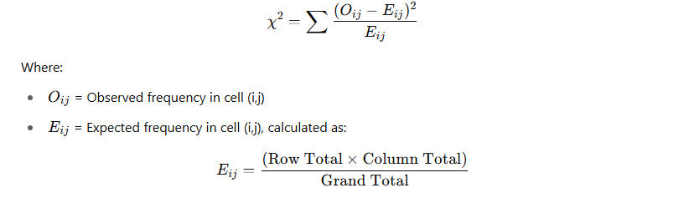
The calculated Chi-Square value is compared against the critical value from the Chi-Square distribution table at a 5% significance level. If the computed value exceeds the critical value, the null hypothesis is rejected, indicating a significant association between the variables.
This statistical test allows the researcher to determine whether key socio-economic or environmental factors significantly influence malaria outcomes in under-five children.
3.3 SOURCE OF DATA
The data use in this research work is a primary data (Questionnaire), which 50 questionnaire was administered within Ilorin Metropolis.
3.4 DATA PRESENTATION
The data use in this research work is a primary data (Questionnaire) and can be view in Appendix I.

CHAPTER FOUR

DATA ANALYSIS

4.1 Introduction
This chapter presents the analysis of data collected from caregivers of under-five children in Ilorin Metropolis on malaria prevention and management practices. Descriptive statistics are used to summarize frequencies and proportions, while bar and pie charts visualize trends and behaviors. Inferential analysis using Chi-Square Tests examines associations between key categorical variables such as use of insecticide-treated nets, malaria testing, and treatment administered.
4.2 Data Analysis
Descriptive (Frequency, Bar chart and Pie Chart)
has your children under five had a fever in the past two(2) weeks?
 |  | Frequency | Percent | Valid Percent | Cumulative Percent
Valid | yes | 26 | 52.0 | 52.0 | 52.0
Valid | no ( skip to Q20) | 24 | 48.0 | 48.0 | 100.0
Valid | Total | 50 | 100.0 | 100.0

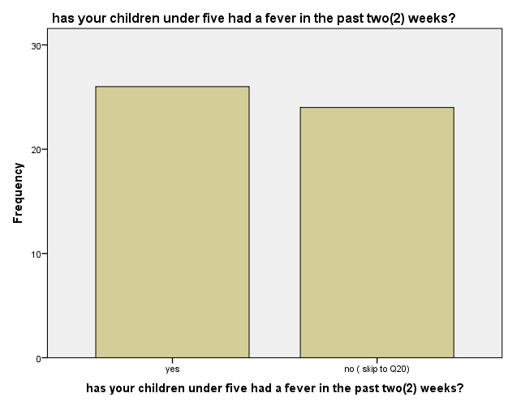
Interpretation: 52% of caregivers reported that their under-five child had a fever recently, which may indicate potential malaria exposure.

does your house hold own at least one insecticide-treated net ( ITN)?
 |  | Frequency | Percent | Valid Percent | Cumulative Percent
Valid | yes | 49 | 98.0 | 98.0 | 98.0
Valid | no | 1 | 2.0 | 2.0 | 100.0
Valid | Total | 50 | 100.0 | 100.0

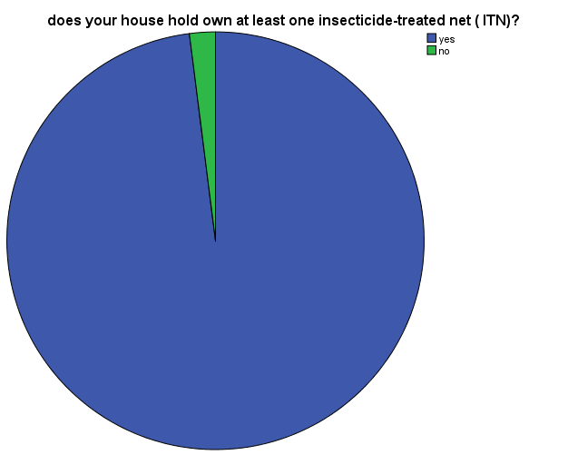

Interpretation: Nearly all households own at least one ITN, showing high preventive coverage.

have you ever used indoor spraying or other mosquito control methods in your home?
 |  | Frequency | Percent | Valid Percent | Cumulative Percent
Valid | yes | 49 | 98.0 | 98.0 | 98.0
Valid | no | 1 | 2.0 | 2.0 | 100.0
Valid | Total | 50 | 100.0 | 100.0

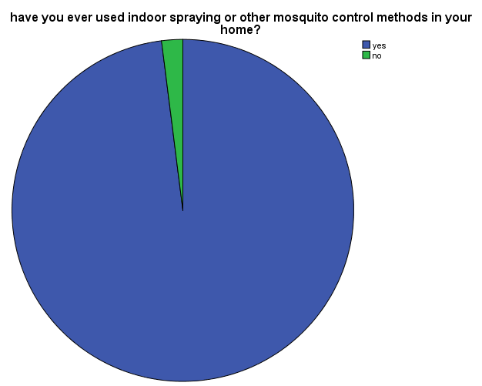
Interpretation: Most respondents practice mosquito control in their homes.

what other malaria prevention method do you currently use ?
 |  | Frequency | Percent | Valid Percent | Cumulative Percent
Valid | spraying insecticides | 19 | 38.0 | 38.0 | 38.0
Valid | insecticide -treated nets | 13 | 26.0 | 26.0 | 64.0
Valid | use of malaria drugs | 7 | 14.0 | 14.0 | 78.0
Valid | mosquito coil | 6 | 12.0 | 12.0 | 90.0
Valid | mosquito cream | 4 | 8.0 | 8.0 | 98.0
Valid | keeping the environment clean | 1 | 2.0 | 2.0 | 100.0
Valid | Total | 50 | 100.0 | 100.0

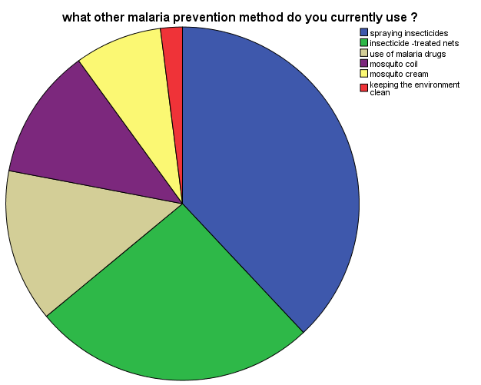

Interpretation: The most common methods are insecticide spraying and ITNs.

what treatment was given to the child?
 |  | Frequency | Percent | Valid Percent | Cumulative Percent
Valid | artemisinin-based combination therapy(ACT) | 7 | 14.0 | 14.0 | 14.0
Valid | other antimalaria drugs | 14 | 28.0 | 28.0 | 42.0
Valid | herbal/tradittional medicine | 4 | 8.0 | 8.0 | 50.0
Valid | no treatment | 25 | 50.0 | 50.0 | 100.0
Valid | Total | 50 | 100.0 | 100.0
Interpretation: Alarmingly, 50% of children received no treatment despite fever.

did you follow the full course of the prescribed malaria treatment?
 |  | Frequency | Percent | Valid Percent | Cumulative Percent
Valid | yes | 25 | 50.0 | 50.0 | 50.0
Valid | no | 25 | 50.0 | 50.0 | 100.0
Valid | Total | 50 | 100.0 | 100.0
Interpretation: Half of the respondents did not complete the full course of malaria treatment

during illness did you increase the child's fluid intake or feeding?
 |  | Frequency | Percent | Valid Percent | Cumulative Percent
Valid | yes | 32 | 64.0 | 64.0 | 64.0
Valid | no | 18 | 36.0 | 36.0 | 100.0
Valid | Total | 50 | 100.0 | 100.0
Interpretation: A majority increased fluid or food intake for the child during illness.

Inferential Statistics (Chi-Square)
Case Processing Summary
 | Cases
 | Valid |  | Missing |  | Total
 | N | Percent | N | Percent | N | Percent
was the child tested for malaria (e.g rapid diagnostic test or microscopy)? * what treatment was given to the child? | 50 | 100.0% | 0 | 0.0% | 50 | 100.0%

was the child tested for malaria (e.g rapid diagnostic test or microscopy)? * what treatment was given to the child? Crosstabulation
Count
 |  | what treatment was given to the child? |  |  |  | Total
 |  | artemisinin-based combination therapy(ACT) | other antimalaria drugs | herbal/tradittional medicine | no treatment | Total
was the child tested for malaria (e.g rapid diagnostic test or microscopy)? | yes | 7 | 14 | 3 | 1 | 25
 | no | 0 | 0 | 1 | 24 | 25
Total |  | 7 | 14 | 4 | 25 | 50

Chi-Square Tests
 | Value | df | Asymp. Sig. (2-sided)
Pearson Chi-Square | 43.160ª | 3 | .000
Likelihood Ratio | 56.419 | 3 | .000
Linear-by-Linear Association | 38.147 | 1 | .000
N of Valid Cases | 50
a. 4 cells (50.0%) have expected count less than 5. The minimum expected count is 2.00.

Chi-Square Value = 43.160, df = 3, p = .000
Interpretation: There is a highly significant relationship between whether a child was tested for malaria and the treatment administered. Tested children were more likely to receive proper medication.

Case Processing Summary
 | Cases
 | Valid |  | Missing |  | Total
 | N | Percent | N | Percent | N | Percent
does your house hold own at least one insecticide-treated net ( ITN)? * has your children under five had a fever in the past two(2) weeks? | 50 | 100.0% | 0 | 0.0% | 50 | 100.0%

does your house hold own at least one insecticide-treated net ( ITN)? * has your children under five had a fever in the past two(2) weeks? Crosstabulation
Count
 |  | has your children under five had a fever in the past two(2) weeks? |  | Total
 |  | yes | no ( skip to Q20) | Total
does your house hold own at least one insecticide-treated net ( ITN)? | yes | 25 | 24 | 49
 | no | 1 | 0 | 1
Total |  | 26 | 24 | 50

Chi-Square Tests
 | Value | df | Asymp. Sig. (2-sided) | Exact Sig. (2-sided) | Exact Sig. (1-sided)
Pearson Chi-Square | .942ª | 1 | .332
Continuity Correction^{b} | .000 | 1 | 1.000
Likelihood Ratio | 1.327 | 1 | .249
Fisher's Exact Test |  |  |  | 1.000 | .520
Linear-by-Linear Association | .923 | 1 | .337
N of Valid Cases | 50
a. 2 cells (50.0%) have expected count less than 5. The minimum expected count is .48.
b. Computed only for a 2x2 table

Chi-Square Value = .942, df = 1, p = .332
Interpretation: There is no significant relationship between owning an ITN and whether the child had a fever in the last two weeks.

Case Processing Summary
 | Cases
 | Valid |  | Missing |  | Total
 | N | Percent | N | Percent | N | Percent
what treatment was given to the child? * how serious do you think malaria is for children under five? | 50 | 100.0% | 0 | 0.0% | 50 | 100.0%

what treatment was given to the child? * how serious do you think malaria is for children under five? Crosstabulation
Count
 |  | how serious do you think malaria is for children under five? |  |  | Total
 |  | very serious | sometime serious | not serious | Total
what treatment was given to the child? | artemisinin-based combination therapy(ACT) | 5 | 2 | 0 | 7
what treatment was given to the child? | other antimalaria drugs | 12 | 1 | 1 | 14
what treatment was given to the child? | herbal/tradittional medicine | 2 | 2 | 0 | 4
what treatment was given to the child? | no treatment | 17 | 8 | 0 | 25
Total |  | 36 | 13 | 1 | 50

Chi-Square Tests
 | Value | df | Asymp. Sig. (2-sided)
Pearson Chi-Square | 6.427ª | 6 | .377
Likelihood Ratio | 6.980 | 6 | .323
Linear-by-Linear Association | .212 | 1 | .645
N of Valid Cases | 50
a. 8 cells (66.7%) have expected count less than 5. The minimum expected count is .08.

Chi-Square Value = 6.427, df = 6, p = .377
Interpretation: The perceived seriousness of malaria did not significantly influence the type of treatment given.

CHAPTER FIVE

SUMMARY, CONCLUSION AND RECOMMENDATIONS

5.1 Summary of Findings
This study examined the prevention and management of malaria in under-five children in Ilorin Metropolis using statistical methods, including descriptive statistics, bar and pie charts, and Chi-Square tests of independence. A total of 50 caregivers were surveyed.
Key Findings include:
- Fever Prevalence: 52% of children had a fever within the last two weeks, suggesting a high exposure to malaria risks.
- ITN Ownership and Usage: 98% of households reported owning an insecticide-treated net (ITN), and a similar percentage also used indoor spraying and mosquito control methods, indicating good knowledge of preventive practices.
- Alternative Prevention Methods: Spraying insecticides (38%) and using ITNs (26%) were the most common methods, while fewer caregivers used mosquito coils, creams, or environmental sanitation.
- Treatment Behavior: Half of the children (50%) received no treatment despite showing symptoms, and only 14% received ACT, the WHO-recommended therapy. Furthermore, 50% of those who received treatment did not complete the prescribed dosage.
- Caregiver Support During Illness: 64% of caregivers increased fluid or food intake during illness, which aligns with recommended supportive care practices.

Inferential Statistics Findings:
- There was a significant relationship between malaria testing and the treatment administered (p = 0.000), showing that tested children were more likely to receive appropriate medication.
- There was no significant relationship between ITN ownership and recent fever incidence (p = 0.332), suggesting other risk factors may influence malaria transmission.
- There was also no significant relationship between type of treatment given and caregiver perception of malaria seriousness (p = 0.377).

5.2 Conclusion
The statistical analysis revealed that although awareness and ownership of preventive tools like ITNs are high, gaps remain in treatment adherence and proper health-seeking behavior. Many caregivers either do not test children for malaria or do not follow through with complete treatments, which undermines malaria control efforts. Furthermore, while the majority consider malaria a serious disease, this perception does not consistently translate into effective management. The study underscores the need for continued education and reinforcement of appropriate malaria management practices in the community.

5.3 Recommendations
Based on the findings of this study, the following recommendations are made:
- Strengthen Health Education: Intensify awareness campaigns on the importance of testing and completing full malaria treatment, even when symptoms subside.
- Subsidize ACTs: Government and NGOs should ensure the availability and affordability of ACTs to reduce the use of ineffective or incomplete treatments.
- Improve Access to Testing: Expand access to rapid diagnostic tests in local communities to enable early diagnosis and prompt treatment.
- Monitor and Evaluate ITN Use: Health officials should follow up not only on ITN distribution but also on actual usage patterns to assess effectiveness.
- Promote Environmental Sanitation: Encourage consistent cleaning of household surroundings to reduce mosquito breeding grounds.
- Encourage Supportive Care: Reinforce the importance of increased fluid and food intake during illness as part of holistic malaria management.

REFERENCES
Adebayo, A. M., Akinyemi, O. O., & Cadmus, E. O. (2015). Knowledge of malaria prevention
among pregnant women and female caregivers of under-five children in rural southwest Nigeria. PeerJ, 3, e792. https://doi.org/10.7717/peerj.792

Adeneye, A. K., Jegede, A. S., Mafe, M. A., & Nwokocha, E. E. (2007). Perception and practices
on malaria prevention in a rural community in south-western Nigeria. Nigerian Journal of Parasitology, 28(2), 111–117.

Ajayi, I. O., & Falade, C. O. (2008). Adherence to malaria diagnosis and treatment guidelines
among healthcare workers in Ogun State, Nigeria. BMC Public Health, 8, 1–6.

Akpan, G. E., & Adepoju, K. A. (2020). Modelling the spatial distribution of malaria in Nigeria
using geoinformation techniques. Malaria Journal, 19, 1–14.

Aribodor, D. N., Ugwuanyi, I. K., & Aribodor, O. B. (2021). Assessing the impact of long-lasting
insecticide-treated nets in malaria control in Nigeria. Journal of Vector Borne Diseases, 58(1), 45–52.

Ezeoke, O. P., Onwasigwe, C. N., & Uzochukwu, B. S. (2013). Malaria control in Nigeria: Current
status and challenges. African Journal of Medical Sciences, 42(2), 165–172.

Federal Ministry of Health. (2021). National Malaria Strategic Plan 2021–2025. Abuja: National
Malaria Elimination Programme.

Iliyasu, Z., Arotiba, J. T., & Babashani, M. (2005). Socioeconomic status and malaria morbidity
in children attending general outpatient clinic in Kano, Nigeria. Annals of African Medicine, 4(3), 144–147.

National Population Commission (NPC) [Nigeria] & ICF. (2019). Nigeria Demographic and
Health Survey 2018. Abuja, Nigeria, and Rockville, Maryland, USA: NPC and ICF.

Okeke, T. A., Uzochukwu, B. S. C., & Okafor, H. U. (2006). An in-depth study of patent medicine
sellers’ perspectives on malaria in rural Nigerian communities. Malaria Journal, 5(1), 97. https://doi.org/10.1186/1475-2875-5-97

Olayemi, I. K., & Ande, A. T. (2008). Species composition and seasonal abundance of mosquitoes
in Ibadan, Nigeria. Nigerian Journal of Entomology, 25, 43–47.

Onwujekwe, O. E., Chima, R. I., & Okonkwo, P. O. (2000). Economic burden of malaria in
Nigeria: Implications for control. Tropical Medicine & International Health, 5(6), 439–446.

Oyeyemi, A. S., & Ogunleye, B. S. (2017). Factors associated with the use of insecticide-treated
nets among caregivers of under-five children in Osun State, Nigeria. Malaria Research and Treatment, 2017, Article ID 7429151.

UNICEF. (2022). Malaria: Current situation and UNICEF's response.
https://www.unicef.org/nigeria/malaria

World Health Organization. (2023). World Malaria Report 2023. Geneva: WHO.
https://www.who.int/publications/i/item/9789240064898

