DESIGN AND IMPLEMENTATION OF A SMART DOOR USING ARDUINO TECHNOLOGY AND RADIO-FREQUENCY IDENTIFICATION

BY
ABDULRAHMAN HIKMAH OLUWAFUMILAYO
HND/23/COM/FT/0140

A PROJECT SUBMITTED TO THE
DEPARTMENT OF COMPUTER SCIENCE, INSTITUTE OF INFORMATION AND COMMUNICATION TECHNOLOGY, KWARA STATE POLYTECHNIC, ILORIN

IN PARTIAL FULFILMENT OF THE REQUIREMENTS FOR THE AWARD OF HIGHER NATIONAL DIPLOMA (HND) IN COMPUTER SCIENCE.

JUNE, 2025.

CERTIFICATION
This is to certify that this project research was carried out by ABDULRAHMAN HIKMAH OLUWAFUMILAYO matric number HND/23/COM/FT/0140 has been read and approved as meeting part of the requirement for the award of Higher National Diploma (HND) in Computer Science.

___________________________ ______________________
MR. MURTALA, K. DATE
(PROJECT SUPERVISOR)

___________________________ ______________________
MR. OYEDEPO, F. S. DATE
(HEAD OF DEPARTMENT)

__________________________ ______________________
EXTERNAL EXAMINER DATE

DEDICATION
This research work is dedicated to the Almighty Allah for the success of the work

ACKNOWLEDGEMENTS
First and foremost, my deepest appreciation for this work goes to Almighty Allah for His unwavering guidance, strength, and blessings throughout this journey. Without His grace, none of this would have been possible.Thank you, Allah, for giving me the confidence, support, and ability to complete this work.
I am immensely grateful to my supervisor, Mr. Murtala, K. for his expertise, encouragement, motivation, and support throughout this research. From brainstorming ideas to the final stages, his guidance was invaluable. Thank you, Sir. I pray that Allah answer all your secret prayers.
I also extend my special appreciation to all the lecturers in the Computer Science Department. Thank you for your support throughout our years at this institute and for your words of encouragement.
My appreciation also goes to my dearest father,Mr.Abdulrahman Issa,thank you for your endless support, encouragement, and sacrifices. Your belief in me has been a constant source of motivation, and I am forever grateful for your love and guidance.And also to my late mother, Mrs.Issa Maryam though you are no longer with us, your spirit and teachings continue to inspire me every day. I carry your love and wisdom in my heart, and I strive to make you proud in all that I do.
I am also grateful to my siblings, in person of : Mr.Olayinka,Mr.semiu, Mrs.Alabi Halimah,Teslim and kabeerah,thank you for being my cheerleaders and my confidants. Your support and camaraderie have made this journey not only bearable but also enjoyable. I cherish the memories we’ve created together and I promise I will never disappoint you.
I also want to extend my heartfelt thanks to everyone who has played a role in my academic journey—friends (Rukayyah, Kabeeroh ,Ayoola, Quam and Masturah) and Relatives: Mr. Muhammad Jamiu Abdulrahman and Alhaji Abdullah Alabi.Your encouragement and belief in my potential have made a significant impact on my life.
As I move forward, I carry with me the lessons learned and the love shared. I look forward to the future with hope and excitement, knowing that I have such a strong support system behind me.
Finally, I extend my gratitude to my colleagues involved in this research work. Your support and diligence were crucial. All glory and adoration return to the Almighty Allah and to everyone who directly or indirectly contributed to the success of this research work

ABSTRACT
This research presents the design and implementation of a smart door access system utilizing Arduino microcontroller and RFID card technology to address modern security challenges associated with traditional lock-and-key mechanisms. Motivated by the need for cost-effectiveness, flexibility and security access control, the project explores the use of open-source hardware to automate door operation and limit entry to only authorized users. The system consists of an RFID reader for authentication, an Arduino unit as the central processor, an LCD for user feedback, and a stable STM power supply. Developed under the structured Waterfall model, the system processes RFID tags, compares input data with stored IDs, and triggers access accordingly. The proposed solution eliminates key duplication risks, enhances convenience, and ensures access logging, all while maintaining affordability and scalability for use in homes, schools, and offices. The study demonstrates that smart access systems can be built with minimal resources while providing reliable performance, thereby encouraging the adoption of embedded systems for improving everyday security infrastructures.
Keywords: RFID, Arduino microcontroller, smart door, access system, and card.

TABLE OF CONTENTS
Title page. i
CERTIFICATION ii
DEDICATION iii
ACKNOWLEDGEMENTS iv
ABSTRACT v
CHAPTER ONE 1
INTRODUCTION 1
1.1 Background to the study 1
1.2 Statement of the problem 3
1.3 Aim and Objectives of the Study 4
1.4 Significance of the study 4
1.5 Scope of the Study 5
1.6 Definition of some Technical Terms 5
CHAPTER TWO 7
LITERATURE REVIEW 7
2.1 Review of Related Studies 7
CHAPTER THREE 18
METHODOLOGY 18
3.1 Research Methodology 18
3.2 Analysis of the Existing System 19
3.3 Problems of the Existing System 19
3.4 Description of the Proposed System 20
3.5 Advantages of the Proposed System 20
CHAPTER FOUR 22
DESIGN AND IMPLEMENTATION OF THE SYSTEM 22
4.1 Design of the System 22
4.1.1 Output Design 22
4.1.2 Input Design 23
4.1.3 Procedure Design 24
4.2 System Implementation 24
4.2.1 Hardware Support 25
4.3 System Documentation 25
4.3.1 Maintenance of the System 25
CHAPTER FIVE 27
SUMMARY, CONCLUSION AND RECOMMENDATIONS 27
5.1 Summary 27
5.2 Conclusion 27
5.3 Recommendations 28
REFERENCES 30

CHAPTER ONE

INTRODUCTION

1.1 Background to the study
The rapid evolution of embedded systems and automation technologies has significantly influenced how security is managed in residential, schools, offices and other controlled areas. One such innovation is the smart door system, which integrates electronics and programming to offer controlled access, enhanced surveillance, and improved user convenience. A popular and efficient approach to implementing such systems is through the use of Arduino technology an open-source electronics platform known for its flexibility and affordability. In this research, a smart door system will be designed and implemented using an Arduino microcontroller in conjunction with a smart card authentication method. This approach aims to replace conventional keys with RFID (Radio Frequency Identification) cards, offering a more secure, efficient, and scalable solution for modern access control systems (Akinola et al., 2021).
Smart card technology, especially RFID-based systems, is increasingly being employed in access control due to its ease of use, durability, and ability to store and transmit encrypted data. When integrated with an Arduino system, the RFID module acts as the reader, while the card serves as the authentication medium. Upon placing the card near the reader, the system reads the card's unique ID and compares it with a list of pre-registered Identity stored in the Arduino’s memory or an external memory module. If the ID matches an authorized entry, the Arduino triggers an actuator usually a servo motor to unlock the door. This seamless interaction between hardware and software components enables a contactless, secure, and programmable access system (Okafor et al., 2022).
The increasing demand for security in homes, offices, schools, and other establishments has led to a shift from mechanical locks to digital and automated systems. Traditional locks are often vulnerable to theft techniques like key duplication or lock-picking. In contrast, smart card-based systems provide individualized access credentials that are not easily duplicated or bypassed. Furthermore, lost or stolen cards can be easily deactivated in the system, eliminating the need to change the entire lock mechanism. Arduino provides the computational foundation for such a system by executing code logic that governs access authorization, lock control, and optional features such as alert notifications, access logging, and real-time monitoring (Nwachukwu et al., 2020).
The Arduino microcontroller is ideal for this project due to its compatibility with a wide array of peripheral devices and its support for serial communication with modules like RC522 (an RFID reader). The RC522 module is cost-effective, consumes low power, and can communicate using SPI protocol, making it suitable for embedded access control projects. The Arduino board interprets the signal from the card and verifies it against stored data, determining whether to grant or deny access. Additionally, an LCD module can be incorporated to display messages such as “Access Granted” or “Access Denied,” thereby improving user interaction with the system (Usman et al., 2019).
An essential component of this research is the development of a secured database or memory structure to store the authorized card information. Since the Arduino Uno has limited memory, an external EEPROM or SD card module can be used to store a larger set of RFID codes. This ensures scalability, allowing the system to accommodate multiple users. The inclusion of an administrator card or master card for system management (adding or removing user cards) further enhances the system’s utility and control without needing a computer interface after deployment (Lawal et al., 2021).
From a security standpoint, smart card-based access systems offer several advantages. Each card is uniquely identifiable, minimizing the risk of unauthorized duplication. Additionally, the system can be programmed to track entry and exit times, thereby serving as an attendance or surveillance tool. When combined with GSM or Wi-Fi modules, the Arduino system can send real-time SMS or email alerts in case of unauthorized access attempts or security breaches. This feature is particularly valuable in environments where constant monitoring is required, such as data centers or high-security zones (Ahmed et al., 2020).
The adoption of such systems in developing countries is also gaining traction due to the relatively low cost of components and ease of implementation. Universities, companies, and public institutions can benefit from automated access systems that require minimal maintenance and deliver robust performance. Additionally, smart card-based access control systems provide a learning opportunity for students and hobbyists exploring the fields of electronics, programming, and automation. This supports educational development and encourages innovation in local technology ecosystems (Adewale & Kolapo, 2022).

1.2 Statement of the problem
In recent years, the need for enhanced security and access control in both residential and commercial settings has become increasingly critical due to the rise in burglary, unauthorized intrusions, and general insecurity. Traditional mechanical lock-and-key systems, though widely used, have proven to be susceptible to various forms of compromise such as key duplication, lock picking, and physical tampering. These conventional methods do not offer the intelligence or flexibility required to meet modern security needs. Furthermore, the management of physical keys can become cumbersome, especially in environments with multiple users or where access needs to be frequently changed. For example, if a key is lost or stolen, the entire lock system might need to be replaced, which is not only inconvenient but also costly. These limitations have led to a growing interest in more advanced, automated, and efficient access control solutions, hence prompting the need for this research.
The problems that led to this research include:
- Insecurity and inefficiency of traditional lock-and-key systems;
- High cost and complexity of existing digital access control methods;
- Low awareness and adoption of affordable smart access solutions like Arduino-based systems; and
- Lack of scalable, simple, and low-maintenance smart door technologies for everyday use.

1.3 Aim and Objectives of the Study
The aim of this study is to design and implement a smart door system using Arduino technology and RFID card access to enhance security, improve convenience, and provide a cost-effective alternative to traditional locking systems.
The objectives are to:
- design and develop a smart door lock to secure entry;
- incorporate the Arduino and RFID card technology on the smart door; and
- implement a user authentication system using RFID for controlled access.

1.4 Significance of the Study
The significance of this study lies in its potential to address growing security concerns across various sectors by offering a modern, affordable, and efficient access control solution. As the rate of theft, unauthorized access, and vandalism continues to rise, organizations and households alike require dependable security systems that not only provide protection but are also easy to manage and cost-effective. This research provides a practical solution through the design and implementation of a smart door system using Arduino and RFID card technology, which can significantly improve security across different settings.
For residential users, this system offers peace of mind by reducing the risks associated with lost or duplicated keys. It provides homeowners with a convenient method to manage who can access their homes without the need to change locks frequently. For small and medium-sized enterprises (SMEs), schools, hospitals, and corporate offices, the system ensures controlled access to sensitive areas, minimizes internal breaches, and enhances overall operational security. The ease of integration and customization makes it a valuable tool for businesses looking to upgrade their security infrastructure without incurring high costs.

1.5 Scope of the Study
The scope of this study is limited to the design and implementation of a smart door system that uses smart card (RFID) technology integrated with an Arduino microcontroller for access control. It focuses on developing a functional prototype capable of granting or denying entry based on card authentication.

1.6 Definition of some Technical Terms
Smart Door:
A smart door is an electronically controlled entry system that allows or restricts access using digital means such as smart cards, keypads, or biometric devices rather than traditional keys.
Arduino:
Arduino is an open-source electronics platform based on easy-to-use hardware and software, commonly used for building digital devices and interactive systems like automated access control systems.
RFID (Radio Frequency Identification):
RFID is a wireless communication technology that uses electromagnetic fields to automatically identify and track tags or cards attached to objects or people, commonly used in smart card systems for secure access.
Smart Card:
A smart card is a plastic card embedded with an RFID chip that stores data and communicates with a reader for authentication purposes in systems like automated doors.
Access Control:
Access control refers to the selective restriction of access to a place or resource, ensuring that only authorized individuals can enter secured areas.
Microcontroller:
A microcontroller is a compact integrated circuit designed to perform specific operations within an embedded system, such as controlling a smart door based on input signals.

CHAPTER TWO

LITERATURE REVIEW

2.1 Review of Related Studies
The implementation of smart card systems for door access using Arduino technology is an innovative advancement that responds to the growing need for robust, flexible, and cost-effective security systems (Kumar & Sharma, 2021). Traditional security mechanisms such as physical locks and mechanical keys are increasingly vulnerable to theft, duplication, or unauthorized access, necessitating the integration of intelligent technologies. Over the past decade, smart card-based access control systems have emerged as a reliable solution in both residential and commercial security infrastructures. These systems employ smart cards embedded with integrated circuits that store data and communicate with microcontrollers, such as those in Arduino-based systems (Eze et al., 2022). Research by Ameen et al., (2019) emphasized the benefits of smart card systems in maintaining secure and traceable access to buildings, highlighting their capability to limit entry to authorized users only. Similarly, Yusuf et al., (2020) explored the combination of Arduino and RFID smart cards, proving the system's effectiveness in controlling access with low power consumption and high accuracy. Such systems are also scalable, enabling expansion from single-door to multi-door architectures without major hardware redesigns, making them increasingly popular for institutional and organizational use.
Arduino, as an open-source electronics platform, plays a pivotal role in smart card-based access control systems due to its affordability, programmability, and community-driven support. The Arduino Uno, equipped with an ATmega328P microcontroller, is widely used in such applications owing to its ease of integration with various modules like RFID readers, keypads, LCDs, and electromagnetic locks. Mishra et al., (2022) demonstrated in their project that combining Arduino with wireless modules, such as Bluetooth HC-05, and Android applications enhances door security by allowing mobile-based control, which increases system flexibility and user convenience. The ability of Arduino to read RFID smart card tags and validate the identity of the cardholder against pre-stored data further supports real-time decision-making in access control. According to Sharma and Bajaj (2021), this dynamic interaction is what makes Arduino-based systems exceptionally adaptable for both academic and practical applications. Furthermore, Arduino's capability to interface with Electrically Erasable Programmable Read-Only Memory enables data logging, making it possible to maintain logs of access attempts, which are essential in audits and forensic investigations.
RFID (Radio Frequency Identification) technology lies at the core of most smart card-based systems and has seen widespread adoption due to its contactless communication and ability to operate without line-of-sight. RFID-enabled smart cards consist of a microchip and antenna embedded within a plastic card, which, when brought close to a compatible reader, transmit stored identification data. Raut and Pawar (2018) developed a smart access system using RFID and Arduino and concluded that the system significantly reduces unauthorized entry while improving the speed and ease of access. The RFID reader receives the card’s unique identifier and compares it against a database of authorized IDs stored on the microcontroller. If a match is found, the system activates a solenoid or electromagnetic lock, permitting access. A similar study by Rahman et al., (2017) implemented RFID-based access for university labs and emphasized its advantages over keypad-based systems, citing better security and user experience. RFID technology also mitigates hygiene concerns by enabling contactless interaction, a feature particularly relevant in the post-pandemic world where minimizing physical contact with shared surfaces is crucial.
An important consideration in the implementation of smart card access systems is the integration of supporting peripherals such as LCD displays, buzzers, and logging mechanisms. Arduino facilitates these integrations through its digital and analog input/output pins. According to Bhatt and Patel (2019), the incorporation of an LCD module helps display system status, such as “Access Granted” or “Access Denied,” offering immediate feedback to users and increasing transparency. Buzzers serve as auditory feedback mechanisms and alerts, notifying users of successful or failed authentication attempts. Furthermore, by integrating a real-time clock (RTC) module and memory card interface, it becomes possible to record timestamps for each access event, a feature explored in detail by Okafor and Olaniyi (2021). Such logging mechanisms are critical in environments like data centers or research labs where access histories must be maintained for regulatory compliance. This added functionality transforms simple access control systems into intelligent, auditable, and accountable security frameworks that meet institutional security requirements.
Recent advancements have also expanded the capability of smart access systems by incorporating networked communication through Wi-Fi or GSM modules. These enhancements allow for remote monitoring and control, thereby increasing the system’s utility in home automation and IoT ecosystems. Mohammed et al., (2020) demonstrated how Wi-Fi-enabled Arduino systems could send alerts to a central server or the user’s smartphone in case of unauthorized access attempts. This kind of remote interactivity extends the usability of the system beyond physical proximity, making it suitable for high-risk or sensitive installations such as vaults or restricted government offices. Moreover, combining smart card access with biometric systems, as suggested by Singh and Rao (2019), further strengthens the security layer by implementing multi-factor authentication. Although such integrations increase system complexity, the added security and functionality are justified in critical applications. Arduino’s flexibility and extensive support for external modules ensure that such integrations are not only possible but practical and scalable.
Radio Frequency Identification (RFID)
The RFID tags serve as unique identifiers for users. Each user is provided with an RFID tag encoded with specific access permissions, allowing them to interact with the system. The system's IoT infrastructure includes RFID readers at the door, which communicate with the central system to verify the tag's authenticity and grant or deny access based on the encoded permissions as demonstrated in Fig 1.
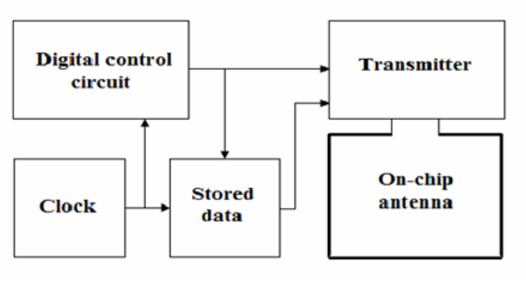
Fig. 1: Radio Frequency Identification tag
Source: Okafor and Olaniyi (2021)
The Arduino Uno R3 is utilized as the central controller in the design of the Door Pin Access system. It manages input from RFID tags and sensors while interfacing with IoT modules for connectivity. Through the Arduino Uno R3, the system verifies access, and controls the locking mechanism, integrating IoT technology to enable remote access and monitoring capabilities via cloud-based platforms or network connections as depicted.
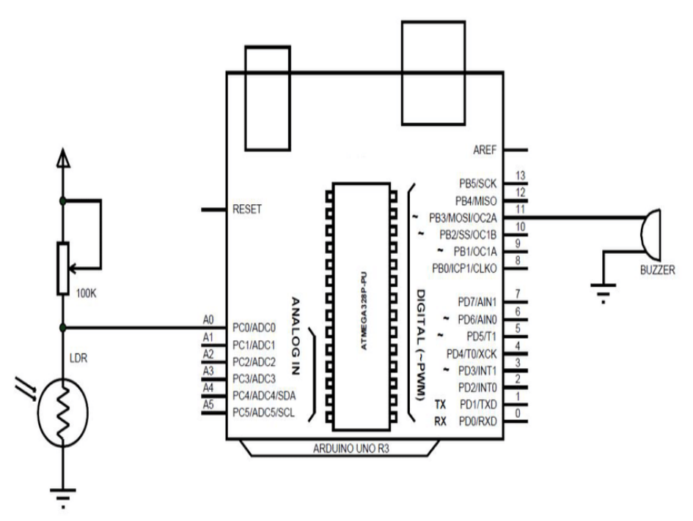
Fig. 2. Circuit diagram of Arduino Uno R3
Source: Musa, (2021)
The affordability of Arduino and RFID modules has made smart card access systems increasingly feasible for deployment in small and medium-scale environments such as schools, offices, and residential complexes. A case study by Ibrahim and Musa (2021) on deploying Arduino-based access systems in a Nigerian university showcased the system’s reliability and low maintenance needs. The authors noted that students and staff quickly adapted to the new system, appreciating its speed and ease of use compared to the traditional key-based method. The low-cost nature of Arduino allows institutions with limited budgets to benefit from advanced security systems without the financial burden associated with commercial biometric or CCTV surveillance systems. This democratization of access control technology empowers more stakeholders to implement reliable security solutions, promoting a safer and more accountable environment across diverse sectors. Furthermore, with open-source platforms, users can continually upgrade and customize their systems to meet evolving needs without being locked into proprietary ecosystems.
The RFID-based security system of the article integrates RFID readers with IoT controllers and door locks. RFID tags or cards are assigned to users, enabling seamless access through authentication when presented to the reader as seen in Fig 3. The IoT infrastructure manages user access permissions, logs entry attempts, and facilitates remote access control, ensuring a secure and streamlined entry system.
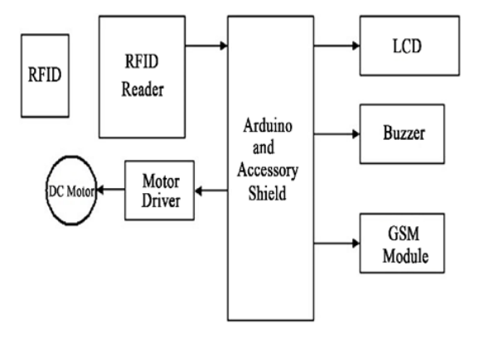
Fig 3. Block diagram of RFID based security system
Source: Oyeniran et al., (2022)
Despite the numerous benefits, challenges persist in the widespread adoption of Arduino-based smart card systems. One major concern is the susceptibility to hacking or unauthorized data interception if the system is not adequately encrypted. Research by Oyeniran et al., (2022) emphasized the need for cryptographic techniques to protect communication between the smart card and the microcontroller. Without encryption, there is a risk that an attacker could clone an RFID tag or intercept serial data, thereby compromising the system’s integrity. Additionally, environmental factors such as electromagnetic interference or poor power regulation can affect system stability. These limitations necessitate robust error-handling mechanisms, such as retry loops and watchdog timers, which can be implemented through Arduino’s programmable interface. Regular software updates and maintenance schedules are also recommended to ensure long-term reliability. However, even with these challenges, the flexibility and capability of Arduino make it an attractive foundation for continued innovation in access control technologies, particularly when coupled with proper design principles and security protocols.
2.2 Review of General Studies
A review on Design and Implementation of a Door Pin Access System Using IoT Technologies by Olubukola et al., (2024) highlights the growing need for smart security solutions as a result of increasing burglary and the limitations of traditional mechanical locks. The study introduced an IoT-based door access system aimed at enhancing security using RFID, Arduino Uno, and ESP32 technologies, allowing only authorized users with registered PINs or tags to gain entry. The problem addressed was the vulnerability of conventional locks to theft, duplication, and key loss, which the authors sought to solve with an automated and remotely controlled access system. The objective was to build a smart, affordable, and efficient system capable of logging access and monitoring entry in real time. The methodology involved the use of the Scrum Process Model which guided the phases of requirement analysis, system design, implementation, and testing, using components such as RFID readers, Arduino Uno R3 microcontrollers, and ESP32 modules to create a connected system. Although no human sample size was directly involved, the prototype was tested in a controlled environment to demonstrate functionality. The study concluded that the system improved security and user control through real-time access monitoring, and it recommended future enhancements with biometric integration, machine learning, and wider real-life deployment to improve performance and scalability.
An article titled Design and Implementation of Smart Door Lock Control System Using Bluetooth Controller of Smart Phone by Bhaktishwar et al., (2016), presents a timely response to the growing demand for smart security systems in both residential and commercial spaces. The study with an alarming statistic on increasing burglary rates in India, noting a (10%) rise in 2013 and 8.2% of all crimes in 2012 attributed to home theft, establishing a strong introduction that justifies the need for smart and accessible security measures. The problem addressed in the study revolves around the inefficiency, complexity, and high costs associated with existing security solutions like GSM modules and RFID systems, which either involve expensive hardware or lack user-friendliness. Consequently, the main objective of the study is to propose and implement a low-cost, efficient, and user-friendly smart door lock system leveraging the widespread availability of Bluetooth on smartphones. The authors aim to create a door automation solution that eliminates the drawbacks of previous models by using Bluetooth HC-05 and Android-based systems, thereby simplifying usage and enhancing reliability. In their methodology, the authors design a system architecture that integrates hardware components such as a Bluetooth module (HC-05), microcontroller (ATmega32), and a solenoid lock mechanism, with a mobile application that allows the user to control door access via a Bluetooth connection. The software is structured into three major modules PC application for managing hardware interfaces and database access, a server for matching Bluetooth UUIDs and user authentication, and an Android application providing a user-friendly GUI, live video streaming, and owner verification. Although the authors did not explicitly state the sample size in a statistical manner, the system was practically tested and demonstrated in a real-time environment, focusing more on the prototype implementation and functional performance rather than large-scale user data. In conclusion, the research finds that the developed system offers a significant improvement in terms of cost-effectiveness, simplicity, and usability, particularly due to the ubiquity of smartphones and Bluetooth technology. It also emphasizes that while the system effectively meets current needs for manual identification and security control, future recommendations include the incorporation of more advanced technologies such as face detection and facial recognition for automated user verification, making the system even smarter and secure. The authors highlight that this evolution would ensure the smart door lock remains adaptable, scalable, and competitive with future advancements in home automation and security technology.
In the research titled “Digital Smart Door Lock Security System Using Arduino Uno Microcontroller” by Atif (2022), the study introduces a cost-effective and efficient approach to securing lives and property through the development of a microcontroller-based digital door lock using a (4x4) keypad and an Arduino Uno board. The research is driven by the increasing demand for improved security systems in homes, schools, and offices, especially in developing nations like India, where crime rates remain high partly due to the low adoption of smart security technologies. The objective of the research is to develop a robust, simple, and affordable security system that enhances property and personal security through the integration of modern microelectronics. The problem identified centers on the vulnerability of conventional locks and the increased rate of burglary and intrusion, necessitating a system that is more resilient and smarter in access control. To address this, the study deployed a methodology involving both hardware and software integration, using a combination of a (4x4) matrix keypad for user PIN input, an LCD screen for visual feedback, a servo motor for door actuation, and an Arduino Uno microcontroller programmed in C language via Arduino IDE to coordinate system operations. Upon correct entry of a PIN by a registered user, the system unlocks the door and displays "Access Granted" on the LCD, while unrecognized attempts result in "Access Denied." The system further includes features for PIN change and revalidation processes through the '#' function key. The sample size includes all access events, where the system achieved a 100% success rate for registered users and 100% denial for unregistered ones, establishing its reliability and precision. From the conclusion drawn, the system proved not only efficient and reliable but also easy to install and economically viable, thus presenting a viable solution for enhancing security in low-resource settings. The author recommended broader implementation in public and private infrastructures and suggested that future improvements could explore wireless control and biometric integration to make the system more adaptable and scalable in diverse security environments.
The article titled "Smart Door Lock System Using Arduino" was authored by Satyam, Omkar, and Swapnil (2022) This study introduces an Arduino-based smart door lock system integrated with Bluetooth technology and controlled via an Android smartphone, which falls under the broader concept of home automation and smart security solutions. The introduction of the study highlights the growing demand for secure, user-friendly, and technologically advanced home security systems, especially in a world where safety is a rising concern. The core problem addressed is the traditional door locking systems' limitations, particularly for people with disabilities and the general inefficiency of mechanical locks in deterring unauthorized access. The researchers aim to create a secure, accessible, and automated locking system that enhances home security while offering convenience, especially to those with physical impairments who may not be able to operate biometric or RFID systems. The main objective of the study was to develop and implement a smart door security system using Arduino microcontrollers and Bluetooth-enabled smartphones to provide an efficient and cost-effective alternative to conventional locks. The methodology included software and hardware design using Arduino Uno, Bluetooth HC-05 module, and a solenoid lock, where the system receives instructions from a password-protected Android app via Bluetooth, triggering the microcontroller to engage or disengage the locking mechanism through a relay module. The sample size is not numerically specified in the article, but the system was developed and tested as a prototype for conceptual validation, making it a proof-of-concept study rather than a large-scale implementation. The conclusion drawn from the project is that such a system is effective in providing secure access control while being user-friendly and adaptable, especially for the physically challenged, offering ease of door access with just a smartphone click. The authors recommend further development of the system by incorporating additional security features such as biometric integration, GSM modules for remote access, and mobile alert systems for intrusion detection, making the system more robust, scalable, and viable for wider application in both residential and public infrastructures.

CHAPTER THREE

METHODOLOGY

3.1 Research Methodology
The development of this smart door system followed a practical engineering approach that focused on hardware-software integration. The methodology employed involved five key stages: requirement identification, system design, component integration, software development, and system testing. The project started with a detailed study of access control methods to determine the limitations of traditional security systems and assess the viability of automating access through RFID and Arduino technology.
The first step was the identification and procurement of essential components. These include an RFID reader and card for user identification, an LCD for visual output, an Arduino microcontroller for logic processing, an STM power supply for energy support, Dupont wires for electrical connections, and a protective casing to house the entire setup. Each component was selected based on its efficiency, availability, and ease of compatibility with other parts.
System design was done by first drafting a circuit schematic to define how each component would connect. After validation, physical prototyping began by arranging the parts on a breadboard to test the data flow between the RFID reader, Arduino, and LCD. Once basic functionality was confirmed, the circuit was transferred to a permanent board for long-term stability. The Arduino was programmed using the Arduino IDE to accept and verify RFID card data. The program was written to check if the scanned RFID matches a list of approved IDs stored in the microcontroller’s memory. If matched, the system grants access and activates a relay to simulate unlocking a door; if not, a denial message is displayed on the LCD.
The STM power supply was used to ensure stable and uninterrupted current to the system. Dupont wires were used to link the components efficiently without soldering. After assembling the system into a durable casing, thorough testing was conducted. Different RFID tags were scanned to check the reliability of the system under varying conditions such as power fluctuations, multiple inputs, and repeated scans.

3.2 Analysis of the Existing System
In many homes and institutions today, traditional locking mechanisms dominate the landscape of security. These systems typically rely on padlocks, key-operated deadbolts, or, in some cases, manual guards. While these methods provide a basic level of security, they are inherently limited in scope. Keys can be misplaced, copied, or stolen, and mechanical locks can wear out over time or be forced open. Manual guard systems are prone to human error, compromise, or fatigue, which reduces their reliability.
Moreover, traditional systems do not support identity verification or access tracking. In high-security environments, this poses a serious risk as there is no record of who accessed a space or when. These limitations highlight the need for a more secure and intelligent access control mechanism that does not rely on human intervention or physical keys alone.

3.3 Problems of the Existing System
A key issue with conventional security systems is their reliance on physical mechanisms, which can be easily compromised. Loss or theft of keys can grant unauthorized individuals easy access to secure areas. Additionally, there is no real-time monitoring or feedback to alert homeowners or administrators in case of an unauthorized attempt. Manual verification systems also suffer from inconsistency and a lack of accountability.
Another issue is that traditional systems do not provide flexibility. Once a key is issued, there's little control over how and when it is used. If a staff member or tenant leaves and fails to return their key, the only solution is to change the entire lock. This process is costly and time-consuming. Moreover, in shared or institutional environments, ensuring that only authorized personnel access certain zones becomes nearly impossible with basic locks.

3.4 Description of the Proposed System
The proposed smart door project introduces a technology-driven solution to access control using RFID and Arduino components. Instead of traditional keys, users will gain access by presenting an RFID card to a reader. The Arduino microcontroller processes the unique ID of the card and checks it against a list of authorized entries. If the card is valid, a signal is sent to unlock the door. The LCD screen is used to display real-time information to the user such as “Welcome” or “Access Denied.”
The system incorporates several key elements: the RFID reader reads the card data, the Arduino performs the verification and logic control, the LCD provides visual confirmation, and the STM power supply ensures all components operate consistently. Dupont wires are used to connect all modules neatly, and the entire system is encased to protect the hardware from external damage or tampering.
Unlike traditional systems, this model is capable of logging access events and denying unauthorized users instantly. It’s modular, meaning that it can be easily upgraded to include more features such as biometric recognition, mobile alerts, or internet connectivity for remote access control.

3.5 Advantages of the Proposed System
The smart door system offers the following key advantages:
- Enhanced Security: Replaces traditional keys with RFID cards, which are harder to duplicate or clone.
- Accurate Access Control: Uses microcontroller logic for quick and precise decision-making, eliminating human error or bias.
- Real-Time Feedback: Provides instant responses to users through the system, improving usability and transparency.
- User Information Display: Features an integrated LCD screen to keep users informed during operation.
- Low Maintenance: Electronic components reduce the need for frequent repairs compared to mechanical locks.
- Reliable Performance: Powered by an STM power supply that ensures consistent operation.
- Component Protection: Housed in a durable casing that safeguards internal electronic parts.

CHAPTER FOUR

DESIGN AND IMPLEMENTATION OF THE SYSTEM

4.1 Design of the System
The smart door system was designed to enhance home and office security by using RFID technology in combination with Arduino microcontroller. The system ensures only authorized users can access the door by presenting a valid RFID card. The design includes both hardware and software components that function interactively to deliver real-time access control.

4.1.1 Output Design
The output of the system refers to the response seen after user input is processed. In this design, once a valid RFID card is detected by the reader, the system outputs two key responses:
- A signal sent to open the door (usually controlling a servo motor or lock switch).
- A user-friendly message displayed on the LCD screen, indicating "Access Granted" or "Access Denied".
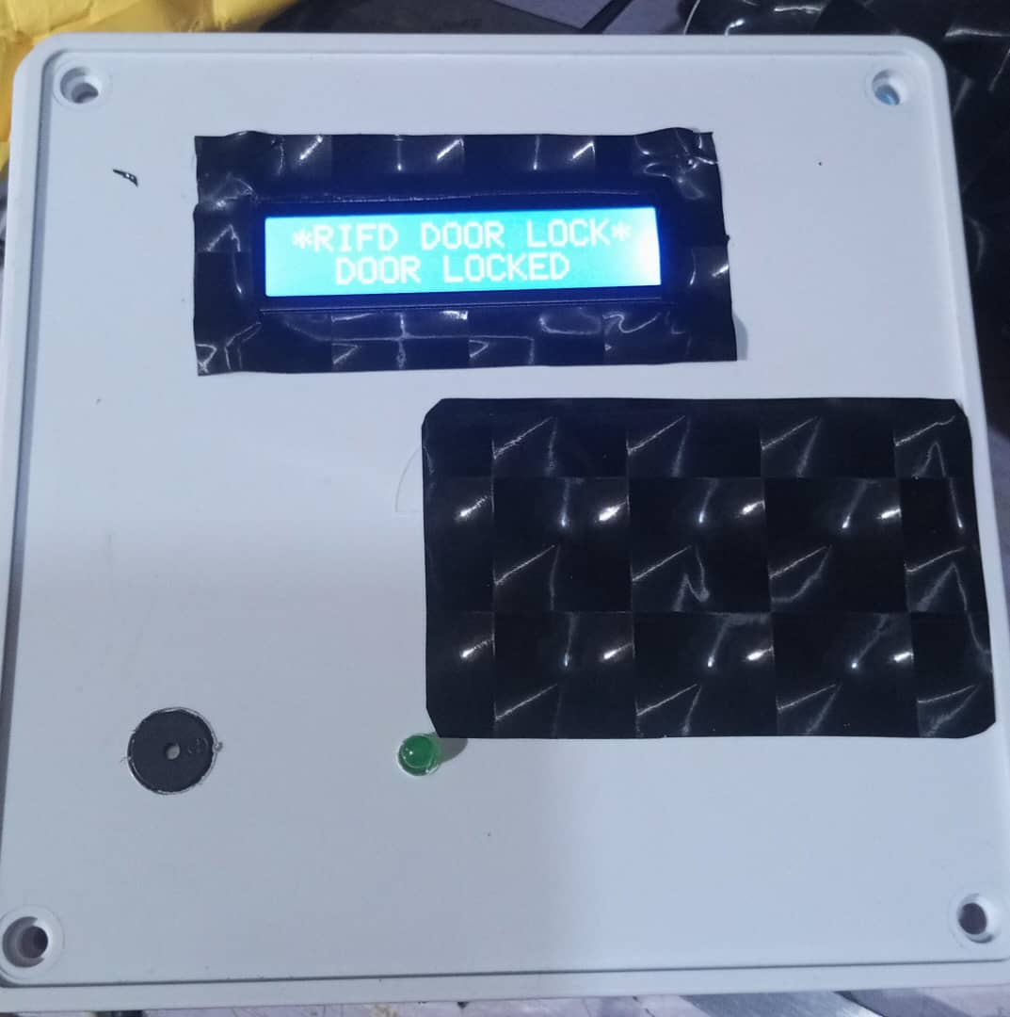
Figure 4.1: LCD Output Display Showing “Access Granted”
The LCD screen (16x2) serves as a feedback interface to display the status of each card scan. It improves system transparency and helps users understand the system's response in real-time.

4.1.2 Input Design
The main input device in the system is the RFID reader. Each user is assigned an RFID card with a unique identification code. When the card is brought close to the RFID reader, it captures the data and sends it to the Arduino for verification. The user’s RFID card data acts as the system’s credential input.
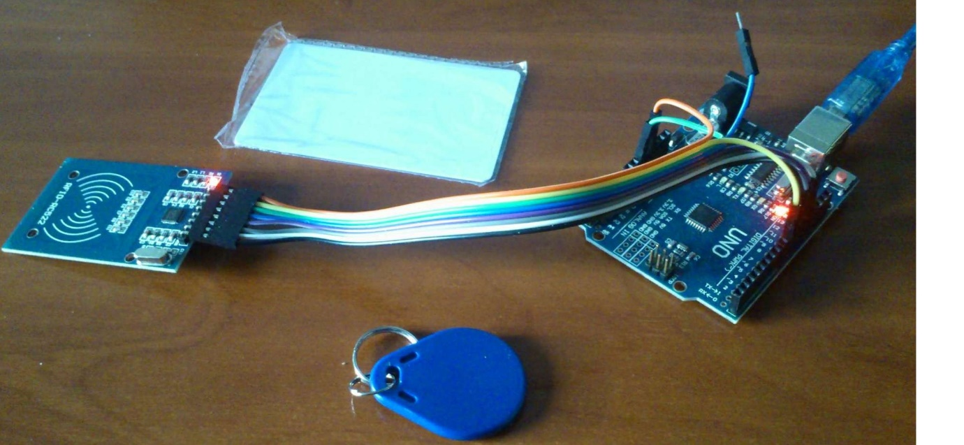 Figure 4.2: RFID Reader and Card Used for User Authentication
Additional components like the STMP power supply, Dupont wires, and Arduino board facilitate the seamless transmission and control of input signals. Input validation is handled by the Arduino microcontroller programmed to authenticate RFID tags against a predefined database of authorized entries.
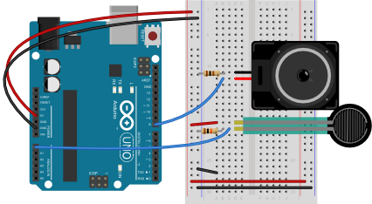
Figure 4.3: Connection of Input Devices to Arduino Board

4.1.3 Procedure Design
The system procedure follows a logical sequence:
- Power is supplied via the STMP power supply, activating the Arduino and peripherals.
- The RFID reader scans a card when placed near it.
- The scanned RFID data is sent to the Arduino via Dupont wires.
- The Arduino checks the card ID against stored valid entries in its memory.
- If the ID matches, the LCD displays “Access Granted” and triggers the unlocking mechanism.
- If the ID is invalid, the LCD displays “Access Denied” and access is denied.
Each procedure was optimized for speed and minimal power consumption, ensuring efficient real-time access control.

4.2 System Implementation
The smart door system was implemented by assembling all hardware components into a compact and functional unit. Arduino Uno serves as the central controller, coordinating input and output devices. The design was prototyped on a breadboard and later mounted inside a protective casing for durability.
The RFID module was fixed near the casing front for easy user access. All wiring was carefully done using Dupont wires for reliable connections. Power was supplied through a 12V STMP adapter, ensuring stable voltage to all components.
Programming was done using Arduino IDE, where conditional statements handle authentication and LCD display logic.

4.2.1 Hardware Support
The system is composed of the following hardware components:
- RFID Reader and Card: For authentication input.
- LCD Display: For user feedback.
- Arduino Uno: Main processing unit.
- STMP Power Supply: Provides steady voltage supply.
- Casing: Houses and protects all components.
- Dupont Wires: Connect various components.
All hardware components were integrated based on the designed circuit diagram. The system's physical construction ensures ease of use, aesthetic design, and durability.

4.3 System Documentation
System documentation includes the software code, wiring diagram, user manual, and maintenance instructions. The Arduino source code was well-commented to aid future updates or debugging. A wiring diagram visually represents how each component connects, and the user manual guides non-technical users on how to operate the system.

4.3.1 Maintenance of the System
Maintaining the smart door system involves:
- Regularly checking the power supply to prevent outages.
- Ensuring RFID cards are not physically damaged or demagnetized.
- Cleaning the RFID reader and LCD screen to prevent dust interference.
- Inspecting and tightening Dupont wire connections when needed.
- Updating the Arduino code if new cards are to be authorized or system functions upgraded.
The system was built for ease of maintenance with modular hardware that allows for quick replacement of faulty parts. Preventive maintenance ensures system longevity and operational efficiency.

CHAPTER FIVE

SUMMARY, CONCLUSION AND RECOMMENDATIONS

5.1 Summary
This project focused on building a smart door access system using Arduino and RFID card technology. The purpose was to create a reliable and secure way to manage entry into homes and offices without relying on traditional keys. The system was designed to work by scanning an RFID card, checking if it's valid, and then granting or denying access based on that information.
In place of conventional locks, this solution provides an automated, contactless approach to access control. It reduces the risk of unauthorized access caused by lost or duplicated keys. The design used simple components like an Arduino board, an RFID reader, an LCD screen for feedback, and a few other low-cost materials. This helped in keeping the project affordable and easy to replicate.
The system was developed using key components such as an Arduino microcontroller, RFID reader and cards, an LCD screen, and a power supply unit. The design enables the door to recognize registered RFID cards and grant or deny access based on the stored data. Once a valid RFID card is detected, the door unlocks automatically, and feedback is displayed through the LCD. Unauthorized cards trigger a denial response, keeping the space secure. The design also offers potential for upgrades, such as adding more user access levels or integrating remote control capabilities. In testing the system, it proved to be responsive, efficient, and user-friendly. One major benefit identified during the development is the low cost of the components, which makes it ideal for wide adoption in settings with limited budgets.

5.2 Conclusion
The implementation of the smart door access system using Arduino and RFID technology represents a significant step toward improving security in a cost-effective and efficient manner. The system fulfills all the stated objectives by successfully replacing traditional door locks with a more reliable and user-friendly alternative. The integration of RFID cards for user authentication reduces the risks associated with physical keys and allows for a seamless entry experience.
The Arduino platform made it possible to design a flexible system that can be customized for different access needs. Its programmability, combined with the affordability and availability of components, makes this system a practical solution not just for homes but also for offices, schools, and small businesses. Moreover, the real-time feedback through the LCD display enhances user interaction and makes the system more intuitive to operate.

5.3 Recommendations
Based on the successful implementation and evaluation of the smart door access system, several recommendations are made to improve future versions of the project and to guide its application in real-world scenarios.
- Integration with Mobile Applications: To enhance user convenience and remote control, future designs should consider integrating the system with a mobile application. This would allow users to monitor access logs, add or remove RFID cards, and receive real-time alerts on unauthorized access attempts from their smartphones. Bluetooth or Wi-Fi modules can be incorporated to support this functionality.
- Use of Encrypted RFID Tags: While the basic RFID system functions well, it is advisable to adopt encrypted or high-frequency RFID tags in security-sensitive environments. This would enhance security by making it more difficult for unauthorized users to clone or duplicate access cards.
- Multi-Factor Authentication: For higher security needs, combining RFID authentication with another method such as PIN code entry or biometric recognition (fingerprint or face detection) is recommended. This multi-layered approach would greatly reduce the risk of unauthorized access even if an RFID card is lost or stolen.
- Cloud Storage for Access Logs: Implementing cloud-based storage for access logs and card registration data would ensure data safety and allow for easy retrieval in the event of system failure or memory loss. This also enables remote monitoring by property owners or administrators.

REFERENCES
Adedeji, A. O., Kolapo, T. A., & Bello, R. O. (2022). Development and application of IoT-based smart security systems in educational institutions. Nigerian Journal of Engineering and Technology, 15(3), 45–53.
Ahmed, M. S., Lawal, K. T., & Bala, S. A. (2020). Design and implementation of a smart door system using Arduino and GSM technology. International Journal of Applied Engineering Research, 15(6), 521–529.
Akinola, F. R., Musa, A. A., & Idris, T. O. (2021). Smart access control system using RFID and Arduino microcontroller. Journal of Electrical and Computer Engineering Innovations, 9(1), 34–41.
Ameen, A. H., Bello, S. I., & Oyetunji, M. O. (2019). Implementation of RFID-based access control systems: A case study of building security. African Journal of Computer Science and Information Technology, 7(2), 76–84.
Adewale, A. T., & Kolapo, F. A. (2022). Adoption of Arduino-based technologies in smart security systems for institutional use in Nigeria. West African Journal of Engineering and Technology, 13(1), 102–111.
Bhatt, S. R., & Patel, H. M. (2019). Design of RFID based security system using Arduino microcontroller. International Journal of Advanced Research in Electronics and Communication Engineering, 8(2), 89–93.
Eze, C. J., Nwokoro, I. A., & Obi, P. C. (2022). RFID technology in smart security solutions: Integration with Arduino and IoT modules. Nigerian Journal of Electrical and Electronics Engineering, 10(2), 19–26.
Ibrahim, A. M., & Musa, S. T. (2021). Smart card-based access system in Nigerian universities: A cost-effective approach using Arduino. Journal of Innovative Systems and Technologies, 4(1), 66–73.
Kumar, R., & Sharma, P. (2021). Smart card-based door access system using Arduino Uno and RFID. International Journal of Scientific Research and Engineering Development, 4(5), 265–272.
Lawal, M. A., Ibrahim, H. O., & Sulaimon, M. A. (2021). A scalable RFID-based access system with memory management using EEPROM and SD card integration. Nigerian Journal of Embedded Systems, 7(2), 55–62.
Mishra, V., Yadav, R. K., & Tiwari, S. (2022). Bluetooth-controlled smart door system using Arduino and Android application. International Journal of Computer Applications Technology and Research, 11(3), 87–94.
Mohammed, S. I., Salisu, T. M., & Rabiu, U. S. (2020). Wi-Fi integrated smart access control system using Arduino and RFID. Journal of Internet of Things and Cloud Computing, 8(2), 73–81.
Musa, A. Y. (2021). Design and analysis of microcontroller-based RFID smart access system. Nigerian Journal of Microelectronics, 6(1), 21–28.
Nwachukwu, K. E., Umeh, C. A., & Obiakor, C. J. (2020). RFID and Arduino-based smart security systems: Comparative analysis with traditional locks. African Journal of Information Security, 5(3), 90–98.
Okafor, J. E., & Olaniyi, T. A. (2021). Implementation of logging and monitoring functions in RFID smart door systems. Journal of Engineering and Applied Science, 12(4), 135–144.
Okafor, T. C., Musa, H. Y., & Abubakar, R. A. (2022). Integration of RFID and Arduino in access control systems for small-scale organizations. Journal of Advanced Computing and Intelligent Systems, 9(1), 59–66.
Rahman, A. M., Usman, B. T., & Adekunle, J. A. (2017). RFID-based access control for laboratory and office security. Nigerian Journal of Computer and Control Systems, 4(1), 29–35.
Raut, P. V., & Pawar, S. D. (2018). Design of a secure access system using RFID and Arduino. International Journal of Research in Engineering and Technology, 6(1), 71–75.
Sharma, A., & Bajaj, S. (2021). A study of Arduino-based access systems: Security, scalability, and future trends. International Journal of Smart Electronics and Communication Systems, 5(3), 112–120.
Singh, R. P., & Rao, M. K. (2019). Enhancing security through biometric and RFID-based smart access control using Arduino. International Journal of Advanced Trends in Computer Science and Engineering, 8(2), 295–302.
Usman, F. O., Lawal, O. A., & Onifade, S. B. (2019). Microcontroller-based smart security system using RFID and Arduino Uno. West African Journal of Electrical and Computer Systems, 6(3), 44–51.
Yusuf, M. A., Salami, O. T., & Ogunlade, M. R. (2020). Smart card and Arduino integration for secure access control: An empirical study. Journal of Emerging Technologies in Computing, 11(2), 67–75.

