KWARA STATE POLYTECHNIC, ILORIN
INSTITUTE OF TECHNOLOGY
DEPARTMENT OF CIVIL ENGINEERING

CAUSES, PREVENTION AND TREATMENT OF DAMP ON BUILDINGS (A CASE STUDY OF MANDATE HOUSING ESTATE. ILORIN KWARA STATE)

BY

SAAD BASHIR

HND/23/CEC/FT/0106

BEING A RESEARCH WORK SUBMITTED TO THE DEPARTMENT OF CIVIL ENGINEERING, INSTITUTE OF TECHNOLOGY, KWARA STATE POLYTECHNIC, ILORIN, KWARA STATE

IN PARTIAL FULFILMENT OF THE REQUIREMENTS FOR THE AWARD OF HIGHER NATIONAL DIPLOMA (HND) IN CIVIL ENGINEERING

JULY, 2025

CERTIFICATION
This is to certify that this research study was conducted by SAAD BASHIR (HND/23/CEC/FT/0106) and had been read and approved as meeting the requirement for the award of Higher National Diploma (HND) in Civil Engineering of the Department of Civil Engineering, Institute of Technology, Kwara State Polytechnic, Ilorin.

……………………………………. …………………………..
ENGR. A.O. SAADU DATE
Project Supervisor

……………………………………. …………………………..
ENGR. A. NAALLAH DATE
Head of Department

……………………………………. …………………………..
ENGR. DR. MUJEDU KASALI ADEBAYO DATE
External Examiner

DEDICATION

This project is sincerely dedicated to Almighty Allah, whose mercy, favour, guidance, and protection have been my source of strength throughout the journey of my programme and the successful completion of this project. I also dedicate this work to my beloved parents for their unwavering support both morally and financially towards my academic success. May Allah continue to bless and preserve them to witness and enjoy the fruits of their labour.

To my dear siblings and extended family, thank you for your constant prayers, encouragement, and support, especially during trying times. Your belief in me kept me going.

A special dedication goes to my two roommates, Abdulqudus and Abdulwaris, whose brotherhood, motivation, and support have been a source of strength during this journey. May Allah reward them abundantly.

This project is also dedicated to all those who strive for excellence and innovation in the field of engineering. May your efforts continue to benefit humanity.

ACKNOWLEDGMENT

Firstly, I give all thanks, honour, and praise to Almighty Allah, who has granted me life, strength, and guidance throughout my academic journey, and for making the completion of this project a reality.

My sincere appreciation goes to my project supervisor, Engr. A.O. SAADU, for his valuable time, guidance, and supervision, which greatly contributed to the success of this project. I am also grateful to the Head of Department, Engr. A. NALLAH, for his support and encouragement, as well as to all the dedicated staff of the Civil Engineering Department for their efforts and commitment to our academic growth.

I extend my heartfelt gratitude to my beloved parents, whose moral and financial support, prayers, and encouragement have played a major role in the successful completion of my course.

Lastly, I deeply appreciate my friends, classmates, and colleagues for their support, advice, and companionship, especially during times of academic challenges. May Allah reward you all abundantly.

TABLE OF CONTENT
Title page
Certification
Dedication
Acknowledgement
Abstract
Table of content
CHAPTER ONE

INTRODUCTION
  - Background of the Study
1.2 Statement of the Problem
1.3 Objectives of the Study
1.4 Research Questions
1.5 Research Hypotheses
1.6 Significance of the Study
1.7 Scope of the Study
1.8 Limitations of the study
1.9 Definition of Terms
CHAPTER TWO
LITERATURE REVIEW
2.1 Introduction
2.2 Dampness in buildings
2.3 Types of damp
2.4 Diagnosing Dampness
2.5 Principles of dampness investigation
2.6 Causes of damp
2.7 Elimination of damp
2.8 The procedure applied in Romania
CHAPTER THREE
RESEARCH METHODOLOGY
3.0 Introduction
3.1 Research Design
3.2.0 Rainfall amount and intensity
3.2.1 Infiltration capacity of the soil in the area
3.2.2 Depth of water in hand dug well
3.3.0 Research Design
3.3.1 Population of the Study
3.3.2 Sample and Sampling Techniques
3.4 Research Instrument and Instrumentation
3.5 Validity of Instrument
3.6 Reliability of Instrument
3.7 Method of Data Collection
3.7.1 Method of Data Analysis
CHAPTER FOUR
DATA ANALYSIS AND INTERPRETATION
4.0 Introduction
4.1 physical inspection of the area.
4.2. Analysis of Demographic Data of Respondents
4.2.1 Analysis of Psychographic Data
4.2.2 Rainfall Analysis.
4.3 Soil infiltration Capacity.
4.4 Groundwater Level
4.5 Test of Hypothesis

CHAPTER FIVE
5.1 SUMMARY OF FINDINGS
5.2 CONCLUSION
5.3 RECOMMENDATIONS
REFERENCES

ABSTRACT
This study was intended to examine the causes, prevention and treatment of damp on buildings in Mandate Adewole Estate Ilorin, Kwara state. This study was guided by the following objectives; to identify the causes of damp on buildings in Mandate Adewole Estate Ilorin, Kwara state., to evaluate the effects of damp on buildings in Ilorin West local government in kwara state, to identify measures (if any) for preventing damp in building in order to improve the life span of the buildings in Mandate area and to proffer the proper treatment to the buildings that are affected by damp in Mandate Adewole Estate. The study employed the descriptive and explanatory design; questionnaires in addition to library research were applied in order to collect data. Primary and secondary data sources were used and data was analyzed using the chi square statistical tool at 5% level of significance which was presented in frequency tables and percentage. The respondents under the study were 100 residents in Mandate Adewole Estate Ilorin, Kwara state. Nigeria. The study findings revealed that there is an effect of damp on buildings in mandate adewole housing estate of kwara state; based on he findings from the study, builders should do proper concrete mix ratio and fine aggregates which helps to make concrete impervious.

CHAPTER ONE
INTRODUCTION
  - Background of the Study
Damp is the presence of unwanted moisture in the structure of a building, either the result of intrusion from outside or condensation from within the structure. According to Don Prowler (2011) moisture in buildings is a major contributor to mold growth, unhealthy buildings, and poor indoor air quality. A high proportion of damp problems in buildings are caused by condensation, rain penetration and rising damp. Dampness tends to caused secondary damage to a building. The unwanted moisture enables the growth of various fungi in wood, causing rots or mold health issues and may eventually lead to a sick building syndrome. Plaster and wallpaper loosen: stains from the water, salts and from mold mar surfaces. In Mandate estate metropolis of Ilorin West local government area of Kwara state, damp has been a major issue which affects building. And has put the life of the occupants at risk of health problem such as asthma, it also causes damage to their properties and also the deterioration of building. This project will help the people of Mandate Estate and its environs to know the causes of this damp, means of preventing the damp from occurring and the major problem or treatment needed for the buildings that has been affected with damp.

  - Statement of the Problem
Damp problems in buildings causes poor indoor air qualities, respiratory illness in occupants, falling of mortar from the affected walls, failure of building components and at times serious health effects in humans. Hence there is need to find out the causes, prevention and treatment of damp in building.

  - Objectives of the Study
The main objective of this study is to determine the causes, prevention and treatment of damp on buildings. Specific objectives include;
- To identify the causes of damp on buildings in Mandate Housing Estate area of Ilorin West local government in Kwara state.
- To evaluate the effects of damp on buildings in Mandate Housing Estate area of Ilorin West local government in Kwara state.
- To identify measures (if any) for preventing damp in building in order to improve the life span of the buildings in Mandate Estate area.
- To proffer the proper treatment to the buildings that are affected by damp in Mandate Estate area.

1.4 Research Questions
- What are the causes of damp on buildings in Mandate Housing Estate area of Ilorin West local government in Kwara state?
- What are the effects of damp on buildings in Mandate Housing Estate area of Ilorin West local government in Kwara state?
- Are there measures for preventing damp in building in order to improve the life span of the buildings in Mandate Estate area?
- What are the necessary treatments needed for buildings that are affected by damp?

1.5 Research Hypotheses
Hypothesis I
H₀: There is no effect of damp on buildings in mandate housing estate area of Ilorin West local government in Kwara state.
H_{i}: There is an effect of damp on buildings in mandate estate area of Ilorin west local government in kwara state.
Hypothesis II
H₀: There are no measures for preventing the damp in order to improve the life span of the buildings in mandate estate.
H_{i}: There are measures for preventing the damp in order to improve the life span of the buildings in mandate estate.
1.6 Significance of the Study
At the end of this research project the following people will be the beneficiary of the proffer solution to the problem: the landlords and landladies, the building occupants, the maintenance technicians, the builders. Specifically, this study will help the landlord and landladies (building owners) to know that damp that can deteriorates their buildings and they will be able to know and make the right choice of materials to demand for when their house is under construction or renovation. They will also appreciate the needs to employ professionals when constructing. This study will help occupants to be aware of damp which can damage their properties, and be injurious to their health. It will also guide them in the choice of accommodation. This study will serve as a guideline to the maintenance technicians who are required to carry out renovation/repairs in a building, to prevent the effects of this damp on such building and the right treatment needed for the houses that are affected. The builder will benefit from this project due to the fact that this project will guide in the choice of materials to be used for construction which will serve as an antidote to the effects of damp in building, how to treat a swamping area (example foundation type) before building on it in order to prevent rising damp.
1.7 Scope of the Study
The scope of this study will be limited to the dampness effect in buildings at mandate estate. This project also enumerates the causes, prevention and treatment of damp in building in Mandate Housing Estate area of Ilorin West local government in Kwara state.
1.8 Limitations of the study
The demanding schedule of respondents made it very difficult getting the respondents to participate in the survey. As a result, retrieving copies of questionnaire in timely fashion was very challenging. Also, the researcher is a student and therefore has limited time as well as resources in covering extensive literature available in conducting this research. Information provided by the researcher may not hold true for all but is restricted to the selected respondents used as a study in this research especially in the locality where this study is being conducted. Finally, the researcher is restricted only to the evidence provided by the participants in the research and therefore cannot determine the reliability and accuracy of the information provided. Other limitations include:
Financial constraint: Insufficient fund tends to impede the efficiency of the researcher in sourcing for the relevant materials, literature or information and in the process of data collection (internet, questionnaire and interview).
Time constraint: The researcher will simultaneously engage in this study with other academic work. This consequently will cut down on the time devoted for the research work.

1.9 Definition of Terms
Damp: This is the moisture diffused through the air or a solid substance or condensed on a surface, typically with detrimental or unpleasant effects. It is a discouragement or check. Structural dampness is the presence of unwanted moisture in the structure of a building, either the result of intrusion from outside or condensation from within the structure. A high proportion of damp problems in buildings are caused by ambient climate dependent factors of condensation and rain penetration.
Causes: This is a principle, aim, or movement to which one is committed and which one is prepared to defend or advocate.
Prevention: This is an act of stopping something from happening or of stopping someone from doing something
Treatment: Treatment is the manner in which something or a disease is cared for or dealt with. An example of treatment is when someone is cared for very well. An example of treatment is when you are given antibiotics for your illness.

CHAPTER TWO
LITERATURE REVIEW

2.1 Introduction
This chapter gives an insight into various studies conducted by outstanding researchers, as well as explained terminologies with regards to the causes, prevention and treatment of damp in building.
2.2 Dampness in buildings
Dampness can be defined as water penetration through the walls and certain elements of a building (Halim et al., 2012). Dampness can also be defined as an excessive quantity of moisture contained in building materials and components which causes adverse movements or deterioration and results in unacceptable internal environmental conditions (Briffet, 1994).
Burkinshaw and Parrett (2004) defined dampness as the amount of moisture content present in a material and can be classified as capillary moisture content, equilibrium moisture content, hygroscopic moisture content, total moisture content and potential moisture content. Dampness is the most frequent and main problem in buildings and contributes more than 50% of all known building failures (Halim et al., 2012; Trotman, 2004).
According to Hollis (2000), dampness is inextricably linked to most building deterioration. A source of water close to a building will also be one of the problems associated with dampness. These problems include symptoms such as dirty spots on the building, biological plants like the growth of fungi, mosses and creeping plants, paint flaking, blistering etc. (Halim et al., 2012). In order to successfully diagnose and make appropriate recommendations for remedial actions, one should understand dampness and its impact on buildings.
The ultimate objective of any dampness study is to identify the lead source of moisture in order to recommend actions to remedy the problem (Halim et al., 2012). According to Hollis (2000), sources of dampness can be classified as rising dampness, penetrating dampness, condensation and pipe leakages. According to Burkinshaw and Parrett (2004), dampness can be classified as air moisture condensation, penetrating dampness, internal plumbing leaks, below ground moisture or building specific sources.
Rising dampness occurs as a result of capillary suction of moisture from the ground into porous masonry building materials such as stone, brick, blocks, earth and mortar (Halim & Halim, 2010; Ahmed & Rahman, 2010; Riley & Cotgrave, 2005; Trotman et al., 2004; New South Wales Heritage Office, NSWHO, 2005). The moisture evaporates from either face of the wall (inside or outside), allowing more to be drawn from below. The height to which the moisture will rise is determined by the evaporation rate and the nature of the wall (Halim & Halim, 2010; Ahmed & Rahman, 2010; Trotman et al., 2004; Riley & Cotgrave, 2005; NSWHO, 2005). The normal limit for rising dampness ranges from 0.5 m to 1.5 m above ground level (Halim & Halim, 2010; Ahmed & Rahman, 2010; Trotman et al., 2004; Riley & Cotgrave, 2005; NSWHO, 2005). Rising dampness may show as a high-tide-like stain on wall paper and other interior finishes, and, when it is severe, as blistering of paint and loss of plaster. Damp walls encourage the growth of mold which in conjunction with high humidity, can lead to health problems to occupants (Halim & Halim, 2010; Ahmed & Rahman, 2010; Trotman et al., 2004; Riley & Cotgrave, 2005; NSWHO, 2005).
Water penetration through a building enclosure depends on the simultaneous occurrence of three things: the presence of water; an opening through which water can enter and a physical force to move the water (Beall, 2000). Water can be present as rain, melting snow and soil moisture. Several forces such as gravity, air currents, capillary suction, surface tension, kinetic energy, air pressure and hydrostatic pressure influence the penetration of water into buildings (Beall, 2000). Drips from air conditioning or hot water system overflows, rain water, pipe leakages, water from horizontal directions, etc. can also cause penetration dampness in buildings (NSWHO, 2005). These sources tend to produce small, localized patches of dampness and decay, whereas rising dampness may affect the base of a whole building (NSWHO, 2005).
According to Curtis (2007), dampness resulting from condensation occurs where water in the air inside a building condenses on a cooler surface. This is usually indicative of cold spots in the building, sometimes called cold bridges (Curtis, 2007). It can also occur where there is poor ventilation or where short intense heating cycles do not allow the walls to fully warm up (Curtis, 2007). This situation allows the heated air to hold more water, which condenses when the temperature drops (Curtis, 2007). Excessive condensation frequently results in severe mould growth which can in turn create health hazards. Condensation is one of the most common forms of dampness in residential buildings, mainly caused by warm moist air formed from cooking, washing, bathing or even by just breathing, condensing onto colder surfaces in the homes (Burns, 2010). Damp patches can appear on plaster walls in odd places, particularly on outside walls, often appearing and disappearing on a regular basis (Burns, 2010). Condensation is mostly accompanied by mold which is black in colour but can virtually be of any colour and is very common on walls and ceiling, underneath bay windows, etc. (Burns, 2010). According to the British Research Establishment (BRE), 80-85% of dampness problems in the United Kingdom arise due to condensation or manmade moisture (Ryan, 2002).
There are many visual signs to look out for when diagnosing any damp situation (South Northamptonshire Council, SNC, 2012). In Denmark, rising dampness in the walls of buildings is associated with symptoms such as salt efflorescence, deterioration of rendering and plastering mortar, deterioration of wooden parts of buildings, etc. Condensation is associated with mold growth, usually on top of walls and ceilings (Burns, 2010). Rising dampness may show as a high-tide-like stain on wall paper and other interior finishes, and, when it is severe, as blistering of paint and loss of plaster (Halim & Halim, 2010; Ahmed & Rahman, 2010; Burns, 2010; Curtis, 2007; Trotman et al., 2004; Riley & Cotgrave, 2005; NSWHO, 2005). Mold growth may also be associated with rising and penetration dampness in buildings (Burns, 2010). The 1991 House Condition Survey found that 10.4million homes were affected by mold growth (Ryan, 2002; Wheeler & Critchley, 1998) and the Northern Ireland House Condition Survey in 1996 also found that 16% of homes experienced some form of mold growth (Ryan, 2002).

2.3 Types of damp
Dampness may result from exposure to one or more of the following primary sources of water intrusion into buildings. s
1) Rising damp: Rising damp refers to the upward movement of water through a material. In building construction, moisture present in the ground may be drawn up into porous materials through capillary action, in a uniform or non-uniform manner.
2) Wind-driven rain: Wind-driven rain is rain falling with a horizontal velocity onto the exterior surfaces of a building. Winds with strong horizontal pressure may contribute to rain penetration through the envelope by driving moisture into masonry pores, joints, and cracks. Additionally, upward pressures produced by wind encourage water already collected at these areas of weakness to breach the envelope through a suction effect, thereby permitting further penetration into materials through capillary action (Gratwick, 1974).
3) Condensation: When warm, moisture-laden air comes into contact with a cooler surface, the water vapor present in the air precipitates into a liquid against the cooler surface. The amount of saturation in the air is often referred to as relative humidity; and the temperature at which fully saturated water vapor precipitates is called the dew point (Denison, 1975). The term “condensation” describes this phenomenon of precipitation, which often occurs within cavity walls where the airspace forms a barrier between the cooler outside atmosphere and a warmer, more humid indoor atmosphere.
4) Leaks: Deficiencies in roof cover, improper flushing, lack of drainage due to blocked gutters, and open mortar joints are examples of poor construction and maintenance methods that can result in leaks. Moisture, acted upon by the force of gravity, will continue to move in a downward pattern, wetting materials beneath the point of origin.
Once moisture comes into contact with, and is absorbed by, building materials, it moves from wetter to drier areas through capillary action. Capillary action, or the ability of liquid to flow through the narrow tube-like spaces of a material, is the result of inter-molecular attractive forces and surface tension within the walls of the tube. It is stronger within narrower spaces, and may occur in opposition to gravity.5
2.4 Diagnosing Dampness
Dealing effectively with the problem of dampness requires the adoption of an organized system of investigative procedures to confirm all the sources of dampness and to ensure that the recommended remedial works are appropriate (Halim et al., 2012). Such a system must commence with identifying and recognizing symptoms or signs of dampness (Halim et al., 2012). A professional who undertakes any form of building inspections should be aware of information already available (Carillion, 2001). The selection of an effective remedy for any form of dampness must start with a correct diagnosis of the cause (Carillion, 2001). There are four major stages to any dampness investigation. These are visual inspection, investigations using moisture meters/ non-destructive tests, a more detailed investigation/destructive tests and homing in on the problem/assessment study (Halim et al., 2012; Burkinshaw & Parrett, 2004). This study is a preliminary investigation and based on stage 1, thus the visual inspection stage. This procedure requires a surveyor to inspect the defect closely and it is the first of the four stages involved in any dampness investigation. This stage may be subjective and based on experience and skill of the personnel involved (Halim et al., 2012). The identification of a dampness problem is dependent on the symptom of defect i.e. staining of water, cracking, rotten timber, decay, blisters, etc. (Halim et al., 2012; Burkinshaw & Parrett, 2004). The diagnosis requires knowledge of the behavior of relevant building materials, construction knowledge and knowledge on the use (past, present and future) of the building. The surveyor needs to record the defect by description, photograph or sketch drawings, etc. (Halim et al., 2012; Burkinshaw & Parrett, 2004).
2.5 Principles of dampness investigation
The most important objective of any dampness study is to identify the lead source of moisture in order to recommend actions to remedy the problem (Halim et al, 2012). During the course of an investigation, the sense of sight, touch, taste, smell and hearing as well as communication and analytical skills need to be utilized (Burkinshaw et al, 2004). The investigator needs to be proficient with a range of specialist equipment, like those for conducting tests, or taking samples for testing at a laboratory (Burkinshaw et al, 2004). There are four major stages to any dampness investigation (Figure 1). These are visual inspection, non-destructive testing, destructive testing and laboratory assessment study (Hamid and Ngah, 2010).

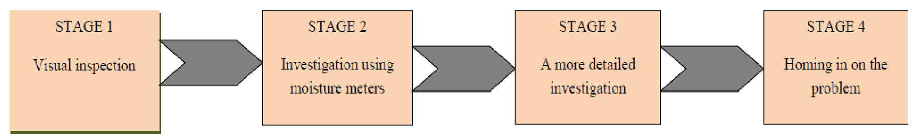

Figure 1. The four stages approach to damp investigation.
The visual investigation stage requires the surveyor to inspect the defect closely and act as a preliminary assessment for further investigation and confirmation of the defect assessed (Burkinshaw et al, 2004). At this stage the identification of a dampness problem is dependent on symptoms such as staining of water, cracking, rotten timber, decay, blisters, etc. and the diagnosis requires knowledge of the behavior of relevant building materials, construction knowledge and knowledge of the use (past, present and future) of the building. At stage 2, the most widely used instrument for the diagnosis of dampness is the moisture meter (Ahmed et al, 2010). The two types of moisture meters in use are resistance meters and capacitance meters. Multi-functional instruments that feature a resistance function, capacitance function, a humidity sensor, an air thermometer, a surface thermometer and deep probe facility are now available on the market. This technique may be used to inspect or observe materials or elements of construction in place without causing alteration, damage or destruction to the fabric of the building (Hamid and Ngah, 2010).
The stage 3 investigation requires a collection of techniques that may be used to inspect or observe materials or elements of construction in place, and it involves causing alteration, damage or destruction to the fabric of the building. Tools or techniques that are used involve cutting pieces of materials, drilling, salt test, carbide meter, electronic-thermo hygrometer and mechanical hygrometer.
Oven drying method which is the most accurate method of determining the moisture content of materials involves taking samples, weighing and drying the samples to constant weight in an oven at a suitable temperature (100°C) and then re-weighing. The dampness is expressed by the weight loss achieved through drying as a percentage of the oven dry weight of material being examined (Ahmed et al, 2010)
In stage 4, destructive tests and examinations that require opening up are conducted. More emphasis is placed on the sampling which aims at confirming moisture conditions within structural elements (primarily walls and floors) by drilling out masonry samples (Burkinshaw et al, 2004).
The decision on where samples are drilled depends on the kind of investigation undertaken and prevailing site conditions (Burkinshaw et al, 2004). A typical investigation could first involve sampling at various positions laterally to confirm a damp zone, followed sometimes by vertical sampling where damp patches extend upwards. A typical stage 4 investigation of an average-sized house with very average moisture conditions could involve drilling 10-12 holes (Burkinshaw et al, 2004).
2.6 Causes of damp
Dampness in buildings gives rise to processes of change in building materials usually with very evident symptoms. In our profession, we often come across chipped plaster, crumbling bricks, corroded metal components and wooden beams which, because of their hydroscopic nature, swell up, crack and rot. Let us consider the various causes of dampness in walls:
- Consideration dampness: This is difficult to evaluate if the materials used in the construction and seasonal in changes in conditions are not known (winter maximum, summer minimum). It is to be found the inside of buildings at certain critical points (corners) or widespread (e.g. north facing walls) with mould in greater or lesser proportions. In order to eliminate this dampness, it is necessary to insulate the wall and ventilate the rooms both naturally and by using forced air. In order to eliminate the mould it is necessary to use disinfectant products mixed in paint or wash the walls with vinegar or bleach (Campian, 2005).
- Descending damp: This generally results from the breakage of drainage piping or defective or poorly made roofing with imperfect sealing of expanding joints. Careful repair and successive regular maintenance should solve all these problems.
- Rising damp: This is the worst type of damp as it always implies much more radical and expensive treatment compared to the others. This type of damp may occur because of water rising from water tables in the ground, from water dispersed in the ground from a faulty or defective water supply or sewerage systems (Campian, 2005).
This problem may be solved by finding the fault and carrying out repairs with care. Regarding this problem, there are several procedures which vary in their effectiveness and duration but which can be carried out to prevent this problem. These procedures can be divided into three approaches: chemical, electro osmotic and physical.
2.7 Elimination of damp
Chemical method
The first stage of this procedure consists of drilling holes in the wall, usually only on one side and up to a certain depth of the wall. Depending on which company carries out the work, either injectors or simple transfusion tubes are used. Resins are then fed into these tubes either under pressure using a suitable pump or simply by gravitational force so that a chemical barrier is created against the capillary rise of dampness and to saturate the treated part (Streza and Câmpian, 2002).
This de-humidification process may meet difficulties if the injected product does not penetrate the affected surfaced uniformly; it must be added that very often the walls to be treated are very old and may have vertical cracks, internal cavities and air spaces which impede the resins injected either by gravity or under pressure, from spreading in a capillary and correctly horizontal way which could jeopardize the entire treatment. Even very few untreated points allow dampness to pass beyond the level of the line of holes. A second chemical method consists of using special plasters which dry out the wall without stopping the capillary rise of damp through the wall but encourages evaporation of the dampness in the wall.
This effect is produced by including progenies in the mixture which create intercommunicating macrospores in the mortar and increase the total evaporation surface area. In the presence of a high rate of rising damp it is possible that an insufficient exchange between the capillary action of the rising damp and the evaporation in walls treated in this wall can occur (Campian, 2005).
This type of plaster could be used together with the de-humidifying chemical barrier technique with holes. We believe that these methods are too recent development to judge their effectiveness over a significant length of time. These procedures must be reapplied after few years (2-5 years), because this is not a definitive solution and the moisture reappears (Streza and Câmpian, 2002).

Electro osmotic system
One of the first procedures of this type consisted of introducing triangular, trapezoidal or round elements of brick, called siphons, into the wall which contained a small copper plate in an internal cavity whose function was to attract the dampness contained in the wall inside the element; water resulting from this process was transferred to the outside because of the inclination of the element itself (Cobîrzan, 2014).
After a period of enormous popularity (several public buildings and churches in Europe still bear the signs of this method) it was completely abandoned as the copper plate corroded and was no longer able to fufil its function.
Another method using this system, mostly used in Switzerland, consists of encircling the entire building with cooper conductor wire connected to probes, also made of cooper, which are inserted at predetermined intervals in the wall to be treated. The line of connection is then tied to iron or cooper pegs which are inserted in the ground so that a difference of potential is created which brings about de-humidification (Sharon, 1994).
Physical Method
It must be started that this is a system which provides a radical solution to the problem of rising damp. Whichever method is chosen, an insulating barrier is created in the cut made at the base of the wall and provides an effective stop to rising damp. There are two main methods used at the present:
Mechanical holes drilling method
In this method a series of holes are made in a line along the wall. The diameter of the hole depends on the type of material to be treated and the type of insulating material to be inserted. A first series of holes is created in a horizontal line at a constant height from ground level and in alternating sections. Silicone resin mortars are inserted into these cut sections. When the resin has hardened, more holes are drilled as before in the parts of the wall which had not been touched. This system is very costly because of the number of holes which have to be drilled (Carmod and Andreson, 2016).
Mechanical cutting system
This method is commonly known as the COMER-RECON Method from the name of the company in Italy, Recon being its representative in Romania, which manufactures patented cutting machines as well as the accompanying products and equipment. It can be used on outside walls made of brick, tinstones, and concrete and expanded clay blocks. It is necessary to use diamond tipped tools on hard rock or stone walls. The first stage consists of removing a certain high of the wall plaster, of the wall to be cut. If the remaining plastering is in very bad condition, it is a good idea to remove it before cutting the wall in order to encourage evaporation of water contained in the wall to be treated and the removal of soluble salts. Cuts sections of lengths varying according to the existing wall structure are made and plastic sheeting is inserted into them (Campian et al, 2015).
These sheets act as a barrier to the rising damp (figure 1). In the lagoon city of Venice, because of the very particular structure in which walls are supported by foundation piles, an insulating barrier is created by inserting polyethylene coated lead sheets into the cut. This type of operation was carried out by Fiat engineering in 1985 during the restoration of Palazzo Grassi in Venice, property of Palazzo Grassi Spa. The use of sheets creates a perfect insulating barrier with excellent dielectric properties, good chemical inertia, and excellent thermal resistance to compression. The normal procedure involves applying mortar to the insulating material.
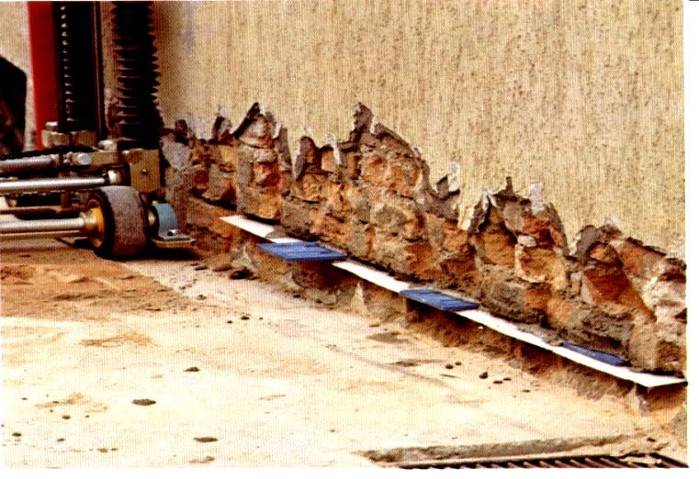
Figure 2 Introduction of anchoring wedges.
Then a number of patented plastic anchoring wedges are inserted in the gap for each wall section which, while they compress the mortar in the cut, secure the insulating material and assure the stability of the wall during the hardening of the saturating mortar.
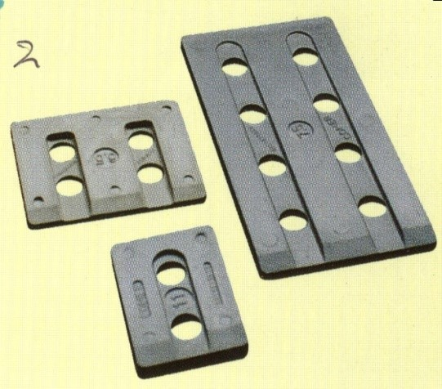
Figure 3 Anchoring wedges.
The wedges are inserted in the gap first. Pre-mixed anti-shrinking mortar is injected into the cut.
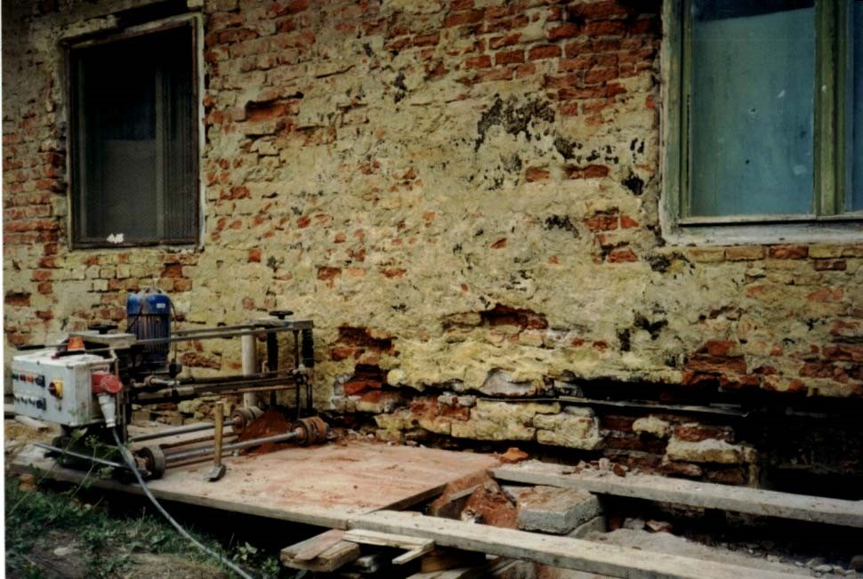
Figure 4 Wall in treatment (Arcalia Castle, Romania).
This penetrates not only the wedge grooves and the cut itself but also any existing cavities in the wall structure, reinforcing it at the base. It is very important to wait until the whole wall has dried out before proceeding to re-plastering. Regarding modalities for this type of operation in seismic areas, in Germany, Austria, Great-Britain, France, Thailand, Czech Republic, Slovakia, Hungary, Spain and Belgium, wall cutting machinery is used regularly. It should not be forgotten that even in new constructions a separating cut is made for the insertion of waterproofing insulating sheaths (so-called wall-cutter product once made of asphalt sheets) between the foundations and the base of the walls which are also used in multi-story buildings and are frequently simply laid without using any type of binder.
2.8 The procedure applied in Romania
In Romania, this procedure was applied with success at many buildings as old ones, historical monuments and even an old castle. These old buildings have become new buildings. An interesting work was made at the Arcadia Castle in Bistrita-Nasaud in 2002.
The castle was in a much-degraded state, but now here it is the Centre of Biological Research oh Babes-Bolyay University, as it can be seen from the next pictures. Nothing has remained from the old state in which the building was before the intervention.
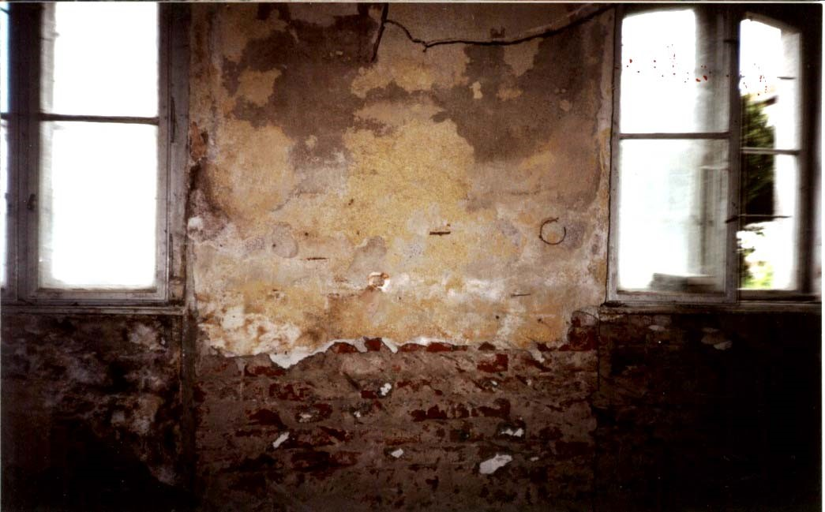
Figure 5 Wall before the treatment (Arcadia Castle, Romania).
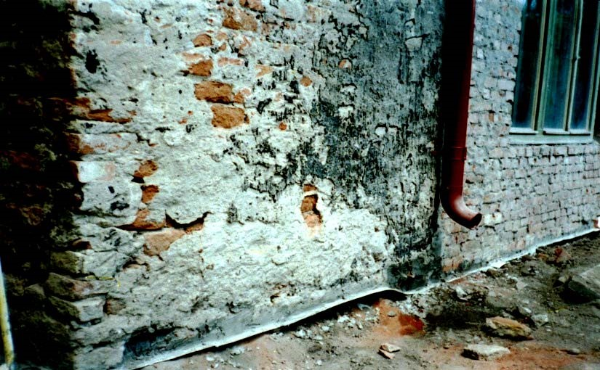
Figure 6 Structural Wall the treatment.
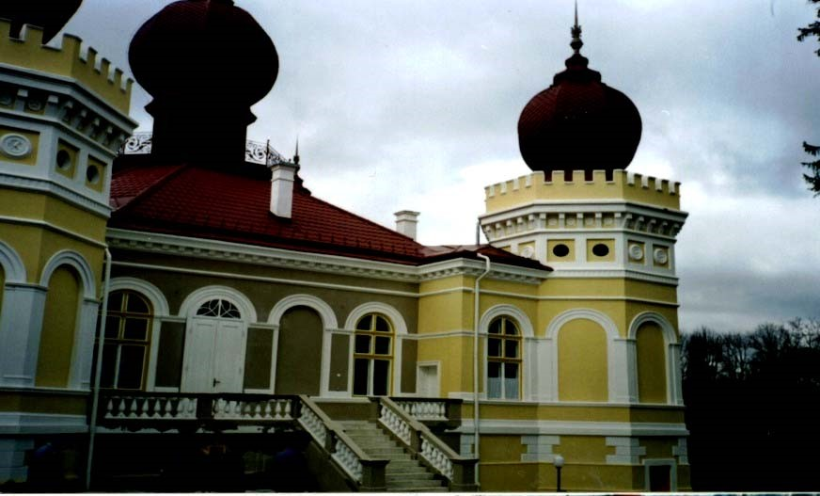
Figure 7 Arcalia Castle today.
Buildings have an expected lifetime of 60 to over 100 years, during which they offer shelter from the weather to human beings, animals and properties. Weather and its variations cause degradation of building materials and structures (www.chalmers.se/.../building). When designing a sustainable building, it is important to take into consideration the location, natural shading, shelter (from storms, etc.) and structural materials (Cukierski, 1999).
This is because certain parameters such as ambient air temperature and humidity, solar radiation, wind, precipitation and ground water cause different processes of deterioration in buildings. Serious environmental problems can also arise where existing buildings have other design problems. A common problem that can result from such conditions is moisture problems. Typical of these moisture problems is rising dampness, a type of dampness which occurs where ground water is conducted up through a masonry wall or a concrete floor slab. Moisture can damage shelving and increase humidity in a building (Cukierski, 1999).
Dampness in buildings is one of the most widespread problems associated with both historic and modern types of buildings (Hetreed, 2008; Karoglou et al., 2007; Burkinshaw & Parrett, 2004). Moisture in general causes damage to the exterior and interior walls of buildings, high heating energy consumption and uncomfortable indoor environment for occupants (Karouglou et al., 2007). The building envelope restoration suffering from moisture problems is one of the critical issues in sustainable refurbishment of buildings (Karouglou et al., 2007).
The transfer of moisture in buildings is a very complex issue and has been a topical issue for decades. Moisture in buildings can cause deterioration of buildings by damaging brick/block work, cause decay and breaking up of mortar joints, fungal attack in timber and corrosion in iron and steel as well as stained wall surfaces internally and externally (Trotman et al., 2004). Damp surfaces encourage the formation of mold, and the spread of mold and mites in conditions of high relative humidity is associated with ill health (World Health Organization, WHO, 2009). Damp conditions also typically affect the mental health of dwelling occupants, causing depression and anxiety, particularly where there is damage to decoration from mold or damp staining (Nicol, 2006). As the most frequently reported cause of building deterioration, dampness in all its forms has assumed an alarming proportion and countries like the United Kingdom, United States of America, Australia, Denmark, Canada, Japan, Estonia, Iceland, Norway, Sweden, Taiwan, etc. have recorded the enormity of the problem (WHO, 2009).
2.9 SUMMARY OF LITERATURE REVIEW
The review was done to understand the concepts of damp, it remote causes as related to building construction, the preventive measures to put in place to avert damp and the various remediation measures were covered in the review of literature.

CHAPTER THREE
RESEARCH METHODOLOGY
3.0 Introduction
This chapter covers the description and discussion on the various techniques and procedures used in the study to collect and analyze the data as it is deemed appropriate
3.1 Research Design
For this study, the survey research design was adopted. The choice of the design was informed by the objectives of the study as outlined in chapter one. This research design provides a quickly efficient and accurate means of assessing information about a population of interest. It intends to study the causes, prevention and treatment of damp on buildings. The study will be conducted in Kwara state.
- Physical inspection of the environment
This involves a thorough examination of the physical space to identify potential hazards (causes and how to prevent damping) in Mandate housing estate. The physical inspection involves integrity of the structures, cleanliness and waste water management in mandate housing estate, Ilorin.
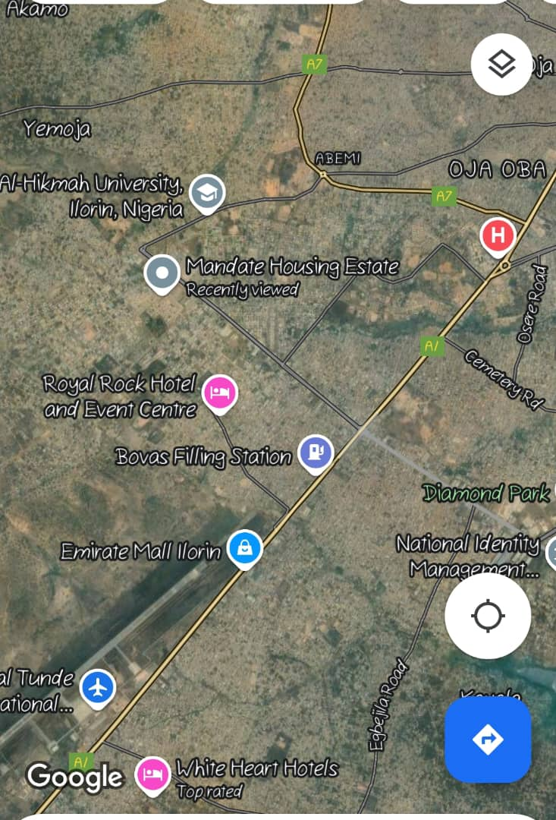
Map of Study Area
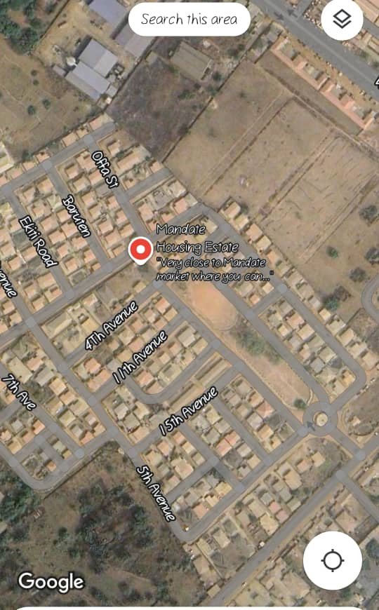

3.2.0 Rainfall amount and intensity
Rainfall amount is the total depth of rain water collected over a period, usually expressed in millimeters per day(mm/day). Rainfall intensity is the rate at which rain falls calculated by dividing the depth of water received by the duration of the shower in hours expressed(mm/hour). This would carry out by collecting data from meteorological station to analyze patterns and intensity that contribute to water damping.
3.2.1 Infiltration capacity of the soil in the area.
This refers to the maximum rate at which soil can absorb water. It is critical parameter in understanding soil ability to manage water, prevent runoff, and maintain water quality. Soil sample from Mandate Adewole Housing Estate will be tested to determine their infiltration rates, which influence water absorption and runoff.
3.2.2 Depth of water in hand dug well
Measurement of water levels in hand dug wells will be taken to access the groundwater table and its influence on rising damp in buildings. And it could be determine by either water level indicator or measuring tape or rope.
3.3.0 Research Design
For this study, the survey research design was adopted. The choice of the design was informed by the objectives of the study as outlined in chapter one. This research design provides a quickly efficient and accurate means of assessing information about a population of interest. It intends to study the causes, prevention and treatment of damp on buildings. The study will be conducted in Kwara state.
3.3.1 Population of the Study
The population for this study were residents in, Mandate Housing Estate area of Ilorin West local government in Kwara State, Nigeria. A total of 50 respondents were selected from the population figure out of which the sample size was determined. The reason for choosing Kwara state is because of its proximity to the researcher.
3.3.2 Sample and Sampling Techniques
The researcher used Taro Yamane’s formula to determine the sample size from the population.
Taro Yamane’s formula is given as;

n = N
1+N (e)²
Where N = Population of study (50)
n = Sample size (?)
e = Level of significance at 5% (0.05)
1 = Constant
.: n = 50 = 50 = 50
1 + 50 (0.05)² 1+50(0.0025) 1+0.125
n = 50 = 44
1.125
The sample size therefore is 44 respondents.
3.4 Research Instrument and Instrumentation
Data for this study was collected from primary and secondary sources. The primary source of data collected was mainly the use of a structured questionnaire which was designed to elicit information on the causes, prevention and treatment of damp on buildings. The secondary source of data collections were textbooks, journals and scholarly materials.
3.5 Validity of Instrument
The instrument of this study was subjected to face validation. Face validation tests the appropriateness of the questionnaire items. This is because face validation is often used to indicate whether an instrument on the face of it appears to measures what it contains. Face validations therefore aims at determining the extent to which the questionnaire is relevant to the objectives of the study.
In subjecting the instrument for face validation, copies of the initial draft of the questionnaire will be validated by supervisor. The supervisor is expected to critically examine the items of the instrument with specific objectives of the study and make useful suggestions to improve the quality of the instrument. Based on his recommendations the instrument will be adjusted and re-adjusted before being administered for the study.

3.6 Reliability of Instrument
The coefficient of 0.81 was considered a reliability coefficient because according to Etuk (1990), a test-retest coefficient of 0.5 will be enough to justify the use of a research instrument.

3.7 Method of Data Collection
This study is based on the two possible sources of data which are the primary and secondary source.
- Primary Source of Data: The primary data for this study consist of raw data generated from responses to questionnaires and interview by the respondents.
- Secondary Source of Data: The secondary data includes information obtained through the review of literature that is journals, monographs, textbooks and other periodicals.
3.7.1 Method of Data Analysis
Data collected will be analyzed using frequency table, percentage and mean score analysis while the nonparametric statistical test (Chi- square) was used to test the formulated hypothesis using SPSS (statistical package for social sciences). Haven gathered the data through the administration of questionnaire, the collected data will be coded, tabulated and analyzed using SPSS statistical software according to the research question and hypothesis. In order to effectively analyze the data collected for easy management and accuracy, the chi square method will be used for test of independence. Chi square is given as
X² = ∑ (o-e)²
e
Where X² = chi square
o = observed frequency
e = expected frequency
Level of confidence / degree of freedom
When employing the chi – square test, a certain level of confidence or margin of error has to be assumed. More also, the degree of freedom in the table has to be determined in simple variable, row and column distribution, degree of freedom is: df = (r-1) (c-1)
Where; df = degree of freedom
r = number of rows
c = number of columns.
In determining the critical chi _ square value, the value of confidence is assumed to be at 95% or 0.95. a margin of 5% or 0.05 is allowed for judgment error.

CHAPTER FOUR
DATA ANALYSIS AND INTERPRETATION
4.0 Introduction
This chapter deals with the presentation and analysis of the result obtained from questionnaires. The data gathered were presented according to the order in which they were arranged in the research questions and simple percentage were used to analyze the demographic information of the respondents while the chi square test was adopted to test the research hypothesis.
4.1 physical inspection of the area.
The inspection revealed that 55% of building showed signs of water damping, including wall discoloration and mold. And below is some picture of buildings affected by damping in mandate Adewole housing estate, Ilorin Kwara State.
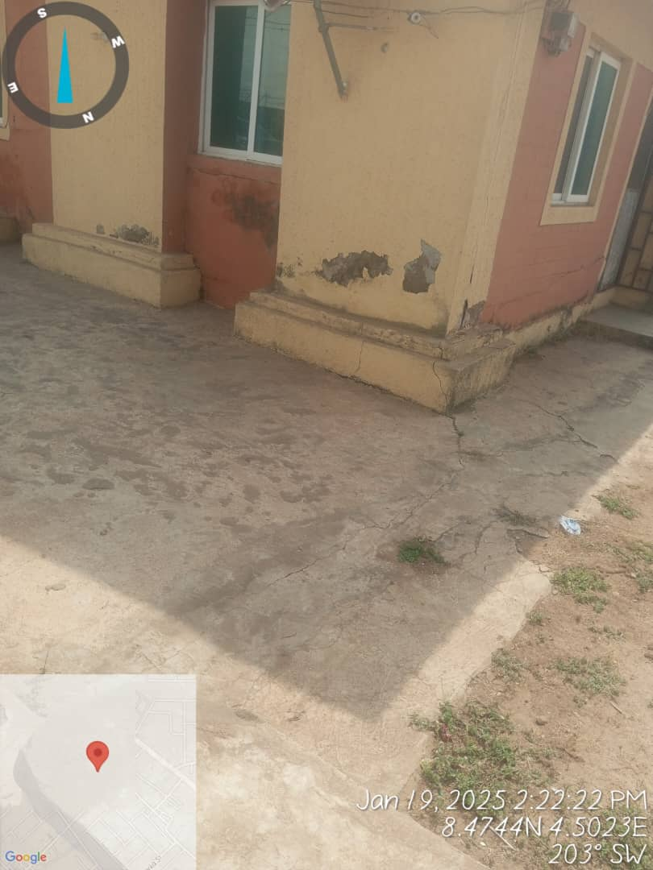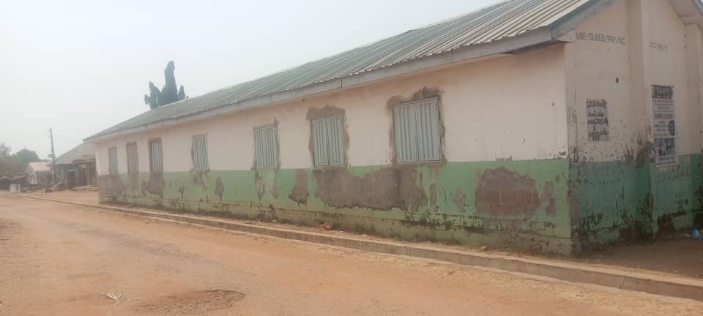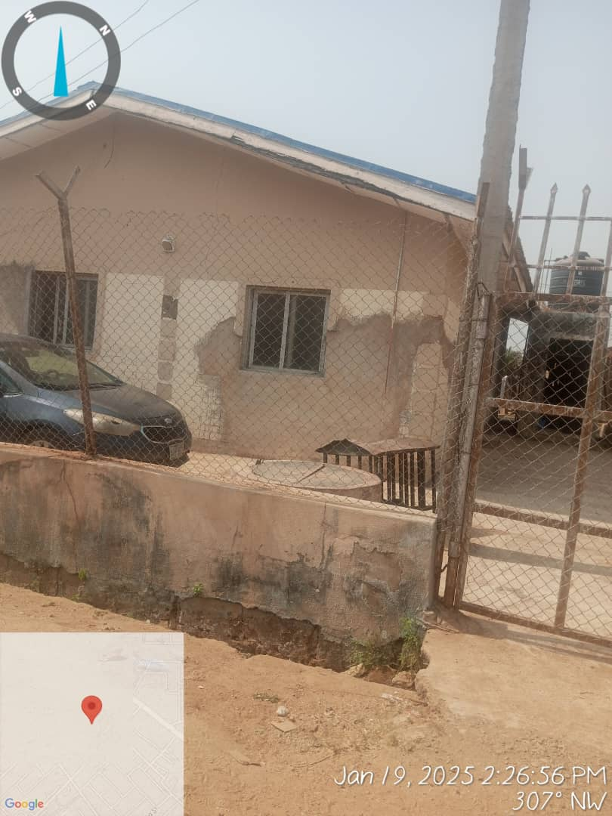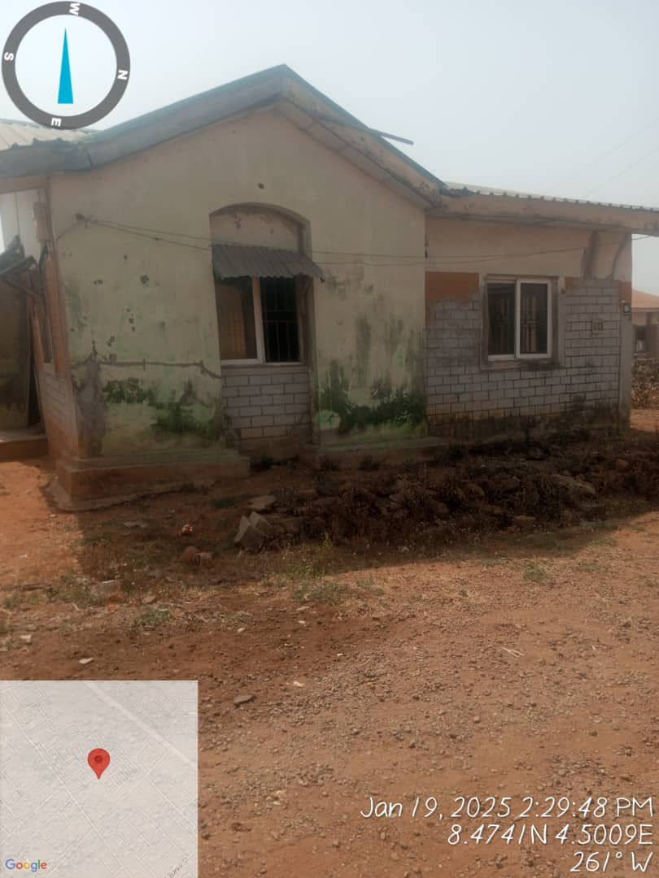
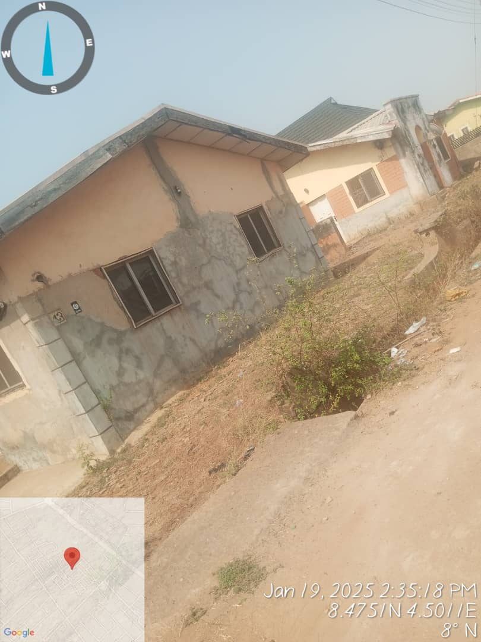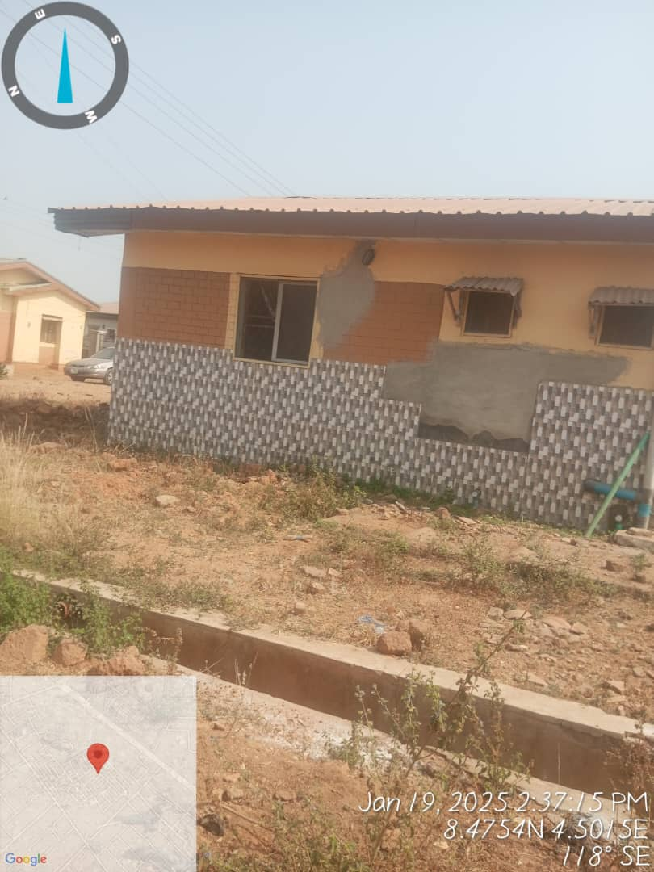
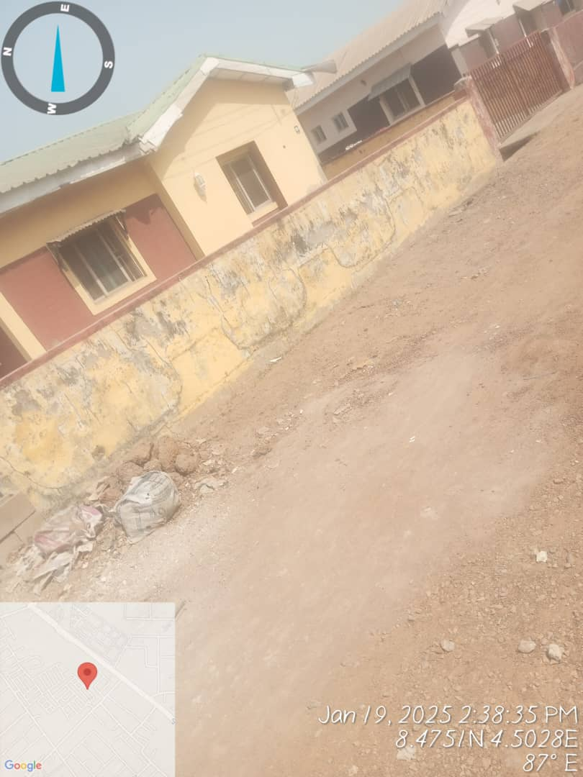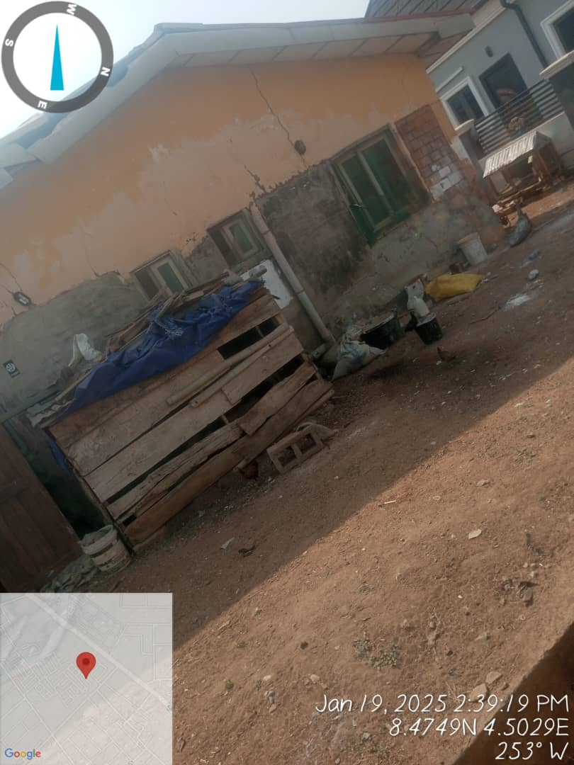

The height of the damp wall above DPC is vary on different building.
Building Location | Height of Damp wall Above DPC (meters)
Building A | 0.40m
Building B | 1.20m
Building C | 1.80m
Building D | 2.00m
Building E | 2.10m

4.2. Analysis of Demographic Data of Respondents
Table 1: Gender of Respondents

 |  | Frequency | Percent | Cumulative Percent
Valid | Male | 65 | 65.0 | 65.0
Valid | Female | 35 | 35.0 | 100.0
Valid | Total | 100 | 100.0
Source: Field Survey.

Table1 above shows the gender distribution of the respondents used for this study. Out of the total number of 100 respondents, 65respondents which represent 65.0percent of the population are male. 35 which represent 35.0 percent of the population are female.

Table 2: Age range of Respondents
 |  | Frequency | Percent | Cumulative Percent
Valid | 20-30years | 15 | 15.0 | 15.0
Valid | 31-40years | 10 | 10.0 | 25.0
Valid | 41-50years | 25 | 25.0 | 50.0
Valid | 51-60years | 20 | 20.0 | 70.0
Valid | above 60years | 30 | 30.0 | 100.0
Valid | Total | 100 | 100.0
Source: Field Survey.
Table 2 above shows the age grade of the respondents used for this study. Out of the total number of 100 respondents, 15 respondents which represent 15.0percent of the population are between 20-30years. 10respondents which represent 10.0percent of the population are between 31-40years. 25respondents which represent 25.0percent of the population are between 41-50years. 20respondents which represent 20.0percent of the population are between 51-60years. 30respondents which represent 30.0percent of the population are above 60years.

Table 3: Category of Respondent
 |  | Frequency | Percent | Cumulative Percent
Valid | Architect | 20 | 20.0 | 20.0
Valid | Civil Engineer | 15 | 15.0 | 35.0
Valid | Contractor  Civil Servant | 25  40 | 25.0  40.0 | 60.0  100.0
Valid | Total | 100 | 100.0
Source: Field Survey
Table 3: shows the category of respondents used for the study. 25 respondents representing 25.0perrcent of the population under study are Architect. 15 respondents representing 15.0percent of the population under study are Civil Engineer. 25 respondents representing 25.0perrcent of the population under study are Contractor while 40 respondents representing 40.0perrcent of the population under study are unemployed.

4.2.1 Analysis of Psychographic Data
Table 4: Water is major causes of damp on buildings
 |  | Frequency | Percent | Cumulative Percent
Valid | Strongly agree | 30 | 30.0 | 30.0
Valid | Agree | 42 | 42.0 | 72.0
Valid | Undecided | 10 | 10.0 | 82.0
Valid | Disagree | 10 | 10.0 | 92.0
Valid | Strongly disagree | 8 | 8.0 | 100.0
Valid | Total | 100 | 100.0
Source: Field Survey.
Table 4. shows the responses of respondents if there are causes of damp on buildings. 30 respondents representing 30.0percent strongly agreed that there are causes of damp on buildings. 42 respondents representing 42.0percent agreed that there are causes of damp on buildings. 10 respondents representing 10.0 percent were undecided. 10 respondents representing 10.0percent disagreed that there are causes of damp on buildings. 8 respondents representing 8.0percent strongly disagreed that there are causes of damp on buildings.

Table 5: Water Damps on buildings has a significant effect on the buildings and the environment
 |  | Frequency | Percent | Cumulative Percent
Valid | Strongly agree | 10 | 10.0 | 10.0
Valid | Agree | 15 | 15.0 | 25.0
Valid | Undecided | 5 | 5.0 | 30.0
Valid | Disagree | 40 | 40.0 | 70.0
Valid | Strongly disagree | 30 | 30.0 | 100.0
Valid | Total | 100 | 100.0
Source: Field Survey.
Table 5: show the responses of respondents if damps on buildings has a significant effect on the buildings and the environment. 10 of the respondents representing 10.0percent strongly agree that damps on buildings has a significant effect on the buildings and the environment. 15 of the respondents representing 15.0percent agree that damps on buildings has a significant effect on the buildings and the environment. 5 of them representing 5.0percent were undecided. 40 of the respondents representing 40.0percent disagree that damps on buildings has a significant effect on the buildings and the environment. 30 of the respondents representing 30.0percent strongly disagree that damps on buildings has a significant effect on the buildings and the environment.

Table 6: Fixings drainage and plumbing problems, preventing damp on buildings
 |  | Frequency | Percent | Cumulative Percent
Valid | Strongly agree | 60 | 60.0 | 60.0
Valid | Agree | 25 | 25.0 | 85.0
Valid | Undecided | 10 | 10.0 | 95.0
Valid | Disagree | 5 | 5.0 | 100.0
Valid | Total | 100 | 100.0
Source: Field Survey.
Table 6. show the responses of respondents if sanitation is a treatment of preventing damp on buildings. 60 of the respondents representing 60.0percent strongly agree that sanitation is a treatment of preventing damp on buildings. 25 of the respondents representing 25.0percent agree that sanitation is a treatment of preventing damp on buildings. 10 of them representing 10.0percent were undecided. 5 of the respondents representing 5.0percent disagree that sanitation is a treatment of preventing damp on buildings.

Table 7: Replastering damps area treat damp on buildings?
 |  | Frequency | Percent | Cumulative Percent
Valid | Strongly agree | 25 | 25.0 | 25.0
Valid | Agree | 28 | 28.0 | 53.0
Valid | Undecided | 13 | 13.0 | 66.0
Valid | Disagree | 24 | 24.0 | 90.0
Valid | Strongly disagree | 10 | 10.0 | 100.0
Valid | Total | 100 | 100.0
Source: Field Survey.

Table 7: shows the responses of respondents if surface treatment prevents damp on buildings. 25 of the respondents representing 25.0percent strongly agree that surface treatment prevents damp on buildings. 28 of the respondents representing 28.0percent agree that surface treatment prevents damp on buildings. 13 of the respondents representing 13.0percent were undecided. 24 of the respondents representing 24.0percent disagree that surface treatment prevents damp on buildings. 10 of the respondents representing 10.0percent strongly disagree that surface treatment prevents damp on buildings.

Table 10: Usage of land-drains treats damp on buildings
 |  | Frequency | Percent | Cumulative Percent
Valid | Strongly agree | 65 | 65.0 | 65.0
Valid | Agree | 30 | 30.0 | 95.0
Valid | Disagree | 3 | 3.0 | 98.0
Valid | Strongly disagree | 2 | 2.0 | 100.0
Valid | Total | 100 | 100.0
Source: Field Survey.
Table 10 show the responses of respondents if usage of land-drains treats damp on buildings. 65 of the respondents representing 65.0percent strongly agree that usage of land-drains treats damp on buildings. 30 of the respondents representing 30.0percent agree usage of land-drains treats damp on buildings. 3 respondents representing 3.0percent were undecided. 3 of the respondents representing 3.0percent disagree that usage of land-drains treats damp on buildings. 2 of the respondents representing 2.0percent strongly disagree that usage of land-drains treats damp on buildings.

4.2.2 Rainfall Analysis.
Rainfall is the essential for understanding the impact of water on dampness in buildings, as excessive or poorly managed rainfall can lead to water infiltration and damp issues.
Some factor to consider for rainfall analysis in relation to dampness.
1. Rainfall data collection.
- Source: Historical rainfall data obtained from meteorological agencies or relevant research in Ilorin.
- Parameter: Analyze daily, monthly, and annual rainfall dada, focusing on:
a. Total rainfall (mm)
b. Intensity (mm/hr)
2. Rainfall runoff relationship
- Assess how rainfall interacts with landscape and soils.
- High intensity storms may cause surface runoff, leading to water damping near structure.
- Poor drainage systems exacerbate water accumulation and dampness issues.
3. Soil infiltration analysis
- Examine soil infiltration rates (as discussed earlier).
- Soils with low infiltration infiltration capacity (e.g, clayey soils) are prone to waterlogging and damp problems.
4. Building vulnerabilities.
- Roof: Leaks or inadequate drainage system
- Wall: Poorly sealed walls or rising damp from the foundation.
- Basement: Poor waterproofing or drainage around the structure.
5. Seasonal Analysis
- Damp problems are often worse during rainy seasons. Analyze seasonal patterns of rainfall to predict periods of high risk.
Rainfall intensity in Ilorin averages 1,200mm annually, with peak periods during April to October. The high rainfall contributes significantly to water ingress in buildings.
Month | Rainfall amount (mm) | Intensity(mm/h)
January | 1.46 | 1.46
February | 12 | 6
March | 41 | 8.2
April | 93 | 0.33
May | 141 | 9.4
June | 163 | 9.59
July | 144 | 8.47
August | 136 | 8.5
September | 224 | 11.79
October | 361 | 9.71
November | 17 | 17
December | 7 | 7
Total 1340.46

4.3 Soil infiltration Capacity.
The soil infiltration test indicated a low infiltration rate of 3mm/hr, suggesting poor drainage condition and increased surface water runoff.
Sample Location | Infiltration Rate (mm/hr) | Soil Type
Area A | 3.0 | Clayey
Area B | 4.5 | Sandy loam

4.4 Groundwater Level
The average water depth in wells was found to be 6 meters, with variations depending on proximity to drainage systems and topography. High groundwater levels were linked to rising damp in low-lying areas.
Well ID | Depth(m) | Location
Well 1 | 5.5 | Low-lying area
Wall 2 | 6.5 | Elevated area

4.5 Test of Hypothesis
Hypothesis I
H₀: There is no effect of damp on buildings in mandate estate area of Ilorin West local government in Kwara state.
H_{i}: There is an effect of damp on buildings in mandate estate area of Ilorin West local government in Kwara state.

Level of significance: 0.05
Decision rule: reject the null hypothesis H₀ if the p value is less than the level of significance. Accept the null hypothesis if otherwise.
Table 11 Test Statistics
 | There is an effect of damp on buildings in mandate estate area of Ilorin West local government in Kwara state.
Chi-Square | 105.520ª
Df | 3
Asymp. Sig. | .000
a. 0 cells (.0%) have expected frequencies less than 5. The minimum expected cell frequency is 25.0.

Conclusions based on decision rule:
Since the p-value= 0.000 is less than the level of significance (0.05), we reject the null hypothesis and conclude that there is an effect of damp on buildings in mandate estate area of Ilorin West local government in Kwara state.

Hypothesis II
H₀: There are no measures for preventing the damp in order to improve the life span of the buildings in mandate estate.
H_{i}: There are measures for preventing the damp in order to improve the life span of the buildings in mandate estate.
Level of significance: 0.05
Decision rule: reject the null hypothesis H₀ if the p value is less than the level of significance. Accept the null hypothesis if otherwise.
Table 12 Test Statistics
 | There are measures for preventing the damp in order to improve the life span of the buildings in mandate estate.
Chi-Square | 70.347ª
Df | 2
Asymp. Sig. | .000
a. 0 cells (.0%) have expected frequencies less than 5. The minimum expected cell frequency is 25.0.

Conclusions based on decision rule:Since the p-value= 0.000 is less than the level of significance (0.05), we reject the null hypothesis and conclude that there are measures for preventing the damp in order to improve the life span of the buildings in mandate.

CHAPTER FIVE
SUMMARY, CONCLUSION AND RECOMMENDATIONS
5.1 SUMMARY OF FINDINGS
The objectives of the study were to;
- To identify the effects of damp on buildings in mandate estate area of Ilorin West local government in Kwara state.
- To measures for preventing the damp in order to improve the life span of the buildings in mandate.
- To proffer the proper treatment to the buildings that are affected by damp in mandate.
Findings from the study revealed that majority of the respondents were of the opinion that there is an effect of damp on buildings in mandate estate area of Ilorin West local government in Kwara state. And that there are measures for preventing the damp in order to improve the life span of the buildings in mandate.
5.2 CONCLUSION
The study identified heavy rainfall, low soil infiltration capacity, and high groundwater levels as primary causes of water damping in Mandate Adewole Housing Estate. Poor construction further exacerbated the issue.
With correct maintenance, repair and adequate ventilation, traditional buildings can be kept dry and healthy. To address damp problems the source of the moisture must be identified and addressed before other works are considered. With the right approach and correct use of materials the removal of internal linings is not normally required to enable drying. Treatments suggested for use in modern construction are often not appropriate for traditionally constructed buildings and may cause further problems.
5.3 RECOMMENDATIONS
- Install proper drainage systems like guttering and ensure runoff is directed away from structure.
- use high quality waterproof material for walls, roofs, and basement, during construction.
- improve ventilation in buildings to reduce moisture level and internal dampness.
- Builders should use raft foundation mostly in waterlogged area.
- Builders should do proper concrete mix ratio and fine aggregates which helps to make concrete impervious.
- Adequate concrete thickness should be done by the builders.

REFERENCES
Burkinshaw, R. and Parrett, M. 2004. Diagnosing Damp. Coventry, UK: Rics–Royal Institution of Chartered Surveyors Books.
Halim, A. A., Harun, S. N. and Hamid, Y. 2012. Diagnosis of dampness in conservation of historic buildings. Journal Design Built. 5(1):1-11.
Agyekum, K., Ayarkwa, J., Koranteng C. and Adinyira, E. 2013. Preliminary assessment of dampness in walls of residential buildings in four climatic zones in Ghana.Journal of Sustainable Development. 6(9):51-61.
Rirsch, E. and Zhang, Z. 2010. Rising Damp in Masonry Walls and the Importance of Mortar Properties. Construction and Building Materials. 24 (1):1815-1820.
Rirsch, E., MacMullen, J., and Zhang, Z. 2011. Evaluation of mortar samples obtained from UK houses treated for rising damp. Construction and Building.
Agrement tehnic nr.007-03/051-1999 – S.C. RECON SRL, Cluj-Napoca, privind metoda de eliminare a umiditatii din pereti de caramida ai cladirilor, INCERC Cluj.

T. Streza, Cr. Câmpian, 2002 Tehnologia COMER de eliminare a umiditatii din ziduri, 26-28 aprilie, „SIBSTIL 2002”, Sibiu.
C. Campian, 2005 Methods for elimination of dampness in old masonry building walls, Traditional Craft in 21 st Century Architecture“, Conference Proceedings ISBN 83-9219030-0, Szczecin University of Technology, Poland, pag 195-201.

C. Campian, Z. Nagy, M. Pop, P. Pernes, 2015 Sustainable Buildings – 5th International U.A.B. – B.E.N.A. Conference, Alba Iulia 28-30 Mai, pp.46.

N. Cobîrzan, S. Palacean, 2014 Making existing building accessible, Meditech, Springer Publishing Company, DOI 10.1007/978-3-319-07653-9_1, ISBN 10.1007/978-3-31907653-9_1, Volume 4, pp 1-6.

J. Carmody, B. Andreson, 2016 Moisture in basements: causes and solutions, University of Minnesota.

C. Sharon Park, 1994 Moisture in Historic Buildings and Preservation Guidance, ASTM Manual Series, MNL 18 Febr., ASTM Publication Code Number 28-0018094-10.

N. Moyer, D. Beal, D. Chasar, J. McIlvaine, Moisture Problems in Manufactured Housing, Florida Solar Energy Center, Publication Number FSEC-GP-212-01.
Materials.25 (2): 2845-2850.
Lourenco, P.B., Luso, E. and Almeida, M.G. 2006. Defects and moisture problems in buildings from historical city centres: A case study in Portugal.Building and Environment. 41(2): 223-234.
Young, D. 2008. Salt attack and rising damp: A guide to salt damp in historic and older buildings. Heritage Council of NSW-Heritage Victoria,-South Australia.
Young, E.M. 2007. Dampness penetration problems in granite buildings in Aberdeen, UK: Causes and Remedies. Construction and building materials, 20(2):1846-1859.
Oxley, T.A. and Gobert, E.G. 1989. Dampness in buildings, 2ndedn, Oxford: Butterworth Heinemann, Revised.
Alfano, G., Chiancharella, C., Cirillo, E., Fato, I. and Martellotta, F. 2006. Long-term performance of chemical damp proof courses: Twelve years of laboratory testing. Building and Environment. 41 (2): 1060-1069.
Burkinshaw, R. 2009. Remedying Damp. Coventry, UK: Rics–Royal Institution of Chartered Surveyors Books.
Burkinshaw, R. 2011. Rising damp: Part 1, Case study examples and the Lambeth Pier Test: How to isolate ground-sourced rising damp by the ‘Burkinshaw Test Method’. Journal of Building Survey, Appraisal and Valuation, 1(1): 1-15.
Franzoni, E. 2014. Rising damp removal from historical masonries: A still open challenge. Construction and Building Materials. 54(1): 123-136.
Baker, P.H., Bailly, D., Campbell, M., Galbraith, G.H., McLean, R.C., Poffa N. and Sanders, C. 2007. The application of X-ray absorption to building moisture transport studies. Measurement. 40 (1): 951– 959.
I’Anson S.J. and Hoff, W.D. 1986. Water movement in porous building materials – VIII. Effects of evaporative drying on height of capillary rise equilibrium in walls. Build Environ 21(1):195–200.
Ahmed, A.G. and Abdul Rahman, F. 2010. Treatment of Salt Attack and Rising Damp in Heritage Buildings in Penang, Malaysia. Journal of Construction in Developing Countries. 15(2): 93-113
Burkinshaw, R. 2012. Rising damp: Part 1, Case Study Examples and the Lambeth Pier Test: How to Isolate Ground-Sourced Rising Damp by the ‘Burkinshaw Test Method’. Journal of Building Survey, Appraisal and Valuation. 1(1): 1-15.
Hamid, Y. and Ngah, S. 2010. Assessment of Dampness Problems in the Higher Education Institution Building, 12th International Surveyor’s Congress (Reaching 50 and Surveying Ahead), Hotel Istana, Kuala Lumpur, 17-18June 2010.
Carillion, S. 2001. Defects in Buildings: Symptoms, investigations, diagnosis and cure. United Kingdom, The Stationary Office.
Borrelli, E. 1999. Salts. Conservation of Architectural heritage, historic structures and materials. Arc. Laboratory handbook, ICCROM.
Burkinshaw, R. 2010. The rising damp tests of Camberwell Pier: Potential height of moisture rise in brickwork and the effectiveness of a modern chemical injection cream damp coursing application. Journal of Building Appraisal. 6(1): 5-19.
Agyekum, K., Ayarkwa, J. and Adinyira, A. 2014. A holistic survey of dampness in a three-bedroom residential bungalow in Kumasi, Ghana. Case Studies in Construction Materials. 1(1): 125-137.
Agyekum, K. and Ayarkwa, J. 2014. A two-stage approach to damp investigation in a three-bedroom residential building in Kumasi, Ghana. Journal of Building Performance. 5(1): 50-61.
Agyekum, K., Ayarkwa, J. and Koranteng, C. (2014). A holistic survey of dampness in a six-bedroom residential apartment. Journal of Science and Technology. 34(1): 30-45.
Bucea L., Sirivivatnanom V. and Khatri R. 2005. Building Materials Deterioration due to Salt Attack; Laboratory Experimental Program, Internal Technical Report, CSIRO Manufacturing and Infrastructure Technology.

APPENDIX I
QUESTIONNAIRE
INSTRUCTION: Please endeavor to complete the questionnaire by ticking the correct answer (s) from the options or supply the information where necessary.
Section A: General information
- Age:
- 20-30
- 31-40
- 41-50
- 51-60
- Above 60
- Profession:
- Architect
- Civil Engineer
- Contractor
- Property Owner
- Others(Please specify)
- Years of Experience in Building Construction/Maintenance
- Less than 5 years
- 5-10 years
- More than 10 years

Section B: Causes of water damping
- in your experience, what are the common causes of water damping in building? (check all that apply)
- poor drainage system
- defective roofing
- high ground water level
- poor construction materials
- faulty plumbing
5 How frequently do you encounter water damping issues in buildings?
- Very frequently
- Occasionally
- Rarely
- Never
6 At which part of the building have you noticed water damping most frequently?
- Walls
- Floors
- Roof
- Foundation
- Other (please specify)_____________________

7. On a scale of 1-5, how significant is the role of improper maintenance in causing water damping.
- 1 (Not significant)
- 2
- 3
- 4 (Highly significant)
Section C: Prevention of water damping.
8. What measures do you believe can effectively prevent water damping? (Select all that apply)
- Use of quality waterproofing materials
- Proper site drainage system
- Regular maintenance and inspection
- Proper ventilation in the building

9. Have you implemented any of these preventive measures in your building?
- Yes
- No
10. If yes, which measure have been most effective?
_______________________________________

Section D: Treatment of water damping
11. How do you usually treat water damping issues when they occur?
a. Replastering damp areas.
b. Applying waterproof coatings
c. Fixing drainage and plumbing problems.
d. Other (please specify):
_________________

12. What challenges do you face in treating water damping in buildings? (select all that apply)
a. High cost of treatment
b. Lack of technical expertise
c. Difficulty identifying the root cause.
d. Recurrence of the issue

