DEVELOPMENT OF E-CLEARANCE SYSTEM FOR THE FINAL YEAR STUDENT
(A CASE STUDY OF KWARA STATE POLYTECHNIC, ILORIN)

By:

OLUWADARE OLUWASOLA TEMITOPE
ND/23/COM/PT/0377

A Project Submitted to the
Department of Computer Science,
Institute of Information and Communication Technology
Kwara State Polytechnic, Ilorin

In Partial Fulfillment of the Requirements for the award of National Diploma (ND) in Computer Science

July, 2025
CERTIFICATION
This is to certify that this project was carried out by OLUWADARE OLUWASOLA TEMITOPE with matriculation number ND/23/COM/PT/0377 as part of requirement for the award of National Diploma (ND) in the department of Computer Science.

------------------------------------- ----------------------
Akanbi, M. B. (Mrs.) Date
(Project Supervisor)

--------------------------------- ----------------------
MR OYEDEPO F.S. Date
(Head of Department)

----------------------------------- ---------------------
External Supervisor Date

DEDICATION
I dedicate this project to Almighty God who's protect me, guide me through this work a big thanks to Almighty God.

ACKNOWLEDGMENT
All praise is due to Almighty God for His grace, guidance, and strength throughout the course of this project. I am profoundly grateful to numerous individuals and institutions whose support and contributions were vital to the successful completion of this work.
Foremost, I extend my sincere appreciation to Akanbi, M. B. (Mrs.) whose exceptional guidance, expertise, and unwavering support were instrumental in navigating the complexities of this research. His valuable insights and constructive feedback greatly shaped the direction and quality of this project. I am deeply thankful to my parents, Mr. and Mrs. Oluwadare, for their constant encouragement, prayers, and moral support throughout this journey. Their words of wisdom and emotional backing kept me focused and motivated during challenging periods. My heartfelt appreciation also goes to my entire family and friends, whose patience and uplifting presence provided strength and inspiration at every stage of this endeavor.
I would also like to acknowledge the Head of the Department of Computer Science, Mr. Oyedepo F. S., along with other dedicated staff members of the department. Their insightful critiques and academic support were invaluable in refining the scope and content of this work.
Lastly, I am sincerely grateful to all the participants and respondents who willingly provided their time, data, and perspectives for this research. Their contributions played a crucial role in the empirical validation and practical relevance of this study.

ABSTRACT
Computer Software Based online clearance system is an internet base research work that will help build an effective information management for schools. It is aimed at developing a computer software system that replaces the manual method of clearance for graduating students. The designed software will serve as a more reliable and effective means of undertaking students clearance, remove all forms of delay and stress as well as enable you to understand the procedure involved, as well as how to do your clearance online. This project work makes use of data collection from the university, materials and journals from various authors and the software was developed to effectively achieve the aim of the project. In this project. The aim of this project is to design and develop an online student’s clearance system using PHP and MySQL that will eliminate the delays in the manual process and create a central repository for students to be cleared. It will be implemented as a web-based application which will be a central repository for clearing students. The main modules of clearance system are Main Module, Clearance Registration, Cleared/ Not Cleared and Administer. The user is created and managed by the Systems Administrator using the Administer module
TABLE OF CONTENTS
TITLE PAGE PAGE
CERTIFICATION ii
DEDICATION iii
ACKNOWLEDGEMENT iv
LIST OF FIGURES v
LIST OF TABLES vi
ABSTRACT vii
TABLE OF CONTENTS viii
CHAPTER ONE: GENERAL INTRODUCTION
1.1. BACKGROUND TO THE STUDY 1
1.2 STATEMENT OF THE PROBLEM 1.
1.3 AIM AND OBJECTIVES 3
1.4 SIGNIFICANCE OF THE STUDY 4
1.5 SCOPE OF THE STUDY 5
1.6 DEFINITIONS OF TERMS 6
CHAPTER TWO: LITERATURE REVIEW
2.1 REVIEW OF RELATED WORK 7
2.2 TECHNOLOGY ENHANCE COMPUTER SOFTWARE BASED ONLINE CLEARANCE SYSTEM 8
2.3 COMPUTER-BASED ONLINE INFORMATION SYSTEM 10
CHAPTER THREE: RESEARCH METHODOLOGY AND ANALYSIS OF THE EXISTING SYSTEM
3.1 RESEARCH METHODOLOGY 12
3.3 ANALYSIS OF THE EXISTING SYSTEM 13
3.3 PROBLEMS OF THE EXISTING SYSTEM 14
3.4 DESCRIPTION OF THE PROPOSED SYSTEM 14
3.5 ADVANTAGES OF THE PROPOSED SYSTEM 15
CHAPTER FOUR: DESIGN AND IMPLEMENTATION OF THE SYSTEM
  - DESIGN OF THE SYSTEM 16
4.1.1. OUTPUT DESIGN 16
    - INPUT DESIGN 17
4.1.3. DATABASE DESIGN 18
4.1.4. PROCEDURE DESIGN 19
4.2. IMPLEMENTATION OF THE SYSTEM 19
4.2.1. CHOICE OF PROGRAMMING LANGUAGE 19
4.2.2 HARDWARE SUPPORT 20
4.2.3 SOFTWARE REQUIREMENTS 20
4.2.4 CHANGE OVER TECHNIQUE 20
4.3 DOCUMENTATION OF THE SYSTEM 21
4.3.1 PROGRAM DOCUMENTATION 21
4.3.2 OPERATING THE SYSTEM 22
4.3.3 MAINTAINING THE SYSTEM 22
CHAPTER FIVE: SUMMARY, CONCLUSION AND RECOMMENDATION
5.1 SUMMARY 24
5.2 CONCLUSION 24
5.3 RECOMMENDATION 25
REFERENCES
APPENDIX 1: SIGN UP 28
APPENDIX 2: FORM TO ENROLL RECORD 29
APPENDIX 3: REGISTERED PATIENTS FORM 30
APPENDIX 4: SOURCE CODE 31

CHAPTER ONE
GENERAL INTRODUCTION
  - BACKGROUND OF THE STUDY
The internet has change the face of the world and make receiving and sending of information spread widely and easily, this can be done at the tips of peoples hand and without wasting any time. Compared to when internet has not evolved, before information could be received another end, it takes time depending on the distance of the journey.
According to Adesanya, (2022), The Internet is a global collection of many types of computers and computer networks that are linked together. It is increasingly becoming the solution to many information, problems, information exchange, and marketing.
According to Awuzie (2021) Clearance is the process of determining and negotiating any permission that are needed to include the use of someone else’s intellectual property in creative project. Clearance systems for graduating students are vital incessant procedures and process in every University or high institution that is inevitable. The clearance must be carried out so as to check if the student is eligible to go for NYSC service and not owning the school anything. It is the polytechnic practice to carry out these processes at the completion of the last exam in school, where the student did not have any carryover left.
Online clearance system is a web base system which makes use of the internet. Nigerian Army Institute of Technology and Environmental Studies (NAITES) current method of clearance is not internet base which increase the stress of student going from school to school to sign the forms. The form given to student must be signed by the following; Dean of all school, University Liberian, Head of department, Sport official, Dean of student affair.
Thus the need of a web based clearance system for graduating student is inevitable to save the time and the cost of transportation from one location to another.
The term "clearance” is also sometimes used in private organizations that have a formal process to vet employees for access to sensitive information. A clearance by itself is normally not sufficient to gain access; the organization must determine that the cleared individual has a "need to know" the information. No one is supposed to be granted access to classified information solely because of rank or position, but once a clearance is obtained, access to certain information or gain of freedom will be granted.
The quick development of electronic management systems has made administrative functions more efficient and effective by saving information in digital form. Graduating students and staff can use the electronic clearing system to achieve their final year clearance swiftly and conveniently (Alroobaea, 2021). Clearance is an important compulsory document giving permission to the students who have graduated from their respective schools or polytechnics (Agbo-Ajala, and Makinde, 2020).

  - STATEMENT OF THE PROBLEM
A final year enhanced e-clearance system is an online based system that allows graduating students do their final year clearance electronically or online (Chen and Yang, 2020). This system is an alternative to the usual manual or traditional approach. It permits the graduating students to do his/her clearance with the saved information in the database against their individual’s account (Bharamagoudar, et al., 2021). There is need for web-based methods of keeping data more so a greater need for graduating students e-clearance system (Sandeep, et al., 2022). This proposed system would go a long way in alleviating the various problems involved in the automated process.

  - AIM AND OBJECTIVES
The aim of this research work is to develop an electronics clearance system for the final year student. The objectives of this project are to:-
- Design an electronics clearance system.
- Implement electronics clearance system in (i) using PHP, and MySQL as backend
- Verify each graduating students electronically using above implemented electronics clearance system

  - SIGNIFICANCE OF THE STUDY
The project work will help in a good number of ways to ease the queuing system in the institution as the online clearance system will help student to achieve whatever they want to achieve without coming to the various offices for clearance. Clear advantages of internet information processing over those of traditional manual system are higher yields. Online clearance system allows the users to check their clearance status as whether they are in any way indebted to the school, fill and submit their clearance form, and obtain their clearance letter.
1.5 SCOPE OF THE STUDY
This project work is to develop a computer software based online clearance system for doing clearance for graduating students of Kwara State Polytechnic, Ilorin. The software development will be carried out using PHP, and MySQL to manage both the database and at the same time make the software online.

  - ORGANIZATION OF REPORT
Chapter one contains the background to the project, statement of the problem, the aim and objectives, significance of the study, justification of the study, scope of the study, and organization of the report. Chapter two entails the review of related past work and related work of proposed system.
More so, chapter three examines the method of the proposed system, the, the description and advantages of proposed system. Chapter Four, explains the implementation and documentation of the system which contains design, implementation techniques, documentation, hardware and software requirements. Lastly, chapter five includes the summary, conclusions and recommendations.
  - DEFINITION OF TERMS
Computer Network: Computer network is a system that connects two or more computers together using a communication link.
World Wide Web: World Wide Web simply called “www” is the most important tool of the internet, it was created in the late 1980’s in Europe and was limitedly use in academics cycle.
Clearances: official certification of blamelessness trustworthiness or suitability for graduation and issue of certificate in degree course.
File Transfer: Any kind of computer file can be sent via the internet from one internet user to another. Table of account in a spreadsheet, design by a graphic artist, music and sound files etc can all be exchanged in this way.
Web Browser: this is special kind of software that processes hypertext mark-up language (HTML) document. In other words, a web browser is a computer program that interprets HTML command to collect, arranged and display the parts of a web page. Web Site: A web site is a collection of many interconnected web page organized by a specific college, organization company etc, containing web page (goods and commodities) on the internet. Web site is stored on web servers. There are many web sites and thousands of HTML pages on each web site. A web is a treasure of information and entertainment.
Hyperlinks: Hyperlinks are highlighted words and phrase you find on a web document that you can click on as to jump to some other document or internet services.
Online: connected via a computer attached to or available via a central computer network
Offline: Disconnected from computer network, describe a computer terminal or peripheral devices disconnected from a computer network.
System: Set of computer components that is, an assembling of hardware, software and peripheral functioning together.

CHAPTER TWO
LITERATURE REVIEW
2.1 REVIEW OF RELATED PAST WORK
Nneji et al., (2021), proposed clearance management system by removing paperwork, this study article intends to reduce procedure time, document loss, and physical presence, making it more efficient, safe, and dependable. Front-End To design and implement the proposed system, HTML is used to generate web pages, CSS is used to style web pages, JavaScript is used to program web pages, Sublime Text 3 is used as a code editor, PHP is used for the back-end, MySQL is used for the database, and the XAMPP servers are utilized(Nneji et al., 2021). Online clearance system in Taif university building by Alroobaea, Roobaea in 2018 for helps the students and staff of university by reducing the consuming time and efforts for complete clearance process.

Agbo-Ajala, and Makinde, (2020) designed online clearance system using PHP and MySQL that reducing the time of manual process as well as creates a centralized database for students to be cleared. It will be implemented as a web-based application that will serve as a student clearance database.

Ifeanyi, (2018) designed software that will serve as a more dependable and effective means of completing student clearance, reducing all delays and stress while also helping you to grasp the laws and how to complete your clearance online.. PHP, CSS, APACHE, and MYSQL for the database were used during the implementation of this system.

2.2 TECHNOLOGY ENHANCE COMPUTER SOFTWARE BASED ONLINE CLEARANCE SYSTEM
According to Jeremy (2022), a comparison of traditional and hybrid online system in communication technology Online system has become a central element of the discourse on higher education. There seems to be an overall derive towards online system given the mountain need for flexibility in scheduling and the daily emergency of communication technology and capabilities (Hill stock 2018). Online system is presented as a means of conveying instruction to an extensive learning community any place at any time. Indicate that adequate designate online learning as the driving force and model for transformation in teaching, learning and formal schooling online course has the potential to provide learner individualized attention by the instructor, otherwise impossible in a large classroom environment (environmental education and training partnership 2020).
With the continue development of online system applications, many colleges and universities has began to offer online courses as an alternative to traditional face-to-face instructions. 67% of colleges and universities agreed that online education is the most logical long term strategies for their institutions. However,there are considerable hesitation rising predominantly related quality and student respectively to online system, (Yong and Conellus 2021). Just as their advantages there are also disadvantages to the online system instruction delivery method. There is evidence through previous research that student fill isolated or disconnected when not engaged in traditional face-to-face instruction, while other report indicate large success. There remains a lack of clarity whether online courses are as affective as traditional courses (Peirier and Feldman 2021).
While there has been vast amount of research conducted on the advantages and the disadvantages of online system institution, little is known on how assessment is used in online classroom to monitor performance and progress (Liang and Jeremy v ernestJeremy_ernest @ NCSU.edu) is an assistant professor in the department of mathematics science and technology education at North Carolina state university Ralugh. Hew, et al., (2021) describe the evaluation of current online education system at three levels; the macro level, the meso level and micro level. The macro level is an online evaluation that access an entire online program, the meso level evaluation access individual online courses, and the micro level access the learning of the online student.
Online clearance system present educational experience very different from standard face-to-face environment (Hew, et al., 2021). When conducting a micro level courses evaluation, interest commonly lies in learner perception of the course experience pertaining to the level of comfort, ability to communicate with class mate and the instructor, as well as comparison to traditional face-to-face lecture. Many times the only means of evaluating learner perception is in the form of a questionnaire or survey. Although perception of online system can be extremely useful information, it is usually not sufficient to conclude the evaluation without expanding to learners understanding.
2.3 COMPUTER-BASED ONLINE INFORMATION SYSTEM
An information specialist Lucey (2021)define computer based management information system as: the combination of human and computer based resource that result in the collection, storage, retrieval, communication and use of data for the purpose of efficient management of operations and for business planning.
Computer based information system is a feature of all large organization nowadays. The literature identifies four kinds of computer based information: Transaction Processing System (TPS), Management Information System (MIS), Decision Support System (DSS) and Executive Support System (ESS). Some system record routine activities: Employees hired, material purchased or produced and the like. Such recorded events are called transactions. Other system uses this recorded event to help managerial planning and control. The systems form a pyramid each primarily supporting one another level of management.
  - Transaction processing system (TPS): these system record day-to-day transactions such as customer order, bills, inventory levels and production output. The TPS helps supervisors by generating data base that act as foundation for other information system.
  - Management information system (MIS): These summarize the detailed data of the transaction processing system standard report for middle level managers. Such report might include production schedules and budget summarizes.
  - Decision support system (DSS):The DSS provide the flexible tools for analyzes. The DSS help middle level managers and other in the organization analyze a wide range of problem, such as effect of event and trend outside the organization. Like the MIS, the DSS draws on the detailed data of transaction processing system.
  - Executive support system (ESS): The ESS is easy-to-use systems that present information in a very highly summarized form. It helps top level management to oversee the company operation and develop strategic plans. The ESS combines internal data from TPS and MIS with external data.
CHAPTER THREE
RESEARCH METHODOLOGY AND ANALYSIS OF THE EXISTING SYSTEM
3.1 RESEARCH METHODOLOGY
The methodology applied here is the structured system analysis and design methodology (SSADM). This is a waterfall method (sequential design method) used for the analysis and design of an information system.
Waterfall Methodology: This model is referred to as sequential life cycle model. In waterfall model, each phase must be completed before the next phase can begin and there is no overlapping in the phases. This means that any phase in the development process begins only if the previous phase is completed. The diagram below is a representation of the waterfall model.

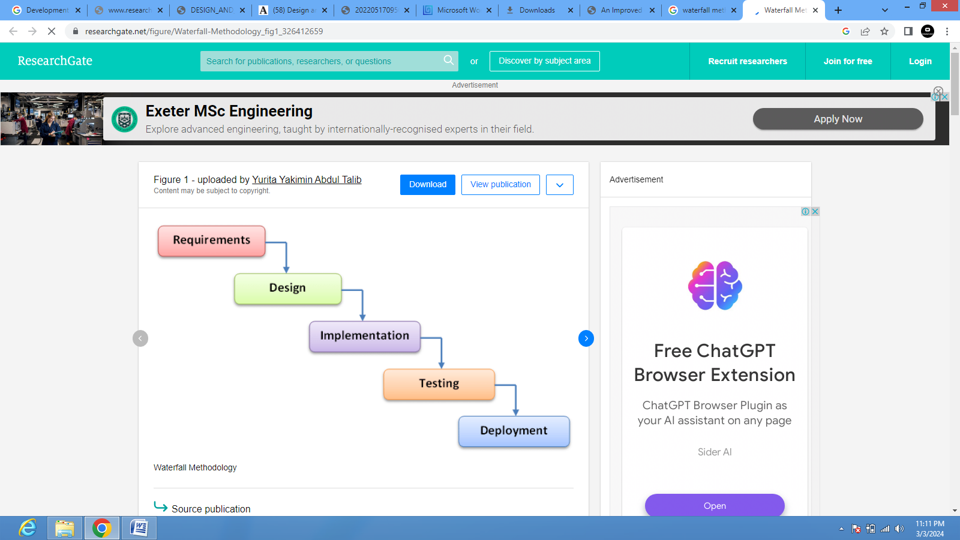
Figure 3.1: Proposed Waterfall Model

3.2 DESCRIPTION OF THE PROPOSED SYSTEM
- Requirement Analysis: At this stage of the waterfall model, the possible requirements of the proposed system are captured and documented. The requirements gathered includes; research of the existing system, fingerprint technology, data collection (Students details), etc.
- System Design: In this system design stage, we studied the requirement specifications from the first stage and the design was prepared. Here also this paper considers the two levels of system design: Logical design and Physical design. Logical design produces a specification of the major features of the new system. While the physical takes the blueprint of the logical design to produce the program specifications, physical file or database definition, and user interface.
- Implementation: With inputs from the system design, the design was implemented in small programs called units, which are integrated in the next phase.
- Testing: All the units developed in the implementation phase are at this stage integrated into a system after testing each unit. After which the entire system was tested for any fault and failure.
- Deployment: After the system has undergone the functional and non-functional testing, the product was deployed to the user environment.
- Maintenance: To enhance the performance of this new system, it may be debugged on a regular base.

3.3 PROBLEMS OF THE EXISTING SYSTEM
Due to the manual means been used by the university, keeping information about student clearance, a lot problems are encountered which includes:
        - Delay in processing clearance form
        - Unavailability of some key staffs while processing clearance form, which leads student repeatedly visiting a particular office in other to sign his/her clearance form.
        - Lose of vital document as the filing system is manual.
        - Damage of document due to fire or rain incident.
        - Illegal removal of forms by fraudulent staff leading to insecurity.
        - Take a lot of time to retrieve a particular clearance form.

  - ANALYSIS OF PROPOSED SYSTEM
This method allows the graduate student to register or do their clearance through an automated application. It involves students logging into the web application with their unique identifier which is usually the matriculation/registration number. The major requirements are the front-end web interface, back-end and internet connection.

  - ADVANTAGES OF THE PROPOSED SYSTEM
The new system is designed to solve problem affecting the manual system in use. It is design to be used online thereby relieving both student and staff from much stress as experienced from the manual system. This will do the analyzing and storing of information either automatically or interactively, it will make use of online access to internet. The proposed system will also have some other features like.
- Accuracy in handling of data
- Fast rate of operation and excellent response time.
- Flexibility (i.e.) it can be accessed at any time
- Easy way of back up or duplicating data in diskette in case of data loss.
- Better storage and faster retrieval system.
- Accessibility from any part of the world.

CHAPTER FOUR

DESIGN, IMPLEMENTATION AND DOCUMENTATION OF THE SYSTEM
  - DESIGN OF THE SYSTEM
The proposed system is designed in modules with each modules working together to perform the electronic allocation system in order to enhance the performance of the existing system as earlier discussed in chapter three.
The ability to analyze and give focus to the system is explained in the following formats which are output design, input design, database design and procedure design.
    - OUTPUT DESIGN
Output design for the computerized system to go to the screen and the outputs are designed to present report in a meaningful way. The outputs of the system include import report and lying report.
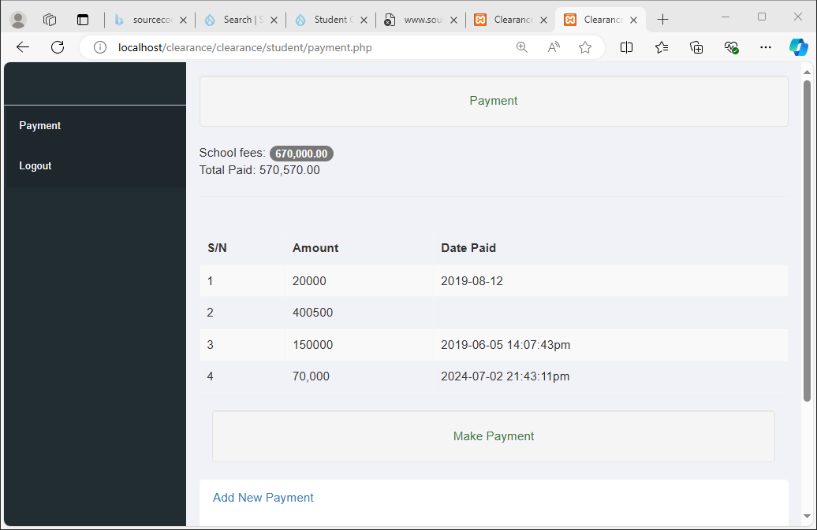
Figure 4.1: Payment Clearance
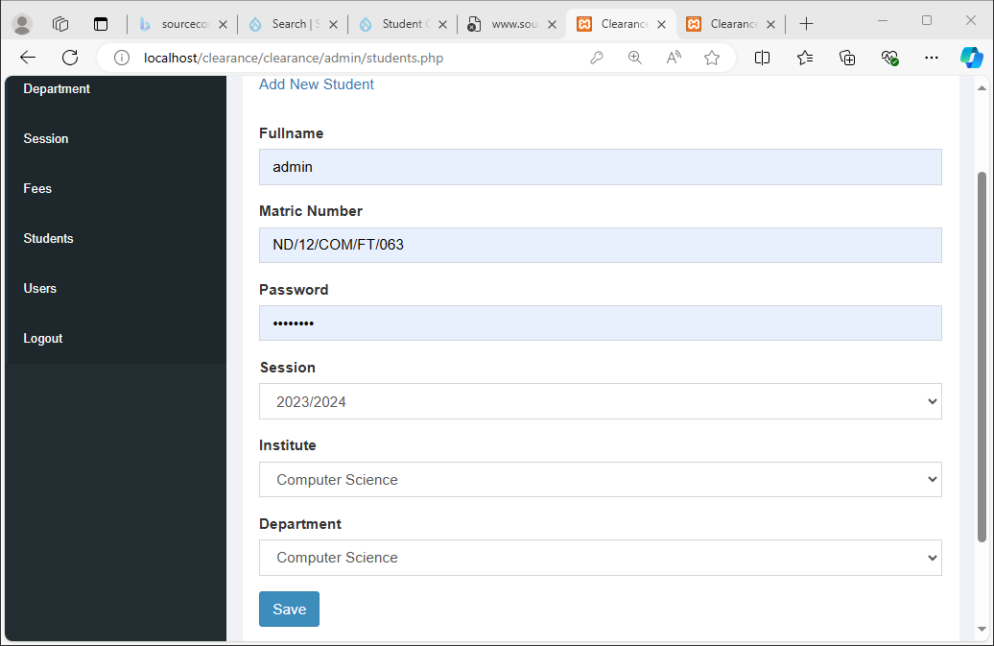
Figure 4.2: Student Details
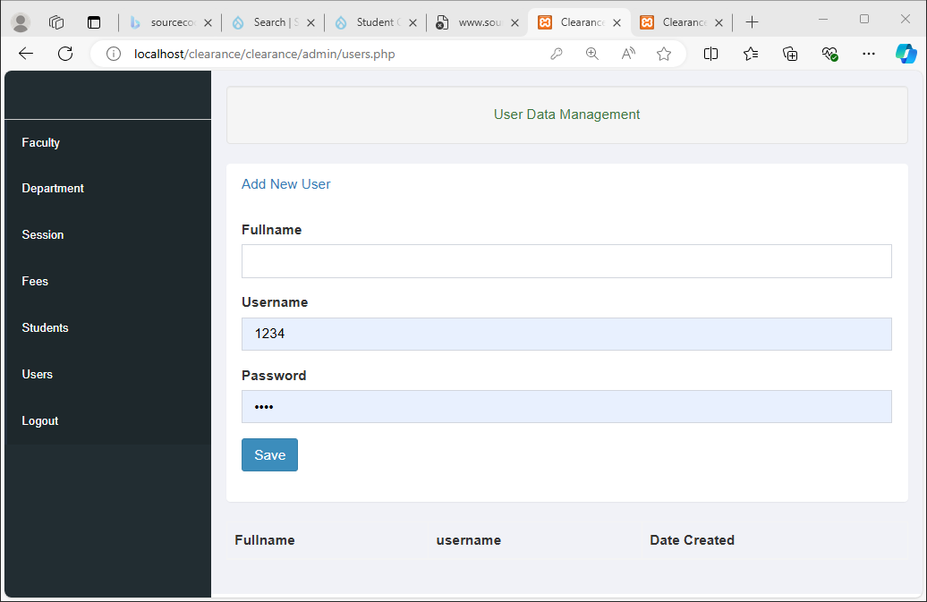
Figure 4.3: Data Management

    - INPUT DESIGN
This aspect entails the description of the expected data input that will provide our output as described above. This section list out all the input required for the implementation of Career Guidance System. Data entry is done through the keyboard and mouse selection where required. The sample input interfaces are as shown below:
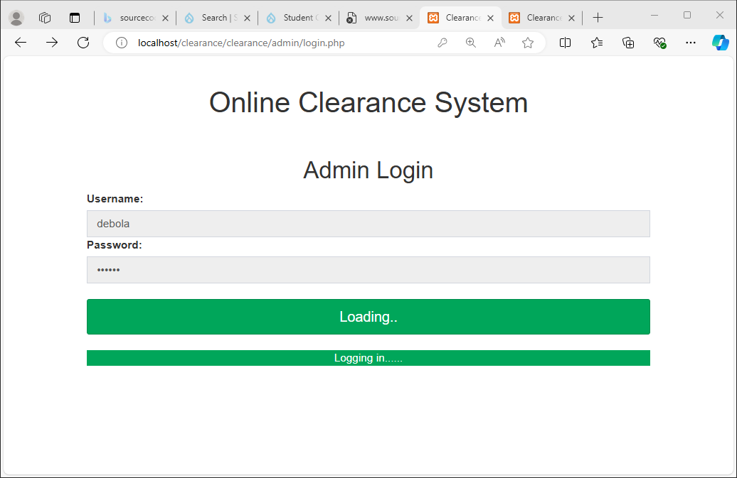
Figure 4.4: Admin Login
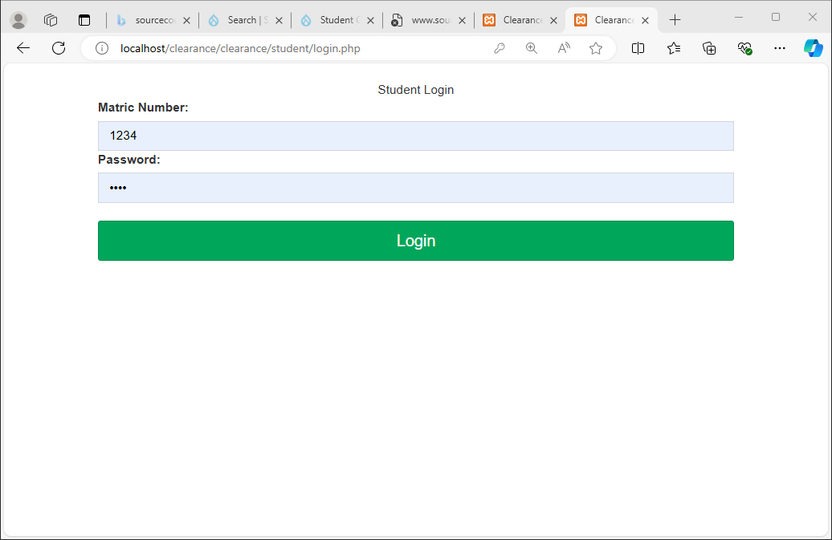
Figure 4.5: Student Login

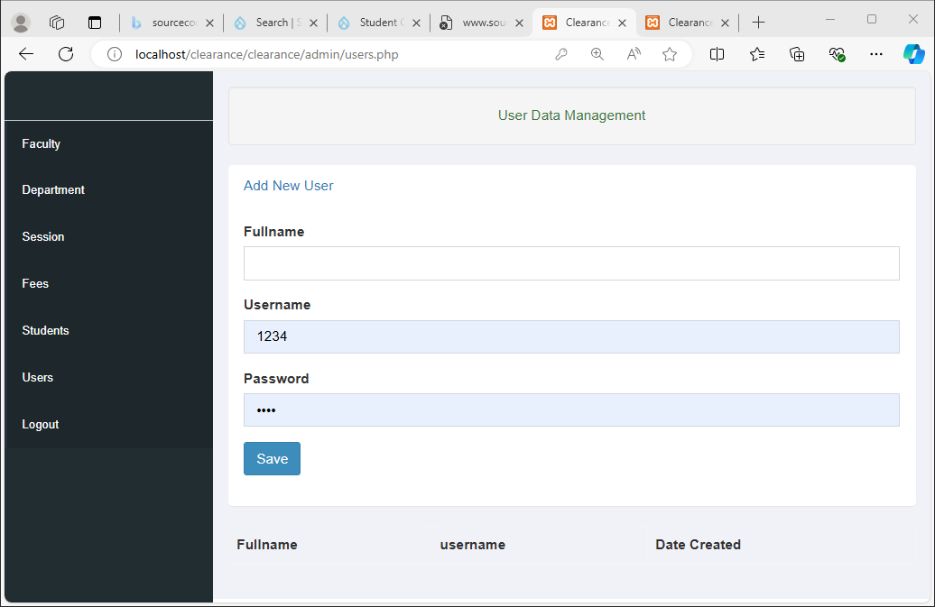
Figure 4.6: Data Management

    - DATABASE DESIGN

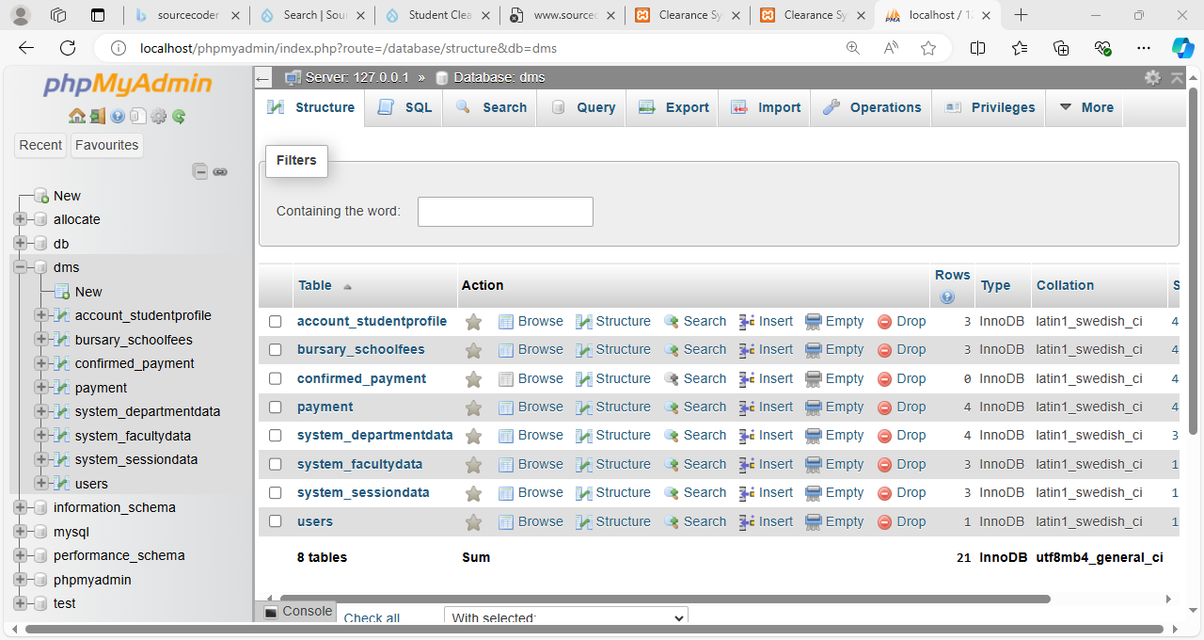
Table 4.1: Database

4.1.4 PROCEDURE DESIGN
The administrator can perform the following
- Add new clearance
- Generate new clearance

4.2 IMPLEMENTATION OF THE SYSTEM
4.2.1 CHOICE OF PROGRAMMING LANGUAGE
In determining a suitable programming language for the design of the online patient management system, the factors to be considered are:-
- The difficulty of the problem
- The technical skills required of the computer program
- The type of processing required
- The availability of sub-programming facilities
- The efficiency of the language translator
- Ease of maintaining and updating the program
- Hardware and software requirement
For the project work, the programming language to be used for the design of the system is PHP and MYSQL for database management system with embedded Structured Query Language (SQL) for database manipulation
4.2.2 HARDWARE SUPPORT
The hardware requirements for this program are:
- PC: The computer should be minimum of Pentium IV with 1000GHs processor speed but preferably Dua Core Processor for greater efficiency
- Memory: This system requires a Higher RAM not less than 512MG, 1GB RAM is recommended.
- Storage: the storage capacity must be 80GB and above.
- VDU: Visual Display Unit required should be a very high resolution not less than 1024 x 768 with 256 colour capability.
- Printer: This system also requires a printer
- Input: The input device required is a mouse, Optical Mouse should be provides for easy use.

4.2.3 SOFTWARE REQUIREMENTS
The software requirements for the operation of this program are as follows:
- Window Operating System
- XAMPP or WampServer (for Apache server on localhost)
- Web Browser e.gMozila Firefox
- Macromedia dreamweaver
4.2.4 CHANGE OVER TECHNIQUE
The method used in the implementation of the proposed system is parallel, simply because parallel system supports the use of the existing system together with the proposed system and when there system failure information will not be totally lost and will not be back to square one for the users.
4.3 DOCUMENTATION OF THE SYSTEM
4.3.1 PROGRAM DOCUMENTATION
In order for the proposed system to be used on any computer system it takes the following ways
- Boot the system
- Copy the folder to www inside wamp folder of the drive C: after WAMP server is installed onto the system.\qq
- Open any browser on the system (Microsoft internet Explorer, Mozilla Firefox, Netscape Navigator, Opera, Flock, Safari e.t.c)
- Type http://localhost/onlineclearance/index.php on the address bar and press the return key or enter key.

4.3.2 OPERATING THE SYSTEM
This refers to the step by step method of using the proposed system. The proposed system comprises of. The steps to use the proposed system are as follows
- On the address bar of any browser type http://localhost/www. onlineclearance/index.php
- You are prompted to supply the username and password this verifies that you are a registered voter and has the privileged to vote.
4.3.3 MAINTAINING THE SYSTEM
- Data cable should be plugged properly
- Repair or replacement of all damaged accessories, system cards, peripheral e.t.c.
- prevention from dust
- Prevention of system from heat and moisture
- Prevention from static charges
- Examination of the new system from time to time to ensure it is performing as specified.
- Operators and users to the system must constantly check the output of the system to make sure that it is working accordingly.

CHAPTER FIVE
SUMMARY, CONCLUSION AND RECOMMENDATION

5.1 SUMMARY
The use of computer software based online clearance system forms the basis of the school management decision. It aims at providing the management with adequate, effective, well documented up-to-date and formatted output. To help as a tool in planning and decision making/based on the student clearance form. The lack of learner outcome variation of the online system signals the establishment of concurrency between the two measures even though they are measures of same construct. This investigation supports the use the online system delivery structure to broaden the instruction audience in technology education program.

5.2 CONCLUSION
Research and development are continuous processes; this is same in computer and software development. However the effectiveness and efficiency of this new system provide room for further improvement. As early mentioned some of the objectives of this project were not actualized due to some limitation. So this objectives could be improved upon, the outline clearance system developed will offer greater opportunity in school management. All transaction or payment with regards to student’s clearance can be carried out online.

5.3 RECOMMENDATION

The research work carried out is limited to online clearance only. It would be better if a full portal is developed for effective and wholesome of information management technology in our universities. When this is done the following modules are recommended to include in the portal.
      - Developing an online students admission system to enable full tracking of student records
      - Automation of student academic record to enable the management to have access to student academic performance.
      - Maintaining a central database for accessing information relating to student

REFERENCES
Agbo-Ajala, O. and Makinde, O., (2022) "A web-based database-driven students’ clearance system," International Journal, vol. 5, no. 7.
Alroobaea, R. (2021) "Factors in the Design, Implementation and Usability Evaluation of Online Clearance System: A Case Study of Taif University," International Information Institute (Tokyo). Information, vol. 21, no. 8, pp. 2157-2168.
Bharamagoudar, S.R.Geeta R.B., Totad S.G., (2021) “Web Based Student Information Management System”, International Journal of Advanced Research in Computer and Communication Engineering, ISSN : 2319-5940.
Chen Y., Yang S., (2021) "Key Techniques of Student Information Management System Based on Internet & Intranet", Journal of Wuhan University of Technology(Transportation Science &Engineering), Wuhan, 28(4), pp. 614-617.
Hew Y., Liu, Martinez, G., Bonk, H., and Lee Y., (2021) Records managements in Nigeria: to be or not to be? Nigeria library or information science review.
Jeremy v ernest (2020). Systematic planning for educational change. California: Mayfield publishing company.
Lucey I. (2021). Managing record in the Moden office. Training the wild frontier. Archivaria 39 (spring).
Nneji, G. U., Deng, J. , Shakher, S. S., Monday, H. N., Agomuo, D. , and Dike, I. D. (2021) "An Improved e-Clearance Management System for Graduating Students in a University Environment," in 2018 IEEE 9th Annual Information Technology, Electronics and Mobile Communication Conference (IEMCON), 2018, pp. 74-80: IEEE.
Peirier E., and Feldman, B., (2021).Management of records in Nigerian Universities. Problems and prospect. The flectional library 23 (30).
Sandeep K., Mohammed A. Q., Archana G., (2022) “Location Based Services using Android”, IEEE.
Yong, K., and Conellus, l., (2021) “Use of local area network in school. ERIC Digest” Syracus, NY: ERIC Clearinghouse on information resources.

APPENDIX 1: SIGN UP
STOP
USER NAME
PASSWORD
IS
VALID
?
Main Menu
RETURN
NO

YES

APPENDIX 2: FORM TO ENROLL RECORD
START
Open DB

Accept Field
Is
Field
ok
Write DB
More
Close DB
RETURN
Close DB
Open DB
YES
YES

Display option

NO

NO

APPENDIX 3: PERSONAL DETAILS PAGE
START
Open DB

Accept Field
Is
Field
ok
Write DB
More
Close DB
RETURN
Close DB
Open DB
YES
YES

Display option

NO

NO

