A PROJECT REPORT

ON

DIGITAL MAPPING OF INFRASTRUCTURAL FACILITIES OF
ROYAL VALLEY ESTATE, SANGO, ILORIN SOUTH LOCAL GOVERNMENT AREA, KWARA STATE.

BY

OGUNDEPO QUADRI OLALEKAN
HND/23/SGI/FT/0102

SUBMITTED TO:

THE DEPARTMENT OF SURVEYING AND GEO-INFORMATICS,
INSTITUTE OE ENVIRONMENTAL STUDIES, KWARA STATE
POLYTECHNIC ILORIN.

IN PARTIAL FULFILLMENT OF THE REQUIREMENT FOR THE AWARD OF HIGHER NATIONAL DIPLOMA IN SURVEYING AND
GEO-INFORMATICS

JUNE, 2025
CERTIFICATE
I hereby certify that the information given in this project was obtained as a result of the observation and measurement made by me and that the survey was carried out in accordance with survey laws, regulations and departmental instructions.
__________________________
OGUNDEPO QUADRI OLALEKAN
Matric No: HND/23/SGI/FT/0102

CERTIFICATION
This is to certify that this project was carried out by OGUNDEPO QUADRI OLALEKAN with Matric No: HND/23/SGI/FT/0102 under my instruction and supervision for the award of Higher National Diploma in Surveying and Geo-informatics, Kwara State Polytechnic, Ilorin, Kwara State Nigeria. I hereby declare that he has conducted himself with due diligence and honesty on the said duties.

_____________________ _____________________
SURV. R.S AWOLEYE DATE
(Project Supervisor)

____________________ _____________________
SURV. R.S AWOLEYE DATE
(Project Coordinator)

_____________________ _____________________
A.I ISHAU DATE
(Head Of Department)
Surveying and Geo-informatics

_____________________ _____________________
EXTERNAL EXAMINER DATE

DEDICATION
This project is dedicated to Almighty God, who gave me the privilege to attain this height in my academic pursuit.

ACKNOWLEDGEMENT

I wish to express my sincere gratitude to Almighty God for His grace and strength throughout the course of this project. My profound appreciation goes to my HOD; SURVEYOR A.I ISHAU and my supervisor, SURV. R.S AWOLEYE, for their invaluable guidance, constructive criticism, and encouragement which contributed immensely to the success of this work.
I am also grateful to all the lecturers and staff of Surveying and Geo-informatics department, Kwara State Polytechnic, for their support and contributions towards my academic journey. Special thanks to my family and friends for their unwavering support, understanding, and motivation during the research and writing of this project.
I am deeply grateful to my parents; MR & MRS OGUNDEPO for their unconditional love, support and backing. Their encouragement and sacrifices have been the driving force behind my endeavors. May you eat the fruit of your labour.
Lastly, I appreciate everyone whose contributions, directly or indirectly, made this project a reality.

TABLE OF CONTENTS
Pages
Title Page i
Certification ii
Dedication iii
Acknowledgement iv
Table of contents v
List of Figures ix
Abstract x
CHAPTER ONE
General Introduction

ABSTRACT

CHAPTER 1
1.0 INTRODUCTION
Infrastructure forms the foundation upon which the socio-economic development and everyday functioning of human societies are built. It encompasses essential physical systems such as roads, electricity supply networks, drainage systems, water distribution channels, buildings, waste management structures, and communication lines. These infrastructural facilities are integral to ensuring mobility, connectivity, productivity, health, and safety within any community. Their presence, functionality, and management determine the quality of life of the people and significantly influence urban and rural development patterns.
Traditionally, the management of infrastructure has relied heavily on analogue methods including sketches, handwritten records, and printed maps. These methods are often static, difficult to update, prone to errors, and disconnected from real-time realities. In contrast, modern technology offers a more dynamic and efficient approach:
Digital Mapping: Digital mapping involves the use of geospatial technologies such as Geographic Information Systems (GIS), Global Navigation Satellite Systems (GNSS), Total Stations, drones, and remote sensing to acquire, process, analyze, and present spatial data in a digital format. These technologies have revolutionized the surveying and mapping profession by increasing accuracy, enabling real-time updates, and allowing for easier sharing and analysis of spatial information.
This study seeks to address the gap in infrastructural data within the Royal Valley Estate by conducting a comprehensive digital mapping exercise. In addition to improving spatial documentation, this project will serve as a case study to demonstrate the practical application of digital surveying tools in a real-world scenario.
  - BACKGROUND TO THE STUDY
Infrastructural development plays a critical role in the socio-economic advancement and quality of life within urban and rural communities. From transportation networks and drainage systems to electricity grids, water supply, and public buildings, infrastructure supports nearly every aspect of human activity. In Nigeria and other developing countries, the demand for efficient infrastructural planning and management is growing due to rapid urbanization, population expansion, and the increasing need for sustainable development. However, a major challenge remains: the lack of accurate, up-to-date, and geospatially referenced data on existing infrastructure.
Traditionally, the process of infrastructural planning and documentation relied on manual surveying methods and analogue mapping systems. While these conventional approaches have contributed significantly to early development, they are time-consuming, costly, prone to human error, and difficult to update or integrate into modern decision-making systems. Additionally, paper-based records are not easily accessible, often poorly archived, and limited in scope, making it difficult for stakeholders to obtain a clear overview of the infrastructural assets within a given area.
The evolution of geospatial technology has introduced more efficient and versatile methods for spatial data acquisition, storage, analysis, and presentation. Among these technologies, Digital Mapping stands out as a transformative approach in modern surveying and urban planning. Digital mapping refers to the process of creating maps that are stored in digital formats, using tools such as Geographic Information Systems (GIS), Global Navigation Satellite Systems (GNSS), Total Stations, photogrammetry, and remote sensing. These tools offer higher accuracy, speed, interactivity, and the ability to integrate different datasets to produce comprehensive geospatial representations.
In surveying, digital mapping has redefined the way professionals capture and visualize real-world features. It allows surveyors to represent infrastructures as georeferenced data that can be layered, queried, and analyzed in real time. This digital environment facilitates better planning, infrastructure maintenance, utility management, and disaster risk assessment. It also promotes transparency, accountability, and evidence-based decision-making among stakeholders including government agencies, estate developers, and utility service providers.
The integration of digital mapping in infrastructure planning is particularly important in planned estates and urban communities that require coordinated development. Residential estates such as Royal Valley Estate in Sango Ilorin, situated within Ilorin South Local Government Area of Kwara State, are rapidly expanding. However, like many growing estates across Nigeria, it suffers from a lack of well-documented infrastructure records. This makes it difficult to coordinate utility services, manage repairs, monitor development trends, and enforce zoning regulations.
By applying digital mapping techniques to the Royal Valley Estate, this study aims to bridge the existing information gap. It will produce a visual, interactive, and updateable map showing the current distribution of key infrastructures within the estate. This will aid not only in physical planning and resource allocation but also in long-term estate management and community development. The project also aligns with Nigeria's broader push for digital transformation in governance, data management, and smart city initiatives.

In conclusion, the background of this study lies in the intersection of increasing infrastructural needs, the inefficiency of traditional documentation methods, and the potential of digital technologies to revolutionize spatial data management. Through digital mapping, the study seeks to demonstrate how modern surveying practices can support better planning, efficient infrastructure management, and sustainable urban development in Nigeria.

1.2 STATEMENT OF PROBLEM
Infrastructural facilities such as roads, drainage systems, electricity lines, water pipelines, and buildings are crucial to the development and functionality of urban and rural environments. However, in many developing regions, including parts of Nigeria, there is a lack of accurate, up-to-date, and accessible spatial data on the distribution and condition of these facilities. This gap leads to poor planning, inefficient resource allocation, overlapping infrastructural development, and a general lack of coordination among service providers.
Traditional methods of mapping and managing infrastructural data often paper-based or non-standardized are time-consuming, prone to errors, and difficult to update. As a result, decision-makers, engineers, town planners, and surveyors often rely on incomplete or outdated data when planning upgrades or new developments.
The advent of digital mapping technologies presents an opportunity to overcome these limitations by offering a more precise, interactive, and easily updatable representation of infrastructure. Yet, the adoption of such technologies remains limited in many local planning contexts due to technical, financial, and human resource constraints.
This study, therefore, seeks to address the problem of inefficient infrastructure mapping by applying digital surveying and mapping techniques to produce an accurate and comprehensive geospatial representation of infrastructural facilities in the study area. The findings aim to
contribute to better spatial planning, improved infrastructure management, and enhanced data availability for future development initiatives.

1.3 AIM AND OBJECTIVES
Aim:
The study aims to determine how digital mapping can enhance decision-making, optimize resource allocation, and improve the long-term sustainability of infrastructural facilities in Royal Valley Estate, Sango Ilorin, Kwara State.

Objectives:
The following objectives were established in order to accomplish the above aim:
1. Project Planning: To conduct office-based planning and field reconnaissance in preparation for effective data acquisition and mapping.
2. Station Selection and Monumentation: To select suitable control points within the estate and establish monuments or reference stations necessary for accurate surveying and data referencing.
3. Data Acquisition: To acquire geometric data using Total Station equipment for accurate location referencing of infrastructure.
To collect attribute data through social survey methods including oral interviews, particularly for descriptive details of infrastructural features such as electricity poles, water sources, and drainage channels.
To document and describe pillar/reference station information relevant for georeferencing.
4. Data Processing: To download field-acquired data and process it using appropriate software tools such as AutoCAD, ArcGIS, or related GIS applications.
To correct, format, and prepare the data for spatial analysis and map production.

1.4 SCOPE OF THE PROJECT
In line with the aim and objectives, the scope of this project includes the following:
1. Project Planning: This includes desktop research, logistics planning, and field reconnaissance to understand the terrain and infrastructure layout.
2. Station Selection and Monumentation: Selection and marking of primary and secondary control points to serve as reference bases for the mapping exercise.
3. Data Acquisition: Collection of both geometric and descriptive data using digital surveying equipment and oral interviews.
4. Data Downloading and Processing: Compilation and transformation of raw survey data into mappable datasets using relevant processing software.
5. Data Analysis and Information Presentation: Analysis of spatial data, map creation, and generation of a geo-referenced digital map in printable and interactive formats.

1.5 PERSONNEL

Table 1.1: Shows the group personnel involved in project
S/N | NAMES | MATRIC NO | REMARKS
1 | OGUNDEPO QUADRI OLALEKAN | HND/23/SGI/FT/102 | AUTHOR
2 | POPOOLA BLESSING | HND/23/SGI/FT/094 | MEMBER
3 | ADEYEMO MARIAM O. | HND/23/SGI/FT/095 | MEMBER
4 | ALAI ABDULLAH AKANNI | HND/23/SGI/FT/105 | MEMBER
5 | ADEKANBI ABIGEAL BIMBO | HND/23/SGI/FT/096 | MEMBER
6 | OKE TEMITOPE JOHN | HND/23/SGI/FT/103 | MEMBER
7 | ALADA TOLUWANI O. | HND/22/SGI/FT/0126 | MEMBER
8 | OLANREWAJU OLUWATOSIN D. | HND/22/SGI/FT/131 | MEMBER
1.6 STUDY AREA
Royal valley estate Sango Ilorin, kwara state, Ilorin south local government area. Nigeria. It lies approximately within latitude 8°2927.87"N and longitude 4°30'53.02"E with an approximate area of 5 hectares. The project site has some embedded facilities such as road, parking space, class room, telecommunication mast, administration block, electric pole, street light, etc

KWARA
N

NIGERIA

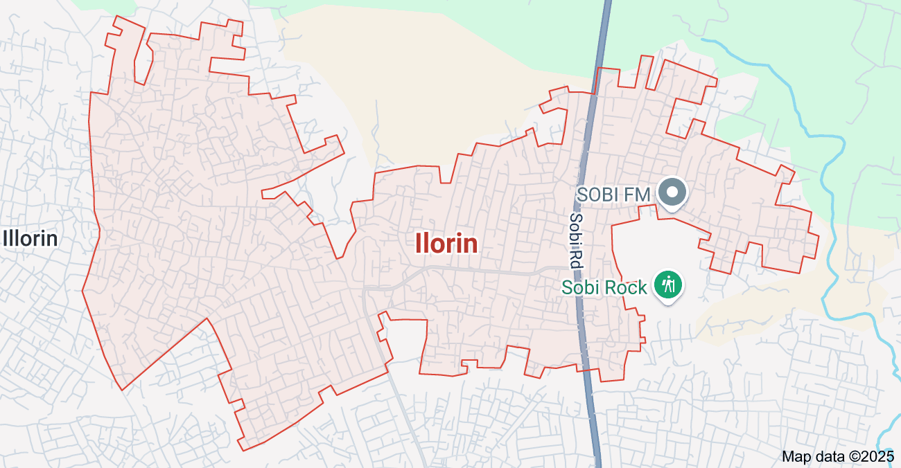
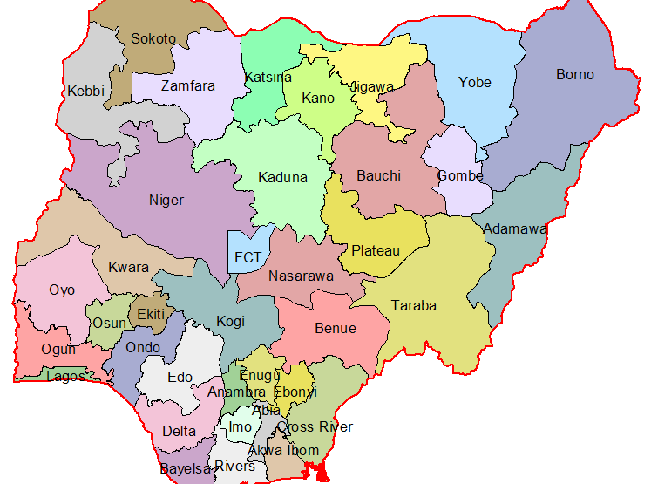

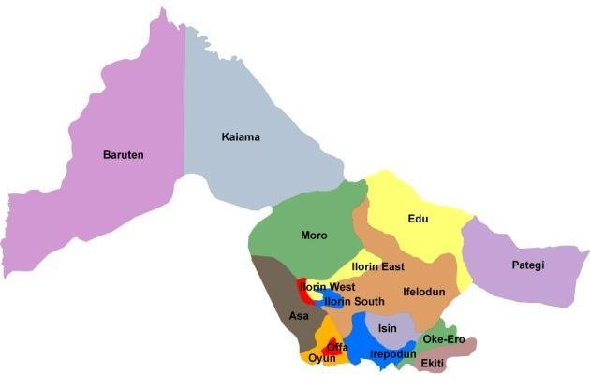
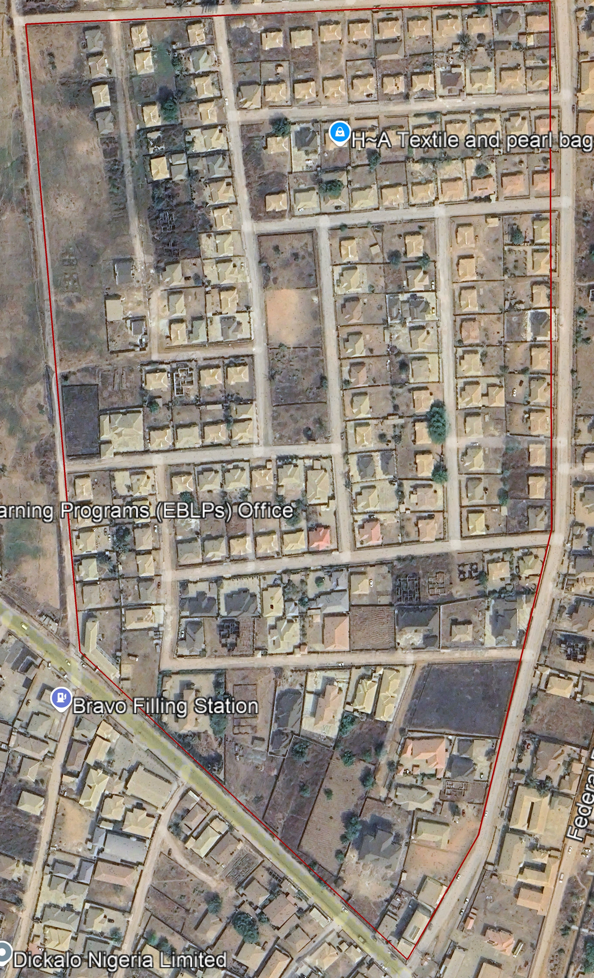

ROYAL VALLEY ESTATE
ILORIN

Figure 1.1: Map shows the study area of the project

1.7 SPECIFICATIONS
The project specifications were referenced to the speciation for land information system using Total Station which was sources from the Higher National Diploma. The specification includes the following:
Total station (YE00240)
Minimum number of datum control required- three (3)
Traverse should run between secondary or higher order control point

CHAPTER TWO
2.0 LITERATURE REVIEW
Digital mapping has emerged as a critical tool in the planning, management, and analysis of infrastructural facilities in both urban and rural settings. With increasing demand for sustainable infrastructure development, digital mapping technologies such as Geographic Information Systems (GIS), Remote Sensing (RS), and Global Positioning Systems (GPS) are being applied to efficiently collect, visualize, and analyze spatial and non-spatial data. This chapter reviews existing literature on digital mapping techniques, applications in infrastructure monitoring, and the benefits and limitations of using such systems.

2.1 CONCEPT OF DIGITAL MAPPING
Digital mapping refers to the creation and manipulation of map-based data using digital technology. Unlike traditional maps, digital maps are dynamic, scalable, and interactive, capable of integrating multiple data layers such as roads, topography, buildings, and utility lines. These maps are produced using data captured from satellite imagery, aerial surveys, GPS, Total Stations, and various geospatial technologies.
Digital mapping enables surveyors and planners to visualize infrastructure with a high degree of accuracy and detail, facilitating better decision-making, data analysis, and communication. As highlighted by Kraak and Ormeling (2010), the integration of digital cartography into survey practices enhances the speed, precision, and flexibility of spatial data managements.

2.3 DIGITAL MAPPING TERMINOLOGIES
Understanding digital mapping requires familiarity with common terminologies:
- Geospatial Data: Data that has a geographic component and is referenced by coordinates.
- Raster Data: Pixel-based data often used for aerial imagery and remote sensing.
- Vector Data: Point, line, or polygon-based data used for representing discrete features.
- GIS (Geographic Information Systems): Software platforms that store, manage, and analyze geospatial data.
- Georeferencing: Assigning spatial coordinates to map data.
- Remote Sensing: Acquisition of information about an object or phenomenon without making physical contact.
- Total Station: An optical/electronic instrument used in surveying for data collection.
- DEM (Digital Elevation Model): A 3D representation of terrain elevations.
- Topology: The spatial relationships between connecting or adjacent features.

2.4 METHODOLOGIES IN DIGITAL MAPPING
The process of digital mapping typically involves several steps:
1. Project Planning and Reconnaissance: This involves defining objectives, reviewing available data, and conducting site visits.
2. Data Acquisition:
Geometric Data: Collected using Total Stations, GNSS, or drone surveys.
Attribute Data: Collected through field surveys, interviews, and observations.
3. Monumentation: Setting physical reference points (control stations) for data referencing
4. Data Processing and Analysis: Data is downloaded and processed using GIS software (e.g., ArcGIS, QGIS) and CAD platforms (e.g., AutoCAD).
5. Presentation and Visualization: Output is generated in the form of digital maps, 3D models, thematic layers, and printed maps for stakeholder use.
6. Validation and Quality Control: Ensures the accuracy, completeness, and reliability of the final output.
2.5 APPLICATIONS OF DIGITAL MAPPING IN INFRASTRUCTURE
Digital mapping is widely applied in various aspects of infrastructure development and urban management:
- Urban Planning and Land Use Management: Enables city planners to analyze spatial patterns and allocate land appropriately.
- Utility Management: Used to track and manage underground pipelines, power lines, water supply, and telecommunication networks.
- Disaster Management: Supports emergency response by mapping flood zones, fire-prone areas, and evacuation routes.
- Transport and Mobility Planning: Assists in the design of road networks, traffic flow modeling, and public transport planning.
- Facility Management: Tracks the condition, age, and maintenance schedules of public assets such as buildings, roads, and drainage systems.
- Real Estate and Estate Development: Provides developers and stakeholders with detailed layouts and zoning plans for effective property management.
- Environmental Monitoring: Supports sustainable practices by mapping land cover changes, forest loss, erosion-prone areas, and pollution zones.
These applications demonstrate the value of digital mapping as a multi-functional tool essential to modern infrastructure development.

2.6 HOW DIGITAL MAPS IMPROVED PLANNING AND MANAGEMENT OF INFRASTRUCTURE FACILITIES
- Enhanced Decision-Making: Digital maps, especially those integrated with GIS, allow planners to analyze spatial data comprehensively, helping prioritize repairs, allocate resources efficiently, and plan future infrastructure projects with better understanding of environmental and urban factors.
- Increased Efficiency and Accuracy: Technologies like mobile mapping surveys (using LiDAR, GPS, and high-resolution cameras) enable rapid, precise data collection over large and complex sites without disrupting ongoing activities. This reduces time, labor costs, and manual survey errors, leading to faster project execution and real-time monitoring.
- Improved Visualization and Planning: Digital maps provide detailed 2D and 3D visualizations of infrastructure, such as underground utilities and transportation networks, allowing planners to optimize routes, detect potential conflicts, and design infrastructure that minimizes negative impacts on traffic, water flow, and the environment.
- Safety and Risk Reduction: Accurate digital mapping of underground utilities significantly lowers the risk of accidental strikes during excavation by providing real-time, reliable location data. This enhances worker and public safety and prevents costly project delays and repairs.
- Collaboration and Communication: Shared digital maps and GIS platforms facilitate better collaboration among stakeholders by providing a centralized, up-to-date source of information, improving coordination and decision-making across departments and organizations.

- 2.7 CORE TECHNOLOGIES AND TOOLS
Several key technologies and tools are central to digital mapping of infrastructural facilities:
- Airborne Laser Terrain Mapping and Digital Photography: These technologies provide a cost-effective and efficient means for digital mapping in civil and environmental applications. They can be used in conjunction with GPS receivers for accurate data collection.
- Geographic Information Systems (GIS): GIS software like Quantum GIS (QGIS) are crucial for digital geological mapping and geodata analysis. QGIS, an open-source program, offers tools and plugins for various Earth Sciences applications, including Structural Geology, Engineering Geology, and Hydrogeology.GIS is also used to integrate building and geospatial information, creating a conceptual mapping standard to link BIM and GIS data.
- Digital Surveying and Mapping Technology: This technology is widely used in territorial surveying to improve measurement accuracy and land resource utilization. It includes various techniques such as global positioning systems (GPS), remote sensing, and digital photogrammetry.
- Building Information Modeling (BIM): BIM is used to create digital models of infrastructure projects, facilitating design, engineering, and management. Integrating BIM with GIS enhances the lifecycle management and resilience of critical infrastructures like hydropower projects.
- Digital Twin Technology: Digital twins are virtual representations of physical assets, processes, or systems. They are used to monitor, analyze, and optimize the performance of infrastructural facilities in real-time. Digital twin technology combines IoT, cloud computing, and AI to enable intelligent management and decision-making in various fields, including cultural heritage preservation and plant factory management.

2.8 APPLICATIONS IN INFRASTRUCTURE MANAGEMENT
Digital mapping plays a crucial role in various aspects of infrastructure management:
- Construction and Maintenance of Underground Infrastructure: Digital technologies are used to facilitate the construction, operation, and maintenance of urban underground infrastructure, providing essential services to residents.
- Management of Sports Infrastructure Facilities: Digital technologies improve the efficiency of managing sports infrastructure by providing tools for information and analytical support
- Land Renovation Planning: Digital surveying and mapping technology supports land survey and planning, enabling effective management and utilization of land resources
- Flood Risk Management: The integration of spatio-temporal GIS with hydrodynamic models enables dynamic 3D simulation of flood risks, enhancing emergency management and disaster response

2.9 SMART CITIES AND DIGITAL TRANSFORMATION
Digital mapping is an integral part of smart city initiatives, enhancing urban sustainability and resilience. The integration of digital transformation, infrastructure, service delivery, and governance is crucial for developing intelligent urban centers.
Digital mapping supports various smart city applications, including:
Urban Mobility: Assessing the impact of autonomous vehicles on urban mobility using open-source microscopic traffic simulators.
Traffic Management: Improving traffic flow and transportation access through digital technologies.
Emergency Response: Optimizing road network accessibility and emergency facility allocation during flooding using web-based decision support frameworks.

2.10 BENEFITS OF DIGITAL MAPPING

Digital mapping offers numerous benefits:

- Enhanced Accuracy: High-resolution data ensures precise identification and documentation of infrastructural element
- Data Integration: Combines spatial and non-spatial data for comprehensive analysis.
- Time Efficiency: Rapid data collection and real-time updates reduce planning and execution time.
- Improved Decision-Making: Visual data supports informed and data-driven policy decisions.
- Resource Optimization: Helps in prioritizing infrastructure investments and avoiding redundancies.
- Stakeholder Engagement: Interactive maps enable better communication with clients, planners, and the public.
- Sustainability: Assists in environmental planning and climate resilience by integrating sustainability indicators.

2.11 CHALLENGES OF DIGITAL MAPPING
Despite its advantages, digital mapping poses several challenges:
- High Initial Cost: The procurement of advanced tools, software, and training programs is capital-intensive.
- Technical Expertise Requirement: There is a shortage of skilled personnel capable of managing complex GIS and CAD systems.
- Data Inconsistency: Data from different sources may vary in format or projection, leading to integration issues.
- Infrastructure Limitations: Poor internet connectivity and electricity shortages can hinder real-time operations, especially in developing regions.
- Limited Accessibility: High costs and proprietary restrictions may prevent small organizations or communities from accessing mapping tools.
- Data Privacy and Security: Unauthorized access and misuse of sensitive geospatial data pose ethical and security risks.

2.12 CASE STUDIES IN DIGITAL MAPPING OF INFRASTRUCTURE
Examples from around the world reinforce the practical relevance of digital mapping:
- Smart City Mapping in Singapore: Integrates sensor data with GIS for traffic management and smart infrastructure.
- GIS-Based Asset Management in Canada: Municipalities use GIS to monitor roads, bridges, and utility systems for maintenance.
- Water Infrastructure Mapping in Kenya: GIS tools have been used to map rural water systems for planning and funding.
- Abuja Infrastructure Map (Nigeria): Uses satellite imagery and GIS layers for planning and monitoring infrastructure within the city.
These cases validate the adaptability of digital mapping to diverse infrastructure challenges and its potential for replication in estates like Royal Valley.

2.13 THEORETICAL FRAMEWORK
This study is anchored on two theories:
- Systems Theory: Emphasizes the interdependence between infrastructure components, geospatial data, and their environments.
- Decision Support Theory: Highlights how spatial data facilitates systematic analysis and improves decision-making through visualization, simulation, and modeling tools.
These frameworks provide a foundation for exploring the integration of digital mapping in infrastructure planning, monitoring, and sustainability efforts.

2.14 ESSENTIAL DATASETS FOR COMPREHENSIVE INFRASTRUCTURE VISUALIZATION
- Critical Infrastructure Sectors Data: Geospatial data covering agriculture, chemicals, communications (cellular towers, broadcast towers), education, emergency services, energy, finances, transportation, and water infrastructure, as provided by Homeland Infrastructure Foundation-Level Data (HIFLD).
- Communication Infrastructure: Detailed datasets on cellular towers, land mobile broadcast and commercial transmission towers from the Federal Communications Commission (FCC).
- Energy Infrastructure: Data on energy facilities and networks, often integrated with other infrastructure datasets for visualization and planning.
- Geometrical and Non-Geometrical Data: Includes 2D CAD models, 3D models (design, construction, as-built), GIS datasets, and linked data such as construction schedules (4D), cost estimates (5D), and asset management information (6D).
- Surface and Subsurface Data: Integration of LiDAR, satellite imagery, hyperspectral data, and underground infrastructure models to enable 3D/4D visualization of both aboveground and underground assets.
- Urban Infrastructure Data: Diverse datasets from multiple sources including municipal, state, and federal levels that cover electric, natural gas, telecom, water, wastewater, and district heating/cooling systems, often requiring data standardization and integration frameworks like GUIDES.

2.15 WHY COST-EFFECTIVE DIGITAL MAPPING IS ESSENTIAL FOR DEVELOPING COUNTRIES' INFRASTRUCTURE PROJECTS
Cost-effective digital mapping is essential for infrastructure projects in developing countries because it addresses critical challenges and maximizes development impact efficiently:
- Data Scarcity and Accuracy: Developing countries often suffer from sparse and outdated geospatial data, which hampers planning and optimization of infrastructure such as roads and healthcare facilities. Cost-effective digital mapping methods improve data quality and coverage, enabling better decision-making and resource allocation.
- Economic Efficiency: Limited financial resources in developing countries require infrastructure projects to be planned and executed with maximum cost-effectiveness. Digital mapping helps identify priority areas, optimize routes, and reduce construction and maintenance costs by providing accurate spatial data and analytics.
- Improved Accessibility and Service Delivery: Enhanced digital infrastructure maps improve accessibility to essential services like healthcare and markets, directly impacting social and economic development goals (e.g., SDGs 3 and 8). For example, better digital road networks have been shown to increase access to hospitals and improve trade opportunities for smallholder farmers.
- Transparency and Accountability: Digital tools increase transparency in project management by providing real-time monitoring and accessible data on project progress and financial flows, reducing corruption risks and improving governance.
- Bridging the Digital Divide: Many developing countries face a "geospatial digital divide," lacking access to reliable mapping technologies and data. Cost-effective.

2.16 HOW DIGITAL MAPPING REDUCE DATA SCARCITY IN INFRASTRUCTURE PLANNING.
- High-Resolution Remote Sensing and Satellite Imagery: Modern remote sensing technologies provide finer spatial resolution and efficient data acquisition, allowing detailed mapping of built infrastructure even in semi-arid or data-poor regions where ground data is scarce.
- Integration of Real-Time and IoT Data: Digital mapping platforms can incorporate real-time data streams from sensors, GPS devices, and IoT networks, creating dynamic digital twins or shadows of infrastructure that reflect current conditions, reducing reliance on static, outdated datasets.
- Use of GPS and Digital Photogrammetry: GPS and digital photogrammetric techniques enable rapid and cost-effective generation of precise maps, including urban features like roads, water bodies, and buildings, which can be updated frequently to maintain relevance.
- Centralized and Accessible Geospatial Databases: Platforms such as GIS-based systems aggregate data from diverse sources into unified, searchable databases, overcoming fragmentation and making data more accessible for planners and decision-makers.
- Capacity Building and Open Data Initiatives: Training local planners in geospatial analytics and promoting open data sharing help sustain data availability and quality, addressing technical and institutional barriers to data scarcity.
- Risk Reduction and Asset Management: GIS data supports risk assessment and infrastructure asset management by providing spatial context and condition data, which reduces uncertainties and improves planning accuracy.

2.17 HOW DIGITAL MAPPING FILL GAPS IN INFRASTRUCTURE DATA FOR BETTER PLANNING
- Combining Multiple Data Layers: GIS platforms merge data on existing infrastructure (roads, utilities, buildings), population density, land use, and environmental factors, allowing planners to identify where infrastructure is lacking or insufficient relative to community needs.
- Real-Time and High-Resolution Data Collection: Advances in remote sensing, drones, and mobile mapping provide up-to-date, high-resolution imagery and sensor data that capture current conditions and changes in infrastructure, filling temporal and spatial data gaps.
- Identifying Service and Connectivity Gaps: Tools like the Million Neighborhoods Map use algorithms on open-source GIS data to pinpoint neighborhoods, especially informal settlements, with limited access to street networks and services, highlighting underserved areas for targeted intervention.
- Supporting Scenario Analysis and Site Selection: Digital maps enable spatial analysis to evaluate environmental, social, and financial factors simultaneously, helping planners select optimal locations for new infrastructure and avoid costly mistakes or environmental damage.
- Enhancing Transportation and Utility Planning: By mapping traffic patterns, utility networks, and infrastructure conditions, digital mapping reveals deficiencies in transportation and utility services, guiding improvements and expansions to meet demand efficiently.
- Facilitating Integration of Aboveground and Underground Data: 3D mapping aligns surface and subsurface infrastructure data, providing a complete picture that prevents conflicts and supports coordinated planning.

- Enabling Public Participation and Transparency: Sharing geospatial data with communities improves feedback and inclusivity, ensuring infrastructure development aligns with local needs and reduces planning blind spots.

2.18 CONCLUSION
The reviewed literature has clearly demonstrated that digital mapping is not merely a modern upgrade of traditional cartography it is a transformative tool in the realm of surveying, spatial data management, and infrastructure development. Digital mapping integrates technology, software, data analysis, and visualization to improve planning, implementation, and monitoring of infrastructural facilities. It serves as a foundation for efficient decision-making and resource optimization in both urban and rural settings.
By utilizing sophisticated tools like Total Stations, GPS, GIS platforms, and remote sensing technologies, digital mapping has enabled the capture, processing, and visualization of spatial data with unprecedented accuracy and speed. The process ensures a comprehensive representation of physical environments, allowing for better analysis and coordination in infrastructural development projects.
Applications of digital mapping are widespread from estate planning and road network analysis to utilities management, disaster preparedness, and environmental monitoring. In the context of Royal Valley Estate, it facilitates accurate site layout, efficient allocation of land resources, identification of existing infrastructure, and planning for future expansion.
Despite the many advantages, the literature highlights several challenges, including high initial costs, technical complexity, data integration difficulties, and infrastructure deficits in developing regions. These limitations underscore the need for increased investment in digital infrastructure, capacity building, and policy support to promote widespread adoption.

CHAPTER THREE

3.0 METHODOLOGY
This stage involves the methods and procedure used in planning, data acquisition, data processing, and creation of database, creation of database management system and information presentation. These operations were logically structured and carried out in stages involving database design. It is normally considered to involve a spatially referenced and structured digital database and appropriate application software for geospatial analysis. This basically describes the techniques and principles adopted in carrying out the project.
Geographic information system methods were adopted in accomplishing the desired results.

3.1 DATABASE DESIGN
The design of any database involves three stages namely;
i Conceptual design
ii Logical design iii Physical design

3.1.1 VIEW OF REALITY
In database design, there is need for reality which is referred to as the phenomenon that actually exists, including all aspects which may or may not be perceived by individuals. The view of reality however, is the mental abstraction of the reality for a particular application or group of applications.
For this application, the view of reality is made of the topography of the project. Since it is not possible to represent the real world, the only option is to conceptualize and model it in a specified manner to represent the real world. The area of interest to us in this project

Includes; Green Reserve, Roads, Electric poles, Trees, Water Facilities, Buildings, Football pitch, Streams.
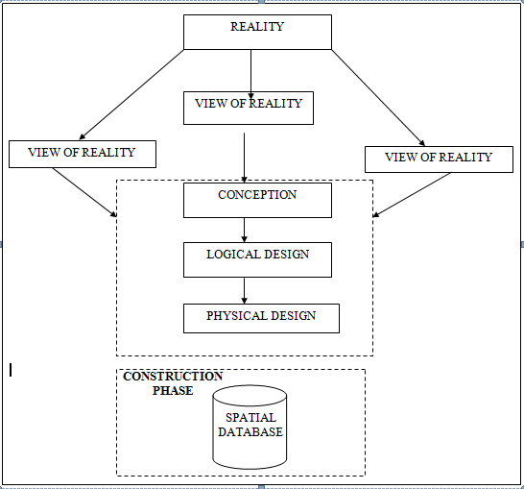

Fig. 3.1 Design and Construction Phases in Spatial Database

3.1.2 CONCEPTUAL DESIGN

Vector data model is the data type adopted for this project, which is represented, by points, lines and polygon. The identified entities are:-
      - Vegetation area (polygon)

      - Roads (line)

      - Trees (point)

      - Boundary line (polygon)

      - Buildings(polygon)
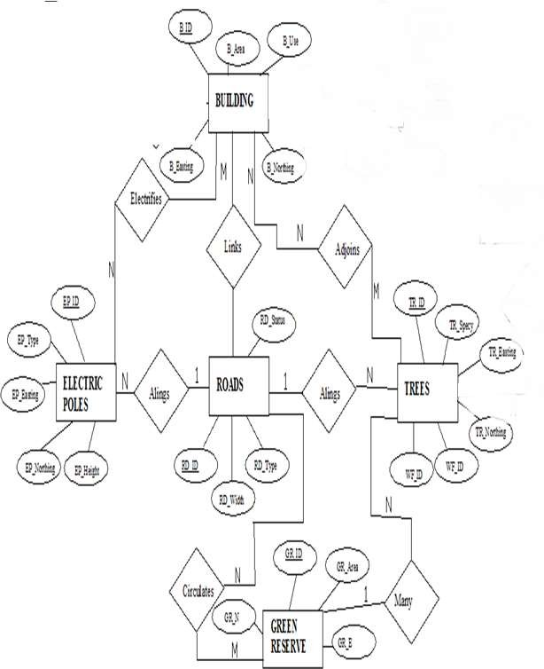

Fig. 3.2.: E-R Diagram (Entity relationship diagram

3.1.3 LOGICAL DESIGN

This is the design aspect of the database refers to the process of creating a conceptual framework or model that represents the structure and organization of spatial data within the system. It involves defining the data element, their relationship, and the rules for data manipulation and analysis. In this phase, the entities, their attributes and their relationships are represented in a single uniform manner in form of relation in such a way that would be no information loss and at the same time no unnecessary duplication of data. In this study, the logical database design is employed to generate a geo-relation database structure. Each entity has unique identifier in bold type. An attribute type or combination of attribute types that serves to identify an entity type is termed an identifier.
- Building( B_ID, B_Area, B_Name, B_Easting, B_Northing)

- Roads (R_ID, R_Width, R_Type, R-Condition, R_Easting, R_Northing )

- Vegetation (V_ID,GR_Area,)

- Tree (TR_ID, TR_spp, TR_Importance, TR_Easting, TR_Northing )

- Electric Pole (EP_No, EP_Type, EP_Height,EP_Easting, EP_Northing)

- Water Facility (WF_ID, WF_Depth,WF_Type, WF_Easting, WF_Northing)

- Football Pitch (FP_ID , FP_Area, FP_Status)

- Stream(S_ID, Length, Width)
3.1.4 PHYSICAL DESIGN
Table 3.1: Building and its attribute

ENTITY | DESCRIPTION
B_ID | Building Identification
B_name | Building Name
B_Area | Building Area
B_Easting | Building Easting
B_Northing | Building Northings

Table 3.2: Road and its attributes

ENTITY | DESCRIPTION
R_ID | Road Identifier
R_Length | Road Length
R_Width | Road Width
R_Type | Road Type
R_Condition | Road Condition

Table 3.3: Trees and its attributes

ENTITY | DESCRIPTION
TR_ID | Tree Identifier
TR_Spp | Tree specy
TR_E | Tree_Easting
TR_N | Tree Northing

3.2 RECONNAISSANCE
This is the preparatory stage before the execution of this project; it involves collection of available information about the project area.
The necessary step taken for the successful execution of the project involves two stages, which are:-
- Office Planning
- Field reconnaissance

3.2.1 OFFICE PLANNING

This involves the collection of information about the study area, testing the instrument to be used in execution of the project and itemizing the numbers of equipment needed, number of days to be use, how each activity is to be carried out, delegation of works to each team members based on supervisor’s guide/instructions.

Table 3.4 Coordinates of Controls

Station | Northing (m) | Easting (m) | Height (m)
KWCS 625T | 941451.040 | 674200.278 | 255.212
KWCS 623T | 941753.095 | 673845.702 | 250.532
KWCP 690 | 94I802.041 | 673810.314 | 249.087

Source: Surveyor general office Kwara

3.2.2 FIELD RECONNAISSANCE

The field reconnaissance is the first visitation to the project site to get intimated with the environment.
- Boundary points was selected

- The distribution of features was studied

- Controls to be used were located

- Method and type of instrument to be uses was determined

- Subsidiary point for Ground control Points were picked and define using nail and bottle cock
- A diagram of the study area was drawn.
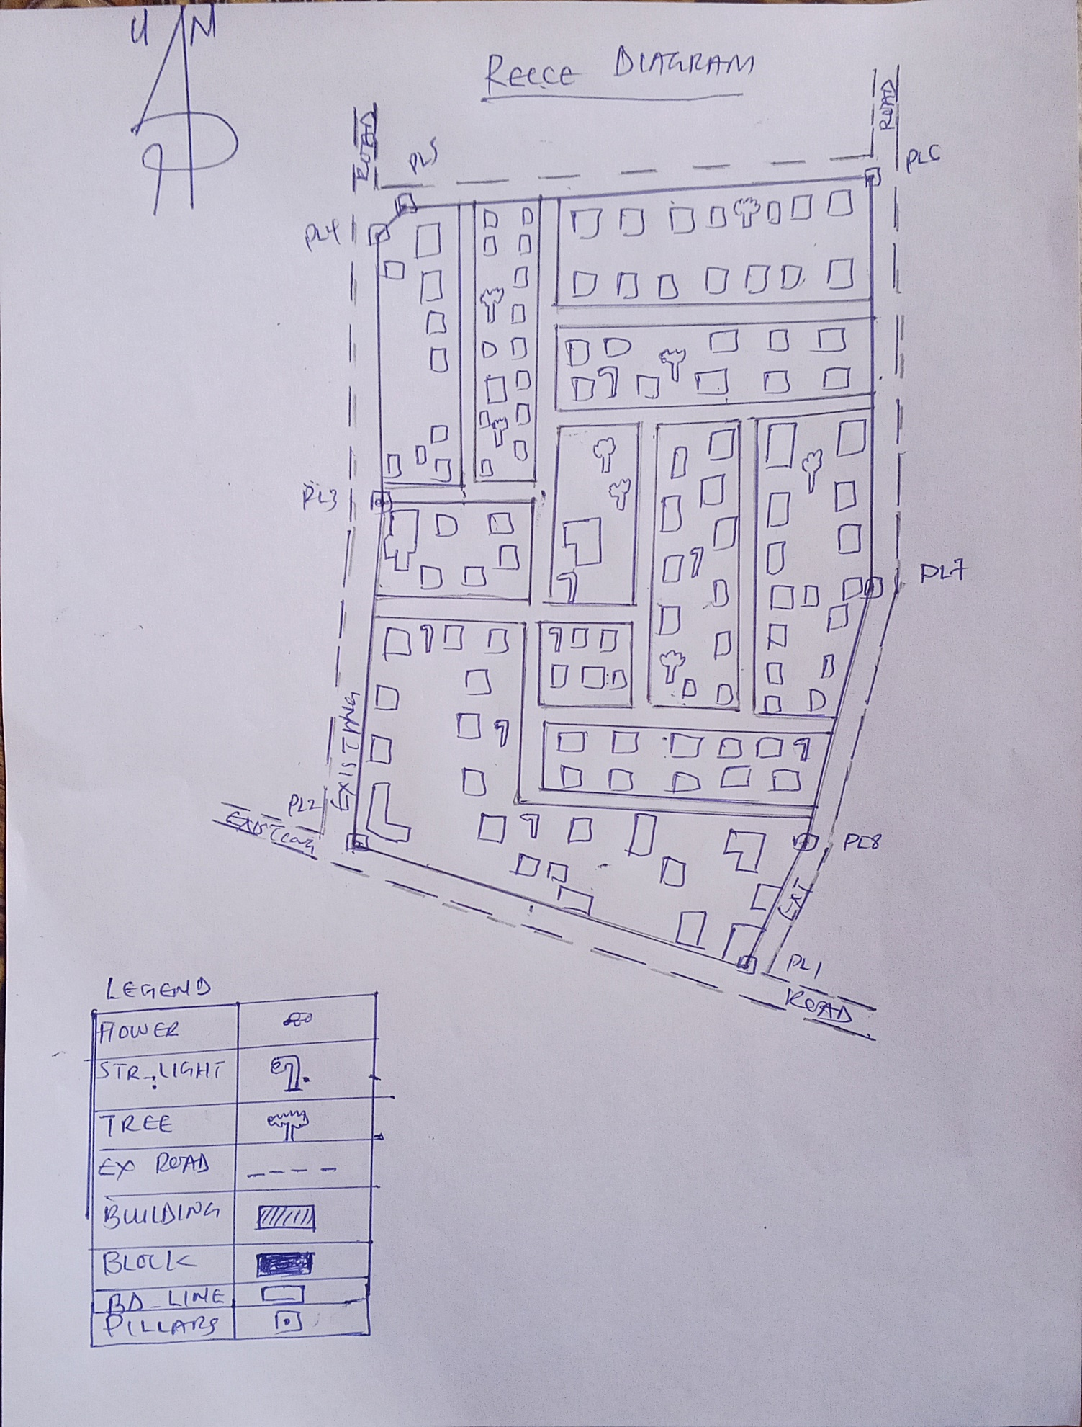

Fig. 3.3: Recce diagram of the study area (not drawn to scale).

3.3 EQUIPMENT USED/ SYSTEM SELECTION AND SOFTWARE

3.3.1 HARDWARE USED

- Total station

- 1 reflector with a tracking rod.

- 1 Tripod

- One (1) 50m tape

- One (1) umbrella

- 1 cutlass

- Hand held GPS

- Hammer

- Nails and bottle cover

- Field book and writing materials

- 1-No of Personal Computer HP655 and its accessories

- 1-No of HP Desk Jet K7100 A3 printer

- 1-No of HP Desk Jet 1110 A4 printer

3.3.2 SOFTWARE COMPONENT

- Notepad.

- Microsoft Excel.

- AutoCAD 2007

- ArcGIS 10.3

- Microsoft Word.

3.4 INSTRUMENT TEST

To ensure data quality, the Total Station used for this project was tested for both vertical index and horizontal collimation errors. It was also to ascertain the efficiency and reliability of the instrument. The procedure used is described below.

3.4.1 HORIZONTAL COLLIMATION TEST
This test was conducted to ensure that the line of sight was perpendicular to the trunnion axis. The Total Station was positioned over a specific point, and initial adjustments were made to ensure proper alignment, leveling, and focus (to eliminate parallax in the telescope). A vertical target was placed at a distance of 100 meters from the Total Station. To access the configuration menu of the Total Station, the menu key was pressed and held for approximately 2 seconds. From the main menu, the calibration sub-menu was selected, and within that, the horizontal collimation test option was chosen. The target was then observed and divided into two halves, with horizontal readings recorded for Face left and Face right. The readings are shown in Table 3.4.1 below.

Total Station
100m
REFLECTO R (TARGET)

STATION A
Fairly Level Ground
STATION B

Fig 3.4: Horizontal Collimation and Vertical Index error test.

Table 3.5: Horizontal Collimation Data

Station | Target | Face | Hz Reading | Difference | Error
A | B | L | 38˚42‟32”
 |  | R | 218˚42‟35” | 180˚00‟03” | 03”

3.4.2 VERTICAL INDEX ERROR TEST

This test was conducted to verify the accuracy of the vertical reading when the line of sight is horizontal. The desired measurement for this test is exactly ninety degrees (90˚), any deviation from this value is referred to as the vertical index error.
The Total Station was positioned over a specific point, and necessary temporary adjustments were made to ensure proper alignment and functionality. A target was placed approximately 100 meters away from the Total Station, and the instrument was aimed at the target. The target was bisected by aligning the instrument on the face left, and the corresponding reading was recorded. Similarly, the target was then bisected on the face right, and the respective reading was also recorded. The recorded readings are provided below:

Table 3.6: Vertical Index Data
Instrument Station | Target Station | Face | Vertical | Sum | Error
A | B | L | 90˚00‟00”
 |  | R | 270˚00‟02” | 360˚00‟02” | 02”

3.4.3 ANALYSIS OF COLLIMATION AND VERTICAL INDEX DATA

The reading obtain during calibration were reduced to obtain new collimation and vertical errors.
Horizontal collimation = {(FR – FL) – 180}/2 = {(00˚00‟03”}/2 = 1.5”

Vertical collimation = {(FL + FR) – 360} = (90˚00‟00” + 270˚00‟02”) - 360} = 02” The result shows that the instrument is still in good working condition.

3.5 CONTROL CHECK
Three control beacons (KWCS 625T, KWCS 623T and KWCP 690) were used. In order to ascertain the in-situ of the control beacons, a check was carried out on them by observing the angle between them and comparing the result obtained with the computed angles from the giving coordinates.
The total station instrument was set on the control beacon KWCS 623T. After performing all the necessary temporary adjustment, the reflector was placed on the control beacon KWCS 625T which served as the back station. The horizontal angular reading was taken and recorded while the instrument was on face left. The reflector was then taken to the control beacon KWCP 690 which serves as the forward station, the horizontal angle reading was then taken and recorded on both face left and face right. The reflector was taken back to the back station, the horizontal angle was then recorded on face right.

Table 3.7: showing the back computation of the control coordinates

From STN | Bearing | Dist (m) | ∆N | ∆E | Northing (m) | Easting  (m) | To STN
 |  |  |  |  | 941451.040 | 674200.278 | KWCS 625T
KWCS 625T | 130°25'37'' | 465.791 | 302.055 | -354.576 | 941753.095 | 673845.702 | KWCS 623T
KWCS 623T | 149°38'02'' | 60.399 | 48.946 | -35.388 | 941802.041 | 673810.314 | KWCP 690

Table 3.8: showing the distance observation result of the control check
FROM | OBSERVED DISTANCE  (m) | COMPUTED DISTANCE  (m) | TO
KWCS 625T | 465.902 | 465.791 | KWCS 623T
KWCS 623T | 60.521 | 60.399 | KWCP 690

Table 3.9 showing the observation result of the control check

STN | SIGHT | FACE | OBSERVED HZ ANGLE | REDUCED  HZ ANGLE | MEAN
 | KWCS 625T | L1 | 195° 14' 07''
KWCS 623T | KWCP 690 | L2 | 64° 47' 29'' | 130°26'38''
 | KWCP 690 | R2 | 15° 14' 13'' | 130°26'22''
 | KWCS 625T | R1 | 145° 40' 35'' |  | 130°26'30''

Difference in angle (observed - computed) =188° 31' 40''-188° 31' 36''

= 00° 00' 04''

Since the allowable accuracy (angular) of third order traverse of one station is 00° 00' 30'' and the result obtained from the control check (00° 00' 04'') is less than allowable error. Therefore, the controls were angularly intact.
3.6 MONUMENTATION
The boundary of the area carved out was demarcated with the precast concrete beacons, after clearing the required line of sights. The identified points of changes in directions were dug and beacons were buried on it, leaving about 15cm part of the beacon above the ground level. The beacons were buried at convenient distances as dictated by the nature of the boundary
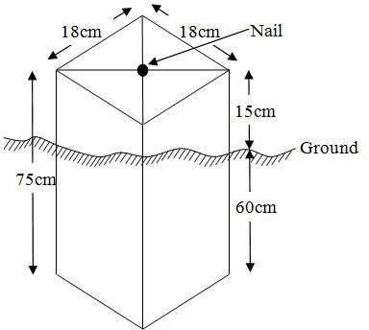

Fig. 3.5: Pillar Description

3.7 DATA ACQUISITION

PRIMARY DATA SOURCE
Field observation was the primary source of data for this project. Ground based method was used in acquiring data with the use of Total Station Instrument, which involved the collection of X, Y, Z data through coordinated Ground control Points (GCP) established at conspicuous points within the study area .
SECONDARY DATA SOURCE
An imagery of the area was acquired through Updated Google earth; this was used to ascertain the extent of coverage of the project area.

3.7.1 GEOMETRIC DATA ACQUISITION
The total station instrument was set carefully on control point KWCS 623T back sight taken to KWCS 625T after necessary station adjustments has been carried out on it. The adjustments includes; centering, leveling and focusing. The following procedures were then followed to determine the position of the next point KWCS 623T and the same procedure were repeated until all we come close to the site. The method used in acquiring data on site was radiation method where two or more points are coordinated from one point.
- Having set up the instrument and temporary adjustment carried out, the instrument was powered „on‟ and a job was created under job menu in the internal memory of the instrument. The job created was named GRP6B
- On the job, the coordinates of the three (3) control points were keyed in to the memory of the instrument and some codes were also saved. The codes include
- „RD‟ for road, „SP‟ for spot height, „BD for buildings, etc.
- The height of the instrument was measured and saved on the memory of the instrument as well as the reflector height.
- On coordinate menu, orientation was set by inputting the coordinates of the instrument station and back sight. The reflector at the back station was perfectly bisected before the orientation was confirmed by clicking „yes‟.
- Having done the orientation, the reflector at the next nail; was bisected and „obs‟ (observe) option was clicked. The three dimensional coordinate of the point (E,N, H) were displayed on the display unit of the instrument and „rec‟ (record) was clicked to save the data into the memory of the instrument. For subsequent observation after this, „all‟ option was used instead of pressing „obs‟ and pressing
- „Record‟ later.
- It was ensured that the center of the prism of the reflector was bisected and that it was set perfectly on the tripod in order to minimize the error on height determination.
- The instrument is been shifted to another nail after all details, spot height and boundary point visible from the instrument station have been picked, set over it and temporary adjustments carried out.
- Nonetheless, the above operations were repeated until all the boundary points with heights were coordinated.
- In this project all spot height are not in grid intervals but randomly acquired. Three edges (3) of building were picked. At the end of data acquisition process all details were acquired and properly recorded to be shown in their respective positions on the plan.

3.7.2 ATTRIBUTES DATA ACQUISITION
Attribute data is information about spatial features. They provide the characteristics, description and nomenclature about spatial objects. Thus the attributes data acquired includes names of buildings and their uses such as classrooms, roads, water facilities and prominent natural features likes river and trees found and vegetation were properly identified within and around the study area.

3.8 DATA DOWNLOADING AND PROCESSING

3.8.1 DATA DOWNLOADING AND EDITING
This is stage whereby all data acquired which were automatically stored in the Total Station were downloaded into personal computer. This was done with the aid of downloading cable connected to the computer and some associated complementing software installed on the System.

3.8.2 DATA PROCESSING AND DATA EDITING
The geometric data downloaded were further processed in order to convert it to a useful format and to enhance its accuracy. The output coordinates, were edited and exported in *.txt, *.xls and *.pdf format. Thereafter, they were imported into Arc GIS 10.3 for further operations and to carry out spatial analysis.

3.8.3 DATA PROCESSING USING ARCGIS 10.3s
Before launching of ArcGIS AutoCAD was used in plotting of feature data saving them separately in different file named road, boundary line, buildings, trees and electric poles.
- Launch the Arc Map in ArcGIS 10.3
- Click on A NEW EMPTY MAP on the dialog box displayed after loading
- Click on Tools on the menu bar, then select extensions, mark all and close.
- At the LHS, right click on layers, and then select properties.
- Click on coordinate system to set the projection system to MINNA DATUM ZONE 31N and general to set the unit, then apply and okay.
- Add data was selected at the tool bar all saved AutoCAD fie was selected and load onto the table of content layer section

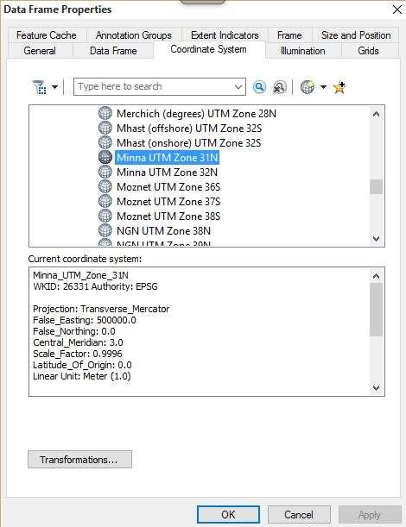

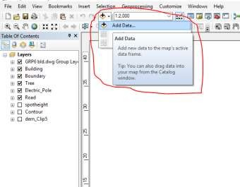

All drawing was exported to shape file. After the feature class has been creates, click on Editor to start Editing, and then click on the load object.

3.8.4 Topographical Map (DEM)
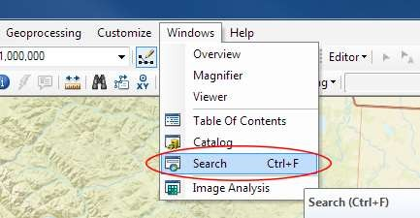
CRATING CONTOUR: Firstly DEM was created by searching in the search icon INTERPOLATION> NATURAL NIGHBOR and selecting THE XYZ data for creation of DEM in respect to the boundary line as extent. In order to create contours, you will need to enable the Spatial Analyst toolbar, which can be found by going to Customize > Toolbars > Spatial Analyst or open the search bar. You can do this by clicking Windows > Search, or by clicking on the search icon.

In the search bar type Contour, and select Contour (Spatial Analyst) from the search results list
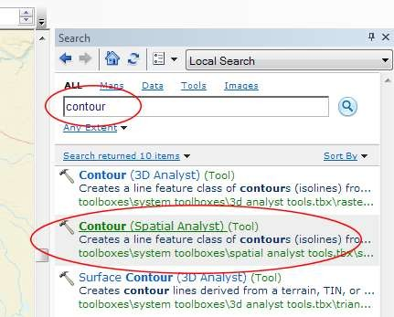

After choosing Contour, a dialogue window will appear, prompting you for five settings: Input raster: select the DEM file from which you want to generate contours by locating it on your hard drive or in the dropdown menu, showing layers present in the Table of Contents Output polyline features: indicate where you want to save your output contours Contour interval: set the distance between contour lines in meters – the smaller the number, the greater the number of lines Base contour (optional): the starting point from which the lines are generated – for example, the default is 0 so with an interval of 25 meters, the contours are generated at 25, 50, 75, 100…, but if the base contour is set at 40, then the contours are generated at 65, 90, 115, 140 and so on Z factor (optional): can be used to adjust the units of data; for example, if you have data in meters and you want to produce your contours in feet, use a z-factor of 3.28 because 3.28 feet equals one meter.

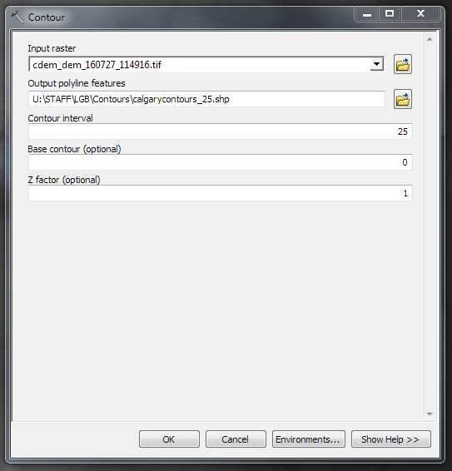

The generated contours will automatically be added to the map.
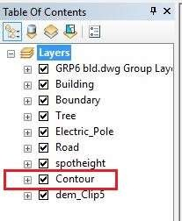

Input the data which is the AutoCAD drawing and select the feature type you want to load,

- Click Add and Next, then select the Target layer you want it to be

- Load it into from the feature class created on the ARCGLS.

- Click on Next, then select “only the features that satisfy the

- Query” and click on Query Builder to query for the feature to be loud e.g. “layer” = Boundary”.
- Click on Next. Then finish

Right click on the Boundary In the table of content and click on zoom to layer to display the feature.

EDITING, CONVERTING AND MERGING GEODATABASE

- Remove all necessary features by right clicking on it and press "REMOVE"

- Convert some features that are not in their correct „features -type‟ like point, line, and polygon features etc.
- To convert a GOEDATABASE FEATURE CLASS to another the following steps were taken:
- FOR LINE FEATURE CLASS TO POLYGON FEATURE CLASS
- Go to WINDOW on the menu bar and select ARC Toolbox.
- Select DATA MANAGEMENT TOOLS, click on FEATURES, and then Select FEATURE TO POLYGON.
- ON INPUT FEATURES, select feature to be converted, on OUTPUT FEATURE CLASS, then save on the GRP6C FOLDER, press OK and CLOSE.
- Then remove the converted feature class in the LAYER Menu and ARC CATALOG files.
- On INPUT DATASETS, select features to be merged, on OUTPUT DATASETS, then save on the GRP6C folder, press OK and CLOSE.
- Then remove the converted feature class in the LAYER Menu and ARC CATALOG files.

ADDING SPOT HEIGHTS DATA
- NOTE: STOP EDITING on the EDITOR MENU before adding data field,
- Go to FIELD ON THE MENU BAR, scroll to add Data and then ADD XYZ DATA
- Browse the EXCEL FILE for SPOT HEIGHTS, select EASTING VALUE on X - FIELD and NORTHING VALUE on Y - IELD and ELEVATION
- « Select DATA the EXPORT DATA, locate the folder created and give it name then YES AND OK, remove the previous layer by right clicking on it and select REMOVE.

TIN, ASPECT AND SLOPE CREATION USING ARCMAP
NOTE: Making sure the 3D Analyst Extension is active, select VIEW on MENU bar, then click TOOLBARS and MARK the 3D Analyst EXTENTION Then X, Y Data
TO CREATE TIN
- Click on 3D Analyst arrow, select create TIN and then create TIN from FEATURE.
- On layers mark the SPOTHEIGHT LAYER, select height data on HEIGHT, then ok.

TO CHANGE THE FACE OF THE TIN ACCODING TO ITS ELEVATION
- RIGHT CLICK on the TIN, select PROPERTIES, and click on SYMBOLOGY.
- Then ADD, select FACE ELEVATION WITH COLOR RAMP, click ADD, and then select APPLY and OK.

TO CREATE ASPECT
- Click on 3D analyst arrow, select SPATIAL ANALYST TOOLS, SURFACE and THEN DOUBLE CLICK on ASPECT.
- Browse to where the raster format of all the acquired data created from the surfer was saved to.
- Browse to where you want the OUTPUT RASTER to be saved
- You can change the OUTPUT MEASUREMENT to Degree OR percent
- Click OK [then it displays on the data view screen], then Close.

3.8.5 FACILITY MAP PRODUCTION
The buildings were digitized from the downloaded Google earth image using ArcGIS 10.2.1. Shape files for the facilities were created in Arc Catalogue. The created shape files were added to Arc Map and editor was started to digitize out to facilities. The road network, buildings are extracted using polyline and polygon respectively while street lights and trees are represented by point data for 3D map production the generated 2D map is shown in Figure 3.6, Figure 3.7 shows the old 2D CAD map of the campus.

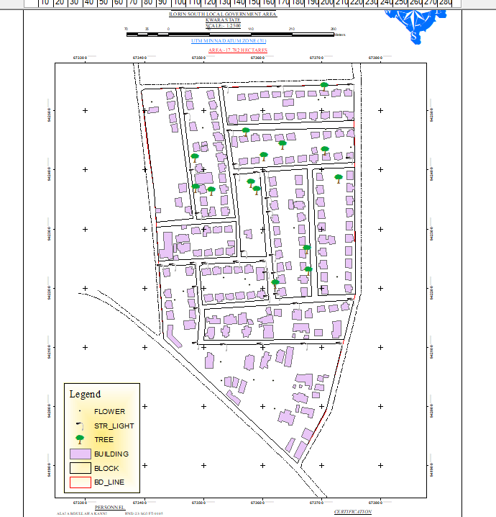

Figure 3.6 showing the 2D facility map of the study area.

3.8.6 3D MAP PRODUCTION
The 3D image was done Arc Scene using the created DEM; the created DEM was added to Arc Scene and extruded with the heights gotten on the field. Extrusion incorporates the height of these features in their representation to give them 3D look and was made to float on DEM to have a true land representation.
The created DEM was also added to Arc Scene, The height of the buildings gotten from the field was added to the already created height field in the attribute table of each of the facility shape file in Arc Map. Arc Scene was launched and all the shape files were added, from the table of content each shape file was right clicked on to access the property dialog box, from the property dialog box the shape files were extruded to give them 3D look and were made to float on the DEM to have a full 3D visualization.

3.8.7 FINDINGS
This study has demonstrated a capability of GIS in facility mapping with different visualizations techniques i.e. 2D and 3D visualization, Figure 3.6 shows the generated 2D map while Figure 4(a) and Figure 4(b) show cross-sections of the generated 3D map of the campus. All the facilities were geo-located with the aid of total station and imported into ArcGIS 10.2, the facilities were also digitized from the Google earth image downloaded for the study area. 3D topographic maps of the study areas were created from the point data gotten from field-work and also from the downloaded SRTM DEM image downloaded from USGS, Figure 5 shows the 2D Topographic map generated from the point data gotten from the field using Total station while Figure 6 shows the 3D topographic map generated using the same data source. Figure 7 shows the 2D topographic map generated from SRTM 30 m while Figure 8 shows the 3D topographic map generated using the same data source. The 2D facility map was produced by digitizing all the facilities out as features from the Google earth image downloaded using Google downloader. The 3D model of the campus was produced by exporting all the features created in Arc Map to Arc Scene for extrusion; the extruded features were made to float on the 3D topography map created through interpolation using Kriging method. The 3D visualization gives the study area a near real life view.
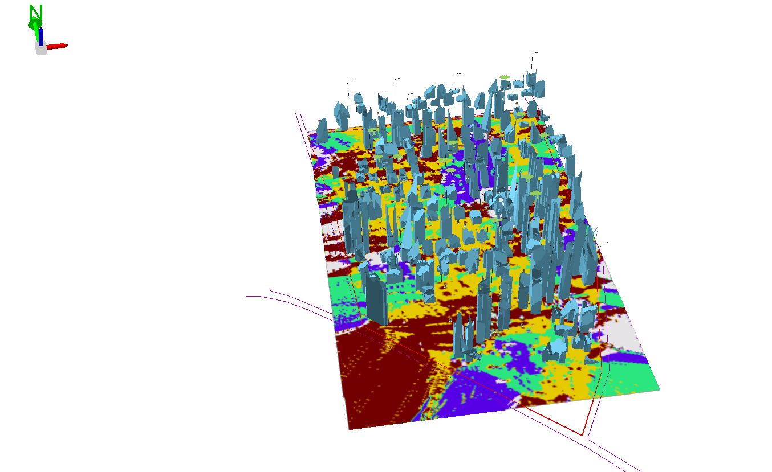

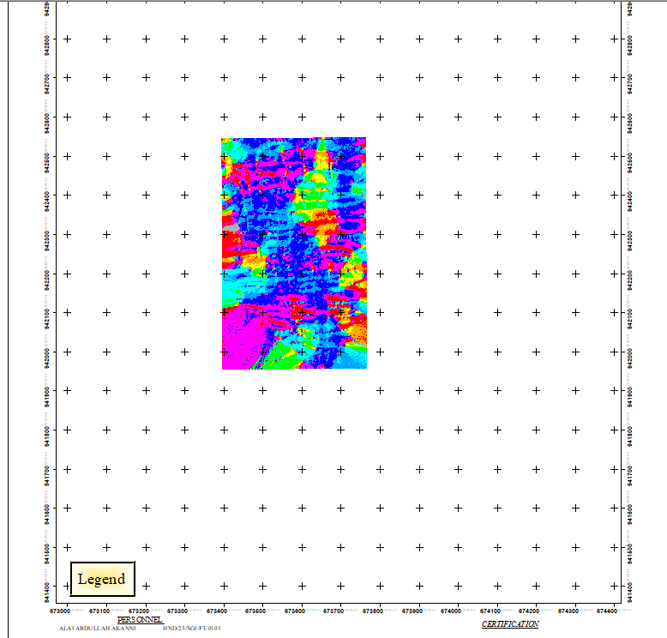
Figure 3.7 (a) Showing 3D model of the study area area

Figure 3.8 showing the 2D DEM (Digital elevation model) of the study area (derived from the field data).

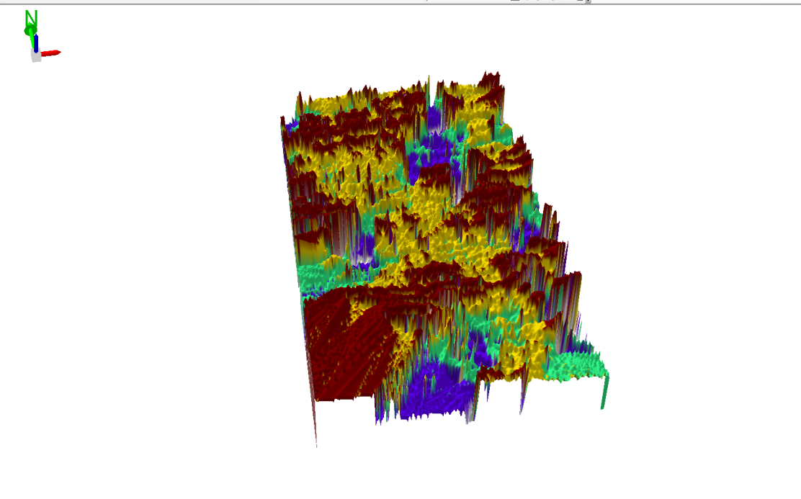

Figure 3.9 Showing 3D DEM (Digital Elevation Model) of the study area (derived from the field data).

3.8.8 Attribute data creation
There is need to create attribute tables for the features so as to be used for queries. NOTE: The editor on the menu bar must be stopped before adding field to its table. THE FOLLOWING PROCEDURES WERE FOLLOWED:
- Right click on the feature class, then select OPEN ATTRIBUTES TABLE click on OPTIONS and select ADD FIELD.
- Give it FIELD NAME, click on TYPE and select [SHORT INTEGER or LONG INTEGER for SHORT or LONG WHOLE VARIABLES or DOUBLE FOR DECIMAL VARIABLES OR TEXT variable or DATE for DATE], then enter precision or LENGTH for text width and scale for DECIMAL PLACES, and then click OK
- To input variables on the ATTRIBUTE TABLE, go to the EDITOR on Menu bar, select START EDITING,
- Click on ATTRIBUTE on menu bar [behind the TARGET], click on the features on the DATA VIEW display, and then input the variables of data acquired through SOCIAL SURVEY or DATA ACQUIRED ON THE FIELD.
- Save it after the input by selecting SAVE EDITS on the editor menu. To switch to other layers, select STOP EDITING on the EDITOR menu. Then repeat the above step to create other fields. Populate the table and save.

Table 3.10: Building

ENTITY | FIELD ALIAS | DATA TYPE | FIELD SIZE
B_ID | Building Identification | Numeric | -
B_name | Building Name | Text | 10
B_Area | Building Area | Numeric | -
B_E | Building Easting | Numeric | -
B_Northing | Building Northings | Numeric | -

Table 3.11: Road

ENTITY | FIELD ALIAS | DATA TYPE | FIELD SIZE
R_ID | Road Identifier | Numeric | -
R_Length | Road Length | Numeric | -
R_Width | Road Width | Numeric | -
R_Type | Road Type | Text | 10
R_Condition | Road Condition | Text | 10

Table 3.12: Trees

ENTITY | FIELD ALIAS | DATA TYPE | FIELD SIZE
TR_ID | Tree Identifier | Numeric | -
TR_Spp | Tree specy | Text | 10
TR_E | Tree_Easting | Numeric | -
TR_N | Tree Northing | Numeric | -

Table 3.13: Electric Poles

ENTITY | FIELD ALIAS | DATA TYPE | FIELD SIZE
EP_ID | Electric pole Identifier | Numeric | -
EP_Type | Electric pole Type | Text | 10
EP_Height | Electric pole Height | Numeric | -
EP_E | Electric pole Easting | Numeric | -
EP_N | Electric pole Northing | Numeric | -

3.8.9 DATABASE IMPLEMENTATION
This is the database creation phase. Having completed the three stages of design phase (i.e. Reality, Conceptual and Logical design), the database was created using ArcGIS 10.3 software. It involves the combination and storage of acquired graphic data and attributes data in creating the database for the purpose of spatial analysis and query.
Database is an organized integrated collection of data stored so as to be capable of use by revenant application with data being accessed by different logical part. After the Attribute table was populated via the keyboard, some attributes such as areas of settlements were automatically displayed by special command in the ArcGIS 10.3 version. The ArcGIS software was used to link the graphic data and table for query generation.

3.8.10 DATABASE MANAGEMENT SYSTEMS

Database management is a collection of software for creating, storing, manipulating, updating, organizing and querying of information in a database (Kufoniyi, 1998). It is a software package whose function is to manipulate a database on behalf of the user.
A good DBMS must provide the following functions:

      - Storage and retrieval of data.
      - Access to by several users at a time.
      - A standardized interface between database and application programmed.
      - Standardized access to data and separation of data storage and retrieval functions from the program using the data.
      - Maintenance of data security and integrity.

3.8.11 DATABASE MAINTENANCE

Having created the database, proper maintenance practice was made to meet its stated objectives. The ability to include more data and remove irrelevant data was possible by way of maintenance. There is every need for the data to be updated regularly because of the physical changes that may occur on the landscape with time. Both security and integrity were also exercised to ensure maintenance and to meet its stated objectives.
Proper observance, updating and management of database ensure its currency and quality to stand a profound chance in Spatial Decision Support System (SDSS). The quality of any database depends on the currency and fitness for use as a decision support system (SDSS). The quality of database depends on its ability to generally fit and use as a decision system (DSS). The storage media should be from time to time justified if otherwise could necessitate data inaccessibility or physical deterioration of the storage media. Also care must be taken during populating any database system, as a database is only good as the data supplied. In archiving stable media should be used. Examples of these are:-
- Computer compatible tape reader
- Magnetic tape
- Optical disc and compact disc
- 3.8.12 AREA COMPUTATION TABLE
Table 3.14: shows area computation
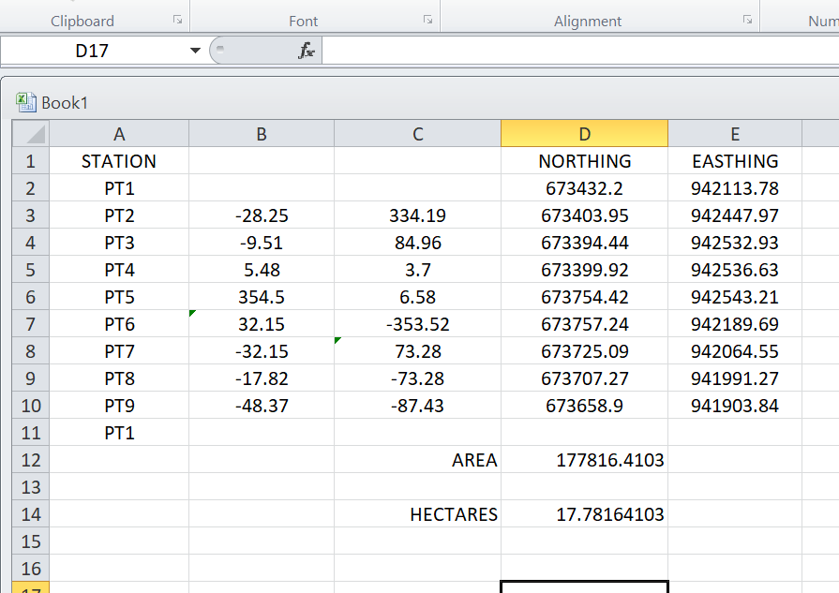

CHAPTER FOUR

4.0 SPATIAL ANALYSES AND PRESENTATION

GIS is distinct among other information system because of its spatial analytical capability; especially overlay operation, buffering, spatial search, topographic operation, and neighborhood and connectivity operations. GIS uses this spatial analytical capability to answer fundamental generic question of location, condition, trend, routing, pattern and modeling by the manipulation and analysis of input data. The major analyses performed in this project were overlay operations, topographic operations and spatial search.

4.1 TESTING OF DATABASE

This is the test carried out to determine whether there exists a relationship between data modeled about entities in a spatial database as well as putting into test its retrieval capabilities. This was done by designing a sample query with certain conditions attached and the query will be ran to see if desired result is achieved.

4.11 ANALYSIS OF RESULT

The contour whose value is greater or equal to 350 meters depicts the likelihood that such area may not be prone to flood in the project area as shown in Fig. 4.5(Query 1). This represents the elevation of points that are greater than to 350m. The displayed attribute table confirmed that North-East part of the institute had the highest elevation. Height is an important factor when considering the surface or slope of the terrain. The South-west part of the school had the lowest elevation which is very prone to erosion. Buildings that will be sited in that region must have a very high foundation above the ground level. The result of the query will afford the school management to decide concisely the terrain characteristics and the kind of building that should build in every region of the project area looking critically at the terrain of the area.

SINGLE SELECTION CRITERION

Query 1: shows the completed building

SELECT* FROM Building WHERE "BLD_STATUS" LIKE COMPLETED
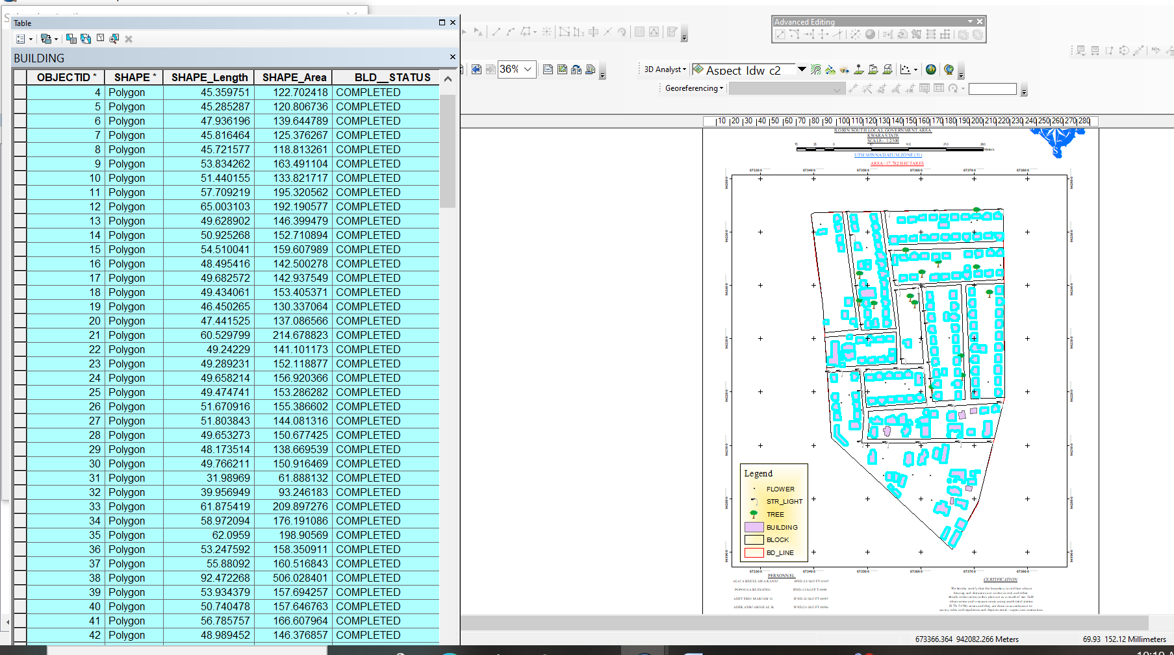

Fig 4.1: shows the completed building
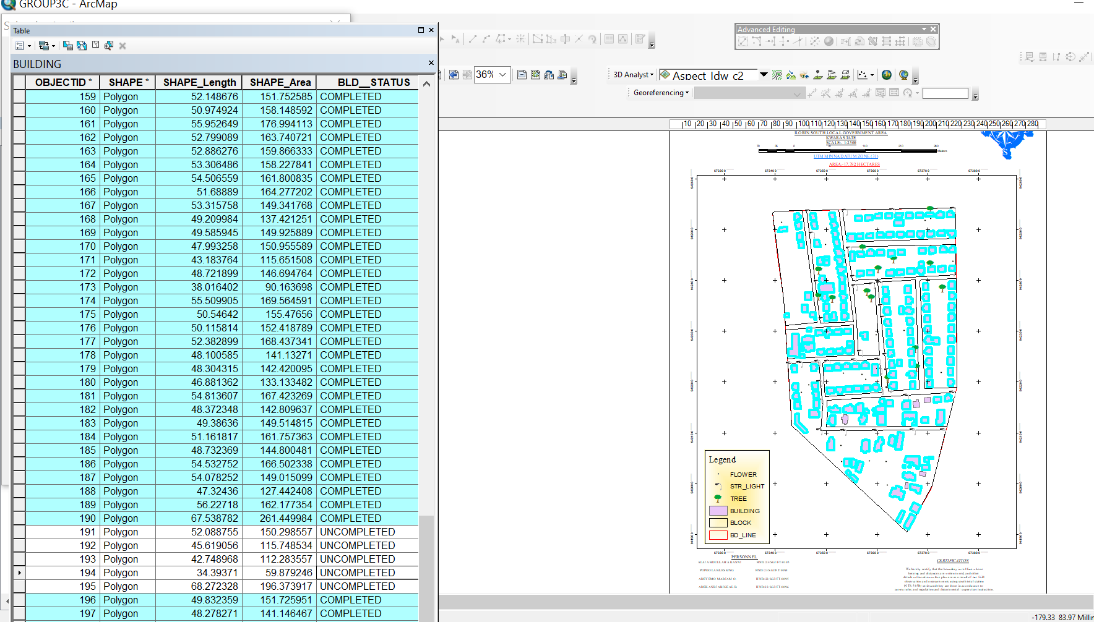

Fig 4.2: shows the 2D completed building
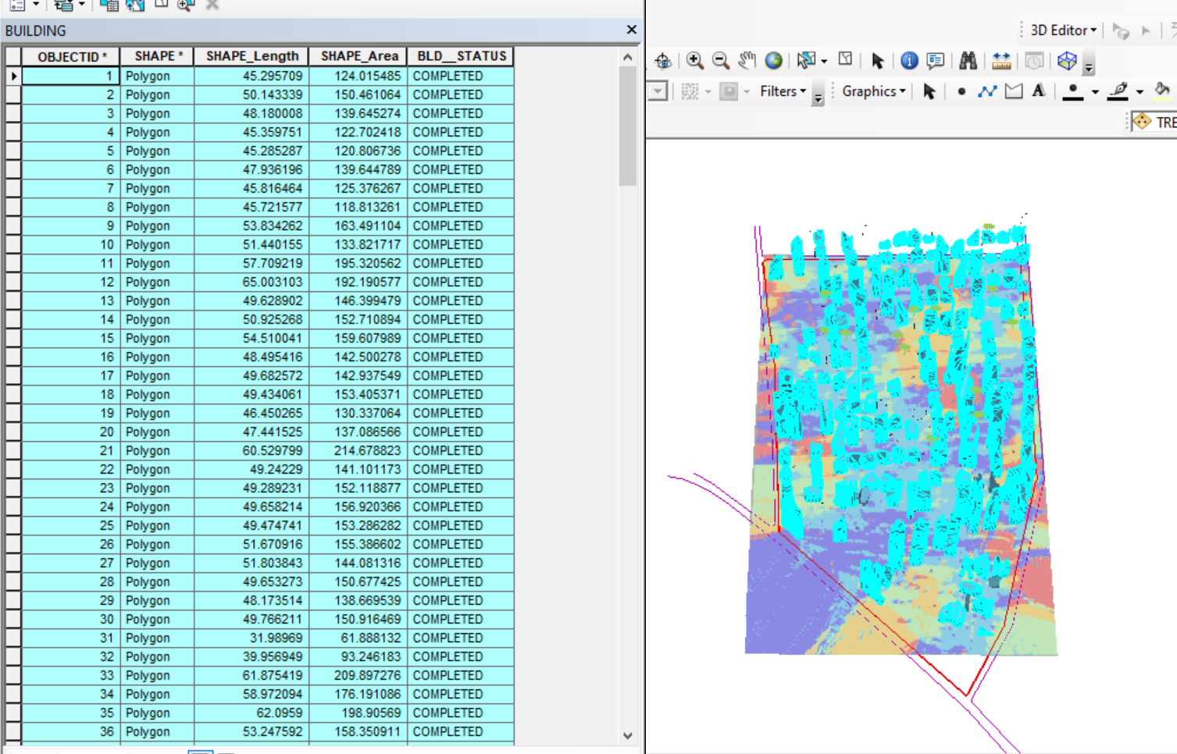

Figure 4.3 shows the 3D of completed building
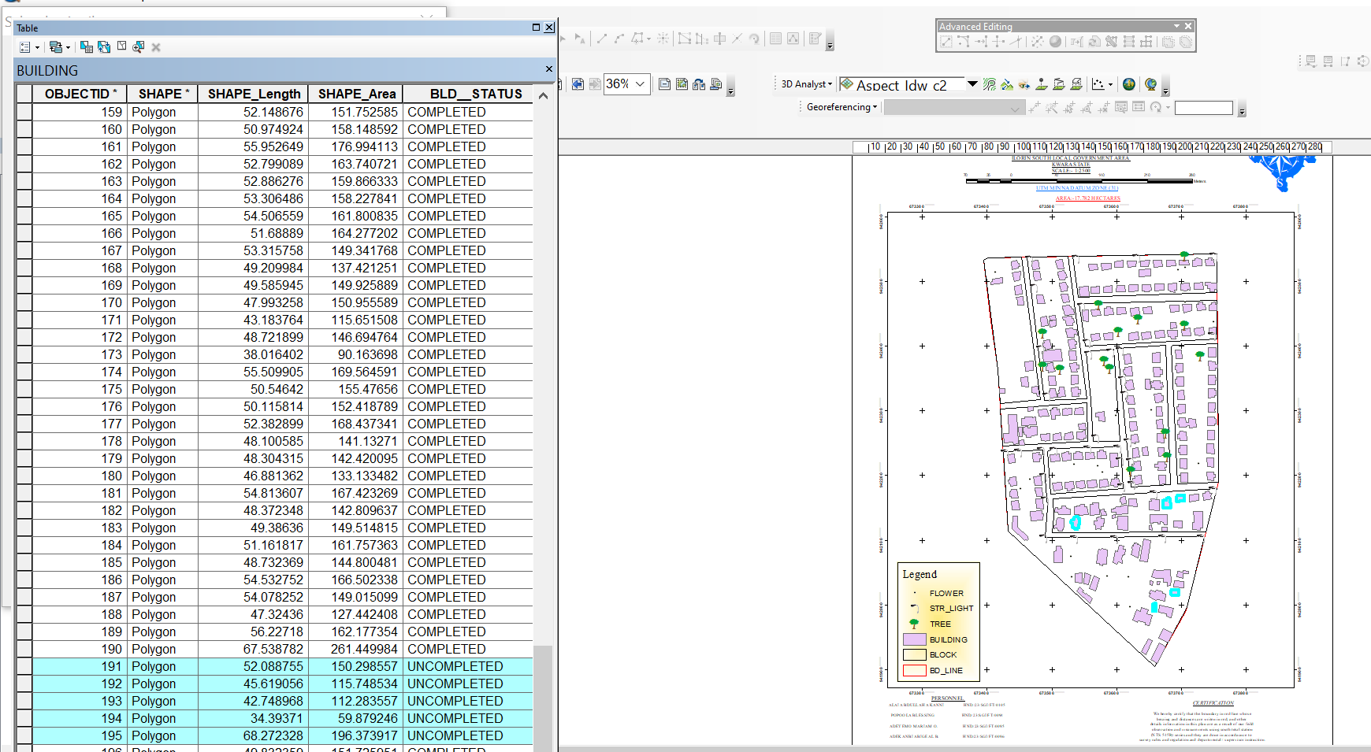

Fig 4.4 Query shows the 2D of uncompleted building

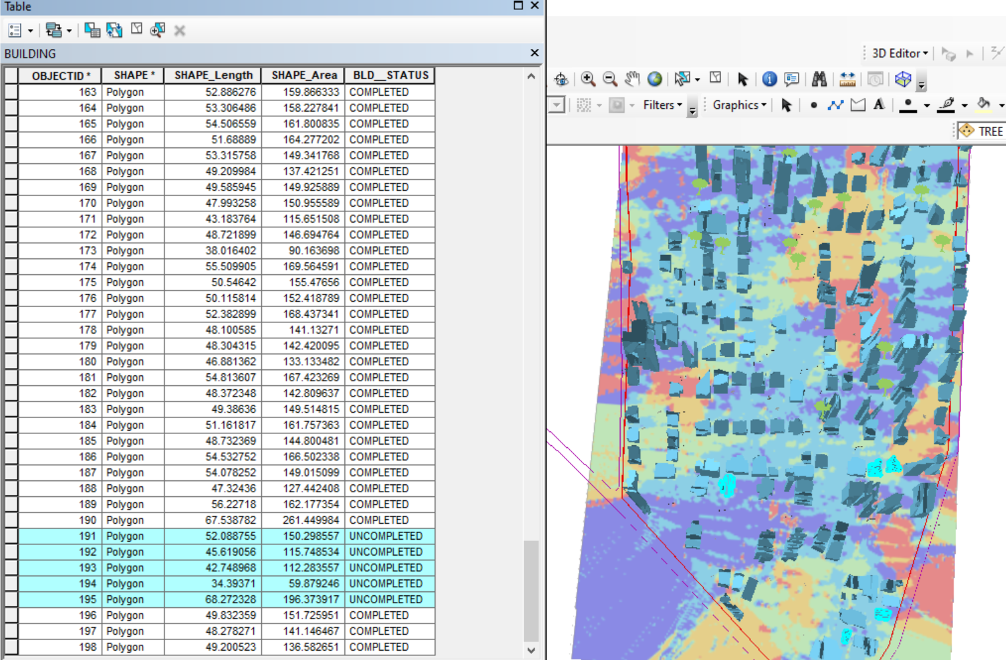

Figure 4.5 shows the 3D of uncomplted building

CHAPTER FIVE
5.0 Costing Estimation, Summary, Conclusion, Recommendation and Problem Encountered
5.1 Costing Estimation
RECCONNAISSANCE
S/N | PERSONNEL | QTY | DAILY RATE | NO OF DAYS | REMARK
1 | Group leader | 1 | 5000 | 1 | 5000
2 | Ass group leader | 1 | 2500 | 1 | 2500
3 | Basic equipment | 1 | 25000 | 1 | 25000
4 | Transportation | 1 | 3000 | 1 | 3000
Subtotal = #35,500
Monumentation
S/N | PERSONNEL | QTY | DAILY RATE | NO OF DAYS | REMARK
1 | Group leader | 1 | 5000 | 1 | 5000
2 | Ass group leader | 1 | 2500 | 1 | 2500
3 | Skilled labor | 3 | 1500 | 1 | 4500
4 | Basic equipment | 1 | 25000 | 1 | 25000
5 | Transportation | 1 | 7500 | 1 | 3000
Subtotal = #40,000

Beaconing
S/N | PERSONNEL | QTY | DAILY RATE | NO OF DAYS | REMARK
1 | Group leader | 1 | 5000 | 1 | 5000
2 | Ass group leader | 1 | 2500 | 1 | 2500
3 | Basic equipment | 1 | 5000 | 1 | 5000
4 | Transportation | 1 | 3000 | 1 | 3000
Subtotal = #5,500

Beacon
S/N | PERSONNEL | QTY | DAILY RATE | NO OF DAYS | REMARK
1 | Group leader | 1 | 5000 | 1 | 5000
2 | Ass group leader | 1 | 2500 | 1 | 2500
3 | Beacon | 10 | 1000 | 1 | 10,000
4 | Transportation | 1 | 3000 | 1 | 3000
Subtotal = #19,500
Traversing
S/N | PERSONNEL | QTY | DAILY RATE | NO OF DAYS | REMARK
1 | Supervisor | 1 | 6000 | 1 | 6000
2 | Group leader | 1 | 5000 | 1 | 5000
3 | Ass group leader | 1 | 2500 | 1 | 2500
4 | Skilled labour | 6 | 1500 | 1 | 10,000
5 | Basic equipment | 1 | 25000 | 1 | 5000
6 | Transportation | 1 | 10,500 | 1 | 10,500
Subtotal = #43,500

Spot Height
S/N | PERSONNEL | QTY | DAILY RATE | NO OF DAYS | REMARK
1 | Supervisor | 1 | 6000 | 2 | 12,000
2 | Group leader | 1 | 5000 | 2 | 10,000
3 | Ass group leader | 1 | 2500 | 2 | 5000
4 | Skilled labor | 6 | 1500 | 2 | 20,000
5 | Basic equipment | 1 | 25000 | 1 | 5000
6 | Transportation | 1 | 10,500 | 2 | 21,000
Subtotal = #73,000
Data processing
S/N | PERSONNEL | QTY | DAILY RATE | NO OF DAYS | REMARK
1 | Group leader | 1 | 5000 | 1 | 5000
2 | Ass group leader | 1 | 2500 | 1 | 2500
3 | Basic equipment | 1 | 10,000 | 1 | 10,000
4 | Generator and fuel | 1 | 10,000 | 1 | 10,000
Subtotal = #27,500

Technical report
S/N | PERSONNEL | QTY | DAILY RATE | NO OF DAYS | REMARK
1 | Group leader | 1 | 5000 | 1 | 5000
2 | Ass group leader | 1 | 2500 | 1 | 2500
3 | Basic equipment | 1 | 10,000 | 1 | 10,000
4 | Generator and fuel | 1 | 10,000 | 1 | 10,000
Subtotal = #27,500
Sum total = 271,500.00

Contingency allowance = 271,500.00 X 5 = 13,575
100

VAT = 271,500.00 X 7.5 = 20,362.5
100

ACCOMODATION = 271,500.00 X 1.5 = 4,072.5 100
MOB/DEMB = 271,500.00 X 10 = 27,150
CLEARANCE TAX =65,159.5
5.2 Summary
The project title digital mapping was carried out at Federal royal valley estate Sango Kulende area, Ilorin Kwara State. The project was carried out in accordance with third order specifications, the reconnaissance [office and field] was properly carried out and this enhanced proper planning of the operations by locating initial controls for proper orientation, the instrument to be used, and selection of total station were put into consideration and finally drawing of sketched diagram of the area to be surveyed. This project covered the aspect of traversing, perimeter, leveling, detailing and spot heights by using Total Station as main instrument.
Traversing was done to determine the coordinate [Northing and Easting] of the stations while heights of the stations were obtained from the perimeter, leveling, tachometry was used to obtain the values of position of new points. Thereafter, data processing was done and the plan was produced in analysis [manual] and digital format title plan showing perimeter and details of all project area. Finally, a comprehensive report was written on how the entire project was executed.
5.3 Conclusion
In conclusion, the project exercise has been successfully executed since the result of the above operation agreed the requirement and accuracy of third order job and adequate data acquired, processed and represented in plans, all necessary computation was carried out to a specification given and in accordance with the survey rules and departmental instructions.

5.4 Recommendations
Having participated in this practical work and due to the experience, I had acquired during this project and products generated, I hereby make the following recommendations.
- The Government should use this plan available for decision making regarding the premises and as well fence the school premises because the school is bounded by many roads.
- The Government should give proper supervision to the available resource such as borehole, chairs and table as well as staff.
- Application of computer programming should be fully implemented so as to make the students carry out the data processing exercise more efficiently and faster.
- This project is available for review

5.5 Problems Encountered
The problem encountered on the site were unavoidable especially the movement of vehicles and the students of our site project were disturbing when working. Also, the total station battery was also getting weak time to time, so it consumes us more battery and stress before getting another battery.
References
- Allan, A. L. Hollwey, J.R. Marynes, J.H.B. (1968): Practical Field Surveying and Computation, Heinemann, London. Pg.201.
- BanisterA. and RaymondS. (1986): Surveying 4thEdition London, pitman publishing limited.
- Dashe J. P. (1987): cadastral surveying and practice in Nigeria.
- Encarta encyclopedia (2009): www.google.com
- Eruteya E. O. (2009): basic principles in surveying handout
- Oxford advance leaner’s dictionary (2001): 6th edition oxford university press Walton street.

Appendix
ID |  | EASTINGS | NORTHINGS
B1 |  | 666472 | 937402.5
B2 |  | 666484.9 | 937400.9
B3 |  | 666483.2 | 937390.2
B4 |  | 666470 | 937391.8
B5 |  | 666488.5 | 937412
B6 |  | 666516 | 937406.7
B7 |  | 666514.7 | 937395
B8 |  | 666486.5 | 937399.9
B9 |  | 666493.4 | 937431.3
B10 |  | 666505.4 | 937428.8
B11 |  | 666501.4 | 937411.7
B12 |  | 666489 | 937414.4
B13 |  | 666502.4 | 937464.7
B14 |  | 666512.1 | 937462.9
B15 |  | 666505.4 | 937428.8
B16 |  | 666495.4 | 937431.5
B17 |  | 666496.1 | 937473.4
B18 |  | 666501.2 | 937472.2
B19 |  | 666499.9 | 937465.1
B20 |  | 666494.2 | 937467
B21 |  | 666502.1 | 937480.3
B22 |  | 666555 | 937468.8
B23 |  | 666553.3 | 937459.1
B24 |  | 666501 | 937470.5
B25 |  | 666556 | 937468.2
B26 |  | 666563.7 | 937466.8
B27 |  | 666560.9 | 937455.8
B28 |  | 666553.1 | 937457.4
B29 |  | 666536.1 | 937394
B30 |  | 666550.7 | 937457.5
B31 |  | 666563.2 | 937454.9
B32 |  | 666548.6 | 937390.6
B33 |  | 666520.1 | 937405.8
B34 |  | 666536.3 | 937403.6
B35 |  | 666534.7 | 937393.3
B36 |  | 666516.3 | 937395.6
B37 |  | 666516.6 | 937401.6
B38 |  | 666519.4 | 937401.4
B39 |  | 666512.5 | 937495.1
B40 |  | 666559 | 937484.2
B41 |  | 666556.4 | 937472
B42 |  | 666509.4 | 937484.4
B43 |  | 666508.3 | 937512.3
B44 |  | 666546 | 937503.8
B45 |  | 666541.7 | 937489.7
B46 |  | 666505.1 | 937499.1
B47 |  | 666512.5 | 937530.7
B48 |  | 666550.1 | 937522.3
B49 |  | 666546 | 937506.4
B50 |  | 666508.8 | 937514.8
B51 |  | 666552.2 | 937521.6
B52 |  | 666564 | 937518.3
B53 |  | 666556.3 | 937489.5
B54 |  | 666545.2 | 937493.2
B55 |  | 666566.8 | 937517.6
B56 |  | 666577.2 | 937515
B57 |  | 666569.7 | 937485.5
B58 |  | 666559.1 | 937489.6
B59 |  | 666574.3 | 937526
B60 |  | 666604 | 937520
B61 |  | 666601.9 | 937508.7
B62 |  | 666572.4 | 937516.2
B63 |  | 666612.9 | 937520.2
B64 |  | 666617.9 | 937519.7
B65 |  | 666617.2 | 937510.3
B66 |  | 666611.8 | 937511.1
B67 |  | 666612.3 | 937503
B68 |  | 666617 | 937502.6
B69 |  | 666615.9 | 937491.5
B70 |  | 666611.5 | 937492
B71 |  | 666470.8 | 937486.2
B72 |  | 666474.4 | 937486.1
B73 |  | 666474.1 | 937481.5
B74 |  | 666470.7 | 937481.7
B75 |  | 666473.3 | 937500.4
B76 |  | 666476.9 | 937500.3
B77 |  | 666476.9 | 937497.6
B78 |  | 666473 | 937497.8
B79 |  | 666472.1 | 937517.6
B80 |  | 666476.4 | 937517.2
B81 |  | 666475.8 | 937510.8
B82 |  | 666471.9 | 937511.4
B83 |  | 666472.7 | 937535
B84 |  | 666478.9 | 937534.7
B85 |  | 666478.1 | 937526.2
B86 |  | 666472.2 | 937526.3
B87 |  | 666479.4 | 937539.6
B88 |  | 666485.9 | 937539.1
B89 |  | 666485.9 | 937535.6
B90 |  | 666479.2 | 937536.3
B91 |  | 666495 | 937536.2
B92 |  | 666508 | 937534
B93 |  | 666505.6 | 937519.6
B94 |  | 666492.6 | 937522.1
PL1 |  | 666472.2 | 937540.7
PL2 |  | 666618.3 | 937521.3
PL3 |  | 666607.4 | 937371.4
PL4 |  | 666468.4 | 937392
RD 1 |  | 666651 | 937536.1
RD2 |  | 666470.5 | 937557.3
RD3 |  | 666469.8 | 937584.6
RD 4 |  | 666651.8 | 937521.6
RD 5 |  | 666469.2 | 937545.7
RD 6 |  | 666463.1 | 937332.5
RD 7 |  | 666445.1 | 937341.2
RD 8 |  | 666452.1 | 937584.6
RD 9 |  | 666464.5 | 937381.6
RD 10 |  | 666609.9 | 937359.6
RD 11 |  | 666464.5 | 937381.6
RD 12 |  | 666609.9 | 937359.6
RD 13 |  | 666624.2 | 937525.6
RD 14 |  | 666608.8 | 937346.4
RD 15 |  | 666637.5 | 937523.5
RD 16 |  | 666619.4 | 937345.5

