SMART ATTENDANCE MONITORING SYSTEM USING VOICE RECOGNITION

BY

MUHAMMED ABDULRAHMAN
HND/23/COM/FT/570

A Project Submitted to the Department of Computer Science, Institute of Information and Communication Technology, Kwara State Polytechnic, Ilorin

In Partial Fulfillment of the Requirements for the Award of Higher National Diploma (HND) in Computer Science

July, 2025

CERTIFICATION
This is to certify that this project was carried out by MUHAMMED Abdulrahman with matriculation number HND/23/COM/FT/570 has been read and approve as meeting part of the requirements for the award of Higher National Diploma (HND) in Computer Science.

_______________________ ___________________
MR. SAKA T. O. Date
Project Supervisor

_______________________ ___________________
MR. OYEDEPO F. S Date
Head of Department

_________________________ ____________________
EXTERNAL EXAMINER Date
DEDICATION
This project is dedicated to the creator of the earth and universe, the Almighty God. It is also dedicated to my parents for their moral and financial support.

ACKNOWLEDGEMENT
All praise is due to the Almighty God the Lord of the universe. I praise Him and thank Him for giving me the strength and knowledge to complete my HND programme and also for my continue existence on the earth.
I appreciate the utmost effort of my supervisor, Mr. Saka, T. O., whose patience support and encouragement have been the driving force behind the success of this research work. She gave useful corrections, constructive criticisms, comments, recommendations, advice and always ensures that excellent research is done. My sincere gratitude goes to the Head of the Department and other members of staff of the Department of Computer Science, Kwara State Polytechnic, Ilorin, for their constant cooperation, constructive criticisms and encouragements throughout the programme.
Special gratitude to my parents who exhibited immeasurable financial, patience, support, prayers and understanding during the periods in which I was busy tirelessly in my studies. Special thanks go to all my lovely siblings.
My sincere appreciation goes to my friends and classmates.

TABLE OF CONTENTS
Title Page i
Certification ii
Dedication iii
Acknowledgements iv
Abstract v
Table of Contents vi
CHAPTER ONE: GENERAL INTRODUCTION
  - Background to the Study 1
  - Statement of the Problem 3
  - Aim and Objectives of the Study 3
  - Significance of the Study 4
  - Scope of the Study 4
  - Organization of the Report 5
CHAPTER TWO: LITERATURE REVIEW
2.1 Review of Related Works 6
2.2 Review of Related Concepts 10
2.2.1 Overview of Attendance System 10
2.2.2 Overview of Biometric Systems 11
2.2.3 Types of Biometric Systems 12
2.2.4 Overview of Machine Learning 13
2.2.5 Voice Recognition in Attendance System 14
CHAPTER THREE: RESEARCH METHODOLOGY AND ANALYSIS OF THE EXISTING SYSTEM
  - Research Methodology 15
  - Analysis of the Existing System 16
  - Problems of the Existing System 17
  - Description of the Proposed System 17
  - Advantages of the proposed system 18
CHAPTER FOUR: DESIGN, IMPLEMENTATION AND DOCUMENTATION OF THE SYSTEM
  - Design of the System 19
    - Output Design 19
    - Input Design 22
4.1.3 Procedure Design 24
  - Implementation of the System 26
    - Choice of Programming Language 26
    - Hardware Support 26
    - Software Support 27
  - Documentation of the System 28
    - Program Documentation 28
    - Maintaining the System 29
CHAPTER FIVE: SUMMARY, CONCLUSION AND RECOMMENDATION
  - Summary 30
  - Conclusion 30
  - Recommendation 31
References
Appendices

ABSTRACT
The advent of smart technologies has significantly transformed traditional systems, including attendance monitoring. This project explores the design and implementation of a smart attendance monitoring system using voice recognition technology. The system uses artificial intelligence and machine learning algorithms to automate and enhance the process of tracking attendance in academic and corporate settings. we used the speech recognition module proposed by Google in Python to make it intelligent and automatic. This approach aims to mitigate issues such as time inefficiency, inaccuracies, and potential fraud inherent in traditional systems. The project demonstrates the feasibility, reliability, and efficiency of integrating voice recognition in attendance systems, providing a foundation for further research and practical applications. This system will be developed using Python programming together with MySQL.

CHAPTER ONE
INTRODUCTION
  - BACKGROUND TO THE STUDY
In today’s dynamic landscape, attendance tracking has evolved from a mundane administrative task to a sophisticated process revolutionized by cutting-edge technologies. Attendance monitoring plays a critical role in maintaining discipline and accountability in both educational and corporate environments. Traditional attendance systems, ranging from manual roll calls to paper-based registers and even electronic card systems, have proven to be time-consuming, error-prone, and susceptible to manipulation. These challenges necessitate the exploration of smarter, more reliable solutions to enhance attendance management (Vinesh et al., 2024).
Voice recognition technology, a subset of biometrics, has emerged as a promising tool in modern systems. It leverages unique vocal characteristics to authenticate individuals, making it an ideal candidate for attendance monitoring. Unlike other biometric methods, such as fingerprint or facial recognition, voice recognition offers a contactless and user-friendly approach that aligns with current trends in technology and public health concerns (Venkatesh & Anesh, 2023).
Sandhya et al., (2022) claimed that speech recognition is a technology that can transform audio to text. This has a very less chance of being incorrect. Obviously, this type of setup with a speech recognition system can ripe us many benefits and would help the administration to analyze the attendance in an efficient way. Early systems featured only a single speaker and a small vocabulary of roughly a dozen words. Modern voice recognition systems have large vocabularies in many languages and can distinguish speech from several speakers. Speech is, of course, the first component of speech recognition. With a microphone, actual sound is turned to an electrical signal, which is then converted to digital data with an analog-to-digital converter. After the audio has been digitized, numerous models can be employed to convert it to text.
Attendance monitoring has evolved from manual methods to digital systems over the decades. However, these advancements often fail to address persistent issues like data manipulation, proxy attendance, and system inefficiencies. With the increasing adoption of artificial intelligence and machine learning, voice recognition technology has gained attention as a viable solution. As attendance tracking systems permeate various societal domains, safeguarding privacy rights and adhering to ethical standards become paramount. Robust regulations must mitigate risks associated with data misuse or unauthorized access, ensuring these innovations uphold integrity in the digital age (Soewito et al., 2019).
In today's dynamic organizational environments characterized by evolving workflows and technological advancements, the demand for streamlined and accurate attendance management has never been more pronounced. Manual methods of attendance tracking, reliant on paper-based registers or card-swipe systems, not only entail significant labor but also are prone to errors, resulting in discrepancies in attendance records and impeding effective decision-making processes. Against this backdrop, the smart attendance system using voice emerges as a beacon of innovation, offering organizations a dependable, efficient, and scalable solution to tackle the challenges associated with attendance tracking (Jain & Kumar, 2023).
Current way of getting attendance like long queuing is a big disadvantage and has to replace with a handy smart phone where they log their attendance handily. Instead of facing the issues of the attendance machine like maintenance and repair works this is a very feasible way to get the work done by just using a smart phone. This can also overcome the limitations of taking attendance manually like accuracy, accessibility and storage of the data. Also, it saves time. It can also integrate while deciding employee’s salary and awarding marks to student (Sandhya et al., 2022).
This project seeks to address the limitations of traditional attendance systems by designing a smart attendance monitoring solution using voice recognition. The system employs advanced algorithms to authenticate voices, ensuring high accuracy and security. By automating attendance processes, it reduces human intervention, saving time and minimizing errors.
  - STATEMENT OF THE PROBLEM
Traditional attendance systems are riddled with inefficiencies, inaccuracies, and vulnerabilities to fraud. Manual methods are time-consuming and prone to human error. The existing attendance tracking methods, such as roll calls and ID-based authentication, are often time-consuming, prone to errors, and vulnerable to proxy attendance. Biometric alternatives, like fingerprint scanners, require physical contact, raising hygiene concerns and potential inefficiencies. To overcome these limitations, this project introduces a secure, reliable, and efficient attendance monitoring solution that leverages modern voice technology to eliminate these drawbacks.
  - AIM AND OBJECTIVES OF THE STUDY
The aim of this proposed project is to develop a smart attendance monitoring system using voice recognition technology to enhance accuracy, efficiency, and security in attendance tracking. The meet this aim, the objectives are to:
- design and implement a prototype for voice-based attendance tracking;
- evaluate the system’s performance and compare it with traditional methods; and
- developed the system using Google voice recognition in Python programming.
1.4 SIGNIFICANCE OF THE STUDY
This project holds significant importance in both academic and corporate environments. By introducing a smart, automated, and secure attendance monitoring system, it addresses existing challenges and offers a practical solution. The project provides a blueprint for integrating advanced technologies in routine processes, promoting efficiency and reliability. Additionally, it paves the way for further advancements in biometric applications.
  - SCOPE OF THE STUDY
The scope of this study is limited to the design and evaluation of a voice recognition-based attendance monitoring system. It focuses on the system’s applicability in educational institutions and corporate organizations. The study emphasizes technical aspects, including algorithm design, implementation, and performance evaluation, while excluding hardware-specific considerations and large-scale deployment challenges.
1.6 ORGANIZATION OF THE REPORT
The project write-up is organized into five distinct chapters. Chapter one covers general introduction, which contains introduction to the project topic, statement of the problem, aim and objectives of the study, significance of the study, scope of the study and organization of the report. Chapter two covers the literature review, which contains review of related past works, overview of artificial intelligence, description attendance system and other related concepts. Chapter three explains the project methodology which includes analysis of existing system, problems of the existing system, the description of the proposed system and advantages of proposed system. Chapter four explains the design, implementation and documentation of the system which contain system designed output design, input design, database design, procedure design, implementation of the system hardware and software support and documentation of the new system installation procedure, operating the system and system maintenance. Lastly, chapter five explains the summary of the research, recommendations, and conclusion.

CHAPTER TWO
LITERATURE REVIEW
2.1 REVIEW OF RELATED LITERATURE
Venkatesh and Anesh (2023) implemented smart attendance system using voice recognition. The system used the speech recognition module proposed by Google in Python to make it intelligent and automatic. Speech Recognition is an interdisciplinary subfield of computer science and computational linguistics that develops methodologies and technologies that enable the recognition and translation of spoken language into text by computers. The proposed system stores the attendance by taking the voice input using App developed with the help of Kivy and provides a user interface to know the detailed status of the employees/students. As there is no possibility of the error except for the Google speech recognition API, so a fully working and equipped is 95% accurate according to Mary Meeker’s annual Internet Trends Report which is also the human threshold.
Vinesh et al., (2024) developed an attendance management system using image and voice recognition. The paper introduces an innovative approach to attendance management in educational institutions, integrating state-of-the-art image and voice recognition technologies seamlessly. This advanced solution automates attendance tracking with unmatched precision, utilizing image recognition for data capture and voice recognition for accurate student identification. The system streamlines administrative workflows and provides educators with comprehensive attendance records that seamlessly integrate with existing school management systems. It ensures centralized data management while adhering to stringent data privacy regulations. The intuitive interface empowers educators with efficient attendance monitoring capabilities, marking a significant advancement in educational administration. The system transcends traditional attendance management methods, enriching the educational journey by fostering student engagement and accountability through its innovative real-time feedback system. This encourages students to actively participate in their academic pursuits and take responsibility for their learning outcomes.
Soewito et al., (2019) worked on smart mobile attendance system using voice recognition and fingerprint on smartphone. In this paper the researcher introduced an attendance system that can be used to record the attendance of employees who are duty outside the building. the system is also integrated with payroll system that make
accounting department can easily calculate and report the salary included the overtime cost. The proposed attendance system used smartphone to verify the employee. The system provides two options for doing verification, such as fingerprint and voice recognition. In this research, we find that fingerprint verification has false positive 95% and the false negative of voice recognition is 5.88%.
Sandhya et al., (2022) designed a smart attendance system using speech recognition. The system used the speech recognition module proposed by Google in Python to make it intelligent and automatic. Speech Recognition is an interdisciplinary subfield of computer science and computational linguistics that develops methodologies and technologies that enable the recognition and translation of spoken language into text by computers. The proposed system stores the attendance by taking the voice input using App developed with the help of Kivy and provides a user interface to know the detailed status of the employees/students. As there is no possibility of the error except for the google speech recognition API, so a fully working and equipped is 95% accurate according to the Mary Meeker’s annual Internet Trends Report which is also the human threshold.
Li et al., (2017) in their journal titled automated attendance management system using face recognition, proposed a face recognition-based attendance system for university classrooms. The system utilized a combination of face detection, feature extraction, and recognition algorithms to identify and record students' attendance automatically. The study reported promising results in terms of accuracy and efficiency, highlighting the potential of face recognition technology in attendance management within academic settings.
Sharma and Garg (2018) explored the application of face recognition technology in the context of employee attendance tracking in corporate environments. While the focus was on organizational settings rather than academic institutions, the findings underscored the benefits of automating attendance processes using facial recognition systems. The study highlighted improvements in accuracy, reliability, and time efficiency compared to traditional methods such as manual entry or swipe cards.
Saini et al., (2019) in their research titled face recognition-based attendance system for schools presented a comprehensive framework for implementing a face recognition-based attendance system in schools. Although the target audience was different, the study provided valuable insights into the design considerations, challenges, and potential benefits of deploying such systems within educational institutions. Key findings emphasized the importance of user acceptance, data security, and system reliability in ensuring the success of the implementation.
Silva (2018) proposed an automated attendance management system based on face recognition algorithm. The system, which is based on face detection and recognition algorithm, automatically detects the staff when he enters the class room and mark the attendance by recognition him. The technique was used in order to handle the treats like spoofing. The problem with this approach is that it captures only one staff image at a time when he enters the classroom thus it is time consuming and may distract the attention of the staff.
2.2 REVIEW OF RELATED CONCEPTS
2.2.1 Overview of Biometric System
A biometric system is a technology-based solution designed to identify and authenticate individuals based on their unique biological or behavioral characteristics. These systems offer a highly secure and reliable method of authentication, as they rely on traits that are inherently specific to each individual, making them difficult to forge or replicate. Biometric systems can capture various types of biometric data, including fingerprints, iris patterns, facial features, voiceprints, hand geometry, and behavioral traits such as typing patterns or gait. The process of biometric authentication involves capturing biometric data from an individual, converting it into a digital format, and comparing it against stored templates or reference data to verify the person's identity.
One of the key advantages of biometric systems is their accuracy and reliability. Biometric traits are unique to each individual and remain relatively stable over time, making them highly reliable for authentication purposes. Unlike traditional methods such as passwords or PINs, which can be forgotten, stolen, or shared, biometric data is inherently tied to the individual and cannot be easily replicated or stolen. This makes biometric authentication a robust and secure solution for controlling access to sensitive information, physical spaces, or digital systems (Adam & Andrzej, 2020).

    - Classifications of Biometric System
Biometric systems can be classified into several types based on the biological or behavioral characteristics used for identification or verification. Here are some of the most common types of biometric systems:
- Fingerprint Recognition Systems: Fingerprint recognition is one of the oldest and most widely used biometric technologies. These systems capture and analyze the unique patterns of ridges and valleys present on an individual's fingertip. Fingerprint recognition systems are used for various applications, including access control, time and attendance tracking, border control, and criminal identification.
- Iris Recognition Systems: Iris recognition systems identify individuals based on the unique patterns present in the iris of the eye. The iris is the colored part of the eye surrounding the pupil, and its patterns are highly distinctive and stable over time. Iris recognition systems use specialized cameras to capture high-resolution images of the iris, which are then analyzed to create a unique iris template for each individual.
- Face Recognition Systems: Face recognition systems identify individuals based on the unique features of their face, such as the arrangement of eyes, nose, mouth, and other facial characteristics. These systems use algorithms to analyze facial images captured by cameras or sensors and compare them against stored templates to verify identity. Face recognition systems are widely used for applications such as surveillance, access control, and digital authentication.
- Voice Recognition Systems: Voice recognition systems authenticate individuals based on the unique characteristics of their voice, including pitch, tone, cadence, and pronunciation. These systems analyze speech patterns and vocal features to create a voiceprint, which is then compared against stored templates to verify identity. Voice recognition systems are used in applications such as telephone banking, voice-controlled devices, and forensic analysis.
- Hand Geometry Recognition Systems: Hand geometry recognition systems authenticate individuals based on the physical dimensions and proportions of their hand. These systems capture images of the hand using specialized sensors and analyze characteristics such as finger length, width, and knuckle shape to create a unique hand template for each individual. Hand geometry recognition systems are commonly used for access control in environments such as workplaces and educational institutions.
- Behavioral Biometrics: Behavioral biometrics authenticate individuals based on their unique behavioral patterns, such as typing rhythm, gait, signature dynamics, or mouse movements. These systems capture and analyze behavioral data using specialized sensors or software algorithms and compare them against stored templates to verify identity. Behavioral biometrics are used in applications such as fraud detection, continuous authentication, and user profiling (Mohamed & Raghu, 2019).
    - Overview of Machine Learning in Attendance System
Machine Learning (ML) has revolutionized attendance systems by making them more efficient, secure, and adaptable. Traditional attendance systems, such as manual entry or swipe cards, often face issues of human error, fraud, and inefficiency. By leveraging ML algorithms, modern attendance systems can automate processes, reduce errors, and enhance user experience. The adoption of biometric identification, such as facial recognition, fingerprint scanning, and voice recognition, ensures a seamless and reliable method for tracking attendance, eliminating the need for physical tokens or manual record-keeping.
At the core of ML-powered attendance systems is the ability to process and analyze large datasets to recognize patterns. For example, facial recognition systems use deep learning techniques to identify and verify individuals by analyzing facial features. These systems are trained on diverse datasets to enhance their accuracy and robustness against variations such as lighting, angles, or expressions. Similarly, anomaly detection algorithms can identify irregularities, such as multiple entries for the same individual or unauthorized attempts to mark attendance, thereby enhancing security.
ML-based attendance systems also support scalability and adaptability to different organizational needs. For instance, these systems can integrate with other tools, such as employee management software or academic performance trackers, to provide actionable insights. Predictive analytics can help organizations optimize resource allocation by identifying patterns like attendance trends, absenteeism rates, or seasonal fluctuations. Furthermore, ML enables real-time monitoring and reporting, allowing for swift decision-making and greater operational efficiency.
Despite its advantages, ML implementation in attendance systems poses challenges, including data privacy concerns, potential biases in algorithms, and the need for substantial computational resources. However, with the integration of ethical AI practices and data security protocols, these challenges can be mitigated. As organizations continue to adopt ML-driven solutions, attendance systems will likely evolve to become even more intelligent, secure, and tailored to user requirements, transforming how attendance is managed across sectors (Patel, 2021).

    - Voice Recognition
Voice recognition technology, powered by advancements in machine learning and artificial intelligence, enables systems to process, interpret, and respond to spoken language. This technology operates through the conversion of spoken words into text, which is then analyzed for specific commands, phrases, or authentication purposes. Voice recognition systems rely on acoustic models to understand sound patterns and language models to interpret context, enabling applications in areas like virtual assistants, call centers, and security systems.
In attendance systems, voice recognition is gaining traction as a hands-free and convenient alternative for identity verification. Using unique vocal characteristics such as pitch, tone, and speech patterns, the system can distinguish one user from another, making it both efficient and secure. By leveraging neural networks, voice recognition algorithms can adapt to individual accents, dialects, and variations in speech, ensuring accuracy even in diverse environments. Integration with cloud-based platforms further enhances its capability to process and store large datasets for continuous improvement.
However, the adoption of voice recognition faces challenges related to ambient noise, data security, and user privacy. Background sounds or poor-quality microphones can reduce system accuracy, requiring noise-cancellation techniques and high-quality audio inputs. Additionally, storing voice data for training purposes raises concerns about data misuse and breaches, necessitating robust encryption and compliance with privacy regulations. Despite these challenges, voice recognition continues to evolve as a reliable and accessible technology, finding applications across industries, from healthcare to education and beyond (Williams, 2019).

    - Voice Recognition-based Smart Attendance
Voice recognition-based smart attendance systems utilize advanced machine learning and artificial intelligence technologies to automate and streamline the process of tracking attendance. Unlike traditional methods such as manual roll calls or card swipes, voice recognition offers a contactless and user-friendly solution. These systems identify and verify individuals based on their unique vocal characteristics, such as pitch, tone, and speech patterns, ensuring accurate and secure attendance logging. The convenience and efficiency of voice-based systems make them ideal for environments such as workplaces, educational institutions, and public events.
The core functionality of these systems lies in their ability to convert spoken words into digital signals, which are analyzed using acoustic and language models. By training on diverse datasets, voice recognition algorithms can adapt to various accents, languages, and environmental factors like noise levels. For instance, an employee or student can simply state their name or unique identifier, and the system matches the voiceprint to pre-registered profiles. Advanced systems can even handle group scenarios, enabling multiple individuals to mark attendance simultaneously through voice.
Voice recognition-based smart attendance systems offer several advantages. They eliminate the need for physical tokens such as ID cards, reducing the risk of fraud or lost credentials. These systems are also highly scalable, allowing integration with cloud platforms and other management tools for real-time data tracking and reporting. Furthermore, they promote inclusivity by accommodating individuals with disabilities who might face challenges with traditional systems. Predictive analytics can also be employed to monitor attendance trends and provide actionable insights, improving overall management and planning.
Despite their potential, voice recognition systems must address challenges to ensure widespread adoption. Issues such as ambient noise, language diversity, and voice changes due to illness or aging can affect accuracy. Data privacy is another critical concern, as voice data must be securely stored and protected against misuse. By implementing robust encryption, anonymization techniques, and adhering to data protection regulations, these challenges can be mitigated. As technology evolves, voice recognition-based smart attendance systems are poised to transform attendance management, offering a blend of convenience, security, and innovation (Sivakumar & Balasubramanian, 2020).

CHAPTER THREE
RESEARCH METHODOLOGY AND ANALYSIS OF THE EXISTING SYSTEM
3.1 RESEARCH METHODOLOGY
The methodology chosen for this project is the waterfall model because it is a software development process that emphasizes logical progression of steps to be taken throughout the software development life cycle and also because it allows for early design changes. Below are the stages involved in waterfall methodology:
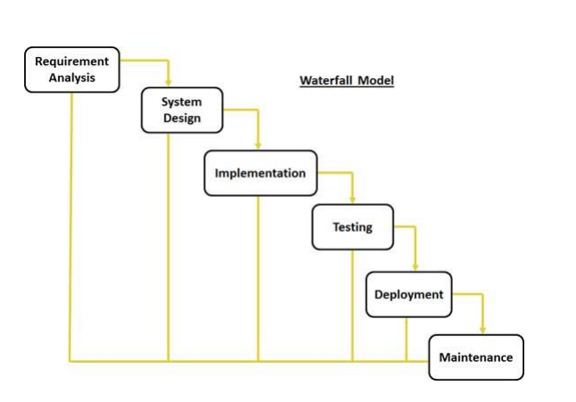
Figure 3.1: Diagram of a Waterfall Development Methodology, Source: (Sama, 2020).
The system model of the proposed system is shown below.

Figure 3.2: The System Model
The Proposed Approach is Divided into the Following Main modules:
  - Image and Voice Data Acquisition
  - Data Preprocessing and Feature Extraction
  - Attendance Recording and Verification
  - User Interaction and Feedback
i. Image and Voice Data Acquisition
At the core of our attendance management system lies the pivotal module of Image and Voice Data Acquisition.” This foundational stage serves as the gateway to capturing attendance data through the sophisticated integration of image and voice recognition technologies. Leveraging the prowess of advanced computer vision techniques, our system meticulously employs facial detection and recognition algorithms to discern and identify individuals within the captured images.
ii. Data Preprocessing and Feature Extraction
Image Preprocessing: This module initiates with the meticulous preprocessing of image data, encompassing essential steps such as resizing, normalization, and feature extraction. These techniques optimize facial recognition accuracy by standardizing facial features and enhancing their quality for subsequent processing stages.
Facial Recognition Optimization: Through careful image preprocessing, the system ensures that facial features are uniformly represented and extracted, thereby improving the accuracy of facial recognition algorithms. This optimization step is crucial for reliable attendance tracking outcomes.
Voice Data Processing: In parallel, voice data undergoes thorough processing to extract key speech features, including pitch, intensity, and formants. These extracted features are vital for accurate transcription and identification of spoken language, facilitating precise attendance tracking.
Standardization for Analysis: By standardizing image and voice data through preprocessing techniques, the system prepares the information for effective analysis. Standardization ensures consistency and uniformity, enabling robust attendance management solutions.
iii. Attendance Recording and Verification
In this module, we leverage preprocessed voice data to efficiently manage attendance and verify individual identities. This module serves as a cornerstone in ensuring accurate attendance tracking and maintaining security protocols within the system.
iv User Interaction and Feedback
The” User Interaction and Feedback” module serves as the cornerstone of the attendance tracking system, prioritizing user experience and engagement. At its core is a user-friendly interface accessible across multiple devices, ensuring seamless interaction regardless of location. This intuitive interface empowers users to effortlessly navigate the system, accessing attendance records and performing tasks with ease. Moreover, the integration of voice command functionality revolutionizes user interaction, allowing individuals to log attendance or query records hands-free, particularly beneficial in situations where manual input may pose challenges.

3.2 ANALYSIS OF THE EXISTING SYSTEM
Existing attendance systems, whether manual or electronic, exhibit several shortcomings. Manual systems are labor-intensive, time-consuming, and prone to errors. Electronic systems, such as swipe cards or biometric scanners, are more efficient but often susceptible to fraud, including proxy attendance and data breaches. Moreover, these systems lack adaptability and scalability, making them unsuitable for larger organizations or environments with dynamic needs. The reliance on physical devices or human intervention further limits their efficiency and effectiveness. These challenges underscore the necessity for a smarter, technology-driven solution.
3.3 PROBLEMS OF THE EXISTING PROBLEM
The existing attendance system has the following disadvantages:
- Time-consuming and error-prone processes.
- Susceptibility to fraud, such as proxy attendance.
- High dependency on physical devices or human intervention.
- Limited scalability and adaptability to dynamic environments.
3.4 DESCRIPTION OF THE PROPOSED SYSTEM
The proposed smart attendance monitoring system utilizes voice recognition technology to address the limitations of existing systems. It employs machine learning algorithms to authenticate individuals based on unique vocal characteristics. This contactless approach ensures ease of use and aligns with current technological and health-related trends. The system architecture comprises a voice recognition module, a database for storing voice samples, and a user-friendly interface for attendance tracking. During registration, users provide voice samples, which are processed and stored in the database. During attendance, the system authenticates the user’s voice in real-time, recording their presence. Designed for scalability, the system can be deployed in diverse environments, from small classrooms to large corporate organizations. It incorporates security features to protect user data and prevent unauthorized access. The system’s adaptability and efficiency make it a robust solution for modern attendance challenges.
3.5 ADVANTAGES OF THE PROPOSED SYSTEM
- The proposed system has the following advantages:
- Enhances accuracy and reliability in attendance tracking.
- Reduces time and labor involved in manual processes.
- Eliminates risks of fraud, such as proxy attendance.
- Provides a contactless and user-friendly solution.
- Ensures scalability and adaptability across various environments.

CHAPTER FOUR
DESIGN, IMPLEMENTATION AND DOCUMENTATION OF THE SYSTEM
4.1 DESIGN OF THE SYSTEM
This is the computation of the particulars of a new system and the determination of what the new system would be and the function it is to perform. This may involve changing from one system to another or modifying the existing system operation.
The most challenging phase of the system life cycle is the change from manual operation to a faster and more accurate one; system design stage covers the technical specifications that will be employed in the implementation of the new system in order to modify the previous system. Some factors are put in consideration. These factors include input design, output design, definitions file and procedure designs and other documentation.
4.1.1 OUTPUT DESIGN
This incorporates the objectives of solving the existing system problems and challenges. This involves the structuring of the desired information and also enhancing an efficient and effective attendance system. Things taken into consideration in determining the output are represented below:
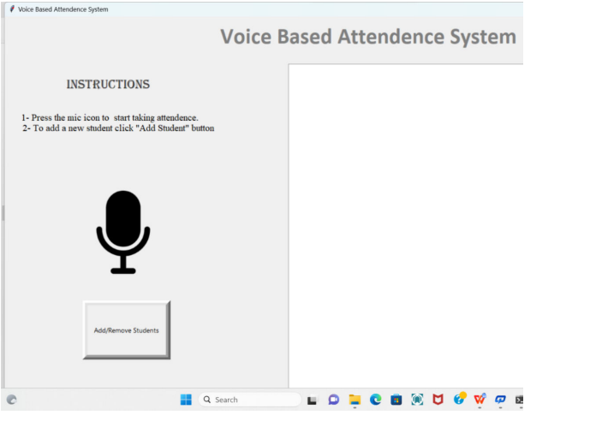
Figure 4.1: The Main Page
This is the page that will be displayed after the developed system has been loaded successfully. It contain some instruction and a button which can be used while testing the system.
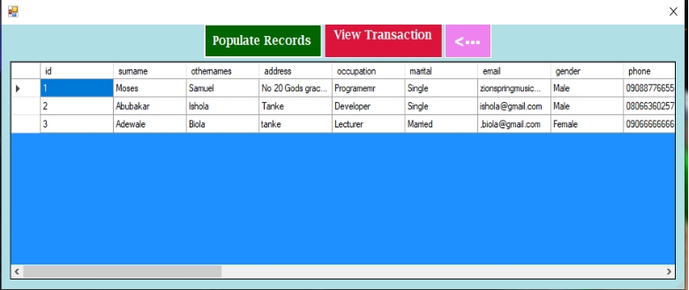
Figure 4.2: Student Records
This displays the records of all the student registered on the system.
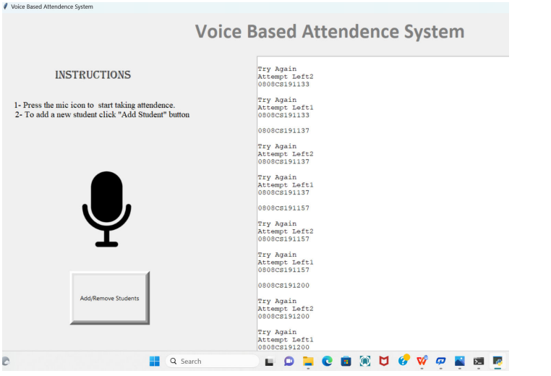
Figure 4.3: Attendance Response Screen
The interface above shows the attendance response screen where the attendance will be taken.
4.1.2 INPUT DESIGN
The input to run this software is obtained from the class attendance system using a voice recognition system. The administrator is expected to safeguard the files and documents using fingerprint authentication. The input design describes the input interface for data entry into the program. Data entry interfaces need to be considered in developing a new system to ensure user friendliness. Data entry is done through the use of a keyboard, camera, and in some cases, selection from the dropdown combos and list boxes is done using mouse selection. The interface descriptions are as shown below:
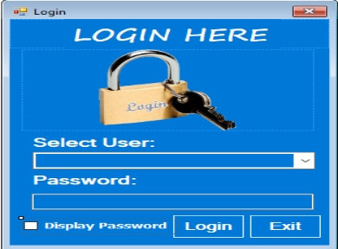
Figure 4.4: Login Interface
This interface is where the admin and student can login to the system by entering their username and password respectively.
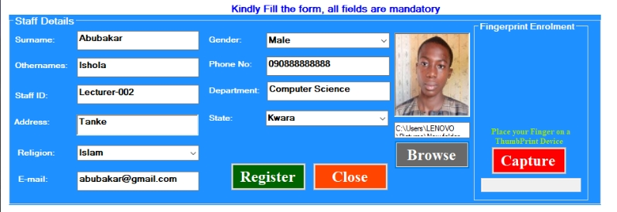
Figure 4.5: Student Registration Form
This page displays some textboxes that the student will fill out to register on the system.
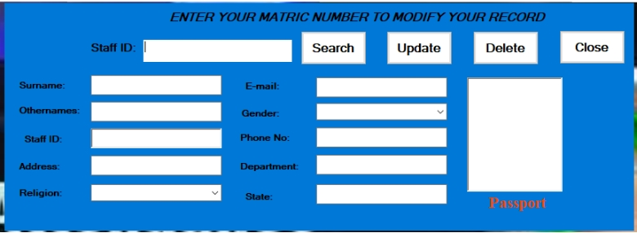
Figure 4.6: Student Records Modification Interface Student
The interface above shows the page where user details can be modified after successful registration.
4.1.3 DATABASE DESIGN
The structure and organization of records in the tables is a database file is essential to be considered in designing a database driven application. The database files main record where house for keeping data and information relevant for this application.
Table 1: Student Table
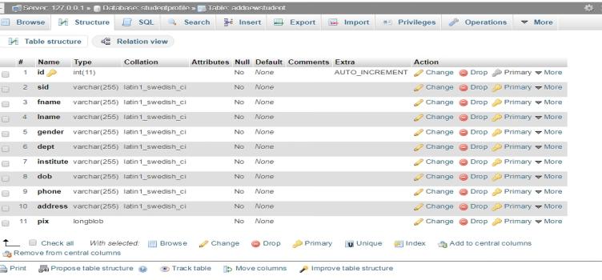
This houses the entire record of registered students.
Table 2: Attendance Table
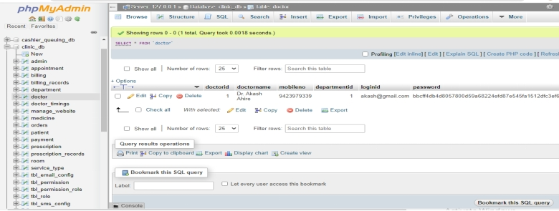
This is the table that houses the attendance of all the present students.
4.13 PROCEDURE DESIGN
These are the steps involved in unifying the whole process to produce the desired output. It involves computer procedures which starts from the original input lessons to the output result file. This allows the processing of the information and result to be possible. Menu is provided to aid user in the processing of the output file.
4.2 IMPLEMENTATION OF THE SYSTEM
This entails the choice of the programming language employed to implement the software which should-be suitable for lecture attendance using fingerprint recognition authentication. The software is designed for the use of lecture attendance system which should serve as an assistant for the management in monitoring the attendance system for students.
4.2.1 CHOICE OF PROGRAMMING LANGUAGE
The Application was developed in a .net (dot net) integrated development environment (.net IDE). The Application IDE is chosen following the fact that extracted information needs to be presented in an enhanced pictorial/graphical format and easy communication with the database for program flexibility in windows platform.
4.2.2 HARDWARE REQUIREMENTS
Minimum of Microcomputer Pentium IV- Intel 1.5 GHZ processor, 1.0 GB RAM, 40GB Hard disk, 14” VGA Monitor Windows XP or higher, Enhanced keyboard, mouse and pad.
4.2.3 SOFTWARE REQUIREMENT
i. Windows 7
ii. C#
iii. Fingerprint Sensor
IV. MYSQL Server
4.2.4 CHANGE OVER TECHNIQUE
These deals with the processes and steps taking to put the system into use, before the system can be fully employed into the system, some training might have been done by the user of the application if he or she is a computer illiterate, because the user might be a computer illiterate, so also the system might have also been use. Since the work of an expert cannot be eliminated from the system, the computerized system will have to work hand in hand with the expert in the field.
4.3 DOCUMENTATION OF THE SYSTEM
After the program has been well tested with input that the output is already been known, the next step is to install the software into the computer system for use.
The process of installing are been stated below
- Insert the CD into the system through the CD-ROM after the computer is switch on
- Locate the CD drive directory in my computer and click it to open
- After open, locate setup.exe, and then click to install the program by following the necessary step in installing the program.
- Ensure full installing of the software for effective operation of the system.
After the program has been fully install. The next thing is to locate the package install to put it into operation, to locate the package for expiration purpose the following step are to be taking.
- Click on start menu from task bar. Then select all program
- From the display sub option, select by locating the software installed named Information to load the software.
4.3.1 PROGRAM DOCUMENTATION
The program is packaged for use in any system irrespective of either it runs C# Application or not. After developing a program in Visual Basic, there is a facility provided in the Microsoft Visual Studio suite called “Package and Deployment Wizard” that is used in Visual Studio application packaging and deployment.
The automated face recognition-based lecture attendance system is packaged into an installable setup that can be run from any system.
4.3.2 MAINTAINING THE SYSTEM
The system maintenance refers to making modification to an already existing application/program without necessarily re-writing everything from start. Program maintenance of a program includes modification of the program to meet-up with certain requirements of the users. In this course, additional features can be added, errors corrected, ambiguous interfaces redesigned to eliminate confusions and unnecessary features removed.
Maintaining this program can be done in Visual studio environment. Any future modification can be by re-running the program source code in a C# environment making necessary changes and updates and recompile the application into an upgrade version of the existing version of the mini word processing application. Further versions of this program can be named following their year of release or it can be given a different version number.

CHAPTER FIVE
SUMMARY, CONCLUSION AND RECOMMENDATIONS
5.1 SUMMARY
Attendance monitoring is a critical aspect of organizational management, yet traditional methods often fail to meet the demands of modern environments. This study introduces a smart, efficient, and secure alternative using voice recognition technology. By leveraging unique vocal characteristics, the proposed system addresses the limitations of existing systems. The project’s findings underscore the potential of voice recognition technology in transforming routine processes. Through detailed analysis and performance evaluation, it demonstrates the feasibility of integrating advanced biometrics in attendance systems. This project contributes to the growing body of knowledge on AI-driven solutions.
By bridging the gap between theoretical advancements and practical applications, this study lays the groundwork for future innovations. The proposed system not only improves attendance monitoring but also serves as a model for adopting smart technologies in various domains. The attendance system was developed using Python open-source libraries with google voice recognition system.
5.2 CONCLUSION
The proposed smart attendance monitoring system using voice recognition offers a revolutionary approach to managing attendance in academic and corporate settings. By addressing the inefficiencies and vulnerabilities of traditional systems, it enhances accuracy, security, and efficiency. The project highlights the transformative potential of voice recognition technology in routine processes. Its findings advocate for the broader adoption of AI-driven solutions, emphasizing the importance of continuous research and innovation in this field.
5.3 RECOMMENDATIONS
Based on the findings of this research, the following were recommended:
- Further research to optimize voice recognition algorithms for diverse environments.
- Development of comprehensive security measures to safeguard user data.
- Pilot implementation in varied settings to assess scalability and adaptability.
- Integration with other smart systems for holistic organizational management.

REFRENCES
Anjola, C., K. (2019). Face Recognition Based Attendance Marking System. Journal of Software Engineering and Simulation Vol. 5. Issue: 2. Pp: 18-19. DOI: 10.48047/ecb/2023.12.si4.1679.
Amit, K., Varma, P. K., Perala, S. & Chadha, P. R. (2016): Automatic Attendance System by Visual Programming Language LabVIEW,” in IEEE International Conference on Smart Systems and Inventive Technology. Pp. 14-15. DOI:10.1109/ICSSIT53264.2022.9716261.
Chintalapati, S. & Raghunadh, V. (2017). Automated Attendance Management System Based on Face Recognition Algorithms. IEEE International Conference on Computational Intelligence and Computing Research. DOI:10.32628/ICPEICES229147.
Eisert, P. & Girod, B. (2020). Analyzing Facial Expressions for Virtual Conferencing, Computer Graphics and Applications. Vol. 18, Issue: 5. Pp. 70-78. DOI:10.17577/CGA9IS050861.
Sandhya, N., Francisco, S., Victor, F. & Antonio, P. (2022). Smart Attendance System Using Speech Recognition, IEEE International Conference. Pp. 14-15. https://doi.org/10.1007/978-981-15-5400-1_62.
Soewito, B., Simanjuntak, E., Gunawan, E., F., (2019). Smart Mobile Attendance System Using Voice Recognition and Fingerprint on Smartphone. International Journal on Engineering Applications (I.R.E.A.). Vol. 11. Issue: 2. Pp. 567-569. https://doi.org/10.37082/irea.v12.i2.230598
Jain, A., & Kumar, S. (2023). Applications of voice recognition in modern systems. International Journal of Artificial Intelligence Research, 12(4), 45-60. DOI: 10.1109/ICTC.2016.7763360
Katsaggelos, K. (2020). Automatic Facial Action Recognition in Face Profile Image Expression Recognition Using Facial Animation sequences, in Proceedings IEEE International Conference Multimedia, Parameters and Multi stream HMMs. Pp. 37-40. Harlow, England: Addison-Wesley.
Kumar, P. K., Perala, V. & Chadha, P. R. (2016). Automatic Attendance System by Visual Programming Language LabVIEW, in IEEE International Conference on Power Electronics, Intelligent Control and Energy System. Pp. 20-21.
Maddu, K. & Kumar, P. (2019). Wireless Fingerprint Attendance Management System, Fifth International Conference on Image Information Processing (ICIIP), Shimla, India. Pp. 10-11. DOI: 10.1109/ICIIP47207.2019.8985867
Mohammed, S. & Raghu, P. (2019). Automatic Control of Student Attendance in Classroom Using RFID, IEEE International Conference. Vol. 3. Pp. 14-15. IOP Publisher.
Patel, M. (2021). Contactless solutions in the post-pandemic era. Technology Today, 8(3), 34-42.
Sivakumar, H. & Balasubramanian, U. (2020). Attendance Marking System, Journal of Software Engineering and Simulation Vol. 5, Issue: 2. Pp. 27-29.
Smith, R., & Lee, T. (2022). The role of AI in attendance management systems. Journal of Organizational Efficiency, 19(2), 102-118. DOI: 10.1109/JOE47207.2019.45386289
Venkatesh, K. & Anesh, M. (2023). Smart Attendance System Using Voice Recognition, (International Journal of Engineering Science and Advanced Technology (IJESAT). Vol. 23. Issue: 9. Pp. 1234-1235.
Vinesh, A., Prasad, A., K., Govind, S., Surya, S., G. & Shandry, K. (2024). Attendance Management System using Image and Voice Recognition, International Journal of Innovative Science and Research Technology. Vol. 9: Issue 7. doi.org/10.38124/ijisrt/IJISRT24JUL1745
Watson, L., & Brown, K. (2020). Challenges in implementing voice recognition technology. Tech Innovations, 15(5), 78-85. DOI: 10.1109/TIP47207.2019.8985867
Williams, D. (2019). Enhancing educational administration with AI. Educational Technology Review, 14(1), 23-39.

Appendices
Appendix 1: System Flowchart
TAKE ATTENDANCE
VIEW STUDENT LIST
VIEW ATTENDANCE
REGISTER NEW STUDENT

STOP
SPLASH SCREEN

FILE
START

Appendix 2: Student Registration Flowchart
START
OPEN DATABASE
INCREMENT ID BY 1
ENTER STUDENT DETAILS
SAVE INTO DATABASE
CLOSE DATABASE
MORE RECORD?
RETURN
Yes
No
DISPLAY STUDENT
ENTRY FORM
CAPTURE STUDENT VOICE

Appendix 3: Take Attendance Flowchart
OPEN DATABASE
START

CAPTURE STUDENT VOICE

VERIFY STUDENT VOICE
RETURN
CLOSE DATABASE
MORE ?

Yes

No

Appendix 4: View Student List Flowchart
RETURN
CLOSE DATABASE
OPEN DATABASE
START
DISPLAY ALL
STUDENT DETAILS

MORE TO VIEW?
No
Yes
Appendix 5: View Attendance Flowchart
RETURN
CLOSE DATABASE
OPEN DATABASE
START
VIEW ALL STUDENT ATTENDANCE

VIEW MORE?
Yes
No

Appendix 6: Source Program Listing
using System;
using System.Collections.Generic;
using System.ComponentModel;
using System.Data;
using System.Drawing;
using System.Linq;
using System.Text;
using System.Windows.Forms;
using System.Data.OleDb;

namespace MultiFaceRec
{
public partial class Form3 : Form
{
private OleDbConnection bookConn;
private OleDbCommand oleDbCmd = new OleDbCommand();
private String connParam = @"Provider=Microsoft.Jet.OLEDB.4.0;Data Source=C:\Users\PROGRAMMER\Desktop\face recornition project\FaceRecProOV\bin\Debug\faceattendance.mdb;Persist Security Info=False";

public Form3()
{
bookConn = new OleDbConnection(connParam);
InitializeComponent();
}

private void nDIToolStripMenuItem1_Click(object sender, EventArgs e)
{

int hh = 1;

dataGridView1.DataSource = null;
dataGridView1.Rows.Clear();
dataGridView1.Refresh();

OleDbDataAdapter dAdapter = new OleDbDataAdapter("select * from StudentDetails WHERE Slevel = 'ND I'", connParam);
OleDbCommandBuilder cBuilder = new OleDbCommandBuilder(dAdapter);

DataTable dataTable = new DataTable();
DataSet ds = new DataSet();
dAdapter.Fill(dataTable);
for (int i = 0; i < dataTable.Rows.Count; i++)
{
dataGridView1.Rows.Add(hh, dataTable.Rows[i][1], dataTable.Rows[i][2], dataTable.Rows[i][3], dataTable.Rows[i][4], dataTable.Rows[i][5]);
hh++;
}

bookConn.Close() }

