GSM-BASED REMOTE SWITCHING SYSTEM FOR HOUSEHOLD SECURITY

BY

LATEEF HABEEB OPEYEMI
ND/23/COM/PT/0070

A PROJECT REPORT SUBMITTED TO THE
DEPARTMENT OF COMPUTER SCIENCE
INSTITUTE OF INFORMATION AND COMMUNICATION TECHNOLOGY, KWARA STATE POLYTECHNIC ILORIN

IN PARTIAL FULFILLMENT OF THE REQUIREMENT FOR THE AWARD OF NATIONAL DIPLOMA (ND) IN COMPUTER SCIENCE

2025
CERTIFICATION
This is to certify that this project was carried out by Lateef Habeeb Opeyemi with Matriculation Number ND/23/COM/PT/0070 in the department of Computer Science, Institute of Information and Communication Technology, Kwara State Polytechnic, Ilorin.

------------------------------------- ----------------------
MR. ISIAKA, O.S. Date
(Project Supervisor)

--------------------------------- ----------------------
MR. OYEDEPO, F.S. Date
(Head of Department)

----------------------------------- ---------------------
External Supervisor Date

DEDICATION
This project is dedicated to the Almighty God, the creator of the earth and universe.

ACKNOWLEDGEMENT

TABLE OF CONTENTS
PAGE
TITLE PAGE i
CERTIFICATION ii
DEDICATION iii
ACKNOWLEDGEMENT iv
TABLE OF CONTENTS v – vii
ABSTRACT viii
CHAPTER ONE: GENERAL INTRODUCTION
1.1 INTRODUCTION 1
1.2 STATEMENT OF THE PROBLEM 2
1.3 AIM AND OBJECTIVES OF THE STUDY 3
1.4 SIGNIFICANCE OF THE STUDY 3
1.5 SCOPE OF THE STUDY 4
1.6 ORGANISATION OF THE STUDY 4
CHAPTER TWO: LITERATURE REVIEW
2.1 REVIEW OF RELATED LITERATURE 5
2.2 CONCEPT OF INSTRUSION DETECTION 7
2.2.1 TYPES OF INTRUSION DETECTION TOOLS 7
2.3 INTRUSION DETECTION SYSTEM (IDS) 8
2.3.1 TYPES OF INTRUSION DETECTION SYSTEM 9
2.4 INTRUSION DETECTION SYSTEM TECHNIQUES 10
2.5 TYPES OF ATTACK 12

CHAPTER THREE: METHODOLOGY AND ANALYSIS OF THE EXISTING SYSTEM
3.1 RESEARCH METHODOLOGY 15
3.2 ANALYSIS OF THE EXISTING SYSTEM 15
3.3 PROBLEMS OF EXISTING SYSTEM 16
3.4 DESCRIPTION OF THE PROPOSED SYSTEM 17
3.5 ADVANTAGES OF PROPOSED SYSTEM 17
CHAPTER FOUR: DESIGN AND IMPLEMENTATION OF THE SYSTEM
4.1 DESIGN OF THE SYSTEM 18
4.1.1 OUTPUT DESIGN 18
4.1.2 INPUT DESIGN 20
4.1.3 DATABASE DESIGN 21
4.1.4 PROCEDURE DESIGN 21
4.2 SYSTEM IMPLEMENTATION 22
4.2.1 CHOICE OF PROGRAMMING LANGUAGE 22
4.2.2. HARDWARE SUPPORT 22
4.2.3 SOFTWARE SUPPORT 22
4.2.4 IMPLEMENTATION TECHNIQUES 23
4.3 SYSTEM DOCUMENTATION 23
4.3.1 PROGRAM DOCUMENTATION 23
4.3.2 OPERATING THE SYSTEM 24
4.3.3 PROGRAM MAINTENANCE 25
CHAPTER FIVE: SUMMARY, CONCLUSION AND RECOMMENDATION
5.1 SUMMARY 26
5.2 CONCLUSION 26
5.3 RECOMMENDATION 27
REFERENCES 28
FLOWCHARTS 30
SOURCE CODE LISTINGS 33

ABSTRACT
With rising energy consumption and population, there is an urgent need to save energy in all available ways. One of the primary reasons for energy waste in Nigeria is the inability to access and manage appliances from a remote location. As a result, this study is focused on the advancement of GSM-based remote switching technology. It is also a secure mode for security warning, which will limit the number of frauds and other external threats to people at home or in the office. Also, make it simple to detect any intruders attempting to hack into home or business appliances. The software is a desktop application that was created with the help of the Java integrated development environment (Netbeans 6.5). It includes a feature-rich text editor with refactoring tools and cold templates, as well as high level and granular application views and a drag and drop graphic user interface (GUI) design. Netbeans IDE can run on any drag-and-drop graphic user interface (GUI) design. Netbeans IDE may run on any operating system that has a compatible JVM. However, the GSM-based remote control system enables home owners to manage household appliances from anywhere using a mobile phone while simultaneously preventing unlawful access to these goods. The provision of security upon detection of intrusion via SMS using GSM technology is critical to the current system. This GSM-based HACS is recommended for installation in every home in order to combat Nigeria's massive energy waste.

CHAPTER ONE
GENERAL INTRODUCTION
1.1 INTRODUCTION
The advancement of digital information has resulted in a rapid shift in human lifestyle. The use of electricity is critical because it is one of the primary sources of energy that is required in modern life. Technology is constantly evolving, and as a result, new methods for easier and safer control of electrical devices for more efficient power management at homes and workplaces are being developed. When most people leave their homes, they invariably leave their lights, fans, and other appliances on, resulting in energy waste and inefficiencies. It is not always possible to be physically present in the home environment, but in any case, much should be done to reduce energy waste. In Nigeria, these wastes are extremely harmful to industrial development.
As a result, available technologies must be expanded in order to eliminate or reduce these wastes in electricity usage. Negligence in leaving lights and other electrical appliances on can result in exorbitant electricity bills, wastage of much-needed power (electrical energy), and a shorter life span of electrical devices or appliances. This project describes the design and implementation of a centralized remote lighting and appliance control system for smart home applications using GSM technology, which significantly reduces the cost of power consumption. This system is implemented through the use of a customized and user-friendly mobile application. This same system handles intrusion detection, notification alerts, and alarms.
In recent years, home security has become an essential requirement for households in order to keep their homes safe from intruders and robbers. As a result, researchers and companies are attempting to implement algorithms and create gradations that will keep your home safe from intruders. This results in advanced technology that makes your home intelligent or modern, which is also known as a home automation system. House owners can use this technology to control other appliances such as lighting, dimming, electrical appliances, and many more. Instead of a wired topological connection, wireless technology is now used to control home appliances. GSM (Global System for Mobile Communication) technology is used to communicate input signal from appliances to device output message. That is, when an intrusion is detected, the GSM Modem sends the appropriate message to the house owner's phone.
Signals or data from sensors or other equipment are digitized by a GSM module and sent to a receiver. Many advantages are provided by a home automation or household security system. It is very simple to install and has a low cost. Basically, it is installed over the entry door, and that door contains a magnet that is connected to a relay. When the relay detaches from the magnet, signals are generated and sent to an 8051 microcontroller, where action is taken according to a piece of code written in the chip, and the GSM module sends the message to the owner's phone. Much research has been conducted on various types of home security systems, such as sensor-based home security systems, palm print and keypad activation for authentication, and so on. All types of security systems rely solely on the GSM module technique.
1.2 STATEMENT OF THE PROBLEM
Hackers, intruders, poorly configured networks, and other malicious traffic are constantly bombarding homes and offices. The work in this project is primarily concerned with the security of the user's home while he or she is away. GSM-based technology is proposed to keep the owner informed about house security. This security system is SMS-based and sends SMS to the owner via GSM technology. Typically, the goal of this type of system is to keep intruders out of the house. A lot of research is being done to improve the performance of a smart automated house.
1.3 AIM AND OBJECTIVES OF THE STUDY
The study is based on GSM-based remote switching for household security systems, which improves security measures for those who are concerned about their safety at home. The study's specific objectives are as follows:
- Design a system for accurately detecting malfunctions in home electronics and sending a message to the home owner.
- Design a system that detects smoke near home appliances and sends an appropriate signal.
1.4 SIGNIFICANCE OF THE STUDY
The significance of this study is to improve home security systems and create simple means of effective home security management in order to reduce security challenges and facilitate efficient operation in terms of home security management. The research findings will promote effective and enhanced security expert knowledge on improved security and safety system at home and offices, as well as broaden the knowledge of respective security experts, individual households on the importance of home security system, most notably through the design and development of GSM-based switching system.
1.5 SCOPE OF THE STUDY
The scope of this study is limited to a receiver with sufficient signal strength that can receive SMS messages from a cellular phone network, as well as the controlling unit's ability to receive and decode SMS messages.
1.6 ORGANIZATION OF THE STUDY
The research work is divided into five chapters: The first chapter consists of an introduction, a statement of the problem, a goal and objectives, the significance of the study, the scope of the study, the organization of the report, and the definition of terms. The second chapter is based on previous work on the subject, a review of general text, and the historical background of the case study. The third chapter highlights and discusses research methodology, data analysis and the existing system, problems with the existing system, a description of the proposed system, and the benefits of the proposed system. The fourth chapter discusses the system's design, detailed implementation techniques, system documentation, program documentation, operating the system, and maintaining the system. The fifth chapter contains a summary of the findings, conclusions, recommendations.
CHAPTER TWO
LITERATURE REVIEW
2.1 REVIEW OF RELATED PAST WORK
Gartner (2013) described an imagined Intrusion Detection system in which genetic programming is used to set the appropriate alarm levels on a set of "agents" (sensors analyzing the audit data stream). His main contribution is the emphasis on a modifiable sensor set as well as the approach to automatic threshold configuration. The paper discusses Intrusion Detection for users rather than problems with untrusted code and is thus unrelated to the Security Assistant. The semi-autonomous sensor design approach inspired and influenced the design considerations in Section. There are no experimental results yet, but there is a paper available that discusses how to structure the programs to make them more prone to mutation.
Mehdi et al. (2010) employ an expert system to enforce special rules as well as a statistical component to detect changes. They carried out an experiment in which the statistical component was used to detect programs masquerading as others. Historical data on the programs' previous behaviors was gathered, and the profiles of the programs were compared to the profiles of the other programs. One of the findings is that programs with a high similarity score have no special relationship in terms of functionality. Cat, cp, and rm, for example, were considered similar, whereas cat, fmt, less, man, more, and sort were not.
Garvey & Teresa (2014) discovered that in a set of audit data, the subset of all possible (known) attacks is the most likely to have occurred. Because there are many possible attack types and finding the optimal subset is computationally expensive, genetic algorithms are used to search efficiently. The population to be evolved is made up of vectors with bits set for each attack in the data set. Crossover and mutation converge the population to the most likely candidates.
According to Younis, Youssef & Arisha (2011), the audit trial analysis system consists of a central master host and one or more monitored machines. The monitored machines use a host-based version of an intrusion detection system to analyze their local audit data, and relevant events are selected to be sent to the central host. Before being transmitted to the central host for global analysis, the selected events are converted to a normalized security audit data format (NADF). The conversion enables global analysis of data from disparate environments. The local host-based and global analysis engines are both rule-based systems that detect well-known penetration patterns. This hierarchical model is well suited to detecting pattern components at the local level and deriving the aggregate pattern at the global level.
Robbins (2002) demonstrated a method for detecting an attack whenever a user performs operations at a high privilege level without using legal bottleneck methods to get there. It is theoretically capable of detecting any novel attack that illegally elevates a user to a high privilege level without prior knowledge of the attack mechanism. Bottleneck verification was compared to a baseline intrusion detection system that employs keyword counts and an expert system to determine the likelihood of an attack in a telnet session. Bottleneck verification reduced the false alarm rate by nearly two orders of magnitude compared to the baseline system at a detection rate of 80%.
Marinova (2014) approaches intrusion detection problems from a different perspective, proposing a distributed architecture instead of a monolithic intrusion detection system design. Scalability, efficiency, fault tolerance, and ease of configuration are all advantages of the design.

2.2 CONCEPT OF INTRUSION DETECTION
Any mechanism that detects intrusive behavior is referred to as intrusion detection. This is the process of monitoring and analyzing events in a computer system or network for signs of intrusion, such as unauthorized entry, activity, or file modification. Monitoring and analyzing traffic, identifying abnormal activities, and assessing severity and raising alarm are the three steps in the intrusion detection process.
2.2.1 TYPES OF INTRUSION DETECTION TOOLS
Based on the underlying methodologies, Intrusion Detection System fall into three basic categories:
i. Post-event audit trail analysis: Products in this category are more valuable if they also perform automated audit trail and management. This entails extracting and archiving critical information as well as removing old and unnecessary audit trail data. This type of product has two major advantages. One benefit is that it addresses the enormous difficulties that organizations face when examining and managing audit trails. The second advantage is that investigators can go back in time and conduct historical analysis of past events. More sophisticated products can graph results and show trend analysis by attack category, system, system type, and so on. This is especially useful in the investigation of break-ins that occurred over a period of time. The disadvantage of a pure "after-the-fact" product in network security is that by the time it detects the security problem, it is usually too late to respond and protect the data, and the resulting consequences of the attack go far deeper into the network without resistance.
ii. Real-time packet analysis: Prior to the last few years, the idea of performing real-time network-wide Intrusion Detection appeared to be impossible. Systems lacked the necessary speed to perform this type of analysis without experiencing unacceptable performance issues. There are now a number of products on the market that detect attacks in real time and respond quickly, hopefully before any damage is done. A system dedicated to sniffing packets traveling across a single network segment is one method of real-time Intrusion Detection (remember the "link" discussed in the Network example).
iii. Real-time activity monitoring: Monitoring security-related activity on the various systems and devices that comprise the network is an effective method for real-time Intrusion Detection. To return to the bank analogy, this is equivalent to installing surveillance cameras and alarms inside the bank to monitor the tellers and vault. The surveillance is in close proximity to the valuables. While most activity monitors track audit trails from the operating system, more sophisticated tools also track audit trails from applications, databases, webservers, routers, firewalls, and so on. Examine critical files for Trojan horses, unauthorized changes, and so on.
- INTRUSION DETECTION SYSTEM (IDS)
The Intrusion Detection System (IDS) monitors network traffic for suspicious behavior that could compromise security. If it detects a threat, it notifies the system or network administrator. The goal of intrusion detection systems (IDS) is to detect and notify users of intrusions. IDS is a collection of techniques and methods for detecting suspicious activity on both the network and the host level. There are two types of intrusion detection systems: host-based intrusion detection systems (HIDS) and network-based intrusion detection systems (NIDS) (NIDS).
2.3.1 TYPES OF INTRUSION DETECTION SYSTEM
i. Host-based IDSs (HIDS): This investigation looks at data stored on individual computers that act as hosts. The host-based network architecture is agent-based, which means that a software agent is installed on each of the hosts that will be governed by the system. The term "host-based intrusion detection system" (HIDS) refers to the processing of data generated by computers, such as event and kernel logs. HIDS tracks which programs access which resources and may flag them. HIDS also monitors the system's state and ensures that everything makes sense, which is similar to the concept of anomaly filters. HIDS normally keeps a database of system objects and records both normal and abnormal system behavior. The database stores critical information about system files, behavior, and objects such as attributes, modification time, size, and so on. If it detects any suspicious or anomalous behavior, it raises an alarm and takes appropriate action against the detected threat or attack.
ii. Network-based IDSs (NIDS): This investigation looks into data exchanged between computers. More efficient host-based intrusion detection systems can monitor and collect system audit trails in real time as well as on a scheduled basis, distributing CPU utilization and network overhead and allowing for more flexible security administration. When the system is used to analyze network packets, intrusion detection is network-based. Network-based Intrusion Detection Systems (NIDS) capture network traffic as it travels through the wire to a host. This can be analyzed to look for a specific signature or unusual or abnormal behavior. Several sensors, which are essentially computer systems designed to monitor network traffic, are used to sniff packets on the network. If they detect any suspicious or anomalous behavior, they raise an alarm and send the message to the central computer system or administrator (who monitors the IDS), who then generates an automatic response.
2.4 INTRUSION DETECTION SYSTEM TECHNIQUES
i. Anomaly Detection Technique: Anomaly detection techniques save the system's normal behavior into a database, including kernel information, system log events, network packet information, software running information, operating system information, and so on. An alarm is generated if any abnormal or intrusive behavior or activity occurs in the computer system that deviates from the system's normal behavior. It is intended to detect abnormal patterns of behavior. The IDS establishes a baseline of normal usage patterns, and anything that deviates significantly from it is flagged as a potential intrusion. Non-intrusive anomalous activities are flagged as intrusive. This will result in a false-positive, i.e. false alarm. Intrusive activities that are not abnormal result in a false negative. It recognizes anomalies as deviations from "normal" behavior and automatically detects any deviation from it, flagging it as suspect. As a result, these techniques detect new types of intrusion as deviations from normal usage. If a user in the graphics department suddenly begins accessing accounting programs or compiling code, the system can properly alert its administrators.
Advantages of Anomaly Detection
Anomaly-based intrusion detection systems, which outperform signature-based ones, can detect attacks even when detailed information about the attack is unavailable. Signature information used by misuse-based intrusion detection systems can be obtained using anomaly-based detectors.

Disadvantages of Anomaly Detection
Because user and network behavior are not always known ahead of time, anomaly-based intrusion detection systems frequently generate false alarms. In order to construct a normal behavior profile using an anomaly-based approach, a large set of training data, consisting of system event logs, is required.
ii. Misuse detection (Signature detection): The idea behind signature detection or misuse detection schemes is that they save the sequence of patterns, signatures of attacks or intrusions, and so on into a database. When an attacker attempts to attack or an intrusion occurs, the IDS compares the intrusion signatures to the predefined signatures that are already stored in the database. When a successful match is found, the system generates an alarm. As long as the attacks are labeled appropriately, these techniques can automatically retrain intrusion detection models on different input data that includes new types of attacks. Models of misuse, as opposed to signature-based IDS, are created automatically and can be more sophisticated and precise than manually created signatures. They are very good at detecting known attacks and their variants.
Advantages of Misuse Detectors
Misuse detectors are extremely effective at detecting attacks while avoiding false alarms. They can detect specially designed intrusion tools and techniques quickly and provide system administrators with an easy tool to monitor their systems, even if they are not security experts.
Disadvantages of Misuse Detectors
Misuse detectors can only detect attacks that are known ahead of time. As a result, newly discovered attack signatures must be added to the systems. Misuse detectors are intended to detect only attacks with signatures introduced into the system. When a well-known attack is slightly modified, a variant of that attack is obtained, and the detector is unable to detect this variant of the same attack.

2.5 TYPES OF ATTACK
Passive communication monitoring, active network attacks, close-in attacks, insider exploitation, and service provider attacks are all possible types of attacks. Information systems and networks are appealing targets and should be resistant to attack from a wide range of threat agents, ranging from hackers to nation-states. When an attack occurs, a system must be able to limit damage and recover quickly. Passive attack, active attack, distributed attack, insider attack, close-in attack, phishing attack, password attack, buffer overflow attack, hijack attack, spoofing attack, and exploit attack are the eleven types of attacks.
- Passive Attack: A passive attack examines unencrypted traffic for clear-text passwords and sensitive data that can be used in other types of attacks. Passive attacks include traffic analysis, unprotected communication monitoring, weakly encrypted traffic decryption, and Turing authentication information such as passwords. Adversaries can see upcoming actions by passively intercepting network operations. Passive attacks involve the disclosure of information or data files to an attacker without the user's consent or knowledge.
- Active Attack: In an active attack, the attacker attempts to circumvent or breach secure systems. This can be accomplished through the use of stealth, viruses, worms, or Trojan horses. Active attacks include attempting to circumvent or break security features, introducing malicious code, and stealing or modifying data. These attacks target a network backbone, exploit information in transit, electronically penetrate an enclave, or target an authorized remote user while attempting to connect to an enclave. Active attacks result in data file disclosure or dissemination, denial of service, or data modification.
- Distributed Attack: A distributed attack necessitates the adversary injecting code, such as a Trojan horse or back-door program, into a trusted component or software that will later be distributed to a large number of other companies and users. Distribution attacks are centered on the malicious modification of hardware or software at the factory, such as a back door to a product, in order to gain unauthorized access to information or a system function at a later date.
- Inside Attack: An insider attack occurs when someone from within the organization, such as a disgruntled employee, attacks the network. Insider attacks can be malicious or non-malicious. Malicious insiders eavesdrop, steal, or damage information on purpose; use information fraudulently; or deny access to other authorized users. Malicious attacks are typically the result of carelessness, a lack of knowledge, or intentional security circumvention for reasons such as performing a task.
- Close-In Attack: A close-in attack involves someone physically approaching network components, data, and systems in order to learn more about the network. Close-in attacks involve regular people getting close to networks, systems, or facilities with the intent of modifying, gathering, or denying access to information. Surreptitious network entry, open access, or both are used to achieve close physical proximity. Social engineering is a popular type of close-in attack in which the attacker compromises the network or system through social interaction with a person, such as via email or phone.
- Phishing Attack: In a phishing attack, the hacker creates a fake web site that appears to be a popular site. The phishing portion of the attack involves the hacker sending an e-mail message to the user in an attempt to trick the user into clicking a link that leads to the fake site. When a user attempts to log in using their account information, the hacker records the username and password and then attempts to log in using that information on the real site.
- Password Attack: An attacker attempts to crack passwords stored in a network account database or a password-protected file in a password attack. Password attacks are classified into three types: dictionary attacks, brute-force attacks, and hybrid attacks. A dictionary attack makes use of a word list file, which contains a list of possible passwords. A brute-force attack occurs when the attacker tries every possible character combination.
- Buffer Overflow Attack: When an attacker sends more data to an application than is expected, a buffer overflow attack occurs. In most cases, a buffer overflow attack results in the attacker gaining administrative access to the system through a command prompt or shell.

CHAPTER THREE
METHODOLOGY AND ANALYSIS OF THE EXISTING SYSTEM
3.1 RESEARCH METHODOLOGY
This section briefly describes the design methodology used to complete the project. The project was designed to provide global access to the system for security purposes by utilizing extensive GSM technology for communication and a microcontroller for device control. The system's highlights are its long communication range and robust coordinating software with a data base containing information about the user's (client's) mobile phone number. The design is also based on a microcontroller-based home security system with SMS alerts through the use of a human body motion detector and a GSM module. The system design is divided into three stages: sensitivity, central process, and action. The perception section is performed by a PIR sensor mounted in the watch-area, central processing is performed by a programmed microcontroller, and the action (task) is performed by an interaction of an attached on-board GSM module to the processor (the microcontroller), which then sends an SMS alert to the user or owner's mobile phone number. This system is intended to detect only (or a portion of) human body motion.
3.2 ANALYSIS OF THE EXISTING SYSTEMS
GSM-based remote switching systems are a home automation technology standard that is similar to wifi and Bluetooth technology. Radio frequency (RF) is used for signaling and control in this technology. Zigbee is a mesh protocol that allows devices to act as repeaters. This technology has the benefit of increasing the connectivity of devices in the home. The use of GSM-based remote switching technology aids in overcoming the issue of intrusive installation. The system provides a sufficient data rate for controlling home devices. The installation and operating costs are minimal. With the help of a common gateway, the GSM-based system and the WiFi network are integrated in this system. As a light switch, radiator valve, safety sensor, and remote control, four devices are used in this system. The system is broken down into two subsystems. (i) DSM, or Digital Home Service Distribution and Management System, provides an interface for controlling and monitoring home devices. (ii) The home gateway is used to manage the home automation system. It is capable of receiving mobile phone signals. In addition, it activates or deactivates an LED for home devices. B. X10 X10 is a versatile home automation technology that uses existing electrical wiring in the home to remotely control lights, appliances, security systems, and other devices. X10 commands are transmitted from X10 transmitters to X10 receivers via standard household wiring. This technology can communicate via both wired power lines and wireless radio waves. X10 is a low-cost technology with a wide range of devices. This technology gives you only a limited amount of control over your home's devices.
3.3 PROBLEMS OF EXISTING SYSTEM
The following is a list of constraint Considerations
- The controlled appliances will necessitate the use of an electrical control interface. Only electrical devices can be controlled by this system.
- The control module must be protected against electrostatic discharges. This will improve the system's dependability.
- In the event of a power outage, a battery backup for the controlling unit can be implemented. This system will take into account a variety of networks, communication protocols, and interfaces.
3.4 DESCRIPTION OF THE PROPOSED SYSTEM
The proposed system is a home automation system based on GSM. There are numerous technologies, but the range of the system that employs these technologies is approximately 120 m. GSM technology has a wide range, allowing you to operate your system from anywhere in the world. SMS is used to control and access home appliances. As a result, this technology offers cost-effective solutions for remotely controlling home appliances. Because the system is wireless, it is both inexpensive and simple to set up. Using GSM technology, the proposed system allows users to control home devices via SMS. The system can provide feedback on the state of the home devices. And the system follows a specific SMS pattern to provide user authentication.
3.5 ADVANTAGES OF PROPOSED SYSTEM
The following benefit accrued from the proposed GSM based remote switching system as a security at home:
(a). To improve the security technology.
(b). To use technological advancement in such a way that a person leaving the office does not melt due to the hot climate.
(c). To facilitate users to ultimate their home having universal access
(d) To reduce cost and built a convenient home security using mobile technology.
(e) To facilitate remote controlling of home appliances, availability and ease of users.

CHAPTER FOUR
DESIGN AND IMPLEMENTATION OF THE SYSTEM
4.1 DESIGN OF THE SYSTEM
The process of defining the architecture, modules, interfaces, and data for a system in order to meet specified requirements is known as system design. The system design that is being written is tested and handled properly. Java Programming Language (Java Netbeans) and MySQL are used to implement the system. This system is also equipped with coding that prevents unauthorized individuals from gaining access to the office and matrimonial home. Before granting authentication, the restriction policy always requires a username and password. Various requirements are expected to be provided for the developed system to function properly in order for it to be properly implemented and meet the objectives for which it was developed. With regard to hardware and software requirements, installation, operational procedures, and system documentation
4.1.1 OUTPUT DESIGN
When developing any standard software, it is critical to understand the output specification. It is the specification provided to whoever is developing the software by the users or intended users. This specification provides an overview of the various reports and inquiries that the new system is expected to generate. However, this output specification must be known before any other specification can be used to achieve the output specification. The following are the output specifications for this project:
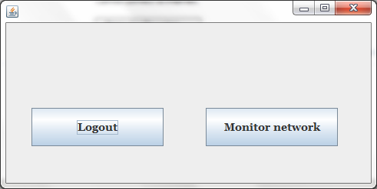

FIGURE 4.1: MONITOR NETWORK

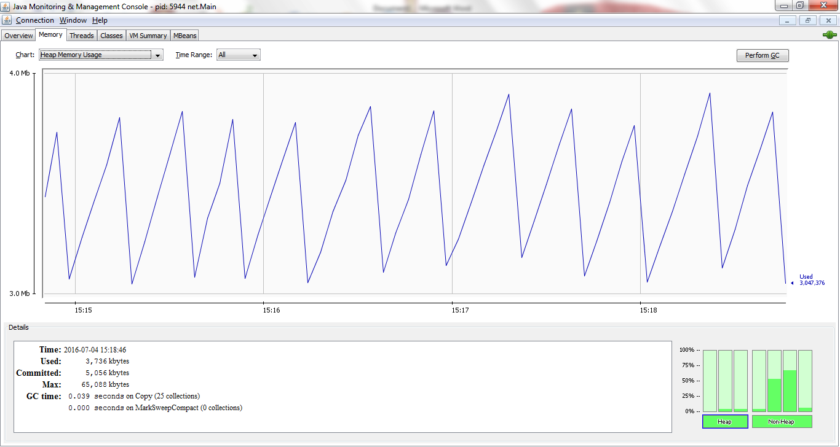
FIGURE 4.2: MEMORY USAGE

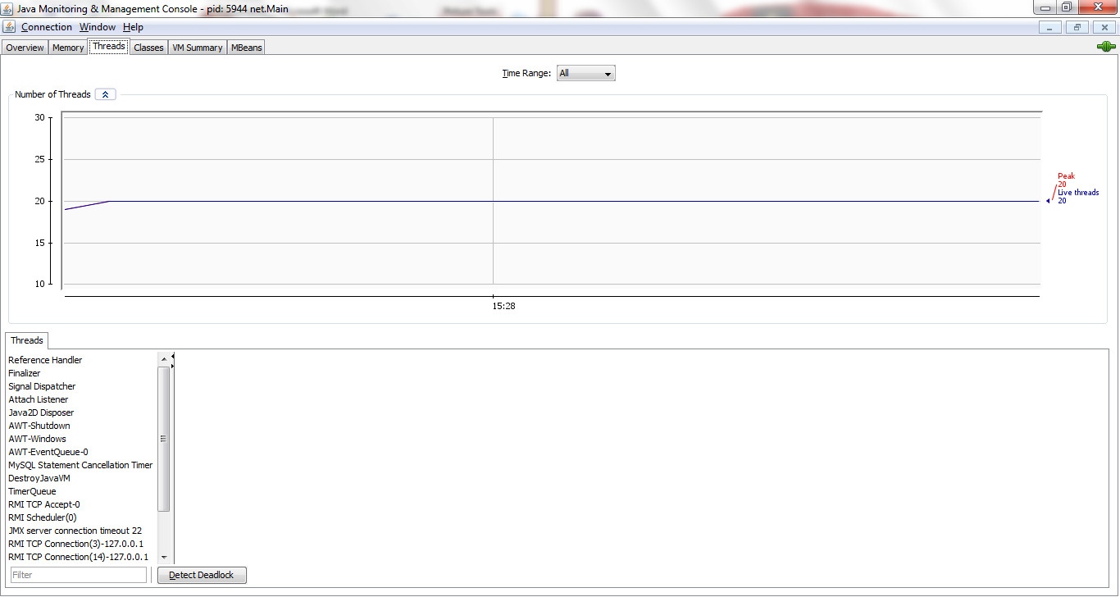
FIGURE 4.3: NETWORK LIVE THREADS
4.1.2 INPUT DESIGN
The input specification is important in the design phase of the new system after knowing the output specification. The system's input must be known because it serves as the foundation for output generation. The input specifications for the new system are listed below.
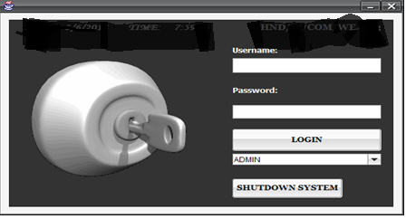

FIGURE 4.4: LOGIN
4.1.3 DATABASE DESIGN
User-supplied data must be stored in a database. In this instance. MySQL is the database software we use. The database is described in detail below.
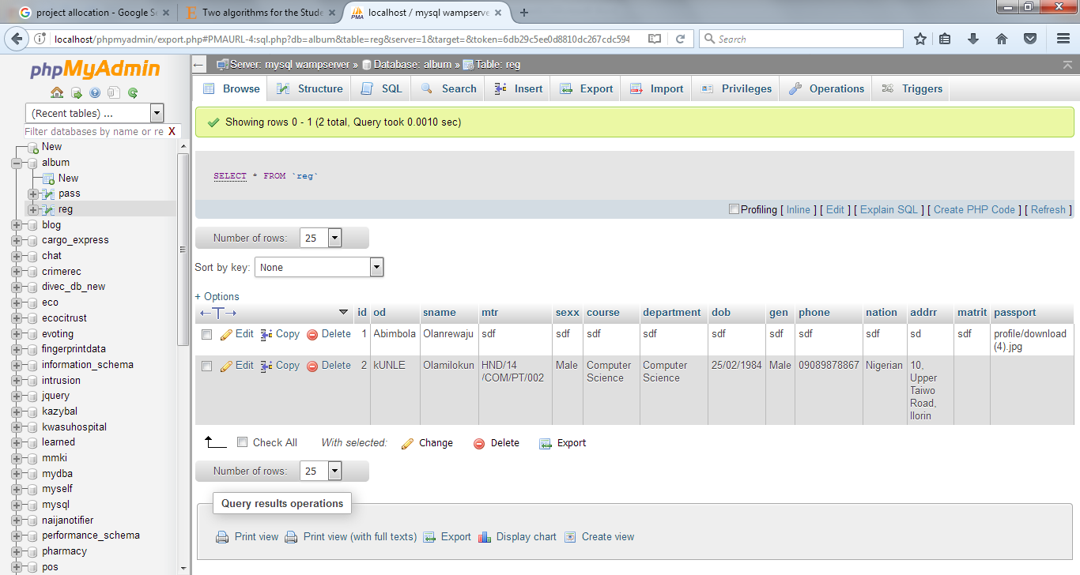

Figure 4.5: Data base Design

4.1.4 PROCEDURE DESIGN
GSM-based remote switching design and implementation for a home security system. When the system is activated, a menu will display to show the operation which includes login with two different privileges which are admin login and user login, the admin will login to have access to the system management features, while the users are family members and office staff.
User
Admin
User Login
User
Admin
Logout
Check the Status
VIEW APPROVED PROJECT

Figure 4.6: Procedure Design

4.2 SYSTEM IMPLEMENTATION
4.2.1 CHOICE OF PROGRAMMING LANGUAGE
There are a few tools that have been used to implement this for developing Project Allocation and Management for Computer Science:
- Language: PHP and HTML
- Database: MYSQL
- Web Server: XAMPP
4.2.2 HARDWARE SUPPORT
The hardware and software components of a computer system are broadly classified. The physical component of a computer system or computer peripherals is referred to as hardware. The developed web-based application cannot, of course, function in isolation. A variety of computer peripherals are required for the developed software to function properly. The following hardware components are required:
- A complete computer system
- A minimum of 1.2GHz processor
- 70MB of Available Hard Disk Space or more
- At least 512MB of Random Access Memory (RAM)
- Mouse and Enhanced Keyboard
- Printer e.g. laser jet
4.2.3 SOFTWARE SUPPORT
The term "software" refers to a collection of programs that are a set of instructions given to a computer to perform a specific task. The developed software can be either system software or application software; however, the developed software requires the assistance of other system software to run properly. The following software requirements are required for the proposed system to function properly:
- Microsoft Windows XP/VISTA/7
- .net framework environment
- .net framework 4.0
- Microsoft SQL Server
4.2.4 IMPLEMENTATION TECHNIQUE
This system is implemented using pilot changeover because pilot operation is a combination of both direct changeover and parallel operation, which limits the implementation to a pilot site and reduces the risk of system failure when compared to a direct cut over method.
4.3 SYSTEM DOCUMENTATION
Documentation was used as a process throughout the system development. The documentation ensures that the process involved in the development of the system, the system's content, operational procedure, and software maintenance can be communicated to the user in a concise manner, and that a well-documented system will assist the user through the process of setting up the software application.
4.3.1 PROGRAM DOCUMENTATION
The program is turned into an application that can run on any computer without the need for a development environment. The program is compiled into an installable setup that can be installed on any system and made executable as a standard application from the start menu. This program is divided into four modules;
- Login module: to authenticate the administrator and users with limited access to the platform
- The memory module: shows the memory usage life cycle when an intruder enters the system
- Network life trend module: Shows the current status of the platform, whether it is active or passive, allowing the administrator to know how active the platform is.
- Overview module: The overview module displays a comprehensive summary of the intrusion detected.
The installable setup is stored on a CD-ROM, which can be accessed via the CD-ROM drive in "my computer." The user navigates to the "My Computer" folder and selects the CD-ROM drive, which contains the setup file. Double-clicking on the setup icon launches the installation wizard, which walks the user through the installation process from start to finish.
4.3.2 OPERATING THE SYSTEM
To operate the system, the user follows the following steps
- Boot the system.
- Click on start menu> all programs and locate the application name “GSM Switching monitoring System”.
- Enter the correct username and password and click login. If the correct username and password is entered the main menu appears.
- Click on any of the program menu for your desired operation. Each menu option as explained in the procedure design above.
4.3.3 PROGRAM MAINTENANCE
Maintenance is the act of making modifications/changes to a program in order to meet future changes without having to rewrite the program from the ground up. A good program should be able to adapt to changes without breaking down. Maintaining a program must take place in the programming environment in which it was created. As a result, program maintenance is possible in Java NetBeans IDE 6.5. Any future changes to the program are made by opening the main project source in the Java NetBeans IDE. After the modification is complete and the program has been tested for errors, you can build it to be installable.

CHAPTER FIVE
SUMMARY, CONCLUSION AND RECOMMENDATION
5.1 SUMMARY
A lot of findings were made on intrusion detection system, GSM based remote switching system for household security system help information systems prepare for, and deal with attacks with the level of research carried out on this project. They accomplish this by gathering data from various systems and network sources and then analyzing the data for potential security issues. Anomaly detection techniques save the system's normal behavior into a database, including kernel information, system log events, network packet information, software running information, operating system information, and so on. An alarm is generated if any abnormal or intrusive behavior or activity occurs in the computer system that deviates from the system's normal behavior. It is intended to detect abnormal patterns of behavior.
5.2 CONCLUSION
The broader world of information and communications technologies (ICT) offers tremendous prospects and will reach new heights much faster if all technological tools are appropriately utilized. This paper provides a thorough examination of the types, life cycle, diverse domains, attack types, and tools. IDS are becoming increasingly important in today's corporate sector and for network users. The intrusion detection system specifies the detecting measures for security.
5.3 RECOMMENDATION
Because information systems and networks are vulnerable to electronic attacks, an intrusion detection system is highly recommended in today's information and technology world. Attempts to breach information security are increasing on a daily basis, as is the availability of free Vulnerability Assessment tools on the Internet. I recommend that this new system be implemented for effective network security monitoring in homes and offices. It is critical; security is required for users to protect their systems from intruders.
REFERENCES
Anita, K. J. & Robert S. S. (2009). Computer system intrusion detection survey. International Journal of Computer Theory and Engineering, Vol.2, No.6
Avancha, S. (2013). A holistic approach to secure sensor netis then compared with the works. PhD Dissertation, University of Maryland
Garlan, D. & Shaw, M. (2011). An introduction to software architecture. In Advances in Software Engineering and Knowledge Engineering, vol. I. River Edge, NJ: World Scientific Publishing Company
Gartner, K. (2013). Protect your network with an intrusion detection system, available at http://www.techrepublic.com/article.jhtml?src=search&id=r005210209ggr.htm
Garvey, T. & Teresa, F. (2014). Model based intrusion detection. In Proceedings of the 14th National Computer Security Conference, pages 372-385
Heikkilä, M. & Pietikäinen, M. (2010). A texture-based method for modeling the background and detecting moving objects, IEEE Trans. Pattern Analysis and Machine Intelligence, 28(4), 657-662.
Kaplantzis, S. (2012). Security models for wireless sensor networks, PhD Conversion Report, Centre of Telecommunications and Information Engineering, Monash University, Australia,
Marinova, V. (2014). A short survey of intrusion detection systems. Bulgarian academy of sciences.
Mehdi, B., Ahmad, F. & Amir, M. (2010). AGC4ISR, new software architecture for autonomic grid computing. International Conference on Intelligent Systems, Modelling and Simulation, pp.318 - 321
Nanni, L. & Lumini, A. (2012). Ensemble of multiple pedestrian representations. IEEE Trans. on Intelligent Transportation Systems, 9(2), 365-369.
Robbins R. (2002). Distributed intrusion detection systems, an introduction and review.
Shipley G. (2010). Watching the watchers: Intrusion detection available at http://www.networkcomputing.com/1122/1122f3.html
Symposium on Modeling, (2009). Analysis and simulation of computer and telecommunications systems.
Vera, M (2010). A short survey of intrusion detection systems.. Bulgarian academy of sciences.
Yu-Xi, L., Tim, S., John, L., Henry, L. & Owen, P. (2010). Wireless intrusion detection and response. Proceedings of IEEE Workshop on Information Assurance
Younis, M., Youssef, M. & Arisha, K. (2011). Energy-aware routing in cluster-based sensor networks. Proc. 10th IEEE International

PROGRAM FLOWCHART

Start

Login

Monitor system
Stop

LOGIN FLOWCHART

Yes
Start
Do username and password correct?
Return
Click on Login
Monitor system
Enter username and password
No

MONITOR SYSTEM FLOW CHART

Start
Open Data Base
Possible intrusion
Detect intrusion signature
Detect no intrusion signature
Alert Admin
Detect trans data
Store in Database
Close Database
Stop
No
Yes

SOURCE CODE
* To change this template, choose Tools | Templates
* and open the template in the editor.
* idsmain.java
* Created on 12-Jan-2020, 11:41:51
import java.io.IOException;
import java.util.logging.Level;
import java.util.logging.Logger;
public class idsmain extends db {
/** Creates new form idsmain */
public idsmain() {
initComponents();
}
/** This method is called from within the constructor to
* initialize the form.
* WARNING: Do NOT modify this code. The content of this method is
* always regenerated by the Form Editor.
*/
@SuppressWarnings("unchecked")
// <editor-fold defaultstate="collapsed" desc="Generated Code">
private void initComponents() {
jButton1 = new javax.swing.JButton();
setDefaultCloseOperation(javax.swing.WindowConstants.EXIT_ON_CLOSE);
jButton1.setText("Monitor Network");
jButton1.addActionListener(new java.awt.event.ActionListener() {
public void actionPerformed(java.awt.event.ActionEvent evt) {
jButton1ActionPerformed(evt);
}
});
javax.swing.GroupLayout layout = new javax.swing.GroupLayout(getContentPane());
getContentPane().setLayout(layout);
layout.setHorizontalGroup(
layout.createParallelGroup(javax.swing.GroupLayout.Alignment.LEADING)
.addGroup(layout.createSequentialGroup()
.addGap(190, 190, 190)
.addComponent(jButton1, javax.swing.GroupLayout.PREFERRED_SIZE, 227, javax.swing.GroupLayout.PREFERRED_SIZE)
.addContainerGap(173, Short.MAX_VALUE))
);
layout.setVerticalGroup(
layout.createParallelGroup(javax.swing.GroupLayout.Alignment.LEADING)
.addGroup(layout.createSequentialGroup()
.addGap(119, 119, 119)
.addComponent(jButton1, javax.swing.GroupLayout.PREFERRED_SIZE, 54, javax.swing.GroupLayout.PREFERRED_SIZE)
.addContainerGap(137, Short.MAX_VALUE))
);
java.awt.Dimension screenSize = java.awt.Toolkit.getDefaultToolkit().getScreenSize();
setBounds((screenSize.width-606)/2, (screenSize.height-348)/2, 606, 348);
}// </editor-fold>
private void jButton1ActionPerformed(java.awt.event.ActionEvent evt) {
ProcessBuilder p = new ProcessBuilder("jConsole");
try {
p.start();
} catch (IOException ex) {
Logger.getLogger(idsmain.class.getName()).log(Level.SEVERE, null, ex);
}
}
public static void main(String args[]) {
java.awt.EventQueue.invokeLater(new Runnable() {
public void run() {
new idsmain().setVisible(true);
}
});
}
// Variables declaration - do not modify
private javax.swing.JButton jButton1;
// End of variables declaration
}

