CHAPTER THREE
RESEARCH METHODOLOGY AND ANALYSIS OF THE EXISTING SYSTEM
3.1 RESEARCH METHODOLOGY
In this project, a student identity verification face recognition service model was proposed. The model is aimed at identifying suspected cases of impersonation during examination exercise. Although the service can also be used for full scale student identity verification before entering the examination hall.
This project adopted an iterative waterfall design model which was used to identify the biometric application software that was developed to serve as an interface between the server and the facial recognition system as shown in the figure below:
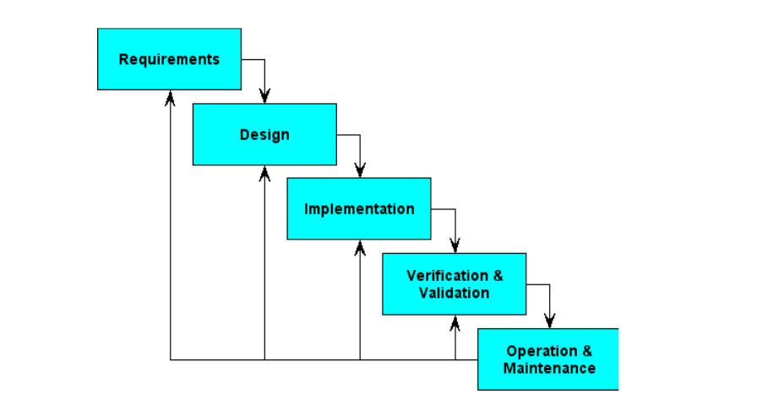
Figure 3.1: The Iterative Waterfall Model Source: Walia, (2022)
The iterative waterfall model of software at Bell Laboratory is proposed in a series of short Plan-to-Study-Act (PDSA), cycles for quality improvement. Software development is broken down into large numbers of iterations, where each iteration is a complete development loop resulting in a release of executable software and it allows for improvement and changes to be made at each stage of the development process.
Materials and Methods
Face Recognition
Generally, face recognition could be described as a four steps processes as shown in figure 3.2 below. These are:
- Face Detection: Locating one or more faces in the image and mark with a bounding box.
- Face Alignment: Normalizing the face to be consistent with the database, such as geometry and photometrics.
- Feature Extraction: Extracting features from the face that can be used for the recognition task.
- Face Recognition: Performing match of the face against one or more known faces in a database.
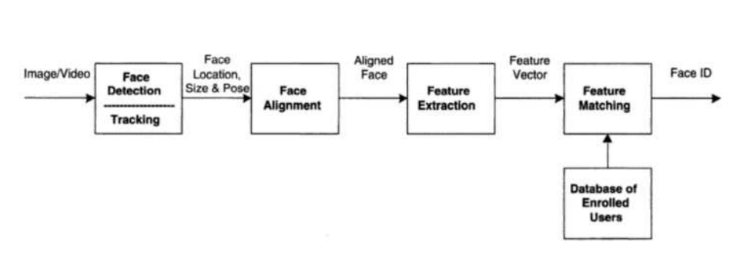
Figure 3.2: Face Recognition Process Source: Adam, (2021)
In this project the face recognition pipeline was built using OpenCV implementation of Neural Network (NN). Basically, a standard Neural Network (NN) consists of many simple, connected processors called neurons, each producing a sequence of real-valued activations. Figure 3.3 depicts a neural network with three layer.
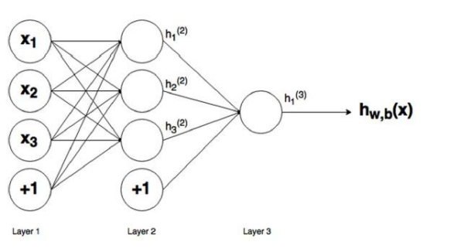
Figure 3.3: A Three Layer Neural Network Source: Thomas, (2017)
3.2 ANALYSIS OF THE EXISTING SYSTEM
Traditional examination verification methods heavily rely on manual processes and invigilator oversight. These methods are not only prone to human error but also susceptible to manipulation and fraudulent activities. The process of manually verifying candidate identities often results in delays and inefficiencies, especially in large-scale examination settings. Biometric systems, such as fingerprint recognition, have been introduced in some contexts but face significant challenges in terms of hygiene concerns, particularly in a post-pandemic era. Additionally, these systems require physical contact and often lack the scalability needed for institutions with high student populations.
Another drawback of existing systems is their inability to provide real-time detection and verification of candidates. This results in a reactive rather than proactive approach to combating impersonation. The dependence on standalone systems, without the integration of modern technologies such as neural networks and multi-factor authentication, limits their effectiveness in addressing sophisticated impersonation tactics. The growing sophistication of fraud necessitates an advanced, automated, and scalable solution that can ensure examination integrity in diverse operational environments. Traditional systems rely on manual ID checks and invigilator oversight, which are prone to errors and manipulation. Biometric systems, such as fingerprint scanners, face scalability challenges and are susceptible to hygiene concerns, especially in the post-pandemic era. These limitations necessitate a more robust and automated solution.
3.3 PROBLEMS OF THE EXISTING SYSTEM
Existing student verification system during exams primarily rely on manual method. The problems faced by the existing system are:
- High susceptibility to human error.
- Vulnerability to fraud and manipulation.
- Scalability and reliability issues in biometric systems.
- Lack of real-time detection and verification.
3.4 DESCRIPTION OF THE PROPOSED SYSTEM
The proposed system integrates facial recognition technology and smart card authentication to verify candidates. The neural network processes facial images captured by cameras and matches them against stored data. The smart card ensures the candidate’s presence and provides additional security by storing encrypted identity information. The system operates in real-time, ensuring quick and accurate verification.

3.5 ADVANTAGES OF THE PROPOSED SYSTEM
Advantages of the proposed system are:
- Enhanced security through dual-factor authentication.
- Real-time detection of impersonation attempts.
- Scalability for large examination centers.
- Reduced reliance on manual verification.
- Improved fairness and integrity in examinations.

CHAPTER FOUR
DESIGN, IMPLEMENTATION AND DOCUMENTATION OF THE SYSTEM
4.1 DESIGN OF THE SYSTEM
This is the computation of the particulars of a new system and the determination of what the new system would be and the function it is to perform. This may involve changing from one system to another or modifying the existing system operation.
The most challenging phase of the system life cycle is the change from manual operation to a faster and more accurate one; system design stage covers the technical specifications that will be employed in the implementation of the new system in order to modify the previous system. Some factors are put in consideration. These factors include input design, output design, the database and procedure designs and other documentation.
4.1.1 OUTPUT DESIGN
This incorporates the objectives of solving the existing system problems and challenges. The outputs extracted from the system are displayed in the screenshot images below:
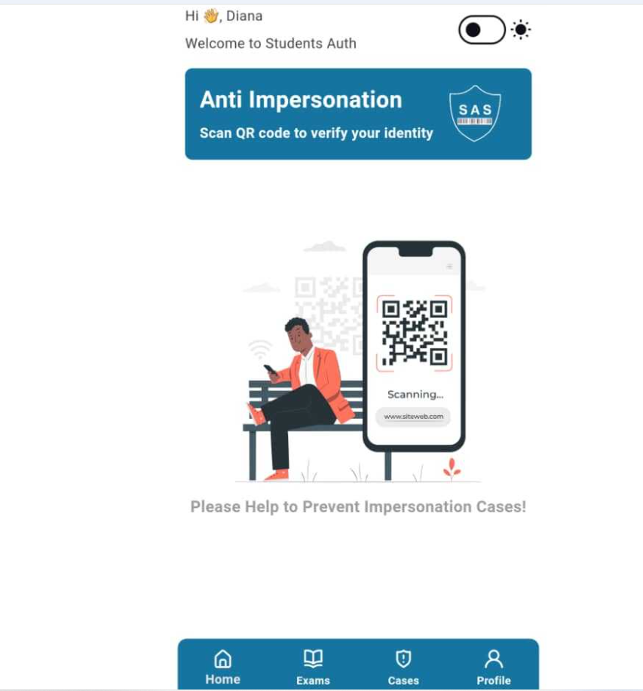
Figure 4.1: The Main Menu of the System
The figure 4.1 above is the main interface of the system. There are some clickable menus below to navigate to various places on the system. These include Home, Exams, Cases and Profile.
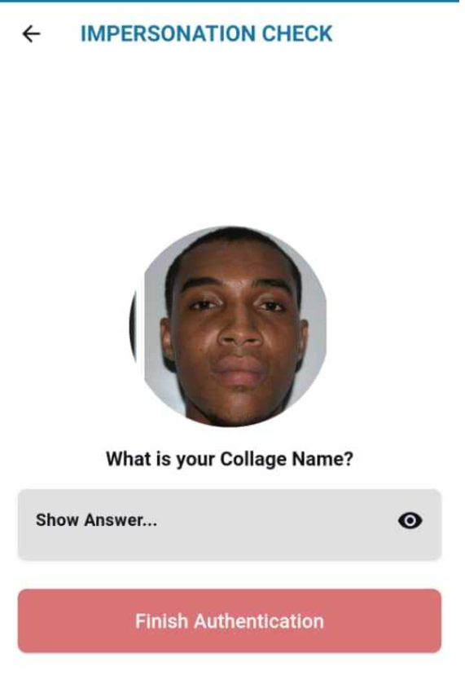
Figure 4.2: The Impersonation Check Interface
The image above shows the impersonation check page. A student who is yet to be verified will stand in front of the system, the system will have to capture his/her face to authenticate its eligibility for that particular exam.

Figure 4.3: The Authentication Confirmation Page
This image above is the authentication page. After a student is confirmed to be who he said he is then a page pops up to confirm its authentication. It is include in this page student name, Matric number, phone number and email.

4.1.2 INPUT DESIGN
The input to implement this hardware is obtained from the facial recognition and smart card-based impersonation detection system materials purchased from the market. The researchers are expected to couple and install the system. They can achieve this by coupling these materials together. These materials are shown below:

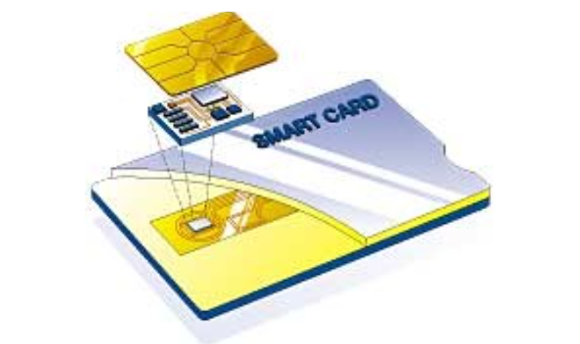
Figure 4.4: Smart Card
The image above is a sample of the smart card to be used on the system, each student has his or her own smart card for authentication.
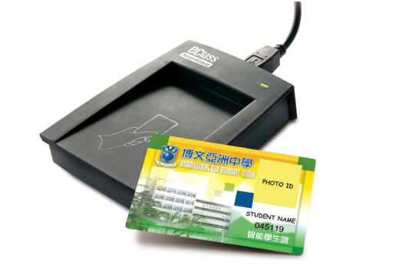
Figure 4.5: A Smart Card Reader
This is the smart card reader used in the system. When a student card is inserted it displays the details of the students indicating the authenticity of the said students.
4.1.4 PROCEDURE DESIGN
These are the steps involved in unifying the whole process to produce the desired output. It involves implementation of the system which starts from the original input lessons to the output that is the implemented system. This allows the processing of user information and result to be possible. Display unit is provided to help user with some information.
4.2 IMPLEMENTATION OF THE SYSTEM
This entails the choice of the programming language employed to implement the system which should-be suitable for facial recognition and smart card-based impersonation detection system. The system is designed for the use of higher institution of learning which should serve as an assistant. It is also expected to be used in conjunction with the admistrator.
4.2.1 HARDWARE REQUIREMENTS
i. The Microcontroller
ii. Andruino Uno
iii. Power Box
iv. Smart Card
- LCD Screen
- Facial and Card Reader
4.3 MAINTAINING THE SYSTEM
The system maintenance refers to making modification to an already existing system without necessarily changing from the beginning. System maintenance includes modification of the system to meet-up with certain requirements of the users. In this course, additional features can be added, errors corrected, ambiguous materials replaced to eliminate confusions and unnecessary features removed.
Maintaining this system can be done by a technician or an expert. Any future modification can be by replacing some parts that has fault and re-install the system.

CHAPTER FIVE
SUMMARY, CONCLUSION AND RECOMMENDATIONS
5.1 SUMMARY
Summary
Examination impersonation has long been a persistent issue undermining the credibility of academic assessments. Traditional methods, including manual ID verification and biometric systems, have failed to fully address this challenge due to issues such as human error, hygiene concerns, and limited scalability. The emergence of neural networks and facial recognition technologies presents a groundbreaking opportunity to tackle this problem with precision and efficiency.
This project introduces a Facial Recognition and Smart Card-Based Examination Impersonation Detection System designed to ensure secure and fair examination environments. This system leverages the adaptive learning capabilities of neural networks, enabling accurate facial recognition even in challenging conditions such as varying lighting and facial orientations. Coupled with smart card authentication, the system provides a dual-layer security mechanism to prevent impersonation and other malpractices.
By addressing the limitations of existing systems, this project highlights the potential of integrating advanced technologies into examination security frameworks. The proposed system not only enhances the integrity of academic assessments but also serves as a scalable and cost-effective solution for institutions worldwide. Its implementation represents a significant step toward maintaining trust and fairness in educational evaluations.
5.2 CONCLUSION
The proposed system addresses critical gaps in examination security by providing an effective solution to impersonation. By integrating facial recognition and smart card technologies with neural networks, the system offers real-time verification and dual-factor authentication to ensure the authenticity of candidates. This approach not only enhances examination integrity but also sets a benchmark for academic institutions worldwide.
  - RECOMMENDATIONS
Based on the findings of this research, the following were recommended:
- Educational institutions should prioritize the adoption of this technology to strengthen examination processes and prevent malpractices.
- Further research should explore the incorporation of additional biometric features, such as iris or voice recognition, to enhance the system's robustness.
- The scalability of the system can be expanded to include broader identity verification applications beyond academic settings, such as in professional certifications and corporate testing environments. proposed system addresses critical gaps in examination security by providing an effective solution to impersonation.
- It is recommended that educational institutions adopt this technology to enhance the credibility of their assessment processes. Further research could explore the integration of additional biometric features and the adaptation of the system for broader identity verification applications.

REFERENCES
Anuradha, S. G., Kavya, B., Akshatha, S., Jyothi, K & Ashalatha, G. (2018). Automated Face Detection & Recognition for Detecting Impersonation of Candidate in Examination System, International Journal of Scientific & Engineering Research. Vol. 7, Issue: 3. Pp. 149-150. DOI: 10.33136/ijser.8976
Idemudia, S. Rohani, M. F., Siraj, M. & Othman, S. H. (2018). A Smart Approach of E-Exam Assessment Method Using Face Recognition to Address Identity Theft and Cheating, International Journal of Computer Science and Information Security (IJCSIS). Vol. 14, Issue: 10. Pp.123-124. DOI: 10.22146/ijccs.3764
Latha, M. P., Swathi, C., Sathvikai, G. K., Mukesh, D. S. & Raj, M. B. (2024). Preventing Impersonation in Exams through Face Recognition Technology, International Research Journal on Advanced Engineering and Management. Vol. 2, Issue: 9. Pp. 23-25. https://doi.org/10.47392/IRJAEM.2024.0441 e
Mamun A. M. (2023). Authentication System for Exam Halls Using Face Biometrics, Open Access Journal of Data Science & Artificial Intelligence. Vol. 1, Issue: 1. Pp. 12-13. DOI: 10.23880/oajda-16000101
Musambo, K. & Phiri, J. (2021). Student Facial Authentication Model based on OpenCV’s Object Detection Method and QR Code for Zambian Higher Institutions of Learning, (IJACSA) International Journal of Advanced Computer Science and Applications. Vol. 9, Issue: 5. Pp. 88-89. doi: https://doi.org/10.32628/CSEIT2063225
Siyaka, H. O., Owolabi, O. & Hashim, B. I. (2020). An Examination Conduct Mechanism for Nigeria Based on Modified Convolutional Neural Networks Algorithm Authentication Scheme, Journal of Behavioral Informatics. Vol. 6. Issue: 1. Pp. 122-123.
Udoh, O. & Nseabasi, P. Essien, N. P. (2024). Development of a Biometric Capturing System for Preventing Impersonation in Examinations in Tertiary Institutions in Akwa Ibom State, Asia-Africa Journal of Recent Scientific Research. Vol. 4, Issue: 1. Pp. 67-69. doi:10.5281/zenodo.1234567
Vivian, N. I. & Ise, O. A. (2020). Face Recognition Service Model for Student Identity Verification Using Deep Neural Network and Support Vector Machine (SVM), International Journal of Scientific Research in Computer Science, Engineering and Information Technology. Vol. 11, Issue: 4. Pp. 2456-2457 doi: https://doi.org/10.32628/CSEIT2063225 11
Walia, W. & Jain, J. (2019). Acceptability of Biometric Security Systems, Radio Frequency Identification Technology, Pacific journal of science and technology. Vol 6: 7 (1). Pp. 14 – 15. Medwin Publishers
Wang, Y., Huang, J., Su, C. & Li, H. (2018). Furnace Thermal Efficiency Modeling using an Improved Convolution Neural Network Based on Parameter-Adaptive Mnemonic Enhancement Optimization, Applied Thermal Engineering. Vol. 3, Issue: 2. Pp. 35-37. https://doi.org/10.1016/j.applthermaleng.2018.12.048
Yang, S., and Verbauwhede I. (2020). A Real Time, Memory Efficient Fingerprint Verification System. In: Proc. IEEE International Conference on Acoustics, Speech and Signal Processing. Vol 5. Pp. 189 – 192.

