CADASTRAL LAYOUT SURVEY OF PART OF DE-GOLDEN SISTER RESIDENTIAL LAYOUT
AT ALUFA AGUNBIADE VILLAGE, SENTU COMMUNITY, OFF OKE-OSE - LAJIKI ROAD, ILORIN EAST LOCAL GOVERNMENT AREA, KWARA STATE, NIGERIA.

PRESENTED BY

AJIDE RECHEAL OLUWASEUN
ND/23/SGI/FT/0004

SUBMITTED TO THE DEPARTMENT OF SURVEYING AND GEOINFORMATICS, KWARA STATE POLYTECHNIC, ILORIN, KWARA STATE.

IN PARTIAL FULFILMENT OF THE REQUIREMENTS FOR THE
AWARD OF NATIONAL DIPLOMA IN SURVEYING AND GEOINFORMATICS.

JUNE, 2025.
CERTIFICATE
I hereby certify that all the information given in this project was obtain as a result of the observation and measurements, carried out by me in accordance with survey rules, regulation and departmental instructions.

--------------------------- ---------------------------
AJIDE RACHEAL OLUWASEUN DATE AND SIGNATURE
ND/23/SGI/FT/0004

CERTIFICATION
This is to certify that Ajide Rachael Oluwaseun matric no: ND/23/SGI/FT/0004 has satisfactorily carried out his project under my instructions and direct supervision. I hereby declare that he has conducted himself with diligence, honesty and sobriety on the project.

………………………….. ……………………………………
Surv. I. I. Abimbola Sign and Date
(Project Supervisor)
.................................... .......................................
Surv. Babatunde kabir Date and Sign
(Project Supervisor)

....................................... ........................................
Surv. R. S. Awoleye Sign and Date
Project Coordinator

………………………….. ………………………………..
Surv. I. I. Abimbola Sign and Date
Head of the Department

………………………….. ….………………………………
External Examiner Sign and Date

DEDICATION
I dedicate this project report to my family.

ACKNOWLEDEMENT
I wish to express my sincere gratitude to the Almighty God for the strength, knowledge, and guidance throughout the course of this project. My heartfelt appreciation goes to my project supervisor, Surv. I. I. Abimbola and Surv. Babatunde Kabir, for their continuous support, encouragement, and constructive criticism, which greatly improved the quality of this work.
I also thank all the lecturers and staff of the Department of Surveying and Geo-informatics lecturers. HOD Surv. I.I Abimbola, Surv. Banji, Surv. Babatunde Kabir Surv. Felix Diran, Surv. Kazeem, Mr.Benard, Surv. R.S Awoleye and others for the academic training and guidance provided during my studies. Special thanks to my family and friends for their moral and emotional support, and to my course mates and teammates for their cooperation and encouragement throughout the project.
Finally, I appreciate all individuals who contributed in one way or another to the successful completion of this project. May God bless you all.

ABSTRACT
This project is the layout survey of the property of De-golden sisters at Sentu village, off Oke-ose to Lajiki road, Ilorin East Local Government Area, Kwara State. The components of the project include: Perimeter survey, setting out of points, beaconing of demarcated points, and coordination of 56 plots of land and production of layout plan at a suitable scale. The survey was tied to three existing control within the vicinity and the survey data was computed and AutoCAD Software was used for plotting of the final layout plan. Kolida (Model: SET 02) Total Station with its accessories were used for the setting out and final survey exercises. A total number of 80 points were monumented and surveyed. The total area covered is 2.7383 hectares. The average area of the plots is within 960Sqm. Being a third order job, an accuracy of 1:20,000 was achieved.

TABLE OF CONTENTS
- Title page
- Certificate
- Certification
- Dedication
- Acknowledgement
- Abstract
- Table of contents
Pages
CHAPTER ONE
1.0. INTRODUCTION 1-2
1.1. STATEMENTS OF PROBLEM 3
1.2. AIMS OF THE PROJECT 3
1.3. OBJECTIVES OF THE PROJECT 4
1.4. SCOPE OF THE PROJECT 4
1.5. SPECIFICATION OF THE PROJECT 4-5
1.6. PROJECT LOCATION 6
1.7. PROJECT LOCATION 7

CHAPTER TWO
2.0. LITERATURE REVIEW 8-11

CHAPTER THREE
3.0 PROJECT PLANNING 12
3.1 RECONNAISANCE 12
3.2 FIELD RECONNAISANCE (RECCE) 12
3.3 OFFICE PLANNING 12
3.4 INSTRUMENT TEST 13
3.5 TEST OF TOTAL STATION COLLIMINATION TEST 13
3.5.1 PROCEDURE FOR COLLIMINATION AND VERTICAL INDEX ADJUSTMENT 14
3.5.2 IN-SITU CHECK OF CONTROLS USED 15
3.6 SCHEDULE OF FIELD WORK 16
3.7 DATA ACQUISITION 16
3.8 SETTING OUT OF POINT 17
3.9 MONUMENTATION 18
3.10 TRAVERSING 19

CHAPTER FOUR
4.0 DATA DOWNLOADING AND PROCESSING 20
4.1 DATA PROCESSING & ANALYSIS 20
4.2 PLOTIND AND PLAN PRODUCTION 21
4.3 PROJECT STATISTICS 21
4.4 COMPUTATIONS 21-22
4.5 DISCUSSION OF RESULT 23
4.5.1 PERIMETER SURVEY PLAN 24
4.5.2 DISGN PLAN 25
4.5.3 LAYOUT PLAN 26

CHAPTER FIVE
5.0 SUMMARY, CONCLUSION, PROBLEMS ENCOUNTERED AND RECOMMENDATION 27
5.1 SUMMARY 27
5.2 CONCLUSION 27
5.3 PROBLEMS ENCOUNTERED 28
5.4 RECOMMENDATION 28
REFERENCE 29
RAW DATA 30-31

CHAPTER ONE
- INTRODUCTION
Land management is a critical component of sustainable development, particularly in urban and per-urban areas. One of the essential tools for effective land management is the cadastral layout survey. A cadastral layout survey involves the accurate identification and demarcation of land parcels for legal documentation, ownership, and future development planning. This type of survey is typically used to create layout plans that guide land use, property subdivision, and infrastructural development. In many developing regions, the absence of clear land boundaries often leads to land disputes, informal settlements, and inefficiencies in property taxation and development control. Cadastral surveys help address these challenges by providing detailed spatial information that can be used for legal registration and planning decisions. They also play a key role in supporting land tenure security, property valuation, and government land management systems.
Cadastral layout surveys play a pivotal role in modern land administration by providing a clear spatial representation of land parcels. These surveys involve accurately measuring and mapping land to delineate property boundaries and support land registration, ownership verification, and developmental control. In growing urban and peri-urban areas, cadastral surveys are necessary tools for preventing encroachment, resolving land disputes, and enabling effective infrastructure development. As land continues to be a valuable and contested resource, especially in developing countries like Nigeria, the need for organized land allocation and formal documentation becomes increasingly urgent. Informal settlements, overlapping claims, and weak land tenure systems often arise from the lack of precise boundary definitions and proper layout planning. By conducting a cadastral layout survey, these issues can be addressed through the creation of structured layouts that guide land use and development according to planning regulations.
Common issues affecting cadastral surveys include high equipment costs, outdated records, overlapping land rights, and legal inconsistencies. Burns et al. (2007) emphasized the importance of institutional coordination, trained personnel, and community participation in overcoming these challenges and ensuring successful cadastral layout implementation. Despite the benefits, cadastral surveying in developing regions often faces barriers such as poor institutional coordination, limited technical skills, inadequate funding, and legal inconsistencies between statutory and customary land rights (Burns et al., 2007). Addressing these challenges requires not only the use of advanced tools but also policy reforms, stakeholder collaboration, and community engagement.
1.1 STATEMENT OF PROBLEM
Inaccurate or incomplete data can lead to boundary disputes, property ownership conflicts and difficulties in land transactions. In many cases, the lack of reliable cadastral information can hinder economic development, leading to social unrest and create challenges for land administration authorities. Therefore, conducting a thorough cadastral survey is essential to gather accurate data and mitigate these risks land dispute among the land owner and other unrest issue in a smart community. This call for the layout of landed property said to belong to the De-Golden sister at Sentu Village.
1.2 AIM OF THE PROJECT
The aim of this project is to carry out Cadastral Layout Survey of plots of land belongs to De-Golden Sister at Sentu Village to accurate delineate the plots and produced a reliable data on land parcels within the designated area, This data will serve as a foundation for land administration, property registration, and urban planning.
1.3 OBJECTIVES OF THE PROJECT
The objectives of this project are:
- To determine the boundaries and ownership of land parcel within the designated area (perimeter plan).
- To provide accurate data on property values and land use (computation sheet).
- To produce area computation sheet.
- To produce standard layout plan
  - SCOPES OF THE PROJECT
- Planning
- Reconnaissance
- Monumentation
- Perimeter Travers
- Layout Design
- Setting-out and Traversing
- Data Processing
- Information Presentation

1.5 PROJECT SPECIFICATIONS
Project is based on the procedures used to execute a project in terms of how the measurements are taken. Specifications mean the requirements necessary to be met when carrying out the survey job of any order (cadastral layout survey). The following specifications are followed:
- Establishment​ of ​traverse​ points​ with​ property​ beacons ( monumentations ).
- Traverse commenced on three existing control points and closed on the same set of controls to check if the traverse is precise and accurate. The accuracy of the control points was found undisturbed before using them for orientation.
- The ​sub-division ​of ​the project area​was done with the dimension of 15.25m x 30.50m for each plots and turning right angle.
- The residential plots should be regular and standard plots 50ft by 100ft.
- Property beacons should be emplaced at all plots.
- Each plot must have access road.
- The accuracy of the job should be third order. (less than1:3,000).
- There mustn't be cross or plus junction without a roundabout within the layout.
- Avoid sharp turning.

1.6 PROJECT LOCATION
The project site is situated in Alufa Agunbiade village area, Sentu community, off Oke-Ose - Lakiji Road, Ilorin East L.G.A, Kwara State which has an area of 2.747 hectares and it fall on geographical coordinate of 8°30'59.96"N ; 4°41'11.16"E to 8°31'9.67"N ; 4°41'10.73"E. The figure below shows the maps of the study area.
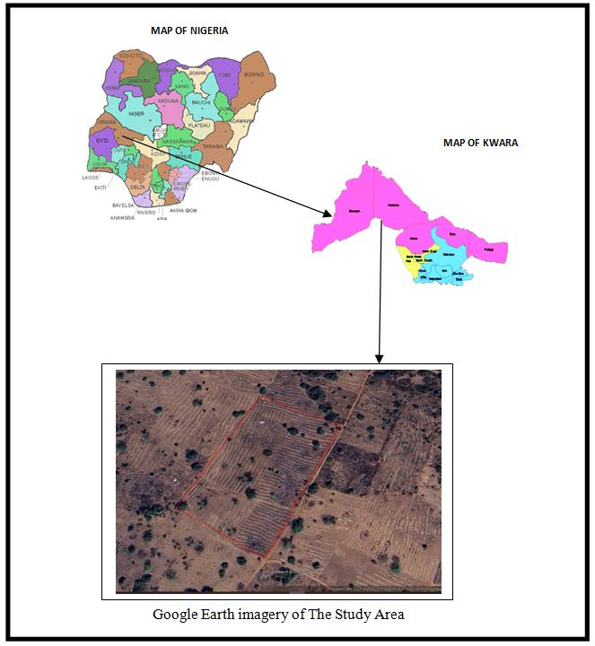

1.7 PERSONNEL MEMBERS OF THE GROUP
The following students contributed greatly to the success of the field practical and they are;
S/N | Name | Matric No | Roles
1. | Ajide Racheal Oluwasewun | ND/23/SGI/FT/0004 | Author
2. | Oloyede Favour Eniola | ND/23/SGI/FT/0001 | Member
3. | Afolayan Joshua O. | ND/23/SGI/FT/0002 | Member
4. | Babatomi Favour | ND/23/SGI/FT/0011 | Member
5. | Kareem Abass Adebayo | ND/23/SGI/FT/0005 | Member
6. | Sulyman Muinat Bukola | ND/23/SGI/FT/0008 | Member
7. | Olafimihan Racheal Olamide | ND/23/SGI/FT/0009 | Member
8. | Idris Abdullahi Umar | ND/23/SGI/FT/0003 | Member
9. | Haroon Abdulmutolib Opeyemi | ND/22/SGI/FT/0018 | Member

CHAPTER TWO
2.1 LITERATURE REVIEW
Cadastral surveys are fundamental for managing land information and supporting land governance systems. According to Dale and McLaughlin (1999), a cadastre is a systematic documentation of land parcels, capturing spatial information and associated rights. These surveys provide the framework for land tenure systems and are used in preparing maps for registration and development planning. Cadastral surveys are a core component of land management systems, providing spatial documentation of land parcels and their boundaries. As defined by the International Federation of Surveyors (FIG, 1995), a cadastre records the size, location, and ownership of land parcels for use in legal, fiscal, and planning frameworks. These surveys are especially crucial in ensuring the security of land tenure and formalizing property rights.
The application of cadastral surveys extends beyond land registration. They are essential for designing urban layouts, zoning, infrastructure development, and ensuring orderly growth. In rural areas, they support land reform programs and secure land rights. As Enemark et al. (2005) noted, effective cadastral systems are necessary for improving land governance and supporting socio-economic development. In both rural and urban settings, cadastral surveys provide essential data for land use planning, zoning, and resource allocation. According to Williamson et al. (2010), cadastral systems serve as a base for decision-making in urban development, land reform, and property taxation. Layout surveys also support the preparation of development plans that include roads, drainage networks, and utility corridors.
Technological tools like GNSS, Total Stations, and GIS have revolutionized cadastral surveying. These instruments enhance the precision, efficiency, and speed of data collection. GIS further enables the integration and analysis of spatial data, allowing surveyors and planners to visualize land parcels and make informed decisions. Abdullahi and Pradhan (2017) highlighted the role of spatial technologies in improving cadastral systems, especially in countries with limited resources. The concept of Fit-for-Purpose Land Administration (FFPLA), as proposed by Enemark et al. (2016), promotes the use of affordable and flexible survey techniques, especially in regions where conventional cadastral systems are expensive or impractical. FFPLA supports the use of aerial imagery, satellite data, and community-based mapping to improve access to land information and simplify the surveying process.

CHAPTER THREE
3.0 PROJECT PLANING
This is the preliminary stages of the project were the schedule and all other logistic will be decided and this planning is done in office in two was below.
3.1 RECONNAISSANCE
Reconnaissance is a very important aspect of any project work in surveying field; it generally consists of two methods.
1. Field reconnaissance
2. Office planning.
3.2 FIELD RECONNAISSANCE (RECCE)
In the process of obtaining field reconnaissance, the site was visited, drawing of the Recce diagram was carried out in order to decide on how best to do the job of the approved layout, the map covering the project site which was prepared by Ministry of Lands and Survey as a guide. The existing control points were located and the values were collected from the survey that did the part of the control to be use lather checking will be done for the in-situ.
3.3 OFFICE PLANNING
The relevant maps in the department were checked in order to get information’s about the site. The coordinates of the nearby control points were also obtained from the Ministry of lands and survey Department. These are the information of the controls within the project site.
Table 2.1 Coordinates of Controls
Pillar No | Northing(m) | Easting(m)
SC/KW B10991R | 941701.318 | 685715.747
SC/KW B10992R | 941756.109 | 685609.382
SC/KW B10993R | 941788.423 | 685544.026
Source: Private Practicing Surveyor
3.4 INSTRUMENT TEST
The Total Station was found to be in good working condition after checking for Collimation error, the Circular plate bubble and Plate level.

3.5 TEST OF TOTAL STATION COLLIMINATION TEST
The following test was carried out to test the workability of the equipment before the data capturing process. The tests are of two types which are
- Temporary Adjustment
- Permanent Adjustment
The temporary adjustments are the ones that are carried out on every station before observation. They are;
- Centering of instrument
- Removal of parallax
The permanent adjustments carried out are
1. Collimation adjustment
2. Vertical Index adjustment
2.5.1 PROCEDURE FOR COLLIMATION AND VERTICAL INDEX ADJUSTMENT
The instrument was set up on station SC/KW B10991R and all necessary temporary adjustments were performed. A target was set up at SC/KW B10991R to the line of site. It was aimed at and bisected. The instrument was switch on and program which is on-board of the instrument was switch to the collimation program. Then, horizontal collimation and vertical index were in sequence recorded and stored in the memory of the instrument. The telescope was transited and the same target bisected. Both the new vertical index and collimation were recorded and stored accordingly. It was transited to the same target with both horizontal and vertical readings recorded to check the instrument’s accuracy. The readings obtained are as follows:
Table 2.2 Test of Total Station
 | Old Reading | New Reading
Horizontal collimation error | +00⁰00’ 14” | +00⁰00’ 09”
Vertical index | +00⁰00’ 20” | +00⁰00’ 04”
 |  | +00⁰00’ 09”
Source: Author 2024
From the above reading, it is shown that the new value have higher precision than the previous. Therefore, the new value is set in the instrument for corrections applicable on any of the two axes.

3.5. IN-SITU CHECK OF CONTROLS USED
The following pillars SC/KW B10991R, SC/KW B10992R and SC/KW B10993R were among the ones found on the ground and checks were carried out on them to determine their true position and reliability.
Checks carried out on these pillars show that:
Observed Included angle = 180° 21’ 12’’
Computed Included angle = 180° 21’ 18’’
Difference: 00° 00’06’’
Observed distance: = 120.305m (SC/KW B10992R - SC/KW B10991R)
Computed distance: = 120.315m (SC/KW B10992R - SC/KW B10993R)
Difference: = 0.010m
Remarks: The difference in both the angular and distance observations was within acceptable limit; hence the Pillars were in-situ.

SC/KW B10993R
SC/KW B10992R
$180°$ 21’12”
SC/KW B10991R

Fig 2.1 In-situ check for control

3.6 SCHEDULE OF FIELD WORK
Having completed the reconnaissance, the schedule of field work was designed as follows:
- Perimeter traverse
- Setting out of boundary beacons
- Layout design
- Pillar Numbering
- Traversing
- Report writing
3.7 DATA ACQUISITION
Layout is the sub-division of parcel of land into blocks and subsequently plots. The surveying process of defining the positions of various beacons that make up a layout on the ground by a surveyor using approved layout design made by the town planner is known as setting out. In the execution of this project the principle of “working from whole to parts” was adhered to as the perimeter beacons that formed the framework for the setting out of the blocks and the blocks formed the framework for the setting out of the plots.
The traditional or classical methods of surveying were decided upon for the execution of this project. The methods are:
- Setting out of the entire perimeter.
- Traverse method for acquisition of the entire perimeter.
- Stake out method for block by block and plot by plot setting out.
- Traverse method and interpolation for acquisition of the entire block and plot data.
3.8 SETTING OUT OF POINTS
Sokkia green label (Model: SET 02) Total Station was set up on SC/KW B10992R and oriented to SC/KW B10991R and coordinates of the stations were keyed into the instrument. Total station computed the bearing between the two stations for orientation. Then coordinates of points to be set out were entered into the total station and the setting out program of the instrument was used to get the angle to turn in order to face the direction of the point after orientation, the instrument was rotated until horizontal angle read 0°00’00”, reflector was held along the direction and distance between the instrument and the reflector was measured.
The instrument displayed the remaining distance as either positive or negative. Positive distance means that the reflector should move away from the instrument by that amount while negative distance means that the reflector should move towards the instrument. When the horizontal angle read 0°00’ 00” and measured distance displayed 0.000m this marked the exact position to be set out. The point was pegged and point number was written with permanent marker. All other points were set out in similar manner. Observations were carried out on the set out points and stored in the instrument memory. Also, the measurements made were found out to be permissible since the incurred error is within allowable. The principle of working from whole to part was observed while setting out the points as the boundary of the layout and some selected points within the boundary of the layout were first observed to server as subsidiary points (minor control points). Subsequent points were set-out from them.

3.9 MONUMENTATION
All the points set out were beaconed with a property beacon in compliance with cadastral survey regulations. The property Beacons were of dimension 18cm x 18cm x 75cm and made of concrete mixture of ratio 3:2:1in (3 parts of sand to 2 part of gravels and 1 part of cement) respectively. These beacons were emplaced in such a way that 15cm of its total length was above the ground surface while the remaining length was buried under the ground.
The boundary pillars were numbered accordingly as they were in the working diagram and where they fell during their setting out. However, the pillars were prefixed with identification mark SCKW. Because SURCON private numbers were obtained from the Office of State Surveyor General
SC/KW
B2134R
10cm
65cm
Ground level
18cm
18cm
18cm
B
R

2134

Fig 2.3 Description of pillar used showing portions above and below the ground
3.10 TRAVERSING
Total station was set up on SC/KW B10992R, switched on and all temporary adjustments were carried out. Then, “Job” was set in the instrument, height of instrument and reflectors were measured with steel tape and stored in the instrument’s memory, and coordinates of the control stations were recalled from the instruments’ memory SC/KW B10991R, was bisected for orientation, and Total station was instructed to compute the bearing between the two stations which was confirmed with a prismatic compass. One of the reflectors was taken to pillar SC/KW B10993R, the reflector’s cross hair was bisected with that of the telescope eye piece of the total station and “All” key was pressed so as to measure and record observation in the memory of the instrument. The instrument was switched off and moved to SC/KW B10993R, and the above stated processes were carried out to coordinate the entire boundary points in X, Y, Z. The above process was repeated for other blocks shown on the plan including subsidiary traverses.

CHAPTER FOUR
4.0 DATA DOWNLOADING AND PROCESSING
The coordinates of the observed boundary were downloaded into the computer and were compiled in Microsoft excel for further processing. A script file of boundary points of individual plot was prepared in note pad using Polyline command. These script file was run in AutoCAD and the area information of each plots as well the bearing and distances of each consecutive lines were obtained.
4.1 DATA PROCESSING & ANALYSIS
The acquired field data was downloaded to the computer in the office. This was done using a NTS software. The following procedure was followed:
- Connecting the SET and host computer, using communication cable.
- Selecting “JOB” in Memory Mode.
- Selecting “comms” output to display the JOB list.
- Pressing OK.
- Selecting the output formation
- At the end of the downloading, the data was displaced in the following format, Point No., Easting and Northing.
The data was then copied to other software such as Microsoft Excel for further processing. Here, the data was arranged and stored as formatted Text (space delimited), ready for plotting. The observed data were reduced and corrected, Master Survey programmer software was used to process the data.

4.2 PLOTTING AND PLAN PRODUCTION
Auto-CAD2007 software was used for plotting all the set out pillars. The plotting procedure was as follows,
- Launch Auto-CAD 2007.
- Select Format on the menu tool bar and set all necessary units such as meter, Decimal places, Directions etc.
- Select tool from the menu bar and highlight run script.
- Open the saved formatted Text from Microsoft Excel.
- Zoom extents, by pressing Z enter and E enter.
All the coordinated points are plotted and displayed on the screen and with the help of the Recce diagram; all the boundary points were joined for individual plots to produce the boundary lines and the existing features such as Roads.
The final Layout plan was plotted at scale of 1: 2,500
4.3 PROJECT STATISTICS
- Total Number of residential plots 56 plots
- Total number of boundary beacons 4
- Coordinate Properties UTM
4.4 COMPUTATIONS
The backward and area computation were done to the coordinates of the boundary pillar as show in the tables below;

Tab: 4.1: the table shows the back computation of the perimeter survey
Station form | Bearing | Distance (m) | ∆N | ∆E | Northing (m) | Easting (m) | To Station
 |  |  |  |  | 942244.886 | 684890.452 | SC/KW  J5920BK
SC/KW  J5920BK | 117° 13' 45’’ | 126.709 | -57.976 | 112.668 | 942186.910 | 685003.119 | SC/KW  J7719BK
SC/KW  J7719BK | 206° 44' 54" | 222.330 | -198.539 | -100.065 | 941988.371 | 684903.055 | SC/KW  B10990R
SC/KW  B10990R | 297° 14' 20" | 119.643 | 54.761 | -106.375 | 942043.132 | 684796.679 | SC/KW  B10991R
SC/KW  B10991R | 024° 55' 42" | 222.481 | 201.754 | 93.772 | 942244.886 | 684890.452 | SC/KW  J5920BK

Tab: 4.2: the area computation by double latitude and single departure.
∆E | ∆N | PRODUCT
112.668 | X -57.976 | = -6532.039968
112.668
225.336
-100.065
125.271 | X -198.539 | = -24871.179069
-100.065
25.206
-106.375
-81.169 | X 54.761 | = -4444.895609
-106.375
-187.544
93.772
-93.772 | X 201.754 | = -18918.876088
93.772
0.000
= -6532.039968 -24871.179069 -4444.895609 -18918.876088
= -54766.990734\2 =27,383.495m²\10000 =2.7383 Hectares
4.5 DISCUSSION OF THE RESULT
The following were the results obtained at the end of the project exercise, they are:
- Perimeter Survey plan.
- Design plan
- Layout plan

4.5.1 PERIMETER SURVEY PLAN
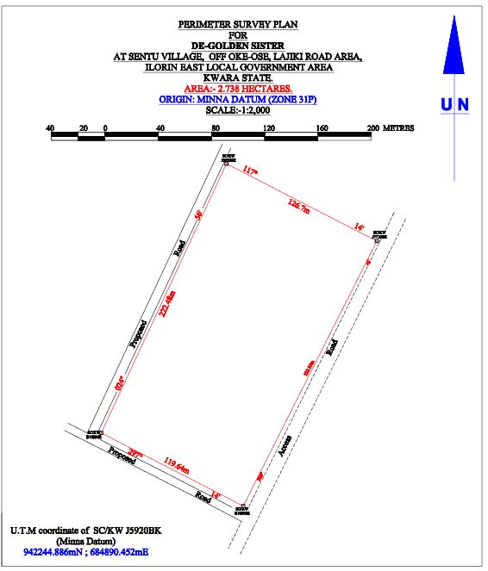

4.5.2 DESIGN PLAN
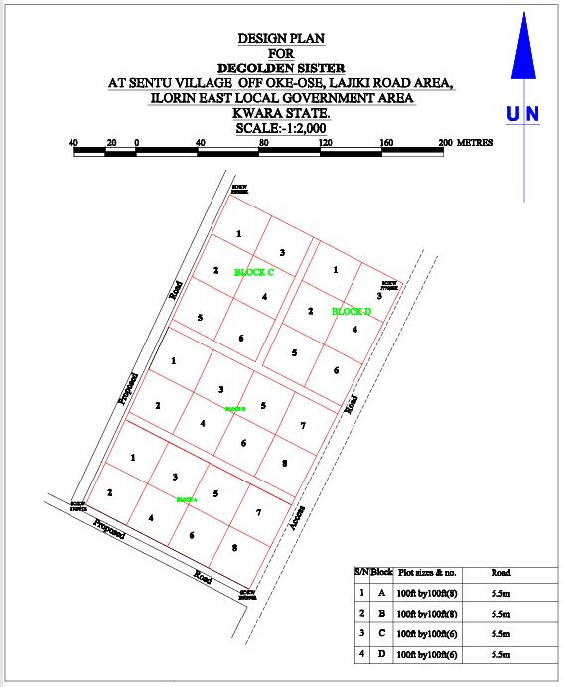

4.5.3 LAYOUT PLAN
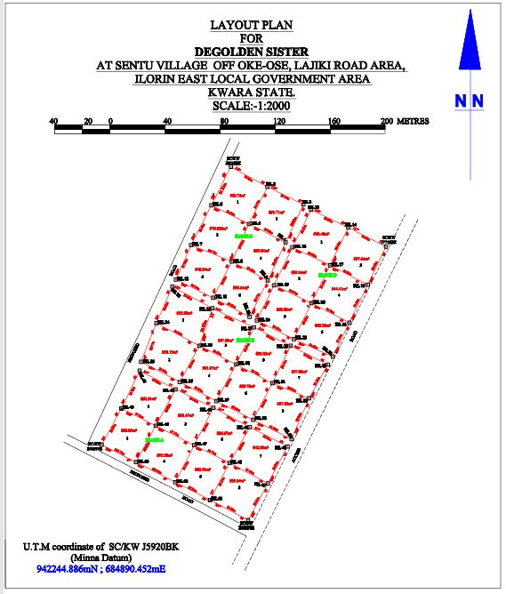

CHAPTER FIVE
5.0 SUMMARY, CONCLUSION PROBLEMS ENCOUNTERED AND RECOMMENDATION.
5.1 SUMMARY
The project area covered a total area 2.738 hectares with total number of 4 pillars used for the Perimeter Survey. Whereas the total number of beacons used for the layout was 54, making a total number of 54 pillars emplaced. The total numbers of plots are 28 at 100ft x 100ft. The project cut across the following; reconnaissance, monumentation and traversing and settingout. Kolida Total Station was used for the geometric data acquisition and its software was used in downloading and transforming the acquired data.
The final adjusted coordinates were used for the production of Perimeter Survey plan and the Layout Survey plan using AutoCAD 2007. The final plan was drawn at a scale of 1:2,000
5.2 CONCLUSION
In every aspect of the project, the results obtained were all within the limits of permissible accuracies. The principle of whole to path was adhering to and all the observations and measurements that were made in total conformity with survey rules and regulations. The final plan was presented to them in hard and soft copies. The hard copy was plotted on A3 paper size.
However, based on the results obtained in the project, it is obvious that the aim of the project has been achieved. Conclusively, I hereby submit the Final Layout Survey Plan of De-Golden sister cooperative Land, which was successfully carried out.

5.3 PROBLEMS ENCOUNTERED
The only problem encountered was from the youths from the area who demanding some money for public relation. This was later settled by the Family representatives.
5.4 RECOMMENDATION
We hereby urge the department to exposed the students to more practical works in and outside the school. This project work show most of us the setting methods and exposed us to the uses of the survey instruments.

REFERENCES
- Abdullahi, A., & Pradhan, B. (2017). Integrating spatial technologies for effective land administration systems in developing countries. Geocarto International,
- Burns, T., Grant, C., Nettle, K., Brits, A., &Dalrymple, K. (2007). Land Administration Reform: Indicators of Success and Future Challenges. Washington, DC: World Bank.
- Dale, P., & McLaughlin, J. (1999). Land Administration. Oxford: Oxford University Press.
- Enemark, S., Williamson, I., & Wallace, J. (2005). Building modern land administration systems in developed economies. Journal of Spatial Science,
- Enemark, S., Bell, K., Lemmen, C., McLaren, R., & Palmer, D. (2016). Fit-for-Purpose Land Administration. FIG / World Bank Report. https://www.fig.net/resources/publications/figpub/pub60/Figpub60.pdf
- International Federation of Surveyors (FIG). (1995). Statement on the Cadastre. FIG Publication No. 11. Retrieved from https://www.fig.net/resources/publications/figpub/pub11/figpub11.asp
- Williamson, I., Enemark, S., Wallace, J., &Rajabifard, A. (2010). Land Administration for Sustainable Development. Redlands, CA: ESRI Press.

RAW DATA
PL | 685715.372 | 941701.43 | 378.762
RD | 685712.862 | 941697.33 | 378.756
PL2 | 685687.678 | 941716.11 | 379.535
PL3 | 685662.456 | 941729.037 | 380.403
B10992R | 685609.007 | 941756.221 | 381.96
PL5 | 685623.378 | 941782.638 | 382.269
PL6 | 685676.16 | 941755.88 | 380.721
PL7 | 685701.779 | 941742.941 | 379.918
PL8 | 685729.781 | 941728.182 | 379.197
PL9 | 685716.533 | 941769.016 | 380.451
PL10 | 685744.061 | 941754.972 | 379.637
PL11 | 685746.929 | 941760.165 | 379.651
PL12 | 685718.942 | 941774.294 | 380.431
PL13 | 685690.1 | 941783.065 | 381.239
PL14 | 685692.255 | 941787.928 | 381.343
PL15 | 685662.604 | 941796.453 | 381.709
PL16 | 685665.695 | 941801.784 | 382.098
G7065KP | 685636.516 | 941809.908 | 382.586
PL18 | 685648.743 | 941844.451 | 383.092
PL19 | 685679.925 | 941828.131 | 382.466
PL20 | 685706.604 | 941814.556 | 381.644
PL21 | 685732.978 | 941800.893 | 380.756
PL22 | 685759.615 | 941789.914 | 380.405
I7720BK | 685776.835 | 941820.074 | 380.555
PL24 | 685759.721 | 941821.191 | 380.853
PL25 | 685748.544 | 941832.933 | 381.25
PL26 | 685746.205 | 941828.009 | 381.176
PL27 | 685719.623 | 941841.467 | 381.902
PL28 | 685721.682 | 941846.436 | 381.831
PL29 | 685716.38 | 941849.007 | 382.014
PL30 | 685702.871 | 941848.943 | 382.391
PL31 | 685686.689 | 941856.609 | 382.611
PL32 | 685689.859 | 941862.847 | 382.662
J5924BK | 685662.878 | 941876.172 | 383.422
PL34 | 685660.297 | 941871.011 | 383.473
J5920BK | 685702.779 | 941957.975 | 383.13
PL36 | 685729.38 | 941943.477 | 382.642
PL37 | 685755.528 | 941930.597 | 382.315
PL38 | 685761.105 | 941926.821 | 381.93
PL39 | 685788.187 | 941913.917 | 381.554
PL40 | 685815.447 | 941899.999 | 381.103
PL41 | 685802.232 | 941872.409 | 380.764
PL42 | 685774.836 | 941886.5 | 381.446
PL43 | 685747.487 | 941899.504 | 381.831
PL44 | 685742.594 | 941903.187 | 382.27
PL45 | 685715.892 | 941916.485 | 382.829
PL46 | 685788.895 | 941844.863 | 380.654
PL47 | 685761.351 | 941859.132 | 381.119
PL48 | 685734.181 | 941872.012 | 381.875
PL49 | 685729.669 | 941875.413 | 382.035
PL50 | 685703.469 | 941889.197 | 382.652
PL51 | 685702.677 | 941887.507 | 382.665
PL52 | 685669.388 | 941903.005 | 383.426

