DESIGN AND CONSTRUCTION
OF SINGLE-PHASE TRANSFORMER TRAINER

BY

ADEYEMI DAVID OLADIRAN
HND/23/EEE/FT/0044

A PROJECT REPORT SUBMITTED TO
THE DEPARTMENT OF ELECTRICAL/ELECTRONIC
ENGINEERING,
INSTITUTE OF TECHNOLOGY, KWARA STATE POLYTECHNIC, ILORIN
IN
PARTIAL FULFILMENT OF THE REQUIREMENT FOR THE AWARD OF HIGHER NATIONAL DIPLOMA (HND) INN ELECTRICAL/ ELECTRONICS ENGINEERING KWARA STATE POLYTECHNIC, ILORIN

SUPERVISED BY
T ALHAJI MUSTAPHA

JUNE, 2025

CERTIFICATION
This is to certify that this project work was carried out and submitted by Adeyemi David Oladiran of Matric No: HND/23/EEE/FT/0044 to the Department of Electrical/Electronic Engineering is accepted having confirm with the requirement for the award of Higher National Diploma (HND) program in Electrical/Electronic Engineering.

______________________ ___________________
T ALHAJI MUSTAPHA Date
PROJECT SUPERVISOR

______________________ ___________________
ENGR. Z.A ABDULKADIR Date
PROJECT CO-ORDINATOR

______________________ ___________________
ENGR. O.A LAWAL Date
HEAD OF DEPARTMENT

______________________ ___________________
EXTERNAL EXERMINER Date

DEDICATION
This project is dedicated to almighty God

ACKNOWLEDGEMENT

ABSTRACT
Many tertiary institutions in Nigeria have limited access to technological equipment, especially in terms of practical equipment in the laboratory. This limitation causes students to be unable to think quickly, and has technological impact on the society during and after graduation. This project report presents the design and construction of a single-phase transformer trainer for educational purposes. The trainer is designed to provide a hands-on learning experience for students by allowing them to understand the principles and operation of transformers, effectively measure and perform different transformer tests. The trainer includes a step-down transformer, measurement instruments, and a load bank, enabling students to conduct experiments and demonstrations. The project aims to support students’ practical activities and to enhance students' understanding of transformer theory and applications, providing a practical learning experience in electrical engineering education.The objectives of this work were accomplished, and the trainer designed is reliable. Hence, it can be used to bridge and give better interpretations to concepts in the field of Electrical/Electronic Engineering irrespective of the population at a particular period.

TABLE OF CONTENT
Title page i
Certification ii
Dedication iii
Acknowledgement iv
Abstract v
Table of contents vi
List of table x
List of figures xi
CHAPTER ONE: INTRODUCTION
1.1 Background Information 1
1.2 Aim of the Project 3
1.3 Objectives of the Project 3
1.4 Statement of The Problem 3
1.5 Significance of the Project 4
1.6 Scope and Limitation of the Project 4
CHAPTER TWO: LITERATURE REVIEW
2.1 Introduction 5
2.1.1 Transformer 5
2.1.2 Single Phase Transformer 5
2.1.3 Faraday's Law of Electromagnetic Induction 6
2.1.4 Single-Phase Transformer Construction and Working Principle 6
2.1.5 Primary Windings 7
2.1.6 Secondary Windings 7
2.1.7 Classification of Transformer Based on Voltage Levels 7
2.2 Arduino LCD Display 8
CHAPTER THREE: DESIGN AND METHODOLOGY
3.1 Design and Methodology 9
3.2 Single-Phase Transformer Trainer 9
3.2.1 Power Supply 9
3.2.2 Output 10
3.2.3 Wire Selection 11
3.2.4 Insulation 11
3.2.5 Core Sheets 12
3.3 Assembling of A Single-Phase Transformer 12
3.3.1 Frame Construction 14
3.3.2 Procedure for The Construction of Single-Phase Transformer Trainer 14
3.4 Testing
3.5 Experiments
3.5.1 Experiment 1: Voltage and Turns Ratio Test for Step-Up And
Step-Down Transformer 14
3.5.2 Experiment 2: Open Circuit Test (Core Loss Test) 16
3.5.3 Experiment 3: Short Circuit Test (Copper Loss Test) 18
3.5.4 Experiment 4: Transformer Efficiency Test (Load Test) 20
3.5.5 Experiment 5: Voltage Regulation of a Transformer 22
CHAPTER FOUR:
4.1 Testing, Result and Discussion 24
4.2 Testing of the Components 24
4.3 Soldering and Rearrangement of Components 24
4.4 Testing and Results 24
4.4.1 Experiment 1: Voltage and Turns Ratio Test of a Single-Phase Transformer 24
4.4.2 Experiment 2: Open Circuit Test
(Core Loss in a Transformer) 26
4.4.3 Experiment 3: Short Circuit Test (Copper Loss Test) 27
4.4.4 Experiment 4: Transformer Efficiency Test 28
4.4.5 Experiment 5: Voltage Regulation of a Transformer (Load Test) 30
CHAPTER FIVE:
5.1 Conclusion 31
5.2 Recommendation 31
References 32

LIST OF TABLES
Table Page

Table 4.1 Comparing Step-Down (2:1) and Step-Up Turn Ratio of Transformer 25
Table 4.2 Open Circuit Test (Core Loss in a Transformer) 26
Table 4.3 Short Circuit Test (Core Loss Test) 27
4.3.1 Comparison of Open Circuit and Short Circuit Test 28
Table 4.4 Transformer Efficiency Test 29
Table 4.5 Voltage Regulation of a Transformer (Load Test) 30

LIST OF FIGURES
Figure Page
2.1 Single-Phase Transformer Core 6
2.2 Arduino LED 8
3.1 Block Diagram of a Single-Phase Transformer Trainer 9
3.2 Output Digital Display 10
3.3 Paper binding Tape 11
3.4 The Core T and I Sheet 12
3.5 Transformer Circuit Board Internal Connection 13
3.6 Front view of Single-Phase Transformer Trainer 14
3.7 Circuit Diagram of Voltage and Turns Ratio 15
3.8 Open Circuit (No Load Test) 17
3.9 Short Circuit Test (Copper Loss Test) 19
3.10 Circuit Diagram for Transformer Efficiency 21
3.11 Circuit Diagram for Voltage Regulation 23
CHAPTER ONE
1.0 INTRODUCTION
  - BACKGROUND INFORMATION
Trainer means an object that can train, teach and educate. A single-phase transformer trainer is a self-contained set of electrical and electronic circuits that can be interlinked/ switch on by students to create a multifunctional and flexible trainer instructional aid in the power and machines laboratory. This transformer trainer provides a set of components modules which are specially designed for performing certain experiments in such a way to understand the principles and operation of transformers. It effectively measures and perform different transformer tests.
In any learning institution it has been proven that practical bridges and gives a better interpretation and understanding to the theories. For this reason, practical works can be made efficient by developing practical models and training systems for practical hands on (Nasir, Syed Zain 2018).
Transformers play a critical role in the transmission and distribution of electrical power by efficiently stepping voltage levels up or down to meet system requirements. Their importance in electrical systems—ranging from power generation stations to household appliances—makes them a key topic in electrical and electronics engineering education.
A single-phase transformer is one of the simplest types of transformers, primarily used in residential, light commercial, and educational applications. It operates on the principle of electromagnetic induction, transferring electrical energy between two circuits through a magnetic field. In academic environments, it becomes essential not only to study these theoretical concepts but also to understand how transformers behave in practical settings under varying load conditions.
However, students often struggle to connect textbook theory with real-world application without hands-on experience. To bridge this gap, a transformer trainer serves as an instructional tool that simulates real operating conditions in a safe, controllable environment. A well-designed trainer allows students to perform practical tests such as open-circuit, short-circuit, efficiency, and load regulation tests.
This project aims to design and construct such a trainer, incorporating measurement instruments, safety features, and accessible terminals. The trainer will be housed in a durable casing with clearly labeled components, allowing for multiple experiments and visual demonstration of transformer principles. This practical approach enhances student engagement and deepens understanding of key transformer characteristics, such as voltage transformation ratio, efficiency, losses, and the effects of different load types.
This report outlines the design and construction of a single-phase transformer trainer which is an is an essential educational tool used in electrical engineering laboratories to demonstrate the principles of transformer operation, including voltage transformation, turns ratio, efficiency, and losses.Also, the project supports engineering education by enabling effective and safe transformer experimentation in the laboratory, preparing students for industry-standard knowledge and practices.

1.2 AIM OF THE PROJECT

The aim of this work is to design and construct a single-phase transformer trainer system that can be used for practical purpose in the laboratory

1.3 OBJECTIVES OF THE PROJECT
The objectives are:

To design and demonstrate and understand transformer principles such as turns ratio, voltage transformation, and efficiency.

To analyze transformer performance on open circuit and short circuit test

To evaluate transformer efficiency and losses like no-load losses, load losses, and voltage regulation.

To develop practical skills in transformer operation and measurement

1.4 STATEMENTOFTHEPROBLEM

The lack of practical, hands-on experience with transformers in educational settings hinders students' understanding of transformer principles and operation, leading to a gap between theoretical knowledge and real-world applicationSome ofthet available Transformertrainer makes use of the analogue measuring instrument with a continuous varying data output display unit where individuals need to work at a very close range to view results whereby parallax error could occur during thetimeoftaking reading fromthiscontinuousand fluctuating varying data output.There is therefore a critical need for an affordable, customizable, and safe single-phase transformer trainer that enables students to conduct meaningful experiments, measure performance characteristics accurately, and develop practical skills in transformer operation and analysis. Such a solution would bridge the current educational gap while remaining cost-effective for institutional adoption.

1.5 SIGNIFICANCE OF THE STUDY

The significance of this study lies in its potential to enhance the learning experience of students by providing hands-on experience with single-phase transformers, equipping them with practical skills, and bridging the gap between theoretical concepts and real-world applications, ultimately leading to improved student outcomes and better preparation for careers in electrical engineering.
1.6 SCOPEAND LIMITATIONSOFTHESTUDY:
This study is limited to the design and construction of a single-phase transformer trainer intended for educational use in electrical engineering laboratories. The trainer covers basic transformer operations such as step-up and step-down voltage transformation, open-circuit and short-circuit testing, efficiency analysis, and load variation demonstrations. It is designed to operate at standard laboratory voltage levels (e.g., 230V/24V, 50Hz) with moderate current ratings suitable for academic experiments. However, the trainer does not support high-power industrial applications, three-phase transformer systems, or advanced digital data acquisition features. Additionally, the design prioritizes safety and simplicity over precision measurement, so it may not be suitable for highly accurate or specialized testing. Despite these limitations, the trainer serves as a robust educational tool for illustrating fundamental transformer principles in a controlled and safe environment.

CHAPTER TWO LITERATUREREVIEW
  - INTRODUCTION
This chapter is a description of some of major components that are used in the design and construction of a single-phase transformer trainer. It highlights the principle of operation employed by these components.

Transformer
It is a static electrical device which transforms the electrical energy from one electricalcircuit to another without anychange offrequencythroughthe processofelectromagnetic induction. It is interesting to note that the transfer of energy from onecircuit to another takes place with the help of mutual induction that is flux induced in the primary winding gets linked with the secondary winding (Engineering World, 2019).
2.1.2Single Phase Transformer
A single-phase transformer is a power transformer that operates on single phase alternating current. It consists of a primary winding connected to the source of supply and a secondary winding to provide electric power to the load. The two windings are wound around a common magnetic core made of laminated silicon steel sheets which provides a low reluctance path for the magnetic flux. Single phase transformers convert the alternating voltage from one circuit to another without any direct electrical connection between the two circuits. A typical single-phase transformer uses single-phase AC, meaning it operates with a voltage cycle that moves in sync over time. This type of transformer works based on Faraday's law of electromagnetic induction, which states that a change in magnetic flux through a coil induces a voltage in the coil.

2.1.3 Faraday's Law of Electromagnetic Induction
Faraday's law states that an electromotive force (EMF) is induced in any closed circuit when there is a change in the magnetic flux through the circuit. This electromagnetic induction effect is the basis for the working of single-phase transformers. When an alternating current flow through the primary winding, it produces an alternating magnetic flux around the core. According to Faraday's law, this changing flux induces an EMF in the secondary winding.

2.1.4 Single-Phase Transformer Construction and Working Principle
A single-phase transformer is a high-efficiency piece of electrical equipment, and its losses are very low because there isn’t any mechanical friction involved in its operation. Transformers are used in almost all electrical systems, from low voltage up to the highest voltage level. It operates only with alternating current (AC) because direct current (DC) does not create any electromagnetic induction.
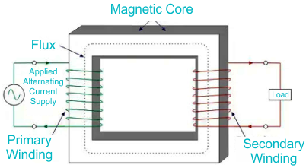
Figure 2.1: Single Phase Transformer Core
The primarycoilofthe transformer receives the voltage which is alternating in nature. The alternating current flowing in the coil produces a continuously changing and alternating flux which is produced around the primary winding. Then we have the other coil or the secondary coil which is near to the primary coil which get linked to the primary because some alternating flux gets linked. As the flux is changing continuously it induces an EMF in the secondarycoilaccording to Faraday’s law of electromagnetic induction. If the secondary side circuit is closed a current will flow and this is the most basic working of a transformer, (Marshall Brain & Charles W. Bryant. 2007)
Thethreemainpart ofanytransformerare:

  - Theprimarywindingii.Secondarywindingiii.Themagneticcore.

2.1.5PrimaryWinding
This is the main winding where the incoming alternating current is expected. Depending on the fact that the transformer is either a step up or step-down transformer the winding construction changes accordingly.
2.1.6SecondaryWinding
This is the winding in which the flux produced by the primary winding get linked. In thiscase also depending on the fact that the transformer is either a step up or step-down transformer the winding construction changes accordingly.
    - ClassificationofTransformerBasedonVoltageLevels
- Step-UpTransformer
As the name suggest, step up transformer are used to increase the voltage at the secondary sideofthetransformer. This isachievedbyhaving agreaternumberofturns inthesecondarysideof the transformer as compared to the primary side of the transformer.
- Step-DownTransformer
Asthenamesuggest, stepdowntransformer areusedtodecreasethevoltageatthesecondary side of the transformer. This is achieved by having a smallernumber of turns in the secondary side of the transformer as compared to the primary side of the transformer.

2.2 ARDUINOLCD DISPLAY
The Arduino LCD (Liquid Crystal Display) module is a widely used output device that allows microcontrollers like Arduino to display text, numbers, and simple graphics. The most common type is the 16x2 LCD, which shows 16 characters per line across 2 lines, though other sizes (e.g., 20x4) are also available. These displays are popular due to their low power consumption, ease of interfacing, and clear visibility.

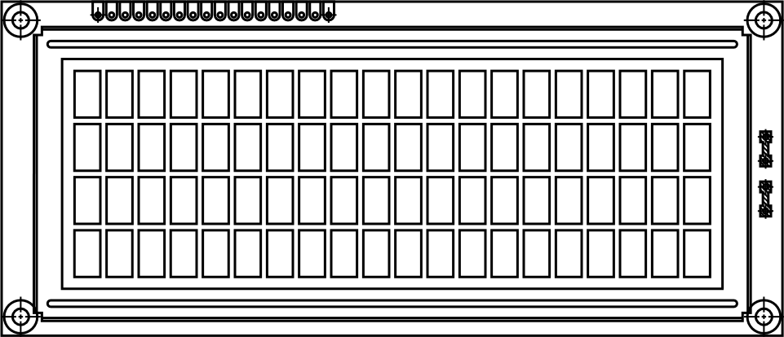

Figure2.2:Arduino LED
Source:Raj,2015

CHAPTER THREE
3.1 DESIGNANDMETHODOLOGY
Thischapterdealswiththeentireproceduresanddesignsinvolvedinthedesignofallthe electrical/electronic component of Single-phase transformer trainer.
3.2 SINGLE PHASE TRANSFORMERTRAINER

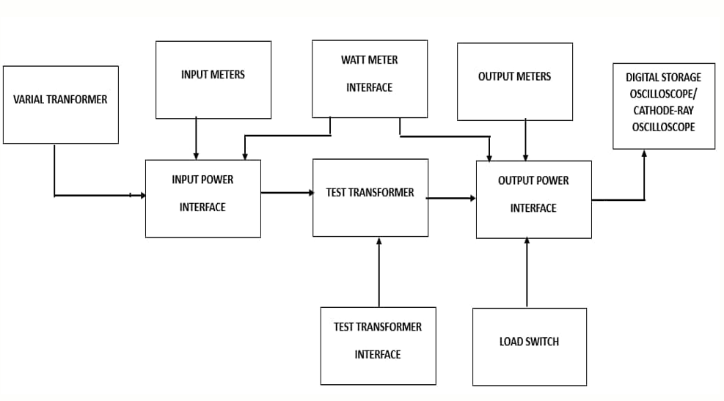

Figure 3.1: Block diagram of a single-phase transformer trainer
Source: Engineering World (2019).

3.2.1PowerSupply
Thepower supplyinthe mother boardisto supplyavoltageof5VDCtotheLCDdisplayon the transformer trainer. ThistaskisaccomplishedbyrectifyingACtoDCandthensmootheningtherectifiedvoltageto remove AC ripples before it is regulated to 5V using IC voltage regulator.

Thepower supplysupplies12vand 2Abyusing two voltageregulatorsconnected inparallel. It also supplies 5v for powering the LCD and the current sensor. In achieving this, the power from the authorities has to be stepped down, filtered and regulated. The power supply unit consist of the following components:
- Transformer
- Therectifier circuits
- Smoothingcapacitor
- Theregulators

3.2.2Output

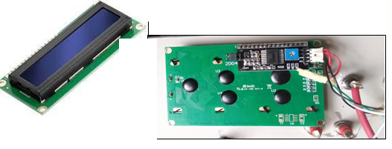The output from the trainer is connected to LCD to display the result of various experiment performed on the trainer. The trainer and the LCD are linked via the digital pin on theArduino board.

Figure3.2: Output Digital Display

Source:Raj,Aswinth(2015)

3.2.3Wire Selection
The selection of SWG (Standard Wire Gauge) wire in a transformer is a critical aspect of transformer design, particularly for the winding of coils. The wire gauge chosen impacts various transformer characteristics such as resistance, current-carrying capacity, and space utilization The SWG of the wire should be chosen to handle the expectedcurrentinthewindingwithoutexcessiveheating.HigherSWGvaluesindicate thinner wire, which may have lower current-carrying capacity.
Primarycurrent𝐼𝑝=4𝐴
Secondarycurrent = 2A
Using table; Primary Winding = 17 SWG
Secondary Winding =19 SWG
3.2.4 Insulation
Insulation materials are crucial in transformers to prevent electrical breakdown andensure the safe and reliable operation of the device. The insulation between primary and secondary windings is essential to avoid short circuits and maintain the electrical integrity of the transformer.We have used paper binding tape for the purpose as shown in the figure below.

Figure 3.3: Paper Binding Tape

3.2.5 Coresheets

Inserting core E sheets is the next step in the construction of the core of a transformer. The core E sheets, typically made of laminated silicon steel, form the magnetic circuit thatallowstheefficienttransferofmagneticflux.Theselamination stampings when connected together form the requiredcoreshape.Forexample,two “E”stampingsplustwo end closing“I”stampings to give an E-Icore forming one element of a standard shell-type transformer core. These individual laminations are tightly butted together during it’s constructiontoreducethereluctanceoftheairgapatthejoints producing a highly saturated magnetic flux density.


Figure 3.4: The Core E and I Sheet

3.3 ASSEMBLING OF A SINGLE-PHASE TRANSFORMER
3.3.1 FrameConstruction

The trainer is enclosed in a square shape cast wooden frame with a vertical position slightly bent backwards. The meters are mounted on a vertical section while the mimic diagram data is covered with vanished ½ plywood board screwed into the meter frame. The front panelwhere the meters are mounted is covered with velvet clothto enhance its ecstatic. The trainer frame rests onfour legs, the material for the Trainer construction was chosen with the utmost regard to their reliability,durability, maintainability and readability attributes.

3.3.2Procedures fortheconstructionofthe single-phasetransformertrainer
Theproceduresfortheconstructionofthetransformertrainer areas follow;
- Thewoodenframe is first cut into requiresizeof60cmby43cmby58cmto formaskeletalframeof how the trainer will look like.
- Thepointedboardofthetransformershowstheparametersofthetransformercircuittorequired shape and length.
- Theplacingofthesocketsattherelevant areasto showthecurrent,voltageandpower isdone bythe drilling to give the reading for the connectiontothe ammeter, voltmeter and wattmeter ofthe board.
- Wiringofthesocketafterdrillingisdonesothatthereadingscanbeshownattheammeterand voltmeter.
- Placingtheammeter,voltmeter,circuitbreakerandtoggleswitchwasdoneattheirrespective position.
- Thewiringwasdoneinsuchawaythatareturnpathwasmadesothatacompletecircuitwas established.
- Aftertheconnectionoftheequipmentitisthenwrappedwithsuitableleathertogiveitecstatic
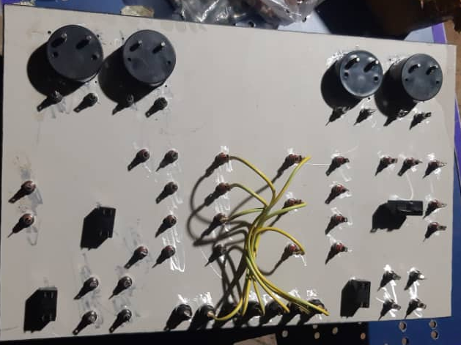

Figure 3.5: Transformer circuit board internal connection
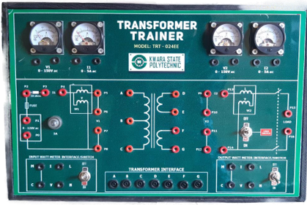Figure3.6:Front view of a Single Phase Trainer

TESTING

Thefollowingtestswerecarriedoutduringandaftertheconstruction

Continuitytest:

The continuitytest was carried out to check for disconnectionand opencircuit in the work using a multimeter.

Powerconsumption:

The voltage across each component and the entire circuit was measured when the system was powered.

SystemTesting and Integration

After the design and implementation stage, the system was tested for durability and effectiveness and also to ascertain if there is need to modify the design. The system was first assembled using breadboard. All the component where properly soldered to the ferro board and test werecarriedoutatvariousstages.Toensureproperfunctioningofthecomponents,theywere testedusingadigitalmultimetertoensurethattheywerewithinthetolerancevalue.Faulty components were discarded.

3.5SOME OF THE EXPERIMENTS THAT CAN BE CARRIED OUT ON THE CONSTRUCTED TRAINER
3.5.1Experiment 1: Voltage and Turn Ratio Test forStep down and Step upTransformer
Objective: To measure the primary and secondary voltages and currents of a transformer

EquipmentRequired
- Transformertrainer(TRT– 024EE)
- AC powersupply(0-120Vadjustable)
- Voltmeters(1andV2 onthe panel)
- Connectingwires(patchchords)
Diagram;
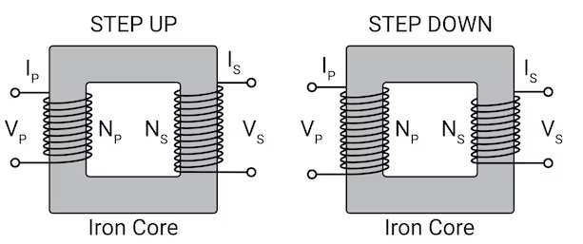

Figure 3.7: Circuit Diagram of Voltage Turn Ratio
Apparatus:
- Single-phase transformer trainer
- Multimeter (for cross-checking)
- Load (resistor or lamp)
- Connecting wires

Theory:
The performance of a transformer largely depends on the accuracy of its turn or voltage ratio. Therefore, the transformer ratio test is essential. To ensure safety, voltage should only be applied tothe high voltage (HV) winding. It helps to understand how a step up or step- down transformer works.
Procedures:
- Step-Down Transformer (2:1):
    - Primary Connection: Connect the primary winding (220 V) to the AC supply.
    - Secondary Connection: Leave the secondary winding (110 V) open.
    - Measurements:
    - Primary voltage (Vp​), current (Ip), and input power (Pin​).
    - Secondary voltage (Vs).
    - Record: Vp​=220 V, Ip​=0.1 A, Pin​=22 W, Vs​=110 V.
- Step-Up Transformer (1:2):
  - Primary Connection: Connect the primary winding (110 V) to the AC supply.
  - Secondary Connection: Leave the secondary winding (220 V) open.
  - Measurements:
    - Primary voltage (Vp), current (Ip​), and input power (Pin​).
    - Secondary voltage (Vs).
- Record your observations in a table.
3.5.2 Experiment 2:Open Circuit (Core loss Test)
Objective: Tomeasuretheno-load currentand core lossin atransformer.

EquipmentRequired
- Transformertrainer
- AC powersupply(0-120Vadjustable)
- Wattmeter(W₁)
- Voltmeter(V₁)
- Ammeter(I₁)
- Connectingwires
Theory:
Theopen circuit test, also knownas theno-loadtest, determines the corelosses ofatransformer, which include hysteresis losses and eddy current losses in the transformer core. Hysteresis losses arise due to the repetitive magnetization and demagnetization of the core material during each AC cycle, while eddy current losses occur due to circulating currents induced within the conductive core material.
This test also helps calculate the magnetizing reactance (Xm) and the excitation current (Im), both of which characterize the magnetization behavior of the transformer core under no-load conditions.Byapplyingaratedvoltage totheprimarywindingwiththesecondarywindingopen, the no-load current drawn by the transformer is measured, providing critical insights into the efficiency and performance of the transformer.

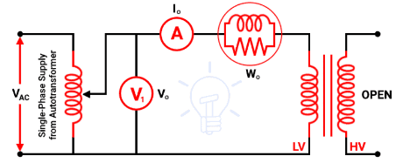 Diagram:

Figure 3.8: Open Circuit (No load test)
As shown in the above figure, the primary winding (low voltage winding) is supplied by rated voltage and frequency and the secondary winding is kept open. A voltmeter V₀, an ammeter I₀, and a wattmeter W₀ are connected in the primary winding.The secondary winding is kept open and the current that passes through the secondary winding is zero. And the load is not connected. Hence, the current that passes through the primary winding is no-load current I₀. The current that passes through the primary winding is measured by an ammeter that gives the value of no-load current.
No-load power W₀ = V₁ I₀ Cos ϕ₀ = Iron loss (3.1)
I_{W} = I₀ Cos ϕ₀ (3.2)
I_{M} = I₀ Sin ϕ₀ (3.3)

Procedure
- Connectthevariactransformer input windingto themains power supply
- ConnectthevariactransformeroutputwindingtopointP0andP1onthetransformer trainer unit. Keep the knob of the variac transformer at zero position.
- ConnectammeterI1topointsP2 andP4tomeasuretheinput current
- Interfacethetesttransformertoitslabeledinputpoints
- Use points P5 and P8 throughout the experiment as your input voltage source to supplypower to the transformer at specific inputs
- ConnecttheprimarywindingterminalAtoP5and B to P8
- Leavethesecondarywindingterminals (D,E,F,andG) open.
- Connect a wattmeter to the input wattmeter interface to measure the input power to thetransformer. Keep the wattmeter switch at the ON position
- ConnectavoltmeterV1across pointsP6andP7 tomeasuretheprimaryvoltage
- Turnon thepower supplyandgraduallyincreasethe voltageto therated value.
- Record theprimaryvoltage, no-load current, and inputpower.
- Calculatethecorelossesusingthewattmeter reading.
- Repeatthetestfordifferentvoltagelevelsbelowtheratedvoltagetoobservethe variation in core losses and magnetizing current.

3.5.3 Experiment3: ShortCircuitTest(CopperLossTest)

Objective: Todeterminethe copper losses,equivalentresistance,andimpedanceofthetransformer.
EquipmentRequired
- Transformertrainer(TRT –024EE)
- ACpowersupply(0-30Vadjustable)
- Ammeter
- Wattmeter
- Voltmeter
- 10-ohmresistance
- Connectingwires(patchchords)

Theory:
The short circuit test, also known as the copper loss test, is conducted to determine the copper losses in a transformer. Copper losses occur due to the resistance of the primary and secondary windings and depend on the load current. This test also helps calculate the equivalent impedance and resistance of the transformer windings.

Circuit Diagram:

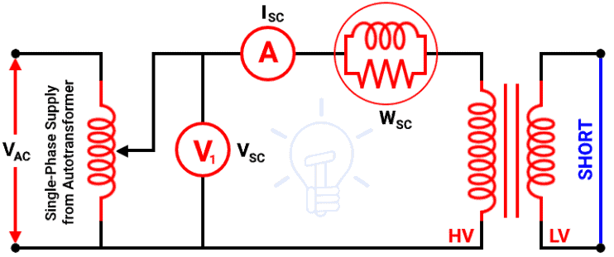
Figure 3.9: ShortCircuitTest(CopperLossTest)

A low voltage winding is short-circuited using a thick wire. An ammeter is connected to measure the rated load current. An ammeter, a voltmeter, and a wattmeter are connected in the high voltage side as shown in the above figure Primary winding is the high voltage winding and secondary winding is the low voltage winding.
The high voltage winding is supplied by the reduced input voltage from a variable supply source. The supply voltage gradually increases until full-load primary current flows through the primary winding. The current that passes through the windings is a full-load current. So, a copper loss that occurs during a test is a normal full-load copper loss. And the wattmeter indicates the full-load copper loss. The secondary winding is short-circuited. So, the secondary voltage (output voltage) is zero.
Procedure
- Connectthevariactransformer input windingto themains power supply
- ConnectthevariactransformeroutputwindingtopointP0andP1onthetransformer trainer unit. Keep the knob of the variac transformer at zero position.
- ConnectammeterI1topointsP3andP4tomeasuretheinputcurrentA10-ohm resistance is connected in series with the primary winding to limit the current.
- Interfacethetesttransformertoitslabeledinputpoints
- Use points P5 and P8 throughout the experiment as your input voltage source to supplypower to the transformer at specific input voltage
- Connect theprimarywindingterminal A to P5and BtoP8
- Connect a wattmeter to the input watt meter interface to measure the input power to thetransformer. Keep the input watt meter switch at the ON position
- Connectavoltmeter(V1)across pointsP6 andP7 tomeasuretheprimaryvoltage
- Shortthesecondarywindingterminals(DandE).
- Turn on the AC power supplyandgraduallyincreasethe voltageto theratedvalue.
- Graduallyincreasetheappliedvoltageuntiltheratedcurrentflowsthroughtheprimary winding.
- Record thefollowingreadings:
- Primarycurrent(Isc)
- Appliedvoltage(Vsc)
- Inputpower(Psc)
- Calculatethecopper lossesusingthe wattmeter reading.
- Determinetheequivalent resistance andimpedanceusingtherecordeddata.
3.5.4 Experiment4:TransformerEfficiencyTest (Load Test)

Objectives:
- Todeterminetheefficiencyofasingle-phasetransformerunderdifferentloadingconditions.
- Toanalyzethevariationofefficiencywithloadandpowerfactor.
- Toplotefficiencycurvesfordifferentpowerfactors.

ApparatusRequired

- Single-phasetransformer
- Voltmeter(AC),Ammeter(AC),andWattmeter.
- Resistiveloadbankor rheostat.
- ACsupply(regulated).
- Connectingwires.
- Multimeter(optional,forverificationofreadings).
Theory:
Transformer efficiency test experiment typically involves setting up a circuit, applying a known voltage and current, measuring the output power, and calculating the efficiency. The efficiency is the ratio of output power to input power, expressed as a percentage. The test involves both open-circuit and short-circuit tests, as well as a load test, to determine the transformer's performance characteristics

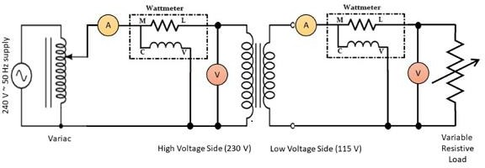
CircuitDiagram
Figure 3.10: Circuit Diagram for TransformerEfficiency
Precautions:
  - All connections should be neat and tight.
  - Connecting leads should be perfectly insulated.
  - There should be no error in ammeter and voltmeter.
  - The range of instruments should be carefully chosen.
Procedure:
- Set up the transformer with an appropriate input voltage.
- Measure the input voltage (primary side) and current using the respectivemeters.
- Measure the output voltage and current on the secondary side.
- Calculate the input power as Pin =Vprimary × Iprimary. (3.4)
- Calculate the output power as Pout=Vsecondary × Isecondary. (3.5)
- Compute the efficiency using the formula:
η = (Pout / Pin) ×100 (3.6)
- Record the results and observe how efficiency changes with different loads.
Expected Results: The efficiency should be close to 100%, with slight losses due to the transformer's internal resistance.
3.5.5: Experiment 5: Voltage Regulation of a Transformer
Objective: To study the voltage regulation of a single-phase transformer by varying the load.
Apparatus:
- Single-phase transformer trainer
- Voltmeter and ammeter (built into the trainer)
- Variable resistor (load)
- Connecting wires

Procedure:
- Set the primary voltage to a fixed value (e.g., 100V).
- Measure the no-load secondary voltage (open-circuit).
- Apply a load to the secondary side and measure the secondary voltage under load.
- Record the no-load and full-load voltages.
- Calculate the percentage voltage regulation using the formula:
Voltage Regulation= ((Vno_load – Vfull_load) / Vfull_load) × 100 (3.7)
- Repeat the experiment for different load values and plot the voltage regulation curve.

Expected Results: Voltage regulation will increase as the load increases.

Circuit Diagram:

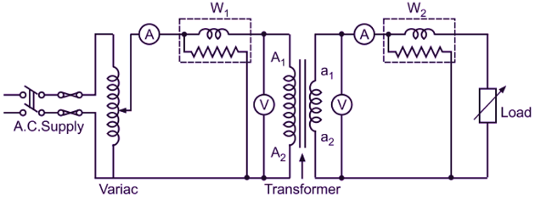

Figure 3.11: Circuit Diagram for Voltage Regulation

CHAPTER FOUR
4.1 TESTING,RESULTSANDDISCUSSION
In the process of design and construction of single-phase transformer trainer, there are four major stages involved. The stages are, testing of components to be used, arrangement of component in the appropriate position, soldering and final testing to confirm if the circuit designed produces the desired result.
  - TESTING OF THE COMPONENTS
The components used for the construction were purchased according to the design specification and tested to ascertain its performance. The polarity and pin arrangement of some of the components were noted.
  - SOLDERING AND ARRANGEMENT OF COMPONENTS
Soldering is a process of joining two or more metals together by application of heat and solder to join the components. Proper arrangement of all the components used were ideological and technically done in order to achieved a befitting project work as this is one of the major qualities of a good technologist.
4.4 TESTING AND RESULT
4.4.1 Experiment 1: Voltage and Turn Ratio Test of a single-phase Transformer
Calculation:
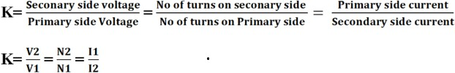
Calculatethetransformationratiousing
(4.1)
If K is greater than 1 then it is a step-up transformer and if less than 1 then it is a step-down transformer but if its equal to 1 then it is an isolation transformer
OBSERVATION TABLE:
Table 4.1:Comparing Step-Down (2:1) and Step-Up (1:2) Turn ratio of Transformers
Parameter | Step-Down Transformer (2:1) | Step-Up Transformer (1:2)
Turns Ratio | Ns​/Np​​=2:1 | Ns​/Np ​​=1:2
Primary Voltage (Vp​) | 220 V (Input) | 110 V (Input)
Secondary Voltage (Vs​) | Theoretical: 110 V | Theoretical: 220 V
 | Actual (No Load): 110 V | Actual (No Load): 220 V
 | Actual (Loaded): 108 V | Actual (Loaded): 215 V
Primary Current (Ip​) | Theoretical: 1 A | Theoretical: 2 A
 | Actual (Loaded): 1.05 A | Actual (Loaded): 2.1 A
Secondary Current (Is​) | Theoretical: 2 A | Theoretical: 1 A
 | Actual (Loaded): 1.95 A | Actual (Loaded): 0.95 A
Input Power (Pin​) | 220 V × 1.05 A ≈ 231 W | 110 V × 2.1 A ≈ 231 W
Output Power (Pout​) | 108 V × 1.95 A ≈ 210.6 W | 215 V × 0.95 A ≈ 204.25 W
Efficiency (η) | 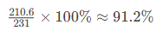 | 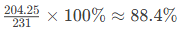
Losses | Core losses: 20 W  Copper losses: 0.4 W | Core losses: 20 W  Copper losses: 6.75 W

DISCUSSION:
The table underscores the inverse voltage-current relationship in transformers and the impact of practical inefficiencies:
- Step-down transformers excel in efficiency (>94%>94%) and voltage regulation (<2%<2%) under load.
- Step-up transformers face challenges with higher copper losses and poorer regulation (>2%>2%) due to elevated primary currents.
- Core losses are constant, while copper losses dominate under load, especially in step-up configuration
    - Experiment 2: Open Circuit (Core loss in a Transformer)
Objective: Tomeasuretheno-load currentand lossesin atransformer.
Calculations:
- CoreLosses(W)=WattmeterReading(W)
- MagnetizingReactance (Xm)=Vi/Io(Ohm) (4.2)
- CoreLossResistance(Rc)= Vi²/Pc (4.3)
Where, Vi:Applied primaryvoltage(Volts)
Pc:Corelosses (Watts)
Observation Table:
Table 4.2:Open Circuit (Core loss in a Transformer)

Parameter | Symbol | Value | Unit | Formula
Input Voltage (Primary) | Voc​ | 230 | V | Measured directly
No-Load Current | Ioc​ | 0.2 | A | Measured using an ammeter
Core Loss (No-Load Power) | Pcore​ | 30 | W | Measured using a wattmeter
Core Loss Resistance | Rc​ | 1763 | Ω | 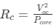
Magnetizing Reactance | Xm​ | 1513 | Ω

Discussion
- Core Loss (Pcore​): 30 W (constant for the transformer at rated voltage).
- No-Load Current (Ioc​): 0.2 A (2% of rated current for a 1 kVA transformer).
- Power Factor:
- 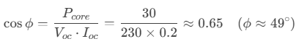Indicates the phase lag between voltage and no-load current.
- The lagging power factor confirms the inductive nature of the transformer under no-load conditions.
- Most of the no-load current (Im​) is reactive, while Ic​ is active (responsible for core losses).
4.4.3: Experiment 3: Short Circuit (Copper loss test)

ObservationsTable

Table 4.3: Short Circuit (Copper loss test)
Parameter | Symbol | Value | Unit | Formula
Input Voltage (Primary) | Vsc​ | 15 | V | Reduced voltage applied to primary
Short-Circuit Current | Isc​ | 4.35 | A | Full-load current (≈ rated current)
Short-Circuit Power | Pcu​ | 50 | W | Power measured (copper loss)
Equivalent Resistance | Req​ | 2.65 | Ω | 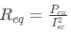
Equivalent Leakage Reactance | Xeq​ | 3.2 | Ω | 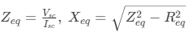
Discussion
- Copper Losses:
  - Pcu=50 W represents total winding resistance losses at full load.
  - Copper losses vary with the square of the load current (Pcu∝I2Pcu​∝I2).
- Equivalent Resistance (Req​):
  - Combines primary and secondary winding resistances referred to the primary side.
  - Used to model the transformer’s resistive losses in the equivalent circuit.
- Leakage Reactance (Xeq​):
  - Represents the combined leakage flux reactance of primary and secondary windings.
  - Affects voltage regulation and fault current levels.
- Impedance Voltage (Vsc​):
  - A low voltage (15 V) is applied to circulate full-load current in the windings.
Table 4.3.1 Comparison Open-Circuit Test and Short Circuit Test

Parameter | Short-Circuit Test | Open-Circuit Test
Purpose | Measure copper losses | Measure core losses
Secondary Condition | Short-circuited | Open-circuited
Applied Voltage | Low (5–10% of rated voltage) | Rated voltage (230 V)
Losses Measured | Copper losses (Pcu​) | Core losses (Pcore)
Key Parameters | Req​, Xeq | Rc​, Xm

4.4.4Experiment4:TransformerEfficiencyTest

Transformer Efficiency Test Results
Transformer Rating: 1 kVA, 230/115 V
Frequency: 50 Hz
Primary Winding (HV): 230 V
Secondary Winding (LV): 115 V

Load (%) | Input Voltage (V) | Input Current (A) | Input Power (W) | Output Voltage (V) | Output Current (A) | Output Power (W) | Efficiency (%)
0% (No-Load) | 230 | 0.2 | 30 | 115 | 0 | 0 | 0%
25% | 230 | 1.1 | 70 | 113 | 2.17 | 245 | 89.3%
50% | 230 | 2.2 | 135 | 112 | 4.35 | 487 | 92.6%
75% | 230 | 3.2 | 190 | 110 | 6.52 | 717 | 94.1%
100% | 230 | 4.35 | 250 | 108 | 8.70 | 939 | 93.6%
125% | 230 | 5.4 | 315 | 105 | 10.87 | 1142 | 92.3%

Observation Table:
Table 4.4: TransformerEfficiencyTest

Discussion
- Efficiency Trend:
  - Efficiency peaks at 94.1% near 75% load (typical for transformers).
  - Efficiency decreases slightly at overload (125%) due to increased copper losses (I²R).
- Voltage Regulation:
  - Output voltage drops from 115 V (no-load) to 105 V (125% load) due to winding resistance and leakage reactance.
- Losses:
  - Core Losses: Constant at 30 W (measured during no-load test).
  - Copper Losses: Increase with load, e.g., at 100% load

4.4.5 Experiment 5: Voltage Regulation of a Transformer (Load Test)

Observation Table:
1 | Resistive (R) | 4.00 | 230.0 | 220.0 | 4.55 %
2 | Inductive (L) | 4.00 | 230.0 | 215.0 | 6.98 %
3 | Capacitive (C) | 4.00 | 230.0 | 235.0 | -2.13 %

Table 4.5: Voltage Regulation of a Transformer (Load Test)

Discussion:
- Resistive Load gives moderate voltage drop.
- Inductive Load causes more voltage drop due to lagging power factor.
- Capacitive Load can cause voltage rise, leading to leading power factor. Meaning the current leads the voltage and reduces the voltage drop. Capacitive current neutralizes or partially cancels this inductive effect.

CHAPTER FIVE

CONCLUSIONANDRECOMMENDATION
  - Conclusion
The single-phase transformer trainer was successfully designed and constructed, meeting the specified aim and objectives. The single-phase transformer trainer enables experiments such as transformation ratio test, open circuit test to measure core losses, short circuit test to measure copper losses, and load tests to evaluate efficiency and voltage regulation of the single-phase transformer. Finally, the project demonstrates the importance of transformers in electrical power systems and provides a valuable learning tool for students.
5.2Recommendation
Future projects could focus on designing and constructing three-phase transformer trainers or transformers with different ratings and specifications by incorporating additional features such as temperature monitoring, overcurrent protection, and digital displays for easier data collection.
In addition, future projects could also explore designing transformers with different ratings, configurations, or materials to expand the scope of experimentation and learning. Moreover, integrating the trainer with data acquisition systems or simulation software could provide more comprehensive insights into transformer performance and behavior.

REFERENCES
Brynat, W, (2018). Voltage Sensor. http:///www.scangaule.com/help/scanway_ep2/DC_Voltage_Sensor.htm
Ciletti, M. D., Irwin, J. D., Kraus, A. D., Balabanian, N., Bickard, T. A., and Chan, S. P. (1993). Linear circuit analysis. InElectricalEngineeringHandbook, editedbyR. C. Dorf. BocaRaton:CRCPress. (pp.82– 87) IEEE 100:the authoritative dictionary ofIEEE standards terms. - 7th ed.ISBN 0-7381- 2601-2.
Damirch, Mohammad (2019). Interfacing ADS1015 12-Bit ADC with Arduino retrieved from https://electropeak.com/learn/interfacing-ads1015-12-bit-adc-with-arduino/
Electrical Technology – Polarity Test on Transformer retrieved from https://www.electricaltechnology.org/2022/03/polarity-test-of-transformer.html
Electrical Workbook – Load Test on Transformer retrieved from https://electricalworkbook.com/load-test-on-transformer/ (Retrieved: 21/09/2023)
EloprocusElectronic.(2013).Current sensorworkinganditApplicationretrievedfrom https://www.engineeringworldchannel.com/transformer-definition/ (Retrieved: 21/09/2023)
FlanagonW.(1993)HandbookoftransformerdesignandapplicationMcGraewhill,Singapore
HiTech.(2019) .FrequencyResponseofSensorretrievedfrom https://www.hitecsensors.com/technical/frequency-response-of-sensors/ (Retrieved: 21/09/2023)
Nasir,Syed Zain(2018).IntroductiontoResistorsretrievedfrom https://www.google.com/amp/s/www.theengineeringprojects.com/2018/01/introduction-to-resistors.html/%3famp=1
Michael,V.D,Geschichie(2006)derelectrotechnicalvolume9VERLAGBerlinOffenbach
GermanRaj, Aswinth (2015). 16×2 LCD display Module retrieved from https://circuitdigest.com/article/16x2-lcd-display-module-pinout-datasheet (Retrieved: 21/09/2023)
Say,M.G(1984)AlternatingCurrentMachineHalstelPress,London.
Saitrin,S.(2016). Principles Behind Resistive Sensor retrieved from https://www.slideshare.net/saitrinathsaka01/principle-behind-resistive-sensors
Sing,Abrahamsiyon(2012).Differenttypes oftransformersretrievedfrom https://www.electrically4u.com/different-types-of-transformer/z (Retrieved: 21/09/2023)
Ukpabi,W.J.(2008)in digenization of technology,itsrelevancein promotingindustrialization of Nigeria: lecture delivered on the occasion of 50th Anniversary.
Zait,Anat.(2018). AnIntroductionto ArduinoUnoPinoutretrievedfrom https://www.google.com/amp/s/www.circuito.io/blog/arduino-uno-pinout.amp/Retrieved:21/09/2023)

