FILE SECURITY IN THE CLOUD USING RSA AND BLOWFISH ALGORITHMS

BY

IBRAHEEM YUSUF OLANIYAN
ND/23/COM/PT/0293

A PROJECT REPORT SUBMITTED TO THE
DEPARTMENT OF COMPUTER SCIENCE
INSTITUTE OF INFORMATION AND COMMUNICATION TECHNOLOGY, KWARA STATE POLYTECHNIC ILORIN

IN PARTIAL FULFILLMENT OF THE REQUIREMENT FOR THE AWARD OF NATIONAL DIPLOMA (ND) IN COMPUTER SCIENCE

JUNE 2025

CERTIFICATION
This is to certify that this project was carried out by Ibraheem Yusuf Olaniyan with Matriculation Number ND/23/COM/PT/0293 in the department of Computer Science, Institute of Information and Communication Technology, Kwara State Polytechnic, Ilorin.

------------------------------------- ---------------------
MR. ISIAKA. O. S. Date
(Project Supervisor)

--------------------------------- ---------------------
MR. OYEDEPO, F.S. Date
(Head of Department)

----------------------------------- --------------------
External Supervisor Date

DEDICATION
This research work is dedicated to almighty Allah and my parents Mr. & Mrs. IBRAHEEM

ACKNOWLEDGEMENT
All praise and thanks to our inestimable Almighty God, the most beneficial, merciful, nourished and sustainer for His guidance over my live throughout this research work and our programme in this great institution.
I also appreciate the effort of my amiable supervisor Mr. Isiaka, O.S for his supervision and corrections made during the project work. May Almighty Allah bless him and his home,
Special thanks to Head of the department (Mr. Oyedepo F.S), Mr. Abiodun E.T, Dr. (Mrs.) Olusi R.T, Dr. Agboola O.M, Dr. Raji A.K, Dr. (Mrs.) Dada M.O, and other members of the staff of the Department of Computer Science for their support always.
My appreciation goes to my parents for their support and prayer since they gave birth to me.

TABLE OF CONTENTS

CERTIFICATION ii
DEDICATION iii
ACKNOWLEDGEMENT iv
TABLE OF CONTENTS v
ABSTRACT viii
CHAPTER ONE 1
GENERAL INTRODUCTION 1
1.1 INTRODUCTION 1
1.2 STATEMENT OF THE PROBLEM 2
1.3 AIM AND OBJECTIVES 3
1.4 SIGNIFICANT OF THE STUDY 3
1.5 SCOPE OF THE STUDY 3
1.6 ORGANIZATION OF THE REPORT 4
CHAPTER TWO 5
LITERATURE REVIEW 5
2.1 REVIEW OF RELATED PAST WORKS 5
2.2 CLOUD COMPUTING OVERVIEW 7
2.3 TYPES OF CLOUD COMPUTING 8
2.4 FOUNDATION OF CLOUD COMPUTING 9
CHAPTER THREE 11
METHODOLOGY AND ANALYSIS OF THE EXISTING SYSTEM 11
3.1 RESEARCH METHODOLOGY 11
3.2 ANALYSIS OF THE EXISTING SYSTEM 12
3.3 PROBLEM OF THE EXISTING SYSTEM 13
3.4 DESCRIPTION OF THE PROPOSED SYSTEM 13
3.5 ADVANTAGE OF THE PROPOSED SYSYTEM 14
CHAPTER FOUR 16
DESIGN AND IMPLEMENTATION OF THE SYSTEM 16
4.1 DESIGN OF THE SYSTEM 16
4.2 SYSTEM IMPLEMENTATION 23
4.3 SYSTEM DOCUMENTATION 24
CHAPTER FIVE 27
SUMMARY, RECOMMENDATION AND CONCLUSION 27
5.1 SUMMARY OF THE FINDING 27
5.2 CONCLUSION 27
5.3 RECOMMENDATION FOR FUTURE WORKS 28
REFERENCES 29
PROGRAM FLOWCHART 31
WELCOME PAGE FLOWCHART 32
LOGIN FLOWCHART 33
MAIN MENU FLOWCHART 34
OPERATION FLOWCHART 36
ENCRYPT FILE FLOWCHART 37
DECRYPT FILE FLOWCHART 39
TRANSFER FLOWCHART 40
VIEW FLOWCHART 42
LOGOUT FLOWCHART 43
SOURCE CODE 44

ABSTRACT
Data security is provided in accordance with the client's specifications. Cloud computing offers a variety of services and deployment models. Each cloud computing model has a different level of security. Security is provided in this proposed system based on the model selected by the user. To achieve data confidence, integrity, and authentication in cloud deployment models, a combination of RSA and Blowfish algorithms is used. Data is stored in various cloud computing deployment models based on the user's security requirements. The program will be built with Dreamweaver for interface design, PHP and JavaScript for scripting, and MySQL for database management.

CHAPTER ONE

GENERAL INTRODUCTION

1.1 INTRODUCTION
Cloud computing is the use of internet "clouds" based on the advancement and application of computer technology "computing." In theory, this is a paradigm shift in which users no longer require knowledge, experience, or control over the 'cloud' technology infrastructure that supports them. Cloud computing is a new model for replenishing, consuming, and delivering internet-based IT services. It typically entails delivering dynamically scalable and frequently virtualized resources as a service over the internet. Message exchange security has become a major concern in recent years. Encryption has emerged as a solution and is critical in an information security system. Many techniques are required to safeguard the shared data.
This study focuses on the use of cryptography to secure data / information during network transmission. To begin, the data to be sent from the sender to the recipient on the network must be divided into shares and encrypted with an encryption algorithm using visual cryptography. Second, the recipient can view the original data by employing the decryption technique. Cloud computing is now widely used in a variety of fields. Everyday life generates a large amount of data. Cloud computing is used to store massive amounts of data. It offers the user a variety of services. There are several issues with storing data in the cloud. Data security, integrity, authentication, and confidentiality are the primary issues with cloud computing. Different algorithms and techniques have been introduced by different researchers to provide a solution to these security problems, but each algorithm and technique has its own set of advantages and disadvantages.
Cloud computing storage is used based on the needs of the user. The data can be accessed from the cloud at any time and from any location. Nowadays, a large amount of data is stored on the cloud, but we don't know whether or not our data is stored securely on the cloud. Cryptography algorithms are one solution for providing data security on the cloud. Cryptography is a process that allows us to securely store data on the cloud and transmit it in an unreadable format so that only authorized individuals can access sensitive data. There are different types of cryptography. There are two types of algorithms: symmetric algorithms and asymmetric algorithms. AES, DES, IDEA, TDES, and Blowfish are symmetric algorithms, while RC6, RSA, and ECC are asymmetric algorithms. Symmetric algorithms use the same secret key for data encryption and decryption, whereas asymmetric algorithms use two keys. The public key is used to encrypt data, while the private key is used to decrypt data.
The project makes use of a variety of cryptography algorithms. The new type of security model addresses various cloud security issues, such as data security, verification, and authentication. The RSA algorithm provides high-level data security as well as data confidentiality. Asymmetric algorithms are used to ensure secure communication. Encrypted data is stored on the cloud, so unauthorized individuals cannot access the data. The blowfish algorithm is used for user authentication, so that only authorized individuals can upload data to the cloud. Because different cryptography algorithms are run at different locations in the cloud models, no one can access the user's secure data in this proposed system.

1.2 STATEMENT OF THE PROBLEM
Aside from its benefits, the cloud has a number of security concerns. Data security is the most difficult challenge in the cloud. How is the data of users safeguarded in cloud storage? This is the main source of concern about cloud storage. There is a greater possibility that the data will be accessed by other cloud storage users or by staff from the cloud storage provider. Data security must be considered when storing data in the cloud. Cryptography is the most well-known technique for securing data through encryption. It is necessary to propose encryption methods that are appropriate for cloud storage.

1.3 AIM AND OBJECTIVES
The aim of this project is to secure cloud file storage by combining the RSA and blowfish algorithms. This aim can be met by pursuing the following objectives:
- To ensure file security, implement the proposed hybrid cryptographic approach on the cloud.
- To design high ranked security algorithms for giving secured communication process.
- Propose a hybrid cryptographic approach in conjunction with a file mechanism.

1.4 SIGNIFICANT OF THE STUDY
The significance of this research is to improve the security of data stored in the cloud by encrypting it with hybrid cryptographic algorithms. The algorithms are designed and implemented in such a way that one authenticates the authorized user while the other ensures the confidentiality and security of cloud data.

1.5 SCOPE OF THE STUDY
The study's scope is limited to message encryption and decryption only, with no monitoring of the messages' actual transport over the network.

1.6 ORGANIZATION OF THE REPORT
This report is divided into five chapters. The first chapter introduces the new system, its goal and objectives, its significance, the scope of the proposed system, and technical terms. The second chapter focuses on reviewing related previous works, cloud computing overview, types of cloud computing, cloud computing foundation, cloud computing deployment models, cloud computing characteristics, security issues in cloud, key components of data security, and encryption algorithms used. The third chapter includes the research methodology, data analysis of the existing system, which includes the description of the current procedure, problem of the existing procedure, description of the proposed system, and advantages of the proposed system. The fourth chapter reveals the system design, system implementation, including the output input file structure, and system procedure design. It also includes detailed implementation techniques, programming languages used with reason, hardware and software support, and documentation. The fifth chapter is a summary of all the research that has been done. Recommendation and report conclusion with the experience and problem encountered during the investigation, followed by the reference, flowchart, program listing, and computer output.

CHAPTER TWO

LITERATURE REVIEW

2.1 REVIEW OF RELATED PAST WORKS
According to Fortine, Michael & George (2017), data stored in the cloud is becoming increasingly popular for all users, including personal, institutional, and business purposes. Depending on the security and scalability requirements, the data is usually highly protected, encrypted, and replicated. Despite technological advances, the practical usefulness and longevity of cloud storage in today's systems is limited. This paper proposes a solution to the problem of securely storing the client's data in the cloud while maintaining the data's confidentiality and integrity. This paper addresses the issue of ensuring data confidentiality in the cloud and against unauthorized access. To address these concerns, we created a data encryption model that is responsible for storing data in an encrypted format in the cloud. To improve the efficiency of the designed architecture, the service in the form of the model allows users to select the level of security of the data, and different encryption algorithms are used based on this level.
According to Ramalingam & Sharmila (2015), the proposed SEA improves the security of data stored in cloud storage. This method is appropriate for the education, medical, and agricultural communities to securely store their data in cloud storage. For storage, cloud computing is more dependable. It has a number of security issues. The primary concern in cloud data storage is security. The paper proposed a symmetric encryption algorithm for securing cloud storage data. SEA converts the original text into ASCII code in order to process the data during the encryption process. For encryption and decryption, two symmetric keys are used. These keys are kept on the cloud users' end. Data in the cloud should only be accessed by authorized people from a CSP or a cloud user. The SEA reduces the amount of time required for encryption and decryption. It also ensures the highest level of security for data stored in the cloud. As a result, the proposed SEA assists CSPs and cloud users in maintaining cloud security.
Aayushi, Rana, & Patel (2015) proposed a hybrid work that consists of three stages. In the first stage, the Ceaser Ciphering technique is used, which provides an initial level of security while also providing more efficiency. The proposed work's second level deals with a newly designed encryption algorithm based on the symmetric cryptographic concept (block based). This work employs a 128-bit block size for encryption, which provides a higher level of security. This 128-bit block size is encrypted with the help of an encrypted key, which is also 128-bits in size. The encrypted key is created by performing an XOR operation on the user's private key and the cloud's secret key. As a result, the third stage of the newly proposed work focuses on cloud user authentication using Attribute Based Cryptography (ABC) techniques. Using this technique, the algorithm generates an attribute related to ciphertext and handles user authentication based on this attribute. If the user meets this condition, the newly proposed Cloud-based Security checks for the key as well.
Swathi and Bhaludra (2017) concluded that the majority of servers, clients, and people share assets. As a result, it is difficult for the cloud provider to guarantee record security. Thus, it is simple for a gatecrasher to gain access to, abuse, and destroy the first type of information. If a trade-off must be made at any cost, relying on the cloud is pointless. A procedure that is "for all intents and purposes solid and impossible to be attacked" turns out to be crucial. The paper depicts a record security display that employs the concept of a cross breed encryption plan to address security concerns. The proposed model encrypts and decrypts data at the cloud server using blowfish and a modified version of RSA.

2.2 CLOUD COMPUTING OVERVIEW
Cloud computing, which evolved from large-scale distributed computing technology, offers users computation power, storage, and software services. It does not necessitate knowledge of the physical location or the specific hardware configuration on which the services are running. It operates on the same logic as a power grid that distributes energy to various houses, where the consumer is not required to understand how the power is generated or delivered to the house.
Cloud computing has been coined as an umbrella term to describe a class of sophisticated on-demand computing services initially offered by commercial providers such as Amazon, Google, and Microsoft. It refers to a model in which a computing infrastructure is viewed as "Cloud," from which businesses and individuals can access applications from anywhere in the world on demand. The definition of cloud computing is the use of web-based applications and/or server services that you pay to access rather than software or hardware that you buy and install locally. Using the internet to communicate and transport hardware, software, and networking services to clients, the general public, enterprises, corporations, and business markets.

Figure 2.1: Cloud Computing

2.3 TYPES OF CLOUD COMPUTING
- The Public Cloud deployment model is a true cloud hosting model. Services and infrastructure are provided to various clients, such as Google, under this deployment model.
- The Personal Cloud This model isn't particularly cost-effective: it's comparable to purchasing, building, and managing your own infrastructure. Nonetheless, it adds tremendous value in terms of security. For instance, a bank.
- The Hybrid Cloud is an infrastructure that includes links between one cloud managed by the user (typically referred to as "private cloud") and at least one cloud managed by a third party (typically referred to as "public cloud"). Although the public and private segments of the hybrid cloud are linked, they remain distinct entities. As a result, a hybrid cloud can provide the advantages of multiple deployment models at the same time.

2.4 FOUNDATION OF CLOUD COMPUTING
Cloud computing's emergence is inextricably linked to technologies such as grid computing, utility computing, and so on.
- Grid Computing: Grid computing is defined by IBM as "the ability to gain access to applications, data, processing power, storage capacity, and a vast array of other computing resources over the Internet by utilizing a set of open standards and protocols." Gris computing enables the transparent aggregation of distributed resources. Building standard Web services-based protocols that allow distributed resources to be "discovered, accessed, allocated, monitored, accounted for, and billed for, etc., and in general managed as a single virtual system" has been a key aspect of grid vision realization.
- Utility Computing: Utility computing is a service delivery model in which a service provider makes computing resources and infrastructure management available to customers on an as-needed basis and charges them based on usage rather than a flat rate. Users assign a "utility" value to their jobs in utility computing environments, where utility is a fixed or time-varying valuation that captures various QoS constraints (deadline, importance, satisfaction). The valuation is the sum of money they are willing to pay a service provider to meet their needs.
- Cluster Computing: A computer cluster is a collection of loosely or tightly connected computers that work together to form what appears to be a single system in many ways. A cluster's components are typically linked together via a fast local area network (LAN), with each node (computer used as a server) running its own instance of an operating system. Computer clusters arose as a result of the convergence of several computing trends, such as the availability of low-cost microprocessors, high-speed networks, and software for high-performance distributed computing. Clusters are typically deployed to improve performance and availability over a single computer because they are much more cost-effective than single computers of comparable speed and availability.

CHAPTER THREE

METHODOLOGY AND ANALYSIS OF THE EXISTING SYSTEM

3.1 RESEARCH METHODOLOGY
Data encryption and decryption are accomplished by combining the RSA and Blowfish algorithms. When the two algorithms are combined, the run time for both encryption and decryption increases, as does the total time required for both processing. The proposed system's methodology, as shown in Figure 3.1, examined the reliability and efficiency of the combination (RSA + Blowfish) based on performance parameters such as throughput, encryption time, cipher text size, and delay on various file sizes.
Vary data size e.g. 2mb, 4mb, 6mb e.t.c.
Figure 3.1: RSA and Blowfish Algorithms for data security on cloud
Input file
Encrypt with RSA algorithm
Encrypt with Blowfish algorithm

Output file
Decrypt with RSA algorithm
Decrypt with Blowfish algorithm

Record time after encryption with RSA algorithm
Record time after encryption with Blowfish algorithm
Transfer in a wireless network
Record time before decryption with Blowfish algorithm
Record time after decryption with Blowfish algorithm
Record time after decryption
Record time before encryption

The named parameters can be calculated as follows:
      - Throughput: This is the number of bits transferred in one unit of time. The standard unit is bytes per second.
Throughput = uploaded file size/delay time
- Cipher text size: This refers to the length of encrypted data, which is measured in bytes.
Cipher text size = length of encrypted data
- Encryption Time: This is the amount of time it takes the server to encrypt any file or data. Its standard measurement units are nanoseconds.
Encryption Time = Encryption End Time – Encryption Start Time
- Delay time: This is the difference between the uploading time at the beginning and the uploading time at the end. It uses the same standard units as encryption time.
Delay Time = End uploading time – Start Uploading Time

3.2 ANALYSIS OF THE EXISTING SYSTEM
Cloud computing is the next generation of IT enterprise architecture. Unlike traditional solutions, cloud computing relocates application software and files to large data centers, where the management of the files and services may not be completely reliable. This one-of-a-kind feature, on the other hand, introduces a slew of unknown security challenges. All servers, users, and individuals share resources in the cloud. As a result, everyone now has access to files or data stored in the cloud. As a result, all other cloud users can access an individual's data or files. As a result, the data or files are more vulnerable to being attacked. As a result, an intruder can easily access, misuse, and destroy the original form of data. Furthermore, cloud service providers offer a variety of mission-critical applications. As a result, it is critical that the cloud be secure. It is the most serious concern about cloud computing. Because cloud data management and infrastructure management are provided by third parties, there is always a risk in entrusting sensitive information to cloud service providers. Despite the fact that cloud computing vendors provide highly secured password protection accounts, any sign of a security breach may result in the loss of customers and businesses. Cloud computing ensures data confidentiality, integrity, and availability.

3.3 PROBLEM OF THE EXISTING SYSTEM
There are some issues with the current system that make it difficult to adapt to a high technology and modern system of providing security to our information or messages.
- One of the major issues with cloud computing is security. Because it is entirely based on the Internet, it is vulnerable to hacking attacks.
- The service provider typically monitors all data uploaded to the cloud by the user. This monitoring issue puts users' activities at risk.
- Cloud computing data is stored on a server in a different country, exposing confidential data to the outside world.

3.4 DESCRIPTION OF THE PROPOSED SYSTEM
Figure 3.2 depicts a cloud storage architecture with a data owner and a data user. If the data owner wants to share the data on the cloud, the data owner must first covert the original plain text into cipher text using various cryptography algorithms. Cipher has been uploaded to the cloud. As a result, only authorized users have access to sensitive data. If a user wishes to download data from the cloud, he or she must provide authentication information. If the authentication details match those in the database, the user is authorized and has access to the original plain text.

3.5 ADVANTAGE OF THE PROPOSED SYSYTEM
The proposed system secures cloud file storage using the RSA and Blowfish algorithms, and it is expected to improve services and optimize operation. The following are the primary benefits of the proposed system:
- Allow an individual/organization to store secure files on a cloud database.
- A cost-effective and comprehensive approach to cloud-based information acquisition, distribution, and storage.
- Only the authorized user can decrypt information that is readily available.
- To prevent hackers or unauthorized users from interpreting the information in the cloud database if they gain access to it.
- Improve record-keeping procedures.

CHAPTER FOUR

DESIGN AND IMPLEMENTATION OF THE SYSTEM

4.1 DESIGN OF THE SYSTEM
The new system is designed to operate in accordance with standard software development procedures. It is web-based and uses a relational database structure to store the various activities that take place. The encryption system is embedded in PHP code for online access, along with a MySQL database.
    - OUTPUT DESIGN
The system generates a web page as its output. These pages contain a wireless network technology tutorial. Aside from that, the results of the user tests are displayed on the screen, as well as the class forum, which is interactive and accessible to everyone on the network. If necessary, the output of this program can be printed.

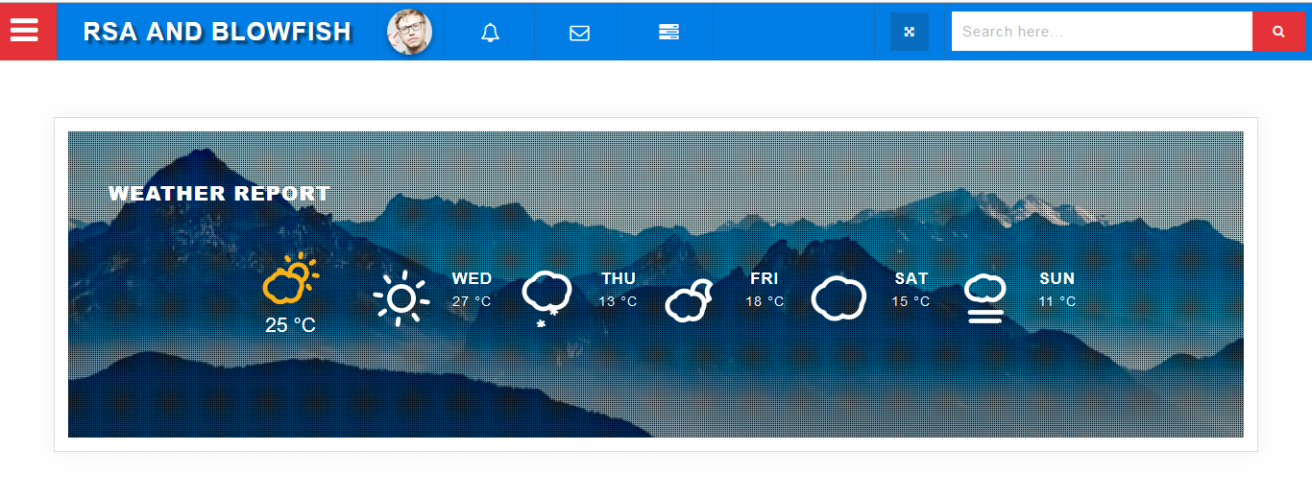
Figure 4.1: Output Design of Index Page
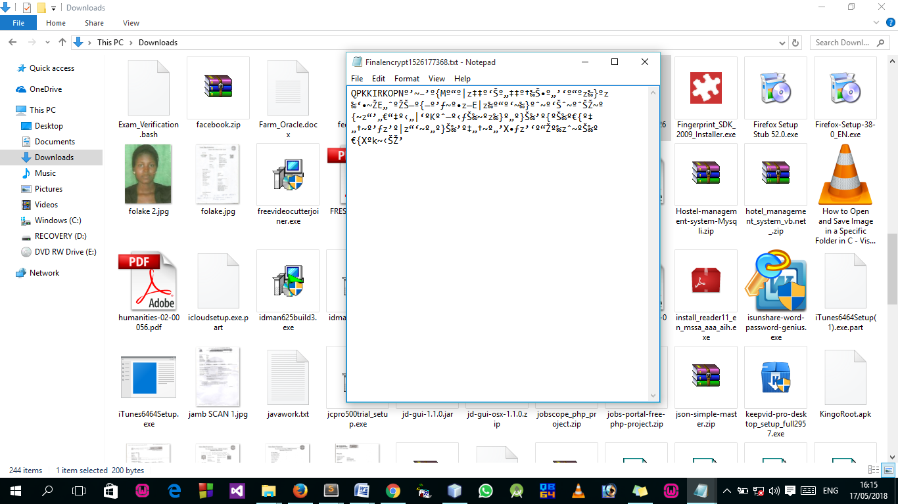

Figure 4.2: Output Encrypted File
4.1.2 INPUT DESIGN
User-generated inputs are converted to a computer-compatible format during input design. The goal of designing input is to ensure that data is as accurate as possible. The sources document must be organized as the first step in the input design process. Then a decision is made about which media will be used to enter data into the system. A source document is an original user-generated form, and in the course of this project work, the source document is the user data from the source, data will be captured/read directly from an input device, a source document will be logically organized, and it will be simple to understand. The form's sections will be organized and clearly labeled. The proposed design's input interface is shown below.
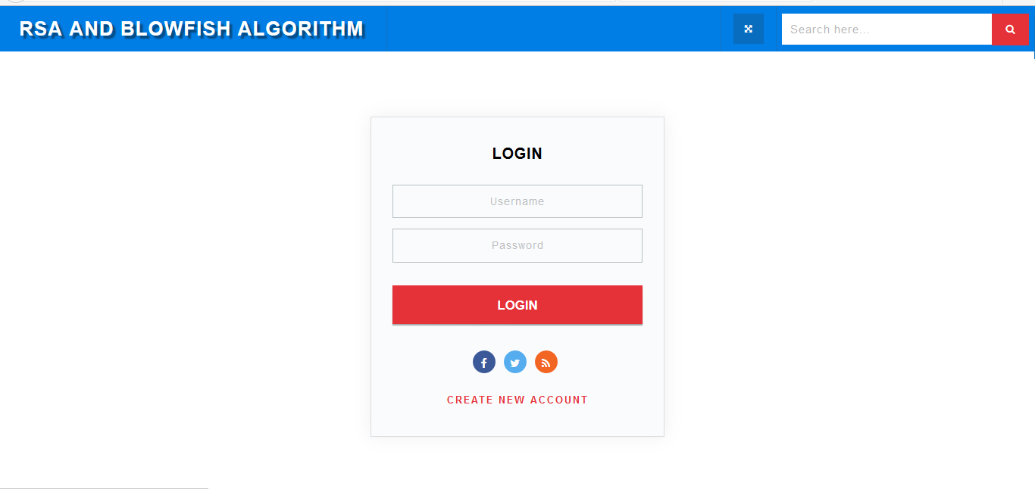
Figure 4.3: Inputs Interface for Login
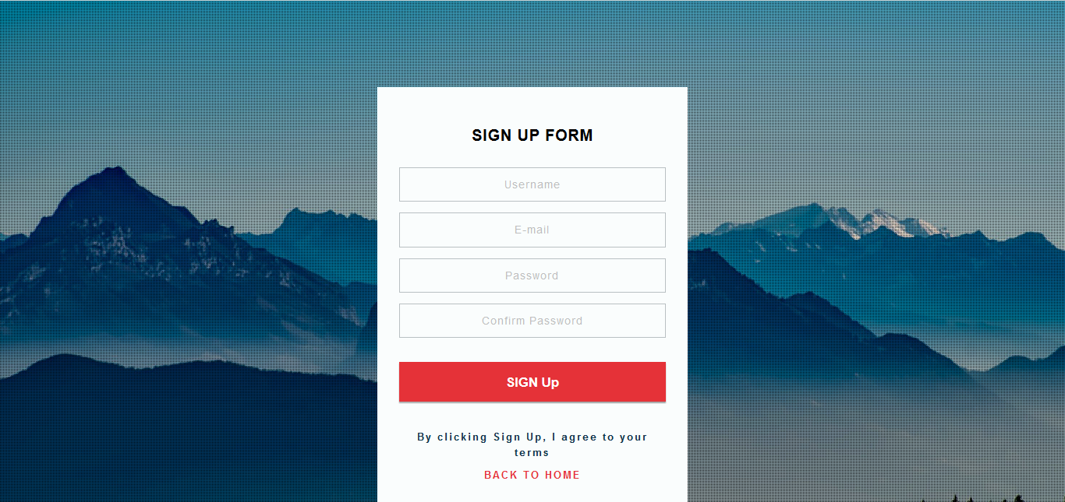
Figure 4.4: Input Interface for Sign Up
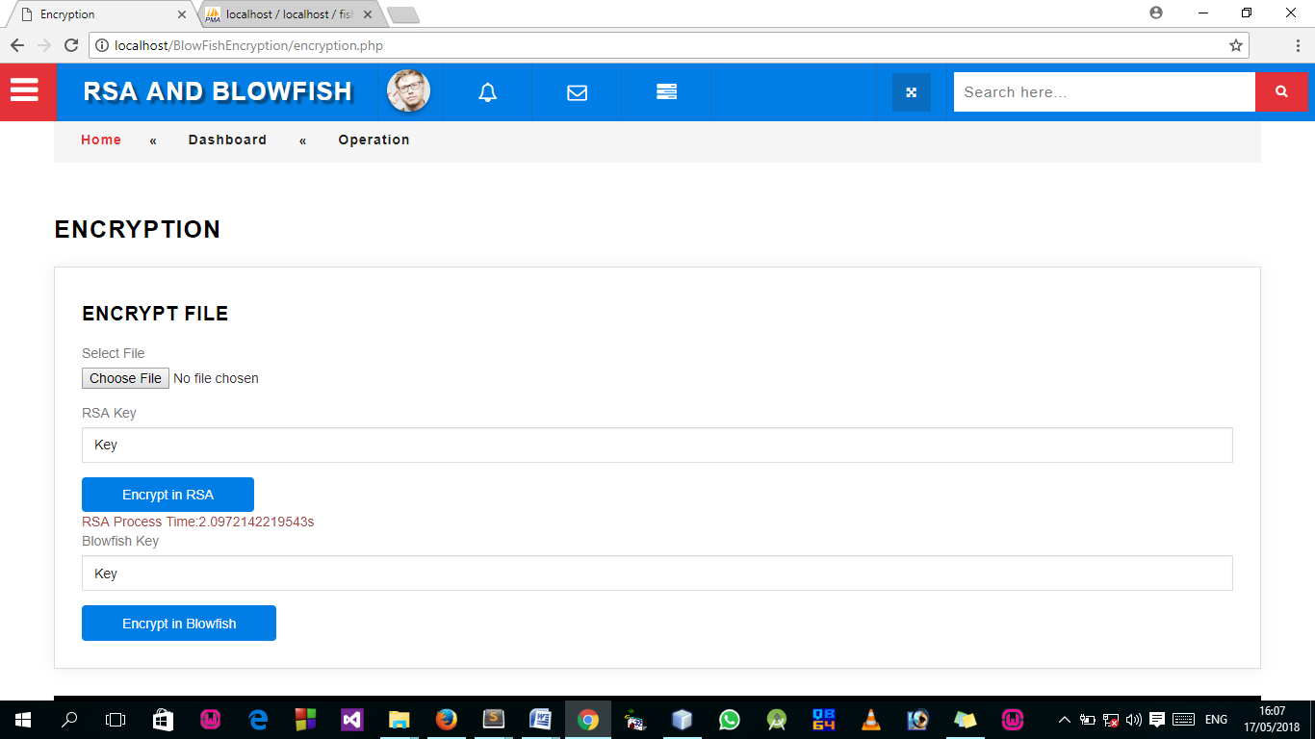
Figure 4.5: RSA Encryption Module Input Design with Process Time
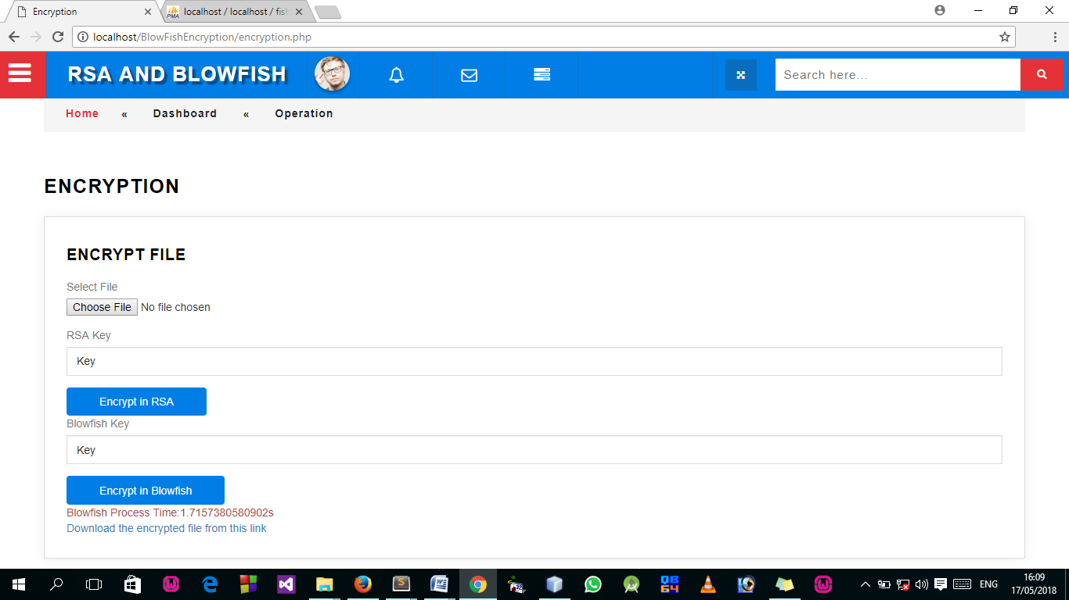
Figure 4.6: Blowfish Encryption Module Input Design with Process Time

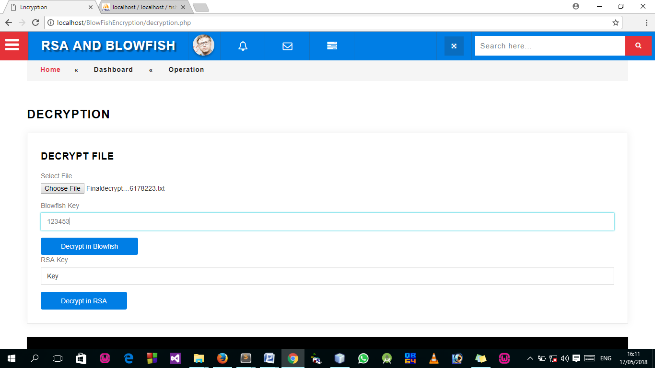
Figure 4.7: Blowfish Decryption Module Input Design with Process Time
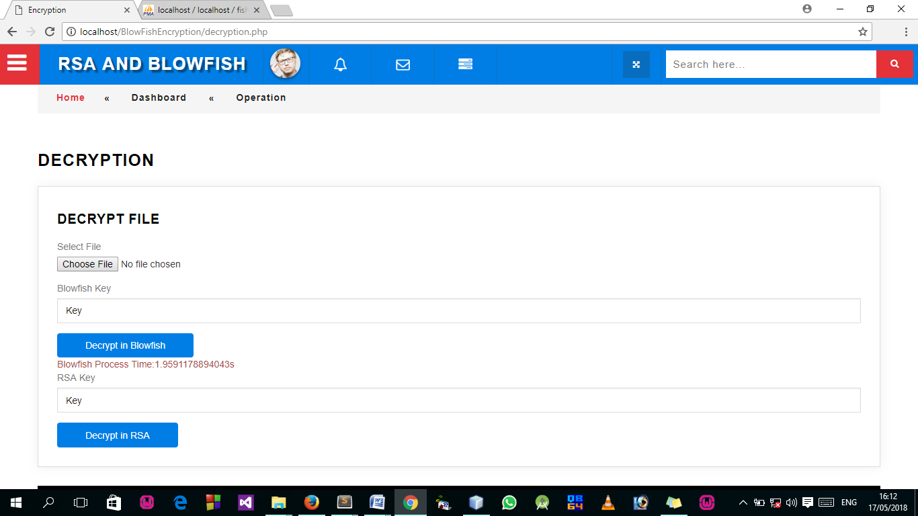
Figure 4.8: RSA Decryption Module Input Design with Process Time
    - DATABASE DESIGN
The design made use of the MySQL database. Tables are used in the design. The phone number table and the customer profile table.
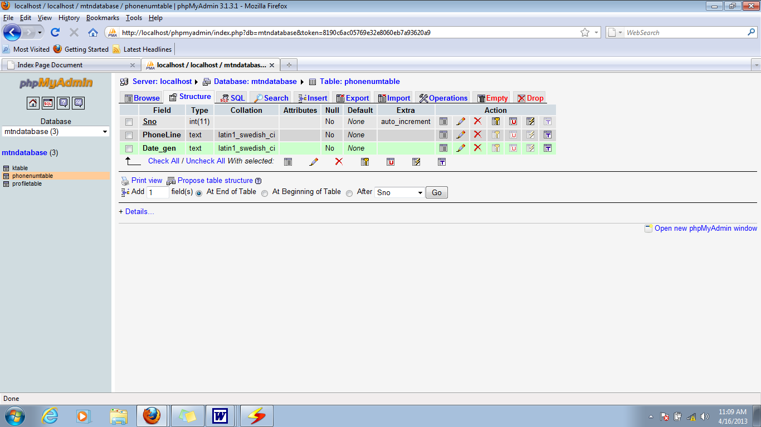

Figure 4.9: User Database Structure
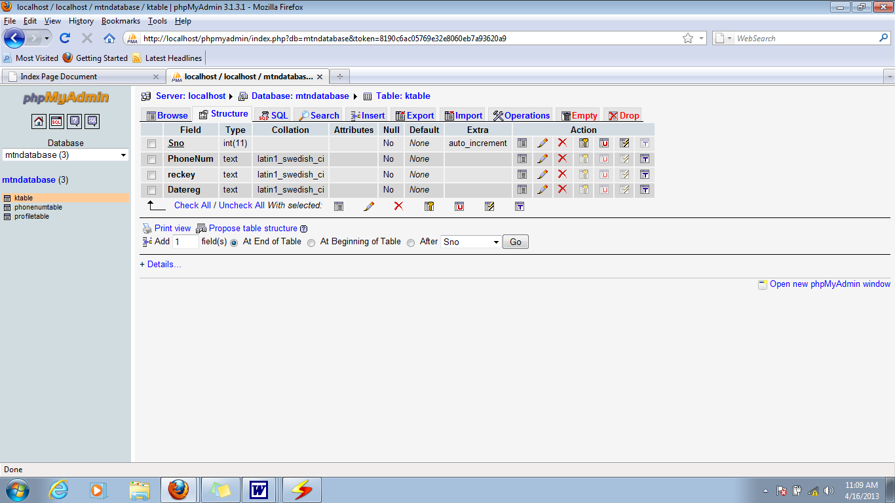
Figure 4.10: Client Profile Table Structure
4.1.4 PROCEDURE DESIGN
This highlights the program's structural form, as it is readable and simple to understand. The program is capable of registering users and also of providing encryption and modification of customer information. This design includes the following menus:
- Home Module: This menu is used to provide users with links to all of the design's web pages.
- Registration: The user uses this module to enter their information into the database in encrypted format.
- Modification Module: This module allows customers to make changes to their information. Remember that the information stored at first is encrypted, but before it can be modified, this application is designed in such a way that the data is first decrypted into plain text for the users to modify before being re-encrypted into the database.

4.2 SYSTEM IMPLEMENTATION
The stage of the project in which the theoretical design is transformed into a working system is known as implementation. It is the most important stage in achieving a successful new system because it gives users confidence that the new system will work, be effective, and accurate. Its primary focus is on user training and documentation. Conversion usually occurs at the same time as the user is being trained, or later. Implementation simply refers to the process of converting a new revised system design into an operational one.
4.2.1 CHOICE OF PROGRAMMING LANGUAGE
Dreamweaver is used in the design of the project work's interface, along with PHP and JavaScript for scripting and MySQL for database.
4.2.2 HARDWARE REQUIREMENTS
The software developed in the design requires the following hardware for the new system to operate effectively and efficiently.
- The Intel Computer System.
- A minimum of 2GB RAM.
- Improved keyboard.
- A hard disk with a capacity of at least 200GB.
- A monitor with color.
- Units of uninterruptible power supply (UPS)
- Printer (LaserJet or DeskJet).
4.2.3 SOFTWARE REQUIREMENTS
The software requirements are as follows:
- Windows XP or higher for faster processing.
- The database server (apache).
- The web server (apache).
- Graphical software (Corel Draw).
- Dreamweaver 8.0.
- Mozilla's web browser.

4.3 SYSTEM DOCUMENTATION
System documentation entails compiling all of the documents associated with the application and compiling them into an operation manual. In this case, make every effort to ensure that the documents are as clear as possible and that the purpose or scope of programming is clear and concise. This application has been designed to be easy to maintain and modify if necessary, or even in the case of the application developer.
    - PROGRAM DOCUMENTATION
Working with software requires proper and adequate documentation, which is part of the quality of a good program. You click the start button, then locate all programs and click on cloud the home screen, enter your password and username, and the cloud home page will appear, listing all available friends in green for online friends and red for offline friends. As a result, you can select any menu from the list provided in order to perform any operation you desire.
4.3.2 OPERATING THE SYSTEM
Users of this proposed system will require some instruction in order to make the best use of their propped. The duration and level of training are determined by the user's level of knowledge and the system requirements. The system's requirements range from simple and user-friendly to advance. A user-friendly system is almost self-instructional, with menu-driven features and user manuals that are simple to understand. Even for the most inexperienced user, training will be measured in hours and days. The level of training will be determined by the following factors:
i. The user's computer knowledge.
ii. The system's complexity and how well it accommodates the average.
iii. The trainer's ability.
iv. The environment in which training is conducted.
A well-written user manual, simple – to – use help screens, and job aids all contribute to successful training. User manuals will be invaluable training documents, especially when the user is geographically isolated.
- A well-written and well-illustrated manual.
- Access to graphics, templates, and other tools for quick reference or as a teaching aid.
- Screens to assist in the correction of symbolic errors.

4.3.3 MAINTAINING THE SYSTEM
The term "system maintenance" refers to the process of modifying a system. It refers to the ease with which changes can be made to the system under certain conditions. It also refers to the addition, deletion, or modification of a portion or the entire program. Programs with structure and a feature of maintainability are considered to be good. The newly proposed system could be modified to handle certain operations such as displaying the Homepage, sending encrypted data into the database, and decrypting it back into normal form. In general, to make changes to any of these operations, go to the code environment and make the necessary changes, and the changes will be effected immediately, making system maintenance very simple.

CHAPTER FIVE

SUMMARY, RECOMMENDATION AND CONCLUSION

5.1 SUMMARY OF THE FINDING
Cloud computing technology is widely used so that data that has been outsourced to the cloud can be easily accessed. Different members can access that data via different virtual machines while remaining on a single physical machine. The need is to securely share data with users. To ensure data security, the cloud service provider and users must be authenticated. Maintaining privacy in the cloud is critical to ensuring that the user's identity is not revealed to everyone. Anyone can share data in the cloud. As a result, keeping data secure is a critical aspect of cloud computing. Cryptography enables users to share data in a secure manner. The RSA algorithm will provide data authenticity and non-repudiation, while the Blowfish algorithm will provide security by encrypting the data. As a result, the user encrypts the data and uploads it to the server. To decrypt the selected data, the encryption and decryption keys are shared.

5.2 CONCLUSION
When clients store data in the cloud, there is always the question of whether the cloud service provider secures the data. As previously stated, security is the primary challenge encountered when storing data in the cloud. The proposed system provides security for data stored in the cloud computing model using the RSA and Blowfish algorithms. The results show that combining RSA and Blowfish gives the properties of both algorithms, making the resulting hybrid algorithm much more resistant to threats. By gradually increasing the complexity of the functionalities, the formed hybrid system becomes more secure.

5.3 RECOMMENDATION FOR FUTURE WORKS
This work's future scope can be expanded by:
- Carrying out the same experiments with audio and video as well.
- A compression algorithm can be used to speed up encryption.

REFERENCES
Aayushi P., Rana Y.K. & Patel B.P. (2015). Design and implementation of an algorithm to enhance cloud security. International Journal of Computer Applications. 113(12).
Buyya R. et al. (2011). Introduction to cloud computing. Cloud Computing Principles and Paradigms. John Wiley & Sons.
Fortine M., Michael K. & George O. (2017). Enhanced secure data storage in cloud computing using hybrid cryptographic techniques (AES and Blowfish). International Journal of Science and Research (IJSR), 6(3).
Jasleen K. and Sushil G. (2015). “Security in cloud computing using hybrid of algorithms”. International Journal of Engineering Research and General Science, 3(5).
Mangtani N. and Bhigarkar S. (2012). The appraisal and judgement of Nimbus, OpenNebula and Eucalyptus. International Journal of Computational Biology, 3(1), 44–47.
Manikandan G. et al (2011). A hybrid approach for security enhancement by modified Crypto-Stegno scheme. European Journal of Scientific Research, 2(1), 206–212.
Mukhopadhyay D. (2013). Enhanced security for cloud storage using file encryption. Proc. International Conference on Distributed Computing and Internet Technologies.
Ramalingam S. and Sharmila B.S. (2015). Symmetric encryption algorithm to secure outsourced data in public cloud storage. Indian Journal of Science and Technology, 8(23), doi:10.17485/ijst/ 2015/v8i23/79210.
Rimal B. et al (2009). A taxonomy and survey of cloud computing systems. Proc. Fifth International Joint Conference on INC, IMS and IDS, pp: 44 – 51, held at Korea.
Swathi B. and Bhaludra R.S. (2017). Secure file storage in cloud computing using hybrid cryptography algorithm. International Journal of Advance Research in Science and Engineering, 6(11), 70–77.
Stallings W. (2010). Cryptography and network security. Fourth ed.

PROGRAM FLOWCHART
Start
Welcome Page
Login
Main Menu
Operation
Transfer
View
Logout
Stop

WELCOME PAGE FLOWCHART

Start
Display Welcome Page Content
Return
Open Database
Close Database

LOGIN FLOWCHART

Yes
Start
Do username and password correct?
Return
Click on Login
Main Menu
Enter username and password
No

MAIN MENU FLOWCHART

Yes
Yes
No
No
No
No
Start
Select option
Return
Is it option Operation?
Operation
Transfer
View
Logout
Is it option Transfer?
Is it option View?
Is it option Logout?
Yes
Yes

OPERATION FLOWCHART
No
No
Start
Select option
Return
Is it option Encrypt File?
Encrypt File
Decrypt File
Is it option Decrypt File?
Yes
Yes

ENCRYPT FILE FLOWCHART
No
Yes
Start
Open Database
Select File to Encrypt
Is File Empty?
Encrypt using RSA algorithm
Display Process Time
Enter Blowfish Key
Second Encryption with Blowfish algorithm
Save to Database
Return
Enter RSA Key
Please select valid File to Proceed
Display Process Time
Close Database

DECRYPT FILE FLOWCHART
No
Yes
Start
Open Database
Select File to Decrypt
Is File Empty?
Decrypt using Blowfish algorithm
Display Process Time
Enter RSA Key
Second Decryption with RSA algorithm
Save to Database
Return
Enter Blowfish Key
Please select valid File to Proceed
Display Process Time
Close Database

TRANSFER FLOWCHART
No
Yes
Start
Enter Sender Email
Save copy to Database
Return
Is any File Empty?
Send File
Please select valid file to proceed
Open Database
Enter Receiver Email
Select file to send
Close Database

VIEW FLOWCHART

No
No
Start
Select option
Return
Is it option Encrypted File?
Display file encrypted
Is it option Decrypted File?
Yes
Yes
Display file decrypted

LOGOUT FLOWCHART

Yes
Start
Are you sure you want to logout?
Stop
Click on Logout
Main Menu
No
Welcome Page

SOURCE CODE
<?php
include("dashboard.php");
session_start();
?>
<div class="inner_content">
<!-- /inner_content_w3_agile_info-->

<!-- breadcrumbs -->
<div class="w3l_agileits_breadcrumbs">
<div class="w3l_agileits_breadcrumbs_inner">
<ul>
<li><a href="main-page.html">Home</a><span>«</span></li>
<li>Dashboard <span>«</span></li>
<li>Transfer</li>
</ul>
</div>
</div>
<!-- //breadcrumbs -->

<div class="inner_content_w3_agile_info two_in">
<h2 class="w3_inner_tittle">Sending by Email</h2>

<!--/forms-->
<div class="forms-main_agileits">

<div class="graph-form agile_info_shadow">
<h3 class="w3_inner_tittle two">Send Files </h3>
<div class="form-body">
<form method="post" action="send_process.php" enctype="multipart/form-data">
<div class="form-group">
<label for="exampleInputFile">Select File</label>
<input type="file" id="File" name="file">
</div>
<div class="form-group">
<label for="inputEmail3" class="col-sm-2 control-label">Your Email</label>
<div class="col-sm-9">
<input type="email" class="form-control" id="sender" name="sender" placeholder="Sender Email">
</div>
</div>
<div calss="form-group">
<label for="Space" class="col-sm-12 control-label"></label>
</div>
<div class="form-group">
<label for="inputEmail3" class="col-sm-2 control-label">To</label>
<div class="col-sm-9">
<input type="email" name="receiver" class="form-control" id="receiver" placeholder="Receiver Email">
</div>
</div>
<div calss="form-group">
<label for="Space" class="col-sm-12 control-label"></label>
</div>
<div class="form-group">
<label for="note" class="col-sm-2 control-label">Notes</label>
<div class="col-sm-9">
<textarea class="form-control" name"notes" id="notes"> </textarea>
</div>
</div>
<div calss="form-group">
<label for="Space" class="col-sm-12 control-label"></label>
</div>
<div class="col-sm-offset-2">
<button type="submit" class="btn btn-default">Send</button>
</div>
</form>
</div>

</div>
</div>
</div>
<?php include("footer.php");?>
<!--
author: W3layouts
author URL: http://w3layouts.com
License: Creative Commons Attribution 3.0 Unported
License URL: http://creativecommons.org/licenses/by/3.0/
-->
<!DOCTYPE html>
<html lang="zxx">
<head>
<title>Encryption</title>
<!-- custom-theme -->
<meta name="viewport" content="width=device-width, initial-scale=1">
<meta http-equiv="Content-Type" content="text/html; charset=utf-8" />
<meta name="keywords" content="Esteem Responsive web template, Bootstrap Web Templates, Flat Web Templates, Android Compatible web template,
Smartphone Compatible web template, free webdesigns for Nokia, Samsung, LG, SonyEricsson, Motorola web design" />
<script type="application/x-javascript"> addEventListener("load", function() { setTimeout(hideURLbar, 0); }, false);
function hideURLbar(){ window.scrollTo(0,1); } </script>
<!-- //custom-theme -->
<link href="css/bootstrap.css" rel="stylesheet" type="text/css" media="all" />
<link href="css/component.css" rel="stylesheet" type="text/css" media="all" />
<link href="css/export.css" rel="stylesheet" type="text/css" media="all" />
<link href="css/flipclock.css" rel="stylesheet" type="text/css" media="all" />
<link href="css/circles.css" rel="stylesheet" type="text/css" media="all" />
<link href="css/style_grid.css" rel="stylesheet" type="text/css" media="all" />
<link href="css/style.css" rel="stylesheet" type="text/css" media="all" />

<!-- font-awesome-icons -->
<link href="css/font-awesome.css" rel="stylesheet">
<!-- //font-awesome-icons -->
<link href="//fonts.googleapis.com/css?family=Open+Sans:300,300i,400,400i,600,600i,700,700i,800" rel="stylesheet">
</head>
<body>
<!-- banner -->
<div class="wthree_agile_admin_info">
<!-- /w3_agileits_top_nav-->
<!-- /nav-->
<div class="w3_agileits_top_nav">
<ul id="gn-menu" class="gn-menu-main">
<!-- /nav_agile_w3l -->
<li class="gn-trigger">
<a class="gn-icon gn-icon-menu"><i class="fa fa-bars" aria-hidden="true"></i><span>Menu</span></a>
<nav class="gn-menu-wrapper">
<div class="gn-scroller scrollbar1">
<ul class="gn-menu agile_menu_drop">
<li><a href="main.php"> <i class="fa fa-tachometer"></i> Dashboard</a></li>
<li>
<a href="#"><i class="fa fa-cogs" aria-hidden="true"></i> Operation <i class="fa fa-angle-down" aria-hidden="true"></i></a>
<ul class="gn-submenu">
<li class="mini_list_agile"><a href="encryption.php"><i class="fa fa-caret-right" aria-hidden="true"></i> Encrypt File</a></li>
<li class="mini_list_w3"><a href="decryption.php"> <i class="fa fa-caret-right" aria-hidden="true"></i> Decrypt File</a></li>
</ul>
</li>
<li>
<a href="#"> <i class="fa fa-file-text-o" aria-hidden="true"></i>Transfer<i class="fa fa-angle-down" aria-hidden="true"></i></a>
<ul class="gn-submenu">
<li class="mini_list_agile"><a href="sendemail.php"><i class="fa fa-caret-right" aria-hidden="true"></i> Email Sending</a></li>
<li class="mini_list_w3"><a href="#"><i class="fa fa-caret-right" aria-hidden="true"></i> Send</a></li>
</ul>
</li>
<li><a href="#"><i class="fa fa-list" aria-hidden="true"></i>File History<i class="fa fa-angle-down" aria-hidden="true"> </i></a>
<ul class="gn-submenu">
<li class="mini_list_agile"><a href="#"><i class="fa fa-caret-right" aria-hidden="true"></i> All Ecrypted File</a></li>
<li class="mini_list_w3"><a href="#"> <i class="fa fa-caret-right" aria-hidden="true"></i> All Decrypted File</a></li>

</ul>
</li>
</nav>
</li>
<!-- //nav_agile_w3l -->
<li class="second logo"><h1><a href="#"><i class="fa fa-graduation-cap" aria-hidden="true"></i>RSA and Blowfish</a></h1></li>
<li class="second admin-pic">
<ul class="top_dp_agile">
<li class="dropdown profile_details_drop">
<a href="#" class="dropdown-toggle" data-toggle="dropdown" aria-expanded="false">
<div class="profile_img">
<span class="prfil-img"><img src="images/admin.jpg" alt=""> </span>
</div>
</a>
<ul class="dropdown-menu drp-mnu">
<li> <a href="#"><i class="fa fa-cog"></i> Settings</a> </li>
<li> <a href="#"><i class="fa fa-user"></i> Profile</a> </li>
<li> <a href="index.php"><i class="fa fa-sign-out"></i> Logout</a> </li>
</ul>
</li>

</ul>
</li>
<li class="second top_bell_nav">
<ul class="top_dp_agile ">
<li class="dropdown head-dpdn">
<a href="#" class="dropdown-toggle" data-toggle="dropdown" aria-expanded="true"><i class="fa fa-bell-o" aria-hidden="true"></i></a>
<ul class="dropdown-menu">
</ul>
</li>

</ul>
</li>
<li class="second top_bell_nav">
<ul class="top_dp_agile ">
<li class="dropdown head-dpdn">
<a href="#" class="dropdown-toggle" data-toggle="dropdown" aria-expanded="true"><i class="fa fa-envelope-o" aria-hidden="true"></i></a>
<ul class="dropdown-menu">
</ul>
</li>

</ul>
</li>
<li class="second top_bell_nav">
<ul class="top_dp_agile ">
<li class="dropdown head-dpdn">
<a href="#" class="dropdown-toggle" data-toggle="dropdown" aria-expanded="false"><i class="fa fa-tasks"></i></a>
<ul class="dropdown-menu">
</ul>
</li>
</ul>
</li>

<li class="second w3l_search">
<form action="#" method="post">
<input type="search" name="search" placeholder="Search here..." required="">
<button class="btn btn-default" type="submit"><i class="fa fa-search" aria-hidden="true"></i></button>
</form>
</li>
<li class="second full-screen">
<section class="full-top">
<button id="toggle"><i class="fa fa-arrows-alt" aria-hidden="true"></i></button>
</section>
</li>

</ul>
<!-- //nav -->

</div>
<?php
include("dashboard.php");
session_start();
?>
<div class="inner_content">
<!-- /inner_content_w3_agile_info-->

<!-- breadcrumbs -->
<div class="w3l_agileits_breadcrumbs">
<div class="w3l_agileits_breadcrumbs_inner">
<ul>
<li><a href="main-page.html">Home</a><span>«</span></li>
<li>Dashboard <span>«</span></li>
<li>Operation</li>
</ul>
</div>
</div>
<!-- //breadcrumbs -->

<div class="inner_content_w3_agile_info two_in">
<h2 class="w3_inner_tittle">Encryption</h2>

<!--/forms-->
<div class="forms-main_agileits">

<div class="graph-form agile_info_shadow">
<h3 class="w3_inner_tittle two">Encrypt File </h3>
<div class="form-body">
<form method="post" action="encrypt.php" enctype="multipart/form-data">
<div class="form-group">
<label for="exampleInputFile">Select File</label>
<input type="file" id="File" name="file">
</div>
<div class="form-group">
<label for="rsakey"> RSA Key</label>
<input type="Text" name="rsakey" class="form-control" id="rsakey" placeholder="Key" required>
</div>
<button type="submit" class="btn btn-default">Encrypt in RSA</button>
</form>
<?php
echo @$_SESSION['redow4'];
?>
<form method="post" action="encryptfish.php" enctype="multipart/form-data">
<div class="form-group">
<label for="rsakey"> Blowfish Key</label>
<input type="Text" name="fishkey" class="form-control" id="fishkey" placeholder="Key" required>
</div>
<button type="submit" class="btn btn-default">Encrypt in Blowfish</button>
</form>
<?php echo @$_SESSION['redow5'];
echo @$_SESSION['redow1'];
?>
</div>
</div>
<?php include("footer.php");?>

<?php
unset($_SESSION['redow1']);
unset($_SESSION['redow4']);
unset($_SESSION['redow5']);
?>

