FINAL YEAR PROJECT REPORT
ON
PERIMETER AND DETAILING SURVEY
OF
PERIMETER AND DETAILING SURVEY OF OLD INSTITUTE OF ENVIRONMENTAL STUDIES (IES) AND VILLAGE, KWARA STATE POLYTECHNIC, ILORIN ALONG OLD JEBBA ROAD, MORO LOCAL GOVERNMENT AREA, KWARA STATE.

BY
OJO SERAH ADESOLA ND/23/SGI/FT/0021

BEING A RESEARCH PROJECT SUBMITTED TO THE DEPARTMENT OF SURVEYING & GEO-INFORMATICS INSTITUTE OF ENVIRONMENTAL STUDIES
IN PARTIAL FULFILLMENT OF THE REQUIREMENT FOR THE AWARD OF NATIONAL DIPLOMA (ND) IN SURVEYING & GEO-INFORMATICS
JUNE 2025

CERTIFICATE
I hereby certify that the field work and information given in this project were obtained as a result of my observation and measurement and were carried out in accordance with survey laws and departmental institution.

Ojo serah Adesola
Date of Completion
Student Name

CERTIFICATION
This is to certify that OJO SERAH ADESOLA with Matric number ND/23/SGI/FT/0021 surveying and Geo-informatics, Institute of Environment Studies carried out this project under my supervision and the project has been read and approved as part of the requirement for the award of National Diploma (ND).

SURV. ABDULSALAM AYUBA SURV. BENARD OGUNTAYO

(Project Supervisor)

DATE

SURV BANJI AKINYEDE DATE
(Project Coordinator)

SURV. ABINBOLA ISAU DATE
(Head of Department)

SURV. J.O OPALEYE
EXTERNAL EXAMINER DATE

DEDICATION
I dedicate this project to Almighty God for his mercy on me and for giving me strength, wisdom, knowledge, skills and understanding in working towards my arms and objectives through this project period and also to my Dad Mr. OJO ADESANMI OLUWASEGUN who has been giving me financial support, in my academics, may God continue to Enrich your pocket (Amen).

ACKNOWLEDGEMENT
My utmost gratitude goes to the Almighty and ever living God, for his divine grace from which I have always benefited from. I also appreciate him for giving me the inspiration and ability which cannot be qualified to face all challenges from the beginning of my life bill now, in him I live, move and have my being.

Also, appreciation goes to my guidance Mr. and Mrs. OJO for their advices prayers & financial support, and to my Brothers for their love, care, advices, prayers and moral supports. I love you.

I also give thanks to my project supervisors in the person of Surv. Abdulsalam Ayuba And Suvr. Benard Oguntayo for their strictly and through supervision. I will like to thank all lecturers of this noble department starting from H.O.D Surv. Abinbola isau, Surv. A. Ayube, Mr. Bello Felix Diran, Surv. Williams Kzeem, Surv. A.O. Akinyede, and also the Director of Special Duty
Surv. A.G. Aremu and other supportive staff of the department of Surveying and Geo-informatics, Kwara State Polytechnic, Ilorin.

To my group right from the (group leader) Fagbohun Isaac Olamide you are one in a million may continue to bless you, Oyeniyi moshood Akinola, Awoyemi Mariam Deborah, Niniola Mutiat Omowumi, Musa Oladimeji Zulu, Raheem Rokibat Anike, Abdulrosheed Olayinka, Sheu Rokibat Ayoka, I pray all our effort shall not be in vain and we shall all meet in our dreamlands (Amen).

ABSTRACT
This project report focused on various methods used in exclusion of perimeter and detail survey of old institute of environmental studies(IES) and village Kwara State polytechnic Ilorin along old Jebba road, Moro local government area Kwara state.
The project was carried out using the basic survey operation include reconnaissance which involves filed and office reconnaissance survey, followed by data acquisition which involves third order theodolite traversing, total station for detailing, but we use total station.
All the data acquired from the field were deduced, computed and adjusted according to specification and result were analyzed and found to be within the expected accuracy.
Finally computed data were presented in graphical form in digital using Civil CAD software and a comprehensive report on how the whole operation was carried out was finally written.
TABLE OF CONTENTS
Title Page i
Certificate ii
Certification iii
Dedication iv
Acknowledgement v-vi
Abstract vii
Table of Contents viii-ix
CHAPTER ONE
  - Introduction 1
  - Background to the Study 1-3
  - Aim and Objective 3-4
  - Scope of the Project 4
  - Project Specification 4
  - Personal Involved 5
  - Study Area 5
  - Map of study area 6
CHAPTER TWO
  - Literature Review 7-10
CHAPTER THREE

3.0 Methodology | 11
3.1.1 Reconnaissance | 11-12
3.2 Instrument Test | 12-16
3.3 Monumentation | 16-17
3.4 Control check | 18-19
3.5.1 Perimeter Survey | 19-20
3.5.2 Detailing survey | 20-21

CHAPTER FOUR
  - Data Processing 22
  - Result analysis 22-25
  - Graphic Plotting 26

CHAPTER FIVE
  - Summary 27
  - Problems Encounter 27
  - Recommendation 28
  - Conclusion 28
References 29
Appendix 30-33
CHAPTER ONE

  - INTRODUCTION
  - BACKGROUND TO THE STUDY
A perimeter and detail survey can determine the measurement ground your property and is conducted by a professional surveyor to ensure that an accurate report is conducted and recorded. A perimeter and detail survey is a specific type of survey that measures the distance along the boundary line of your land. A perimeter and detail survey is important to find out the exact location of your property lines and you can also discover if there is any encroachment on your property. Although it might sound like a simple survey where you just need to measure the length of your boundary, in reality it includes many other assumptions and calculation. While the surveyors use this approach, they have to analyze, calculate and measure a wide range of factors which includes but not limits to:
- Boundary Momentation
- Boundary encroachments
- Unresolved conflicts with existing property deeds & maps
- Lines of occupation: Fences, walls, hedges, yards and natural elements.
Professional land surveyors use different tools & techniques in perimeter and detail survey that include both conventional and modern technologies. However, most of the surveyors prefer to use the conventional surveying tool & techniques that include bearing and distance or compass and tape. Although they are considered primitive tools, they still remain an important asset to a land surveyor.
Although there are some minor adjustments and improvements in the compass and tape, they still follow the same age-old concept and technique. In addition to them, surveyors will use GPS technology in a perimeter and detail survey which is one of the greatest advancements in the surveying industry. Both of these two techniques, if carried out by a professional, can result in a detailed analysis of your property with a small margin of error. Typically, a surveyor would prefer to use the bearing and distance technique when working over a smaller distance and use GPS technology on larger distances.
A perimeter and detail survey is a specific type of property survey that maps and measure a distance along the property boundary. Professional land surveyors use either bearing or distance (compass and tape) or GPS technology for a perimeter and detail survey. Land is considered to be one of the best long-term assets that anyone
can have. It is of high value, is always in demand, and is easy to liquidate. On the other hand, owing a piece of land is not that easy. It includes certain duties and responsibilities that the landowner is required to perform in order to maintain its market value. Perhaps one of the most important duties is performing an updated perimeter and detail survey to determine the land’s boundaries and size.
A perimeter and detail survey is a type of land survey that defines the perimeter boundaries of a particular parcel of real estate property. This survey map a strip along the boundaries using a minimum width of 15feet.This requires surveying the entire perimeter of the said real estate in order to determine the exact average and geometry of the property and identify any easements and encroachments that may be present within the land.
This process will require the installation of monuments to mark the boundary corners of the land for future references. This requirement can be waived through a written agreement between the surveyor and homeowner. Perimeter and detail surveying is a service that can be performed by a professional and surveying firm, such as Godfrey-Haffman & Hodge Connecticut, to ensure reliable, accurate and detailed surveying results.
Perimeter and detail surveys are used to identify the location and boundary menu mentation and survey pins, or they can be used to set up new ones.
Perimeter and detail surveys does not identify the features and improvements that exist within a property, such as barns, garages, shades, dwelling, surface utilities, roadways, pools and visible bodies of water; only features that fall within the 15feet width around the boundary perimeter will be depicted.
Perimeter and detail survey pinpoints any visible evidence of easements and other public facilities within the property.
A perimeter and detail survey detects any visible ingress and egress on the property.
A perimeter and detail survey resolves conflicts on maps and deed descriptions. A perimeter and detail survey shows structures such as fences, hedges, yards,
and walls.
A perimeter and detail survey may be a cost effective way to map your boundary without the added cost of making locations of features on your entire parcel.
A perimeter and detail survey is a type of land survey that defines the perimeter boundaries of a particular parcel of real estate property.
A perimeter and detail survey will require the installation of monuments to marks the boundary corners of the land for future references. This requirement can waived through a written agreement between the surveyor and homeowner.
A detail survey is carried out to locate all features on a piece of land. This includes both natures and man-made structures natural features include vegetation of all sorts-rocks, bees, stumps and do on. Man-made structure include anything built glove the ground-buildings, walls, driveways, utilities and so on.
Another feature of a detail survey is teal it takes a look at the elevation of the land. It will collect data regarding points of elevation in the land and any contours on the land.
Detail surveys are a basic prerequisite for building and land development. In most cases, the purpose of detail survey is to indicate features on, and adjacent to a property. Here are number of site features and levels required by architects and planners. Features of generals detail surveys include:
- Title information
- Contours’
- Sport levels
- Site co-ordination and location of true north
- Levels on the kerb and other critical features
- Location of existing visible services etc.
They are generally out using survey equipment such as total station and theodolite. The data is then carried to the office for analysis and preparations of detail plan are. These plan are usually useful for engineers and architects who use them in their design and plain. The survey should be carried out by a qualified land surveyor who may be assisted by a chairman.
With is kind of survey one can obtain a property which would consist of the inventory of all the property lines together with list of the reputed owners and the type and use of building there on. These data will be plotted on maps as accurately as possible considering the best sources of information.
  - AIM AND OBJECTIVE
    - AIM
The aim of this project is to carry-out perimeter and detailing survey of old institute of environmental studies (IES) and village, Kwara State Polytechnic, Ilorin along Jebba road, Moro local government area, Kwara state
    - OBJECTIVE
The following objectives were pursued to actualized or realize the aim of the project.
      - Reconnaissance: It is a preliminary survey or investigation of the area to be surveyed, aimed at gathering information about the sites conditions, features and potential challenges.
      - Data acquisition: It is the process of collecting and recording data about the site or area being surveyed, using various techniques and equipment.
      - Data processing: It is the process of analyzing, editing and transforming raw survey data into a usable format, ensuring, accuracy, consistency, and reliability.
      - Data presentation: It is the process of communicating survey result in a clear, concise, and meaningful way, using various format and visualization.
      - Report writing: It is the process of documenting survey result, methodology, and findings in a clear concise, and comprehensive written report.

  - SCOPE OF THE PROJECT
The entire project covered the following

- Office and field planning for data acquisition

- Instrument selection and calibration (Total Station)

- Perimeter traversing and control point establishment

- Feature detailing using offsets and angular measurements

- Data processing and map production

- Report compilation with graphical presentation of findings

  - PROJECT SPECIFICATION
The following are the specifications to be ascertained in the project
- The length of each traverse leg must not be greater than 250m
- The horizontal distance should be given in 3 decimal places
- The linear accuracy should not be less than 1:5000
- The control checks must be thoroughly done.
  - PERSONNAL INVOLVED
The under listed students of ND II 2023/2024 session are those who participated in the execution of this project. They are
S/N | NAME | MATRIC NO | REMARK
1 | Ojo Serah Adesola | ND/23/SGI/FT/0021 | Author
2 | Fagbohun Isaac Olamide | ND/23/SGI/FT/0014 | Member
3 | Oyeniyi Mashood Akinola | ND/23/SGI/FT/0019 | Member
4 | Awoyemi Mariam Deborah | ND/23/SGI/FT/0025 | Member
5 | Niniola Mutiat Omowumi | ND/23/SGI/FT/0024 | Member
6 | Musa Oladimeji Zulu | ND/23/SGI/FT/0017 | Member
7 | Raheem Rokibat Anike | ND/23/SGI/FT/0026 | Member
8 | Ishola Abdulrosheed Olayinka | ND/23/SGI/FT/0028 | Member
9 | Sheu Rokibat Ayoka | ND/23/SGI/FT/0020 | Member

  - STUDY AREA

The project site is the old institute of environmental studies (IES) and village, Kwara State Polytechnic, Ilorin along Jebba road, Moro local government area, Kwara state. The coordinates for the study area are approximately Latitude N 284° 54' 23" and Longitude E 194° 39' 06".The Village Area is accessible through several campus roads and is adjacent to academic buildings, hostels, and administrative structures. Due to increased student population and development pressures, this area has grown significantly in both usage and importance.
  - MAP OF STUDY AREA

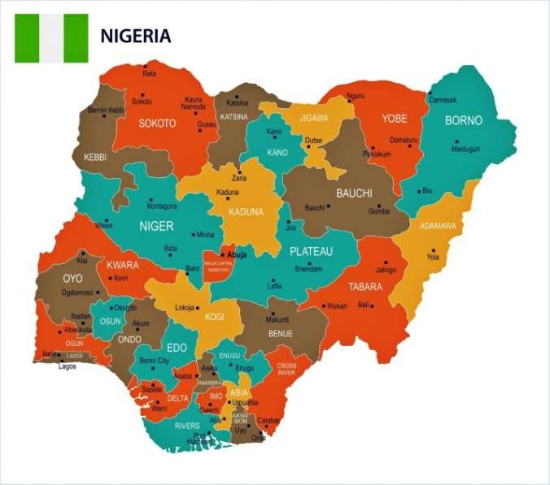
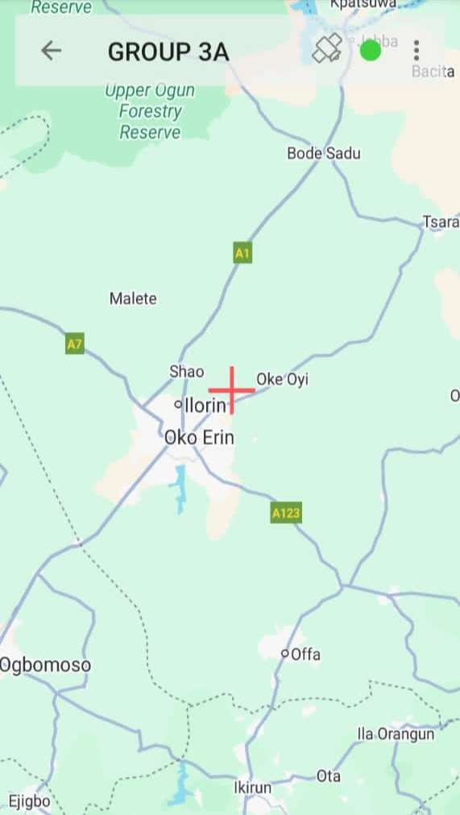
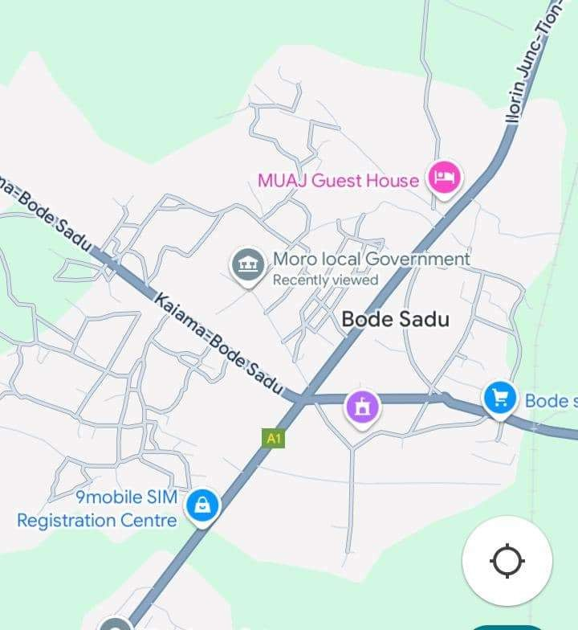
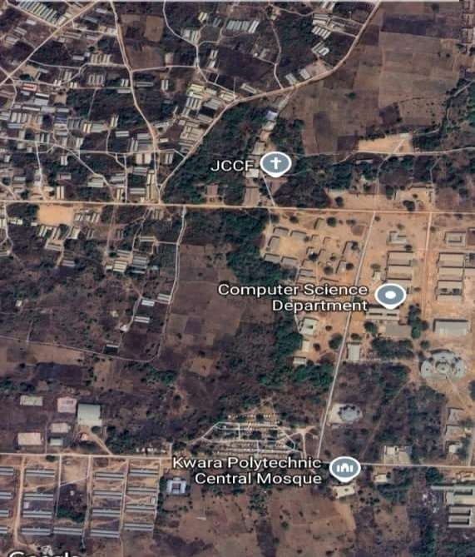

CHAPTER TWO

LITERATURE REVIEW
A detail survey are a basic prerequisite for building and land development. In most cases, the purpose of detail surveys is to indicate features on and adjacent to a property. There are a number of site feature and levels required by architects and planners. This kind of survey is usually confined to the assisted by a chairman. According to Jurovich Surveying, a detail survey is defining the location and heights of any number of varieties of features on the property in question. A contour plan along with the physical features located are shown on a plan. Contour and detail plan survey will result which shows all relevant site information, typically site levels, the location of features urban services and infrastructure, existing trees, existing buildings structures and retaining walls and frontage works (such as footpaths, overhead power, kerb and channel). The earlier in the process the survey is undertaken, the earlier development constraints can be identified. Constraints should be identified in the early stages of the design process prior to committing significant resources to the product. The detail survey should ideally be undertaken prior to preparation of proposal plans. Having a contour and detail survey will provide you with all of the site and conditions in a manner which is both accurate and up to date. The survey information will also allow specialist consultants such as architects, engineers and land scale architects, to design the proposal to suit conditions (e.g Sewer pipe running through the site may have to be relocated on the building design altered to suit).
Perimeter survey and detailing is about mapping and determine if there’s an encroachment. Surveyors might use a combination of methods such as GPS to accomplish this aside from determine the geometry; perimeter surveying is also valuable in documenting boundary locations with respect to existing features near the property lines. This is useful in working with the deed restrictions when it comes to new construction projects.
Perimeter surveying is similar to building a fence, the parcels of land in addition, perimeter surveying is much more accurate way of setting boundaries, fences still serve as visual reminders. However, where they stand might not be consistent with the true boundaries of the property. As mentioned earlier, a perimeter survey is also valuable in resolving conflicts with regards to deed restrictions. On the survey you’ll see the existing features within meter of the perimeter line you can see the driveways, swimming pools, bodies of water and
other natural and man-made features existing nearby. For the proper owner a developer, this is valuable information for construction planning, property developers could accurately assess the potential of a land in addition, they can also accurately to better protect their properly.
The survey is also valuable for future reference. After the survey, the team of surveyors will install monuments to serve as markings of boundary corners. These will serve as visual reminders for the owners, developers and neighbors ground the landed property.
(Dashe, 1987) perimeter surveying may be described as the type of survey made purposely for producing plans showing property boundaries or plan on which area necessary for the assessment of property or land taxes may be computed, it is also referred to as legal surveying because such survey forms the basis of a statutory registration of ownership and other rights land.
Perimeter survey and detailing according to Geosuru, they perform accurate surveys for residential, commercial and government projects.
A topographic survey is a vital component of a successful development application for any development of your land. We can undertake topographic survey using a range of technologies, from remote access reflect or less, total stations and 3D scanners (where there may be restricted access) to GPS technology (large scale topographic surveys). Features of general detail surveys include:
    - Title information
    - Contours
    - Spot levels
    - Site coordination and location of true north
    - Levels in the kerb and other critical features
    - Locations of existing visible services (Scwerage, Power Poles Telephone)
    - Ridge and gutter heights for subject building
    - Outline of adjacent buildings
    - Window position and heights for adjacent buildings facing subjects sites
    - Height and width of major vegetation
    - Floor level of a subject property
    - Location of auxiliary Structures (garden sheds, pergoles).
    - Level benchmark to Australian height datum (AHD) where applicable on any other feature of a site that may impact upon development potential site detail extras may include accurate boundary definition boundary marking and services search. We can also provide
highly accurate internal surveys of buildings to show room layouts or design purposes.
Detail survey must common purpose of a pre-design survey is to form a base to design from. For example, survey is often requested from building designers, architects, land scope, engineers or builders, in order to design new structures, building or land scope.
The purpose of detailing survey
To determine the required areas and volumes of land and the features to know the materials need during construction at times.
Detail and engineering surveying according to MACKAY SURVEY detail, level and engineering.
Surveying may be required for planning and for development.
Whether a detail survey is required over a small residential plot or over a large commercial site, a detail survey determines the location of features on natural or man-made in an area. It can include vegetation, buildings, Sewers and drainage, services fences roads etc. detail surveys usually include heights, floor levels sewer inverts, drainage depths, ground levels and contours.
Perimeter and details survey can also be described as cadastral survey because it involve in showing the demarcation of a given site land, ownership, survey registration, land dispute resolution and information management for future purpose. It can also refer to financial assets.
Cadastral surveying is very important activity likewise perimeter and detail survey because it create sound and good land information system which could be capable of describing shape, size, location extent of the estate boundaries, surfaces area and other related attribute data associated with individual estate owner or corporate body owner.
Perimeter and details survey also provide reliable information for planning the better use and administration of land vegetation covers, building, electricity provision, drainage, refuse disposal.
Property surveyors it involves in establish property corners, boundaries and area of land parcels they also termed land surveys, cadastral survey and boundary surveys (Russel C., Brinker).
In a nutshell, a “Detail Survey” or level and contour survey locates the shape and sizes of features and adjacent to your property. The intention is to provide a plan to an architects or other party which indicates the relative heights
of features on and adjacent to the property. There is also a requirement for a detail survey to be provided to council as part of a development application.
Some of the features that are included in a detail survey
- Building outlines
- Height of all major features including, but not limited to ridges heights, gutter heights, natural surface and spot height, kerb, drive ways and paths.
- Information of the cadastral components of the plot.
- Height and features of neighboring properties including window height, ridge levels and gutter levels. If required more measurement can be taken in relation to the finished floor level and features.
The amount of information required from a detail survey it dependent upon what the survey us being used for. If the detail survey is for a complying development, then very minimal information is required. The designer of the extension, or new structure may only require a survey to provide the terrain where the structure is to be built. If a fall development application is required to construct the new features, then more information may be required. The amount of information dependent also relies in what the architect or designer may need is important to consult with a surveyor prior to works to ensure that all works that are carried out contain the required information. Re-visit to site can be a costly exercise.
The heights of all feature are compared to Australian Height Datum (AHD), which is especially relevant in flood prone areas. Keystone survey uses the network of survey marks in New South Wales to ascertain the relative’s values of all features within the detail survey.
A benchmark is placed, either a cat in the kerb or a nail in the kerb, which can then be used for the construction phase.
It should be noted that which list detail survey provided may be accurate, it is still necessary to have the new structure fully set out before construction takes place. The intention of a detail survey is not locate boundaries of a property nor it is to be of use to mark the boundary corners. For this reason, it is important to engage a registered surveyor to carry out the works after the detail survey has been completed. Keystone survey is able to comply, with this as we employs a registered surveyor to oversee the detail process.
Keystone survey, as part of their wide range of services can provide quality detail surveys with a very fast turn arrow.

CHAPTER THREE

  - METHODOLOGY

Methodology is a system or principle used is solving problem, with specific component such as task, method technique and tools.
This is also the techniques used to achieve the aims and objectives of this project work, the execution of this project was based on the following basic principles of surveying.
    - Working from whole to part.
    - The principle of choosing the method of survey most appropriate to meet the desire result.
    - The principle of provision of adequate check to meet the require accuracy.
    - RECONNAISSANCE

Reconnaissance which is the first stage and vital aspect of any survey work Carried out is as well the preliminary stage of this project.
This also is the initial operation or preliminary investigation undertaken by the surveyor in order to have a thorough overview of the site before the commencement of the actual survey ,it can also be abbreviated as “recci’’ as the project was concerned the reconnaissance was carried out in two ways.
      - Field Reconnaissance
      - Office Reconnaissance

    - Field or Site Reconnaissance
This involves the actual [physical] visit to the site and was carried out before the actual operation. This project site was visited by the group in order to have a prior knowledge as well as true picture of the site and to ascertain the information collected during the office planning. The boundaries were marked with wooden peg driven into the ground to avoid disturbance or removal, taking into consideration the following
factors.

      - Inter-visibility of the selected traverse station.
      - Safety of the selected station for future reference.
      - Accessibility of the stations.

    - Office Reconnaissance

This involves knowing the type of instrument, purpose and accuracy required for the survey to be carried out. Information related to the given project was collected from various sources such as project supervisor. The specification/ instructions and coordinates of the control stations were collected from the department of surveying and geo-informatics Kwara State Polytechnic.
Table 3.1.3 Co-ordinates of control used.

STATION | NORTHINGS (M) | EASTINGS (M)
KW/PT/2001 | 946677.273 | 679647.447
SC/KW/FRS/4404 | 946699.489 | 679449.408

  - INSTRUMENT TEST

HORIZONTAL COLLIMATION TEST
The aim of this test was to be sure that the line of sight is perpendicular to the trunion axis.
Procedure:
The Total Station instrument was set over a point and all necessary temporary adjustments (centering, leveling and focusing) performed. Then the configuration menu of the total station was accessed by pressing down the menu key for about two seconds and the calibration sub-menu and consequently the horizontal collimation test was chosen. This test was done by sighting and bisecting a well-defined vertical target about 100m away and taking the horizontal readings on face left and face right. From the analysis of the results, the total station was in good adjustment.
VERTICAL INDEX ERROR TEST
This adjustment ensures that the vertical circle reading is exactly 90° when the line of sight is horizontal. Any deviation from this figure is termed vertical index error.
Procedure:
The instrument was set over a point and necessary temporary adjustments (centering, leveling and focusing) performed. The vertical index error test was carried out by sighting a target at a distance of about 120m on face left. The vertical circle reading was recorded and on face right the target was sighted and bisected again and the vertical circle reading recorded.
    - IN-SITU CHECK FOR CONTROL

In-situ checks observations (angular and linear) were executed for the purpose of verifying the integrity of the existing controls. The following observational schedules were executed:
The instrument was set on KWPT2001 and angular observations were made to targets on SC/KW/FRS/4404 as back station.
The results of the observations as shown below confirm that the controls were still in their original positions and therefore suitable for use.

TABLE 3.2.1 IN-SITU CHECKS DATA ANALYSIS (Control Pillars).

STATION | COORDINAT E (m) | KNOWN VALUES (m) | MEASURED VALUES  (m) | DIFFERENCE  (m)
 | NORTHING | 946677.273 | 946677.273 | 0
KWPT2001 | EASTING | 679647.447 | 679647.447 | 0
SC/KW/FRS/44 04 | NORTHING EASTING | 946699.489  679449.408 | 946699.489  679449.408 | -0.005  +0.004

KWPT2001 . .SC/KW/FRS/4404

FIGURE 3.2.1 Diagram Showing Control Used

    - DATA ACQUISITION
This involves the processes in acquiring the data needed for the project. This involves the actual making of measurements and recording of observed data on the field. There are different methods of acquiring data in the site with different instrument such as Total station, Theodolite, Compass, Level Instrument etc.
    - Geometric Data Acquisition.

These are positional data, that is, they are data having the [x, y, and z] coordinates which is possible to locate their position on the surface of the earth.
    - Attribute Data Acquisition.
These data are acquired by social survey, these are data used for defining the purpose of features located on the earth surface.
    - EQUIPMENT USED/SYSTEM SELECTION AND SOFTWARE

This comprises of two components, namely: the hardware components and software components.
HARDWARE COMPONENT: These are the physical equipment used for the execution of the project and they are:
      - Total station (MATO)and its accessories
      - Steel tape
      - Nails and bottle corks
      - Field book and pen
      - Personal computer
      - pegs
SOFTWARE USED FOR DATA PROCESSING
- AutoCAD 2017 for plotting the boundary and detailing
- Note Pad, and Microsoft Excel (for Script preparation, editing and restructuring of data and report writing).
    - SETTING OUT OF PERIMETER BOUNDARY
Based on the office planning and field reconnaissance conducted, the instrument was first set on Control Pillar KWPT2001 being the closest control and all temporary adjustment performed. The coordinate of the control point KWPT2001 was key into the instrument. SC/KW/FRS/4404 was sighted as back sight.
The coordinates of the station SC/KW/FRS/4404 was key-in the instrument via the keyboard. The instrument then computed the bearing between the two stations for orientation. Then coordinates of points to be set out were entered into the total station and the setting out program of the instrument was used to get the angle to turn in order to face the direction of the point after orientation, the instrument was rotated until horizontal angle read 0° 00’ 00”, reflector was held along the direction and
distance between the instrument and the reflector was measured. The instrument displayed the remaining of the point to be fixed distance as either positive or negative. Positive distance means that the reflector should move away from the instrument by that amount while negative distance means that the reflector should move towards the instrument.
  - MONUMENTATION

The beacons measuring 18cm by 18cm by 75 cm were molded in-situ with a mixture of 1:2:3 of cement, sand and gravel respectively. A 12mm diameter Iron rod defines the center of the beacon was placed. The perimeter boundary line was cleared to ensure inter-visibility between the beacons. The numbering of the beacons was carried out after molding in a clockwise pattern with an arrow pointing to the succeeding station. Also, numbering as carried out accordingly as they were in the Title Deed Plan(TDP).
KP

P
T
220
FIGURE 3.2.2: PLAN VIEW
18cm
18cm
●
7.5cm Above ground
12 mm iron rod
75cm
67.5cm
Beneath ground level

FIGURE 3.3: PROPERTY BEACON
  - CONTROL CHECK

After the demarcation, capping and numbering of the beacons, the actual data acquisition using the total statio SOKKIA51OT commenced. The traverse started from KWPT2001with SC/KW/FRS/4404as reference point. The total station was set up over control KWPT2001, centered, leveled and telescope focused to eliminate parallax. The parameters of the instrument station i.e. station name, height of instrument over the station mark, and the XYZ coordinates of the station were keyed in. The reference control point was then bisected and the station name SC/KW/FRS/4404, height of target over the station mark, and the XYZ coordinates of the station were key in. Though the total station was set in coordinate mode it actually measured and recorded horizontal readings, vertical readings and distances automatically into the internal memory of the instrument on both faces which it used to compute and display coordinates. At every set up of the total station, the temporary adjustment was carried out and the following parameters measured:
- Height of instrument
- Height of the back target
- Height of the fore target
- Distance to back and fore station
This is the determination of bearing and distance of series of connected lines from known coordinated point so as to obtain coordinate of the newly established station.
This include the following with formula

- Linear measurement : the difference between the coordinates were first derived using (∆E=E2-E1, E3-E2) etc. and the distance of end traverse leg was obtained using the formula: distance =√(∆E)^2 +(∆N)^2
- Angular measurement: to calculated the bearing after the difference in coordinates has been derived, the formula is Bearing=Tan-1 ∆E/∆N.

TABLE 3.4.1. Coordinates of the Boundary
The coordinates are as follows

S/n | Easting | Northing
1 | 679582.728 | 946429.840
2 | 679448.029 | 946465.672
3 | 679434.376 | 946560.036
4 | 679449.408 | 946699.489
5 | 679647.447 | 946677.273

    - PERIMETER SURVEY

The perimeter survey focuses primarily on defining the outer limits of a parcel of land. It involves careful measurements and mapping of the property boundaries to confirm ownership and establish any easements that may exist. During this surveying process, a minimum width of 15 feet is typically employed for mapping the perimeter, which requires a thorough assessment of the entire boundary of the property. The primary objectives of a perimeter survey include:
- Boundary Definition: The survey provides accurate positioning of property lines, critical for resolving conflicts related to land ownership and ensuring compliance with legal obligations.
- Identification of Existing Monuments: Perimeter surveys confirm the locations of existing boundary monuments—historical markers that help define property limits—and can assist in the establishment of new markers if necessary.
- Documentation of Proximal Features: While a perimeter survey captures features that fall within the specified 15-foot width around the boundary, it generally does not include improvements or structures located further within the property, such as sheds, underground utilities, driveways, and pools. Instead, it emphasizes boundary-related elements, such as fences, hedges, and walls.
The result of a perimeter survey offers clarity regarding the extent of the property, enabling stakeholders to understand land use limits and addressing potential encroachments. This survey type is also instrumental in providing accurate data needed for land registration and formal acknowledgment under Nigerian land laws and guidelines.
    - DETAILING SURVEY

In contrast, a detailing survey conveys a comprehensive picture of a parcel of land, focusing on all significant natural and man-made features within it. This survey extends beyond the mere identification of boundaries to encompass various on-site elements, making it crucial for the design, planning, and construction efforts. Key objectives of a detailing survey include:
- Feature Documentation: The detailing survey provides a detailed inventory of all existing features, including buildings, roads, pathways, utilities, vegetation, and other structural elements on the property. This thorough documentation is essential for architects, engineers, and urban planners tasked with developing projects on the land.
- Facilitating Land Development: The data obtained from detailing surveys supports informed decision-making in relation to land use, zoning compliance, and development approvals. This is particularly important in Nigeria, where adherence to local zoning regulations is critical.
- Informing Site Design: By recording the types and locations of features on- site, detailing surveys provide designers and developers with critical insights needed for creating functional and efficient site layouts. Understanding these features is vital for ensuring that new developments harmonize with existing conditions and community needs.
CHAPTER FOUR
  - DATA PROCESSING

After the data was downloaded, Microsoft Excel 2007 Software was used to type the final coordinates of all points.
  - RESULT ANALYSIS
The data was analyzed and found to meet with the departmental standards and this is the main traverse result extracted from field, then it was arranged accordingly as the observation was held in the field. The results are as follows.
SURVEY COMPUTATION

From Station | Observer d Bearing | Horizo ntal Distan ce(m) | - (E) | - (E) | Sum | - (N) | +  (N) | Sum | Easting | Northing | To Stati on
 |  |  |  |  |  |  |  |  | 679582.7  28 | 946429.840 | A
A | 284°45' | 139.38  0 |  | 134.69  9 | 134 | 35.832 |  | 35 | 679448.0  29 | 946465.672 | B
B | 351°1646' | 95.450 |  | 13.653 | 147 | 94.364 |  | 129 | 679434.3  76 | 946560.036 | C
C | 06°09' | 140.26  0 | 15.  032 |  | 162 | 139.45  3 |  | 268 | 679449.4  08 | 946699.489 | D
D | 96°24' | 199.28  0 | 198  .03  9 |  | 360 |  | 22.21  6 | 290 | 679647.4  47 | 946677.273 | E
E | 194°39 | 255.76  0 |  | 64.719 | 424 |  | 247.4  33 | 537 | 679602.3  88 | 946505.003 | F
DE DN

COMPUTE FOR TOTAL AREA USING DN EOUBLE LATITUDE AND DEPARTURE

∆E | ∆N | Easting | Northing
+134.699 | -35.832 | 679582.728 | 946429.840
+ 13.653 | -94.364 | 679448.029 | 946465.672
-15.032 | -139.453 | 679434.376 | 946560.036
-198.039 | +22.216 | 679449.408 | 946699.489
+64.719 | +247.433 | 679647.447 | 946677.273

Source: Writer, 2025

+134.699
+134.699 × -35.832 = -4826.535

+269.398
+013.653
+283.051
+013.653 × -94.364= ̵ 1288.352
+296.704
- 015.032
+281.672
-015.032 × ̵ 139.453= +2096.257
+266.640
-198.039
+068.601
-198.039 × +22.216 = ̵ 4399.634
-129.438
+ 064.719
-064.719
+ 0.64.719 × +247.433 = +16013.616
0.00

SUM OF POSITIVE (+) - SUM OF NEGATIVE (-) 18109.873 - 10514.521
= 7595.352 2
AREA = 4.265 square meters

GRAPHIC PLOTTING

This simply refers to the graphically representation i.e. plotting of plan. It was plotted using AutoCAD and other software in a computer system and a suitable scale was used to for the hard copy format. Presented information include boundary details and beg, conventional sign and symbol were also used in the plan.
The digital plan was produced using AutoCAD software and these are procedures followed.
    - Switch on the computer and allow it to boost
    - Select notepad, from notepad, a script file for the coordinate p-line easting, northing was structured.
    - File was saved with extension. SCR
    - AutoCAD was launched.
    - Format was clicked and set the unit then press “OK”
    - Press “Tool” and select Run script to pick your saved file then press escape and press zoom, extent and the image was displayed.
    - The boundary line was changed to Red and necessary editing was done.
CHAPTER FIVE

SUMMERY, CONCLUSION AND RECOMMENDATION
  - SUMMARY
The project “perimeter and detailing in survey” was carried out at old institute of environmental studies(IES) and village Kwara State polytechnic Ilorin along old Jebba road, Moro local government area Kwara state.. This project was carried out I accordance with third other specification of survey. The reconnaissance survey was carried out properly and effectively in the office and the field, this is done purposely for proper planning of the operation by locating initial control that is within the project site for effective orientation, the instrument to be used and selection of traverse station in which the indivisibility of the selected station were put into consideration and finally, join of sketch diagram of the area to be surveyed.
The field operations include both traversing along the perimeter of the site project along with the detailing of physical features on both natural and manmade
i.e. artificial features within the site project. And conclusively the report was written on how the entire project was orientated both field and office work.

PROBLEM ENCOUNTER
The problem encountered during the process of the execution of this project
    - Student passing by were obstructing the right of observer and causing disturbance.
    - The weather was not conducive and it was sunny through all day.

RECOMMENDATIONS
I hereby recommend this particular project practical to be done often to update the infrastructural features and the society for the development of the particular area, also it should be carried out in school for the next development in the premises, moreover it is necessary for every Survey & Geo-Informatics Students to be able to carry out this particular practical.

CONCLUSION
In conclusion, the project task and exercise has been successfully existed since the result of the above operation agreed with the requirement and accuracy of third other job of the perimeter and detailing survey. Plan of the study were produced, the survey was executed in the accordance and respect with survey rules and the departmental instruction in carrying out the project topics. And conclusively the report written was done on how the entire project was executed both field and office work.

REFERENCES
Oliver J.G Clending (1978) Principles of Surveying Working Ham Berkshire, England ppl.
Uren J and Price W.F (1994) Engineering survey, Richard and Day Limited Bungayi Suffork pp.8
Igbokwe (1999) Digital mapping-a big stride vol-12 no 1 Magazine of Nigeria institution of Surveying Students University of Nigeria Chapter.
Geosurv/Privacy Policy/Terms of Service Website Design by Quickclicks.com.au.

Godfrey Hoffman Assoc, LLC 26 Broadyway, North Haven CT 06473 Ph
.203.239.4217 Hhodge,LLC 17837 Farmington AVO, Union Ville, CT 06085 Ph: 860-673-0444 @2019/QTIC.
Dashe, 1987. web knowledge online (2003).

MACKAY SURVEY Detail and Engineering Surveying. (Russel c., Brinker) Property, Cadastral and Boundary Surveys.
APPENDIX

ID | EASTING | NORTHING
PL1 | 679582.728 | 946429.840
PL2 | 679448.029 | 946465.672
PL3 | 679434.376 | 946560.036
PL4 | 679449.408 | 946699.489
PL5 | 679647.447 | 946677.273
BLD1 | 679549.274 | 946642.233
BLD1 | 679541.227 | 946644.456
BLD1 | 679549.407 | 946673.891
BLD1 | 679557.454 | 946671.668
BLD2 | 679606.155 | 946611.461
BLD2 | 679615.524 | 946608.893
BLD2 | 679605.691 | 946573.081
BLD2 | 679596.322 | 946575.649
BLD3 | 679564.348 | 946602.906
BLD3 | 679557.622 | 946604.990
BLD3 | 679563.626 | 946623.263
BLD3 | 679570.352 | 946621.179
BLD4 | 679541.131 | 946609.275
BLD4 | 679533.505 | 946611.284
BLD4 | 679538.580 | 946629.766
BLD4 | 679546.206 | 946627.757
BLD5 | 679498.379 | 946640.771
BLD5 | 679523.756 | 946633.877
BLD5 | 679520.271 | 946620.744
BLD5 | 679494.894 | 946627.638
BLD6 | 679463.996 | 946650.142
BLD6 | 679489.373 | 946643.248
BLD6 | 679485.888 | 946630.115
BLD6 | 679460.511 | 946637.009
BLD7 | 679457.544 | 946625.842
BLD7 | 679472.023 | 946621.924
BLD7 | 679465.087 | 946596.289
BLD7 | 679450.608 | 946600.207

BLD8 | 679529.818 | 946596.942
BLD8 | 679537.413 | 946594.907
BLD8 | 679531.409 | 946576.634
BLD8 | 679523.814 | 946578.669
BLD9 | 679554.668 | 946590.470
BLD9 | 679561.394 | 946588.386
BLD9 | 679555.390 | 946570.113
BLD9 | 679548.664 | 946572.197
BLD10 | 679592.068 | 946560.674
BLD10 | 679599.873 | 946559.664
BLD10 | 679593.075 | 946538.68
BLD10 | 679585.270 | 946539.689
BLD11 | 679519.000 | 946565.197
BLD11 | 679528.569 | 946563.532
BLD11 | 679525.179 | 946544.786
BLD11 | 679515.610 | 946546.451
BLD12 | 679478.939 | 946569.537
BLD12 | 679504.880 | 946562.819
BLD12 | 679501.237 | 946549.083
BLD12 | 679475.296 | 946555.801
BLD13 | 679444.388 | 946578.416
BLD13 | 679470.160 | 946571.719
BLD13 | 679465.756 | 946554.842
BLD13 | 679439.984 | 946561.539
BLD14 | 679510.302 | 946527.118
BLD14 | 679514.054 | 946537.943
BLD14 | 679534.343 | 946533.641
BLD14 | 679531.147 | 946521.705
BLD14 | 679521.697 | 946523.093
BLD14 | 679522.114 | 946524.897
BLD15 | 679509.302 | 946524.064
BLD15 | 679541.890 | 946519.170
BLD15 | 679539.930 | 946509.505
BLD15 | 679506.975 | 946515.133
BLD16 | 679553.651 | 946516.785
BLD16 | 679586.238 | 946511.89
BLD16 | 679584.278 | 946502.226
BLD16 | 679551.323 | 946507.854

BLD17 | 679504.954 | 946503.304
BLD17 | 679537.91 | 946497.676
BLD17 | 679536.226 | 946487.819
BLD17 | 679503.271 | 946493.447
BLD18 | 679549.303 | 946496.025
BLD18 | 679582.258 | 946490.397
BLD18 | 679580.575 | 946480.54
BLD18 | 679547.619 | 946486.168
BLD19 | 679545.936 | 946476.31
BLD19 | 679578.891 | 946470.682
BLD19 | 679577.208 | 946460.825
BLD19 | 679544.253 | 946466.453
BLD20 | 679501.588 | 946483.590
BLD20 | 679534.543 | 946477.961
BLD20 | 679532.859 | 946468.104
BLD20 | 679499.904 | 946473.732
BLD21 | 679498.221 | 946463.875
BLD21 | 679531.176 | 946458.24
BLD21 | 679529.493 | 946448.390
BLD21 | 679496.537 | 946454.018
BLD22 | 679542.569 | 946456.596
BLD22 | 679575.524 | 946450.968
BLD22 | 679573.841 | 946441.111
BLD22 | 679540.886 | 946446.739
MSQ | 679496.29 | 946502.143
MSQ | 679496.168 | 946499.145
MSQ | 679477.014 | 946499.605
MSQ | 679477.641 | 946514.971
MSQ | 679496.779 | 946514.133
MSQ | 679496.657 | 946511.135
MSQ | 679499.882 | 946506.709
TOI1 | 679447.828 | 946594.614
TOI1 | 679452.651 | 946593.297
TOI1 | 679450.521 | 946585.496
TOI1 | 679445.698 | 946586.813
TOI2 | 679593.536 | 946572.708
TOI2 | 679598.359 | 946571.391
TOI2 | 679596.229 | 946563.590

TOI2 | 679591.406 | 946564.907
E.P | 679492.26 | 946690.694
E.P | 679562.54 | 946684.428
E.P | 679610.758 | 946683.743
E.P | 679445.846 | 946617.55
E.P | 679483.807 | 946478.219
E.P | 679549.084 | 946628.813
RD | 679445.277 | 946712.177
RD | 679643.316 | 946689.961
RD | 679652.008 | 946683.482
RD | 679579.403 | 946403.808
RD | 679698.787 | 946684.724
RD | 679671.309 | 946687.806
RD | 679662.698 | 946681.966
RD | 679659.235 | 946674.342
RD | 679588.012 | 946402.041
RD | 679446.392 | 946722.115
RD | 679700.67 | 946694.575

