IMPLEMENTATION OF INTRUSION DETECTION SYSTEM USING WIRESHARK

BY

LATEEF QUADRI TITILOPE
ND/23/COM/FT/0074

A PROJECT REPORT SUBMITTED TO THE
DEPARTMENT OF COMPUTER SCIENCE
INSTITUTE OF INFORMATION AND COMMUNICATION TECHNOLOGY, KWARA STATE POLYTECHNIC ILORIN

IN PARTIAL FULFILLMENT OF THE REQUIREMENT FOR THE AWARD OF NATIONAL DIPLOMA (ND) IN COMPUTER SCIENCE

2025
CERTIFICATION
This is to certify that this project was carried out by LATEEF QUADRI TITILOPE with Matriculation Number ND/23/COM/FT/0074 in the department of Computer Science, Institute of Information and Communication Technology, Kwara State Polytechnic, Ilorin.

------------------------------------- ----------------------
MR. ISIAKA, O.S. Date
(Project Supervisor)

--------------------------------- ----------------------
MR. OYEDEPO F.S. Date
(Head of Department)

----------------------------------- ---------------------
External Supervisor Date

DEDICATION
This work is dedicated to Almighty Allah who spare my life throughout my course of study.

ACKNOWLEDGEMENT
All praise and adoration belongs to almighty Allah the lord of the universe, who gave me the strength and the ability to complete this project successfully without any obstacles.
I express my sincere appreciation and thanks to my incomparable supervisor MR. ISIAKA O.S. for his fatherly support and his moral advice throughout this project.
Special thanks to head of department MR OYEDEPO, F.S and other members of the staff of the department of computer science for their support always
My sincere gratitude also goes to my beloved parents Mr and Mrs Lateef, my sisters, brother for their moral and financial support throughout this project. I say a big thank you and may God bless you immensely (Amen)

TABLE OF CONTENT
Title page i
Certification ii
Dedication iii
Acknowledgement iv
Table of content v
Abstract viii
CHAPTER ONE: GENERAL INTRODUCTION
  - Introduction 1
  - Statement of the problem 2
  - Aim and Objectives of the study 3
  - Significance of the Study 3
  - Scope and limitation 3
  - Organization of the report 4
CHAPTER TWO: LITERATURE REVIEW
2.1 Review of Related Work 5
2.2 Overview of Intrusion 6
2.3 Packet Filtering 7
2.4 Packet Sniffer 8
2.5 Malware 8
2.6 Concept of Wireshark 9
2.7 Intrusion types and detection 9
2.8 Detection Method 10

CHAPTER THREE: METHODOLOGY AND ANALYSIS OF THE EXISTING SYSTEM
3.1 Research Methodology 11
3.2 Analysis of the Existing System 12
3.3 Problems of the existing system 12
3.4 Description of the proposed system 13
3.5 Advantages of the proposed system 13
CHAPTER FOUR: DESIGN, IMPLEMENTATION AND DOCUMENTATION OF THE SYSTEM
4.1 Design of the System 14
4.1.1 Output Design 14
4.1.2 Input Design 15
4.1.3 Database Design 18
4.1.4 Procedure Design 18
4.2 Implementation of the system 18
4.2.1 Choice of Programming Language 18
4.2.2 Hardware Support 18
4.2.3 Software Support 19
4.2.4 Implementation Technique used in Details 19
4.3 System Documentation 19
4.3.1 Program Documentation 19
4.3.2 Operating the System 19
4.3.3 Maintaining the System 19

CHAPTER FIVE: SUMMARY, CONCLUSION AND RECOMMENDATION
5.1 Summary 21
5.2 Conclusion 21
5.3 Recommendation 22
References 23
Flowcharts 24
Source Codes 30

ABSTRACT
Intrusion detection is the process of monitoring and analyzing events in a computer system or network for signs of potential incidents, such as violations or imminent threats of violations of computer security policies, acceptable use policies, or standard security practices. Intrusion detection is the process of monitoring and analyzing events in a computer system or network for signs of potential incidents, which are violations or imminent threats of violations of computer security policies, acceptable use policies, or standard security practices. An intrusion detection system (IDS) is a piece of software that automates the detection of intrusions. Both an intrusion prevention system (IPS) and an intrusion detection system (IDS) examine traffic for malicious activity, but they are fundamentally different. The deployment of these systems in networks differs in that IDS are out of band in the system, meaning they cannot sit within the network path, whereas IPS are in-line in the system, meaning they can pass through in between the devices. IDS generates only alerts if anomaly traffic passes through network traffic, which could be false positive or false negative, implying that IDS detects only malicious activities but takes no action on those activities, whereas IPS has a detection and prevention feature with auto or manual action taken on those detected malicious activities, such as dropping, blocking, or terminating connections. For simulation, wireshark was used to create the proposed system.

CHAPTER ONE
GENERAL INTRODUCTION
1.1 INTRODUCTION
Many different things can go wrong with a computer system's network at any given time, ranging from simple spyware or malware infections to complex router configuration errors, and it is impossible to solve every problem right away. All network problems originate at the packet level, where even perfectly functional applications can reveal their hideous implementation, and seemingly trustworthy protocols can turn out to be malicious. Packet Sniffing is the process of capturing and interpreting live data packets as they flow across a network in order to gain a more comprehensive understanding of what is going on inside the network. Chris Sander (Chris Sander, 1986).
A Packet Sniffer is a tool that can run actively in a network device and passively receive all data link layer frames passing through the device's network adapter (Mohammed, Rasheed & Waheed, 2010). A packet sniffer is a tool that captures raw network data as it travels across the wire. The Data Packet is the ideal concept for all communication systems. In this sense, network security equates to data packet security. The internet's heinous attacks became more widespread on a daily basis. Quality of service has become an issue, necessitating the use of a powerful traffic analysis and distribution engine for network applications. Using a set of complete packet analysis, network operators can obtain the profile of each application running within the network and act as the primary method of detecting an intrusion into a system. Network security is thus enabled by a network monitoring tool, which enables the intrusion detection system to easily gather detailed information.
A Network Intrusion Detection System (NIDS) is a system that monitors network activity for malicious or unauthorized users and logs a report to the management station so that appropriate action can be taken immediately. There are two types of intrusion detection systems (IDS): anomaly-based detection and signature-based detection (Singh, Manisha & Nene, 2013).
This project will primarily involve the use of the network packet analyzer Wireshark to detect network intrusions. Wireshark is an open source graphical network analyzing tool that can capture and display detailed information about live data packets passing through network traffic. It is similar to tcpdump, but it includes a graphical user interface as well as sorting and filtering options. It is officially known as Ethereal, and it captures packets in human-readable format (Banerjee, et al, 2010). Snort is used to detect and capture intrusions in real-time network traffic, and Wireshark is used to analyze the captured packets. Packets are captured from a wireless or wired network, and intrusion detection is performed using snort (Rashmi & Mohan, 2015).
Snort is a network-based intrusion detection system developed by Roesch Martin that is free and open source (Vanathi & Gunasekaran, 2012). Snort, according to Roesch, is a lightweight intrusion detection system capable of capturing and analyzing real-time network traffic as well as logging detailed captured packets on IP networks. Snort is a network analyzer that uses signatures. The VRT Rules serve as the foundation for snort analysis of network traffic. To analyze the network, snort employs a pre-processor and rules. The snort rules allow for the analysis of single packets using predefined signatures, whereas the pre-processor codes allow for the analysis of data packets that cannot be analyzed using rules alone (Northcutt & Novak, 2003).
1.2 STATEMENT OF THE PROBLEM
Traditional home security solutions are mostly based on host-based detection, which consumes host resources. This issue is more noticeable in resource-constrained environments such as smartphones and tablets. Furthermore, once a machine is infected, the malware can disable or hide from any host-based security system, providing the user with a false sense of security. As a result, those appliances are usually too expensive to buy, too difficult to set up, and too complicated to maintain. This project is an attempt to create a low-cost network-based detection system suitable for use in the home.
1.3 AIM AND OBJECTIVES
The aim of this research is to design and implement an intrusion detection system using Wireshark with the following objectives:
- Examine the performance evaluation of machine learning in both routing protocol and network traffic analysis.
- To investigate the effectiveness of both packet sniffers (Snort and Wireshark) in detecting an intrusion into network traffic or the specifics of protocol communication in a network.
1.4 SIGNIFICANCE OF STUDY
Computer intrusion detection systems provide comprehensive protection against identity theft, data mining, and network hacking. Large corporations and government agencies use such software to safeguard information and accounts, as well as to monitor employees' network activities to ensure that on-site facilities are not being abused. Despite their benefits, intrusion detection systems are hampered by their inability to distinguish between malicious and accidental or lawful activity, and they may lock down a network, resulting in lost work and revenue.
1.5 SCOPE AND LIMITATION OF THE STUDY
Network intrusion detection systems (NIDS) are strategically placed within the network to monitor traffic to and from all network devices. It analyzes all traffic passing through the subnet and compares it to a database of known attacks. When an attack is detected or unusual behavior is detected, an alert can be sent to the administrator.
1.6 ORGANIZATION OF REPORT
The first chapter of this project is devoted to a general overview of the project's work. It also includes a statement of the problem, the project's aim and objectives, the significance of the study, the methods used for data collection, and the scope and limitations of the study. The second chapter is a review of the literature. It addresses current issues in software quality control. It also examines a review of previous projects related to the project's topic of study. The third chapter discusses the existing system's analysis, the current procedure's description, the existing system's (procedure's) problems, the proposed system's description, and the basic advantages of the proposed web-based application for library management. The design, implementation, and documentation of the system are covered in Chapter four. The system design, output design form, input design form, database structure, and system procedure are all included in the design. The implementation includes the details of the implementation techniques used, the programming language chosen, and the hardware and software support. The system documentation includes the system's operation and upkeep. The summary, conclusion, recommendation, and references are all covered in chapter five.

CHAPTER TWO
LITERATURE REVIEW
2.1 REVIEW OF RELATED WORKS
Mohammad et al. (2012) proposed intrusion detection as a method of combating computer and networking attacks and misuses. An intrusion detection system implements intrusion detection, and there are many commercial intrusion detection systems available today. In general, most commercial implementations are ineffective and insufficient, necessitating research into more dynamic intrusion detection systems.
According to Vijayarani and Sylviaa (2015), an intrusion detection system is an application that monitors the network and protects it from intruders. With the rapid advancement of internet-based technology, new computer network application areas have emerged. In some cases, LAN and WAN applications have advanced in fields such as business, finance, industry, security, and healthcare. Because of all of these application areas, the network became an appealing target for abuse and a major vulnerability for the community.
Ahmad (2014) observed that an intrusion occurs when an attacker attempts to gain access to an information system or cause disruption; in fact, the attacker's behavior is intended to cause harm. Intrusion detection and prevention systems assist information systems in preparing for and dealing with attacks. They accomplish this by gathering data from a variety of systems, monitoring it, and then analyzing it for potential security issues. Indeed, an intrusion detection system (IDS) raises an audible or visual alarm when a violation is detected, or it can be silent, like an e-mail message or pager alert.
Amrita & Brajesh (2012) demonstrated how scanning attacks can be used to gather information about the system under attack. The attacker can gain topology information, types of network traffic allowed through a firewall, active hosts on a network, OS and kernel of hosts on a network, server software running, software version numbers, and so on by using scanning techniques. Using this information, the attacker can launch more targeted attacks against specific exploits.
Santos et al. (2013) demonstrated that both intrusion detection and intrusion prevention systems need to be improved to ensure a network's unfailing security. They are untrustworthy (especially in terms of false positives and false negatives) and difficult to use. Nonetheless, it is clear that these systems are now required for businesses to ensure their security. It is strongly advised to combine several types of detection systems to ensure effective computerized security. The IPS, which attempts to compensate for some of these issues, is not yet effective enough to be used in a production setting.
2.2 OVERVIEW OF INTRUSION
The two most important reasons for launching attacks are to force a network to stop providing some service(s) or to steal some information stored in a network. Such anomalous activities must be detectable by an intrusion detection system. However, what is normal and what is anomalous is not detected; an event may be considered normal in relation to some criteria, but it may be labeled anomalous when this criterion is changed; this applies to values within the interval, i.e., all will be viewed as normal to the same degree. Unfortunately, this creates a sharp distinction between normalcy and anomaly. After the fuzzy input sets have been defined, the next step is to develop the rules for identifying each type of attack.
A fuzzy system is a collection of fuzzy rules that all have the same input and output variables. We believe that security administrators can use their expert knowledge to assist in the development of a set of rules for each attack. The rules are created with the MATLAB Fuzzy Toolbox's fuzzy system editor. This tool includes a graphical user interface that allows the rule designer to create the member function for each input or output variable, as well as the inference relationships between the various member functions and the control surface for the resulting fuzzy system. However, it is not expected that the rule designer will completely rely on intuition to create the rules.
Visual data mining can help rule designers determine which data features are most appropriate and relevant in detecting various types of attacks. The goal of using ANNs for intrusion detection is to generalize from incomplete data and to classify data as normal or intrusive. An ANN is made up of a collection of highly interconnected processing elements. The weights associated with the interconnections among processing elements determine the transformation from input to output given a set of inputs and a set of desired outputs. The network can adapt to desired outputs by modifying these interconnections. Because of their high tolerance for learning-by-example, neural networks are flexible and powerful in IDS.
2.3 PACKET FILTERING
Packet filtering is a firewall technique for controlling network access by monitoring outgoing and incoming packets and allowing them to pass or fail based on the source and destination Internet Protocol (IP) addresses, protocols, and ports. Packet filtering rule sets defined by network layer firewalls provide highly efficient security mechanisms. Static filtering is another name for packet filtering.
A node transmits a packet that is filtered and matched with predefined rules and policies during network communication. When a packet matches, it is either accepted or denied. Packet filtering examines both the source and destination IP addresses. If the IP addresses of both parties match, the packet is considered secure and verified. Because the sender may employ a variety of applications and programs, packet filtering also examines source and destination protocols such as User Datagram Protocol (UDP) and Transmission Control Protocol (TCP) (TCP). Source and destination port addresses are also validated by packet filters. Some packet filters are not intelligent and cannot remember previously used packets. Other packet filters, on the other hand, can remember previously used packet items such as source and destination IP addresses. Packet filtering is typically an effective defense against attacks from computers that are not connected to a local area network (LAN). Because most routing devices include filtering capabilities, packet filtering is regarded as a standard and cost-effective method of security.
2.4 PACKET SNIFFER
A sniffer (packet sniffer) is a tool that intercepts data as it travels through a network. If computers are connected to an unfiltered or switched local area network, traffic can be broadcast to all computers in the same segment. This is uncommon because computers are generally instructed to ignore all incoming and outgoing traffic from other computers. In the case of a sniffer, however, when the sniffer software instructs the Network Interface Card (NIC) to stop ignoring traffic, all traffic is shared. The NIC is set to promiscuous mode, which allows it to read communications between computers in a specific segment. This allows the sniffer to intercept everything that is passing through the network, potentially resulting in unauthorized access to sensitive data. A packet sniffer can be either a hardware or a software solution. A sniffer is also referred to as a packet analyzer.
2.5 MALWARE
Malware, an abbreviation for malicious software, is any software that is used to disrupt computer or mobile operations, collect sensitive information, gain access to private computer systems, or display unwanted advertising. Before Yisrael Radai coined the term malware in 1990, malicious software was referred to as computer viruses. The first type of malware propagation involves parasitic software fragments that attach to existing executable content. The fragment could be machine code infecting an existing application, utility, or system program, or it could even be the code used to boot a computer system. Malware is defined by its malicious intent, acting against the computer user's requirements, and does not include software that causes unintentional harm due to a flaw.
2.6 CONCEPT OF WIRESHARK
Wireshark is a packet analyzer that is available for free and open source. It is used for network troubleshooting, analysis, the development of software and communications protocols, and education. Due to trademark issues, the project's name was changed to Wireshark in May 2006. Wireshark is cross-platform, implementing its user interface with the Qt widget toolkit in current releases and capturing packets with pcap; it runs on Linux, macOS, BSD, Solaris, some other Unix-like operating systems, and Microsoft Windows. TShark, a terminal-based (non-GUI) version, is also available. Wireshark, as well as the other programs distributed with it, such as TShark, are free software licensed under the GNU General Public License. Wireshark is very similar to tcpdump, but it has a graphical interface as well as some built-in sorting and filtering options.
Wireshark allows users to enter promiscuous mode on network interface controllers that support it, allowing them to see all traffic visible on that interface, not just traffic addressed to one of the interface's configured addresses and broadcast/multicast traffic. However, capturing with a packet analyzer in promiscuous mode on a network switch port does not necessarily send all traffic through the switch to the port where the capture is done, so capturing in promiscuous mode is not always sufficient to see all network traffic. Capture can be extended to any point on the network by using port mirroring or various network taps. Simple passive taps are extremely difficult to tamper with.
2.7 CLASSIFICATION OF INTRUSION
Intrusion detection systems are classified into four types:
- Network-based intrusion prevention system (NIPS): analyzes protocol activity to monitor the entire network for suspicious traffic.
- Wireless intrusion prevention systems (WIPS): analyze wireless networking protocols to monitor a wireless network for suspicious traffic.
- Network behavior analysis (NBA): examines network traffic to detect threats that cause unusual traffic flows, such as distributed denial of service (DDoS) attacks, specific types of malware, and policy violations.
- Host-based intrusion prevention system (HIPS): a software package that is installed and monitors a single host for suspicious activity by analyzing events that occur on that host.
2.8 DETECTION METHODS
The majority of intrusion prevention systems employ one of three detection techniques: signature-based, statistical anomaly-based, or stateful protocol analysis.
- Signature-Based Detection: A signature-based intrusion detection system (IDS) monitors network packets and compares them to pre-configured and pre-determined attack patterns known as signatures.
- Statistical Anomaly-Based Detection: An anomaly-based IDS will monitor network traffic and compare it to a predefined baseline. If the baselines are not intelligently configured, they will identify what is "normal" for that network – what kind of bandwidth is generally used, what protocols are used, and it may raise a False Positive alarm for a legitimate use of bandwidth.
- Stateful Protocol Analysis Detection: This method identifies protocol state deviations by comparing observed events to "predetermined profiles of generally accepted definitions of benign activity."

CHAPTER THREE
RESEARCH METHODOLOGY
3.1 RESEARCH METHODOLOGY
Wireshark and snort will be used to develop the Intrusion Detection System in order to achieve the proposed system's objectives. Snort is the most widely used Open Source intrusion detection system (IDS) in the world today. It is compatible with both Unix and Windows operating systems. It works by inspecting network traffic entering VLANs that connect servers to the NACIO Netsource Center. When it detects an intrusion, it compares the traffic to a database of known attack signatures and abnormal behaviors and issues an alert. Signatures for new types of intrusions and exploits are added to the database as soon as they appear due to their widespread use.
When any of the following events occurs, an intrusion is detected and the system administrator is notified about the type of intrusion:
- If a foreign entity was discovered in a log entry.
- If the user attempts to access information that is not available to him/her.
- Critical system resources such as CPU utilization, file entries, disk activity, user logins, and so on are measured as baselines. The system can then be triggered if there is a deviation from this baseline.
HOW IT WORKS
- User: The user sends a request to the server, which responds by providing the requested service.
- Network: The network transports IP packets from source to destination.
- Intrusion Detection System (IDS): IDS collects and analyzes network packets.
- System Administrator: The IDS notifies the System Administrator of any suspicious activity or intrusion.
3.2 ANALYSIS OF THE EXISTING SYSTEM
The existing system under consideration employs one of the following detection methods:
An intrusion detection system (IDS) can analyze potentially unwanted traffic using signature-based detection, which relies on known traffic data. This type of detection is quick and simple to set up. An attacker, on the other hand, can slightly modify an attack to make it undetectable by a signature-based IDS. Nonetheless, signature-based detection, despite its limitations, can be very accurate.
Anomaly-based detection refers to an intrusion detection system that examines network traffic and detects data that is incorrect, invalid, or otherwise abnormal. This method is useful for detecting unwelcome traffic that is not well-known. For example, an anomaly-based intrusion detection system (IDS) will detect a malformed Internet protocol (IP) packet. It does not detect malformation in a specific way, but rather indicates that it is abnormal.
Stateful protocol inspection is similar to anomaly-based detection, but it can also analyze network and transport layer traffic, as well as vendor-specific traffic at the application layer, which anomaly-based detection cannot.
3.3 PROBLEMS OF THE EXISTING SYSTEM
The existing system has the following flaws, which prompted the creation of the proposed system:
    - In the case of signature-based IDS, an attacker can slightly modify an attack so that it is undetectable by a signature-based IDS.
    - In the case of anomalous-based, it does not detect malformation in a specific way, but rather indicates that it is anomalous.
3.4 DESCRIPTION OF THE PROPOSED SYSTEM
A Network Intrusion Detection System (NIDS) is a type of IDS that analyzes network traffic at all layers of the Open Systems Interconnection (OSI) model and makes decisions about the traffic's purpose while looking for suspicious activity. Most NIDSs are simple to set up on a network and can frequently monitor traffic from multiple systems at the same time. The term "Wireless Intrusion Prevention System" (WIPS) is being used more frequently by vendors to describe a network device that monitors and analyzes the wireless radio spectrum in a network for intrusions and performs countermeasures that monitor network traffic for specific network segments or devices and analyzes network and application protocol activity to identify suspicious activity.
  - ADVANTAGES OF THE PROPOSED SYSTEM
The following are the benefits of the proposed system:
- Identifying potential incidents, documenting them, attempting to stop them, and reporting them to security administrators.
- Organizations also use IDSs for other purposes, such as identifying issues with security policies, documenting existing threats, and discouraging individuals from violating security policies.
- Intrusion detection systems (IDSs) have become a necessary addition to (e.g., reconfiguring a firewall) or changing the attack's content.
CHAPTER FOUR
DESIGN AND IMPLEMENTATION OF THE SYSTEM
4.1 DESIGN OF THE SYSTEM
System designs necessitate the analyst's imagination. As a result, in order to create an acceptable design, the system analyst must eliminate all prejudice. The system design approach is the method of determining how best computers, in conjunction with other resources, can be used to perform data storage, management, and retrieval for decision making.
4.1.1 Output Design
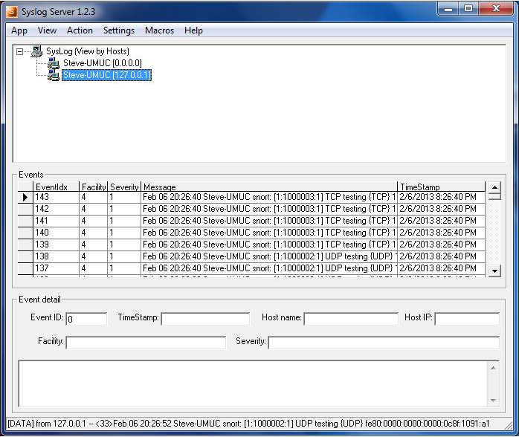
Figure 1: Intrusion Page

Figure 2: Syslog Server logging intrusion information communicating with snort.
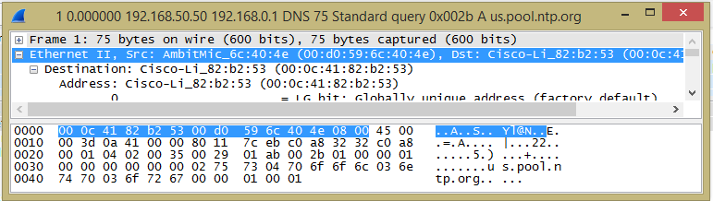
Figure 3: Analysis of information sent and received on network
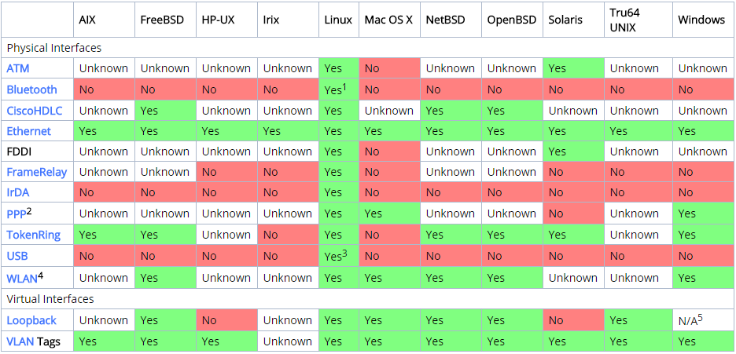
Figure 4: Networks Supported for intrusion simulation
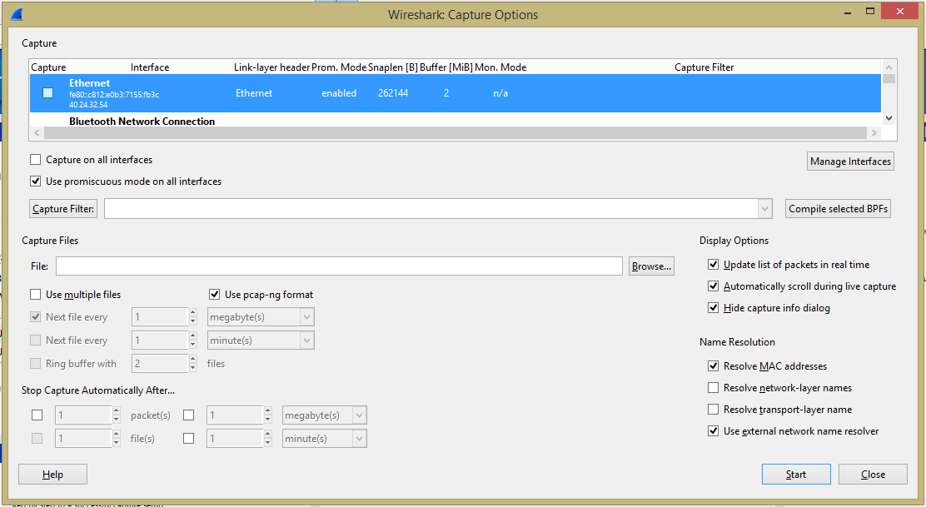
Figure 5: Intrusion Detection Mechanism
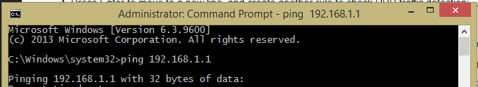
Figure 6: Testing server for intrusion detection
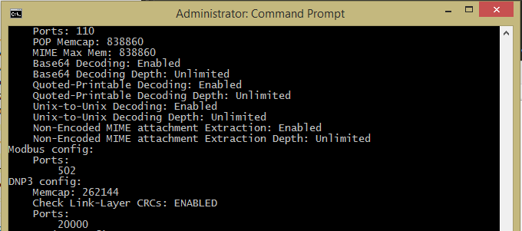
Figure 7: Intrusion Program Running on command line
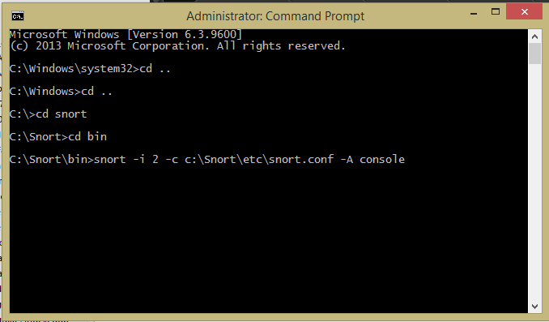
Figure 8: Serving snot for intrusion purpose
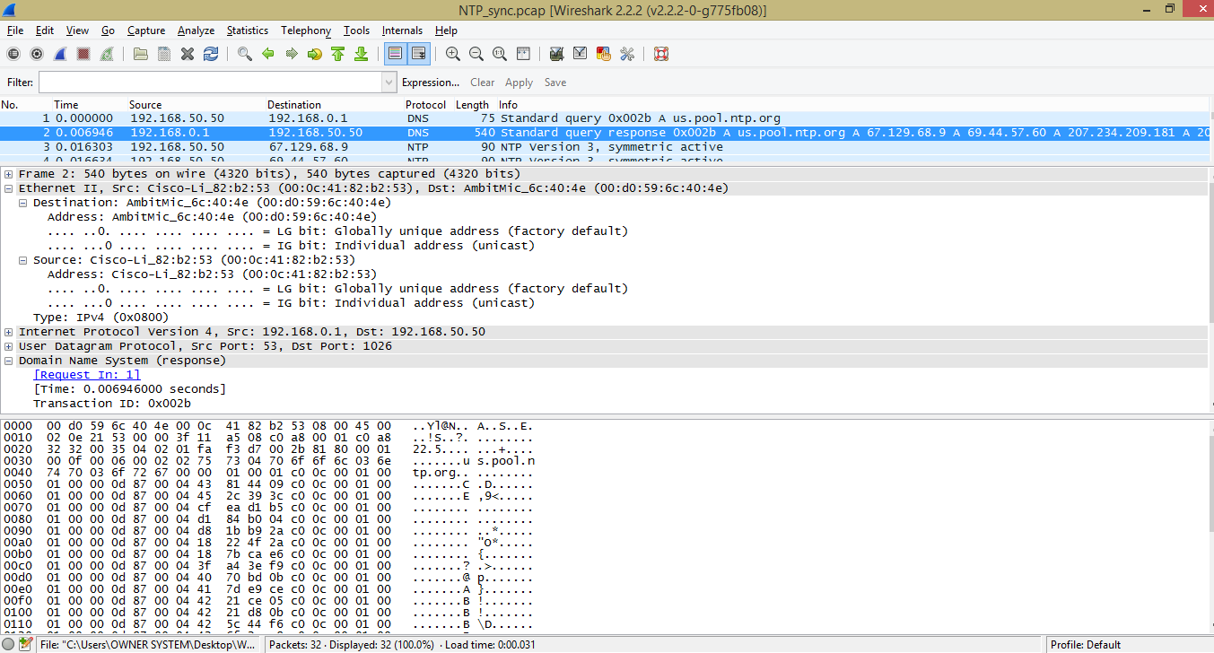
Figure 9: List of connected networks and their respective information
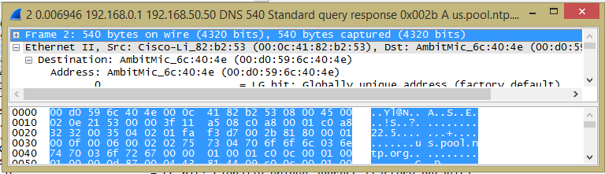
Figure 10: Analysis of Intrusion on LAN network

4.1.3 DATABASE DESIGN
A Database Management System (DBMS) is a collection of programs that allows you to store, modify, and extract information from a database. It also gives users tools for adding, deleting, accessing, modifying, and analyzing data stored in a single location.
4.1.4 PROCEDURE DESIGN
This refers to how the proposed system will be used, and the steps are as follows:
- Download and install wireshark, snort, syslog, and wincap.
- Open the command line as administrator.
- Select all programs
4.2 SYSTEM IMPLEMENTATION
4.2.1 Choice of Programming Language
The simulation is done using the wireshark, snort, syslog, wincap.
4.2.2 HARDWARE SUPPORT
These are the physical component of the computer that supports the project.
- An enhance keyboard and mouse.
- SVGA or VGA monitor to incorporate the graphics so that the friendly usability interface is enjoyed.
- Minimum of a 334 MHZ, Microprocessor computer with at least minimum of 128MB RAM and about 20GB Hard Disk.
- Network interface card.
- Printer
4.2.3 SOFTWARE SUPPORT
These are the software supported by then program.
- Microsoft window XP and newer version of windows.
4.2.4 IMPLEMENTATION TECHNIQUES USED IN DETAILS
The parallel approach will be used to implement the system. This method is considered because it ensures that the new system is tested alongside the old system to ensure the system's effectiveness and efficiency. The parallel approach was used for the project because, while the new system has been tested and works effectively, no one knows whether it can still fail, so the techniques were entailed because of the importance of the system, and we can easily go back to the old one because we did not pack it off at the end.
4.3 SYSTEM DOCUMENTATION
4.3.1 PROGRAM DOCUMENTATION
To make the best use of the system, it must be used exactly as instructed by the hardware and software supports.
4.3.2 OPERATING THE SYSTEM
The program has been written on compact disk; the following steps must be completed in order for the program to function.
- i. Turn on the computer. ii. Insert the program CD into the CD drive.
- iii. Open the CD by double-clicking the CD ROM icon on my computer.
- iv. Save the file to the disk v. Launch the local Hard-Disk Drive
4.3.3 MAINTAINING THE SYSTEM
In order to make the most of the system, the following instructions must be strictly followed. Install an anti-virus program and keep it up to date at all times. The aesthetic and functional aspects of a website require constant attention and growth, especially if a group of individuals shares responsibility for updating the content. Someone must be in charge of coordinating and vetting the new content stream, as well as maintaining the graphic and editorial standards. The following points should be noted in order to keep the program running.

CHAPTER FIVE
SUMMARY, CONCLUSION AND RECOMMENDATIONS
5.1 SUMMARY
Choosing effective and key features for intrusion detection is a critical topic in information security. The goal of this research is to identify critical features in developing an intrusion detection system that are both computationally efficient and effective. The goal of this research is to create an intrusion detection system using an ant colony optimization algorithm to accomplish the following goals. The wireless intrusion detection system will be designed with the above considerations in mind to provide a light weight, low-overheat mechanism-based mobile security agent as Ant for sensor framework. An ant colony will be used as an example for causal network construction because it is a typical example of a mobile multi-agent system. The scope of this project was limited to detecting denial of service attacks, web server attacks, and buffer overflow attacks because it is impossible to design a network intrusion detection system for every type of attack due to the large number of attack types.
5.2 CONCLUSION
Wireshark cannot perform the intrusion alone, which is why it should be used in conjunction with snort, syslog, and the appropriate intrusion mechanism. A network intrusion detection system (NIDS) is a system that detects and reports network intrusions. Techniques such as anomaly detection, signature pattern matching, and so on can be used to detect intrusion. Anomaly detection is a method for capturing normal network behavior and detecting any abnormalities in the network, such as a sudden increase in network traffic rate (number of IP packets per second). Signature pattern matching is a technique that compares network data to known attack techniques stored in a database. For example, an intrusion detection system (IDS) that monitors web servers could be programmed to look for the string "phf" as an indicator of a CGI program attack.
5.3 RECOMMENDATION
It is recommended that the proposed system be implemented to address the constraints of the existing system, and that future research be conducted to optimize the performance of intrusion detection tools, and that heuristic approaches be developed to reduce audits that rely on pre-established relationships among attributes. In the future, intrusion detection systems (IDS) will face several daunting but exciting challenges in the realm of network security, including providing more effective attack response mechanisms such as shutting down or isolating compromised systems.

REFERENCE
Ahmad A. (2014). Intrusion Detection and Prevention Systems (IDPS) and Security Issues
Amrita A. and Brajesh P. (2012). An Overview on Intrusion Detection System and Types of Attacks It Can Detect Considering Different Protocols.
Crowell, K. (2002). Importance of biometric Technology. Carnegie Mellon University.
Jones, J.R. (1999). Statistical color models with application to skin detection. In Proceedings of IEEE Conference on Computer Vision and Pattern Recognition.
Mohammad S, et al (2012). An Implementation of Intrusion Detection System using Genetic Algorithm.
Mohammed J., Rasheed T. & Waheed M. (2010). A. Intrusion Detection System.
Rehg J.R. & Kanade T. (1993). DigitEyes: Vision-Based Human Hand-Tracking. School of Computer Science Technical Report CMU- CS-93-220, Carnegie Mellon University.
Sato, Y.K. & Koike, H. (1991). Fast tracking of hands and fingertips in infrared images for augmented desk interface.
Santos, B. et al (2013). Intrusion Detection System- Types and Prevention.
Segen, J., Segen, S. & Kumar, J. (1999). Shadow gestures: 3D hand pose estimation using a single camera.
Trucco, E. (1998). Introductory Techniques for 3D Computer Vision. Prentice-Hall, Vision and Pattern Recognition.
Vijayarani, S. & Sylviaa, S (2015). Intrusion Detection System – a Study.
Zhang, Z., Shan, Y. & Shafer, S. (2001). Visual panel: Virtual mouse keyboard and 3rd controller with an ordinary piece of paper. In Proceedings of Perceptual User Interfaces.
SPLASH SCREEN FLOWCHART
Start
Display Splash
Return
Open Database

Close Database

LOGIN FLOWCHART
No
Yes
Start
Enter Username and Password
Is any field empty?
Is Username and Password Correct?
Main Menu
Return
Invalid Username and Password
All field are required to proceed
Open Database

Close Database

No
Yes

Yes
No

MAIN MENU FLOWCHART
Return
Yes
No
No
Yes
Yes
Help
Change Password
Is it option Help?
Is it option Change Password?
Start
Select option
Open Database

End Select
No
Close Database

Exit
Is it option About the Software?

HELP FLOWCHART
Start
Display Help
Return
Open Database

Close Database

CHANGE PASSWORD FLOWCHART
Start
Display Change Password
Open Database

Return
Close Database

Enter New Password
Re-enter New Password
Save New Password

EXIT FLOWCHART
No
Yes
Start
Do you want to Logout?
Return
Click on Logout
Welcome Page
Main Menu
Open Database

Close Database

SOURCE CODE
alert ( msg:"DECODE_NOT_IPV4_DGRAM"; sid:1; gid:116; rev:1; metadata:rule-type decode; classtype:protocol-command-decode;)
alert ( msg:"DECODE_IPV4_INVALID_HEADER_LEN"; sid:2; gid:116; rev:1; metadata:rule-type decode; classtype:protocol-command-decode; )
alert ( msg:"DECODE_IPV4_DGRAM_LT_IPHDR"; sid:3; gid:116; rev:1; metadata:rule-type decode; classtype:protocol-command-decode; )
alert ( msg:"DECODE_IPV4OPT_BADLEN"; sid:4; gid:116; rev:1; metadata:rule-type decode; classtype:protocol-command-decode; )
alert ( msg:"DECODE_IPV4OPT_TRUNCATED"; sid:5; gid:116; rev:1; metadata:rule-type decode; reference:cve,2005-0048; reference:url,www.microsoft.com/technet/security/bulletin/ms05-019.mspx; classtype:protocol-command-decode;)
alert ( msg:"DECODE_IPV4_DGRAM_GT_IPHDR"; sid:6; gid:116; rev:1; metadata:rule-type decode;classtype:protocol-command-decode; )
alert ( msg:"DECODE_TCP_DGRAM_LT_TCPHDR"; sid:45; gid:116; rev:1; metadata:rule-type decode;classtype:protocol-command-decode; )
alert ( msg:"DECODE_TCP_INVALID_OFFSET"; sid:46; gid:116; rev:1; metadata:rule-type decode; reference:cve,2004-0816; classtype:bad-unknown; )
alert ( msg:"DECODE_TCP_LARGE_OFFSET"; sid:47; gid:116; rev:1; metadata:rule-type decode; classtype:bad-unknown; )
alert ( msg:"DECODE_TCPOPT_BADLEN"; sid:54; gid:116; rev:1; metadata:rule-type decode; reference:bugtraq,14811; classtype:protocol-command-decode; )
alert ( msg:"DECODE_TCPOPT_TRUNCATED"; sid:55; gid:116; rev:1; metadata:rule-type decode; classtype:protocol-command-decode; )
alert ( msg:"DECODE_TCPOPT_TTCP"; sid:56; gid:116; rev:1; metadata:rule-type decode; classtype:protocol-command-decode; )
alert ( msg:"DECODE_TCPOPT_OBSOLETE"; sid:57; gid:116; rev:1; metadata:rule-type decode; classtype:protocol-command-decode; )
alert ( msg:"DECODE_TCPOPT_EXPERIMENT"; sid:58; gid:116; rev:1; metadata:rule-type decode; classtype:protocol-command-decode; )
alert ( msg:"DECODE_TCPOPT_WSCALE_INVALID"; sid:59; gid:116; rev:1; metadata:rule-type decode; classtype:protocol-command-decode; )
alert ( msg:"DECODE_UDP_DGRAM_LT_UDPHDR"; sid:95; gid:116; rev:1; metadata:rule-type decode; classtype:protocol-command-decode; )
alert ( msg:"DECODE_UDP_DGRAM_INVALID_LENGTH"; sid:96; gid:116; rev:1; metadata:rule-type decode; classtype:protocol-command-decode; )
alert ( msg:"DECODE_UDP_DGRAM_SHORT_PACKET"; sid:97; gid:116; rev:1; metadata:rule-type decode; classtype:protocol-command-decode; )
alert ( msg:"DECODE_UDP_DGRAM_LONG_PACKET"; sid:98; gid:116; rev:1; metadata:rule-type decode; classtype:protocol-command-decode; )
alert ( msg:"DECODE_ICMP_DGRAM_LT_ICMPHDR"; sid:105; gid:116; rev:1; metadata:rule-type decode; classtype:protocol-command-decode; )
alert ( msg:"DECODE_ICMP_DGRAM_LT_TIMESTAMPHDR"; sid:106; gid:116; rev:1; metadata:rule-type decode; classtype:protocol-command-decode; )
alert ( msg:"DECODE_ICMP_DGRAM_LT_ADDRHDR"; sid:107; gid:116; rev:1; metadata:rule-type decode; classtype:protocol-command-decode; )
alert ( msg:"DECODE_IPV4_DGRAM_UNKNOWN"; sid:108; gid:116; rev:1; metadata:rule-type decode; classtype:protocol-command-decode; )
alert ( msg:"DECODE_ARP_TRUNCATED"; sid:109; gid:116; rev:1; metadata:rule-type decode; classtype:bad-unknown; )
alert ( msg:"DECODE_EAPOL_TRUNCATED"; sid:110; gid:116; rev:1; metadata:rule-type decode; classtype:bad-unknown; )
alert ( msg:"DECODE_EAPKEY_TRUNCATED"; sid:111; gid:116; rev:1; metadata:rule-type decode; classtype:bad-unknown; )
alert ( msg:"DECODE_EAP_TRUNCATED"; sid:112; gid:116; rev:1; metadata:rule-type decode; classtype:bad-unknown; )
alert ( msg:"DECODE_BAD_PPPOE"; sid:120; gid:116; rev:1; metadata:rule-type decode; classtype:bad-unknown; )
alert ( msg:"DECODE_BAD_VLAN"; sid:130; gid:116; rev:1; metadata:rule-type decode; classtype:bad-unknown; )
alert ( msg:"DECODE_BAD_VLAN_ETHLLC"; sid:131; gid:116; rev:1; metadata:rule-type decode; classtype:bad-unknown; )
alert ( msg:"DECODE_BAD_VLAN_OTHER"; sid:132; gid:116; rev:1; metadata:rule-type decode; classtype:bad-unknown; )
alert ( msg:"DECODE_BAD_80211_ETHLLC"; sid:133; gid:116; rev:1; metadata:rule-type decode; classtype:bad-unknown; )
alert ( msg:"DECODE_BAD_80211_OTHER"; sid:134; gid:116; rev:1; metadata:rule-type decode;classtype:bad-unknown; )
alert ( msg:"DECODE_BAD_TRH"; sid:140; gid:116; rev:1; metadata:rule-type decode;classtype:bad-unknown; )
alert ( msg:"DECODE_BAD_TR_ETHLLC"; sid:141; gid:116; rev:1; metadata:rule-type decode;classtype:bad-unknown; )
alert ( msg:"DECODE_BAD_TR_MR_LEN"; sid:142; gid:116; rev:1; metadata:rule-type decode;classtype:bad-unknown; )
alert ( msg:"DECODE_BAD_TRHMR"; sid:143; gid:116; rev:1; metadata:rule-type decode;classtype:bad-unknown; )
alert ( msg:"DECODE_BAD_TRAFFIC_LOOPBACK"; sid:150; gid:116; rev:1; metadata:rule-type decode;classtype:bad-unknown; )
alert ( msg:"DECODE_BAD_TRAFFIC_SAME_SRCDST"; sid:151; gid:116; rev:1; metadata:rule-type decode; reference:cve,1999-0016; reference:cve,2005-0688; reference:bugtraq,2666; reference:url,www.microsoft.com/technet/security/bulletin/ms05-019.mspx; classtype:bad-unknown; )
alert ( msg:"DECODE_GRE_DGRAM_LT_GREHDR"; sid:160; gid:116; rev:1; metadata:rule-type decode; classtype:protocol-command-decode; )
alert ( msg:"DECODE_GRE_MULTIPLE_ENCAPSULATION"; sid:161; gid:116; rev:1; metadata:rule-type decode; classtype:protocol-command-decode; )
alert ( msg:"DECODE_GRE_INVALID_VERSION"; sid:162; gid:116; rev:1; metadata:rule-type decode; classtype:protocol-command-decode; )
alert ( msg:"DECODE_GRE_INVALID_HEADER"; sid:163; gid:116; rev:1; metadata:rule-type decode; classtype:protocol-command-decode; )
alert ( msg:"DECODE_GRE_V1_INVALID_HEADER"; sid:164; gid:116; rev:1; metadata:rule-type decode; classtype:protocol-command-decode; )
alert ( msg:"DECODE_GRE_TRANS_DGRAM_LT_TRANSHDR"; sid:165; gid:116; rev:1; metadata:rule-type decode; classtype:protocol-command-decode; )
alert ( msg:"DECODE_ICMP_ORIG_IP_TRUNCATED"; sid:250; gid:116; rev:1; metadata:rule-type decode; classtype:bad-unknown; )
alert ( msg:"DECODE_ICMP_ORIG_IP_VER_MISMATCH"; sid:251; gid:116; rev:1; metadata:rule-type decode; classtype:protocol-command-decode; )
alert ( msg:"DECODE_ICMP_ORIG_DGRAM_LT_ORIG_IP"; sid:252; gid:116; rev:1; metadata:rule-type decode; classtype:protocol-command-decode; )
alert ( msg:"DECODE_ICMP_ORIG_PAYLOAD_LT_64"; sid:253; gid:116; rev:1; metadata:rule-type decode; classtype:protocol-command-decode; )
alert ( msg:"DECODE_ICMP_ORIG_PAYLOAD_GT_576"; sid:254; gid:116; rev:1; metadata:rule-type decode; classtype:protocol-command-decode; )
alert ( msg:"DECODE_ICMP_ORIG_IP_WITH_FRAGOFFSET"; sid:255; gid:116; rev:1; metadata:rule-type decode; classtype:protocol-command-decode; )
alert ( msg:"DECODE_IPV6_MIN_TTL"; sid:270; gid:116; rev:1; metadata:rule-type decode; classtype:protocol-command-decode; )
alert ( msg:"DECODE_IPV6_IS_NOT"; sid:271; gid:116; rev:1; metadata:rule-type decode; classtype:protocol-command-decode; )
alert ( msg:"DECODE_IPV6_TRUNCATED_EXT"; sid:272; gid:116; rev:1; metadata:rule-type decode; classtype:bad-unknown; )
alert ( msg:"DECODE_IPV6_TRUNCATED"; sid:273; gid:116; rev:1; metadata:rule-type decode; classtype:bad-unknown; )
alert ( msg:"DECODE_IPV6_DGRAM_LT_IPHDR"; sid:274; gid:116; rev:1; metadata:rule-type decode; classtype:protocol-command-decode; )
alert ( msg:"DECODE_IPV6_DGRAM_GT_IPHDR"; sid:275; gid:116; rev:1; metadata:rule-type decode; classtype:protocol-command-decode; )
alert ( msg:"DECODE_IPV6_DST_ZERO"; sid:276; gid:116; rev:1; metadata:rule-type decode; classtype:protocol-command-decode; )
alert ( msg:"DECODE_IPV6_SRC_MULTICAST"; sid:277; gid:116; rev:1; metadata:rule-type decode; classtype:protocol-command-decode; )
alert ( msg:"DECODE_IPV6_DST_RESERVED_MULTICAST"; sid:278; gid:116; rev:1; metadata:rule-type decode; classtype:protocol-command-decode; )
alert ( msg:"DECODE_IPV6_BAD_OPT_TYPE"; sid:279; gid:116; rev:1; metadata:rule-type decode; classtype:protocol-command-decode; )
alert ( msg:"DECODE_IPV6_BAD_MULTICAST_SCOPE"; sid:280; gid:116; rev:1; metadata:rule-type decode; classtype:protocol-command-decode; )
alert ( msg:"DECODE_IPV6_BAD_NEXT_HEADER"; sid:281; gid:116; rev:1; metadata:rule-type decode; classtype:protocol-command-decode; )
alert ( msg:"DECODE_IPV6_ROUTE_AND_HOPBYHOP"; sid:282; gid:116; rev:1; metadata:rule-type decode; classtype:protocol-command-decode; )
alert ( msg:"DECODE_IPV6_TWO_ROUTE_HEADERS"; sid:283; gid:116; rev:1; metadata:rule-type decode; classtype:protocol-command-decode; )
alert ( msg:"DECODE_ICMPV6_TOO_BIG_BAD_MTU"; sid:285; gid:116; rev:1; metadata:rule-type decode; classtype:protocol-command-decode; )
alert ( msg:"DECODE_ICMPV6_UNREACHABLE_BAD_CODE"; sid:286; gid:116; rev:1; metadata:rule-type decode; classtype:protocol-command-decode; )
alert ( msg:"DECODE_ICMPV6_SOLICITATION_BAD_CODE"; sid:287; gid:116; rev:1; metadata:rule-type decode; classtype:protocol-command-decode; )
alert ( msg:"DECODE_ICMPV6_ADVERT_BAD_CODE"; sid:288; gid:116; rev:1; metadata:rule-type decode; classtype:protocol-command-decode; )
alert ( msg:"DECODE_ICMPV6_SOLICITATION_BAD_RESERVED"; sid:289; gid:116; rev:1; metadata:rule-type decode; classtype:protocol-command-decode; )
alert ( msg:"DECODE_ICMPV6_ADVERT_BAD_REACHABLE"; sid:290; gid:116; rev:1; metadata:rule-type decode; classtype:protocol-command-decode; )
alert ( msg:"DECODE_IPV6_TUNNELED_IPV4_TRUNCATED"; sid:291; gid:116; rev:1; metadata:rule-type decode; classtype:attempted-dos; reference:cve,2008-2136; reference:bugtraq,29235; )
alert ( msg:"DECODE_IPV6_DSTOPTS_WITH_ROUTING"; sid:292; gid:116; rev:1; metadata:rule-type decode; classtype:protocol-command-decode; )
alert ( msg:"DECODE_IP_MULTIPLE_ENCAPSULATION"; sid:293; gid:116; rev:1; metadata:rule-type decode; classtype:protocol-command-decode; )
alert ( msg:"DECODE_ESP_HEADER_TRUNC"; sid:294; gid:116; rev:1; metadata:rule-type decode; classtype:protocol-command-decode; )
alert ( msg:"DECODE_IPV6_BAD_OPT_LEN"; sid:295; gid:116; rev:1; metadata:rule-type decode; classtype:protocol-command-decode; )
alert ( msg:"DECODE_IPV6_UNORDERED_EXTENSIONS"; sid:296; gid:116; rev:1; metadata:rule-type decode; classtype:protocol-command-decode; )
alert ( msg:"DECODE_GTP_MULTIPLE_ENCAPSULATION"; sid:297; gid:116; rev:1; metadata:rule-type decode; classtype:protocol-command-decode; )
alert ( msg:"DECODE_GTP_BAD_LEN_STR"; sid:298; gid:116; rev:1; metadata:rule-type decode; classtype:protocol-command-decode; )
alert ( msg:"DECODE_BAD_MPLS"; sid:170; gid:116; rev:1; metadata:rule-type decode; classtype:protocol-command-decode; )
alert ( msg:"DECODE_BAD_MPLS_LABEL0"; sid:171; gid:116; rev:1; metadata:rule-type decode; classtype:protocol-command-decode; )
alert ( msg:"DECODE_BAD_MPLS_LABEL1"; sid:172; gid:116; rev:1; metadata:rule-type decode; classtype:protocol-command-decode; )
alert ( msg:"DECODE_BAD_MPLS_LABEL2"; sid:173; gid:116; rev:1; metadata:rule-type decode; classtype:protocol-command-decode; )
alert ( msg:"DECODE_BAD_MPLS_LABEL3"; sid:174; gid:116; rev:1; metadata:rule-type decode; classtype:protocol-command-decode; )
alert ( msg:"DECODE_MPLS_RESERVEDLABEL"; sid:175; gid:116; rev:1; metadata:rule-type decode; classtype:protocol-command-decode; )
alert ( msg:"DECODE_MPLS_LABEL_STACK"; sid:176; gid:116; rev:1; metadata:rule-type decode; classtype:protocol-command-decode; )
alert ( msg:"DECODE_TCP_XMAS"; sid: 400; gid: 116; rev: 1; metadata: rule-type decode ; classtype:attempted-recon; reference:bugtraq,7700; reference:cve,2003-0393; )
alert ( msg:"DECODE_TCP_NMAP_XMAS"; sid: 401; gid: 116; rev: 1; metadata: rule-type decode ; classtype:attempted-recon; reference:bugtraq,7700; reference:cve,2003-0393; )
alert ( msg:"DECODE_DOS_NAPTHA"; sid: 402; gid: 116; rev: 1; metadata: rule-type decode ; classtype:attempted-dos; reference:bugtraq,2022; reference:cve,2000-1039; reference:nessus,275; reference:url,razor.bindview.com/publish/advisories/adv_NAPTHA.html; reference:url,www.cert.org/advisories/CA-2000-21.html; reference:url,www.microsoft.com/technet/security/bulletin/MS00-091.mspx; )
alert ( msg:"DECODE_SYN_TO_MULTICAST"; sid: 403; gid: 116; rev: 1; metadata: rule-type decode ; classtype:bad-unknown; )
alert ( msg:"DECODE_ZERO_TTL"; sid: 404; gid: 116; rev: 1; metadata: rule-type decode ; classtype:misc-activity; reference:url,support.microsoft.com/kb/q138268; reference:url,tools.ietf.org/html/rfc1122; )
alert ( msg:"DECODE_BAD_FRAGBITS"; sid: 405; gid: 116; rev: 1; metadata: rule-type decode ; classtype:misc-activity; )
alert ( msg:"DECODE_UDP_IPV6_ZERO_CHECKSUM"; sid:406; gid:116; rev:1; metadata:rule-type decode; classtype:protocol-command-decode; )
alert ( msg:"DECODE_IP4_LEN_OFFSET"; sid:407; gid:116; rev:1; metadata:rule-type decode; classtype:misc-activity; )
alert ( msg:"DECODE_IP4_SRC_THIS_NET"; sid:408; gid:116; rev:1; metadata:rule-type decode; classtype:misc-activity; )
alert ( msg:"DECODE_IP4_DST_THIS_NET"; sid:409; gid:116; rev:1; metadata:rule-type decode; classtype:misc-activity; )
alert ( msg:"DECODE_IP4_SRC_MULTICAST"; sid:410; gid:116; rev:1; metadata:rule-type decode; classtype:misc-activity; )
alert ( msg:"DECODE_IP4_SRC_RESERVED"; sid:411; gid:116; rev:1; metadata:rule-type decode; classtype:misc-activity; )
alert ( msg:"DECODE_IP4_DST_RESERVED"; sid:412; gid:116; rev:1; metadata:rule-type decode; classtype:misc-activity; )
alert ( msg:"DECODE_IP4_SRC_BROADCAST"; sid:413; gid:116; rev:1; metadata:rule-type decode; classtype:misc-activity; )
alert ( msg:"DECODE_IP4_DST_BROADCAST"; sid:414; gid:116; rev:1; metadata:rule-type decode; classtype:misc-activity; )
alert ( msg:"DECODE_ICMP4_DST_MULTICAST"; sid:415; gid:116; rev:1; metadata:rule-type decode; classtype:misc-activity; )
alert ( msg:"DECODE_ICMP4_DST_BROADCAST"; sid:416; gid:116; rev:1; metadata:rule-type decode; classtype:misc-activity; )
alert ( msg:"DECODE_ICMP4_TYPE_OTHER"; sid:418; gid:116; rev:1; metadata:rule-type decode; classtype:misc-activity; )
alert ( msg:"DECODE_TCP_BAD_URP"; sid:419; gid:116; rev:1; metadata:rule-type decode; classtype:misc-activity; )
alert ( msg:"DECODE_TCP_SYN_FIN"; sid:420; gid:116; rev:1; metadata:rule-type decode; classtype:misc-activity; )
alert ( msg:"DECODE_TCP_SYN_RST"; sid:421; gid:116; rev:1; metadata:rule-type decode; classtype:misc-activity; )
alert ( msg:"DECODE_TCP_MUST_ACK"; sid:422; gid:116; rev:2; metadata:rule-type decode; classtype:misc-activity; )
alert ( msg:"DECODE_TCP_NO_SYN_ACK_RST"; sid:423; gid:116; rev:2; metadata:rule-type decode; classtype:misc-activity; )
alert ( msg:"DECODE_ETH_HDR_TRUNC"; sid:424; gid:116; rev:1; metadata:rule-type decode; classtype:misc-activity; )
alert ( msg:"DECODE_IP4_HDR_TRUNC"; sid:425; gid:116; rev:1; metadata:rule-type decode; classtype:misc-activity; )
alert ( msg:"DECODE_ICMP4_HDR_TRUNC"; sid:426; gid:116; rev:1; metadata:rule-type decode; classtype:misc-activity; )
alert ( msg:"DECODE_ICMP6_HDR_TRUNC"; sid:427; gid:116; rev:1; metadata:rule-type decode; classtype:misc-activity; )
alert ( msg:"DECODE_IP4_MIN_TTL"; sid:428; gid:116; rev:1; metadata:rule-type decode; classtype:misc-activity; )
alert ( msg:"DECODE_IP6_ZERO_HOP_LIMIT"; sid:429; gid:116; rev:1; metadata:rule-type decode; classtype:misc-activity; )
alert ( msg:"DECODE_IP4_DF_OFFSET"; sid:430; gid:116; rev:1; metadata:rule-type decode; classtype:misc-activity; )
alert ( msg:"DECODE_ICMP6_TYPE_OTHER"; sid:431; gid:116; rev:1; metadata:rule-type decode; classtype:misc-activity; )
alert ( msg:"DECODE_ICMP6_DST_MULTICAST"; sid:432; gid:116; rev:1; metadata:rule-type decode; classtype:misc-activity; )
alert ( msg:"DECODE_TCP_SHAFT_SYNFLOOD"; sid:433; gid:116; rev:1; metadata:rule-type decode; classtype:attempted-dos; reference:cve,2000-0138; )
alert ( msg:"DECODE_ICMP_PING_NMAP"; sid:434; gid:116; rev:1; metadata:rule-type decode; classtype:attempted-recon; )
alert ( msg:"DECODE_ICMP_ICMPENUM"; sid:435; gid:116; rev:1; metadata:rule-type decode; classtype:attempted-recon; )
alert ( msg:"DECODE_ICMP_REDIRECT_HOST"; sid:436; gid:116; rev:1; metadata:rule-type decode; classtype:attempted-recon; )
alert ( msg:"DECODE_ICMP_REDIRECT_NET"; sid:437; gid:116; rev:1; metadata:rule-type decode; classtype:attempted-recon; )
alert ( msg:"DECODE_ICMP_TRACEROUTE_IPOPTS"; sid:438; gid:116; rev:1; metadata:rule-type decode; classtype:attempted-recon; )
alert ( msg:"DECODE_ICMP_SOURCE_QUENCH"; sid:439; gid:116; rev:1; metadata:rule-type decode; classtype:attempted-recon; )
alert ( msg:"DECODE_ICMP_BROADSCAN_SMURF_SCANNER"; sid:440; gid:116; rev:1; metadata:rule-type decode; classtype:attempted-recon; )
alert ( msg:"DECODE_ICMP_DST_UNREACH_ADMIN_PROHIBITED"; sid:441; gid:116; rev:1; metadata:rule-type decode; classtype:attempted-recon; )
alert ( msg:"DECODE_ICMP_DST_UNREACH_DST_HOST_PROHIBITED"; sid:442; gid:116; rev:1; metadata:rule-type decode; classtype:attempted-recon; )
alert ( msg:"DECODE_ICMP_DST_UNREACH_DST_NET_PROHIBITED"; sid:443; gid:116; rev:1; metadata:rule-type decode; classtype:attempted-recon; )
alert ( msg:"DECODE_IP_OPTION_SET"; sid:444; gid:116; rev:1; metadata:rule-type decode; classtype: bad-unknown; )
alert ( msg:"DECODE_UDP_LARGE_PACKET"; sid:445; gid:116; rev:1; metadata:rule-type decode; classtype: bad-unknown; )
alert ( msg:"DECODE_TCP_PORT_ZERO"; sid:446; gid:116; rev:1; metadata:rule-type decode; classtype: misc-activity; )
alert ( msg:"DECODE_UDP_PORT_ZERO"; sid:447; gid:116; rev:1; metadata:rule-type decode; classtype: misc-activity; )
alert ( msg:"DECODE_IP_RESERVED_FRAG_BIT"; sid:448; gid:116; rev:1; metadata:rule-type decode; classtype: misc-activity; )
alert ( msg:"DECODE_IP_UNASSIGNED_PROTO"; sid:449; gid:116; rev:1; metadata:rule-type decode; classtype: non-standard-protocol; )
alert ( msg:"DECODE_IP_BAD_PROTO"; sid:450; gid:116; rev:1; metadata:rule-type decode; classtype: non-standard-protocol; )
alert ( msg:"DECODE_ICMP_PATH_MTU_DOS"; sid:451; gid:116; rev:1; metadata:rule-type decode; reference:bugtraq,13124; reference:cve,2004-1060; classtype:attempted-dos;)
alert ( msg:"DECODE_ICMP_DOS_ATTEMPT"; sid:452; gid:116; rev:1; metadata:rule-type decode; reference:url,www.kernel.org/pub/linux/kernel/v2.6/ChangeLog-2.6.15.3; reference:cve,2006-0454; reference:bugtraq,16532; classtype:denial-of-service;)
alert ( msg:"DECODE_IPV6_ISATAP_SPOOF"; sid:453; gid:116; rev:1; metadata:rule-type decode; reference:cve,2010-0812; reference:url,www.microsoft.com/technet/security/bulletin/MS10-029.mspx; classtype:misc-attack; )
alert ( msg:"DECODE_PGM_NAK_OVERFLOW"; sid:454; gid:116; rev:1; metadata:rule-type decode; reference:url,www.microsoft.com/technet/security/bulletin/ms06-052.mspx; reference:cve,2006-3442; reference:bugtraq,19922; classtype:attempted-admin; )
alert ( msg:"DECODE_IGMP_OPTIONS_DOS"; sid:455; gid:116; rev:1; metadata:rule-type decode; reference:url,www.microsoft.com/technet/security/bulletin/ms06-007.mspx; reference:cve,2006-0021; reference:bugtraq,16645; classtype:attempted-dos; )
alert ( msg:"DECODE_IP6_EXCESS_EXT_HDR"; sid:456; gid:116; rev:1; metadata:rule-type decode; classtype:misc-activity; )
alert ( msg:"DECODE_ICMPV6_UNREACHABLE_NON_RFC_4443_CODE"; sid:457; gid:116; rev:1; metadata:rule-type decode; classtype:protocol-command-decode; )
alert ( msg:"DECODE_IPV6_BAD_FRAG_PKT"; sid:458; gid:116; rev:1; metadata:rule-type decode; classtype:protocol-command-decode; )
alert ( msg:"DECODE_ZERO_LENGTH_FRAG"; sid:459; gid:116; rev:1; metadata:rule-type decode; classtype:protocol-command-decode; )
alert ( msg:"DECODE_ICMPV6_SOLICITATION_BAD_CODE"; sid:460; gid:116; rev:1; metadata:rule-type decode; classtype:protocol-command-decode; )
alert ( msg:"DECODE_IPV6_ROUTE_ZERO"; sid:461; gid:116; rev:1; metadata:rule-type decode; classtype:protocol-command-decode; )
alert ( msg:"DECODE_ERSPAN_HDR_VERSION_MISMATCH_STR"; sid:462; gid:116; rev:1; metadata:rule-type decode; classtype:protocol-command-decode; )
alert ( msg:"DECODE_ERSPAN2_DGRAM_LT_HDR_STR"; sid:463; gid:116; rev:1; metadata:rule-type decode; classtype:protocol-command-decode; )
alert ( msg:"DECODE_ERSPAN3_DGRAM_LT_HDR_STR"; sid:464; gid:116; rev:1; metadata:rule-type decode; classtype:protocol-command-decode; )

