UTILIZATION OF WHOLE UNRIPE PLANTAIN IN THE PRODUCTION OF AMALA AND POTTAGE
BY:
OLATUNJI MUJEEB OLAMILEKAN
ND/23/HMT/PT/0002

BEING A RESEARCH PROJECT SUBMITED TO THE DEPARTMENT OF HOSPITALITY MANAGEMENT
INSTITUTE OF APPLIED SCIENCE,
KWARA STATE POLYTECHNIC, ILORIN.

IN PARTIAL FULFILLMENT OF THE REQUIREMENT OF THE AWARD OF NATIONAL DIPLOMA (ND) IN HOSPITALITY MANAGEMENT

MAY,2025
DEDICATION
This project is dedicated to Almighty God and our lovely Parents.

ACKNOWLEDGEMENT
All gratitude goes to Almighty God who is in His infinite mercy made this research a successful one and kept us throughout our stay as a student of this great institution.
Our sincere and utmost gratitude goes to our Supervisor MRS.ADEBAYO who took her time to patiently read, correct, encourage, advice and supervise this research, may Almighty God continue guiding and protecting you (Amen).
Our profound gratitude also goes to my our H.O.D in person ofMRS AREMU. O.Omay you live long to reap the fruit of your labour (Amen).
We also want to use this medium to appreciate all our Lecturers in the Department of Hospitality Management may Almighty God continue guiding and protecting each and everyone of you (Amen).
Our immensely gratitude also goes to our wonderful Parents for their love, financial support, prayers, advice and care, may the Almighty God bless you abundantly (Amen).
Our profound gratitude also goes to our wonderful Siblings; may you all be blessed (Amen).Our appreciation will not be completed if we don't acknowledge our friends; and many others. We appreciate and love you all for your moral support, advice, may Almighty God bless you all.
Our apology also goes to our friends and relatives whose names does not appear on this write up, it is due to the limited space provided, you are all acknowledged.
CERTIFICATION
This researchbeen read and approved as meetingthe requirement of the apartment of Hospitality Management, Institute of Applied Sciences, Kwara State Polytechnic, Ilorin for the Award of National Diploma (ND) in Hospitality Management.

__________________________ __________________________
MRS. ADEBAYO.S.M DATE
Project Supervisor

__________________________ __________________________
MRS. ADEBAYO.S.M DATE
Project coordinator

__________________________ __________________________
MRS. ADEBAYO.S.M DATE
Head of Department

ABSTRACT
The study explores the utilization of whole unripe plantain in the production of amala and pottage as e dietary intervention for the management of diabetes.
Unripe plantains are known for their low glycemic index, high fiber content, and rich nutrient profile, making them suitable for diabetic patients. The research focuses on the processing methods and nutritional benefits of incorporating unripe plantain into traditional dishes, specifically amala (a staple food in southwester Nigeria) and pottage. The aim is to assess the potential health benefits, particularly in regulating blood sugar levels, enhancing satiety, and providing essential vitamins and minerals. Preliminary findings indicate that unripe plantain-based meals can significantly reduce postprandial glucose levels and improve overall glycemic control in diabetic individuals. Additionally, the sensory evaluation of these modified dishes suggests high acceptability among consumers. This study underscores the importance of functional foods in diabetes management and provides a basis for further research into the therapeutic applications of unripe plantain in dietetics.

TABLE OF CONTENTS
Title Page i
Certification ii
Dedication iii
Acknowledgement iv
Abstract v
Table of Contents vi
CHAPTER ONE: INTRODUCTION
1.0 Introduction 1
1.1 Statement of Research Problems 4
1.2 Aim and Objectives of the Study 5
1.3 Significance of the Study 6
1.4 Scope and Limitations of the Study 6
CHAPTER TWO: LITERATURE REVIEW
2.0 Literature Review 8
CHAPTER THREE: METHODOLOGY
3.0 Methodology 14
Method and Procedure 14
CHAPTER FOUR: ANALYSIS AND INTEPRETATION OF DATA
4.0 Analysis and Interpretation of Data 16
4.1 Discussion of Findings 21
CHAPTERFIVESUMMARY, CONCLUSION AND RECOMMENDATION
5.1 Summary 24
5.2 Conclusion 25
5.2 Recommendation 28
References 28

CHAPTER ONE
1.0 INTRODUCTION
Diabetes mellitus is a global metabolic disease that affects essential biochemical pathways in the body resulting to complications. Excess hepatic glycogen accumulation is seen in 80% of diabetic patients due to impaired glycogen synthesis and this could be a leading cause of liver disease in diabetics. Patients showing solely excessive glycogen deposition may exhibit hepatomegaly and liver enzyme abnormalities which are improved with sustained glucose control.
Though synthetic drugs have been useful in the management of this disease, their use is limited by the side effects associated with them as well as the enormous cost they pose on the economies of developing nations. Moreover, these therapies only partially compensate for metabolic derangements seen in diabetics and do not necessarily correct the fundamental biochemical lesions. Therefore, the need for alternative therapies cannot be overemphasized.
Plantain is cultivated in many tropical countries of the world, and it is known to be rich in iron, fiber, vitamins, minerals, and serotonin.
In folklore medicine, unripe plantain is useful in the management of diabetes, treatment of anemia, and liver disorders (independent of diabetes).
Although the ant diabetic potentials of unripe plantain on animal models have been reported the biochemical' basis of its folkloric use in the management of diabetes and liver dysfunctions has not been fully investigated. In addition, there is paucity of information in literature on the effect of unripe plantain on hepatic dysfunction arising from diabetes or other sources (alcohol, viral hepatitis or demographic factors). Since the incidence of hepatic complications arising solely from diabetes mallets is gradually on the increase and though it is most prevalent in patients of type 2 diabetes, results obtained from this study could provide an insight into the prospects of unripe plantain in the management of hepatic dysfunction arising from type 2 diabetes.
Raw green plantains can only be eaten after cooking, each fruit measures about 3 to 10 inches or more in length depending upon the cultivar type. They tend to have coarser external features with prominent edges and flat surface (http.//www.nutrition-and-you.com/banana-fruit.html).Musaparadisiacal (plantain) is a major starchy staples in the sub-Saharan Africa both for rural and urban populace, providing more than 25% of the carbohydrate and 10% of the daily calorie intake for more than 70 million people in the continent (Kayode, et al.,2013).
After 2 weeks of acclimatization, freshly prepared solution of streptozotocin (0.1 g dissolved in 5 mL of freshly prepared sodium citrate buffer 0.1 M, pH 4.5) was injected intraperitoneally to forty-two of the rats at a dosage of 65 mg/kg body weight at fasting state while six of the remaining rats served as the non diabetic group and received standard rat pellets. Blood was collected from the tail vein, and blood glucose concentration was analyzed in the ST-treated rats prior to the commencement of the dietary feeding using a blood glucose meter (Double G glucometer, USA) and subsequently, twice in a week, throughout the duration of the experiment. The STZ-treated rats with fasting blood glucose levels >200 mg/dL, after 12 days of induction of STZ and with evidence of glycosuria, were considered to be diabetic and used for the study
1.1 STATEMENT OF THE PROBLEM
1. In Kwara State, plantain is one of the staple foods. It is enjoyed by many at meal time, but its production are in the hands of aged holder farmers who still engage in traditional method of farming in plantain production at their back yard gardens, which lead to low yield. In addition to low yield, the demand for plantain is increasing.
2. The peasant farmers could not guarantee adequate supply ... of plantain because of their fewer products.
3. Methods of farming and their interest in producing other crops such as cocoyam, maize, cassava and so on.
4. The government of Kwara State may want to improve her fund generation from plantain which is favored as a raw material in bakery industry.
Following the ban placed on wheat importation by Federal Government of Nigeria. But in the state, the production is low to meet with the demand. It is difficult for government to convince the rural farmers to embrace the government proposal of sole cropping of plantain at the expense of their either favored crops.
On a yearly basis, there are many secondary school graduates who could not secure admission into higher institution or get employed in any skill occupation. This group of youths usually roams about in the street without any employment, thus constituting security risk individuals and wasteful to the economy of the state. These youths could be trained in skill acquisition centers meant for training these idle and unskilled youths in certain occupations. But the skill acquisition centers do not have programmed for training youths for jobs in plantain production.
Therefore, the situation of lack of employment for secondary school graduates, the absence of skills for plantain production in the state skill acquisition centers and the increasing demand for plantain, called the need for this study.
1.2 OBJECTIVES OF THE STUDY
The essence of this project is to introduce a nutritious100% unripe plantain flour into the market majorly for people suffering from diabetes, obesity, people that are watching their "weight, and many more and for general consumption. It also provides self-employment, creating job of opportunity and encouragement of plantain farming and thereby increasing the economy.

1.3 SIGNIFICANCE OF THE STUDY
1. 100% unripe plantain flour: The essence of this project is to introduce nutritious unripe plantain flour into the market and this will increase the food security in Nigeria.
2. Serve as treatment for diseases such as obesity, diabetes, gallstone, coronary heart and colon cancer.
3. Self-employment. The population of unemployed people will decrease by one by providing job for me.
4. Creating job opportunity. At a start the project will provide job for at least 15 people and as we grow, it will further provides more jobs.
5. Encourage plantain farming: Since the discovery of oil, little attention has been given to agriculture, so with this project local farmers will be encourage.
6. Increasing the GDP of the economy.
1.4 SCOPE AND LIMITATIONS OF THE STUDY
This study concerns itself with the utilization of whole unripe plantain for production of Amala and Porridge with reference to the treatment of diabetics. The study will focus on its nutritive value, health benefit, production, uses and importance.
The research work has been constrained by the under listed which hinders effective completion of the study.
1. Financial constraints
2. Time factors
3. Lack of recent and adequate research materials
4. Seasonal problem
However, it should be noted that the above limitations did not hinder the quality of the research work.

CHAPTER TWO
LITERATURE REVIEW
According to Makanjula et al., (2013). Plantain and cooking banana belong to the family Musaceae and the genus Musa, tree like perennial, 2 - 9 inch tall, with an underground rhizome. They can be differentiated by the number of fingers in the bunch, a characteristics used in naming the fruit in many parts of southern part of Nigeria. The origin of cultivated plantain and banana is from two wild diploid species: Musa acuminate and
Musa balbisiana which have the genome as AA and BB respectively. Raw green plantains can only be eaten after cooking, each fruit measures about 3 to 10 inches or more in length depending upon the cultivar type. They tend to have coarser external features with prominent edges and flat surface (http.//www.nutrition-and-you.com/banana-fruit.html).Musaparadisiacal (plantain) is a major starchy staples in the sub-Saharan Africa both for rural and urban populace, providing more than 25% of the carbohydrate and 10% of the daily calorie intake for more than 70 million people in the continent. Over 2.11 million metric tons of plantains are produced in Nigeria annually which contributes substantially to the nutritional of subtropical local population (Akinsanmi, 2015).
The plant is a source of food, beverages, fermentable sugars, medicines, flavoring, cooked foods, silage, fragrance, rope, cordage, garlands, shelter, clothing, smoking material and numerous ceremonial and religious uses (Nelson et al., 2006).
Plantain flowers, ripe fruit, unripe fruit, leaves and stem extract and its active constituents have been used for the treatment of a large number of human ailments (Auta and Kumurya, 2015). The main pharmacological effects of this plant are: hepatoprotive, diuretic, analgesic, anti-ulcer, wound healing, hair – growthpromoter and haemostatic activity (Kumar et al., 2012).
Plantain is a staple food in the tropical regions of the world, treated in the same way as potato and yam with a similar texture and neutral flavor when the unripe fruit is cooked by steaming, boiling or frying (Aderounmu, 2006). Plantain is a staple triploid hybrid between the species Musa acuminata and Musa balbisiana.
The Musa species is likely a native to India and Southern Asia. Plantain contains carbohydrates (32%), protein (1%), fat (0.02%), water (60%) and some vitamins and mineral elements.
The food is extremely low in fat and protein, high in fibre and starch. It is a good source of vitamin A, B6 and C which helps maintain vision, good skin and builds immunity against diseases.
It is also rich in potassium, magnesium and phosphate when cooked green (Ogazi et al., 1996). FAO (2009) has reported that more than 2.5 million metric tons of plantains are produced in Nigeria annually, but about 40 to 60% post-harvest losses had been reported which is attributed to lack of storage facilities and inadequate technologies for food processing.
According to (Ukhum and Ukpebor, 1991) traditionally, unripe plantain can be processed into flour. The flour is mixed with boiling water to make a stretchable paste (known as Amala) which is eaten with various soups. However, plantain is increasingly finding a gradual application in weaning food formulation and composite flour preparations.
Many researchers have been carried out in developing countries recently with the efforts focused on the improvement of protein and fat qualities of root crops and cereals. Various levels of achievement have been made in this aspect such as the fortification of cassava with soy bean or with cassava leaf as well as maize with soy bean (Adeyemi et al., 1991; Akingbala et al., 1995). Ogazi et al. (1996) have reported that feeding only on plantain cannot meet up with the recommended daily intake requirements; hence, the need for supplementation is essential.
Although unripe plantain (Musa paradisiaca) and ginger (Zingiber officinale) are used as single plants to manage diabetes mellitus in Nigeria, the possibility of combining them in a typical diabetic diet and the glycemic response elicited as a result of such combination has not been investigated. To determine the effect of unripe plantain and ginger on serum total proteins, albumin, creatinine and urea levels of streptozotocin induced diabetic rats.
"Twenty four male albino rats were used and were divided into 4 groups of 6 rats each. Group 1 (non-diabetic) received standard rat feeds; Group 2 (diabetic) received standard rat feeds; Group 3 received unripe plantain pellets and Group 4 received unripe plantain ginger pellets. There were significant increases (P=0.045) of both serum urea and cretonne, but significant decreases (P=0.045) of both serum total protein and albumin levels, in Group 2 rats compared with Group 1. There were significant decreases (P=0.033) of both serum urea and creating in levels of Group 3 and 4 rats compared with Group 2. In addition, there were significant increases of both serum total protein and albumin levels (P=0.033) in Group 3 rats compared with Group 2, but the comparison of serum total protein and albumin levels between Group 4 and Group 2 did not reach the significant level (P=0.056 and P=0.065 for serum total protein and albumin levels, respectively. Combination of unripe plantain and ginger at the ratio used in the management of renal dysfunction in diabetics was not very effective compared with unripe plantain alone.
This study aims to investigate the effect of unripe plantain (Musa paradisiaca) on markers of hepatic dysfunction in streptozotocin induced diabetic rats. Blood glucose; relative liver weight (RLW); relative kidney weight (RKW); relative heart weight (RHW); relative pancreatic weight (RPW); serum and hepatic serum aspartate transaminase (AST), alanine transaminase (ALT), and alkaline phosphatase (ALP); serum amylase, lipase, total, and conjugated bilirubin; and chemical analysis of the test feed were determined using standard techniques. The diabetic rats had significant alteration (P < 0.05) of blood glucose; RLW; RKW; RPW; serum and hepatic AST, ALT, and ALP; serum total and conjugated bilirubin; and serum lipase activities compared with non diabetic while these parameters were significantly improved (P < 0.05) in the rats fed unripe plantain. There were no significant differences (P > 0.05) in the RHW of the rats in the three groups, as well as significant decreases (P < 0.05) in the amylase levels of the diabetic rats compared with the non diabetic, but there was no significant increase (P > 0.05) in the amylase levels of the rats fed unripe plantain compared with the non diabetic rats. The test and standard rat feeds contained considerable amount of proteins, carbohydrates, fats, Phenols and crude fiber.
Amelioration of acute pancreatitis by unripe plantain could play a key role in its management of diabetes and related complications.

CHAPTER THREE
3.0 METHOD OF PREPARING AMALA WITH UNRIPE PLANTAIN USING GRINDER AND MIXING
RECIPE
2 Unripe plantains
Small quantity of water to blend hand mixer
STEP 1
Take the plantain of the freezer and leave to sit on your kitchen worktop for 30minutes, which will make it easy to peel off the skin. I tried to get the skin off straight from the freezer and had a battle on my hands. It will be best to chop the plantain in small pieces before blending.
STEP 2
Blend to a smooth puree
STEP 3
Pour into a saucepan
STEP 4
Where you would have normally gotten out the wooden spoon, get out the hand mixer and attach the whisk rods.
STEP 5
Set the engine in motion and whisk. I started at number 1 and cracked it up to number 3 about a minute after because the whisking motion is faster than what turning with a wooden spoon will achieve; it make the plantain amala much quicker. Trust me, I timed this one too. I achieved the result below in weigh less time, than I would have using my hands.
STEP 6
As the mixture, thickens a result of heat, the amala wraps itself around the whisk rods, in a rapid circular motion, making it very stretchy and fluffy and ready to serve.
CHAPTER FOUR
ANALYSIS AND PRESENTATION OF DATA
This chapter deals with statistical result presentation and analysis of data collected through the study of practical developed by the researcher with the help of the supervisor. The result obtained will be basis of the chapter
Data collected will be represented in tables and pie-chart will be in group and in percentage for easy understanding on how readers will on groups with high percentage is thus considered to be answer of the group
Table 1: Fasting blood glucose of rats (mg/dL)
Groups Animals Initial Final Percentage change
Non-diabetic 83.75 士85.50 士2.05
Group 1
Control 4.98a 12.39a (i/c)
241.00 士312.75 士22.94
Group 2 Diabetic control
69.24b 62.56c (i/c)
Diabetic + unripe 252.25 士97.20 士159.52
Group 3
Plantain 40.32b 11.10a (d/c)

Groups Animals Initial Final Percentage change
Diabetic + unripe 366.00 士213.00 士-71.83
Group 4
Plantain + ginger 24.04c 54.56b (d/c)
Values are means 士SD. A-c Means with different super scripts along the column are significantly different. i/c - increase; d/c – decrease The diabetic rats fed with unripe plantain incorporated feed had 24.91% loss of weight, the diabetic rats fed unripe plantain and ginger incorporated feeds had 35.32% loss of weight, the diabetic control rats recorded 45.36% loss of weight compared to the non-diabetic control rats that had 13.42% gain in weight
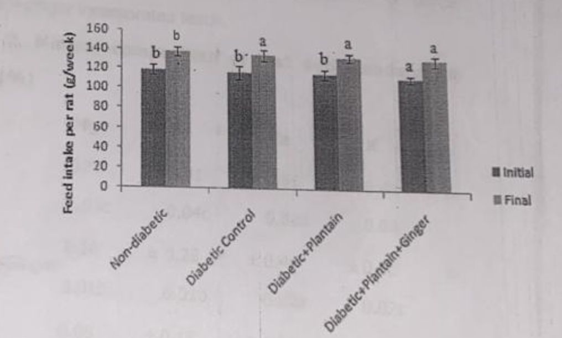

Body weight and percentage change in weight of rats. Values are means ‡ SD. a Means with different superscripts are significantly different.
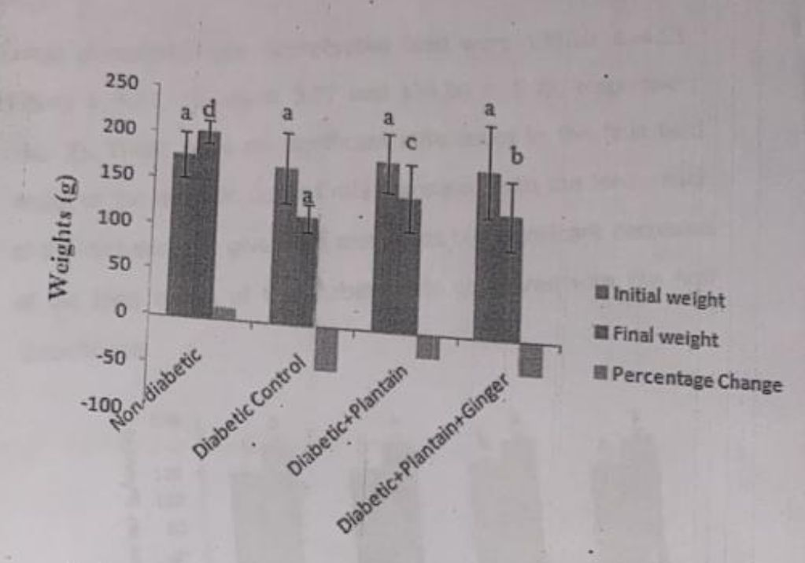

The initial feed intake of the non-diabetic, diabetic, diabetic rats fed unripe plantain incorporated feed and diabetic rats fed unripe plantain ginger incorporated feed were 119.40 ‡ 5.40, 118.00 ‡ 6.70, 118.00 ‡ 4.66 and 114.22 ‡ 3.77 respectively, while the final feed intake of the non-diabetic, diabetic, diabetic rats fed unripe plantain incorporated feed and diabetic rats fed unripe plantain ginger incorporated feed were 139.20 ‡ 4.55, 136.40 ‡ 5.33, 135.66 # 3.77 and 134.00 ‡ 5.25, respectively (Fig. 2). There were no significant differences in the final feed intake of the diabetic control rats compared with the feed intake of the diabetic rats given the test feeds but significant decreases of the feed intake of the diabetic rats compared with the non-diabetic rats
FIG. 2FEED INTAKE PER RAT
Mineral analysis of the test and standard rat feeds showed that the unripe plantain incorporated feed contained significantly higher quantities of Ca compared with the unripe plantain+gingerincorporated feeds, and significantly higher quantities of Mg and Fe compared with the unripe plantain ginger and the standard rat feeds while the standard rat feeds contained significantly higher quantities of Ca than the unripe plantain and unripe plantain ginger incorporated feeds while the unripe plantain +ginger incorporated feeds contained significantly higher quantities of K compared with the unripe plantain or unripe plantain +ginger incorporated feeds.
Table 2. Mineral composition of test and standard rat feeds (%)
Plants Mg Fe Ca K
0.15 士 0.41 士 0.51 士 0.44 士
Plantain
0.03c 0.04c 0.02b 0.02b

0.10 士 0.28 士 0.44 士 0.52 士
Plantain + Ginger
0.01b 0.01b 0.02a 0.02c

0.6 士 0.15 士 1.04 士 0.27 士
Rat feeds
0.02a 0.04a 0.05c 0.03a
Values are means # SD. a-c Means with different super scripts along each column are significantly different Proximate analysis of the test and standard rat feeds showed that the unripe plantain ginger incorporated feed contained the highest crude protein contents amongst the samples investigated while unripe plantain incorporated feed had the least though not significantly different (P>0.05) from that of the standard rat feed (Table 3).
Table 3. Proximate composition of test and standard rat feeds (%)
Plants Crude protein Carbohydrates Crude fat
Plantain 14.33士0.50a 55.96士0.05c 2.59士0.16b
Plantain Ginger 16.28士0.03b 43.12士0.10b 20.44士0.07C
Rat feeds 15.05士1.15a 33.00土3.46a 7.00土1.15a
Values are means’s. ^{a-c} Means with different superscripts along each column are significantly different
The unripe plantain ginger incorporated feed contained the highest crude fat contents amongst the samples investigated while the standard rat feed had the least (Table 3).
4.1 DISCUSSION OF FINDINGS
The choice of 10% ginger being incorporated into the test feeds of the rats of group 4 was because ginger is merely used asa food adjunct or spice not more than 10% of it is added into foods).
The significant decrease in the fasting blood glucose levels of the diabetic rats fed unripe plantain incorporated feed or a combination of unripe plantain and ginger incorporated feed suggests the anti-hyperglycemic actions of the test plants.
However, unripe plantain was found to be more effective in lowering the elevated blood glucose of the diabetic rats compared with its combination with ginger at the dosage used in this study.
The reduction of the body weights of the diabetic control rats despite their increased feed intake is attributed to their hyperglycemic condition, leading to catabolism of structural proteins while the decrease in weight loss after feeding of unripe plantain incorporated feed or a combination of unripe plantain and ginger incorporated feed could be attributed to the ability of the plants to reduce hyperglycemia.
Magnesium is a cofactor of the glycolytic enzyme hexokinase and pyruvate kinase. It also modulates glucose transport Iron influences glucose metabolism, insulin action and it also interferes with insulin inhibition of glucose production by the liver.
Calcium is an important component of intracellular processes that occur within insulin responsive tissues like muscle and adipose tissues. Although the standard rat feeds contained higher quantities of Ca than the unripe plantain and unripe plantain incorporated feeds, consumption of this feed by the diabetic control rats did not modulate their elevated blood glucose levels.

CHAPTER FIVE
5.0 SUMMARY, CONCLUSION AND RECOMMENDATIONS
5.1 SUMMARY
From the study so far, physiochemical properties of unripe and ripe plantain has given details on the proximate analysis and functional properties of the flour. The proximate analysis shows that unripe plantain has less moisture content than ripe plantain flour. The ash content of the sample is the same, the ripe plantain flour has more lipid content than unripe, the crude protein content as the same they have the same carbohydrate content as weli as mineral content.
The functional properties where moisture of the samples differs with the ripe having more moisture than the unripe flour, the swelling power and solubility shows that unripe flour has higher swelling power and solubility than ripe, the unripe plantain shows higher binding capacity than the ripe one, ripe plantain flour has higher PH than unripe plantain flour, unripe plantain flour has higher rehydration than ripe plantain.
Plantain contains many health benefits social and economic benefits. It contains a good percentage of the basic food nutrients which includes energy, carbohydrates, sugars, dietary fibre, fat, protein, vitamins, minerals and water.
Plantain comes in varying varieties, which makes it a useful fruit which can either be eaten raw when ripped, cooked or added to enhance meal presentation and also made into flour.
5.2 CONCLUSION
The study showed the potential of unripe plantain or its combination in the management of diabetes. However, such dietary combination of ginger and unripe plantain at the dosage used in this study was not found to be very effective in the management of diabetes compared with unripe plantain alone.
Further studies are therefore recommended to give some detailed explanation regarding this.
Combination of unripe plain and ginger at the close used in the management of diabetes was not very effective compared with unripe plantain alone.
5.3 RECOMMENDATIONS
The Recommended Daily Allowance for proteins in diabetic patients is 15-20% of the total calories. Thus, the range of proteins in the plantain +ginger incorporated feed or the standard rat feeds fell within the recommended range and the implication is that consumption of the unripe plantain +ginger incorporated feed or standard rat feed by the diabetic animals of groups 4 or 2 could meet their daily protein requirement while the protein contents of the unripe plantain incorporated feed did not meet the required standard.
The Recommended Daily Allowance for fat in diabetic patients is 15-20% of the total calorie.
The Recommended Daily Allowance for carbohydrates iniabetics is 50-70% of the total calorie. Thus the range of carbohydrates in the unripe plantain incorporated feed (approximately 55.96% of total calories) was within their commended range while the range of carbohydrates in the unripe plantain ginger incorporated feeds (43.12%) and the standard rat feed (approximately 33% of the total calorie) did not
Meet the required standard.
We therefore conclude that the higher amounts of Mg and Fe in the unripe plantain feeds compared with the unripe plantain ginger incorporated and standard rat feeds could be one plausible explanation for the higher anti-hyperglycemic action demonstrated by the unripe plantain incorporated feeds compared with the unripe plantain ginger incorporated feed and standard rat feed.

REFERENCES
Al-Amin ZM, Thomson M, Al Qattan KK, Peltonen-Shalaby R, All M.
(2006). Anti-diabetic and hypolipidaemic properties of ginger (Zingiber officinale) in streptozotocin-induced diabetic rats. Br. J. Nutr. 96:660-666.
Divi, SM, Bellamkonda, R, Dasireddy, SK. (2012). Evaluation of antidiabetic and antihyperlipedemic potential of aqueous extract of Moringa oleifera in fructose fed insulin resistant and STZ induced diabetic Wistar rats: A comparativestudy. Asian J. Pharm, Clin. Res.(1):67-72.
Dolly, J, Prashant, K, Rai AK, Shikha, M, Geeta W. (2009). Effect of Moringa oleifera Lam.Leaves aqueous therapy on hyperglycemic rats. . 3. Ethnopharmacol. 123: 392-396.
Emam, MA. (2012). Comparative evaluation of antidiabetic activity of Rosmarinus officinalis Land Chamomile recutita in streptozotocin induced diabetic rats. Agric. Biol. J. N. Am. 3(6):247-252. [Google Scholar]
Eleazu, CO, Eleazu KC, Chukwuma S, Essien UN. (2013). Review of the mechanism of cell death resulting from streptozotocin challenge in experimental animals, itsPage 28practical use and potential risk to humans. J. Diab.Metabolic. Disorders. 12 (60):2-7.
Eleazu, CO, Okafor, PN, Ikpeama Al. (2010). Total antioxidant capacity, nutritional composition and inhibitory activity of unripe plantain (Musa paradisiacae) on oxidative stress in alloxan induced diabetic rabbits. Pak. J. Nutr. 9(11):1052-1057.
Eleazu, CO, Iroaganachi M, Okafor PN, Ijeh II, Eleazu KC.Ameliorative potentials of ginger (Z.Officinale Roscoe) on relative organ weights in streptozotocin induced diabetic rats. Int. J. Biomed. Sci.. 013b;9(2):82-090.
Krentz, AJ, Bailey CJ. Oral anti-diabetic agents: current role in type 2 diabetes mellitus. Drugs. 2005;65(3):385 - 411.
Morakinyo, AO, Akindele, A], Ahmed, Z. (2011). Modulation of antioxidant enzymes and inflammatory cytokines: Possible mechanism of anti-diabetic effect of ginger extracts. Afr.J. Biomed. Res. 14(3):195-202.
National Research Council (NRC) "Guide for the care and use of laboratory animals,". Publication 8523 National Institute of Health Bethesda Md. 1985;USA:22-27.
Ojewole, 3A, Adewunmi CO. (2003). Hypoglycemic effect of methanolic extract of Musa paradisiacee (Musaceae)green fruits in normal and diabetic mice. Methods Find.Exp. Clin. Pharm. 25:453-456.
Okafor, PN, (2010). Anyanwu VO, Onyema HO. The effects ofcassava cyanide on the antioxidant (Glutathione) status and some clinically important enzymes of rats. J. Pharm.Toxicol. 5(7):389-395. [Google Scholar]
Official Methods of Analysis (15th ed): Philip Harris (Holdings) Ltd.
Washington DC. 1990. AOAC Association of OfficialAnalytical Chemists. pp. 836-79.
Pari L, Suman S. (2010). Efficacy of Naringin on hepatic enzymesof carbohydrate metabolism in streptozotocin-nicotinamide induced type 2 diabetic rats. Int. J. Pharm.Biol. Arch. 1(2):280-286.Page 30

