SECURE A CLOUD-BASED HEALTH INSURANCE POLICY USING DATA ENCRYPTION STANDARD (DES)

BY

IBRAHIM ABDULSALAM ABIOLA
ND/23/COM/PT/0177

A PROJECT REPORT SUBMITTED TO THE

DEPARTMENT OF COMPUTER SCIENCE
INSTITUTE OF INFORMATION AND COMMUNICATION TECHNOLOGY, KWARA STATE POLYTECHNIC ILORIN

IN PARTIAL FULFILLMENT OF THE REQUIREMENT FOR THE AWARD OF NATIONAL DIPLOMA (ND) IN COMPUTER SCIENCE

2025
CERTIFICATION
This is to certify that this project was carried out by Ibrahim Abdulsalam Abiola with Matriculation Number ND/23/COM/PT/0177 in the department of Computer Science, Institute of Information and Communication Technology, Kwara State Polytechnic, Ilorin.

------------------------------------- ----------------------
MR. ISIAKA, O.S. Date
(Project Supervisor)

--------------------------------- ----------------------
MR. OYEDEPO, F.S. Date
(Head of Department)

----------------------------------- ---------------------
External Supervisor Date

DEDICATION

ACKNOWLEDGEMENT

TABLE OF CONTENTS
PAGE
Title Page i
Certification ii
Dedication iii
Acknowledgement iv
Table of Contents v – vi
Abstract vii
CHAPTER ONE: GENERAL INTRODUCTION
  - Introduction 1
  - Statement of the Problem 2
  - Aim and Objectives 2
  - Significance of the Study 3
  - Scope of the Study 3
  - Organization of the Report 3
CHAPTER TWO: LITERATURE REVIEW
  - Review of Related Past Works 4
  - Electronic Medical Record Contrast with Paper Based Record 5
2.3 Health Informatics in Many Countries 7
CHAPTER THREE: METHODOLOGY AND ANALYSIS OF THE EXISTING SYSTEM
3.1 Research Methodology 9
3.2 Analysis of the Existing System 9
3.3 Problems of the Existing System 9
3.4 Description of the Proposed System 10
3.5 Advantages of the Proposed System 10
CHAPTER FOUR: DESIGN AND IMPLEMENTATION OF THE SYSTEM
4.1 Design of the System 11
4.1.1 Output Design 11
4.1.2 Input Design 12
4.1.3 Database Design 13
4.1.4 Procedure Design 14
4.2 System Implementation 14
4.2.1 Choice of Programming Language 14
4.2.2 Hardware Requirements 14
4.2.3 Software Requirements 14
4.2.4 Implementation Techniques Used in Details 15
4.3 System Documentation 15
4.3.1 Program Documentation 15
4.3.2 Operating the System 16
4.3.3 Maintaining the System 16
CHAPTER FIVE: SUMMARY, CONCLUSION AND RECOMMENDATION
5.1 Summary 17
5.2 Conclusion 17
5.3 Recommendation 17
References 18
Flowcharts 20
Source Code Listing 29

ABSTRACT
Health insurance is an insurance that covers the whole or a part of the risk of a person incurring medical expenses, spreading the risk over numerous persons. By estimating the overall risk of health care and health system expenses over risk pool, an insurer can develop a routine finance to pay for the health care benefits specified in the insurance agreement online. To guide against manipulation by an unauthorized user, data encryption standard (DES) was used in this system to protect and secure the data. Security is provided for data according to the requirements of client. Cloud computing provides different types of services and deployment model. Every cloud computing model provides the different level of security. This system is implemented using PHP as a server-side programming language, JavaScript for scripting and MySQL for Database.

CHAPTER ONE
GENERAL INTRODUCTION
  - INTRODUCTION
Medical informatics is a scientific discipline that combines medical information with computer science. It is a controlled scientific field of study that focuses on acquiring information, storing, retrieving, and processing medical data in order to interpret knowledge for prediction and decision making. This personal health information is stored, managed, and controlled in a single location on the internet. This facilitates the efficient sharing of medical information. This health information is stored and maintained by the health organization, a third-party service provider, and the data should be secure because it contains critical and sensitive patient data (Rizwana et al., 2016).
Digital technology has drastically altered our daily lives and communication methods. Medicine is a data-driven industry. Maintaining paper-based patient records in healthcare organizations can become difficult over time. Electronic Health Records are used to ensure the smooth flow of information within a healthcare infrastructure. Electronic health record (EHR) systems have the potential to completely digitize the health care system by utilizing clinical information to assist providers in providing higher quality care to their patients. The primary concern with EHRs is the security and privacy of the records. So, in order to maintain such privacy, it is critical to take the necessary precautions to safeguard health records by allowing only authorized users to access them ( Shaikh, Jagrutee & Bandi, 2017). The project proposes a data classification encryption technique for protecting confidential data in records.
In the past, patient information was stored on paper documents, which could result in data loss. To address this, new architectures have been developed to store patient information in the cloud while maintaining the privacy of the data stored in the cloud. Because MHR contains sensitive data, the data in the cloud should be secure. In order to provide security, the patient should be able to control the data so that only legitimate patients can access it. Providing efficient healthcare services has become a difficult problem for governments all over the world. On the one hand, rising health-awareness has resulted in increased demand for health-care services. Governments have limited funds and personnel to devote to this sector.
  - STATEMENT OF THE PROBLEM
Exposing sensitive information to unauthorized parties can result in stigma and embarrassment for the patient. Furthermore, tampering with health record information can completely change its meaning; it is a crime that can result in humiliation to the patient's dignity. When these records are outsourced on a public platform, the task of securing these records becomes even more difficult.
  - AIM AND OBJECTIVES
The project's aim is to provide security for the medical insurance policy system so that proper transactions can take place. Through the following objectives, this project provides a mechanism to combat fraud in the healthcare system.
- Design a system to provide data security in the cloud by utilizing the DES encryption method.
- Design an online system for managing the patient's insurance record.
  - SIGNIFICANCE OF THE STUDY
The system provides a secure platform for patient records; the system will not divulge or expose any of the patient's insurance health records. It improved the credibility of the specific health insurance organization that might use the system.
  - SCOPE OF THE STUDY
This study is limited to the patient's insurance information system, which includes treatments, bills, and payments. This project covers every aspect of the medical system in terms of patient information.
1.6 ORGANISATION OF THE REPORT
This project is divided into five chapters. The first chapter describes the general introduction, the statement of problems, the aims and objectives, the significance of the study, the purpose of the study, the scope and limitations, and the organization of the report. The second chapter examines the related literature under the following headings: industrial training fund, site review, online students industrial training fund, industrial training fund (ITF) new mode of payment, and so on. The third chapter discusses the research methodology, analysis of the existing system, problems with the existing system, description, and advantages of the proposed system. Chapter four examines the system's design, which includes the output, input, database, and procedure design of the system, the implementation, which includes hardware and software support, and the documentation, which includes how to use the system and system maintenance. Chapter five provided a summary, conclusion, and recommendation.
CHAPTER TWO
LITERATURE REVIEW
2.1 REVIEW OF RELATED PAST WORKS
Prashant, Nitish & Jagadish (2012) discovered that by improving on the LSB insertion method and using truly random data arrangement within the cover medical image, textual data can be given an additional level of security. The system's robustness can be increased by using ECC prior to interleaving the data onto the image, which secures the data against channel noise, external interferences, and single bit attacks.
A number of transformations in the health care industry, according to Rizwana-Kowsar, Somasekhar, DivyaShree & Pooja (2016), are driving the use of the Internet as a medium for sharing information among providers, patients, and administrators. New Internet-based health companies are springing up to provide consumers with medical information, tools to help them better monitor their care, and other medical products and services. Existing organizations are using the Internet to change their position, relationships, role, and power in the health care industry by branching out into new areas, often involving direct contact with patients. The more forward-thinking health-care providers are providing customers with Internet-based resources to help them better assess their medical needs and seek appropriate advice. These trends reflect and reinforce ongoing efforts to reduce medical costs by reducing hospital stays and outpatient care, particularly in the emergency department, and by promoting prevention through improved monitoring of wellness, chronic disease, and behavior.
According to Jorge, Diego & Yeison (2015), encryption algorithms are frequently replaced by more secure algorithms. A new algorithm's security is only relative. As described in vulnerability penetration tests19, any algorithm can be broken with sufficient computing resources and time. One mechanism for making an algorithm stronger is to use large encryption keys. However, in scenarios where computing resources are limited, such as in mobile environments, this mechanism is impractical. Nowadays, mobile devices have large amounts of memory, multiple cores, gigabytes of storage, and wide bands such as 4G LTE (LTE). As a result, security is required to protect information from potential attacks in mobile scenarios. The evaluated algorithms in their paper have been reported as insecure by the industry due to previous failures. When these algorithms are combined, however, the security is enhanced.
According to Udofia (2013), our economy would be in jeopardy if computerized medical systems were not used. Since its implementation, this system has done more good than harm in our country, particularly in the health sector. As a result, it not only provides good health with the help of the following factors: accuracy, flexibility, and quick treatment. However, it will also be a significant relief for medical doctors and nurses when attending to patients. This project is well designed with dependability and efficiency as our mainstays, and it has arrived just in time to correct the weaknesses and anomalies in the existing manual method.
According to Sri-Varsha & Suryateja (2014), a patient's health record contains various types of data pertaining to various fields such as dentistry, cardiology, oncology, and so on. Each area's data may also be of various types, such as lab reports, medical treatment, discharge summaries, and so on. Each of these files is organized around a specific attribute. The owner will use Advanced Encryption Standard to upload the files. A patient may want to share specific data with his doctor but not with others. As a result, based on the attributes, the owner will only grant access to that portion of the record to those individuals with whom he wishes to share the data. Furthermore, the data in the database is encrypted in this framework. As a result, even if intruders gain access to the database, they will be unable to read the data in the database. Only authorized individuals in the framework, such as PHR owners and doctors, have access to the data.
2.2 ELECTRONIC MEDICAL RECORD CONTRAST WITH PAPER BASED RECORD
An electronic medical record (EMR) is a computerized medical record created in a care-delivery organization, such as a hospital or doctor's office (Perlin, 2006). Electronic medical records are typically part of a local stand-alone health information system that allows for the storage, retrieval, and modification of records. In the United States-New England Journal of Medicine, paper-based records are still by far the preferred method of recording patient information for the vast majority of hospitals and practices. The majority of doctors are still reluctant to give up their ease of data entry and low cost. However, as simple as it is for the doctor to record medical data at the point of care, they take up a significant amount of storage space when compared to digital records. Most states in the United States require physical records to be kept for a minimum of seven years. The costs of paper and film storage media per unit of information differ dramatically from those of electronic storage media.

When paper records are stored in different locations, bringing them together in a single location for review by a health care provider is time consuming and complicated, whereas electronic records make the process easier. This is especially true for person-centered records, which are impractical to keep unless they are kept electronically (thus difficult to centralize or federate). When paper-based records must be copied, faxed, and transported to multiple locations, the costs of copying, faxing, and transporting are significant when compared to digital record duplication and transfer. Because of these numerous "after-entry" advantages, federal and state governments, insurance companies, and other large medical institutions are heavily promoting the use of electronic medical records.
According to one study, electronic medical records improve overall efficiency by 6% per year, and the monthly cost of an EMR may be offset (depending on the cost of the EMR) by the cost of only a few "unnecessary" tests or admissions (Perlin, 2006). Jerome Groopman questioned these findings, publicly questioning "how such dramatic claims of cost savings and quality improvement could be true" (Hartzband, 2009). However, the increased portability and accessibility of electronic medical records may also increase the ease with which they can be accessed and stolen by unauthorized persons or unscrupulous users when compared to paper medical records, as evidenced by the increased security requirements for electronic medical records included in the Health Information and Accessibility Act and recent large-scale breaches in confidential records reported by EMR users. Concerns about security contribute to the widespread opposition to their use. Handwritten paper medical records may have poor legibility, which can contribute to medical errors. To improve the reliability of paper medical records, pre-printed forms, standardization of abbreviations, and penmanship standards were encouraged.
Standardization of forms, terminology and abbreviations, and data input are all aided by electronic records. The digitization of forms makes data collection for epidemiology and clinical studies easier. EMRs, on the other hand, can be continuously updated (within certain legal limitations). The ability to exchange records between different EMR systems ("interoperability") would improve healthcare delivery coordination in non-affiliated healthcare facilities. Furthermore, data from an electronic system can be used anonymously for statistical reporting in areas such as quality improvement, resource management, and communicable disease surveillance in public health (Judy, 2006).
2.3 HEALTH INFORMATICS IN MANY COUNTRIES
Health informatics (also known as health care informatics, healthcare informatics, medical informatics, nursing informatics, or biomedical informatics) is a branch of information science, computer science, and health care. It is concerned with the resources, devices, and methods required to optimize information acquisition, storage, retrieval, and use in health and biomedicine. Clinical guidelines, formal medical terminologies, and information and communication systems are all examples of health informatics tools. Nursing, clinical care, dentistry, pharmacy, public health, occupational therapy, and (bio) medical research are all areas where it is used.
Informatics was a critical component of the Nazi health-care system, which included Nazi eugenics as one of its guiding principles. New systems and technology, such as electronic punch card tabulating and sorting machines and the science of medical statistics, were used to collect, sort, and analyze personal data on a scale never seen before in human history. Many of the designers of these systems went on to play important roles in the postwar medical informatics field (Baek, 2009). With the rise of computers in the early 1950s, global use of technology in medicine began. Gustav Wager founded the first professional organization for informatics in Germany in 1949. In this reference, the prehistory, history, and future of medical information and health information technology are discussed. During the 1960s, specialized university departments and informatics training programs were established in France, Germany, Belgium, and the Netherlands. Medical informatics research units first appeared in Poland and the United States in the 1970s. Since then, the United States and the European Union have worked to develop high-quality health informatics research, education, and infrastructure. Medical computing, medical computer science, computer medicine, medical electronic data processing, medical automatic data processing, medical information processing, medical information science, medical software engineering, and medical computer technology were some of the early names for health informatics.
The health informatics community is still growing; it is far from mature, but work in the UK by the voluntary registration body, the UK Council of Health Informatics Professions, has suggested eight key constituencies within the domains of information project management, ICT, education and research, clinical informatics, health records (service and business-related), and health informatics service management. These constituencies include professionals working in and for the NHS, as well as those in academia and commercial service and solution providers. Despite the fact that the concept of using computers in medicine emerged as technology advanced in the early twentieth century, it was not until the 1950s that informatics made a real impact in the United States.
It was the most commonly used programming language for clinical applications in the 1970s and 1980s. The MUMPS operating system was used to support MUMPS language specifications. As of 2004, a descendant of this system was being used in the United States Veterans Affairs hospital system. The Veterans Health Information Systems and Technology Architecture, which includes an electronic medical record, is the largest enterprise-wide health information system in the world (VistA). The Computerized Patient Record System (CPRS) is a graphical user interface that allows health care providers to review and update a patient's electronic medical record at any of the VA's over 1,000 health care facilities.
A growing number of commercial vendors began to market practice management and electronic medical records systems in the 1970s. Despite the fact that many products are available, only a small percentage of health practitioners use fully featured electronic health care records systems. In 1968, Homer R. Warner, one of the founding fathers of medical informatics (Gardner, 1999), established the Department of Medical Informatics at the University of Utah. The American Medical Informatics Association (AMIA) has named an award after him for his contributions to informatics in medicine. Since 1997, the Buenos Aires Biomedical Informatics Group, a non-profit organization, has represented the interests of a diverse group of clinical and non-clinical professionals working in the field of health informatics. Its purposes are as follows:
- Encourage the use of computer tools in healthcare, scientific research, and health administration, as well as in all areas related to health sciences and biomedical research.
- Support, promote, and disseminate content-related activities associated with the management of health information and tools that were previously referred to as biomedical informatics.
- Promote collaboration and the exchange of actions generated in the field of biomedical informatics, both in the public and private sectors, at the national and international levels.
- Interact with all scientists and recognized academics to encourage the creation of new instances with the same goal and inspired by the same purpose.
CHAPTER THREE
METHODOLGY AND ANALYSIS OF THE SYSTEM
3.1 RESEARCH METHODOLOGY
The proposed system is based on a web-based system with secure login and registration, Cloud storage for flexible retrieval, and data classification and encryption. Web-based system with password-protected login and registration: With good internet connectivity, a web-based system can be accessed from anywhere, at any time. The system will be designed in such a way that only authorized users will be able to access the necessary data. Both patients and doctors must first register. They will be given a Unique Key after registering, which they will use to access the information.
Cloud storage allows for more flexible retrieval and is a viable alternative: Cloud storage allows for rapid deployment. It has increased accessibility and dependability, as well as the ability to backup and recover data in the event of a disaster. Overall storage costs are low because there is no need to purchase, manage, or maintain expensive hardware, making Cloud storage economically feasible.
Data classification and encryption: Data will be classified based on the sensitivity levels of confidential medical information. Data with a higher level of sensitivity will receive more security attention than data with a lower level of sensitivity. Data will be divided into three categories: authentication information, personal information, and medical tests and reports. Medical tests and reports, as well as financial transactions, require greater protection from unauthorized access than authentication information and personal information. This will be accomplished through the use of Data Encryptions Standard (DES) cryptographic techniques to provide data security based on the associated sensitivity level.
3.2 ANALYSIS OF THE EXISTING SYSTEM
The majority of healthcare systems still use paper medical records. Digitized information is typically not portable, limiting information sharing across healthcare sectors. There is a limited use of technology to facilitate collaboration and coordination among patients, physicians, and the medical community. There were no authentication or security measures in place for patient data or staff data management in the existing computerized medical record management system. The system entails storing and accessing the patient record by any level of clinic staff.
3.3 PROBLEM OF THE EXISTING SYSTEM
The existing system has a number of flaws, which led to the creation of the proposed system. This problem has existed for a long time, and the consequences have had an impact on the technological advancement of healthcare in the modern era; some of these problems are listed below:
- The system necessitates a significant amount of paperwork.
- Unauthorized personnel can easily alter the record.
- Patient record confidentiality does not exist.
- Patient file loss or misplacement
3.4 DESCRIPTION OF THE PROPOSED SYSTEM
The proposed system implements data classification based on data sensitivity levels, i.e. for more sensitive data, a higher level of encryption will be enforced, and for less sensitive data, a lower level of encryption will be used. The system allows the doctor and/or insurer to upload the document, and then the system asks the doctor and/or insurer for his/her secret key, which the system uses along with the doctor and/or insurer and patient information to generate a system generated key to encrypt the document.
3.5 ADVANTAGES OF THE PROPOSED SYSTEM
The following are the benefits of the proposed system that add to the reasons for the proposed system's need:
- Possible elimination of various attacks such as SQL Injection, Cross-Site Scripting, and so on.
- Database security is provided.
- Data retrieval from the database is simple because the system is aware of the classified data.
- It allows for more time for cryptanalysis, increasing the security of electronic healthcare records.
CHAPTER FOUR
DESIGN AND IMPLEMENTATION OF THE SYSTEM
4.1 DESIGN OF THE SYSTEM
System designs necessitate the analyst's imagination. As a result, in order to create an acceptable design, the system analyst must eliminate all prejudice. The system design approach is the method of determining how best computers, in conjunction with other resources, can be used to perform data storage, management, and retrieval for decision making.
4.1.1 OUTPUT DESIGN
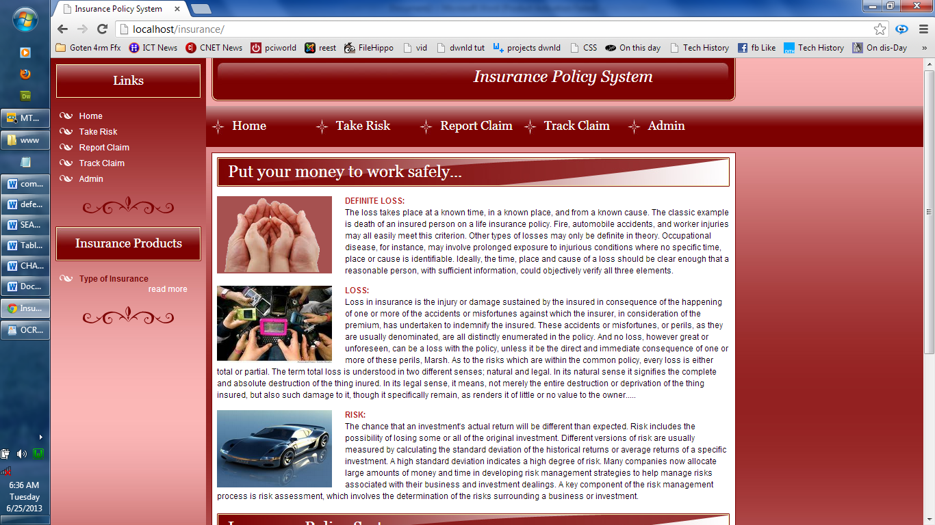
Figure 4.1: The system's default page

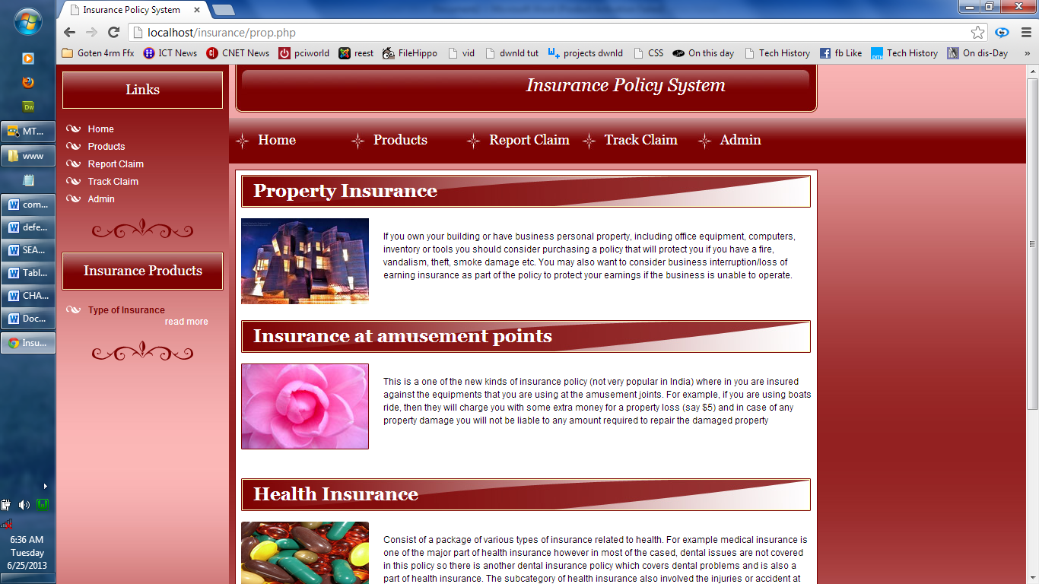
Figure 4.2: The various types of insurance products available in the system

4.1.2 INPUT DESIGN
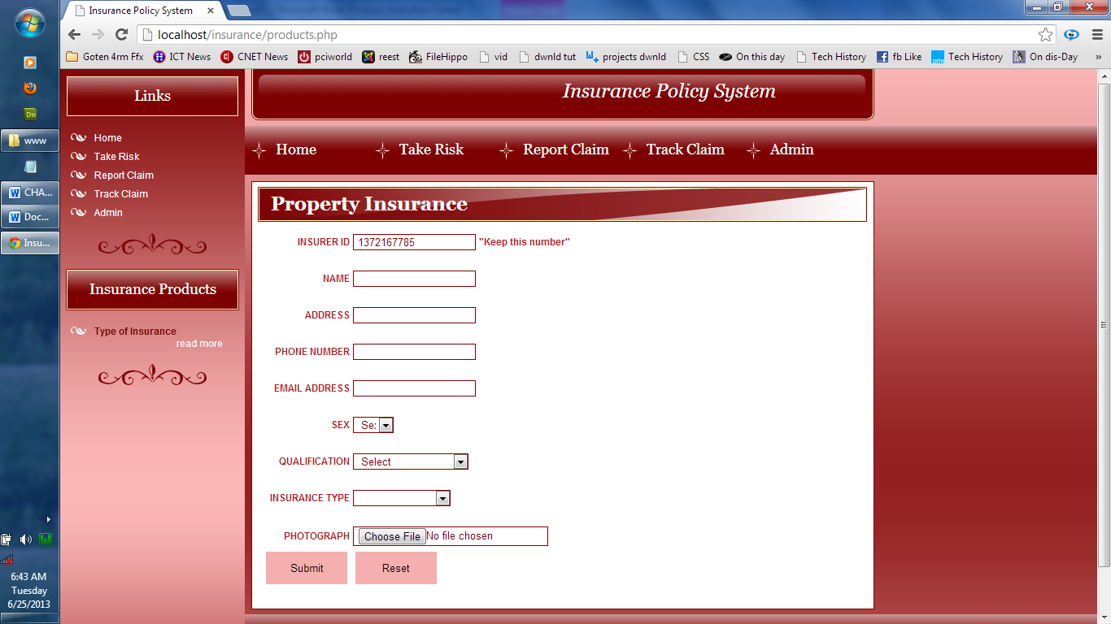
Figure 4.3: This is the screen where the products are entered into the database

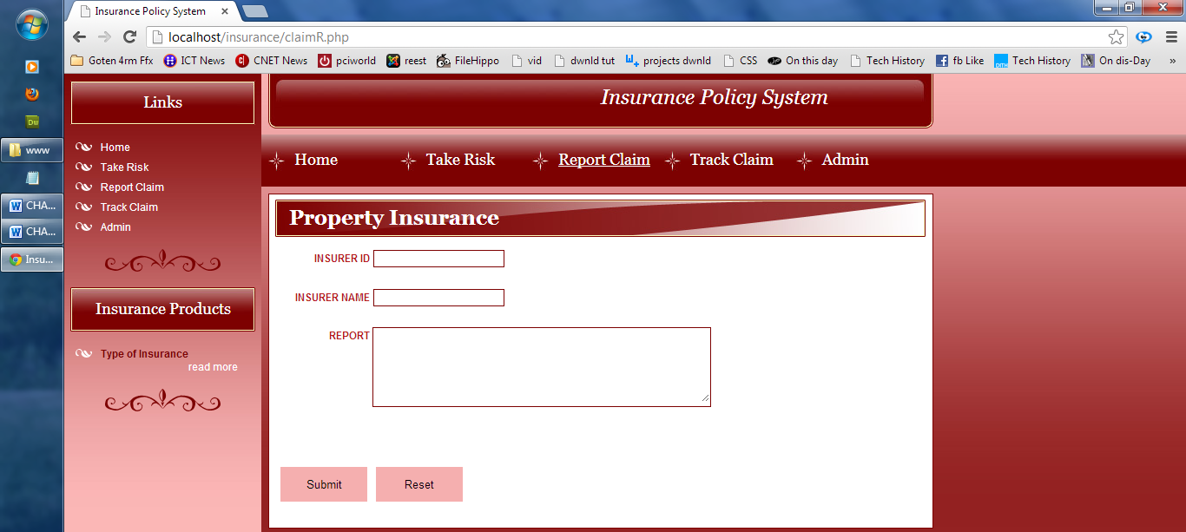
Figure 4.4: This is the location where the products are claimed

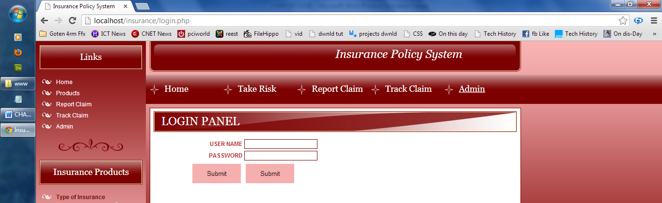
Figure 4.5: The system administrator panel

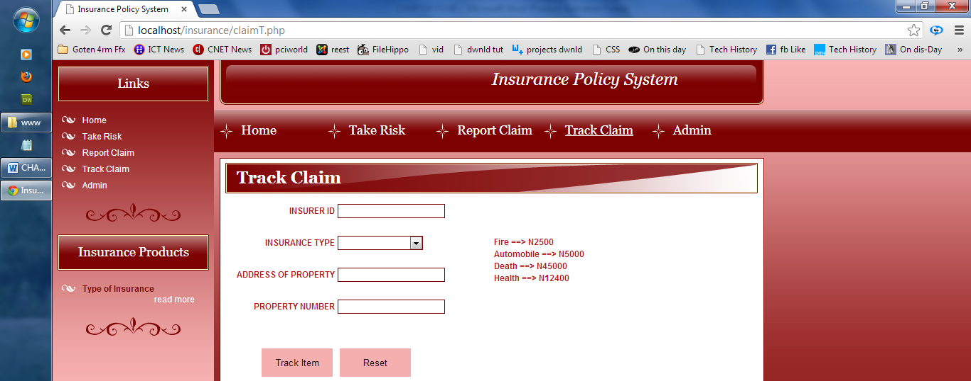
Figure 4.6: This is where a user keeps track of their products
4.1.3 DATABASE DESIGN
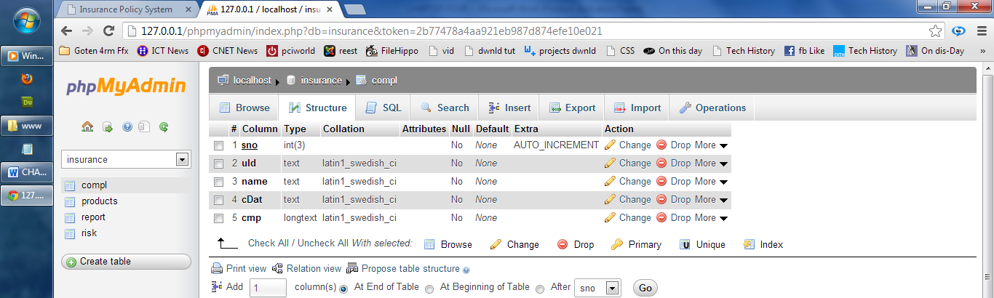
Figure 4.7: The structure of a complaint filed in the system is represented by this database
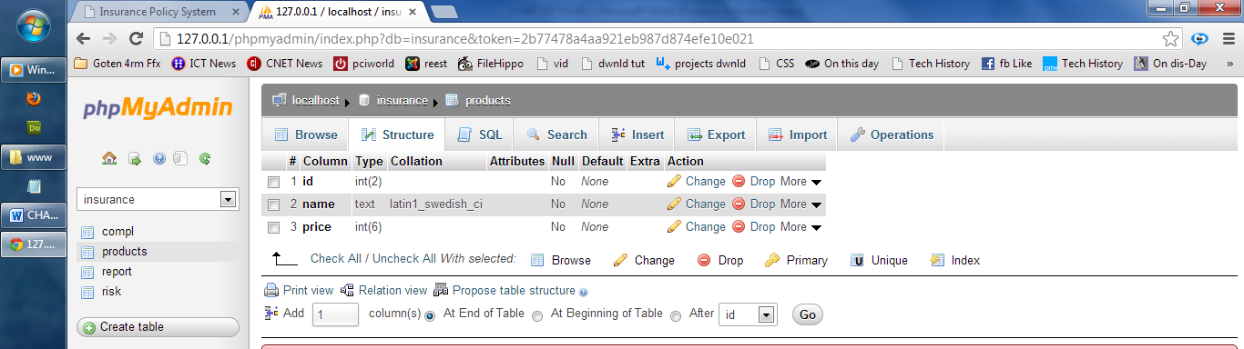
Figure 4.8: This depicts the details of the products in the database
4.1.4 PROCEDURE DESIGN
Procedure design entails gathering all of the documents associated with the application and compiling them into an operation manual. In this case, every effort should be made to ensure that documents are as clear as possible and that the purpose or scope of programming is clear and concise. This application has been designed to be easy to maintain and modify if necessary, or as the case may be, even by the application developer.
4.2 SYSTEM IMPLEMENTATION
4.2.1 CHOICE OF PROGRAMMING LANGUAGE
PHP is the programming language employed in the proposed system. PHP (PHP Hypertext Preprocessor) is a server-side programming language. It is an open source server-side scripting language that has advanced web-based development to a new level of sophistication. The PHP scripting engine is well optimized for the response times required by web applications; it can even be part of the web server itself, increasing throughput even further. If it were simply a matter of increasing the speed of the scripts, PHP would be one of many options. But there's more to the PHP equation than that. The language and scripting engine are both simple and robust. There is connectivity to a growing number of database servers, shorter development cycles, and the ease (encouraged by syntaxes and constructs) of creating modular and reusable components.
4.2.2 HARDWARE SUPPORT
The hardware required is the computer system's basic hardware, which includes:
- VDU (Visual Display Unit),
- Central Processing Unit (CPU),
- Mouse,
- Uninterrupted Power Supply (UPS), and
- Keyboard.
4.2.3 SOFTWARE SUPPORT
The following software is required:
- Any web browser (such as Internet Explorer, Firefox, and others),
- Wamp Server, and
- A network service, whether wired or wireless
4.2.4 IMPLEMENTATION TECHNIQUES USED IN DETAILS
The parallel approach will be used to implement the system. This method is considered because it ensures that the new system is tested alongside the old system to ensure the system's effectiveness and efficiency.
4.3 SYSTEM DOCUMENTATION
4.3.1 PROGRAM DOCUMENTATION
This system is divided into five modules: Home, Take Risk, Report Claim, Track Claim, and Administration. Here's a quick rundown of what they are:
- The system's home page is the default page that is displayed. The first page that the user sees when they launch the application.
- The Take Risk module displays various types of insurance products that system users can purchase.
- The Report Claim module accepts user complaints about insurance policies and benefits.
- Track claim allows the system to access all claims and use the information to upgrade the system as needed. In this module, users can also track products.
- The Admin module provides the system administrator with the ability to add users, view user profiles, and handle all other matters related to the system's smooth operation.
4.3.2 OPERATING THE SYSTEM
- On the computer's desktop, click the Start button.
- Choose all programs.
- Choose a browser, such as Internet Explorer, Mozilla Firefox, or Google Chrome.
- Enter the system's url (Uniform Resource Locator) into the address bar (localhost/insurance/).
4.3.3 MAINTAINING THE SYSTEM
In order to make the most of the system, the following instructions must be strictly followed. Install an anti-virus program and keep it up to date at all times.
CHAPTER FIVE
SUMMARY, CONCLUSION AND RECOMMENDATION
5.1 SUMMARY
A web-based insurance policy application is a large and ambitious project. I am grateful for the wonderful opportunity to work on it. As previously stated, this project has undergone extensive research. I successfully designed and implemented a web-based insurance policy System based on my research work. The work entails defining the manual system of operations in relation to the identified problems, stating the goals of the new system, defining the various specifications, and then implementing the programs. The work was successfully developed using web technologies and a user-friendly scripting language, and the package was tested and improved, resulting in a computerized product registration and claim processing system. The project work cannot be described as perfect, but its benefits cannot be overstated. It has resulted in an increase in processing speed, efficiency, accuracy, and data storage capacity.
5.2 CONCLUSION
The idea of a cashless society is the hope of the future as the world becomes more of a global village run by paperless systems. As a result, more innovations will emerge that will make insurance policies more accessible and affordable. Health insurance is a type of insurance that covers the policyholder's medical expenses. Depending on the health insurance plan selected, the policyholder may be covered for critical illness expenses, surgical expenses, hospital expenses, and so on. This system is intended to accurately store data on the cloud and to capture a patient's state over time. It eliminates the need to locate a patient's previous paper medical insurance records and aids in ensuring data accuracy and legibility. It reduces the risk of data replication because there is only one modifiable file, which means the file is more likely to be up to date and reduces the risk of lost paperwork. Because of data tampering by unauthorized users on cloud assessments, this system is protected by data encryption standard (DES), one of the most well-known cryptographic techniques.
5.3 RECOMMENDATION
This system is hereby recommended for future improvement so as to maintain a high level of patient insurance privacy through the use of multiple cryptographic algorithms.
REFERENCES
Akerlof, G. (2010). The Market for Lemons: Quality Uncertainty and the Market Mechanism. The Quarterly Journal of Economics.
Anderson, L.R. & Mellor, J.M. (2008). Predicting health behaviors with an experimental measure of risk preference. Journal of Health Economics.
Annear, P.L., & Wilkinson, D. et al. (2007). Study of Financial Access to Health Services for the Poor in Cambodia. Phnom Penh, Cambodia Ministry of Health, WHO, AugAID, RMIT University.
Ashraf, N., Karlan, D.S. et al. (2006). Tying Odysseus to the Mast: Evidence from a Commitment Savings Product in the Philippines. The Quarterly Journal of Economics.
Barsky, R.B. et al. (2009). Preference Parameters and Behavioral Heterogeneity: an Experimental Approach in the Health and Retirement Study. The Quarterly Journal of Economics.
Bellemare, C. & Shearer, B.S. (2006). Sorting, Incentives and Risk Preferences: Evidence from a Field Experiment.
Case, A. et al. (2002). Economic Status and the Health in Childhood: The Origins of the Gradient.
Cawley, J. & Philipson, T. (1999). An Empirical Examination of Information Barriers to Trade in Insurance. American Economic Review.
Chiappori, P.A., et al. (2004). Asymmetric Information in Insurance: General Testable Implications, Working Paper.
Currie, J. et al. (2003). Socioeconomic Status And Child Health: Why Is The Relationship Stronger For Older Children? American Economic Review.
Cutler, D. M. and Zeckhauser, R. J. (2008). Adverse Selection in Health Insurance. Frontiers in Health Policy Research.
Fang, H., et al. (2008). Sources of Advantageous Selection: Evidence from the Medigap Insurance Market. Journal of Political Economy.
Finkelstein, A. & McGarry, K. (2006). Multiple Dimensions of Private Information: Evidence from the Long-Term Care Insurance Market. The American Economic Review.
Finkelstein, A. & Poterba, J. (2004). Adverse Selection in Insurance Markets: Policyholder Evidence from the U.K. Annuity Market. Journal of Political Economy.
Giné, X., Townsend, R. M. et al. (2007). Patterns of Rainfall Insurance Participation in Rural India. World Bank Policy Research Working Paper Series, World Bank Policy Research Working Paper No. 4408.
Harrison, G.W. et al. (2007). Naturally Occurring Preferences and Exogenous Laboratory Experiments: A Case Study of Risk Aversion. Econometric.
Jacobson, S. and Petrie, R. (2007). Inconsistent Choices in Lottery Experiments: Evidence from Rwanda. Experimental Economics Center Working Paper Series, Georgia State University.
Jullien, B. et al. (2003). Screening Risk-Averse Agents Under Moral Hazard: Single-crossing and the CARA Case.
Jütting, J.P. (2004). Do Community-based Health Insurance Schemes Improve Poor People’s Access to Health Care? Evidence from Rural Senegal. World Development.
Kimball, M.S. et al. (2007). Imputing Risk Tolerance from Survey Responses. NBER Working Paper Series.
Koufopoulus, K. (2005). Asymmetric Information, Heterogeneity in Risk Perceptions and Insurance: An Explanation to a Puzzle, Working Paper.
Lamiraud, K. et al. (2005). The Impact of Social Health Protection on Access to Health Care, Health Expenditure and Impoverishment. Extension of Social Security Papers: 23, International Labour Organization.
Wagstaff, A. et al. (2007). Extending Health Insurance to the Rural Population: An Impact Evaluation of China’s New Cooperative Medical Scheme. Impact Evaluation Series No. 12, World Bank Policy Research Working Paper 4150.
Wagstaff, A. & Pradhan M. (2005). Health Insurance Impacts on Health and Nonmedical Consumption in a Developing Country. Policy Research Working Paper Series, World Bank Policy Research Working Paper 3563.
PROGRAM FLOWCHART
Report Claim
Start
Track Claim
Stop
Track Risk
Admin

ADMIN FLOWCHART
Start
View Claim Trackers
Available Products
View Claim Report
View Insurers
Return
Is Login Details Correct?
Yes
Enter Login Details
No
VIEW CLAIM REPORTS FLOWCHART
VIEW TRACKER REPORT FLOWCHART
Start
Is Database Empty?
Select Serial No
Open Database
Display Serial No, UserId and Name
Return
Display Track Reports Details
More Operation?
Close Database
Display Empty Database
No
N
Yes
Y
AVAILABLE PRODUCTS FLOWCHART
Start
Is Database Empty?
Select User No
Open Database
Display User No and Insurance Type
Return
Display Tracker Report Details
More Operation?
Close Database
Display Empty Database
No
No
Yes
Yes
VIEW CUSTOMER FLOWCHART
Start
Is Database Empty?
Select Product Id
Open Database
Display product id, name and price
Return
Display Product Details
More Operation?
Close Database
Display Empty Database
No
No
Yes
Yes
Start
Is Database Empty?
Select User Id
Open Database
Display User Id and Username
Return
Display Insurer Details
More Operation?
Close Database
Display Empty Database
No
No
Yes
Yes
TRACK CLAIM FLOWCHART

Yes
Yes
No
Display Empty Database
Save Claim to Database
Is Insurer ID exist?
Enter Insurance Details
No
Close Database
More Operation?
Display Track Information Sent
Return
Open Database
Start
REPORT CLAIM FLOWCHART
More Operation?
Display Report Details Saved Successfully
Return
Close Database
Open Database
Enter Report Details
Start
Save Report to Database
TAKE RISK FLOWCHART
Start
Yes
Enter Insurer Details
No
Open Database
Close Database
Return
Display Insurer Details Saved Successfully
More Operation?
Save Details to Database

SOURCE PROGRAM LISTINGS
INDEX PAGE
<!DOCTYPE html PUBLIC "-//W3C//DTD XHTML 1.0 Strict//EN" "http://www.w3.org/TR/xhtml1/DTD/xhtml1-strict.dtd">
<html xmlns="http://www.w3.org/1999/xhtml">
<head>
<meta http-equiv="content-type" content="text/html; charset=utf-8" />
<title>Insurance Policy System</title>
<meta name="keywords" content="" />
<meta name="description" content="" />
<link href="styles.css" rel="stylesheet" type="text/css" />
</head>
<body>
<div id="futer">
<div id="menu">
<div id="left_bg">
<div id="main">
<div id="left">
<h1>Links</h1>
<ul class="munth">
<li><a href="index.php" class="wite">Home</a></li>
<li><a href="products.php" class="wite">Take Risk</a></li>
<li><a href="claimR.php" class="wite">Report Claim</a></li>
<li><a href="claimT.php" class="wite">Track Claim</a></li>
<li><a href="admin.php" class="wite">Admin</a></li>
</ul><br />
<div class="left_razd"></div><br />
<h1>Insurance Products</h1>
<ul>
<li><strong>Type of Insurance</strong>
<div class="read_left"><a href="prop.php" class="wite">read more</a></div></li>
</ul><br />
<div class="left_razd"></div><br />
</div>
<div id="right">
<div id="header">
<div id="top">Insurance Policy System</div>
<div id="buttons">
<ul>
<li><a href="index.php" title="">Home</a></li>
<li><a href="products.php" title="">Take Risk</a></li>
<li><a href="claimR.php" title="">Report Claim</a></li>
<li><a href="claimT.php" title="">Track Claim</a></li>
<li><a href="login.php" title="">Admin</a></li>
</ul>
</div>
</div>
<div id="right_content">
<h2>Put your money to work safely...</h2>
<div class="text">
<img src="images/claim.png" width="168" height="113" class="img" alt="" />
<span>DEFINITE LOSS:</span> <br />
The loss takes place at a known time, in a known place, and from a known cause. The classic example is death of an insured person on a life insurance policy. Other types of losses may only be definite in theory. Occupational disease, for instance, may involve prolonged exposure to injurious conditions where no specific time, place or cause is identifiable. Ideally, the time, place and cause of a loss should be clear enough that a reasonable person, with sufficient information, could objectively verify all three elements.<br />
</div>
<div class="text">
<img src="images/images28.jpg" width="168" height="113" class="img" alt="" />
<span>LOSS: </span> <br />
Loss in insurance is the injury or damage sustained by the insured in inured. In its legal sense, it means, not merely the entire destruction or deprivation of the thing insured, but also such damage to it, though it specifically remain, as renders it of little or no value to the owner..... <br />
</div>
<div class="text">
<img src="images/car.jpg" width="168" height="113" class="img" alt="" />
<span>RISK:</span> <br />
The chance that an investment's actual return will be different than expected. Risk includes the possibility of losing some or all of the original assessment, which involves the determination of the risks surrounding a business or investment. <br />
</div><br />
<h2>Insurance Policy System</h2>
<div class="text2"> Insurance is the equitable transfer of the risk of a loss, from one entity to another in exchange for payment. It is a form of risk management primarily used to hedge against the risk of a contingent, uncertain loss.<br />
An insurer, or insurance carrier, is a company selling the insurance; the insured, or policyholder, is the person or entity buying the insurance policy. Risk management, the practice of appraising and controlling risk, has evolved as a discrete field of study and practice.<br />
The transaction involves the insured assuming a guaranteed and
industry, but individual entities can also self-insure through saving money for possible future losses.<br /><br />
</div>
</div>
</div>
<!-- content ends -->
<!-- footer begins -->
<div id="footer">Copyright 2013. Designed by <a href="#" title="">Folake</a><br /></div>
<!-- footer ends -->
</div>
<div style="clear: both"></div>
</div>
</div>
</div>
</body>
</html>
TRACK CLAIM
<!DOCTYPE html PUBLIC "-//W3C//DTD XHTML 1.0 Strict//EN" "http://www.w3.org/TR/xhtml1/DTD/xhtml1-strict.dtd">
<html xmlns="http://www.w3.org/1999/xhtml">
<head>
<script language="JavaScript" type="text/javascript">
<!--
function valForm (track){
// Checks if any of the text boxes is empty
if ((track.id.value=="")||(track.insNam.value=="")||(track.report.value=="")){
alert("some text missen");
track.id.focus();
return false;
}
// END
return true;
}
//-->
</script>
<meta http-equiv="content-type" content="text/html; charset=utf-8" />
<title>Insurance Policy System</title>
<meta name="keywords" content="" />
<meta name="description" content="" />
<link href="styles.css" rel="stylesheet" type="text/css" />
</head>
<body>
<div id="futer">
<div id="menu">
<div id="left_bg">
<div id="main">
<div id="left">
<h1>Links</h1>
<ul class="munth">
<li><a href="index.php" class="wite">Home</a></li>
<li><a href="#" class="wite">Take Risk</a></li>
<li><a href="claimR.php" class="wite">Report Claim</a></li>
<li><a href="claimT.php" class="wite">Track Claim</a></li>
<li><a href="admin.php" class="wite">Admin</a></li>
</ul><br />
<div class="left_razd"></div><br />
<h1>Insurance Products</h1>
<ul>
<li><strong>Type of Insurance</strong>
<div class="read_left"><a href="prop.php" class="wite">read more</a></div></li>
</ul><br />
<div class="left_razd"></div><br />
</div>
<div id="right">
<div id="header">
<div id="top">Insurance Policy System</div>
<div id="buttons">
<ul>
<li><a href="index.php" title="">Home</a></li>
<li><a href="products.php" title="">Take Risk</a></li>
<li><a href="#" title="">Report Claim</a></li>
<li><a href="claimT.php" title="">Track Claim</a></li>
<li><a href="login.php" title="">Admin</a></li>
</ul>
</div>
</div>
<div id="right_content">
<h2><strong>Property Insurance</strong></h2>
<div class="text">
<form action="claimRP.php" method="post" enctype="multipart/form-data" id="form1" name="track" onsubmit="return valForm(this);">
<table width="410" border="0" align="center">
<tr>
<td align="right"><span>INSURER ID</span></td>
<td width="94"><input name="id" type="text" class="txt" id="textfield5" value="" /></td>
<td width="186">&nbsp;</td>
</tr>
<tr>
<td align="right">&nbsp;</td>
<td colspan="2">&nbsp;</td>
</tr>
<tr>
<td align="right"><span>INSURER NAME</span></td>
<td colspan="2"><input name="Nam" type="text" class="txt" /></td>
</tr>
<tr>
<td align="right">&nbsp;</td>
<td colspan="2">&nbsp;</td>
</tr>
<tr>
<td width="116" align="right" valign="top"><span>REPORT</span></td>
<td colspan="2" class="txt"><textarea name="report" id="textarea" cols="45" rows="5"></textarea></td>
</tr>
<tr>
<td align="right">&nbsp;</td>
<td colspan="2">&nbsp;</td>
</tr>
<tr>
<td align="right">&nbsp;</td>
<td colspan="2">&nbsp;</td>
</tr>
<tr>
<td align="right">&nbsp;</td>
<td colspan="2">&nbsp;</td>
</tr>
<tr>
<td><input name="button" type="submit" class="btn" id="button" value="Submit" /></td>
<td colspan="2"><input name="button2" type="reset" class="btn" id="button2" value="Reset" /></td>
</tr>
</table>
<br /> </form>
</div>
</div>
</div>
<!-- content ends -->
<!-- footer begins -->
<div id="footer">Copyright 2020. Designed by <a href="#" title="">Folake</a><br /></div><!-- footer ends --></div><div style="clear: both"></div></div></div>/div></body>
</html>

