DESIGN AND IMPLEMENTATION OF COMPUTER BASED TEST (CBT)

BY

OYENIYI MOSES KOREDE
ND/23/COM/PT/0076

A PROJECT REPORT SUBMITTED TO THE
DEPARTMENT OF COMPUTER SCIENCE
INSTITUTE OF INFORMATION AND COMMUNICATION TECHNOLOGY, KWARA STATE POLYTECHNIC ILORIN

IN PARTIAL FULFILLMENT OF THE REQUIREMENT FOR THE AWARD OF NATIONAL DIPLOMA (ND) IN COMPUTER SCIENCE

JUNE, 2025
CERTIFICATION
This is to certify that this project is written by Oyeniyi Moses Korede, with matriculation number ND/23/COM/PT/0076 in Computer Science Department, Institute of Information and Communication Technology, Kwara State Polytechnic, Ilorin.

------------------------------------- ----------------------
MR. ISIAKA, O.S. Date
(Project Supervisor)

--------------------------------- ----------------------
MR. OYEDEPO, F.S. Date
(Head of Department)

----------------------------------- ---------------------
External Supervisor Date

DEDICATION

This project is dedicated to Almighty GOD, the alpha and omega, the beginning and the end, the first and last, protects my life throughout all my ND program and my parents MR & MRS OYENIYI for their blessing over me.

ACKNOWLEDGEMENT

All Glory and Adoration belongs to God Almighty for the success of my ND program through thick and thin. He made this course a reality for me, I also want to acknowledge the support of my parent because without God and my parent am nobody, they have been so supportive financially, physically, spiritual aspect throughout the course of the study.

My sincere Appreciation goes to my supervisor (MR. ISIAKA, O.S.) for taking time to read and correct the manuscript and to my Head of Department of Business Administration and Management (HOD) MR. ALAKOSO I. K and other lectures in Department of Business Administration and Management.

TABLE OF CONTENTS
PAGE
TITLE PAGE i
CERTIFICATION ii
DEDICATION iii
ACKNOWLEDGEMENT iv
TABLE OF CONTENTS v – vii
ABSTRACT viii
CHAPTER ONE: GENERAL INTRODUCTION
  - INTRODUCTION 1
  - STATEMENT OF THE PROBLEM 3
  - AIM AND OBJECTIVES 3
  - SIGNIFICANT OF THE STUDY 4
  - SCOPE AND LIMITATION 4
  - ORGANIZATION OF THE REPORT 4
CHAPTER TWO: LITERATURE REVIEW
  - REVIEW OF RELATED PAST WORKS 5
  - THE CONCEPTUAL MEANING OF COMPUTER BASED TEST 7
  - HISTORICAL DEVELOPMENT OF COMPUTER BASED TEST 8
2.4 APPLICATIONS OF CBTS IN NIGERIA 10
CHAPTER THREE: METHODOLOGY AND ANALYSIS OF THE EXISTING SYSTEM
3.1 RESEARCH METHODOLOGY 12
3.2 ANALYSIS OF THE EXISTING SYSTEM 13
3.3 PROBLEMS OF THE EXISTING SYSTEM 13
3.4 DESCRIPTION OF THE PROPOSED SYSTEM 13
3.5 ADVANTAGES OF THE PROPOSED SYSTEM 14
CHAPTER FOUR: DESIGN, IMPLEMENTATION AND DOCUMENTATION
4.1 DESIGN OF THE SYSTEM 16
4.1.1 OUTPUT DESIGN 16
4.1.2 INPUT DESIGN 17
4.1.3 DATABASE DESIGN 18
4.1.4 PROCEDURE DESIGN 21
4.2 SYSTEM IMPLEMENTATION 22
4.2.1 CHOICE OF PROGRAMMING LANGUAGE 22
4.2.2 HARDWARE AND SOFTWARE REQUIREMENTS 22
4.2.3 IMPLEMENTATION TECHNIQUE USED 23
4.3 SYSTEM DOCUMENTATION 23
4.3.1 PROGRAM DOCUMENTATION 23
4.3.2 OPERATING THE SYSTEM 23
4.3.3 MAINTAINING THE SYSTEM 24
CHAPTER FIVE: SUMMARY, CONCLUSION AND RECOMMENDATION
5.1 SUMMARY OF THE FINDING 25
5.2 CONCLUSION 25
5.3 RECOMMENDATION 25
REFERENCES 27
FLOWCHARTS 29
SOURCE CODE 32
ABSTRACT
As flexible and online learning mediated by ICT becomes more pervasive, there is a growing need for educators to consider modes of assessment using similar tools. Computer Based Test (CBT) is an effective solution for mass education evaluation. Though, a variety of e-assessment approaches and systems have been developed in recent times, yet lack of flexible timing functionality to automatically log-off candidates upon expiration of allotted time, result integrity comprise, stand-alone deployment, lack of flexibility, robustness and scalability as well as human error are major limitations of the existing platforms. In this paper, a web-based online examination system is developed to address these aforementioned drawbacks. The system is designed to facilitate the examination processes and manage challenges surrounding the conduct of examination, auto-submission, auto-marking and examination result report generation. The conceptual design including the Data Flow Diagram (DFD) for the system developed is also presented. The programming tools used for the front-end development of the system are Hypertext Markup Language (HTML) and Microsoft Visual Studio 2012 integrated development environment while Microsoft SQL Server 2008 is used as the database backend.

CHAPTER ONE

GENERAL INTRODUCTION

1.1 INTRODUCTION
Education is basically the motivating force of the society. An examination is the assessment planned to measure the skill, knowledge, physical fitness or aptitude and also classification in so many subjects. An exam may be on paper, on the computer, orally, in exam centers, which are conducted to test, calculate or examine the set of skills. Also the main purpose of the examination is to select the capable candidates for different positions (Rukesh et al 2017). A test or examination is also an assessment intended to measure a test-taker’s knowledge, skill, aptitude, physical fitness, or classification in many other topics (e.g., beliefs). A test may be administered orally, on paper, on a computer, or in a confined area that requires a test taker to physically perform a set of skills. Tests vary in style, rigor and requirements.
In Information Technology (IT), biometrics refers to technologies for measuring and analyzing human physiological characteristics such as fingerprints, eye retinas and irises, voice patterns, facial patterns, and hand measurements, especially for authentication purposes. Examples of behavioral measureable characteristics include signature recognition, gait recognition, speaker recognition and typing recognition. Biometrics authentication is by measuring a person's physiological or behavioral features. In the past, the common perception of biometrics was that they were limited to use by government facilities and high security areas. However, biometrics is becoming more prevalent in day-to-day applications. It is a type of verification that can be used for authentication when using computers for a variety of purposes (Olaniyi et al, 2012).
The fingerprint biometric system is a touch-based recognition system, with comparatively small finger surface exposed to the sensor for feature extraction and comparison, thus leading to relatively high matching speed and accuracy with moderate cost. Due to these advantages, it has become the most widely used and most convenient biometric authentication system (Mahesh et al, 2018). The fingerprint biometric system is a pattern recognition technique that recognizes a person based on a feature vector extracted from the person’s fingerprint pattern.
However, this research is to design and implement an examination file protection system using fingerprint authentication for the National Open University of Nigeria (NOUN). The system is designed on a server-client based architecture with the questions for examinations being set on the server via the Computer Based Assessment (CBA) application. Also registrations of students are done one on one on the server. The server houses the main database of the application as well as the templates for the biometric fingerprint information. The client application connects to the database and template of the server, to verify the last five digits of the matriculation number and password provided by each student before being allowed into the question/test interface, this security system will be designed and developed using php, java script and html as the programming languages and MySQL as the database Management system. The motivation for this project came from our enthusiasm and strong urge to learn website design and development which is one of the fastest growing technologies in today’s world.
The present problems associated by tertiary institution with the conduct of electronic examination and registration for testing the ability of their candidates are lack of resumption capability when power, network and or physical computer’s component failures; Poor integrity of the result due to examination questions passes through so many hands, especially when a private individual is involved. Questions to be uploaded into the server are script which is very tasking and a measure of errors introduced into the questions, scrupulous practices by some administrator in the manipulation of the scores of the students and in ability of the system to keep track of user activities and finally choice randomization distribution within each question must be performed to ensure security, robustness against cheat attempts during examination process and impersonation in the examination hall, as well as conspiracy and collaboration of security agents and officials to compromise the integrity of the examination.
However, the research will allow capturing of examination supervisor fingerprint which will be used to upload examination question into the database and as well as authorized the student to start examination, it will also enable sending of Short Message Service (SMS) notification once the file is unlocked and finally it secure the examination question database with fingerprint authentication which will prevent unauthorized user from accessing the system and take log of activities of each authorized user. This application when implemented will be able to monitor the activities of the examination supervisor by taking screenshots of the user, process capture and capture the content of the index.dat file which will help the security with substantial evidence to prosecute any intruder that tries to manipulate the student record.
1.2 STATEMENT OF THE PROBLEM
The information system is an online examination system that delivers questions set by the lecturers to the student and generates the report of the results of students who take the examination as well as overall examination result summary based on the user’s query. Challenges including examination malpractices, low capacity examination venues, inadequate invigilators, inadequate examination materials, omission of student’s results and human error(s) during the marking / grading process will be automatically eliminated following the adoption of this e-examination system.

1.3 AIM AND OBJECTIVES
The aim of this project is development of an online computer based test.This aim can be achieved with the following objective:
i. To design an online multiple-choice and structured question formats that the CBT system can accommodate.
ii. To develop a user friendly platform for easy accessibility by the students.
iii. To implement automatic grading systems for students who sat for the examination.
1.4 SIGNIFICANT OF THE STUDY
The significant of this research is to encourage the organization to improve the level of security and secrecy provided by the different algorithm for encryption. The message encryption and decryption algorithm is design and implemented to provide confidentially and security in transmission of the message, information and image based data as well as the database storage. This proposed encryption and decryption system can ensure the security.
1.5 SCOPE OF THE STUDY
The scope of the study is limited to the network aspect of computer based test so as to monitor secure data on the platform.
1.6 ORGANIZATION OF THE REPORT
This report consists of five chapters. Chapter one introduces the new system, the aim and objective, its significance, scope of the proposed system, technical term.Chapter two reviewsrelated past works, the conceptual meaning of computer based test, historical development of computer based test, applications of CBTs in Nigeria.Chapter three consists of the research methodology, analysis of the data of the existing system, which include the description of the current procedure, problem of the existing procedure, description of the proposed system and advantage of the proposed system and advantages of the proposed system.
Chapter four reveals the system design, implementation of the system which includes the output input file structure and procedure design of the system. It also contains the implementation techniques used in details, programming language used with reason, hardware and software support with the documentation.Chapter five consists of the summary of all the investigation carried out. Recommendation and conclusion of the report with the experience again and problem encountered during the investigation followed by the reference, flowchart, program listing and computer output.

CHAPTER TWO
LITERATURE REVIEW
2.1 REVIEW OF RELATED PAST WORKS
There have been a number of researches focusing on the development of automated examination systems and electronic learning information systems.
Zhenming et al (2003) developed a novel online examination system based on a Browser/Server framework which carries out automatic grading for objective questions in computer related topics such as programming, Microsoft Windows operating systems and Microsoft Office applications. It was successfully applied to the distance evaluation of basic operating skills of students offering computer science in some Universities.
Lei (2006) presented a web-based educational assessment system by applying Bloom’s taxonomy to evaluate student learning outcomes and teacher instructional practices in real time. The system performance is rather encouraging with experimentation in science and mathematics courses of two local high schools.
Emary & Abu (2006) developed an online website for tutoring and e-examination of economic courses. This novel software tool was used for online examination and tutorial application of the syllabus of economic courses so as to ensure that students study all the concepts of economics. So, the proposed software is structured from two major modules: The first one was an online website to review and make self-test for all materials of economic course. The second part is an online examination using a large database bank of questions through it the level of students can be evaluated immediately and some statistical evaluations can be obtained. The developed software offers the following features:
a) Instructors could add any further questions to maximize the size of the bank of questions.
b) Different examinations for each student with randomly selected questions from the bank of questions can be done.
c) Different reports for the instructors, students, classes etc. can be obtained.
d) Several students can take their exams simultaneously without any problem inside and outside their campus. The proposed software has been designed to work based on the client server architecture.
Ayo et al (2007) proposed a model for electronic examination in Nigeria which enforces all applicants to be subjected to online entrance examination as a way of curbing the irregularities as in the Joint Admissions Matriculation Board (JAMB) examinations. This model was designed and tested in Covenant University, one of the private universities in Nigeria. Findings revealed that the system has the potential to eliminate some of the problems that are associated with the traditional methods of examination such as impersonation and other forms of examination malpractices.
Akinsanmi et al (2010) developed a web application where tests in multiple choice formats could be taken online and graded immediately. The web application relies solely on Microsoft developed technologies. It runs on the Microsoft.net framework, uses the ASP.NET web server, C# as the intermediate language, ADO.NET to interact with the relational database and Microsoft SQL server as the relational database.
Rashad et al (2010) developed an online examination system that carry out the examination and automatic grading for students examinations. The system facilitates conducting examinations, collection of answers, automatically marking the submissions and production of reports for the test. It supports many kinds of questions. It was used via Internet and also suitable for both local and remote examination. The system could help lecturers, instructors, teachers and others who are willing to create new examinations or edit existing ones as well as students participating in the examinations. The system was built using various open source technologies such as PHP, HTML and MYSQL database engine. An automatic grading module was developed to incorporate different examination and question types. The system was tested in the Mansoura university quality assurance center. The test proved the validity of using this kind of web based systems for evaluating students in the institutions with high rate of students. The limitations of the above systems are enormous: these systems are domain / application area-specific, so cannot fit into all deployment area needs; not well secured in terms of data security and integrity; do not present a generalized model for adoption by any user willing to migrate to the e-examination platform; most of the systems are stand-alone applications that only run on distributed networks and thus access is limited to the networked geographical domain.
2.2 THE CONCEPTUAL MEANING OF COMPUTER BASED TEST
Computer based examination requires a system of interconnected computer networks that the Standard Internet Protocol Suite (SIPS) to serve the users. Computer systems which are used for CBT are made of two major components for them to carry out their functions as delivering examination questions they help to store examination questions and allow students to access them. The two parts are hardware and software. Computer hardware refers to the physical components of the computer i.e. the aspect of computer that can be seen, touch and felt. While software refers to the set of instruction that are fed into the system which enable the computer to process information or data, and these are application software (Williams, 2007).
Bennett (2015) asserted that computer-based test represents a modern way of answering an examination questions, replacing the written pen and paper (PNP) format. CBT is a combination of networks, hardware and software as well as means of communication, collaboration and engagement that enables the processing, management and exchange of data, information and knowledge. It can be understood to be a complex of artificial techniques and knowledge for solving instructor’s problem involving marking pen and examination (Bennett, 2015).
Computer–based tests (CBT) are the form of assessment in which the computer is an integral part of question papers’ delivery, response storage, marking of response or reporting of results from a test or exercise. Conole & Warburton (2005) defined CBT as ‘the use of computers for assessing.
2.3 HISTORICAL DEVELOPMENT OF COMPUTER BASED TEST
From the punctual, a considerable length of time of instructive registering in the 1960s it might have been envisaged that exams or tests might be completed around computers, yet all the normally this just recognized completing on the PC what might have been generally completed on paper (Ilesanmi & Lasisi, 2015). Throughout the years different courses in which appraisals could be encouraged by utilizing PCs have been visualized and as a rule attempted (Clarke-Midura and Dede, 2010). Pilots and specialists frequently do PC based exams utilizing test systems, some oral dialect exams have included "talking" into the PC (Pearson Instruction Australia, 2012), drawing and varying media computerized apparatuses have been utilized to present and record exhibitions, and the e-scape extend in the UK had understudies utilizing versatile PCs to record their advance chipping away at handy work (Kimbell, Wheeler, Mill operator& Pollitt, 2007).
An exam should measure some sort of performance and there is a multitude of ways in which this could be done on a computer system using the range of hardware, software and networking options now available. For example, a computer-based exam could be delivered on a stand-alone personal computer or within an isolated Local Area Network (LAN) or use online technologies such as web-pages over the Internet. Technical and administrative methods can be used to assure security and fairness (McNulty et al., 2011). The increasingly sophisticated range of peripheral devices can provide audio-visual and kinaesthetic support to collect an enormous range of types of student responses and evidence of performance.
For more than a decade, researchers at the Centre for Schooling and Learning Technologies (CSaLT) at Edith Cowan University (ECU) have grappled with the multitude of ways in which digital technologies can be used to improve assessment, including with computer-based exams (Newhouse &Njiru, 2009). In so doing we have identified a number of categories of exams or exam items. Traditional exams are based on response items, but an exam could include performance tasks or be based on the production of artefacts(s).
Computer-based response items can provide stimuli using a full range of sensory forms and can allow responses in text, graphic, audio and kinaesthetic forms. Performance task items may involve recording a representation of a performance (e.g. making an audio recording of a talk), simulating a performance on the computer (e.g. demonstrating capability in using virtual equipment), or in some cases the performance is in using software on the computer (e.g. an ICT literacy test). Similarly, production items may involve recording the process of production and/or representing the final artefact(s) (e.g. e-scape project (Kimbell et al., 2007)). Naturally in practice the distinction between these categories of items is not always clear and there may be some blending.
There have been trials of diverse types of PC based exams in various nations including the UK, Norway, Denmark, USA and Australia. In Australia a PC based test was utilized to survey the PC proficiency of 12 and 16-year-old understudies (Clerical Committee on Instruction, Work, Preparing and Youth Undertakings, 2007). The test was developed around a simulated computer environment and utilized using sets of networked laptop computers. While the test was successfullyimplemented with over 7000 students this was over a long period of time and would not be readily scalable. Also, the use of a simulated environment would be expensive and difficult to provide a great enough variety of activities each year. The trial in the UK also involved a multi-million-pound simulated system but was accessed by students through their school computers (Boyle, 2006). In the Norwegian illustration understudies utilized their own legislature gave journal PCs (English Telecom Company, 2009). In the USA progressively, national testing is PC based and PC education will be incorporated inside national testing as is as of now the case in various states (Clarke-Midura and Dede, 2010; Harris, 2008).
Computer-based exams are a part of e-assessment that Ripley (2009) defines as “the use of technology to digitize, make more efficient, redesign or transform assessments and tests” that includes “professional examinations, qualifications, certifications and school tests, classroom assessment and assessment for learning”. He proposes that there are two “drivers” of e-assessment being “business efficiency” and “educational transformation”. E-assessment driven by business efficiency will tend to use digital technologies to support the same forms of assessment traditionally done on paper such as multiple-choice and short answer items. Where the driver is educational transformation then it is likely that the e-assessment will take on different forms and designs to suit the outcomes or the performances to be assessed.
The history of computer-based testing began in the early 1970s with the introduction of the early computers in the 1970s which revealed the potentials of using technology not only for new learning environments but also for completely new settings in the design and administration of tests. E-assessment originated with the PLATO system from the University of Illinois and was commercialized by Control Data Corporation in the 1970s, starting with a computer testing system for National Association of Securities Dealers (now the Financial Industry Regulatory Authority). The testing business grew slowly and is today known as Thomson Prometric. Further expansion of the testing system was occasioned by Pearson VUE in 1994 which was one of the first to use the internet for CBTS. Today many universities and institutions employ the use of computer-based testing.
2.4 APPLICATIONS OF CBTS IN NIGERIA
Computer Based software has come a long way in Nigeria and is more adopted in mass-driven examination. This is to curb time wasting during marking, assessment and provide error free computations and result. A CBT is aimed at providing good execution of examination and evaluation. Recently the Joint Admission Matriculation Board (JAMB), the body responsible for admission into University employed the use of electronic examination in conducting her examinations. Universities, Polytechnic and Secondary schools have adopted this means in assessing and evaluating student’s performance. Some Universities fully or partially implementing the CBTS for assessing their students include the following:
- University of Ibadan in conducting Post Graduate Use of English Test Examination
- Obafemi Awlowo University, Ile Ife
- National Open University of Nigeria (NOUN)
- University of Ilorin, Ilorin
- Federal University of Technology, Minna
- Covenant University, Ota (Private)
- University of Nigeria, Nsukka
- University of Lagos, Lagos
- Kwara State Polytechnic, Ilorin who use it recently for CBS exam.
Furthermore, the Joint Admissions and Matriculation Board(JAMB) which is the national matriculation examination bodyfor admissions into Nigerian higher institutions of learning hasadopted the use of a CBTS for the conduct of its examination.The revolutionary dimensions of this ICT-enhanced servicehas revolutionized the body in attaining almost 100% result.

CHAPTER THREE
METHODOLOGY AND ANALYSIS OF THE EXISTING SYSTEM
3.1 RESEARCH METHODOLOGY
A data flow diagram (DFD) uses a very limited number of primitive symbols to represent the functions performed by a system and the data flow among the functions. Starting with a set of high-level functions that a system performs, a DFD model hierarchy represents various sub-functions. The data flow diagram depicted in figure 3.1 below shows the relationship among the entities in the CBT system. The entity “STUDENT” can take examination after he or she gains access to the system. The entity “LECTURER” can upload questions to be answered by student into the CBT database using any preferred question format, set the examination instructions and configure the correct options or set of options for the questions. The entity “ADMINISTRATOR” is saddled with the responsibility of inserting students, lecturer and setting the default password for the users of the system. The entity “SERVER” is responsible for authenticating the users of the system and also provides the timing functionality for the examination. The system logs off a student upon expiration of duration for the examination.
LECTURER
ADMINISTRATOR
STUDENT
CBT
SYSTEM
Insert
Student
Insert Lecturer
Accept/Reject
Accept/
Reject
Accept/Reject
Set Timer
Give Result
Take Exam
Set Instruction
Insert Questions
Figure 3.1: Data flow diagram for the CBT system

3.2 ANALYSIS OF THE EXISTING SYSTEM
Most schools basically use paper-based test in assessing student’s performance from the junior school to Secondary school. Teacher’s supplies question for typist to type the questions and all students assemble in an examination hall to write and answer questions using OMR sheet. The OMR sheet consist of questions mostly 50 questions having 5 options A, B, C, D and E. The student uses a pencil to tick the correct option corresponding to the questions to be answered. After the exams, the teachers are given some period of time to individually mark the OMR sheet based on what was there assumed answers.
3.3 PROBLEM OF THE EXISTING SYSTEM
- Inaccessibility: Administering paper-based evaluations in-class may exclude certain students from participating. Students who are absent from class, or who have impairments, may not be able to access or complete the evaluation.
- Lower quality data: Peer pressure and in-class evaluation time limits can also negatively affect the quality of the data collected.
- Limited flexibility: Using a paper-based process does not afford much flexibility in terms of the reports that can be generated for instructors and faculty.
- Lengthy process: The process of administering paper-based assessments is a lengthy one. As instructors do not receive results quickly, valuable time is lost in responding to student concerns and implementing possible course changes.
- High cost: The number of personnel involved as well as the printing, distributing, scanning, rekeying, filing and archiving is very costly.

3.4 DESCRIPTION OF THE PROPOSED SYSTEM
The CBT system is composed of two (2) core pages which are the admin page and student page. The admin contains a dashboard which include add new student/registration page, check and edit question page, search panel page, view and edit existing student page and the upload page using CSV format.
A. Student Login Page
This is the page displayed after picking class of the user. It contains the login section for the student to provide his or her details which is used to authenticate the student to gain access to the system. The full name is automatically generated when the required ID is provided.The student logs-in with the matric numberto serve as the user name and his/her surname as password. Simple login system was used in order to get rid of frequentcase of misplaced password or forgetfulness on the part of thestudent.
Question Page: After successfully logging in, the system displays a simple and short summary of the candidate information: matriculation number, student name and his/her picture. Student can view previous and next question in random order from the database, that is, no two questions are alike. On clicking on the submit button, a summary of the result is displayed. Each question is picked randomly from the database and no two students can have the same question. The summary result displays the order in which the question was picked randomly and shows the answer, what he/she picked and Status (FAIL or PASS).
B. Admin Login Page
This page is used by the teacher to logininto the system in other to carry out operations like uploadingquestions and corresponding answers, viewing the result summaryreport to generate a complete list of student’s grade after theirexaminations, registering new students among other things.The lecturer always logs in with a pre-assigned and re-modifiedusername and password.
3.5 ADVANTAGE OF THE PROPOSED SYSYTEM
- Multiple-Test Administrations: Learners can take multiple, short, reliable assessments administered throughout the life of an e-learning program. The data gathered from these assessments can be correlated with national or regional standards so that learners can be measured on these standards.
- Dynamic and Individualized Assessments: Tests can be personalized and tailored to individual students. The level of difficulty of each question can be modulated depending on the learner’s previous responses
- Immediate Grading: Select-response tests (like multiple choice or True/False) can be scored instantly, allowing learners to instantly see how they did on an assessment and online instructors to make real-time instructional changes based on assessment evidence.
- Value-Added Growth Measures: Tests measure individual growth over time, so programs are able to benchmark where learners should be at the end of the year based on tests from the beginning of the year.
- Engaging: The use of computer-based scenarios can make assessments more engaging than standard multiple-choice or essay tests.
- Greater Amount of Test Items: Computer-based assessments, because they draw from a back-end database of test items, typically comprise more test items than fixed paper-and-pencil exams.

CHAPTER FOUR
DESIGN AND IMPLEMENTATION OF THE SYSTEM
4.1 DESIGN OF THE SYSTEM
The design of the system gives the details of the design components that make up the project application. The program design components discuss in this section are the output design, input design, database design and procedure design. Each of the section is explained as follows with a diagram.
4.1.1 OUTPUT DESIGN
The output design covers the mode output presentation of the program, description of the output interface and the specific output medium. The output interfaces are designed in a report form for better presentation and well formatted interpretation of its content. The medium of output varies depending on the choice of the program user.
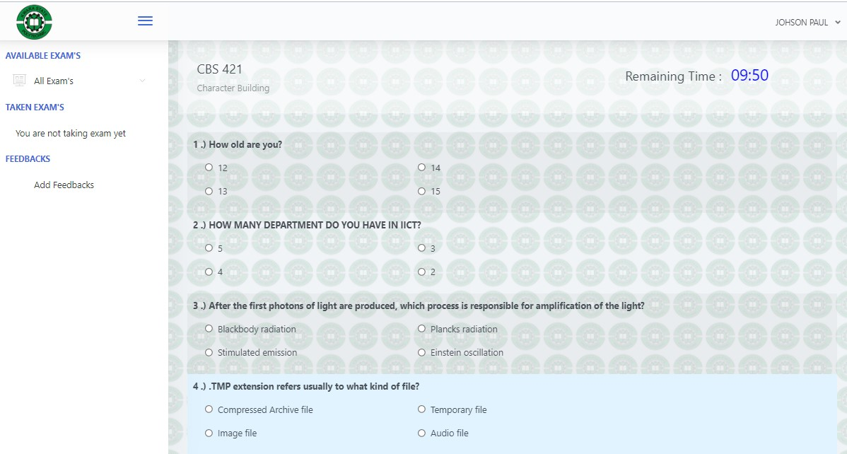
Figure 4.1: Question page (Source: CBT project, 2021)

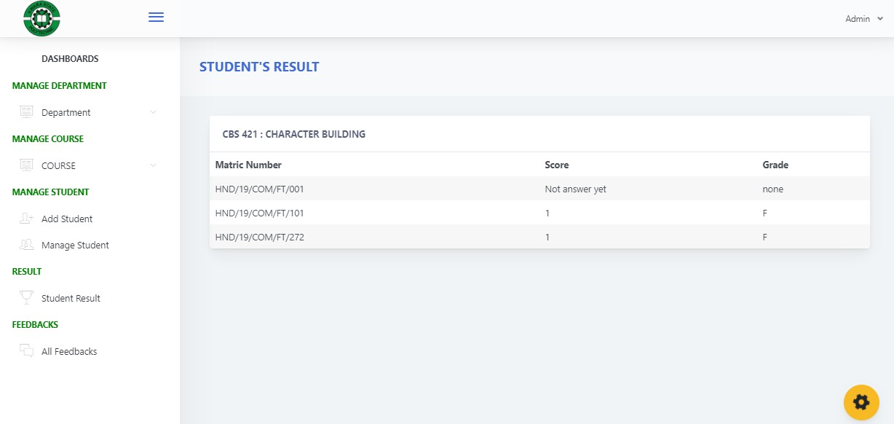
Figure 4.2: Student Result Page (Source: CBT project, 2021)
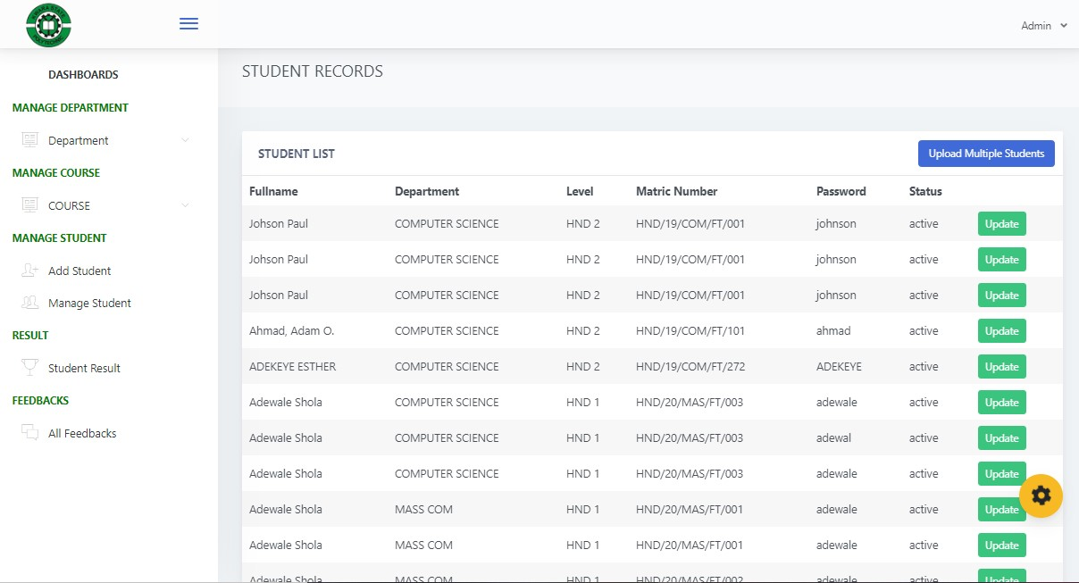
Figure 4.3: Student Record (Source: CBT project, 2021)
4.1.2 INPUT DESIGN
Input design refers to the format or the design of the input format on the screen. Inputs are necessary information needed for processing so as to produce the expected output; which are supplied through the keyboard. The input to the proposed system is shown below.

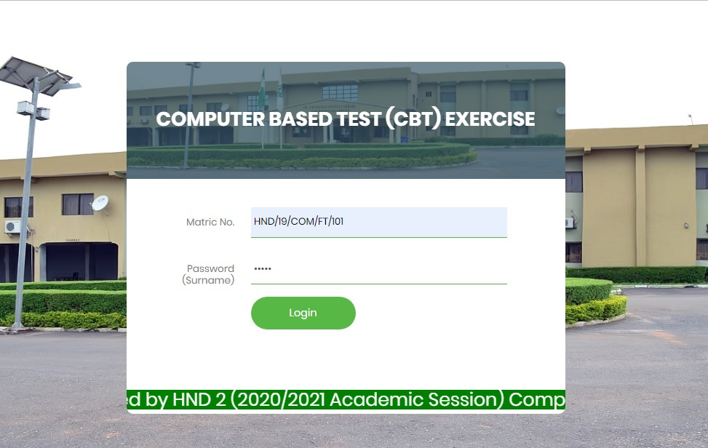
Figure 4.4: Student Login Page (Source: CBT project, 2021)

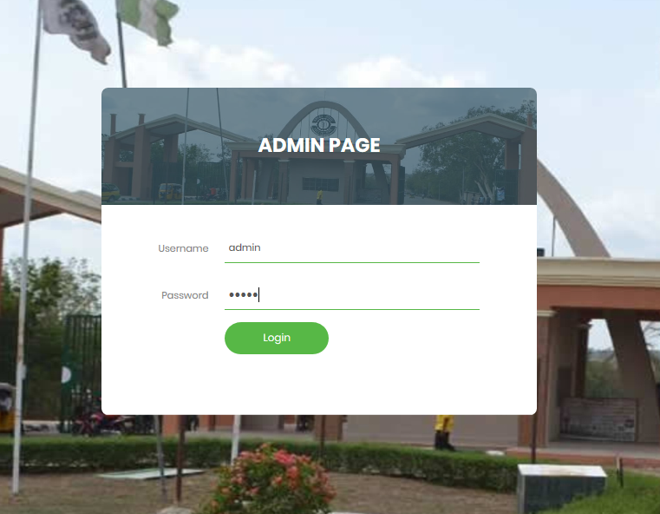
Figure 4.5: Admin Login Page (Source: CBT project, 2021)

4.1.3 DATABASE DESIGN
The structure and organization of records in the tables in a database file is essential to be considered in designing a database driven application. The database file main record where house for keeping data and information relevant for this application. The creation of the database is done using MySQL and file is named “cee_db”. It contains number of tables named as follows:
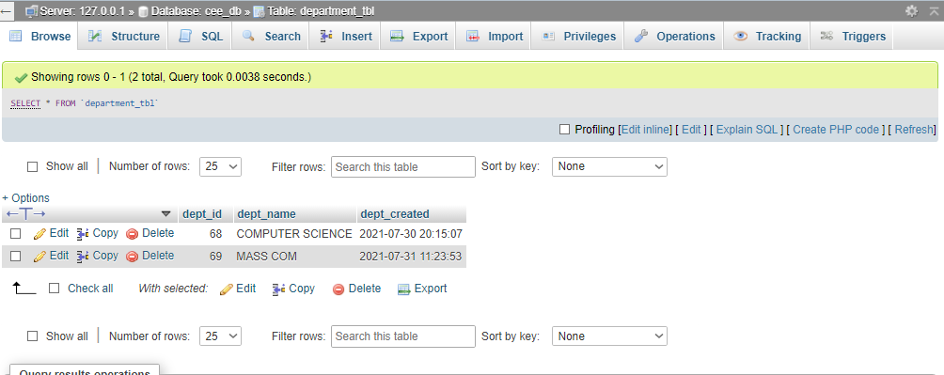
Figure 4.6: Department Table (Source: CBT project, 2021)
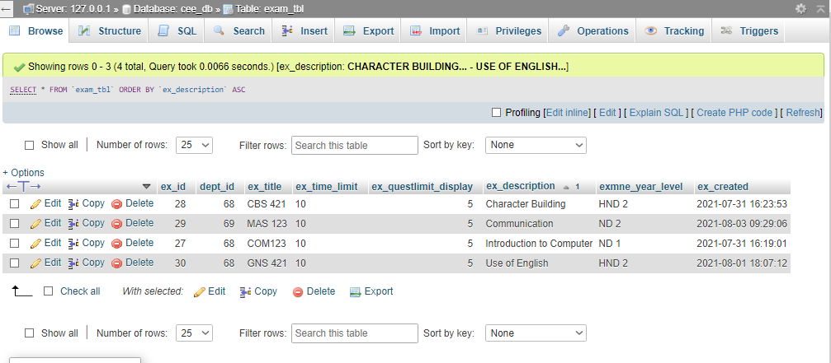

Figure 4.7: Course Table (Source: CBT project, 2021)

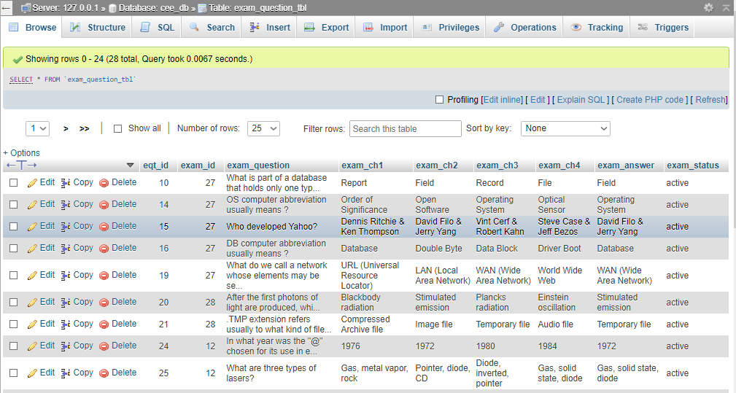

Figure 4.8: ExamQuestion Table (Source: CBT project, 2021

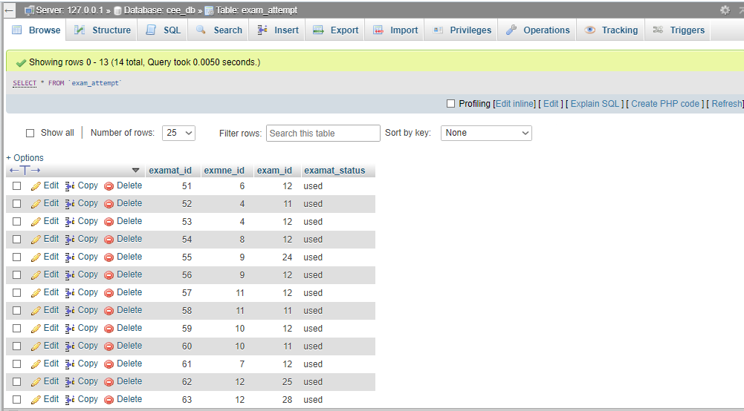
Figure 4.9: ExamAttempt Table (Source: CBT project, 2021)
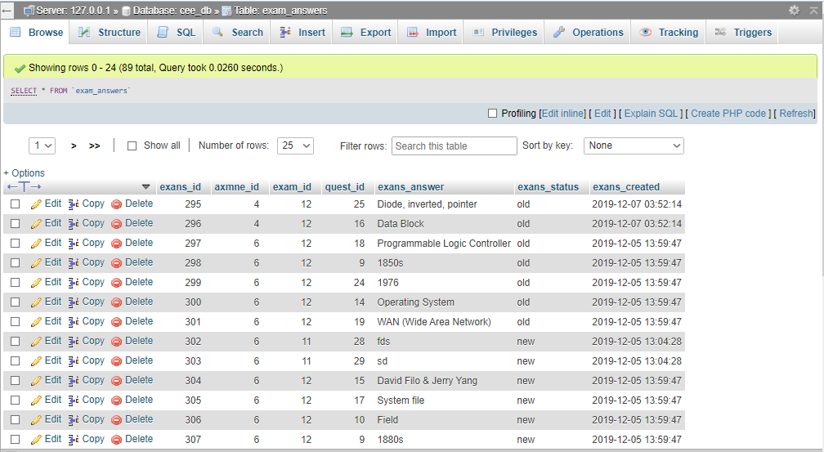

Figure 4.10: ExamAnswer Table (Source: CBT project, 2021)
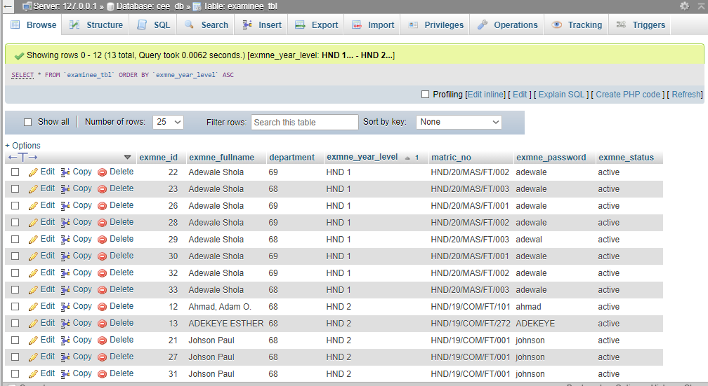

Figure 4.11: Student Table (Source: CBT project, 2021)
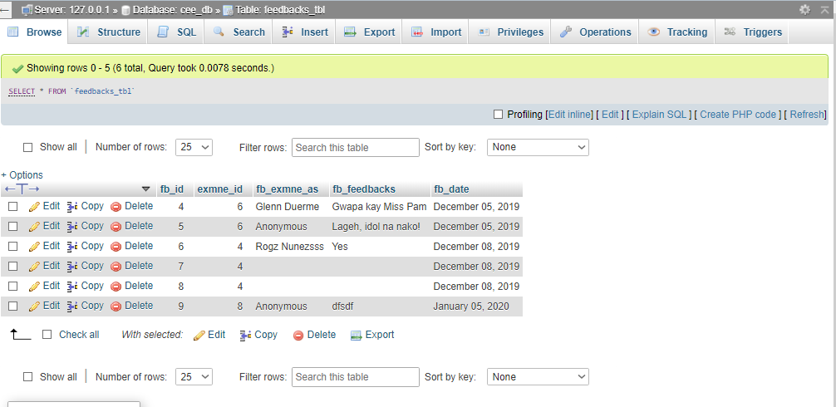

Figure 4.12: Feedback Table (Source: CBT project, 2021)
4.1.4 PROCEDURE DESIGN
This refers to the step by step method of using the proposed system. The proposed system comprises of the Login screen, Question screen, Logout screen etc.

4.2 SYSTEM IMPLEMENTATION
This section presents the implementation of the different modules of the CBTS and the testing of these modules to ensure that they function in accordance with the Computer Based Testing System (CBTS) requirements.
4.2.1 CHOICE OF PROGRAMMING LANGUAGE
The programming language used is PHP. PHP is a server side scripting that is used to develop static websites or dynamic websites or web applications. PHP stands for Hypertext Pre-processor, that earlier stood for Personal Home Pages. PHP can only be interpreted on a server that has PHP installed. The client computer accessing the PHP scripts requires a web browser only.Some features of PHP are:
- PHP is a server side scripting language (i.e you only need to install it on the server and client computers requesting for resources from the server do not need to have PHP installed; only a web browser would be enough).
- PHP has in-built support for working hand in hand with MySQL.
- PHP is easy to learn and runs efficiently on the server side.
- PHP runs on various platforms (Windows, Linux, Unix, Mac OS X, etc).
- Most web hosting servers support by default unlike other languages.
- PHP is regular updated to keep abreast with the latest technology trends.
4.2.2 HARDWARE SUPPORT
The software application designed needed the following hardware for effectiveoperation of the newly designed system:
- Core 2 duo and above system with a processor speed of 500MHz.
- The Random-Access Memory (RAM) should be at least 500MB.
- Enhanced Keyboard and Mouse.
- At least 80GB Hard Disk.
- VGA or SVGA colored monitor to be able to achieve the effective user friendliness of the program.
- An Uninterruptible Power Supply (UPS) Units.
- Voltage Stabilizer: This facilitates the regulation of voltage needed by the computer system in order to avoid electrical damage of the system.
4.2.3 SOFTWARE SUPPORT
The software requirements for this system include:
- A Windows 7, 8, or 10 Operating System.
- Structured Query Language (MySQL)
- PHP console
- HTML
- Apache server
4.2.4 IMPLEMENTATION TECHNIQUES
The implementation is the process of putting theories into practice i.e all the system design being written are put to test and properly handed over. The language used for implementing this system is “PHP” and “MySQL” for the database for easy understanding, accessibility and efficiency in data management.

4.3 SYSTEM DOCUMENTATION
4.3.1 DOCUMENTATION OF THE PROGRAM
Documentation is very important in the development of any software application. This is because documentation makes the software application easier to all users, and if an application is not well documented it becomes difficult to use.
4.3.2 OPERATING THE SYSTEM
The program is packaged in a deployable package for easy installation on the server system. The program is started on the server system and accessed on the client system using the web browser.Launch the web browser (i.e Google Chrome). At the start of the web browser, input the localhost URL and wait for the page to load which takes between 2-5 seconds (depending on the system speed) before the login form displays. The login form has spaces for the entry of student Matric No and password. The system accepts the user inputs, validates them and authenticate the user. Access is granted if the Matric No and password match the correct specification and access is denied if otherwise.The granting of user access displays the exam page which allows the respective student to select answer to the questions displayed and submit when done.
4.3.3 MAINTAINING THE SYSTEM
This is the act of affecting minor changes and corrections to an operational system to meet the requirements that arise in the normal course of events.The task involved are essentially the summary of the functions defined in the system development and must accomplished in accordance with the procedures for authorizing changes, making changes to the system and retest before the changed system is permanently put into fully operations.Any changes to the system must be properly documented for future referencing, would there be any problem arising from changes. More so, the changes must be subject to approval of the administrator of the system.

CHAPTER FIVE
SUMMARY, RECOMMENDATION AND CONCLUSION
5.1 SUMMARY OF THE FINDING
In an evolving and technologically-driven world, the need for a computerized examination system in our secondary school cannot be overemphasized. The information system is an online examination system that delivers questions randomly set by the teachers to the student and generates the report of the results of students who take the examination as well as overall examination result summary. In this project, a CBT system is developed and deployed in schools using Component Based Software model. Using this model provided the CBT software with independent extensions, component market, interactions between components and reduced cost in deployment of the software. There are challenges involved in using CBSE as maintenance cost and timing to develop software components takes a big effort. The cost implication of conducting a mass-driven examination will become drastically and significantly reduced as there will be no need to print questions or answer booklets anymore.
5.2 CONCLUSION
In this research, a CBT system is developed and proposed for adoption in Nigerian Universities. The information system is an online examination system that delivers questions set by the lecturers to the student and generates the report of the results of students who take the examination as well as overall examination result summary based on the user’s query. The system will definitely reduce drastically the problems of human interference, impersonation, bribe-taking by lecturers, invigilators and supervisors, too much paper work, examination leakages and also reduce the number of invigilators needed for invigilation.

5.3 RECOMMENDATION
However, future research work should accommodate theory-based questions as opposed to only the multiple-choice and structured question formats that the CBT system currently accommodates. Also, provision for ideo-based e-assessment can be investigated.Adding more effective security which may include biometric fingerprint authentication, picture capture and data encryption and decryption to the existing design.

REFERENCES
Lei, H. (2006). A novel web-based educational assessment system with Bloom’s Taxonomy. Current Developments in Technology-Assisted Education, 1861-1865.
Zhenming, Y.Y., Liang, Z. & Guohua, Z. (2003). A novel web-based online examination system for Computer Science education. 33rd ASEE/IEEE Frontiers in Education Conference, S3F-7-S3F-10.
Emary, I.M.M. & Abu, J.A.A. (2006). An online website for tutoring and e-examination of economic course. American Journal of Applied Sciences, 3(2), 1715-1718.
Ayo, C.K., Akinyemi, I.O., Adebiyi, A.A. & Ekong, U.O. (2007). The prospects of e-examination implementation in Nigeria. Turkish Online Journal of Distance Education, 8(4), 125-135.
Rashad M.Z., Kandil, M.S., Hassan, A.E. & Zaher, M.A. (2010). An Arabic web-based exam management system, International Journal of Electrical & Computer Sciences, 10(1), 48-55.
Newhouse, C.P. & Njiru, J. (2009). Using digital technologies and contemporary psychometrics in the assessment of performance on complex practical tasks. Technology, Pedagogy and Education, 18(2), 221–234.
McNulty, J.A, Sonntag, B & Sinacore, J. (2011). Test-taking behaviors on a multiple-choice exam are associated with performance on the exam and with learning style. Journal of the International Association of Medical Science Educators 2007; 17(1).
Kimbell, R., Wheeler, T., Miller, A. & Pollitt, A. (2007). e-scape: e-solutions for creative assessment in portfolio environments. London: Technology Education Research Unit, Goldsmiths College.
Ilesanmi, O.A. & Lasisi, F.A. (2015). Nexus of Change Management on Organizational Performance and Survival in Nigerian Universities: A Case Study of University of Ilorin. International Journal of Business and Management Review, 3(4), 66 – 81.
Boyle, A. (2006). An evaluation of the decision to base the key stage 3 ICT test on a bespoke virtual desktop environment. London, U.K: Qualifications and Curriculum Authority.
Clarke-Midura, J. & Dede, C. (2010). Assessment, technology, and change. Journal of Research on Technology in Education, 42(3), 309–328.
Bennett, R. E. (2015). The Changing Nature of Educational Assessment. Review of Research in Education, 39(1), 370-407.
Conole, G., & Warburton, B. (2005). A Review of Computer Assisted Assessment. ALT-J,Research in Learning Technology 13(1), 17-31.
Williams, B. (2007). Students’ perception of pre-hospital web-based examinations. International Journal of Education and Development using Information and Communication Technology, 3(1),, 54-63.

SYSTEM ACTIVITIES FLOWCHART
START
Authenticate Student
Eligible?

Questions = 50? Or Time = 30mins
Compute Result

Display Result

END

YES
NO
Display Message

YES
Generate Question

Randomize Question

NO
Display Question

ADMIN MENU FLOWCHART

Start
Login

Admin
Dashboard

Add/Manage Department

Add/Manage Student
Add/Manage Exam
View Result
View Student Feedback
Assign Department
Assign Course(s)
End
Set/update Question
Ranking by Exam

STUDENT FLOWCHART
AutomaticallyStopUser
Forward Result to Database

HastheTimeforExamElapsed?

Stop
Display Message

Yes
No
Start
Input Matric Number and Password

Select Exam

IstheMatricNoandPasswordValid?

HasTheExam Already Taken?

StartExam
Yes
No
Input Answer
Yes
No

SOURCE CODE
<?php
session_start();
if(!isset($_SESSION['examineeSession']['examineenakalogin']) == true) header("location:index.php");
?>
<?php include("conn.php"); ?>
<!-- MAO NI ANG HEADER -->
<?php include("includes/header.php"); ?>
<!-- UI THEME DIRI -->
<div class="app-main" style="background-image: url(login-ui/images/logo.png);">
<!-- sidebar diri -->
<?php include("includes/sidebar.php"); ?>
<!-- Condition If unza nga page gi click -->
<?php
@$page = $_GET['page'];
if($page != '')
{
if($page == "exam")
{
include("pages/exam.php");
}
else if($page == "result")
{
include("pages/result.php");
}
else if($page == "myscores")
{
include("pages/myscores.php");
}

}
// Else ang home nga page mo display
else
{
include("pages/home.php");
}
?>
<!-- MAO NI IYA FOOTER -->
<?php include("includes/footer.php"); ?>
<?php include("includes/modals.php"); ?>
index
<?php
session_start();
if(isset($_SESSION['examineeSession']['examineenakalogin']) == true) header("location:home.php");
?>
<?php
include("login-ui/index.php");
?>
<script type="text/javascript" src="js/jquery.js"></script>
<script type="text/javascript" src="js/ajax.js"></script>
<script type="text/javascript" src="js/sweetalert.js"></script>
<!doctype html>
<html lang="en">
<head>
<meta charset="utf-8">
<meta http-equiv="X-UA-Compatible" content="IE=edge">
<meta http-equiv="Content-Language" content="en">
<meta http-equiv="Content-Type" content="text/html; charset=utf-8"/>
<title>Analytics Dashboard - This is an example dashboard created using build-in elements and components.</title>
<meta name="viewport" content="width=device-width, initial-scale=1, maximum-scale=1, user-scalable=no, shrink-to-fit=no" />
<meta name="description" content="This is an example dashboard created using build-in elements and components.">
<meta name="msapplication-tap-highlight" content="no">
<!--
=========================================================
* ArchitectUI HTML Theme Dashboard - v1.0.0
=========================================================
* Product Page: https://dashboardpack.com
* Copyright 2019 DashboardPack (https://dashboardpack.com)
* Licensed under MIT (https://github.com/DashboardPack/architectui-html-theme-free/blob/master/LICENSE)
=========================================================
* The above copyright notice and this permission notice shall be included in all copies or substantial portions of the Software.
-->
<link href="./main.css" rel="stylesheet"></head>
<body>
<div class="app-container app-theme-white body-tabs-shadow fixed-sidebar fixed-header">
<div class="app-header header-shadow">
<div class="app-header__logo">
<div class="logo-src"></div>
<div class="header__pane ml-auto">
<div>
<button type="button" class="hamburger close-sidebar-btn hamburger--elastic" data-class="closed-sidebar">
<span class="hamburger-box">
<span class="hamburger-inner"></span>
</span>
</button>
</div>
</div>
</div>
<div class="app-header__mobile-menu">
<div>
<button type="button" class="hamburger hamburger--elastic mobile-toggle-nav">
<span class="hamburger-box">
<span class="hamburger-inner"></span>
</span>
</button>
</div>
</div>
<div class="app-header__menu">
<span>
<button type="button" class="btn-icon btn-icon-only btn btn-primary btn-sm mobile-toggle-header-nav">
<span class="btn-icon-wrapper">
<i class="fa fa-ellipsis-v fa-w-6"></i>
</span>
</button>
</span>
</div><div class="app-header__content">
<div class="app-header-left">
<div class="search-wrapper">
<div class="input-holder">
<input type="text" class="search-input" placeholder="Type to search">
<button class="search-icon"><span></span></button>
</div>
<button class="close"></button>
</div>
<ul class="header-menu nav">
<li class="nav-item">
<a href="javascript:void(0);" class="nav-link">
<i class="nav-link-icon fa fa-database"></i>
Statistics
</a>
</li>
<li class="btn-group nav-item">
<a href="javascript:void(0);" class="nav-link">
<i class="nav-link-icon fa fa-edit"></i>
Projects
</a>
</li>
<li class="dropdown nav-item">
<a href="javascript:void(0);" class="nav-link">
<i class="nav-link-icon fa fa-cog"></i>
Settings
</a>
</li>
</ul></div>
<div class="app-header-right">
<div class="header-btn-lg pr-0">
<div class="widget-content p-0">
<div class="widget-content-wrapper">
<div class="widget-content-left">
<div class="btn-group">
<a data-toggle="dropdown" aria-haspopup="true" aria-expanded="false" class="p-0 btn">
<img width="42" class="rounded-circle" src="assets/images/avatars/1.jpg" alt="">
<i class="fa fa-angle-down ml-2 opacity-8"></i>
</a>
<div tabindex="-1" role="menu" aria-hidden="true" class="dropdown-menu dropdown-menu-right">
<button type="button" tabindex="0" class="dropdown-item">User Account</button>
<button type="button" tabindex="0" class="dropdown-item">Settings</button>
<h6 tabindex="-1" class="dropdown-header">Header</h6>
<button type="button" tabindex="0" class="dropdown-item">Actions</button>
<div tabindex="-1" class="dropdown-divider"></div>
<button type="button" tabindex="0" class="dropdown-item">Dividers</button>
</div>
</div>
</div>
<div class="widget-content-left ml-3 header-user-info">
<div class="widget-heading">
Alina Mclourd
</div>
<div class="widget-subheading">
VP People Manager
</div>
</div>
<div class="widget-content-right header-user-info ml-3">
<button type="button" class="btn-shadow p-1 btn btn-primary btn-sm show-toastr-example">
<i class="fa text-white fa-calendar pr-1 pl-1"></i>
</button>
</div>
</div>
</div>
</div></div>
</div>
</div><div class="ui-theme-settings">
<button type="button" id="TooltipDemo" class="btn-open-options btn btn-warning">
<i class="fa fa-cog fa-w-16 fa-spin fa-2x"></i>
</button>
<div class="theme-settings__inner">
<div class="scrollbar-container">
<div class="theme-settings__options-wrapper">
<h3 class="themeoptions-heading">Layout Options
</h3>
<div class="p-3">
<ul class="list-group">
<li class="list-group-item">
<div class="widget-content p-0">
<div class="widget-content-wrapper">
<div class="widget-content-left mr-3">
<div class="switch has-switch switch-container-class" data-class="fixed-header">
<div class="switch-animate switch-on">
<input type="checkbox" checked data-toggle="toggle" data-onstyle="success">
</div>
</div>
</div>
<div class="widget-content-left">
<div class="widget-heading">Fixed Header
</div>
<div class="widget-subheading">Makes the header top fixed, always visible!
</div>
</div>
</div>
</div>
</li>
<li class="list-group-item">
<div class="widget-content p-0">
<div class="widget-content-wrapper">
<div class="widget-content-left mr-3">
<div class="switch has-switch switch-container-class" data-class="fixed-sidebar">
<div class="switch-animate switch-on">
<input type="checkbox" checked data-toggle="toggle" data-onstyle="success">
</div>
</div>
</div>
<div class="widget-content-left">
<div class="widget-heading">Fixed Sidebar
</div>
<div class="widget-subheading">Makes the sidebar left fixed, always visible!
</div>
</div>
</div>
</div>
</li>
<li class="list-group-item">
<div class="widget-content p-0">
<div class="widget-content-wrapper">
<div class="widget-content-left mr-3">
<div class="switch has-switch switch-container-class" data-class="fixed-footer">
<div class="switch-animate switch-off">
<input type="checkbox" data-toggle="toggle" data-onstyle="success">
</div>
</div>
</div>
<div class="widget-content-left">
<div class="widget-heading">Fixed Footer
</div>
<div class="widget-subheading">Makes the app footer bottom fixed, always visible!
</div>
</div>
</div>
</div>
</li>
</ul>
</div>
<h3 class="themeoptions-heading">
<div>
Header Options
</div>
<button type="button" class="btn-pill btn-shadow btn-wide ml-auto btn btn-focus btn-sm switch-header-cs-class" data-class="">
Restore Default
</button>
</h3>
<div class="p-3">
<ul class="list-group">
<li class="list-group-item">
<h5 class="pb-2">Choose Color Scheme
</h5>
<div class="theme-settings-swatches">
<div class="swatch-holder bg-primary switch-header-cs-class" data-class="bg-primary header-text-light">
</div>
<div class="swatch-holder bg-secondary switch-header-cs-class" data-class="bg-secondary header-text-light">
</div>
<div class="swatch-holder bg-success switch-header-cs-class" data-class="bg-success header-text-dark">
</div>
<div class="swatch-holder bg-info switch-header-cs-class" data-class="bg-info header-text-dark">
</div>
<div class="swatch-holder bg-warning switch-header-cs-class" data-class="bg-warning header-text-dark">
</div>
<div class="swatch-holder bg-danger switch-header-cs-class" data-class="bg-danger header-text-light">
</div>
<div class="swatch-holder bg-light switch-header-cs-class" data-class="bg-light header-text-dark">
</div>
<div class="swatch-holder bg-dark switch-header-cs-class" data-class="bg-dark header-text-light">
</div>
<div class="swatch-holder bg-focus switch-header-cs-class" data-class="bg-focus header-text-light">
</div>
<div class="swatch-holder bg-alternate switch-header-cs-class" data-class="bg-alternate header-text-light">
</div>
<div class="divider">
</div>
<div class="swatch-holder bg-vicious-stance switch-header-cs-class" data-class="bg-vicious-stance header-text-light">
</div>
<div class="swatch-holder bg-midnight-bloom switch-header-cs-class" data-class="bg-midnight-bloom header-text-light">
</div>
<div class="swatch-holder bg-night-sky switch-header-cs-class" data-class="bg-night-sky header-text-light">
</div>
<div class="swatch-holder bg-slick-carbon switch-header-cs-class" data-class="bg-slick-carbon header-text-light">
</div>
<div class="swatch-holder bg-asteroid switch-header-cs-class" data-class="bg-asteroid header-text-light">
</div>
<div class="swatch-holder bg-royal switch-header-cs-class" data-class="bg-royal header-text-light">
</div>
<div class="swatch-holder bg-warm-flame switch-header-cs-class" data-class="bg-warm-flame header-text-dark">
</div>
<div class="swatch-holder bg-night-fade switch-header-cs-class" data-class="bg-night-fade header-text-dark">
</div>
<div class="swatch-holder bg-sunny-morning switch-header-cs-class" data-class="bg-sunny-morning header-text-dark">
</div>
<div class="swatch-holder bg-tempting-azure switch-header-cs-class" data-class="bg-tempting-azure header-text-dark">
</div>
<div class="swatch-holder bg-amy-crisp switch-header-cs-class" data-class="bg-amy-crisp header-text-dark">
</div>
<div class="swatch-holder bg-heavy-rain switch-header-cs-class" data-class="bg-heavy-rain header-text-dark">
</div>
<div class="swatch-holder bg-mean-fruit switch-header-cs-class" data-class="bg-mean-fruit header-text-dark">
</div>
<div class="swatch-holder bg-malibu-beach switch-header-cs-class" data-class="bg-malibu-beach header-text-light">
</div>
<div class="swatch-holder bg-deep-blue switch-header-cs-class" data-class="bg-deep-blue header-text-dark">
</div>
<div class="swatch-holder bg-ripe-malin switch-header-cs-class" data-class="bg-ripe-malin header-text-light">
</div>
<div class="swatch-holder bg-arielle-smile switch-header-cs-class" data-class="bg-arielle-smile header-text-light">
</div>
<div class="swatch-holder bg-plum-plate switch-header-cs-class" data-class="bg-plum-plate header-text-light">
</div>
<div class="swatch-holder bg-happy-fisher switch-header-cs-class" data-class="bg-happy-fisher header-text-dark">
</div>
<div class="swatch-holder bg-happy-itmeo switch-header-cs-class" data-class="bg-happy-itmeo header-text-light">
</div>
<div class="swatch-holder bg-mixed-hopes switch-header-cs-class" data-class="bg-mixed-hopes header-text-light">
</div>
<div class="swatch-holder bg-strong-bliss switch-header-cs-class" data-class="bg-strong-bliss header-text-light">
</div>
<div class="swatch-holder bg-grow-early switch-header-cs-class" data-class="bg-grow-early header-text-light">
</div>
<div class="swatch-holder bg-love-kiss switch-header-cs-class" data-class="bg-love-kiss header-text-light">
</div>
<div class="swatch-holder bg-premium-dark switch-header-cs-class" data-class="bg-premium-dark header-text-light">
</div>
<div class="swatch-holder bg-happy-green switch-header-cs-class" data-class="bg-happy-green header-text-light">
</div>
</div>
</li>
</ul>
</div>
<h3 class="themeoptions-heading">
<div>Sidebar Options</div>
<button type="button" class="btn-pill btn-shadow btn-wide ml-auto btn btn-focus btn-sm switch-sidebar-cs-class" data-class="">
Restore Default
</button>
</h3>
<div class="p-3">
<ul class="list-group">
<li class="list-group-item">
<h5 class="pb-2">Choose Color Scheme
</h5>
<div class="theme-settings-swatches">
<div class="swatch-holder bg-primary switch-sidebar-cs-class" data-class="bg-primary sidebar-text-light">
</div>
<div class="swatch-holder bg-secondary switch-sidebar-cs-class" data-class="bg-secondary sidebar-text-light">
</div>
<div class="swatch-holder bg-success switch-sidebar-cs-class" data-class="bg-success sidebar-text-dark">
</div>
<div class="swatch-holder bg-info switch-sidebar-cs-class" data-class="bg-info sidebar-text-dark">
</div>
<div class="swatch-holder bg-warning switch-sidebar-cs-class" data-class="bg-warning sidebar-text-dark">
</div>
<div class="swatch-holder bg-danger switch-sidebar-cs-class" data-class="bg-danger sidebar-text-light">
</div>
<div class="swatch-holder bg-light switch-sidebar-cs-class" data-class="bg-light sidebar-text-dark">
</div>
<div class="swatch-holder bg-dark switch-sidebar-cs-class" data-class="bg-dark sidebar-text-light">
</div>
<div class="swatch-holder bg-focus switch-sidebar-cs-class" data-class="bg-focus sidebar-text-light">
</div>
<div class="swatch-holder bg-alternate switch-sidebar-cs-class" data-class="bg-alternate sidebar-text-light">
</div>
<div class="divider">
</div>
<div class="swatch-holder bg-vicious-stance switch-sidebar-cs-class" data-class="bg-vicious-stance sidebar-text-light">
</div>
<div class="swatch-holder bg-midnight-bloom switch-sidebar-cs-class" data-class="bg-midnight-bloom sidebar-text-light">
</div>
<div class="swatch-holder bg-night-sky switch-sidebar-cs-class" data-class="bg-night-sky sidebar-text-light">
</div>
<div class="swatch-holder bg-slick-carbon switch-sidebar-cs-class" data-class="bg-slick-carbon sidebar-text-light">
</div>
<div class="swatch-holder bg-asteroid switch-sidebar-cs-class" data-class="bg-asteroid sidebar-text-light">
</div>
<div class="swatch-holder bg-royal switch-sidebar-cs-class" data-class="bg-royal sidebar-text-light">
</div>
<div class="swatch-holder bg-warm-flame switch-sidebar-cs-class" data-class="bg-warm-flame sidebar-text-dark">
</div>
<div class="swatch-holder bg-night-fade switch-sidebar-cs-class" data-class="bg-night-fade sidebar-text-dark">
</div>
<div class="swatch-holder bg-sunny-morning switch-sidebar-cs-class" data-class="bg-sunny-morning sidebar-text-dark">
</div>
<div class="swatch-holder bg-tempting-azure switch-sidebar-cs-class" data-class="bg-tempting-azure sidebar-text-dark">
</div>
<div class="swatch-holder bg-amy-crisp switch-sidebar-cs-class" data-class="bg-amy-crisp sidebar-text-dark">
</div>
<div class="swatch-holder bg-heavy-rain switch-sidebar-cs-class" data-class="bg-heavy-rain sidebar-text-dark">
</div>
<div class="swatch-holder bg-mean-fruit switch-sidebar-cs-class" data-class="bg-mean-fruit sidebar-text-dark">
</div>
<div class="swatch-holder bg-malibu-beach switch-sidebar-cs-class" data-class="bg-malibu-beach sidebar-text-light">
</div>
<div class="swatch-holder bg-deep-blue switch-sidebar-cs-class" data-class="bg-deep-blue sidebar-text-dark">
</div>
<div class="swatch-holder bg-ripe-malin switch-sidebar-cs-class" data-class="bg-ripe-malin sidebar-text-light">
</div>
<div class="swatch-holder bg-arielle-smile switch-sidebar-cs-class" data-class="bg-arielle-smile sidebar-text-light">
</div>
<div class="swatch-holder bg-plum-plate switch-sidebar-cs-class" data-class="bg-plum-plate sidebar-text-light">
</div>
<div class="swatch-holder bg-happy-fisher switch-sidebar-cs-class" data-class="bg-happy-fisher sidebar-text-dark">
</div>
<div class="swatch-holder bg-happy-itmeo switch-sidebar-cs-class" data-class="bg-happy-itmeo sidebar-text-light">
</div>
<div class="swatch-holder bg-mixed-hopes switch-sidebar-cs-class" data-class="bg-mixed-hopes sidebar-text-light">
</div>
<div class="swatch-holder bg-strong-bliss switch-sidebar-cs-class" data-class="bg-strong-bliss sidebar-text-light">
</div>
<div class="swatch-holder bg-grow-early switch-sidebar-cs-class" data-class="bg-grow-early sidebar-text-light">
</div>
<div class="swatch-holder bg-love-kiss switch-sidebar-cs-class" data-class="bg-love-kiss sidebar-text-light">
</div>
<div class="swatch-holder bg-premium-dark switch-sidebar-cs-class" data-class="bg-premium-dark sidebar-text-light">
</div>
<div class="swatch-holder bg-happy-green switch-sidebar-cs-class" data-class="bg-happy-green sidebar-text-light">
</div>
</div>
</li>
</ul>
</div>
<h3 class="themeoptions-heading">
<div>Main Content Options</div>
<button type="button" class="btn-pill btn-shadow btn-wide ml-auto active btn btn-focus btn-sm">Restore Default
</button>
</h3>
<div class="p-3">
<ul class="list-group">
<li class="list-group-item">
<h5 class="pb-2">Page Section Tabs
</h5>
<div class="theme-settings-swatches">
<div role="group" class="mt-2 btn-group">
<button type="button" class="btn-wide btn-shadow btn-primary btn btn-secondary switch-theme-class" data-class="body-tabs-line">
Line
</button>
<button type="button" class="btn-wide btn-shadow btn-primary active btn btn-secondary switch-theme-class" data-class="body-tabs-shadow">
Shadow
</button>
</div>
</div>
</li>
</ul>
</div>
</div>
</div>
</div>
</div><div class="app-main">
<div class="app-sidebar sidebar-shadow">
<div class="app-header__logo">
<div class="logo-src"></div>
<div class="header__pane ml-auto">
<div>
<button type="button" class="hamburger close-sidebar-btn hamburger--elastic" data-class="closed-sidebar">
<span class="hamburger-box">
<span class="hamburger-inner"></span>
</span>
</button>
</div>
</div>
</div>
<div class="app-header__mobile-menu">
<div>
<button type="button" class="hamburger hamburger--elastic mobile-toggle-nav">
<span class="hamburger-box">
<span class="hamburger-inner"></span>
</span>
</button>
</div>
</div>
<div class="app-header__menu">
<span>
<button type="button" class="btn-icon btn-icon-only btn btn-primary btn-sm mobile-toggle-header-nav">
<span class="btn-icon-wrapper">
<i class="fa fa-ellipsis-v fa-w-6"></i>
</span>
</button>
</span>
</div><div class="scrollbar-sidebar">
<div class="app-sidebar__inner">
<ul class="vertical-nav-menu">
<li class="app-sidebar__heading">Dashboards</li>
<li>
<a href="index.html" class="mm-active">
<i class="metismenu-icon pe-7s-rocket"></i>
Dashboard Example 1
</a>
</li>
<li class="app-sidebar__heading">UI Components</li>
<li
>
<a href="#">
<i class="metismenu-icon pe-7s-diamond"></i>
Elements
<i class="metismenu-state-icon pe-7s-angle-down caret-left"></i>
</a>
<ul
>
<li>
<a href="elements-buttons-standard.html">
<i class="metismenu-icon"></i>
Buttons
</a>
</li>
<li>
<a href="elements-dropdowns.html">
<i class="metismenu-icon">
</i>Dropdowns
</a>
</li>
<li>
<a href="elements-icons.html">
<i class="metismenu-icon">
</i>Icons
</a>
</li>
<li>
<a href="elements-badges-labels.html">
<i class="metismenu-icon">
</i>Badges
</a>
</li>
<li>
<a href="elements-cards.html">
<i class="metismenu-icon">
</i>Cards
</a>
</li>
<li>
<a href="elements-list-group.html">
<i class="metismenu-icon">
</i>List Groups
</a>
</li>
<li>
<a href="elements-navigation.html">
<i class="metismenu-icon">
</i>Navigation Menus
</a>
</li>
<li>
<a href="elements-utilities.html">
<i class="metismenu-icon">
</i>Utilities
</a>
</li>
</ul>
</li>
<li
>
<a href="#">
<i class="metismenu-icon pe-7s-car"></i>
Components
<i class="metismenu-state-icon pe-7s-angle-down caret-left"></i>
</a>
<ul
>
<li>
<a href="components-tabs.html">
<i class="metismenu-icon">
</i>Tabs
</a>
</li>
<li>
<a href="components-accordions.html">
<i class="metismenu-icon">
</i>Accordions
</a>
</li>
<li>
<a href="components-notifications.html">
<i class="metismenu-icon">
</i>Notifications
</a>
</li>
<li>
<a href="components-modals.html">
<i class="metismenu-icon">
</i>Modals
</a>
</li>
<li>
<a href="components-progress-bar.html">
<i class="metismenu-icon">
</i>Progress Bar
</a>
</li>
<li>
<a href="components-tooltips-popovers.html">
<i class="metismenu-icon">
</i>Tooltips &amp; Popovers
</a>
</li>
<li>
<a href="components-carousel.html">
<i class="metismenu-icon">
</i>Carousel
</a>
</li>
<li>
<a href="components-calendar.html">
<i class="metismenu-icon">
</i>Calendar
</a>
</li>
<li>
<a href="components-pagination.html">
<i class="metismenu-icon">
</i>Pagination
</a>
</li>
<li>
<a href="components-scrollable-elements.html">
<i class="metismenu-icon">
</i>Scrollable
</a>
</li>
<li>
<a href="components-maps.html">
<i class="metismenu-icon">
</i>Maps
</a>
</li>
</ul>
</li>
<li >
<a href="tables-regular.html">
<i class="metismenu-icon pe-7s-display2"></i>
Tables
</a>
</li>
<li class="app-sidebar__heading">Widgets</li>
<li>
<a href="dashboard-boxes.html">
<i class="metismenu-icon pe-7s-display2"></i>
Dashboard Boxes
</a>
</li>
<li class="app-sidebar__heading">Forms</li>
<li>
<a href="forms-controls.html">
<i class="metismenu-icon pe-7s-mouse">
</i>Forms Controls
</a>
</li>
<li>
<a href="forms-layouts.html">
<i class="metismenu-icon pe-7s-eyedropper">
</i>Forms Layouts
</a>
</li>
<li>
<a href="forms-validation.html">
<i class="metismenu-icon pe-7s-pendrive">
</i>Forms Validation
</a>
</li>
<li class="app-sidebar__heading">Charts</li>
<li>
<a href="charts-chartjs.html">
<i class="metismenu-icon pe-7s-graph2">
</i>ChartJS
</a>
</li>
<li class="app-sidebar__heading">PRO Version</li>
<li>
<a href="https://dashboardpack.com/theme-details/architectui-dashboard-html-pro/" target="_blank">
<i class="metismenu-icon pe-7s-graph2">
</i>
Upgrade to PRO
</a>
</li>
</ul>
</div>
</div>
</div><div class="app-main__outer">
<div class="app-main__inner">
<div class="app-page-title">
<div class="page-title-wrapper">
<div class="page-title-heading">
<div class="page-title-icon">
<i class="pe-7s-car icon-gradient bg-mean-fruit">
</i>
</div>
<div>Analytics Dashboard
<div class="page-title-subheading">This is an example dashboard created using build-in elements and components.
</div>
</div>
</div>
<div class="page-title-actions">
<button type="button" data-toggle="tooltip" title="Example Tooltip" data-placement="bottom" class="btn-shadow mr-3 btn btn-dark">
<i class="fa fa-star"></i>
</button>
<div class="d-inline-block dropdown">
<button type="button" data-toggle="dropdown" aria-haspopup="true" aria-expanded="false" class="btn-shadow dropdown-toggle btn btn-info">
<span class="btn-icon-wrapper pr-2 opacity-7">
<i class="fa fa-business-time fa-w-20"></i>
</span>
Buttons
</button>
<div tabindex="-1" role="menu" aria-hidden="true" class="dropdown-menu dropdown-menu-right">
<ul class="nav flex-column">
<li class="nav-item">
<a href="javascript:void(0);" class="nav-link">
<i class="nav-link-icon lnr-inbox"></i>
<span>
Inbox
</span>
<div class="ml-auto badge badge-pill badge-secondary">86</div>
</a>
</li>
<li class="nav-item">
<a href="javascript:void(0);" class="nav-link">
<i class="nav-link-icon lnr-book"></i>
<span>
Book
</span>
<div class="ml-auto badge badge-pill badge-danger">5</div>
</a>
</li>
<li class="nav-item">
<a href="javascript:void(0);" class="nav-link">
<i class="nav-link-icon lnr-picture"></i>
<span>
Picture
</span>
</a>
</li>
<li class="nav-item">
<a disabled href="javascript:void(0);" class="nav-link disabled">
<i class="nav-link-icon lnr-file-empty"></i>
<span>
File Disabled
</span>
</a>
</li>
</ul>
</div>
</div>
</div></div>
</div><div class="row">
<div class="col-md-6 col-xl-4">
<div class="card mb-3 widget-content bg-midnight-bloom">
<div class="widget-content-wrapper text-white">
<div class="widget-content-left">
<div class="widget-heading">Total Orders</div>
<div class="widget-subheading">Last year expenses</div>
</div>
<div class="widget-content-right">
<div class="widget-numbers text-white"><span>1896</span></div>
</div>
</div>
</div>
</div>
<div class="col-md-6 col-xl-4">
<div class="card mb-3 widget-content bg-arielle-smile">
<div class="widget-content-wrapper text-white">
<div class="widget-content-left">
<div class="widget-heading">Clients</div>
<div class="widget-subheading">Total Clients Profit</div>
</div>
<div class="widget-content-right">
<div class="widget-numbers text-white"><span>$ 568</span></div>
</div>
</div>
</div>
</div>
<div class="col-md-6 col-xl-4">
<div class="card mb-3 widget-content bg-grow-early">
<div class="widget-content-wrapper text-white">
<div class="widget-content-left">
<div class="widget-heading">Followers</div>
<div class="widget-subheading">People Interested</div>
</div>
<div class="widget-content-right">
<div class="widget-numbers text-white"><span>46%</span></div>
</div>
</div>
</div>
</div>
<div class="d-xl-none d-lg-block col-md-6 col-xl-4">
<div class="card mb-3 widget-content bg-premium-dark">
<div class="widget-content-wrapper text-white">
<div class="widget-content-left">
<div class="widget-heading">Products Sold</div>
<div class="widget-subheading">Revenue streams</div>
</div>
<div class="widget-content-right">
<div class="widget-numbers text-warning"><span>$14M</span></div>
</div>
</div>
</div>
</div>
</div>
<div class="row">
<div class="col-md-12 col-lg-6">
<div class="mb-3 card">
<div class="card-header-tab card-header-tab-animation card-header">
<div class="card-header-title">
<i class="header-icon lnr-apartment icon-gradient bg-love-kiss"></i>
Sales Report
</div>
<ul class="nav">
<li class="nav-item"><a href="javascript:void(0);" class="active nav-link">Last</a></li>
<li class="nav-item"><a href="javascript:void(0);" class="nav-link second-tab-toggle">Current</a></li>
</ul>
</div>
<div class="card-body">
<div class="tab-content">
<div class="tab-pane fade show active" id="tabs-eg-77">
<div class="card mb-3 widget-chart widget-chart2 text-left w-100">
<div class="widget-chat-wrapper-outer">
<div class="widget-chart-wrapper widget-chart-wrapper-lg opacity-10 m-0">
<canvas id="canvas"></canvas>
</div>
</div>
</div>
<h6 class="text-muted text-uppercase font-size-md opacity-5 font-weight-normal">Top Authors</h6>
<div class="scroll-area-sm">
<div class="scrollbar-container">
<ul class="rm-list-borders rm-list-borders-scroll list-group list-group-flush">
<li class="list-group-item">
<div class="widget-content p-0">
<div class="widget-content-wrapper">
<div class="widget-content-left mr-3">
<img width="42" class="rounded-circle" src="assets/images/avatars/9.jpg" alt="">
</div>
<div class="widget-content-left">
<div class="widget-heading">Ella-Rose Henry</div>
<div class="widget-subheading">Web Developer</div>
</div>
<div class="widget-content-right">
<div class="font-size-xlg text-muted">
<small class="opacity-5 pr-1">$</small>
<span>129</span>
<small class="text-danger pl-2">
<i class="fa fa-angle-down"></i>
</small>
</div>
</div>
</div>
</div>
</li>
<li class="list-group-item">
<div class="widget-content p-0">
<div class="widget-content-wrapper">
<div class="widget-content-left mr-3">
<img width="42" class="rounded-circle" src="assets/images/avatars/5.jpg" alt="">
</div>
<div class="widget-content-left">
<div class="widget-heading">Ruben Tillman</div>
<div class="widget-subheading">UI Designer</div>
</div>
<div class="widget-content-right">
<div class="font-size-xlg text-muted">
<small class="opacity-5 pr-1">$</small>
<span>54</span>
<small class="text-success pl-2">
<i class="fa fa-angle-up"></i>
</small>
</div>
</div>
</div>
</div>
</li>
<li class="list-group-item">
<div class="widget-content p-0">
<div class="widget-content-wrapper">
<div class="widget-content-left mr-3">
<img width="42" class="rounded-circle" src="assets/images/avatars/4.jpg" alt="">
</div>
<div class="widget-content-left">
<div class="widget-heading">Vinnie Wagstaff</div>
<div class="widget-subheading">Java Programmer</div>
</div>
<div class="widget-content-right">
<div class="font-size-xlg text-muted">
<small class="opacity-5 pr-1">$</small>
<span>429</span>
<small class="text-warning pl-2">
<i class="fa fa-dot-circle"></i>
</small>
</div>
</div>
</div>
</div>
</li>
<li class="list-group-item">
<div class="widget-content p-0">
<div class="widget-content-wrapper">
<div class="widget-content-left mr-3">
<img width="42" class="rounded-circle" src="assets/images/avatars/3.jpg" alt="">
</div>
<div class="widget-content-left">
<div class="widget-heading">Ella-Rose Henry</div>
<div class="widget-subheading">Web Developer</div>
</div>
<div class="widget-content-right">
<div class="font-size-xlg text-muted">
<small class="opacity-5 pr-1">$</small>
<span>129</span>
<small class="text-danger pl-2">
<i class="fa fa-angle-down"></i>
</small>
</div>
</div>
</div>
</div>
</li>
<li class="list-group-item">
<div class="widget-content p-0">
<div class="widget-content-wrapper">
<div class="widget-content-left mr-3">
<img width="42" class="rounded-circle" src="assets/images/avatars/2.jpg" alt="">
</div>
<div class="widget-content-left">
<div class="widget-heading">Ruben Tillman</div>
<div class="widget-subheading">UI Designer</div>
</div>
<div class="widget-content-right">
<div class="font-size-xlg text-muted">
<small class="opacity-5 pr-1">$</small>
<span>54</span>
<small class="text-success pl-2">
<i class="fa fa-angle-up"></i>
</small>
</div>
</div>
</div>
</div>
</li>
</ul>
</div>
</div>
</div>
</div>
</div>
</div>
</div>
<div class="col-md-12 col-lg-6">
<div class="mb-3 card">
<div class="card-header-tab card-header">
<div class="card-header-title">
<i class="header-icon lnr-rocket icon-gradient bg-tempting-azure"></i>
Bandwidth Reports
</div>
<div class="btn-actions-pane-right">
<div class="nav">
<a href="javascript:void(0);" class="border-0 btn-pill btn-wide btn-transition active btn btn-outline-alternate">Tab 1</a>
<a href="javascript:void(0);" class="ml-1 btn-pill btn-wide border-0 btn-transition btn btn-outline-alternate second-tab-toggle-alt">Tab 2</a>
</div>
</div>
</div>
<div class="tab-content">
<div class="tab-pane fade active show" id="tab-eg-55">
<div class="widget-chart p-3">
<div style="height: 350px">
<canvas id="line-chart"></canvas>
</div>
<div class="widget-chart-content text-center mt-5">
<div class="widget-description mt-0 text-warning">
<i class="fa fa-arrow-left"></i>
<span class="pl-1">175.5%</span>
<span class="text-muted opacity-8 pl-1">increased server resources</span>
</div>
</div>
</div>
<div class="pt-2 card-body">
<div class="row">
<div class="col-md-6">
<div class="widget-content">
<div class="widget-content-outer">
<div class="widget-content-wrapper">
<div class="widget-content-left">
<div class="widget-numbers fsize-3 text-muted">63%</div>
</div>
<div class="widget-content-right">
<div class="text-muted opacity-6">Generated Leads</div>
</div>
</div>
<div class="widget-progress-wrapper mt-1">
<div class="progress-bar-sm progress-bar-animated-alt progress">
<div class="progress-bar bg-danger" role="progressbar" aria-valuenow="63" aria-valuemin="0" aria-valuemax="100" style="width: 63%;"></div>
</div>
</div>
</div>
</div>
</div>
<div class="col-md-6">
<div class="widget-content">
<div class="widget-content-outer">
<div class="widget-content-wrapper">
<div class="widget-content-left">
<div class="widget-numbers fsize-3 text-muted">32%</div>
</div>
<div class="widget-content-right">
<div class="text-muted opacity-6">Submitted Tickers</div>
</div>
</div>
<div class="widget-progress-wrapper mt-1">
<div class="progress-bar-sm progress-bar-animated-alt progress">
<div class="progress-bar bg-success" role="progressbar" aria-valuenow="32" aria-valuemin="0" aria-valuemax="100" style="width: 32%;"></div>
</div>
</div>
</div>
</div>
</div>
<div class="col-md-6">
<div class="widget-content">
<div class="widget-content-outer">
<div class="widget-content-wrapper">
<div class="widget-content-left">
<div class="widget-numbers fsize-3 text-muted">71%</div>
</div>
<div class="widget-content-right">
<div class="text-muted opacity-6">Server Allocation</div>
</div>
</div>
<div class="widget-progress-wrapper mt-1">
<div class="progress-bar-sm progress-bar-animated-alt progress">
<div class="progress-bar bg-primary" role="progressbar" aria-valuenow="71" aria-valuemin="0" aria-valuemax="100" style="width: 71%;"></div>
</div>
</div>
</div>
</div>
</div>
<div class="col-md-6">
<div class="widget-content">
<div class="widget-content-outer">
<div class="widget-content-wrapper">
<div class="widget-content-left">
<div class="widget-numbers fsize-3 text-muted">41%</div>
</div>
<div class="widget-content-right">
<div class="text-muted opacity-6">Generated Leads</div>
</div>
</div>
<div class="widget-progress-wrapper mt-1">
<div class="progress-bar-sm progress-bar-animated-alt progress">
<div class="progress-bar bg-warning" role="progressbar" aria-valuenow="41" aria-valuemin="0" aria-valuemax="100" style="width: 41%;"></div>
</div>
</div>
</div>
</div>
</div>
</div>
</div>
</div>
</div>
</div>
</div>
</div>
<div class="row">
<div class="col-md-6 col-xl-4">
<div class="card mb-3 widget-content">
<div class="widget-content-outer">
<div class="widget-content-wrapper">
<div class="widget-content-left">
<div class="widget-heading">Total Orders</div>
<div class="widget-subheading">Last year expenses</div>
</div>
<div class="widget-content-right">
<div class="widget-numbers text-success">1896</div>
</div>
</div>
</div>
</div>
</div>
<div class="col-md-6 col-xl-4">
<div class="card mb-3 widget-content">
<div class="widget-content-outer">
<div class="widget-content-wrapper">
<div class="widget-content-left">
<div class="widget-heading">Products Sold</div>
<div class="widget-subheading">Revenue streams</div>
</div>
<div class="widget-content-right">
<div class="widget-numbers text-warning">$3M</div>
</div>
</div>
</div>
</div>
</div>
<div class="col-md-6 col-xl-4">
<div class="card mb-3 widget-content">
<div class="widget-content-outer">
<div class="widget-content-wrapper">
<div class="widget-content-left">
<div class="widget-heading">Followers</div>
<div class="widget-subheading">People Interested</div>
</div>
<div class="widget-content-right">
<div class="widget-numbers text-danger">45,9%</div>
</div>
</div>
</div>
</div>
</div>
<div class="d-xl-none d-lg-block col-md-6 col-xl-4">
<div class="card mb-3 widget-content">
<div class="widget-content-outer">
<div class="widget-content-wrapper">
<div class="widget-content-left">
<div class="widget-heading">Income</div>
<div class="widget-subheading">Expected totals</div>
</div>
<div class="widget-content-right">
<div class="widget-numbers text-focus">$147</div>
</div>
</div>
<div class="widget-progress-wrapper">
<div class="progress-bar-sm progress-bar-animated-alt progress">
<div class="progress-bar bg-info" role="progressbar" aria-valuenow="54" aria-valuemin="0" aria-valuemax="100" style="width: 54%;"></div>
</div>
<div class="progress-sub-label">
<div class="sub-label-left">Expenses</div>
<div class="sub-label-right">100%</div>
</div>
</div>
</div>
</div>
</div>
</div>
<div class="row">
<div class="col-md-12">
<div class="main-card mb-3 card">
<div class="card-header">Active Users
<div class="btn-actions-pane-right">
<div role="group" class="btn-group-sm btn-group">
<button class="active btn btn-focus">Last Week</button>
<button class="btn btn-focus">All Month</button>
</div>
</div>
</div>
<div class="table-responsive">
<table class="align-middle mb-0 table table-borderless table-striped table-hover">
<thead>
<tr>
<th class="text-center">#</th>
<th>Name</th>
<th class="text-center">City</th>
<th class="text-center">Status</th>
<th class="text-center">Actions</th>
</tr>
</thead>
<tbody>
<tr>
<td class="text-center text-muted">#345</td>
<td>
<div class="widget-content p-0">
<div class="widget-content-wrapper">
<div class="widget-content-left mr-3">
<div class="widget-content-left">
<img width="40" class="rounded-circle" src="assets/images/avatars/4.jpg" alt="">
</div>
</div>
<div class="widget-content-left flex2">
<div class="widget-heading">John Doe</div>
<div class="widget-subheading opacity-7">Web Developer</div>
</div>
</div>
</div>
</td>
<td class="text-center">Madrid</td>
<td class="text-center">
<div class="badge badge-warning">Pending</div>
</td>
<td class="text-center">
<button type="button" id="PopoverCustomT-1" class="btn btn-primary btn-sm">Details</button>
</td>
</tr>
<tr>
<td class="text-center text-muted">#347</td>
<td>
<div class="widget-content p-0">
<div class="widget-content-wrapper">
<div class="widget-content-left mr-3">
<div class="widget-content-left">
<img width="40" class="rounded-circle" src="assets/images/avatars/3.jpg" alt="">
</div>
</div>
<div class="widget-content-left flex2">
<div class="widget-heading">Ruben Tillman</div>
<div class="widget-subheading opacity-7">Etiam sit amet orci eget</div>
</div>
</div>
</div>
</td>
<td class="text-center">Berlin</td>
<td class="text-center">
<div class="badge badge-success">Completed</div>
</td>
<td class="text-center">
<button type="button" id="PopoverCustomT-2" class="btn btn-primary btn-sm">Details</button>
</td>
</tr>
<tr>
<td class="text-center text-muted">#321</td>
<td>
<div class="widget-content p-0">
<div class="widget-content-wrapper">
<div class="widget-content-left mr-3">
<div class="widget-content-left">
<img width="40" class="rounded-circle" src="assets/images/avatars/2.jpg" alt="">
</div>
</div>
<div class="widget-content-left flex2">
<div class="widget-heading">Elliot Huber</div>
<div class="widget-subheading opacity-7">Lorem ipsum dolor sic</div>
</div>
</div>
</div>
</td>
<td class="text-center">London</td>
<td class="text-center">
<div class="badge badge-danger">In Progress</div>
</td>
<td class="text-center">
<button type="button" id="PopoverCustomT-3" class="btn btn-primary btn-sm">Details</button>
</td>
</tr>
<tr>
<td class="text-center text-muted">#55</td>
<td>
<div class="widget-content p-0">
<div class="widget-content-wrapper">
<div class="widget-content-left mr-3">
<div class="widget-content-left">
<img width="40" class="rounded-circle" src="assets/images/avatars/1.jpg" alt=""></div>
</div>
<div class="widget-content-left flex2">
<div class="widget-heading">Vinnie Wagstaff</div>
<div class="widget-subheading opacity-7">UI Designer</div>
</div>
</div>
</div>
</td>
<td class="text-center">Amsterdam</td>
<td class="text-center">
<div class="badge badge-info">On Hold</div>
</td>
<td class="text-center">
<button type="button" id="PopoverCustomT-4" class="btn btn-primary btn-sm">Details</button>
</td>
</tr>
</tbody>
</table>
</div>
<div class="d-block text-center card-footer">
<button class="mr-2 btn-icon btn-icon-only btn btn-outline-danger"><i class="pe-7s-trash btn-icon-wrapper"></i></button>
<button class="btn-wide btn btn-success">Save</button>
</div>
</div>
</div>
</div>
<div class="row">
<div class="col-md-6 col-lg-3">
<div class="card-shadow-danger mb-3 widget-chart widget-chart2 text-left card">
<div class="widget-content">
<div class="widget-content-outer">
<div class="widget-content-wrapper">
<div class="widget-content-left pr-2 fsize-1">
<div class="widget-numbers mt-0 fsize-3 text-danger">71%</div>
</div>
<div class="widget-content-right w-100">
<div class="progress-bar-xs progress">
<div class="progress-bar bg-danger" role="progressbar" aria-valuenow="71" aria-valuemin="0" aria-valuemax="100" style="width: 71%;"></div>
</div>
</div>
</div>
<div class="widget-content-left fsize-1">
<div class="text-muted opacity-6">Income Target</div>
</div>
</div>
</div>
</div>
</div>
<div class="col-md-6 col-lg-3">
<div class="card-shadow-success mb-3 widget-chart widget-chart2 text-left card">
<div class="widget-content">
<div class="widget-content-outer">
<div class="widget-content-wrapper">
<div class="widget-content-left pr-2 fsize-1">
<div class="widget-numbers mt-0 fsize-3 text-success">54%</div>
</div>
<div class="widget-content-right w-100">
<div class="progress-bar-xs progress">
<div class="progress-bar bg-success" role="progressbar" aria-valuenow="54" aria-valuemin="0" aria-valuemax="100" style="width: 54%;"></div>
</div>
</div>
</div>
<div class="widget-content-left fsize-1">
<div class="text-muted opacity-6">Expenses Target</div>
</div>
</div>
</div>
</div>
</div>
<div class="col-md-6 col-lg-3">
<div class="card-shadow-warning mb-3 widget-chart widget-chart2 text-left card">
<div class="widget-content">
<div class="widget-content-outer">
<div class="widget-content-wrapper">
<div class="widget-content-left pr-2 fsize-1">
<div class="widget-numbers mt-0 fsize-3 text-warning">32%</div>
</div>
<div class="widget-content-right w-100">
<div class="progress-bar-xs progress">
<div class="progress-bar bg-warning" role="progressbar" aria-valuenow="32" aria-valuemin="0" aria-valuemax="100" style="width: 32%;"></div>
</div>
</div>
</div>
<div class="widget-content-left fsize-1">
<div class="text-muted opacity-6">Spendings Target</div>
</div>
</div>
</div>
</div>
</div>
<div class="col-md-6 col-lg-3">
<div class="card-shadow-info mb-3 widget-chart widget-chart2 text-left card">
<div class="widget-content">
<div class="widget-content-outer">
<div class="widget-content-wrapper">
<div class="widget-content-left pr-2 fsize-1">
<div class="widget-numbers mt-0 fsize-3 text-info">89%</div>
</div>
<div class="widget-content-right w-100">
<div class="progress-bar-xs progress">
<div class="progress-bar bg-info" role="progressbar" aria-valuenow="89" aria-valuemin="0" aria-valuemax="100" style="width: 89%;"></div>
</div>
</div>
</div>
<div class="widget-content-left fsize-1">
<div class="text-muted opacity-6">Totals Target</div>
</div>
</div>
</div>
</div>
</div>
</div>
</div>
<div class="app-wrapper-footer">
<div class="app-footer">
<div class="app-footer__inner">
<div class="app-footer-left">
<ul class="nav">
<li class="nav-item">
<a href="javascript:void(0);" class="nav-link">
Footer Link 1
</a>
</li>
<li class="nav-item">
<a href="javascript:void(0);" class="nav-link">
Footer Link 2
</a>
</li>
</ul>
</div>
<div class="app-footer-right">
<ul class="nav">
<li class="nav-item">
<a href="javascript:void(0);" class="nav-link">
Footer Link 3
</a>
</li>
<li class="nav-item">
<a href="javascript:void(0);" class="nav-link">
<div class="badge badge-success mr-1 ml-0">
<small>NEW</small>
</div>
Footer Link 4
</a>
</li>
</ul>
</div>
</div>
</div>
</div></div>
<script src="http://maps.google.com/maps/api/js?sensor=true"></script>
</div>
</div>
<script type="text/javascript" src="./assets/scripts/main.js"></script></body>
</html>

