CHAPTER ONE
INTRODUCTION
  - BACKGROUND TO THE STUDY
Surveillance is generally used for the act of watching someone or something (i.e. home, business, school premises and surrounding property) in order to prevent or detect an intruder entering a secured area. Systems are set up by strategically placing a network of video cameras in a designated area to capture events as they occur. Surveillance footage is either broadcasted to a monitor and/or recorded for future use. Let me give an example of what a surveillance system will do. Let’s say you are leaving for the week and you’ve installed surveillance cameras around your property. If a burglar comes and breaks in, your cameras will capture everything and you will have footage of the entire intrusion. The negative aspect is that by the time you receive this information a significant amount of time will have already passed before the intrusion is actually reported. Presences of surveillance cameras are useful for deterring crime, constant observation, and the access of recorded footage. Unfortunately they are of little use until someone has actually seen the footage, which results in a very delayed response time. You may ask, “what if the cameras are being constantly monitored by a person?” That is something that is common, especially in and around bigger buildings and properties. However, issues with this option come down to attentiveness. Can you imagine staring at a motionless screen for 12 hours? If not multiple screens? Guards have been an important piece of security for a long time in a variety of industries, but there is only a certain extent of ability one person can achieve. Security systems go a bit further by keeping you safe from harm or loss with a network of alarms and sensors. They will also protect you from non-crime related situations that are potentially harmful to you, your family, or assets. Security systems enable 24/7 monitoring; with sensors for floods, heat/smoke/fire, motion, glass break, doors, and windows; and real-time alerts sent directly to you and proper authorities.
Security has been defined, by, as safety from harm. It is aterm that has different dimensions in psychology, public safety,defense and military matters and information access. Safety, alsoby, is defined as protection from action from without orsubversion from within. Security and safety are alwaysintertwined and it is impossible to design a security systemwithout taking into account the safety of the object or personinto consideration. Security in embedded systems is usually anafterthoughtAggrey, (2023).As storage became cheaper, audit logs moved online and researchers developed programs to analyze the data.However, analysis was slow and often computationally intensive,and, therefore, intrusion detection programs were usually run at night when the system’s user load was low. Therefore, most intrusions were still detected after they occurred.Security and safety are two intertwined terms. It is a common belief that when a place or system is secure, it is safe. This research shows a means of integrating a devices for physical intrusion detection. This research thus suggests a means of increasing the level of security in an enclosed area with the use security layers necessary for optimum security Awodele, (2019).
In the early ’90s, researchers developed real-time intrusion detection systems that reviewed audit data as it was produced. This enabled the detection of attacks and attempted attacks as they occurred, which in turn allowed for real-time response, and, in some cases, attack preemption.More recent intrusion detection efforts have centered on developing products that users can effectively deploy in large networks. This is no easy task, given increasing security concerns, countless new attack techniques, and continuous changes in the surrounding computing environment.
Surveillance is the monitoring of behavior, activities, or information for the purpose of information gathering, influencing, managing or directing. This can include observation from a distance by means of electronic equipment, such as closed-circuit television (CCTV), or interception of electronically transmitted information, such as Internet traffic. It can also include simple technical methods, such as human intelligence gathering and postal interception. Surveillance is used by governments for intelligence gathering, prevention of crime, the protection of a process, person, group or object, or the investigation of crime. It is also used by criminal organizations to plan and commit crimes, and by businesses to gather intelligence on criminals, their competitors, suppliers or customers. Religious organizations charged with detecting heresy and heterodoxy may also carry out surveillance. Surveillance can be used by governments to unjustifiably violate people's privacy and is often criticized by civil liberties activists. Liberal democracies may have laws that seek to restrict governmental and private use of surveillance, whereas authoritarian governments seldom have any domestic restrictions. International espionage seems to be common among all types of countries.
Considering the current global security environment, the importance of good physical security is difficult to ignore. Physical security services are becoming a private rather than public service i.e. individuals and organizations tend to hire private security firms and install security equipment and use the police as the back. According to the Bureau of Labor Statistics(2004), private security officers outnumber police officers bymore than 2 to 1 in the United States of America. Recent reports suggest that this trend holds true for both daily security operations responding to terrorism, natural disasters. Intrusion Detection is the process of detecting actions that try to compromise the overall integrity and confidentiality of a resource. The goal therefore of intrusion detection is to identify accessors that attempt to intrude and compromise security controls Wanjala, (2022).
Originally, system administrators performed intrusion detection by sitting in front of a console and monitoring user activities. They might detect intrusions by noticing, for example, that a vacationing user is logged in locally or that a seldom-used printer is unusually active. Although effective enough at the time, this early form of intrusion detection was ad hoc and not scalable. The next step in intrusion detection involved audit logs, which system administrators reviewed for evidence of unusual or malicious behavior. In the late ’70s and early ’80s, administrators typically printed audit logs on fan-folded paper, which were often stacked four- to five-feet high by the end of an average week. Searching through such a stack was obviously consuming more time. With this overabundance of information and only manual analysis, administrators mainly used audit logs as a forensic tool to determine the cause of a particular security incident after the fact. There was little hope of catching an attack in progress.

  - STATEMENT OF THE PROBLEM
Security is an important aspect of all our lives. A secure environment tends to give individuals rest of mind. However, with a global recession occurring, people have resorted to less honorable means to make ends meet. Theft rates (in a typical Nigerian Polytechnics) have increased causing disharmony in theatre as where such events occur. This sometimes leads to unpleasant occurrences such as fights and sometimes injuries. These injuries are either sustained when the culprit is caught and a mob action is decided upon. The new system is introduced to reduce lapses of the existing system by alerting the appropriate quarters while an unauthorized entrance into offices occurs.
  - AIM AND OBJECTIVES
The aim of this project work is to install security surveillance as an aid of Intrusion detection system. The objectives are as follows:
- To develop a well secured model and software that will give a high level of security.
- To identify security threats in Departments of Computer Science, Kwara State Polytechnics.
- To investigate all measures and models of security in other to achieve a well-defined surveillance.
1.4 SIGNIFICANCE OF THE STUDY
With the increase in security surveillance related crimes in recent years, and particularly the rise in incidence of ‘identity theft’, it is imperative that people begin to take the proper precautions regarding their use of surveillance cameras. Too often, security is an afterthought, or is ignored altogether. The discretion of these services means that companies and individuals are able to collect unbiased data to help them through investigations, court cases etc. This is one big problem in which nationwide are facing when it’s come to security surveillance, there is always a large number of going in and coming out from the departments which is not for an individual (i.e security men and women) to recognize each of them. Through surveillance cameras, the departments can also prevent crimes from happening and can quickly solve criminal cases with material evidence. In addition, surveillance cameras protect against property theft, vandalism and scare off burglars and intruders
  - SCOPE OF THE STUDY
The scope of this paper is limited to Department of Computer Science with only one entrance and exit. Such rooms include stores and vaults. Such offices ensure that all individuals accessing the office can only access the office and leave the office via one door. This makes keeping track of access information very convenient for the user.
In computer security field, an intrusion is defined as an active sequence of related events that deliberately try to cause harm, such as rendering system unusable, accessing unauthorized information or manipulating such information.
  - ORGANIZATION OF THE STUDY
For easy study and proper understanding of this project write-up, It is planned and organized into five chapters. The description of what each chapter contains is explained below:
Chapter One: This contains an Introduction to the whole write-up, the problem of the study, aims and objectives of the study, the significant of the study, the scope and limitation of the study, and organization of the report.
Chapter Two: It focuses on the literature review of the study, organization of the board of director, computerization of the current state of the art.
Chapter Three: It presents data collection method employed, analysis of data and existing system, advantages of the proposed system, design and implementation, programming language used with reasons, hardware and software support.
Chapter Four: It deals with the system design implementation and documentation, design of the system, output design, input design, file system, procedural design, and documentation of the new system.
Chapter Five: This centres the summary, experienced gained, recommendation and conclusion.

CHAPTER TWO
LITERATURE REVIEW
2.1 RELATED WORK
Kemmerer &Vigna (2022) wrote an article on “Intrusion Detection: A Brief History and Overview” Suppose a strange man is standing in front of your house. He looks around, studying the surroundings, and then goes to the front door and starts turning the knob. The door is locked. He moves to a nearby window and gently tries to open it. It, too, is locked. It seems your house is secure. So why install an alarm? This question is often asked of intrusion detection advocates. Why bother detecting intrusions if you’ve installed firewalls, patched operating systems, and checked passwords for soundness? The answer is simple: because intrusions still occur. Just as people sometimes forget to lock a window, for example, they sometimes forget to correctly update a firewall’s rule set. Even with the most advanced protection, computer systems are still not 100 percent secure. In fact, most computer security experts agree that, given user-desired features such as network connectivity, we’ll never achieve the goal of a completely secure system. As a result, we must develop intrusion detection techniques and systems to discover and react to computer attacks.
Neyole&Wanjala (2023) “A Review of Intrusion Detection Systems” An intrusion detection system (IDS) are devices or software’s that are used to monitors networks for any unkind activities that bridge the normal functionality of systems hence causing some policy violation. This paper reviews some of the intrusion detection systems and software’s highlighting their main classifications and their performance evaluations and measure.
Awodele Oludele, Ogunnusi Ayodele, Omole Oladele, Seton Olurotimi (2015) “Design of an Automated Intrusion Detection System incorporating an Alarm” Security and safety are two intertwined terms. It is a common belief that when a place or system is secure, it is safe. This paper shows a means of integrating three devices for physical intrusion detection. This paper thus suggests a means of increasing the level of security in an enclosed area with the use three of the four security layers necessary for optimum security. This paper intends to show that a system with more than one security device in place tends to prevent unauthorized access. This paper would be illustrating the implementation of this in an enclosed area whose security level must be kept on the high at all times.
Dr. S.Vijayarani1 and Ms. Maria Sylviaa.S (2020) “INTRUSION DETECTION SYSTEM – ASTUDY” Intrusion Detection System (IDS) is meant to be a software application which monitors the network or system activities and finds if any malicious operations occur. Tremendous growth and usage of internet raises concerns about how to protect and communicate the digital information in a safe manner. Nowadays, hackers use different types of attacks for getting the valuable information. Many intrusion detection techniques, methods and algorithms help to detect these attacks. This main objective of this paper is to provide a complete study about the definition of intrusion detection, history, life cycle, types of intrusion detection methods, types of attacks, different tools and techniques, research needs, challenges and applications.
D. Ashok Kumar&S. R. Venugopalan (2017) “INTRUSION DETECTION SYSTEMS: A REVIEW” Given the exponential growth of Internet and increased availability of bandwidth, Intrusion Detection has become the critical component of Information Security and the importance of secure networks has tremendously increased. Though the concept of Intrusion Detection was introduced by James Anderson J. P. in the year 1980, it has gained lots of importance in the recent years because of the recent attacks on the IT infrastructure. The main objective of this study is to examine the existing literature on various approaches for Intrusion Detection in particular Anomaly Detection, to examine their conceptual foundations, to taxonomize the Intrusion Detection System (IDS) and todevelop a morphological framework for IDS for easy understanding. In this study a detailed survey of IDS from the initial days, the development of IDS, architectures, components are presented.
Rebecca Bace1 and Peter Mell2 (2015) “Intrusion Detection Systems” As network attacks have increased in number and severity over the past few years, intrusion detection systems have become a necessary addition to the security infrastructure of most organizations. This guidance document is intended as a primer in intrusion detection, developed for those who need to understand what security goals intrusion detection mechanisms serve, how to select and configure intrusion detection systems for their specific system and network environments, how to manage the output of intrusion detection systems, and how to integrate intrusion detection functions with the rest of the organizational security infrastructure. References to other information sources are also provided for the reader who requires specialized or more detailed advice on specific intrusion detection issues.
Shahid Anwar 1,*, JasniMohamadZain 2, MohamadFadliZolkipli 1, ZakiraInayat 3,4,
Suleman Khan 4, Bokolo Anthony 1 and Victor Chang 5(2019) “From Intrusion Detection to an IntrusionResponse System: Fundamentals, Requirements, and Future Directions” In the past few decades, the rise in attacks on communication devices in networks has resulted in a reduction of network functionality, throughput, and performance. To detect and mitigate these network attacks, researchers, academicians, and practitioners developed Intrusion Detection
Systems (IDSs) with automatic response systems. The response system is considered an important component of IDS, since without a timely response IDSs may not function properly in countering various attacks, especially on a real-time basis. To respond appropriately, IDSs should select the optimal response option according to the type of network attack. This research study provides a complete survey of IDSs and Intrusion Response Systems (IRSs) on the basis of our in-depth understanding of the response option for different types of network attacks. Knowledge of the path from IDS to IRS can assist network administrators and network staffs in understanding how to tackle different attacks with state-of-the-art technologies.
Herv´e Debar (2024) “An Introduction to Intrusion-Detection Systems” Intrusion-detection systems aim at detecting attacks against computer systems and networks or, in general, against information systems. Indeed, it is difficult to provide provably secure information systems and to maintain them in such a secure state during their lifetime and utilization. Sometimes, legacy or operational constraints do not even allow the definition of a fully secure information system. Therefore, intrusion–detection systems have the task of monitoring the usage of such systems to detect any apparition of insecure states. They detect attempts and active misuse either by legitimate users of the information systems or by external parties to abuse their privileges or exploit security vulnerabilities. This paper is the first in a two-part series; it introduces the concepts used in intrusion–detection systems around a taxonomy.
Therese R. Metcalf, Leonard J. LaPadula (2023) “Intrusion Detection System Requirements” This paper presents the intrusion detection and vulnerability scanning capabilities that the authors consider necessary for the U.S. Air Force network. These capabilities are described as requirements for the Network Monitoring and Assessment (NMA) module of the Computer Security Assistance Program for the Twenty-First Century (CSAP21) architecture.
The advantage of this approach is that it provides a global and comprehensive context in which to describe intrusion detection system (IDS) requirements. We have adapted and organized requirements derived from a number of sources, including intrusion monitoring practitioners.

2.2 OVERVIEW INTRUSION DETECTION
Computer surveillance
Intrusion detection systems (IDSs) are software or hardware systems that automate the process of monitoring the events occurring in a computer system or network, analyzing them for signs of security problems. As network attacks have increased in number and severity over the past few years, intrusion detection systems have become a necessary addition to the security infrastructure of most organizations. This guidance document is intended as a primer in intrusion detection, developed for those who need to understand what security goals intrusion detection mechanisms serve, how to select and configure intrusion detection systems for their specific system and network environments, how to manage the output of intrusion detection systems, and how to integrate intrusion detection functions with the rest of the organizational security infrastructure. References to other information sources are also provided for the reader who requires specialized or more detailed advice on specific intrusion detection issues.
An Intrusion Detection System is an application used for monitoring the network and protecting it from the intruder. With the rapid progress in the internet based technology new application areas for computer network have emerged. In instances, the fields like business, financial, industry, security and healthcare sectors the LAN and WAN applications have progressed. All of these application areas made the network an attractive target for the abuse and a big vulnerability for the community. Malicious users or hackers use the organization’s internal systems to collect information’s and cause vulnerabilities like Software bugs, Lapse in administration, leaving systems to default configuration.
INTRUSION DETECTION is referred as burglar alarm. For example the lock system in the house protects the house from theft. But if somebody breaks the lock system and tries to enter into the house, it is the burglar alarm that detects that the lock has been broken and alerts the owner by raising an alarm.
Understanding Different Types of Surveillance
INVESTIGATION TOOLS AND DOCUMENT
Many people have security systems that protect their homes and businesses, meaning that they are aware of some form of overt and mechanical surveillance. However, there are several types of surveillance that go beyond stationary cameras and alarm sensors. The practice of surveilling is only in part video and security, and it extends into the arena of covert tactics and investigations. While not everyone will need to utilize these tools, it does pay to understand their purpose and most common forms.
PURPOSE OF SURVEILLANCE
While corporations and insurance entities can use surveillance, you do not have to be an enterprise or business to find the practice useful. There are several reasons that people use private investigators and security firms for investigations. The goal of intrusion detection is seemingly simple: to detect intrusions.
However, the task is difficult, and in fact intrusion detection systems do not detect intrusions at all they only identify evidence of intrusions, either while they’re in progress or after the fact.
Such evidence is sometimes referred to as an attack’s “manifestation.” If there is no manifestation, if the manifestation lacks sufficient information, or if the information it contains is untrustworthy, then the system cannot detect the intrusion.
For example, suppose a house monitoring system is analyzing camera output that shows a person fiddling with the front door. The camera’s video data is the manifestation of the occurring intrusion. If the camera lens is dirty or out of focus, the system will be unable to determine whether the person is a burglar or the owner. The amount of system activity information a system collects is a trade-off between overhead and effectiveness. A system that records every action in detail could have substantially degraded performance and require enormous disk storage. For example, collecting a complete log of a 100-Mbit Ethernet link’s network packets could require hundreds of Gbytes per day. Collecting information is expensive, and collecting the right information is important. Determining what information to log and where to collect it is an open problem. For example, having your house alarm system monitor the water for pollution levels is an expensive activity that doesn’t help detect burglars. On the other hand, if the house’s threat model includes terrorist attacks, monitoring the pollution level might be reasonable.
We thus need standards that will support interoperability. A first step in this direction is the current Intrusion Detection Message Exchange Format standard proposed by the Internet Engineering Task Force’s Intrusion Detection Working Group.11 IDMEF defines the format of alerts and an alert exchange protocol. Additional effort is needed to provide a common ontology that lets sensors agree on what they see. Without this common way of describing the involved entities, sensors will continue to disagree when detecting the same intrusion. Pushing the evolution even further, software-based intrusion detection might evolve into hardware-based sensing technology. New types of pervasive sensors might also open new directions for intrusion detection. Perhaps in the future, our sensor-woven clothing will be capable of detecting pickpockets; the possibilities are intriguing, if not endless. Physical security has seen less attention and it is primarily an applied field, it has no dedicated line of research. Instead, it is scattered through fields like engineering, computer science, chemistry and physics as well as social sciences such as criminology, sociology and psychology. Providing security relies on two main elements:
• Equipment or technology and
• People
Without any statistical proof, it is the belief of that major funding goes more into equipment security research than people security research. Others might disagree with this point of view for example, stated that General Eugene Habiger (retired),former commander of US strategic nuclear forces and advisor to the US department of Energy was quoted saying that “good security is 20% equipment and 80% people”. Human security, according to [3], has the tendency to want to cover more ground than actually securing the ground. Human security has several reoccurring problems which include:
• Disgruntled employees
• Professionalism
• Job characteristics
• Security structure and climate for security
Common Forms of Surveillance
Many security firms offer a variety of investigatory packages and services. However, when stripped down to the essentials, surveillance can be broken down into four distinct disciplines.
Interviews – For a missing person investigation, interviews are paramount to understanding the subject. Most often family members, co-workers, friends and neighbors will be talked to in an attempt to discover information and insight.
Physical observation – Physical observation is common for spousal investigations. This type of surveillance involves the actual viewing and following of a subject, and it may include stakeouts, disguises and multiple investigators.
Electronic – Electronic monitoring is often the tool of choice among investigators. This involves the use of electronic equipment to record and document activity. For instance, wiretaps, radios and televisions are often used.
Technical – Technical surveillance can also be referred to as A/V surveillance. This involves the use of audio and visual equipment, like digital cameras, to record and document investigations.

CHAPTER THREE

METHODOLOGY AND ANALYSIS OF EXISTING THE SYSTEM
3.1 RESEARCH METHODOLOGY
Deep learning algorithm is a commonly used data mining method for establishing classification systems based on multiple covariates or for developing prediction algorithms for a target variable. This method classifies a population into branch-like segments that construct an inverted tree with a root node, internal nodes, and leaf nodes. The algorithm is non-parametric and can efficiently deal with large, complicated datasets without imposing a complicated parametric structure. When the sample size is large enough, study data can be divided into training and validation datasets. Using the training dataset to build a decision tree model and a validation dataset to decide on the appropriate tree size needed to achieve the optimal final model.
The programming language used in the implementation of this project is by PHP and HTML (Dream weaver). Dream weaver application is interacting in the sense that the user is constantly with the program. The language was used because of its stability, execution efficiency and its support for database. It also support graphical user interface (GUI) and other features that makes an application to be user friendly.

APPLICATION OF DEEP LEARNING ALGORITHM
The diagram below represents the working of the model. It basically gives us a rough idea on how the loan prediction system works. After collecting data, it use feature selection process on data. Feature selection can be defined as a process of reducing number of input variables when e develop a predictive model.
Feature selection is divided into two parts i.e. supervised method and unsupervised method. Supervised method is divided into three parts which are wrapper, filter and intrinsic. In supervised method it used target variable to remove discrepancies in data. While in unsupervised method it do not use target variable to remove discrepancies. Unsupervised method uses the process of correlation.
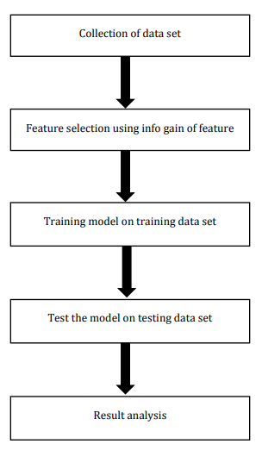
DEEP LEARNING NEURAL NETWORK

3.2 ANALYSIS OF THE EXISTING SYSTEM
Security is the condition of being protected against danger, loss, and criminals. In the general sense, security is a concept similar to safety. The slight difference between the two is an added importance on being protected outside threats or dangers. Individuals or actions that go or act against the general rules of protection are responsible for the breach of security. Security can also be seen as:
• A condition that results from the establishment and maintenance of protective measures that ensures a state of inviolability from hostile acts or influences.
• With respect to classified matter, the condition that prevents unauthorized persons from having access to official information that is safeguarded in the interests of national security.
• Security has to be compared and contrasted with other related concepts: Safety, continuity, reliability.

The key difference between security and reliability is that security must take into account the actions of people attempting to cause destruction. There is an immense literature on the analysis and categorization of security. It is common knowledge as with all systems that the "weakest link in the chain" is the most important. This can also be incorporated in security systems. The situation is asymmetric since the defender must cover all points of attack while the attacker need only identify a single weak point upon which to concentrate.

3.3 PROBLEMS OF THE EXISTING SYSTEM
Crime Prevention through Environmental Design and mechanical
layer which include gates, doors, and locks. This makes the system effective to some extent but largely ineffective and vulnerable to attacks and manipulation both from within and without the system. The system bases its physical security on two main features namely, people (Security Men and Women) and Structures (Walls and locks).These two features are easy to bypass and this is evident by the high rates of theft and manipulation of security men by students to do their biddings.
Ease of Access through Breaking of Locks
All doors in our immediate environment are based on the cylindrical lock mechanism. This lock mechanism is very common and this fact makes it easy to breakdown by either breaking the lock or duplicating the keys. This makes the system rather unsafe for all users
Lack of Intrusion Detection Alerts
All intrusion alerts are based dependent on discovery by individuals i.e. either security personnel’s or students. This delay gives the culprit enough time to dispose of whatever has been stolen and more than enough time to cover his tracks. This leads to a string of an ever increasing number of unsolved cases of theft.
Inefficient Monitoring Method
Monitoring one’s belongings are left to the vigilance on the path of the security officials and the owners of such goods. This can prove to be ineffective considering the fact that as human beings, we tend to get bored performing monotonous tasks.

3.4 ANALYSIS OF THE PROPOSED SYSTEM
The challenge for increased system effectiveness is to develop a system that detects close to 100 percent of intruders with minimal false positives. We are still far from achieving this goal. Placing security surveillance at critical locations lets administrators detect intrusions against the school departments as a whole. That is, the sensing security surveillance is able to provide an integrated, “big picture” view of the intruders. A person that might appear irrelevant might be extremely dangerous when considered from the security. It’s now time for operating systems and network software to integrate intrusion detection sensors. Intrusion detection will no doubt become a default feature, rather than an esoteric option.

3.5 ADVANTAGES OF THE NEW SYSTEM OVER THE EXISTING SYSTEM
Despite the documented contributions intrusion detection make to security, in many organizations one must still justify the acquisition of intrusion detection.
- When surveillance is continuous with no visible break, it tends to deter the less desperate thieves and thereby reducing the theft rate.
- To prevent problem behaviors by increasing the perceived risk of discovery and punishment for those who would attempt theft or otherwise disobey the school rules,
- To detect attacks and other security violations that are not prevented by other security measures,
- It reduce the theft rates by increasing the security of such areas by making them “safe rooms”
- To act as quality control for security design and administration,
- To provide useful information about intrusions that do take place, allowing recovery of lots properties etc.

CHAPTER FOUR
DESIGN, IMPLEMENTATION AND DOCUMENTATION OF THE SYSTEM

4.1 DESIGN OF THE SYSTEM
System design gives details of the components that make up the whole application. The entities of any computer-based applications are the expected computer output, input specification, database/file structure description and the procedure design of the system.

4.1.1 OUTPUT DESIGN
Output design describes the computer output interface expected from the program and details of the medium of the output presentation to the user.
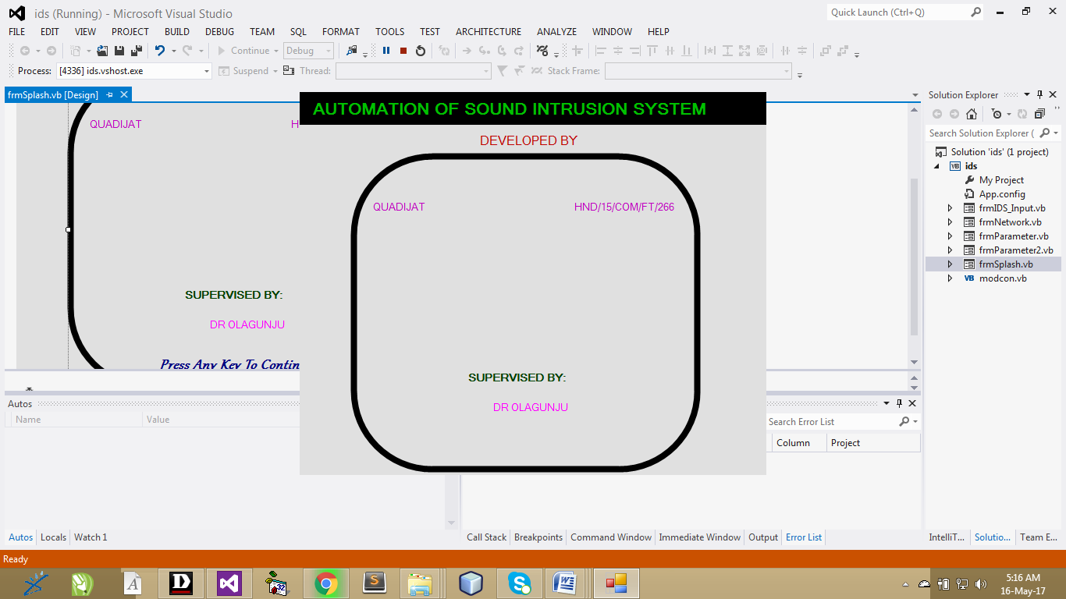
Figure 4.1: Splash screen
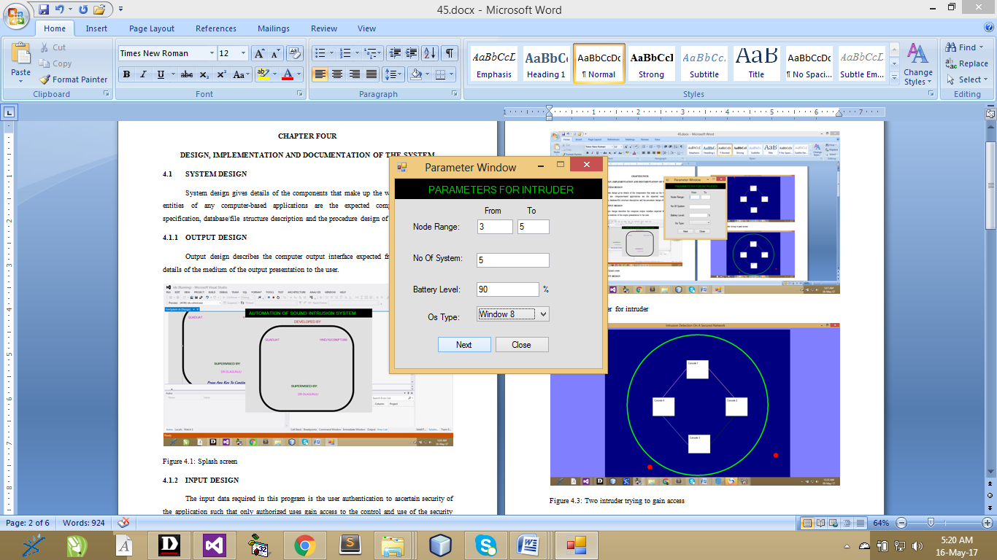
Figure 4.2: Parameter for intruder
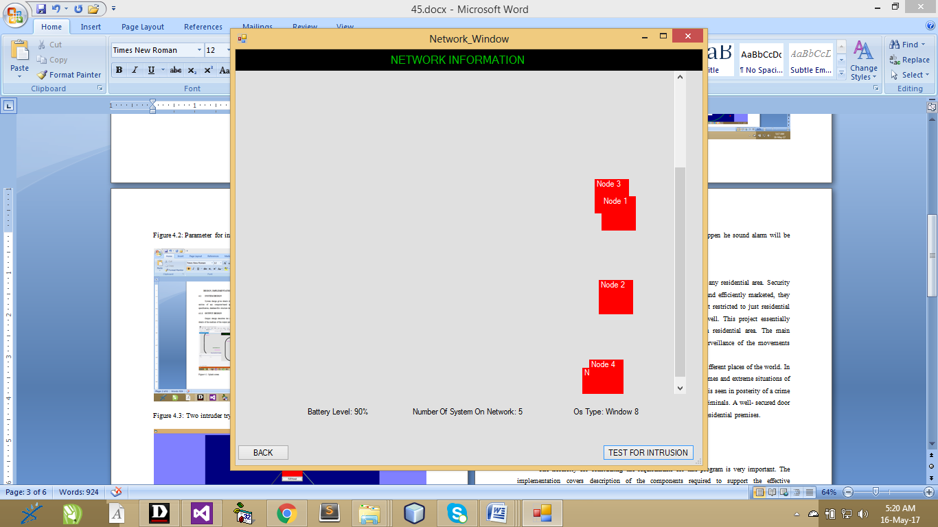
Figure 4.3 Nodes location

4.1.2 INPUT DESIGN
The input data required in this program is the user authentication to ascertain security of the application such that only authorized uses gain access to the control and use of the security system.
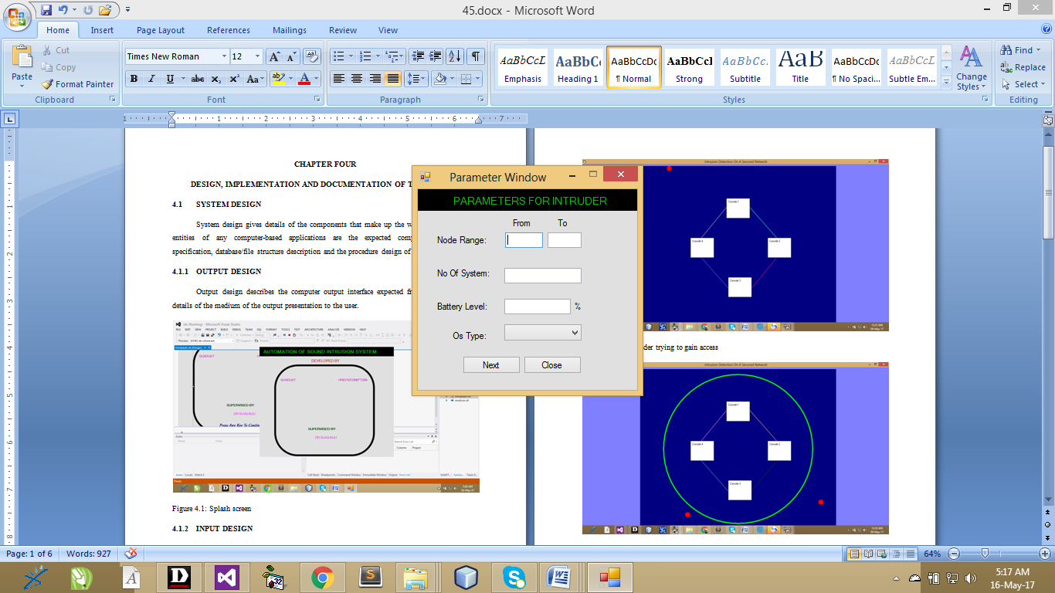
Figure 4.4: Parameter for intruder
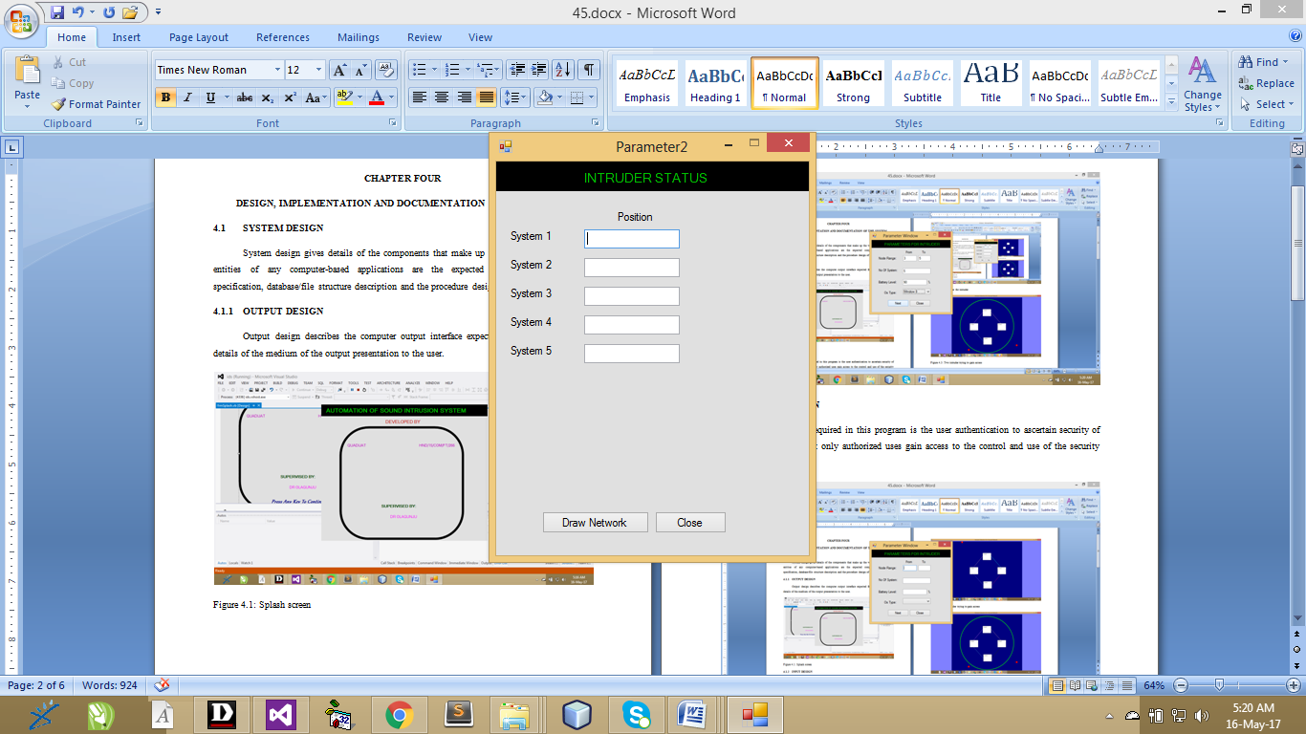
Figure 4.5: Five intruders status
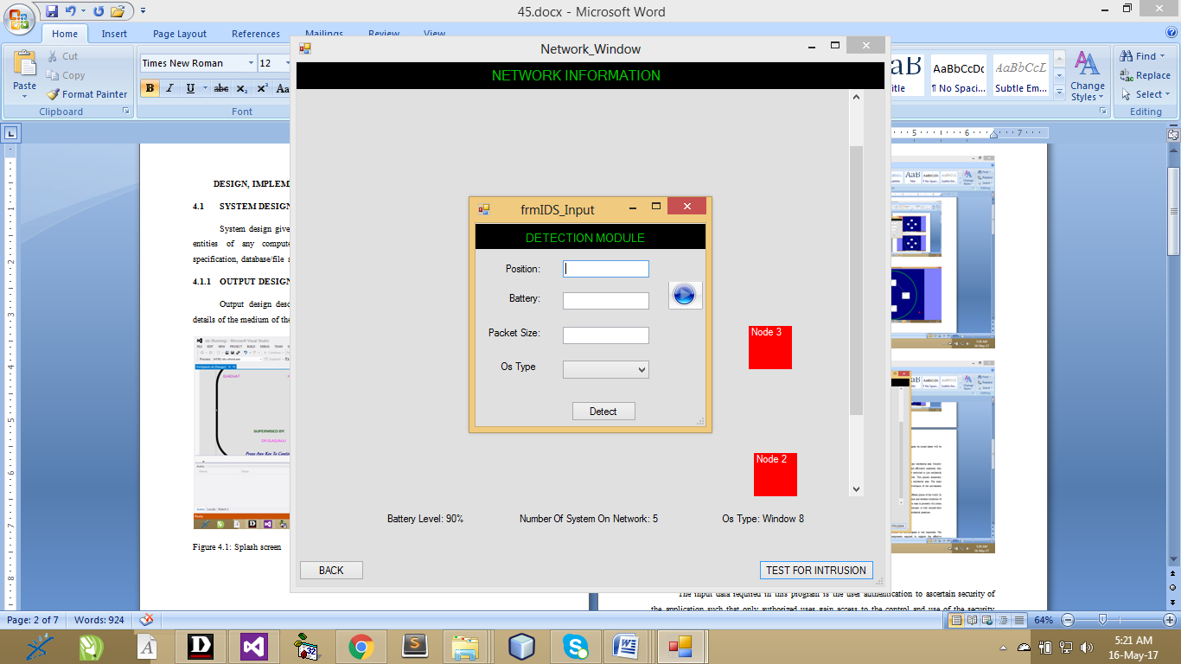
Figure 4.6: Detection intruder
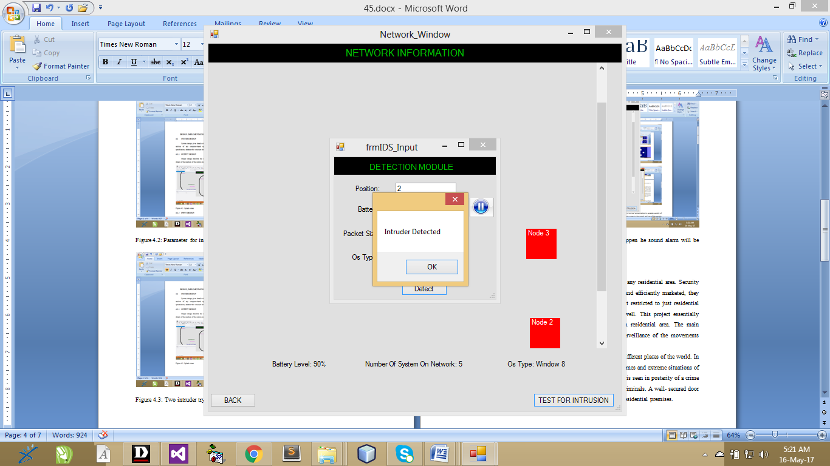
Figure 4.7: Successful detection of an intruder

4.1.3 PROCEDURE DESIGN
Security is one of the primary concerns when moving into any residential area. Security products are very marketable and if designed, properly developed and efficiently marketed, they can have good economic feasibility in the long run. Security is not restricted to just residential purposes. This is even more applicable to office workspaces as well. This project essentially deals primarily with developing a digital security system for a residential area. The main functionality of the project is going to revolve around video surveillance of the movements around the doors, gate and windows of the house.
The need for security is always of primary importance in different places of the world. In addition, this is true especially in the wake of different types of crimes and extreme situations of anti social activities in different parts of the world. In most cases, it is seen in posterity of a crime that a slackness in security when it came to the entry and exit of criminals. A well- secured door entry system is thus, considered essential for both commercial and residential premises.

4.2 SYSTEM IMPLEMENTATION
4.2.1 CHOICE OF PROGRAMMING LANGUAGE
The programming language used is VB.Net 2010. Visual Basic is a tool that allows you to develop Windows (Graphic User Interface - GUI) applications. The applications have a familiar appearance to the user.
Visual Basic is event-driven, meaning code remains idle until called upon to respond to some event (button pressing, menu selection). Visual Basic is governed by an event processor. Nothing happens until an event is detected. Once an event is detected, the code corresponding to that event (event procedure) is executed. Program control is then returned to the event processor.
Some Features of Visual Basic
- Full set of objects - you 'draw' the application
- Lots of icons and pictures for your use
- Response to mouse and keyboard actions
- Clipboard and printer access
- Full array of mathematical, string handling, and graphics functions
- Can handle fixed and dynamic variable and control arrays
- Sequential and random access file support
- Useful debugger and error-handling facilities
- Powerful database access tools
- ActiveX support
- Package & Deployment Wizard makes distributing your applications simple

4.2.2 HARDWARE SUPPORT
The hardware that is required in the successful completion of this project includes monitor, CPU, keyboard, mouse, printer and an uninterrupted power supply (UPS) and an internet access.
- An appropriate hard disk storage of at least 120 GB (for the dynamically expandable database)
- A minimum of 1.0 GHz processor
- Random access memory (RAM) of at least 1 GB
- An effective display unit (VGA monitor)
- A suitable printer
- Standard input devices such as keyboard, mouse, etc.
- CD-ROM drive or DVD-ROM drive (since the installation would be made through this medium)
- An uninterrupted power supply (UPS) unit (to prevent abrupt interruption due to power failure)
- A network modem (for internet connection).

4.2.3 IMPLEMENTATION TECHNIQUES
The implementation techniques used in the detailed record of the project is with the used of parallel approach techniques which allow the existing and the proposed system to work together concurrently.

4.2.4 SYSTEM DOCUMENTATION
The following are the modules in the application
- Splash screen
- Parameter for window
- Intruder status
- Network information
- Detection module

4.3.1 PROGRAM DOCUMENTATION
Program documentation includes:
- Installing application software to allow easy use of the proposed system
- Open Application software to implement the program
- Locate the project by Browsing through the system by going to the window menu key.
- Then prompt All Programmes then click on Microsoft visual studio
- Follow all the instruction to use the application.

4.3.2 OPERATING THE SYSTEM
System analysis is the process examining an existing system to the designing and the implementation of the new system entirely. Hence, the act of developing any computer application involved carrying out system study and converting them into a form that can be easily programmed into the computer by providing the input design, the files within the output design and the linkage between them. This refers to the ways in which the proposed system will be used and the steps are as follows:
- insert the disc into the system cd-rom
- Open the content from “my computer” icon on the desktop or clicking the start button.
- Double click the set up icon from the content of the package folder in the device (flash, CD).
- Follow the instruction and click on the appropriate button and the installation will be completed in a few moments.
Using the software after installation
- Click start on the computer desktop
- Select all programs
- Select intruder_application
- Wait for the splash screen to finish loading
Enter username and password to begin using the software

4.3.3 MAINTAINING THE SYSTEM
This can be referred to as the act of seeing through something to make sure that the system are working efficiently and effectively in maintaining this system.
- Keeping the system free from virus so as not to corrupt the program installed on the system.
- Having an updated anti-virus.

CHAPTER FIVE
SUMMARY, CONCLUSION AND RECOMMENDATION

5.1 SUMMARY
Intrusion detection is the problem of identifying individuals who are using a computer without authorization. Intrusion-detection systems have emerged in the computer security area because of the difficulty of ensuring that an information system will be free of security ﬂaws. Indeed, a taxonomy of security ﬂaws by Land where it shows that computer systems is secure from security vulnerabilities regardless of their purpose, manufacturer, or origin, and that it is technically difficult as well as economically costly (in terms of both building and maintaining such a system) to ensure that computer systems and networks are not susceptible to attacks. Also refers to as hackers.
5.2 CONCLUSION
Intrusion detection is viable and practical approach for providing a different notions of security, in our huge and existing infrastructure of (possible insecure) computer and network systems. Intrusion detection systems based on host-audit-trail and network traffic analysis, and their goal is to detect attacks, preferably in real time.
5.4 RECOMMENDATIONS
It is recommended that whenever you are setting up a network, always make sure that this network is protected so that outside threat (virus, malwares, hackers, etc) will not disrupt the flow of secured connection and communication. File transfer and communication on a secured network are reliable than unsecured network.

REFERENCE
Bruce Schneier (2000): Secrets & Lies: Digital Security in a Networked World, ISBN 0-471-25311-1
Clifford Stoll (2010): Cuckoo's Egg: Tracking a Spy Through the Maze of Computer Espionage, Pocket Books, ISBN 0-7434-1146-3
Morrie Gasser (1988): Building a secure computer system ISBN 0-442-23022-2 1988
Paul A. Karger, Roger R. Schell (2004): Thirty Years Later: Lessons from the Multics Security Evaluation, IBM white paper.
Peter G. Neumann (2004): Principled Assuredly Trustworthy Composable Architectures 2004
Quantometrix, 2011. Video Door Entry Systems. Door Entry Video Systems For Homes and Buildings. Source: http://www.Quantometrix.com
Renu Rohila, (2010). Door Entry Systems - Important Security Accessories. Ezine Articles. Source: http://EzineArticles.com/?expert=Renu_Rohila
Ross J. Anderson (2000): Security Engineering: A Guide to Building Dependable Distributed Systems, ISBN 0-471-38922-6Robert C. Seacord (2005): Secure Coding in C and C++. Addison Wesley, September, 2005. ISBN 0-321-33572-4
Stephen Haag, Maeve Cummings, Donald McCubbrey, Alain Pinsonneault, Richard Donovan (2010): Management Information Systems for the information age, ISBN 0-07-091120-7
Steven R. Keller, (2009). Motion Detector. Microsoft Encarta 2009. Microsoft Corporation.
Stewart Lee E. (1999): Essays about Computer Security Cambridge, 1999

