CHAPTER ONE
GENERAL INTRODUCTION
  - BACKGROUND OF THE STUDY
As is all known, image is one of the most widespread forms of multimedia, and it plays a really important role in people’s lives. It also has an extensive application requirement in all walks of life. In people’s daily lives, images can easily reveal personal privacy, and images have high confidentiality requirements in some special fields, so it is very important to encrypt images. Today, most images are stored and displayed in the form of digital images, so the encryption method of digital images has also been extensively studied in secure communication(Zhenlong, et al., 2020).
Due to advancements in technology, digital images are utilized in many applications such as medical imaging, remote sensing, and private conferencing. These images may contain confidential and sensitive information. The transmission of these images over public networks is prone to several issues such as modification and unauthorized access. The leakage of sensitive information may raise military, national security, and discretionary issues. Moreover, when individuals wish to exchange images through a public network, it is necessary to assure their privacy. Therefore, images require security against different security attacks, (Mandeep, et al., 2021).
It has been found that image encryption approaches can be utilized to provide security to these images. Image encryption is a procedure which converts plain image to an encrypted image by employing a secret key. The decryption process decrypts the cipher image into the original image by employing the secret key. Mainly, decryption operation is like encryption operation but applies in reverse order. The secret keys play a critical role in encryption. Because the security of the encryption approach is mainly dependent on it, two types of keys are utilized, namely, private key and public key. In the private key, the encryption and decryption processes use the same key to encrypt and decrypt the images. In the case of a public key, two keys are utilized, one key for encryption and one for decryption. In this, the encryption key is made public, but the decryption key is always kept private, (Mandeep, et al., 2021).
Digital images are stored in a matrix. Essentially, they are a group of two-dimensional sequences. Encrypting digital images is hiding the information carried in these two-dimensional sequences, so that the attackers cannot read it. However, the image encryption algorithm is different from the traditional encryption algorithm, because image encryption needs to meet high computation efficiency and avoid information loss at the same time. Due to the inherent characteristics of the image, such as high redundancy, large amount of data, strong correlation between adjacent pixels, and real-time transmission, some classic algorithms such as the RSA algorithm will be computationally expensive when encrypting the image, (Gao, et al., 2021).
Digital image is ordered of pixels in a matrix that represent a form of specific rows and columns which identify image width and height. Each individual pixel contains an intensity value which declared by fixed bits number. The compression technique be a goal to overcome the wasted bytes, depend on the utilization of redundancy, in which cover all types of repetition or similarity, and needless or undesired values of image pixel. Generally, there are two categories image redundancy, (i) statistical and (ii) psych-visual redundancy. Image compression basically reduces the size of image by represent the important image data with smaller size of bits, by removing the not important image information. Most significant topics in the techniques of image compression are how to manage digital image data in order to increase grade of compressed image and the ratio of compression efficiency during data transmission and storage.
The error free imitation of the original images is not essential in numerous cases. For instance, De-noising is a method which can be used to reduce the noise occurs due to some error. In this case, the little amount of error developed by lossy compression may be adequate. In the application of internet, this type of lossy compression is adequate for the quick transmission of the still images. Then, Images with 4096 graylevels are denoted as 12 bpp (bits per pixel). When there are 256 levels of feasible intensity for every pixel, then it is known as 8 bpp images.
  - STATEMENT OF THE PROBLEM
Image transfer application developed earlier and used by the organization still allow Information redundancy in stored. The proposed system will be introduced to eradicate the lapses in the earlier version. Therefore, information compression and decompression using embedded zero tree algorithm to increasing effective data density. Image processing equipments are also increasingly being connected to network environments. Images are intuitive and sensitive, which means that without proper privacy protection, data leaks, such as privacy breaches, and confidential information leaks can occur. As such threats increase in severity and number, concerns about privacy are growing, spurring the requirement for image information to be stored and protected by encryption based on a security algorithm.
1.3 AIM AND OBJECTIVES
The main aim of this project is to implement an Ip camera in Computer Science Department.
The project has the following objectives:
- To design an application that will secure image using the algorithm and techniques.
- To develop an application that will reduce information size using the algorithm and techniques.
- To implement embedded elliptic curve algorithm using c# programming language.

1.4 SIGNIFICANCE OF THE STUDY
The main importance of this project is that it increases the efficiency in the operations of image and file transfer in an organization. The development of image encryption improves relations by alleviating the difficulties faced in manual ways of securing, sharing data and file. It is very significant because it helps to speed the process and also make the process much easier and assessable. Only the users with the right keys will be able to access the messages. Secondly, the messages remain encrypted during the transit. When it goes to the wrong recipient, the recipients will not be able to read or decrypt and hence ensuring confidentiality and integrity of the message.

1.5 SCOPE OF THE STUDY
The scope of this study is to create an application that will provide security to data and file transfer on the network. This project is limited to the compress and decompression of image which will help in reducing the size of image. This phenomenon is known as loss of confidentiality. When the information is altered without necessary authorization, we say there is a loss of integrity. Information can also be made inaccessible to authorized users. This often occurs when the media used for the storage, processing or/and transiting the information is attacked.

1.6 ORGANIZATION OF THE STUDY
For easy study and proper understanding of this project write-up, it is planned and organized into five chapters. The description of what each chapter contains is explained below:
Chapter One: This contains an Introduction to the whole write-up, the problem of the study, aims and objectives of the study, the significant of the study, the scope and limitation of the study, and organization of the report.
Chapter Two: It focuses on the literature review of the study, organization of the board of director, computerization of the current state of the art.
Chapter Three: It presents data collection method employed, analysis of data and existing system, advantages of the proposed system, design and implementation, programming language used with reasons, hardware and software support.
Chapter Four: It deals with the system design implementation and documentation, design of the system, output design, input design, file system, procedural design, and documentation of the new system.
Chapter Five: This center the summary, experienced gained, recommendation and conclusion.

CHAPTER TWO
LITERATURE REVIEW
2.1 REVIEW OF RELATED PASTWORK
Mandeep, et al. (2021) wrote and presented a journal titled “Computational Image Encryption Techniques: A Comprehensive Review” Images contain very sensitive and confidential information. Because images play a significant role in many applications such as military communication, remote-sensing, and medical-imaging, therefore, it is necessary to protect sensitive and confidential information from unauthorized use and modification. To achieve this objective, encryption is one of the best methods among the information hiding methods. In recent years, many image encryption approaches are designed by the researchers. They use different concepts for image encryption to increase security.Themain aim of this paper is to present a comprehensive review of the existing image encryption approaches. These approaches are categorized based on different concepts such as chaotic maps, DNA, compressive sensing, and optical image encryption. Comparisons are made among the existing approaches to access the various security parameters. Key performance metrics are also presented. The future scope of image encryption is also presented to encourage the research community.

According to Gao, et al. (2021) “An Image Encryption Algorithm Based on the Improved Sine-Tent Map” this paper makes use of the characteristics of initial sensitivity and randomness of the chaotic map to design an image encryption algorithm based on the sine map and the tent map. .e sine map is used to improve the tent map; then, the improved sine-tent map is proposed. The traditional tent map proposed in this paper has an expanded control parameter range and better chaos. In this algorithm, bit rearrangement is adopted to further improve the improved sine-tent map, which can reconstruct the output value and expand the chaotic characteristics of the map. In this algorithm, the image parameters are connected with the algorithm to generate the key. In the encryption step, a method of replacing the most significant bit and scrambling-diffusion algorithm is designed to encrypt the plaintext image. Finally, the algorithm is simulated with the experiment and evaluated with analysis; then, the experimental results are given. .e evaluation results show that the ciphertext of the algorithm has high randomness, strong robustness, and better resistance to differential attacks after comparison. .e correlation of the ciphertext image pixels is very low, and the algorithm is highly secure as a conclusion.
Wonyoung and Sun-Young (2020) carried out “Partial image encryption using format-preserving encryption in image processing systems for Internet of things environment” Concomitant with advances in technology, the number of systems and devices that utilize image data has increased. Nowadays, image processing devices incorporated into systems, such as the Internet of things, drones, and closed-circuit television, can collect images of people and automatically share them with networks. Consequently, the threat of invasion of privacy by image leakage has increased exponentially. However, traditional image-security methods, such as privacy masking and image encryption, have several disadvantages, including storage space wastage associated with data padding, inability to decode, inability to recognize images without decoding, and exposure of private information after decryption. This article proposes a method for partially encrypting private information in images using FF1 and FF3-1. The proposed method encrypts private information without increasing the data size, solving the problem of wasted storage space. Furthermore, using the proposed method, specific sections of encrypted images can be decrypted and recognized before decryption of the entire information, which addresses the problems besetting traditional privacy masking and image encryption methods. The results of histogram analysis, correlation analysis, number of pixels change rate, unified average change intensity, information entropy analysis, and NIST SP 800-22 verify the security and overall efficacy of the proposed method.

Tsu-Yang, et al. (2019) makes a research on “A DNA computation based image encryption scheme for cloud CCTV systems” With the rapid development of information technology, huge amounts of images stored in cloud-based CCTV systems. How to protect the transmitted image efficiently and reducing the storage cost for the system become to critical research issues. The concept of DNA computing has been intrigued researchers in recent years. It has many potentials, for example, the high density and low cost storage provided by a double stranded DNA; or a realization of low cost parallel computation to solve nondeterministic polynomial time problem using replication of DNA strands. As a result, a vast number of theoretical studies of the application of DNA computing on information security, which require extensive computation power, has been published. In this paper we study DNA computation based image encryption scheme which applies to cloud CCTV system. In many different image encryption research the artifact hyper-chaotic map was used. We proposed an image encryption algorithm based on DNA coding and hyper-chaotic map which utilizes the chaotic property of the hyper-chaotic map on top of DNA computing. Experiment showed that our algorithm is more secure and more computation efficient than some of the recent similar works.

Heping, et al. (2021) also writes and presented a paper on Security-Enhanced Image Communication Scheme Using Cellular Neural Network. In the current network and big data environment, the secure transmission of digital images is facing huge challenges. The use of some methodologies in artificial intelligence to enhance its security is extremely cutting-edge and also a development trend. To this end, this paper proposes a security-enhanced image communication scheme based on Cellular Neural Network (CNN) under cryptanalysis. First, the complex characteristics of CNN are used to create pseudorandom sequences for image encryption. Then, a plain image is sequentially confused, permuted and diffused to get the cipher image by these CNN-based sequences. Based on cryptanalysis theory, a security-enhanced algorithm structure and relevant steps are detailed. Theoretical analysis and experimental results both demonstrate its safety performance. Moreover, the structure of image cipher can effectively resist various common attacks in cryptography. Therefore, the image communication scheme based on CNN proposed in this paper is a competitive security technology method.

Zhenlong, et al. (2021) concluded that in cryptosystems, the generation of random keys is crucial. The random number generator is required to have a sufficiently fast generation speed to ensure the size of the keyspace. At the same time, the randomness of the key is an important indicator to ensure the security of the encryption system. The chaotic random number generator has been widely used in cryptosystems due to the uncertainty, non-repeatability, and unpredictability of chaotic systems. However, chaotic systems, especially high-dimensional chaotic systems, have slow calculation speed and long iteration time. This caused a conflict between the number of random keys and the speed of generation. In this paper, we introduce the Least Squares Generative Adversarial Networks(LSGAN)into random number generation. Using LSGAN’s powerful learning ability, a novel learning random number generator is constructed. Six chaotic systems with different structures and different dimensions are used as training sets to realize the rapid and efficient generation of random numbers. Experimental results prove that the encryption key generated by this scheme can pass all randomness tests of the National Institute of Standards and Technology (NIST). Hence, our result shows that LSGAN has the potential to improve the quality of the random number generators. Finally, the results are successfully applied to the image encryption scheme based on selective scrambling and overlay diffusion, and good results are achieved.

Yiying, et al. (2021) wrote an article titled “Image Processing Method Based on Chaotic Encryption and Wavelet Transform for Planar Design” this paper provides an in-depth study and analysis of image processing for graphic design through chaotic encryption combined with a wavelet transform algorithm. Firstly, the traditional Mallat algorithm is optimized; since the mean value of the transform coefficients generated after the wavelet transform of the image is used as the initial value of the chaotic system to iterate, when the image is modified, then the mean value of the wavelet coefficients will also change, and the final iteration comes out as two different sequences using the property that the chaotic system is extremely sensitive to the initial conditions, so the algorithm has a certain sensitivity to tampering and localization effect. The image of the encrypted graphic design is decrypted by the chaos decryption system, and the final image information of the graphic design is obtained. In terms of the security of the graphic design image itself, the complex dynamical properties of chaos are fully utilized to encrypt it, and the algorithm has a good encryption effect after statistical characteristic analysis, attack complexity, difference analysis, adjacent pixel correlation analysis, and key sensitivity analysis. The plaintext image is decomposed in odd-even sequence using the boosting algorithm to get the sequence with an even index and the sequence with an odd index; then, the diffusion algorithm is applied to the two sequences by the prediction and update algorithm, and this process is repeated many times to get the two ciphertext sequences after scrambling, merging these two sequences, and matrixing them to get the ciphertext image. Finally, the testing of the embedded planar designed image revolves around four aspects, namely, image processing, tamper sensitivity, robustness, and imperceptibility, to examine the designed planar designed image system. In the diffusion manipulation, the key matrix for diffusion is obtained using the threshold processing method of the Local Binary Pattern (LBP) algorithm for the matrices generated by the Logistic Chaos system, which improves the randomness of the algorithm. The experimental results verify the effectiveness and security of the algorithm.

Akomolafe and Matthew (2017) makes a research on “Hybrid Cryptographic Model for Data Storage in Mobile Cloud Computing”, Mobile Cloud Computing (MCC) is a paradigm that integrates Cloud Computing and Mobile Computing to deliver a better Quality of Experience (QoE) and Quality of Service (QoS) to mobile users and cloud subscribers. Mobile Cloud Computing (MCC) inherited resource limitation from Mobile Computing which was solved with Cloud Computing. Meanwhile, Cloud Computing has inherent problems such as privacy of user’s data stored on cloud, intrusion detection, platform reliability, and security threats caused by multiple virtual machines. Thus, hindering the growth and the full acceptance of Mobile Cloud Computing (MCC) by subscribers. However, using a signature based hybrid cryptography ensures confidentiality, integrity, authentication and non-repudiation on resource-poverty devices used in Mobile Cloud Computing. This paper presents a data protection scheme where data is encrypted using a hybrid cryptographic algorithm which is composed of Advanced Encryption Standard (AES), Blake2b and Schnorr signature before being stored in the cloud storage (Amazon Simple Storage Server). Thus, data confidentiality, integrity, authentication and non-repudiation are ensured.

2.2 OVERVIEW OF COMPUTATIONAL BASED
Digital images have been widely used in various application areas such as military, financial, legal, and medical, where the requirements for image security are getting higher and higher. This section analyzes and compares the current state of research on digital image encryption techniques, focusing on the advantages and shortcomings of digital image encryption algorithms based on chaotic systems, and finally discusses the application of chaotic image encryption techniques in medical image encryption. Preprocessing is required in encrypting images, converting the two dimensional image pixel matrix into a one-dimensional stream of plaintext data, and then applying the corresponding algorithm to encrypt under the control of the key and restore it to the original image when decrypting. The advantage of this type of cryptographic algorithm is that the algorithm is open, and the disadvantage is that it is inefficient, so it is often used in combination with other encryption techniques. Shankar et al. proposed a satellite image encryption algorithm based on chaos and AES techniques. The algorithm first uses Arnold cat mapping to permute the image pixels and then uses Henon chaos mapping for generating a random sequence for the AES algorithm. Finally, the image is encrypted using the AES algorithm. The algorithm improves the key sensitivity and has a large key space and uniform pixel distribution, and the encryption speed is within the acceptable range to ensure high security. Image scrambling has a limited number of transformations of the matrix of the image, which is periodic and reverts to the original image after several transformations. The mathematical description corresponding to chaotic systems has no analytic solution, which means that the end position cannot be calculated directly by inputting initial values and time but can only be approximated continuously by iteration, but the approximation is never exact (Zhenlong, et al.2021).

2.3 IMAGE ENCRYPTION APPROACHES
Different types of image encryption approaches are designed so far. By reviewing the literature, we have divided it into different types such as spatial, transform, optical, and compressive sensing based image encryption approaches. In the preceding subsection, these approaches are discussed and analyzed utilizing evaluation metrics. These parameters are KA, NPCR, HA, UACI, IE, CC, and NA. In comparisons, ✓and ✗symbols are utilized to represent whether the given approach has considered the respective metric and not, respectively (Tsu-Yang, et al. 2019).
2.3.1. Image Encryption in Spatial Domain.
The approaches that are directly manipulating the pixels of the image are considered as spatial domain approaches. The various spatial domain-based image encryption are present in the literature. But we have considered the most famous approaches such as chaotic-based, elliptic curve-based, fuzzy-based, DNA, and Metaheuristics-based approaches.
2.3.2. Chaos-Based Image Encryption Approaches.
Chaotic maps have great significance in the field of encryption. These maps generate random numbers that are utilized as secret keys in encryption. The reason is its properties such as dynamic and deterministic nature, sensitive to initial conditions, and ergodicity. Different types of chaotic maps are utilized so far. But these are mainly divided as one-dimensional and higher-dimensional chaotic maps. Chaotic maps help in performing the confusion and diffusion operations in the encryption process.
2.3.3. Elliptic Curve-Based Image Encryption. Elliptic Curve Cryptography (ECC) works on the least amount of memory with the small key size. The use of elliptic curve in image encryption. The color image is initially compressed and changed into gray scale. Then, encryption is done by utilizing elliptic curve, 3D Lorenz chaotic map, and 4D Arnold cat map.
2.3.4. Cellular Automata-Based Image Encryption Approaches. Cellular automata have been widely used inimage encryption as a pseudorandom generator. Thesemodels are complex which have a degree of efficiency androbustness. Cellular automata use rules to produce randomsequences. Due to the properties of cellular automata such asparallelism and easy and simple hardware structure, it issignificant for encryption approaches. Figure 6 demonstratesthe general framework of cellular automata-basedimage encryption. The confusion and diffusion operationsare performed by utilizing the key generator and cellularautomata, respectively. Cellular automata generate randomsequences to diffuse the pixel values of the image.
2.3.5. DNA-Based Image Encryption Approaches.
Deoxyribonucleic Acid (DNA) cryptography has becomevery popular due to its properties such as massive parallelism,huge storage, and ultra-low power consumption. Thecomplementary rules of DNA are utilized to perform encoding and decoding. Firstly, the color image is decomposed into three channels red (R), blue (B), and green (G). After that, DNA encoding and XOR operations are utilized to encode the channels. A chaotic map is utilized to scramble matrices. Finally, three R, G, and B channels are combined to obtain the cipher image.
2.3.6. Metaheuristics-Based Image Encryption Approaches.
Metaheuristic approaches are mainly utilized in a situation where we need optimized results. Recently, the use of such approaches has been increased in the image encryption. There are two aspects to use metaheuristic approaches in image encryption: (a) generate multiple cipher images and then select optimized one and (b) optimize the initial parameters of chaotic maps to generate efficient keys. Researchers have implemented the image encryption approaches based on metaheuristic approaches, considering different aspects. Medical images are encrypted by [96] utilizing coupled map lattices and modified genetic algorithm. The genetic algorithm selects the encrypted image which has high entropy. The algorithm approach is utilized to generate the optimized key.
2.3.7. Compressive Sensing-Based Image Encryption Approaches.
Compressive sensing can perform compression as well as encryption at the same time. It uses a measurement matrix and reconstruction approach to perform the same. The measurement matrix is utilized to perform the compression. At the same time, when the measurement matrix is utilized as a secret key between the sender and receiver, it works as a cryptosystem.
Various image encryption approaches based on compressive sensing have been proposed by the researchers. Some of the approaches are discussed in this section. Chaotic compressive sensing to encrypt the color images. It also performed compression at the same time. The chaotic measurement matrix constructed utilizing one-dimensional chaotic map is utilized. This approach is further enhanced in by making it visually meaningful. Wavelet transform is utilized to hide the encrypted image into a cover image. Analog-digital hybrid electro-optic chaotic sources and compressive sensing to encrypt the images.

CHAPTER THREE
METHODOLOGY AND ANALYSIS OF THE EXISTING SYSTEM
  - RESEARCH METHODOLOGY
Research methodology has many research dimensions and methods. The scope of research methodology is wider than research method. This is mainly adopted by the researcher in undertaking this research. Methodology is the underlying principles and rules that govern a system method on the other hand it is a systematic procedure for a set of activities. Thus, from these definitions a methodology encompasses the methods used within a study.
3.1.1 ENCRYPTION OF IMAGE
Step 1: Specifying the Rate (bits available) and Distortion (tolerable error) parameters for the target image.
Step 2: Dividing the image data into various classes, based on their importance.
Step 3: Dividing the available bit budget among these classes, such that the distortion is a minimum.
Step 4: Quantize each class separately using the bit allocation information derived in step 2.
Step 5: Encode each class separately using an entropy coder and write to the file.
Step 6: Reconstructing the image from the compressed data is usually a faster process than
compression. The steps involved are
Step 7: Read in the quantized data from the file, using an entropy decoder (reverse of step 5).
Step 8: Dequantize the data. (Reverse of step 4).
Step 9: Rebuild the image. (Reverse of step 2).
3.1.2 COMPRESSION ALGORITHM
I = imread('peppers.png');
Y_d = rgb2ycbcr( I );
% Downsample:
Y_d(:,:,2) = 2*round(Y_d(:,:,2)/2);
Y_d(:,:,3) = 2*round(Y_d(:,:,3)/2);
% DCT compress:
A = zeros(size(Y_d));
B = A;
for channel = 1:3
for j = 1:8:size(Y_d,1)-7
for k = 1:8:size(Y_d,2)
II = Y_d(j:j+7,k:k+7,channel);
freq = chebfun.dct(chebfun.dct(II).').';
freq = Q.*round(freq./Q);
A(j:j+7,k:k+7,channel) = freq;
B(j:j+7,k:k+7,channel) = chebfun.idct(chebfun.idct(freq).').';
end
end
end
subplot(1,2,1)
imshow(ycbcr2rgb(Y_d))
title('Original')
subplot(1,2,2)
imshow(ycbcr2rgb(uint8(B)));
title('Compressed')
shg

Algorithm 3.1: Compression Algorithm
Source:(Tsu-Yang, 2017)

3.2 ANALYSIS OF EXISTING SYSTEM
Image encryption has been one of the critical enabling technologies for the on-going digital multimedia revolution for decades. Without encrypting techniques, none of the ever growing Internet, digital TV and Website. In the physical world, compression concept image Compression, also known as source of compression techniques, is the process of compression or converting data in such a way that it consumes less memory space. Image compression reduces the image of resources required to upload on the internet.It can be done in two ways- lossless compression and lossy compression. Lossy compression reduces the size of data by removing unnecessary information, while there is no data loss in lossless compression.

3.3 PROBLEMS OF THE EXISTING SYSTEM
- In the past, many methods have been used for image encryption such as embedded zero tree algorithm, DNAbased encryption etc.. Image compression can improve the performance of the virtual systems by way of lowering time and cost in image garage and transmission without sizable reduction of the image excellent. For Image compression it is applicable that the selection of rework needs to lessen the dimensions of resultant data set as compared to source statistics set.
The problems of the existing system are as follows;
- Lack of Privacy on personal data:Information can easily be altered by an unauthorized user
- Inconsistency of data:There is also the problem of missing data and information records which might have been caused by theft or wrongly placed or kept by the officer(s) in charge.
- Lack of integrity: Integrity basically means ensuring that the data are not modified. An integrity service that deals with a stream of messages assures that messages are received as sent, with no duplication, insertion, modification, reordering or replays.
- Information been access by unauthorized user: The authentication service is concerned with assuring that a communication is authentic. In the case of a single message, such as a warning or alarm signal, the function of the authentication service is to assure the recipient that the message is from the source that it claims to be from.

3.4 DESCRIPTION OF THE PROPOSED SYSTEM
We propose the comparison study of the embedded elliptic curve algorithm it will perform the embedded elliptic curve algorithm of the input image and performs the compress using standard technique like JPEG, DCT(Discrete Cosine Transform) or DWT(Discrete Wavelet Transform) algorithm by applying the mathematical properties of elliptic curves over finite fields to perform encryption and digital signatures, it relies on “trapdoor” function inherent in elliptic curve operations, where it is easy to compute a point multiplication (Public key generate from private key) but computationally infeasible to reverse the process (finding the private key from the pubic key)
The proposal system is a pc-based data encryption system that works in the windows OS environment. It is designed to be able to accept text input and apply a series of transformations on the input text to produce an encrypted text. A user chooses a curve equation (e.g., y² = x³ + ax + b) and a base point on that curve, private key (a random integer) is selected, The public key is derived by multiplying the base point by the private key (using elliptic curve point multiplication)
To encrypt a message, it's first encoded as a point on the elliptic curve, the sender uses the receiver's public key to perform elliptic curve operations (point multiplication and addition) on the message point, the resulting cipher-text is a set of points on the curve that can only be decrypted by the corresponding private key.
To decrypt a message, The receiver uses their private key and the cipher-text to perform reverse elliptic curve operations, effectively undoing the encryption process, this process reveals the original message point, which can then be decoded.
For digital signatures, ECDSA (Elliptic Curve Digital Signature Algorithm) is a common way to create digital signatures using ECC, a sender uses their private key and a cryptographic hash of the message to generate a signature.
The receiver can verify the signature using the sender's public key and the message hash, ensuring the message's authenticity and integrity.
3.5 ADVANTAGE OF THE PROPOSED SYSTEM
A lot of benefits are derived from the proposed system, they include:-
- Data integrity: Data integrity refers to maintaining and assuring the accuracy and consistency of data over its entire life-cycle, and is a critical aspect to the design, implementation and usage of any system which stores, processes, or retrieves data.
- Message authentication: Message authentication provides two services. It provides a way to ensure message integrity and a way to verify who sent the message. To request authentication, the sending application must set the authentication level of the message to be authenticated.
- Non-repudiation of data: Nonrepudiation is the assurance that someone cannot deny something. Typically, nonrepudiation refers to the ability to ensure that a party to a contract or a communication cannot deny the authenticity of their signature on a document or the sending of a message that they originated.
- Lossless and lossy data compression Data compression is simply a means for efficient digital representation of a source of data such as text, image and the sound. The goal of data compression is to represent a source in digital form with as few bits as possible while meeting the minimum requirement of reconstruction. This goal is achieved by removing any redundancy presented in the source.

CHAPTER FOUR
DESIGN AND IMPLEMENTATION OF THE SYSTEM
4.1 DESIGN OF THE SYSTEM
System designs calls for the creativity of the analyst. Therefore, creating an acceptable design, the system analyst must exclude all prejudice.The design of the system is the approach of work out how best computers together with other resources may be applied to perform data storage, management and retrieval for decision making.
4.1.1 OUTPUT DESIGN
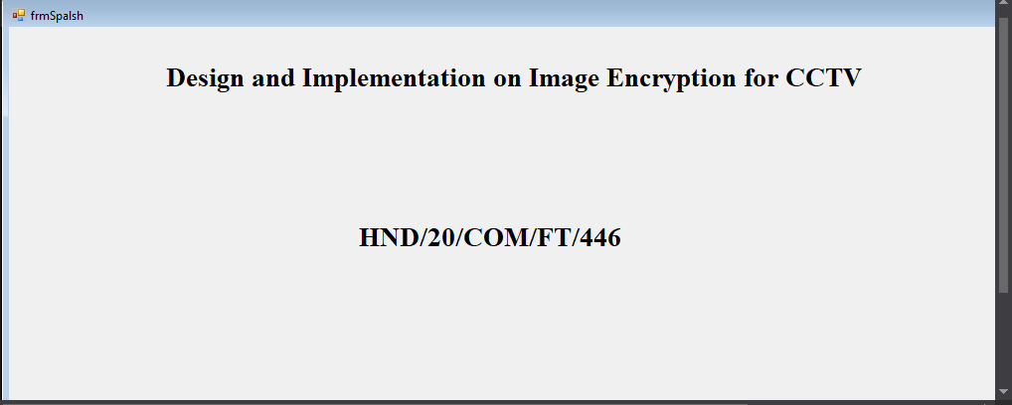
Figure 4.1: Welcome Menu
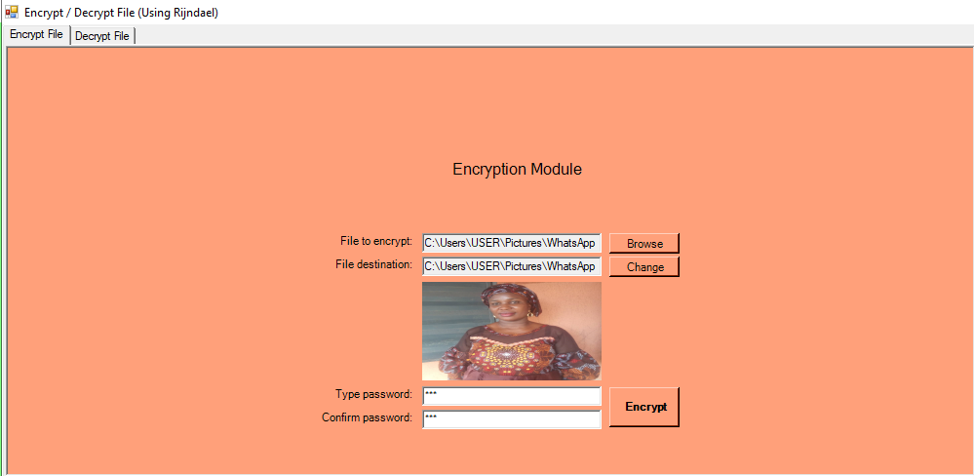
Figure 4.2: Encryption Module

4.1.2 INPUT DESIGN
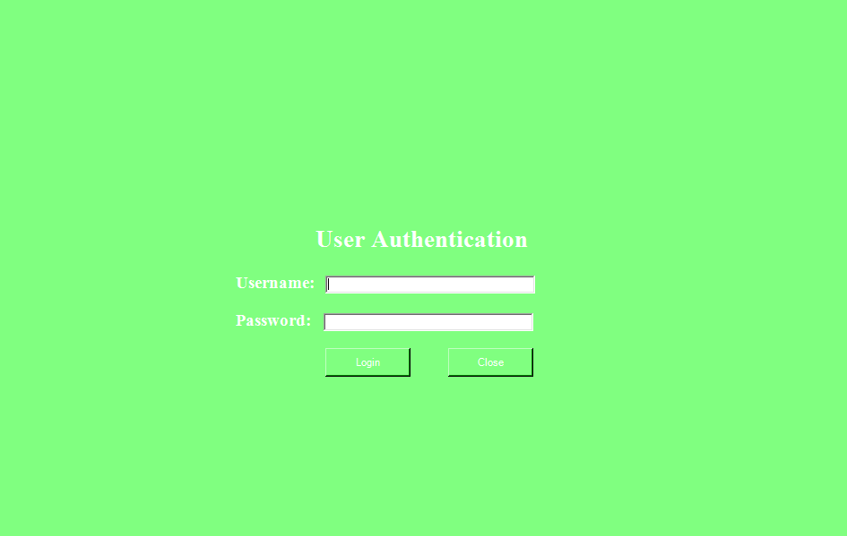
Figure 4.3: Login menu

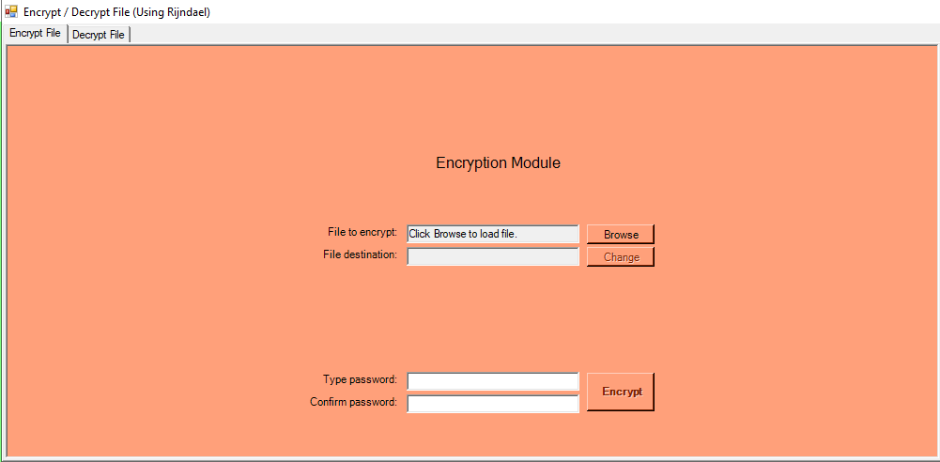
Figure: 4.4 Encryption menu
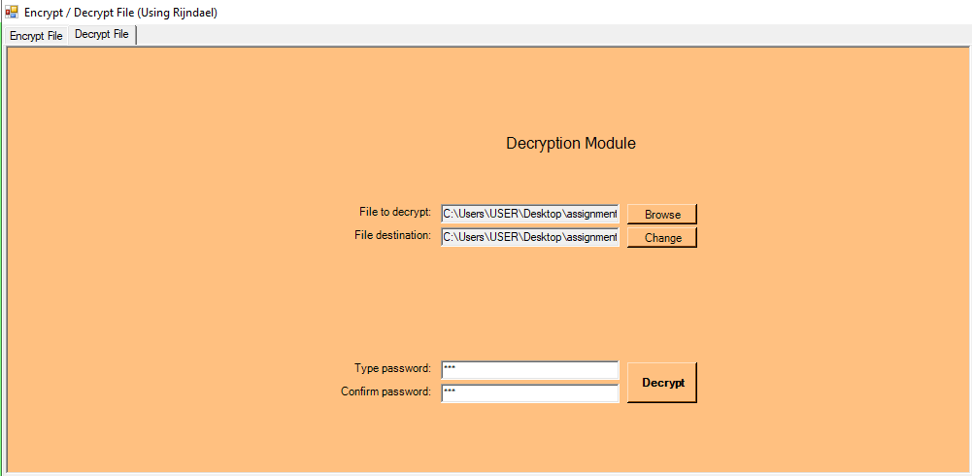
Figure 4.5: Decryption Menu

4.1.3 DATABASE DESIGN
Database Design is the collection or related data in an organized mechanism that has the capability of storing information. End-user can retrieve stored information in an effective and efficient manner which has the means of protecting them.
In an Automated Security Lock System, data are handled using WAMP server as the server-side for the design. The database design is structure using Mysql and PHP linking codes.
Below is the database design of the system:
Table 4.1: the administrator table in phpmyadmin
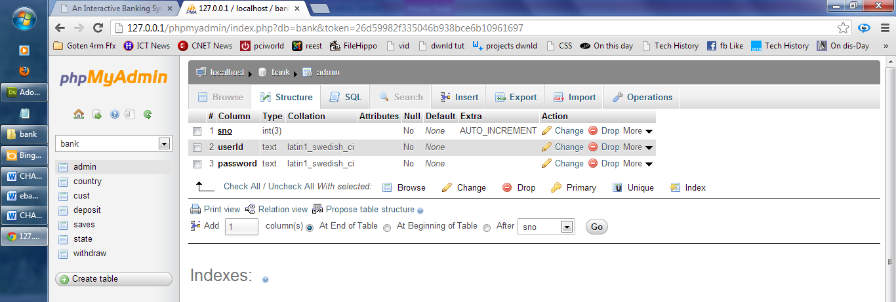

Table 4.2: Table view for all encrypted message
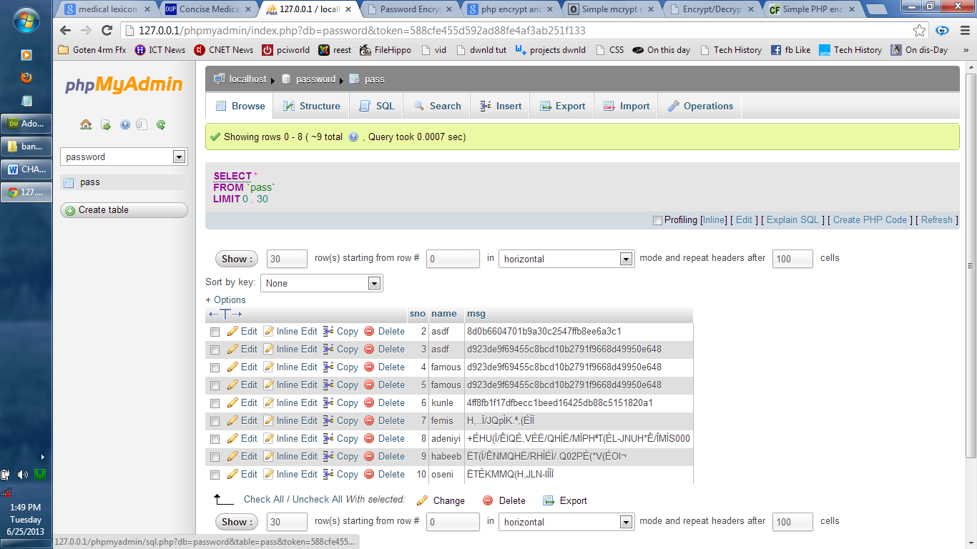

4.1.4 PROCEDURE DESIGN
The procedural design describes the system generally. It describes the various main programs in the system as well as the relationship that exist between all subprograms included. The procedural designs in this new system are of 5 menus of which each menu has it sub menu.
The application also contains several modules of which each module has its own specific function. The purpose of dividing the program into modules is because it enhances maintainability, readability and easy debugging.
4.2 SYSTEM IMPLEMENTATION
4.2.1 CHOICE OF PROGRAMMING LANGUAGE
Visual basic 6.0 is the chosen programming language for the implementation of the proposed system because of its pedagogy and open source help when needed. As well it has a support for variety of database application like sql server, sqllite, mysql, and Microsoft access but Microsoft Access is selected.
4.2.2 HARDWARE SUPPORT
The computer configuration required to run the software is;
Computer/memory processor PC with a 48dx, MHZ or Pentium, Intel or higher processor required.
Memory, a minimum of :512MB of RAM
Cache memory :512KB
Hard disk Minimum size : 10.2GB
Recommended : 40GB
Virtual Memory :32Bits
Cache memory :512KB
Floppy disk drive :1.44MB
4.2.3 SOFTWARE SUPPORT
The software support for the design of the proposed system involves;
- Operating system
- Microsoft visual basic 6.0
- Microsoft Access
- Anti-virus software which prevents the system from being infected by virus.
4.2.4 IMPLEMENTATION TECHNIQUES USED IN DETAILS
The system will be implemented using the parallel approach. This approach is considered because it ensure that the new system is tested along side with the old system to ensure the effectiveness and efficiency of the system.

4.3 SYSTEM DOCUMENTATION
4.3.1 OPERATING THE SYSTEM
The system must be used as instructed according to the hardware and software supports so as to make optimal use of it.
- Click start on the computer desktop
- Select all programs
- Select any browser e.g internet Explorer, Mozilla Firefox, Google Chrome e.t.c
- Type the url (Uniform Resource Locator) of the system into the address bar (localhost/password/)
4.3.2 MAINTAINING THE SYSTEM
Maintenance is any activities carried out after the implementation of the new system to make sure that the system is correctly and constant running. This can be any of the following types of maintenance.
(a) Corrective maintenance: This is done to correct and defect that discover in the course of using the new system to keep the system in tune with day to day function.
(b) Adaptive maintenance: This is done to make sure that the system is not obsolete and adapt to any new systems of technology.
(c) Preventive Maintenance: This is a kind of maintenance adopted for continuous improvement in new system without waiting for the failure to occur or for the user to change. This is adopted to prevent the occurrence of failure.

CHAPTER FIVE
SUMMARY, CONCLUSION AND RECOMMENDATION
5.1 SUMMARY
In this project, we proposed a method for partially encrypting private information, such as faces and body parts, in images using the format-preserving encryption standards FF1 and FF3-1. Traditional image protection technology has problems such as increasing data by padding and storage space wastage over time. Furthermore, as the entire image is encrypted, the image cannot be recognized before decryption and, once decrypted, information requiring privacy is exposed. Traditional partial image encryption incurs a problem in that unnecessary portions are encrypted by encrypting a rectangular area that covers the information requiring privacy. The proposed method solves this problem. The proposed method has no padding, so there is no increase in the data size, and the information requiring privacy can be specifically set and encrypted. In this study, we measured the encryption and decryption speed of the proposed method and determined the most suitable block unit for encryption to improve the encryption and decryption speed of the image part. The security of the developed method was evaluated through analysis of histograms, correlation coefficients and information entropy. The developed method can be used in various environments that use images, such as Internet of things (IoT), drones, and CCTV, and can be useful in responding to image leakage threats, such as privacy invasion and confidential information leakage.
5.2 CONCLUSION
This project presented a comprehensive study of the existing image encryption approaches. It was observed that the image encryption approaches require high confusion, zero correlation with the input images, less computational complexity, and high resistance to cryptanalysis process. The comparisons among the image encryption approaches were carried out based on evaluation parameters to show their strength and weaknesses. Future research directions related to image encryption strategies were examined. It was found that the development of image encryption approaches is still an open area for researchers. This paper encourages researchers to understand the challenges involved in image encryption approaches. It will also help them to choose an appropriate approach to develop new encryption models according to an application which saves their time.

5.3 RECOMMENDATIONS
From the comprehensive review, it has been found that the existing image encryption approaches suffer from various issues. Also, there is still room for improvement in various fields of image encryption approaches. Therefore, in the near future, one may consider the following issues to continue the research in the field of image encryption.
- Application-specific approaches: the current research in the field of image encryption is not done towards the building of application-specific image encryption approaches. So, in the near future, the development of application-aware image encryption approaches is a hot area of research.
- Compressive sensing: development of compressive sensing-based image encryption approaches can be improved further for lightweight devices such as mobiles, spy cameras, and surveillance cameras.
- Hyperparameters tuning: hyperparameters tuning of key generators such as chaotic map can be achieved utilizing the recently developed metaheuristic approaches, machine learning, deep learning, deep belief networks, or deeptransfer learning.
- Parallel processing: due to rapid advancement in the various multimedia applications such as medical and satellite imaging. These applications require high-resolution images; therefore, the development of image encryption approaches for such applications will be computationally extensive. So, the parallel image encryption approaches can be utilized to handle this issue.
- Multidimensional multimedia data: development of encryption approaches for multimedia data such as multispectral images is still an undeveloped area. It is required to design high-dimensional hyperchaotic systems for such kind of multidimensional multimedia data.
- Steganography/data hiding: the combination of encryption with reversible data hiding/steganography has become another research direction. Therefore, one may combine both encryption and steganography kind of approaches to obtain more secure results.
REFERENCES
Belazi,A., Abd El-Latif, A. A., and Belghith, S., (2017) A novel image encryption scheme based on substitution-permutation network and chaos,” Signal Processing, vol. 128, pp. 155–170.
Chidambaram, N.,et al., (2020) An Advanced Framework for highly secure and cloud-based storage of colour Images,IET Image Processing, 2020.
J. Zheng and L. Liu, (2020) Novel image encryption by combining dynamic DNA sequence encryption and the improved 2D logistic the sine map,” IET Image Processing, vol. 14, no. 11.
Lama S. (2018) Design and implementation of lightweight and secure cryptographic algorithms for embedded devices. Cryptography and Security. Université Bourgogne Franche Comté, . English. NNT: 2020UBFCD018.
Kaur,M. &Kumar, V. (2018) Adaptive differential evolutionbased lorenz chaotic system for image encryption.Arabian Journal for Science and Engineering, vol. 43, no. 12, pp. 8127 8144.
Kaur, M.&Kumar, K. (2017) Beta chaotic map based image encryption using genetic algorithm,” International Journal of Bifurcation and Chaos, vol. 28, no. 11, Article ID 1850132.
Kaur, M. et al, (2018) “Color image encryption using non-dominated sorting genetic algorithm with local chaotic search based 5d chaotic map,” Future Generation Computer Systems, vol. 107, pp. 333–350.
Machbah U. et al., (2021) AnovelDNA-basedkeyscramblingtechniqueforimageencryption. Complex & Intelligent Systems.7:3241–3258 https://doi.org/10.1007/s40747-021-00515 6
Mandeep, K., Surender, S. & Manjit, K. (2021) Computational Image Encryption Techniques: A Comprehensive Review. Hindawi Mathematical Problems in Engineering Volume 2021, Article ID 5012496, 17 pages https://doi.org/10.1155/2021/5012496
Pandapotan S. & Erick F. (2021) The Design and Implementation of a Dashboard Web-Based Video Surveillance in OpenStack Swift. Procedia Computer Science 179 (2021) 448–457
Sundararaman, R.,Siva, P.&Mukund, N.et al., (2020) “Chua’s diode and strange attractor: a three layer hardware software codesign for medical image conﬁdentiality,” IET Image Processing, vol. 14, no. 7, 2020.
Ismail, S. M., Said,L. A., & Radwan,A. G., Madian,A. H.& Abu-ElYazeed, M. F. (2019) “A novel image encryption system merging fractional-order edge detection and generalized chaotic maps,” Signal Processing, vol. 167, Article ID 107280.
Veena, G. and Ramakrishna, M. (2021) A survey on image encryptionusingchaos-based techniques, International Journal of Advanced Computer Science and Applications, vol.12, no.1.
Wen, H.et al.(2021) A Security-Enhanced Image Communication Scheme Using Cellular Neural Network. Entropy, 23, 1000. https://doi.org/ 10.3390/e23081000
Wonyoung J. and Sun-Young L. (2020) Partial image encryption using format-preserving encryption in image processing systems for Internet of things environment.International Journal of Distributed Sensor Networks, Vol. 16(3) The Author(s) 2020 DOI: 10.1177/1550147720914779 journals.sagepub.com/home/dsn
Wang, X. & Luan,D. (2014) A novel image encryption algorithm using chaos and reversible cellular automata,” Communications in Nonlinear Science and Numerical Simulation, vol. 18, no. 11, pp. 3075–3085.
Yiying L. & Young C., K. (2021) Image Processing Method Based on Chaotic Encryption and Wavelet Transform for Planar Design. Advances in Mathematical Physics Volume 2021, Article ID 7511245, 12 pages https://doi.org/10.1155/2021/7511245
Verma, N. Z. Jhanjhi, and M. N. Talib, “Secure surveillance system using chaotic image encryption technique,” in Proceedings of the IOP Conference Series: Materials Science and Engineering, vol. 993, Chennai, India, September 2020.
Zhenlong M. (2021) Anovelimageencryptionalgorithmbasedonleast squaresgenerative adversarialnetworkrandom numbergenerator. Multimedia Tools and Applications (2021) 80:27445–27469
Zijing, G., Zeyu, L. & Lichan, W. (2021) An Image Encryption Algorithm Based on the Improved Sine-Tent Map. Discrete Dynamics in Nature and Society Volume 2021, Article ID 9187619, 16 pages https://doi.org/10.1155/2021/9187619

