AUTOMOBILE ASSET TRACKING SYSTEM USING ANDROID PHONE

By

OKE AYOMIDE JOSHUA

ND/23/COM/FT/0018

A PROJECT REPORT SUBMITTED TO THE

DEPARTMENT OF COMPUTER SCIENCE
INSTITUTE OF INFORMATION AND COMMUNICATION TECHNOLOGY, KWARA STATE POLYTECHNIC ILORIN

IN PARTIAL FULFILLMENT OF THE REQUIREMENT FOR THE AWARD OF NATIONAL DIPLOMA (ND) IN COMPUTER SCIENCE

JUNE, 2025

CERTIFICATION

This is to certify that this project research was carried out by OKE AYOMIDE JOSHUA

with Matriculation Number ND/23/COM/FT/0018, has been read and approved as meeting part of the requirements for the award of National Diploma (ND) in computer science.

_______________________ ___________________
MR. DASUKI I.I Date
Project Supervisor

_______________________ ___________________
MR. OYEDEPO F.S Date
Head of Department

______________________ ___________________
External Examiner Date

DEDICATION

This project work is dedicated to the creator of the earth and universe, the Almighty God. It is also dedicated to my parents for their moral and financial support.

ACKNOWLEDGEMENT

All praise is due to Almighty God the lord of Universal. I praise Him and thank Him for giving me the strength and knowledge to complete my ND program and also for my continued existence of the earth.

I appreciate the utmost effort of my supervisor MR. DASUKI I.I whose patience, support and encouragements have been the driving force behind the success of this research work. It took time out of his tight schedule to guide me and go through this project. He gave useful corrections, constructive criticism, comments, recommendations, advice and always ensures that an excellent research is done. My sincere gratitude goes to Head of the Department MR. OYEDEPO F.S, and other members of staff of the department of computer science, Kwara State Polytechnic, Ilorin. For their constant corporation, constructive criticism an ad encouragements throughout the program.

Special gratitude to my parent MR & MRS OKE, who exhibited immeasurable financial, patience, support, prayers and understanding during the period in which I was busy tirelessly on my studies. Special thanks goes to my lovely siblings and friends, I pray that God bless them all abundantly (Amen).

TABLE OF CONTENTS
TITLE PAGE
CERTIFICATION PAGE
DEDICATION
ACKNOWLEDGMENT
TABLE OF CONTENTS
ABSTRACT
CHAPTER ONE: GENERAL INTRODUCTION
  - INTRODUCTION
  - BackgroundofStudy

StatementoftheProblem

Aim oftheProject

ofthe Project objective

Scopeofthe Study

Significanceofthe Study

JustificationoftheStudy

Limitationsofthe Study

Definitionof Terms

CHAPTER TWO: LITERATURE REVIEW
  - LITERATURE REVIEW
  - ConceptofAutomobileasset tracking

2.2 ScopeandApplications

2.3 ClassificationofTracking Systems

2.4 ImportanceofAccuracyandReliability

2.5 GlobalNavigationSatelliteSystems(GNSS)

2.6 OverviewofGNSSConstellations

2.7 GNSSSignalStructureand Frequencies

2.8 TrilaterationandPositionComputation

2.9 ErrorSourcesinGNSS

2.10 GNSS Receiver Architectures

2.11 CoordinateSystemsand GeodeticFrameworks

2.12 AssistedGNSSandHybrid Positioning

2.13 EmbeddedSystemsinVehicle Tracking

2.14 FunctionalRoleofEmbeddedSystemsinTrackingDevices

2.15 MicrocontrollersandMicroprocessorsUsed

2.16 Real-TimeOperatingSystems(RTOS)

2.17 PowerManagementand Reliability

2.18 EmbeddedCommunicationProtocols

2.19 DataSecurityand Integrity

2.20 IntegrationwithVehicleSystems

2.21 GSM/GPRS/LTECommunicationinTrackingSystems

2.22 GSMinVehicleTracking

2.23 GPRSforPacket-SwitchedData

2.24 LTEand4GNetworksinTrackingSystems

2.25 APNs,IPConfiguration,andDataRouting

2.26 AntennasandRFConsiderations

2.27 SIMCardManagementandNetwork Selection

2.28 SecurityinCellular Communication

2.29 DataCostandBandwidth Optimization

2.30 PowerSupplyDesigninTrackingSystems

2.31 InputVoltageRangeandAutomotivePower Characteristics

2.32 BuckandBoost Regulators

2.33 LinearRegulatorsandLow-Dropout Designs

2.34 PowerSupplySequencingandModuleStart-UpBehavior

2.35 BatteryBackupandPowerFailover

2.36 PowerOptimizationandSleepModes

2.37 EMI/ESDProtectionandAutomotiveStandards

2.38 PowerDistributionArchitecture

CHAPTER THREE: ANALYSIS OF THE CURRENT SYSTEM
- Research Methodology
  - System overview

BlockDiagramExplanation
    - PowerSupplyandBuckConverter
    - Arduino Nano (Central controller)
    - GPS module (Neo-6m)
    - GSM module
    - Ignition Key interface

  - Working Principle
  - System Design Considerations and Operational Logic
    - Software/ Firmware Design
    - Data Security
    - Fault Handling
    - Power Efficiency
  - Software Development and code deployment
3.6.1 Code Writing and Compilation
3.6.2 Code Uploading Process
3.7 Algorithm and Programm Logic flow
3.7.1 System Pseudocode overview
3.7.2 Aurdino Code Implementation
3.8 System Interfacing and Communication P{protocol

CHAPTER FOUR: PERFORMANCE TESTING AND EVALUATION
4.1 Testing Environment and setup
4.1.1 Equipment and tools Utilized
4.2 Prototype and Testing Setup
4.3 functional Testing of individual module
4.3.1 GPS module performance
4.3.2 GSM module testing
4.4 System Integration Testing
4.5 Power supply and buck converter performance
4.6 Field Deployment and Data collection
4.6.1 Sample output data cable
4.6.2 Route Mapping visualization
4.7 Performance Metrics summary
CHAPTER FIVE: CONCLUSION AND RECOMMENDATION
5.1 Conclusion
5.2 Recommendation
REFERENCES

ABSTRACT

The increasing reliance on road transport for both personal and commercial activities hashighlightedtheneedforrobustvehicleassettrackingsystemstoenhancesecurity, efficiency,andfleetmanagement.Thisprojectpresentsthedesignandimplementation of a cost-effective, real-time automobile tracking system integrating GPS for geolocation and GSM for data transmission. Using embedded systems technology specifically the Arduino Nano platform, GPS Neo-6M module, and GSM module, the prototype tracks vehicle location and ignition status, transmitting this information wirelessly to remote users. The study explores system architecture, communication protocols, software design, and real-world deployment challenges such as power management and signal reliability. A literature review contextualizes the project within current trends including IoT integration, data visualization platforms, and emerging technologies like edge computing and blockchain security. Testing validates the system's effectiveness in delivering timely and accurate location data. The project contributes a scalable and accessible solution to vehicle asset monitoring, with applicationsinlogistics,security,andtelematics.

CHAPTERONE

INTRODUCTION

  - BackgroundofStudy

In recent years, the importance of real-time vehicle tracking has grown significantly due to the increasingrelianceonroadtransportforbothpersonalandcommercialpurposes.Automobilesare not only modes of transportation but also high-value assets that require constant monitoring to ensure security, efficient use, and optimal maintenance. This necessity has become more prominent with the rise in vehicle theft, unauthorized usage, fuel pilferage, and operational inefficiencies within transportation networks.

Traditionally, vehicle monitoring involved manual methods such as record keeping, driver logs, orbasicmechanicalodometers.Theseapproachesarenotonlyinefficientandtime-consumingbut alsopronetohumanerrorandmanipulation.Withtheevolutionofdigitaltechnologies,theadvent of automated tracking systems has revolutionized asset management in the transportation sector.

Modern automobile tracking systems leverage a combination of technologies — notably the Global Positioning System (GPS) for accurate location detection and Global System for Mobile Communications (GSM) for real-time data transmission to a centralized monitoring platform. When combined with a user-friendly graphical interface (such as a web dashboard or mobile application), users can track and manage their vehicles remotely with ease.

Such tracking systems are widely used in logistics and fleet management industries to monitor deliveries, track driver performance, enforce route compliance, and optimize travel routes. Law enforcementagenciesalsorelyontrackingsystemsforvehiclerecoveryincaseoftheft.Insurance companies are increasingly offering telematics-based insurance packages that depend on data collected from tracking systems to assess risk and set premiums.

Furthermore, the integration of microcontrollers, sensor technologies, and cloud computing has made it possible to construct cost-effective and scalable tracking solutions for individuals and small businesses. Low-cost GPS modules, GSM shields, and microcontroller platforms such as Arduino, ESP32, or Raspberry Pi have enabled DIY tracking solutions that offer many of the features found in commercial products.

Thisprojectseekstoexploreandconstructaworkingprototypeofsuchasystem.Itdemonstrates how embedded systems and telecommunications can be integrated to develop a functional, real- timeautomobileasset tracker.Thesystem is designed to collect geographic coordinatesvia GPS, processthedatausingamicrocontroller,andtransmititviaGSMtoauserinterfaceformonitoring.

InlightofglobaladvancementsinInternetofThings(IoT),suchasystemhasthepotentialtoserve as a foundational model for more advanced applications, such as automated dispatch systems, predictivemaintenanceusingdataanalytics,integrationwithsmartcityinfrastructure,orreal-time traffic management.

Therefore, this study is not only timely but also relevant to current technological trends and practical demands in transport asset management. It combines engineering knowledge, system design, and software development to solve a real-world problem, making it valuable from both academic and professional perspectives.

StatementoftheProblem

Due to the absence of a cost-effective, real-time tracking system that integrates GPS and GSM technologies, vehicle owners and fleet managers face persistent challenges in monitoring asset location,preventingtheft,detectingunauthorizedusage,andensuringoptimalrouteplanningand resource utilization. This limitation hinders operational efficiency, increases security risks, and reduces overall asset accountability.

Aim oftheProject

The aim of this project is to design and construct a cost-effective, real-time automobile asset tracking system using GPS and GSM technologies to enable continuous location monitoring, enhance vehicle security, and improve operational efficiency through remote data transmission and user-friendly tracking interfaces.

ofthe ProjectObjective
    - TodesignandimplementaGPS-enabledembeddedsystemcapableofacquiringreal-time geospatial coordinates of an automobile.
    - TointegrateaGSMcommunicationmoduleforasynchronoustransmissionoflocationdata to a centralized monitoring platform.
    - Todevelopfirmwareforamicrocontrollerunit(MCU)tomanagesensorinput,data parsing, and serial communication protocols.
    - Toevaluatethesystem’soperationalaccuracy,datatransmissionlatency,andreliability
undervaryingenvironmentalandnetworkconditions.

Scopeofthe Study

This project focuses on the design, development, and implementation of a real-time automobile asset tracking system that employs GPS for precise geolocation and GSM for wireless data communication. The study encompasses hardware integration of GPS and GSM modules with a microcontroller-based embedded system, as well as the development of firmware to handle data acquisition,processing,andtransmission.Thesystemisdesignedtotransmitlocationcoordinates toaremoteserverormobiledevice,wherethedatacanbevisualizedviaabasicsoftwareinterface. The scope excludes advanced features such as vehicle diagnostics, driver behavior analysis, and integration with existing fleet management software.

Significanceofthe Study

Thisprojectdeliversatechnicallyrobust,real-timeautomobiletrackingsystemthatintegratesGPS andGSMtechnologiestoenhanceassetsecurityandoperationalefficiency.Itenablesprecise

vehicle localization, theft deterrence, and optimized fleet utilization through continuous data acquisition and wireless transmission. The system supports data-driven decision-making in logistics and fleet management while providing a scalable framework for future IoT-enabled vehicular applications and telematics solutions.

JustificationoftheStudy

The increasing rate of vehicle theft and mismanagement in both private and commercial sectors necessitates the deployment of an effective and economical automobile tracking solution. High- end commercial tracking systems often come with prohibitive costs and maintenance contracts. By constructing a low-cost, DIY system using readily available components, this project demonstrates how technological innovation can be democratized for widespread use.

Thisstudyisalsojustifiedonthebasisofitseducationalvalue.Itprovides apracticalapplication of theoretical knowledge in electronics, programming, telecommunications, and systems integration.

Limitationsofthe Study

The system’s performance is limited by the availability and quality of GPS satellite signals and GSMnetworkcoverage,whichcanbeadverselyaffectedintunnels,denseurbanareas,orremote locations. Power consumption and battery life constrain continuous operation, and the prototype does not currently support advanced vehicle diagnostics or driver behavior monitoring. Additionally, data security depends on the implementation of encryption protocols, which are outside the current scope, potentially exposing transmitted data to interception.

Definitionof Terms
    - GPS(GlobalPositioningSystem):Asatellite-basednavigationsystemthatprovides location and time information.
    - GSM(GlobalSystemforMobileCommunications):Astandardformobile communication that allows the transmission of data over cellular networks.
    - Microcontroller: A compact integrated circuit designed to governaspecific operation in an embedded system.
    - AssetTracking:Theprocessofmonitoringthelocation,status,andusageofphysical assets.
    - Geofencing: A feature that defines a virtual boundary and triggers alerts when a deviceenters or leaves the area.
    - IoT(InternetofThings):Anetworkofphysicaldevicesconnectedtotheinternet,capable of collecting and sharing data.

CHAPTERTWO

  - LITERATUREREVIEW

  - ConceptofAutomobileasset tracking

Automobile asset tracking refers to the systematic monitoring and management of vehicles or automotive assets using technological solutions that enable the determination of real-time or historical locations, movements, and status information. This technology has become integral to modern fleet management, logistics optimization, theft prevention, and regulatory compliance, playing a crucial role in enhancing operational efficiency, safety, and cost-effectiveness across multiple sectors including transportation, delivery services, insurance, and publicsafety agencies (Patel, Patel, & Joshi, 2020).

Thefundamentalobjectiveofautomobileassettrackingsystemsistoprovideaccurateandtimely dataregardingthelocationandstatusofvehiclestoend-usersorcentralizedmonitoringplatforms. Thiscapabilityempowersfleetoperatorstoperformrouteoptimization,fuelconsumptionanalysis, driver behavior monitoring, and proactive maintenance scheduling (Mohan & Gupta, 2019). Furthermore,itservescriticalsecurityfunctionssuchasreal-timetheftdetection,unauthorizeduse alerts, and vehicle recovery assistance (Ramkumar, Vinoth, & Kumaravel, 2016).

ScopeandApplications

The scope of automobile asset tracking systems extends beyond mere positional information. Modern systems integrate multiple sensors and communication modules to capture a wide array of vehicle parameters, including speed, acceleration, engine status, fuel levels, and diagnostic trouble codes via onboard diagnostics (OBD-II) interfaces (Khan, Ahmed, & Tariq, 2022). This multidimensional data collection facilitates comprehensive vehicletelematics, enabling informed decision-making.

Asset tracking systems are widely deployed in commercial logistics fleets to improve shipment visibility, reduce delivery times, and comply with regulations such as hours of service (HOS) for drivers.Insurancecompaniesleveragetrackingdatafortelematics-basedpoliciesthatrewardsafe drivingbehaviorswithpremiumdiscounts(Khan etal.,2022).Publictransportationagenciesuse trackingtomonitorvehicleadherencetoschedulesandtoprovidereal-timepassengerinformation (Zhang, Wang, & Li, 2021).

ClassificationofTracking Systems

Automobile tracking systems can be broadly classified based on the tracking methodology and communication technology employed:

      - ActiveTrackingSystems:Thesesystemsusereal-timesatellitenavigation,predominantly Global Positioning System (GPS), combined with cellular communication modules (GSM/GPRS/3G/4G) to transmit location and telemetry data continuously or at configurableintervals(Alvi,Javaid,&Khan,2017).Activesystemsprovidelivetracking,

enabling immediate responses to events such as unauthorized movement or emergency situations.
      - Passive Tracking Systems: In contrast, passive trackers record location and sensor data onboardstoragemedia,suchasSDcardsorinternalmemory.Dataisonlyretrievedduring physical connection or vehicle docking. This method reduces communication costs but does not support real-time monitoring (Ramkumar et al., 2016).

ImportanceofAccuracyandReliability

The accuracy and reliability of automobile asset tracking are paramount to the system’s effectiveness.Positioningerrors,communicationfailures,andhardwaremalfunctionscanseverely impact operational decisions. Typical GPS accuracy ranges between 3 to 10 meters under open sky conditions but degrades in urban canyons or tunnels due to multipath and signal obstruction (Kaplan & Hegarty, 2017). Therefore, system designers often incorporate augmentation techniques such as Differential GPS (DGPS) and sensor fusion with inertial measurement units (IMUs) to enhance robustness (Groves, 2013).

Reliabilityalsodependsoncontinuousandsecuredatatransmissionovercellularnetworks,which must handle latency, signal loss, and power constraints inherent in mobile environments (Sauter, 2014).Embeddedsoftwaremustefficientlymanagehardwareresources,errorhandling,andpower consumption to maximize device uptime.

GlobalNavigationSatelliteSystems(GNSS)

Global Navigation Satellite Systems (GNSS) are at the coreof modern automobile asset tracking technologies.Thesesatellite-basedpositioningsystemsprovidegeospatialandtiminginformation critical for real-time location tracking, navigation, and fleet management applications. The most prominent GNSS constellations in operation today include the United States’ Global Positioning System (GPS), Russia’s GLONASS, the European Union’s Galileo, and China’s BeiDou Navigation Satellite System (BDS). These systems collectively enhance tracking reliability, accuracy, and global coverage (Kaplan & Hegarty, 2017).

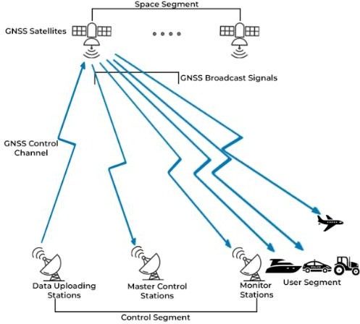
Fig2.1:GlobalNavigationSatelliteSystem diagram

OverviewofGNSSConstellations

Each GNSS constellation comprises a network of satellites orbiting the Earth and transmitting signals containing orbital parameters and precise timing information. These signals allow GNSS receivers to compute the three-dimensional location of the vehicle using trilateration techniques. The U.S. GPS, for instance, maintains at least 24 active satellites in Medium Earth Orbit (MEO) at an altitude of approximately 20,200 kilometers, with six orbital planes to ensure global availability (Misra & Enge, 2011).

Other constellations such as GLONASS use a similar orbital configuration, while Galileo and BeiDou offer additional civilian signals and global interoperability. Modern GNSS receivers are oftenmulti-constellationcapable,allowingthesimultaneoususeofsignalsfromGPS,GLONASS, Galileo, and BeiDou to enhance positioning accuracy and reliability, especially in urban and obstructed environments (Teunissen & Montenbruck, 2017).

GNSSSignalStructureand Frequencies

GNSS signals aretransmitted on specific radio frequency bands knownas L-bands. ForGPS, the primary signals include L1 (1575.42 MHz), L2 (1227.60 MHz), and L5 (1176.45 MHz). These bands carry modulated data such as navigation messages and pseudorandom noise (PRN) codes used by receivers to calculate distances to satellites (Kaplan & Hegarty, 2017). Other systems followasimilarstructure,withGalileotransmittingonE1,E5a,andE5bbandsandBeiDouusing B1, B2, and B3 bands.

Dual-frequency and triple-frequency receivers, which can receive multiple bands (e.g., L1/L5), provide better error correction and robustness against ionospheric delays, which are among the major sources of positioning inaccuracy.

TrilaterationandPositionComputation

GNSSreceiverscalculatepositionusingtrilateration,whichrequiresdistancemeasurementstoat leastfoursatellites.Thereceivermeasuresthetimetakenforeachsignaltoreachitandmultiplies it by the speed of light to obtain the range (pseudorange). Since the receiver clock may not be synchronizedwithGNSSsystemtime,afourthsatelliteisneededtosolvefortimeoffsetandthree spatial coordinates (Misra & Enge, 2011).

Mathematically,thisinvolvessolvingnonlinearequationsderivedfromthesatellitepositionsand the pseudoranges. Advanced receivers employ numerical methods and filtering techniques (e.g., Kalman filtering) to refine position estimates and mitigate noise.

ErrorSourcesinGNSS

Despiteitshighutility,GNSSissubjecttoseveralerrorsourcesthataffectaccuracy:

      - IonosphericandTroposphericDelay:Signalpropagationisaffectedbyatmospheric layers, causing delays.

      - MultipathInterference:Reflectedsignalsfrombuildingsorsurfacesmayleadtoerroneous measurements.
      - Satellite Clock Errors and Ephemeris Inaccuracy: Imperfect satellite timekeeping or orbital data can introduce biases.
      - Receiver Noise: Internal thermal noise and quantization errors contribute to inaccuracy(Teunissen & Montenbruck, 2017).

Corrections such as Satellite-Based Augmentation Systems (SBAS), including WAAS (U.S.), EGNOS (Europe), and MSAS (Japan), provide differential corrections to improve accuracy to within 1–2 meters.

GNSSReceiverArchitectures

GNSSreceiversusedinvehicletrackingsystemsarecomposedofseveralcriticalcomponentsthat worktogethertodetermineaccuratepositionaldata.TheRFfront-endisresponsibleforfiltering and amplifying the incoming satellite signals to ensure they are suitable for further processing. These signals are then passed to the baseband processor, which down-converts the high- frequency signals and digitizes them for computational interpretation. Subsequently, the navigationprocessorperformsessentialtaskssuchassignalacquisition,tracking,andexecuting algorithmstocalculatethereceiver'sposition.Basedontheirabilitytoaccesspreviouslyacquired satellitedata,GNSSreceiversaretypicallyclassifiedintothreetypes:coldstart,warmstart,and hotstart.Thisclassificationimpactsthetime-to-first-fix(TTFF)—thetimeittakesforareceiver to obtain its initial location fixafterpower-up. In automotiveapplications, achieving a fast TTFF and maintaining low power consumption are essential design considerations, especially in environments where rapid and efficient location tracking is required (Kaplan & Hegarty, 2017).

Fig2.2:GNSSreceiver

CoordinateSystemsand GeodeticFrameworks

GNSS-derived positions are referenced against standardized coordinate systems to ensure consistency and global interoperability. The most widely used reference framework is the World Geodetic System 1984 (WGS-84), which establishes a global coordinate frame based on an ellipsoidalmodeloftheEarth.Thissystemprovidesthemathematicalandgeodeticfoundationfor

positioningandnavigation.GNSSpositionaldatacanbeexpressedintwoprimaryforms:geodetic coordinatesandEarth-Centered,Earth-Fixed(ECEF)coordinates.Geodeticcoordinatesrepresent positions in terms of latitude, longitude, and altitude, making them intuitive for mapping and navigation purposes. In contrast, ECEF coordinates use a three-dimensional Cartesian (X, Y, Z) system with the origin at the Earth's center of mass, offering a more precise and computationally efficient format for satellite navigation algorithms and integration with spatial databases. Conversionbetweenthesecoordinatesystemsisessentialforintegrationwithmappingplatforms, GIS applications, and tracking databases (Leick, Rapoport, & Tatarnikov, 2015).

AssistedGNSSandHybrid Positioning

ToreduceTTFFandimproveperformanceinurbancanyonsorindoors,systemsoftenincorporate Assisted GNSS (A-GNSS), which uses cellular networks to provide aiding information such as satelliteephemerisandtimedata.Additionally,hybridpositioningtechniquescombineGNSSwith othersourceslikeWi-Fi,Bluetooth,orcellulartriangulationtomaintaincontinuityinchallenging environments (Groves, 2013).

In vehicle tracking applications, inertial sensors such as accelerometers and gyroscopes are also fused with GNSS data to provide smoother tracking and continuity during temporary signal loss.

EmbeddedSystemsinVehicle Tracking

Embedded systems are integral to the architecture of modern vehicle tracking solutions. These systems consist of dedicated microcontroller- or microprocessor-based hardware designed to perform specific real-time control functions within a larger electromechanical system. In the context of automobile asset tracking, embedded systems serve as the computational core that interfaces with GNSS modules, communication peripherals (e.g., GSM, LTE), onboard sensors, and power management circuits. They handle tasks such as data acquisition, processing, communication,andsystemdiagnostics,formingthebackboneofintelligentvehicletrackingunits (Mazidi, Naimi, & Naimi, 2016).

FunctionalRoleofEmbeddedSystemsinTrackingDevices

An embedded system in a vehicle tracking unit is primarily responsible for controlling data flow between various subsystems. It processes signals from the GNSS receiver to interpret positional information and packages this data along with other sensor readings—such as speed, engine temperature, or fuel level—for transmission via wireless communication modules. It may also storethisdatalocallyusingEEPROMormicroSDmemorycardsforpassivetrackingapplications (Shibu, 2017).

Keytasksincludeinterfacingwithserialcommunicationbuses(e.g.,UART,SPI,I2C),executing positioning algorithms, applying data compression or encryption for secure transmission, and implementingreal-timedecision-makinglogicsuchasgeofencingalertsorengineimmobilization. These operations are governed by firmware coded in low-level languages such as C or C++ and are optimized for power efficiency and reliability (Barr & Massa, 2006).

MicrocontrollersandMicroprocessorsUsed

Mostvehicletrackingsystemsarebuiltaroundlow-powermicrocontrollers(MCUs)suchasthe AtmelAVR(usedinArduino),ARMCortex-Mseries,orMicrochipPICfamilies.Thesedevices offer sufficient computational capability to handle real-time tasks while maintaining minimal energyc

onsumption—an important factorin vehicularenvironmentswhere continuousoperation is required. More advanced platforms may use microprocessors (MPUs), such as ARM Cortex- Aseries or embedded Linux systems liketheRaspberry Pi, which offergreaterprocessing power andsupportmultitaskingviareal-timeoperatingsystems(RTOS)orfullLinuxdistributions(Wolf, 2012).

Microcontrollers are typically equipped with integrated analog-to-digital converters (ADCs), timers,pulse-widthmodulation(PWM)modules,anddigitalI/Oports,whichsimplifyinterfacing with sensors, actuators, and other peripheral modules.
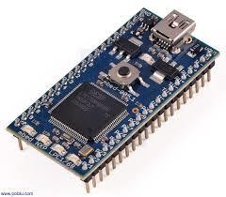
Fig2.3:Microcontroller

Real-TimeOperatingSystems(RTOS)

Incomplexvehicletrackingapplicationsrequiringmultitasking,determinism,andfault isolation, embedded systems often utilize Real-Time Operating Systems (RTOS). An RTOS ensures that time-critical tasks—such as GPS data processing or GSM signal handling—are executed within definedtimeconstraints,improvingsystemresponsivenessandreliability.Examplesofcommonly used RTOS platforms include FreeRTOS, VxWorks, and Keil RTX (Labrosse, 2013). These operating systems provide features such as task scheduling, inter-task communication, and memory management tailored to embedded environments.

PowerManagementand Reliability

Powermanagementisacrucialdesignconsiderationinembeddedvehicletrackingsystems.These systemsareoftenpoweredfromthevehicle’sbattery,buttheymustsupportvoltageregulationand protection circuitry to guard against surges, noise, and brownouts. Buck or boost converters are typicallyemployedtostepvoltagesupordownasneededbysystemcomponents(Wong&Daoud, 2016). Additionally, sleep modes and interrupt-driven wake cycles are implemented to conserve power when the vehicle is inactive or parked for long durations.

Reliability is further ensured through watchdog timers, error-correcting memory, and fail-safe programmingthatallowsystemstorecoverfromunexpectederrorsorsystemcrasheswithoutdata loss.

EmbeddedCommunicationProtocols

To support modularity and integration, embedded systems use a variety of communication protocols.UniversalAsynchronousReceiver-Transmitter(UART)iscommonlyusedforserial communication between the microcontroller and GNSS/GSM modules. Serial Peripheral Interface (SPI) and Inter-Integrated Circuit (I2C) protocols are used to interface with sensors or external EEPROMs. In advanced automotive applications, Controller Area Network (CAN) or Local Interconnect Network (LIN) buses are employed for real-time communication with Electronic Control Units (ECUs) and other subsystems within the vehicle (Axelson, 2007).

DataSecurityand Integrity

Embedded systems in vehicle tracking solutions must address data security to prevent unauthorized access or tampering. Encryption algorithms such as AES or RSA are often implemented to secure transmitted data. Additionally, checksums and cyclic redundancy checks (CRC)are used to verify data integrity, ensuring that positioning and telemetrydatais accurately received at the monitoring server (Pfleeger & Pfleeger, 2015).

Firmware-levelsecuritymeasures,suchassecurebootloadersandcodesigning,preventmalicious firmware updates and enhance system trustworthiness. Systems also incorporate EEPROM wear leveling and flash memory error correction to ensure long-term data retention.

IntegrationwithVehicleSystems

Modern embedded tracking systems are increasingly integrated with vehicle systems such as the OBD-II port, which provides access to diagnostic and performance data including engine RPM, coolant temperature, throttle position, and fuel system status. This allows for enhanced tracking solutionsthatcombinelocationdatawithvehicle healthmonitoring(Sharma&Khanduja,2019).

GSM/GPRS/LTECommunicationinTrackingSystems

Inautomobileassettrackingsystems,wirelesscommunicationplaysapivotalroleinensuringreal- timedatatransmissionbetweenthevehicle'sembeddedsystemandremotemonitoringcenters.

Global System for Mobile Communications (GSM), General Packet Radio Service (GPRS), and Long-Term Evolution (LTE) are the most widely adopted technologies for cellular-based telematics communication. These standards facilitate the transfer of location data, diagnostic information, control commands, and alerts over cellular networks to centralized servers or user interfaces. The transition from GSM to LTE reflects the evolution in bandwidth, latency, and efficiency, which significantly enhances the performance and reliability of modern vehicle tracking systems (Holma & Toskala, 2011).

GSMinVehicleTracking

GSM is a second-generation (2G) cellular network protocol that enables voice and basic data communication through circuit-switched transmission. In vehicle tracking, GSM is commonly usedtosupportShortMessageService(SMS)forlow-bandwidthtransmissionofGPScoordinates andeventnotifications.ItsglobalcoverageandsimplicitymakeGSMacost-effectiveandreliable option,particularlyinregionswhereadvanceddatanetworksarenotavailable.GSMmoduleslike the SIM800 and SIM900 are widely integrated into tracking devices, providing serial UART interfaces for communication with microcontrollers (Harri, Filali, Bonnet, & Fiore, 2009).

Although GSM’s data rate is limited (typically up to 14.4 kbps for circuit-switched data), its robustness and low power consumption make it suitable for passive tracking applications or scenarios where continuous real-time updates are not critical.

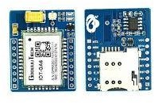

Fig2.4:GSM module

GPRSforPacket-SwitchedData

GPRS,anenhancementtoGSM,introducespacket-switcheddatatransmission,allowingefficient useofavailablespectrumandenablingalways-onconnectivity.GPRSsupportsdataratesranging from 56 kbps to 114 kbps, enabling vehicle tracking systems to transmit richer datasets, such as route history, vehicle diagnostics, and driver behavior metrics (Yacoub, 2000).

In embedded tracking systems, GPRS modules interface with the microcontroller to establish TCP/IP or UDP socket connections with the tracking server. This facilitates real-time communication,allowingfortwo-waydataexchange.GPRSusesstandardATcommandsfor

session control, making it easily programmable within embedded environments. Moreover, its supportforIP-basedcommunicationallowsintegrationwithmodernserver-sideplatforms,cloud- based dashboards, and mobile applications.
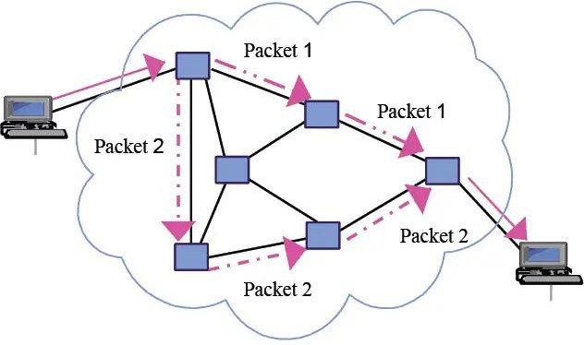

Fig2.5:GPRSforPacket-switched Data

LTEand4GNetworksinTrackingSystems

LTE,a fourth-generation(4G)wireless standard, significantlyimprovesuponitspredecessors by offeringhigherdatarates(upto100Mbps),lowerlatency(<50ms),andbetterspectralefficiency. In vehicle tracking systems, LTE enables high-speed real-time transmission of large volumes of data, including live location streaming, video feeds, and vehicle-to-everything (V2X) communication. LTE's architecture supports IP-only data services, making it highly compatible with modern IoT frameworks (Sauter, 2014).

LTE also allows remote firmware over-the-air (FOTA) updates, remote diagnostics, and integration with cloud-based analytics platforms, expanding the functional scope of vehicle tracking systems beyond mere positioning.

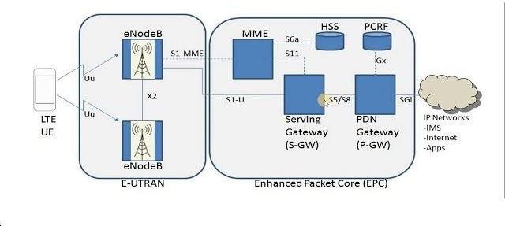
Fig2.6:LTEand4Gnetwork

APNs,IPConfiguration,andDataRouting

Anessentialelementincellular-basedcommunicationistheconfigurationofAccessPointNames (APNs), which serve as gateways between the cellular network and the internet. Proper APN configurationallowstrackingmodulestoestablishasecuresessionwithbackendservers.Devices may use dynamic or static IP addressing, depending on whether the tracking server initiates communication with the client (vehicle) or vice versa.

Typically, devices push data to a public IP address using the HTTP or MQTT protocols, or establish UDP/TCP sessions for custom protocol communication. The selection of the transport protocol is influenced by requirements such as reliability (TCP), low overhead (UDP), or event- based messaging (MQTT).

AntennasandRFConsiderations

ThereliabilityofGSM/GPRS/LTEcommunicationalsodependsonthequalityoftheRFhardware and antenna design. External or PCB-embedded antennas are used to optimize signal reception. Signal quality is often measured using parameters such as Received Signal Strength Indicator (RSSI)andSignal-to-NoiseRatio(SNR).Antennaplacement,impedancematching,andisolation from high-frequency interference sources (e.g., switching regulators) are critical for optimal performance (Balanis, 2016).
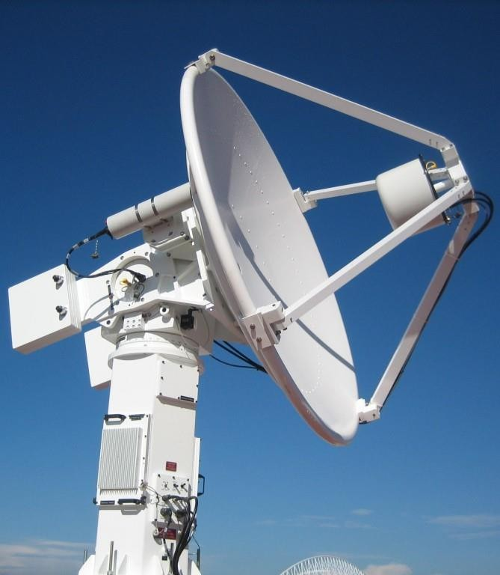
Fig2.7:Antenna

SIMCardManagementandNetwork Selection

Cellular modules require Subscriber Identity Module (SIM) cards to authenticate with mobile networks. In professional vehicle tracking deployments, M2M (machine-to-machine) or IoT SIM cards are used. These SIMs offer enhanced durability, better lifecycle management, and supportforroamingacrossmultiplenetworkoperators.SomesystemsutilizeeSIMtechnology,

which allows for remote provisioning and network switching without physical SIM card changes (GSMA, 2020).

Theabilitytoscanformultiplecarriersandchoosethebestavailablenetworkisvitalforensuring connectivity in fleet tracking applications that cross regional or national boundaries.

SecurityinCellular Communication

Data transmitted over GSM/GPRS/LTE networks must be protected against interception and tampering.WhileGSMusesA5encryptionalgorithms,LTEprovidesenhancedsecurityvia 128- bit Advanced Encryption Standard (AES) and integrity protection mechanisms. In addition to network-level encryption, end-to-end encryption via SSL/TLS is often implemented at the application layer to secure sensitive vehicle and user data (Pfleeger & Pfleeger, 2015).

Authentication mechanisms such as two-factor verification, SIM whitelisting, and IMEI filtering are also employed to prevent unauthorized access to the tracking system.

DataCostandBandwidth Optimization

Incommercialtrackingdeployments,datacostisanoperationalconcern.Efficientdataencoding, suchasbinarypayloadstructuresanddeltacompressiontechniques,isusedtoreducethevolume of transmitted data. Tracking frequency can be dynamically adjusted based on vehicle speed, motion detection, or geofencing events to further optimize bandwidth usage.

Some systems also employ store-and-forward techniques, where data is temporarily stored in local memory and transmitted in bursts when network conditions are optimal, reducing connectivity costs and improving reliability.

PowerSupplyDesigninTrackingSystems

The power supply system is a critical component in the design and operation of automobile tracking devices. A well-engineered power system ensures reliable functionality, minimizes energy loss, protects sensitive electronics, and supports both standby and active modes of operation. Due to the mobile nature of vehicles and their varying electrical conditions, power supplydesigninautomotivetrackingsystemsmustberobust,energy-efficient,noise-resistant,and capable of operating across wide voltage ranges. Power systems typically consist of voltage regulators, protection circuits, filtering components, and sometimes energy storage units such as supercapacitors or rechargeable batteries.

InputVoltageRangeandAutomotivePower Characteristics

Vehicles supply power through a 12 V or 24 V DC battery system, depending on the class (e.g., 12 V for passenger vehicles, 24 V for heavy-duty trucks). However, this voltage is not stable—it fluctuatesduringenginecranking,alternatorloadchanges,orsuddenacceleration.Forexample,a cold crank may momentarily reduce the supply voltage to as low as 6 V in 12 V systems, while alternatorsurgesmayraiseitto16Vormore(Horowitz&Hill,2015).Therefore,trackingdevices

must tolerate wide input voltage ranges, typically from 6 V to 30 V, to avoid reset, malfunction, or permanent damage.

BuckandBoost Regulators

To power the 3.3 V or 5 V logic circuits used in GPS modules, GSM modules, and microcontrollers, DC-DC converters are employed. These are usually buck (step-down) converters when the supply voltage is higher than the required output, or boost (step-up) converters in rare low-voltage scenarios.

Buckconvertersarepreferredfortheirhighefficiency(typically>85%)andtheirabilitytohandle moderatecurrentloads.CommonlyusedswitchingregulatorICs,suchastheLM2596orMP1584, offer compact footprints, built-in protection features, and adjustable output voltages. For noise- sensitive applications likeGPS reception, proper filtering using LC circuits is critical to suppress high-frequency switching noise from buck regulators (Erickson & Maksimovic, 2007).

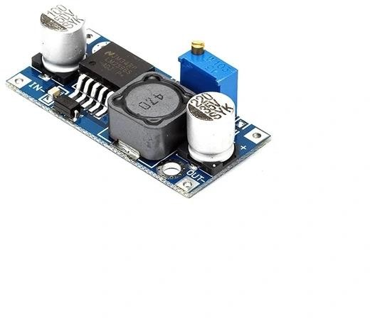
Fig2.8:BuckConverter

LinearRegulatorsandLow-Dropout Designs

In less demanding or ultra-low-noise applications, linear voltage regulators like the AMS1117 or LM7805 are used. Although these regulators offer simpler implementation and lower ripple, they are less efficient, especially when the voltage differential between input and output is large. Low-Dropout Regulators (LDOs) are preferred when the supply voltage is only marginally higher than the output requirement, and noise minimization is critical (Razavi, 2013).

LDOs are often employed for analog blocks within GPS receivers, timing crystals, or ADC reference voltages, ensuring clean power for precision measurements.

PowerSupplySequencingandModuleStart-UpBehavior

Sometrackingsystemcomponentsrequirecarefulsequencingduringpower-up.Forinstance,GPS and GSM modules may need their power rails to stabilize before activation or reset signals. Improper sequencing can lead to brownout conditions or latch-up, especially in modules that containinternalswitchingregulatorsorsensitivebasebandprocessors (Texas Instruments,2022).

Sequencing circuits may involve simple RC delays, dedicated power sequencing ICs, or microcontroller-supervised control through MOSFET switches. Proper sequencing extends module lifespan and avoids initialization errors.

BatteryBackupandPowerFailover

Many vehicle tracking systems include backup power sources to ensure continuous operation during main power loss or deliberate disconnection. Lithium-ion (Li-ion) or Lithium-polymer (Li-Po) rechargeable batteries are common for this purpose. Integrated charging ICs, such as the TP4056,managechargingcyclesandoverchargeprotection.Alternatively, supercapacitorsmay be used for short-term energy bridging, especially where quick recovery is required.

Battery-backedsystemsmustmonitorvoltagelevelstopreventdeepdischarge,whichcandegrade batteryhealth.Fuelgaugingcircuitsandbatterymanagementsystems(BMS)providevoltage, temperature, and current data to the microcontroller to ensure safe operation.

PowerOptimizationandSleepModes

To conserve energy, especially in GSM-enabled tracking systems, power optimization strategies are employed. Microcontrollers (e.g., ATmega328 or STM32) are programmed to enter sleep modes during idle periods. Similarly, GPS modules support low-power states such as standby, periodicmode,oralwayslocatemode.GSMmodulescanbetemporarilyshutdownorplacedin flight mode to reduce power draw when not transmitting.

EfficientpowergatingthroughMOSFET-basedhigh-sideswitchesenablesselectivepoweringof subsystems. This modular control extends system uptime in battery-backed applications and reduces thermal load.

EMI/ESDProtectionandAutomotiveStandards

Power supply lines in vehicle environments are prone to electromagnetic interference (EMI), electrostatic discharge (ESD), and voltage transients. Therefore, the power input stage includes:

      - TVS(TransientVoltage Suppression)diodes forsurgeprotection.
      - FerritebeadsandLCfilters toblockhigh-frequencynoise.
      - Polyfusesorresettable fusestopreventovercurrentdamage.

Designs must comply with standards such as ISO 7637-2, which defines transient immunity requirements for automotive electronics (ISO, 2011). EMI shielding and proper PCB grounding are also essential for ensuring signal integrity and safety.

PowerDistributionArchitecture

Modernembeddedtrackingsystemsemployastructuredpowerdistributionarchitecture.Multiple voltage rails (e.g., 5 V for GSM, 3.3 V for GPS and MCU, 1.8 V for sensors) are derived from a common bus through separate regulators. Power tree design helps in balancing efficiency, load sharing, and thermal dissipation. Some systems also implement power monitoring ICs to detect undervoltage or overcurrent events, providing fail-safe operation through microcontroller intervention.

EmbeddedSystemArchitectureinTracking Devices

The embedded system architecture is fundamental to the functionality of modern automobile tracking devices. It acts as the central processing unit that integrates data acquisition, real-time processing, communication, and control, ensuring accurate and timely vehicle location tracking. These embedded systems are designed to meet rigorous requirements such as low power consumption, real-time responsiveness, fault tolerance, and scalability within the automotive environment (Barr & Massa, 2006).

Microcontrollersand Microprocessors

Microcontrollers(MCUs)arethemostwidelyadoptedcomputingunitsin vehicletrackingdevices, chosenprimarilyfortheirintegrationofprocessingcores,memory,andperipheralinterfacesona single chip. Common MCUs include the ATmega328P for simpler tracking applications, the STM32 series based on ARM Cortex-M cores for more demanding tasks, and the ESP32, which combines an MCU with integrated wireless communication capabilities such as Wi-Fi and Bluetooth (Kolban, 2017). In higher-performance tracking systems that require advanced data processingormultimediacapabilities,microprocessorssuchasthosefoundintheRaspberryPior BeagleBoneBlackplatformsareused.Thesemicroprocessorssupportcomplexoperatingsystems like Linux, enabling the execution of sophisticated software for analytics and cloud connectivity.
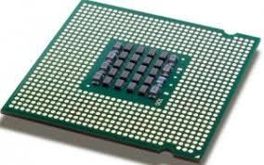
Fig2.9:Microprocessor

Memory Systems

Embedded memory architecture in tracking devices consists of multiple types of storage, each serving specific purposes. Non-volatile flash memory stores the device firmware and persistent configuration data, while volatile SRAM or DRAM provide fast access memory for runtime processing. Additionally, EEPROM or FRAM modules are commonly employed for long-term storage of GPS logs, sensor data, and fault diagnostics, even during power loss. Designers must ensuredataintegrityunderharshconditionsbyimplementingfeaturessuchasbrownoutdetection and watchdog timers to protect against unexpected resets or power failures (Mazidi, Naimi, & Naimi, 2016).
I0uo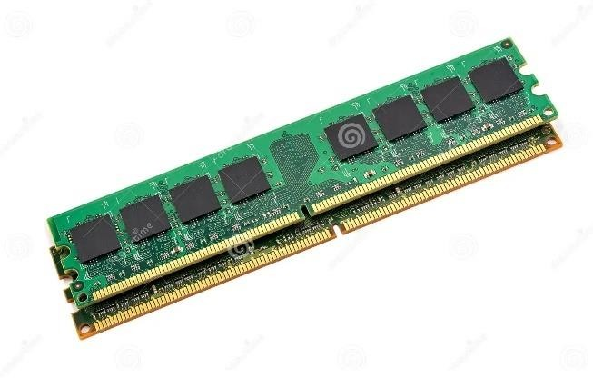

Fig2.10:MemorySystem

PeripheralInterfaceIntegration

Efficient peripheral integration is critical for acquiring sensor data and communicating with external modules. Communication protocols such as UART, SPI, and I2C facilitate interfacing withGPSreceivers,GSMmodems,EEPROMs,andvarioussensorslikeaccelerometersandfuel- level detectors. Dueto thelimitednumberofMCUpins, techniquessuch as multiplexing and the use of external I/O expanders are frequently employed to manage multiple peripherals. Additionally, analog-to-digital converters (ADCs) enable the system to process analog signals from sensorsmeasuring parameterslikebatteryvoltageortemperature, thus expanding thescope of monitoring capabilities.
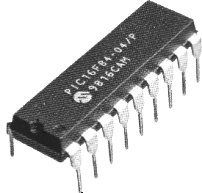
Fig2.11:PeripheralInterface Integration

Interrupt-DrivenProcessing

Interrupt-driven architectures are crucial for real-time responsiveness in embedded tracking systems. External interrupts generated by events such as GPS pulse-per-second (PPS) signals, incoming GSM messages, or motion detected by accelerometers trigger immediate processor attention. These interrupts invoke carefully optimized Interrupt Service Routines (ISRs) that prioritize high-urgency events while minimizing latency. ARM Cortex-M MCUs feature Nested Vectored Interrupt Controllers (NVICs) that support prioritized and nested interrupts, allowing sophisticated management of concurrent hardware events (Yiu, 2016).

PowerManagementandSleepModes

Power efficiency is paramount for embedded systems deployed in vehicles, especially when operatingonbackuppowersources.ModernMCUssupportmultiplelow-powerstates,including idle, standby, and deep sleep modes, which reduce power consumption during inactivity. Peripheral modules can be selectively disabled or powered down, and techniques such as clock gating and dynamic frequency scaling are used to optimize energy use further. These capabilities enable prolonged device operation and contribute to the reliability of vehicle tracking systems under varying power conditions (Barr & Massa, 2006).

FirmwareandOver-The-Air(OTA) Updates

Firmwareservesasthesoftwarefoundationofembeddedtrackingsystems,typicallywritteninC or C++. Modular design separates hardware abstraction layers, communication stacks, and applicationlogictoensuremaintainabilityandscalability.Theincorporationofover-the-air(OTA) update mechanisms has become essential, allowing remote delivery of firmware patches and feature upgrades without physical access. OTA update processes often utilize dual-bank flash architectures to ensure safe firmware replacement, with cryptographic validation employed to guarantee firmware authenticity and integrity (Zhang, Cao, Wang, & Liu, 2020).

SecurityandTamper Resistance

Giventhecriticalnatureoftrackingdataandthepotentialformaliciousattacks,embeddedtracking devices incorporate robust security measures. Secure bootloaders enforce cryptographic verificationoffirmwareatstartup,preventingunauthorizedcodeexecution.Firmwareencryption techniquesguardagainstreverseengineering,whiletamperdetectioncircuitrycandetectphysical intrusion attempts, triggering alerts or device lockdowns. Many modern MCUs include hardware acceleratorsforcryptographicfunctions(e.g.,AES,RSA,SHA),offloadingthesecomputationally intensive tasks from the main processor to maintain performance while ensuring secure communication and data protection (Mazidi et al., 2016; Yiu, 2016).

CommunicationProtocolsandDataTransmissionModels

Effective communicationprotocols andreliabledatatransmissionmodelsarepivotal in automobile trackingsystems,enablingseamlessexchangeoflocationanddiagnosticdatabetweenthetracking deviceandremoteserversoruserinterfaces.Thesecommunicationtechnologiesareresponsible

for ensuring data integrity, low latency, and scalability across diverse network conditions, which is critical for real-time vehicle tracking, remote monitoring, and fleet management.

CellularCommunicationTechnologies

Cellularnetworks,particularly2G(GSM),3G(UMTS),4G(LTE),andincreasingly5G,formthe backbone of most vehicle tracking communication infrastructures. GSM (Global System for Mobile Communications) was the earliest standard widely used for vehicle tracking, providing reliable SMS and circuit-switched data transmission. However, its limited data rates prompted adoption of UMTS and LTE, which offer packet-switched, high-throughput data transfer capabilities suitable for continuous GPS data streaming and multimedia transmission (Sauter, 2021). The transition to LTE and 5G networks enables ultra-low latency, enhanced bandwidth, and improved network slicing, which are essential for future vehicle-to-everything (V2X) communication paradigms.

ShortMessageService(SMS)andUnstructuredSupplementaryServiceData(USSD)

SMS remains a prevalent data transmission method in automobile tracking due to its universal supportacrossGSMnetworksandlowpowerrequirements.Trackingdevicesoftensendperiodic locationupdatesoralertmessagesviaSMStocentralizedserversoruserphones.USSD,asession- oriented protocol, allows real-time interaction with network applications but is less common in tracking applications due to its complexity and limited payload capacity (Rappaport, 2002).

GeneralPacketRadioService(GPRS)andPacketDataProtocol (PDP)

GPRS introduced packet-switched data transmission over GSM networks, enabling efficient and cost-effective communication for vehicle tracking devices. GPRS operates by establishing a Packet Data Protocol (PDP) context that facilitates IP-based communication, allowing tracking devices to transmit real-time GPS coordinates and telemetry data to cloud servers or fleet management platforms. GPRS supports multipleQuality of Service (QoS) profiles that influence latency, throughput, and reliability, enabling service customization depending on the tracking application requirements (Sauter, 2021).

InternetProtocol(IP)BasedCommunication

Modern tracking systems increasingly utilize IP-based communication protocols such as TCP (Transmission Control Protocol) and UDP (User Datagram Protocol) over cellular networks or Wi-Fi. TCP provides reliable, ordered, and error-checked delivery of data packets, making it suitable for critical commands and configuration updates. UDP, while less reliable due to lack of retransmissionmechanisms, offerslowerlatency, makingit preferable forstreamingreal-timeGPS datawhereoccasional packet loss is tolerable (Stevens, 1994). Transport LayerSecurity (TLS)is oftenimplementedtoencrypttheseIPcommunications,ensuringconfidentialityanddataintegrity against interception or tampering.

SatelliteCommunication

In areas with limited cellular coverage, satellite communication provides an alternative transmission medium for vehicle tracking systems, particularly for fleets operating in remote or maritime environments. Satellite modems integrated into tracking devices communicate via geostationary or low-earth orbit satellites, offering global coverage. Although satellite communication typically incurs higher latency and cost compared to cellular networks, its reliability in off-grid locations makes it indispensable for critical asset tracking (Kaplan & Hegarty, 2017).

WirelessLocalAreaNetworks(WLAN)and Bluetooth

Some tracking systems incorporate short-range wireless communication such as Wi-Fi (WLAN) and Bluetooth for local data transfer or device configuration. WLAN enables high-speed data exchange when vehicles are within range of hotspots, allowing bulk data offloading or firmware updates without cellular data costs. Bluetooth facilitates device pairing and configuration, or communication with onboard sensors and mobile applications, offering low power consumption and ease of integration (Kurose & Ross, 2017).
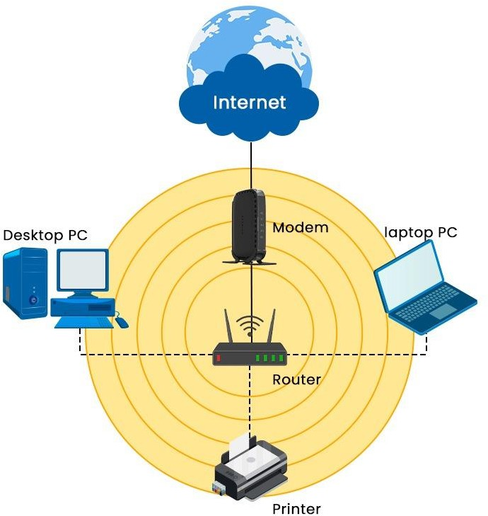

Fig2.12:WirelessLocal AreaNetwork

MessageQueuingTelemetryTransport(MQTT)andOtherIoTProtocols

With the emergence of the Internet of Things (IoT), lightweight communication protocols like MQTT have been adopted in tracking systems to enable efficient machine-to-machine (M2M) communication. MQTT employs a publish-subscribe model over TCP/IP, minimizing network bandwidthusageandenablingreliablemessagedeliveryeveninconstrainedenvironments.Its

simplicity and support for Quality of Service (QoS) levels make it suitable for transmitting GPS coordinates, vehicle status updates, and alerts to cloud platforms in real time (Light, 2017).
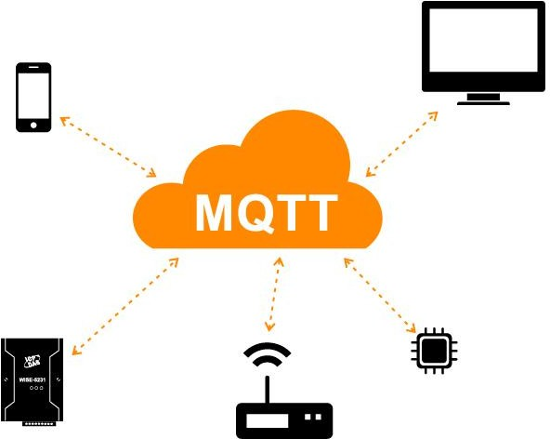

Fig2.13: MessageQueuingTelemetryTransport (MQTT)

DataTransmissionModels

Data transmission in automobile tracking systems follows several models, including periodic, event-driven,andon-demandreporting.Periodictransmissioninvolvessendinglocationandstatus updates at fixed intervals, balancing accuracy and power consumption. Event-driven models triggertransmissionsbasedonpredefinedeventssuchasignitionon/off,speedthresholdbreaches, or geofence violations, optimizing bandwidth use and enabling timely alerts. On-demand transmission allows remote querying of the vehicle’s current status, typically initiated by a fleet manageroruserapplication.Thesemodelscanbecombinedandconfigureddynamicallybasedon operational requirements (Stojmenovic & Wen, 2014).

PowerManagementandEnergyEfficiencyinAutomobileTracking Devices

Powermanagementisa criticalaspectofautomobiletrackingsystems,particularlybecausethese devices often operate in environments where reliable power sources may be intermittent or constrained. Efficient energy consumption not only prolongs device lifetime but also ensures continuous tracking functionality and reduces maintenance costs associated with battery replacement or vehicle power interruptions. Consequently, tracking devices are engineered with advanced power management strategies that balance performance, responsiveness, and energy efficiency (Barr & Massa, 2006).

PowerSourcesandConsumptionProfiles

Automobile tracking devices are typically powered from the vehicle’s battery system, which provides a nominal voltage (usually 12V or 24V) that must be regulated and converted to lower voltages suitable for embedded circuits. Devices may also incorporate rechargeable backup batteriesorsupercapacitorstomaintainoperationduringengine-offperiodsorpowerdisruptions. Thepowerconsumptionprofileofatrackingdevicevariesdynamicallydependingonoperational states, such as GPS acquisition, data transmission, sensor monitoring, and sleep mode (Mazidi, Naimi, & Naimi, 2016).

VoltageRegulationandPower Conversion

Efficient power regulation is essential for minimizing losses and ensuring stable voltage supplies tosensitiveelectronics.Buckconverters(step-downswitchingregulators)arepreferredoverlinear regulators due to their higher efficiency, especially when stepping down from vehicle battery voltages to microcontroller and module operating voltages (typically 3.3V or 5V). The choice of regulator topology, switching frequency, and inductor/capacitor components directly impacts overall power efficiency and electromagnetic interference (EMI) levels (Sedra & Smith, 2014).

SleepModesandLow-PowerOperation

Toconserveenergyduringperiodsofinactivity,embeddedtrackingsystemsemployvariouslow- power modes available in modern microcontrollers. These modes range from light sleep, where the CPU clock is gated but peripheral functions remain active, to deep sleep or standby modes, which significantly reduce current draw by disabling most system components except essential wakeup sources. Wakeup events can be triggered by timer interrupts, motion detection via accelerometers,ornetworkmessages,allowingthe devicetoremainresponsivewhileconserving energy (Yiu, 2016).

DutyCyclingandAdaptiveSampling

Power savings can be further enhanced by employing duty cycling strategies, where the tracking device periodically activates GPS modules and communication interfaces only when needed to collect and transmit data. Adaptive sampling algorithms optimize this process by dynamically adjustingthefrequencyofGPSfixesandsensorreadingsbasedonvehiclemotion,speed,oruser- defined criteria. For instance, the device may reduce sampling rate when the vehicle is stationary or in low-movement scenarios, thereby extending battery life without compromising tracking accuracy (Kaplan & Hegarty, 2017).

Power-AwareCommunication

Communication modules such as GSM or LTE modems are significant contributors to overall power consumption due to their radio frequency (RF) transmission requirements. Power management techniques include controlling transmission power levels, employing efficient communication protocols (e.g., MQTT with QoS), and aggregating data to reduce the frequency ofnetworktransmissions.Somedevicesutilizenetwork-assistedpowersavingmodessuchas

Discontinuous Reception (DRX) to allow modems to periodically enter low-power states while maintaining network connectivity (Sauter, 2021).

EnergyHarvestingandAlternativePowerSources

Emerging technologies integrate energy harvesting mechanisms, such as solar panels or regenerative braking energy converters, to supplement or replace conventional power sources. Whilestillatanearlyadoptionstageinvehicletracking,thesetechniquespromisetofurtherreduce dependency on batteries and vehicle electrical systems, enabling near-perpetual device operation in off-grid scenarios (Stojmenovic & Wen, 2014).

SensorIntegrationandDataAcquisitioninAutomobileTrackingSystems

Sensor integration forms a vital component of automobile tracking systems, enriching location datawithadditionalcontextualandoperationalparameters.Bycombiningglobalpositioningdata with inputs from various onboard sensors, tracking systems provide comprehensive insights into vehicle status, driver behavior, and environmental conditions. Effective sensor data acquisition and fusion techniques are essential for enhancing tracking accuracy, enabling predictive maintenance, and supporting advanced telematics applications (Miller, 2017).

TypesofSensorsinVehicle Tracking

- Inertial Sensors (Accelerometers and Gyroscopes): Automobiletrackingsystemsuseaccelerometersandgyroscopestocapturereal-timedata on vehicle acceleration, angular velocity, and orientation. Accelerometers measure linear accelerationforces,whichareessentialfordetectingsuddenbraking,rapidacceleration,or collisions.Gyroscopesmeasurerotationalmovement,helpingtodetectchangesinvehicle heading and rollover events. Together, these sensors provide critical motion data that complements GPS signals, especially in environments with poor satellite reception (El- Sheimy, Hou, & Niu, 2008).
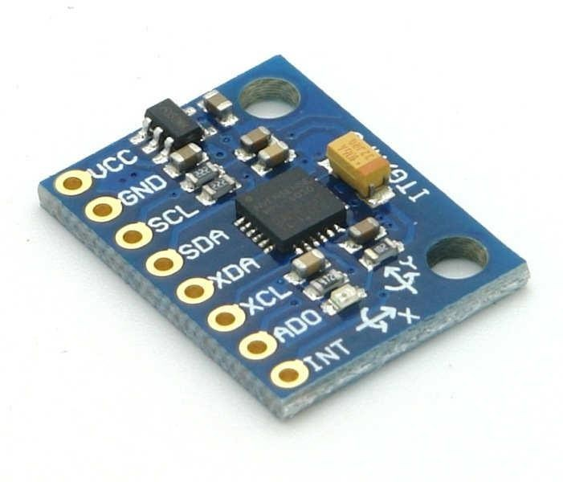
Fig2.14: InertialSensors(AccelerometersandGyroscopes)

- Magnetometers:
Magnetometers measure the Earth's magnetic field to provide directional heading information. Acting as digital compasses, these sensors improve navigation accuracy by determiningvehicleorientation,particularlyinurbanareaswhereGPS signalsmaysuffer from multipath interference.
- Fuel-Level Sensors:
These sensors monitor the amount of fuel in the vehicle’s tank in real time. By tracking fuel consumption and tank status, fleet managers can detect fuel theft, monitor usage patterns, and optimize refueling schedules, which enhances operational efficiency and security.
- Temperature Sensors:
Temperature sensors monitor both engine and ambient temperature conditions. Engine temperaturemonitoring helpspreventoverheatingandpotentialmechanicalfailure,while ambient temperature data can indicate environmental conditions or alert unauthorized usage when the vehicle operates outside safe temperature thresholds.
- Vehicle Diagnostics Interfaces (OBD-II Port): The On-Board Diagnostics II (OBD-II) interface is widely used to access comprehensive vehicle diagnostic data. It provides information such as engine performance, fault codes, vehicle speed, and RPM. Integration with the OBD-II port enables tracking systems to extend beyond location tracking, allowing for real-time vehicle health monitoring and predictive maintenance (Miller, 2017).

SensorInterfacesandCommunication Protocols

Sensors are interfaced with the tracking system's embedded controller through a variety of communication protocols, including analog voltage signals, Serial Peripheral Interface (SPI), Inter-Integrated Circuit (I2C), and Controller Area Network (CAN) bus. CAN bus, in particular, is widely used in modern vehicles for high-speed, robust communication of sensor and actuator datawithinthevehicle’sinternalnetwork.AccessingCANdataenablestrackingdevicestoextract detaileddiagnosticandoperationalinformationdirectlyfromthevehicle’sElectronicControlUnit (ECU), thereby extending the range of telematics features (Bosch, 2011).

DataAcquisitionandSignal Conditioning

Rawsensorsignalsoftenrequireconditioningbeforeprocessing,includingamplification,filtering, and analog-to-digital conversion. Signal conditioning ensures that noise, offset, and other distortions areminimized,improvingmeasurementaccuracy.Embedded ADCsintegratedwithin microcontrollersconvertanalogsensoroutputsintodigitaldatastreamsforprocessingandstorage. Advancedfilteringtechniques,suchasKalmanfilters,areappliedtosensordatafusion,combining GPS position data with inertial sensor inputs to yield more accurate and robust vehicle location and movement estimates, especially in urban canyons or tunnels where GPS signals are weak or unavailable (Groves, 2013).

SensorFusionTechniques

Sensor fusion algorithms are critical in enhancing the reliability and accuracy of vehicle tracking databycombininginformationfromheterogeneoussensors.Thesealgorithmsmitigateindividual sensor limitations and errors through statistical methods and model-based approaches. For example, integrating GPS data with inertial navigation systems (INS) compensates for GPS outages or multipath errors. Extended Kalman Filters (EKF) and Particle Filters are commonly implemented to process and fuse sensor inputs in real time, enabling continuous and accurate tracking under dynamic conditions (Farrell, 2008).

Real-TimeDataAcquisitionand Processing

Automobile tracking systems must acquire, process, and transmit sensor data in real time to support prompt decision-making and alerts. Embedded systems employ interrupt-driven architecturesandDirectMemoryAccess(DMA)techniquestoefficientlyhandlehigh-ratesensor data streams with minimal CPU overhead. Real-time operating systems (RTOS) facilitate task scheduling and synchronization for simultaneous GPS, sensor data acquisition, and communication,ensuringtimelyupdatesandreducinglatencyincriticalscenariossuchascollision detection or theft alerts (Labrosse, 2002).

CommunicationProtocolsandDataTransmissioninAutomobileTrackingSystems

    - CellularCommunicationTechnologies

Effective communication protocols are essential for transferring vehicle location and status data reliably in automobile tracking systems. Cellular communication remains the backbone of most vehicle tracking solutions. Early-generation networks such as GSM (Global System for Mobile communications), GPRS (General Packet Radio Service), and EDGE (Enhanced Data rates for GSM Evolution) have been widely adopted because of their extensive coverage and cost- effectiveness. These networks facilitate packet-switched data transfer, allowing tracking devices totransmitlocationandtelemetrydataefficiently,thoughatmoderatedataratesandlatency.With the evolution of cellular technologies, 3G and 4G LTE (Long-Term Evolution) networks provide significantly higher data rates, reduced latency, and improved reliability. These advancements support richer data transmissions including real-time video streaming, over-the-air updates, and complextelematics,making4GLTEthecurrentstandardforvehicletrackingsystems.Moreover, 5Gnetworksareemerging,promisingultra-lowlatency,enhancedbandwidth,andthecapacityto support massive numbers of connected IoT devices, which will further revolutionize automobile tracking (Sauter, 2021).

Short-RangeCommunication Protocols

In addition to cellular technologies, short-range wireless protocols such as Bluetooth and Wi-Fi arefrequentlyintegratedintotrackingsystemstosupportlocaldatatransfer,deviceconfiguration, anddiagnostics.Bluetoothenablessecure,low-powercommunicationbetweenthetrackingdevice and nearby smartphones or diagnostic equipment, allowing for convenient wireless access to vehicledatawithoutincurringcellulardatacosts.Wi-Fimodulesprovidehigherbandwidth

connections that are particularly useful for bulk data offloading when the vehicle is within range of a trusted network, such as at a depot or maintenance facility. These protocols complement cellular connectivity by offering efficient, cost-effective local communication options (Deng, Li, & O’Donnell, 2017).

SatelliteCommunication

Forvehiclesoperatinginremoteoroffshoreenvironmentswherecellularcoverageisunavailable or unreliable, satellite communication is indispensable. Satellite networks such as Iridium, Inmarsat, and Globalstar offer global coverage by relaying data from tracking devices through satellites to ground stations, ensuring uninterrupted vehicle monitoring regardless of geographic location. Although satellite communication systems typically introduce higher latency and operational costs compared to terrestrial cellular networks, they provide critical tracking capabilities for maritime fleets, long-haul trucking, and other applications requiring global reach (Kaplan & Hegarty, 2017).

CommunicationProtocolsandDataFormats

Communicationprotocolsgoverningdatatransmissionfromtrackingdevicestocentralserversor cloud platforms are pivotal for system efficiency and security. MQTT (Message Queuing TelemetryTransport)isawidelyadoptedprotocolinIoTandvehicletrackingapplicationsdueto its lightweight design, minimal bandwidth requirements, and efficient publish-subscribe messaging model. HTTP and HTTPS protocols are also commonly used, offering standardized and secure methods for web-based communication between devices and servers. The choice of protocolimpactsdatathroughput,latency,powerconsumption,andsecurityofthetrackingsystem (Hunkeler, Truong, & Stanford-Clark, 2008).

Data packets sent by tracking devices generally encapsulate GPS coordinates, sensor measurements,timestamps,anddeviceidentifiersinstructuredformats.Toensureconfidentiality and integrity, encryption standards such as AES (Advanced Encryption Standard) are implemented, preventing unauthorized interception and tampering. Secure data transmission is essential to protect sensitive location and vehicle status information, thereby safeguarding user privacy and preventing potential security breaches (Fischer, 2016).

DataProcessingandCloudIntegrationinAutomobileTrackingSystems

    - DataAcquisitionand Preprocessing

Automobile tracking systems continuously collect vast amounts of raw data from GPS modules, sensors, and vehicle diagnostics. This data acquisition process involves capturing geospatial coordinates,speed,acceleration,enginestatus,andenvironmentalconditionsatfrequentintervals. Beforetransmission,preprocessingstepssuchasdatafiltering,errorcorrection,andformattingare performedwithinthetrackingdeviceoredgecomputingunits.Thesepreprocessingtechniquesare essential to reduce noise, eliminate outliers, and compress data, thereby optimizing bandwidth usage and improving the accuracy and reliability of the tracking information transmitted to backend servers (Li & Chen, 2019).

Cloud-BasedDataStorageand Management

Theintegrationofcloudcomputinghasrevolutionizeddatastorageandmanagementinautomobile tracking systems. Cloud platforms offer scalable, on-demand resources that enable efficient handling of large volumes of telemetry and geolocation data generated by vehicle fleets. Cloud databases store structured and unstructured data securely while supporting rapid query responses and data retrieval for analytics and reporting. Moreover, cloud infrastructures facilitate real-time data synchronization across multiple user devices and administrative consoles, enabling fleet operators to monitor vehicle status dynamically regardless of location (Kaur & Singh, 2020).

Real-TimeAnalyticsandDecisionSupport Systems

Advancedtrackingsystemsemploycloud-basedanalyticsenginestoprocessstreamingdatainreal time. These analytics frameworks utilize machine learning algorithms and statistical models to detect patterns, anomalies, and predictive insights from vehicle behavior and environmental factors.Real-timeanalyticscanidentifyharshdrivingevents,unauthorizedusage,ormaintenance needs,triggeringautomatedalertstofleetmanagersordrivers.Theintegrationofdecisionsupport systems enhances operational efficiency by enabling proactive interventions, optimizing routes, and reducing downtime (Jain, Kumar, & Singh, 2021).

APIIntegrationandUserInterfaces

Cloud-based tracking platforms commonly expose Application Programming Interfaces (APIs) that allow third-party software, mobile apps, and enterprise resource planning (ERP) systems to accessvehicletrackingdata.TheseAPIsenablecustomization,integrationwithexistingbusiness workflows, and development of user-friendly dashboards. User interfaces present processed data visually through interactive maps, graphs, and reports, facilitating intuitive understanding and actionable insights for fleet operators and end-users (Zhou & Wang, 2018).

CHAPTER THREE
  - METHODOLOGY

POWER SUPPLY
IGNITIONKEY
GSMMODULE
ARDUINO NANO

GPSNEO-6M

Fig.3.1:Block Diagram

SystemOverview

Theassettrackingsystemiscomposedoffivekey components:

- ArduinoNano(ControlUnit)
- GPSModule(Neo-6M)
- GSMModule(SIM800/SIM900)
- IgnitionKey Interface
- PowerSupplywithBuck Converter

Thesemodulesinteractwitheachothertoachievereal-timevehicletracking,ignitionmonitoring, and communication with a remote server or mobile client.

BlockDiagramExplanation

    - PowerSupplyandBuckConverter

Abuckconverterorstep-downconverterisaDC-to-DCconverterwhichdecreasesvoltage,while increasingcurrent,fromitsinput(supply)toitsoutput(load).Itisaclassofswitched-modepower supply.Switchingconverters(suchasbuckconverters)providemuchgreaterpower efficiencyas

DC-to-DCconvertersthanlinearregulators,whicharesimplercircuitsthatdissipatepowerasheat, but do not step up output current. The efficiency of buck converters can be very high, often over 90%,makingthemusefulfortaskssuchasconvertingacomputer'smainsupplyvoltage,whichis usually 12V, downtolower voltagesneededby USB,DRAMandthe CPU, whichareusually5,
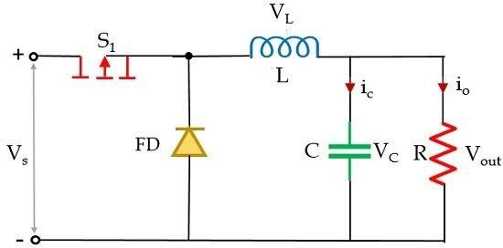
  - or1.8 V.

Fig.3.2:BuckConverter

Connections:

Thepowersupplysystemintheprojectbegins witha12VDCinput,whichserves astheprimary powersource—typicallyfromabatteryoranexternaladapter.This12Vpowerisfirst directedto abuckconverter,adevicespecificallydesignedtostepdownhighervoltagestolower,moreusable levels.Inthiscase,thebuckconverterreducesthe12Vinputtoastable5Voutput.This5Voutput is then distributed to all the main components of the system. The Arduino Nano receives the 5V either through its VIN pin or directly through the 5V pin, depending on the wiring setup. In addition to the Arduino, the 5V line also powers the GPS and GSM modules, both of which are designed to operate at 5V. By using a buck converter, the system ensures that all components receive the correct voltage, which is crucial for stable and efficient operation.

ArduinoNano(Central Controller)

The Arduino Nano is an open-source breadboard-friendly microcontroller board based on the Microchip ATmega328P microcontroller (MCU) and developed by Arduino.cc and initially released in 2008. It offers thesameconnectivity and specs oftheArduino Unoboardin asmaller form factor.

The Arduino Nano is equipped with 30 male I/O headers, in a DIP-30-like configuration, which canbeprogrammedusingtheArduinoSoftwareintegrateddevelopmentenvironment(IDE),

whichiscommontoallArduinoboardsandrunningbothonlineandoffline.Theboardcanbe
poweredthrough itsUSBMini‑Breceptacle orfrom a9 Vbattery.
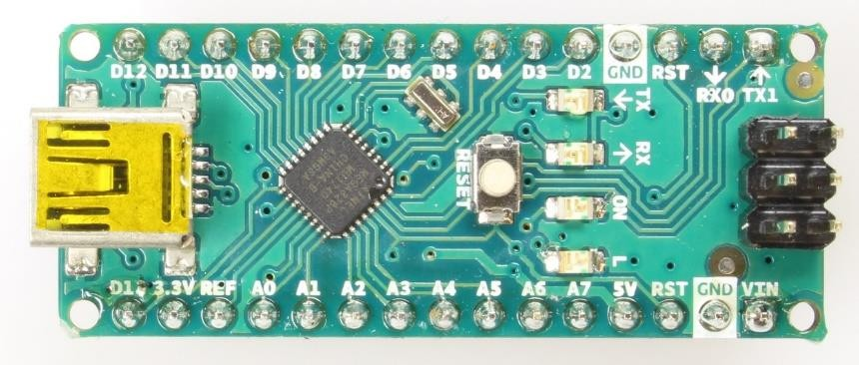
Fig3.2:ArduinoNano

Connections:

The Arduino Nano acts as the central control unit of the system. It receives regulated 5V power fromthebuckconvertertooperatesafely.ItcommunicateswiththeGPSNeomoduleusingUART serial communication to receive real-time location data such as latitude and longitude. Simultaneously, italso uses anotherUARTinterfaceto send ATcommands and datato theGSM module for tasks like sending location updates via SMS. Additionally, the Arduino monitors the state of the vehicle’s ignition key through one of its GPIO (General Purpose Input/Output) pins, allowing it to detect whether the vehicle is turned on or off.

GPSModule(Neo-6M)

The NEO-6M is a compact GPS module by u-blox, widely used for accurate positioning and navigation. It receives signals from multiple satellite systems like GPS, GLONASS, and Galileo, processesthemusingtrilateration,andprovideslocationdatasuch aslatitude,longitude,altitude, speed,andtimeinNMEAformatviaUART.Themodulesupportsconfigurablebaudrates(9600 and115200),featuresacoldstarttimeof38secondsandahotstarttimeof1second,andoperates withinatemperaturerangeof-40°Cto85°C.Itincludesaseparate18x18mmantenna,EEPROM for saving settings, a backup battery, and offers high tracking sensitivity up to -162 dBm.

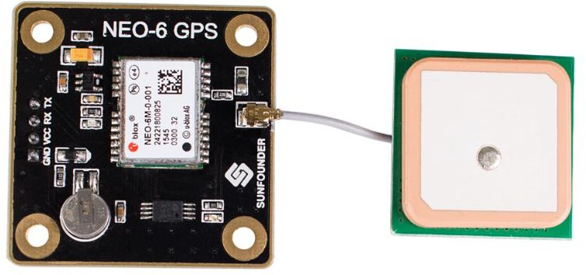

Fig3.3:GPSmoduleNEO-6M

Connections:

The GPS module, specifically the NEO-6M, is powered by a stable 5V supply provided through the buck converter, ensuring reliable operation. Once powered, the module begins receiving signals from various satellites and processes them to determine accurate location data. This data, which includes important parameters such as latitude, longitude, altitude, speed, and time, is continuously transmitted in the form of serial data. The module communicates this data to the ArduinoNanoviaUARTserialcommunication,allowingtheArduinotousetheGPSinformation for tasks such as tracking the vehicle’s position or sending updates through the GSM module.

GSMModule

AGSMmoduleisadevicethatallowselectronicdevicestocommunicatewitheachotheroverthe GSM network. GSM is a standard for digital cellular communications, which means that it provides a platform for mobile devices to communicate with each other wirelessly. The GSM module is a specialized device that enables a device to send and receive data over the GSM network.AGSMmoduleworksbyconnectingtotheGSMnetworkthroughaSIMcard.TheSIM cardprovidesthemodulewithauniqueidentificationnumber,whichisusedtoidentifythedevice on the network. The GSM module then communicates with the network using a set of protocols, which allows it to send and receive data.
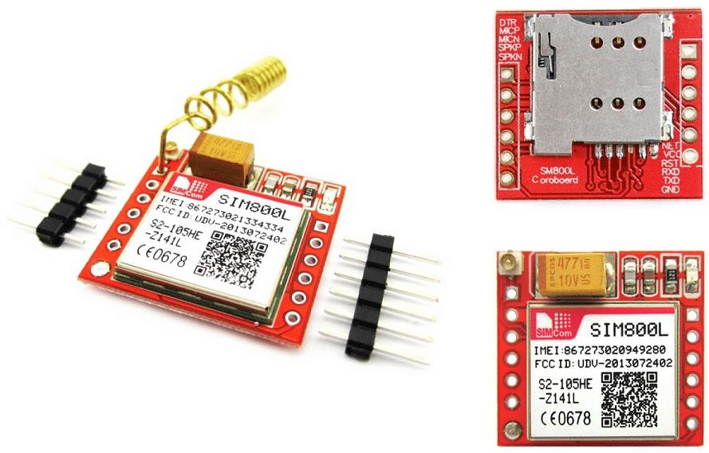
Fig3.4:GSM module

IgnitionKeyInterface

Anignitionswitch,starterswitchorstartswitchisaswitchinthecontrolsystemofamotorvehicle that activates the main electrical systems for the vehicle, including "accessories" (radio, power windows,etc.).Invehiclespoweredbyinternalcombustionengines,theswitchprovidespowerto the starter solenoid and the ignition system components (including the engine control unit and ignitioncoil),andisfrequentlycombinedwiththestarterswitchwhichactivatesthestartermotor.

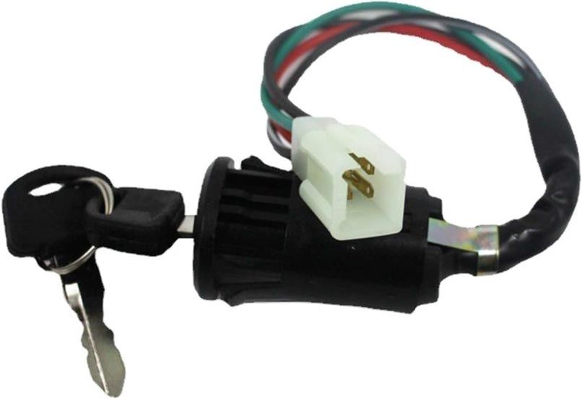
Fig3.5: IgnitionKeyInterface

Connections:

The ignition circuit signal is carefully read by the system after being properly conditioned for safetyandcompatibility.Thisinvolvesusingeitheravoltagedivideroran opto-isolatortoreduce thevoltagetoasafelevelandtoprotecttheArduinofromanypotentialelectricalspikesornoise. The conditioned signal is then connected directly to one of the Arduino Nano’s GPIO input pins, enabling the microcontroller to monitor the state of the vehicle’s ignition key accurately. This setupensuresreliabledetectionofwhethertheignitionisturnedonoroffwithoutriskingdamage to the Arduino.

WorkingPrinciple

- Whenthevehicleispowered,thesystemgetspowerfromthevehiclebattery.
- The buck converter steps the 12V down to 5V, safely powering the Arduino Nano, GPS, and GSM modules.
- TheGPSmodulestartsreceivingsatellitedataandsendslocationinformationtothe Arduino.
- Theignitionkeystatusismonitored continuously.
- The Arduino processes the GPS data and, upon detecting key status change or periodicintervals,transmitsthedatatoapredefinedphone numberorserverviathe GSMmodule.
- Userscantrackthevehicleinrealtimeorreceivealertsonunauthorizedmovementor ignition.

SystemDesignConsiderationsandOperationalLogic

    - Software/FirmwareDesign

The system’s programming is done in C/C++ using the Arduino IDE, which provides a flexible environmentfordevelopingembeddedapplications.KeylibrariesutilizedincludeSoftwareSerial formanagingmultipleserialconnections,TinyGPS++forparsingGPSdatafromNMEA

sentences like $GPRMC and $GPGGA, and optionally Adafruit_FONA for handling GSM communication. Interrupts may be employed to detect real-time changes in the ignition state, allowingtheprogramtorespondpromptlytovehiclestatusupdates.OncetheGPSdataisparsed, it is formatted into readable messages, either as SMS text or JSON format, to be transmitted via the GSM module for easy tracking and monitoring.

Data Security

Secure phone numbers are stored safely in the Arduino’s EEPROM to ensure they are retained even when the system powers down. For enhanced security, GSM communication can be encrypted,especiallywhenusingGPRSorHTTPSprotocolsforserverinteractions,protectingthe data from interception. Additionally, the system can implement optional password-based SMS command handling, which requires a correct password before executing any remote commands, thereby preventing unauthorized access and ensuring only trusted users can control the device.

Fault Handling

To ensure system reliability, a watchdog timer is implemented on the Arduino to automatically reset the microcontroller in case of software hangs or freezes, helping the device recover without manualintervention.TheGSMmoduleincludesaresetmechanismcontrolledthroughatransistor connected to its reset pin, allowing the Arduino to perform hardware resets of the module if it becomesunresponsive.Additionally,thesystemmonitorstheGPSsignal,andifalossofsignalis detected, it triggers a reinitialization process to restore accurate positioning data, maintaining continuous operation.

PowerEfficiency

To conserve power, the Arduino is programmed to enter sleep modes whenever the vehicle is stationary or the system is idle. During these low-power states, both the GPS and GSM modules are switched off or put into standby mode to further reduce energy consumption. This power management strategy helps extend battery life and ensures the system operates efficiently, especially during periods of inactivity.

SoftwareDevelopmentandCode Deployment

The backbone of the system functionality is implemented through an embedded C/C++ program written for the Arduino Nano microcontroller using the Arduino IDE. The code governs the acquisition of GPS data, formatting, condition checking, and the triggering of GSM communication.

CodeWritingandCompilation

The source code for the GPS- and GSM-based vehicle tracking system was developed using the Arduino-compatible C/C++ programming language within the Arduino Integrated Development Environment (IDE), version 1.8.19. This environment provided a user-friendly platform for writing,compiling,anduploadingcodetotheArduinoNanomicrocontroller.Toensurereliable

communication and data parsing, several essential libraries were incorporated into the codebase. The SoftwareSerial.h library was used to establish serial communication between the Arduino Nano and the peripheral modules, specifically the GPS and GSM modules, which operate on separate UART ports. Additionally, the TinyGPS++ library was employed to efficiently parse NMEAsentencesreceivedfromtheGPSmodule,therebyenablingaccurateextractionoflatitude, longitude, speed, and timestamp data. These libraries collectively streamlined the software development process and ensured accurate data acquisition and transmission throughout system operation.

CodeUploadingProcess

After successful compilation, the developed code was uploaded to the Arduino Nano microcontroller using a USB-to-Serial interface based on the CH340G driver chip. This interface enabled reliable communication between the Arduino IDE and the microcontroller. The Arduino Nanocomespreloadedwithabootloader,whichsimplifiestheuploadingprocessbyallowingthe transferofthecompiledbinary(.hex)filedirectlyintotheonboardflashmemorywithouttheneed forexternalprogrammers.Onceuploaded,thefirmwarebeginsexecutionautomatically,initiating serial communication with both the GPS and GSM modules and managing data acquisition and transmission as per the programmed logic.

Once uploaded, the code is executed automatically upon boot-up, leveraging the bootloader’s initializationprocess.ThefirmwarebeginsbyinitializingserialcommunicationwithboththeGPS and GSM modules, establishing reliable channels for data exchange. It then enters a continuous loop where it actively parses real-time GPS coordinates using the TinyGPS++ library. Upon acquiring valid location data, the Arduino transmits the coordinates through the GSM module usingATcommands,effectivelysendingthem asSMSmessagestoadesignatedmobilenumber. This automation ensures real-time tracking with minimal user intervention.

AlgorithmandProgramLogicFlow

To enhance technical understanding and provide a comprehensive view of the system's intelligence,thissectiondetailsthesequentiallogicanddecision-makingprocessesgoverningthe operation of the GPS- and GSM-based vehicle tracking system. The algorithm encapsulates the structuredflowofdata,fromhardwareinitializationtoreal-timedataacquisition,processing,and transmission.ItservesasthebackboneoftheembeddedsoftwaredeployedontheArduinoNano, ensuring that all modules function harmoniously under defined constraints and logic rules.

Thesystembeginsbyinitializingallnecessaryhardwareinterfaces,suchasserialcommunication with the GPS and GSM modules. Upon successful startup, it enters a continuous execution loop whereitlistensforincomingGPSsignalsandverifiesthevalidityofreceivedlocationdata.Once areliableGPSfixisobtained,thesystemparsesthecoordinatesandformatsthemintoastructured SMS message. This message is then transmitted via the GSM module using AT command instructions.

If no valid GPS data is available at a given moment, the system gracefully handles the exception bysendingapredefinedalertindicatingaGPSsignaldelay.Thisflowensuresreal-timetracking

functionality with built-in resilience to temporary data unavailability. The logic further includes conditional timing, message formatting, and peripheral communication control to guarantee operational stability and reliability throughout the tracking session.

The pseudocode and actual Arduino-based C/C++ implementation provided in the subsequent subsections illustrate this algorithm in both abstract and executable forms, thereby bridging the gap between system logic design and functional deployment.

SystemPseudocodeOverview:

BEGIN

Initialize serial communication (HardwareSerial for debugging, SoftwareSerial for GSM and GPS)

Initialize GPS module InitializeGSMmodule WHILE true DO
IFGPS modulehasdata THEN

ParsetheGPSdata(latitude,longitude) IF valid location acquired THEN Format location into SMS message Send SMS via GSM module
ELSE

Send"WaitingforGPSsignal"message ENDIF
ENDIF

Waitforashortdelay ENDWHILE
END

    - AurdinocodeImplementation #include <SoftwareSerial.h>#include <TinyGPS++.h> TinyGPSPlus gps;
// Define RX and TX pins for GSM and GPS SoftwareSerial gpsSerial(4, 3); // GPS RX, TX SoftwareSerial gsmSerial(7, 8); //GSMRX,TX void setup() {
Serial.begin(9600); // Serial Monitor gpsSerial.begin(9600); // GPS Module gsmSerial.begin(9600); //GSMModule delay(1000);
sendCommand("AT");

sendCommand("AT+CMGF=1"); //Set GSMmodule to text mode

}

void loop(){

while(gpsSerial.available()>0){ gps.encode(gpsSerial.read());
if (gps.location.isUpdated()) { float lat = gps.location.lat(); floatlng=gps.location.lng();
Serial.print("Lat: "); Serial.println(lat, 6); Serial.print("Lng:");Serial.println(lng,6);

Stringmessage="Location:\nLat:"+String(lat,6)+"\nLng:"+String(lng,6); sendSMS("+234XXXXXXXXXX", message);// Replace with your number delay(60000); // Wait 60 seconds before sending again
}

}

}

voidsendCommand(Stringcommand){ gsmSerial.println(command); delay(1000);
while (gsmSerial.available()) { Serial.write(gsmSerial.read());
}

}

voidsendSMS(Stringnumber,Stringmessage){ gsmSerial.println("AT+CMGF=1");delay(500);
gsmSerial.print("AT+CMGS=\""); gsmSerial.print(number); gsmSerial.println("\"");delay(500); gsmSerial.print(message); delay(500);
gsmSerial.write(26);//CTRL+Ztosendmessage

delay(5000);

}

SystemInterfacingandCommunicationProtocols

The system involves serial communication between the microcontroller and both GPS and GSM modules.
ComponentConnection ProtocolBaudRate GPS ModuleArduino via SoftwareSerial UART 9600 bps GSM Module Arduino via SoftwareSerial UART
- SoftwareSerial was used to create additional serial ports as the Arduino Nano has onlyone hardware UART.
- Themodulesoperatealternatelyto preventcollision indata streams.

3.10System DeploymentConsiderations

- PCBMounting:FinalcircuitwassolderedontoaVeroboardorcustomPCBtominimize noise and ensure compactness.
- AntennaPositioning:GPSmoduleantennawaspositionedoutsidethechassisforunobstructed satellite visibility.
- GSMSIM:AvalidSIMcardwithSMScreditandnetworkcoveragewasinsertedintothe GSM module for communication.
- MobilePhone:ActsasareceiverforlocationdataviaSMS.

CircuitAssemblyandHardware Integration
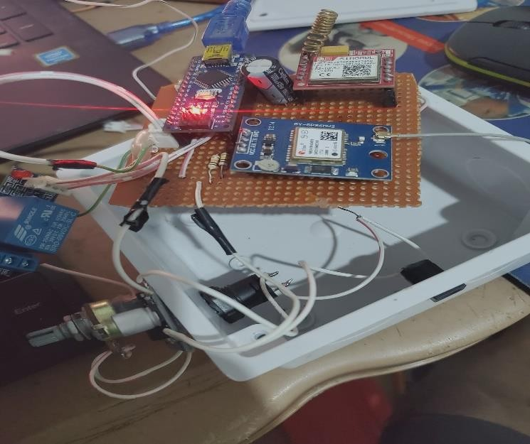
Fig3.6:HardwarecircuitshowingArduinoNano,GSMmodule(SIM800L),GPSmodule(GY- GPS6MV2), and supporting components assembled on a perforated board

CHAPTER4
PERFORMANCETESTINGAND EVALUATION

  - TestingEnvironmentandSetup

The system prototype was initially tested on a breadboard before final implementation on a custom-designedPCB.Bothindoorandoutdoorenvironmentswereusedfortestingtoevaluate system responsiveness, GPS signal strength, and GSM data transmission under varying conditions.

EquipmentandToolsUtilized

Component/Equipment Function/Description
Arduino Nano Centralmicrocontrollerhandlinglogicandperipheralcommunication Neo-6M GPS Module Provides real-time geographical coordinates
SIM800LGSMModuleTransmitsGPSdatatoamobiledevicevia SMS
LM2596BuckConverterConverts12VDCsupplyto5VDCtosafelypowertheArduino 12V Lead-Acid Battery Primary power supply for field testing
Digital Multimeter Usedforvoltage,current,andcontinuitytests Mobile Phone Receives SMS containing location data

PrototypeTestingSetup
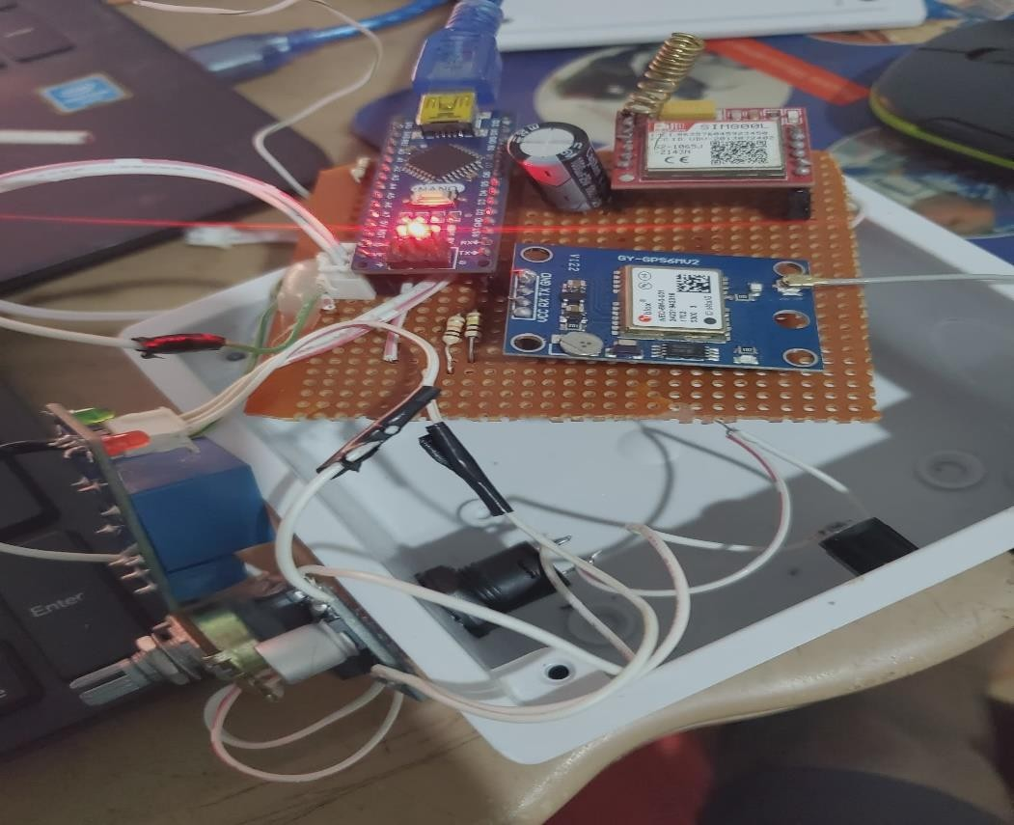
Fig4.1: Physicalprototypesetupduring testingphasewithlive module connections

FunctionalTestingofIndividualModules

    - GPSModule Performance

TheGPS module'sresponsivenessandprecisionweretestedusingthe followingparameters:

Test Parameter Expected OutcomeObserved Result Status Time to First Fix Less than 60 seconds 52 seconds Pass Positional Accuracy Within ±10 meters ±6.3 meters Pass Coordinate Update Rate 1 second 1.1 seconds (average) Pass
Inference:TheGPSmoduleconsistentlydeliveredaccuratecoordinatesinopenareas.Indoor performance was limited due to signal attenuation.

GSMModuleTesting

Testswereperformedto evaluatethemodule’sabilitytosendformattedSMSmessages under
variousconditions:

Scenario ExpectedResult ActualResult Status

SMSonvalidGPS fix
CoordinatestransmittedviaSMS Receivedin7seconds Pass

GPSunavailable Erroror waitingmessagesent "WaitingforGPS Signal"
received
Pass

Formatverification Clear,readablelatitudeand
longitude
Format:Lat:6.5244,Long: 3.3792
Pass

Inference:TheGSMmodulereliablytransmitteddatawithacceptabledelaysandconsistent formatting across networks.

SystemIntegrationTesting

Onceindividualcomponentswerevalidated,thesystemwasintegratedaspertheproject architecture. A complete test cycle was executed:

- 12Vpowersupply activated.
- Buckconverter steppeddown thevoltageto 5V.
- ArduinoNanoinitialized bothGPSandGSMmodules.
- Uponsatelliteacquisition,GPScoordinateswere processed.
- GSMmoduletransmittedthedataviaSMS.
- Mobiledevicereceived andverifiedthemessage.

Outcome:Theintegratedsystemoperatedseamlessly,confirmingtheproperinterfacingofall modules.

PowerSupplyandBuckConverter Performance

StabilityandefficiencyoftheLM2596buckconverter weretestedundervarying loads:

InputVoltage(V) OutputVoltage(V) LoadCurrent(mA) Status

12 | 5.02 | 500 | Pass
12 | 4.95 | 700 | Pass

Inference:Thebuckconvertermaintainedastable5Voutput,safeguardingtheArduinoNano and other peripherals against overvoltage.

FieldDeploymentandData Collection

Thesystemwasmountedonatestvehicleanddrivenalongapredefinedroutetovalidatereal- time tracking and data transmission.

    - SampleOutputData Table

Timestamp LatitudeLongitudeSpeed(km/h)SMSReceived

10:00:00AM6.52445 | 3.37923 | 15 | Yes
10:01:00AM6.52487 | 3.37998 | 20 | Yes
10:02:00AM6.52531 | 3.38074 | 25 | Yes

    - RouteMappingVisualization

CoordinatescollectedduringthejourneywereplottedonGoogleMaps.Thegeneratedpath closely followed the actual driving route, confirming GPS accuracy and real-time communication.

PerformanceMetricsSummary

Evaluation Parameter TargetPerformanceMeasuredResult GPS Fix Time < 60 seconds 52 seconds Coordinate Accuracy ±10 meters ±6.3 meters
SMSTransmissionDelay<10 seconds ~7 seconds
Power Output Stability 5V ±0.1V Stableacrosstests OperationalDuration ≥ 1 hour 1 hour45 minutes

CHAPTERFIVE
  - CONCLUSIONANDRECOMMENDATION
  - Conclusion
The automobile tracking system developed in this project successfully met the stated objectives. By integrating GPS and GSM technologies with microcontroller-based logic, a reliable and functional tracking prototype was realized. The project demonstrated the capability of real-time vehicle monitoring with efficient power usage and accurate spatial resolution.
Thistrackingsystemcanbeappliedinscenariossuchasfleetmanagement,anti-theftmonitoring, and logistics optimization. The use of open-source platforms like Arduino and standard communicationmodulesmakesthesystemcost-effectiveandscalableforlarge-scaledeployment. Furthermore, modular design allows for future enhancements such as cloud integration, mobile application support, and advanced analytics.
Theconclusionsdrawnfromtheperformanceevaluationshowthatthesystemisrobustinitscore functions and serves as a viable solution for modern transportation asset management.

Recommendations
Based on the experience gained and limitations identified during the course of this project, the following recommendations are made for future work and system improvement:
    - Cloud-Based Data Logging: Incorporate cloud platforms such as Firebase, AWS IoT, or Azure for real-time data logging, historical tracking, and multi-user access through web/mobile interfaces.
    - Mobile App Integration: Develop Android or iOS applications for easier end-user interaction, alert notifications, and remote command functionalities.
    - 4G/5GUpgrade:ReplaceGSMmoduleswith4GLTEorNB-IoTmodulesforfaster,more reliable communication and compatibility with evolving cellular networks.
    - InertialNavigationSystem(INS):Integrateaccelerometersandgyroscopesforenhanced positioning in GPS-denied environments such as tunnels and underground parking.
    - Geo-Fencing and Alerts: Implement geofencing algorithms to define safe zones, with automatic alerts when vehicles exit or enter designated areas.
    - SolarCharging:Exploresolar-basedpoweroptionsforautonomousoperationinremote
environmentswithoutaccesstothevehicle’selectricalsystem.
    - Data Security Enhancements: Introduce encrypted communication and secure APIs to prevent unauthorized access and safeguard user privacy.
    - OBD-II Integration: Extend functionality to read diagnostic trouble codes (DTC) and vehicle performance metrics via the OBD-II port.

REFERENCES
Alvi, M. R., Javaid, N., & Khan, M. K. (2017). GSM-Based Vehicle Tracking andMonitoringSystem.InternationalJournalofComputerApplications,167(6),20–25.
Balanis,C.A.(2016).Antennatheory:Analysis anddesign(4thed.).Wiley.
Barr,M.,&Massa,A.(2006).Programmingembeddedsystems:WithCand GNU development tools (2nd ed.). O’Reilly Media.
Bosch.(2011).CANspecificationversion2.0.RobertBoschGmbH.
El-Sheimy, N., Hou, H., & Niu, X. (2008). Analysis and modeling of inertia sensorsusingAllanvariance.IEEETransactionsonInstrumentationandMeasurement, 57(1), 140–149.
Erickson,R.W.,&Maksimovic,D.(2007). Fundamentalsofpowerelectronics
(2nded.). Springer.
Farrell,J.A.(2008). Aidednavigation:GPSwith highratesensors. McGraw-
Hill.
Groves,P.D.(2013).PrinciplesofGNSS,inertial,andmultisensor integrated
navigationsystems(2nded.).ArtechHouse.
GSMA.(2020).eSIM: ThefutureofSIMtechnology.GSMAssociation.
Harri, J., Filali, F., Bonnet, C., & Fiore, M. (2009). Vehicular mobility simulationforVANETs.SimulationModellingPracticeandTheory,17(5),818–835.
Holma,H.,&Toskala,A.(2011). LTEforUMTS:Evolutionto LTE-Advanced
(2nded.). Wiley.
Horowitz,P.,&Hill,W.(2015).Theartofelectronics(3rded.).Cambridge University Press.
InternationalOrganizationforStandardization.(2011).ISO7637-2:2011- Road vehicles—Electrical disturbances from conduction and coupling—Part 2: Electrical transient conduction along supply lines only. ISO.
Kaplan,E.D.,&Hegarty,C.J.(2017).UnderstandingGPS/GNSS:Principles and applications (3rd ed.). Artech House.
Khan, S., Ahmed, A., & Tariq, S. (2022). Insurance Telematics: Driver BehaviorAnalysisUsingGPSData.JournalofTransportationSecurity,15(1),15–28.
Kolban,N.(2017).Kolban'sbookonESP32.Self-published.
Kurose,J.F.,&Ross,K.W.(2017).Computernetworking:Atop-down approach (7th ed.). Pearson.

Leick,A.,Rapoport,L.,&Tatarnikov,D.(2015).GPSsatellitesurveying(4th ed.). John Wiley & Sons.
Light,R.(2017).MQTT essentials–AlightweightIoTprotocol.MQTT.org.
Mazidi,M.A.,Naimi,S.,&Naimi,S.(2016).AVRmicrocontrollerand embedded systems: Using assembly and C (2nd ed.). Pearson Education.
Miller,M.(2017).Modernautomotivetechnology(8thed.). Pearson.
Misra,P.,&Enge,P.(2011).Globalpositioningsystem:Signals,measurements,and performance (2nd ed.). Ganga-Jamuna Press.
Mohan, A., & Gupta, R. (2019). Optimizing Logistics using GPS Tracking Systems.InternationalJournalofLogisticsResearchandApplications,22(5),473–487.
Patel,D.,Patel,N.,&Joshi,P.(2020).DesignandImplementationofaReal- Time Vehicle Tracking System. International Journal of Advanced Research in Computer Engineering & Technology, 9(3), 1204–1212.
Pfleeger,C.P., &Pfleeger,S. L.(2015).Securityincomputing (5th ed.).
Pearson Education.
Ramkumar,M.,Vinoth,K.,&Kumaravel,A.(2016).EmbeddedSystem Design for Vehicle Tracking. Procedia Computer Science, 85, 197–204.
Rappaport,T.S.(2002).Wirelesscommunications:Principlesandpractice(2nd ed.). Prentice Hall.
Razavi,B.(2013).DesignofanalogCMOSintegratedcircuits(2nd ed.).
McGraw-Hill.
Sauter,M.(2014).FromGSMtoLTE:Anintroductiontomobilenetworksand mobile broadband. Wiley.
Sauter,M.(2021).FromGSMtoLTE-advancedproand5G:Anintroductionto mobile networks and mobile broadband (3rd ed.). Wiley.
Sedra,A.S.,&Smith,K.C.(2014).Microelectroniccircuits(7thed.).Oxford University Press.
Stojmenovic,I.,&Wen,S.(2014).TheInternetofThings:Keyapplicationsand protocols. Wiley.
Teunissen,P.J.G.,&Montenbruck,O.(2017).Springerhandbookofglobal navigation satellite systems. Springer.
Yacoub,M.D.(2000).Foundationsofmobileradioengineering.CRCPress.
Yiu,J.(2016).ThedefinitiveguidetoARM®Cortex®-M3andCortex®-M4 processors (3rd ed.). Newnes.

Zhang,W.,Wang,X.,&Li,H.(2021). IoTArchitecturesforSmartCityVehicle Tracking. Sensors, 21(4), 1339.
Zhang,Y.,Cao,J.,Wang,H.,&Liu,W.(2020).SecureandflexibleOTA firmware update scheme for embedded systems. IEEE Access, 8, 174393–174406.

