A SECURE ELECTION RESULT TRAMISSION USING ENCRYPTION TECHNIQUES
BY

ADEKANYE NIFEMI OLUWASEGUN

ND/23/COM/PT/0094

SUBMITTED TO THE DEPARTMENT OF COMPUTER SCIENCE, INSTITUTE OF INFORMATION AND COMMUNICATION TECHNOLOGY
KWARA STATE POLYTECHNIC,ILORIN.
IN PARTIAL FULFILLMENT OF THE REQUIREMENTS FOR THE AWARD OF ORDINARY NATIONAL DIPLOMA (OND) IN
COMPUTER SCIENCE

JUNE,2025.

CERTIFICATION

This is to certify that this project was carried out by Adekanye Nifemi Oluwasegunwith matriculation number ND/23/COM/PT/0094has been read and approved by the Department of Computer Science, Kwara State Polytechnic Ilorin. In partial fulfillment of the requirements for the award of National Diploma (ND) in Computer Science.

Mr. Bolaji-Adetoro D.F.
Project Supervisor Date

Mr.Oyedepo,F.S.
Head of Department Date

ExternalExaminer Date

DEDICATION

I dedicate this work to Almighty God, whose unfailing love and mercy have been my source of strength and inspiration throughout this journey.
To my beloved parents, for their unconditional love, sacrifices, and unwavering support that have shaped who I am today.
Tomy family and friends,whoseencouragement, prayers,andbeliefin me providedthe motivationto persevere through every challenge.
This achievement is a testament to all of you who have stood by me, encouraged me, and believed in my potential. Thank you for being my pillars of strength.

ACKNOWLEDGEMENT

All glory and praise be to Almighty God, the Lord of the unierse. I sincerely thank Him for granting me the strength, wisdom, and perseverance to complete my ND program and for His continuous guidance throughout my journey on earth.
I am deeply grateful to my supervisor, Mr. Bolaji-Adetoro D.F., whose unwavering patience, insightful guidance, and constant encouragement were instrumental to the success of this research work. His valuable corrections, constructive criticisms, and recommendations ensured the highest standards of excellence were maintained.
I would also like to express my profound appreciation to the Head of the Department, Mr. Oyedepo F. S., and the entire staff of the Department of Computer Science at Kwara State Polytechnic, Ilorin, fortheir continual support, constructivefeedback, and motivation throughout my studies.
Myheartfeltgratitudegoestomybelovedparents,whoprovidedimmeasurablefinancial support, patience, prayers, and understanding during my academic pursuit.

ABSTRACT
Ensuring the integrity and confidentiality of election results is critical to maintaining public trust in democratic processes. This research presents a secure election result transmission system that leverages modern encryption techniques to safeguard data during transmission between polling units and the central election database. Traditional methods of result transmission are prone to manipulation, interception, and unauthorized access, which can lead to electoral fraud and misinformation. By integrating asymmetric and symmetric encryption algorithms—such as RSA for secure key exchange and AES for fast, encrypted data transfer—this system ensures end-to-end security and prevents tampering of results in transit. Additionally, digital signatures are employed to verify the authenticity of the transmitting source and detect any alterations. The proposed systemwas simulated and tested to evaluate its performance in terms of security, speed, and reliability. The results demonstrate a significant improvement over existing manual and unsecured digital methods, highlighting the potential of encryption-based transmission in enhancing electoral transparency and credibility.

TABLEOF CONTENTS

Titlepage i

Certification ii
Dedication iii
Acknowledgement iv
Abstract v
Tableofcontents vi
List of Tables ListofFigures
CHAPTERONE:GENERALINTRODUCTION
  - Backgroundofthe Study 1
  - StatementoftheProblem 2
  - AimandObjectivesoftheStudy 3
  - SignificanceoftheStudy 3
  - Scopeofthe Study 3
  - OrganizationoftheStudy 4
CHAPTERTWO:REVIEWOFRELATEDPASTWORK
  - ReviewofRelatedPastWork 5
  - OverviewofResultProcess 9
  - EncryptionTechniques 10
CHAPTERTHREE:RESEARCHMETHODOLOGYANDANALYSIS
  - ResearchMethodology 13
  - AnalysisoftheExistingSystem 14
  - ProblemoftheExistingSystem 15
  - AnalysisoftheProposedSystem 15
  - AdvantageoftheNewSystemOvertheExistingSystem 15
CHAPTERFOUR:DESIGNIMPLEMENTATIONANDDOCUMENTATIONOFTHE SYSTEM
  - DesignoftheSystem 17
    - Output Design 17
    - InputDesign 20
    - DatabaseDesign 22
    - ProcedureDesign 22
  - SystemImplementation 23
    - ChoiceofProgrammingLanguage 23
    - SoftwareSupport 23
    - ImplementationTechniquesUsedinDetails 23
  - System Documentation 23
    - ProgramDocumentation 23
    - MaintainingtheSystem
CHAPTERFIVE:SUMMARY,CONCLUSIONANDRECOMMENDATION
  - Summary 24
  - ExperienceGainedandProblems Encountered 24
  - Conclusions 24
  - Recommendations 25

References

CHAPTER ONE GENERALINTRODUCTION

BACKGROUNDOFTHESTUDY
Voting and elections are essential ingredients of modern democratic societies.Unlikeany other transaction event, the result of electionscan have many effects on societies, economics andfinancialwellbeing. Recentelectionshaveseenagradualdeclineintheoverallpercentageof the electorate exercising their right to vote. This is from a democratic point of view in that, if the reasons of the decline are left unchecked, the mandate of those elected to hold the positionsmight eventually be questionable. Moreover, it is interesting to note here that traditional/manual voting systems are slow, complex, inaccurate and inefficient. To counter these drawbacks, governments have proposed a number of possible methods for re-engaging the electorate in the voting process. One of these methods is the modernization of the way in which the elections are being conducted. These methods include the use of electronic voting (e-Voting) as a new and modernized way to carry out the election process. E-voting extends polling hours (anytime voting)andenablescastingofvotesfromanyplace(anywhere thatcanaidelection voting)using different electronic means (any device, laptop voting) such as mobile devices and Internet-based voting. (Steve & et al, 2017)
In a well-functioning democracy, voting should be protected as fundamental citizenship right and responsible and responsibility. Accurately registering every eligible voter to vote is a necessary step toward protecting this right, yet a very high percentage of eligible Nigerian citizens’ voters are not registered and many people are registered inaccurately or engage in multiple registration. An “automated” voter registration system is one in which government offices, including social service offices, collect and transfer voter registrations to election officials without using separate paper forms but direct capture machines. These offices enter registration data into their computers and transfer them electronically, in a format that election officials can securely review and upload directly into their voter registration database systems. ManydevelopedStatessuchas Arkansas,California,Georgia,Kentucky, Michigan,New Jersey, North Carolina, South Carolina, South Dakota, Texas and even Nigeriaare already at this stage. Analternativeapproach which is an “online” registration system is onethat allowsindividuals to submitavoterregistrationapplicationovertheInternet.SixstatessuchasArizona,Colorado,

Kansas, Louisiana, Oregon, and Washington currently have online systems in place for individuals who have a driver’s license or non-driver’s identification card. At least five more stateslikeCalifornia, Indiana,Nevada, NorthCarolina,andUtah aredevelopingsimilarsystems. (Andriy &Bakshalov, 2019)
The Federal Republic of Nigeria, with an area of 923,769 square kilometers (made up of 909,890 square kilometers of land area and 13,879 square kilometers of water area. The 2006 national population census puts the country population at 140,431,790 people. The country is subdivided in 39 states plus Federal Capital Territory (Abuja). The states are further divided into a total of 774 local government areas. Democracy in Nigeria is still in the struggle to leapfrog to an ideal democratic setting. Usually, every election in Nigeria is associated with fraud of various dimensions. Nigeria is in the 4th republic yet it is embarking on new voters register. One thing is for sure, there are no effective registration system to enhance complete, accurate consistent and continuous voters register which is a pre-requisite for a credible election. (Olabode, 2018)

STATEMENTOFTHEPROBLEM

Election is the basis of democracy because if the wrong person is placed in the wrong position then the organization of such community is bound to be disorganized as a result of this better concentration should be made in choosing the right person for a particular position for a better tomorrow.Onemajorproblemsofthetraditionalmethodofconductingelections isdiscrepancies with the election system threaten the very principles that make our society democratic.

AIMAND OBJECTIVES

The aim of this project is to implement election result transmission using exception techniques (a cases study of kwara state polytechnic, Ilorin student union). The objectives of this project are:
    - Implementationofauser friendlywebapplication.
    - Forthestudent tovoteirrespectiveoftheir departments.
    - Proposedsystemprovidesvotingsystem only forauthorized people.

SIGNIFICANCEOFTHESTUDY

The main importance of this study is that it will improved speed and accuracy incounting, accessibility, voting from home and as many are concerned with the risk it poses, such asunequalaccess,violationtosecrecyandanonymityandalterationoftheresultsofanelection.

Another importance is that this study prevents voting twice and secured authentication for Internet voting system using encryption techniques.

SCOPEANDLIMITATIONSOFTHESTUDY

The proposed system is a distributed database system for election using encryption forthe student uniongovernment of KwaraState Polytechnic. It allows adding of new positionto be contested for by different aspirant and it is a dynamic desktop based application developed with visual basic.net 2010 which will be managed by an administrator and used by the voters and the result can be viewed as the election is going on, to see how each aspirant performs before the completion of the election exercise and as well as viewing the final computation of the result at the end of the election. The limitation of this system is that, it is a standalone system whereby each voters will come to a designated place where the system is concentrated to cast their notthat they can do online voting at their convenient time.

DEFINITIONOFTECHNICALTERMS
Phishing: Phishing is the practice of sending unsolicited emails in which the senderimpersonates an authority figure. Emails of this kind attempt to misdirect recipients into unwittingly revealing their login credentials. A typical target is online banking passwords.
Cryptography:Cryptography is the science of providing security for information. Authentication: Authentication is a process for verifying the identity of something or someone. InstantMessaging:Passwordinstantmessagingisthemethodinwhichtheuserreceivesa message with a link directing them to a fake phishing website which has the same look and feel as the legitimate website
Link Manipulation: Link manipulation is the technique in which the phisher sends a link to a website. When the user clicks on the deceptive link, it opens up the phisher’s website instead of the website mentioned in the link.
Session Hacking: In session hacking, the phisher exploits the web session control mechanism to steal information from the user.
Malware Phishing: Phishing scams involving malware require it to be run on the user’s computer. The malware is usually attached to the email sent to the user by the phishers. Onceyou click on the link, the malware will start functioning. Sometimes, the malware may also be attached to downloadable files.

Paper ballot System: Paper ballot system is the commonly used traditional voting system. It is widelyusedbeforetheintroductionofelectronicvotingsystem.Paperballotsystemincludes casting the vote using the paper and the stamp. Each voter uses one ballot and it is not shared Electronicvotingsystem:Anelectronicvotingsystemisatypeofvotingsystemwhichuses electronic ballot that would allow voters to broadcast their secret vote ballot to election officials over Internet.

ORGANISATIONOFTHE REPORT

This is the overall organizational structure of the work as presented in this project write- up. Chapter one of this project deals with the introduction to the general work in the project. It also entails the statement of the problem, aims and objectives of this project, the significance of the study, the scope and limitation of the study and organization of the report.
Chapter two deals with the review related journals and books, historical background of the study, as well as computerization current state of the art.
Chapter three covers the methods used for data collection, description of the current procedure, problems of existing system, description of the proposed system and the basic advantages of the proposed web based application.
Chapterfourentailsdesign,implementationanddocumentationofthesystem.Thedesign involves the system design, output design form, input design form, database structure and the procedure of the system. The implementation involves the implementation techniques used in details, choice of programming language used and the hardware and software support. The documentation of the system involves the operation of the system and the maintenance of the system.

CHAPTER TWO LITERATUREREVIEW

REVIEWOFRELATEDWORKS

Hosany, &Chedembrun (2020) presented a journal titled “Design and implementation of an online voting system for the election of students of the University of Mauritius” Voting systems have been present for long time but, with the emergence of new web technologies, the conventional electoral process, be it is for general election or for electing candidates for student council in a university, should be modernized. Electronic voting is one of the most troublesome overhauls faced to obtain aperfect outcomehence, this innovation touches theheartofthe whole electoral process that is voting and tallying of the votes. Online voting significantly decreases directhuman controlwhichisviewedas apositivepointbutatthesametimeitpresentsanentire scopeofnewconcerns.Thispaperprovidesthespecificationandrequirementstomeet
„University of Mauritius (UoM) Student Online Voting System which is an android based application to be used by the students of University of Mauritius during the Student Union Election. It covers the entire system development life cycle from the identification of a solid problem to background research about the topic on to analysis, design and implementation of an android based application. The concluding sections cover the application testing and evaluation as well as possible enhancements to the application.
Parvateesam,&Arunkumar(2021)wrotejournal on“DesignandImplementationofReal Time Online E-Voting Prototype System with IOT” In democratic societies, voting is an important tool to collect and re-act people thinking’s. Traditionally, voting is conducted in centralized or distributed places called polling booths. Voters go to polling booths and cast their votes under the supervision of authorized parties. Then the votes are counted manually once the election has completed. With the rapid growing development of computer technology and cryptographic methods. The electronic voting systems can be employed that replace the incident and most importantly error-prone human Component. Our project proposes and implements a simpleand secured method ofpolling voteby using biometric. Due to the changeoccurred in the technology, so many advancements were introduced in the field of voting. The improvisations aimatincreasingtheflexibilitysecurity,reliability,scalabilityofthemodelandprovidelesstime consumptiontoannouncetheresult.Nowadays,thevotingprocedurewasheldbymanually

operating machines and even through SMS also. But this electronic voting machine is a unique and new concept which saves a lot of time and avoids the false voting by a false person. In this system, the user has to use his fingerprint to poll the authenticated vote. The finger print module was already stored in the government database. Hence this project provides a best solution to avoid the false voting. The electronic voting machine was connected with the computer. The computer is having the full database list of the peoples who is having the eligibility to vote. For each polling the corresponding person identity was deleted. So it avoids the false voting.
Steve & et al., (2021) writes a journal on “Design and Implementation of Electronic Ballotting System; Acase study of Nigeria”. Elections have been found to be a panacae for good governance. Governments become accountatble when voters are allowed to choose whorepresent them. Traditional manual based balloting system have been shown to be susceptible to elections malpractices. This is apart from the huge financial and other costs associated with manual ballotting. This work adresses the above issues by designing and implementing an Android tablet based Electronic ballotting System. An android-based application has been developed using android programming kit. An electronic ballot paper was simulated using a Graphical user interface (GUI) on a touchscreen device to eliminate the use of keyboard and mouse to avoid complications for voters. At the conclusion of polling, results are dispayed. An electronic based Voter Verified Audit Trail (VVAT) was implemented to ensure recount is possible where neccessary. Results of tests shows that usability of the system is high while accuracy have been shown to better and more cost effective than a manual ballotting system.
Andriy Bakshalov (2020) wrote a report on “Design and implementation of an Electronic Voting system based on homorphic tallying of votes”. In modern society almost everything is tending to make things in the democratic way, giving everyone a chance to make their own decisions. One of the most important processes in every democratic country is selecting a new president or the government representatives. For now, a lot of people think that this process is defrauded and the results are simply manipulated by others. This is a fear of everyone and they probably think that their vote will not change anything. This process makes people to gather in a public place and deposit their vote in the urn, and after the voting all votes are going to be counted and the result published.
Ghassan, (2020) wrote a report on “REQUIREMENTS, DESIGN AND IMPLEMENTATIONOFANE-VOTINGSYSTEM”.Therapidadvancementindatabase,web

andwirelesstechnologieshavegivenrisetonew applicationsthatwereimpossiblejustfewyears ago. One of these applications is e-Voting. The term “e-Voting” is defined as the process of casting votes in an election using electronic means. This paper details the requirements, design and implementation of a generic and secure electronic voting system where voters can cast their votes anytime, anyplace and using a number of electronic devices including Web and mobile phones.
Taban & et al., (2020) writes an article on “Design and Implementation of Electronic Voting System”. The Public opinion and democratic in universities setting are the mostimportant determinant to establish a good administration. Voting is the process through which individuals convey their opinion and has the freedom to elect a leader of the choice to signifyand address the student’s issues. In today’s technological and knowledge age, computerized related matters become widespread. E-voting is one of these substances and it is capable to deliver appropriate, less costly, fast and secure services. The aim of this paper is to present an electronic voting system (EVoting) to be applied to Muni University student’s electoral body. Several security measures were integrated into the E-Voting system in order to achieve an enhanced, speedy and accurate performance. A computer software application was developed using PHP (Hypertext processor) programming language and MYSQL (My Structural Query Language), a relational database management system in designing the database; tested and found to have produced the expected results. It is about time that traditional voting in Muni University gives way to E-Voting and hence simplifies the task for Electoral commission and his/her Officials.
OlabodeOlatubosun (2021)writesareviewon“ModelingaDistributedDatabaseSystem for Voters Registration in Nigeria”. The Independent National Electoral Commission, Nigeria is characterized for managing large volume of dispersed data making distributed data processing a necessity. When voter rolls are error-ridden and a quarter of eligible voters cannot vote, registration laws are not only failing their primary function of ensuring that voters are qualifiedto vote but also acting as barriers to citizens democratic participation. The traditional voter registration methods employed by many developing countries for periodic elections have many associated problems such as incomplete, inconsistent, unavailability and erroneous records. This article presents an application of distributed database system for a complete and continuing voter registrationinNigeria.Thesystemhasitscomponentpartsphysicallystoredinanumberof

distinct real databases at a number of distinct sites. Each site has its own local real databases, its own local users, its own local DBMS and transaction management software including its own local locking, logging, recovery, replication, fragmentation, e.t.c. software and its own local data communication manager. Distributing data across sites within state and local government allow votersdatatoberesident wheretheyaregeneratedormostneeded,butstillaccessiblefromother sites within the state and local government areas. Java and Oracle were the developmental platform of the system. Some important relations for the systems were presented and possible management transaction and operation models were presented. The system require a Unix/windows NT operation system in a network environment such as provided by communication networks in Nigeria and internet connection.

REVIEWOFGENERALTEXT

Traditional voting system also known as ballot voting system is a method by which recordingand counting votes are carried out on paper cards. For this type of election, the most well-known approach to voice out one’s decision is voting at a particular area known as the polling station. Traditionalvotingsystemscanbe classified intoseveraltypesnamelymajorityrule,proportional representation, semi-proportional representation, plurality voting, preferential voting and many others whereby majority rule is a decision rule that chooses those having dominant part, that is, more than a large portion of the votes. Proportional representation characterizes electoralsystems by which divisions in an electorate are reflected proportionately in the chosen body. On other side, plurality voting is a voting framework in which every voter is permitted to vote in favorofoneand onlycompetitor,andtheapplicantwhosurveysmostvotes (majority)thanother is elected. Ranked voting system also known as preferential voting is a method wherecandidates are ranked in order of preference. Electronic voting (otherwise called e-voting) will be voting using an electronic device to record or check votes. Online voting system introduced numerous advantages. Some of the benefits include lesser fraud, lesser cost, accurate counting. But, based on other’s work, several cases cropped up where electronic machines making capricious and conflicting mistakes or making ill use of default administration passwords and voting twice into the database.

OVERVIEWOFADISTRIBUTEDDATABASESYSTEMFORELECTORAL BODY
The importance of e-voting areobvious; empowerment; it empowers members to have a voice in the leadership and direction of their organization. When allowed to vote in fair and open elections, members will feel a greater sense of value, ownership, and responsibility. Accessibility; With the surge of mobile devices, online voting is a convenient option for many members, allowing them to access ballots anytime, anywhere. Cost effectiveness; Elections are cost effective, especially when considering production costs of printing, postage, and mailing ballots.Securityandconfidentiality;Aproperlydesignede-votingsystemwillsafeguardinplace to assure the security of ballots and protection of voter identities. Transparency; e-elections, particularly those run by a third-party, eliminate the chance of election mismanagement or fraud. An audible trail helps increase voter confidence. Accuracy and expedience; since e-votingutilizes electronic ballots, there are no rejected, mismarked, or invalid votes and results are automatically calculated, eliminating the need for manual tabulation or dreaded recounts. Furthermore, the system promises an increase in participation and offers voters more options of convenience to vote, encourages more voters to cast their votes remotely, and has great potential to stimulate higher voter turnout. Casting and counting votes are much faster and more accurate with e-voting systems, by default there are no invalid or unclear ballots and the automatic gathering and counting of ballots reduce the amount of time spent counting votes and delivering the results. In addition, the system reduced logistical and administrative costs. The system will reduce the materials required for printing and distribute ballots, the personnel required to assistin voting stations reduces and greater accessibility for the old and disabled people increase and allows to accommodate them as they cast their votes comfortably at their own homes.

CHAPTER THREE METHODOLOGYANDANALYSISOFTHESYSTEM

RESEARCHMETHODOLOGY

Method of data collection refers to the practices and techniques in research used togather, process, and manipulateinformation that can thenbeused to test ideas and theories about social life. Types of methodologies include interview, textbooks and internet research. The main type of method employed in this system is observation on the ways in which message is beensent and not known may be it delivered or not.

ADAPTATIONOFTHETECHNIQUES

GENERATEuser’sVoter’sID

GETuser’sVoter’sID SET total to 0
LOOPbackwardfromthelastvoter’sidinthedatabasetothefirstoneatatime IF the position of the current voter’s id is found THEN
DOUBLEuser’s Voter’sIDfound

ELSE

INSERTtheuser’sVoter’sID

ENDIF

ENDLoop

IFtotal%10==0THEN

SHOWuser’s Voter’s IDis valid

ELSE

SHOWuser’sVoter’sIDalready exists

ENDIF

The propose system will be develop in Web Application which makes use of the following HTML, CSS, JAVASCRIPT and PHP as the programming language due to its user friendliness and it’s the most popular web script that is easy to embed with mark-up language while MYSQL is used as the back end (Database)

ANALYSISOFTHEEXISTINGSYSTEM

The existing system uses manual method of voting whereby each voters go to the polling boots and cast their vote manually. This system has a lot of advantage and as well as disadvantages. Advantage of this system are: it is efficient and it enables people to be able to visually witness what and how election procession and procedure is going.

PROBLEMSOFTHEEXISTINGSYSTEM

The use of paper work for work leave does not ensures security of every record. It increases the redundancy of data and gives various facilities. It leads to loss of data. The traditional voting system has the following setbacks:
    - Ridging: tendency of getting manipulated by electoral officials and representatives.
    - Sellingofvote:officialscansellvotessinceitisdone manually.
    - Invalid vote: there is high probability of having invalid votes in a situation whereby one person can vote more than once since there is no automated system put in place

ANALYSISOFTHEPROPOSEDSYSTEM
Theproposedsystemissegmentedintotwoenvironmentstheadministratorenvironmentandthe
voter’senvironment.
    - ADMINISTRATOR ENVIRONMENT: The administrator environment entails the following:
- Add Voter Detail: This page allows the accredited voter details to be added to the database and this allows the registered user to be able to log in and vote in the voter’s environment.

- Add Contestant: It allows the list of contestant who has gotten the form and submitted to be added to the database with their details. This include their pictures and nicknames together with the pot aspired for.
- View Result: Result of the election can be viewed and not able to be edited by the administrator to avoid biasness and all other forms of the problems which arise from the traditional voting system. The result is grouped in the order of the post displaying the score of each candidate immediately after their names.
- List of Contestant: This displays the list of previously added contestant with equivalent post applied for.
- VotedUser: Itdisplaysthelistofuserwhohasvotedintheongoingvoting exercise.
- NotVotedUser:Thisdisplaysthelistof userwhohasnot votedintheongoing exercise
- AllVoters:Thisdisplaysthelistofallregisteredvoterforthe election.

VOTERS ENVIRONMENT
The voters’ environment prompts the user to supply the previously saved fingerprint for comparison with the user supplied fingerprint. If there is a match between the supplied fingerprint and the user has not yet voted then the voting environment will be displayed for the user to vote otherwise if the user has voted a message is displayed for the user.

ADVANTAGEOFTHENEWSYSTEMOVERTHEEXISTINGSYSTEM
Theproposedsystemhasthefollowingadvantages:

- Itisfreefrombiasness
- Convenience vs. security: In the past, changes in the election process have proceeded deliberately and judiciously, often entailing lengthy debates over even the minutestdetail. These changes have been approached with caution because discrepancies with the election system threaten the very principles that make our society democratic.
- General:Institutionallyequivalenttotraditional,Eligibility(registrationand identification).
- Nopropagandainthee-votingsiteandentailsnon-validvotingcapability
- Secrecy:itissecretiveinwhatever avoterhasselectedashis/her candidate
- Direct:Notmonitoredballotrecordingandcounting
- Democratic:Trust,transparency,verifiability,accountability,Reliabilityandsecurity and simplicity

CHAPTER FOUR IMPLEMENTATIONOFTHEPROPOSEDSYSTEM
  - DESIGNOFTHE SYSTEM
For a design to have good feedbacks, the need for database at the back end of the design is a requirement that must be in place. Design is the development phase for any engineered productorsystem. Itisa creative processof makinganinteractivedesigntodevelop aneffective system through proper evaluation and optimization of the design. Design is the process of applying various techniques and principles for the purpose of defining a process or a system in sufficient detail to permit its physical realization.
Software design sits at the technical kernel of the software engineering process which is applied regardless of the development paradigm that is used to satisfy users need. System design goes through two phases of development: Logical and Physical Design and the conceptualdesign of the database.
The logical design of a system describes the content in the physical database while the physical database itself is the entire database design of a system.
Theconceptualviewisanintermediarybetweenthelogicalandthephysical database.

OUTPUT DESIGN
A quality output meets the requirements of the end user and presents the information clearly. It is used to determine how the information is to be displaced for immediate need and alsothehardcopyoftheoutputinthedesignwhichservesasthedirectsourceinformationtothe end user. Efficient and intelligent output design improves the system’s relationship to help end user in decision-making. Below are the sampled output diagram:
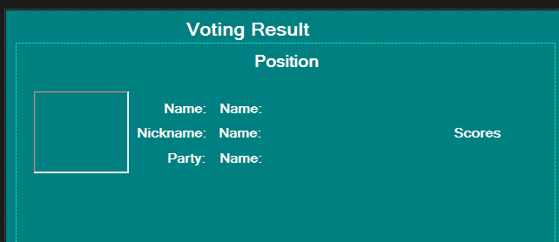
Figure1:VotingResult PageScreenshot

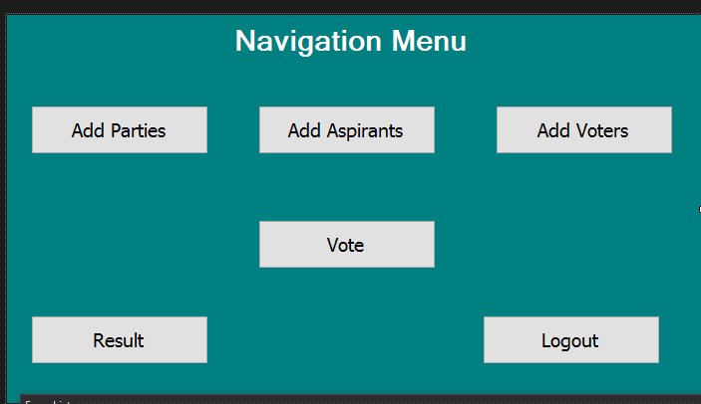

Figure2: Navigation Menu PageScreenshot
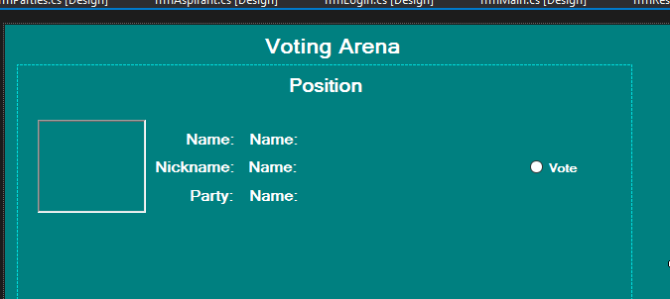

Figure3: Voting ArenaPageScreenshot

INPUTDESIGN

Inputdesignfocuseson controllingtheamountofinputrequired,controllingtheerrors,avoiding delay, avoiding extra steps and keeping the process simple.The inputs manage information that is needed for the development of the online tutor. it provides ease of use with retaining the privacy.
Diagramoftheinputsdesignisas follows:

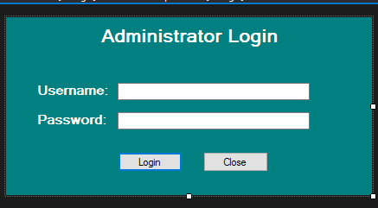

Figure4:LoginPageScreenshot
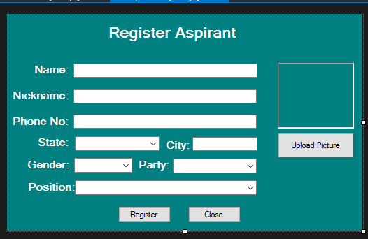

Figure5:RegistrationPageScreenshot
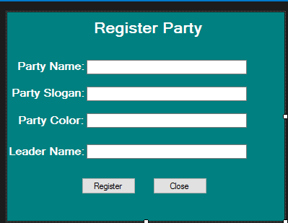

Figure6:RegisterPartyPage Screenshot

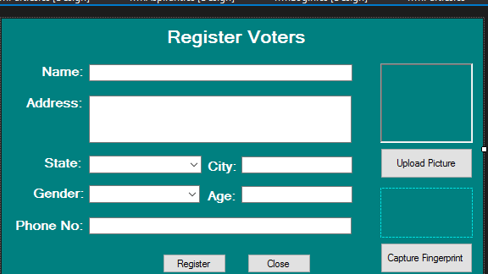

Figure7:RegisterVoters Page Screenshot

DATABASEDESIGN

Database Design is the collection or related data in an organized mechanism that has the capability of storing information. End-user can retrieve stored information in an effective and efficient manner which has the means of protecting them.
InanAutomatedSecurityLockSystem,dataarehandledusingWAMPserverasthe server-side for the design. The database design is structure using Mysql and PHP linking codes. Below is the database design of the system:
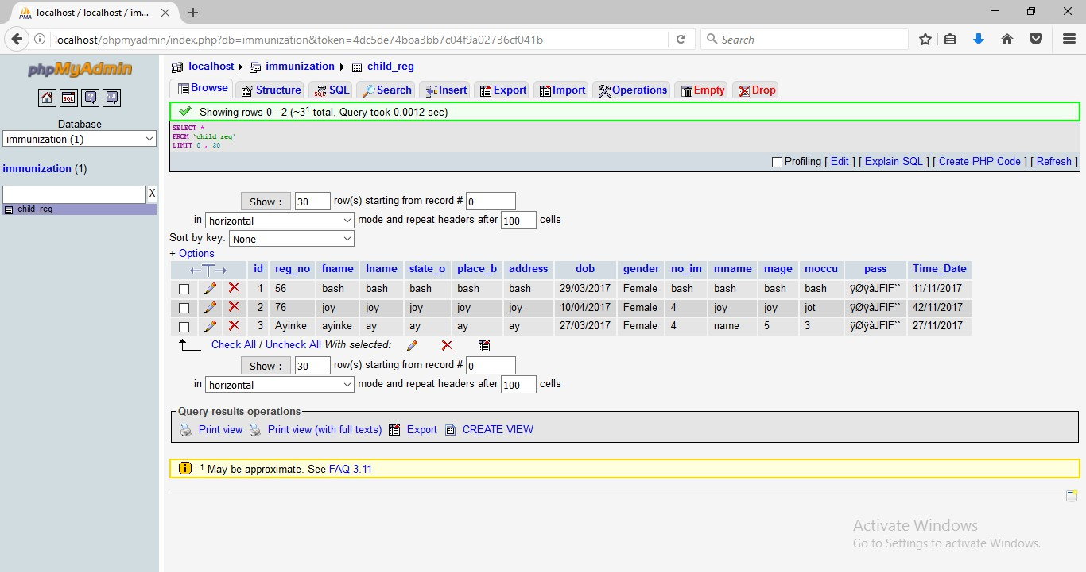
Table:AdminStructurePageScreenshot

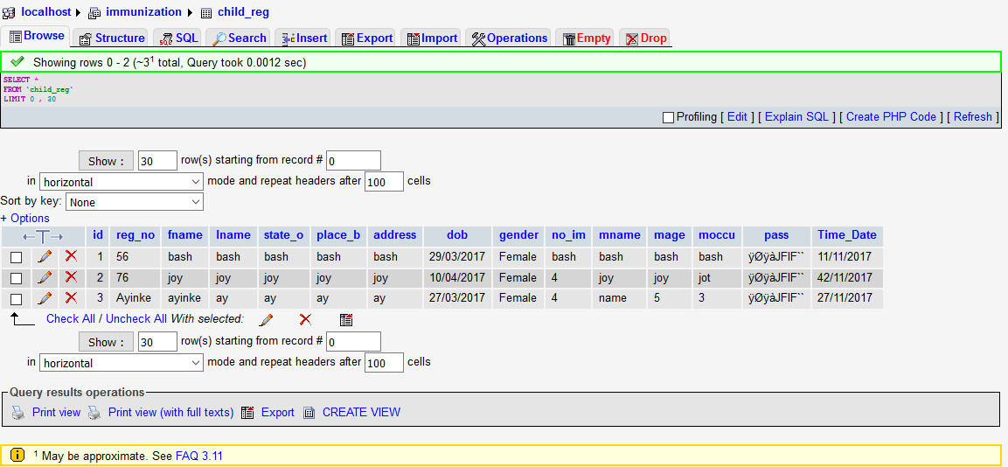

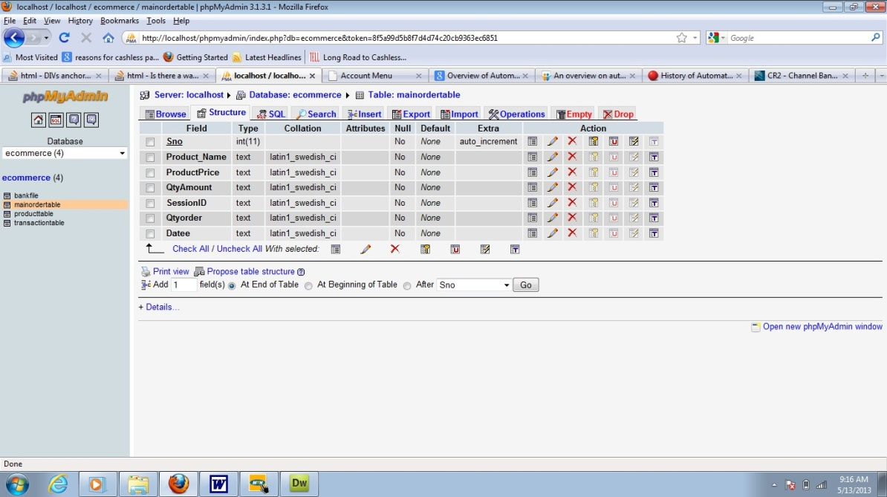
Table2:VotersStructure Page Screenshot

Table3:PartyStructure Page Screenshot

4.1.3 PROCEDUREDESIGN
Procedures arestepswhichverifythewholeprocessi.e whichareeverythingputtogether to produce the desired output. This involves the organization of the source document and end with the output result.
Documents are sent to various departments to be filled by the employees and later returned to the personnel department which areanalysed to determine which record goes into the computer.
Afterselectingthenecessarydata,thisservesasinputtothecomputersystem.

SYSTEMIMPLEMENTATION

CHOICEOFPROGRAMMINGLANGUAGE
C# is the chosen programming language for the implementation of the proposed system because of its pedagogy and open source help when needed. As well it has a support for variety of database application like sql server, sqllite, mysql, and Microsoft access but Microsoft Access is selected.

HARDWARESUPPORT
- MinimumofMicrocomputerPentiumII- Intel533MHZprocessor,128MB RAM,
3.5GBHDD,3.5”FDD,14”VGAMonitorWindows2000Enhancedkeyboard,mouse
andpad.
- Scanner
- Printer
- HPDeskJet3820cseries

SOFTWARESUPPORT
Thesoftwaresupportfor thedesignoftheproposedsysteminvolvesoperatingsystem,Microsoft visual studio, MYSQL as well as an anti-virus software which prevents the system from being infected by virus.

IMPLEMENTATIONTECHNIQUEUSED
In preparation for the installation of the new system, the method of changeover is given serious consideration to determine the success of the new system. Suitable changeover technique for this system is pilot changeover. The pilot changeover operates by applying the new system bit-by-bit until it covers the whole of the operations. The result obtained from using the pilot method on a small portion of the operations would be used in determining the suitability of the need system for the rest of the operations. This method is similar to testing small sample of a distribution ifthe test yields a good result then the whole system because fully operational and the manual/existing system is eliminated.

PROGRAMDOCUMENTATION
    - DOCUMENTATIONOFTHESYSTEM
This is the detailed description of the proposed system. It important because it helps to designandimplementasystemthatwouldallowshoppingbygettingintothecompanywebsite

on the internet from anywhere. It also helps to design and implement a website that will be more interactive and more information about company activities.
Moreover, it design and implements a system that will create a virtual community, which does not necessitate the use of offices and staff stationed around the world.

OPERATINGTHE SYSTEM
Step 1: Bootyourcomputerandclickonstartbuttonontaskbar Step 2: Launch wamp server
Step 3: LogintoyourApplication Step 4: Click on Options
  - ClickonRegister Aspirant(toRegister Aspirant)
  - ClickonRegisterParty(toRegister Party)
  - ClickonRegisterVoter(toRegister Voter)
  - ClickonVotingResult(toViewtheVotingResult) Step 5: Logout

MAINTAININGTHESYSTEM
The use of the term maintenance for software is different from other references to maintenance.Unlikethe tires on yourcar,softwaredoes not “wearout”.Ifthis is thecase, then why does software maintenance account for such a high percentage of the Total Cost of Ownership for software?
The software maintenance definition refers to changes for defect correction, performance improvements, or adaptations to a changed environment (enhancements).According to this definition, if we build software that is defect-free, performs well, and contains user-controlled parameters to adjust processing rules in response to changing requirements then most maintenance would not be necessary.
Why does this happen?There are many reasons but the most common reasons are time constraints and lack of experience.Adding validation logic takes time. So, people make assumptions about the quality of in-bound data.Assumptions arealso made about the volume of transactions and the impact on performance and the stability of the automated businessprocesses.Finally, it is common for new software to be developed by younger developers who don’t understand the maintenance impacts of their designs.

The reality is that business requirements change and most of these assumptions are flawed.Transaction volumes increase, changing business processes require new transactions or new validation criteria, and softwareusers will use the softwareincorrectly. The cost of software maintenance and the total cost of ownership can dramatically be reduced if developers build software that adjusted to changes in transaction volumes; validated all inbound data and provide user-configurable options for decision logic and data validation.

CHAPTERFIVE

SUMMARY,CONCLUSIONANDRECOMMENDATIONS

SUMMARY
Online transactions are nowadays become very common and there are various attacks present behind this. In these types of various attacks, phishing is identified as a major security threat and new innovative ideas are arising with this in each second so preventive mechanisms should also be so effective .Thus the security in these cases be very high and should not be easily tractable with implementation easiness. Today, most applications are only as secure as their underlying system. Since the design and technology of middleware has improved steadily, their detection isa difficult problem. As a result, it is nearly impossible to be sure whether a computer that is connected to the internet can be considered trustworthy and secure or not. Phishing scams are also becoming a problem for online banking and e-commerce users. The question is how to handle applications that require a high level of security. Phishing is a form of online identitytheft that aims to steal sensitive information such as online banking passwords and credit card information from users. One definition of phishing is given as “it is a criminal activity using social engineering techniques. Phishers attempt to fraudulently acquire sensitive information, such as passwords and credit card details, by masquerading as a trustworthy person or businessin an electronic communication”. The attacker extracts all the information of the victim andsaves the data for its own illegal use. And there are different types of phishing attacks like deceptive phishing, malware based phishing, Web Trojans, System reconfiguration attack.

CONCLUSION

Now-a-days internet is used on a large scale so the phishing attacks are becoming very common. Internet has become a necessary need of the person. The phishing attacks can globally acquirethe user’s confidential information like username, credit card number, and password, etc. And this data may be stored on to the database and may be used for the illegal purposes. Phishing is basically the attack mainly done to gain the access to confidential information of the victims. By using the proposed method of ―Anti-phishing Structure Based on Visual Cryptography andRSAAlgorithm phishingwebsites can beidentified. Thus with help ofthetechniquesused in the paperwecansuccessfullyhelpedtheuserstoidentifythefakeandgenuinewebsitesothathe

doesn’tfallpreytothephishingattacks. Thusthesecuritypurposegetsserved here.

RECOMMENDATION
Efforts have been made to design and develop application that will cater for all activities on voting system. With security issue we are recommended to some problemsthatmayoccurinthefuture.Buttherearestillareasthatmaybeconsidered asafurtherandimportantareatoimproveon,andmysuggestiongothus.
i. There is the need more research on this voting system because hackers or Phishers develop new techniques for phishing.

REFERENCES
Jayalaxmi M. & Udupi V.R. (2020) Prepared a journal on the project titled “Online PollingSystem Based onVisual Cryptography” Now a days only few people go for voting because of their tight schedule.
Nisha. S & Neela M. (2021) Prepared a journal on the project titled “Phishing Attack Prevention in Corporate Companies for Internet Voting with Secure Authentication” Corporations and organizations routinely use Internet voting to elect officers and Board members and for other proxy elections.
Pavithra G. & John D. S. (2021). Prepared a journal on the project titled “Countering Phishing Threats using Visual Cryptography” Phishing is an attempt by an individual or a group to get personal confidential information such aspasswords.
Pratik S., Vaishnavi K. & Aishwary P. (2020) Prepared a journal on the project titled “E-Voting” E-Voting is an Application which provides facility to caste vote for critical and corporate decisions.
Sneha M. Shelke, & Prachi A. Joshi. (2020) “Prevention of Phishing Threats using Visual Cryptography and One Time Password (OTP)” Cryptography and authenticating along with dynamic OTP has been proposed to recognize the whether the site is safe or unsafe to carry out transaction.
Snehal M. & Uday P.(2021) prepared a journal on the project titled “Phishing Attacks and Its Preventions” Now-a-days online attacks have increased to a great extent and the most popular attack among them is phishing.
Ramya. R. et al., (2021) “Anti-Phishing I-Voting System using Visual Cryptography”. Visual Cryptography (VC) aims at providing a facility to cast vote for critical and confidential internal corporate decisions.

