SMART ATTENDANCE MONITORING SYSTEM USING FACIAL RECOGNITION

PRESENTED BY

SAKA NURAT ATINUKE
HND/23/COM/FT/464

A Project Submitted to the Department of Computer Science, Institute of Information and Communication Technology, Kwara State Polytechnic, Ilorin

In Partial Fulfillment of the Requirements for the Award of Higher National Diploma [HND] In Computer Science

June, 2025

CERTIFICATION
This is to certify that this project was carried out by SAKA Nurat Atinuke with matriculation number and HND/23/COM/FT/464 has been read and approve as meeting part of the requirements for the award of Higher National Diploma (HND) in Computer Science.

_______________________ ___________________
MR. SAKA T. O. Date
Project Supervisor

_______________________ ___________________
MR. OYEDEPO F.S Date
Head of Department

_________________________ ____________________
EXTERNAL EXAMINER Date

DEDICATION
This project is dedicated to the creator of the earth and universe, the almighty God. It is also dedicated to my parents for their moral and financial support.

ACKNOWLEDGEMENT
All praise due to Almighty God the Lord of the Universe. I praise Him and thank Him for giving me the strength and knowledge to complete my HND programme and also for me continue existence on the earth.
I appreciate the utmost effort of my supervisor, Mr. Saka, T. O., whose patience support and encourages have been the driving force behind the success of this research work. He gave useful corrections, constructive criticisms, comments, recommendations, advice and always ensures that excellent research is done. My sincere gratitude goes to Head of the Department and other members of student of the Department of Computer Science, Kwara State Polytechnic, Ilorin, for their constant cooperation, constructive criticisms and encouragements throughout the programme.
Special gratitude to my parents who exhibited immeasurable financial, patience, support, prayers and understanding during the periods in which I was busy tirelessly in my studies. Special thanks go to all my lovely siblings.
My sincere appreciation goes to my friends and classmates.

TABLE OF CONTENTS
Title Page i
Certification ii
Dedication iii
Acknowledgements iv
Abstract v
Table of Contents vi
CHAPTER ONE: GENERAL INTRODUCTION
  - Background to the Study 1
  - Statement of the Problem 3
  - Aim and Objectives of the Study 4
  - Significance of the Study 4
  - Scope of the Study 5
  - Organization of the Report 5
CHAPTER TWO: LITERATURES REVIEW
  - Review of Related Works 7
  - Review of Related Concepts 12
2.2.1 Face Recognition 13
2.2.2 Biometric System 14
2.2.3 Face Recognition Biometric System 16
2.2.4 Face Recognition Based Attendance Marking System 17

CHAPTER THREE: RESEARCH METHODOLOGY AND ANALYSIS
  - Research Methodology 19
  - Analysis of the Existing System 19
  - Problems of the Existing System 20
  - Description of the Proposed System 21
  - Advantages of the Proposed System 22
CHAPTER FOUR: DESIGN, IMPLEMENTATION AND DOCUMENTATION OF THE SYSTEM
  - Design of the System 24
    - Output Design 24
    - Input Design 29
    - Database Design 33
    - Procedure Design 34
  - Implementation of the System 34
    - Choice of Programming Language 35
    - Hardware Support 35
    - Software Support 36
  - Documentation of the System 36
    - Program Documentation 37
    - Maintaining the System 37
CHAPTER FIVE: SUMMARY, CONCLUSION AND RECOMMENDATION
  - Summary 39
  - Conclusion 40
  - Recommendation 40
References
System Flowchart / Program Flowchart of the Existing System
Source Program Listings

ABSTRACT
Attendance management is important to every single organization; it can decide whether or not an organization such as educational institutions, public or private sectors will be successful in the future. Institution will have to keep a track of students within the institution such as students and students to maximize their performance. Managing student attendance during lecture periods has become a difficult challenge. The ability to compute the attendance percentage becomes a major task as manual computation produces errors, and wastes a lot of time. For the stated reason, an efficient face recognition-based attendance system is designed to track student’s activity in the class. Attendance Management System is based on .Net application, which can be implemented on any computer. In This application, C Sharp is the programming language adopted in the system, MySQL is used as back-end design. In compression with other traditional attendance systems, the proposed system provides faster, cheaper and reachable system for student attendance and generate the attendance report automatically.

CHAPTER ONE
GENERAL INTRODUCTION
  - BACKGROUND TO THE STUDY
Nowadays Educational institutions are concerned about regularity of student attendance. Even in pandemic situation attendance is still a major issue in schools and colleges. Mainly there are two conventional methods of marking attendance which are calling out the roll call or by taking student sign on paper. They both were more time consuming and difficult. Hence, there is a requirement of computer-based student attendance management system which will assist the faculty for maintaining attendance record automatically (Mrunal, Prasad, Manish, Aniket & Chinmay, 2021).
The Attendance management is the significant process that were carry out in every institute to monitor the performance of the student. Every institute does this in its own way. Some of these institute use the old paper or file-based system and some have adopted strategies of automated attendance system using some biometric technique. A facial recognition system is a computerized software which is suited for determining or validating a person by performing comparisons on patterns based on their facial appearances, the Automated Attendance System is the progress that has taken place in the field of automation replacing the attendance marking activity traditionally. Automated Attendance Systems are generally bio-metric. These systems are widely used in different organizations. Traditional method of attendance marking is very time consuming and becomes difficult when the strength is high. Automation of Attendance System has boundary over conventional method as it saves time and also can be used for security purposes. This also helps to prevent fake attendance (Shireesha, Ruth & Anjola, 2019).
Facial recognition or face recognition as it is often referred to as, analyses characteristics of a person's face image input through a camera. It measures overall facial structure, distances between eyes, nose, mouth, and jaw edges. These measurements are retained in a database and used as a comparison when a user stands before the camera. One of the strongest positive aspects of facial recognition is that it is non-intrusive. Verification or identification can be accomplished from two feet away or more, without requiring the user to wait for long periods of time or do anything more than look at the camera. Traditionally student’s attendance is taken manually by using attendance sheet, given by the faculty member in class.
The Current attendance marking methods are monotonous & time consuming. Manually recorded attendance can be easily manipulated. Moreover, it is very difficult to verify one by one student in a large classroom environment with distributed branches whether the authenticated students are actually responding or not. Hence the paper is proposed to tackle all these issues.
Face Recognition-based Lecture Attendance System proposed a system that takes the attendance of students for classroom lecture. The system takes attendance automatically using face recognition. However, it is difficult to estimate the attendance precisely using each result of face recognition independently because the face detection rate is not sufficiently high. In this paper, we propose a method for estimating the attendance precisely using all the results of face recognition obtained by continuous observation, the Attendance System using Face – Recognition is a replacement way method for the traditional way of marking attendance (Turk & Pentland, 2017).
1.2 STATEMENT OF THE PROBLEMS
According to the previous attendance management system, the accuracy of the data collected is the biggest issue. This is because the attendance might not be recorded personally by the original person, in another word, the attendance of a particular person can be taken by a third party without the realization of the institution which violates the accuracy of the data. For example, student A is lazy to attend a particular class, so student B helped him/her to sign for the attendance which in fact student A didn’t attend the class, but the system overlooked this matter due to no enforcement practiced. Supposing the institution establish an enforcement, it might need to waste a lot of human resource and time which in turn will not be practical at all. Thus, all the recorded attendance in the previous system is not reliable for analysis usage. The second problem of the previous system is where it is too time consuming. Assuming the time taken for a student to sign his/her attendance on a 3-4 paged name list is approximately 1 minute. In 1 hour, only approximately 60 students can sign their attendance which is obviously inefficient and time consuming. The third issue is with the accessibility of those information by the legitimate concerned party.
1.3 AIM AND OBJECTIVES
The aim of this project is to develop a face recognition-based student attendance system. The objectives are to: -
i. Implement face recognition biometric system that verifies and identifies a user to the security system based on an individual enrollment in the database.
ii. Implement an “Automated Attendance System Based on Face Recognition”
iii. Build a face recognition-based attendance monitoring system
iv. Ensure the speed of the attendance recording process is faster than the previous system which can go as fast as approximately 3 second for each student.
1.4 SIGNIFICANCE OF THE STUDY
The use of student attendance system is very important because of human being proneness to error, leaving the student to write down their names might not be accurate as student can even write attendance for their fellow student and their handwriting legibility can be a case when compiling the attendance record at the end of the lecture.
The official in charge of attendance collation is highly favored by this system because use of pen and paper as a means of collating student attendance will leave the official in charge with numerous sheets of paper, which will be hectic as he/she has to start comparing several sheets to record the average attendance for just a student. The official is going to waste a lot of time compiling the attendance percentage at the end of the month, mistake can creep in due to the large volumes of papers. Successful implementation of this project means the student attendance credibility can be queried or put to test anytime, and result are produced fast and accuracy, without stress.
1.5 SCOPE OF THE STUDY
The human face is a unique representation of individual’s identity. Thus, the face recognition is a type of biometric method through which identification of an individual is performed by comparing the real time captured image with the stored images of that person in the database, this research centered on face recognition-based student attendance system which is use to records student attendance.
1.6 ORGANISATION OF REPORT
This report is organized as stated below chapter one discusses the general introduction and overview of the whole project. It also discusses the statement of the problem, aim and objectives of the proposed system, significance of the study, scope and limitations of the project, organization of the report and the definition of technical terms used. Chapter two deals the literature review, the review of related writing of the project topic, it gives a detail information of all writing related to the topic which help to know for information on the project topic. Chapter three deals with analysis of the system which include the data collection method employed, the description of the existing system and its problems and the description of the proposed system and possible advantages it will provide and will solve the problems encountered in the existing manual system. While chapter four deals with the design, implementation and the description of the proposed system. It covers description of the output design, input design, database design and procedure design. The implementation techniques used, the programming language used in developing the new system and system requirements for running the system. And also talks about the program documentation as well user documentation. Lastly chapter five present a brief summary of the work done, experience gained and problems encountered in the course of the project, conclusion and recommendation. Other appendices included after the references used are; algorithm, system flowchart, program flowchart, program source listing and generated computer output.

CHAPTER TWO
LITERATURE REVIEW
2.1 REVIEW OF RELATED PAST WORK
Face recognition is an important research problem spanning numerous fields and disciplines. This is because face recognition, in addition to having numerous practical applications such as bankcard identification, access control, Mug shots searching, security monitoring, and surveillance system, is a fundamental human behaviour that is essential for effective communications and interactions among people.
Liu, Ruth and Anjola, (2018) proposed the first formal method of classifying faces in “Design of Face Detection and Tracking”. The author proposed collecting facial profiles as curves, finding their norm, and then classifying other profiles by their deviations from the norm. This classification is multi-modal, i.e. resulting in a vector of independent measures that could be compared with other vectors in a database.
Silva, (2019) proposed an automated attendance management system based On Face Recognition Algorithm. This system, which is based on face detection and recognition algorithm, automatically detects the student when he enters the class room and mark the attendance by recognition him. This technique is to be use in order to handle the treats like spoofing. The problem with this approach is that it captures only one student image at a time when he enters the classroom thus it is time consuming and may distract the attention of the student.
According to Schmidt, (2018) in an article entitled “The Performance of the Haar Cascade Classifiers Applied to the Face and Eyes Detection”, Computer Recognition Systems authors have considered a system based on real time face recognition which is reliable, secure and fast which needs improvement in different lighting conditions. In the literatures, face recognition problem can be formulated as: given static (still) or video images of a scene, identify or verify one or more persons in the scene by comparing with faces stored in a database. When comparing person verification to face recognition, there are several aspects which differ. First, a client – an authorized user of a personal identification system is Manuscript received February 22, 2005. Tolba is with the Information Systems Department, Mansoura University, Egypt. EL-Baz is with the Mathematics Department, Damietta Faculty of Science, New Damietta, Egypt, and doing PhD research on pattern recognition EL-Harby is with the Mathematics Department, Damietta Faculty of Science, New Damietta, Egypt, assumed to be co-operative and makes an identity claim.
Computationally this means that it is not necessary to consult the complete set of database images (denoted model images below) in order to verify a claim. An incoming image (referred to as a probe image) is thus compared to a small
number of model images of the person whose identity is claimed and not, as in the recognition scenario, with every image (or some descriptor of an image) in a potentially large database. Second, an automatic authentication system must operate in near-real time to be acceptable to users. Finally, in recognition experiments, only images of people from the training database are presented to the system, whereas the case of an imposter (most likely a previously unseen person) is of utmost importance for authentication. Face recognition is a biometric approach that employs automated methods to verify or recognize the identity of a living person based on his/her physiological characteristics. In general, a biometric identification system makes use of either physiological characteristics (such as a fingerprint, iris pattern, or face) or behaviour patterns (such as hand-writing, voice, or key-stroke pattern) to identify a person. Because of human inherent protectiveness of his/her eyes, some people are reluctant to use eye identification systems. Face recognition has the benefit of being a passive, non-intrusive system to verify personal identity in a “natural” and friendly way.
The attendance system is improved by using NFC technology and mobile application. According to the research paper, each student is given an NFC tag that has a unique ID during their enrolment into the college. Attendance of each class will then be taken by touching or moving these tags on the lecturer mobile phone. The embedded camera on the phone will then capture the students face to send all the data to the college server to do validation and verification. The advantages of this method are where the NFC is simple to use, and the speed of connection establishment is very high. It indeed speeds up the attendance taking process a lot. However, this system couldn’t automatically spot the violation when the NFC tag is not personally tagged by the original owner. Apart from that, the convenience of the system which uses the mobile phone as the NFC reader was actually an inconvenience to the lecturer. Imagine if the lecturer had forgotten to bring their mobile phones to work, what would be the backup procedure for the attendance to be recorded? Moreover, most of the lecturer will not likely to prefer their personal smart phones to be used in this way due to privacy matter. Hence, unique information about the student like biometrics or face recognition, which is guanine for a student should be used in replacement of the NFC tag. This will ensure attendance to be taken originally by the actual student (Suresh et al., 2019).
2.2 REVIEW OF RELATED CONCEPTS
2.2.1 Face Recognition
The application of face recognition technique can be categorized into two main parts: law enforcement application and commercial application. Face recognition technology is primarily used in law enforcement applications, especially Mug shot albums (static matching) and video surveillance (real-time matching by video image sequences). The commercial applications range from static matching of photographs on credit cards, Automated Teller Machine (ATM) cards, passports, driver’s licenses, and photo Identification to real-time matching with still images or video image sequences for access control. Each application presents different constraints in terms of processing.
All face recognition algorithms consist of two major parts: (1) face detection and normalization and (2) face identification. Algorithms that consist of both parts are referred to as fully automatic algorithms and those that consist of only the second part are called partially automatic algorithms. Partially automatic algorithms are given a facial image and the coordinates of the center of the eyes. Fully automatic algorithms are only given facial images.
On the other hand, the development of face recognition over the past years allows an organization into three types of recognition algorithms, namely frontal, profile, and view tolerant recognition, depending on the kind of images and the recognition algorithms. While frontal recognition certainly is the classical approach, view-tolerant algorithms usually perform recognition in a more sophisticated fashion by taking into consideration some of the underlying physics, geometry, and statistics. Profile schemes as stand-alone systems have a rather marginal significance for identification, (for more detail see. However, they are very practical either for fast coarse pre-searches of large face database to reduce the computational load for a subsequent sophisticated algorithm, or as part of a hybrid recognition scheme. Such hybrid approaches have a special status among face recognition systems as they combine different recognition approaches in an either serial or parallel order to overcome the shortcoming of the individual components. Another way to categorize face recognition techniques is to consider whether they are based on models or exemplars. These models capture class information (the class face), and provide strong constraints when dealing with appearance variation. At the other extreme, exemplars may also be used for recognition.
Focusing on the aspect of pose invariance, face recognition approaches may be divided into two categories: (i) global approach and (ii) component-based approach. In global approach, a single feature vector that represents the whole
face image is used as input to a classifier.
According to Liu (2016), the proposed attendance system using face recognition system and class monitoring system. Camera is present inside the classroom where the students are seated. The camera capturing the images of students from the video frame. A face recognition system which automatically identifies and verifies the identity of person from video frame from video source. We used Open Cv library that can be formulated as given images are identify or verify all the students seated in front of camera from the stored database of faces.
2.2.2 Biometric System
Biometric System is the technical term for body measurements and calculations. It refers to metrics related to human characteristics. Biometrics authentication (or realistic authentication is used in computer science as a form of identification and access control. It is also used to identify individuals in groups that are under surveillance.
Biometric identifiers are the distinctive, measurable characteristics used to label and describe individuals. Biometric identifiers are often categorized as physiological versus behavioral characteristics. Physiological characteristics are related to the shape of the body. Examples include, but are not limited to fingerprint, palm veins, face recognition, deoxyribonucleic acid, sometimes called "the molecule of life (DNA), palm print, hand geometry, iris recognition, retina and odour/scent. Behavioral characteristics are related to the pattern of behavior of a person, including but not limited to typing rhythm, gait, and voice. Some researchers have coined the term behaviometrics to describe the latter class of biometrics.
More traditional means of access control include token-based identification systems, such as a driver's license or passport, and knowledge-based identification systems, such as a password or personal identification number. Since biometric identifiers are unique to individuals, they are more reliable in verifying identity than token and knowledge-based methods; however, the collection of biometric identifiers raises privacy concerns about the ultimate use of this information.
2..2.3 Face Recognition Biometric System
Face Recognition Biometric is a technology capable of identifying or verifying a person from a digital image or a video frame from a video source. There are multiples methods in which facial recognition systems work, but in general, they work by comparing selected facial features from given image with faces within a database.
While initially a form of computer application, it has seen wider uses in recent times on mobile platforms and in other forms of technology, such as robotics.
It is typically used in security systems and can be compared to other biometrics such as fingerprint or eye iris recognition systems. Recently, it has also become popular as a commercial identification and marketing tool.
2.2.4 Face Recognition Based Attendance Marking System
The second research journals “Face Recognition Based Attendance Marking System” (SenthamilSelvi, Chitrakala, Antony Jenitha, 2014) is based on the identification of face recognition to solve the previous attendance system’s issues. This system uses camera to capture the images of the employee to do face detection and recognition. The captured image is compared one by one with the face database to search for the worker’s face where attendance will be marked when a result is found in the face database. The main advantage of this system is where attendance is marked on the server which is highly secure where no one can mark the attendance of other. Moreover, in this proposed system, the face detection algorithm is improved by using the skin classification technique to increase the accuracy of the detection process. Although more efforts are invested in the accuracy of the face detection algorithm, the system is yet not portable. This system requires a standalone computer which will need a constant power supply that makes it not portable. This type of system is only suitable for marking student‟s attendance as they only need to report their presence once a day, unlike students which require to report their attendance at every class on a particular day, it will be inconvenient if the attendance marking system is not portable. Thus, to solve this issue, the whole attendance management system can be developed on a portable module so that it can be work just by executing the python program.
CHAPTER THREE
RESEARCH METHODOLOGY AND ANALYSIS OF THE EXISTING SYSTEM
3.1 RESEARCH METHODOLOGY
In the analysis of the existing system, the information gathered were analyzed and restricted in a more relevant and useful data. Data analysis that was gotten was based on the identification of the basic needs and also the structure of project. The data gatherer shows that they are analyzed and restructured in a way that the subsystems were achieved efficiently. There are also facilities for testing of knowledge
Interview
This was conducted orally by asking questions and the respondents giving answer to the question almost immediately. This interview was conducted with some of the personnel within the organization. Also interview were done in view of analyzing the investigation carried out as to make sure that they can appropriately be used effectively in designing the new system
Personal Observation
This was conducted through physical observation within the organization. This form of investigation was introduced to give room to measuring the extent to which the organization actually lacks computer operational facilities the constraint resulting from the managerial protocols. It equally has the advantages to the researcher by having more knowledge on face recognition base lecture attendance system (investopedia.com).

3.2 ANALYSIS OF THE EXISTING SYSTEM
The existing system used in taking student attendance in tertiary institution before the advent of computer is what is referred to as the manual method, which is the use of pen and paper to record student’s attendance. This is done by signing the attendance sheet by each student to write his/her name, sign in time that is resumption time and sign out time that is closing time of each student and signature as evidence for been punctual to work.
This system contains student records and monitors student movement; it monitors all the movement of the student pertaining to assumption time and closing time.
3.3 DESCRIPTION OF THE PROPOSED SYSTEM
The proposed system consists of a high-resolution digital camera to monitor the classroom or office room. It is embedded on a micro-controller-based motor system which enables it to rotate in left & right directions. The data or images obtained by the camera are sent to a computer programmed system for further analysis. The obtained images are then compared with a set of reference images of each of the employees or students & mark the corresponding attendance. The system also provides for continuous monitoring of the classroom by an operator if needed. The camera module can be a wireless or wired system.
This is an automated way of monitoring the movement of the student in the organization. It captured their image as a means of recording their attendance. This system is implemented to eliminate absenteeism and lateness to work by the student.
3.4 PROBLEMS OF THE EXISTING SYSTEM
Formally student’s attendance is taken manually by using attendance sheet in the class, given by class representative or lecturer.
i. This attendance marking methods are monotonous & time consuming.
ii. Manually recorded attendance can be easily manipulated.
iii. It is very difficult to verify one by one student in a large classroom environment with distributed branches whether the authenticated students are actually responding or not.
iv. The lecturer also has to perform manual computation to obtain the students’ attendance percentage, which normally consume a lot of time.
v. Lecturer can no longer trace the students overall record throughout the particular year.
vi. Lecturer also has limited access to the single-copy record.
Some students may accidentally sign another student's name. The first case leads to a student missing out their name, while the latter leads to a false attendance record. Another issue of having the record in a hardcopy form is that a lecturer may lose the sheet. Sometimes storage of sheets needs cupboard or lots of space. The limitations imposed by the conventional system, we propose a solution in form of an attendance tracking system based on RFID technology.
3.5 ADVANTAGES OF PROPOSED SYSTEM
- It is very fast in verification or identification of student face for attendance purpose without taking much time or delay in operation.
- It improved ways of taking the attendance in the class i.e nobody can help another to take his/her attendance because this method uses individual biometric for recognition and verification
- It helps the management to maintain a strong security. Since image is used as a means of authentication it is difficult for someone to mark an attendance on behalf of another person and this creates a strong security measure.
- It saves time and accurate that is, the attendance is taken very fast, correct, exact, and without any mistakes.

CHAPTER FOUR
DESIGN AND IMPLEMENTATION OF THE SYSTEM
4.1 DESIGN OF THE SYSTEM
This is the computation of the particulars of a new system and the determination of what the new system would be and the function it is to perform. This may involve changing from one system to another or modifying the existing system operation.
The most challenging phase of the system life cycle is the change from manual operation to a faster and more accurate one, system design stage covers the technical specifications that will be employed in the implementation of the new system in order to modify the previous system. Some factors are put in consideration. These factors include input design, output design, definitions file and procedure designs and other documentation.
4.1.1 OUTPUT DESIGN
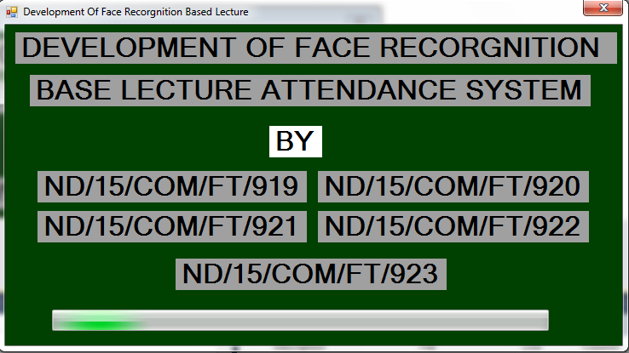
This incorporates the objectives of solving the existing system problems and challenges. This involves the structuring of the desired information and also to enhance efficient and effective attendance system. Things taken into consideration in determining the output are represented below:
BIOMETRIC ATTENDANCE SYSTEM WITH FACIAL RECOGNITION
By
ABDULRASAK SULAIMON OPEYEMI

Figure 4.1: Splash Screen
This page tells brief introduction about the project topic as well as the researcher.
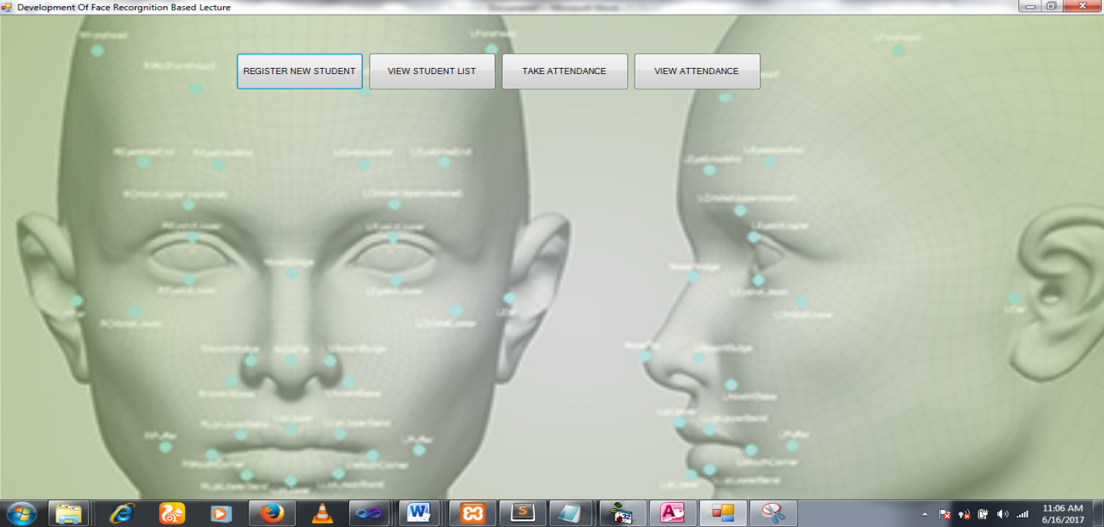
Figure 4.2: Home page
This is the main menu that contains submenus where user can navigate from one page to another within the environment.
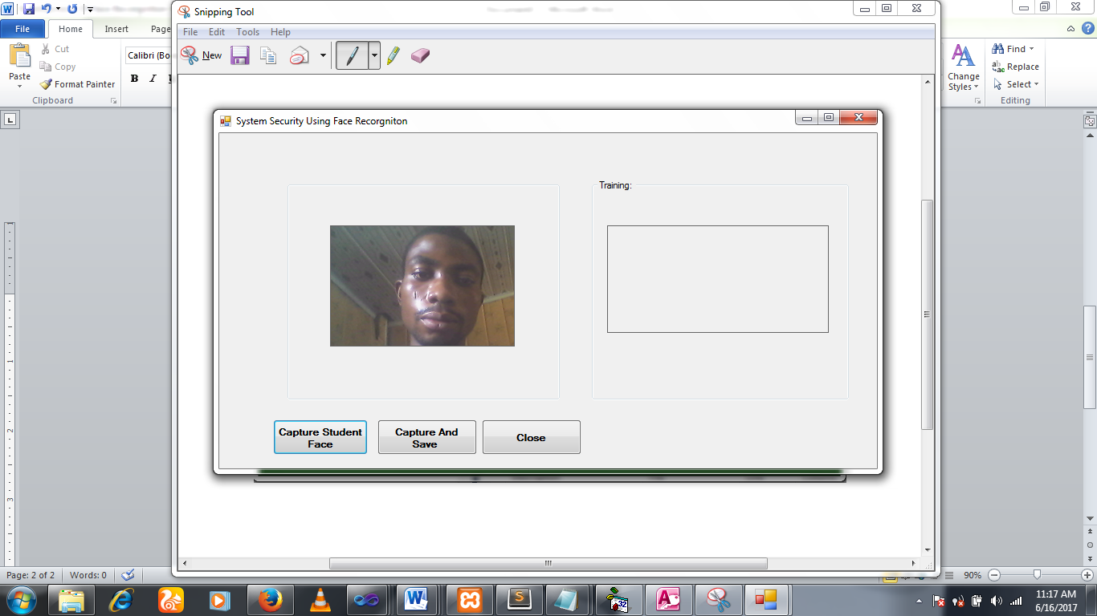
Figure 4.3: Student Attendance Interface
This page is where student attendance can be captured.
4.1.2 INPUT DESIGN
The input to run this software is obtained from lecture attendance system using facial based recognition system. The administrator is expected to safeguard the files and document using facial authentication. The input design describes the input interface for data entry into the program. Data entry interfaces needs to be considered in developing a new system to ensure users’ friendliness. Data entry is done through the use of keyboard, camera, and in some cases selection from the dropdown combos and list boxes are done using mouse selection. The interface descriptions are as shown below:
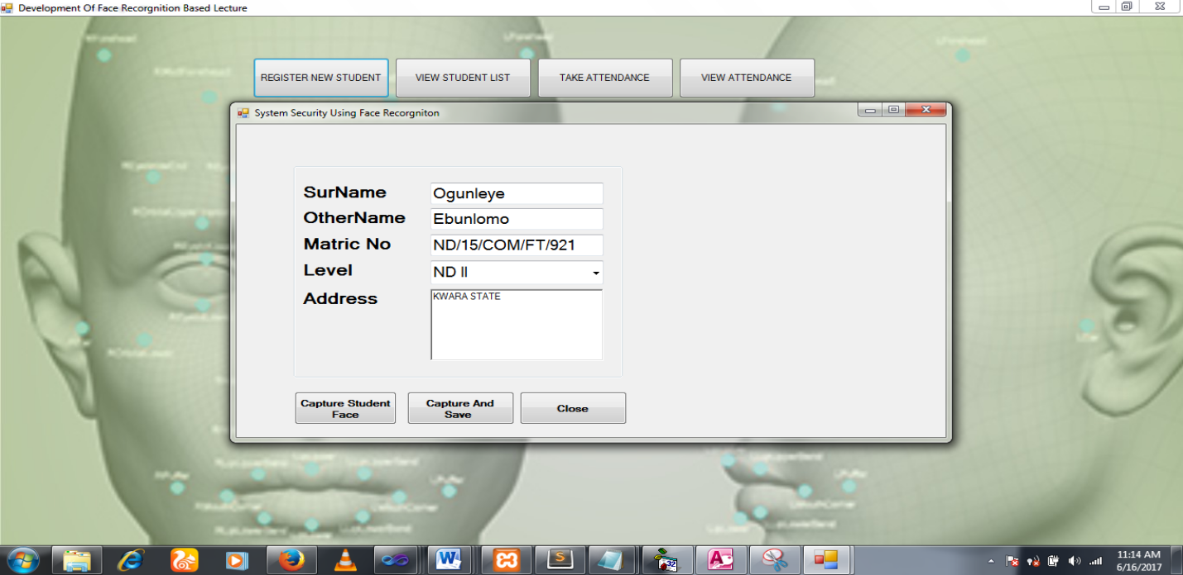
Figure 4.4: Registration form
This page is use by student to supply or enter their information and capture their face for recognition and identification purpose.
4.1.3 DATABASE DESIGN
The structure and organization of records in the tables is a database file is essential to be considered in designing a database driven application. The database files main record where house for keeping data and information relevant for this application.
Table 1: Student Registration Table
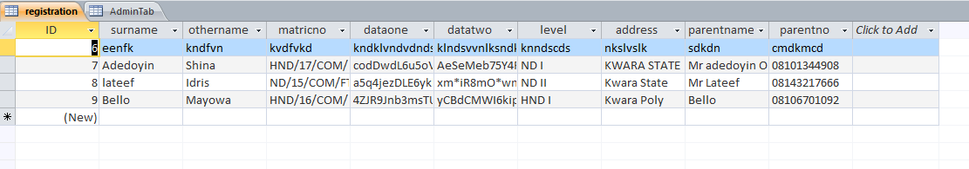
This table entails all the student details.
Table 2: Attendance Table
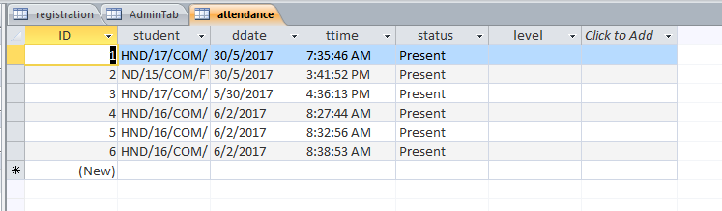
This table entails all the attendance details
4.13 PROCEDURE DESIGN
These are the steps involved in unifying the whole process to produce the desired output. It involves computer procedures which starts from the original input lessons to the output result file. This allows the processing of the information and result to be possible. Menu is provided to aid user in the processing of the output file.
4.2 IMPLEMENTATION OF THE SYSTEM
This entails the choice of the programming language employed to implement the software which should-be suitable for lecture attendance using facial recognition authentication. The software is designed for the use of lecture attendance system which should serve as an assistant for the management in monitoring the attendance system for students.

4.2.1 CHOICE OF PROGRAMMING LANGUAGE
The Application was developed in a .net (dot net) integrated development environment (.net IDE). The Application IDE is chosen following the fact that extracted information needs to be presented in an enhanced pictorial/graphical format and easy communication with the database for program flexibility in windows platform.
4.2.2 HARDWARE REQUIREMENTS
Minimum of Microcomputer Pentium IV- Intel 1.5 GHZ processor, 1.0 GB RAM, 40GB Hard disk, 14” VGA Monitor Windows XP or higher, Enhanced keyboard, mouse and pad.
4.2.3 SOFTWARE REQUIREMENT
i. Windows 7
ii. Microsoft Visual C#.
iii. Webcam
IV. Microsoft Access Database
4.2.4 CHANGE OVER TECHNIQUE
These deals with the processes and steps taking to put the system into use, before the system can be fully employed into the system, some training might have been done by the user of the application if he or she is a computer illiterate, because the user might be a computer illiterate, so also the system might have also been use.
Since the work of an expert cannot be eliminated from the system, the computerized system will have to work hand in hand with the expert in the field.
4.3 DOCUMENTATION OF THE SYSTEM
After the program has been well tested with input that the output has already been known, the next is to install the software in to the computer system for use.
The process of installing is been stated below
- Insert the CD into the system through the CD-ROM after the computer is switch on
- Locate the CD drive directory in my computer and click it to open
- After open, locate setup.exe, and then click to install the program by following the necessary step in installing the program.
- Ensure full installing of the software for effective operation of the system.
After the program has been fully install. The next thing is to locate the package install to put it into operation, to locate the package for expiration purpose the following step are to be taking.
- Click on start menu from task bar. Then select all program
- From the display sub option, select by locating the software installed named Information to load the software.
4.3.1 PROGRAM DOCUMENTATION
The program is packaged for use in any system irrespective of either it runs Visual Basic Application or not. After developing a program in Visual Basic, there is a facility provided in Microsoft Visual Studio suite called “Package and Deployment Wizard” that is used in Visual studio application packaging and deployment.
The automated face recognition-based lecture attendance system is packaged into an installable setup that can be run from any system.
4.3.2 MAINTAINING THE SYSTEM
The system maintenance refers to making modification to an already existing application/program without necessarily re-writing everything from start. Program maintenance of a program includes modification of the program to meet-up with certain requirements of the users. In this course, additional features can be added, errors corrected, ambiguous interfaces redesigned to eliminate confusions and unnecessary features removed.
Maintaining this program can be done in PHP environment. Any future modification can be by re-running the program source code in a VB environment making necessary changes and updates and recompile the application into an upgrade version of the existing version of the mini word processing application. Further versions of this program can be named following their year of release or it can be given a different version number.

CHAPTER FIVE
SUMMARY, CONCLUSION AND RECOMMENDATIONS
5.1 SUMMARY
Face Recognition based Students Attendance Monitoring System is the progress that has taken place in the field of automation replacing the attendance marking activity traditionally. Automated Attendance Systems are generally bio-metric. These systems are widely used in different organizations. Traditional method of attendance marking is very time consuming and becomes difficult when the strength is high. Automation of Attendance System has boundary over conventional method as it saves time and also can be used for security purposes. This also helps to prevent fake attendance. Computer visual class library (OpenCV) which source code is open, develops for application developers, including plenty of functions which used to tackle the common problems in computer visual field, for example, motion analysis and tracing, face recognition, three-dimensional reconstruction and target recognition. We propose a method that take the attendance using recognition of face based on continuous observation. In this paper, our purpose is to obtain the attendance, positions and images of students’ face, which are useful information in the classroom lecture.
5.2 CONCLUSION
This project discusses the development of face recognition-based lecture attendance. Attendance system using face recognition and class monitoring system based on face recognition techniques thus proved to be time saving and secure. The system estimates the attendance and the position of each student by continuous observation and recording.
A key factor of improving the quality of education is having students attend classes regularly. Traditionally students are stimulated to attend classes using attendance points which at the end of a semester constitute a part of a students’ final grade. However, traditionally this presents additional effort from the lecturer, who must make sure to correctly mark attending students, which at the same time wastes a considerable amount of time from the teaching process. Furthermore, it can get much more complicated if one has to deal with large groups of students.
This project introduces a new automatic attendance management marking system, without any interference with the regular teaching process. The system can be used also during exam sessions or other teaching activities where attendance is obligatory. This system eliminates classical student identification such as calling student names, or checking respective identification cards, which can not only interfere with the teaching process.
Furthermore, the system performs an in-depth step in implementing the aforementioned concepts in sensitivity analysis by detecting the expressions of the order to automate attendance generation in institutional human face and utilizing them in creating statistical systems as well as extract real time feedback based on
accounts of the level of interest and emotion shown by expression Analysis.
5.3 RECOMMENDATIONS
Based on the findings of the study, the researcher recommends the following;
User Training
Every student or administrator who lectures in the organization should be trained on how to operate the new face recognition-based lecture attendance.
Both entry and exit doors should be camera based. There should be a minimum number of total days for monthly attendance summary for the students
The administrator should be able to view daily attendance, as well as monthly summary report for all students.

REFRENCES
Adam Schmidt, Andrzej Kasinski, (2019). The Performance of the Haar Cascade Classifiers Applied to the Face and Eyes Detection, Computer Recognition Systems. Pp. 10-11.
Amit, P. K. Varma, S. P. & Chadha, P. R. (2016). Automatic Attendance System by Visual Programming Language LabVIEW, International Conference on Power Electronics, Intelligent Control and Energy System. Vol. 2, Issue: 3. Pp. 19-21.
Eisert, P. & B. Girod, (2020). Analyzing Facial Expressions for Virtual Conferencing, Computer Graphics and Applications, Vol. 18, Issue: 5. Pp. 70-73.
Francisco, S., Victor, F. & Antonio P. (2018). Automatic Control of Student Attendance in Classroom Using RFID, International Conference. Pp. 3-4.
Kamaraju, M. & Kumar, P. N. (2018). Wireless Fingerprint Attendance Management System, 3rd International Congress on Image and Signal Processing. Pp. 4-6.
Katsaggelos, K. (2020). Automatic Facial, Facial Action Recognition in Face Profile Image Expression Recognition Using Facial Animation Sequences, in Proc. IEEE Int. Conf. Multimedia and Parameters and Multi stream HMMs" in IEEE Expo. Pp. 37-40.
Mohamed, B. K. & C. Raghu (2019). Fingerprint Attendance System for Classroom Need, International Journal of Scientific Research in Computer Science, Engineering and Communication Technology, Vol. 3. Pp. 36-39.
Mrunal A., Prasad L., Manish T., Aniket J., Chinmay B. (2021), Attendance Management System using Face-Recognition, International Journal of Scientific Research in Computer Science, Engineering And Communication Technology, Vol. 7. Pp. 336-341.
Ruian Liu Mimi Zhang Shengtao Ma (2019). Design of Face Detection and Tracking System, 2019 IEEE 3rd International Congress on Image and Signal Processing. Pp. 11-12.
Shireesha, C., Raghunadh, M.V. (2021). Automated Attendance Management System Based on Face Recognition Algorithms, 2021IEEE International Conference on Computational Intelligence and Computing Research. Pp. 23-24.
Senthamil, S., Chitrakala, P. & Antony, J. (2019). Face Recognition Based Attendance Marking System, IJCSMC. Vol. 3, Issue. 2. Pp. 17-18.
Suresh, V., Srinivasa, D. C., Chiranjeevi, D. V. & Haneesha A. J. (2019). Student Attendance Management System. Journal of Software Engineering and Simulation. Vol. 5, Issue 2. Pp. 18-29

Appendices
Appendix 1: System Flowchart
TAKE ATTENDANCE
VIEW STAFF LIST
VIEW ATTENDANCE
REGISTER NEW STAFF

STOP
SPLASH SCREEN

FILE
START

Appendix 2: Student Registration Flowchart
START
OPEN DATABASE
INCREMENT ID BY 1
ENTER STUDENT DETAILS
SAVE INTO DATABASE
CLOSE DATABASE
MORE RECORD?
RETURN
Yes
No
DISPLAY STAFF
ENTRY FORM
CAPTURE STUDENT FACE

Appendix 3: Take Attendance Flowchart
OPEN DATABASE
START

CAPTURE STUDENT FACE

VERIFY STUDENT FACE
RETURN
CLOSE DATABASE
ANYMORE ?

Yes

No

Appendix 4: View Student List Flowchart
RETURN
CLOSE DATABASE
OPEN DATABASE
START
DISPLAY ALL
STUDENT DETAILS

ANYMORE TO VIEW?
No
Yes
Appendix 5: View Attendance Flowchart
RETURN
CLOSE DATABASE
OPEN DATABASE
START
VIEW ALL STUDENT ATTENDANCE

VIEW MORE?
Yes
No

Appendix 6: Source Program Listing

using System;
using System.Collections.Generic;
using System.ComponentModel;
using System.Data;
using System.Drawing;
using System.Linq;
using System.Text;
using System.Windows.Forms;
using System.Data.OleDb;

namespace MultiFaceRec
{
public partial class Form3 : Form
{
private OleDbConnection bookConn;
private OleDbCommand oleDbCmd = new OleDbCommand();
private String connParam = @"Provider=Microsoft.Jet.OLEDB.4.0;Data Source=C:\Users\PROGRAMMER\Desktop\face recornition project\FaceRecProOV\bin\Debug\faceattendance.mdb;Persist Security Info=False";

public Form3()
{
bookConn = new OleDbConnection(connParam);
InitializeComponent();
}

private void nDIToolStripMenuItem1_Click(object sender, EventArgs e)
{

int hh = 1;

dataGridView1.DataSource = null;
dataGridView1.Rows.Clear();
dataGridView1.Refresh();

OleDbDataAdapter dAdapter = new OleDbDataAdapter("select * from StudentDetails WHERE Slevel = 'ND I'", connParam);
OleDbCommandBuilder cBuilder = new OleDbCommandBuilder(dAdapter);

DataTable dataTable = new DataTable();
DataSet ds = new DataSet();
dAdapter.Fill(dataTable);
for (int i = 0; i < dataTable.Rows.Count; i++)
{
dataGridView1.Rows.Add(hh, dataTable.Rows[i][1], dataTable.Rows[i][2], dataTable.Rows[i][3], dataTable.Rows[i][4], dataTable.Rows[i][5]);
hh++;
}

bookConn.Close();

}

{

int hh = 1;

dataGridView1.DataSource = null;
dataGridView1.Rows.Clear();
dataGridView1.Refresh();

OleDbDataAdapter dAdapter = new OleDbDataAdapter("select * from StudentDetails WHERE Slevel = 'HND II'", connParam);
OleDbCommandBuilder cBuilder = new OleDbCommandBuilder(dAdapter);

DataTable dataTable = new DataTable();
DataSet ds = new DataSet();
dAdapter.Fill(dataTable);
for (int i = 0; i < dataTable.Rows.Count; i++)
{
dataGridView1.Rows.Add(hh, dataTable.Rows[i][1], dataTable.Rows[i][2], dataTable.Rows[i][3], dataTable.Rows[i][4], dataTable.Rows[i][5]);
hh++;
}

bookConn.Close();

}

private void Form3_Load(object sender, EventArgs e)
{

}
}
}

