CHAPTER ONE
GENERAL INTRODUCTION
  - Background to the Study
Analyzing financial data in securities has been an important and challenging issue in the investment community. Stock price efficiency for public listed firms is difficult to achieve due to the opposing effects of information competition among major investors and the adverse selection costs imposed by their information advantage. There are two main schools of thought in analyzing the financial markets. The first approach is known as fundamental analysis. The methodology used in fundamental analysis evaluates a stock by measuring its intrinsic value through qualitative and quantitative analysis. This approach examines a company’s financial reports, management, industry, micro and macro-economic factors (Nordan and Han, 2020).
In addition to purchasing and selling stocks and shares in stock markets, each stock is not only characterized by its price, but also by other variables such as closing price which represents the most important variable for predicting next day price for a specific stock. There is a relationship and specific behavior exists between all variables that effect stock movements overtime. Different economic factors, such as political stability, and other unforeseeable circumstances are variables that have been considered for stock price predictions (Alkhatib, 2023).
The field of finance and investment is inherently dynamic and unpredictable, with stock market trends influenced by a myriad of factors ranging from economic indicators to geopolitical events. Successful forecasting of these trends is of paramount importance to investors, traders, and financial institutions seeking to optimize their decision-making processes. Traditional methods of stock market prediction often fall short in capturing the complexities of market behavior, necessitating the exploration of more sophisticated techniques rooted in machine learning. As noted by, the incorporation of machine learning algorithms like K-Nearest Neighbors (KNN) presents a promising avenue for enhancing the accuracy and reliability of stock market trend forecasts, Ban and Karoui (2021)
A nearest neighbor search (NNS) method produced an intended result by the use of KNN technique with technical analysis. This model applied technical analysis on stock market data which include historical price and trading volume. It applied technical indicators made up of stop loss, stop gain and RSI filters. The KNN algorithm part applied the distance function on the collected data. This model was compared with the buy-and-hold strategy by using the fundamental analysis approach, Karoui (2021).

  - Statement of the Problem
Recent business research interests concentrated on areas of future predictions of stock prices movements which make it challenging and demanding. Researchers, business communities, and interested users who assume that future occurrence depends on present and past data, are keen to identify the stock price prediction of movements in stock markets. However, financial data is considered as complex data to forecast and or predict. Predicting market prices are seen as problematical, and as explained in the efficient market hypotheses (EMH) that was put forward by Fama (1990). The EMH is considered as bridging the gap between financial information and the financial market; it also affirms that the fluctuations in prices are only a result of newly available information; and that all available information reflected in market prices. The EMH assert that stocks are at all times in equilibrium and are difficult for inventors to speculate. Furthermore, it has been affirmed that stock prices do not pursue a random walk and stock prediction.
  - Aim and Objectives of the Study
The aim of this study is to develop and evaluate a predictive model using the K-Nearest Neighbors (KNN) algorithm for short-term stock market trend prediction based on historical data and the objectives are to;
- Gather a comprehensive dataset of historical stock market information.
- Cleanse and preprocess the collected data to handle missing values, normalize numerical features, and encode categorical variables
- Utilize the preprocessed data to train a KNN model for predicting stock market trends.

  - Significance of the Study
The significance of this study lies in its potential to advance financial forecasting by demonstrating the effectiveness of the K-Nearest Neighbors (KNN) algorithm in predicting short-term stock market trends with enhanced accuracy. By leveraging machine learning techniques, particularly KNN, this research expands the toolkit available to practitioners in the finance industry, empowering them to make more informed investment decisions and optimize portfolio management strategies. Accurate predictions contribute to effective risk management practices and support policymakers in economic policy formulation and market surveillance. Furthermore, the study contributes to research advancement at the intersection of machine learning and finance, fostering innovation and knowledge dissemination that can directly impact industry practices and inspire further developments in financial technology. Ultimately, the outcomes of this research have the potential to enhance the efficiency and resilience of financial markets by promoting data-driven decision-making and advancing the adoption of advanced computational methods in financial forecasting.
  - Scope of the Study
The scope of this study revolves around developing and evaluating a predictive model using the K-Nearest Neighbors (KNN) algorithm for short-term stock market trend prediction. Key aspects include collecting and preprocessing historical stock market data, implementing the KNN algorithm to predict trends, and evaluating model performance using metrics like accuracy and precision. The study will also compare the KNN model against baseline methods and analyze factors influencing predictions. Acknowledging limitations such as data availability and market unpredictability, the study aims to provide valuable insights into applying machine learning in finance, with implications for investment strategies and financial decision-making.
  - Organisation of the Report
For easy study and proper understanding of this project write-up, It is planned and organized into five chapters. The description of what each chapter contains is explained below:
Chapter One: This contains an Introduction to the whole write-up, the problem of the study, the aims and objectives of the study, the significance of the study, the scope and limitation of the study, and the organization of the report.
Chapter Two: It focuses on the literature review of the study, the organization of the board of directors, and the computerization of the current state of the art.
Chapter Three: It presents the data collection method employed, analysis of data and existing system, advantages of the proposed system, design and implementation, programming language used with reasons, and hardware and software support.
Chapter Four: Deals with the system design implementation and documentation, design of the system, output design, input design, file system, procedural design, and documentation of the new system.
Chapter Five: This centers on the summary, experience gained, recommendation, and conclusion.

CHAPTER TWO
LITERATURE REVIEW
2.1 Review of Related Work
Alkhatib, et al., (2021) developed a Stock Price Prediction Using K-Nearest Neighbor (KNN) Algorithm. Stock prices prediction is interesting and challenging research topic. Developed countries' economies are measured according to their power economy. Currently, stock markets are considered to be an illustrious trading field because in many cases it gives easy profits with low risk rate of return. Stock market with its huge and dynamic information sources is considered as a suitable environment for data mining and business researchers. In this paper, we applied k-nearest neighbor algorithm and non-linear regression approach in order to predict stock prices for a sample of six major companies listed on the Jordanian stock exchange to assist investors, management, decision makers, and users in making correct and informed investments decisions. According to the results, the kNN algorithm is robust with small error ratio; consequently the results were rational and also reasonable. In addition, depending on the actual stock prices data; the prediction results were close and almost parallel to actual stock prices.
Nordin & Han (2021) designed a model for Predicting Stock Price Trends using K-Nearest Neighbors Probabilistic Model. This paper examines a hybrid model which combines a K-Nearest Neighbors (KNN) approach with a probabilistic method for the prediction of stock price trends. One of the main problems of KNN classification is the assumptions implied by distance functions. The assumptions focus on the nearest neighbors which are at the centroid of data points for test instances. This approach excludes the non-centric data points which can be statistically significant in the problem of predicting the stock price trends. For this it is necessary to construct an enhanced model that integrates KNN with a probabilistic method which utilizes both centric and non-centric data points in the computations of probabilities for the target instances. The embedded probabilistic method is derived from Bayes’ theorem. The prediction outcome is based on a joint probability where the likelihood of the event of the nearest neighbors and the event of prior probability occurring together and at the same point in time where they are calculated. The proposed hybrid KNN Probabilistic model was compared with the standard classifiers that include KNN, Naive Bayes, One Rule (OneR) and Zero Rule (ZeroR). The test results showed that the proposed model outperformed the standard classifiers which were used for the comparisons.
Reddy, et al., (2021) develop a Stock Market Trend Prediction Using K-Nearest Neighbour (KNN) Algorithm. Stock prediction has always been a challenging problem for statistics experts and finance. The main reason behind this prediction is buying stocks that are likely to increase in price and then selling stocks that are probably to fall. Generally, there are two ways for stock market prediction. Fundamental analysis is one of them and relies on a company’s technique and fundamental information. In this paper author is evaluating performance of KNN(K-Nearest Neighbor) supervised machine learning algorithm. In the finance world stock trading is one of the most important activities. Stock market prediction is an act of trying to determine the future value of a stock other financial instrument traded on a financial exchange. The programming language is used to predict the stock market using machine learning is Python. In this paper we propose a Machine Learning (ML) approach that will be trained from the available stocks data and gain intelligence and then uses the acquired knowledge for an accurate prediction. In this context this study uses a machine learning technique called K-Nearest Neighbor to predict stock prices for the large and small capitalizations and in the three different markets, employing prices with both daily and up-to-the-minute frequencies.
Sarala and Bhushan (2022) examines a hybrid model which combines a K-Nearest Neighbors (KNN) approach with a probabilistic method for the prediction of stock price trends. One of the main problems of KNN classification is the assumptions implied by distance functions. The assumptions focus on the nearest neighbors which are at the centroid of data points for test instances. This approach excludes the non-centric data points which can be statistically significant in the problem of predicting the stock price trends. For this it is necessary to construct an enhanced model that integrates KNN with a probabilistic method which utilizes both centric and non-centric data points in the computations of probabilities for the target instances. The embedded probabilistic method is derived from Bayes’ theorem. The prediction outcome is based on a joint probability where the likelihood of the event of the nearest neighbors and the event of prior probability occurring together and at the same point in time where they are calculated. The proposed hybrid KNN Probabilistic model was compared with the standard classifiers that include KNN, Naive Bayes, One Rule (OneR) and Zero Rule (ZeroR). The test results showed that the proposed model outperformed the standard classifiers which were used for the comparisons.
Cao, et al., (2019) make a research on Stock Price Pattern Prediction Based on Complex Network and Machine Learning. Complex networks in stock market and stock price volatility pattern prediction are the important issues in stock price research. Previous studies have used historical information regarding a single stock to predict the future trend of the stock’s price, seldom considering comovement among stocks in the same market. In this study, in order to extract the information about relation stocks for prediction, we try to combine the complex network method with machine learning to predict stock price patterns. Firstly, we propose a new pattern network construction method for multivariate stock time series. The price volatility combination patterns of the Standard & Poor’s 500 Index (S&P 500), the NASDAQ Composite Index (NASDAQ), and the Dow Jones Industrial Average (DJIA) are transformed into directed weighted networks. It is found that network topology characteristics, such as average degree centrality, average strength, average shortest path length, and closeness centrality, can identify periods of sharp fluctuations in the stock market. Next, the topology characteristic variables for each combination symbolic pattern are used as the input variables for K-nearest neighbors (KNN) and support vector machine (SVM) algorithms to predict the next-day volatility patterns of a single stock. The results show that the optimal models corresponding to the two algorithms can be found through cross-validation and search methods, respectively. The prediction accuracy rates for the three indexes in relation to the testing data set are greater than 70%. In general, the prediction ability of SVM algorithms is better than that of KNN algorithms.
Tanuwijaya and Hansun (2020) LQ45 Stock Index Prediction using k-Nearest Neighbors Regression. The capital market is an organized financial system consisting of commercial banks, intermediary institutions in the financial sector and all outstanding securities. One of the benefits of the capital market is creating opportunities for the community to participate in economic activities, especially in investing. In daily stock trading activities, stock prices tend to have fluctuated. Therefore, stock price prediction is needed to help investors make decisions when they want to buy or sell their shares. One asset for investment is shares. One of the stock price indices that attracts many investors is the LQ45 stock index on the Indonesian stock exchange. One of the algorithms that can be used to predict is the k-Nearest Neighbors (kNN) algorithm. In the previous study, kNN had a higher accuracy than the moving average method of 14.7%. This study uses kNN regression method because it predicts numerical data. The results of the research in making the LQ45 stock index prediction application have been successfully built. The highest accuracy achieved reaches 91.81% by WSKT share.
Patil, et al., (2023) developed a Stock Trend Prediction Using KNN Algorithm. Stock forecasting has always been a difficult task for statisticians and financial analysts. The key strategy used to make this prediction is buying stocks with a high probability of price growth and selling stocks with a high probability of price decline. There are typically two approaches to stock market forecasting. One of them is fundamental analysis, which is dependent on a company's methodology and fundamental data. The performance of the supervised machine learning algorithm KNN (KNearest Neighbor) is evaluated by the author in this study. Stock trading is one of the most significant activities in the world of finance. Trying to anticipate the future value of a stock or other financial instrument traded on a financial exchange is known as stock market prediction. Python is the computer language used to make stock market predictions using machine learning. In this article, we present a Machine Learning (ML) approach that will be trained using the stock market data that is currently accessible, gain intelligence, and then use the learned information to make an accurate prediction. This study employs prices with both daily and up-to the- minute frequencies and a machine learning method known as KNearest Neighbor to forecast stock prices for both large and small capitalizations and in the three separate marketplaces.
2.2 Review of General Study
This section provides an overview of general studies related to stock market trend prediction, examining a broad spectrum of methodologies and theoretical frameworks that have been explored in the literature. The aim is to contextualize the development of predictive models and highlight significant contributions to the field.
2.3 Machine Learning and AI
The advent of machine learning (ML) and artificial intelligence (AI) has revolutionized the field of stock market trend prediction. These technologies have enabled the development of models that can process vast amounts of data, identify complex patterns, and make highly accurate predictions. Machine learning algorithms, such as decision trees, support vector machines (SVM), and neural networks, have become essential tools for analysts and researchers seeking to model the non-linear and dynamic nature of financial markets.
One of the key strengths of machine learning in stock market prediction is its ability to handle and learn from large datasets. Unlike traditional statistical methods, which may struggle with the volume and variety of financial data, machine learning algorithms can efficiently process and analyze millions of data points. This capability allows them to capture intricate relationships and dependencies that are often missed by conventional techniques. For instance, neural networks, particularly deep learning models like convolutional neural networks (CNN) and recurrent neural networks (RNN), have been employed to extract features from raw data and model temporal sequences in stock prices.
Moreover, machine learning models can adapt to new data and changing market conditions. This adaptability is crucial in the fast-paced and ever-evolving financial markets where historical patterns may not always predict future movements accurately. Machine learning models continuously learn from new data, updating their predictions based on the latest information. This continuous learning process enhances their robustness and reliability, making them more effective in real-time trading and investment decisions.
In addition to traditional market data, AI and machine learning have facilitated the incorporation of alternative data sources into predictive models. Sentiment analysis, for example, uses natural language processing (NLP) techniques to analyze textual data from news articles, social media, and financial reports. By gauging market sentiment, these models can provide additional context and predictive power, complementing traditional quantitative indicators. Studies have shown that integrating sentiment analysis with machine learning models can significantly improve prediction accuracy and provide a more holistic view of market dynamics.
Ensemble methods, which combine multiple machine learning models, have also gained traction in stock market prediction. Techniques such as bagging, boosting, and stacking leverage the strengths of different models to produce more accurate and reliable predictions. By mitigating the weaknesses of individual models, ensemble methods enhance overall performance and robustness. These approaches are particularly valuable in handling the diverse and often noisy data inherent in financial markets.
Overall, the integration of machine learning and AI in stock market trend prediction represents a significant advancement over traditional methods. These technologies offer enhanced predictive capabilities, adaptability, and the ability to process large and diverse datasets. As financial markets continue to grow in complexity, the role of machine learning and AI in forecasting trends and informing investment strategies will likely become increasingly critical. The ongoing research and development in this field promise to further refine these models, improving their accuracy and applicability in real-world financial decision-making.
2.3.1 Theoretical Foundations in Stock Market Trend Prediction
The theoretical foundations of stock market trend prediction provide the conceptual underpinnings and rationale for various forecasting methodologies. These foundations encompass a range of theories from financial economics, behavioral finance, and statistical modeling, each contributing unique insights into the mechanisms driving market behavior and the feasibility of predicting market trends.
2.3.2 Efficient Market Hypothesis (EMH)
One of the cornerstone theories in financial economics is the Efficient Market Hypothesis (EMH), proposed by Eugene Fama in the 1970s. EMH asserts that financial markets are "informationally efficient," meaning that asset prices fully reflect all available information at any given time. According to this theory, it is impossible to consistently achieve returns that exceed average market returns on a risk-adjusted basis, since any new information that could affect a stock's value is quickly and accurately incorporated into its price. EMH is often segmented into three forms: weak, semi-strong, and strong, each differing in the degree to which they consider market prices to reflect information. Despite its prominence, EMH has faced criticism, particularly for its implications that active trading and market prediction efforts are futile .
2.3.3 Behavioral Finance:
In contrast to EMH, behavioral finance provides a framework that accounts for psychological factors and cognitive biases affecting investor behavior and market outcomes. Pioneered by researchers like Daniel Kahneman and Amos Tversky, behavioral finance theories argue that markets are not always efficient due to irrational behavior, herd mentality, overconfidence, and other biases. Concepts such as prospect theory explain how investors evaluate potential gains and losses, often deviating from rational decision-making models. These insights suggest that predictable patterns and anomalies, such as momentum effects and market bubbles, can arise from collective investor psychology, providing opportunities for trend prediction .
2.3.4 Real-World Applications
General studies have also examined the practical application of predictive models in real-world scenarios. Case studies involving financial institutions and investment firms illustrate how predictive analytics can inform trading strategies, risk management, and portfolio optimization. These applications underscore the tangible benefits and challenges of implementing predictive models in practice.
In summary, the review of general studies in stock market trend prediction highlights the diverse methodologies and theoretical perspectives that have shaped the field. From statistical methods and technical/fundamental analysis to advanced machine learning techniques and hybrid models, the literature provides a comprehensive overview of the tools and strategies employed to forecast market trends. This body of research underscores the ongoing evolution of predictive methodologies and their critical role in enhancing financial decision-making.

CHAPTER THREE
RESEARCH METHODOLOGY AND ANALYSIS
3.1 Research Methodology
Stock market prediction is an act of trying to determine the future value of a stock other financial instrument traded on a financial exchange. The programming language is used to predict the stock market using machine learning is Python. In this paper we propose a Machine Learning (ML) approach that will be trained from the available stocks data and gain intelligence and then uses the acquired knowledge for an accurate prediction. In this context this study uses a machine learning technique called K-Nearest Neighbor to predict stock prices for the large and small capitalizations and in the three different markets, employing prices with both daily and up-to-the-minute frequencies.
Compute Financial Ratios
Fractional Data
Standardise to Common Percentage Data
Percentage Data Format
Set Ranking by Ranges or Percentage Data Value
Conversion Table Percentage ranges to Categorical

Data Mapping
Categorical data
Numerical Data

Figure 3.1: Proposed model
3.1.1 Algorithm
The steps adopted for classification by KNN are illustrated as follows:
Steps:
- Classification: KNN
- Initialization of k value on nearest neighbors
- Compute the distance between the X query instance and all the training samples.
- Sort the distance values
- Determine the nearest neighbors to the query instance based on the k value
- Calculate the number of Profit instances of the nearest neighbors in the vicinity of X query instance
- Calculate the number of Loss instances of the nearest neighbors in the vicinity of X query instance
The steps adopted for classification by the probabilistic method is illustrated as follows:
Steps:
- Classification: Probabilistic method
- Calculate the prior probabilities of Profit class and Loss class from the data set
- Calculate the KNN’s probabilities of Profit class and Loss class based on the number of Profit nearest neighbors and the number of Loss nearest neighbors.
- Calculate the joint probabilities from the prior probabilities and KNN’s probabilities on Profit class and Loss class
- Compare the joint probabilities of Profit class and Loss class
- Select the predictive value from the class values with the highest joint probability
3.1.2 Data Collection
Data collection is a very basic module and the initial step towards the project. It generally deals with the collection of the right dataset. The dataset that is to be used in the market prediction has to be used to be filtered based on various aspects. Data collection also complements to enhance the dataset by adding more data that are external. Our data mainly consists of the previous year stock prices. Initially, we will be analyzing the live dataset and according to the accuracy, we will be using the model with the data to analyze the predictions accurately.
3.1.3 Pre Processing
Data pre-processing is a part of data mining, which involves transforming raw data into a more coherent format. Raw data is usually, inconsistent or incomplete and usually contains many errors. The data pre-processing involves checking out for missing values, looking for categorical values, splitting the data-set into training and test set and finally do a feature scaling to limit the range of variables so that they can be compared on common environs.
3.1.4 Training the Machine
Training the machine is similar to feeding the data to the algorithm to touch up the test data. The training sets are used to tune and fit the models. The test sets are untouched, as a model should not be judged based on unseen data. The training of the model includes cross-validation where we get a well-grounded approximate performance of the model using the training data. Tuning models are meant to specifically tune the hyperparameters like the number of nearest neighbours. We perform the entire cross-validation loop on each set of hyperparameter values. Finally, we will calculate a cross-validated score, for individual sets of hyperparameters.
3.1.5 Data Scoring
The process of applying a predictive model to a set of data is referred to as scoring the data. The technique used to process the dataset is the KNN Algorithm. Based on the learning models, we achieve interesting results. The last module thus describes how the result of the model can help to predict the probability of a stock to rise and sinkbased on certain parameters. It also shows the vulnerabilities of a particular stock or entity. The user authentication system control is implemented to make sure that only the authorized entities are accessing the results.
3.2 Analysis of the Existing System
Manual approaches, such as fundamental and technical analysis, are subjective, time-consuming, and prone to human biases and errors. These methods struggle to handle large datasets, adapt to real-time market conditions, and capture complex data patterns effectively. As financial markets evolve, the transition to automated and machine learning-driven systems becomes imperative. Automation offers advantages in data processing and decision-making objectivity, while machine learning techniques like K-Nearest Neighbors (KNN) enhance predictive capabilities by identifying intricate patterns in market data. By embracing automation and advanced technologies, stakeholders can improve investment decision-making, mitigate risks, and capitalize on market opportunities more effectively in dynamic financial environments.
3.3 Problems of Existing Procedures
The problems associated with existing procedures and traditional methods for stock market trend prediction are multifaceted and highlight the limitations of manual approaches. This section examines the key challenges faced by analysts and investors using conventional techniques and provides insights into the need for adopting more advanced methodologies, including machine learning.
1. Subjectivity and Bias:
Manual procedures often suffer from subjectivity and bias introduced by human judgment. Analysts and traders may be influenced by personal experiences, emotions, or cognitive biases, leading to inconsistent decision-making and suboptimal outcomes.
2. Limited Scalability:
Traditional methods struggle to scale with increasing data volumes and market complexity. Manual analysis is time-consuming and labor-intensive, making it difficult to process large datasets efficiently and adapt to rapidly changing market conditions.
3. Inability to Capture Complex Patterns:
Manual procedures may overlook subtle or non-linear patterns in market data due to inherent limitations in human cognition. This can result in missed opportunities or inaccurate predictions, especially in dynamic and unpredictable financial environments.

4. Time Sensitivity and Delayed Decision-Making:
Manual analysis often fails to meet the time-sensitive nature of stock market trends. Delays in data processing and decision-making can lead to missed opportunities or reactive rather than proactive investment strategies.
5. Lack of Adaptability:
Conventional methods are less adaptable to evolving market dynamics and emerging trends. They may rely on outdated models or assumptions that do not reflect current market realities, limiting their effectiveness in providing actionable insights.
6. Risk of Human Error:
Human error is inherent in manual procedures and can have significant implications for investment outcomes. Errors in data entry, analysis, or interpretation can introduce inaccuracies and undermine the reliability of decision-making processes.
7. Inefficient Data Handling:
Manual systems struggle to efficiently handle diverse and unstructured data sources prevalent in modern financial markets. This inefficiency can lead to incomplete or biased analysis, hindering the ability to extract meaningful insights from available data.
8. Complexity of Market Dynamics:
Financial markets exhibit complex and interconnected dynamics that may surpass the analytical capabilities of traditional methods. Manual procedures may oversimplify market behavior, leading to inadequate risk assessment and strategic planning.
9. Lack of Real-Time Analysis:
Manual systems often rely on historical data and periodic updates, limiting their ability to perform real-time analysis and respond promptly to market fluctuations and emerging trends.

3.4 Description of the Proposed System
A nearest neighbor search (NNS) method produced an intended result by the use of KNN technique with technical analysis. This model applied technical analysis on stock market data which include historical price and trading volume. It applied technical indicators made up of stop loss, stop gain and RSI filters. The KNN algorithm part applied the distance function the collected data. This model was compared with the buy-and-hold strategy by using fundamental analysis approach. The proposed system for stock market trend prediction integrates advanced machine learning techniques, specifically the K-Nearest Neighbors (KNN) algorithm, to enhance predictive accuracy and facilitate informed investment decision-making.
Firstly, the system will gather historical stock market data from reliable sources such as financial databases or APIs. This data will include daily price movements (open, close, high, low), trading volumes, and relevant financial indicators. Preprocessing steps will involve cleaning the data, handling missing values, and normalizing numerical features to prepare it for model training.
The core of the system involves implementing the KNN algorithm for stock market trend prediction. The KNN model will learn from historical data patterns to make predictions based on the similarity of current market conditions to past instances. Parameter tuning will be performed to optimize the KNN model's performance, including determining the optimal number of neighbors (K) for prediction. Additionally, the system will provide real-time prediction capabilities, continuously updating the KNN model with new data to adapt to changing market dynamics. This allows for timely analysis of market trends and identification of potential investment opportunities or risks.
3.5 Advantages of the Proposed System
The proposed system for stock market trend prediction aims to leverage machine learning techniques, particularly the K-Nearest Neighbors (KNN) algorithm, to address the limitations of existing procedures and enhance predictive capabilities. This section outlines the key components and features of the proposed system:

1. Automation and Data Processing:
The proposed system automates data collection, preprocessing, and analysis tasks to improve efficiency and scalability. It integrates with reliable financial databases or APIs to fetch real-time market data and applies preprocessing techniques to cleanse, normalize, and encode data for model training.
3. Real-Time Analysis and Decision Support:
The system provides real-time analysis of market trends and generates predictive insights to support investment decision-making. By continuously updating and retraining the KNN model with new data, the system adapts to changing market dynamics and identifies emerging patterns for timely decision-making.
4. Model Evaluation and Performance Metrics:
The proposed system incorporates robust model evaluation techniques to assess the performance of the KNN algorithm. It utilizes metrics such as accuracy, precision, recall, and F1-score to quantify the predictive capabilities of the model and identify areas for improvement.
5. Interactive Visualization and Reporting:
To facilitate user interaction and interpretation of results, the system integrates interactive visualization tools and generates comprehensive reports. Users can explore predictive trends, analyze model outputs, and gain actionable insights through intuitive dashboards and visual representations of data.
6. Scalability and Adaptability:
The proposed system is designed to scale with growing data volumes and evolving market conditions. It accommodates diverse data sources and can be extended to incorporate additional features or algorithms to enhance predictive accuracy and adaptability.

7. Integration with Existing Systems:
The system is designed to integrate seamlessly with existing financial platforms and tools used by analysts, traders, and investors. It complements traditional methods by providing supplementary insights and data-driven recommendations to support informed decision-making.

CHAPTER FOUR

IMPLEMENTATION AND DOCUMENTATION OF THE SYSTEM

4.1 Design of the System

The design of the system encompasses various aspects that ensure efficient data input, processing, analysis, and output generation. Each component is meticulously crafted to provide a seamless user experience and accurate stock market trend predictions using the K-Nearest Neighbors (KNN) algorithm.

4.1.1 Output Design
The output design focuses on how the information is presented to users. This includes the format, layout, and usability of the predicted stock trends and associated data visualizations
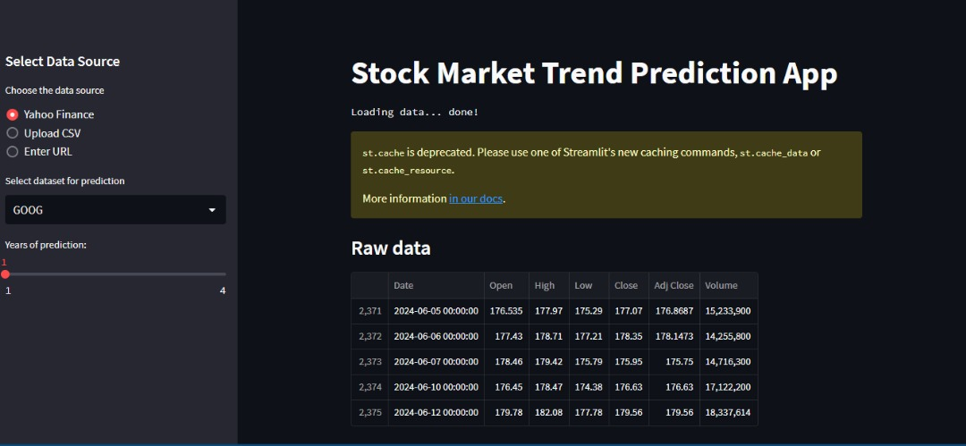Figure 4.1: Interactive dashboards featuring charts, graphs, and trend lines to present predicted stock prices and market trends.
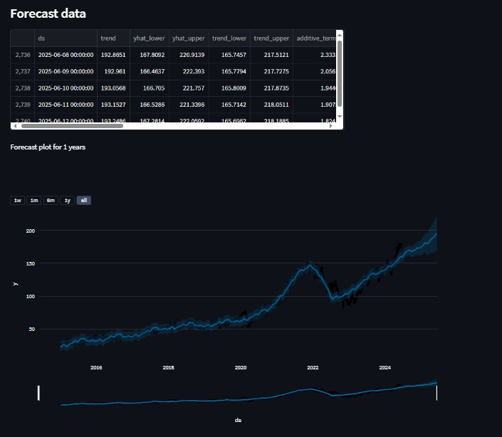
Figure 4.2: Automatically generated reports summarizing key findings, predictions, and performance metrics.
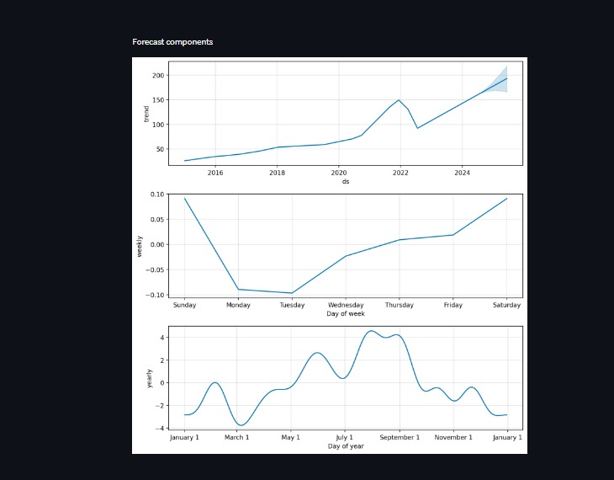Figure 4.3: Real-time alerts for significant market movements or trends to inform timely investment decisions.

4.1.2 Input Design
The input design defines how data is entered into the system, ensuring accuracy and consistency.
The input to be extracted from the proposed system areas are shown below
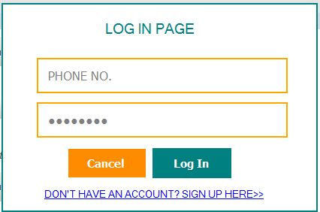
Figure 4.4: Login Page

4.1.3 Database
The database design involves structuring data storage to support efficient retrieval and analysis.
- Schema Design: Tables for storing historical stock prices, trading volumes, financial indicators, user settings, and prediction results.
- Data Management: Implementation of relational database management systems (RDBMS) to handle complex queries and transactions.
- Backup and Recovery: Strategies for data backup and recovery to ensure data integrity and availability.
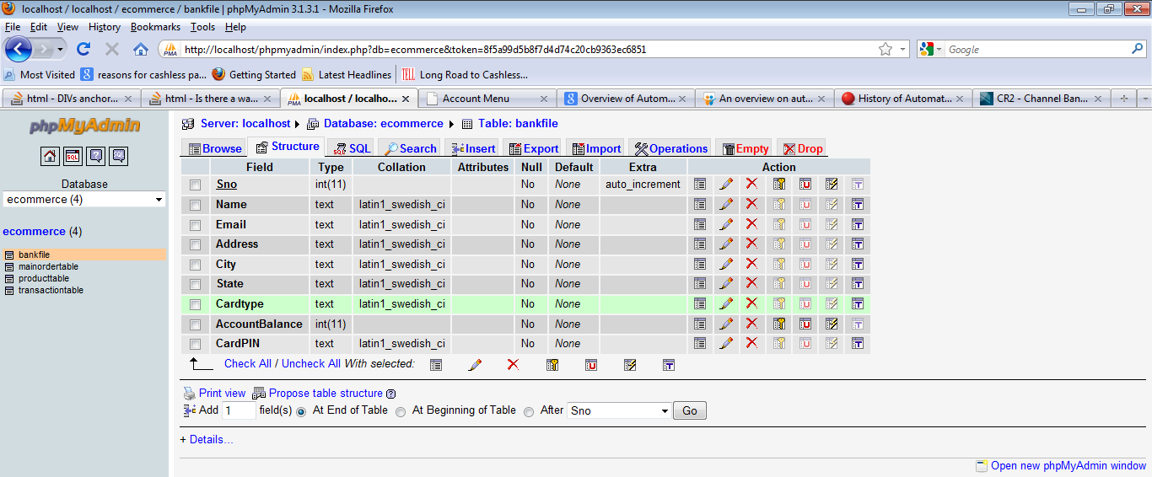
Figure 12: Sales table structure
This is a database where all sales entry or data are displayed are stored.
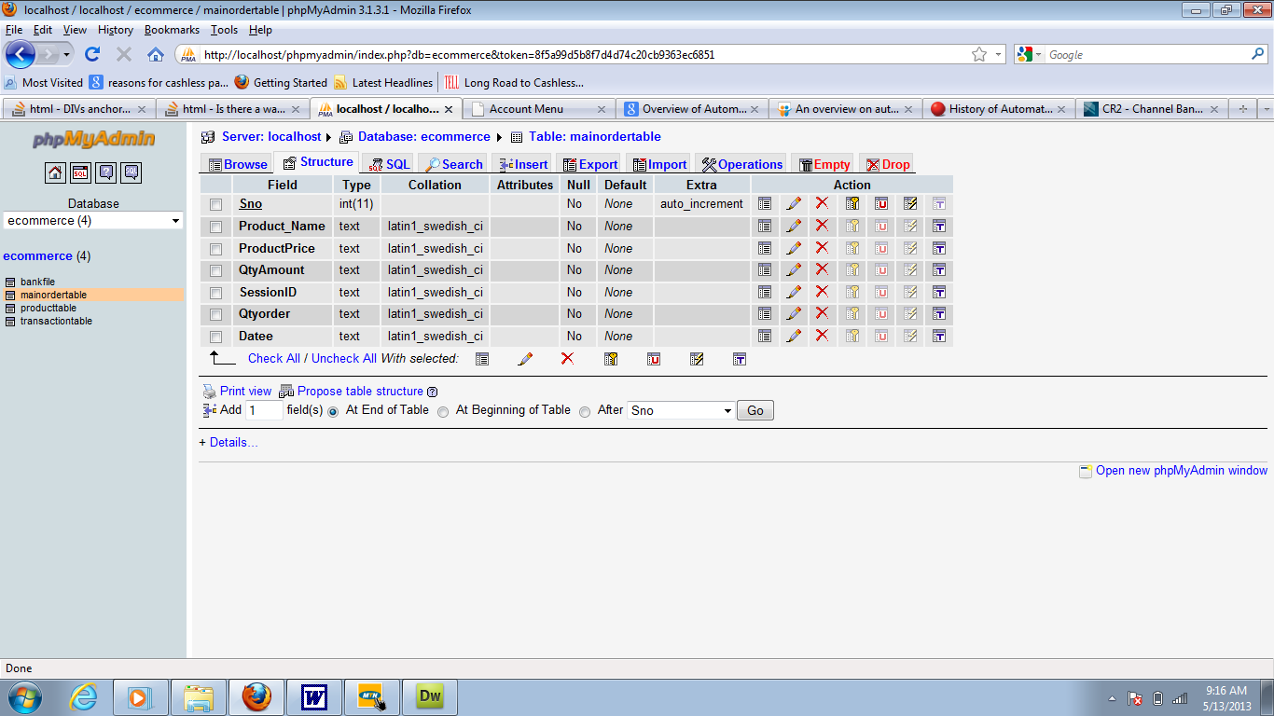

Figure 13: Customer table structure
This is a database where all customers entry or data are displayed are stored.

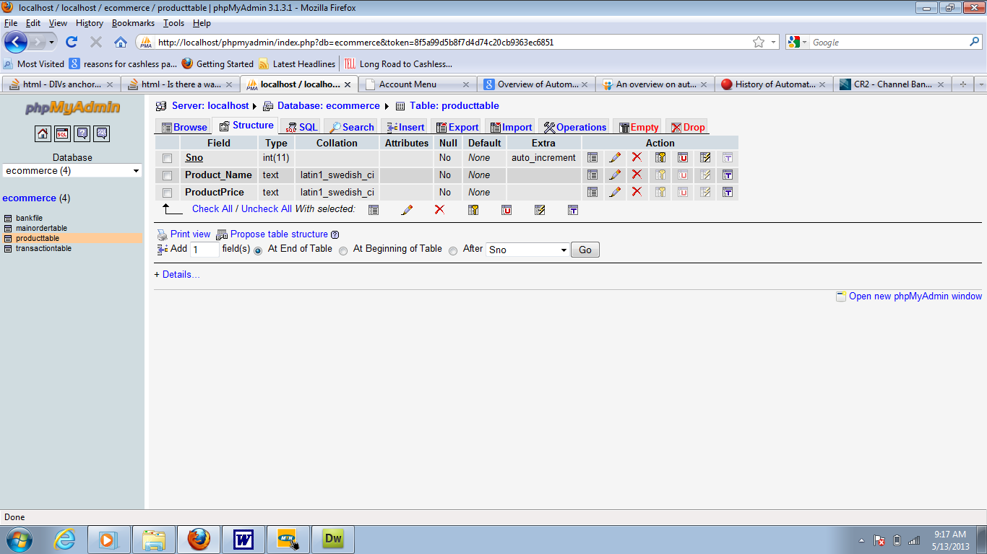
Figure 14: User page
This is a database where the admin entry or data are displayed are stored.

4.1.4 Procedure Design
Procedure design outlines the processes and algorithms used within the system.
- Data Preprocessing Procedures: Steps for cleaning, normalizing, and transforming raw data into a suitable format for analysis.
- KNN Algorithm Implementation: Detailed procedures for implementing and tuning the KNN algorithm, including neighbor selection and distance metrics.
- Real-Time Analysis: Processes for continuously updating the KNN model with new data to maintain prediction accuracy.

4.2 Implementation of the System

4.2.1 Choice of Programming Language
- Python: Chosen for its extensive libraries (such as NumPy, pandas, scikit-learn) and strong support for machine learning and data analysis.
- R: Used for its robust statistical analysis capabilities and visualization tools.
- SQL: Employed for database management and complex queries.

4.2.2 Hardware Support

The hardware support for implementing a stock market trend prediction system using the K-Nearest Neighbors (KNN) algorithm must ensure high performance, reliability, and scalability. The hardware infrastructure should be capable of handling large datasets, performing intensive computations, and providing real-time analysis and predictions. The key components of the required hardware support are detailed below.
- High-Performance Servers: Equipped with multi-core CPUs, large RAM capacity, and high-speed SSDs for efficient data processing, storage, and algorithm execution.
- GPUs: High-performance GPUs (e.g., NVIDIA Tesla, Quadro, RTX) with sufficient VRAM and CUDA cores to accelerate machine learning computations and handle large datasets.
- Network Infrastructure: High-bandwidth network connections with redundant paths to ensure seamless data transfer and reduce latency.
- Storage Solutions: Centralized NAS for secure data storage, supplemented by regular backups to cloud storage or additional NAS for data integrity and disaster recovery.
- User Workstations: High-performance workstations with multi-core CPUs, ample RAM, SSDs, and high-resolution monitors for efficient data analysis and model development.
- Cloud Services: Scalable resources from providers like AWS, GCP, and Azure to reduce on-premise hardware needs and offer cloud-based machine learning and storage solutions.
- Cooling and Power Solutions: Adequate cooling systems and UPS to maintain optimal operating conditions and ensure continuous operation during power outages.

4.2.3 Software
Implementing a stock market trend prediction system using the K-Nearest Neighbors (KNN) algorithm requires a comprehensive software stack to handle data processing, machine learning, database management, and visualization. The key software components are:

- Operating System:
Linux (Ubuntu): Provides a stable and secure environment for server operations and resource management.
- Development Environment:
Jupyter Notebook: Ideal for interactive development and data analysis in Python.
- Programming Language and Library:
Python with scikit-learn: For implementing the KNN algorithm and other machine learning tasks.
- Database Management System:
PostgreSQL: Robust relational database management system for efficient data storage and retrieval.

- Data Integration and API:
Alpha Vantage API: For fetching historical and real-time stock market data.
- Machine Learning Framework:
TensorFlow: For building and training complex machine learning models, including neural networks.
- Visualization Tool:
Plotly: For creating interactive and dynamic visualizations of stock market trends.
- Version Control System:
Git: For source code management and version control.
- Deployment and Containerization:
Docker: For containerizing applications and ensuring consistency across different environments.
- Monitoring Tool:
Grafana: For visualizing monitoring data and system metrics.

4.2.4 Implementation Technique Used
- Agile Methodology: An iterative approach allowing for continuous improvement and adaptation to changing requirements.
- Modular Development: Building the system in modular components to facilitate easier updates and maintenance.
- Continuous Integration/Continuous Deployment (CI/CD): Automated testing and deployment pipelines to ensure smooth and reliable software releases.
4.3 System Documentation

4.3.1 Program Documentation
- Code Comments and Documentation: Detailed comments and documentation within the codebase to explain the functionality and logic of each component.
- User Manuals: Comprehensive guides explaining how to use the system, including input methods, interpretation of outputs, and customization options.
- API Documentation: Detailed documentation for any APIs used or developed, including endpoints, request/response formats, and example queries.

4.3.2 Operating the System
- Installation Guides: Step-by-step instructions for installing and configuring the system, including necessary dependencies and environment setup.
- Usage Instructions: Detailed instructions for daily operations, such as data input, initiating predictions, and generating reports.
- Troubleshooting: A guide to common issues and their resolutions, including error messages and debugging tips.

4.3.3 System Maintenance
System maintenance for the stock market trend prediction system involves critical tasks to ensure its reliability, security, and performance throughout its operational lifecycle:
- Software Updates and Patch Management: Regular updates and version control to incorporate security patches and enhancements, ensuring software components like operating systems and libraries are up to date.
- Data Management and Backup Strategies: Automated backup procedures and data validation mechanisms to maintain data integrity and prevent loss during routine operations or unexpected incidents.
- Performance Monitoring and Optimization: Monitoring system metrics and resource usage using tools like Grafana to detect and resolve performance bottlenecks, optimizing algorithm efficiency and application responsiveness.
- Security Measures: Implementation of encryption, access controls, and compliance with data privacy regulations to protect sensitive financial data and user information.
- User Support and Training: Responsive help desk services and training programs to assist users with technical issues, system usage, and interpretation of prediction outcomes.
- Documentation and Knowledge Management: Comprehensive system documentation and knowledge sharing to maintain clarity on system architecture, operational procedures, and troubleshooting steps among team members.
- Disaster Recovery Planning: Development and testing of contingency plans and backup restoration procedures to ensure rapid recovery from system failures, cyberattacks, or natural disasters.

CHAPTER FIVE

SUMMARY, CONCLUSION, AND RECOMMENDATIONS

5.1 Summary
This study explored the application of the K-Nearest Neighbors (KNN) algorithm in predicting stock market trends, aiming to address the limitations of traditional methods through the integration of machine learning techniques. The research was motivated by the inherent challenges and inefficiencies of manual approaches in handling large datasets and adapting to real-time market conditions. The literature review covered the evolution of stock market prediction methodologies, from traditional statistical methods and technical/fundamental analysis to advanced machine learning techniques. The review highlighted the theoretical foundations underlying these methods, including the Efficient Market Hypothesis (EMH), behavioral finance, and Modern Portfolio Theory (MPT). The analysis of existing systems revealed the limitations and biases of manual prediction approaches, emphasizing the need for automated and data-driven solutions.
The proposed system leverages the KNN algorithm, known for its simplicity and effectiveness in pattern recognition, to predict stock market trends. The system design encompasses automated data collection, preprocessing, real-time analysis, and model evaluation using performance metrics such as accuracy, precision, recall, and F1-score. The integration of interactive visualization tools and scalability features ensures that the system can adapt to evolving market dynamics and diverse data sources.

5.2 Conclusion
The study concludes that the application of the KNN algorithm in stock market trend prediction offers significant improvements over traditional methods. By automating data processing and leveraging machine learning, the proposed system can efficiently handle large datasets and provide real-time, accurate predictions. This enhances the decision-making process for investors and analysts, allowing for more informed and timely investment strategies.
The research underscores the importance of integrating advanced analytical techniques with traditional financial theories to capture the complexity of market dynamics. The findings suggest that while no single model can guarantee absolute accuracy in predicting stock market trends, machine learning approaches like KNN provide a robust framework for improving predictive capabilities and reducing the impact of human biases.

5.3 Recommendations
Based on the findings and conclusions of this study, several recommendations are proposed to further enhance the effectiveness of stock market trend prediction using machine learning:
- Diversification of Data Sources: Incorporate alternative data sources, such as social media sentiment, economic indicators, and global news, to enrich the dataset and provide a more comprehensive view of market influences.
- Hybrid Models: Explore the development of hybrid models that combine KNN with other machine learning algorithms and traditional methods to leverage the strengths of multiple approaches and improve overall predictive accuracy.
- Continuous Model Evaluation: Implement a continuous evaluation and retraining process for the KNN model to ensure it adapts to new data and market conditions, maintaining its predictive performance over time.
- Risk Management Integration: Integrate risk management strategies within the predictive model to account for potential market volatility and mitigate investment risks.
- User Education and Training: Provide training and resources for users to effectively interpret and utilize the predictions generated by the system, enhancing their ability to make informed investment decisions.
- Advanced Visualization Tools: Develop more sophisticated visualization tools to help users better understand predictive trends and model outputs, facilitating more intuitive and actionable insights.
By implementing these recommendations, stakeholders can further optimize the use of machine learning in stock market trend prediction, improving the accuracy and reliability of investment decisions in a dynamic financial environment.
Reference
Alkhatib, K, et al. (2013) Stock Price Prediction Using K-Nearest Neighbor (kNN) Algorithm. International Journal of Business, Humanities and Technology Vol. 3 No. 3; March 2013
Cao, H., et al., (2019) Stock Price Pattern Prediction Based on Complex Network and Machine Learning. Hindawi Complexity Volume 2019, Article ID 4132485, 12 pages https://doi.org/10.1155/2019/4132485
Han, L., S., and Nordin, J. (2018) Predicting the stock price trends using a k-nearest neighbors probabilistic model. Journal of Theoretical and Applied Information Technology. 30th September 2018. Vol.96. No 18
Patil, A., (2023) Stock Trend Prediction Using KNN Algorithm. International Journal of Scientific Research in Science and Technology Print ISSN: 2395-6011 | Online ISSN: 2395-602X (www.ijsrst.com) doi: https://doi.org/10.32628/IJSRST5231035
Reddy, C., K., (2021) Stock Market Trend Prediction Using K-Nearest Neighbour (KNN) Algorithm. Dogo Rangsang Research Journal UGC Care Group I Journal ISSN : 2347 7180 Vol-11 Issue-01.
Sarala, V. and Bhushan, P. (2022) Stock Market Trend Prediction Using K-Nearest Neighbor (KNN) Algorithm. Journal of Engineering Sciences Vol 13 Issue 08,2022, ISSN:0377 9254
Tanuwijaya, J., and Hansun, S. (2019) LQ45 Stock Index Prediction using k-Nearest Neighbors Regression. International Journal of Recent Technology and Engineering (IJRTE) ISSN: 2277-3878, Volume-8 Issue-3.

