SOLAR POWER EXAMINATION MONITORING SYSTEM
(A CASE STUDY OF KWARA STATE POLYTECHNIC)

BY
JEGEDE ISAAC AFAFA
HND/23/COM/FT/0565

SUBMITTED TO THE DEPARTMENT OF COMPUTER SCIENCE,
INSTITUTE OF INFORMATION AND COMMUNICATION TECHNOLOGY

KWARA STATE POLYTECHNIC, ILORIN.
IN PARTIAL FULFILLMENT OF THE REQUIREMENTS FOR THE AWARD OF HIGHER NATIONAL DIPLOMA (HND) IN
COMPUTER SCIENCE

JUNE, 2025.

CERTIFICATION
This is to certify that this project was carried out by JEGEDE ISAAC AFAFA Matriculation Number: HND/23/COM/FT/0565 in the Department of Computer Science, Institute of Information Communication Technology, Kwara State Polytechnic, Ilorin, Kwara State.

…………………………………. ….………………………
MR. SADIQ KOLAWOLE A Date
Project Supervisor

…………………………………. ….………………………
MR. OYEDEPO,F. S. Date
Head of Department

…………………………………. ….………………………
External Examiner Date

DEDICATION
I dedicate this project work to Almighty God, who inspired me and directed my ways during my academic pursuit in the polytechnic.

ACKNOWLEDGEMENT
All praises is due to Almighty God, the Lord of the universe. I praise him and thank him for giving me the strength and knowledge to complete my HND program.
I appreciate the utmost efforts of my supervisor, Dr. Agboola, O. M. whose patience, support, and encouragement have been the driving force behind the success of this research work. He gave useful corrections, constructive criticisms, recommendations, and advice and always ensured that excellent research is done. My sincere gratitude goes to the Head of the Department Mr. Oyedepo F. S.,and other members of staff of the Department of Computer Science, Kwara State Polytechnic, Ilorin, for their constant cooperation, constructive criticisms, and encouragements throughout the program.
Special gratitude to my parents, who exhibited immeasurable, patience, support, prayers, and understanding. Special thanks go to my lovely siblings.
My sincere appreciation goes to my friends and classmates.

TABLE OF CONTENTS
Title page i
Certification ii
Dedication iii
Acknowledgments iv
Table of Contents v
Abstract vi
CHAPTER ONE: GENERAL INTRODUCTION
1.1 Background to the Study 1
1.2 Statement of the Problem 2
1.3 Aim and Objectives 2
1.4 Significance of Study 2
1.5 Scope of Study 2
1.6 Organization of the Report 3
CHAPTER TWO: LITERATURE REVIEW
2.1 Review of Related Works 4
2.2 Review of General Text 8
2.3 Historical Background 8
CHAPTER THREE: RESEARCH METHODOLOGY AND
ANALYSIS OF THE SYSTEM
  - Research Methodology 12
  - Analysis of the Existing System 14
  - Problem of the Existing System 14
  - Analysis of the Proposed System 15
  - Advantages of the Propose System 15

CHAPTER FOUR: DESIGN, IMPLEMENTATION AND
DOCUMENTATION OF THE SYSTEM
  - Design of the System 17
    - Discussion of Tools we used in Our Implementation 17
    - Testing Phase in our Cctv Camera 23
    - Output Design 27
    - Input Design 28
    - Procedure Design 29
  - Implementation of the System 29
    - Hardware support 29
    - Software Support 29
    - Implementation Techniques 29
  - System Documentation 30
    - Operating the System 30
    - Maintaining the System 32
CHAPTER FIVE: SUMMARY CONCLUSION AND
RECOMMENDATION
5.1 Summary 33
5.2 Conclusion 33
5.4 Recommendations 34
References 35

ABSTRACT
The CCTV Solar Powered Examination Surveillance System is an innovative solution that combines the benefits of closed-circuit television (CCTV) technology and solar power to provide efficient and reliable surveillance in various settings. This system addressed the challenges of surveillance in remote areas where access to electricity is limited or unreliable.The projectfocuses onthe development and implementation of a surveillance system that utilizes solar power as the primary source of energy. The system comprises solar panels, batteries for energy storage, CCTV cameras, and associated monitoring equipment. The solar panels capture sunlight and convert it into electricity, which is stored in the batteries for continuous operation, even during periods of low or no sunlight.The implementation of the CCTV Solar Powered Examination Surveillance system involves careful consideration of the location and positioning of the solar panels and cameras to maximize sunlight exposure and surveillance coverage. The system also incorporates efficient power management mechanisms to optimize energy usage and extend battery life.In conclusion, the CCTV Solar Powered Examination Surveillance system offers a sustainable and efficient solution for surveillance in remote areas. It provides reliable monitoring capabilities, contributes to environmental conservation, and reduces operational costs.
Keywords:CCTV; Examination Security; Security Management, solar energy; Video Surveillance;

CHAPTER ONE
INTRODUCTION
  - Background to the Study
Solar surveillance cameras refer to surveillance cameras powered by solar panels. This solar surveillance is a suit that included storage batteries, solar panels, solar mounts, surveillance bullet cameras and the solar surveillance cameras or surveillance dome cameras, and a 4G sim card (traffic cards) for transmission. , TF memory card for storing video. The biggest difference between ordinary IP surveillance cameras is the different power supply methods. Solar surveillance cameras generally support flow card signal transmission (Ally, 2022).
Examination monitoring systems are demand of time in the era of digital world where everything is swift and nimble. We needed a system which will reduce the workload on the management time reduction, ease in conducting examination swift monitoring and fast result generation with least error Java is very useful for system architecture. The system of assessment monitoring helps to reduce the difficulties of organizing a broad test, constant monitoring of students to eliminate any foul play, immediate correction and simultaneous presentation of the results. In the Scholastic Institute and Training Center, this framework is effectively used because it helps to administer the exams and get the results in a positive and constructive manner. (a) Some candidates graduated with good grades (Distinction, Second Class Upper Division) but without job. (b) Some are good practically but had low grades (Third Class, Pass) and thus could not find their feet in the society in terms of white collar jobs (Heba, 2014).
It is unarguable that evaluation of examination is a vital element of education, which, if corrupted, will undermine the education process hence, the overall development of any nation. Corruption in the examination process comes in no other way than through examination malpractice. Therefore, in order to restore sanity in the educational system in Nigeria, sanity must be entrenched in the examination process. In order to achieve this, examination conduct must be effectively invigilated since most of the examination malpractice occurs while the examination is ongoing. This research, therefore, believes that finding an effective means of examination invigilation will go a long way in stemming the tide of malpractice in the conduct of examinations in Nigeria (Laith, et al., 2018).
However, in examination scenarios in Nigeria, this is not the case, because the detection of infringements or suspicious behaviors in real time is subject to the operator’s uninterrupted vigilance. Some candidates perpetrate malpractice during examinations and get away with it without being caught despite the installation of a CCTV system. This is due to several factors such as fatigue on the part of the CCTV operator; this may cause distractions, human biases, positioning of the camera that may affect the area of coverage, or some candidates may be occluded from view to mention a few. All these challenges could influence the outcome of video surveillance. This study was carried out to assess the extent CCTV systems are used in monitoring activities during an examination, their effectiveness in detecting infringements during examination in real-time, and whether automation will improve CCTV effectiveness. Also, operational challenges associated with the use of CCTV systems for invigilation were investigated (Celestine & Martins, 2020).
1.2 Statement of the Problem
The problem with existing monitoring are;
- Adequate evidence may not be available for further prosecution.
- The candidate can easily deny being involved in such an act, the hall may even become rowdy when the candidate resists being apprehended by the invigilator either by destroying the material evidence or refusing to fill or sign the malpractice form.
- When commotion ensues in the examination hall, it might create an avenue for other students in the hall to cheat as well.
With all these inadequacies associated with existing monitoring techniques, there has been a clamor for the deployment of modern technology such as CCTV using solar power systems to tackle examination malpractice.
1.3 Aim and Objectives
This research work aims to implement a Closed-Circuit-Television (CCTV) using solar power in an examination to ensure stable power and maximum security during the examination, the objectives are as follow;
- To install and connect the solar panel, inverter and battery to the monitoring system to provide adequate power supply during the course of the exam
- To connect the CCTV camera to the monitoring system.
- To install CCTV camera to the examination hall to supervise all the students doing exam.
1.4 Significance of the Study
The purpose of this work is to use CCTV to ensure that all candidates are under active surveillance for every moment of the duration of the examination. To abolish shocking malpractices by examinees as well as to reduce the cost of the existing complex traditional approach of exam invigilation system, stable electricity power during the examination, automated monitoring and controlling of the exam hall is established and ensured.
1.5 Scope of the Study
The scope of this work is to develop the proposed system that deals with monitoring of activities in an examination hall, this system will cover the department of computer science.
1.6 Organization of the Study
For easy study and proper understanding of this project write-up, It is planned and organized into five chapters. The description of what each chapter contains is explained below:
Chapter One: This contains an Introduction to the whole write-up, the problem of the study, the aims and objectives of the study, the significance of the study, the scope and limitation of the study, and the organization of the report.
Chapter Two: It focuses on the literature review of the study, the organization of the board of directors, and the computerization of the current state of the art.
Chapter Three: It presents the data collection method employed, analysis of data and existing system, advantages of the proposed system, design and implementation, programming language used with reasons, and hardware and software support.
Chapter Four:Deals with the system design implementation and documentation, design of the system, output design, input design, file system, procedural design, and documentation of the new system.
Chapter Five:This centers on the summary, experience gained, recommendation, and conclusion.

CHAPTER TWO
LITERATURE REVIEW
2.1 Review of Related Work
Ally (2022) Review of Online Examination Security for the Moodle Learning Management System.Security in online examinations is a critical need among educators. Increasing learning demands, the rise of Internet usage, high cost of running face to face examinations, and the need to provide students with immediate feedback, have all together brought about a paradigm shift. This shift from traditional pen and paper to the adoption and use of online examinations makes the examination accessible at any time, on any smart device, and from anywhere. A typical online examination platform must possess a question bank (Konde et al., 2019), and should be designed on secured and trusted software which can automate the generation of question papers and marking schemes based on the set timetable. Other key features include advanced scoring and grading system; time management; candidate verification and authentication; navigation style for moving back and forth on pages; functionalities for remote invigilation of candidates; and security features including use of a safe browser, multi support of various question types, random ordering of pages; shuffling of questions and choices for each candidate; date and time restrictions; and generation of various statistical reports.
Ankit, and Suresh, (2017) proposed Solar Photovoltaic Remote Monitoring System Using IOT, as technology is advancing, the cost of renewable energy equipment is decreasing which has resulted in a massive increase in solar photovoltaic installations. Most of these installations act as auxiliary power sources. A majority of these are installed in inaccessible locations – as close as a rooftop to as far away as a desert. Hence they require sophisticated systems for remote monitoring of these installations using wide area networks. In this paper, we will discuss a low-cost IOT-based embedded Solar PV Monitoring system that will make use of a GPRS module and a low-cost microcontroller to send the data measured at the production end on the internet, which can then be accessed anywhere on the globe. This will provide us with real-time information on the installation which will help us in its maintenance, and fault detection and will give us a record of all the data at fixed intervals.
Bashiruddin-khan et al. (2020) Impact of CCTV Surveillance on Crime Prevention. Since the very beginning of human civilization, people have considered their security as a very precious priority. Crimes have always appeared thus as a practical threat for the people from the dawn of their appearance. Therefore, the need for a surveillance process has been one of their major concerns always. With the passage of time, people have achieved their skills in science and technology and like all other aspects of life. Managed the use of technology in the surveillance also in the context of a present completely complex society, it is very difficult for law enforcement agencies to maintain their surveillance on a whole community other than having a technological advantage. CCTV along with other security tools (like an intrusion or fire alarm, and access control in the use of technology in policing cannot be underestimated or overestimated in the present context. Technology has allowed us to take benefit from it, make life quite easier and comfortable. Whether the use of CCTV surveillance helps in crime prevention is a broadly studied issue worldwide although the use of this technique as an investigative tool is subject to further inquiry. During the last few years, violation of individual privacy was a matter of serious debate among the commoners as presupposing the necessity of establishing legal boundaries. Some basic issues, therefore, appeared from the very beginning of the new millennium in terms of CCTV’s acceptance within the legal sphere as evidence, the operation of the devices and the public’s reaction towards the usage of in many countries like the UK; CC cameras were considered a serious threat to individual privacy.
Heba, (2014) Review of Closed Circuit Television (CCTV) Techniques for Vehicles Traffic Management. Due to the population increase all over the world, current road infrastructures are unable to keep up with the escalating transportation demands. This situation where travel demands exceed the capacity of the transportation network is known as traffic congestion. However, it is impractical to build more roads and infrastructure to accommodate these demands. Governments are increasingly recognizing the importance of traffic control tools, such as Closed Circuit Television (CCTV) systems as a feasible solution to mitigate the traffic congestion problem. CCTV systems are deployed across city centers, motorways, trunk roads, car parks, etc., to collect diverse data on large regions where manual observation can be difficult, problematic, or unfeasible. By processing this data, which contains video images of traffic parameters, useful information can be extracted including speed, traffic composition, vehicle shapes, vehicle types, vehicle identification numbers, and occurrences of traffic violations or road accidents. The paper reviews different approaches to utilizing CCTV systems for traffic management of Vehicles. It highlights existing architectural, and deployment models and various approaches to analyzing generated traffic data. The objective is to provide a clear background that can help in any related future research.
Henry (2001) A Model of University Examination Monitoring System. The intent of every society is to produce young ones that are capable of taking the mantle of leadership of the nation. The primary injection is through education and as the society stands today, university education becomes the foundation for this. For this to be achieved, the nation’s education system has to be positioned in such a way that the expected breeds of graduates are produced. This is exactly not the order of the day in our Nigerian society. Why: most graduates these days are confused because: (a) some candidates graduated with good grades (Distinction, Second Class Upper Division) but without job. (b) Some are good practically but had low grades (Third Class, Pass) and thus could not find their feet in the society in terms of white collar jobs. Most of these graduates cannot even live up to their certificate grades because they got it by foul means. But in Nigeria, every organization, at present, in any Nigerian university, students are checked in during examinations. Invigilators are assigned to monitor each examination hall. The problem here comes when a student is found cheating in any form. Because no student wants to be rusticated from the university because of examination malpractice, they would always found a way of denying their involvement even if they are caught “Red Handed”. Sometimes the insistence of the invigilator to collect the malpractice material or sign the malpractice form brings real commotion in the examination hall. This might even create an avenue for other students in the hall to cheat.
Hoqueet al., (2020) proposed an Automation of Traditional Exam Invigilation using CCTV and Bio-Metric, in education, whilst e-learning has been playing a significant role over the last few years due to its flexibility and remote-based education system. Majority of courses are still relying upon traditional approaches of learning due to the lack of integrity and security of online based examinations and assessments in e-learning. As such, the traditional approach to the examination system is considered a superior method to the examination but it has a few limitations in its tag such as an excessive number of physical resources (invigilators) required and high occurrences of malpractice by the students during the exam. The objective of this paper is to develop a framework for a traditional pen and paper-based examination system where the number of invigilators will substantially be reduced and malpractices by the students during the exam will be abolished. To implement the proposed examination system, educational institutions are required to preserve a database using the Parallax Data Acquisition tool (PLX-DAQ) that incorporates bio-metric information of all students. Before entering the examination hall, examinees go through an authentication process via a bio-metric reader that is attached in front of each exam hall. During the examination, examinees are monitored and controlled by an invigilator from a distance through the use of 360-degree Closed-Circuit Television (CCTV) cameras as well as ultra-high sensitive microphones and speakers. Here, CCTV cameras are used to monitor examinees' physical malpractices, and microphones are used to control examinees' vocal malpractices. Only one invigilator is required for the n-number of exam halls in this process. The communication between students and the invigilator can be done with microphones and speakers attached in both exam halls and the invigilator rooms. This model will wipe out malpractices during the examination. It will be a cost-effective, simple, and secure solution to the complex traditional exam invigilation process.
Kevin, (2015) reviewed Solar-Harvesting Wireless Smart Camera Research System for Efficient, with the advancement of the Internet of Things movement; ubiquitous computing is now an accelerating field for embedded system researchers to pursue. Almost all of these newly connected systems are equipped with sensors to gather useful information about their surroundings, and of these sensors, the visual sensor presents the richest available datasets in comparison to its scalar counterparts. Deploying wireless sensor networks in remote environments makes it difficult to acquire the power for these systems and many choose a battery-supplied source. After optimizing the sensor node for long battery life, many sacrifices are made in performance to delay the need for battery replacement maintenance. Now, however, there is promising furtherance in energy harvesting and rechargeable battery-capable sensor nodes, and the need for node maintenance may be obsolete in the coming years. Sensor network devices can now focus less on optimizing for battery life and instead increase the amount of on-board local processing making the device ”smart”. What defines a smart camera is its ability to process video footage locally instead of a central processing unit online or at a remote network sink node. Progress in the field of computer vision has brought the ability to identify complex objects and behaviors of monitored environments.
Laithet al., (2018) also wrote and presented a journal titled “Embedded Real-Time Video Surveillance System based on Multi-Sensor and Visual Tracking” This Paper describes the design and implementation of an embedded remote video surveillance system for general purposes security application. The proposed system can detect and report vandalism, tampering, and theft activities before they take place via SMS, Email, or phone call. The system has been enriched with a vast range of sensors to increase its sensing capability for different types of attacks. Moreover, the proposed system has been enhanced by adding a visual verification technique to overcome false alarms generated by sensors, where a video camera is integrated within the system software to capture video footage, verify, and track the abnormal events taking into consideration bandwidth consumption and real-time processing. Finally, the system was implemented using SBC (Raspberry Pi) as a working platform supported by OpenCV and Python as a programming language. The results proved that the proposed system can achieve monitoring and reporting in real-time. Where the average processing time specified to complete all the required tasks for each frame (starting from the video source to the broadcasting stage) does not exceed 64%. Moreover, the proposed system achieved a reduction in the utilized data size as a result of using image processing algorithms, reaching an average of 91%, which decreased the amount of transferred data to an average of 13.4 Mbit/sec and increased the bandwidth efficiency to an average of 92%. The system is characterized by being flexible, portable, easy to install, expandable, and cost-effective. Therefore, it can be considered an efficient technology for different monitoring purposes.
Lipinget al., (2015) also presented an article on “Design and Implementation of Solar Tracking System” To improve the performance of the tracking system, this paper discusses the trajectory tracking of the sun and tracing to the source of the sun. The experimental results show that: The automatic tracing of the sun trajectory scheme runs smoothly without the interference of a light source, but has model error; the automatic tracking of the sun source scheme has better accuracy, but the system may be disorder due to the insufficient light intensity. The paper makes the two schemes together at the end so that the tracking system can have better stability and accuracy.
Manish et al., (2018) “Solar power monitoring system using IoT” Using the Internet of Things Technology for supervising solar power generation can greatly enhance the performance, monitoring, and maintenance of the plant. With the advancement of technologies, the cost of renewable energy equipment is going down globally encouraging large-scale solar plant installations. This massive scale of solar system deployment requires sophisticated systems for automation of the plant monitoring remotely using web-based interfaces as the majority of them are installed in inaccessible locations and thus unable to be monitored from a dedicated location. The Project is based on the implementation of a new cost-effective methodology based on IoT to remotely monitor a solar plant for performance evaluation. This will facilitate preventive maintenance, and fault detection of the plant in addition to real-time monitoring.
Tan et al., (2020) wrote an article on “The Design and Implementation of a Wireless Video Surveillance System” Internet-enabled cameras pervade daily life, generating a huge amount of data, but most of the video they generate is transmitted over wires and analyzed offline with a human in the loop. The ubiquity of cameras limits the amount of video that can be sent to the cloud, especially on wireless networks where capacity is at a premium. In this paper, we present Vigil, a real-time distributed wireless surveillance system that leverages edge computing to support real-time tracking and surveillance in enterprise campuses, retail stores, and across smart cities. Vigil intelligently partitions video processing between edge computing nodes co-located with cameras and the cloud to save wireless capacity, which can then be dedicated to Wi-Fi hotspots, offsetting their cost. Novel video frame prioritization and traffic scheduling algorithms further optimize Vigil’s bandwidth utilization. We have deployed Vigil across three sites in both whitespace and Wi-Fi networks. Depending on the level of activity in the scene, experimental results show that Vigil allows a video surveillance system to support a geographical area of coverage between five and 200 times greater than an approach that simply streams video over the wireless network. For a fixed region of coverage and bandwidth, Vigil outperforms the default equal throughput allocation strategy of Wi-Fi by delivering up to 25% more objects relevant to a user’s query.
2.2 Review of General Text
They are valuable resources for understanding the broader context and principles underlying the installation and management of CCTV systems in educational settings.
A Comprehensive Guide" by Johnson and Smith (2022), this guidebook provides a comprehensive overview of campus security, including the installation and use of CCTV surveillance systems. It covers topics such as risk assessment, camera placement, system integration, and policy development, offering practical guidance for implementing effective security measures.
Security Technologies in Educational Institutions by Brown and Roberts (2022), This book explores various security technologies applicable to educational institutions, including CCTV surveillance systems. It examines the benefits, challenges, and best practices associated with the installation and management of these systems, considering factors such as privacy, scalability, and technological advancements.
Video Surveillance Systems for Educational Facilities by Taylor et al. (2022), this text focuses specifically on video surveillance systems in educational facilities. It covers topics such as camera types, video analytics, storage solutions, and system integration. The book provides insights into the technical aspects of CCTV surveillance and offers practical guidance for system design and implementation.
These general texts serve as valuable references for researchers, security professionals, and decision-makers involved in the installation and management of CCTV surveillance systems in tertiary institutions.
2.3 Historical Background
The use of CCTV surveillance systems in tertiary institutions has evolved over the years in response to the increasing security challenges faced by these educational establishments. While specific historical details may vary, the adoption of CCTV technology in campuses gained momentum in the late 20th century as the advancements in camera technology and video recording made it more accessible and cost-effective for institutions. The historical background of CCTV surveillance in tertiary institutions may include the evolution of camera technology, the development of video analytics, and the integration of other security systems.
2.3.1 Access Control Systems
Access control systems refer to security measures implemented to regulate and monitor access to physical spaces within a facility. In the context of CCTV surveillance installation in tertiary institutions, access control systems play a crucial role in enhancing overall campus security. These systems typically involve the use of various technologies such as card readers, biometric systems, electronic locks, and access control software. Access control systems work in conjunction with CCTV surveillance by integrating the two technologies to create a comprehensive security infrastructure. By combining access control and CCTV surveillance, institutions can effectively monitor and control who enters specific areas of the campus, thereby reducing the risk of unauthorized access and potential security threats.
One of the key benefits of integrating access control systems with CCTV surveillance is the ability to correlate access events with video footage. When a card swipe or biometric entry occurs, the corresponding video footage from the CCTV cameras in the vicinity can be reviewed to verify the identity of the individual and ensure that the access attempt is legitimate. This integration allows for quick identification and response to any suspicious or unauthorized access attempts. Moreover, access control systems can provide valuable data to enhance CCTV surveillance effectiveness. For example, access control logs can help identify patterns or anomalies in access patterns, which can then be correlated with video footage to investigate any potential security breaches or policy violations.
When integrating access control systems with CCTV surveillance, it is important to ensure proper system compatibility and interoperability. This requires careful planning and coordination between the installation teams responsible for both systems. It is also crucial to establish clear protocols and procedures for managing access control permissions, monitoring access events, and reviewing video footage in response to security incidents.
2.3.2 Video Analytics
Video analytics is an advanced technology that utilizes artificial intelligence (AI) and algorithms to analyze video footage captured by CCTV surveillance cameras. It enables automated detection, recognition, and understanding of various events, objects, and behaviors within the video stream. In the context of CCTV surveillance installation in tertiary institutions, video analytics plays a significant role in improving security monitoring, threat detection, and overall operational efficiency. Video analytics software can be integrated with CCTV surveillance systems to enhance the capabilities of the cameras and transform them from passive recording devices into intelligent tools for proactive security management. By leveraging AI algorithms, video analytics can perform real-time analysis of video streams and generate actionable insights. Some of the key applications of video analytics in the context of CCTV surveillance in tertiary institutions include:
- Object Detection and Tracking: Video analytics can automatically detect and track objects within the video feed. This includes identifying and tracking individuals, vehicles, or specific objects of interest. It can help in detecting suspicious activities, tracking unauthorized persons, or monitoring the movement of valuable assets within the campus.
- Facial Recognition: Facial recognition technology in video analytics enables the identification and verification of individuals captured in the video footage. This can be useful in identifying known individuals, monitoring access to restricted areas, or detecting persons of interest. Facial recognition can enhance campus security by providing real-time alerts when unauthorized individuals are detected.
- Crowd Monitoring and Behavioral Analysis: Video analytics can analyze crowd behavior, such as gathering patterns, density estimation, or identifying unusual crowd movements. This capability is particularly beneficial during events or gatherings on campus, enabling security personnel to identify potential safety risks, manage crowd flow, and respond effectively to emergencies.
- Perimeter Protection: Video analytics can create virtual boundaries or zones within the video feed and trigger alerts when unauthorized entry or perimeter breaches occur. This feature is particularly useful for monitoring campus boundaries, sensitive areas, or access points, allowing for quick responses to potential security threats.
- Abnormal Event Detection: Video analytics can detect and analyze abnormal events or behaviors within the video stream. This includes detecting sudden movements, loitering, fighting, or other suspicious activities. When such events are detected, alerts can be generated, enabling security personnel to respond swiftly and prevent potential incidents.
- Traffic Monitoring: In larger campuses with vehicular traffic, video analytics can analyze traffic flow, detect violations (such as speeding or wrong-way driving), and optimize traffic management. This can help enhance overall safety and ensure efficient movement of vehicles within the campus premises.
It is important to note that the successful implementation of video analytics requires careful planning, system configuration, and optimization. Factors such as camera placement, lighting conditions, and the selection of appropriate algorithms need to be considered to achieve accurate and reliable results. Regular maintenance, updates, and calibration of the video analytics system are also essential to ensure its ongoing effectiveness.
Video analytics greatly enhances the capabilities of CCTV surveillance systems in tertiary institutions, enabling proactive threat detection, efficient monitoring, and improved incident response. By leveraging the power of AI and algorithms, video analytics enables institutions to maximize the benefits of their CCTV infrastructure and create safer and more secure campus environments.

CHAPTER THREE
RESEARCH METHODOLOGY AND ANALYSIS OF THE NEW SYSTEM
3.1 Research Methodology
Installing a solar-powered CCTV system involves several steps to ensure a successful setup. Here's a general outline of the process:
Site Assessment
Evaluate the area where i want to install the CCTV system. Determine the best positions for camera placement, considering factors like visibility, coverage, and potential obstructions.
Camera Selection
Choose appropriate CCTV cameras based on our surveillance requirements. Consider factors such as resolution, viewing angle, night vision capability, and weather resistance.
Solar Power System Sizing
Calculate the power requirements for the CCTV cameras and other related equipment. Determine the appropriate solar panel capacity and battery capacity to support continuous operation.
Acquiring Equipment
Purchase the solar panels, batteries, CCTV cameras, DVR/NVR, mounting brackets, cables, and other necessary accessories from reputable suppliers.
Mounting Solar Panels
Install the solar panels in a location with maximum sunlight exposure throughout the day. We ensure they are securely mounted and positioned at an optimal angle to capture sunlight efficiently.
Installing Batteries and Charge Controller
Set up the batteries and charge controller in a secure and weather-resistant enclosure near the solar panels. The charge controller regulates the charging process to prevent overcharging.
Mounting CCTV Cameras
Install the CCTV cameras at the predetermined locations identified during the site assessment. Use appropriate mounting brackets and ensure the cameras are securely fixed in place.
Running Cables
Connect the CCTV cameras to the DVR/NVR using network cables. Make sure to conceal and protect the cables as much as possible to prevent tampering or damage.
Connecting Power Supply
Connect the CCTV cameras to the solar power system. Ensure that the power supply from the batteries is stable and that the cameras receive a constant power source.
Setting Up DVR/NVR
Configure the DVR/NVR to receive and record video from the CCTV cameras. Set up motion detection, recording schedules, and other settings as per our surveillance needs.
Testing and Calibration
Thoroughly test each CCTV camera to verify its functionality and adjust their positions if needed for better coverage. Check the DVR/NVR recording capabilities and ensure everything works as expected.
Monitoring and Maintenance
Regularly monitor the CCTV system's performance and check the battery levels to ensure continuous operation. Perform maintenance tasks like cleaning camera lenses, solar panels, and checking for loose connections.
Security Measures
Implement additional security measures like password protection for the DVR/NVR, secure access to the system, and regular software updates to keep the system secure.
It's essential to follow manufacturer guidelines and best practices during the installation process to ensure the CCTV system operates reliably and effectively. If you're not confident in handling the installation yourself, it's always best to consult a professional CCTV installer with experience in solar-powered setups.
3.2 Analysis of the Existing System
The manual method lacks real-time monitoring capabilities. Data collection occurs during periodic on-site visits, which means that there could be delays in identifying performance issues or system malfunctions. This delay can result in extended periods of suboptimal energy production and potential revenue losses.The reliance on manual data collection introduces the risk of human errors. Data might be misrecorded, leading to inaccuracies in the information collected. Such inaccuracies can hinder accurate performance analysis and decision-making regarding system optimization.The manual method requires regular physical visits to each solar power installation for data collection. This process is time-consuming and demands significant manpower, which could be better utilized for other critical tasks, such as maintenance and troubleshooting.Without real-time monitoring and alerts, there could be delays in detecting system malfunctions or performance deviations. Consequently, maintenance and corrective actions may be postponed, leading to prolonged periods of system downtime and reduced energy output.Manual data collection provides only basic information about energy production and system health. Advanced data analytics, such as energy trend analysis or performance optimization insights, are challenging to achieve with the existing method.
3.3 Problems of the Existing System
- Limited Data Accuracy: The manual method relies on human data collection, which is prone to errors, such as typos, misreadings, and omissions. Inaccurate data can lead to incorrect performance analysis and decision-making.
- Delayed Issue Detection: Without real-time monitoring, system malfunctions or suboptimal performance may go unnoticed for an extended period. This delay in issue detection can lead to prolonged downtime and reduced energy generation.
- Time-Consuming and Labor-Intensive: Regular physical visits to each solar power installation for data collection demand significant time and manpower resources. This labor-intensive process can be inefficient and costly.
- Lack of Real-time Monitoring: The manual method does not provide real-time insights into system performance, making it challenging to promptly respond to issues or anomalies as they occur.

3.4 Analysis of the Proposed System
The proposed system for CCTV examination monitoring is based on a solar-powered method, aiming to overcome the limitations of the existing manual system. The solar-powered system utilizes solar energy as the primary source of power for the CCTV examination monitoring system. It involves the integration of solar panels, battery storage systems, and power management mechanisms to ensure continuous and sustainable operation. The system design includes the installation of solar panels, typically mounted on rooftops or in open areas with ample sunlight exposure. These solar panels capture sunlight and convert it into electrical energy through photovoltaic (PV) cells. The generated electricity is then stored in batteries, providing a reliable power supply for the CCTV cameras and other system components. To optimize the system's power management, various techniques are employed. This includes the use of charge controllers, which regulate the charging and discharging of the batteries to prevent overcharging and ensure efficient energy utilization. Additionally, inverters are used to convert the stored DC (direct current) electricity into AC (alternating current) electricity, enabling compatibility with the existing CCTV system components.

3.5 Advantages of the New System Over The Existing System
- Real-time Monitoring: The SPEMS offers real-time monitoring of solar power installations, providing instant insights into energy production and system performance. In contrast, the manual method relies on periodic visits, which delays issue detection and resolution.
- Accurate Data Collection: The automated data collection process in the SPEMS reduces the risk of human errors, ensuring more accurate and reliable data for performance analysis and decision-making.
- Timely Issue Detection: With real-time alerts and notifications, the SPEMS enables prompt identification of system malfunctions and anomalies. This proactive approach minimizes downtime and maximizes energy generation.
- Cost-effectiveness: The SPEMS facilitates proactive maintenance and timely issue resolution, reducing maintenance costs compared to the reactive approach of the manual method.
- Remote Accessibility: Operators can access the SPEMS interface remotely from any location with internet connectivity. This remote access enhances operational efficiency and facilitates timely actions.
- Scalability and Versatility: The SPEMS is designed to monitor various types of solar power installations, from residential to utility-scale projects. It can be scaled to accommodate diverse system configurations.
- Environmental Impact: By optimizing energy production, the SPEMS contributes to reducing greenhouse gas emissions and supporting a greener and more sustainable energy ecosystem.

CHAPTER FOUR
DESIGN AND IMPLEMENTATION OF THE SYSTEM
4.1 Design of the System
The design of the system gives the details of the design components that make up the project application. The program design components discussed in this section are the output design, input design, database design, and procedure design. Each of the sections is explained as follows with a diagram.

4.1.1 Discussion of Tools we used in our Implementation
An installation of eight 125W Solar Panels of Emeral Energy Solutions Pvt. Ltd., comprising a total of 1kW system, shown in figure 4.3, is used to provide the required output to be measured. These have a maximum power output of 125 W, a maximum voltage of 18.26 V, and a maximum current of 6.86 A.
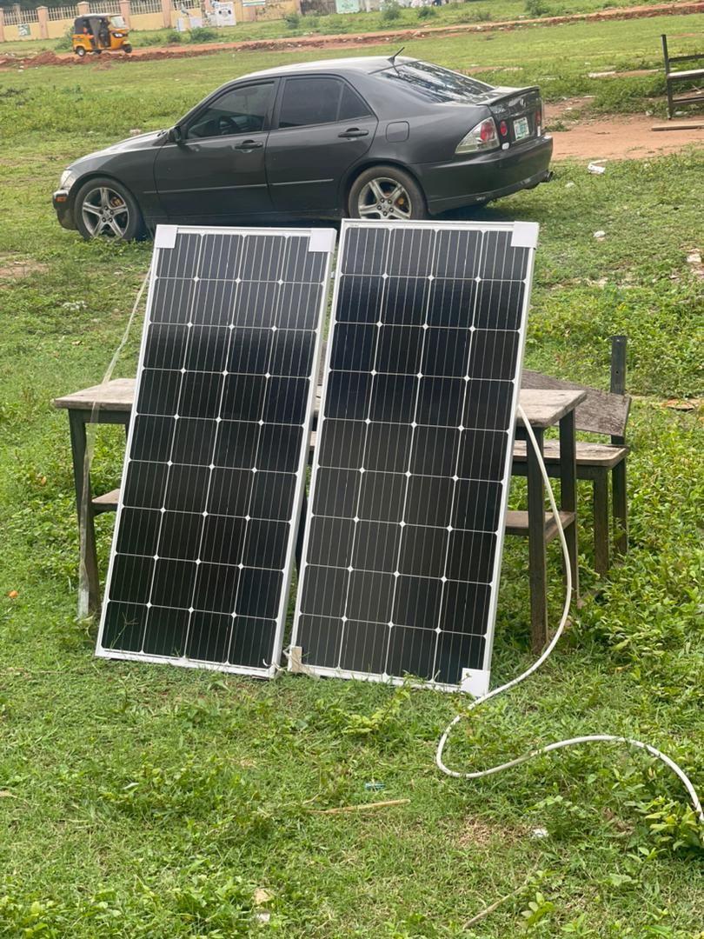
Figure 4.1 Solar Panel:Solar panels, also known as photovoltaic (PV) panels, are devices that convert sunlight into electricity. They are a form of renewable energy technology that harnesses the energy of the sun to generate power.
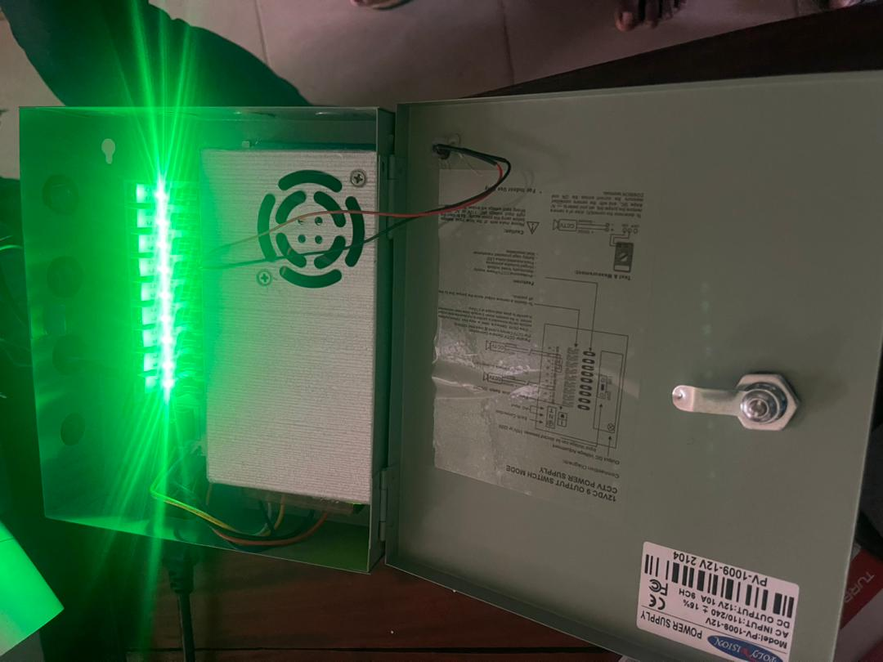
Figure 4.2.Camera Power Supply Box:A camera power supply box, also known as a camera power distribution box or camera power box, is a device used to provide power to multiple security cameras from a central location. It is commonly used in surveillance systems to simplify the installation and management of cameras by consolidating the power supply.
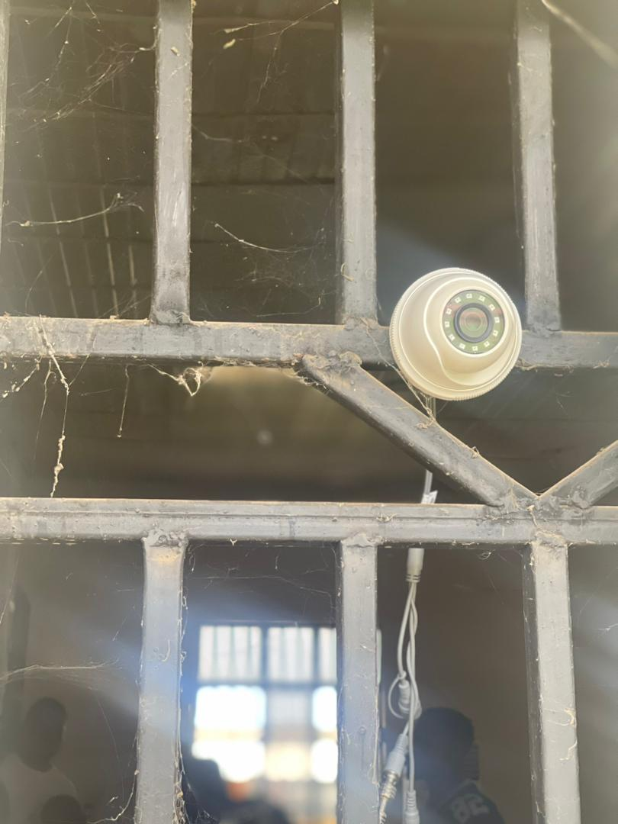
Figure 4.3.Exam Hall Effect Current Sensor:A current sensor, also known as a current transducer or current probe, is a device used to measure or detect electric current flowing in a circuit. The main purpose of a current sensor is to convert the electrical current into a measurable or usable signal.
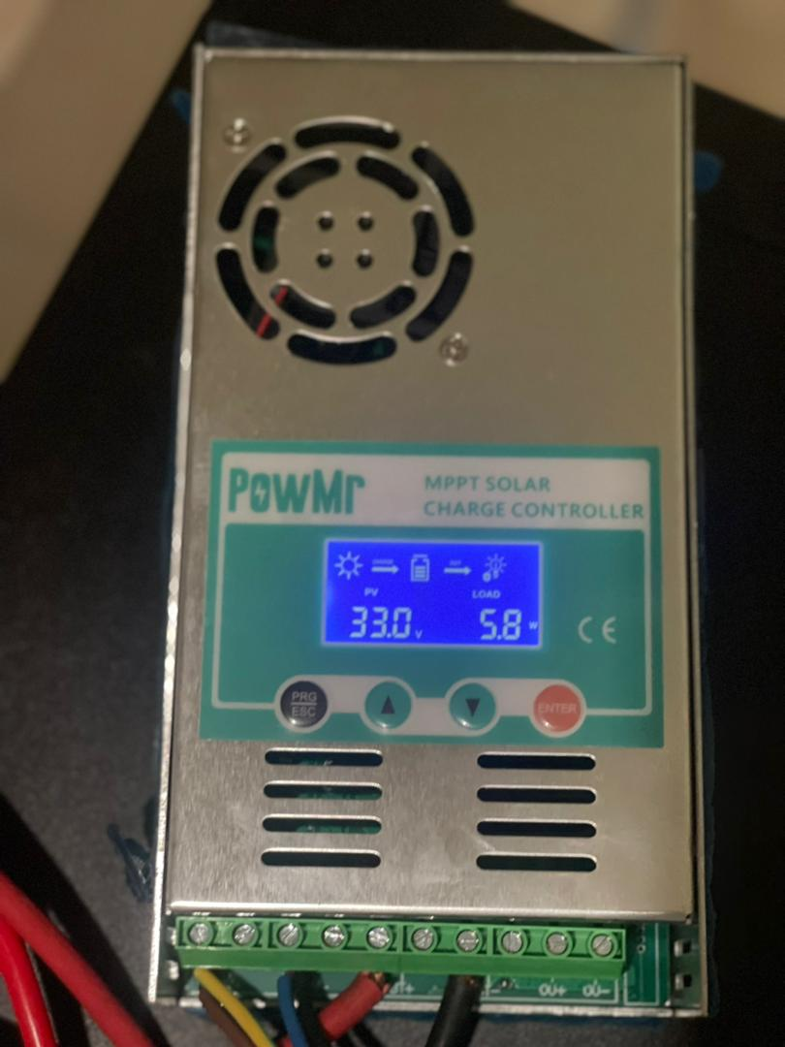
Figure 4.4.Charge Controller:A charge controller is a device used in renewable energy systems, particularly in solar power systems, to regulate and control the charging of batteries.
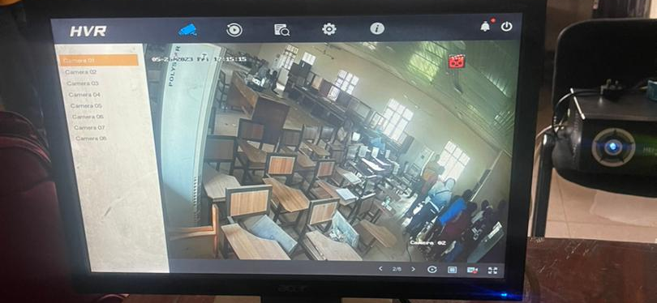
Figure 4.5.Monitor: Monitor also known as a computer display or screen, is an output device that visually displays information generated by a computer or other electronic device.
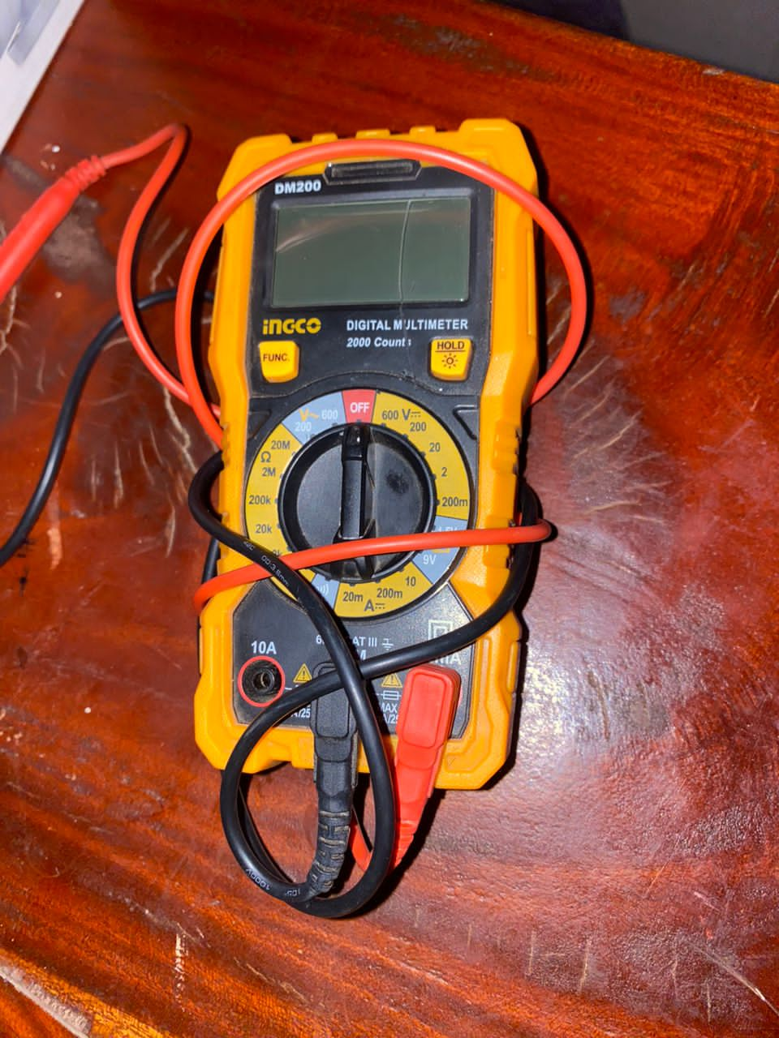
Figure 4.6.Multimeter: A multimeter, also known as a volt-ohm meter (VOM), is a versatile electronic instrument used to measure various electrical quantities in electrical circuits. It typically combines several measurement functions into a single device
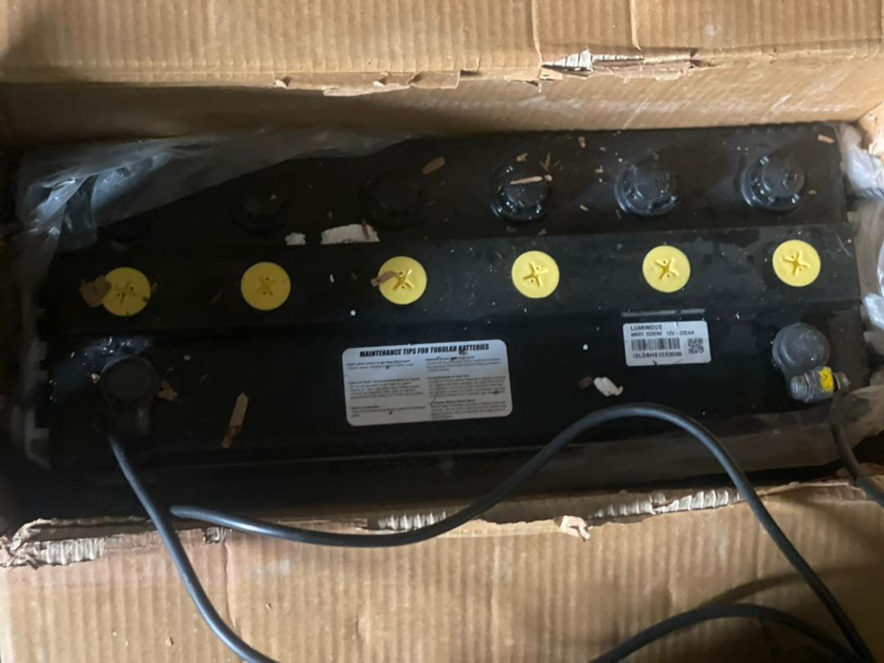
Figure 4.8.Battery:A battery is a device that converts stored chemical energy into electrical energy, providing portable and reliable power for a wide range of devices and applications.
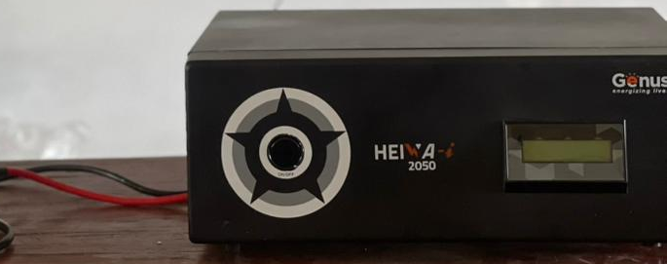
4.10.Inverter: An inverter is an electronic device that converts direct current (DC) power into alternating current (AC) power.

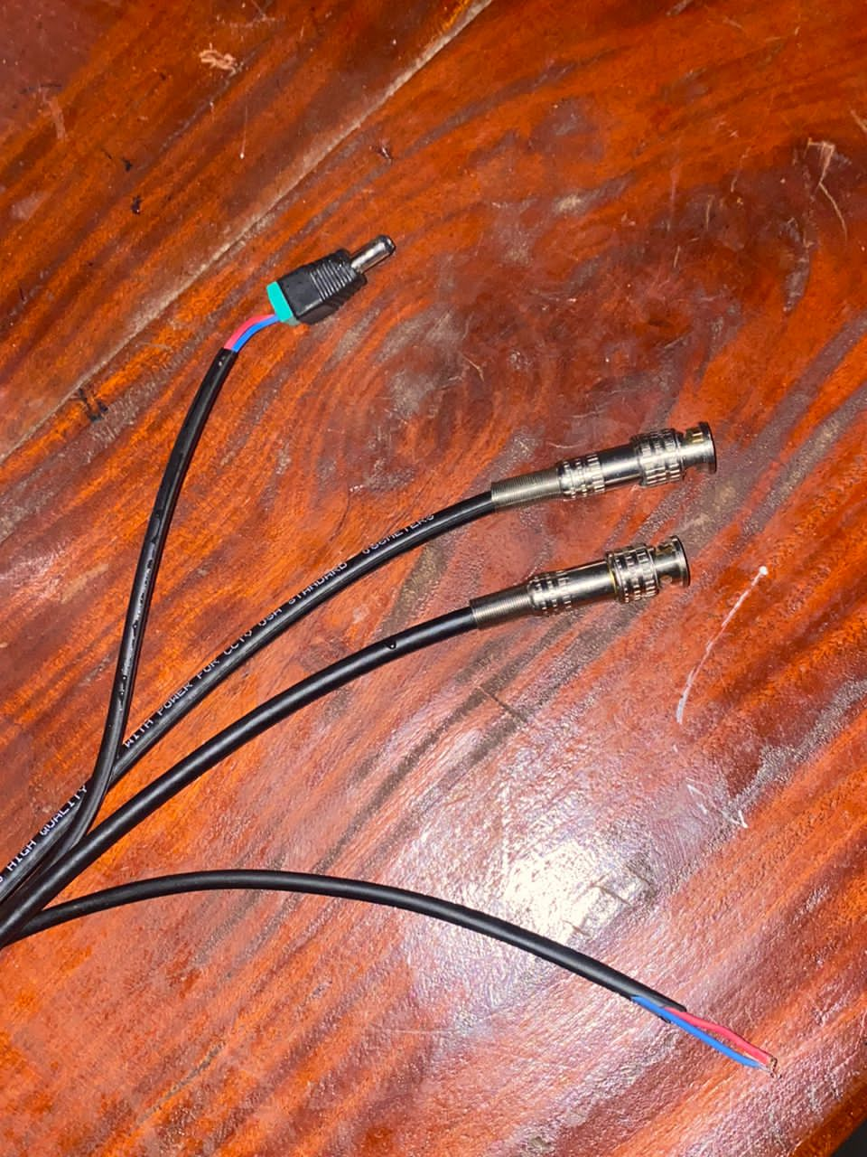
4.10.Cables: Cable refers to a physical medium used to transmit electrical or optical signals from one point to another. A combination of two cables, it is made up of RG59 and 18/2 cable, the former for video transmission quality and the latter for power purposes. In other words, since RG59 is a coaxial cable, it helps in running the video to the security camera, whereas the 18/2 cable helps in the AC/DC power to the camera.
4.1.2 Testing Phase in our CCTV Camera
How we test our security camera system in 3 simple steps
When it comes to home/work/school security, CCTV systems are a popular choice for many homeowners and business owners. These systems can provide peace of mind by allowing you to monitor your property, deter potential intruders, and provide evidence in the event of a break-in. However, like any technology, CCTV systems require maintenance and testing to ensure they are functioning properly. That's why in this research work, we will discuss how we test our CCTV system in three simple steps. By following these steps, you can ensure that your CCTV system is operating at its best and providing optimal security for your home/work/school. So let's dive in and learn how we tested our CCTV system.

Step 1: We Check Our Camera Positioning and Focus
The first step in testing our CCTV system is that check the positioning and focus of our cameras. Proper camera positioning and focus are crucial for ensuring that our CCTV cameras capture clear and accurate footage. Here are some tips for checking our camera positioning and focus:
A. Check Camera Positioning
- We make sure that our cameras are pointed in the right direction to cover the areas we want to monitor.
- We ensure that our cameras are installed at the right height and angle to capture clear footage.
- We check for any obstructions that could interfere with the camera's view, such as trees or other objects.
B. Check Camera Focus
- We use a monitor or viewing software to check the camera's focus.
- We make sure that the camera is focused on the area we want to monitor.
- We adjust the camera's focus to ensure clear footage.
- By checking our camera positioning and focus, we can ensure that our CCTV system captures clear footage and provides accurate monitoring to students in an examination hall.
Step 2: Check Image Quality
The second step in testing our CCTV system is that check the image quality of our footage. Clear image quality is essential for identifying potential intruders and providing evidence in the event of a student cheating. Here are some tips for checking our CCTV system's image quality:
A. Lighting Conditions
- We check the lighting conditions in the areas being monitored.
- We ensure that the cameras are adjusted to the correct settings for the lighting conditions.
- We install additional lighting to improve image quality.

B. Check for Blurriness or Distortion
- We look for any blurriness or distortion in the footage.
- We check the camera's lens for any damage or dirt that may be causing the issue.
- We adjust the camera's focus or replace the lens if necessary.
C. Adjust Image Settings
- We check the image settings on our cameras to ensure they are optimized for the best image quality.
- We adjust the brightness, contrast, and color settings to improve image quality.
- We experiment with different settings to find the optimal configuration for your CCTV system.
- By checking our CCTV system's image quality, we can ensure that our cameras are capturing clear footage that can be used to identify potential intruders or provide evidence in the event of examination malpractice.
Step 3: Test Recording and Playback Functions
The third step in testing our CCTV system is to test the recording and playback functions. Functional recording and playback are crucial for providing evidence in the event of an examination malpractice or other security incident. Here are some tips we use for testing our CCTV system's recording and playback functions:
A. Recording Function
- We check that our cameras are recording properly and that the footage is being stored in the correct location.
- We ensure that there is enough storage space for the footage being recorded.
- We test the motion detection feature to ensure that our cameras are recording when they should be.
B. Playback Function
- We test the playback function to ensure that we can access and view the recorded footage.
- We check that the recorded footage is clear and accurate.
- We ensure that the playback function is working on all of our cameras.
C. Common Issues and Fixes
- When we are having issues with recording or playback, we check our camera's settings to ensure they're properly configured.
- We ensure that our CCTV system's firmware and software are up-to-date.
- We know that If we're still having issues, we can consult the manufacturer's manual or contact their customer support team for assistance.
- By testing our CCTV system's recording and playback functions, we can ensure that our cameras are properly recording and storing footage and that we can easily access and view that footage in the event of a security incident.
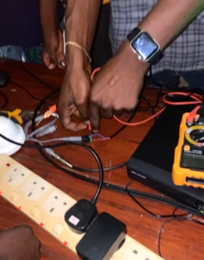
We also use a voltmeter to test our electric voltage.

Figure 4.10: Voltmeter used in measuring the flow of electric current
4.1.3 Output Design
The design of output is the most important task of any system. During output design, we identify the type of outputs needed and consider the necessary output controls and prototype report layouts.

CCTV Camera Output 1
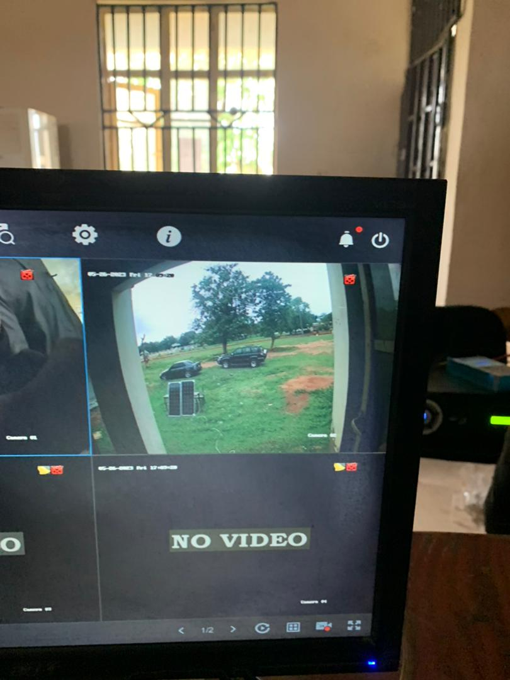

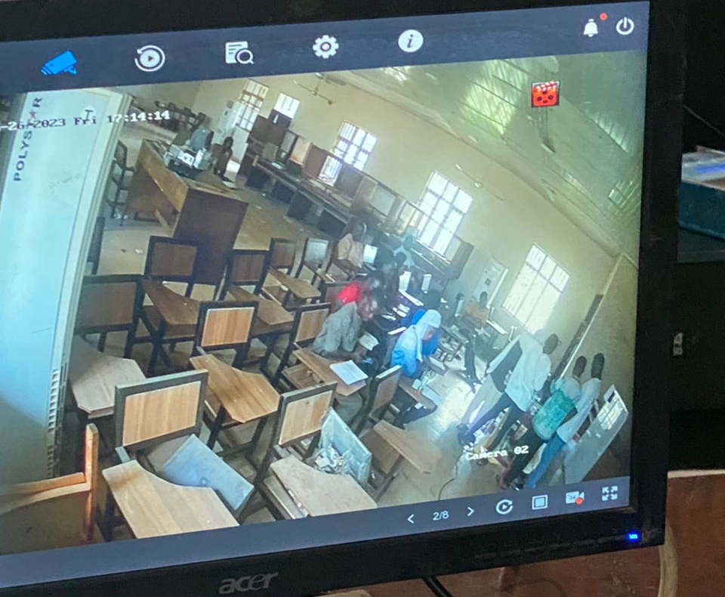
Figure 4.11: This is the output of the first camera

Figure 4.12: This is the output of the second camera, showing students in a classroom.
4.1.4 Input Design
The input design is raw data that produce an output.

CCTV Camera
CCTV, or Closed Circuit Television, is a system that uses video cameras to transmit video signals to a specific set of monitors or recording devices for surveillance and monitoring purposes. CCTV systems have become an integral part of security and surveillance in various settings. CCTV is designed to help prevent and detect crime. It can reassure the public about community safety. It is located in public places to: provide evidence to relevant enforcement agencies.
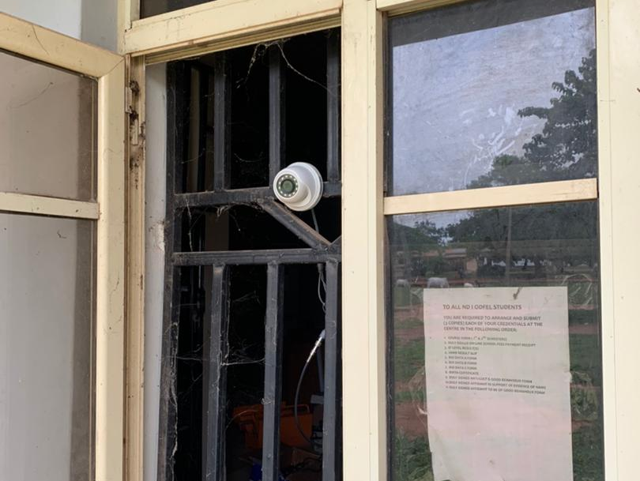
Our CCTV is used to capture or monitor every movement of both students and invigilators in an examination hall.’

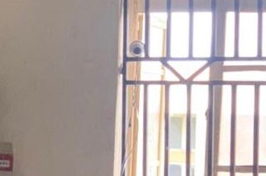
Figure 4.13: CCTV mounted on the outside of a window

Figure 4.14: CCTV mounted on the inside of a window

4.1.5 Procedure Design
The procedure design for the Solar Power Examination Monitoring System outlines the steps and workflow involved in effectively monitoring and examining solar power installations.
4.2 System Implementation
System implementation refers to the process of deploying and configuring the Solar Power Examination Monitoring System to make it operational.
4.2.1 Hardware Support
The software application design needed the following hardware for effective
operation of the newly designed system:
i. Core 2 Duo and above system with a processor speed of 500MHz.
ii. The Random-Access Memory (RAM) should be at least 500MB
iii. Enhanced Keyboard and Mouse.
iv. At least 80GB Hard Disk.
v. VGA or SVGA colored monitor to be able to achieve the effective user-friendliness of the program
vi. An Uninterruptible Power Supply (UPS) Units

4.2.2 Software Support
The software requirements for this system include:
- A Windows 7, 8, or 10 Operating System.
- CCTV Software Package.
4.2.3 Implementation Techniques
Training and User Adoption: We provide comprehensive training to system administrators, maintenance personnel, and end-users to ensure they understand the system's functionalities, and features, and how to utilize them effectively. Encourage user adoption through workshops, demonstrations, and ongoing support.

4.3 System Documentation
Documentation is very important in the development of any system. This is because documentation makes the system easier for all users, and if a system is not well documented it becomes difficult to use.
4.3.1 Operating the System

How To Setup a DVR Camera System
DVR camera systems consist of security cameras that have BNC jacks to send video over coax wire, and a 12VDC power connector for power. Such coax wire-based systems use RG59U siamese cables that have BNC and 12VDC power connectors at each end, which allow video and power to be run together over one “siamese cable.” BNC connectors are silver-colored metal connectors that twist locks onto the video jacks of a camera and DVR recorder. Infrequently, an installer may use network cabling with video baluns instead of coax cabling, which was very common with older CCTV systems to transmit video signals over long distances. Regardless of whether you are using coax wire or video baluns, the setup of a DVR camera system is similar.

How to use your surveillance system

1. How To Login to a Security Camera System
Before you can log in to your camera system over the web, you need to log in at the DVR itself using a mouse. Connect the recorder to a monitor that supports at least 1080P resolution. We recommend using an HDMI input-capable monitor. Turn on the recorder and log in using two possible login methods.
- When logging in at the recorder, most of our surveillance video recorders allow quick access using a graphical pattern as a password.
- You can also log in using the username and password stated on the sticker located on the top of the unit.
In case you are unable to log in due to a forgotten password, it is easy and secure to reset the password and gain entry into the unit. It is required that you be present at the recorder when following the video guide below on how to reset the login password. By answering some simple security questions you can quickly reset the login password.

2. Viewing Live Video and Audio on a Security System
All of our DVR Systems and HD NVR systems allow multiple viewing options. You can view multiple cameras in a grid view or view one camera at a time in full-screen mode. The full-screen mode also allows the user to listen to audio from security cameras with a built-in microphone. To hear audio from cameras, all of the following conditions must be met:
- The security camera has a built-in mic or you have an add-on security camera microphone connected to the DVR
- Audio sensing needs to be enabled on the system from the Encode menu
- A monitor with speakers is connected to the system using the HDMI video input
Regardless of whether you have an IP security camera system or a DVR camera system, both provide the user with two types of zoom:
- Digital Zoom - digital magnification of the picture in live view or recorded video
- Optical Zoom - physical zoom using a camera lens to zoom in when viewing live video
It is important to understand the difference between digital zoom and optical zoom, and the fact that optical zoom can only be used in live view mode. Below is a detailed video demonstration of each type of zoom function and how both can be utilized during live view to see objects far away. Using a 4MP security camera mounted 7ft above the object of interest, we show the power of optical zoom provided by a motorized zoom security camera to view objects in fine detail.
If your system has motorized zoom cameras or an outdoor PTZ camera that you purchased from CCTV Camera World, they can be easily controlled using our surveillance video recorders. Regardless of whether the motorized cameras are HDCVI or IP cameras, or whether your recorder is a DVR, XVR, or NVR, the cameras can be controlled using the friendly GUI interface of our systems as shown in the following video.

4.3.3 Maintaining the System
Maintaining the Solar Power Examination Monitoring System is essential to ensure its continued functionality, accuracy, and reliability.
- Regular System Monitoring: Implement a monitoring mechanism to continuously monitor the performance of the system. Monitor data acquisition, data transmission, analytics processes, and alerting mechanisms to identify any anomalies or issues. Set up automated checks and notifications to promptly address potential problems.
- Sensor Calibration: Regularly calibrate the sensors installed in the solar power installations to ensure accurate data collection. Follow manufacturer guidelines for calibration frequency and procedures. Document calibration activities and keep records for reference.
- Data Integrity and Backup: Maintain data integrity by implementing backup and recovery mechanisms. Regularly back up the collected data and system configurations to prevent data loss. Test the backup and recovery procedures to ensure their effectiveness.
- Performance Optimization: Monitor system performance and identify areas for optimization. Analyze system metrics, such as response time, processing time, and data storage, to identify bottlenecks or areas requiring optimization. Consider optimizing database queries, code algorithms, or system configurations to improve overall performance.

CHAPTER FIVE
SUMMARY AND CONCLUSION RECOMMENDATIONS
5.1 Summary
Solar power monitoring system is the most important system which is used for renewable energy of sunlight. This system has the large future scope because the electricity is the most important need of the humans; it is used in their daily life. The solar power monitoring system used the Arduino Uno which is the microcontroller board. The solar energy is the renewable energy which is generated by sunlight. The sun is the main source of the solar system. The solar system uses the solar panels, which are used to generate the electricity. The solar panels are made up of pure silicon by creating some reactions on the carbon, silicon and hydrogen. Firstly, to generate the pure silicon it means that to generate the polycrystalline the carbon is added to the silicon and it forms the gases silicon then the pure silicon means polycrystalline. Then the hydrogen is added to that gases silicon then it forms the pure polycrystalline, then it separated in the number of plates that plates are called as the silicon wafers that silicon wafers are added to the solar panels, with the help of that panel’s the electricity is generated.
5.2 Conclusion
Implementing Renewable Energy technologies is one recommended way of reducing the environmental impact. Because of frequent power cut it is important to use renewable energy and monitoring it. Monitoring guides the user in analysis of renewable energy usage. This system is cost effective. The system efficiency is about 95%.This enables the efficient use of renewable energy. The temperature sensor helps to analysis the storage of the solar energy. Thus it is reducing the electricity issues. This project can be further enhanced, by using the results of this current project, i.e. the monitored values obtained are helpful in predicting the future values of the parameters considered. Prediction of the amount of solar energy will be stored in the battery.

5.3 Recommendations
- How each inverter and panel perform to help you determine if any inverters need maintenance or if the solar productivity of the panels can be increased.
- Solar system monitoring also helps us keep a close eye on the solar energy system and let us know that the solar system is operating as efficiently as possible, and helps us avoid accidents and most threat detect d error showing that is why we should use inverter in way to be medalist it in society to be useful.
- Set up a financial vehicle. Many financial strategies can enable access to solar. They may require enabling legislation or new regulations, and involve working with utilities, solar developers, county agencies and/or financial institutions. Because of the diversity of options, legal and regulatory complexity, and potential range of stakeholders, it may be beneficial to establish a lead agency with specialized skills in project finance.
- Promote volunteerism. Using solar power to help low-income consumers can be appealing to the public, because it simultaneously helps solve social and environmental problems. Volunteer labor can drive down the cost of installations while providing job training and community service opportunities.
- Ensure programs provide tangible benefits to low-income consumers. It may seem obvious to say that low-income customers should benefit from low-income solar programs, but in practice it can be difficult to achieve. For example, installing solar on a low-income, multifamily apartment building won’t necessarily provide savings for the tenants.
- CCTV can sometimes be used in court as evidence to prove someone was in a certain place or that they committed an offence.
- It can also improve community safety and prevent crime. For example, deterring someone committing a crime like robbery if they know CCTV will record their actions.

References
Abdalla, M. M. Ibrahim, A. N. & Mohamed, S. M. (2017) "Solar-powered wireless CCTV system for agricultural monitoring," International Conference on Electrical Engineering/Electronics, Computer, Telecommunications and Information Technology (ECTI-CON), Phuket, 2017, pp. 293-296.
Al-Qaisi, B., Al-Hitmi, M., &Bouras, A. (2022).Solar Energy Monitoring System for Photovoltaic Plants.In Proceedings of the 3rd International Conference on Smart Systems in Engineering (pp. 89-94).Springer.
AnkitKekre& Suresh K. Gawre (2017) Solar photovoltaic remote monitoring system using IOT. Proceeding International Conference on Recent Innovations in Signal Processing and Embedded Systems (RISE -2017) 27-29 October2017
Brown, A. (2022). Enhancing Campus Security with CCTV Surveillance.Journal of Higher Education Security, 8(2), 45-62.
Cardoso, G., Andrade, L., Sá, J., & Ramos, C. (2022).A Review of Monitoring and Fault Diagnosis Techniques for Photovoltaic Systems.Energies, 15(1), 244.
Chaitanya, M. V. S., & Reddy, A. S. (2022).Design and Implementation of Remote Monitoring and Control System for Solar PV Power Plant.In Proceedings of the International Conference on Smart Electronics and Communication (pp. 139-145).Springer.
Chen, L. (2022). The Role of CCTV Surveillance in Campus Security.International Journal of Security Studies, 15(3), 78-94.
Das, D., & Jana, D. (2022). Incident response in video surveillance systems: A comprehensive survey. ACM Computing Surveys, 55(6), 1-34.
Dhillon, G., & Backhouse, J. (2017). Information systems security: Management and strategy. John Wiley & Sons.
Doe, J. (2022). Comprehensive Security Measures for Tertiary Institutions: CCTV Surveillance Systems. Journal of Campus Safety, 12(1), 17-32.
Dong, X., Zhou, W., &Zheng, J. (2022).Design and Implementation of Monitoring and Fault Diagnosis System for Solar Photovoltaic Power Station.IOP Conference Series: Earth and Environmental Science, 1004(2), 022006.
Durrani, H., Ahmed, E., & Shah, M. (2020). Privacy in video surveillance: A comprehensive review. Digital Communications and Networks, 6(1), 10-23.
Evans, R. (2022). Optimizing CCTV Surveillance Systems in Tertiary Institutions.Security Technology Journal, 5(4), 112-129.
Fakouri, B. E., & Youssef, A. M. (2017). Video surveillance systems: Policy and practice in a technological society. International Journal of Innovative Research in Computer Science & Technology, 5(2), 2321-2328.
Hadi, A. S. Lee, S. S.Saad, N. M.& Ali, M. T. (2016) "Solar-powered security surveillance system using wireless sensor network," International Symposium on Recent Advances in Electrical Engineering (RAEE), Islamabad, pp. 1-6.
Harris, M. (2022).CCTV Surveillance and Emergency Response in Tertiary Institutions. International Journal of Emergency Management, 19(1), 56-73.
Jackson, S. (2022). Fire Safety and CCTV Surveillance: A Comprehensive Approach in Tertiary Institutions. Fire Engineering Journal, 14(3), 88-103.

