CADASTRAL LAYOUT SURVEY OF PART OF DE-GOLDEN SISTER RESIDENTIAL LAYOUT
AT ALUFA AGUNBIADE VILLAGE, SENTU COMMUNITY, OFF OKE-OSE - LAJIKI ROAD, ILORIN EAST LOCAL GOVERNMENT AREA, KWARA STATE, NIGERIA.

PRESENTED BY

BABATOMI FAVOUR
ND/23/SGI/FT/0011

SUBMITTED TO THE DEPARTMENT OF SURVEYING AND GEOINFORMATICS, KWARA STATE POLYTECHNIC, ILORIN, KWARA STATE.

IN PARTIAL FULFILMENT OF THE REQUIREMENTS FOR THE
AWARD OF NATIONAL DIPLOMA IN SURVEYING AND GEOINFORMATICS.

JUNE, 2025.

CERTIFICATE
I hereby certify that all the information given in this project was obtain as a result of the observation and measurements, carried out by me in accordance with survey rules, regulation and departmental instructions.

--------------------------- ---------------------------
BABATOMI FAVOUR DATE AND SIGNATURE
ND/23/SGI/FT/0011

CERTIFICATION
This is to certify that Babatomi Favour Matric no: ND/23/SGI/FT/0011 has satisfactorily carried out his project under my instructions and direct supervision. I hereby declare that he has conducted himself with diligence, honesty and sobriety on the project.

………………………….. ……………………………
Surv. I. I. Abimbola Sign and Date
(Project Supervisor)
.................................... .......................................
Surv. Babatunde kabir Date and Sign
(Project Supervisor)

....................................... ........................................
Surv. R. S. Awoleye Sign and Date
Project Coordinator

………………………….. ……………………………
Surv. I. I. Abimbola Sign and Date
Head of the Department

………………………….. ……………………………
External Examiner Sign and Date

DEDICATION
I dedicate this project report to the most beloved creator, the Almighty Allah.

ACKNOWLEDEMENT
Glory be to Almighty Allah the most beneficent, the most merciful and the most compassionate, the king and the master of the day of resurrection for his guidance and protection over my life from the beginning of my project program till the end, to him be all honour, glory and adoration.
I extend my profound gratitude to my father Mr. Babatomi and to my mother Mrs. Babatomi for the guidance they gave to me spiritually, morally and financially. May Almighty Allah reward them with his blessings and guidance and may they live long to reap the fruit of their labor (Amin).
Also, I express my sincere appreciation to my supervisor, Surv. I. I. Abimbola and Surv. Babatunde Kabir for their assistance and guidance that they have given during the course of this project, even of on its tight schedule.
My immense appreciation goes to head of department in person of Surv. Abimbola Isau and departmental staff Surv. Banji, Surv. Babatunde Kabir Surv. Felix Diran, Surv. Kazeem, Mr.Benard, Surv. R.S Awoleye and others for their support and advice during the project period.
I also acknowledge my project coordinator Surv R.S Awoleye. I can't forget all my colleagues for their cooperation, believe and understanding towards the successful completion of this project. I wish all of us success.

ABSTRACT
This project is the layout survey of the property of De-golden sisters at Sentu village, off Oke-ose to Lajiki road, Ilorin East Local Government Area, Kwara State. The components of the project include: Perimeter survey, setting out of points, beaconing of demarcated points, and coordination of 56 plots of land and production of layout plan at a suitable scale. The survey was tied to three existing control within the vicinity and the survey data was computed and AutoCAD Software was used for plotting of the final layout plan. Kolida (Model: SET 02) Total Station with its accessories were used for the setting out and final survey exercises. A total number of 80 points were monumented and surveyed. The total area covered is 2.7383 hectares. The average area of the plots is within 960Sqm. Being a third order job, an accuracy of 1:20,000 was achieved.

TABLE OF CONTENTS
- Title page
- Certificate
- Certification
- Dedication
- Acknowledgement
- Abstract
- Table of contents
Pages
CHAPTER ONE
1.0. INTRODUCTION 1-2
1.1. STATEMENTS OF PROBLEM 3
1.2. AIMS OF THE PROJECT 3
1.3. OBJECTIVES OF THE PROJECT 4
1.4. SCOPE OF THE PROJECT 4
1.5. SPECIFICATION OF THE PROJECT 4-5
1.6. PROJECT LOCATION 6
1.7. PROJECT LOCATION 7

CHAPTER TWO
2.0. LITERATURE REVIEW 8-11

CHAPTER THREE
3.0 PROJECT PLANNING 12
3.1 RECONNAISANCE 12
3.2 FIELD RECONNAISANCE (RECCE) 12
3.3 OFFICE PLANNING 12
3.4 INSTRUMENT TEST 13
3.5 TEST OF TOTAL STATION COLLIMINATION TEST 13
3.5.1 PROCEDURE FOR COLLIMINATION AND VERTICAL INDEX ADJUSTMENT 14
3.5.2 IN-SITU CHECK OF CONTROLS USED 15
3.6 SCHEDULE OF FIELD WORK 16
3.7 DATA ACQUISITION 16
3.8 SETTING OUT OF POINT 17
3.9 MONUMENTATION 18
3.10 TRAVERSING 19

CHAPTER FOUR
4.0 DATA DOWNLOADING AND PROCESSING 20
4.1 DATA PROCESSING & ANALYSIS 20
4.2 PLOTIND AND PLAN PRODUCTION 21
4.3 PROJECT STATISTICS 21
4.4 COMPUTATIONS 21-22
4.5 DISCUSSION OF RESULT 23
4.5.1 PERIMETER SURVEY PLAN 24
4.5.2 DISGN PLAN 25
4.5.3 LAYOUT PLAN 26

CHAPTER FIVE
5.0 SUMMARY, CONCLUSION, PROBLEMS ENCOUNTERED AND RECOMMENDATION 27
5.1 SUMMARY 27
5.2 CONCLUSION 27
5.3 PROBLEMS ENCOUNTERED 28
5.4 RECOMMENDATION 28
REFERENCE 29
RAW DATA 30-31

CHAPTER ONE
1.0 INTRODUCTION
A cadastral layout survey is a critical process in land administration that involves the measurement, mapping, and documentation of land parcel boundaries. It plays a vital role in land tenure systems, development planning, and property management. The outcome of such a survey ensures clarity of ownership and facilitates land transactions, development control, and taxation. cadastral layout survey of a defined site, aimed at producing an accurate layout plan suitable for land allocation, urban planning, or titling.
A cadastral layout survey is a specialized branch of land surveying that focuses on the precise delineation and documentation of land parcel boundaries. The term "cadastre" originates from the Greek word “katastikhon”, meaning a register or list, and refers to a comprehensive record of the extent, value, and ownership of land parcels, primarily for taxation and legal purposes.
Cadastral surveys serve as the foundational framework for land administration systems, providing accurate and up-to-date information essential for various aspects of land management. They play a pivotal role in establishing property rights, facilitating land transactions, and supporting urban planning and development. By clearly defining property boundaries, cadastral surveys help prevent disputes, ensure legal clarity, and promote efficient land use. The importance of cadastral surveys extends beyond individual property ownership. They are instrumental in land registration processes, enabling governments to maintain accurate records of land tenure and ownership. This, in turn, supports equitable taxation systems and aids in the implementation of land reforms.
Technological advancements have significantly enhanced the efficiency and accuracy of cadastral surveys. Modern tools such as Global Navigation Satellite Systems (GNSS), Geographic Information Systems (GIS), and remote sensing technologies allow for precise data collection and analysis, facilitating the creation of detailed cadastral maps and records.
In the context of this project, the cadastral layout survey aims to systematically measure and map the designated area, producing a detailed layout plan that accurately reflects the subdivision of land parcels. This plan will serve as a critical resource for land administration, development planning, and legal documentation, ensuring that land use within the area is organized, transparent, and sustainable.
1.1 STATEMENT OF PROBLEM
Inaccurate or incomplete data can lead to boundary disputes, property ownership conflicts and difficulties in land transactions. In many cases, the lack of reliable cadastral information can hinder economic development, leading to social unrest and create challenges for land administration authorities. Therefore, conducting a thorough cadastral survey is essential to gather accurate data and mitigate these risks land dispute among the land owner and other unrest issue in a smart community. This call for the layout of landed property said to belong to the De-Golden sister at Sentu Village.

1.2 AIM OF THE PROJECT
The aim of this project is to carry out Cadastral Layout Survey of plots of land belongs to De-Golden Sister at Sentu Village to accurate delineate the plots and produced a reliable data on land parcels within the designated area, This data will serve as a foundation for land administration, property registration, and urban planning.
1.3 OBJECTIVES OF THE PROJECT
The objectives of this project are:
- To determine the boundaries and ownership of land parcel within the designated area (perimeter plan).
- To provide accurate data on property values and land use (computation sheet).
- To produce area computation sheet.
- To produce standard layout plan
  - SCOPES OF THE PROJECT
- Planning
- Reconnaissance
- Monumentation
- Perimeter Travers
- Layout Design
- Setting-out and Traversing
- Data Processing
- Information Presentation

1.5 PROJECT SPECIFICATIONS
Project is based on the procedures used to execute a project in terms of how the measurements are taken. Specifications mean the requirements necessary to be met when carrying out the survey job of any order (cadastral layout survey). The following specifications are followed:
- Establishment​ of ​traverse​ points​ with​ property​ beacons ( monumentations ).
- Traverse commenced on three existing control points and closed on the same set of controls to check if the traverse is precise and accurate. The accuracy of the control points was found undisturbed before using them for orientation.
- The ​sub-division ​of ​the project ​area​ was ​done ​with ​the dimension of 15.25m x 30.50m for each plots and turning right angle.
- The residential plots should be regular and standard plots 50ft by 100ft.
- Property beacons should be emplaced at all plots.
- Each plot must have access road.
- The accuracy of the job should be third order. (less than1:3,000).
- There mustn't be cross or plus junction without a roundabout within the layout.
- Avoid sharp turning.

1.6 PROJECT LOCATION
The project site is situated in Alufa Agunbiade village area, Sentu community, off Oke-Ose - Lakiji Road, Ilorin East L.G.A, Kwara State which has an area of 2.747 hectares and it fall on geographical coordinate of 8°30'59.96"N ; 4°41'11.16"E to 8°31'9.67"N ; 4°41'10.73"E. The figure below shows the maps of the study area.
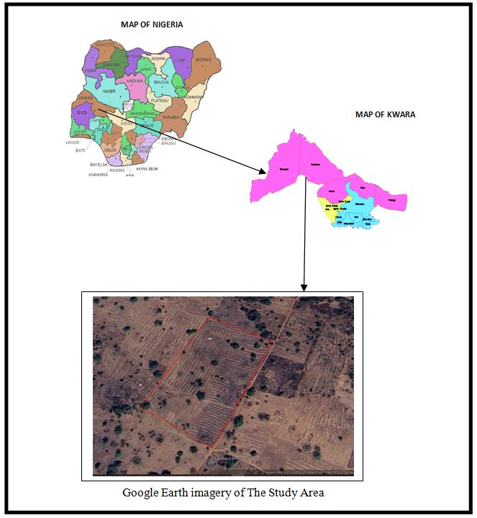

1.7 PERSONNEL MEMBERS OF THE GROUP
The following students contributed greatly to the success of the field practical and they are;
S/N | Name | Matric No | Roles
1. | Babatomi Favour | ND/23/SGI/FT/0011 | Author
2. | Oloyede Favour Eniola | ND/23/SGI/FT/0001 | Member
3. | Afolayan Joshua O. | ND/23/SGI/FT/0002 | Member
4. | Ajide Racheal Oluwasewun | ND/23/SGI/FT/0004 | Member
5. | Kareem Abass Adebayo | ND/23/SGI/FT/0005 | Member
6. | Sulyman Muinat Bukola | ND/23/SGI/FT/0008 | Member
7. | Olafimihan Racheal Olamide | ND/23/SGI/FT/0009 | Member
8. | Idris Abdullahi Umar | ND/23/SGI/FT/0003 | Member
9. | Haroon Abdulmutolib Opeyemi | ND/22/SGI/FT/0018 | Member

CHAPTER TWO
2.0 LITERATURE REVIEW
Land as a commodity can be purchased, disposed and exchanged in an open market economy. In order for land to have an economic value, you must be able to use/develop the land. According to Underwood (2010). Layout Responsibility for Layout of the Work: Contractor shall be solely responsible for complete, timely and accurate layout of the Work including, but not necessarily limited to, horizontal and vertical control and dimensional coordination as necessary to construct the Work in accordance with the Contract Documents. Contractor shall: 1. Employ a Land Surveyor or a Civil Engineer, registered in the State of California, to perform survey work. Alexandra g. (2020)
Layout decisions are one of the key facts determining the long-run efficiency of operations. Layouts have numerous strategic implications because they establish an organization´s competitive priorities in regard to capacity, processes, flexibility, and cost. They are associated with the tactical decision horizon and are dedicated to the concretion of strategic decisions like, e.g., facility location. Configured production systems are input for the operational level, where the goal is to run the given system as efficiently apossible.Gabor z. S. (2017)
An efficient layout facilitates and reduces costs of material flow, people, and information between areas. To achieve these objectives, a variety of configuration designs have been developed. The most relevant ones, in the context of this course, are:1. Fixed-position layout: addresses the layout requirements of large, bulky projects2. Job shop production (Process-oriented layout): deals with low-volume, high-variety production3. Cellular manufacturing systems (work cell layout): arranges machinery and equipment to focus on production of a single product or group of related products4. Flow shop production (Product-oriented layout): seeks the best personnel and machine utilization in repetitive or continuous production As a matter of fact layouts 1 and 2 are often described as centralized, and layouts 3 and 4 as decentralized manufacturing systems. Richard B. (2020)
Satisfactory communal space in high-rise apartments helps to create a harmonious living atmosphere and enhance neighbourhood relations. This review summarises and analyses the research on the design of communal areas in high-rise apartments with consideration of five aspects: space division, universal design, security design, landscape design and decoration design. The aim is to achieve a comprehensive understanding of current design concepts relating to communal space in high-rise apartments and to identify key design considerations that are necessary for the development of sustainable high-rise apartments. Chang C. (2015).
Communal spaces in high-rise apartments are places for residents to interact and communicate. Such spaces comprise two main components: the open area and passageway inside the apartment block, such as the lobby, corridor, public underground parking, elevator, stairs, gym, and other shared areas; and the associated areas outside the apartment block, including the ‘public domain interface’, semi-open and open courtyards or gardens, and rooftop (NSW Department of Planning and Environment, 2015). High-quality communal spaces are the basis for creating healthy neighbourhood relationships.
They help to maintain a sense of belonging and cohesion for residents, and can help to improve social problems that may exist within high-rise apartments Yumin C. (2014). Layout/cut sheets shall be submitted for the Engineer’s approval. Layout must be verified by the Engineer prior to issuance of the Notice to Proceed. Inspection of the Contractor’s layout by the Engineer and the acceptance of all or any part of it shall not relieve the Contractor of his/her responsibility to secure the proper dimensions, grades, and elevations of the several parts of the work.David M. (2018)
We were accompanied into the field by the head of the Lushnja Cadastral Office and one of the surveyors from this office. Once again we enlisted the help of a village leader who had been involved in the original allocation of individual parcels. We were able to recover a nearby geodetic control point, which was used as the base station for the GPS observations. A total of 17 parcels was surveyed in 1 hour and 40 minutes (excluding 35 minutes to recover and set up the base station). Some problems were experienced with the field identification of the parcel corners because Lumthi was one of the first villages to be subdivided and allocated to individual families. This meant that almost 3 years had passed since the work had been completed and the village elder had problems identifying several boundary lines. This indicates the need for the surveying and mapping process to follow closely behind the allocation process, especially where no physical markers are used to demarcate corners (typically the case in this area).Bhandar S. (2019).
Layout implementation is urban design processes which have multidisciplinary process of shaping the physical setting for life in cities, towns and villages. Aribigbola (2008) observed that land use management in Ado-Ekiti has been wholly concerned with the granting of statutory right of occupancy and approval of plans to use land for different purposes, without adequate monitoring of its outcomes. Land belonging to families has been observed to be distributed in sales to make quick monetary gains without considerations for systematic development.

CHAPTER THREE
3.0 PROJECT PLANING
This is the preliminary stages of the project were the schedule and all other logistic will be decided and this planning is done in office in two was below.
3.1 RECONNAISSANCE
Reconnaissance is a very important aspect of any project work in surveying field; it generally consists of two methods.
1. Field reconnaissance
2. Office planning.
3.2 FIELD RECONNAISSANCE (RECCE)
In the process of obtaining field reconnaissance, the site was visited, drawing of the Recce diagram was carried out in order to decide on how best to do the job of the approved layout, the map covering the project site which was prepared by Ministry of Lands and Survey as a guide. The existing control points were located and the values were collected from the survey that did the part of the control to be use lather checking will be done for the in-situ.
3.3 OFFICE PLANNING
The relevant maps in the department were checked in order to get information’s about the site. The coordinates of the nearby control points were also obtained from the Ministry of lands and survey Department. These are the information of the controls within the project site.
Table 2.1 Coordinates of Controls
Pillar No | Northing(m) | Easting(m)
SC/KW B10991R | 941701.318 | 685715.747
SC/KW B10992R | 941756.109 | 685609.382
SC/KW B10993R | 941788.423 | 685544.026
Source: Private Practicing Surveyor
3.4 INSTRUMENT TEST
The Total Station was found to be in good working condition after checking for Collimation error, the Circular plate bubble and Plate level.

3.5 TEST OF TOTAL STATION COLLIMINATION TEST
The following test was carried out to test the workability of the equipment before the data capturing process. The tests are of two types which are
- Temporary Adjustment
- Permanent Adjustment
The temporary adjustments are the ones that are carried out on every station before observation. They are;
- Centering of instrument
- Removal of parallax
The permanent adjustments carried out are
1. Collimation adjustment
2. Vertical Index adjustment
2.5.1 PROCEDURE FOR COLLIMATION AND VERTICAL INDEX ADJUSTMENT
The instrument was set up on station SC/KW B10991R and all necessary temporary adjustments were performed. A target was set up at SC/KW B10991R to the line of site. It was aimed at and bisected. The instrument was switch on and program which is on-board of the instrument was switch to the collimation program. Then, horizontal collimation and vertical index were in sequence recorded and stored in the memory of the instrument. The telescope was transited and the same target bisected. Both the new vertical index and collimation were recorded and stored accordingly. It was transited to the same target with both horizontal and vertical readings recorded to check the instrument’s accuracy. The readings obtained are as follows:
Table 2.2 Test of Total Station
 | Old Reading | New Reading
Horizontal collimation error | +00⁰00’ 14” | +00⁰00’ 09”
Vertical index | +00⁰00’ 20” | +00⁰00’ 04”
 |  | +00⁰00’ 09”
Source: Author 2024
From the above reading, it is shown that the new value have higher precision than the previous. Therefore, the new value is set in the instrument for corrections applicable on any of the two axes.
3.5. IN-SITU CHECK OF CONTROLS USED
The following pillars SC/KW B10991R, SC/KW B10992R and SC/KW B10993R were among the ones found on the ground and checks were carried out on them to determine their true position and reliability.
Checks carried out on these pillars show that:
Observed Included angle = 180° 21’ 12’’
Computed Included angle = 180° 21’ 18’’
Difference: 00° 00’06’’
Observed distance: = 120.305m (SC/KW B10992R - SC/KW B10991R)
Computed distance: = 120.315m (SC/KW B10992R - SC/KW B10993R)
Difference: = 0.010m
Remarks: The difference in both the angular and distance observations was within acceptable limit; hence the Pillars were in-situ.

SC/KW B10993R
SC/KW B10992R
$180°$ 21’12”
SC/KW B10991R

Fig 2.1 In-situ check for control

3.6 SCHEDULE OF FIELD WORK
Having completed the reconnaissance, the schedule of field work was designed as follows:
- Perimeter traverse
- Setting out of boundary beacons
- Layout design
- Pillar Numbering
- Traversing
- Report writing
3.7 DATA ACQUISITION
Layout is the sub-division of parcel of land into blocks and subsequently plots. The surveying process of defining the positions of various beacons that make up a layout on the ground by a surveyor using approved layout design made by the town planner is known as setting out. In the execution of this project the principle of “working from whole to parts” was adhered to as the perimeter beacons that formed the framework for the setting out of the blocks and the blocks formed the framework for the setting out of the plots.
The traditional or classical methods of surveying were decided upon for the execution of this project. The methods are:
- Setting out of the entire perimeter.
- Traverse method for acquisition of the entire perimeter.
- Stake out method for block by block and plot by plot setting out.
- Traverse method and interpolation for acquisition of the entire block and plot data.

3.8 SETTING OUT OF POINTS
Sokkia green label (Model: SET 02) Total Station was set up on SC/KW B10992R and oriented to SC/KW B10991R and coordinates of the stations were keyed into the instrument. Total station computed the bearing between the two stations for orientation. Then coordinates of points to be set out were entered into the total station and the setting out program of the instrument was used to get the angle to turn in order to face the direction of the point after orientation, the instrument was rotated until horizontal angle read 0°00’00”, reflector was held along the direction and distance between the instrument and the reflector was measured.
The instrument displayed the remaining distance as either positive or negative. Positive distance means that the reflector should move away from the instrument by that amount while negative distance means that the reflector should move towards the instrument. When the horizontal angle read 0°00’ 00” and measured distance displayed 0.000m this marked the exact position to be set out. The point was pegged and point number was written with permanent marker. All other points were set out in similar manner. Observations were carried out on the set out points and stored in the instrument memory. Also, the measurements made were found out to be permissible since the incurred error is within allowable. The principle of working from whole to part was observed while setting out the points as the boundary of the layout and some selected points within the boundary of the layout were first observed to server as subsidiary points (minor control points). Subsequent points were set-out from them.

3.9 MONUMENTATION
All the points set out were beaconed with a property beacon in compliance with cadastral survey regulations. The property Beacons were of dimension 18cm x 18cm x 75cm and made of concrete mixture of ratio 3:2:1in (3 parts of sand to 2 part of gravels and 1 part of cement) respectively. These beacons were emplaced in such a way that 15cm of its total length was above the ground surface while the remaining length was buried under the ground.
The boundary pillars were numbered accordingly as they were in the working diagram and where they fell during their setting out. However, the pillars were prefixed with identification mark SCKW. Because SURCON private numbers were obtained from the Office of State Surveyor General
SC/KW
B2134R
10cm
65cm
Ground level
18cm
18cm
18cm
B
R

2134

Fig 2.3 Description of pillar used showing portions above and below the ground
3.10 TRAVERSING
Total station was set up on SC/KW B10992R, switched on and all temporary adjustments were carried out. Then, “Job” was set in the instrument, height of instrument and reflectors were measured with steel tape and stored in the instrument’s memory, and coordinates of the control stations were recalled from the instruments’ memory SC/KW B10991R, was bisected for orientation, and Total station was instructed to compute the bearing between the two stations which was confirmed with a prismatic compass. One of the reflectors was taken to pillar SC/KW B10993R, the reflector’s cross hair was bisected with that of the telescope eye piece of the total station and “All” key was pressed so as to measure and record observation in the memory of the instrument. The instrument was switched off and moved to SC/KW B10993R, and the above stated processes were carried out to coordinate the entire boundary points in X, Y, Z. The above process was repeated for other blocks shown on the plan including subsidiary traverses.

CHAPTER FOUR
4.0 DATA DOWNLOADING AND PROCESSING
The coordinates of the observed boundary were downloaded into the computer and were compiled in Microsoft excel for further processing. A script file of boundary points of individual plot was prepared in note pad using Polyline command. These script file was run in AutoCAD and the area information of each plots as well the bearing and distances of each consecutive lines were obtained.
4.1 DATA PROCESSING & ANALYSIS
The acquired field data was downloaded to the computer in the office. This was done using a NTS software. The following procedure was followed:
- Connecting the SET and host computer, using communication cable.
- Selecting “JOB” in Memory Mode.
- Selecting “comms” output to display the JOB list.
- Pressing OK.
- Selecting the output formation
- At the end of the downloading, the data was displaced in the following format, Point No., Easting and Northing.
The data was then copied to other software such as Microsoft Excel for further processing. Here, the data was arranged and stored as formatted Text (space delimited), ready for plotting. The observed data were reduced and corrected, Master Survey programmer software was used to process the data.

4.2 PLOTTING AND PLAN PRODUCTION
Auto-CAD2007 software was used for plotting all the set out pillars. The plotting procedure was as follows,
- Launch Auto-CAD 2007.
- Select Format on the menu tool bar and set all necessary units such as meter, Decimal places, Directions etc.
- Select tool from the menu bar and highlight run script.
- Open the saved formatted Text from Microsoft Excel.
- Zoom extents, by pressing Z enter and E enter.
All the coordinated points are plotted and displayed on the screen and with the help of the Recce diagram; all the boundary points were joined for individual plots to produce the boundary lines and the existing features such as Roads.
The final Layout plan was plotted at scale of 1: 2,500
4.3 PROJECT STATISTICS
- Total Number of residential plots 56 plots
- Total number of boundary beacons 4
- Coordinate Properties UTM

4.4 COMPUTATIONS
The backward and area computation were done to the coordinates of the boundary pillar as show in the tables below;

Tab: 4.1: the table shows the back computation of the perimeter survey
Station form | Bearing | Distance (m) | ∆N | ∆E | Northing (m) | Easting (m) | To Station
 |  |  |  |  | 942244.886 | 684890.452 | SC/KW  J5920BK
SC/KW  J5920BK | 117° 13' 45’’ | 126.709 | -57.976 | 112.668 | 942186.910 | 685003.119 | SC/KW  J7719BK
SC/KW  J7719BK | 206° 44' 54" | 222.330 | -198.539 | -100.065 | 941988.371 | 684903.055 | SC/KW  B10990R
SC/KW  B10990R | 297° 14' 20" | 119.643 | 54.761 | -106.375 | 942043.132 | 684796.679 | SC/KW  B10991R
SC/KW  B10991R | 024° 55' 42" | 222.481 | 201.754 | 93.772 | 942244.886 | 684890.452 | SC/KW  J5920BK

Tab: 4.2: the area computation by double latitude and single departure.
∆E | ∆N | PRODUCT
112.668 | X -57.976 | = -6532.039968
112.668
225.336
-100.065
125.271 | X -198.539 | = -24871.179069
-100.065
25.206
-106.375
-81.169 | X 54.761 | = -4444.895609
-106.375
-187.544
93.772
-93.772 | X 201.754 | = -18918.876088
93.772
0.000
= -6532.039968 -24871.179069 -4444.895609 -18918.876088
= -54766.990734\2 =27,383.495m²\10000 =2.7383 Hectares
4.5 DISCUSSION OF THE RESULT
The following were the results obtained at the end of the project exercise, they are:
- Perimeter Survey plan.
- Design plan
- Layout plan

4.5.1 PERIMETER SURVEY PLAN
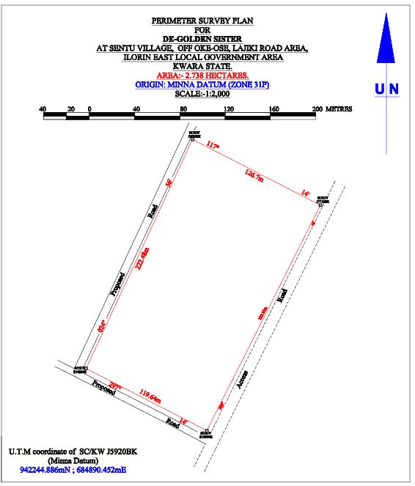

4.5.2 DESIGN PLAN
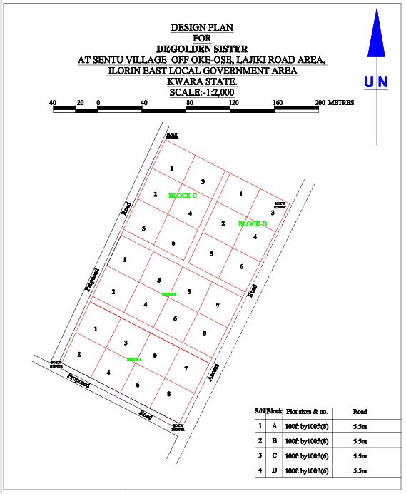

4.5.3 LAYOUT PLAN
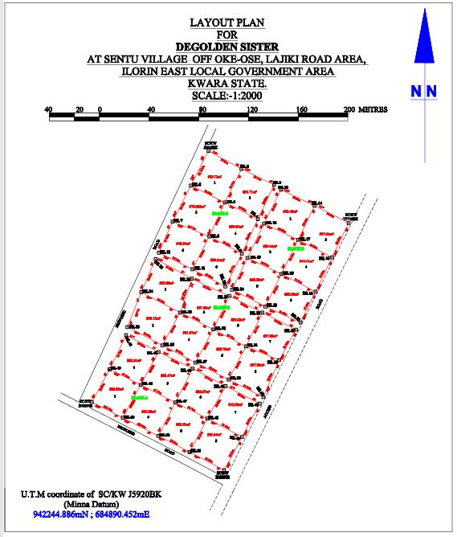

CHAPTER FIVE
5.0 SUMMARY, CONCLUSION PROBLEMS ENCOUNTERED AND RECOMMENDATION.
5.1 SUMMARY
The project area covered a total area 2.738 hectares with total number of 4 pillars used for the Perimeter Survey. Whereas the total number of beacons used for the layout was 54, making a total number of 54 pillars emplaced. The total numbers of plots are 28 at 100ft x 100ft. The project cut across the following; reconnaissance, monumentation and traversing and settingout. Kolida Total Station was used for the geometric data acquisition and its software was used in downloading and transforming the acquired data.
The final adjusted coordinates were used for the production of Perimeter Survey plan and the Layout Survey plan using AutoCAD 2007. The final plan was drawn at a scale of 1:2,000
5.2 CONCLUSION
In every aspect of the project, the results obtained were all within the limits of permissible accuracies. The principle of whole to path was adhering to and all the observations and measurements that were made in total conformity with survey rules and regulations. The final plan was presented to them in hard and soft copies. The hard copy was plotted on A3 paper size.
However, based on the results obtained in the project, it is obvious that the aim of the project has been achieved. Conclusively, I hereby submit the Final Layout Survey Plan of De-Golden sister cooperative Land, which was successfully carried out.

5.3 PROBLEMS ENCOUNTERED
The only problem encountered was from the youths from the area who demanding some money for public relation. This was later settled by the Family representatives.
5.4 RECOMMENDATION
We hereby urge the department to exposed the students to more practical works in and outside the school. This project work show most of us the setting methods and exposed us to the uses of the survey instruments.

REFRENCE
Alexandra g. (2020) practical survey for English universities press ltd
David M. (2018) basic principles of the main cadastral systems in the world
Gabor z. S. (2017): The principles in surveying practice Cambridge University press London. International Journal of Multidisciplinary Research and Development www.allsubjectjournal.com Online ISSN: 2349-4182, Print ISSN: 2349-5979
Yumin C. (2014) Fundamental of surveying computation for student practice 1st published. Underwood (2010)
Waziri A. Gumau (2006) Urban Regional planning published.
Richards, D., & Herman Sen, K. (1995). “Use of extrinsic evidence to aid interpretation of deeds.” Journal of Surveying Engineering, (121), 178.
Groves, R.M. (1989). “Survey Errors and Survey Costs” Wiley. ISBN 0-471-61171-9. View

RAW DATA
PL | 685715.372 | 941701.43 | 378.762
RD | 685712.862 | 941697.33 | 378.756
PL2 | 685687.678 | 941716.11 | 379.535
PL3 | 685662.456 | 941729.037 | 380.403
B10992R | 685609.007 | 941756.221 | 381.96
PL5 | 685623.378 | 941782.638 | 382.269
PL6 | 685676.16 | 941755.88 | 380.721
PL7 | 685701.779 | 941742.941 | 379.918
PL8 | 685729.781 | 941728.182 | 379.197
PL9 | 685716.533 | 941769.016 | 380.451
PL10 | 685744.061 | 941754.972 | 379.637
PL11 | 685746.929 | 941760.165 | 379.651
PL12 | 685718.942 | 941774.294 | 380.431
PL13 | 685690.1 | 941783.065 | 381.239
PL14 | 685692.255 | 941787.928 | 381.343
PL15 | 685662.604 | 941796.453 | 381.709
PL16 | 685665.695 | 941801.784 | 382.098
G7065KP | 685636.516 | 941809.908 | 382.586
PL18 | 685648.743 | 941844.451 | 383.092
PL19 | 685679.925 | 941828.131 | 382.466
PL20 | 685706.604 | 941814.556 | 381.644
PL21 | 685732.978 | 941800.893 | 380.756
PL22 | 685759.615 | 941789.914 | 380.405
I7720BK | 685776.835 | 941820.074 | 380.555
PL24 | 685759.721 | 941821.191 | 380.853
PL25 | 685748.544 | 941832.933 | 381.25
PL26 | 685746.205 | 941828.009 | 381.176
PL27 | 685719.623 | 941841.467 | 381.902
PL28 | 685721.682 | 941846.436 | 381.831
PL29 | 685716.38 | 941849.007 | 382.014
PL30 | 685702.871 | 941848.943 | 382.391
PL31 | 685686.689 | 941856.609 | 382.611
PL32 | 685689.859 | 941862.847 | 382.662
J5924BK | 685662.878 | 941876.172 | 383.422
PL34 | 685660.297 | 941871.011 | 383.473
J5920BK | 685702.779 | 941957.975 | 383.13
PL36 | 685729.38 | 941943.477 | 382.642
PL37 | 685755.528 | 941930.597 | 382.315
PL38 | 685761.105 | 941926.821 | 381.93
PL39 | 685788.187 | 941913.917 | 381.554
PL40 | 685815.447 | 941899.999 | 381.103
PL41 | 685802.232 | 941872.409 | 380.764
PL42 | 685774.836 | 941886.5 | 381.446
PL43 | 685747.487 | 941899.504 | 381.831
PL44 | 685742.594 | 941903.187 | 382.27
PL45 | 685715.892 | 941916.485 | 382.829
PL46 | 685788.895 | 941844.863 | 380.654
PL47 | 685761.351 | 941859.132 | 381.119
PL48 | 685734.181 | 941872.012 | 381.875
PL49 | 685729.669 | 941875.413 | 382.035
PL50 | 685703.469 | 941889.197 | 382.652
PL51 | 685702.677 | 941887.507 | 382.665
PL52 | 685669.388 | 941903.005 | 383.426

