DEVELOPING AND DEPLOYING AN INTELLIGENT TOURISM MANAGEMENT INFORMATION SYSTEM
BY
UGWOKE EZEJA THANKGOD CHIMEZIE
ND/23/COM/PT/0380

SUBMITTED TO THE DEPARTMENT OF COMPUTER SCIENCE, INSTITUTE OF INFORMATION AND COMMUNICATION TECHNOLOGY
KWARA STATE POLYTECHNIC, ILORIN.

IN PARTIAL FULFILLMENT OF THE REQUIREMENTS FOR THE AWARD OF NATIONAL DIPLOMA (ND) IN
COMPUTER SCIENCE

JUNE, 2025.
CERTIFICATION
This is to certify that this project work was carried out by UGWOKE EZEJA THANKGOD CHIMEZIE with Matriculation Number ND/23/COM/PT/0380, has been read and approved as meeting part of the award of National Diploma (ND) in computer Science.

…………………………………. ….………………………
MR. BOLAJI-ADETORO D.F Date
(Project Supervisor)

…………………………………. ….………………………
MR. OYEDEPO F.S. Date
(Head of Department)

…………………………………. ….………………………
External Examiner Date

DEDICATION
I dedicate this project work to Almighty God who inspired me and directed my ways during my academic stay in the polytechnic.

.

ACKNOWLEDGEMENT
My sincere appreciation and profound gratitude goes to God Almighty for sparing my life during the course of this project work.
I appreciate my project supervisor, the person of Mr.Bolaji-Adetoro D.F. for the love and support that he showered on me like his child throughout the project exercise. God bless you sir.
Lastly, great thanks to my lovely parent and my family at large for supporting me endlessly and keeping me up in prayers.

ABSTRACT
In order to visit the region tourists have to go to tour operator’s office or must have a printed guide booklet of the attraction sites. Due to the lack of updated information, tourists are not be able to visit all tourism attraction sites. This research project tries to provide convenience to the visitors by providing a solution to the problems that the tourists faced during their visit. This paper presents the work in developing tourism guide application to replace the old way of tourism guide. The development is based on android platform and delivered as a mobile application. The main objective of this project is to provide tourists the information that they need before and during visits without missing attractions.

TABLE OF CONTENTS
Title page…………………………………………………………………………...i
Certification………………………………………………………………………..ii
Dedication…………………………………………………………………………iii
Acknowledgement………………………………………………………………...iv
Abstract………………………………………………………………………….....v
Table of contents……………………………………………………………..........vi
CHAPTER ONE: GENERAL INTRODUCTION
1.1 Background of the Study…………………………………………………...1
1.2 Statement of the Problem…………………………………………………..2
1.3 Aim and Objectives of the Study…………………………………………..3
1.4 Significance of the Study…………………………………………………..3
1.5 Scope of the Study…………………………………………………………3
1.6 Organization of the Study………………………………………………….3
CHAPTER TWO: REVIEW OF RELATED PAST WORK
2.1 Review of Related Past Work........................................................................5
2.2 The Tourism Industry…………………………………………………………….9
CHAPTER THREE: RESEARCH METHODOLOGY AND ANALYSIS
  - Research Methodology……………………………………………………10
  - Analysis of the Existing System…………………………………………..11
  - Problem of the Existing System…………………………………………..12
  - Analysis of the Proposed System…………………………………………12
  - Advantage of the New System Over the Existing System………………..13
CHAPTER FOUR: DESIGN IMPLEMENTATION AND DOCUMENTATION OF THE SYSTEM
4.1 Design of the System……………………………………………………...14
4.1.1 Output Design …………………………………………………………...14
4.1.2 Input Design……………………………………………………………..16
    - Database Design........................................................................................17
4.1.4 Procedure Design………………………………………………………...19
  - System Implementation
4.2.1 Choice of Programming Language………………………………………19
4.2.2 Hardware Support………………………………………………………..20
4.2.3 Software Support………………………………………………………...20
4.3 Program Documentation…………………………………………………………21
4.3.1 Design Methodology……………………………………………………..21
4.3.2 Operation the System…………………………………………………….21
4.3.3 Maintaining the System………………………………………………….21
CHAPTER FIVE: SUMMARY, CONCLUSION AND RECOMMENDATION
5.1 Summary………………………………………………………………………..23
5.2 Conclusions……………………………………………………………………..23
5.4 Recommendation……………………………………………………………….24
References
APPENDICES
Program Flowchart of the proposed system
Source program
CHAPTER ONE
INTRODUCTION
  - BACKGROUND OF THE STUDY
Tourism can be defined as the act of traveling for sightseeing, leisure, religious, family or business reasons usually for a limited time particularly away from one’s home. Tourism as a word came from two Latin words: which are ‘tornae’ and ‘ism’. ‘Tornae’ means a lathe or circle and ‘ism’ means an action or process. The suffix ‘ist’ means who performed an action. According to the world tourism organization (WTO), tourist is people who travel to other places for at most a year for reasons including business, leisure, and other purposes. ‘A tourist is a person who travels for fun rather than for reasons related to business or an individual who travels to a place or attends a social event out of curiosity (Ardahaey, 2020).
A tourist can be a sick person who is after special medical needs which is unavailable at home, a businessman who travels with family for business is also known as business tourist, educationist travel to another town, city or country to further their educational career, adventurists who look for some unusual or bizarre experience fun seeker or leisure tourists who want to be refreshed with comfort while enjoying a break from normal routine of life and etc. A typical human tourist guide is an individual that assist and provide information on the culture, history, and heritage to people who are on an organized tour. A human guide also provides assistance and information to individual clients in historical sites, educational establishments and venues of relevant interest (Foster, 2020).
A tourist guide is an information system used widely to manage activities of a tourist and make his/her trip comfortable and convenient. Sequel to the understanding of the tourist management concept, several features are considered much important. The researcher would lay more emphasis on services and activities to be enjoyed by the tourist for easy navigation, access, and Comfort in Nigeria. No solution can certainly solve all the problems hence, the scope of the study has to be defined. Tourist guide (Information System for Tourists) is a mobile client application that runs on the Android OS later than (Honeycomb). The application is intended to serve as a compass for the Tourists in Nigeria. It contains some overview of Nigerian tourism agency as a body and as well as information relating to hotels, airlines, history, languages and tourist centers of each of the thirty-six states in Nigeria. The Google map API is embedded in it. This enables the user to navigate easily to and around his/her place of choice (Kiper, 2021).
With the development of national economy, formation of a new life concept and the perfection of vacation system, tourism has become more and more people’s choice during the holidays. Its market is broad and potential. At present, the main way for guide service is the artificial guide service, which have many shortcomings. Such as the insufficient number of tour operators, the high cost of artificial guide service, the quality of tour guides’ explaining and noise pollution, which cause tourists to be dissatisfied with the current traditional tourist guide service quality. (Gregory, 2019)
Previous electronic tourist guide system mainly designed some equipment with electronic information technology. The main content is information related to historical and cultural background, which is in multimedia form. Its function is realized by operation of tourists or staff. This system is usually designed for one specific scenic spot. It cost much for the scenic. Moreover, it is inconvenient for tourists to operate, and services it supply are limited. With developing tourism and refining demands from tourists, previous systems cannot meet the current situation. As the tourist is the key of guide services, we must carry out theoretical study and practical design on intelligent tourist guide systems based on the tourists’ demands. (Zhang, 2019)

  - STATEMENT OF THE PROBLEM
Because of the lack of technology, tourists have a problem of accessing tourism information in some region. Both national and international tourists have been facing problems in acquiring tourist sites and accommodation during their stay in regions. In order to alleviate this trouble, this research project proposes the development of android-based tourism guide application where by the tourist can have information about the places any time anywhere.

  - AIM AND OBJECTIVES
The aim of this project is to develop an android based intelligent tourism guide. The objectives of this project are to:
- develop a user-friendly android application that will enable tourists to navigate easily to their preferred destination.
- Develop the application using Java Programming Language.
- test the application

1.4 SIGNIFICANCE OF THE STUDY
A Tour Guide is important to plan your trips properly without any surprises about the new place. They are required because they help organize, manage and plan the whole trip for you so that you can just concentrate on enjoying the destination and leave everything else on them.

  - SCOPE OF THE STUDY
The research project has only included recognized tourism sites. This allows the research project to display only legal tourism sites. It focuses on android-based app.

1.6 ORGANISATION OF THE REPORT
This is the overall organizational structure of the work as presented in this project write-up.
Chapter one of this project deals with the introduction to the general work in the project. It also entails the statement of the problem, aims and objectives of this project, the significance of the study, the scope and limitation of the study and organization of the report.
Chapter two deals with the review related journals and books, historical background of the study, as well as computerization current state of the art.
Chapter three covers the methods used for data collection, description of the current procedure, problems of existing system, description of the proposed system and the basic advantages of the proposed android application.
Chapter four entails design, implementation and documentation of the system. The design involves the system design, output design, input design form, database structure and the procedure of the system. The implementation involves the implementation techniques used in details, choice of programming language used and the hardware and software support. The documentation of the system involves the operation of the system and the maintenance of the system.
Chapter five deals with the summary, experience gained, conclusion, recommendation and references.
CHAPTER TWO
LITERATURE REVIEW
2.1 REVIEW OF RELATED PAST WORK
Abeselom and Yimer, (2020) developed an Android Based Tourism Guide for Benishangul-Gumuz Region, Ethiopia. Benishangul Gumuz is one of the regions which have a potential of tourism in Ethiopia. In order to visit the region tourists, have to go to tour operators office or must have a printed guide booklet of the attraction sites. Due to the lack of updated information, tourists are not be able to visit all tourism attraction sites. This research project tries to provide convenience to the visitors by providing a solution to the problems that the tourists faced during their visit. This paper presents the work in developing tourism guide application to replace the old way of tourism guide. The development is based on android platform and delivered as a mobile application. The main objective of this project is to provide tourists the information that they need before and during visits without missing attractions.
Anusha, Poorva and Gagandeep, (2021) developed an Artificial Intelligence-Based Method to Improve Tourism with the Help of Android Studio. Artificial intelligence is a new technology in the field of computer science and information technology. Artificial intelligence techniques are very useful and also applied in many businesses. There are many research areas and opportunities in the field of Artificial intelligence. Artificial intelligence refers to the simulation of human intelligence in machines. Artificial intelligence allows app developers to achieve better mobile application experiences and also helps to improve personalized selections for users. This paper explores the different areas of the artificial intelligence-based system in tourism. This paper presents important future research directions.
Adeel, Syed and Awais, (2020) developed an AI-Based Tourist Facilitator and Information Agent. Due to the rapid increase in the demand for information that supports tourists after, before, and during the trip, many tour systems are available. However, these systems are not able to successfully replace a human facilitator that is expensive to hire. The primary key qualities of a human tourist guide are his/her knowledge, communication skills, and interpretation of destination attractions. Traditional tourist facilitator systems are lacking in these qualities. The main idea of the research is to design an agent to guide tourists, provide them accurate information about visitable places, without having any bound for a specific region and it will have human-like communication skills along with the point of interest knowledge, which depends on its internal knowledge base as well as its online searching techniques.
Aishwarya et al., (2020) developed a Tour Management System using Android. Tour management android application is an emerging technology in today’s world. Cell phones have become a necessary tool for many people throughout the world. This application guides the tourists, offers them with all the relevant information such as images, weather condition and description about the places they want to visit. It is especially useful for the users to visit the places having no idea regarding the place. The users can get a better guidance about the places they want to visit by making use of the Google map service provided in the application. Users can view various tour and travel destinations.
Kaijian and Junwu, (2021) developed an Intelligent Tourist Guide System and Development of APP. The developing tourist industry proposes higher and higher demands to the intelligent tourist guide system, which can take place of the traditional artificial guide service. Functions of intelligent automatic interpretation, real time navigation, intelligent route planning and surrounding service reminder are included in it. With rapid development of electronic information technology and computer technology as the support, this thesis combines with the shortest path algorithm and related knowledge of graph theory to design algorithm and processing scheme. Moreover, this thesis also introduces research design of intelligent tourist system as well. Thus, the function of APP on the android platform is realized.
Peter et al., (2019) developed an Android Based Tourist Guide. With the wide range of services provided by a guide, clearly meeting the needs tourist in all aspects is a challenge. Hence, this paper presents a mobile guide for tourists which was majorly designed to provide adequate information for prospective tourist either Nigeria or Foreigners within Nigeria. This mobile guide has information on the tourism Agency in Nigeria, location of hotels, airlines, tourist centers of the 36 states of Nigeria. It also assists tourists in locating tourist centers of choice with the embedded Google Map. The application is to include all airlines plying the domestic ways of Nigeria, few luxury hotels and tourist attractions in the country. The android framework would be implemented and a mobile client application that runs on the Android OS later than 3.2 (Honeycomb). Information is a paramount aspect of any society. To access adequate, complete and current information is the concern of everyone. The need for unadulterated information is a key factor that every society desire. Tourist guide which is an android application developed to address the challenges of where and how to get information. It addresses the issue of the cost of getting information, the authenticity of information and lots more by the Nigerian tourist. Tourists who have this application would familiarize themselves with information about tourist attractions.
Sagnik and Panbu, (2020) developed a Mobile Campus and Android based Mobile Application for University Campus Tour Guide. Android is an open-source mobile operating system based on Linux with java support. It comes under free and open-source software licenses. As per first quarter Report of the year 2012, 400 million people are using Android based devices worldwide and 59% of smart phone market is occupied by android based smart phones. Android provides the support of mobile map and GPS localization. Android based mobile tour-guide application can provide valuable information on different landmarks of a university campus and guide students/parents/visitors to find the desired places in campus with more ease. In this paper we are proposing a tour guide application called Mobile Campus on android based mobile platform for SRM University campus. Near field communication (NFC) is a set of standards for smart phones and similar devices to establish radio communication with each other by touching them together or bringing them into close proximity, usually no more than a few centimeters. This tour guide application includes functionality such as locating current location of users, showing university campus map, route direction of university shuttle and gives small description & contact information of important places on campus.
Wenxiao, et al (2020) developed a Smart Travel System Based on Android. With the rapid development of the mobile GIS, LBS and its extended application bring lots of convenience to people’s life. Under such circumstances, using LBS mobile applications to do travel itinerary planning has become a popular new trend. However, existing LBS systems can only mechanically recommend one kind of tourist attractions at the same time and do route planning from one attraction to the next, which is very inconvenient and cumbersome. To revise this defect, this paper develops a smart travel mobile electronic map system based on android. Besides the traditional functions such as real-time positioning, this system can intelligently recommend the tourist attractions which the users may be interested indue to the relevant information input by the users. At the same time, it can also provide the overall route planning among these attractions, as well as the weather conditions during the tour, which realize the intelligent planning of travel itinerary.
Kevin, (2020) developed a Travel-Based Android Application. Many people in North America enjoy capturing the visual, historical, and experiential contexts that landmarks offer as they travel. These individuals, however, use disjoint resources to plan trips, reducing the quality of the narrative experience they receive when visiting a place. To facilitate the narrativization of a place and create a shared experience of that place, I created an Android smartphone application, which allows users to explore basic facts, photographs, historical details, and travelers’ experiences regarding New England’s 117 coastal lighthouses. I developed three image-processing algorithms to serve as photograph filters and conducted two surveys and five usability studies to inform my iterative, audience-involved application design.
Akil and Santosh, (2021) developed an Android Mobile Based Tour Guide System using Augmented Reality. The application mainly represents mobile tour guide system with augmented reality. Tourism is travel for pleasure; also, the business process of entertaining tourists, attracting and accommodating and the business of operating tours. Augmented reality is nothing but direct or indirect view of the physical environment whose element is changed by computer generated sensory input. To guide tourist with respect to visit, there exist numerous applications. All of them are paper-based and Mobile based having restrictions of interactive visualization and accurate navigations. By considering restrictions of above applications, this system application provides a portable tour guide application with increased the augmented information, called Tour Guide System. The system provides visitors to have more intelligent, instructive and client specific experiences with expanded reality by perceiving or following the contents of a visit booklet. The GPS functionality is also available for the tourist to search tourist places. This Paper describes the features and related work on different android applications based on augmented reality.

  - The Tourism Industry
Ardahaey (2016), examined tourist destinations from five sectors and they are attractions, accommodation, infrastructure, supporting facilities, and transport. According to him, tourists are encouraged to visit a place because of attraction, they get to this place through the transportation
CHAPTER THREE
RESEARCH METHODOLOGY AND ANALYSIS OF THE SYSTEM
3.1 RESEARCH METHODOLOGY
The android framework was adopted in this study. The application runs on any mobile phone on which android OS 3.2 (honeycomb) was installed. This framework was chosen because it’s one of the most widely used in the world. Android is an operating system based on the Linux kernel and designed primarily for touch screens mobile devices such as smartphones and tablet computers. It was initially developed by Android Inc., which Google backed financially and later bought in 2005, Android was unveiled in 2007 along with the founding of the Open Handset Alliance - a consortium of hardware, software, and telecommunication companies devoted to advancing open standards for mobile devices.
The five steps of design-oriented method followed in this research project work are problem identification, solution suggestion, development of the application, evaluation and conclusion.
Problem Identification
The first thing to do in this research project work is to conduct comprehensive review of research projects to acquire a deeper understanding of the research project area and its problem domain. This includes visiting of the tour sites. Existing works related to this research project has been assessed to identify and point out direction in providing solution to the problems.
Solution Suggestion
The second phase of this research project is to determine different solutions for the identified problems. The suggested solution for the problems was developing android based tour guide mobile application.

Development of the Research Project
By putting photos of the sites with the link of information on tour guide application, the users can get information they need at any time anywhere so the process of developing the tour guide mobile application has incorporated this service in order to get the exact information of the tour sites.
Evaluation
Finally, the tour guide application has been evaluated by using different software testing mechanisms such as user, system and unit testing.

3.2 ANALYSIS OF THE EXISTING SYSTEM
Since the beginning of time, man has offered to guide services for visitors to an area. The guide of the escort was there to ensure the safety of the travelers, to provide navigation and to lead them to specific places. To this day, the essence of guiding has not changed – it has just evolved. More and more travelers descend upon various countries around the world and wish to learn more about its attractions and cultures. This is where tour guides are needed. Exclusivity is an important factor when it comes to tour guides, and many visitors will pay top dollar to employ a private tour guide who can offer them the most intricate and comprehensive tour possible.
Travelers are excited to go home and retell tales of ancient tribes and endangered rainforests. This is where tour guiding has led over the last few hundred years. People want to leave a foreign country with more knowledge than when they first arrived, and not just with information that they could find at a bookstore or on the internet. Tour guides are storytellers and lead groups of travelers to interesting places that are sometimes unknown to the outsider or untrained eye. Tourism accounts for about 25 % of any country’s economy, therefore land tours are a segment of the economy that must be nourished, and this means offering guided tours to complete the visitor experience.

3.3 PROBLEMS OF THE EXISTING SYSTEM
The current system is manual. The Tour Guide has to visit all entities in order to submit his information, be for registration or some kind of application. This process, however, is costly, time-consuming and contains duplicate Tour Guide data. The existing system makes use of a human guide, which is not very efficient as the mobile guide because the existing system doesn’t work 24hrs a day. The existing system is specific to a particular location or place. The existing system is not flexible.

3.4 DESCRIPTION OF THE PROPOSED SYSTEM
Tour management system first requires the new user or the tourist to register and if the user has already registered, they may login into their account. Once the user logs in successfully, they can search for the desired places by entering the name of the place. After the search operation completes, the user gets the image and description of the selected places. The caching of all the information about the places is made for the quick access by tourists without using the external sources. The user can also view the map of the selected place for better guidance. The application provides weather forecasting facilities to the user. There is an option for creating tour and the user can select any of the three facilities available such as travelling, food and lodging. The minimum distance between the current location of user and the target destination is measured using GPS module. Based on the user’s selection cost is estimated for the individual facilities. Total cost is then calculated by summation of individual costs. The users can also select the individual facilities. It also provides customized packages, based on the cost and number of days. Before selecting the package, user can view the predefined list of dates, places and hotels. The users can then view the orders placed and pay online. The user will get the notification about the ongoing activity and the current time when he reaches the entered destination. They can also provide the feedback regarding their experience. The feedback provided by each user is visible to everyone, so that the other users can plan for a better trip. The users after visiting the desired locations, can upload the pictures which can be viewed by other users. The uploaded pictures can be liked, disliked or commented by other users.

3.5 ADVANTAGES OF THE PROPOSED SYSTEM
Here are some of the advantages of our tourism app for tourism industries:
- It allows tour or travel agents to understand the customers effectively.
- It is useful to provide customized services to the users of the application.
- Agents can have efficient communication with the customers.
- Using this mobile app, travel agencies can provide all kinds of bookings such as hotels, cabs, events, etc. at once-place.

CHAPTER FOUR
IMPLEMENTATION AND DOCUMENTATION OF THE SYSTEM
4.1 DESIGN OF THE SYSTEM
Generally, all efforts are geared toward designing a system program that eliminates all the setbacks of the existing manual method. This new approach is simple, efficient and guaranteed.
The proposed is designed in order to meet the goal and objective of the organization. The design of the system is intended to solve the various problems contributed in the manual method of Stock Management

4.1.1 OUTPUT DESIGN
It refers to the report expected to be generated from files in database. The generated reports are lists of view, index page e.t.c.. Below are the snapshot of the output designs
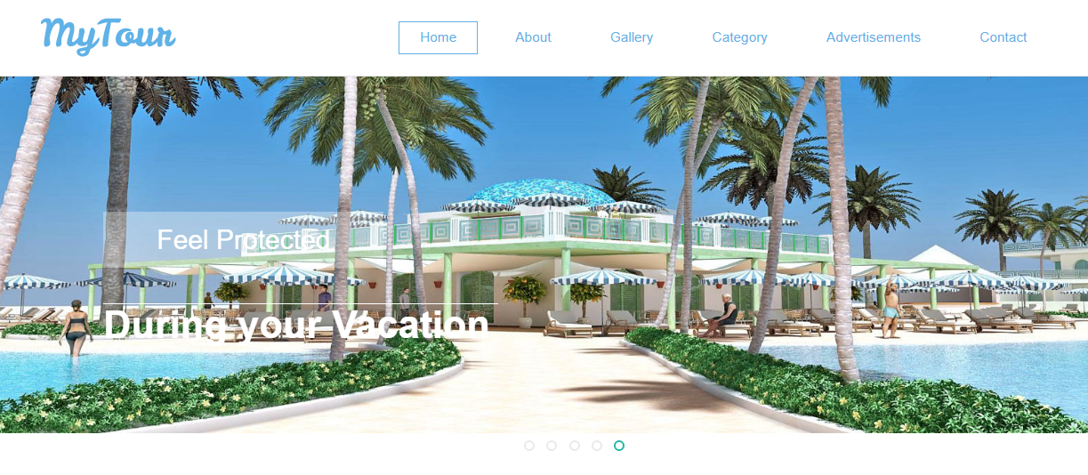

FIGURE 4.1: Index page output design
This is the dashboard where every icon can be accessed, one click on any icon displayed on the diagram above will direct you to another page.

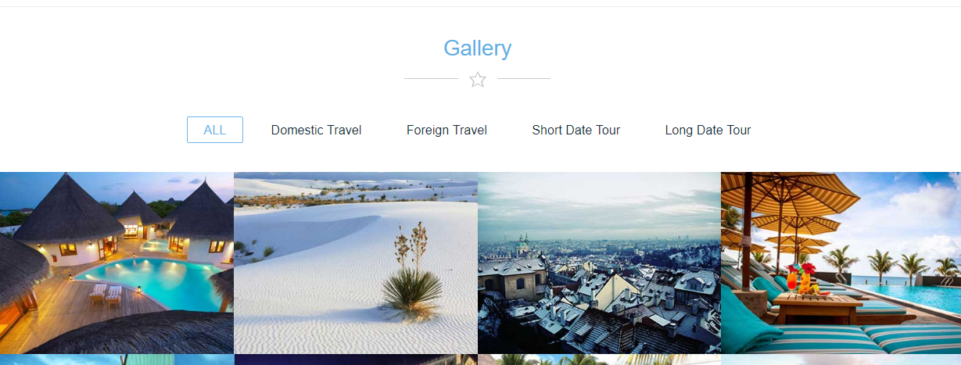
Figure 4.2: Gallery Module Screenshot
This is where the place of tour output will be displayed on the output page as shown above.

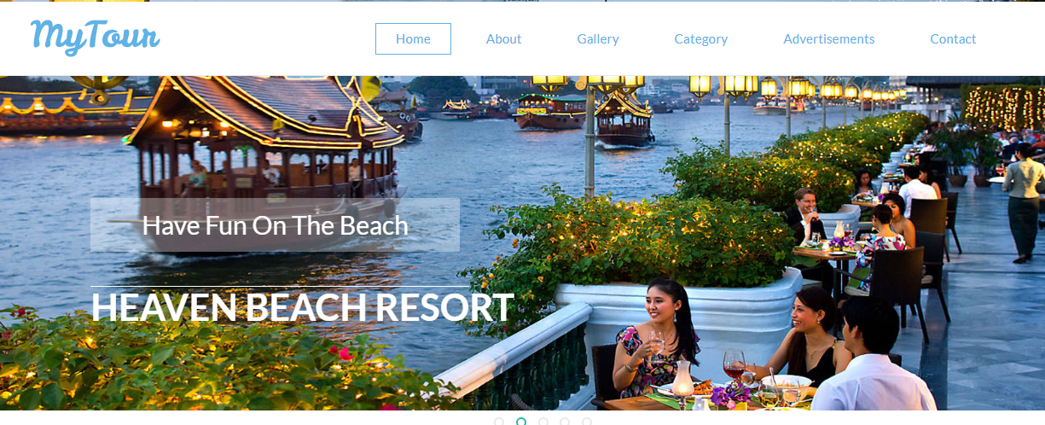
Figure 4.3: Category Module Screenshot
This is where all available places to be visited are displayed.

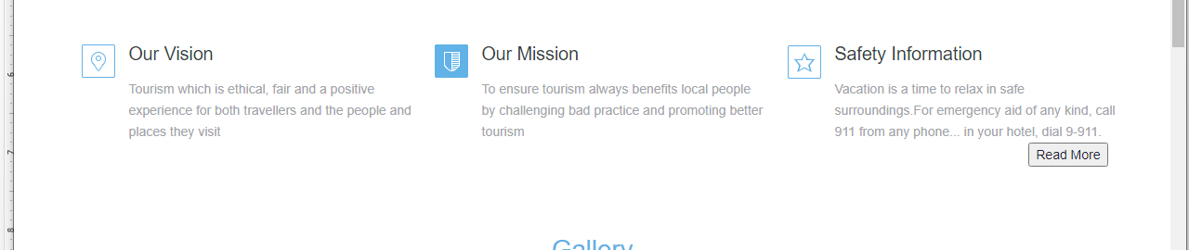
Figure 4.4: About Module Screenshot
This is where, contact as well as the mission are displayed.

4.1.2 INPUT DESIGN
Design is a way of mapping and arranging part into a whole, which satisfies the objective involved. The input design refers to the type of all data used to feed information into the database via the program and the format and the input used for the system. Below are the snapshots of the input designs

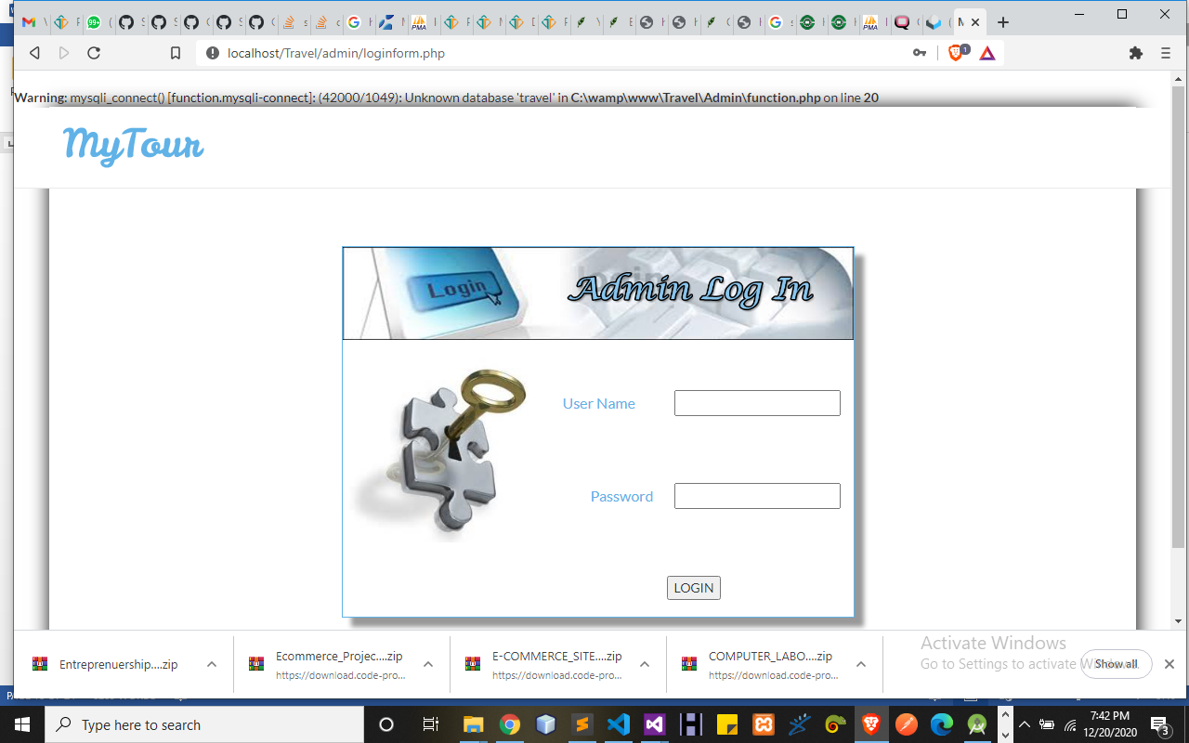
Figure 4.5: Login Page Screenshot
This is the Admin login page.
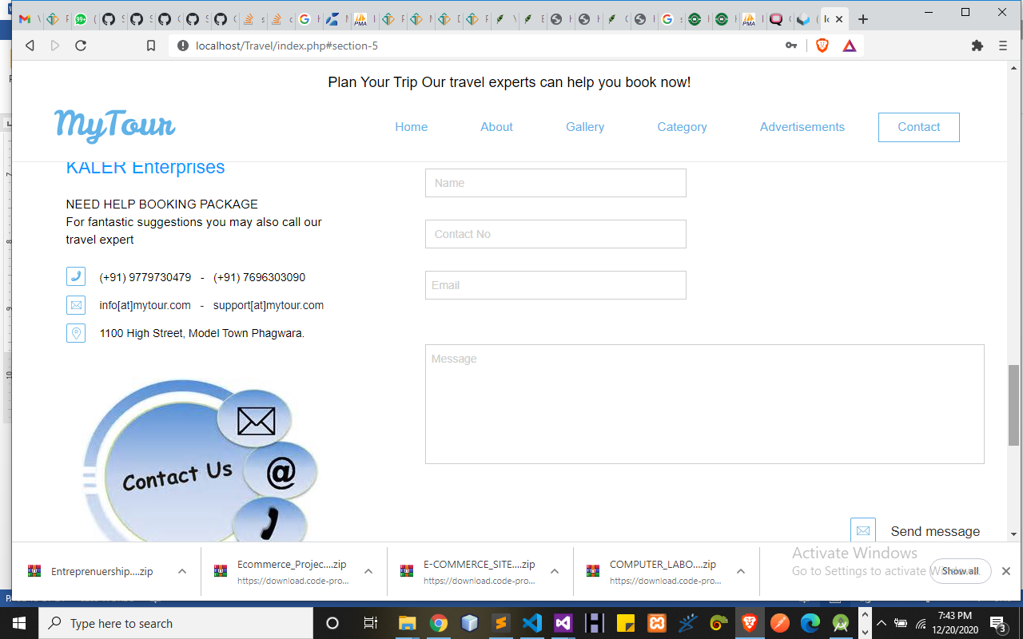
Figure 4.6: Contact Us Module Screenshot
This is where every message received.

4.1.3 DATABASE
Database entails the organization and access mode that are implemented in carrying out our specified operations upon the records of the file.
The files used in this system have records that have been organized randomly (random organization) and for this purpose, it will be more appropriate to access the records of the files randomly (random access mode).
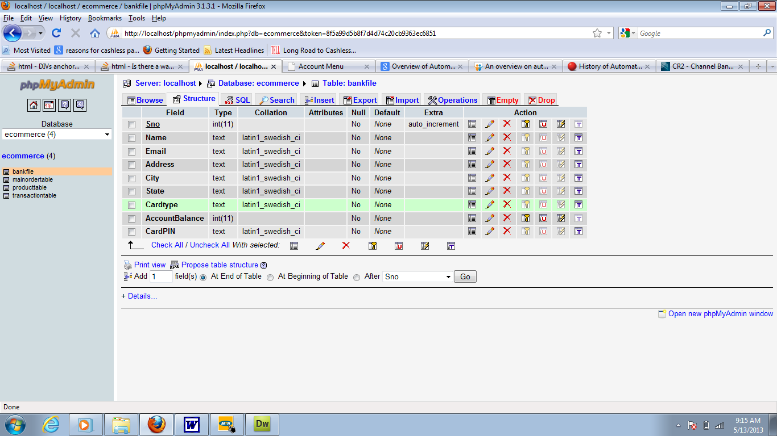
Figure 4.7: Book tour table structure
This is a database where all sales entry or data are displayed are stored.
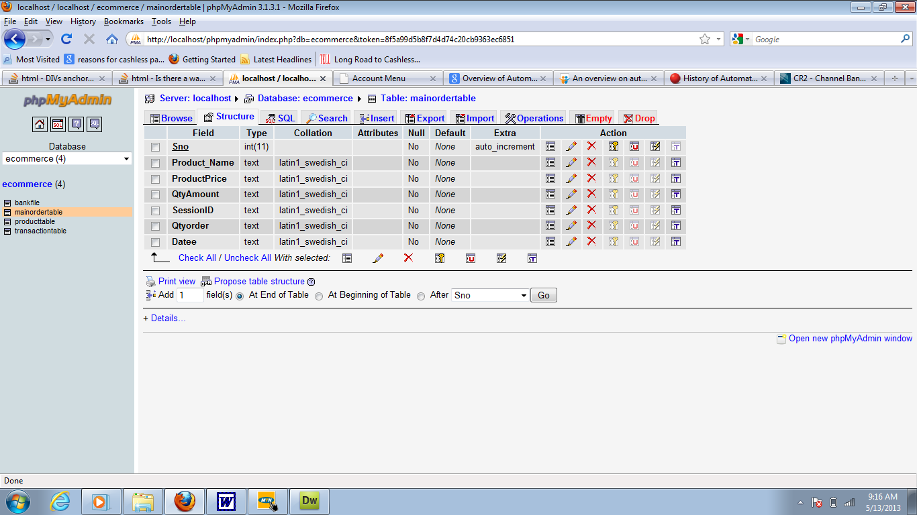

Figure 4.8: Customer table structure
This is a database where all customers entry or data are displayed are stored.

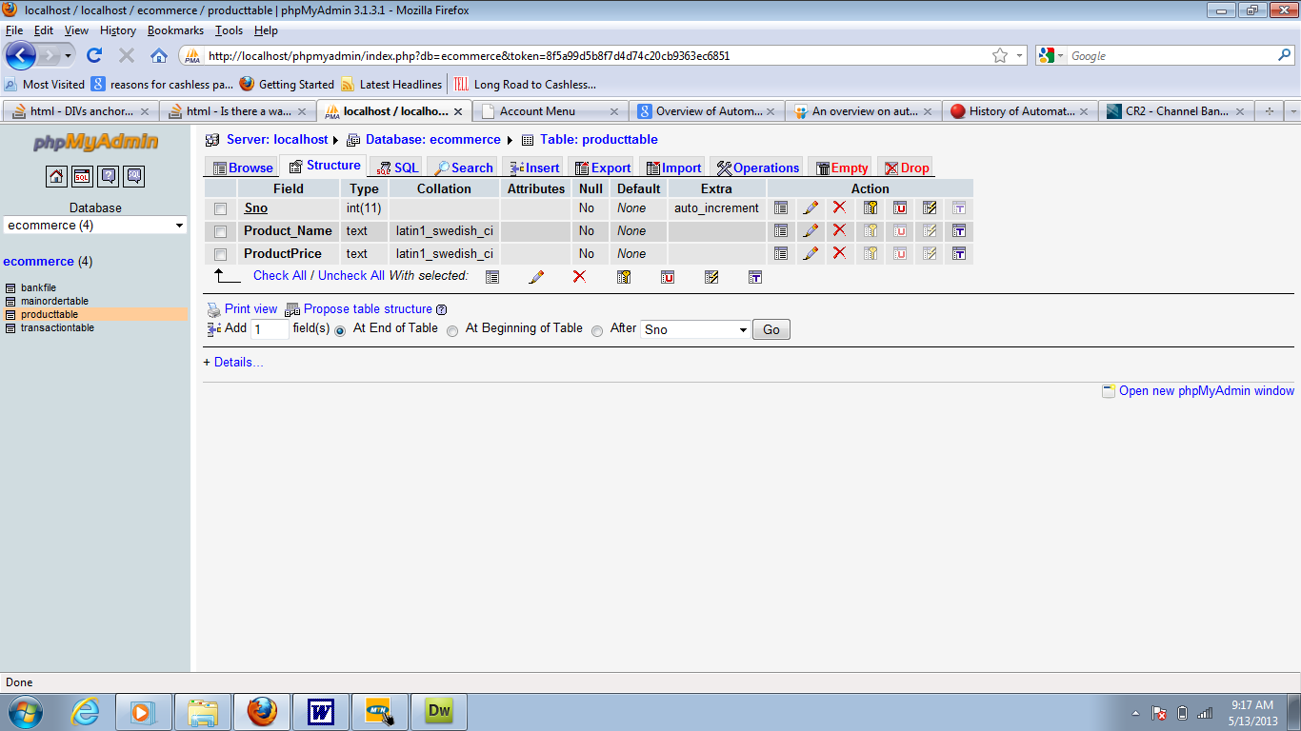
Figure 4.9: User page
This is a database where the admin entry or data are displayed are stored.

4.1.3 PROCEDURE DESIGN
Procedures are steps which verify the whole process i.e which are everything put together to produce the desired output. This involves the organization of the source document and end with the output result.
Documents are sent to various departments to be filled by the employees and later returned to the personnel department which are analysed to determine which record goes into the computer.
After selecting the necessary data, this serves as input to the computer system.

4.2 IMPLEMENTATION OF THE SYSTEM
It is always good to develop new ideas, to implement them on a computer and eventually to relish the satisfaction of achieving a successful result. The implementation process involves converting the system design into a complete and tested EDP that is fully operational and that can be used by the system users to meet their business needs. During implementation phase, the hardware and the software must be implemented.
Implementation of a system can be explained in six steps:-
1. Review design specification
2. Code, test and document programs
3. Train users
4. Perform system test
5. Convert to new system
6. Evaluate and maintain the new system

4.2.1 CHOICE OF PROGRAMMING LANGUAGE
The application is designed in Adobe CS4 Dreamweaver web development package which involves the use of PHP server-side scripting language, MYSQL for database management and HTML (with other embedded functionalities) for the page design and layout settings. Hence, the program testing simply involves running it directly from a Mozilla Firefox web browser on local host server provided by Apache 2.0 in WampServer 2.0 application.
In preparation for the installation of the new system, the method of changeover is given serious consideration to determine the success of the new system. Suitable changeover technique for this system is pilot changeover. The pilot changeover operates by applying the new system bit-by-bit until it covers the whole of the operations. The result obtained from using the pilot method on a small portion of the operations would be used in determining the suitability of the need system for the rest of the operations. This method is similar to testing small sample of a distribution if the test yields a good result then the whole system because fully operational and the manual/existing system is eliminated.

4.2.2 HARDWARE SUPPORT
i. Minimum of Microcomputer Pentium II- Intel 533 MHZ processor, 128 MB RAM, 3.5GB HDD, 3.5”FDD, 14” VGA Monitor Windows 2000 Enhanced keyboard, mouse and pad.
ii. Scanner
iii. Printer
iv. HP DeskJet 3820c series

4.2.3 SOFTWARE
I. Interface Design Language, windows Notepad for help interface design Hypertext Mark-up Language (HTML)
ii. MY SQL Database Management Software
iii. Programming PHP (Hypertext Pre-processor)
iv. Operating system window 07 professional
v. Graphic software paint shop and choosing these two formats GIF (Graphic Image Format)
vi. Scanner software, Mira scan
- Web browser software MOZILLA

4.3 PROGRAM DOCUMENTATION
4.3.1 DESIGN METHODOLOGY
This system will be developed with Macromedia dreamweaver as the text editor while MYSQL will be use as the back end with PHP as the server side scripting language and JAVASCRIPT as the client side scripting language for form validation and user input method.
The system will be design with Macromedia dreamweaver as the text editor using Html and Css for interface design, php and javascript as scripting language, SQL for database provision for querying the database and phpMyAdmin as the database management system.

4.3.2 OPERATING THE SYSTEM
Step 1: Boot your computer and click on start button on task bar
Step 2: Launch wamp server
Step 3: Login to your Application
Step 4: Click on Options
4.1 Click on book Tour (to tour)
4.2 Click on Location (to add location)
4.3 Click on customers (to add customer)
4.4 Click on tour Report (to check for tour report)
Step 5: Logout

4.3.3 MAINTAINING THE SYSTEM
The use of the term maintenance for software is different from other references to maintenance. Unlike the tires on your car, software does not “wear out”. If this is the case, then why does software maintenance account for such a high percentage of the Total Cost of Ownership for software?
The software maintenance definition refers to changes for defect correction, performance improvements, or adaptations to a changed environment (enhancements). According to this definition, if we build software that is defect-free, performs well, and contains user-controlled parameters to adjust processing rules in response to changing requirements then most maintenance would not be necessary.
Why does this happen? There are many reasons but the most common reasons are time constraints and lack of experience. Adding validation logic takes time. So, people make assumptions about the quality of in-bound data. Assumptions are also made about the volume of transactions and the impact on performance and the stability of the automated business processes. Finally, it is common for new software to be developed by younger developers who don’t understand the maintenance impacts of their designs.
The reality is that business requirements change and most of these assumptions are flawed. Transaction volumes increase, changing business processes require new transactions or new validation criteria, and software users will use the software incorrectly. The cost of software maintenance and the total cost of ownership can dramatically be reduced if developers build software that adjusted to changes in transaction volumes; validated all inbound data and provide user-configurable options for decision logic and data validation.

CHAPTER FIVE
SUMMARY, CONCLUSION AND RECOMMENDATION
5.1 SUMMARY
Tourism can be defined as the act of traveling for sightseeing, leisure, religious, family or business reasons usually for a limited time particularly away from one’s home. Tourism as a word came from two Latin words: which are ‘tornae’ and ‘ism’. ‘Tornae’ means a lathe or circle and ‘ism’ means an action or process. The suffix ‘ist’ means who performed an action (WTTC, 2002). According to the world tourism organization (WTO), tourist is people who travel to other places for at most a year for reasons including business, leisure, and other purposes. ‘A tourist is a person who travels for fun rather than for reasons related to business or an individual who travels to a place or attends a social event out of curiosity. Because of the lack of technology, tourists have a problem of accessing tourism information in some region. Both national and international tourists have been facing problems in acquiring tourist sites and accommodation during their stay in regions. In order to alleviate this trouble, this research project proposes the development of android-based tourism guide application where by the tourist can have information about the places any time anywhere. The aim of this project is to develop an android based intelligent tourism guide. The objectives of this project are to: i. develop a user-friendly android application that will enable tourists to navigate easily to their preferred destination. ii. Develop the application using Java Programming Language. iii. test the application.

5.2 CONCLUSION
For so long and still tourism attraction sites have not been promoted enough. The reason behind the bottleneck is the lack of using technology in promoting. Usage of technology especially mobile based application in tourism sector allows both parties to connect and increases the accessibility of information. The final outcome of this research project is very beneficial for the tourists. This mobile application is much more convenient than using a booklet since the tourists can easily install the application and use it without much difficulty. It replaces the traditional tour guides by providing important services for the tourists.

5.3 RECOMMENDATION
I recommend that more research should be done on this project work for tourist’s tour effectiveness. Artificial intelligence should be appended for automation.
REFERENCES
Ardahaey (2021). Economic impacts of tourism industry. International Journal of Business and Management, 6(8), 206-215.
Esuola, (2019) Tourism and Hidden Treasures of Nigeria: Investment Opportunities in the Nigeria Tourism Industry. Bloomington, Indiana. Xlibris Corporation
Esuola, (2019). Tourism and hidden treasures of Nigeria: investment opportunities in the Nigeria tourism industry. Xlibris.
Foster & Rosenzweig (2020). Agricultural productivity growth, rural economic diversity, and economic reforms: India, Economic Development and Cultural Change, 52(3), 509-542.
IEA. (2020). What is ergonomics? Available at: http://www.iea. cc/01_what/What%20is%20Ergonomics.html [March 30, 2020].
Kiper, (2021). Role of Ecotourism in Sustainable Development. Retrieve from https://www.intechopen.com/books/advances-in-landscape-architecture/role-ofecotourism- in-sustainable-development
Lugo (2020). Can we manage tropical landscapes?–an answer from the Caribbean perspective. Landscape Ecology, 17(7), 601-615.
Mowforth & Munt (2020). Tourism and sustainability: Development, globalisation and new tourism in the Third World: Fourth edition. 10.4324/9781315795348
National Academy of Sciences. (2021). Health Care Comes Home: The Human Factors. The National Academic Press. 500 fifth Street, N. W. Washington, DC 20001. https://www.nap.edu/catalog/13149/health-care-comes-home-the-human-factors

SYSTEM FLOWCHART
Start
Stop
Login
Main Menu
Schedule Time
My Booked
Send Message
Inbox
Sent Messages
Profile
Information
Logout
Update Profile

LOGIN
Yes
Start
Enter Username and Password
Is any field empty?
Is Username and Password Correct?
Main Menu
Return
Invalid Username and Password
Open Database

Close Database

All field are required to proceed

MAIN MENU
No
Yes
No
No
Select option
Is it option Schedule Time?
End Select
Return
Schedule Time
Open Database

Close Database

Yes
No
Is it option My Booked?
My Booked
Yes
No
Is it option Send Message?
Send Message
Yes
No
Is it option Inbox?
Inbox
Yes
No
Is it option Sent Messages?
Sent Messages
Yes
No
Is it option Profile?
?
Profile
Yes
No
Is it option Information?
?
Information
Yes
Is it option Logout?
?
Logout

Start

SCHEDULE TIME
No
Yes
Start
Enter Schedule Time Details
Is any field empty?
Display Scheduled Time Details
Return
Open Database

Close Database

Save to Database
All field are required to proceed

MY BOOKED
Start
Display My Booked
Stop
Open Database

Close Database

SEND MESSAGE
No
Yes
Start
Enter Message Details
Is any field empty?
Return
Open Database

Close Database

Save to Database
All field are required to proceed

Start
Display Inbox Messages
Stop
Open Database

Close Database

INBOX

SENT MESSAGES
Start
Display Sent Messages
Stop
Open Database

Close Database

PROFILE
Start
Display Profile
Stop
Open Database

Close Database

INFORMATION
Start
Display Information
Stop
Open Database

Close Database

UPDATE PROFILE
No
Yes
Start
Enter Profile Details
Is any field empty?
Update Student Details
Stop
Open Database

Close Database

Save to Database
All field are required to proceed

LOGOUT
No
Start
Open Database
Select Logout Option
Are You Sure You want to Logout?
Yes
Main Menu
Close Database
End

Source Code
Gallery Module
<?php include 'includes/session.php'; ?>
<?php
$output = '';
if(!isset($_GET['code']) OR !isset($_GET['user'])){
$output .= '
<div class="alert alert-danger">
<h4><i class="icon fa fa-warning"></i> Error!</h4>
Code to activate account not found.
</div>
<h4>You may <a href="signup.php">Signup</a> or back to <a href="index.php">Homepage</a>.</h4>
';
}
else{
$conn = $pdo->open();

$stmt = $conn->prepare("SELECT *, COUNT(*) AS numrows FROM users WHERE activate_code=:code AND id=:id");
$stmt->execute(['code'=>$_GET['code'], 'id'=>$_GET['user']]);
$row = $stmt->fetch();

if($row['numrows'] > 0){
if($row['status']){
$output .= '
<div class="alert alert-danger">
<h4><i class="icon fa fa-warning"></i> Error!</h4>
Account already activated.
</div>
<h4>You may <a href="login.php">Login</a> or back to <a href="index.php">Homepage</a>.</h4>
';
}
else{
try{
$stmt = $conn->prepare("UPDATE users SET status=:status WHERE id=:id");
$stmt->execute(['status'=>1, 'id'=>$row['id']]);
$output .= '
<div class="alert alert-success">
<h4><i class="icon fa fa-check"></i> Success!</h4>
Account activated - Email: <b>'.$row['email'].'</b>.
</div>
<h4>You may <a href="login.php">Login</a> or back to <a href="index.php">Homepage</a>.</h4>
';
}
catch(PDOException $e){
$output .= '
<div class="alert alert-danger">
<h4><i class="icon fa fa-warning"></i> Error!</h4>
'.$e->getMessage().'
</div>
<h4>You may <a href="signup.php">Signup</a> or back to <a href="index.php">Homepage</a>.</h4>
';
}

}

}
else{
$output .= '
<div class="alert alert-danger">
<h4><i class="icon fa fa-warning"></i> Error!</h4>
Cannot activate account. Wrong code.
</div>
<h4>You may <a href="signup.php">Signup</a> or back to <a href="index.php">Homepage</a>.</h4>
';
}

$pdo->close();
}
?>
<?php include 'includes/header.php'; ?>
<body class="hold-transition skin-blue layout-top-nav">
<div class="wrapper">

<?php include 'includes/navbar.php'; ?>

<div class="content-wrapper">
<div class="container">

<!-- Main content -->
<section class="content">
<div class="row">
<div class="col-sm-9">
<?php echo $output; ?>
</div>
<div class="col-sm-3">
<?php include 'includes/sidebar.php'; ?>
</div>
</div>
</section>

</div>
</div>

<?php include 'includes/footer.php'; ?>
</div>

<?php include 'includes/scripts.php'; ?>
</body>
</html>

Login Module
<?php include 'includes/session.php'; ?>
<?php
if(isset($_SESSION['user'])){
header('location: cart_view.php');
}
?>
<?php include 'includes/header.php'; ?>
<body class="hold-transition login-page">
<div class="login-box">
<?php
if(isset($_SESSION['error'])){
echo "
<div class='callout callout-danger text-center'>
<p>".$_SESSION['error']."</p>
</div>
";
unset($_SESSION['error']);
}
if(isset($_SESSION['success'])){
echo "
<div class='callout callout-success text-center'>
<p>".$_SESSION['success']."</p>
</div>
";
unset($_SESSION['success']);
}
?>
<div class="login-box-body">
<p class="login-box-msg">Sign in to start your session</p>

<form action="verify.php" method="POST">
<div class="form-group has-feedback">
<input type="email" class="form-control" name="email" placeholder="Email" required>
<span class="glyphicon glyphicon-envelope form-control-feedback"></span>
</div>
<div class="form-group has-feedback">
<input type="password" class="form-control" name="password" placeholder="Password" required>
<span class="glyphicon glyphicon-lock form-control-feedback"></span>
</div>
<div class="row">
<div class="col-xs-4">
<button type="submit" class="btn btn-primary btn-block btn-flat" name="login"><i class="fa fa-sign-in"></i> Sign In</button>
</div>
</div>
</form>
<br>
<a href="password_forgot.php">I forgot my password</a><br>
<a href="signup.php" class="text-center">Register a new membership</a><br>
<a href="index.php"><i class="fa fa-home"></i> Home</a>
</div>
</div>

<?php include 'includes/scripts.php' ?>
</body>
</html>

