CADASTRAL LAYOUT SURVEY OF PART OF DE-GOLDEN SISTER RESIDENTIAL LAYOUT
AT ALUFA AGUNBIADE VILLAGE, SENTU COMMUNITY, OFF OKE-OSE - LAJIKI ROAD, ILORIN EAST LOCAL GOVERNMENT AREA, KWARA STATE, NIGERIA.

PRESENTED BY

AFOLAYAN JOSHUA O.
ND/23/SGI/FT/0002

SUBMITTED TO THE DEPARTMENT OF SURVEYING AND GEOINFORMATICS, KWARA STATE POLYTECHNIC, ILORIN, KWARA STATE.

IN PARTIAL FULFILMENT OF THE REQUIREMENTS FOR THE
AWARD OF NATIONAL DIPLOMA IN SURVEYING AND GEOINFORMATICS.

JUNE, 2025.

CERTIFICATE
I hereby certify that all the information given in this project was obtain as a result of the observation and measurements, carried out by me in accordance with survey rules, regulation and departmental instructions.

--------------------------- ---------------------------
AFOLAYAN JOSHUA O. DATE AND SIGNATURE
ND/23/SGI/FT/0002

CERTIFICATION
This is to certify that Afolayan Joshua O. Matric no: ND/23/SGI/FT/0002 has satisfactorily carried out his project under my instructions and direct supervision. I hereby declare that he has conducted himself with diligence, honesty and sobriety on the project.

.................................... .......................................
Surv. I. I. Abimbola Date and Sign
(Project Supervisor)

.................................... .......................................
Surv. Babatunde Kabir Date and Sign
(Project Supervisor)

....................................... ........................................
Surv. R. S. Awoleye Sign and Date
Project Coordinator

………………………….. ……………………………
Surv. I. I. Abimbola Sign and Date
Head of the Department

………………………….. ……………………………
External Examiner Sign and Date

DEDICATION
I dedicate this project report to beloved family.

ACKNOWLEDEMENT
Glory be to Almighty Allah the most beneficent, the most merciful and the most compassionate, the king and the master of the day of resurrection for his guidance and protection over my life from the beginning of my PROJECT program till the end, to him be all honour, glory and adoration.
I extend my profound gratitude to my father Mr. Afolayan and to my mother Mrs. Afolayan for the guidance they gave to me spiritually, morally and financially. May Almighty Allah reward them with his blessings and guidance and may they live long to reap the fruit of their labour (Amin).
Also, I express my sincere appreciation to my supervisor, Surv. I. I. Abimbola and Surv. Babatunde Kabir for their assistance and guidance that they have given during the course of this project, even of on its tight schedule.
My immense appreciation goes to head of department in person of Surv. I.I Abimbola, and lecturers. Surv. Banji, Surv. Babatunde Kabir Surv. Felix Diran, Surv. Kazeem, Mr.Benard, Surv. R.S Awoleye and others for their support and advice during the project period.
I also acknowledge my project coordinator Surv R.S AWOLEYE. I can't forget all my colleagues for their cooperation, believe and understanding towards the successful completion of this project. I wish all of us success.

ABSTRACT
This project is the layout survey of the property of De-golden sisters at Sentu village, off Oke-ose to Lajiki road, Ilorin East Local Government Area, Kwara State. The components of the project include: Perimeter survey, setting out of points, beaconing of demarcated points, and coordination of 56 plots of land and production of layout plan at a suitable scale. The survey was tied to three existing control within the vicinity and the survey data was computed and AutoCAD Software was used for plotting of the final layout plan. Kolida (Model: SET 02) Total Station with its accessories were used for the setting out and final survey exercises. A total number of 80 points were monumented and surveyed. The total area covered is 2.7383 hectares. The average area of the plots is within 960Sqm. Being a third order job, an accuracy of 1:20,000 was achieved.

TABLE OF CONTENTS
- Title page
- Certificate
- Certification
- Dedication
- Acknowledgement
- Abstract
- Table of contents
Pages
CHAPTER ONE
1.0. INTRODUCTION 1-2
1.1. STATEMENTS OF PROBLEM 3
1.2. AIMS OF THE PROJECT 3
1.3. OBJECTIVES OF THE PROJECT 4
1.4. SCOPE OF THE PROJECT 4
1.5. SPECIFICATION OF THE PROJECT 4-5
1.6. PROJECT LOCATION 6
1.7. PROJECT LOCATION 7

CHAPTER TWO
2.0. LITERATURE REVIEW 8-11

CHAPTER THREE
3.0 PROJECT PLANNING 12
3.1 RECONNAISANCE 12
3.2 FIELD RECONNAISANCE (RECCE) 12
3.3 OFFICE PLANNING 12
3.4 INSTRUMENT TEST 13
3.5 TEST OF TOTAL STATION COLLIMINATION TEST 13
3.5.1 PROCEDURE FOR COLLIMINATION AND VERTICAL INDEX ADJUSTMENT 14
3.5.2 IN-SITU CHECK OF CONTROLS USED 15
3.6 SCHEDULE OF FIELD WORK 16
3.7 DATA ACQUISITION 16
3.8 SETTING OUT OF POINT 17
3.9 MONUMENTATION 18
3.10 TRAVERSING 19

CHAPTER FOUR
4.0 DATA DOWNLOADING AND PROCESSING 20
4.1 DATA PROCESSING & ANALYSIS 20
4.2 PLOTIND AND PLAN PRODUCTION 21
4.3 PROJECT STATISTICS 21
4.4 COMPUTATIONS 21-22
4.5 DISCUSSION OF RESULT 23
4.5.1 PERIMETER SURVEY PLAN 24
4.5.2 DISGN PLAN 25
4.5.3 LAYOUT PLAN 26

CHAPTER FIVE
5.0 SUMMARY, CONCLUSION, PROBLEMS ENCOUNTERED AND RECOMMENDATION 27
5.1 SUMMARY 27
5.2 CONCLUSION 27
5.3 PROBLEMS ENCOUNTERED 28
5.4 RECOMMENDATION 28
REFERENCE 29
RAW DATA 30-31

CHAPTER ONE
1.0 INTRODUCTION
Cadastral surveying is the sub-field of cadastral and surveying that specializes in the establishment and re-establishment of real property boundaries. It involves the physical delineation of property boundaries and determination of dimensions, areas and certain rights associated with properties. This is regardless of whether they are on land, water or defined by natural or artificial features. It is an important component of the legal creation of properties. A cadastral surveyor must apply both the spatial-measurement principles of general surveying and legal principles such as respect of neighboring titles.
A layout design deals with the splitting of a given parcel of land into smaller developable units in such a manner that township planning requirements are made. Generally, a planned town requires a separation into four distinct parts (i.e. the residential area, the industrial area, the town center and open space (recreational / social centre) A layout plan is a design of roads, plots, social and recreational facilities and other utilities which has been drawn up by the town planners and has been approved on paper by the concerned authorities. The actual operation of marking out this design is called layout survey.
The development of any of these units is preceded by a planner design which is made after a very careful study of economic and social factors or considerations. The operation of marking out the design on the ground is called layout survey. The operation is thus almost the opposite the normal survey procedure where details already on the ground are reproduced to scale on paper. The total process of planning is therefore the responsibilities of at least two professionals, the town planner and the surveyor.
The fundamental requirement of a layout design is a base map.This​is a large scale topographical map of the area selected for development. The surveyor also produces the base map by running a traverse round the area and by preparing a map showing the feature within the area. Demarcation must be made permanent by the using of a standard property beacon (PBs) 18 X 18 cm X 76cm of mixture 1:2:3 of cement, gravel and sand.
​ The ​base ​map ​should ​be ​prepared ​on ​mounted ​paper. ​The principles to be adopted in the execution of the layout survey are the same as in other types of works. The principle of working from whole to part must be followed; the main control points and block corner points of the layout must be established accurately first and their positions checked before the subdivision is carried out.
A Layout Survey also known as Construction Staking, is the process of interpreting construction plans and marking the location of proposed new structures such as roads or buildings. Layout survey is performed to ensure a project is built according to engineering design plans. The staked reference points guide the construction of proposed improvements on the property, and will help to ensure the construction project is completed on schedule, on budget and as intended.
As with all field layouts, the construction staking needs to be verified by some type of independent check. Construction should not proceed until the Surveyor has been afforded the time to confirm the layout is correct. This may mean a set of reties or alternate layout checks.
factors​ to​ be​ considered​ when designing a layout plan
- Terrain and slope of the land.
- Nature of the soil.
- The nature of the surface drainage.
- The provision of physical infrastructure.
Land is one of the most valuable resources in any society. Its ownership, usage, and development are fundamental to economic growth, urban planning, and sustainable development. As such, the need for precise, well-documented land boundaries has made cadastral surveying a cornerstone of effective land administration. A cadastral layout survey, specifically, is the process of subdividing land into plots or parcels, defining their boundaries for legal, developmental, or ownership purposes.
According to the International Federation of Surveyors (FIG), a cadastre is defined as *“a parcel-based, up-to-date land information system containing a record of interests in land (e.g., rights, restrictions, and responsibilities)”* (FIG, 1995). These surveys provide the spatial framework necessary for property registration, land valuation, planning approvals, and the resolution of land disputes. The significance of cadastral layout surveys has grown in response to increasing urbanization and land pressure, particularly in developing countries where informal land occupation and tenure insecurity are common. In urban areas, proper cadastral planning ensures that land is efficiently allocated for residential, commercial, industrial, and public use, with provision for infrastructure like roads, drainage, and utilities. In rural regions, it supports agricultural planning, resource management, and tenure formalization.
Modern cadastral layout surveys employ advanced geospatial technologies such as GNSS (Global Navigation Satellite Systems), Total Stations, GIS (Geographic Information Systems), and UAVs (Unmanned Aerial Vehicles), which have significantly improved the speed, accuracy, and versatility of land surveys. These technologies enable surveyors to collect, process, and present data in formats suitable for decision-making by urban planners, engineers, and land management authorities (Enemark, 2010).
1.1 STATEMENT OF PROBLEM
Inaccurate or incomplete data can lead to boundary disputes, property ownership conflicts and difficulties in land transactions. In many cases, the lack of reliable cadastral information can hinder economic development, leading to social unrest and create challenges for land administration authorities. Therefore, conducting a thorough cadastral survey is essential to gather accurate data and mitigate these risks land dispute among the land owner and other unrest issue in a smart community. This call for the layout of landed property said to belong to the De-Golden sister at Sentu Village.
1.2 AIM OF THE PROJECT
The aim of this project is to carry out Cadastral Layout Survey of plots of land belongs to De-Golden Sister at Sentu Village to accurate delineate the plots and produced a reliable data on land parcels within the designated area, This data will serve as a foundation for land administration, property registration, and urban planning.
1.3 OBJECTIVES OF THE PROJECT
The objectives of this project are:
- To determine the boundaries and ownership of land parcel within the designated area (perimeter plan).
- To provide accurate data on property values and land use (computation sheet).
- To produce area computation sheet.
- To produce standard layout plan

  - SCOPES OF THE PROJECT
- Planning
- Reconnaissance
- Monumentation
- Perimeter Travers
- Layout Design
- Setting-out and Traversing
- Data Processing
- Information Presentation
1.5 PROJECT SPECIFICATIONS
Project is based on the procedures used to execute a project in terms of how the measurements are taken. Specifications mean the requirements necessary to be met when carrying out the survey job of any order (cadastral layout survey). The following specifications are followed:
- Establishment​ of ​traverse​ points​ with​ property​ beacons ( monumentations ).
- Traverse commenced on three existing control points and closed on the same set of controls to check if the traverse is precise and accurate. The accuracy of the control points was found undisturbed before using them for orientation.
- The ​sub-division ​of ​the project ​area​ was ​done ​with ​the dimension of 15.25m x 30.50m for each plots and turning right angle.
- The residential plots should be regular and standard plots 50ft by 100ft.
- Property beacons should be emplaced at all plots.
- Each plot must have access road.
- The accuracy of the job should be third order. (less than1:3,000).
- There mustn't be cross or plus junction without a roundabout within the layout.
- Avoid sharp turning.

1.6 PROJECT LOCATION
The project site is situated in Alufa Agunbiade village area, Sentu community, off Oke-Ose - Lakiji Road, Ilorin East L.G.A, Kwara State which has an area of 2.747 hectares and it fall on geographical coordinate of 8°30'59.96"N ; 4°41'11.16"E to 8°31'9.67"N ; 4°41'10.73"E. The figure below shows the maps of the study area.
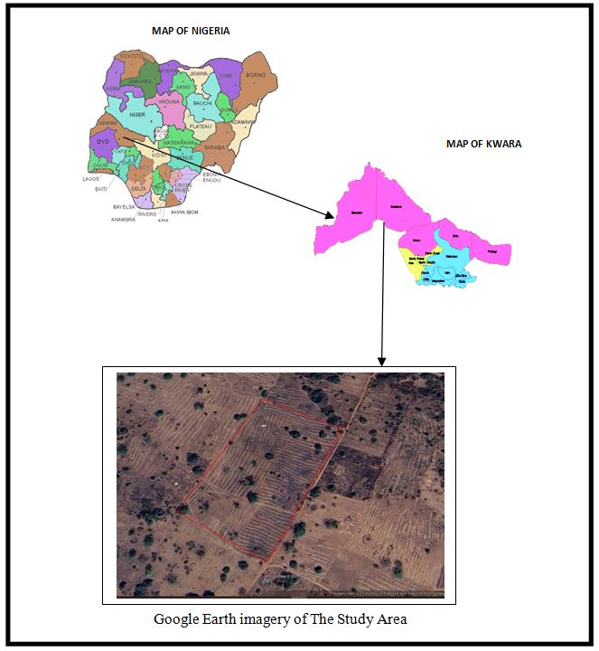

1.7 PERSONNEL MEMBERS OF THE GROUP
The following students contributed greatly to the success of the field practical and they are;
S/N | Name | Matric No | Roles
1. | Afolayan Joshua O. | ND/23/SGI/FT/0002 | Author
2. | Oloyede Favour Eniola | ND/23/SGI/FT/0001 | Member
3. | Idris Abdullahi Umar | ND/23/SGI/FT/0003 | Member
4. | Ajide Racheal Oluwasewun | ND/23/SGI/FT/0004 | Member
5. | Kareem Abass Adebayo | ND/23/SGI/FT/0005 | Member
6. | Sulyman Muinat Bukola | ND/23/SGI/FT/0008 | Member
7. | Olafimihan Racheal Olamide | ND/23/SGI/FT/0009 | Member
8. | Babatomi Favour | ND/23/SGI/FT/0011 | Member
9. | Haroon Abdulmutolib Opeyemi | ND/22/SGI/FT/0018 | Member

CHAPTER TWO
2.0 LITERATURE REVIEW
Land registration in many countries is carried out with graphical or photographic cadastral application. Land parcel registration method without obstruction from satellite and Ariel images are discussed in this paper. The study was carried out in Azerbaijan. Abn and song (2011) discussed the effectiveness of digital photogrammetry techniques for built up urban areas. Rural areas must be surveyed with total station and GPS. Cadastral surveying accuracy is not elaborate in this paper, because the error leads to land administration problems. Land Administration will be crucial when land values increases. The methodology adopted can be used for the effective study of digital photogrammetry in urban cadastral surveying.
Photographs of scale 1: 500 are tested for cadastral mappings which was study for the city Taskopru in Turkey. The methodology Adopted has proved to be effective for large scale cadastral mappings which was carried out by scale 1:500 0photogrametry in rural areas. Photogrammetry created cadastral error for 1:5000 of scale cannot be adjusted to improve accuracy. Accurate urban maps can be created by adapting 1:1000 or 1:2000 scale photogrammetry (Alkan and solak 2010) Expertise in photogrammetry has been demonstrated through the results detailed in this paper. The results are reliable to carry out further study in cadastral mapping. The methodology suggested is useful for identifying suitable photogrammetry scales for cadastral mapping.
Blagonic and pros ten 2007 has demonstrated the importance of applying cadastral data for environmental protection. Protection of environment can be carried out easily by using cadastral maps. Cadastral maps are used for environmental protection through the identification of land use. Land use of parcels classified as protected can be monitored easily, if the cadastral maps are modernized through computer. Further cadastral accuracy ensures boundary demarcation between protected and unprotected parcel. This paper showcases the importance of multipurpose cadastral system for effective land administration. The author concludes cadastre as significant aspect for adaptive successful land administration procedures.
Cagdas and Stubkjaer (2008) showcases the potential of cadastre to be considered for doctorate research. Research should be carried out in portal's of cadastre such as land administration, land tenures, land registration development and policy making. The aspect of cadastre which should be considered for research are explained. The methodology suggested to frame cadastral research is useful for framing methodologies.
In another work cagdas and stubkjaer (2011) deals with the design of research methodologies to be considered for doctorate research. The paper also identifies key issues for cadastral systems which need focus research for effective solution to problems. The authors by their experience recommend cadastre avenues for consideration for doctorate research leading to development cadastre. This paper concludes by identifying avenues for cadastral research. This paper is useful for identifying avenues for cadastral system requiring research.
Urban information system depends on the quality of cadaster . Cadastre when lack reliability result of urban developing system is devastating. So cete and yomraliogku (2004) suggested resurvey with digital cadastral data. Cadastral data which are poor in quality must be resurveyed digitally according to recommendations of the authors. But the legislation of Cadastral does not permit carrying out of the resurvey. The author shows the quality of cadaster . The authors conclude technical suggestion for improvements by cadastral quality but they are surpassing by influencing factors in Turkey.
Simulation technique is also recommended in the facility planning analysis. Nica, et al [25] reported that queuing phenomena of parts before entering assembly area is in uncertainty arrival time. Simulation is an appropriate tool to help the designer to define the storage spaces of assembly system in this stochastic situation. In this research, a concept of ordered parts buffer is proposed for sequencing parts arrived in the assembly process by robot systems. Simulation based on experimental design is developed by Ekren and Ornek (2000) for typical manufacturing job-shop system. They investigated the effects of layout types and their interactions with other manufacturing parameters that can affect performance of the system.
A simulation model has been developed as an analysis tool for line reconfiguration to accommodate the future demand fluctuation. Line balancing becomes the main issue in the research and fuzzy knowledge base of technique was proposed to help define more realistic scenarios. The necessity of sequence coordination within a complex assembly system is reported. This is due to the fact that the complex assembly system generally includes preassembly section for part preparation and this can only be determined by computer aided simulation.
Cadastral surveys are essential components of land administration systems, providing precise geographic definitions of land parcels and supporting legal, economic, and planning frameworks. As defined by Dale and McLaughlin (1999), a cadastre is a "comprehensive land recording system that includes details of ownership, tenure, location, and size of land parcels." The importance of cadastral systems is underlined in both developed and developing contexts where clarity in land ownership and management can stimulate economic activity, reduce conflict, and support sustainable development (Williamson et al., 2010).

CHAPTER THREE
3.0 PROJECT PLANING
This is the preliminary stages of the project were the schedule and all other logistic will be decided and this planning is done in office in two was below.
3.1 RECONNAISSANCE
Reconnaissance is a very important aspect of any project work in surveying field; it generally consists of two methods.
1. Field reconnaissance
2. Office planning.
3.2 FIELD RECONNAISSANCE (RECCE)
In the process of obtaining field reconnaissance, the site was visited, drawing of the Recce diagram was carried out in order to decide on how best to do the job of the approved layout, the map covering the project site which was prepared by Ministry of Lands and Survey as a guide. The existing control points were located and the values were collected from the survey that did the part of the control to be use lather checking will be done for the in-situ.
3.3 OFFICE PLANNING
The relevant maps in the department were checked in order to get information’s about the site. The coordinates of the nearby control points were also obtained from the Ministry of lands and survey Department. These are the information of the controls within the project site.

Table 2.1 Coordinates of Controls
Pillar No | Northing(m) | Easting(m)
SC/KW B10991R | 941701.318 | 685715.747
SC/KW B10992R | 941756.109 | 685609.382
SC/KW B10993R | 941788.423 | 685544.026
Source: Private Practicing Surveyor
3.4 INSTRUMENT TEST
The Total Station was found to be in good working condition after checking for Collimation error, the Circular plate bubble and Plate level.

3.5 TEST OF TOTAL STATION COLLIMINATION TEST
The following test was carried out to test the workability of the equipment before the data capturing process. The tests are of two types which are
- Temporary Adjustment
- Permanent Adjustment
The temporary adjustments are the ones that are carried out on every station before observation. They are;
- Centering of instrument
- Removal of parallax
The permanent adjustments carried out are
1. Collimation adjustment
2. Vertical Index adjustment
2.5.1 PROCEDURE FOR COLLIMATION AND VERTICAL INDEX ADJUSTMENT
The instrument was set up on station SC/KW B10991R and all necessary temporary adjustments were performed. A target was set up at SC/KW B10991R to the line of site. It was aimed at and bisected. The instrument was switch on and program which is on-board of the instrument was switch to the collimation program. Then, horizontal collimation and vertical index were in sequence recorded and stored in the memory of the instrument. The telescope was transited and the same target bisected. Both the new vertical index and collimation were recorded and stored accordingly. It was transited to the same target with both horizontal and vertical readings recorded to check the instrument’s accuracy. The readings obtained are as follows:
Table 2.2 Test of Total Station
 | Old Reading | New Reading
Horizontal collimation error | +00⁰00’ 14” | +00⁰00’ 09”
Vertical index | +00⁰00’ 20” | +00⁰00’ 04”
 |  | +00⁰00’ 09”
Source: Author 2024
From the above reading, it is shown that the new value have higher precision than the previous. Therefore, the new value is set in the instrument for corrections applicable on any of the two axes.
3.5. IN-SITU CHECK OF CONTROLS USED
The following pillars SC/KW B10991R, SC/KW B10992R and SC/KW B10993R were among the ones found on the ground and checks were carried out on them to determine their true position and reliability.
Checks carried out on these pillars show that:
Observed Included angle = 180° 21’ 12’’
Computed Included angle = 180° 21’ 18’’
Difference: 00° 00’06’’
Observed distance: = 120.305m (SC/KW B10992R - SC/KW B10991R)
Computed distance: = 120.315m (SC/KW B10992R - SC/KW B10993R)
Difference: = 0.010m
Remarks: The difference in both the angular and distance observations was within acceptable limit; hence the Pillars were in-situ.

SC/KW B10993R
SC/KW B10992R
$180°$ 21’12”
SC/KW B10991R

Fig 2.1 In-situ check for control

3.6 SCHEDULE OF FIELD WORK
Having completed the reconnaissance, the schedule of field work was designed as follows:
- Perimeter traverse
- Setting out of boundary beacons
- Layout design
- Pillar Numbering
- Traversing
- Report writing
3.7 DATA ACQUISITION
Layout is the sub-division of parcel of land into blocks and subsequently plots. The surveying process of defining the positions of various beacons that make up a layout on the ground by a surveyor using approved layout design made by the town planner is known as setting out. In the execution of this project the principle of “working from whole to parts” was adhered to as the perimeter beacons that formed the framework for the setting out of the blocks and the blocks formed the framework for the setting out of the plots.
The traditional or classical methods of surveying were decided upon for the execution of this project. The methods are:
- Setting out of the entire perimeter.
- Traverse method for acquisition of the entire perimeter.
- Stake out method for block by block and plot by plot setting out.
- Traverse method and interpolation for acquisition of the entire block and plot data.

3.8 SETTING OUT OF POINTS
Sokkia green label (Model: SET 02) Total Station was set up on SC/KW B10992R and oriented to SC/KW B10991R and coordinates of the stations were keyed into the instrument. Total station computed the bearing between the two stations for orientation. Then coordinates of points to be set out were entered into the total station and the setting out program of the instrument was used to get the angle to turn in order to face the direction of the point after orientation, the instrument was rotated until horizontal angle read 0°00’00”, reflector was held along the direction and distance between the instrument and the reflector was measured.
The instrument displayed the remaining distance as either positive or negative. Positive distance means that the reflector should move away from the instrument by that amount while negative distance means that the reflector should move towards the instrument. When the horizontal angle read 0°00’ 00” and measured distance displayed 0.000m this marked the exact position to be set out. The point was pegged and point number was written with permanent marker. All other points were set out in similar manner. Observations were carried out on the set out points and stored in the instrument memory. Also, the measurements made were found out to be permissible since the incurred error is within allowable. The principle of working from whole to part was observed while setting out the points as the boundary of the layout and some selected points within the boundary of the layout were first observed to server as subsidiary points (minor control points). Subsequent points were set-out from them.

3.9 MONUMENTATION
All the points set out were beaconed with a property beacon in compliance with cadastral survey regulations. The property Beacons were of dimension 18cm x 18cm x 75cm and made of concrete mixture of ratio 3:2:1in (3 parts of sand to 2 part of gravels and 1 part of cement) respectively. These beacons were emplaced in such a way that 15cm of its total length was above the ground surface while the remaining length was buried under the ground.
The boundary pillars were numbered accordingly as they were in the working diagram and where they fell during their setting out. However, the pillars were prefixed with identification mark SCKW. Because SURCON private numbers were obtained from the Office of State Surveyor General

SC/KW
B2134R
10cm
65cm
Ground level
18cm
18cm
18cm
B
R

2134

Fig 2.3 Description of pillar used showing portions above and below the ground
3.10 TRAVERSING
Total station was set up on SC/KW B10992R, switched on and all temporary adjustments were carried out. Then, “Job” was set in the instrument, height of instrument and reflectors were measured with steel tape and stored in the instrument’s memory, and coordinates of the control stations were recalled from the instruments’ memory SC/KW B10991R, was bisected for orientation, and Total station was instructed to compute the bearing between the two stations which was confirmed with a prismatic compass. One of the reflectors was taken to pillar SC/KW B10993R, the reflector’s cross hair was bisected with that of the telescope eye piece of the total station and “All” key was pressed so as to measure and record observation in the memory of the instrument. The instrument was switched off and moved to SC/KW B10993R, and the above stated processes were carried out to coordinate the entire boundary points in X, Y, Z. The above process was repeated for other blocks shown on the plan including subsidiary traverses.
CHAPTER FOUR
4.0 DATA DOWNLOADING AND PROCESSING
The coordinates of the observed boundary were downloaded into the computer and were compiled in Microsoft excel for further processing. A script file of boundary points of individual plot was prepared in note pad using Polyline command. These script file was run in AutoCAD and the area information of each plots as well the bearing and distances of each consecutive lines were obtained.
4.1 DATA PROCESSING & ANALYSIS
The acquired field data was downloaded to the computer in the office. This was done using a NTS software. The following procedure was followed:
- Connecting the SET and host computer, using communication cable.
- Selecting “JOB” in Memory Mode.
- Selecting “comms” output to display the JOB list.
- Pressing OK.
- Selecting the output formation
- At the end of the downloading, the data was displaced in the following format, Point No., Easting and Northing.
The data was then copied to other software such as Microsoft Excel for further processing. Here, the data was arranged and stored as formatted Text (space delimited), ready for plotting. The observed data were reduced and corrected, Master Survey programmer software was used to process the data.

4.2 PLOTTING AND PLAN PRODUCTION
Auto-CAD2007 software was used for plotting all the set out pillars. The plotting procedure was as follows,
- Launch Auto-CAD 2007.
- Select Format on the menu tool bar and set all necessary units such as meter, Decimal places, Directions etc.
- Select tool from the menu bar and highlight run script.
- Open the saved formatted Text from Microsoft Excel.
- Zoom extents, by pressing Z enter and E enter.
All the coordinated points are plotted and displayed on the screen and with the help of the Recce diagram; all the boundary points were joined for individual plots to produce the boundary lines and the existing features such as Roads.
The final Layout plan was plotted at scale of 1: 2,500
4.3 PROJECT STATISTICS
- Total Number of residential plots 56 plots
- Total number of boundary beacons 4
- Coordinate Properties UTM

4.4 COMPUTATIONS
The backward and area computation were done to the coordinates of the boundary pillar as show in the tables below;

Tab: 4.1: the table shows the back computation of the perimeter survey
Station form | Bearing | Distance (m) | ∆N | ∆E | Northing (m) | Easting (m) | To Station
 |  |  |  |  | 942244.886 | 684890.452 | SC/KW  J5920BK
SC/KW  J5920BK | 117° 13' 45’’ | 126.709 | -57.976 | 112.668 | 942186.910 | 685003.119 | SC/KW  J7719BK
SC/KW  J7719BK | 206° 44' 54" | 222.330 | -198.539 | -100.065 | 941988.371 | 684903.055 | SC/KW  B10990R
SC/KW  B10990R | 297° 14' 20" | 119.643 | 54.761 | -106.375 | 942043.132 | 684796.679 | SC/KW  B10991R
SC/KW  B10991R | 024° 55' 42" | 222.481 | 201.754 | 93.772 | 942244.886 | 684890.452 | SC/KW  J5920BK

Tab: 4.2: the area computation by double latitude and single departure.
∆E | ∆N | PRODUCT
112.668 | X -57.976 | = -6532.039968
112.668
225.336
-100.065
125.271 | X -198.539 | = -24871.179069
-100.065
25.206
-106.375
-81.169 | X 54.761 | = -4444.895609
-106.375
-187.544
93.772
-93.772 | X 201.754 | = -18918.876088
93.772
0.000
= -6532.039968 -24871.179069 -4444.895609 -18918.876088
= -54766.990734\2 =27,383.495m²\10000 =2.7383 Hectares
4.5 DISCUSSION OF THE RESULT
The following were the results obtained at the end of the project exercise, they are:
- Perimeter Survey plan.
- Design plan
- Layout plan

4.5.1 PERIMETER SURVEY PLAN
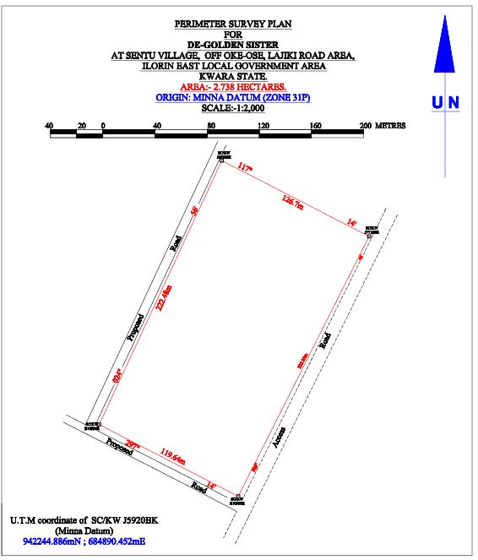

4.5.2 DESIGN PLAN
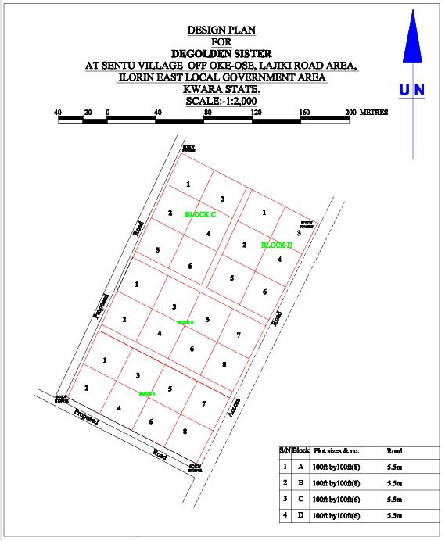

4.5.3 LAYOUT PLAN
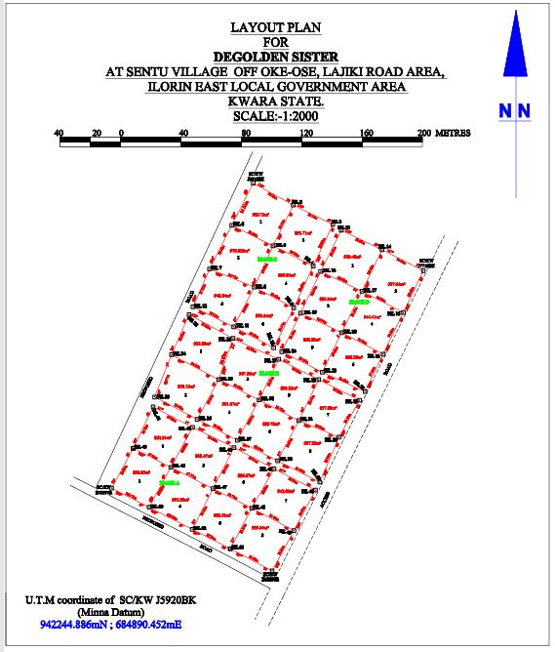

CHAPTER FIVE
5.0 SUMMARY, CONCLUSION PROBLEMS ENCOUNTERED AND RECOMMENDATION.
5.1 SUMMARY
The project area covered a total area 2.738 hectares with total number of 4 pillars used for the Perimeter Survey. Whereas the total number of beacons used for the layout was 54, making a total number of 54 pillars emplaced. The total numbers of plots are 28 at 100ft x 100ft. The project cut across the following; reconnaissance, monumentation and traversing and settingout. Kolida Total Station was used for the geometric data acquisition and its software was used in downloading and transforming the acquired data.
The final adjusted coordinates were used for the production of Perimeter Survey plan and the Layout Survey plan using AutoCAD 2007. The final plan was drawn at a scale of 1:2,000
5.2 CONCLUSION
In every aspect of the project, the results obtained were all within the limits of permissible accuracies. The principle of whole to path was adhering to and all the observations and measurements that were made in total conformity with survey rules and regulations. The final plan was presented to them in hard and soft copies. The hard copy was plotted on A3 paper size.
However, based on the results obtained in the project, it is obvious that the aim of the project has been achieved. Conclusively, I hereby submit the Final Layout Survey Plan of De-Golden sister cooperative Land, which was successfully carried out.

5.3 PROBLEMS ENCOUNTERED
The only problem encountered was from the youths from the area who demanding some money for public relation. This was later settled by the Family representatives.
5.4 RECOMMENDATION
We hereby urge the department to exposed the students to more practical works in and outside the school. This project work show most of us the setting methods and exposed us to the uses of the survey instruments.

References
Abdullahi, A., & Pradhan, B. (2017). *Integrating spatial technologies for effective land administration systems in developing countries*. Geocarto International, 32(2), 165–178.
Bandeira, P., Lima, J., &Formoso, C. T. (2010). *Use of unmanned aerial vehicles in land surveying and mapping*. Journal of Construction Innovation, 10(2), 233–248.
Burns, T., Grant, C., Nettle, K., Brits, A., &Dalrymple, K. (2007). *Land Administration Reform: Indicators of Success and Future Challenges*. World Bank.
Dale, P., & McLaughlin, J. (1999). *Land Administration*. Oxford University Press.

Enemark, S., Bell, K. C., Lemmen, C., & McLaren, R. (2016). *Fit-for-Purpose Land Administration*. FIG & World Bank. Retrieved from
Enemark, S., Williamson, I. P., & Wallace, J. (2005). *Building modern land administration systems in developed economies*. Journal of Spatial Science, 50(2), 51–68.
FIG (International Federation of Surveyors). (1995). *Statement on the Cadastre*. FIG Publication No. 11. Retrieved from
Stoter, J., Ploeger, H., & van Oosterom, P. (2013). *3D Cadastre in an International Context: Legal, Organizational, and Technological Aspects*. CRC Press.
Williamson, I., Enemark, S., Wallace, J., &Rajabifard, A. (2010). *Land Administration for Sustainable Development*. ESRI Press Academic.

RAW DATA
PL | 685715.372 | 941701.43 | 378.762
RD | 685712.862 | 941697.33 | 378.756
PL2 | 685687.678 | 941716.11 | 379.535
PL3 | 685662.456 | 941729.037 | 380.403
B10992R | 685609.007 | 941756.221 | 381.96
PL5 | 685623.378 | 941782.638 | 382.269
PL6 | 685676.16 | 941755.88 | 380.721
PL7 | 685701.779 | 941742.941 | 379.918
PL8 | 685729.781 | 941728.182 | 379.197
PL9 | 685716.533 | 941769.016 | 380.451
PL10 | 685744.061 | 941754.972 | 379.637
PL11 | 685746.929 | 941760.165 | 379.651
PL12 | 685718.942 | 941774.294 | 380.431
PL13 | 685690.1 | 941783.065 | 381.239
PL14 | 685692.255 | 941787.928 | 381.343
PL15 | 685662.604 | 941796.453 | 381.709
PL16 | 685665.695 | 941801.784 | 382.098
G7065KP | 685636.516 | 941809.908 | 382.586
PL18 | 685648.743 | 941844.451 | 383.092
PL19 | 685679.925 | 941828.131 | 382.466
PL20 | 685706.604 | 941814.556 | 381.644
PL21 | 685732.978 | 941800.893 | 380.756
PL22 | 685759.615 | 941789.914 | 380.405
I7720BK | 685776.835 | 941820.074 | 380.555
PL24 | 685759.721 | 941821.191 | 380.853
PL25 | 685748.544 | 941832.933 | 381.25
PL26 | 685746.205 | 941828.009 | 381.176
PL27 | 685719.623 | 941841.467 | 381.902
PL28 | 685721.682 | 941846.436 | 381.831
PL29 | 685716.38 | 941849.007 | 382.014
PL30 | 685702.871 | 941848.943 | 382.391
PL31 | 685686.689 | 941856.609 | 382.611
PL32 | 685689.859 | 941862.847 | 382.662
J5924BK | 685662.878 | 941876.172 | 383.422
PL34 | 685660.297 | 941871.011 | 383.473
J5920BK | 685702.779 | 941957.975 | 383.13
PL36 | 685729.38 | 941943.477 | 382.642
PL37 | 685755.528 | 941930.597 | 382.315
PL38 | 685761.105 | 941926.821 | 381.93
PL39 | 685788.187 | 941913.917 | 381.554
PL40 | 685815.447 | 941899.999 | 381.103
PL41 | 685802.232 | 941872.409 | 380.764
PL42 | 685774.836 | 941886.5 | 381.446
PL43 | 685747.487 | 941899.504 | 381.831
PL44 | 685742.594 | 941903.187 | 382.27
PL45 | 685715.892 | 941916.485 | 382.829
PL46 | 685788.895 | 941844.863 | 380.654
PL47 | 685761.351 | 941859.132 | 381.119
PL48 | 685734.181 | 941872.012 | 381.875
PL49 | 685729.669 | 941875.413 | 382.035
PL50 | 685703.469 | 941889.197 | 382.652
PL51 | 685702.677 | 941887.507 | 382.665
PL52 | 685669.388 | 941903.005 | 383.426

