WIRELESS SENSOR FAULT DETECTION THROUGH SIM CLASSIFIER

BY
OLAYINKA TIMILEYIN ISAAC
HND/23/COM/FT/554

A Project Submitted to the Department of Computer Science, Institute of Information and Communication Technology, Kwara State Polytechnic, Ilorin

In Partial Fulfillment of the Requirements for the Award of Higher National Diploma (HND) in Computer Science

July, 2025
CERTIFICATION
This is to certify that this project research was carried out by OLAYINKA Timileyin Isaac with Matric number HND/23/COM/FT/554, has been read and approved as meeting part of the requirements for the award of Higher National Diploma (HND)in Computer Science.

………………………………. ……………………………….
Mr. Saka T.O Date
Project Supervisor

………………………………. ……………………………….
Mr. Oyedepo, F. S. Date
Head of Department

………………………………. ……………………………….
External Examiner Date

DEDICATION
This project is dedicated to my creator, the Almighty God. It is also dedicated to my parents for the moral and financial support.

ACKNOWLEDGEMENT
All praise is due to the Almighty God the Lord of the universe. I praise Him and thank Him for giving me the strength and knowledge to complete my HND programme and also for my continue existence on the earth.
I appreciate the utmost effort of my supervisor, Mr. Saka T. O., whose patience support and encouragement have been the driving force behind the success of this research work. He gave useful corrections, constructive criticisms, comments, recommendations, advice and always ensures that an excellent research is done. My sincere gratitude goes to the Head of the Department and other members of staff of the Department of Computer Science, Kwara State Polytechnic, Ilorin, for their constant cooperation, constructive criticisms and encouragements throughout the programme.
Special gratitude to my parents who exhibited immeasurable financial, patience, support, prayers and understanding during the periods in which I was busy in my studies. Special thanks go to all my lovely, friends, brothers and sisters.
My sincere appreciation goes to all my classmates.

TABLE OF CONTENTS
Title Page i
Certification ii
Dedication iii
Acknowledgements iv
Abstract v
Table of Contents vi
CHAPTER ONE: GENERAL INTRODUCTION
  - Background to the Study 1
  - Statement of the Problem 3
  - Aim and Objectives of the Study 4
  - Significance of the Study 4
  - Scope of the Study 5
  - Organization of the Report 5
CHAPTER TWO: LITERATURE REVIEW
2.1 Review of Related Works 6
2.2 Review of Related Concepts 10
2.2.1 Overview of Cloud System 10
2.2.2 Hardware Fault Diagnosis 11
2.2.3 Artificial Intelligence Overview 12
2.2.4 Neural Network in Cloud Systems 13
2.2.5 Neural Network Approach for Hardware Faults Diagnosis in Cloud System
CHAPTER THREE: RESEARCH METHODOLOGY AND ANALYSIS OF THE EXISTING SYSTEM
  - Research Methodology 16
  - Analysis of the Existing System 17
  - Problems of the Existing System 17
  - Description of the Proposed System 18
  - Advantages of the proposed system 19
CHAPTER FOUR: DESIGN, IMPLEMENTATION AND DOCUMENTATION OF THE SYSTEM
  - Design of the System 20
    - Output Design 20
    - Input Design 25
    - Procedure Design 28
  - Implementation of the System 29
    - Hardware Support 30
  - Documentation of the System 30
    - Maintaining the System 31
CHAPTER FIVE: SUMMARY, CONCLUSION AND RECOMMENDATION
  - Summary 32
  - Conclusion 32
  - Recommendation 33
References 34
Appendices
Appendix 1 Login Flowchart
Appendix 2 Fault Diagnosis Flowchart

ABSTRACT
Cloud computing systems are susceptible to various hardware faults that can severely impact their performance, reliability, and availability. Timely detection and diagnosis of these faults are crucial for maintaining uninterrupted service delivery and preventing costly downtime. Traditional fault diagnosis methods often struggle to cope with the dynamic and complex nature of cloud environments. In this context, neural networks offer promising capabilities for fault diagnosis due to their ability to learn complex patterns and relationships from data.This project proposes a novel neural network-based approach for diagnosing hardware faults in cloud systems. The approach leverages supervised learning techniques to train neural network models using historical data collected from the cloud infrastructure. The trained models are then used to predict and classify hardware faults based on real-time monitoring data. The proposed approach offers several advantages, including adaptability to changing system conditions, scalability to large-scale cloud environments, and robustness to noisy and incomplete data.To evaluate the effectiveness of the proposed approach, extensive experiments are conducted using simulated cloud environments and real-world datasets. The results demonstrate that the neural network-based approach achieves high accuracy and efficiency in diagnosing hardware faults compared to traditional methods. Furthermore, the approach shows promising potential for proactive fault detection and prevention, thereby enhancing the overall reliability and resilience of cloud systems.
CHAPTER ONE
GENERAL INTRODUCTION
  - BACKROUND TO THE STUDY
Cloud computing has emerged as a cornerstone of modern IT infrastructure, offering unparalleled scalability, flexibility, and cost-efficiency. However, the reliability and availability of cloud systems can be compromised by hardware faults, leading to service disruptions, performance degradation, and potential financial losses. Timely detection and diagnosis of these faults are critical for ensuring uninterrupted service delivery and maintaining customer satisfaction. Traditional fault diagnosis methods often fall short in the dynamic and complex environment of cloud systems, necessitating the exploration of innovative approaches such as neural networks (Wanget al., 2019).
Alibek, (2022) claimed that, cloud computing has revolutionized the landscape of modern IT infrastructure by offering unprecedented scalability, flexibility, and cost-efficiency to businesses and organizations worldwide. With the shift towards cloud-based services, the reliability and availability of these systems have become paramount. However, despite the benefits they offer, cloud environments are not immune to hardware faults, which can disrupt services, degrade performance, and incur significant financial losses. These hardware faults encompass a wide range of issues, including but not limited to CPU failures, memory corruption, network disruptions, and storage malfunctions. Detecting and diagnosing these faults promptly is crucial for minimizing downtime and maintaining service continuity.
Traditional fault diagnosis methods often rely on rule-based or heuristic approaches, which may struggle to keep pace with the dynamic and complex nature of cloud systems. These methods typically involve predefined thresholds or rules to identify anomalies or deviations from expected behavior, but they may overlook subtle patterns or correlations in the data that could indicate underlying hardware faults. Moreover, as cloud environments continue to evolve and scale, manual intervention becomes increasingly impractical for effectively managing and troubleshooting hardware issues. Therefore, there is a growing need for more sophisticated and automated approaches to fault diagnosis that can adapt to the dynamic nature of cloud systems and provide timely insights into hardware failures (Ciaburro, 2022).
Cyber-physical systems require real-time processing, efficient storage, and accessibility and other non-functional requirements such as reliability. Reliability refers to the probability of a system, including all of its hardware and software components, to perform correctly as expected. New trends in semiconductor technology scaling toward a nanometer regime have impelled a resurgence of interest in detecting and diagnosing intermittent faults. The driving forces include shrinking geometries, smaller interconnect dimensions, lower power voltages, decreased noise margins, and so on. It has been forecasted that multicore and many core systems, mostly often integrated in cloud systems build schemes, are more vulnerable to intermittent faults in future technologies (Li & Huang, 2022).
In recent years, machine learning techniques, particularly neural networks, have gained traction as promising tools for fault diagnosis in various domains, including cloud computing. Neural networks excel at learning complex patterns and relationships from data, making them well-suited for handling the diverse and high-dimensional data generated by cloud infrastructure. By training on historical fault data and system telemetry, neural networks can discern subtle indicators of hardware faults and make accurate predictions in real-time. Furthermore, neural network-based approaches offer the advantage of adaptability, as they can continuously learn and improve their performance over time as more data becomes available (Zhang, 2018).
This project aims to leverage the power of neural networks to develop an advanced approach for diagnosing hardware faults in cloud systems. By harnessing the vast amount of data generated by cloud infrastructure, including system logs, performance metrics, and sensor readings, the proposed approach seeks to proactively identify and classify hardware faults before they escalate into critical issues.
  - STATEMENT OF THE PROBLEM
Hardware faults in cloud systems pose significant challenges to system administrators and operators. These faults can manifest in various forms, including CPU failures, memory corruption, network issues, and storage malfunctions, among others. Identifying the root cause of these faults amidst the vast amount of data generated by cloud infrastructure is a daunting task. Traditional rule-based or heuristic-based approaches struggle to cope with the complexity and scale of cloud environments, leading to delayed diagnosis and prolonged downtime. There is a pressing need for more effective and efficient fault diagnosis methods that can adapt to the dynamic nature of cloud systems and provide timely insights into hardware failures.
  - AIM AND OBJECTIVES OF THE STUDY
The aim of this project is to develop and evaluate a neural network-based approach for diagnosing hardware faults in cloud systems. The objectives are to:
- design a supervised learning framework for training neural network models using historical fault data and system telemetry;
- implementa real-time monitoring and data collection mechanisms to feed input data to the neural network models;
- evaluating the performance and accuracy of the proposed approach through extensive experimentation using simulated and real-world cloud environments; and
- comparing the proposed neural network-based approach with traditional fault diagnosis methods to highlight its advantages and limitations.
1.4 SIGNIFICANCE OF THE STUDY
The significance of this project lies in its potential to enhance the reliability, availability, and performance of cloud systems by enabling proactive and accurate diagnosis of hardware faults. By leveraging neural networks, the proposed approach offers a data-driven and adaptive solution that can effectively handle the complexities of modern cloud infrastructures. The findings of this study can benefit cloud service providers, system administrators, and organizations relying on cloud computing for their operations by reducing downtime, improving resource utilization, and enhancing overall system resilience.
  - SCOPE OF THE STUDY
This project focuses specifically on diagnosing hardware faults in cloud systems using neural network-based approaches. The scope encompasses various types of hardware faults, including but not limited to CPU failures, memory errors, disk failures, and network issues. The study will explore supervised learning techniques for training neural network models and real-time monitoring mechanisms for collecting system telemetry data. However, the project does not delve into software-related faults or application-level issues within cloud environments. Additionally, while the proposed approach may have broader applicability beyond cloud systems, this study primarily examines its relevance and effectiveness in the context of cloud computing environments.

1.6 ORGANIZATION OF THE REPORT
This is the overall organizational structure of the work as presented in this project. Chapter one of this project deals with the general introduction to the work in the project. It also entails the aim and objectives of the project, significance of the study, the scope and organization of the project. Chapter two centres on the literature review and discussion of related aspect of the project topic. Chapter three covers the methodology, the analysis of the existing system, description of the current procedure, problems of existing system (procedure) itemized, description of the proposed system and the basic advantages of the proposed neural network based approach for diagnosing hardware fault. Chapter four entails design, implementation and documentation of the system. The design involves the system design, output design form, input design form, database structure and the procedure of the system. The implementation involves the implementation techniques used in details, choice of programming language used and the hardware and software support. The documentation of the system involves the operation of the system and the maintenance of the system. Chapter five presents the summary, conclusion and recommendation.

CHAPTER TWO
LITERATURE REVIEW
2.1 REVIEW OF RELATED WORKS
Wanget al., (2019)developed a neural-network-based approach for diagnosing hardware faults in cloud systems.In the article, they propose a novel scheme for diagnosing intermittent faults for cloud systems. We have investigated the characteristic of high-level symptomatic behavior on top of a cloud system and identified that (1) arrival counts of highlevel symptoms go up with the number of fault injections at different speeds, which may help us to differentiate one fault model from another; (2) the nested level of fatal traps is found to be an indicative of fault duration, which is helpful for fault model diagnosis; (3) fatal traps triggered by certain faulty units is explored, providing useful information for locating faults. Based on these features, an n-dimensional space taking symptom’s arrival rate (grown up skew of the arrival count) as each dimension, which formulates the diagnosis problem as a pattern recognition problem is defined. Then, a backpropagation neural-network-based online hardware fault diagnosis scheme is proposed. Experimental results show that diagnosis accuracy of fault location is 99.2%, the accuracy of fault model is 96.7%, and the latency is affordable. This scheme has been implemented in firmware so that it covers cloud software stacks (virtual machine monitor, virtual machines, and user applications) and incurs zero hardware overhead.
Alibek, (2022) proposed a fault detection and diagnosis using hybrid artificial neural network based method. Thepaper proposed a novel approach to fault detection and diagnosis (FDD) that is focused on artificial neural network (ANN). Unlike traditional methods for FDD, neural networks can take advantage of large amounts of complex process data and extract core features to help detect and diagnose faults. In the first part of the work, a hybrid model was developed to improve efficiency and feasibility of neural networks by combining Kernel Principal Analysis (kPCA) and deep neural network. The hybrid model was successfully validated by Tennessee Eastman Process. The second part of the research focuses on a specific application to gas leak detection and classification. In this scenario, a convolutional network (ConvNet) was used as a feature extraction tool prior to network training due to the visual nature of data. The model was shown to accurately predict leaks and leak sizes; furthermore, further model optimizations were performed and evaluated. The proposed approach was superior to other FDD approaches due to its performance and optimization flexibility.
Łuczak, Brock and Siembab (2023) implemented a cloud based fault diagnosis by convolutional neural network as time–frequency RGB image recognition of industrial machine vibration with internet of things connectivity. The authors presented a usage of HTTP/1.1 protocol for batch processing as a fault diagnosis server. Data are sent by microcontroller HTTP client in JSON format to the diagnosis server. Moreover, the MQTT protocol was used for stream (micro batch) processing from microcontroller client to two fault diagnosis clients. The first fault diagnosis MQTT client uses only frequency data for evaluation. The authors’ enhancement to standard fast Fourier transform (FFT) was their usage of sliding discrete Fourier transform (rSDFT, mSDFT, gSDFT, and oSDFT) which allows recursively updating the spectrum based on a new sample in the time domain and previous results in the frequency domain. This approach allows to reduce the computational cost. The second approach of the MQTT client for fault diagnosis uses short-time Fourier transform (STFT) to transform IMU 6 DOF sensor data into six spectrograms that are combined into an RGB image. All three-axis accelerometer and three-axis gyroscope data are used to obtain a time-frequency RGB image. The diagnosis of the machine is performed by a trained convolutional neural network suitable for RGB image recognition. Prediction result is returned as a JSON object with predicted state and probability of each state. For HTTP, the fault diagnosis result is sent in response, and for MQTT, it is send to prediction topic. Both protocols and both proposed approaches are suitable for fault diagnosis based on the mechanical vibration of the rotary machine and were tested in demonstration.
Zhang, (2018) worked on an online fault detection model and strategies based on svm-grid in clouds. This work proposed an online detection model based on asystematic parameter-search method called SVM-Grid, whose construction was based on a support vector machine (SVM). SVM-Grid was used to optimize parameters in SVM. Proper attributes of a cloud system’s running data are selected by using Pearson correlation and principal component analysis for the model. Strategies of predicting cloud faults and updating fault sample databases are proposed to optimize the model and improve its performance. In comparison with some representative existing methods, the proposed model can achieve more efficient and accurate fault detection for cloud systems.
Li and Huang, (2022) designed a fault diagnosis of control system based on neural network data fusion. The study provided solutions to these problems by introducing a Convolutional Neural Network with several tasks (CNN) with data coimbaining for defect identification and regionalization in rolling element bearings. Predictive maintenance of mechanical equipment utilizing multi-source sensing information from the Internet of Things (IoT) with fusion data processing technologies may greatly increase machine service life and save labour costs for identifying mechanical issues, making it a very important topic. IoT-CNN data fusion may balance the pace of convergence of two classification tasks, allowing training procedures to perform fault diagnosis and localization concurrently, identifying a defect utilizing symptoms, knowledge application, and test results in analysis. The findings indicate discovery and exploration developing a better smart integration model that integrates advantages of multiple fused models is challenging and has certain values for accelerating the improvement of mechanical defect detection and forecast.
Bui et al.,(2020) developed a fault detection and diagnosis approach for multi-tier application in cloud computing. In the study, the researchers proposed a fault detection method for multi-tier web application in cloud computing deployment environment based on the Fuzzy Oneclass support vector machine and Exponentially Weighted Moving Average method. And then, the suspicious metrics are located by using feature selection method which is based on Random Forest algorithm. To evaluate our approach, a multi-tier application is deployed by a transnational web e-Commerce benchmark by using TPC-W (TPC Benchmark™ W, simulates the activities of a business oriented transaction web server in a controlled internet commerce environment) in private cloud and then it is injected typical faults. The effectiveness of the fault detection and diagnosis are demonstrated in experiment results.
Sunet al., (2019) proposed a system-level hardware failure prediction using deep learning. The researchers propose a novel deep-learning based prediction scheme for system-level hardware failure prediction. We normalize the distribution of samples’ attributes from different vendors to make use of diverse training sets. We proposed a temporal Convolution Neural Network based model that is insensitive to the noise in the time dimension. Finally, they design a loss function to train the model with extremely imbalanced samples effectively. Experimental results from an open S.M.A.R.T data set and an industrial data set show the effectiveness of the proposed scheme.
Zhou, (2023) implemented a fault location of distribution network based on back propagation neural network optimization algorithm. The study optimized BPNN by combining the genetic algorithm (GA) and cloud theory. The two types of BPNN before and after optimization are used for single fault and dual fault diagnosis of the DN, respectively. The experimental results showed that the optimized BPNN has certain effectiveness and stability. The optimized BPNN requires 25.65 ms of runtime and 365 simulation steps. And in diagnosis and positioning of dual faults, the optimized BPNN exhibits a higher fault diagnosis rate, with an accuracy of 89%. In comparison to ROC curves, the optimized BPNN has a larger area under the curve and its curve is smoother. The results confirm that the optimized BPNN has high efficiency and accuracy.
2.2 REVIEW OF RELATED TEXTS
2.2.1 OverviewCloud Systems
Cloud systems have revolutionized the way businesses and individuals manage, store, and access data and applications. At their core, cloud systems utilize remote servers hosted on the internet to store and process data, providing users with on-demand access to computing resources without the need for on-premises infrastructure. This paradigm shift has allowed organizations to scale their operations more efficiently, as cloud services offer flexibility in resource allocation, enabling users to quickly adapt to changing demands and avoid the costs associated with maintaining physical hardware.
One of the key advantages of cloud systems is their ability to enhance collaboration and productivity. With cloud-based productivity suites such as Google Workspace and Microsoft 365, users can create, edit, and share documents in real-time from any location with an internet connection. This fosters seamless collaboration among team members, regardless of their geographical location, leading to increased efficiency and innovation within organizations. Additionally, cloud-based project management and communication tools facilitate streamlined workflows and communication channels, further enhancing productivity across teams.
Security and data privacy are paramount considerations in cloud systems. Cloud service providers implement robust security measures to safeguard sensitive data from unauthorized access, ensuring compliance with industry regulations and standards. Encryption, multi-factor authentication, and regular security audits are commonly employed to mitigate risks and protect data integrity. Moreover, cloud systems offer data redundancy and disaster recovery capabilities, minimizing the impact of potential disruptions or data loss incidents. However, users must still exercise due diligence in managing access controls and implementing best practices to mitigate potential security vulnerabilities and data breaches (Sun et al., 2019).
2.2.2 Hardware Fault Diagnosis
Hardware fault diagnosis is a critical process in ensuring the reliability and functionality of computer systems and electronic devices. It involves identifying and resolving issues related to hardware components such as processors, memory modules, storage devices, and peripheral devices. The diagnostic process typically begins with gathering information about the symptoms exhibited by the system, such as error messages, abnormal behavior, or hardware failures. This information serves as a basis for troubleshooting and isolating the root cause of the problem.
Various techniques are employed in hardware fault diagnosis, ranging from simple visual inspection to sophisticated diagnostic tools and tests. Visual inspection involves examining physical components for signs of damage, loose connections, or other abnormalities. Additionally, diagnostic software tools can be used to perform hardware tests, such as memory tests, processor stress tests, and disk diagnostics, to identify faulty components or subsystems. Advanced diagnostic techniques may also include hardware monitoring systems that continuously monitor system parameters such as temperature, voltage, and fan speeds to detect anomalies indicative of hardware failures.
Once the fault is identified, appropriate measures are taken to rectify the issue and restore the system to proper functioning. This may involve replacing defective hardware components, updating device drivers or firmware, or reconfiguring system settings. In cases where the fault is not immediately apparent or cannot be resolved through standard diagnostic procedures, further investigation may be necessary, such as conducting in-depth hardware diagnostics or consulting with hardware manufacturers or technical experts. Ultimately, effective hardware fault diagnosis is essential for minimizing downtime, optimizing system performance, and ensuring the reliability and longevity of computer systems and electronic devices (Zhou, 2023).
2.2.3 Artificial Intelligence Overview
Artificial Intelligence (AI) is a branch of computer science that focuses on the development of intelligent machines that can perform tasks that typically require human intelligence. These tasks include problem-solving, learning, understanding natural language, recognizing patterns, and making decisions. AI systems are designed to mimic cognitive functions associated with human intelligence, such as reasoning, problem-solving, perception, and learning, with the goal of achieving high levels of automation and autonomy.
There are various approaches to AI, including symbolic AI, which relies on rules and logic to represent knowledge and perform tasks, and machine learning, which enables systems to learn from data and improve their performance over time without being explicitly programmed. Deep learning, a subset of machine learning, has gained prominence in recent years for its ability to process large amounts of data and extract complex patterns, leading to breakthroughs in areas such as image recognition, natural language processing, and speech recognition.
AI technologies have widespread applications across industries, ranging from healthcare and finance to transportation and entertainment. In healthcare, AI is used for medical imaging analysis, drug discovery, personalized treatment recommendations, and predictive analytics. In finance, AI powers algorithmic trading, fraud detection, credit scoring, and customer service automation. In transportation, AI enables autonomous vehicles, traffic management systems, and predictive maintenance for infrastructure. Additionally, AI is transforming customer service, marketing, and content creation in the entertainment industry through chatbots, recommendation systems, and content generation algorithms.
While AI presents tremendous opportunities for innovation and efficiency, it also raises ethical, social, and economic considerations. Concerns include the impact of automation on jobs, biases in AI algorithms, privacy implications of data collection and analysis, and the potential for misuse of AI technologies. As AI continues to advance, it is essential to address these challenges and ensure that AI systems are developed and deployed responsibly, ethically, and inclusively to benefit society as a whole.
2.2.4 Neural Network in Cloud Systems
Neural networks have become a cornerstone of modern cloud systems, revolutionizing various industries through their ability to learn complex patterns from data. These systems leverage the computational power and scalability of cloud infrastructure to train and deploy neural networks efficiently. Cloud providers offer services such as Amazon Web Services (AWS), Google Cloud Platform (GCP), and Microsoft Azure, which provide access to powerful GPU and TPU resources necessary for training large neural networks. This allows businesses of all sizes to harness the capabilities of deep learning without investing in expensive hardware infrastructure.
One of the key advantages of deploying neural networks in cloud systems is scalability. Cloud platforms enable users to scale their computational resources up or down based on demand, allowing for efficient training of neural networks on large datasets without the need for significant upfront investment in hardware. This elasticity ensures that organizations can handle varying workloads and accommodate growth without experiencing performance bottlenecks. Additionally, cloud-based neural network deployments benefit from high availability and reliability, as cloud providers offer redundant infrastructure and disaster recovery mechanisms to ensure uninterrupted operation.
Furthermore, cloud-based neural network deployments facilitate collaboration and knowledge sharing among researchers and developers. Cloud platforms provide tools and frameworks for building, training, and deploying neural networks, along with features for version control, model management, and collaboration. This enables teams to work together seamlessly regardless of their geographical location, accelerating the pace of innovation in artificial intelligence and machine learning. Moreover, cloud-based neural network solutions often incorporate advanced features such as auto-scaling, hyperparameter tuning, and model optimization, streamlining the development and deployment process.
Neural networks in cloud systems offer unparalleled flexibility, scalability, and collaboration capabilities for organizations looking to harness the power of deep learning. By leveraging the computational resources and services provided by cloud platforms, businesses can accelerate innovation, reduce time to market, and unlock new opportunities for growth. As advancements in cloud technology and neural network research continue, the integration of these technologies is poised to drive further advancements across various domains, from healthcare and finance to autonomous systems and beyond (Zhou, 2023).
2.2.5 Neural Network Approach for Hardware Faults Diagnosis in Cloud Systems
In the realm of cloud computing, where massive amounts of data are processed and stored, ensuring the reliability and efficiency of hardware systems is paramount. Traditional methods of diagnosing hardware faults often rely on manual inspection or simplistic rule-based systems, which can be time-consuming, inefficient, and prone to human error. Enter neural networks, a powerful tool in the field of artificial intelligence that has shown promise in automating the process of hardware fault diagnosis in cloud systems. By leveraging the inherent parallel processing capabilities and ability to learn complex patterns from data, neural networks offer a sophisticated approach to detecting and diagnosing faults in cloud hardware.
One of the key advantages of employing neural networks for hardware fault diagnosis in cloud systems is their ability to handle large volumes of heterogeneous data from various sources. This includes system logs, sensor readings, performance metrics, and historical data, which can provide valuable insights into the health and behavior of hardware components. Neural networks can be trained on such diverse datasets to recognize patterns associated with different types of faults, enabling them to effectively identify anomalies and pinpoint the root causes of hardware failures.
Moreover, neural networks are inherently adaptable and can continuously learn and improve over time. This is particularly advantageous in dynamic cloud environments where hardware configurations and workloads may change frequently. By regularly updating and retraining neural network models with fresh data, they can adapt to evolving system conditions and become more accurate in detecting and diagnosing faults. This adaptability is essential for ensuring the reliability and effectiveness of fault diagnosis systems in cloud environments.
The application of neural networks for hardware fault diagnosis in cloud systems offers a promising solution to the challenges of ensuring system reliability and uptime in large-scale computing environments. By leveraging their ability to process vast amounts of data, recognize complex patterns, and adapt to changing conditions, neural networks can significantly enhance the efficiency and accuracy of fault diagnosis processes. As cloud computing continues to evolve and expand, neural network-based approaches are likely to play an increasingly important role in safeguarding the integrity and performance of cloud hardware infrastructure (Sun et al., 2019).

CHAPTER THREE
RESEARCH METHODOLOGY AND ANALYSIS OF THE EXISTING SYSTEM
3.1 RESEARCH METHODOLOGY
3.1.1 Process Overview
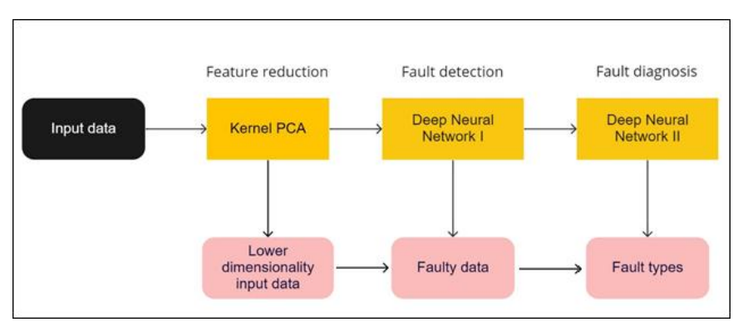
Figure 3.1 Methodology to Develop a Hybrid Model for Fault Detection and Diagnosis using Neural Networks
Figure 3.1 shows that the process consists of three steps: feature reduction using Kernel Principal Components Analysis (KPCA), fault detection and fault diagnosis using two Deep Neural Networks (DNN). The kPCA step is used as a feature reduction step that transforms the dataset so that the neural network can process more accurately. The first neural network NI distinguishes faults from normal operation, and the second neural network NII differentiates the faults by nature. The resulting hybrid model can detect and diagnose faults from complex datasets. Fault detection and fault diagnosis can be conducted simultaneously or separately. Simultaneous detection and diagnosis are a classification task that is efficient in some situations. Only one neural network needs to be trained in that case, and therefore the training time is reduced, and all data is used for diagnosis without loss. However, the accuracy of such a model is highly dependent on the dataset. If a dataset is dominated by one category, there is a high chance of misclassification towards that class. In fault detection and diagnosis, this will usually be the issue since we are interested in the minority (faulty operation). The overall accuracy of the model will be high, but so will the number of false positives. If the data is evenly distributed between operational conditions and different types of faults, the performance of this network will be acceptable. However, this is not the usual case in industrial processes. Therefore, we split fault detection and fault diagnosis into separate classification models using two separate DNN for each. Input data is manually cleaned to remove noise. Effect of noise and randomness on FDD performance of the model needs to be investigated in the future work. The block diagram of the proposed system is as shown below:
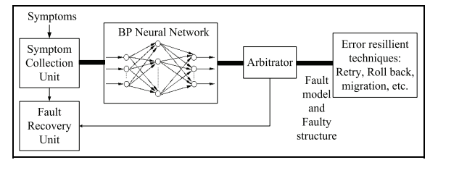
Figure 3.2 The Block Diagram of Back Propagation Fault Diagnosis System.
3.2 ANALYSIS OF THE EXISTING SYSTEM
The current system for diagnosing hardware faults in cloud systems relies heavily on conventional methods such as rule-based systems or statistical analysis. These methodologies, while effective to some extent, often fall short in handling the intricate dynamics of modern cloud infrastructures. With the increasing complexity and scale of cloud environments, the limitations of these traditional approaches become more apparent. They may struggle to adapt to the rapidly changing hardware configurations typical of cloud systems, leading to delays in fault detection and resolution. Moreover, these methods often lack the capability to provide real-time monitoring and diagnosis, which is crucial for ensuring the uninterrupted operation of cloud services.
3.3 PROBLEMS OF THE EXISTING PROBLEM
One of the primary drawbacks of the existing system is its limited adaptability to the dynamic nature of cloud environments. Traditional methods may fail to keep pace with the frequent changes in hardware configurations, resulting in inaccuracies in fault detection. Additionally, scalability issues arise as cloud systems expand, overwhelming the capacity of conventional diagnostic techniques to process large volumes of data efficiently. Furthermore, the lack of real-time detection capabilities means that hardware faults may go undetected for extended periods, leading to increased downtime and potential service disruptions. Finally, the complexity inherent in modern cloud architectures poses a significant challenge for traditional diagnostic approaches, which may struggle to analyze and interpret the vast amount of telemetry data generated by distributed and virtualized systems.
3.4 DESCRIPTION OF THE PROPOSED SYSTEM
The proposed system presents a novel approach to hardware fault diagnosis in cloud systems by leveraging neural network technology. This system involves the development and deployment of neural network models trained on extensive datasets of hardware telemetry and performance metrics. Through supervised learning techniques, these models are capable of identifying subtle patterns and anomalies indicative of hardware faults. The proposed system comprises several key components, including continuous data collection from various hardware components, preprocessing of collected data to remove noise and inconsistencies, training of neural network models using labeled datasets, integration of trained models into the cloud system for real-time monitoring, and automatic generation of alerts and reports when hardware faults are detected.
  - ADVANTAGES OF THE PROPOSED SYSTEM
The proposed system has the following advantages:
- Neural network-based approaches can offer higher accuracy in diagnosing hardware faults compared to traditional methods, thanks to their ability to learn complex patterns and adapt to changing environments.
- The proposed system enables real-time detection of hardware faults, allowing for prompt action to minimize downtime and service disruptions.
- Neural network models can scale effectively with the size and complexity of cloud systems, making them suitable for large-scale deployments.
- The system can adapt to evolving hardware configurations and system dynamics, ensuring robust performance over time.
- By automating the fault diagnosis process, the proposed system reduces the reliance on manual intervention, thereby improving operational efficiency and reducing costs.

CHAPTER FOUR
DESIGN AND IMPLEMENTATION OF THE SYSTEM
4.1 DESIGN OF THE SYSTEM
This is the computation of the particulars of a new system and the determination of what the new system would be and the function it is to perform. This may involve changing from one system to another or modifying the existing system operation.
The most challenging phase of the system life cycle is the change from manual operation to a faster and more accurate one-system design stage covers the technical specifications that will be employed in the implementation of the new system in order to modify the previous system. Some factors are put in consideration. These factors include input design, output design, definitions file and procedure designs and other documentation.
4.1.1 OUTPUT DESIGN
This incorporates the objectives of solving the existing system problems and challenges. This involves the structuring of the desired information and also to enhance efficient and effective hardware fault detection in cloud system. Things taken into consideration in determining the output are represented below:

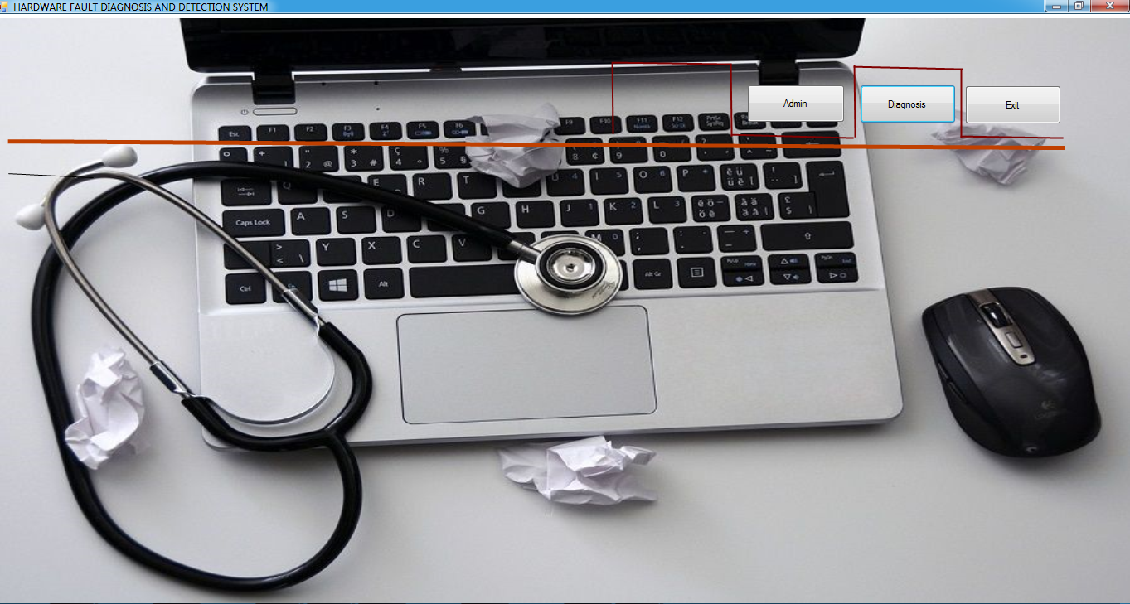
Figure 4.1: Main Menu Interface
This is the main menu of the system; it contains other sub menu where user can navigate or move from one module to another.
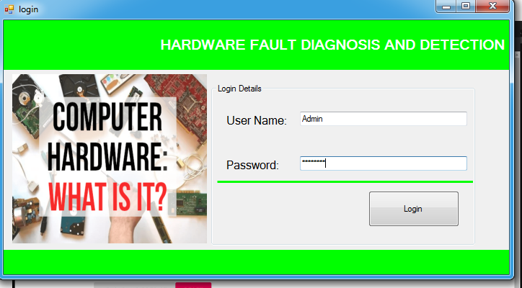
Figure 4.2: Login Page
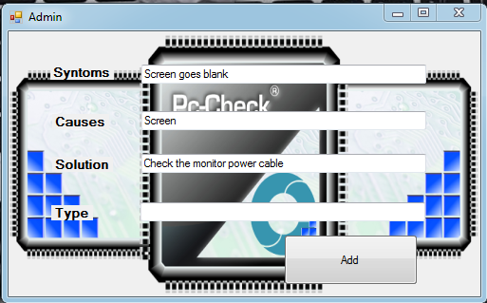
Figure 4.3: Diagnosis Page: This is the page where the user enter or supply their login credentials/details
4.1.2 INPUT DESIGN
The input to run this software is obtained from hardware fault administrator. The administrator is expected to upload the image. He can achieve this by typing via the keyboard or loading from the diskette. It can serve as the various input layouts from the various modules first from the collection of data and module then from the assessment module and input from admin respectively.
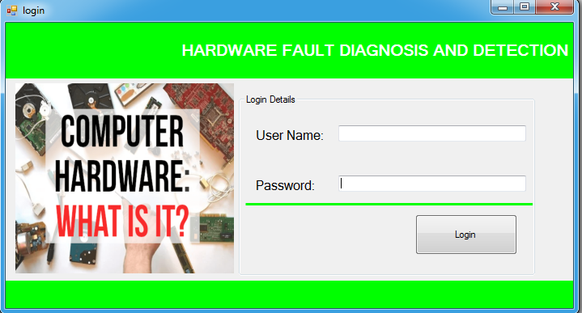
Figure 4.3: Login interface

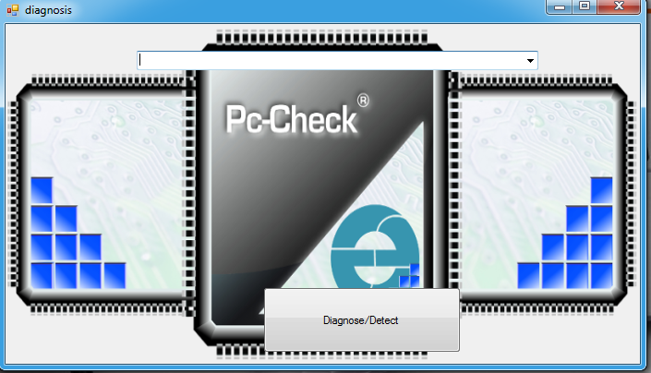
Figure 4.5: fault detection interface
This is a page where computer hardware fault are diagnose and detect
4.1.3 DATABASEDESIGN
The input file is processed against the output file to produce the required output and the" various file layout (designs) has already been given in the various pages, under the input design and the output design for the various modules respectively.
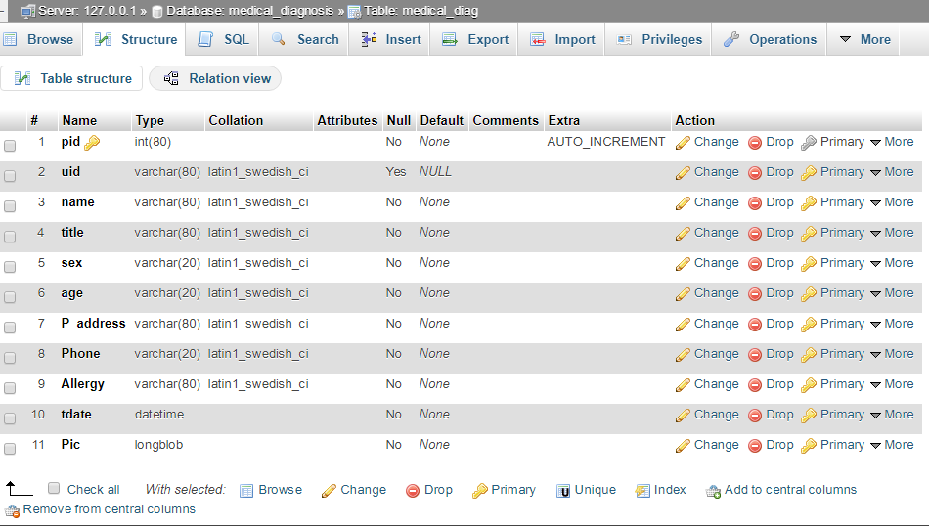
Figure 4.8: Patient Registration Table
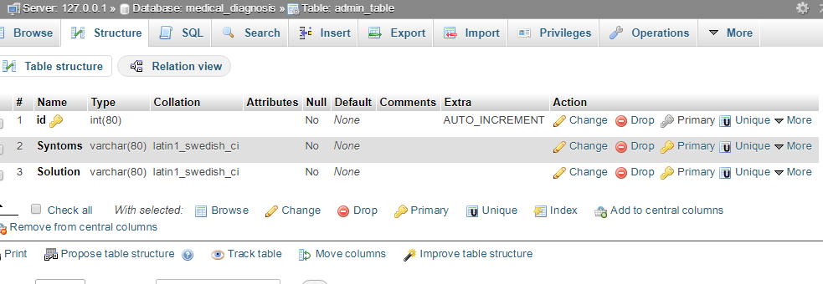
Figure 4.9: Admin Table
4.1.4 PROCEDURE DESIGN
These are the steps involved in unifying the whole process to produce the desired output. It involves computer procedures which start from the original input lessons to the output result file. This allows the processing of User information and result to be possible. Menu is provided to aid User in the processing of the output file.
4.2 IMPLEMENTATION OF THE SYSTEM
This entails the choice of the programming language employed to implement the software which should-be suitable for hardware faultdiagnosis system. The software is designed for the use of hardwarediagnosis system which should serve as an assistant. It is also expected to be used in conjunction with the User. The hardware diagnosis system admin will prepare data base while the admin will provide personal data about the User.
4.2.1 CHOICE OF PROGRAMMING LANGUAGE
The Application was developed in a .net (dot net) integrated development environment (.net IDE). The Application IDE is chosen following the fact that extracted information needs to be presented in an enhanced pictorial/graphical format and easy communication with the database for program flexibility in windows platform.
4.2.2 HARDWARE REQUIREMENT
i. 500 Hz minimum with CD ROM drive etc.
ii. Hard disk of capacity 10GB Minimum
iii. 126-512 megabyte of RAM
iv. An Uninterrupted power supply (UPS)
v. A voltage stabilizer
vi. A power generating set etc.
4.2.3 SOFTWARE REQUIREMENT
i. Windows Operating system such as Windom 7, Windom 8 etc.
ii. Visual studio 2010
iii. Server Query Language (SQL).
4.3 DOCUMENTATION OF THE SYSTEM
4.3.1 PROGRAM DOCUMENTATION
The program is packaged for use in any system irrespective of either it runs visual studio application or not. After developing a program in Visual studio, there is a facility provided in Microsoft Visual Studio suite called “Package and Deployment Wizard” that is used in Visual studio application packaging and deployment.
Hardware fault detection is packaged into an installable setup that can be run from any system.
4.3.2 MAINTAINING THE SYSTEM
The system maintenance refers to making modification to an already existing application/program without necessarily re-writing everything from start. Program maintenance of a program includes modification of the program to meet-up with certain requirements of the Users. In this course, additional features can be added, errors corrected, ambiguous interfaces redesigned to eliminate confusions and unnecessary features removed.
Maintaining this program can be done in a Visual studio environment. Any future modification can be by re-running the program source code in a visual studio environment making necessary changes,updates and recompiling the application into an upgraded version of the existing version of the mini word processing application. Further versions of this program can be named following their year of release or it can be given a different version number.

CHAPTER FIVE
SUMMARY, CONCLUSION AND RECOMMENDATIONS
5.1 SUMMARY
The application of neural network-based approaches for diagnosing hardware faults in cloud systems represents a significant advancement in fault detection and management. Traditional methods often struggle to cope with the dynamic nature and complexity of cloud environments. In contrast, neural networks offer a promising solution by leveraging machine learning techniques to analyze large volumes of telemetry data and identify patterns indicative of hardware faults in real-time. By continuously monitoring system metrics and learning from historical data, these models can provide accurate and timely detection of faults, enabling proactive maintenance and minimizing downtime. The proposed approach involves data collection, preprocessing, model training, real-time monitoring, and alerting/reporting mechanisms to facilitate effective fault diagnosis. The adoption of neural network-based approaches holds the potential to enhance the reliability, efficiency, and scalability of cloud systems by addressing critical hardware issues promptly.
5.2 CONCLUSION
The utilization of neural network-based approaches for diagnosing hardware faults in cloud systems offers a promising avenue for improving system reliability and performance. By leveraging advanced machine learning techniques, these approaches enable more accurate, scalable, and real-time fault detection compared to traditional methods. The proposed system architecture integrates seamlessly into existing cloud infrastructures, providing continuous monitoring and timely alerts to mitigate hardware failures efficiently. However, while the benefits are substantial, challenges such as data quality, model interpretability, and scalability is yet to be addressed. Nevertheless, with ongoing advancements in neural network technologies and increased adoption of cloud computing, the future looks promising for the widespread implementation of these innovative fault diagnosis solutions.
5.3 RECOMMENDATIONS
To further enhance the effectiveness of neural network-based approaches for diagnosing hardware faults in cloud systems, several recommendations can be considered:
- Invest in ongoing research and development to refine neural network architectures, algorithms, and training methodologies for better fault detection accuracy and efficiency.
- Implement robust data quality assurance measures to ensure the reliability and consistency of input data, which is crucial for training accurate neural network models.
- Develop techniques for improving the interpretability and transparency of neural network models to facilitate better understanding and trust among system administrators and stakeholders.
- Address scalability challenges to ensure that the proposed system can effectively handle the increasing volume and complexity of cloud systems without compromising performance.
- Foster collaboration and knowledge sharing among researchers, practitioners, and industry stakeholders to accelerate innovation and adoption of neural network-based fault diagnosis solutions in cloud computing environments.

REFERENCES
Alibek, K. (2022). Fault Detection and Diagnosis using Hybrid Artificial Neural Network Based Method, In Proceedings of the International Conference on Computational Intelligence for Smart Power System and Sustainable Energy (CISPSSE), Keonjhar, India. Pp. 1–4.Doi: 10.26599/Bdma.2018.8115505
Bui, K. T., Vo, L. V., Nguyen, C. N., Pham, T. U. & Tran, T. U. (2020). A Fault Detection and Diagnosis Approach for Multi-tier Application in Cloud Computing,Journal of Communications and Networks. Vol. 22, Issue: 5. Pp. 1123-1124.Doi: 10.34545/2018.8115676
Chen, Z. Xu, J., Alippi, C., Steven, X., Shardt, Y., Peng, T.& Yang, C. (2021). Graph Neural Network-Based Fault Diagnosis,Journal of Computer Design and Engineering. Vol. 3, Issue: 2. Pp. 33–35.https://doi.org/10.3390/su151512083
Chine, A., Mellit, V., Lughi, A., Malek, G., Sulligoi, A. M. & Pavan, K. (2017). A Novel Fault Diagnosis Technique for Photovoltaic Systems Based on Artificial Neural Networks, Renewable Energy, Vol. 6. Issue: 2. Pp. 501–512. doi.org/10.1016/j.renene.2016.01.036
Ciaburro, G. (2022). Machine Fault Detection Methods Based on Machine Learning Algorithms,Mathematical Biosciences and Engineering. IOP Publishing. Vol. 19, Issue: 11. Pp. 11453–11490.
Kustrin, A. & Beresford, R. (2020). Basic Concepts of Artificial Neural Network (ANN) Modeling and its Application in Pharmaceutical Research, Journal of Pharmaceutical and Biomedical Analysis. Vol. 22. Pp. 717–727. doi.org/10.1016/S0731-7085(99)00272-1
Li, C. & Huang, Y. (2021). Fault Diagnosis of Control System Based on Neural Network Data Fusion, Liuzhou Vocational and Technical College. Pp. 4-5.
Łuczak, D., Brock, S. & Siembab, K. (2023). Cloud Based Fault Diagnosis by Convolutional Neural Network as Time–Frequency RGB Image Recognition of Industrial Machine Vibration with Internet of Things Connectivity, Journal of Computer Design and Engineering. Vol. 9, Issue: 4. Pp. 393–405.
Okey, O. Melgarejo, D. C., Saadi, M., Rosa, M. L., Kleinschmidt, J. H. & Rodríguez, D. Z. (2020). Transfer Learning Approach to IDS on Cloud IoT Devices Using Optimized CNN,Journal of Pharmaceutical and Biomedical Analysis. Vol. 2. Pp. 17–18.
Sun, X., Chakrabarty, K., Huang, R. Chen, Y. Zhao, B., Cao, H. Han, Y., Liang, H. & Jiang, L. (2019). System-Level Hardware Failure Prediction using Deep Learning,In IEEE/IFIP International Conference on Dependable Systems and Networks. Pp. 383–394.
Wang, Fu&Cui (2019). A Neural-Network-Based Approach for Diagnosing Hardware Faults in Cloud Systems. Recent Advances in Industrial Internet of Things. Vol. 11, Issue: 2. Pp. 67-68.
Xu, Z., Song, C., Wu, H., Gill, S. & Ye, K. (2022). Deep Neural Network based Multivariate Workload Prediction Approach in Cloud Computing Environments,Journal of Communications and Networks. Vol. 2, Issue: 3. Pp. 11-12.
Zhang, P., Shu, S. &Zhou, M. (2018). An Online Fault Detection Model and Strategies Based on SVM-Grid in Clouds, Journal of Automatica Sinica, Vol. 5, Issue: 2. Pp. 45-46.
Zhou, C., Gui, S., Liu, Y., Ma, J. & Wang, H. (2023). Fault Location of Distribution Network Based on Back Propagation Neural Network Optimization Algorithm,17th International Multi-Conference on Systems, Signals & Devices (SSD). Pp. 234-235.

Appendices: System Flowchart
Appendix 1: Main Menu Flowchart
Start

Welcome Screen

Login

Fault Detection

Diagnose Hardware Fault

Enter Fault Details

Logout

Stop

Appendix 2: Login Flowchart
Start
Open Database
Admin Login

No
Is Details Correct?

Yes

Display main page

Close Database

Return

Appendix 3: Fault Details Flowchart

No Yes
Show Main Page
Is Details Correct?
Login
Open Database
Start

Enter Fault Details

Close Database

Return

Appendix 4: Diagnose Hardware Fault
Enter Hardware Fault
Login
Open Database
Start

No
Is Details Correct?

Yes
Display Main Page

Close Database

Return

Appendix 5: Fault Detection Flowchart
Detect Fault
Display Main menu
Login
Open Database
Start

Is Details Correct?
No

Yes

Close Database

Return

Appendix 7: Source Code
using System;
using System.Collections.Generic;
using System.ComponentModel;
using System.Data;
using System.Text;
using System.Windows.Forms;
using System.IO;
using MySql.Data.MySqlClient;
namespace Fault_detection_in_Cloud
{ publicpartialclassCreateData : Form
{
publicvoid randomareg()
{
String rid = "Rec-001";
MySqlConnection mycon = newMySqlConnection(Class1.connectstring);
mycon.Open();
MySqlCommand cmd = newMySqlCommand("select Count(rid) from recor", mycon);
int i = Convert.ToInt32(cmd.ExecuteScalar());
mycon.Close();
i++;
textBox1.Text = rid + i.ToString();
}
public CreateData()
{
InitializeComponent();
randomareg();
}
privatevoid button4_Click(object sender, EventArgs e)
{
Main_menu mm = newMain_menu();
Hide();
mm.Show();
}
privatevoid timer1_Tick(object sender, EventArgs e)
{ label7.Text = DateTime.Now.ToString("hh:mm:ss tt");
}

