EFFECTS OF ADMIXTURE ON THE WORKABILITY AND STRENGTH DEVELOPMENT OF SELECTED CONCRETE MIX RATIO

BY
BABATUNDE SODIQQ OLAYINKA
HND/23/CEC/FT/0102

SUBMITTED TO:

DEPARTMENT OF CIVIL ENGINEERING,
INSTITUTE OF TECHNOLOGY
KWARA STATE POLYTECHNIC, ILORIN

IN PARTIAL FULFILMENT OF THE REQUIREMENTS FOR THE AWARD OF HIGHER NATIONAL DIPLOMA (HND) IN CIVIL ENGINEERING

JUNE, 2025.

CERTIFICATION
This is to certify that this project was conducted by BABATUNDE SODIQ OLAYINKA with matric number HND/23/CEC/FT/0102 and approved as meeting part of the requirements for the award of Higher National Diploma (HND) in Civil Engineering, Institute of Technology, Kwara State Polytechnic, Ilorin.

DR ENGR E.O IBIWOYE DATE
Project Supervisor

ENGR. NALLAH DATE
Head of department

EXTERNAL SUPERVISOR DATE

DEDICATION
This project is dedicated to Almighty God, for his mercy, favor, blessing and protection throughout the completion of my program and this project. I am also dedicating this project specially to my Parent, Mr. GAIYU BABATUNDE and Mrs. RASHIDAT BABATUNDE for their moral and financial support in making my program and this project a success.
My special dedication goes to my siblings, families and love ones who have worked alongside with me, offering words of encouragement, comfort, and strength, and to all engineers in the world for their innovation and engineering works.
You believing in me meant the world, and I hope this achievement serves as a reflection of the love, support, and dedication we have shared along the way in making this project a reality.
May the Almighty God be with all of them and not let them be wanting when it is time to reap the fruit of their labor.

ACKNOWLEDGMENT
Firstly, I give all thanks, honor, adoration and praise to Almighty God who has made it possible for me to be alive to this very moment and for seeing me through the years of my education.
Secondly, my utmost thanks goes to my project supervisor, DR. Engr. E.O IBIWOYE the successful completion of my project has been to his close supervision and assistance, Special thanks to the Head of Department, Engr.A. Nallah for his love and support and to all the staff of the Civil Engineering Department.
My sincere gratitude goes to my Parent Mr and Mrs. BABATUNDE for their moral, financial support and encouragement towards the success in the completion of my course.
Lastly, I extend and express my appreciation to my friends and colleagues for their love, immensurable contribution and the support they gave me in times of facing academic challenges. Thank you all

ABSTARCT
This study investigates the impact of various admixture on the workability and strength development of selected concrete mix ratios. Concrete is a widely used construction material, and its performance can be significantly enhanced through the incorporation of chemical admixtures. The research focuses on evaluating the effect of different types of admixtures, including superplasticizers, and retarders, on the fresh and hardened properties of concrete.
Experimental tests were conducted to access workability using slump test and compaction methods, while compressive strength was performed at different curing ages. The selected concrete mix ratios were systematically varied to determine the optimal combination of admixtures that improves workability without compromising strength.
The result indicate that the inclusion of admixtures can lead to increased workability and improved early age strength development, depending on the type and dosage of admixture used. This study provides valuable insights into the formulation of high-performance concrete, contributing to enhanced construction efficiency and material sustainability

TABLE OF CONTENT
Title page i
Certification ii
Dedication iii
Acknowledgement iv
Abstract v
Table of content vi
CHAPTER ONE
1.0 Introduction 1
1.1 Background of the study 1
1.2 Statement of the problem 5
1.3 Aim and objective 5
1.4 Justification of the study 6
1.5 Scope of the study 6
CHAPTER TWO
2.0. Literature Review 7
2.1. Concrete Admixtures 7
2.1.1. Types of admixtures 7
2.2. Cement 14
2.2.1. Types of Portland cements 14
2.3. Aggregate 17
2.3.1. Basic characteristics of aggregate 17
2.3.2. Types of aggregate 19
2.4. Water 19
2.5 Workability 21
2.5.1. Slump test 21
2.5.2. Compacting factor test 22
2.5.3. Factors affecting workability 24
2.6. Strength 24
2.6.1. Compressive strength 24
2.6.2. Tensile strength 25
2.6.3. Flexural Strength 26
2.6.4. Factors influencing strength 26
2.7. Concrete Mix Design 27
2.7.1. Properties of hardened concrete 28

CHAPTER THREE
3.0 Methodology 30
3.1. Materials 30
3.1.1. Factors governing the selection of mix proportion 32
3.1.2. Concrete Mix Design 36
CHAPTER FOUR
4.0 RESULTS AND DISCUSSION 38
4.1 Coarse aggregates 38
4.1.1 Sieve analysis for coarse aggregates 38
4.2 Fine aggregates 39
4.2.1 Sieve analysis for fine aggregates 39
4.3 Properties of Plastic Concrete 41
4.3.1 Slump test results 41
4.3.2 Temperature Variation with Time 42
4.4 Properties of Hardened Concrete 43
4.4.1 Flexural strength test results 43
4.4.2 Setting times of cement 46
4.4.2.1 Initial and final setting times of the blue triangle cement 46
CHAPTER FIVE
5.1 Conclusion 48
5.2 Recommendations 48
REFERENCE 50

CHAPTER ONE
1.1 Background of the Study
1.1.1 General
Concrete is any product or mass made by the use of cementing medium, generally this medium is the product of reaction between hydraulic cement and water. The main component of concrete is a mixture of cement, aggregate (fine and coarse), water and sometimes admixtures.
Concrete, in the broadest sense, is any product or mass made by the use of cementing medium. Generally, this medium is the product of reaction between hydraulic cement and water. Firstly, one can view the cementing medium as the essential building material. Secondly, one can view the coarse aggregate as assort of mini- Masonry which is joined together by mortar i.e. by a mixture of hydrated cement and fine aggregate. Thirdly, is to recognize that, concrete consist of two phases hydrated cement paste and aggregate, and, as a result, the properties of concrete are governed by the properties of the two phases and also by the presence of interface between them. In its hardened state, concrete is a rock like materials with a high compressive strength, by virtue of the ease with which fresh concrete in its plastic state may be moulded into virtually any shape and may be used for architecturally advantage or solely decorated purposes.
Concrete is composed mainly of three materials, namely Cement, water, and aggregate and an additional material, known as an admixture, is sometimes added to modify certain of its properties.
Concrete as a construction material has the following advantages:
1. concrete is economical in the long run as compared to other engineering materials, except cement, it can be made from locally available coarse and fine aggregate.
2. Concrete possesses a high compressive strength, and the corrosive and weathering effects are minimum. When properly prepared its strength is equal to that of a hard-natural stone.
3. The green concrete can be easily handled and moulded into any shape or size according to specification.
4. It is strong in compression and has unlimited structural applications in combination with steel reinforcement, the concrete and steel have approximately equal coefficients of thermal expansion. The concrete is extensively used in the construction of foundations, walls roads, airfields, buildings, water retaining structures, docks and harbors, dams' bridges, silos, etc.
5. Concrete can even be sprayed on and filled into fine cracks for repairs by the guniting process.
6. The concrete can be pumped and hence it can be laid in the difficult positions also.
7. It is durable and fire resistance and requires very little maintenance.
The disadvantages of concrete can be as follow:
1. Concrete has low tensile strength and hence cracks easily. Therefore, it is to be reinforced with the steel bars or meshes
2. Fresh concrete shrink on drying, and hardened concrete expands on wetting.
3. Concrete under sustained loading undergoes creep resulting in reduction of prestress of the prestressed concrete construction.
4. Concrete is liable to disintegrate by alkali and sulphate attack.
5. The lack of ductility inherent in concrete is disadvantages with respect to earthquake resistance.
1.1.2. Cement
The different cements used for making concrete are finely powder and all have the important property that when mixed with water a chemical reaction (hydration) takes place which in time produce a very hard and strong binding medium for the aggregate particles, in the early stage of hydration, while in its plastic stage, cement mortar gives to the fresh concrete its cohesive properties.
Types of Portland cements
- Ordinary Portland cement: Ordinary Portland (Type 1) cement is admirably suitable for use in general concrete construction when there is no exposure to sulphates in the soil or groundwater.
2. Low heat Portland cement: Cement having such a low rate of heat development was first produced for use in large gravity dams in the United States, and is known as low heat Portland cement (Type IV). This cement has a low heat of hydration accompanied by a much slower rate of increase in strength than for ordinary cement, although its final strength is similar and its resistance to a chemical attack is greater than that of Portland cement.

1.1 Admixture
This refers to any material added to concrete mixture to enhance it properties or performance. Admixture can improve workability by reducing the water cement ratio; making it easier to mix and place concrete. However, high dosages of admixtures can lead to decreased workability.
1.2. Concrete Mix Ratio
This refers to the proportions of the key ingredients in concrete: Cement, sand (fine aggregate) and coarse aggregate (such as graved or crushed stone). Their most common mix ratio for concrete is
- 1:2:4 (One-part cement, two-part sand, and four-part coarse aggregate)
However, mix ratio can vary depending on the specific application, desired strength, and type of concrete. Some common mix ratios include.
- 1:1:2 (For high-strength concrete)
- 1:3:6 (For general-purpose concrete)
- 1:4:8 (For lightweight concrete)

1.3. statement of the problem
Here are some potential problems that may affect the strength development of a selected concrete mix ratio:
- Inadequate Cement Content: insufficient cement can lead to weak bonding and reduce strength.
- Inappropriate Aggregate Size or Distribution: poor aggregate grading can cause inadequate packing, leading to reduce strength.
- Insufficient Compaction: inadequate compaction can result in porosity, honey combing, and reduce strength.
- High Temperature or Rapid Drying: this can cause thermal cracking and reduce strength.

1.4. aim and OBJECTIVES OF THE STUDY
The aim of this research is to study the effect of admixture on the workability and strength development of selected concrete mix ratio.
The specific objectives are to:
- Determine the type of admixture (Retarders) to be used for the research
- Determine the effect of admixture on the strength and properties of the produced concrete.
- Analysis of result using statistical method
1.5. SCOPE OF STUDY
The scope of this research is limited to production of beam with normal concrete mixes. The material to be used is granite (half inches), cement and fine aggregates. The mix ratio of 1:2:4 will be used; the curing of concrete will be carry out for 7days, 14days, and 28days after production. Also, the types of admixture to be used are limited to just one which is Accelerator (calcium chloride). Concrete beam will be taking to laboratory for the appropriate test (flexural strength and slump tests).
1.6. JUSTIFICATION OF THE STUDY
The main significance of the outcome from this study, is that it will determine the effect of admixture on the flexural strength of concrete, researching on concrete with 1:2:4 mixture ratio in other to determine the required quality suitable to produce concrete of specified requirements.

CHAPTER TWO
2.0 LITERATURE REVIEW
2.1. Concrete Admixtures
Admixtures are substances introduced into concrete mixes in order to alter or improve the properties of the fresh or hardened concrete or both. In general, these changes are affected through the influence of the admixture on hydration, liberation of heat, formation of pores and the development of the gel structure.
Concrete admixtures should only be considered for use when the required modification cannot be made by varying the composition and proportions of the basic constituents' materials, or when the admixtures can produce the required effect more economically.
The specific effects of an admixture generally vary with.
- Type of cement
- Cement-water ratio
2.1.1. Types of admixtures
Several hundreds of proprietary admixtures are available and since a great many usually contain several chemicals intend simultaneously to change several properties of concrete of the different types of admixtures:
- Retarders: Most admixtures in this group are based on lignosulphonate or hydroxylated carboxylic acids and their salts with cellulose or starch. A delay in the setting of the cement paste can be achieved by the addition to the mix of a retarder admixture (ASTM type B), for brevity refer to as a retarder. They are used mainly in hot weather countries where high temperature can reduce the normal setting and hardening time. Slightly reduced water content may be used when using these retarder agents, with corresponding increase in final concrete strength. the lignins –based retarders results in some air-entrainment and tend to increase cohesiveness and reduce bleeding although drying shrinkage may be increased. the hydroxyl_ carboxylic retarders, however, tend to increase bleeding. In general, they prolong the time during which concrete can be transported, placed, and compacted. ASTM C 494-92 requires Type B admixtures to retard the initial set by at least 1 hour but not more than 3.5 hours, as compared with a control mix. the compressive strength from the age of 3 days onwards is allowed to be 10 percent less than the strength of the control concrete.
2. Water-reducing admixtures: Admixtures which are only water- reducing are called Type A, but if the properties are associated with retardation, the admixture is classified as Type- D.
There exist also water-reducing and accelerating admixtures (Type E) but these are of little interest; As their name implies, the function of water reducing admixtures is to reduce the water content of the mix by 5 or 10 per cent, sometimes (in concrete of very high workability) up to 15 per cent.
Thus, the purpose of using water reducing admixtures in a concrete mix is to allow a reduction in the water/cement ratio while retaining the desired workability or, alternatively, to improve its workability at a given water/cement ratio.
Water reducing admixtures improve the properties of fresh concrete made with poorly graded aggregate, e.g. a harsh mix. Concrete containing a water reducing admixture generally exhibits low segregation and good “flowability”.
Their effect is thought to be due to an increased dispersion of cement particles causing a reduction in the viscosity of the concrete.
They can also be used to increase strength and durability, since for a given workability less water is necessary (Memon, M 2019).
3. Superplasticizers: Superplasticizers are admixtures which are water reducing but significantly and distinctly more so than water reducing admixtures. ASTM C494-92 refers to superplasticizers as “water-reducing high range admixtures” Type F admixtures, when the superplasticizers are also retarding, they are called Type G admixtures. There exist four main categories of superplasticizers:
- Sulfonated melamine-formaldehyde condensates
- Sulfonated naphthalene- formaldehyde condensates
- Modified lignosulfonates
- Others such as sulfonic- acids esters and carbohydrate esters.
The first two are the most common ones, for brevity, they will be referring to as:
- Melamine – based superplasticizers
- Naphthalene-based superplasticizers
The main action of the long molecules is to wrap themselves around the cement particles and give them a high negative charge so that they repel each other. These results in deflocculating and dispersion of cement particles.
The resulting improvement in workability can be exploited in two ways:
- By producing concrete with a very high workability
- Concrete with a very high strength
At a given water/cement ratio and water content in the mix, the dispersing action of superplasticizers increase the workability of concrete “flowing concrete” and is useful very heavily reinforced sections. the second use of superplasticizers is in the production of concrete of normal workability but with an extremely high strength owing to a very substantial reduction in the water /cement ratio. most superplasticizers do not produce appreciable set retardation, but there exist also asset-retarding superplasticizers classified by ASTM C 494-92 as Type G. Superplasticizers do not influence shrinkage, creep, modulus of elasticity or resistance to freezing and thawing.
They have no effect on the durability of concrete; specifically, durability on exposure to sulfate is unaffected. Memom et al. (2019). Superplasticizers admixtures improve the workability without increasing water demand, for the three grades of concrete no decreasing in compressive strength was observed.
Superplasticizers admixtures provide an increasing in ultimate strength gain by significantly reducing water demand in a concrete mix for the three grades, without affecting workability. Superplasticizers admixtures reduce cement content up to 23%for the three grades without reducing the compressive strength and no effect on workability strength and reducing w/c ratio.
Superplasticizers admixtures save cost of the reduced cement of about (4.5 – 8.9) % per cubic meter for the three grades of concrete.
4. Accelerators: These can be divided into two groups, namely setting accelerators and setting and hardening accelerators.
The first of these are alkali solution which can considerably reduce the setting time and are particularly suitable for repair working involve water leakage.
Because of their adverse effect on subsequent strength development these admixtures should not be used where the final concrete strength is an important consideration.
Setting and hardening accelerators increase the rate of both setting and early strength development.
The most common admixtures for this purpose are “CaCl2” which should comply with BS 3587. It may usefully be employed for concrete in winter conditions, for emergency repair work where early removal of formwork is required. Ahmad, M., Khan, A. (2020).
Calcium chloride is a by-product of the solvay process for sodium carbonate manufacturing.
CaCO₃ + 2NaCl = Na₂CO₃ + CaCl₂
5. Special admixtures: There exist also admixtures for other purposes, such as air detrainment, anti –bacteria action, and water proofing, but these are not sufficiently standardized to make reliable generalizations possible. Moreover, some of the names under which certain admixtures are sold give an exaggerate impression of their performance.
a) Water proofing admixtures: Water proofing admixtures aims at preventing penetration of water into concrete. Their performance is very much dependent on whether the applied water pressure is low, as in the case of rain or capillary rise, or whether a hydrostatic pressure is applied, as in the case of water retaining structures.
Water proofing admixtures may act in several ways but their effect is mainly to concrete hydrophobic. One action of waterproofing admixtures is through reaction with the calcium hydroxide in hydrate cement paste; examples of products are stearic acid and some vegetable and animal fats. The effect is to make the concrete hydrophobic. Another action of water proofing admixture is through coalescence on contact with the hydrate cement paste which, because of its alkalinity, breaks down the ‘waterproofing’ emulsion; an example is an emulsion of very finely divided wax.
The effect here, too, is to make concrete hydrophobic. The type of waterproofing admixture is in the form of very fine material containing calcium stearate or some hydrocarbon resin or coal tar pitches which produce hydrophobic surfaces.
Some waterproofing admixtures, in addition to their hydrophobic action, also effect pore blocking through coalescent component. Aside effect of some water proofing admixtures is to improve the workability of the mix owing to the presence of finely divided wax or bituminous emulsions.
b) Pozzolanas: The most commonly used Pozzolanas are pumicite and pulverized fuel ash. Because of their reaction with lime, which is liberated during the hydration of cement, these materials can improve the durability of concrete. Since they retard the rate of setting and hardening but have no long-term effect on strength, they can be used in mass concrete work. Pulverized fuel ash can also be used as a replacement for sand (up to 20 per cent) in harsh mixes to improve workability.
c) Water-repelling agents: These are the least effective of all admixtures and are based on metallic soaps or vegetable or mineral oils. Their use gives a slight temporary reduction in concrete permeability.

2.2. Cement
The different cements used for making concrete are finely powder and all have the important property that when mixed with water a chemical reaction (hydration) takes place which in time produce a very hard and strong binding medium for the aggregate particles, in the early stage of hydration, while in its plastic stage, cement mortar gives to the fresh concrete its cohesive properties.
2.2.1. Types of Portland cements
1. Ordinary Portland cement: Ordinary Portland (Type 1) cement is admirably suitable for use in general concrete construction when there is no exposure to sulphates in the soil or groundwater.
2. Low heat Portland cement Cement having such a low rate of heat development was first produced for use in large gravity dams in the United States, and is known as low heat Portland cement (Type IV). This cement has a low heat of hydration accompanied by a much slower rate of increase in strength than for ordinary cement, although its final strength is similar and its resistance to a chemical attack is greater than that of Portland cement.
3. Sulphate resisting Portland cement Except for its high resistance to sulphate attack, have principal properties similar to those of ordinary Portland cement. Calcium chloride should not be used with this cement as it reduces its resistance to sulphate attack.
4. White and colored Portland cements Are similar in basic properties to ordinary Portland cement White cement required special manufacturing methods, using raw materials containing less than 1 per cent iron oxide. Colored cements are produced by intergrading a chemically pigment with ordinary clinker. Because of its inert characteristics, the presence of a pigment slightly reduces the concrete strength. These cements are used for architectural purposes.
5. Manufacture: Cement is prepared by first intimately grinding and mixing the raw constituents in certain proportions, burning this mixture at Avery high temperature to produce clinker, and then grinding it into powder form. Since the clinker is formed by diffusion between the solid particles, intimate mixing of the ingredients is essential if uniform cement is to produced. This mixing may be in dry or wet state depending on the hardness of the available rock.
The wet process is used in general, for the softer materials such as chalks or clay. Water is added to the proportioned mixture of crush chalk and clay to produce slurry which is eventually led off to a kiln. This is steel cylinder, with a refractory lining, which is slightly inclined to the horizontal and rotates continuously about its own axis. It is usually fired by pulverized coal, although or oil may also be used .it may be as large as 3.5 m in diameter and 150m long and handle up to 700 t of cement in a day.
The slurry is fed in at the upper end of the kiln and the clinker is discharge at the lower end where fuel is injected. With its temperature increasing progressively, the slurry undergoes a number of changes as it travels down the kiln. At 100 C the water is driven off, at about 850 C carbon dioxide is given off and at about 1400 c incipient fusion takes place in the firing zone where calcium silicate and calcium aluminates are formed in the resulting clinker. The clinker is allowed to cool and then ground, with 1 to 5 per cent gypsum, to the required fineness.
Different types of Portland cements are obtained by varying the proportions of the raw materials, the temperatures of burning and the fineness of grinding. Gypsum is added to control the setting of the cement, which would otherwise set much too quickly for general use. Certain additives may also be introduced for producing special cements; e.g. calcium chloride is added in the manufacture of extra rapid hardening cement.
The dry or semi-dry process is used for the harder rocks such as limestone and shale and shale. The constituent materials are crushed into powder form, and with a minimum amount of water, passed into an inclined rotate nodulizing pan where nodules are formed. These are known as raw meal. This is fed into a kiln and thereafter the manufacturing process is similar to the wet process although much shorter length of kiln is used. The grinding of the clinker produces a cement powder which is still hot and this hot cement is usually allowed to cool before it leaves the cement works.

2.3 Aggregate
Aggregate is much cheaper than cement and maximum economy is obtained by using much aggregate as possible in concrete. It’s also considerably improves both the volume and the durability of the resulting concrete. Natural aggregate is formed by the process of weathering and abrasion, or by artificially crushing a large parent mass.
2.3.1 Basic characteristics of aggregate
The criterion for a good aggregate is that it should produce the desired properties in both the fresh and hardened concrete
A. Physical properties: The properties of the aggregate known to have a significant effect on concrete behavior are:
1. Strength: The strength of an aggregate limits the attainable strength of concrete only when its compressive strength is less than or of the same order as the design strength of concrete. In practice the majority of rock aggregates used are usually considerably stronger than concrete. While the strength does not normally exceed 80N/mm2 and is generally between 30 to 50N /mm2 the strength of aggregate commonly used is in the range 70 to 350N/mm2.
2. Deformation: The deformation characteristic of an aggregate is seldom considered in assessing its suitability for concrete work although they can easily Be determined from compression tests on specimens from the parent rock. In general, the modulus of elasticity of concrete increases with increasing aggregate modulus. The deformation characteristics of the aggregate also play an important part in the creep and shrinkage properties of concrete as the restraint afforded by the aggregate to the creep and shrinkage of the cement paste depends on their relative modulus of elasticity.
3. Toughness: Is its resistance to failure by impact and this is normally determined from the aggregate impact test. Since the apparatus is portable, cheap, simply to operate and rapid in application it can be used in the field for quality control purposes.
4. Hardness: Is the resistance of an aggregate to wear and is normally determined by an abrasion test. Toughness and hardness properties of an aggregate are particularly important for concrete used in road pavements.
5. Porosity: Is an important property since it affects the behavior of both freshly mixed and hardened concrete through its effect on the strength, water absorption and permeability of the aggregate? An aggregate with high porosity will tend to produce a less durable concrete, particularly when subjected to freezing and thawing, than an aggregate with low porosity. Direct measurement of porosity is difficult and in practice a related property, namely, water absorption, is measured. The water absorption is defined as the weight of water absorbed by a dry aggregate in reaching a saturated surface- dry state and is expressed as a percentage of the weight of the dry aggregate.

2.3.2. Types of aggregate
1. Heavy weight aggregate: It provides an effective and economical use of concrete for radiation shielding by giving the necessary protection against X- rays, gamma- rays and neutron.
2. Normal weight aggregate: These aggregates are suitable for most purposes and produces concrete with density in the range 2300 to 2500 kg/m3.
3. Light weight aggregate: Light weight aggregate find application in a wide variety of concrete products ranging from insulation screed to reinforce or priestesses concrete, although their greatest use has been in the manufacture of precast concrete blocks.
Concrete made with light weight aggregate have good fire resistance properties.
Their bulk density normally ranges from 350 to 850 kg/m3 for coarse aggregate and from 750 to 1100 kg/m3 for fine aggregate.
2.4 Water
Water is used in concrete making for three different purposes:
1. As mixing water.
2. For curing of concrete.
3. For washing aggregate.
The quality and requirements for the water depend on the type of the Summaries of the physical and physicochemical use.
1. Mixing water: The mixing water, that is, the free water encountered in freshly mixed concrete, has three main functions:
(1) it reacts with the cement powder thus producing hydration.
(2) it acts as a lubricant, contributing to the workability of the fresh mixture.
(3) it secures the necessary space in the paste for the development of hydration products.
The amount of water needed for adequate workability is practically always greater than that needed for complete the cement.
2. Water for curing of concrete: The hydration of requirements for curing water are less stringent than those discussed above, mainly because curing water is in contact with the concrete for only a relatively short time. Such water may contain more inorganic and organic materials, sulphuric anhydride acids, chlorides, and so on, than an acceptable mixing water, especially when slight discoloration of the concrete surface is not objectionable. Nevertheless, the permissible amounts of the impurities are still restricted, in cases of any doubt, water samples should be sent to a laboratory for testing.
3. Water for washing aggregate: Water for washing aggregate should not contain materials in quantities large enough to produce harmful films or coatings on the surface of aggregate particles. Essentially the same requirement holds when the water is used for mixing and cleaning concrete.

2.5 Workability
Workability of concrete has never been precisely defined. For practice purposes it generally implies the ease with which concrete mix can be handled from the mixer to its finally compacted shape.
The three main characteristics of the property are:
Consistency: is a measure of wetness or fluidity.
Mobility: the ease with which a mix can flow into and completely fill the formwork or mould.
Compatibility: the ease with which a given mix can be fully compacted, all trapped air should be removed. (Memon, M., Hussain, S. 2019).
Measurement of workability
There is no acceptable test which will measure directly the workability. Three tests widely used for measuring workability are the slump, compacting factor and V-B consist meter test.
2.5.1. Slump test
This is a test used extensively in site work all over the world. the slump test does not measure the workability of concrete, but the test is very useful in detecting variation in the uniformity of a mix of a given nominal properties. The test is not suitable for very dry or wet mixes. Three types of slump usually observed:
1.True slump: is observed with cohesive and rich mixes for which the slump is generally sensitive to variation in workability.
2.Shear slump: Shear slump occurs more often in leaner mixes than harsh mixes. whenever shear slump is obtained the test should be repeated and, if persistent, this fact should record together with test result.
3.Collapse slump: Is usually associated with very wet mixes and is generally indicative of poor-quality concrete and most frequently result from segregation of its constituents’ materials. the standard slump apparatus is only suitable for concretes in which the maximum aggregate size does not exceed 37.5mm.
2.5.2 Compacting factor test
This test measures the degree of compaction for standard amount of work and thus offers a direct and reasonably reliable assessment of the workability of concrete. the apparatus is relatively simple machine contrivance. The test requires measurement of the weights of the partially and fully compacted concrete and the ratio of the partially compacted weight to the fully compacted weight, which is always less than 1, is known as the compacting factor. the apparatus consists essentially of two hopers, each in the shape of a frustum of a cone and one cylinder, the three being above one another. The hopers have hinged doors at the bottom, all inside surfaces are polished to reduce friction. the upper hoper is filled with concrete, this being placed gently so that at this stage no work is done on the concrete to produce compaction. The bottom door of the hopper is then released and the concrete falls into the lower hopper. This is similar than the upper one and is therefore filled to over flowing, and thus always contains approximately the same amount of concrete in a standard state; this reduces the influence of the personal factor in filling the top hopper. The bottom door of the lower hopper is then released and the concrete falls into the cylinder. Excess concrete is cut by two floats slide across the top of the mould, and the net mass of concrete in the known volume of the cylinder is determined. The density of the concrete in the cylinder is now calculated, and this density divided by the density of full compacted concrete is defined as the compacting factor.
The compacting factor = weight of partially compacting concrete
weight of fully compacting concrete
(Memon, M., Hussain, S., & Shan, Z. 2019). V- B Consistometer test the name "vebe" is derived from the initial of V. Bahrner of Sweden who developed the test.
Compaction is achieved using a vibrating table with an eccentric mass rotating at 50 Hz and a maximum acceleration of 3g to 4g. it is assumed that the input of energy required for compaction of workability of the mix, and this is expressed as the time in seconds, called vebe time, required for the remolding to be complete.
Vebe is a good laboratory test, particularly for very dry mixes, the vebe test also has the additional advantages that the treatment of concrete during the test is comparatively closely related to the method of placing in practice. (A.M. Neville 2000).
2.5.3 Factors affecting workability
Various factors known to influence the workability of freshly mixed concrete, and it will be apparent that a change in workability associated with the constituent’s materials is mainly affected by water content and specific surface of cement and aggregate.
- Cement and water
- Admixtures
- Aggregate type and grading
- Ambient conditions (temperature, humidity, wind velocity)
- Time (Memon et al. 2019).
2.6 Strength
The strength of concrete is defined as the maximum load (stress) it can carry. As the strength of concrete increases its other properties usually improve and since the test for strength, particularly in compression, are relatively simple to perform concrete compressive strength is commonly used in the construction industry for the purpose of specification and quality control. Concrete is comparatively brittle material which is relatively weak in tension. (Liu and Zhao, 2020).
2.6.1 Compressive strength
The compressive strength of concrete is taken as the maximum compressive load it can carry per unit area. Concrete strength up to 80 N/mm2 can be achieved by selective use of the type of cement, mix proportion, method of curing conditions. Concrete structures, except for road pavements, are normally designed on the basis that concrete is capable of resisting only compression, the tension being carried by steel reinforcement.
2.6.2. Tensile strength
The tensile strength of concrete is of importance in the design of concrete roads and runways. Concrete members are also required to withstand tensile stresses resulting from any restraint to contraction due to drying or temperature variation.
Unlike metals, it is difficult to measure concrete strength in direct tension and indirect methods have been developed for assessing this property: Of these: Split cylinder test is the simplest and most widely used. This test is fully described in BS 1881 Part 4 and entails diametrically loading a cylinder in compression along its entire length. This form of loading induces tensile stresses over the loaded diametrical plane and the cylinder split along the loaded diameter. The magnitude of the induced tensile stress.
fct at failure is given by:
fct = 2F
πld
where:
F = the maximum applied load
l = the cylinder length
d = the diameter of the cylinder
2.6.3 Flexural Strength
The Flexural strength of concrete is another indirect tensile value which is also commonly used. In this test a simple supported plain concrete Beam is loaded at is third points, the resulting bending moments inducing compressive and tensile stresses in the top and bottom of the beam respectively.
The beam fails in tension and the Flexural strength (modulus of rupture) fcr is defined by:
fcr = FL
bd2
where: F = the maximum applied load
L = the distance between the supports b&d are the beam breadth and depth respectively at the section which failure occurs.
The tensile strength of concrete is usually taken to be about one- tenth of its compressive strength. This may vary, however, depending on the methods used for measuring tensile strength and the type of concrete.
In general, the direct tensile strength and the splitting strength vary from 5 to 13 per cent and the Flexural strength from 11 to 23 per cent of the concrete cube compressive strength. In each case, as the strength increases the percentage decrease. (Liu and Zhao, 2020).
2.6.4 Factors influencing strength
Several factors which affect the strength of concrete are listed below:
1. Influence of the constituent materials (cement, water, aggregate, admixtures).
2. Influence of the methods of preparation.
3. Influence of curing.
4. Influence of test conditions. (Liu and Zhao, 2020).
2.7 Concrete Mix Design
Concrete mix design can be defined as the procedure by which, for any given set of conditions, the proportion of the constituent materials are chosen so as to produce a concrete with all the required properties for the minimum cost.
The cost of the mix design includes
  - The materials
  - The cost of the mix design, of batching, mixing and placing the concrete and of side supervision Two types of concrete mixes are available.

Prescribe mix
It is given in least form included:
- Proportion of cement
- Fine and coarse aggregate
- Workability
Minimum compressive strength is very important to produce proper mix.
Designed mix
The basic requirements for concrete are conveniently considered at two stages in its life.
In its hardened state the concrete should have adequate durability, the required strength and also the desired surface finish. In its plastic state, or the stage during which it is to be handle, placed and compacted in its final form, it should be sufficiently workable for the required properties in its hardened state to be achieved with the facilities available on site.
This means that:
1. The concrete should be sufficiently fluid for it to be able to flow into and fill all parts of the formwork, or mould into which it is placed.
2. It should be so without segregation or separation, of the constituents’ materials while being handled from the mixer or during placing.
3. It must be possible to fully compact the concrete when placed in position.
4. It must be possible to obtain the required surface finish.
If concrete does not have the required workability in its plastic state, it will not be possible to produce concrete with the required properties in its hardened state. (Sharma, S. 2022.).
2.7.1 Properties of hardened concrete
The properties of fresh concrete are important only in the first few hours of its history whereas the properties of harden concrete assume are important which is retained the remainder of the life of the concrete.
The important properties of hardened concrete are:
- Strength
- Deformation under load
- Durability
- Permeability
- Shrinkage
In general, strength is considered to be the most important property and the quality of concrete is often judged by it strength (Liu and Zhao, 2020).

CHAPTER THREE
3.0. Proposed Methodology
- Laboratory tests: workability, slump test, compacting factor test, compressive stress, water absorption test.
- Determine mix ratio
- Curing: 7, 14, and 28 days.
- Analysis of result: using statistical method.
3.1. Materials
1. Cement: The different cements used for making concrete are finely powder and all have the important property that when mixed with water a chemical reaction (hydration) takes place which in time produce a very hard and strong binding medium for the aggregate particles, in the early stage of hydration, while in its plastic stage, cement mortar gives to the fresh concrete its cohesive properties.
2. Coarse aggregate: This refers to a type of construction material, typically consisting of crushed stone, gravel, or rocks, with particles sizes larger than 4.75mm. it is commonly use in:
1. Concrete production: Adds strength and durability
2. Road construction: Provides base layers for roads and highways.
3. Building foundation: Enhances stability and load bearing capacity.
3. Fine aggregate: This refers to a type of construction material, typically consisting of sand, crushed stone, with particles sizes smaller than 4.75mm. it is commonly use in:
1. Concrete production: Concrete production: adds strength and durability and workability
2. Mortar and plaster: Provides binding properties.
3. Asphalt mixtures: Enhances stability and texture.
4. Water: Water is used in concrete making for three different purposes:
1. As mixing water.
2. For washing aggregate.
The quality and requirements for the water depend on the type of the Summaries of the physical and physicochemical use.
1. Mixing water: The mixing water, that is, the free water encountered in freshly mixed concrete, has three main functions:
1. it reacts with the cement powder thus producing hydration.
2. it acts as a lubricant, contributing to the workability of the fresh mixture.
3. it secures the necessary space in the paste for the development of hydration products.
The amount of water needed for adequate workability is practically always greater than that needed for complete the cement.
3. Water for washing aggregate: Water for washing aggregate should not contain materials in quantities large enough to produce harmful films or coatings on the surface of aggregate particles. Essentially the same requirement holds when the water is used for mixing and cleaning concrete.

3.1.1. Factors governing the selection of mix proportion
1. Durability: Adequate durability of exposed concrete can frequently be obtained by ensuring full compaction, an adequate cement content and low water – cement ratio, all of which contribute to producing a dense, impermeable concrete.
The choice of aggregate is also important particularly for concrete wearing surfaces or where improved fire resistance is required.
Aggregate having high shrinkage properties should be used with caution in exposed concrete. Durability is not a readily measured property of the hardened concrete. However, for a correctly design concrete mix any increase in the water – cement ratio on site with the associated reduction in durability, will be a companied by a reduction in concrete strength (A.M. Neville 2019).
2. Strength: The strength of the concrete is frequently an important design consideration particularly in structural application where the load –carrying capacity of a structural member may be closely related to the concrete strength. This will usually be the compressive strength although occasionally the Flexural or indirect tensile strength may be more relevant. the strength requirement is generally specified in terms of a characteristic strength coupled with a requirement that the probability of the strength falling below this shall not exceed a certain value. Typically, this may be 5 per cent or 1 in 20 chances in strength falling below the specific characteristic strength, this generally be the 28 – day strength. An understanding of the factors affecting concrete strength on site, and of the probable variation in strength, is essential if such specifications are to have any real meaning at the design stage. If the proportion of the aggregate and cement and also the quality of the aggregate are maintained constant, the water – cement ratio can be controlled very effectively at the mixer by adding just sufficient water to give the required workability.
Once a suitable mix has been obtained the workability can be assessed quite satisfactorily by an experienced mixer operator, with periodic control tests of the workability (A.M. Neville 2019). Any variation in mix proportions or significant change in the aggregate grading will affect the quantity of water needed to maintain the required workability and this too results in variations in the water – cement ratio and hence in concrete strength. all these factors tend to give water – cement ratios which are as likely greater as they are to be less than the target value. The actual water – cement ratios tend therefore to have normal or Gaussian distribution about the mean, or target, value. the relationship between the water – cement ratio and concrete strength is non – linear. Nevertheless, over a limit range the relationship will be approximately linear and it might be expected that the concrete strengths will also tend to have a normal distribution.
5. Grading and type of aggregate: The grading influences the mix proportions for a desired workability and the water/cement ratio: the coarser the grading the leaner the mix which can be used, but this is true within certain limits only because a very lean mix will not be cohesive without a sufficient amount of fine material.
The influence of the type of aggregate should also be considered because its surface texture, shape and allied properties influence the aggregate – cement ratio for a desired workability and given water – cement ratio. In selection a mix, it is essential, therefore, to know at the outset what type of aggregate is available.
An important feature of satisfactory aggregate is the uniformity of its grading. In the case of coarse aggregate, this is achieved comparatively easily by the use of separate stockpiles for each size fraction. However, considerable care is required in maintaining the uniformity of grading of fine aggregate and this is especially important when the water content of the mix is controlled by the mixer operator on the basis of a constant workability (A.M. Neville 2019).

3. Workability: Beside the requirements for the concrete to be satisfactory in the hardened state, properties when being transported, possibly pumped, and placed are equally important. One essential at this stage is a satisfactory workability. Selection of mix proportions which do not permit the achievement of appropriate workability totally defeats the purpose of rational mix proportioning.
The workability that is considered desirable depends on two factors:
- The minimum size of the section to be concrete and the amount and spacing of reinforcement.
- The method of compaction to be used.
It is clear that when the section is narrow and complicated, the concrete must have a high workability so that the full compaction can be achieved with a reasonable amount of effort. The same applied when embedded steel sections or fixtures are present. Because these features of the structure are determined during its design, the necessary workability must be ensured in the selection of mix proportions. For given water – cement ratio, the principal factors affecting workability are:
1. The shape and grading of the coarse and fine aggregate
2. The aggregate – cement ratio
The choice of suitable concrete mix proportions must take all these factors into account (A.M. Neville 2019).
4. Maximum size of aggregate: In reinforced concrete, the maximum size of aggregate which can be used is governed by the width of the section and the spacing of the reinforcement. It now seems that the improvement in the properties of concrete with an increase in the size of aggregate does not extend beyond about 40mm so that the use of larger size may not be advantageous. In particular, in high performance concrete, the use of aggregate larger than 10 to 15 mm is counter – productive.
Furthermore, the use of a larger maximum size means that a great number of stockpiles have to be maintained and the batching operations become correspondingly more complicated. This may be uneconomical on small sites but, where larger quantities of concrete are to be placed, the extra handling cost may be offset by a reduction in the cement content of the mix.
The choice of the maximum size may also be governed by the availability of the materials and by their cost (A.M. Neville 2019).
3.1.2. Concrete Mix Design
Concrete mix design can be defined as the procedure by which, for any given set of conditions, the proportion of the constituent materials are chosen so as to produce a concrete with all the required properties for the minimum cost.
The cost of the mix design includes
- The materials
- The cost of the mix design, of batching, mixing and placing the concrete and of side supervision Two types of concrete mixes are available.
a) Prescribe mix: It is given in least form included:
- Proportion of cement
- Fine and coarse aggregate
- Workability
Minimum compressive strength is very important to produce proper mix.
b) Designed mix: The basic requirements for concrete are conveniently considered at two stages in its life. In its hardened state the concrete should have adequate durability, the required strength and also the desired surface finish. In its plastic state, or the stage during which it is to be handle, placed and compacted in its final form, it should be sufficiently workable for the required properties in its hardened state to be achieved with the facilities available on site.
This means that:
1. The concrete should be sufficiently fluid for it to be able to flow into and fill all parts of the formwork, or mould into which it is placed.
2. It should be so without segregation or separation, of the constituents’ materials while being handled from the mixer or during placing.
3. It must be possible to fully compact the concrete when placed in position.
4. It must be possible to obtain the required surface finish.
If concrete does not have the required workability in its plastic state, it will not be possible to produce concrete with the required properties in its hardened state. (Sharma, S. 2022.).

CHAPTER FOUR
4.0 RESULTS AND DISCUSSION
4.1 Coarse aggregates
4.1.1 Sieve analysis for coarse aggregates
The results from the sieve analysis for the coarse aggregates were tabulated (and placed in the appendices section).
Appendix 3: Sieve analysis results for coarse aggregate
Sieve sizes(mm) | Retained mass (gm) | % retained | Cumulative passed percentage % | Min. acceptance criteria % | Max. acceptance criteria%
20 | 0 | 0.0 | 100.0
14 | 0 | 0.0 | 100.0 | 100
10 | 110 | 9.6 | 90.4 | 85 | 100
5 | 764 | 66.4 | 24.0 | 0 | 25
2.36 | 276 | 24.0 | 0.0 | 0 | 5

Figure 4.1 Grading curve for the course aggregates:
An investigation into the Effects of an Accelerating Admixture (calcium chloride) in the properties of Concrete
4.2 Fine aggregates
4.2.1 Sieve analysis for fine aggregates
The results from the sieve analysis for the coarse aggregates were tabulated (and placed in the appendices section).
Appendix 2: SIEVE ANALYSIS RESULTS FOR FINE AGGREGATES
Sieve size | Retained mass (gm) | % retained | Cumulative passed percentage % |  | Min. acceptance criteria | Max. acceptance criteria
14 | 0 | 0.0 | 100.0
10 | 4 | 1.6 | 98.4 |  | 100
4.76 | 5 | 1.9 | 96.5 |  | 89 | 100
2.36 | 12 | 4.7 | 91.9 |  | 60 | 100
1.18 | 21 | 8.1 | 83.7 |  | 30 | 100
0.6 | 73 | 28.3 | 55.4 |  | 15 | 100
0.3 | 107 | 41.5 | 14.0 |  | 5 | 70
0.15 | 28 | 10.9 | 3.1 |  | 0 | 15
0.075 | 4 | 1.6 |  | 1.6
 | 254

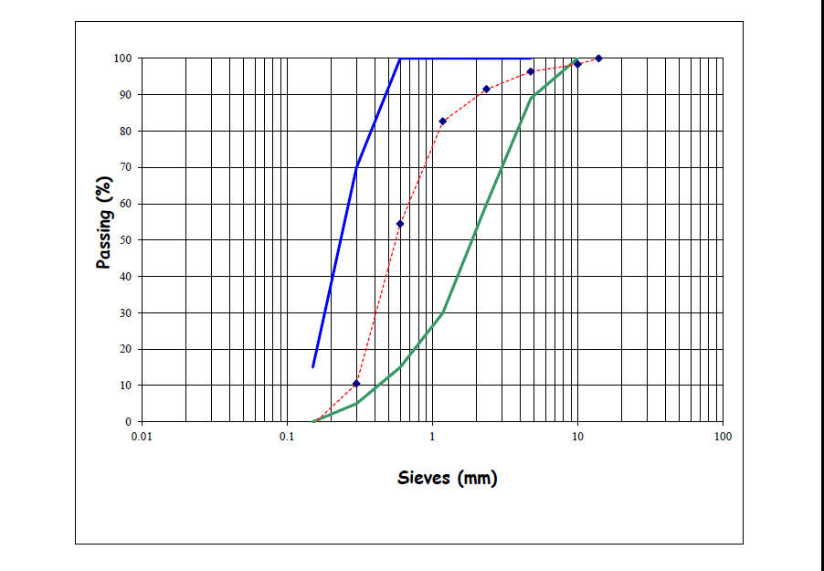

Figure 4.2 Grading Curve for the Fine Aggregates
An investigation into the Effects of an Accelerating Admixture (calcium chloride) in the properties of Concrete
Sieve analysis was done using the standard sieve sizes meeting the requirements of BS 410: 1986 – specification for test sieves and the results were represented graphically in grading curves.
For the fine aggregates, the curve was found to lie outside the upper and lower limits while the same was observed for the course aggregates outside the limits given in BS 882: 1992.
Grading is of importance in concrete mix design in the determination of the fine aggregate content hence the determination of the amount of coarse aggregate required. Grading affects the workability of concrete. Well graded aggregates enhance the workability of concrete by reducing the voids in the mix.
4.3 Properties of Plastic Concrete
4.3.1 Slump test results:
The following results were obtained from the slump tests done on the four mixes;
Mix | Slump(mm)
Control mix | 53
2% Cacl₂ mix | 48
4% Cacl₂ mix | 45
8% Cacl₂ mix | 40

60

50

40

30

20

10

0
control mix
2% CaCl2
4% CaCl2
8% CaCl2

Slump (mm)

Figure 4.1: Graph of Slump Test against control mix
The accelerated mixes showed less slump as compared to the control mix, this could be due to the reduction in workability in the accelerated mix attributed to the early setting of the plastic concrete caused by the calcium chloride admixture.
Slump results for all the mixes were within the design limits (30-60mm).
4.3.2 Temperature Variation with Time
The following temperatures (ºC) were obtained at intervals of 5 minutes (from the time of mixing the ingredients of concrete and during the slump test and compaction factor test) for the four mixes prepared and tested in the laboratory:
Table 4.2: Temperature Variations with Different Mixes
Temperature (ºC)
% acceleration | 5th minute | 10th minute | 15th minute | 20th minute
Control(0% CaCl₂) | 22 | 22 | 24 | 25
2% CaCl₂ mix | 22 | 28 | 32 | 35
4% CaCl₂mix | 22 | 36 | 38 | 40
8% CaCl₂mix | 23 | 37 | 40 | 43
50
45
40
35
30
25
20
15
8% CaCl₂
4%CaCl₂
2%CaCl₄0%CaCl₂
10
5
0
0
5
10
15
20
25
time (minutes)

Figure 4.2: A Graph of Temperature Variations against Different Mixes
The temperatures obtained in the accelerated mix were considerably higher than the ones obtained for the control mix. This is mainly due to the heat generated when calcium chloride is added to the mix causing heat to be generated. The calcium chloride makes the hydration process faster and in turn increasing the early strength gained by the concrete.
The initial reaction of tricalcium aluminate (C₃A) with water in the absence of gypsum is vigorous in the control mix, and can lead to “flash set” caused by the
rapid production of the hexagonal crystal phases, C₂AH₈ (H = H₂O) and C₄AH₁₉
4.4 Properties of Hardened Concrete
4.4.1 Flexural strength test results
The flexural strength results for the specimen beams are tabulated below.
Table 4.3: flexural strength results for 7 days
S/N | Accelerating content agent % | Dry weight kg | Dry density kg/m³ | Average dry density | Deflection | Failure load (KN) | Flexural strength  N/mm² | Average flexural N/mm²
1 | 0 | 5.200 | 2641.26 | 2640.8 | 1.15 | 0.05 | 0.0498 | 0.0448
2 | 0 | 5.198 | 2640.25 |  | 1.13 | 0.04 | 0.0398
3 | 2 | 5.250 | 2666.7 | 2667.19 | 1.17 | 0.06 | 0.0597 | 0.0647
4 | 2 | 5.252 | 2667.68 |  | 1.18 | 0.07 | 0.0697
5 | 4 | 5.278 | 2680.89 | 2681.4 | 2.00 | 0.09 | 0.0896 | 0.09455
6 | 4 | 5.280 | 2681.91 |  | 2.02 | 0.1 | 0.0995
7 | 8 | 5.282 | 2682.9 | 2682.9 | 2.03 | 0.11 | 0.1095 | 0.109
8 | 8 | 5.282 | 2682.9 |  | 2.03 | 0.11 | 0.1095
Flexural strength of a beam = 3pl/2bd²
where:
P: ultimate applied load indicated by test machine
L: Span length
B: average width of the specimen at the fracture
D: average depth of the specimen at the fracture.
Table 4.4: Flexural strength results for 14days
S/N | Accelerating content agent % | Dry weight kg | Dry density kg/m³ | Average dry density | Deflection | Failure load (KN) | Flexural strength  N/mm² | Average flexural N/mm²
1 | 0 | 5.350 | 2717.5 | 2716.95 | 1.20 | 0.08 | 0.0796 | 0.0697
2 | 0 | 5.348 | 2716.4 |  | 1.18 | 0.06 | 0.0597
3 | 2 | 5.380 | 2732.7 | 2732.5 | 1.22 | 0.10 | 0.0996 | 0.1046
4 | 2 | 5.379 | 2732.2 |  | 1.21 | 0.11 | 0.1095
5 | 4 | 5.388 | 2736.8 | 2736.8 | 1.23 | 0.13 | 0.1294 | 0.1294
6 | 4 | 5.388 | 2736.8 |  | 1.23 | 0.13 | 0.1294
7 | 8 | 5.400 | 2742.9 | 2743.4 | 1.26 | 0.15 | 0.1493 | 0.1493
8 | 8 | 5.402 | 2743.9 |  | 1.26 | 0.15 | 0.1493
Table 4.5: Flexural strength results for 28days
S/N | Accelerating content agent % | Dry weight kg | Dry density kg/m³ | Average dry density | Deflection | Failure load (KN) | Flexural strength  N/mm² | Average flexural N/mm²
1 | 0 | 5.650 | 2869.84 | 2857.12 | 1.33 | 0.15 | 0.1493 | 0.1344
2 | 0 | 5.600 | 2844.4 |  | 1.30 | 0.12 | 0.1195
3 | 2 | 5.650 | 2869.84 | 2872.89 | 1.33 | 0.15 | 0.1493 | 0.1593
4 | 2 | 5.662 | 2875.94 |  | 1.35 | 0.17 | 0.1692
5 | 4 | 5.670 | 2880 | 2878.99 | 1.38 | 0.19 | 0.1892 | 0.1842
6 | 4 | 5.666 | 2877.97 |  | 1.36 | 0.18 | 0.1792
7 | 8 | 5.700 | 2895.24 | 2907.94 | 1.38 | 0.20 | 0.1991 | 0.20905
8 | 8 | 5.750 | 2920.63 |  | 1.40 | 0.22 | 0.2190
From the above results and graph (below), we can clearly see that the use of the calcium chloride admixture led to an increase in the 7, 14, and 28 day’s flexural strength of the hardened concrete.
The control beams had always lower flexural strength and the strength increased as the dosage of the calcium chloride admixture was increased.
For instance, the average flexural strength for the control beams in the 28th day were found to be 0.1344N/mm² whereas the average flexural strength for the beams containing 2% cacl₂ were found to be 0.1593N/mm², also the average flexural strength for the beams containing 4% cacl₂ were 0.1842N/mm² and finally average flexural strength for the beams containing 8% cacl₂ were 0.20905N/mm².
As stated earlier in this research project, the use of calcium chloride leads to early development of strength in concrete, and that was observed and proved as indicated above.

Figure 4.3: a graph of average flexural strength against different mixes
4.4.2 Setting times of cement
4.4.2.1 Initial and final setting times of the blue triangle cement 32.5N:
Initial setting time of the cement:
Table 4.6: initial setting times for both the control mix and accelerated mix
Time for the initial setting of the control mix | 40 minutes
Time of the initial setting for the accelerated mix | 27 minutes
Final setting time of the cement:
Table 4.7: Final Setting Times for Both the Control Mix and the Accelerated Mix
Time for the final setting of the control mix | 225minutes
Time for the final setting of the accelerated mix | 113minutes
The initial setting time of the control cement was found to be 40 minutes while the initial setting time of the cement that was mixed with calcium chloride indicated 27 minutes.
However, for the final setting time of cement, the control mix indicated 225 minutes whereas, the introduction of calcium chloride reduced the setting time to 113 minutes.
This explains the fact that the addition of calcium chloride to cement reduces the setting time of cements making it set much faster than the normal/control cements. The results are graphically represented as below.
Percentage accelerator
8%
8%
4%
2%
2%
0%
0
50
initial setting time ( minutes)
final setting time (minutes)
100
150
200
250

Figure 4.4: Initial and Final Setting Times Graph
CHAPTER FIVE
CONCLUSION AND RECOMMENDATIONS
5.1 Conclusions
The objectives of the research project were achieved and below are the conclusions from the tests carried out;
The use of calcium chloride:
- Increased the workability of the concrete mixes since a lower slump of the accelerated mixes than the control mix was obtained,
- The compaction factor increased with increasing percentages of the calcium chloride admixture hence also improved the workability of the concrete mixes,
- Increased the initial strength gain of the concrete mixes with respect to the increase in the percentages of the concrete mixes,
- Raised the temperature of the mixes speeding up the hydration process of the concrete mix,
- Also increased both the overall compressive and tensile strength of the concrete mixes,
- Reduced the both the initial and final setting times of the cement paste.
5.2 Recommendation
Having examined and researched about the use of calcium chloride admixture in a concrete mix, it is recommended to be used in the process of casting concrete as one of the ingredients.
However, care should be taken as to the dosage of the calcium chloride admixture to be added to the concrete mix to avoid situations like corrosion of the reinforcement in the concrete. I recommend the dosage of the calcium chloride to be not more than 8% by weight of the cement in the concrete mix. Above this dosage, extreme heat generation and flash set may occur. For these reasons, adequate supervision should be provided at the batching stage so as to ascertain the correct dosage of the admixture.
To reduce drying shrinkage of the concrete which is mostly caused by the admixture, sodium sulphate should be added in the concrete.
To reduce the effects of the extreme heat generated when calcium chloride is mixed with the concrete ingredients, cold water should be used in the process of making concrete.

REFERENCES
Ahmad, M., Khan, A., & Hussain, T. (2020). Effect of accelerating admixtures on early-stage workability and strength in low-temperature concreting. Journal of Construction Engineering and Management, 146(4), 1-8.
API Spec. (2002) 10A, Specification for Cements and Materials for Well Cementing, 23rd edition.. Washington, DC: API.
Kumar P. Mehta and Paulo J. M. Monteiro (1993) Concrete Microstructure, properties and materials (2nd edition), Prentice-hall.
Kumar, P., Gupta, R., & Sharma, S. (2022). Comparative study of admixtures on workability and shrinkage in fiber-reinforced concrete. Advances in Civil Engineering Materials, 11(2), 89-96.
Liu, X., & Zhao, Y. (2020). Impact of plasticizers on workability and compressive strength in medium-strength concrete mixes. Cement and Concrete Research, 130, 105-112.
Memon, M., Hussain, S., & Shah, Z. (2019). The effect of superplasticizers on high-strength concrete workability and strength development. International Journal of Concrete Structures and Materials, 13(1), 215-225.
Murdock L. J, Brooks K. M., Dewar J.D. (1991) Concrete Materials and Practice (6th edition), Edward Arnold Press, London, 470pp
Neville A. M. (1995) Properties of Concrete (4th edition), Pearson Education Limited, England
Neville, A. M. (1996) Properties of concrete; 4th edition Longman Singapore publication; Singapore
Ojo, T., & Adewale, B. (2021). Effect of retarding admixtures on concrete workability and long-term strength development in hot climates. Journal of Materials in Civil Engineering, 33(3), 031-045.
Ramachandran, V. A. (1984). Super plasticizers. In Concrete admixtures handbook: Properties, Science and technology. Park Ridge, N.j.: Noyes Publications.
Rixom R and Mailvaganam N (1999) Chemical Admixtures for Concrete, 3rd Edition, Taylor & francis e-library, 2002.
Singh, V., Chawla, D., & Kaur, H. (2018). Study on the effect of plasticizers on workability and compressive strength of concrete. Materials Science Forum, 912, 45-52.
Taylor, W.H(1977), Concrete Technology and practice: proportioning and workability, McGraw-Hill Book Company, New York
Zhang, L., & Lee, J. (2019). Influence of superplasticizers on high-strength concrete. Journal of Concrete Technology, 9(4), 101-110

Appendix 1: Mix Design
Design mix ratio
Ratio 1:2:4
W/C 0.5
W = 0.5C
Relative density of cement 3.15
Relative density of fine aggregate 2.56
Relative density of coarse aggregate 2.65
Density of cement = 321.74kg/m³
Density of fine aggregate = 2 x 321.75 = 643.47kg/m³
Density of coarse aggregate =
No of mould = 8
Volume = 75mm x75mm x 350mm
= 0.075m x 0.075 x 0.35m = 0.00196875.
Net volume = 1.3 x 6x 0.00196875
= 0.0153563
Cement = 321.74 x 0.01 53563 = 4.9kg
Fine aggregate = 0.0153563 x 643.47 = 9.88kg
Coarse aggregate = 0.0153563 x 1286.96 = 19.76kg
CalCl₂ = 2% , 4% 8%
CalCl₂ =
CalCl₂ =
CalCl₂ =
Total Calcium Chloride = 686g

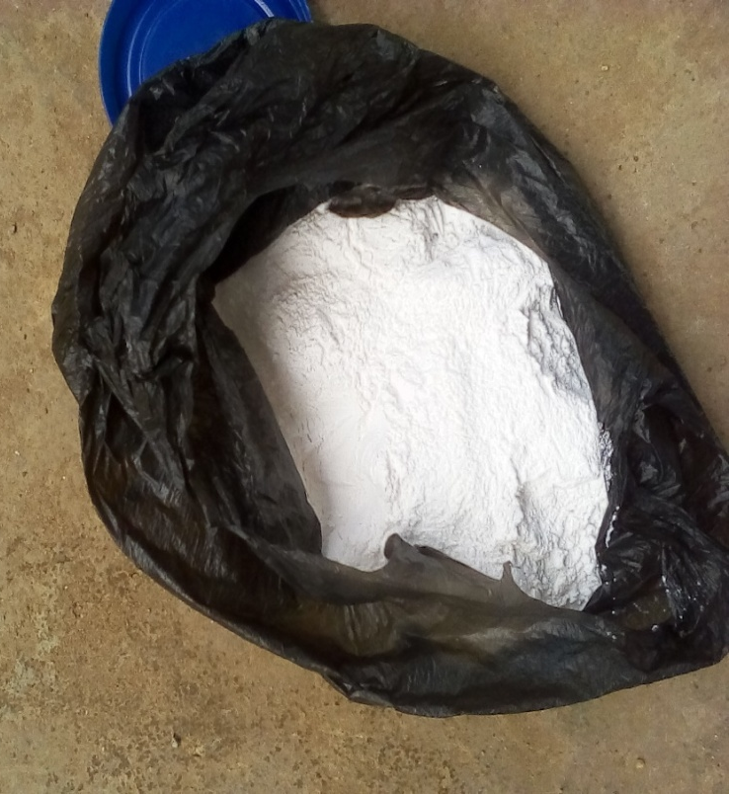
APPENDIX
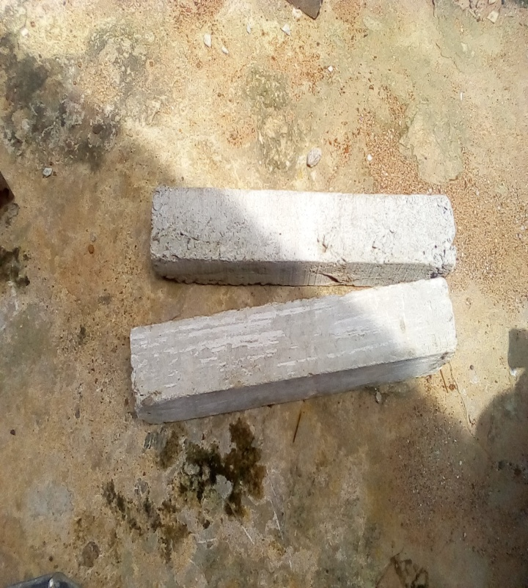

Plate 1: Sample of Calcium Chloride admixture powder
Plate 2: Sample of the beam produced

Plate 7: Curing of the beam produced from calcium chloride admixture

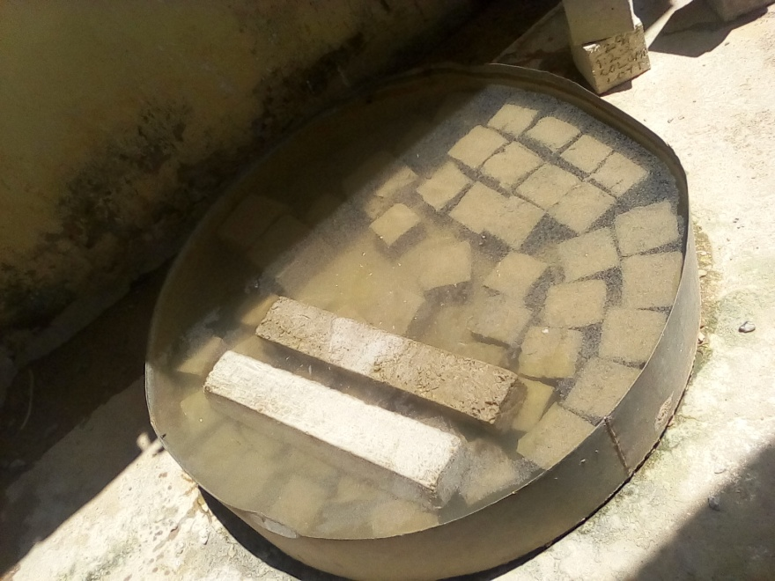
Plate 7: Curing of the beam produced from calcium chloride admixture

Plate 7: Curing of the beam produced from calcium chloride admixture
Plate 7: Curing of the beam produced from calcium chloride admixture

