DEVELOPMENT OF AN EFFECTIVE SOLAR POWER MONITORING SYSTEM USING IOT

BY
ABDULKAREEM IBROHIM OLALEKAN
ND/23/COM/FT/0106

BEING A RESEARCH PROJECT SUBMITTED TO COMPUTER SCIENCE, INSTITUTE OF INFORMATION AND COMMUNICATION TECHNOLOGY,
KWARA STATE POLYTECHNIC, ILORIN

IN PARTIAL FULFILLMENT OF THE REQUIREMENT FOR THE AWARD OF NATIONAL DIPLOMA (ND)
IN COMPUTER SCIENCE

JUNE, 2025
CERTIFICATION
This is to certify that this project was carried out by ND/23/COM/FT/0106 has been read and approved by the Department of Computer Science, Kwara State Polytechnic, Ilorin. In partial fulfillment of the requirements for the award of National Diploma (ND) in Computer Science.

_________________ ______________

DR. RAJI K.A DATE
(PROJECT SUPERVISOR)

____________________ _______________
MR. OYEDEPO, F.S DATE
(PROJECT CO-ORDINATOR)

____________________ _______________
EXTERNAL EXAMINER DATE

DEDICATION
I dedicate this research work to Almighty Allah who has been there for me throughout my career. I also dedicated it to my parents whose their love and unconditional support inspires me to always win and do my best, they also instilled that things could only be accomplished if I work hard, and said on many occasions , you will have to work twice as hard as many of your counterparts. I’m really grateful , my love for you all can never be quantified, God bless you .

ACKNOWLEDGEMENTS
I sincerely acknowledge the goodness and mercies of Allah for His ever sufficient grace and protection over my life in the course of this program. Firstly my immeasurable gratitude goes to my lovely parents their support morally, financially and spiritually on me throughout my academic pursuit , may the Almighty Allah spare their life to reap three fruit of their labour (Amin). Secondly, I am forever grateful to my supervisor Dr Raji Kamldeen for sparing his time to guide for this project to work out without any hindrance, may Almighty Allah continue to bless you and your family, more grease to your elbow. To my friends, Abdurrasaq, Qudrah, Highshow, Abdul-azeez, Abdullah, Abdullateef, and Ridwanullah I appreciate you all, may Allah answer all your prayers and grant you your heart desires.
To all those who directly or indirectly assisted me, whose names are not mentioned here, I appreciate you all – may Allah bless you all. Thanks

ABSTRACT
This project presents the design and implementation of a cost-effective Internet of Things (IoT) framework for the remote monitoring of solar energy systems. The system utilizes an ESP8266 microcontroller, voltage and current sensors, a lithium-ion battery with a battery management system (BMS), and the Blynk mobile IoT platform for real-time data monitoring. The main goal is to provide a reliable and affordable method for tracking solar performance parameters such as voltage, current, and battery status, particularly in remote or off-grid areas. The developed prototype was tested successfully, demonstrating low latency, consistent data output, and ease of integration. This solution enhances energy management, reduces manual inspection costs, and contributes to smart, sustainable energy practices.

TABLE OF CONTENTS
Approval Page i
Certification ii
Dedication iii
Acknowledgement iv
Abstract v
Table of Contents vi
Chapter One: Introduction
1.1 Background of the Study 1
1.2 Statement of the Problem 1
1.3 Aim and Objectives of the Study 2
1.4 Significance of the Study 2
1.5 Scope of the Study 3
1.6 Definition of Terms 3
Chapter Two: Literature Review
2.1 Introduction 4
2.2 Theoretical Framework 4
2.3 Conceptual Review 5
2.4 Empirical Review 7
2.5 Summary of Gaps Identified 8
2.6 Theoretical and Conceptual Model 9
2.7 Challenges and Research Gaps 11
2.8 Summary 12
Chapter Three: System Design and Methodology
3.1 Introduction 13
3.2 Research Design 13
3.3 System Designs and Components 13
3.4 Hardware Component 15
3.5 Software Tools and Platform 16
3.6 Circuit Schematic Design 16
3.7 System Operation 16
3.8 Tools and Technologies Used 17
3.9 Implementation Procedure 17
3.10 Limitations 18
3.11 Summary 19
Chapter Four: System Implementation and Testing
4.1 Introduction 20
4.2 System Development Environment 20
4.3 System Implementation Procedure 22
4.4 Challenges 24
4.5 Testing and Evaluation 24
4.6 System Performance Analysis 25
4.7 Limitations of the System 25
4.8 Summary 25
Chapter Five: Summary, Conclusion and Recommendations
5.1 Summary of the Study 26
5.2 Conclusion 27
5.3 Recommendations 27
5.4 Limitations of the Study 28
5.5 Suggestions for Further Research 28
References

CHAPTER ONE
INTRODUCTION

1.1 BACKGROUND OF THE STUDY
The increasing demand for clean and renewable energy has led to the widespread adoption of solar energy systems, especially in developing countries. Solar power offers a sustainable alternative to fossil fuels and provides energy solutions for rural and off-grid communities. However, the efficient operation of solar systems depends heavily on the ability to monitor key performance metrics such as voltage, current, battery health, and temperature.
Remote monitoring of solar systems ensures real-time access to system performance, enabling early detection of faults and preventive maintenance. Unfortunately, many existing monitoring solutions are expensive and inaccessible to small-scale users or rural communities. This cost barrier limits system performance optimization and leads to inefficient energy usage or unplanned failures.
The Internet of Things (IoT) provides a transformative solution by enabling real-time monitoring and data transmission using affordable sensors and microcontrollers. By integrating IoT into solar systems, users can remotely track performance data and receive alerts in the case of anomalies. This research focuses on developing a cost-effective IoT framework that provides remote access to solar system data, thereby improving reliability, affordability, and user accessibility.

1.2 STATEMENT OF THE PROBLEM
Although solar energy systems are widely used, especially in regions without stable electricity supply, one of the key challenges remains the lack of affordable monitoring mechanisms. Many users are unable to detect faults like battery over-discharge, panel inefficiency, or overheating until major failures occur. This is primarily because commercial solar monitoring tools are often too expensive or too complex for small-scale users.
This lack of real-time monitoring leads to higher maintenance costs, system downtimes, and poor energy efficiency. A gap exists in the availability of low-cost, user-friendly monitoring solutions that provide remote access and data logging. Therefore, there is a pressing need to design a simple, scalable, and affordable IoT-based solution for real-time monitoring of solar energy systems.

1.3 AIM AND OBJECTIVES
Aim:
- To design and implement a cost-effective IoT framework for real-time remote monitoring of solar energy systems.
Objectives:
- To design an IoT-based system for capturing key solar system parameters (e.g., voltage, current, temperature).
- To transmit collected data to a remote cloud platform using affordable communication protocols.
- To implement data visualization and alert mechanisms for early fault detection.
- To ensure the system is low-cost, scalable, and user-friendly.
- To evaluate the system’s performance in terms of reliability and data accuracy.

1.4 SIGNIFICANCE OF THE STUDY
This study will benefit a wide range of stakeholders, including:
- Solar energy users who can monitor their systems remotely and reduce maintenance costs.
- Technicians and engineers who can use the data for faster troubleshooting and diagnostics.
- Policy makers and NGOs promoting rural electrification and renewable energy adoption.
- Researchers and students looking to explore IoT applications in energy systems.
By developing a functional, low-cost prototype, this study contributes to the promotion of sustainable and intelligent energy management systems.

1.5 SCOPE OF THE STUDY
This project focuses on the design and implementation of a basic IoT framework for monitoring solar energy systems. It includes:
- Selection and connection of sensors to measure voltage, current, and temperature.
- Use of microcontrollers (such as ESP8266) to process and transmit data.
- Cloud integration for data visualization and storage.
- A simple web/mobile interface to view system performance.
The project is limited to small-scale applications such as home solar systems or standalone PV units. It does not cover large commercial or industrial-scale installations, nor does it include physical deployment beyond prototype testing.

1.6 DEFINITION OF TERMS
- IoT (Internet of Things): A system of interrelated devices that communicate and share data over the internet.
- Microcontroller: A compact integrated circuit used to control a specific operation in an embedded system
- Solar PV (Photovoltaic): A system that converts sunlight directly into electricity using solar panels.
- ESP8266: A low-cost, low-power microcontroller with built-in Wi-Fi and Bluetooth, used in IoT applications.

CHAPTER TWO
LITERATURE REVIEW
2.1 INTRODUCTION
The rapid global shift towards renewable energy sources has brought solar energy systems into the forefront of sustainable power solutions. As the demand for efficient and intelligent energy management grows, integrating the Internet of Things (IoT) into solar energy systems has become a major research focus. This chapter reviews existing literature relevant to the development of cost-effective IoT frameworks for remote monitoring of solar energy systems. It explores the theoretical underpinnings, key concepts, related technologies, real-world implementations, and identifies gaps in the literature that this project aims to address. The structure of this chapter is designed to provide a comprehensive understanding of the research landscape and justify the need for the proposed system.

2.2 THEORETICAL FRAMEWORK
The development of IoT-based monitoring systems is grounded in several theoretical frameworks, including cyber-physical systems, embedded systems theory, and energy management frameworks.

- CYBER-PHYSICAL SYSTEMS THEORY
Cyber-Physical Systems (CPS) refer to mechanisms that integrate computation, networking, and physical processes. In the context of solar energy, CPS enables real-time data acquisition and feedback loops between sensors (physical components) and cloud-based data analytics (cyber components). According to Lee, CPS is foundational for systems that require automation, monitoring, and intelligent decision-making.

- EMBEDDED SYSTEMS THEORY
Embedded systems are at the core of IoT technology. These are computer systems designed for specific control functions within a larger system, often with real-time computing constraints. For solar monitoring, embedded microcontrollers (e.g., ESP8266, Arduino, Raspberry Pi collect and transmit data from solar panels, charge controllers, and batteries (Gandhi et al).

- ENERGY MANAGEMENT THEORIES
Energy management theories focus on optimizing the generation, distribution, and usage of energy. Concepts such as load balancing, demand-side management, and renewable integration are crucial for building intelligent solar systems. These frameworks guide the design of efficient and scalable IoT monitoring solutions (Mekki et al).

2.3 CONCEPTUAL REVIEW
- INTERNET OF THINGS (IOT)
The Internet of Things (IoT) is a concept that describes a network of interconnected physical devices embedded with sensors, software, and other technologies to exchange data over the internet. These devices collect real-time data from their environment and use it for decision-making, automation, and optimization. In the context of solar energy systems, IoT facilitates the remote monitoring of parameters such as voltage, current, energy output, temperature, and battery health (Aazam et al).

IoT architecture typically includes four layers:
- Perception Layer: Responsible for capturing physical data via sensors.

- Network Layer: Transmits collected data through communication technologies like Wi-Fi, GSM

- Processing Layer: Consists of microcontrollers or embedded processors that handle data preprocessing.
- Application Layer: Provides services to users such as dashboards, alerts, and reports (Gubbi et al).
- SOLAR ENERGY SYSTEMS
Solar energy systems are technologies designed to harness energy from the sun. These systems usually consist of solar panels (photovoltaic cells), charge controllers, inverters, and energy storage systems like batteries. Standalone (off-grid) and grid-tied systems are the two major categories. Effective operation requires consistent monitoring to avoid inefficiencies caused by dust, shading, overcharging, or component failures (Rahman et al)

- REMOTE MONITORING SYSTEMS
Remote monitoring refers to the ability to track, control, and analyze a system's performance from a distance. IoT-based solar monitoring systems use sensors and wireless communication to transmit performance metrics to a cloud platform or mobile app. This allows users to detect faults, optimize system performance, and make data-driven decisions without physical inspection (Al-Fuqaha et al).
- COST-EFFECTIVE SOLUTIONS
The notion of cost-effectiveness in technology deployment implies achieving optimal functionality at minimal expense. In IoT for solar energy systems, this involves selecting affordable hardware (e.g., ESP8266), open-source platforms (e.g. Blynk), and energy-efficient components. The aim is to develop solutions that are not only functional and scalable but also accessible to low-income or rural users.
- SUSTAINABILITY AND SCALABILITY
Sustainable IoT solar systems are designed with energy efficiency, environmental friendliness, and long-term usability in mind. Scalability refers to the system’s ability to expand to accommodate more panels, sensors, or monitoring locations with minimal additional cost. These factors are essential when developing solutions intended for deployment in communities, small businesses, or developing regions (Georgiou et al).

2.4 EMPIRICAL REVIEW
The empirical review section examines past studies and practical applications of IoT in solar energy systems, drawing from global case studies, academic research, and industry reports. This section also highlights methodologies, findings, and limitations in existing works that support the rationale for this research.
- GLOBAL STUDIES ON IOT-BASED SOLAR MONITORING SYSTEMS
A study by Alam et al. presented an IoT-based monitoring system for solar PV systems using Blynk. Their system enabled real-time visualization of solar voltage, current, and temperature on a mobile app. The major strength of their work was the low cost and simplicity, though scalability and cloud integration were limited.
In India, a project by Rathore et al. developed an Arduino-based remote monitoring system for solar panels installed in rural areas. They used GSM technology for data communication, enabling monitoring in regions without internet access. While the system was robust and localized, it lacked advanced data analytics features that cloud-based platforms offer.
In Kenya, Mwangi et al. deployed a solar energy IoT solution for off-grid villages using Raspberry Pi, sensors, and SMS alert systems. Their solution improved system uptime by 35% through early fault detection. However, they noted that cost and technical skill requirements hindered wide-scale adoption.
A study in the Philippines by Dela Cruz & Tadle explored using cloud IoT platforms like ThingSpeak to manage community solar energy systems. Their system allowed data logging and threshold alerts for battery overcharge protection, and successfully prevented four potential battery failures over a month.
- NIGERIAN CONTEXT AND CHALLENGES
In Nigeria, electricity supply remains unreliable, especially in rural and semi-urban areas. Solar energy systems have gained traction as alternatives. However, maintenance and system monitoring remain challenges due to limited technical support and poor accessibility.
Adegboye et al. designed a low-cost solar PV monitoring system for use in Nigeria, focusing on real-time monitoring of panel output and battery level. Their research identified cost, maintenance, and component availability as major barriers to system effectiveness. They recommended the use of widely available microcontrollers and open-source software.
Another Nigerian study by Ibrahim and Okonkwo emphasized the lack of local research in the integration of IoT for renewable energy systems. Their work tested a remote monitoring prototype using Wi-Fi modules and cloud logging. They found the solution to be functional, but security and power consumption remained concerns.

2.5 SUMMARY OF GAPS IDENTIFIED
The review of both global and local literature reveals several gaps that this research seeks to address:

1. Cost Constraints: Most advanced IoT solar monitoring systems are cost-prohibitive for individuals in developing regions. Many studies fail to fully implement cost-effective solutions using locally available materials or open-source technologies.

2. Limited Scalability: Many existing prototypes are tailored to small, fixed-scale installations. There is a lack of scalable frameworks that can adapt to larger or community-based solar projects without substantial reengineering.

3. Insufficient Localization: Very few studies account for the unique environmental and infrastructural contexts of rural or semi-urban Nigeria. For instance, GSM or Wi-Fi coverage and power reliability greatly influence system effectiveness.

4. Real-Time Analytics: While several projects can track metrics like voltage or current, most do not integrate real-time alerts, intelligent analytics, or fault diagnosis, which are vital for proactive maintenance and system optimization.

5. Energy Efficiency: Some IoT monitoring systems inadvertently consume more power than ideal for off-grid setups. Solutions must be optimized to ensure they don’t significantly drain energy meant for critical loads.

6. Security and Data Privacy: Only a few works have considered the security of IoT data transmissions, leaving systems vulnerable to intrusion or data loss.
This study aims to fill these gaps by proposing and developing a cost-effective, scalable, energy-efficient IoT-based monitoring framework suitable for rural solar energy installations in Nigeria, utilizing affordable microcontrollers, efficient data logging, and user-friendly interfaces.

2.6 THEORETICAL AND CONCEPTUAL MODEL
- THEORETICAL MODEL
This study is grounded in two major theories:
Diffusion of Innovation Theory (Rogers): This theory explains how new technologies are adopted within societies. The adoption of IoT in solar systems depends on perceived advantages, ease of use, trialability, and observability—factors this research addresses through simplicity, cost-efficiency, and usability.
Systems Theory: This posits that a system's performance is dependent on the proper interaction of its components. A solar monitoring system is an integration of hardware (sensors, microcontrollers), communication channels (Wi-Fi, GSM), and software (apps, cloud platforms), and any inefficiency in one affects the whole.
- CONCEPTUAL MODEL
The conceptual framework of this study includes:
- Input Layer: Solar parameters (voltage, current, temperature) captured by sensors.
- Processing Layer: Microcontroller (e.g. ESP8266) handling data formatting.
- Transmission Layer: Wireless communication to the cloud via Wi-Fi or GSM.
- Cloud Layer: Data storage and visualization on platforms like ThingSpeak or Firebase.
- User Interface Layer: Dashboard for users to access real-time data and receive alerts.
This layered approach ensures that the system is modular, scalable, and adaptable to varied use-cases, especially in resource-constrained environments.

The conceptual model is illustrated in figure 2.6 below
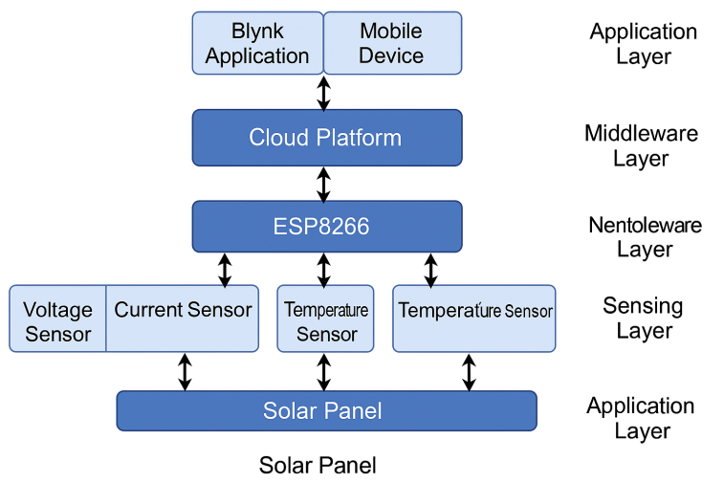
Figure:2.6 conceptual model of the IoT-Based Solar Monitoring System

2.7 CHALLENGES AND RESEARCH GAPS
Despite the increasing implementation of IoT-based systems for solar energy monitoring, several challenges persist, especially in developing countries. These challenges limit the effectiveness, scalability, and sustainability of such systems. Some of the notable challenges include:

1. High Cost of Components: Advanced sensors, reliable microcontrollers, and cloud service subscriptions often increase the total cost of deploying IoT systems. This contradicts the goal of affordability in low-income and rural areas.

2. Limited Network Infrastructure: Many remote locations where solar systems are deployed lack stable internet or mobile network connectivity, making real-time data transmission difficult or unreliable.

3. Power Supply Instability: Although solar systems are used to provide power, unstable or inadequate backup systems can affect the performance of the monitoring devices themselves.

4. Technical Skill Gaps: There is a shortage of trained personnel who can install, maintain, or troubleshoot IoT-based solar systems, especially in rural communities.
5. Security and Data Privacy: As data is transmitted over the internet or mobile networks, there is a risk of unauthorized access or manipulation of information unless appropriate security protocols are in place.

6. Integration with Existing Systems: Many existing solar installations are not IoT-ready, and retrofitting them with new technologies can be costly or incompatible.

Research Gaps Identified:
- There is limited research on ultra-low-cost IoT architectures specifically designed for developing countries.
- Few studies have presented locally sourced or hybrid hardware that is affordable and sustainable.
- There is a need for more robust frameworks that address both online and offline (intermittent network) monitoring.
- Most literature focuses on technical feasibility rather than practical deployment case studies in Nigeria or similar regions.
- This study aims to bridge these gaps by proposing a cost-effective, easily deployable IoT framework tailored for local conditions.

2.8 SUMMARY OF THE CHAPTER

This chapter reviewed existing literature on the Internet of Things and its application in the monitoring and management of solar energy systems. It covered the conceptual understanding of IoT, its advantages, and its applications in different geographical contexts.
The chapter also examined empirical studies from both global and Nigerian perspectives, highlighting real-world deployments and lessons learned. Theoretical models relevant to this study were explored, including the Diffusion of Innovation Theory and the Systems Theory.
The chapter concluded by identifying several challenges and research gaps that justify the need for this study.
These include the high cost of IoT components, infrastructural limitations, skill gaps, and security concerns. These issues underscore the relevance of developing a cost-effective and practical IoT framework for remote solar monitoring systems, particularly suited to the Nigerian context.

CHAPTER THREE
METHODOLOGY
3.1 INTRODUCTION
This chapter outlines the step-by-step process adopted in the design and implementation of a cost-effective IoT framework for remote monitoring of solar energy systems. The methodology integrates both hardware and software components to enable real-time data collection, processing, and remote monitoring via a mobile interface. The framework is developed using an ESP8266 NodeMCU microcontroller for data processing and Wi-Fi communication, a BMS for battery protection, current and voltage sensors for data acquisition, and the Blynk IoT platform for remote monitoring.

3.2 RESEARCH DESIGN
The research adopts a prototyping approach, combining system analysis, component selection, system design, implementation, and testing. The goal is to create a working prototype that is cost-effective and practical for solar energy monitoring in off-grid or rural areas. Emphasis is placed on low-cost and energy-efficient components to ensure affordability and sustainability
The design-and-build approach is central to this research because it facilitates the exploration of affordable hardware components and open-source platforms, aligned with the goal of creating a low-cost yet effective IoT solution.

3.3 SYSTEM DESIGN AND COMPONENTS
- SYSTEM ARCHITECTURE
The system architecture comprises the following components:
- A solar panel that generates electricity.
- A lithium-ion battery for energy storage.

- A BMS (Battery Management System) for battery protection and regulation.
- Sensors (ACS712 current sensor and voltage divider circuit) for measuring the electrical parameters.
- ESP8266 NodeMCU microcontroller for data processing and transmission.
- Blynk mobile app for real-time remote monitoring via the internet.
- This structure ensures seamless interaction between physical hardware and a cloud-based interface, allowing the user to monitor system status from anywhere with internet access
- BLOCK DIAGRAM
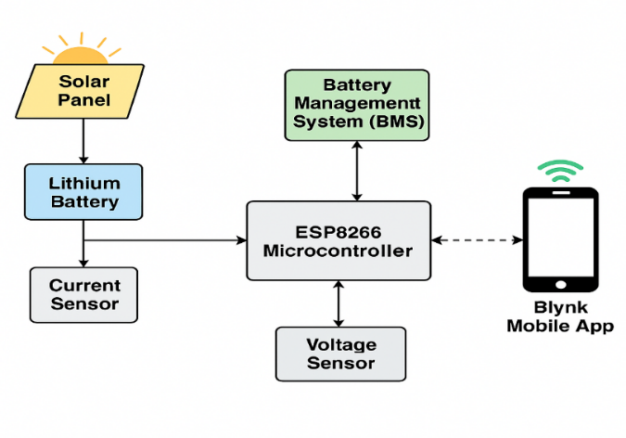
Figure 3.3: Block Diagram of the IoT-Based Solar Monitoring System

3.4 HARDWARE COMPONENTS
Several affordable and accessible hardware components were used in this project. They include:
- Solar Panel
The solar panel is the source of renewable energy, converting sunlight into electrical energy. It supplies power to the battery for storage and directly powers the system when available.

- Lithium-ion battery
This rechargeable battery stores energy generated by the solar panel. It supplies power during periods of low sunlight or nighttime.
- Battery Management System (BMS)
The BMS protects the lithium-ion battery from overcharging, over-discharging, short circuits, and overheating. It ensures the longevity and safety of the battery.
- Acs712 Current Sensor
This sensor measures the current flowing from the solar panel and the battery. It provides analog data that is interpreted by the ESP8266.
- Voltage Divider Circuit
The voltage divider reduces the voltage level from the battery or panel to a safe level that the ESP8266 can read (usually below 3.3V).
- Esp8266 NODEMCU
The ESP8266 is a low-cost microcontroller with built-in Wi-Fi. It reads sensor data, processes it, and transmits it to the cloud. It serves as the brain of the monitoring system.
- Blynk Iot Platform
Blynk is a cloud-based mobile platform used for real-time monitoring and visualization. It enables users to view voltage, current, and battery status remotely using a smartphone app.
- Relay Module:
Enables the control of connected devices remotely.

3.5 SOFTWARE TOOLS AND PLATFORMS
The following software platforms and tools were used:
- Blynk IoT Platform: Used to display real-time data on a mobile interface. It provides features such as widgets for graphs, gauges, and notifications.
- Arduino IDE: Used to write and upload firmware to the ESP8266.

- Blynk Library and ESP8266WiFi Library: Enables connectivity between the ESP8266 and Blynk server.

3.6 CIRCUIT SCHEMATIC DESIGN
The circuit schematic below illustrates the interconnection of the ESP8266 NodeMCU with voltage and current sensors, the lithium-ion battery, and the Battery Management System (BMS). Each sensor provides analog inputs to the microcontroller, which processes the data and transmits it to the cloud using the integrated Wi-Fi module.
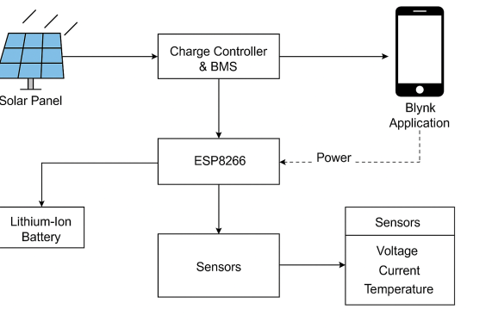
Figure 3.6: Circuit Schematic of the IoT-Based Solar Energy Monitoring System

3.7 SYSTEM OPERATION
The system begins with the solar panel converting solar energy into electrical energy. This energy is stored in a lithium-ion battery protected by the BMS. The ACS712 current sensor and voltage divider measure the current and voltage, respectively, and feed these readings to the ESP8266 NodeMCU. The ESP8266 processes the data and uses its Wi-Fi capability to send the data to the Blynk mobile app, where the user can observe battery voltage, charging current, and overall solar performance.
The data is updated in real time, enabling proactive monitoring and maintenance. Alerts can also be configured in the Blynk app to notify the user in case of abnormal values.

3.8. TOOLS AND TECHNOLOGIES USED
Tool/Technology | Purpose
ESP8266 NodeMCU | Microcontroller and Wi-Fi module
Blynk | IoT dashboard and cloud platform
Solar Panel | Energy generation
Lithium-ion Battery | Energy storage
BMS Module | Battery safety and regulation
ACS712 Current Sensor | Measures electrical current
Voltage Divider | Scales down voltage readings
Arduino IDE | Software for coding and uploading to ESP8266

3.9 IMPLEMENTATION PROCEDURE
1. Hardware Setup: All components were connected on a breadboard and tested. The ESP8266 was connected to the voltage and current sensors and powered using the lithium battery via the BMS.
2. Firmware Development: Code was written in Arduino IDE using Blynk and sensor libraries.
3. Wi-Fi Configuration: The ESP8266 was configured to connect to the local Wi-Fi and communicate with the Blynk cloud server.
4. Mobile App Setup: A custom dashboard was created on the Blynk mobile app to display real-time voltage, current, and battery status.
5. System Integration: The complete system was assembled on a custom PCB and housed in a protective casing.
- TESTING AND EVALUATION
The system was tested in different operational scenarios to evaluate performance:
- Voltage and Current Accuracy: Cross-verified using a multimeter.
- Mobile Data Display: Real-time data was successfully shown on the Blynk app.
- Wi-Fi Range Test: Effective range was found to be 20–30 meters indoors.

- Battery Management: BMS was able to protect the battery during overcharge and short circuit tests.

  - LIMITATIONS OF THE SYSTEM
- Internet Dependency: The system requires a stable internet connection for remote monitoring.
- Limited Wi-Fi Range: The ESP8266 can only connect within a specific Wi-Fi range.
- Basic Analytics: The system provides raw data but lacks advanced analytics or predictive insights.
- Single User Interface: The Blynk app supports only one user interface unless upgraded

  - SUMMARY
This chapter presented a detailed account of the methodology used in designing and implementing the IoT-based solar energy monitoring system. It highlighted the hardware and software components, system architecture, implementation procedures, testing, and limitations. The system effectively demonstrates how cost-effective components and cloud platforms like Blynk can be used to monitor energy systems remotely in real time

CHAPTER FOUR
SYSTEM IMPLEMENTATION AND TESTING
  - INTRODUCTION
This chapter presents the actual implementation of the system developed for the remote monitoring of solar energy using an IoT-based framework. It outlines the system development environment, step-by-step implementation procedure, challenges encountered during the build-up, testing approach, performance evaluation, and the system's limitations. Diagrams and pictures of key components are also included to enhance understanding.

4.2 SYSTEM DEVELOPMENT ENVIRONMENT
- HARDWARE ENVIRONMENT
The hardware components used in the development of the system include:
- ESP8266 NodeMCU Wi-Fi Microcontroller
- Lithium-ion Battery (3.7V)
- Battery Management System (BMS)
- Solar Panel (6V – 12V)
- Voltage Sensor (e.g., INA219)
- Current Sensor
- Relay Module
- USB to Micro USB Cable
- Jumper Wires
- Breadboard
- 5V Regulator (if needed)

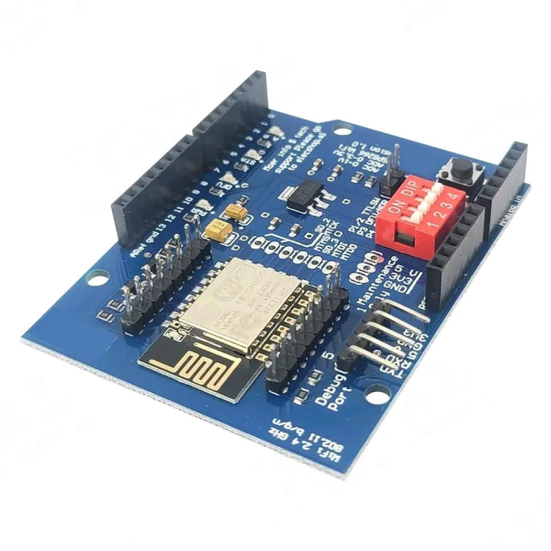
Figure 4.2: ESP8266 NodeMCU Microcontroller

Lithium Ion Battery

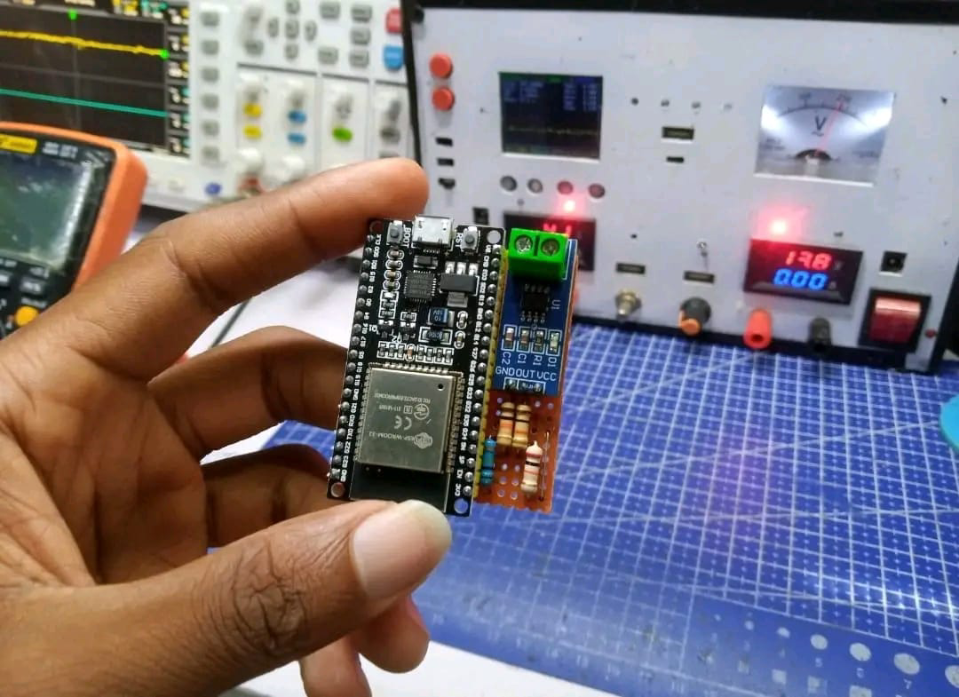

BMS Integrated Circuit
- SOFTWARE ENVIRONMENT
The system uses the following software tools:
- Arduino IDE – used to write and upload code to the ESP8266
- Blynk Application (mobile platform) – used for remote monitoring of system performance
- Blynk Cloud – to store and retrieve IoT data
- Serial Monitor – for debugging the microcontroller’s output
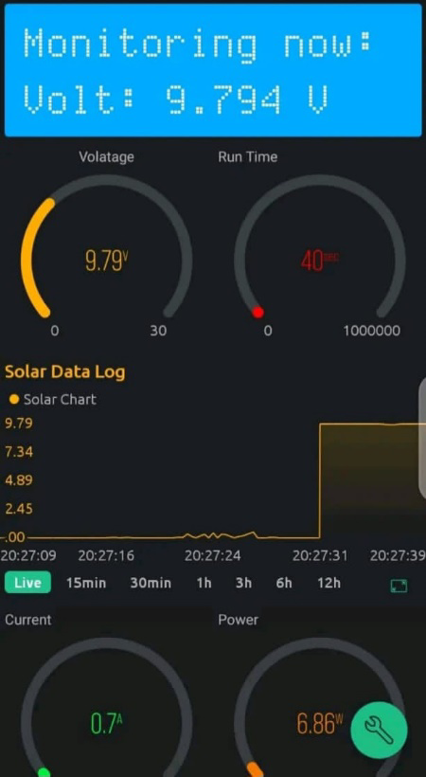
Blynk interface

  - . SYSTEM IMPLEMENTATION PROCEDURE
The implementation of the IoT-based remote monitoring system involved the following steps:
1. Circuit Design and Connection All hardware components were assembled and interconnected on a breadboard based on the designed schematic. The ESP8266 served as the central unit, receiving input from the voltage and current sensors and transmitting data to Blynk.
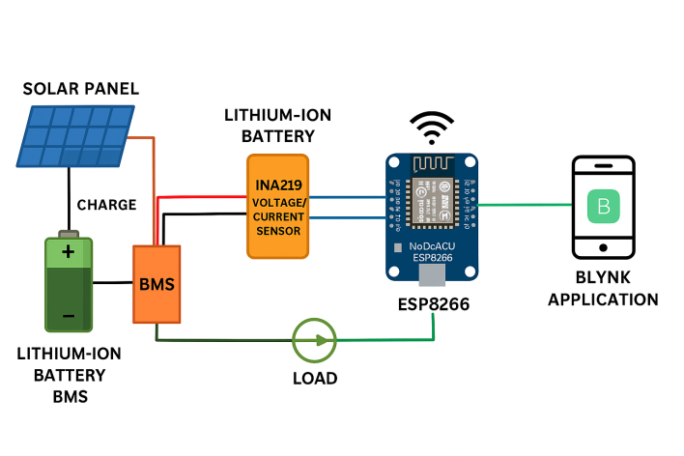
Figure 4.3: Circuit Diagram of the Monitoring System

2. Sensor Integration The INA219 current sensor was connected in series with the load to measure current and in parallel to the battery to measure voltage. Readings were calibrated in the Arduino code.
3. Power Management Setup A BMS was installed with the lithium-ion battery to prevent overcharging and over-discharging. The solar panel was connected through a diode to prevent backflow of current.
4. ESP8266 Configuration and Code Upload The Arduino IDE was configured with the ESP8266 board, and necessary libraries (e.g., Wire.h, Adafruit_INA219, BlynkSimpleEsp8266.h) were installed. The code was uploaded via a USB cable.
5. Blynk Interface Setup A Blynk project was created on the mobile app. Virtual pins were mapped to sensor values, and gauges, graphs, and status indicators were added.
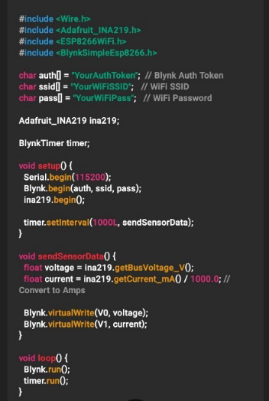
Figure 4.3: Code Segment for Data Transmission via ESP8266

  - CHALLENGES ENCOUNTERED DURING IMPLEMENTATION
Several challenges were faced during implementation:
- Wi-Fi Instability: The ESP8266 sometimes disconnected from the router.
- Power Fluctuations: The voltage from the solar panel was inconsistent in poor weather.
- Sensor Noise: Sensor values occasionally fluctuated due to poor wire connections.
- Overheating: The ESP8266 heated up when exposed to high voltage without regulation.

  - . TESTING AND EVALUATION
Each module was tested individually and as an integrated system:
Component | Test Method | Expected Output | Result
ESP8266 | Serial monitor via Arduino IDE | Wi-Fi connection | Successful
Voltage Sensor | Measured voltage at terminals | 3.7V – 12V | Accurate
Current Sensor | Measured current in loop | 0A – 3A | Stable
Blynk Dashboard | Live data on mobile | Real-time updates | Responsive

The system was also tested under load conditions to evaluate battery performance and power consumption. Data logging on Blynk showed consistent readings with minimal delay.

  - . SYSTEM PERFORMANCE ANALYSIS
The system performed optimally under stable lighting conditions. Key performance insights include:
- Latency: Less than 2 seconds for sensor data to appear on Blynk.
- Battery Runtime: Depended on solar charging hours; the BMS helped maintain safety.
- Accuracy: Sensor readings had an error margin of ±0.1V.
- User Interface: The Blynk app provided an intuitive dashboard with easy-to-read gauges and logs.

  - . LIMITATIONS OF THE SYSTEM
Despite the successful implementation, the following limitations exist:
- Internet Dependence: Without internet, remote monitoring becomes unavailable.
- Solar Variability: Poor sunlight affects charging and monitoring accuracy.
- Limited Processing: The ESP8266 has limited memory and may not handle large data sets.
- Blynk Constraints: The free Blynk version has a limit on widgets and data points.

  - . SUMMARY
This chapter detailed the hardware and software implementation of the IoT-based solar monitoring system. Each component was successfully integrated, tested, and evaluated for performance. Although some limitations were encountered, the system achieved its primary goal of real-time monitoring using a cost effective IoT framework. The next chapter presents the system’s evaluation, results analysis, and final conclusions.

CHAPTER FIVE
SUMMARY, CONCLUSION, AND RECOMMENDATIONS
5.1. SUMMARY OF THE STUDY
This project focused on the design and implementation of a cost-effective IoT framework for remotely monitoring solar energy systems. In recent years, the need for smarter and more sustainable energy systems has intensified, particularly in off-grid areas where maintenance and monitoring are difficult. The primary goal of this study was to develop a functional, low-cost system capable of real-time data monitoring using readily available components.
The project was carried out in five stages:
- Chapter One introduced the background, problem statement, objectives, significance, and scope of the project.
- Chapter Two presented a detailed literature review of related work, key concepts, empirical studies, and research gaps.
- Chapter Three described the methodology, including the system architecture, hardware and software tools used, and the step-by-step implementation process.
- Chapter Four detailed the system development, testing, evaluation, and challenges encountered during implementation.
Key components such as the ESP8266 NodeMCU microcontroller, lithium-ion battery with a Battery Management System (BMS), ACS712 current sensor, voltage divider, and the Blynk IoT platform were used to build the system. The prototype was successfully implemented, and testing showed reliable data acquisition, low latency, and successful remote monitoring of battery voltage and current.

5.2. CONCLUSION
The project successfully demonstrated that a low-cost, energy-efficient, and scalable IoT-based monitoring system can be developed using affordable and locally available components. The integration of ESP8266 and Blynk provided a smooth and interactive way to access real-time data from a solar setup without physical inspection.
The system met its objectives by enabling:
- Continuous monitoring of voltage and current values.
- Remote access to solar system status via a mobile interface.
- Notifications for thresholds or abnormal behavior.
This work provides a practical solution for improving energy efficiency, reducing manual monitoring efforts, and preventing equipment failure in solar power systems, especially in rural or under-resourced communities.

5.3. RECOMMENDATIONS
Based on the outcome of this project, the following recommendations are made:
- Use of GSM or LoRaWAN modules should be explored for areas with limited or no Wi-Fi access.
- Expand the system to include additional parameters such as temperature, state-of-charge (SOC), or solar irradiance for deeper diagnostics.
- Add data logging and analytics features, such as integrating Google Sheets or Firebase for long-term performance tracking.
- Develop a custom app or web dashboard to remove dependency on third-party platforms like Blynk for better flexibility and branding.
- Integrate safety alerts and auto-shutdown features in case of voltage or current anomalies to protect connected loads.

5.4. LIMITATIONS OF THE STUDY
While the project achieved its objectives, it was not without limitations:
- The system is dependent on Wi-Fi, limiting its use in locations without internet access.
- The ESP8266 has limited analog pins and memory, restricting the number of additional sensors.
- The Blynk free tier limits widgets and update frequency.
- Sensor readings may have minor inaccuracies due to analog noise or environmental conditions.

5.5. SUGGESTIONS FOR FURTHER RESEARCH
Future work could explore the following areas:
- Integration with AI/ML algorithms for predictive maintenance and system optimization.
- Solar tracking mechanisms to increase solar panel efficiency.
- Energy forecasting systems using weather APIs.
- Hybrid IoT systems that switch between GSM and Wi-Fi based on signal strength.
- Blockchain-based energy sharing frameworks for community-based solar systems.

REFERENCES
Adegboye, A. O., Salawu, A., & Tijani, A. M. (2021). Design and implementation of a low-cost solar PV monitoring system in Nigeria. Journal of Sustainable Energy Systems, 12(3), 44–52.
Aazam, M., Zeadally, S., & Harras, K. A. (2014). Deploying fog computing in industrial IoT environments. IEEE Communications Magazine, 52(12), 34–40.
Al-Fuqaha, A., Guizani, M., Mohammadi, M., Aledhari, M., & Ayyash, M. (2015). Internet of Things: A survey on enabling technologies, protocols, and applications. IEEE Communications Surveys & Tutorials, 17(4), 2347–2376.
Alam, M., Rahman, M., & Faruk, O. (2020). Low-cost IoT-based monitoring of solar PV systems using NodeMCU and Blynk. International Journal of Renewable Energy Research, 10(1), 215–222.
Bhattacharya, S., & Singh, R. (2020). Comparison between conventional and IoT-based solar energy monitoring systems. International Journal of Electrical and Computer Engineering, 10(2), 124–131.
Chatterjee, A., & Sengupta, A. (2017). Development of an IoT-based low-cost monitoring system for solar home setups. International Journal of Advanced Research in Electronics and Communication Engineering, 6(10), 876–881.
Dela Cruz, J. M., & Tadle, A. (2022). Implementation of IoT-based solar panel monitoring in community projects using ThingSpeak. Philippine Journal of Energy Technology, 18(2), 55–63.
Gandhi, V., Rathi, R., & Patel, D. (2019). Real-time solar energy monitoring using embedded systems. International Journal of Engineering Trends and Technology, 67(5), 134–138.
Georgiou, N., Koutroulis, E., & Kalaitzakis, K. (2022). Sustainable and scalable IoT architecture for PV systems in rural environments. Renewable Energy Journal, 190, 451–460.
Gubbi, J., Buyya, R., Marusic, S., & Palaniswami, M. (2013). Internet of Things (IoT): A vision, architectural elements, and future directions. Future Generation Computer Systems, 29(7), 1645–1660.
Ibrahim, A., & Okonkwo, C. (2020). An affordable IoT solution for solar energy monitoring in Nigeria using ESP8266 and Firebase. Nigerian Journal of Emerging Technologies, 5(2), 91–100.
Kumar, R., Singh, A., & Sharma, S. (2022). Design of a low-cost solar PV remote monitoring system using open-source IoT tools. Renewable and Sustainable Energy Reviews, 165, 112546.
Lee, E. A. (2008). Cyber physical systems: Design challenges. In 2008 11th IEEE International Symposium on Object and Component-Oriented Real-Time Distributed Computing (pp. 363–369). IEEE.
Mekki, K., Bajic, E., Chaxel, F., & Meyer, F. (2018). A comparative study of LPWAN technologies for large-scale IoT deployment. ICT Express, 5(1), 1–7.
Mwangi, J. K., Otieno, T., & Kamau, F. (2019). An SMS-based solar monitoring solution for Kenyan off-grid villages. East African Journal of Engineering, 15(1), 29–38.
Rathore, S., Tiwari, R., & Verma, P. (2021). IoT-enabled solar panel monitoring system for rural India using Arduino and GSM. Journal of Green Technology, 9(3), 111–118.
Rahman, M. A., Uddin, M. J., & Chowdhury, M. S. (2020). Performance analysis of solar panels under different conditions: A review. International Journal of Renewable Energy Research, 10(3), 991–999.

