ASSET TRACKNG SYSTEM USING ANDROID PHONE

By

OPELOYERU HAMMED DAMILARE

ND/23/COM/FT/0040

A PROJECT REPORT SUBMITTED TO THE

DEPARTMENT OF COMPUTER SCIENCE
INSTITUTE OF INFORMATION AND COMMUNICATION TECHNOLOGY, KWARA STATE POLYTECHNIC ILORIN

IN PARTIAL FULFILLMENT OF THE REQUIREMENT FOR THE AWARD OF NATIONAL DIPLOMA (ND) IN COMPUTER SCIENCE

JUNE, 2025

CERTIFICATION

This is to certify that this project research was carried out by OPELOYERU HAMMED DAMILARE with Matriculation Number ND/23/COM/FT/0040, has been read and approved as meeting part of the requirements for the award of National Diploma (ND) in computer science.

_______________________ ___________________
MR. DANSUKI ISMAILA .I Date
Project Supervisor

_______________________ ___________________
MR. OYEDEPO F.S Date
Head of Department

______________________ ___________________
External Examiner Date

DEDICATION

This project work is dedicated to the creator of the earth and universe, the Almighty God. It is also dedicated to my parents for their moral and financial support.

ACKNOWLEDGEMENT

All praise is due to Almighty God the lord of Universal. I praise Him and thank Him for giving me the strength and knowledge to complete my ND program and also for my continued existence of the earth.

I appreciate the utmost effort of my supervisor MR. DANSUKI ISMAILA I. whose patience, support and encouragements have been the driving force behind the success of this research work. It took time out of his tight schedule to guide me and go through this project. He gave useful corrections, constructive criticism, comments, recommendations, advice and always ensures that an excellent research is done. My sincere gratitude goes to Head of the Department MR. OYEDEPO F.S, and other members of staff of the department of computer science, Kwara State Polytechnic, Ilorin. For their constant corporation, constructive criticism an ad encouragements throughout the program.

Special gratitude to my parent MR & MRS OPELOYERU, who exhibited immeasurable financial, patience, support, prayers and understanding during the period in which I was busy tirelessly on my studies. Special thanks goes to my lovely siblings and friends, I pray that God bless them all abundantly (Amen).

TABLE OF CONTENTS
TITLE PAGE
CERTIFICATION PAGE
DEDICATION
ACKNOWLEDGMENT
TABLE OF CONTENTS
ABSTRACT
CHAPTER ONE: GENERAL INTRODUCTION
  - INTRODUCTION
  - Background of Study

Statement of the Problem

Aim of the Project

of the Project objective

Scope of the Study

Significance of the Study

Justification of the Study

Limitations of the Study

Definition of Terms

CHAPTER TWO: LITERATURE REVIEW
  - LITERATURE REVIEW
  - Concept of Automobile asset tracking

2.2 Scope and Applications

2.3 Classification of Tracking Systems

2.4 Importance of Accuracy and Reliability

2.5 Global Navigation Satellite Systems (GNSS)

2.6 Overview of GNSS Constellations

2.7 GNSS Signal Structure and Frequencies

2.8 Trilateration and Position Computation

2.9 Error Sources in GNSS

2.10 GNSS Receiver Architectures

2.11 Coordinate Systems and Geodetic Frameworks

2.12 Assisted GNSS and Hybrid Positioning

2.13 Embedded Systems in Vehicle Tracking

2.14 Functional Role of Embedded Systems in Tracking Devices

2.15 Microcontrollers and Microprocessors Used

2.16 Real-Time Operating Systems (RTOS)

2.17 Power Management and Reliability

2.18 Embedded Communication Protocols

2.19 Data Security and Integrity

2.20 Integration with Vehicle Systems

2.21 GSM/GPRS/LTE Communication in Tracking Systems

2.22 GSM in Vehicle Tracking

2.23 GPRS for Packet-Switched Data

2.24 LTE and 4G Networks in Tracking Systems

2.25 APNs, IP Configuration, and Data Routing

2.26 Antennas and RF Considerations

2.27 SIM Card Management and Network Selection

2.28 Security in Cellular Communication

2.29 Data Cost and Bandwidth Optimization

2.30 Power Supply Design in Tracking Systems

2.31 Input Voltage Range and Automotive Power Characteristics

2.32 Buck and Boost Regulators

2.33 Linear Regulators and Low-Dropout Designs

2.34 Power Supply Sequencing and Module Start-Up Behavior

2.35 Battery Backup and Power Failover

2.36 Power Optimization and Sleep Modes

2.37 EMI/ESD Protection and Automotive Standards

2.38 Power Distribution Architecture

CHAPTER THREE: ANALYSIS OF THE CURRENT SYSTEM
- Research Methodology
  - System overview

Block Diagram Explanation

    - Power Supply and Buck Converter
    - Arduino Nano (Central controller)
    - GPS module (Neo-6m)
    - GSM module
    - Ignition Key interface

  - Working Principle
  - System Design Considerations and Operational Logic
    - Software/ Firmware Design
    - Data Security
    - Fault Handling
    - Power Efficiency
  - Software Development and code deployment
3.6.1 Code Writing and Compilation
3.6.2 Code Uploading Process
3.7 Algorithm and Programm Logic flow
3.7.1 System Pseudocode overview
3.7.2 Aurdino Code Implementation
3.8 System Interfacing and Communication P{protocol

CHAPTER FOUR: PERFORMANCE TESTING AND EVALUATION
4.1 Testing Environment and setup
4.1.1 Equipment and tools Utilized
4.2 Prototype and Testing Setup
4.3 functional Testing of individual module
4.3.1 GPS module performance
4.3.2 GSM module testing
4.4 System Integration Testing
4.5 Power supply and buck converter performance
4.6 Field Deployment and Data collection
4.6.1 Sample output data cable
4.6.2 Route Mapping visualization
4.7 Performance Metrics summary
CHAPTER FIVE: CONCLUSION AND RECOMMENDATION
5.1 Conclusion
5.2 Recommendation
REFERENCES

ABSTRACT

The increasing reliance on road transport for both personal and commercial activities has highlighted the need for robust vehicle asset tracking systems to enhance security, efficiency, and fleet management. This project presents the design and implementation of a cost-effective, real-time automobile tracking system integrating GPS for geolocation and GSM for data transmission. Using embedded systems technology specifically the Arduino Nano platform, GPS Neo-6M module, and GSM module, the prototype tracks vehicle location and ignition status, transmitting this information wirelessly to remote users. The study explores system architecture, communication protocols, software design, and real-world deployment challenges such as power management and signal reliability. A literature review contextualizes the project within current trends including IoT integration, data visualization platforms, and emerging technologies like edge computing and blockchain security. Testing validates the system's effectiveness in delivering timely and accurate location data. The project contributes a scalable and accessible solution to vehicle asset monitoring, with applications in logistics, security, and telematics.

CHAPTER ONE

INTRODUCTION

  - Background of Study

In recent years, the importance of real-time vehicle tracking has grown significantly due to the increasing reliance on road transport for both personal and commercial purposes. Automobiles are not only modes of transportation but also high-value assets that require constant monitoring to ensure security, efficient use, and optimal maintenance. This necessity has become more prominent with the rise in vehicle theft, unauthorized usage, fuel pilferage, and operational inefficiencies within transportation networks.

Traditionally, vehicle monitoring involved manual methods such as record keeping, driver logs, or basic mechanical odometers. These approaches are not only inefficient and time-consuming but also prone to human error and manipulation. With the evolution of digital technologies, the advent of automated tracking systems has revolutionized asset management in the transportation sector.

Modern automobile tracking systems leverage a combination of technologies — notably the Global Positioning System (GPS) for accurate location detection and Global System for Mobile Communications (GSM) for real-time data transmission to a centralized monitoring platform. When combined with a user-friendly graphical interface (such as a web dashboard or mobile application), users can track and manage their vehicles remotely with ease.

Such tracking systems are widely used in logistics and fleet management industries to monitor deliveries, track driver performance, enforce route compliance, and optimize travel routes. Law enforcement agencies also rely on tracking systems for vehicle recovery in case of theft. Insurance companies are increasingly offering telematics-based insurance packages that depend on data collected from tracking systems to assess risk and set premiums.

Furthermore, the integration of microcontrollers, sensor technologies, and cloud computing has made it possible to construct cost-effective and scalable tracking solutions for individuals and small businesses. Low-cost GPS modules, GSM shields, and microcontroller platforms such as Arduino, ESP32, or Raspberry Pi have enabled DIY tracking solutions that offer many of the features found in commercial products.

This project seeks to explore and construct a working prototype of such a system. It demonstrates how embedded systems and telecommunications can be integrated to develop a functional, real- time automobile asset tracker. The system is designed to collect geographic coordinates via GPS, process the data using a microcontroller, and transmit it via GSM to a user interface for monitoring.

In light of global advancements in Internet of Things (IoT), such a system has the potential to serve as a foundational model for more advanced applications, such as automated dispatch systems, predictive maintenance using data analytics, integration with smart city infrastructure, or real-time traffic management.

Therefore, this study is not only timely but also relevant to current technological trends and practical demands in transport asset management. It combines engineering knowledge, system design, and software development to solve a real-world problem, making it valuable from both academic and professional perspectives.

Statement of the Problem

Due to the absence of a cost-effective, real-time tracking system that integrates GPS and GSM technologies, vehicle owners and fleet managers face persistent challenges in monitoring asset location, preventing theft, detecting unauthorized usage, and ensuring optimal route planning and resource utilization. This limitation hinders operational efficiency, increases security risks, and reduces overall asset accountability.

Aim of the Project

The aim of this project is to design and construct a cost-effective, real-time automobile asset tracking system using GPS and GSM technologies to enable continuous location monitoring, enhance vehicle security, and improve operational efficiency through remote data transmission and user-friendly tracking interfaces.

of the Project Objective
    - To design and implement a GPS-enabled embedded system capable of acquiring real-time geospatial coordinates of an automobile.
    - To integrate a GSM communication module for asynchronous transmission of location data to a centralized monitoring platform.
    - To develop firmware for a microcontroller unit (MCU) to manage sensor input, data parsing, and serial communication protocols.
    - To evaluate the system’s operational accuracy, data transmission latency, and reliability
under varying environmental and network conditions.

Scope of the Study

This project focuses on the design, development, and implementation of a real-time automobile asset tracking system that employs GPS for precise geolocation and GSM for wireless data communication. The study encompasses hardware integration of GPS and GSM modules with a microcontroller-based embedded system, as well as the development of firmware to handle data acquisition, processing, and transmission. The system is designed to transmit location coordinates to a remote server or mobile device, where the data can be visualized via a basic software interface. The scope excludes advanced features such as vehicle diagnostics, driver behavior analysis, and integration with existing fleet management software.

Significance of the Study

This project delivers a technically robust, real-time automobile tracking system that integrates GPS and GSM technologies to enhance asset security and operational efficiency. It enables precise

vehicle localization, theft deterrence, and optimized fleet utilization through continuous data acquisition and wireless transmission. The system supports data-driven decision-making in logistics and fleet management while providing a scalable framework for future IoT-enabled vehicular applications and telematics solutions.

Justification of the Study

The increasing rate of vehicle theft and mismanagement in both private and commercial sectors necessitates the deployment of an effective and economical automobile tracking solution. High- end commercial tracking systems often come with prohibitive costs and maintenance contracts. By constructing a low-cost, DIY system using readily available components, this project demonstrates how technological innovation can be democratized for widespread use.

This study is also justified on the basis of its educational value. It provides a practical application of theoretical knowledge in electronics, programming, telecommunications, and systems integration.

Limitations of the Study

The system’s performance is limited by the availability and quality of GPS satellite signals and GSM network coverage, which can be adversely affected in tunnels, dense urban areas, or remote locations. Power consumption and battery life constrain continuous operation, and the prototype does not currently support advanced vehicle diagnostics or driver behavior monitoring. Additionally, data security depends on the implementation of encryption protocols, which are outside the current scope, potentially exposing transmitted data to interception.

Definition of Terms
    - GPS (Global Positioning System): A satellite-based navigation system that provides location and time information.
    - GSM (Global System for Mobile Communications): A standard for mobile communication that allows the transmission of data over cellular networks.
    - Microcontroller: A compact integrated circuit designed to govern a specific operation in an embedded system.
    - Asset Tracking: The process of monitoring the location, status, and usage of physical assets.
    - Geofencing: A feature that defines a virtual boundary and triggers alerts when a device enters or leaves the area.
    - IoT (Internet of Things): A network of physical devices connected to the internet, capable of collecting and sharing data.

CHAPTER TWO

  - LITERATURE REVIEW

  - Concept of Automobile asset tracking

Automobile asset tracking refers to the systematic monitoring and management of vehicles or automotive assets using technological solutions that enable the determination of real-time or historical locations, movements, and status information. This technology has become integral to modern fleet management, logistics optimization, theft prevention, and regulatory compliance, playing a crucial role in enhancing operational efficiency, safety, and cost-effectiveness across multiple sectors including transportation, delivery services, insurance, and public safety agencies (Patel, Patel, & Joshi, 2020).

The fundamental objective of automobile asset tracking systems is to provide accurate and timely data regarding the location and status of vehicles to end-users or centralized monitoring platforms. This capability empowers fleet operators to perform route optimization, fuel consumption analysis, driver behavior monitoring, and proactive maintenance scheduling (Mohan & Gupta, 2019). Furthermore, it serves critical security functions such as real-time theft detection, unauthorized use alerts, and vehicle recovery assistance (Ramkumar, Vinoth, & Kumaravel, 2016).

Scope and Applications

The scope of automobile asset tracking systems extends beyond mere positional information. Modern systems integrate multiple sensors and communication modules to capture a wide array of vehicle parameters, including speed, acceleration, engine status, fuel levels, and diagnostic trouble codes via onboard diagnostics (OBD-II) interfaces (Khan, Ahmed, & Tariq, 2022). This multidimensional data collection facilitates comprehensive vehicle telematics, enabling informed decision-making.

Asset tracking systems are widely deployed in commercial logistics fleets to improve shipment visibility, reduce delivery times, and comply with regulations such as hours of service (HOS) for drivers. Insurance companies leverage tracking data for telematics-based policies that reward safe driving behaviors with premium discounts (Khan et al., 2022). Public transportation agencies use tracking to monitor vehicle adherence to schedules and to provide real-time passenger information (Zhang, Wang, & Li, 2021).

Classification of Tracking Systems

Automobile tracking systems can be broadly classified based on the tracking methodology and communication technology employed:

      - Active Tracking Systems: These systems use real-time satellite navigation, predominantly Global Positioning System (GPS), combined with cellular communication modules (GSM/GPRS/3G/4G) to transmit location and telemetry data continuously or at configurable intervals (Alvi, Javaid, & Khan, 2017). Active systems provide live tracking,

enabling immediate responses to events such as unauthorized movement or emergency situations.
      - Passive Tracking Systems: In contrast, passive trackers record location and sensor data onboard storage media, such as SD cards or internal memory. Data is only retrieved during physical connection or vehicle docking. This method reduces communication costs but does not support real-time monitoring (Ramkumar et al., 2016).

Importance of Accuracy and Reliability

The accuracy and reliability of automobile asset tracking are paramount to the system’s effectiveness. Positioning errors, communication failures, and hardware malfunctions can severely impact operational decisions. Typical GPS accuracy ranges between 3 to 10 meters under open sky conditions but degrades in urban canyons or tunnels due to multipath and signal obstruction (Kaplan & Hegarty, 2017). Therefore, system designers often incorporate augmentation techniques such as Differential GPS (DGPS) and sensor fusion with inertial measurement units (IMUs) to enhance robustness (Groves, 2013).

Reliability also depends on continuous and secure data transmission over cellular networks, which must handle latency, signal loss, and power constraints inherent in mobile environments (Sauter, 2014). Embedded software must efficiently manage hardware resources, error handling, and power consumption to maximize device uptime.

Global Navigation Satellite Systems (GNSS)

Global Navigation Satellite Systems (GNSS) are at the core of modern automobile asset tracking technologies. These satellite-based positioning systems provide geospatial and timing information critical for real-time location tracking, navigation, and fleet management applications. The most prominent GNSS constellations in operation today include the United States’ Global Positioning System (GPS), Russia’s GLONASS, the European Union’s Galileo, and China’s BeiDou Navigation Satellite System (BDS). These systems collectively enhance tracking reliability, accuracy, and global coverage (Kaplan & Hegarty, 2017).

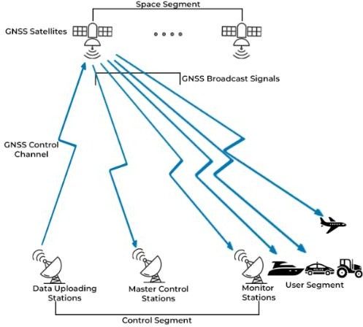
Fig 2.1: Global Navigation Satellite System diagram

Overview of GNSS Constellations

Each GNSS constellation comprises a network of satellites orbiting the Earth and transmitting signals containing orbital parameters and precise timing information. These signals allow GNSS receivers to compute the three-dimensional location of the vehicle using trilateration techniques. The U.S. GPS, for instance, maintains at least 24 active satellites in Medium Earth Orbit (MEO) at an altitude of approximately 20,200 kilometers, with six orbital planes to ensure global availability (Misra & Enge, 2011).

Other constellations such as GLONASS use a similar orbital configuration, while Galileo and BeiDou offer additional civilian signals and global interoperability. Modern GNSS receivers are often multi-constellation capable, allowing the simultaneous use of signals from GPS, GLONASS, Galileo, and BeiDou to enhance positioning accuracy and reliability, especially in urban and obstructed environments (Teunissen & Montenbruck, 2017).

GNSS Signal Structure and Frequencies

GNSS signals are transmitted on specific radio frequency bands known as L-bands. For GPS, the primary signals include L1 (1575.42 MHz), L2 (1227.60 MHz), and L5 (1176.45 MHz). These bands carry modulated data such as navigation messages and pseudorandom noise (PRN) codes used by receivers to calculate distances to satellites (Kaplan & Hegarty, 2017). Other systems follow a similar structure, with Galileo transmitting on E1, E5a, and E5b bands and BeiDou using B1, B2, and B3 bands.

Dual-frequency and triple-frequency receivers, which can receive multiple bands (e.g., L1/L5), provide better error correction and robustness against ionospheric delays, which are among the major sources of positioning inaccuracy.

Trilateration and Position Computation

GNSS receivers calculate position using trilateration, which requires distance measurements to at least four satellites. The receiver measures the time taken for each signal to reach it and multiplies it by the speed of light to obtain the range (pseudorange). Since the receiver clock may not be synchronized with GNSS system time, a fourth satellite is needed to solve for time offset and three spatial coordinates (Misra & Enge, 2011).

Mathematically, this involves solving nonlinear equations derived from the satellite positions and the pseudoranges. Advanced receivers employ numerical methods and filtering techniques (e.g., Kalman filtering) to refine position estimates and mitigate noise.

Error Sources in GNSS

Despite its high utility, GNSS is subject to several error sources that affect accuracy:

      - Ionospheric and Tropospheric Delay: Signal propagation is affected by atmospheric layers, causing delays.

      - Multipath Interference: Reflected signals from buildings or surfaces may lead to erroneous measurements.
      - Satellite Clock Errors and Ephemeris Inaccuracy: Imperfect satellite timekeeping or orbital data can introduce biases.
      - Receiver Noise: Internal thermal noise and quantization errors contribute to inaccuracy (Teunissen & Montenbruck, 2017).

Corrections such as Satellite-Based Augmentation Systems (SBAS), including WAAS (U.S.), EGNOS (Europe), and MSAS (Japan), provide differential corrections to improve accuracy to within 1–2 meters.

GNSS Receiver Architectures

GNSS receivers used in vehicle tracking systems are composed of several critical components that work together to determine accurate positional data. The RF front-end is responsible for filtering and amplifying the incoming satellite signals to ensure they are suitable for further processing. These signals are then passed to the baseband processor, which down-converts the high- frequency signals and digitizes them for computational interpretation. Subsequently, the navigation processor performs essential tasks such as signal acquisition, tracking, and executing algorithms to calculate the receiver's position. Based on their ability to access previously acquired satellite data, GNSS receivers are typically classified into three types: cold start, warm start, and hot start. This classification impacts the time-to-first-fix (TTFF)—the time it takes for a receiver to obtain its initial location fix after power-up. In automotive applications, achieving a fast TTFF and maintaining low power consumption are essential design considerations, especially in environments where rapid and efficient location tracking is required (Kaplan & Hegarty, 2017).

Fig 2.2: GNSS receiver

Coordinate Systems and Geodetic Frameworks

GNSS-derived positions are referenced against standardized coordinate systems to ensure consistency and global interoperability. The most widely used reference framework is the World Geodetic System 1984 (WGS-84), which establishes a global coordinate frame based on an ellipsoidal model of the Earth. This system provides the mathematical and geodetic foundation for

positioning and navigation. GNSS positional data can be expressed in two primary forms: geodetic coordinates and Earth-Centered, Earth-Fixed (ECEF) coordinates. Geodetic coordinates represent positions in terms of latitude, longitude, and altitude, making them intuitive for mapping and navigation purposes. In contrast, ECEF coordinates use a three-dimensional Cartesian (X, Y, Z) system with the origin at the Earth's center of mass, offering a more precise and computationally efficient format for satellite navigation algorithms and integration with spatial databases. Conversion between these coordinate systems is essential for integration with mapping platforms, GIS applications, and tracking databases (Leick, Rapoport, & Tatarnikov, 2015).

Assisted GNSS and Hybrid Positioning

To reduce TTFF and improve performance in urban canyons or indoors, systems often incorporate Assisted GNSS (A-GNSS), which uses cellular networks to provide aiding information such as satellite ephemeris and time data. Additionally, hybrid positioning techniques combine GNSS with other sources like Wi-Fi, Bluetooth, or cellular triangulation to maintain continuity in challenging environments (Groves, 2013).

In vehicle tracking applications, inertial sensors such as accelerometers and gyroscopes are also fused with GNSS data to provide smoother tracking and continuity during temporary signal loss.

Embedded Systems in Vehicle Tracking

Embedded systems are integral to the architecture of modern vehicle tracking solutions. These systems consist of dedicated microcontroller- or microprocessor-based hardware designed to perform specific real-time control functions within a larger electromechanical system. In the context of automobile asset tracking, embedded systems serve as the computational core that interfaces with GNSS modules, communication peripherals (e.g., GSM, LTE), onboard sensors, and power management circuits. They handle tasks such as data acquisition, processing, communication, and system diagnostics, forming the backbone of intelligent vehicle tracking units (Mazidi, Naimi, & Naimi, 2016).

Functional Role of Embedded Systems in Tracking Devices

An embedded system in a vehicle tracking unit is primarily responsible for controlling data flow between various subsystems. It processes signals from the GNSS receiver to interpret positional information and packages this data along with other sensor readings—such as speed, engine temperature, or fuel level—for transmission via wireless communication modules. It may also store this data locally using EEPROM or microSD memory cards for passive tracking applications (Shibu, 2017).

Key tasks include interfacing with serial communication buses (e.g., UART, SPI, I2C), executing positioning algorithms, applying data compression or encryption for secure transmission, and implementing real-time decision-making logic such as geofencing alerts or engine immobilization. These operations are governed by firmware coded in low-level languages such as C or C++ and are optimized for power efficiency and reliability (Barr & Massa, 2006).

Microcontrollers and Microprocessors Used

Most vehicle tracking systems are built around low-power microcontrollers (MCUs) such as the Atmel AVR (used in Arduino), ARM Cortex-M series, or Microchip PIC families. These devices offer sufficient computational capability to handle real-time tasks while maintaining minimal energy c

onsumption—an important factor in vehicular environments where continuous operation is required. More advanced platforms may use microprocessors (MPUs), such as ARM Cortex- A series or embedded Linux systems like the Raspberry Pi, which offer greater processing power and support multitasking via real-time operating systems (RTOS) or full Linux distributions (Wolf, 2012).

Microcontrollers are typically equipped with integrated analog-to-digital converters (ADCs), timers, pulse-width modulation (PWM) modules, and digital I/O ports, which simplify interfacing with sensors, actuators, and other peripheral modules.
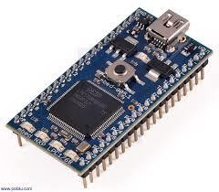
Fig 2.3: Microcontroller

Real-Time Operating Systems (RTOS)

In complex vehicle tracking applications requiring multitasking, determinism, and fault isolation, embedded systems often utilize Real-Time Operating Systems (RTOS). An RTOS ensures that time-critical tasks—such as GPS data processing or GSM signal handling—are executed within defined time constraints, improving system responsiveness and reliability. Examples of commonly used RTOS platforms include FreeRTOS, VxWorks, and Keil RTX (Labrosse, 2013). These operating systems provide features such as task scheduling, inter-task communication, and memory management tailored to embedded environments.

Power Management and Reliability

Power management is a crucial design consideration in embedded vehicle tracking systems. These systems are often powered from the vehicle’s battery, but they must support voltage regulation and protection circuitry to guard against surges, noise, and brownouts. Buck or boost converters are typically employed to step voltages up or down as needed by system components (Wong & Daoud, 2016). Additionally, sleep modes and interrupt-driven wake cycles are implemented to conserve power when the vehicle is inactive or parked for long durations.

Reliability is further ensured through watchdog timers, error-correcting memory, and fail-safe programming that allow systems to recover from unexpected errors or system crashes without data loss.

Embedded Communication Protocols

To support modularity and integration, embedded systems use a variety of communication protocols. Universal Asynchronous Receiver-Transmitter (UART) is commonly used for serial communication between the microcontroller and GNSS/GSM modules. Serial Peripheral Interface (SPI) and Inter-Integrated Circuit (I2C) protocols are used to interface with sensors or external EEPROMs. In advanced automotive applications, Controller Area Network (CAN) or Local Interconnect Network (LIN) buses are employed for real-time communication with Electronic Control Units (ECUs) and other subsystems within the vehicle (Axelson, 2007).

Data Security and Integrity

Embedded systems in vehicle tracking solutions must address data security to prevent unauthorized access or tampering. Encryption algorithms such as AES or RSA are often implemented to secure transmitted data. Additionally, checksums and cyclic redundancy checks (CRC) are used to verify data integrity, ensuring that positioning and telemetry data is accurately received at the monitoring server (Pfleeger & Pfleeger, 2015).

Firmware-level security measures, such as secure bootloaders and code signing, prevent malicious firmware updates and enhance system trustworthiness. Systems also incorporate EEPROM wear leveling and flash memory error correction to ensure long-term data retention.

Integration with Vehicle Systems

Modern embedded tracking systems are increasingly integrated with vehicle systems such as the OBD-II port, which provides access to diagnostic and performance data including engine RPM, coolant temperature, throttle position, and fuel system status. This allows for enhanced tracking solutions that combine location data with vehicle health monitoring (Sharma & Khanduja, 2019).

GSM/GPRS/LTE Communication in Tracking Systems

In automobile asset tracking systems, wireless communication plays a pivotal role in ensuring real- time data transmission between the vehicle's embedded system and remote monitoring centers.

Global System for Mobile Communications (GSM), General Packet Radio Service (GPRS), and Long-Term Evolution (LTE) are the most widely adopted technologies for cellular-based telematics communication. These standards facilitate the transfer of location data, diagnostic information, control commands, and alerts over cellular networks to centralized servers or user interfaces. The transition from GSM to LTE reflects the evolution in bandwidth, latency, and efficiency, which significantly enhances the performance and reliability of modern vehicle tracking systems (Holma & Toskala, 2011).

GSM in Vehicle Tracking

GSM is a second-generation (2G) cellular network protocol that enables voice and basic data communication through circuit-switched transmission. In vehicle tracking, GSM is commonly used to support Short Message Service (SMS) for low-bandwidth transmission of GPS coordinates and event notifications. Its global coverage and simplicity make GSM a cost-effective and reliable option, particularly in regions where advanced data networks are not available. GSM modules like the SIM800 and SIM900 are widely integrated into tracking devices, providing serial UART interfaces for communication with microcontrollers (Harri, Filali, Bonnet, & Fiore, 2009).

Although GSM’s data rate is limited (typically up to 14.4 kbps for circuit-switched data), its robustness and low power consumption make it suitable for passive tracking applications or scenarios where continuous real-time updates are not critical.

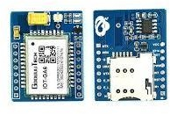

Fig 2.4: GSM module

GPRS for Packet-Switched Data

GPRS, an enhancement to GSM, introduces packet-switched data transmission, allowing efficient use of available spectrum and enabling always-on connectivity. GPRS supports data rates ranging from 56 kbps to 114 kbps, enabling vehicle tracking systems to transmit richer datasets, such as route history, vehicle diagnostics, and driver behavior metrics (Yacoub, 2000).

In embedded tracking systems, GPRS modules interface with the microcontroller to establish TCP/IP or UDP socket connections with the tracking server. This facilitates real-time communication, allowing for two-way data exchange. GPRS uses standard AT commands for

session control, making it easily programmable within embedded environments. Moreover, its support for IP-based communication allows integration with modern server-side platforms, cloud- based dashboards, and mobile applications.
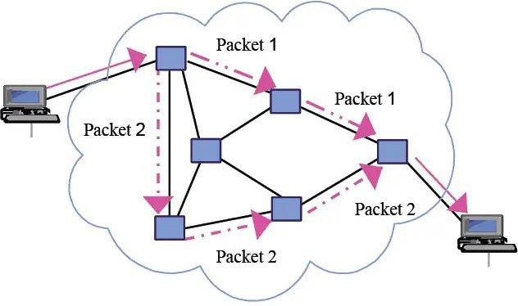

Fig 2.5: GPRS for Packet-switched Data

LTE and 4G Networks in Tracking Systems

LTE, a fourth-generation (4G) wireless standard, significantly improves upon its predecessors by offering higher data rates (up to 100 Mbps), lower latency (<50 ms), and better spectral efficiency. In vehicle tracking systems, LTE enables high-speed real-time transmission of large volumes of data, including live location streaming, video feeds, and vehicle-to-everything (V2X) communication. LTE's architecture supports IP-only data services, making it highly compatible with modern IoT frameworks (Sauter, 2014).

LTE also allows remote firmware over-the-air (FOTA) updates, remote diagnostics, and integration with cloud-based analytics platforms, expanding the functional scope of vehicle tracking systems beyond mere positioning.

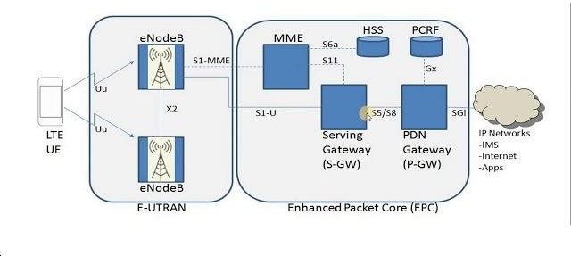
Fig 2.6: LTE and 4G network

APNs, IP Configuration, and Data Routing

An essential element in cellular-based communication is the configuration of Access Point Names (APNs), which serve as gateways between the cellular network and the internet. Proper APN configuration allows tracking modules to establish a secure session with backend servers. Devices may use dynamic or static IP addressing, depending on whether the tracking server initiates communication with the client (vehicle) or vice versa.

Typically, devices push data to a public IP address using the HTTP or MQTT protocols, or establish UDP/TCP sessions for custom protocol communication. The selection of the transport protocol is influenced by requirements such as reliability (TCP), low overhead (UDP), or event- based messaging (MQTT).

Antennas and RF Considerations

The reliability of GSM/GPRS/LTE communication also depends on the quality of the RF hardware and antenna design. External or PCB-embedded antennas are used to optimize signal reception. Signal quality is often measured using parameters such as Received Signal Strength Indicator (RSSI) and Signal-to-Noise Ratio (SNR). Antenna placement, impedance matching, and isolation from high-frequency interference sources (e.g., switching regulators) are critical for optimal performance (Balanis, 2016).
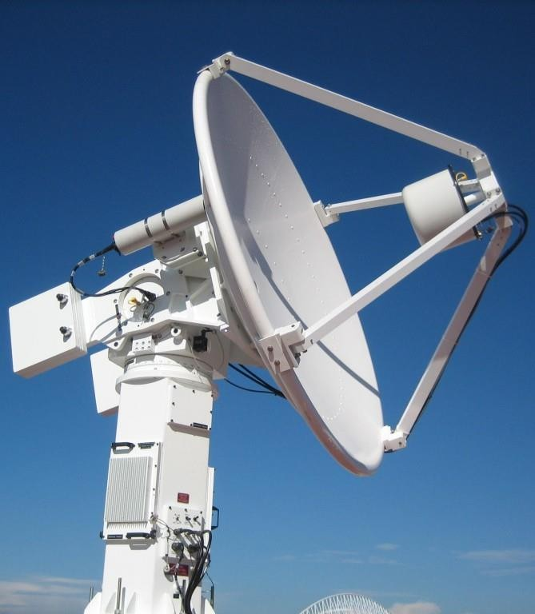
Fig 2.7: Antenna

SIM Card Management and Network Selection

Cellular modules require Subscriber Identity Module (SIM) cards to authenticate with mobile networks. In professional vehicle tracking deployments, M2M (machine-to-machine) or IoT SIM cards are used. These SIMs offer enhanced durability, better lifecycle management, and support for roaming across multiple network operators. Some systems utilize eSIM technology,

which allows for remote provisioning and network switching without physical SIM card changes (GSMA, 2020).

The ability to scan for multiple carriers and choose the best available network is vital for ensuring connectivity in fleet tracking applications that cross regional or national boundaries.

Security in Cellular Communication

Data transmitted over GSM/GPRS/LTE networks must be protected against interception and tampering. While GSM uses A5 encryption algorithms, LTE provides enhanced security via 128- bit Advanced Encryption Standard (AES) and integrity protection mechanisms. In addition to network-level encryption, end-to-end encryption via SSL/TLS is often implemented at the application layer to secure sensitive vehicle and user data (Pfleeger & Pfleeger, 2015).

Authentication mechanisms such as two-factor verification, SIM whitelisting, and IMEI filtering are also employed to prevent unauthorized access to the tracking system.

Data Cost and Bandwidth Optimization

In commercial tracking deployments, data cost is an operational concern. Efficient data encoding, such as binary payload structures and delta compression techniques, is used to reduce the volume of transmitted data. Tracking frequency can be dynamically adjusted based on vehicle speed, motion detection, or geofencing events to further optimize bandwidth usage.

Some systems also employ store-and-forward techniques, where data is temporarily stored in local memory and transmitted in bursts when network conditions are optimal, reducing connectivity costs and improving reliability.

Power Supply Design in Tracking Systems

The power supply system is a critical component in the design and operation of automobile tracking devices. A well-engineered power system ensures reliable functionality, minimizes energy loss, protects sensitive electronics, and supports both standby and active modes of operation. Due to the mobile nature of vehicles and their varying electrical conditions, power supply design in automotive tracking systems must be robust, energy-efficient, noise-resistant, and capable of operating across wide voltage ranges. Power systems typically consist of voltage regulators, protection circuits, filtering components, and sometimes energy storage units such as supercapacitors or rechargeable batteries.

Input Voltage Range and Automotive Power Characteristics

Vehicles supply power through a 12 V or 24 V DC battery system, depending on the class (e.g., 12 V for passenger vehicles, 24 V for heavy-duty trucks). However, this voltage is not stable—it fluctuates during engine cranking, alternator load changes, or sudden acceleration. For example, a cold crank may momentarily reduce the supply voltage to as low as 6 V in 12 V systems, while alternator surges may raise it to 16 V or more (Horowitz & Hill, 2015). Therefore, tracking devices

must tolerate wide input voltage ranges, typically from 6 V to 30 V, to avoid reset, malfunction, or permanent damage.

Buck and Boost Regulators

To power the 3.3 V or 5 V logic circuits used in GPS modules, GSM modules, and microcontrollers, DC-DC converters are employed. These are usually buck (step-down) converters when the supply voltage is higher than the required output, or boost (step-up) converters in rare low-voltage scenarios.

Buck converters are preferred for their high efficiency (typically >85%) and their ability to handle moderate current loads. Commonly used switching regulator ICs, such as the LM2596 or MP1584, offer compact footprints, built-in protection features, and adjustable output voltages. For noise- sensitive applications like GPS reception, proper filtering using LC circuits is critical to suppress high-frequency switching noise from buck regulators (Erickson & Maksimovic, 2007).

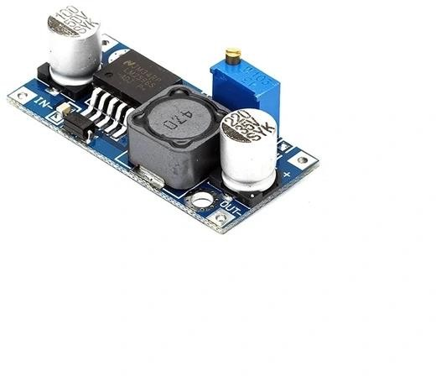
Fig 2.8: Buck Converter

Linear Regulators and Low-Dropout Designs

In less demanding or ultra-low-noise applications, linear voltage regulators like the AMS1117 or LM7805 are used. Although these regulators offer simpler implementation and lower ripple, they are less efficient, especially when the voltage differential between input and output is large. Low-Dropout Regulators (LDOs) are preferred when the supply voltage is only marginally higher than the output requirement, and noise minimization is critical (Razavi, 2013).

LDOs are often employed for analog blocks within GPS receivers, timing crystals, or ADC reference voltages, ensuring clean power for precision measurements.

Power Supply Sequencing and Module Start-Up Behavior

Some tracking system components require careful sequencing during power-up. For instance, GPS and GSM modules may need their power rails to stabilize before activation or reset signals. Improper sequencing can lead to brownout conditions or latch-up, especially in modules that contain internal switching regulators or sensitive baseband processors (Texas Instruments, 2022).

Sequencing circuits may involve simple RC delays, dedicated power sequencing ICs, or microcontroller-supervised control through MOSFET switches. Proper sequencing extends module lifespan and avoids initialization errors.

Battery Backup and Power Failover

Many vehicle tracking systems include backup power sources to ensure continuous operation during main power loss or deliberate disconnection. Lithium-ion (Li-ion) or Lithium-polymer (Li-Po) rechargeable batteries are common for this purpose. Integrated charging ICs, such as the TP4056, manage charging cycles and overcharge protection. Alternatively, supercapacitors may be used for short-term energy bridging, especially where quick recovery is required.

Battery-backed systems must monitor voltage levels to prevent deep discharge, which can degrade battery health. Fuel gauging circuits and battery management systems (BMS) provide voltage, temperature, and current data to the microcontroller to ensure safe operation.

Power Optimization and Sleep Modes

To conserve energy, especially in GSM-enabled tracking systems, power optimization strategies are employed. Microcontrollers (e.g., ATmega328 or STM32) are programmed to enter sleep modes during idle periods. Similarly, GPS modules support low-power states such as standby, periodic mode, or always locate mode. GSM modules can be temporarily shut down or placed in flight mode to reduce power draw when not transmitting.

Efficient power gating through MOSFET-based high-side switches enables selective powering of subsystems. This modular control extends system uptime in battery-backed applications and reduces thermal load.

EMI/ESD Protection and Automotive Standards

Power supply lines in vehicle environments are prone to electromagnetic interference (EMI), electrostatic discharge (ESD), and voltage transients. Therefore, the power input stage includes:

      - TVS (Transient Voltage Suppression) diodes for surge protection.
      - Ferrite beads and LC filters to block high-frequency noise.
      - Polyfuses or resettable fuses to prevent overcurrent damage.

Designs must comply with standards such as ISO 7637-2, which defines transient immunity requirements for automotive electronics (ISO, 2011). EMI shielding and proper PCB grounding are also essential for ensuring signal integrity and safety.

Power Distribution Architecture

Modern embedded tracking systems employ a structured power distribution architecture. Multiple voltage rails (e.g., 5 V for GSM, 3.3 V for GPS and MCU, 1.8 V for sensors) are derived from a common bus through separate regulators. Power tree design helps in balancing efficiency, load sharing, and thermal dissipation. Some systems also implement power monitoring ICs to detect undervoltage or overcurrent events, providing fail-safe operation through microcontroller intervention.

Embedded System Architecture in Tracking Devices

The embedded system architecture is fundamental to the functionality of modern automobile tracking devices. It acts as the central processing unit that integrates data acquisition, real-time processing, communication, and control, ensuring accurate and timely vehicle location tracking. These embedded systems are designed to meet rigorous requirements such as low power consumption, real-time responsiveness, fault tolerance, and scalability within the automotive environment (Barr & Massa, 2006).

Microcontrollers and Microprocessors

Microcontrollers (MCUs) are the most widely adopted computing units in vehicle tracking devices, chosen primarily for their integration of processing cores, memory, and peripheral interfaces on a single chip. Common MCUs include the ATmega328P for simpler tracking applications, the STM32 series based on ARM Cortex-M cores for more demanding tasks, and the ESP32, which combines an MCU with integrated wireless communication capabilities such as Wi-Fi and Bluetooth (Kolban, 2017). In higher-performance tracking systems that require advanced data processing or multimedia capabilities, microprocessors such as those found in the Raspberry Pi or BeagleBone Black platforms are used. These microprocessors support complex operating systems like Linux, enabling the execution of sophisticated software for analytics and cloud connectivity.
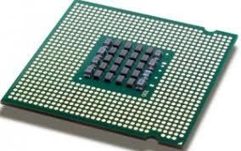
Fig 2.9: Microprocessor

Memory Systems

Embedded memory architecture in tracking devices consists of multiple types of storage, each serving specific purposes. Non-volatile flash memory stores the device firmware and persistent configuration data, while volatile SRAM or DRAM provide fast access memory for runtime processing. Additionally, EEPROM or FRAM modules are commonly employed for long-term storage of GPS logs, sensor data, and fault diagnostics, even during power loss. Designers must ensure data integrity under harsh conditions by implementing features such as brownout detection and watchdog timers to protect against unexpected resets or power failures (Mazidi, Naimi, & Naimi, 2016).
I0uo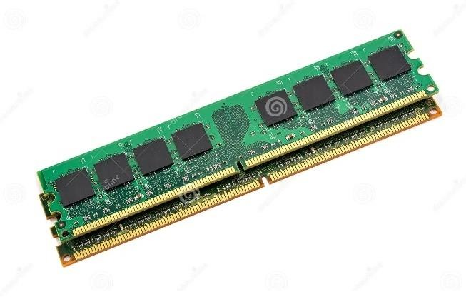

Fig 2.10: Memory System

Peripheral Interface Integration

Efficient peripheral integration is critical for acquiring sensor data and communicating with external modules. Communication protocols such as UART, SPI, and I2C facilitate interfacing with GPS receivers, GSM modems, EEPROMs, and various sensors like accelerometers and fuel- level detectors. Due to the limited number of MCU pins, techniques such as multiplexing and the use of external I/O expanders are frequently employed to manage multiple peripherals. Additionally, analog-to-digital converters (ADCs) enable the system to process analog signals from sensors measuring parameters like battery voltage or temperature, thus expanding the scope of monitoring capabilities.
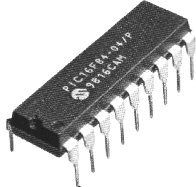
Fig 2.11: Peripheral Interface Integration

Interrupt-Driven Processing

Interrupt-driven architectures are crucial for real-time responsiveness in embedded tracking systems. External interrupts generated by events such as GPS pulse-per-second (PPS) signals, incoming GSM messages, or motion detected by accelerometers trigger immediate processor attention. These interrupts invoke carefully optimized Interrupt Service Routines (ISRs) that prioritize high-urgency events while minimizing latency. ARM Cortex-M MCUs feature Nested Vectored Interrupt Controllers (NVICs) that support prioritized and nested interrupts, allowing sophisticated management of concurrent hardware events (Yiu, 2016).

Power Management and Sleep Modes

Power efficiency is paramount for embedded systems deployed in vehicles, especially when operating on backup power sources. Modern MCUs support multiple low-power states, including idle, standby, and deep sleep modes, which reduce power consumption during inactivity. Peripheral modules can be selectively disabled or powered down, and techniques such as clock gating and dynamic frequency scaling are used to optimize energy use further. These capabilities enable prolonged device operation and contribute to the reliability of vehicle tracking systems under varying power conditions (Barr & Massa, 2006).

Firmware and Over-The-Air (OTA) Updates

Firmware serves as the software foundation of embedded tracking systems, typically written in C or C++. Modular design separates hardware abstraction layers, communication stacks, and application logic to ensure maintainability and scalability. The incorporation of over-the-air (OTA) update mechanisms has become essential, allowing remote delivery of firmware patches and feature upgrades without physical access. OTA update processes often utilize dual-bank flash architectures to ensure safe firmware replacement, with cryptographic validation employed to guarantee firmware authenticity and integrity (Zhang, Cao, Wang, & Liu, 2020).

Security and Tamper Resistance

Given the critical nature of tracking data and the potential for malicious attacks, embedded tracking devices incorporate robust security measures. Secure bootloaders enforce cryptographic verification of firmware at startup, preventing unauthorized code execution. Firmware encryption techniques guard against reverse engineering, while tamper detection circuitry can detect physical intrusion attempts, triggering alerts or device lockdowns. Many modern MCUs include hardware accelerators for cryptographic functions (e.g., AES, RSA, SHA), offloading these computationally intensive tasks from the main processor to maintain performance while ensuring secure communication and data protection (Mazidi et al., 2016; Yiu, 2016).

Communication Protocols and Data Transmission Models

Effective communication protocols and reliable data transmission models are pivotal in automobile tracking systems, enabling seamless exchange of location and diagnostic data between the tracking device and remote servers or user interfaces. These communication technologies are responsible

for ensuring data integrity, low latency, and scalability across diverse network conditions, which is critical for real-time vehicle tracking, remote monitoring, and fleet management.

Cellular Communication Technologies

Cellular networks, particularly 2G (GSM), 3G (UMTS), 4G (LTE), and increasingly 5G, form the backbone of most vehicle tracking communication infrastructures. GSM (Global System for Mobile Communications) was the earliest standard widely used for vehicle tracking, providing reliable SMS and circuit-switched data transmission. However, its limited data rates prompted adoption of UMTS and LTE, which offer packet-switched, high-throughput data transfer capabilities suitable for continuous GPS data streaming and multimedia transmission (Sauter, 2021). The transition to LTE and 5G networks enables ultra-low latency, enhanced bandwidth, and improved network slicing, which are essential for future vehicle-to-everything (V2X) communication paradigms.

Short Message Service (SMS) and Unstructured Supplementary Service Data (USSD)

SMS remains a prevalent data transmission method in automobile tracking due to its universal support across GSM networks and low power requirements. Tracking devices often send periodic location updates or alert messages via SMS to centralized servers or user phones. USSD, a session- oriented protocol, allows real-time interaction with network applications but is less common in tracking applications due to its complexity and limited payload capacity (Rappaport, 2002).

General Packet Radio Service (GPRS) and Packet Data Protocol (PDP)

GPRS introduced packet-switched data transmission over GSM networks, enabling efficient and cost-effective communication for vehicle tracking devices. GPRS operates by establishing a Packet Data Protocol (PDP) context that facilitates IP-based communication, allowing tracking devices to transmit real-time GPS coordinates and telemetry data to cloud servers or fleet management platforms. GPRS supports multiple Quality of Service (QoS) profiles that influence latency, throughput, and reliability, enabling service customization depending on the tracking application requirements (Sauter, 2021).

Internet Protocol (IP) Based Communication

Modern tracking systems increasingly utilize IP-based communication protocols such as TCP (Transmission Control Protocol) and UDP (User Datagram Protocol) over cellular networks or Wi-Fi. TCP provides reliable, ordered, and error-checked delivery of data packets, making it suitable for critical commands and configuration updates. UDP, while less reliable due to lack of retransmission mechanisms, offers lower latency, making it preferable for streaming real-time GPS data where occasional packet loss is tolerable (Stevens, 1994). Transport Layer Security (TLS) is often implemented to encrypt these IP communications, ensuring confidentiality and data integrity against interception or tampering.

Satellite Communication

In areas with limited cellular coverage, satellite communication provides an alternative transmission medium for vehicle tracking systems, particularly for fleets operating in remote or maritime environments. Satellite modems integrated into tracking devices communicate via geostationary or low-earth orbit satellites, offering global coverage. Although satellite communication typically incurs higher latency and cost compared to cellular networks, its reliability in off-grid locations makes it indispensable for critical asset tracking (Kaplan & Hegarty, 2017).

Wireless Local Area Networks (WLAN) and Bluetooth

Some tracking systems incorporate short-range wireless communication such as Wi-Fi (WLAN) and Bluetooth for local data transfer or device configuration. WLAN enables high-speed data exchange when vehicles are within range of hotspots, allowing bulk data offloading or firmware updates without cellular data costs. Bluetooth facilitates device pairing and configuration, or communication with onboard sensors and mobile applications, offering low power consumption and ease of integration (Kurose & Ross, 2017).
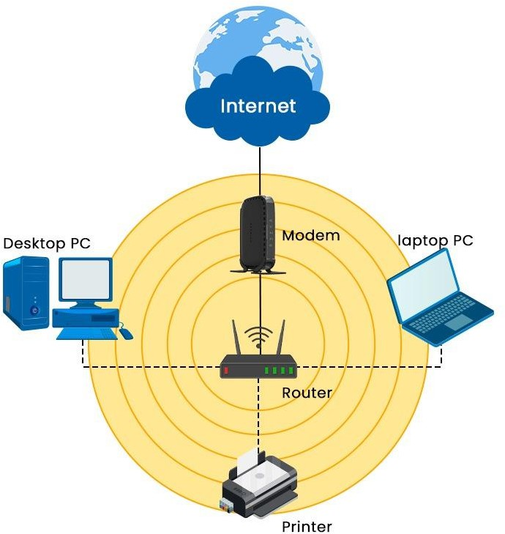

Fig 2.12: Wireless Local Area Network

Message Queuing Telemetry Transport (MQTT) and Other IoT Protocols

With the emergence of the Internet of Things (IoT), lightweight communication protocols like MQTT have been adopted in tracking systems to enable efficient machine-to-machine (M2M) communication. MQTT employs a publish-subscribe model over TCP/IP, minimizing network bandwidth usage and enabling reliable message delivery even in constrained environments. Its

simplicity and support for Quality of Service (QoS) levels make it suitable for transmitting GPS coordinates, vehicle status updates, and alerts to cloud platforms in real time (Light, 2017).
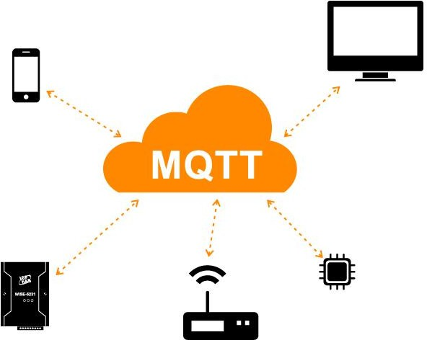

Fig 2.13: Message Queuing Telemetry Transport (MQTT)

Data Transmission Models

Data transmission in automobile tracking systems follows several models, including periodic, event-driven, and on-demand reporting. Periodic transmission involves sending location and status updates at fixed intervals, balancing accuracy and power consumption. Event-driven models trigger transmissions based on predefined events such as ignition on/off, speed threshold breaches, or geofence violations, optimizing bandwidth use and enabling timely alerts. On-demand transmission allows remote querying of the vehicle’s current status, typically initiated by a fleet manager or user application. These models can be combined and configured dynamically based on operational requirements (Stojmenovic & Wen, 2014).

Power Management and Energy Efficiency in Automobile Tracking Devices

Power management is a critical aspect of automobile tracking systems, particularly because these devices often operate in environments where reliable power sources may be intermittent or constrained. Efficient energy consumption not only prolongs device lifetime but also ensures continuous tracking functionality and reduces maintenance costs associated with battery replacement or vehicle power interruptions. Consequently, tracking devices are engineered with advanced power management strategies that balance performance, responsiveness, and energy efficiency (Barr & Massa, 2006).

Power Sources and Consumption Profiles

Automobile tracking devices are typically powered from the vehicle’s battery system, which provides a nominal voltage (usually 12V or 24V) that must be regulated and converted to lower voltages suitable for embedded circuits. Devices may also incorporate rechargeable backup batteries or supercapacitors to maintain operation during engine-off periods or power disruptions. The power consumption profile of a tracking device varies dynamically depending on operational states, such as GPS acquisition, data transmission, sensor monitoring, and sleep mode (Mazidi, Naimi, & Naimi, 2016).

Voltage Regulation and Power Conversion

Efficient power regulation is essential for minimizing losses and ensuring stable voltage supplies to sensitive electronics. Buck converters (step-down switching regulators) are preferred over linear regulators due to their higher efficiency, especially when stepping down from vehicle battery voltages to microcontroller and module operating voltages (typically 3.3V or 5V). The choice of regulator topology, switching frequency, and inductor/capacitor components directly impacts overall power efficiency and electromagnetic interference (EMI) levels (Sedra & Smith, 2014).

Sleep Modes and Low-Power Operation

To conserve energy during periods of inactivity, embedded tracking systems employ various low- power modes available in modern microcontrollers. These modes range from light sleep, where the CPU clock is gated but peripheral functions remain active, to deep sleep or standby modes, which significantly reduce current draw by disabling most system components except essential wakeup sources. Wakeup events can be triggered by timer interrupts, motion detection via accelerometers, or network messages, allowing the device to remain responsive while conserving energy (Yiu, 2016).

Duty Cycling and Adaptive Sampling

Power savings can be further enhanced by employing duty cycling strategies, where the tracking device periodically activates GPS modules and communication interfaces only when needed to collect and transmit data. Adaptive sampling algorithms optimize this process by dynamically adjusting the frequency of GPS fixes and sensor readings based on vehicle motion, speed, or user- defined criteria. For instance, the device may reduce sampling rate when the vehicle is stationary or in low-movement scenarios, thereby extending battery life without compromising tracking accuracy (Kaplan & Hegarty, 2017).

Power-Aware Communication

Communication modules such as GSM or LTE modems are significant contributors to overall power consumption due to their radio frequency (RF) transmission requirements. Power management techniques include controlling transmission power levels, employing efficient communication protocols (e.g., MQTT with QoS), and aggregating data to reduce the frequency of network transmissions. Some devices utilize network-assisted power saving modes such as

Discontinuous Reception (DRX) to allow modems to periodically enter low-power states while maintaining network connectivity (Sauter, 2021).

Energy Harvesting and Alternative Power Sources

Emerging technologies integrate energy harvesting mechanisms, such as solar panels or regenerative braking energy converters, to supplement or replace conventional power sources. While still at an early adoption stage in vehicle tracking, these techniques promise to further reduce dependency on batteries and vehicle electrical systems, enabling near-perpetual device operation in off-grid scenarios (Stojmenovic & Wen, 2014).

Sensor Integration and Data Acquisition in Automobile Tracking Systems

Sensor integration forms a vital component of automobile tracking systems, enriching location data with additional contextual and operational parameters. By combining global positioning data with inputs from various onboard sensors, tracking systems provide comprehensive insights into vehicle status, driver behavior, and environmental conditions. Effective sensor data acquisition and fusion techniques are essential for enhancing tracking accuracy, enabling predictive maintenance, and supporting advanced telematics applications (Miller, 2017).

Types of Sensors in Vehicle Tracking

- Inertial Sensors (Accelerometers and Gyroscopes): Automobile tracking systems use accelerometers and gyroscopes to capture real-time data on vehicle acceleration, angular velocity, and orientation. Accelerometers measure linear acceleration forces, which are essential for detecting sudden braking, rapid acceleration, or collisions. Gyroscopes measure rotational movement, helping to detect changes in vehicle heading and rollover events. Together, these sensors provide critical motion data that complements GPS signals, especially in environments with poor satellite reception (El- Sheimy, Hou, & Niu, 2008).
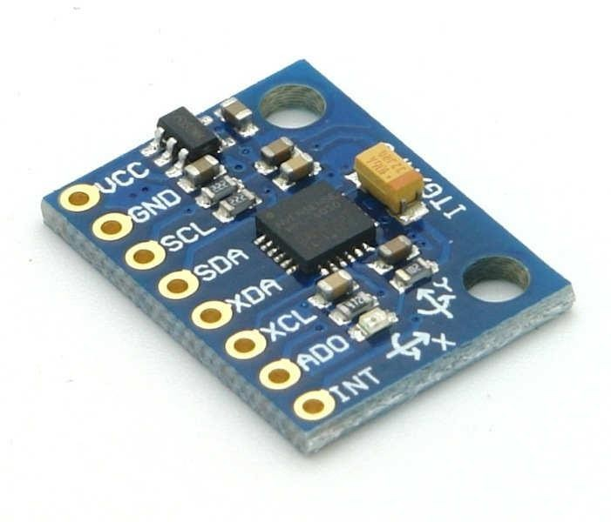
Fig 2.14: Inertial Sensors (Accelerometers and Gyroscopes)

- Magnetometers:
Magnetometers measure the Earth's magnetic field to provide directional heading information. Acting as digital compasses, these sensors improve navigation accuracy by determining vehicle orientation, particularly in urban areas where GPS signals may suffer from multipath interference.
- Fuel-Level Sensors:
These sensors monitor the amount of fuel in the vehicle’s tank in real time. By tracking fuel consumption and tank status, fleet managers can detect fuel theft, monitor usage patterns, and optimize refueling schedules, which enhances operational efficiency and security.
- Temperature Sensors:
Temperature sensors monitor both engine and ambient temperature conditions. Engine temperature monitoring helps prevent overheating and potential mechanical failure, while ambient temperature data can indicate environmental conditions or alert unauthorized usage when the vehicle operates outside safe temperature thresholds.
- Vehicle Diagnostics Interfaces (OBD-II Port): The On-Board Diagnostics II (OBD-II) interface is widely used to access comprehensive vehicle diagnostic data. It provides information such as engine performance, fault codes, vehicle speed, and RPM. Integration with the OBD-II port enables tracking systems to extend beyond location tracking, allowing for real-time vehicle health monitoring and predictive maintenance (Miller, 2017).

Sensor Interfaces and Communication Protocols

Sensors are interfaced with the tracking system's embedded controller through a variety of communication protocols, including analog voltage signals, Serial Peripheral Interface (SPI), Inter-Integrated Circuit (I2C), and Controller Area Network (CAN) bus. CAN bus, in particular, is widely used in modern vehicles for high-speed, robust communication of sensor and actuator data within the vehicle’s internal network. Accessing CAN data enables tracking devices to extract detailed diagnostic and operational information directly from the vehicle’s Electronic Control Unit (ECU), thereby extending the range of telematics features (Bosch, 2011).

Data Acquisition and Signal Conditioning

Raw sensor signals often require conditioning before processing, including amplification, filtering, and analog-to-digital conversion. Signal conditioning ensures that noise, offset, and other distortions are minimized, improving measurement accuracy. Embedded ADCs integrated within microcontrollers convert analog sensor outputs into digital data streams for processing and storage. Advanced filtering techniques, such as Kalman filters, are applied to sensor data fusion, combining GPS position data with inertial sensor inputs to yield more accurate and robust vehicle location and movement estimates, especially in urban canyons or tunnels where GPS signals are weak or unavailable (Groves, 2013).

Sensor Fusion Techniques

Sensor fusion algorithms are critical in enhancing the reliability and accuracy of vehicle tracking data by combining information from heterogeneous sensors. These algorithms mitigate individual sensor limitations and errors through statistical methods and model-based approaches. For example, integrating GPS data with inertial navigation systems (INS) compensates for GPS outages or multipath errors. Extended Kalman Filters (EKF) and Particle Filters are commonly implemented to process and fuse sensor inputs in real time, enabling continuous and accurate tracking under dynamic conditions (Farrell, 2008).

Real-Time Data Acquisition and Processing

Automobile tracking systems must acquire, process, and transmit sensor data in real time to support prompt decision-making and alerts. Embedded systems employ interrupt-driven architectures and Direct Memory Access (DMA) techniques to efficiently handle high-rate sensor data streams with minimal CPU overhead. Real-time operating systems (RTOS) facilitate task scheduling and synchronization for simultaneous GPS, sensor data acquisition, and communication, ensuring timely updates and reducing latency in critical scenarios such as collision detection or theft alerts (Labrosse, 2002).

Communication Protocols and Data Transmission in Automobile Tracking Systems

    - Cellular Communication Technologies

Effective communication protocols are essential for transferring vehicle location and status data reliably in automobile tracking systems. Cellular communication remains the backbone of most vehicle tracking solutions. Early-generation networks such as GSM (Global System for Mobile communications), GPRS (General Packet Radio Service), and EDGE (Enhanced Data rates for GSM Evolution) have been widely adopted because of their extensive coverage and cost- effectiveness. These networks facilitate packet-switched data transfer, allowing tracking devices to transmit location and telemetry data efficiently, though at moderate data rates and latency. With the evolution of cellular technologies, 3G and 4G LTE (Long-Term Evolution) networks provide significantly higher data rates, reduced latency, and improved reliability. These advancements support richer data transmissions including real-time video streaming, over-the-air updates, and complex telematics, making 4G LTE the current standard for vehicle tracking systems. Moreover, 5G networks are emerging, promising ultra-low latency, enhanced bandwidth, and the capacity to support massive numbers of connected IoT devices, which will further revolutionize automobile tracking (Sauter, 2021).

Short-Range Communication Protocols

In addition to cellular technologies, short-range wireless protocols such as Bluetooth and Wi-Fi are frequently integrated into tracking systems to support local data transfer, device configuration, and diagnostics. Bluetooth enables secure, low-power communication between the tracking device and nearby smartphones or diagnostic equipment, allowing for convenient wireless access to vehicle data without incurring cellular data costs. Wi-Fi modules provide higher bandwidth

connections that are particularly useful for bulk data offloading when the vehicle is within range of a trusted network, such as at a depot or maintenance facility. These protocols complement cellular connectivity by offering efficient, cost-effective local communication options (Deng, Li, & O’Donnell, 2017).

Satellite Communication

For vehicles operating in remote or offshore environments where cellular coverage is unavailable or unreliable, satellite communication is indispensable. Satellite networks such as Iridium, Inmarsat, and Globalstar offer global coverage by relaying data from tracking devices through satellites to ground stations, ensuring uninterrupted vehicle monitoring regardless of geographic location. Although satellite communication systems typically introduce higher latency and operational costs compared to terrestrial cellular networks, they provide critical tracking capabilities for maritime fleets, long-haul trucking, and other applications requiring global reach (Kaplan & Hegarty, 2017).

Communication Protocols and Data Formats

Communication protocols governing data transmission from tracking devices to central servers or cloud platforms are pivotal for system efficiency and security. MQTT (Message Queuing Telemetry Transport) is a widely adopted protocol in IoT and vehicle tracking applications due to its lightweight design, minimal bandwidth requirements, and efficient publish-subscribe messaging model. HTTP and HTTPS protocols are also commonly used, offering standardized and secure methods for web-based communication between devices and servers. The choice of protocol impacts data throughput, latency, power consumption, and security of the tracking system (Hunkeler, Truong, & Stanford-Clark, 2008).

Data packets sent by tracking devices generally encapsulate GPS coordinates, sensor measurements, timestamps, and device identifiers in structured formats. To ensure confidentiality and integrity, encryption standards such as AES (Advanced Encryption Standard) are implemented, preventing unauthorized interception and tampering. Secure data transmission is essential to protect sensitive location and vehicle status information, thereby safeguarding user privacy and preventing potential security breaches (Fischer, 2016).

Data Processing and Cloud Integration in Automobile Tracking Systems

    - Data Acquisition and Preprocessing

Automobile tracking systems continuously collect vast amounts of raw data from GPS modules, sensors, and vehicle diagnostics. This data acquisition process involves capturing geospatial coordinates, speed, acceleration, engine status, and environmental conditions at frequent intervals. Before transmission, preprocessing steps such as data filtering, error correction, and formatting are performed within the tracking device or edge computing units. These preprocessing techniques are essential to reduce noise, eliminate outliers, and compress data, thereby optimizing bandwidth usage and improving the accuracy and reliability of the tracking information transmitted to backend servers (Li & Chen, 2019).

Cloud-Based Data Storage and Management

The integration of cloud computing has revolutionized data storage and management in automobile tracking systems. Cloud platforms offer scalable, on-demand resources that enable efficient handling of large volumes of telemetry and geolocation data generated by vehicle fleets. Cloud databases store structured and unstructured data securely while supporting rapid query responses and data retrieval for analytics and reporting. Moreover, cloud infrastructures facilitate real-time data synchronization across multiple user devices and administrative consoles, enabling fleet operators to monitor vehicle status dynamically regardless of location (Kaur & Singh, 2020).

Real-Time Analytics and Decision Support Systems

Advanced tracking systems employ cloud-based analytics engines to process streaming data in real time. These analytics frameworks utilize machine learning algorithms and statistical models to detect patterns, anomalies, and predictive insights from vehicle behavior and environmental factors. Real-time analytics can identify harsh driving events, unauthorized usage, or maintenance needs, triggering automated alerts to fleet managers or drivers. The integration of decision support systems enhances operational efficiency by enabling proactive interventions, optimizing routes, and reducing downtime (Jain, Kumar, & Singh, 2021).

API Integration and User Interfaces

Cloud-based tracking platforms commonly expose Application Programming Interfaces (APIs) that allow third-party software, mobile apps, and enterprise resource planning (ERP) systems to access vehicle tracking data. These APIs enable customization, integration with existing business workflows, and development of user-friendly dashboards. User interfaces present processed data visually through interactive maps, graphs, and reports, facilitating intuitive understanding and actionable insights for fleet operators and end-users (Zhou & Wang, 2018).

CHAPTER THREE
  - METHODOLOGY

POWER SUPPLY
IGNITION KEY
GSM MODULE
ARDUINO NANO

GPS NEO-6M

Fig. 3.1: Block Diagram

System Overview

The asset tracking system is composed of five key components:

- Arduino Nano (Control Unit)
- GPS Module (Neo-6M)
- GSM Module (SIM800/SIM900)
- Ignition Key Interface
- Power Supply with Buck Converter

These modules interact with each other to achieve real-time vehicle tracking, ignition monitoring, and communication with a remote server or mobile client.

Block Diagram Explanation

    - Power Supply and Buck Converter

A buck converter or step-down converter is a DC-to-DC converter which decreases voltage, while increasing current, from its input (supply) to its output (load). It is a class of switched-mode power supply. Switching converters (such as buck converters) provide much greater power efficiency as

DC-to-DC converters than linear regulators, which are simpler circuits that dissipate power as heat, but do not step up output current. The efficiency of buck converters can be very high, often over 90%, making them useful for tasks such as converting a computer's main supply voltage, which is usually 12 V, down to lower voltages needed by USB, DRAM and the CPU, which are usually 5,
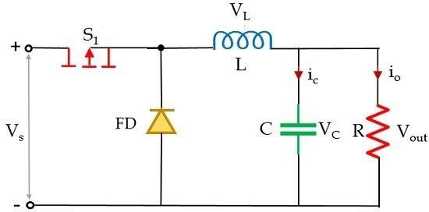
  - or 1.8 V.

Fig. 3.2: Buck Converter

Connections:

The power supply system in the project begins with a 12V DC input, which serves as the primary power source—typically from a battery or an external adapter. This 12V power is first directed to a buck converter, a device specifically designed to step down higher voltages to lower, more usable levels. In this case, the buck converter reduces the 12V input to a stable 5V output. This 5V output is then distributed to all the main components of the system. The Arduino Nano receives the 5V either through its VIN pin or directly through the 5V pin, depending on the wiring setup. In addition to the Arduino, the 5V line also powers the GPS and GSM modules, both of which are designed to operate at 5V. By using a buck converter, the system ensures that all components receive the correct voltage, which is crucial for stable and efficient operation.

Arduino Nano (Central Controller)

The Arduino Nano is an open-source breadboard-friendly microcontroller board based on the Microchip ATmega328P microcontroller (MCU) and developed by Arduino.cc and initially released in 2008. It offers the same connectivity and specs of the Arduino Uno board in a smaller form factor.

The Arduino Nano is equipped with 30 male I/O headers, in a DIP-30-like configuration, which can be programmed using the Arduino Software integrated development environment (IDE),

which is common to all Arduino boards and running both online and offline. The board can be
powered through its USB Mini‑B receptacle or from a 9 V battery.
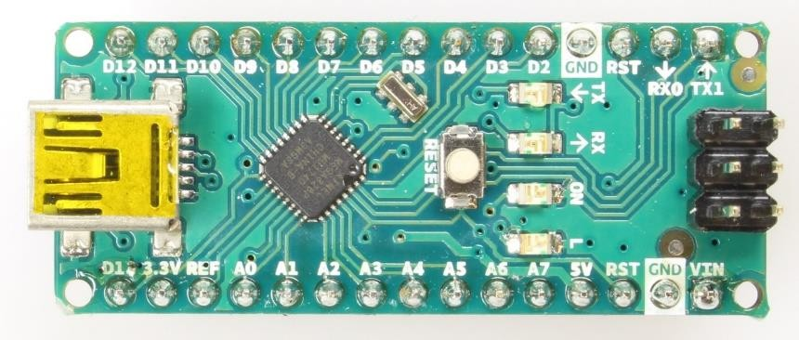
Fig 3.2: Arduino Nano

Connections:

The Arduino Nano acts as the central control unit of the system. It receives regulated 5V power from the buck converter to operate safely. It communicates with the GPS Neo module using UART serial communication to receive real-time location data such as latitude and longitude. Simultaneously, it also uses another UART interface to send AT commands and data to the GSM module for tasks like sending location updates via SMS. Additionally, the Arduino monitors the state of the vehicle’s ignition key through one of its GPIO (General Purpose Input/Output) pins, allowing it to detect whether the vehicle is turned on or off.

GPS Module (Neo-6M)

The NEO-6M is a compact GPS module by u-blox, widely used for accurate positioning and navigation. It receives signals from multiple satellite systems like GPS, GLONASS, and Galileo, processes them using trilateration, and provides location data such as latitude, longitude, altitude, speed, and time in NMEA format via UART. The module supports configurable baud rates (9600 and 115200), features a cold start time of 38 seconds and a hot start time of 1 second, and operates within a temperature range of -40°C to 85°C. It includes a separate 18x18mm antenna, EEPROM for saving settings, a backup battery, and offers high tracking sensitivity up to -162 dBm.

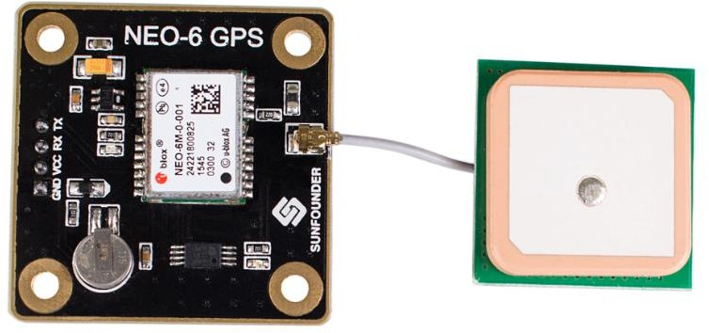

Fig 3.3: GPS module NEO-6M

Connections:

The GPS module, specifically the NEO-6M, is powered by a stable 5V supply provided through the buck converter, ensuring reliable operation. Once powered, the module begins receiving signals from various satellites and processes them to determine accurate location data. This data, which includes important parameters such as latitude, longitude, altitude, speed, and time, is continuously transmitted in the form of serial data. The module communicates this data to the Arduino Nano via UART serial communication, allowing the Arduino to use the GPS information for tasks such as tracking the vehicle’s position or sending updates through the GSM module.

GSM Module

A GSM module is a device that allows electronic devices to communicate with each other over the GSM network. GSM is a standard for digital cellular communications, which means that it provides a platform for mobile devices to communicate with each other wirelessly. The GSM module is a specialized device that enables a device to send and receive data over the GSM network. A GSM module works by connecting to the GSM network through a SIM card. The SIM card provides the module with a unique identification number, which is used to identify the device on the network. The GSM module then communicates with the network using a set of protocols, which allows it to send and receive data.
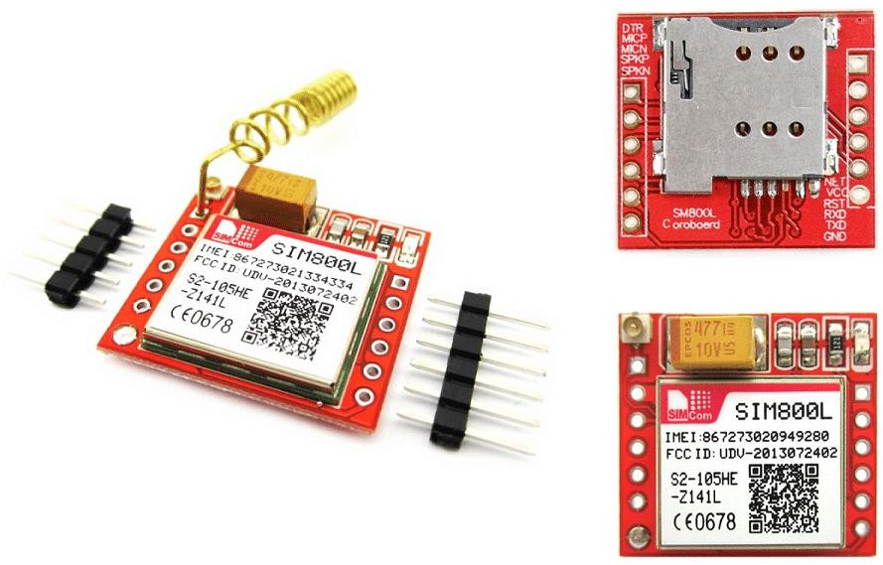
Fig 3.4: GSM module

Ignition Key Interface

An ignition switch, starter switch or start switch is a switch in the control system of a motor vehicle that activates the main electrical systems for the vehicle, including "accessories" (radio, power windows, etc.). In vehicles powered by internal combustion engines, the switch provides power to the starter solenoid and the ignition system components (including the engine control unit and ignition coil), and is frequently combined with the starter switch which activates the starter motor.

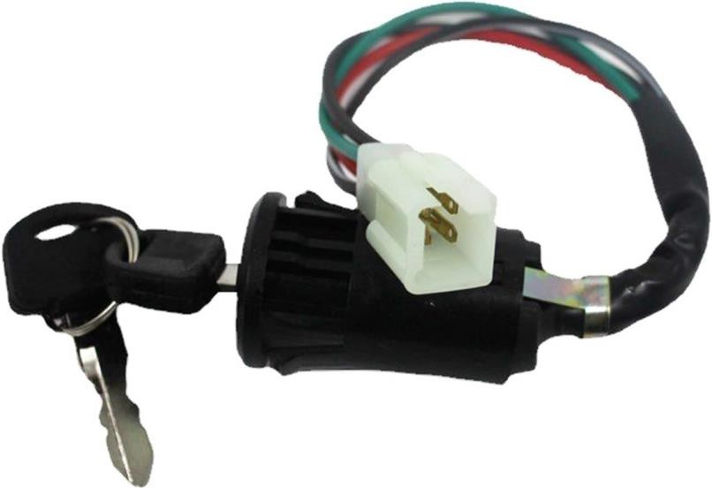
Fig 3.5: Ignition Key Interface

Connections:

The ignition circuit signal is carefully read by the system after being properly conditioned for safety and compatibility. This involves using either a voltage divider or an opto-isolator to reduce the voltage to a safe level and to protect the Arduino from any potential electrical spikes or noise. The conditioned signal is then connected directly to one of the Arduino Nano’s GPIO input pins, enabling the microcontroller to monitor the state of the vehicle’s ignition key accurately. This setup ensures reliable detection of whether the ignition is turned on or off without risking damage to the Arduino.

Working Principle

- When the vehicle is powered, the system gets power from the vehicle battery.
- The buck converter steps the 12V down to 5V, safely powering the Arduino Nano, GPS, and GSM modules.
- The GPS module starts receiving satellite data and sends location information to the Arduino.
- The ignition key status is monitored continuously.
- The Arduino processes the GPS data and, upon detecting key status change or periodic intervals, transmits the data to a predefined phone number or server via the GSM module.
- Users can track the vehicle in real time or receive alerts on unauthorized movement or ignition.

System Design Considerations and Operational Logic

    - Software/Firmware Design

The system’s programming is done in C/C++ using the Arduino IDE, which provides a flexible environment for developing embedded applications. Key libraries utilized include SoftwareSerial for managing multiple serial connections, TinyGPS++ for parsing GPS data from NMEA

sentences like $GPRMC and $GPGGA, and optionally Adafruit_FONA for handling GSM communication. Interrupts may be employed to detect real-time changes in the ignition state, allowing the program to respond promptly to vehicle status updates. Once the GPS data is parsed, it is formatted into readable messages, either as SMS text or JSON format, to be transmitted via the GSM module for easy tracking and monitoring.

Data Security

Secure phone numbers are stored safely in the Arduino’s EEPROM to ensure they are retained even when the system powers down. For enhanced security, GSM communication can be encrypted, especially when using GPRS or HTTPS protocols for server interactions, protecting the data from interception. Additionally, the system can implement optional password-based SMS command handling, which requires a correct password before executing any remote commands, thereby preventing unauthorized access and ensuring only trusted users can control the device.

Fault Handling

To ensure system reliability, a watchdog timer is implemented on the Arduino to automatically reset the microcontroller in case of software hangs or freezes, helping the device recover without manual intervention. The GSM module includes a reset mechanism controlled through a transistor connected to its reset pin, allowing the Arduino to perform hardware resets of the module if it becomes unresponsive. Additionally, the system monitors the GPS signal, and if a loss of signal is detected, it triggers a reinitialization process to restore accurate positioning data, maintaining continuous operation.

Power Efficiency

To conserve power, the Arduino is programmed to enter sleep modes whenever the vehicle is stationary or the system is idle. During these low-power states, both the GPS and GSM modules are switched off or put into standby mode to further reduce energy consumption. This power management strategy helps extend battery life and ensures the system operates efficiently, especially during periods of inactivity.

Software Development and Code Deployment

The backbone of the system functionality is implemented through an embedded C/C++ program written for the Arduino Nano microcontroller using the Arduino IDE. The code governs the acquisition of GPS data, formatting, condition checking, and the triggering of GSM communication.

Code Writing and Compilation

The source code for the GPS- and GSM-based vehicle tracking system was developed using the Arduino-compatible C/C++ programming language within the Arduino Integrated Development Environment (IDE), version 1.8.19. This environment provided a user-friendly platform for writing, compiling, and uploading code to the Arduino Nano microcontroller. To ensure reliable

communication and data parsing, several essential libraries were incorporated into the codebase. The SoftwareSerial.h library was used to establish serial communication between the Arduino Nano and the peripheral modules, specifically the GPS and GSM modules, which operate on separate UART ports. Additionally, the TinyGPS++ library was employed to efficiently parse NMEA sentences received from the GPS module, thereby enabling accurate extraction of latitude, longitude, speed, and timestamp data. These libraries collectively streamlined the software development process and ensured accurate data acquisition and transmission throughout system operation.

Code Uploading Process

After successful compilation, the developed code was uploaded to the Arduino Nano microcontroller using a USB-to-Serial interface based on the CH340G driver chip. This interface enabled reliable communication between the Arduino IDE and the microcontroller. The Arduino Nano comes preloaded with a bootloader, which simplifies the uploading process by allowing the transfer of the compiled binary (.hex) file directly into the onboard flash memory without the need for external programmers. Once uploaded, the firmware begins execution automatically, initiating serial communication with both the GPS and GSM modules and managing data acquisition and transmission as per the programmed logic.

Once uploaded, the code is executed automatically upon boot-up, leveraging the bootloader’s initialization process. The firmware begins by initializing serial communication with both the GPS and GSM modules, establishing reliable channels for data exchange. It then enters a continuous loop where it actively parses real-time GPS coordinates using the TinyGPS++ library. Upon acquiring valid location data, the Arduino transmits the coordinates through the GSM module using AT commands, effectively sending them as SMS messages to a designated mobile number. This automation ensures real-time tracking with minimal user intervention.

Algorithm and Program Logic Flow

To enhance technical understanding and provide a comprehensive view of the system's intelligence, this section details the sequential logic and decision-making processes governing the operation of the GPS- and GSM-based vehicle tracking system. The algorithm encapsulates the structured flow of data, from hardware initialization to real-time data acquisition, processing, and transmission. It serves as the backbone of the embedded software deployed on the Arduino Nano, ensuring that all modules function harmoniously under defined constraints and logic rules.

The system begins by initializing all necessary hardware interfaces, such as serial communication with the GPS and GSM modules. Upon successful startup, it enters a continuous execution loop where it listens for incoming GPS signals and verifies the validity of received location data. Once a reliable GPS fix is obtained, the system parses the coordinates and formats them into a structured SMS message. This message is then transmitted via the GSM module using AT command instructions.

If no valid GPS data is available at a given moment, the system gracefully handles the exception by sending a predefined alert indicating a GPS signal delay. This flow ensures real-time tracking

functionality with built-in resilience to temporary data unavailability. The logic further includes conditional timing, message formatting, and peripheral communication control to guarantee operational stability and reliability throughout the tracking session.

The pseudocode and actual Arduino-based C/C++ implementation provided in the subsequent subsections illustrate this algorithm in both abstract and executable forms, thereby bridging the gap between system logic design and functional deployment.

System Pseudocode Overview:

BEGIN

Initialize serial communication (HardwareSerial for debugging, SoftwareSerial for GSM and GPS)

Initialize GPS module Initialize GSM module WHILE true DO
IF GPS module has data THEN

Parse the GPS data (latitude, longitude) IF valid location acquired THEN Format location into SMS message Send SMS via GSM module
ELSE

Send "Waiting for GPS signal" message ENDIF
ENDIF

Wait for a short delay ENDWHILE
END

    - Aurdino code Implementation #include <SoftwareSerial.h> #include <TinyGPS++.h> TinyGPSPlus gps;
// Define RX and TX pins for GSM and GPS SoftwareSerial gpsSerial(4, 3); // GPS RX, TX SoftwareSerial gsmSerial(7, 8); // GSM RX, TX void setup() {
Serial.begin(9600); // Serial Monitor gpsSerial.begin(9600); // GPS Module gsmSerial.begin(9600); // GSM Module delay(1000);
sendCommand("AT");

sendCommand("AT+CMGF=1"); // Set GSM module to text mode

}

void loop() {

while (gpsSerial.available() > 0) { gps.encode(gpsSerial.read());
if (gps.location.isUpdated()) { float lat = gps.location.lat(); float lng = gps.location.lng();
Serial.print("Lat: "); Serial.println(lat, 6); Serial.print("Lng: "); Serial.println(lng, 6);

String message = "Location:\nLat: " + String(lat, 6) + "\nLng: " + String(lng, 6); sendSMS("+234XXXXXXXXXX", message); // Replace with your number delay(60000); // Wait 60 seconds before sending again
}

}

}

void sendCommand(String command) { gsmSerial.println(command); delay(1000);
while (gsmSerial.available()) { Serial.write(gsmSerial.read());
}

}

void sendSMS(String number, String message) { gsmSerial.println("AT+CMGF=1"); delay(500);
gsmSerial.print("AT+CMGS=\""); gsmSerial.print(number); gsmSerial.println("\""); delay(500); gsmSerial.print(message); delay(500);
gsmSerial.write(26); // CTRL+Z to send message

delay(5000);

}

System Interfacing and Communication Protocols

The system involves serial communication between the microcontroller and both GPS and GSM modules.
Component Connection Protocol Baud Rate GPS Module Arduino via SoftwareSerial UART 9600 bps GSM Module Arduino via SoftwareSerial UART
- SoftwareSerial was used to create additional serial ports as the Arduino Nano has only one hardware UART.
- The modules operate alternately to prevent collision in data streams.

3.10 System Deployment Considerations

- PCB Mounting: Final circuit was soldered onto a Vero board or custom PCB to minimize noise and ensure compactness.
- Antenna Positioning: GPS module antenna was positioned outside the chassis for unobstructed satellite visibility.
- GSM SIM: A valid SIM card with SMS credit and network coverage was inserted into the GSM module for communication.
- Mobile Phone: Acts as a receiver for location data via SMS.

Circuit Assembly and Hardware Integration
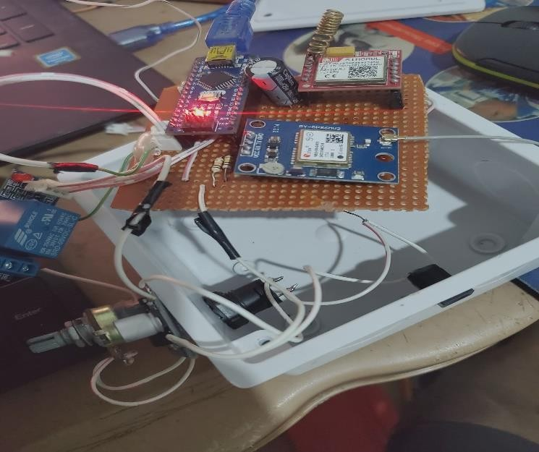
Fig 3.6: Hardware circuit showing Arduino Nano, GSM module (SIM800L), GPS module (GY- GPS6MV2), and supporting components assembled on a perforated board

CHAPTER 4
PERFORMANCE TESTING AND EVALUATION

  - Testing Environment and Setup

The system prototype was initially tested on a breadboard before final implementation on a custom-designed PCB. Both indoor and outdoor environments were used for testing to evaluate system responsiveness, GPS signal strength, and GSM data transmission under varying conditions.

Equipment and Tools Utilized

Component/Equipment Function/Description
Arduino Nano Central microcontroller handling logic and peripheral communication Neo-6M GPS Module Provides real-time geographical coordinates
SIM800L GSM Module Transmits GPS data to a mobile device via SMS
LM2596 Buck Converter Converts 12V DC supply to 5V DC to safely power the Arduino 12V Lead-Acid Battery Primary power supply for field testing
Digital Multimeter Used for voltage, current, and continuity tests Mobile Phone Receives SMS containing location data

Prototype Testing Setup
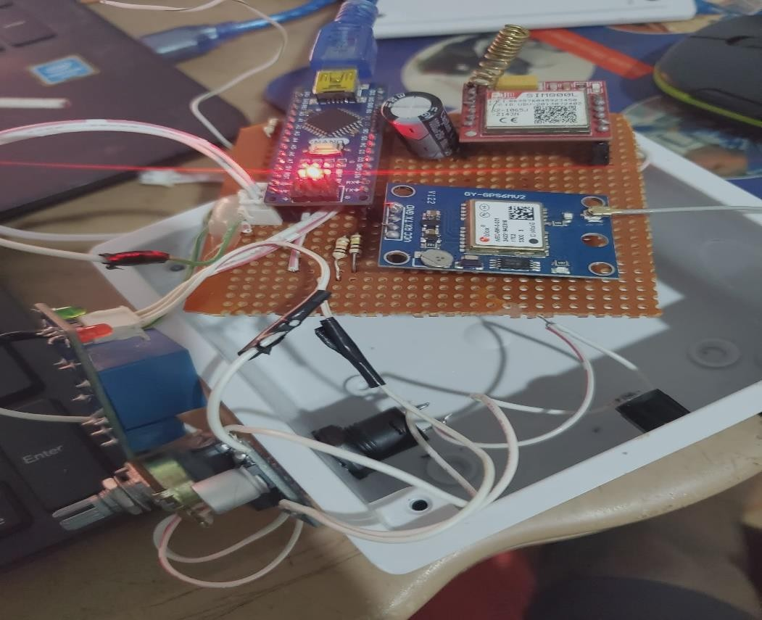
Fig 4.1: Physical prototype setup during testing phase with live module connections

Functional Testing of Individual Modules

    - GPS Module Performance

The GPS module's responsiveness and precision were tested using the following parameters:

Test Parameter Expected Outcome Observed Result Status Time to First Fix Less than 60 seconds 52 seconds Pass Positional Accuracy Within ±10 meters ±6.3 meters Pass Coordinate Update Rate 1 second 1.1 seconds (average) Pass
Inference: The GPS module consistently delivered accurate coordinates in open areas. Indoor performance was limited due to signal attenuation.

GSM Module Testing

Tests were performed to evaluate the module’s ability to send formatted SMS messages under
various conditions:

Scenario Expected Result Actual Result Status

SMS on valid GPS fix
Coordinates transmitted via SMS Received in 7 seconds Pass

GPS unavailable Error or waiting message sent "Waiting for GPS Signal"
received
Pass

Format verification Clear, readable latitude and
longitude
Format: Lat: 6.5244, Long: 3.3792
Pass

Inference: The GSM module reliably transmitted data with acceptable delays and consistent formatting across networks.

System Integration Testing

Once individual components were validated, the system was integrated as per the project architecture. A complete test cycle was executed:

- 12V power supply activated.
- Buck converter stepped down the voltage to 5V.
- Arduino Nano initialized both GPS and GSM modules.
- Upon satellite acquisition, GPS coordinates were processed.
- GSM module transmitted the data via SMS.
- Mobile device received and verified the message.

Outcome: The integrated system operated seamlessly, confirming the proper interfacing of all modules.

Power Supply and Buck Converter Performance

Stability and efficiency of the LM2596 buck converter were tested under varying loads:

Input Voltage (V) Output Voltage (V) Load Current (mA) Status

12 | 5.02 | 500 | Pass
12 | 4.95 | 700 | Pass

Inference: The buck converter maintained a stable 5V output, safeguarding the Arduino Nano and other peripherals against overvoltage.

Field Deployment and Data Collection

The system was mounted on a test vehicle and driven along a predefined route to validate real- time tracking and data transmission.

    - Sample Output Data Table

Timestamp Latitude Longitude Speed (km/h) SMS Received

10:00:00 AM 6.52445 | 3.37923 | 15 | Yes
10:01:00 AM 6.52487 | 3.37998 | 20 | Yes
10:02:00 AM 6.52531 | 3.38074 | 25 | Yes

    - Route Mapping Visualization

Coordinates collected during the journey were plotted on Google Maps. The generated path closely followed the actual driving route, confirming GPS accuracy and real-time communication.

Performance Metrics Summary

Evaluation Parameter Target Performance Measured Result GPS Fix Time < 60 seconds 52 seconds Coordinate Accuracy ±10 meters ±6.3 meters
SMS Transmission Delay < 10 seconds ~7 seconds
Power Output Stability 5V ±0.1V Stable across tests Operational Duration ≥ 1 hour 1 hour 45 minutes

CHAPTER FIVE
  - CONCLUSION AND RECOMMENDATION
  - Conclusion
The automobile tracking system developed in this project successfully met the stated objectives. By integrating GPS and GSM technologies with microcontroller-based logic, a reliable and functional tracking prototype was realized. The project demonstrated the capability of real-time vehicle monitoring with efficient power usage and accurate spatial resolution.
This tracking system can be applied in scenarios such as fleet management, anti-theft monitoring, and logistics optimization. The use of open-source platforms like Arduino and standard communication modules makes the system cost-effective and scalable for large-scale deployment. Furthermore, modular design allows for future enhancements such as cloud integration, mobile application support, and advanced analytics.
The conclusions drawn from the performance evaluation show that the system is robust in its core functions and serves as a viable solution for modern transportation asset management.

Recommendations
Based on the experience gained and limitations identified during the course of this project, the following recommendations are made for future work and system improvement:
    - Cloud-Based Data Logging: Incorporate cloud platforms such as Firebase, AWS IoT, or Azure for real-time data logging, historical tracking, and multi-user access through web/mobile interfaces.
    - Mobile App Integration: Develop Android or iOS applications for easier end-user interaction, alert notifications, and remote command functionalities.
    - 4G/5G Upgrade: Replace GSM modules with 4G LTE or NB-IoT modules for faster, more reliable communication and compatibility with evolving cellular networks.
    - Inertial Navigation System (INS): Integrate accelerometers and gyroscopes for enhanced positioning in GPS-denied environments such as tunnels and underground parking.
    - Geo-Fencing and Alerts: Implement geofencing algorithms to define safe zones, with automatic alerts when vehicles exit or enter designated areas.
    - Solar Charging: Explore solar-based power options for autonomous operation in remote
environments without access to the vehicle’s electrical system.
    - Data Security Enhancements: Introduce encrypted communication and secure APIs to prevent unauthorized access and safeguard user privacy.
    - OBD-II Integration: Extend functionality to read diagnostic trouble codes (DTC) and vehicle performance metrics via the OBD-II port.

REFERENCES
Alvi, M. R., Javaid, N., & Khan, M. K. (2017). GSM-Based Vehicle Tracking and Monitoring System. International Journal of Computer Applications, 167(6), 20–25.
Balanis, C. A. (2016). Antenna theory: Analysis and design (4th ed.). Wiley.
Barr, M., & Massa, A. (2006). Programming embedded systems: With C and GNU development tools (2nd ed.). O’Reilly Media.
Bosch. (2011). CAN specification version 2.0. Robert Bosch GmbH.
El-Sheimy, N., Hou, H., & Niu, X. (2008). Analysis and modeling of inertia sensors using Allan variance. IEEE Transactions on Instrumentation and Measurement, 57(1), 140–149.
Erickson, R. W., & Maksimovic, D. (2007). Fundamentals of power electronics
(2nd ed.). Springer.
Farrell, J. A. (2008). Aided navigation: GPS with high rate sensors. McGraw-
Hill.
Groves, P. D. (2013). Principles of GNSS, inertial, and multisensor integrated
navigation systems (2nd ed.). Artech House.
GSMA. (2020). eSIM: The future of SIM technology. GSM Association.
Harri, J., Filali, F., Bonnet, C., & Fiore, M. (2009). Vehicular mobility simulation for VANETs. Simulation Modelling Practice and Theory, 17(5), 818–835.
Holma, H., & Toskala, A. (2011). LTE for UMTS: Evolution to LTE-Advanced
(2nd ed.). Wiley.
Horowitz, P., & Hill, W. (2015). The art of electronics (3rd ed.). Cambridge University Press.
International Organization for Standardization. (2011). ISO 7637-2:2011 - Road vehicles—Electrical disturbances from conduction and coupling—Part 2: Electrical transient conduction along supply lines only. ISO.
Kaplan, E. D., & Hegarty, C. J. (2017). Understanding GPS/GNSS: Principles and applications (3rd ed.). Artech House.
Khan, S., Ahmed, A., & Tariq, S. (2022). Insurance Telematics: Driver Behavior Analysis Using GPS Data. Journal of Transportation Security, 15(1), 15–28.
Kolban, N. (2017). Kolban's book on ESP32. Self-published.
Kurose, J. F., & Ross, K. W. (2017). Computer networking: A top-down approach (7th ed.). Pearson.

Leick, A., Rapoport, L., & Tatarnikov, D. (2015). GPS satellite surveying (4th ed.). John Wiley & Sons.
Light, R. (2017). MQTT essentials – A lightweight IoT protocol. MQTT.org.
Mazidi, M. A., Naimi, S., & Naimi, S. (2016). AVR microcontroller and embedded systems: Using assembly and C (2nd ed.). Pearson Education.
Miller, M. (2017). Modern automotive technology (8th ed.). Pearson.
Misra, P., & Enge, P. (2011). Global positioning system: Signals, measurements, and performance (2nd ed.). Ganga-Jamuna Press.
Mohan, A., & Gupta, R. (2019). Optimizing Logistics using GPS Tracking Systems. International Journal of Logistics Research and Applications, 22(5), 473–487.
Patel, D., Patel, N., & Joshi, P. (2020). Design and Implementation of a Real- Time Vehicle Tracking System. International Journal of Advanced Research in Computer Engineering & Technology, 9(3), 1204–1212.
Pfleeger, C. P., & Pfleeger, S. L. (2015). Security in computing (5th ed.).
Pearson Education.
Ramkumar, M., Vinoth, K., & Kumaravel, A. (2016). Embedded System Design for Vehicle Tracking. Procedia Computer Science, 85, 197–204.
Rappaport, T. S. (2002). Wireless communications: Principles and practice (2nd ed.). Prentice Hall.
Razavi, B. (2013). Design of analog CMOS integrated circuits (2nd ed.).
McGraw-Hill.
Sauter, M. (2014). From GSM to LTE: An introduction to mobile networks and mobile broadband. Wiley.
Sauter, M. (2021). From GSM to LTE-advanced pro and 5G: An introduction to mobile networks and mobile broadband (3rd ed.). Wiley.
Sedra, A. S., & Smith, K. C. (2014). Microelectronic circuits (7th ed.). Oxford University Press.
Stojmenovic, I., & Wen, S. (2014). The Internet of Things: Key applications and protocols. Wiley.
Teunissen, P. J. G., & Montenbruck, O. (2017). Springer handbook of global navigation satellite systems. Springer.
Yacoub, M. D. (2000). Foundations of mobile radio engineering. CRC Press.
Yiu, J. (2016). The definitive guide to ARM® Cortex®-M3 and Cortex®-M4 processors (3rd ed.). Newnes.

Zhang, W., Wang, X., & Li, H. (2021). IoT Architectures for Smart City Vehicle Tracking. Sensors, 21(4), 1339.
Zhang, Y., Cao, J., Wang, H., & Liu, W. (2020). Secure and flexible OTA firmware update scheme for embedded systems. IEEE Access, 8, 174393–174406.

