DEVELOPMENT OF A COMPUTERIZED LIBRARY INVENTORY SYSTEM AND BOOK ISSURANCE SYSTEM FOR STUDENTS

BY
AJIKANLE ABIODUN FUAD
ND/23/COM/FT/0029

SUBMITTED TO THE DEPARTMENT OF COMPUTER SCIENCE, INSTITUTE OF INFORMATION AND COMMUNICATION TECHNOLOGY
KWARA STATE POLYTECHNIC, ILORIN.

IN PARTIAL FULFILLMENT OF THE REQUIREMENTS FOR THE AWARD OF NATIONAL DIPLOMA (ND) IN
COMPUTER SCIENCE

JUNE, 2025.

CERTIFICATION
This is to certify that this project work was carried out by AJIKANLE ABIODUN FUAD with Matriculation Number: ND/23/COM/FT/0029 in the department of Computer Science, Institute of Information and Communication Technology, Kwara State Polytechnic Ilorin, Kwara State.

____________________________ ____________________
MR. BOLAJI-ADETORO D.F. Date
(Project Supervisor)

____________________________ ____________________
MR. OYEDEPO, F. S. Date
(Head of Department)

____________________________ ____________________
EXTERNAL EXAMINER Date

DEDICATION
I dedicate this project work to Almighty God who inspired me and directed my ways during my academic stay in the polytechnic.

ACKNOWLEDGEMENT
All praise is due to Almighty God the Lord of universe. I praise him and thank him for giving me the strength and knowledge to complete my ND program and also for my continued existence on the earth.
I appreciate the utmost effort of my supervisor, Mr. Bolaji-Adetoro D.F whose patience, support and encouragement have been the driving force behind the success of this research work. He gave useful corrections, constructive criticisms, comments, recommendations, advice and always ensures that an excellent research is done. My sincere gratitude goes to Head of Department and other members of staff of the Department of Computer Science, Kwara State Polytechnic, Ilorin, for their constant cooperation, constructive criticisms and encouragements throughout the programme.
Special gratitude to my parents and siblings, who exhibited immeasurable financial, patience, support, prayers and understanding during the period in which I was busy tirelessly on my studies, special thanks go to my lovely siblings.
My sincere appreciation goes to my friends and classmates.

TABLE OF CONTENTS
Title page i
Certification ii
Dedication iii
Acknowledgements iv
Abstract v
Table of contents vi
CHAPTER ONE: GENERAL INTRODUCTION
1.1 Background to the Study 1
1.2 Statement of the Problem 2
1.3 Aim and Objectives 2
1.4 Significance of the Study 2
1.5 Scope of the Study 2
1.6 Organization of the Report 3
CHAPTER TWO: LITERATURE REVIEW
2.1 Review of Related Past Works 4
2.2 Review of General Text 7
2.3 Misconceptions of the Electronic Library 11
2.4 Types of Library 13
2.5 Concept of Online Library 14
2.6 Difference Between Traditional and Online Library 14
2.7 Features of Library Management System 15
CHAPTER THREE: RESEARCH METHODOLOGY AND ANALYSIS OF THE SYSTEM
  - Research Methodology 16
  - Analysis of the Existing System 17
  - Problem of the Existing System 17
  - Analysis of the Proposed System 18
  - Advantage of the Propose System 18
CHAPTER FOUR: DESIGN, IMPLEMENTATION AND DOCUMENTATION OF THE SYSTEM
  - Design of the System 19
    - Output Design 20
    - Input Design 21
    - Database Design 24
    - Procedure Design 24
  - Implementation of the System 26
    - Choice of programming language 26
    - Hardware support 27
    - Software Support 27
  - System Documentation 27
    - Operating the System 27
    - Maintaining of the System 28
CHAPTER FIVE: SUMMARY CONCLUSION AND RECOMMENDATION
5.1 Summary 29
5.2 Conclusion 29
5.4 Recommendation 30
References 31

Abstracts
A library is an organized collection of information sources which is made accessible to the people. The library usually contains the information physically or in a digitized format. In the olden period the access was usually in the library room as the technology grew up the access that was made online. Library is a fast growing organism. The ancient methods to maintain it are no longer dynamic and efficient. For expeditious retrieval and dissemination of information and better service for the clientele, application of modern techniques has become absolutely indispensable. Library collections house a wide variety of books on many different topics in a particular format. The challenge in making these items available for the use of students is letting those students know what is in the library collection. An online library, filled with books and other information resources, is not necessarily a library unless those books and resources have been appropriately organized for access and made conveniently available for use. There are several large, overlapping literatures on searching: conceptual models, studies of the searching process, and so on. These studies constitute a large proportion of the library research and have many insights to contribute to technology design, however they do not provide the qualitative information we need for understanding the step-by-step, nitty gritty of the research process, especially the resource discovery process as it happens in the wild. However, dealing with problems faced by online readers/viewers, differences in spellings and titles being in different languages (in addition to other issues) contribute to users not being able to find required content. Therefore, it is important to assign a ‘subject area’ to content. However, the numbering of each book may not be very relevant in line with experiences and observations. The main type of method employed in this system is observation on the ways in which message is been sent and not known may be it delivered or not.

CHAPTER ONE
GENERAL INTRODUCTION
1.1 Background to the Study
Library management is a sub-discipline of institutional management that focuses on specific issues faced by libraries and library management professionals. Library management encompasses normal management tasks as well as intellectual freedom, anti-censorship, and fundraising tasks. Issues faced in library management frequently overlap those faced in the management of non-profit organizations (Sharma et al., 2020). Library Management System is an application that portrays a library system that could be generally small or medium in size. It is used by the librarian to categorically manage the library by using a computerized system where he/she can record various transactions like the issue of books, the return of books, the addition of new books, the addition of new students, etc, (Ashutosh and Ashish, 2022).
The library is a fast-growing organism. The ancient methods to maintain it are no longer dynamic and efficient. For expeditious retrieval and dissemination of information and better service for the clientele, the application of modern techniques has become indispensable,. Libraries can be divided into categories by several types, which are: Academic libraries, Corporate libraries, Government libraries such as national libraries, Historical society libraries, Private libraries, Public libraries, School libraries, Special libraries, Digital libraries, Picture (photograph) libraries, Slide libraries, Tool libraries, Architecture libraries, Fine arts libraries, Medical libraries, Theological libraries, etc (Neelakandan et al., 2020).
Books and user maintenance modules are also included in this system which would keep track of the users using the library and also a detailed description of the books a library contains. With this computerized system, there will be no loss of book records or member records which generally happens when a non-computerized system is used. In addition, the report module is also included in Library Management System. If the user’s position is admin, the user can generate different kinds of reports like lists of users registered, lists of books, and issue and return reports. All these modules can help librarians manage the library with more convenience and in a more efficient way as compared to library systems which are not computerized (Dinesh et al., 2019).

1.2 Statement of the Problem
Presently, transactions of books in the institutional libraries have been done manually in most cases, thereby taking more time for transactions like borrowing books or return of books and also searching for members and books. A series of problems occur as a result of this thereby resulting in inefficient library manag ement. In most cases as a result of human error, there may be loss and damage to records due to not using a computerized system in the library. Nevertheless, the difficulty in searching for books which could be termed to be inadequacy in book Management is a problem in the manual library thereby causing inefficiency and time-consuming in the library.

1.3 Aim and Objectives
This study aim to design and implement a digital library system and objectives of the study include:
- Designing a user-friendly interface for the digital library system.
- Implementing efficient search algorithms to enable quick and accurate information retrieval.
- Developing a robust database structure to store and organize digital resources.
- Ensuring the security and integrity of digital resources.
1.4 Significance of the Study
The main purpose of this project is to develop a computerized system that will manage the activities in the library thereby providing easy access to library usage for librarians and users of the library, it will also help librarians keep track of library information, etc. This system will also provide electronic means of storage and help librarians keep track of library information.
1.5 Scope of the Project
The project product to be produced is a Library Management System that will automate the major library operations. The first subsystem is the registration of the users to the system to keep track of authorized users to the system. The second subsystem is the registration of new books into the library management system to know when new books are brought into the library. The third subsystem is a borrower and return of books which is the major area needed by the user. There are three end users for the Library Management System. The end users are the admin, users, and members.

1.6 Organization of the Study
This is the overall organizational structure of the work as presented in this report. This project report is divided into five (5) major chapters.
Chapter one of this project deals with the general introduction of the project, aims and objectives, significance of the study, scope, and limitations, and organization of the report.
Chapter two discusses the literature review and it comprises the historical background of both the case study and online advertisement and also the trend of online advert available.
Chapter three deals with the analysis of the existing system, a description of the current procedure, the problem of the existing procedure, a description of the proposed system, and the basic advantage and also methods of data collection.
Chapter four focuses on the design, implementation, and documentation of the newly proposed system. The design involves the system design output design input design, file/database design, procedure design of the system, the implementation which involves the hardware and software support of the system, program documentation, and maintenance of the system are not left out.
Chapter Five summarizes the entire report along with the experience gained and provides some recommendations. A conclusion is also added to this chapter.

CHAPTER TWO
LITERATURE REVIEW
2.1 Review of Related Past Work
Daniel et al., (2019) presented a journal on “Library Catalog Analysis as a Tool in Studies of social sciences and Humanities: An exploratory study of published book titles in Economics” This paper explores the use of Library Catalog Analysis (LCA), defined as the application of bibliometric or informetric techniques to a set of library online catalogs, to describe quantitatively a scientific-scholarly field based on published book titles. It focuses on its value as a tool in studies of Social Sciences and Humanities, especially its cognitive structures, main book publishers, and the performance of its actors. The paper proposes an analogy model between traditional citation analysis of journal articles and library catalog analysis of book titles. It presents the outcomes of an exploratory study of book titles in Economics included in 42 academic library catalogs from 7 countries. It describes the process of data collection and cleaning and applies a series of indicators and thematic mapping techniques. It illustrates how LCA can be fruitfully used to assess book production and research performance at the level of an individual researcher, a research department, an entire country, and a book publisher. It discusses several issues that should be addressed in follow-up studies and concludes that LCA of published book titles can be developed into a powerful and useful tool in studies of Social Sciences and Humanities.
Posigha (2020 ) writes and presents an article on “The Use of the Library Catalogue by Undergraduate Students in Niger Delta University Library” The library catalog is an essential tool. It is an index or a key to the collection, containing an entry representing each item. The catalog also tells where in the library a book is located. Despite these purposes and characteristics, the use of the catalog is very poor in most Nigerian university libraries. Poor use of the catalog in the Medical Library, attributed to a lack of user education programs states that undergraduates find the university library threatening and doing research intimidating because they do not have library skills. The only solution to this problem is prolonged and intensive user education and current awareness services. The university library faces several challenges in its user instruction programs, yet it is through user education that librarians' work is made easy and students' efforts reduced. If the library is for the use of all, then all must be able to use the catalog to access the library materials. Libraries are for use. Therefore we must be sure that whatever we do serves the ultimate purpose of the library.
Kasimani & Rajendran (2019) wrote a paper titled “Use of Online Public Access Catalogue (OPAC) Services in District Central Library, Chennai, (Tamilnadu)”. This Paper attempt to user satisfaction with the Online Public Access Catalogue (OPAC) in the Public Libraries Chennai. In this investigation about the frequency, purpose, problem faced by users and satisfaction of public library users. This study also analyze the awareness of users, important of OPAC, lack of skills user to OPAC and proper guidance of library staffs to search them needs and locate them resources on the shelves. The present of study survey approach was used distributed 100 questionnaires and 90 questionnaire received back and analyzed with specific objectives. This study focused on the user OPAC to Check availability of document in the library 33(36.67%), followed by the users due to the Internet Speeds 42(46.67%) and 53(58.89%) users Satisfied by the users on use of OPAC.
Muhammad (2021) presented a paper titled “Cataloguing AND Classification System for E-resources in Web-based Digital Libraries” This paper presents an overview of cataloguing and classification process for libraries and analyzes it from the point of view of digital libraries. A case study of Australian Islamic Library’s cataloguing process is presented in line with discussions from literature review and key challenges faced by library’s patrons. Library’s cataloguing method provides ease, flexibility and productivity in assisting users easily find required resources while not becoming a burdon on library staff in terms of its establishment and maintenance. It also addresses most of the improvement opportunities identified by library staff and users.
Karen (20119) presented a journal article on “Online Catalogs: What Users and Librarians Want” An end user’s expectations and work practices on the Web influence his or her decision to use a library online catalog. Catalog interfaces matter, but catalog data quality is also a driving factor of the catalog’s perceived utility—and not only for end users, but also for librarians and library staff. To gain a rounded, evidence-based understanding of what constitutes “quality” in catalog data, OCLC formed a research team to; Identify and compare the data quality expectations of catalog end users and librarians, Compare the catalog data quality expectations of types of librarians, Recommend catalog data quality priorities, taking into account the perspectives of both end users and librarians. Readers who are seeking to define requirements for improved catalog data (exposed in both end-user and staff interfaces) may find this report helpful as a source of ideas. The same is true for readers who have a part to play in contributing, ingesting, syndicating, synchronizing or linking data from multiple sources in next-generation library catalogs and integrated library systems.
Abbas (2019) presented a paper titled “Design and Implementation of an E-Library Search System” E-library system makes the work of a person who is in charge of the library more convenient to search, arrange and make an inventory of the contents of the library. In this paper, a search system for an E-Library for the academic organizations was introduced such as universities, researches centers. This system has some methods of searches and it is convenient for the researchers to find their required information. The data base contains two categories, Books and Theses. The administrator of the E-Library can add, update, and delete any information in the database easily.
Esther (2020) wrote a journal titled “Online Public Access Catalog (OPAC)” Online Public Access Catalog (OPAC) is a catalog of a library's collection that is open and accessible to the public through the internet. It is an online open access bibliography of a library holding. A library catalog provides users a platform to search and locate books and other materials available at the library. A library catalog is a register of all bibliographic items found in a library. A bibliographic item can be any information entity (e.g., books, journals, computer files, graphics, maps, etc.) that is considered library material. An OPAC is just the electronic version of the manual card catalogue. An OPAC makes use of the Z39.50 protocol to handle search requests from users. Z39.50 is a standard communications protocol for the search and retrieval of bibliographic data in online databases. Z39.50 is widely used in the library environment and is often incorporated in Library Management Systems (LMS) like KOHA, Insignia Software and Librarika.
Sridevi et al., (2019) write and presented a journal on “OPAC 2.0: towards the next generation of online library catalogues” While the 4th Law of S.R. Ranganathan’s Five Laws of Library Science (1931) says that: “Save the time of the reader”, it is a big question to ask whether the current Library catalogues precisely do this for its library patrons. There is a common understanding that the evolution of OPAC should be in line with the evolution of technology and its services. They have to be designed in such a way that the users should be able to find what they are looking for in a timely manner only then they will be more satisfied, and more likely to feel like their needs have been met. While it is mandatory that the OPACs should not be a complex matrix for the users, it is important that it should encompass the current trends and features of advancements. There is no doubt that Librarians are the Architects to design best next generation OPACs by amalgamating Web 2.0 tools and the social networking aspects to the traditional catalogues which offer interacting options to the patrons. This paper looks at the current trend in formulating the next generation of Online Library catalogues with glimpses of isolated experiments and improvements in the library catalogues coupled with various open source software packages for OPAC 2.0 and the benefits to the users therewith.
Maidul (2020) presented a journal article on “The Use of the Library Catalogue by Undergraduates” An information institution or a library tends to be prominent or popular for its organized rich collection and effective services. Organization of resources is attained through cataloguing and classification. Classification is a part of cataloguing. Effective and modern cataloguing by a person emanates from devoted, keen interests, long, arduous experience, and studies and knowledge in modern international developments obtaining in the field. This is, otherwise, called specialized up-to-date technical knowledge (Saiful-Islam, 2017). Academic libraries collect material to support the teaching and research objectives of their parent bodies. The library serves both the teaching and nonteaching staff of the university, researchers from other academic institutions, and students.
2.2 Review of General Study
The first library management system to be reviewed is the KOHA library management system. Since its original implementation in 1999, KOHA functionality has been adopted by thousands of libraries worldwide, each adding features and functions, deepening the capability of the system. With the 3.0 release in 2005 and the integration of the powerful Zebra indexing engine, KOHA became a viable, scalable solution for libraries of all kinds. LibLime KOHA is built on this foundation. With its advanced feature set, LibLime KOHA is the most functionally advanced open-source Integrated Library System in the market today. The major setback of this Library Management System is that it is web-based and as a result, it is not security conscious because hackers could have the database hacked and access or modify the information of such users (www.koha.org).
Another Library Management System is Capital’s library software with the following benefits Increases support available for staff and users in any modern library service, provides efficiency, innovative system that saves library time, and improves the user experience.
Librarian at Cohen Hillel Academy points out that after automating their library services; the electronic catalog was faster, more versatile, and easier to use than the old card catalog which they used before automation. The new system encouraged both students and teachers to do more research by utilizing the resources offered. The librarian notes that the school library had only automated its circulation functions which made use of older circulation software. They used this program till 1998 when they decided to upgrade to the Follett Software Company’s Circulation Plus and Catalog which was computerized. She notes that to motivate the library staff their workload must be simplified and the technology used by the school streamlined. This system had several advantages:
- It increased interest in the library and enabled easy access to resources. This helped both the students and staff to find electronic resources more easily.
- It presented a user-friendly technology; whereby the Windows platform was easy to use with less training required. The location of material became easier and it was done promptly.
- Reports were generated easily hence presenting library staff with the opportunity to manage library operations effectively Dr. Sangayya .S. Sirurmath.2011.
- The system presented a consistent learning environment and ease of maintenance.
Highlighted the relevance of digitizing libraries as:
- it improves and widens access to electronic collections done by other digital libraries;
- it enhances the lifetime of information material;
- it encourages and facilitates sharing of resources amongst libraries across the world; and
- it reduces duplication of work.
Library Management System is an online system, which enables its users to access it round the clock. It has an added functionality for users to feel they are part of the system by displaying their profile on login and enabling them to update their details.
Book lending systems were created way back in the past centuries even before the computer age. The French book wheel invention enabled scholars to circulate books by stepping on a pedal that turned a book table. Albert Cotgreave developed the book indicator back in 1863. It housed smaller versions of the books making it possible to tell the availability of the book, or if it was overdue. Automation of libraries began in the 1930s. This is when the punch card systems were used to manage book acquisition and circulation. The virtual library comprises an aspect of remotely accessing services and content of other libraries, alongside other resources of information. The internet acts as a powerful tool through which materials can be made available for sharing and access by anyone across the globe. Libraries have accumulated resources that can provide a good source of information for research and other use. Making these rich resources available to the general public across the globe is of great advantage. Technological advancements aim to make work easier and ensure efficiency is realized in all facets of life where it’s applicable.
Notes that library automation is the process of interconnecting systems to enable the sharing of information through networks hence providing access to large volumes of content and information to users across the globe. The use of the internet and networking has been emphasized a lot. A library needs the latest technology to be used in the 21 century, hence, institutions need to phase out legacy systems and embrace automation of all their services.
Highlights that a virtual library can connect e-learners to online public library catalogs, resource-rich databases which are licensed and electronic books, and materials for research and learning. These virtual libraries allow users to access them around the globe and at any time so long as they are connected to the internet. The adoption of the Library Book Management System poses great benefits to the end users since the system aims at delivering automated services efficiently and effectively via the Internet.
A library management system usually comprises a relational database, software to interact with that database, and two graphical user interfaces (one for users, one for staff). Most integrated library systems, separate software functions into discrete programs called modules, each of them integrated with a unified interface. Examples of modules might include:
- Acquisitions (ordering, receiving, and invoicing materials)
- Cataloging (classifying and indexing materials)
- Circulation (lending materials to patrons and receiving them back)
- Serials (tracking magazine and newspaper holdings)
- The OPAC (public interface for users)

2.2.1 Functions of Automated Library Systems
A good number of Library Management Systems suppliers have come together to integrate several functionalities. These include:
- The inter-library loan modules are incorporated into the circulation system.
- Online Public Access Catalogs providing search functionality.
- Incorporating resource management software and reading list within OPACs.
- Sending users reminders on reservations by using integrated computer telephony.
- Serials check-in using Electronic Packing Slip.
- The use of Radio Frequency Identification technology for checking stock. The use of RFID tags to track library material.

2.2.2 Challenges Facing Automating Libraries in Nigeria
Libraries in Nigeria are faced with several challenges when it comes to automating library services. Some of these reasons include:
- Lack of sufficient funds to support the entire automation process.
- Lack of facilities to run the automated software program.
- Lack of manpower with adequate skills to handle the systems.
The Library Management System facilitates the provision of access to large volumes of resources available online hence enhancing knowledge among its users. Knowledge is meant to be shared; hence this system provides an open environment for all its users to learn from each other by providing a platform for accessing rich material resources online. The system is also cost effective hence it provides a great deal for institutions that cannot afford the more expensive library management systems a chance to own one. To provide and enhance a useful learning and research-oriented environment, libraries should automate all their services provided to their end users.
Over the past years, library management systems have been under rapid development. These online libraries are flexible because they offer a 24hrs access, and operate 7 days a week, and 365 days a year. These library systems enable easy searching of material hence saving time. They enable information that was only available to a few individuals accessible to everyone. They also help in preserving material that could otherwise wear off. Original documents are translated into digital formats and archived in databases.
Library Management System supports the general requirement of the library such as the acquisition, cataloging, circulation, and other sections. Before the advent of the computer in the modern age there were different methods of keeping records in the library. Records were kept in the library on shelves and each shelf was labeled in alphabetical or numerical order, in which the categories of books available were arranged on different positions on the shelves and as well were recorded on the library manuscript and when any book is to be referenced the manuscript is being referred to, to know the position of such required book by the person that requested for the book. After the invention of the computer, different researchers carried out various approaches to an automated library management system which this project is as well all about.
2.3 Misconceptions of the Electronic Library
It is commonly thought that an electronic library enables anyone, at any time or place, to access a library's enormous book collection by using the Internet. It is even believed that one can use all the books in a library's collection without actually going to the library. But these notions are only half-truths.
An electronic library is indeed aimed at making it possible for anyone, at any time or place, to access digitized resources over the Internet. It is only natural, however, that the contents which can be used over an electronic library are limited to those contents which have been digitized at the library so they can be relayed through a network. The process of digitization is a major one, involving much labor and expense. Libraries have huge book collections and it is not possible to digitize all these resources. It is a huge misconception, therefore, to think that anyone, at any time or place, can access any book in a library.
What is more, most of the books in a library's collection are protected by copyright. Electronic libraries must honor copyright and in digitizing and providing information, ample attention must be given to this copyright.
The proposed system plans to actively promote the electronic library as a new library service in the future. As we have just observed, however, this does not mean that all the books in the system’s collection can be used over a network. Through consultations with all those concerned, progress will be made step-by-step within the range of practical limits.

2.4 Types of Library
There are three main types of libraries, which shall be outlined below:
- Public Libraries: For many people, this is what a library is - a publicly funded institution that provides books for loan and is used mainly by the very old and the very young. It is probably divided into Lending and Reference, and the Lending stock is split between fiction and non-fiction. The threat to the public library comes partly from the fact that fewer people now read for pleasure, and those who do are more likely to buy their books from bookshops than borrow them from the library on the non-fiction and reference sides, information is easily and quickly obtainable from the WWW, without the need to make a trip to the library. However, public libraries provide much more than that, such as materials for entertainment and information in a wide range of media. You will also find a lot of information about local services across the spectrum, tailored to the needs of the community served by the library. Above all, you will find professional librarians who are trained to help you find exactly what you are looking for. This includes help with searching the Internet, which you can do from most public libraries these days.
- Academic Libraries: These cover the spectrum from libraries in schools of all sizes, through to those of major universities and research institutions. They have something of a captive audience, in that the institutions they serve are dedicated to teaching and learning, and the libraries' role is to provide access to the sources of information from which that teaching and learning can develop. However, they are still under threat, because they cost money to stock and run, and a school or university has to decide as to the proportion of its funds to devote to its library. Academic libraries are therefore bending over backward to add increasingly more value to the services they provide. Just as with the public library sector, it is the people who run and staff academic libraries who make them what they are. It has been known for institutions to try to run their libraries without professional librarians, but this is a highly misguided attitude because the expertise of a professional librarian is essential in the process of translating a vaguely worded inquiry into the true needs of the enquirer and then into the solution that will best satisfy those needs.
- Special Libraries: These are libraries that serve as a particular institution that has a specific role to play, and they will therefore tend to be "one subject" libraries. For example, they could serve a hospital, a law practice, or an industrial company. They also vary in size, depending in part on the size of the institution they serve, but many of these libraries are run by "solos", that is, librarians working alone or maybe with only clerical assistance. Special librarians have become adept at "reading the runes" of the environment in which their business operates, and scan information sources to find material that they know will be of interest to the people working in their company, etc. They also need to be on top of all the information technology that is available to them and at ways of collecting and presenting information that will save the time of busy people. They may also organize the institution's information resources in ways that best suit local needs, maybe through a company intranet. The title "librarian" has been questioned in some quarters, and many people in this sector prefer to be known as "information scientists".
The threats to this sector of librarianship are obvious, especially where company bottom lines take priority over virtually everything else. It is not easy to gauge the true value of a library to a business, and, to many accountants, anything that cannot be valued in purely monetary terms has no value.
2.5 Concept of Online Library
The concept of the electronic library is information stored electronically and made accessible to users through electronic systems and networks. One of the central tenets (principle of belief) of the electronic library is the delivery of information, whenever required, to the user’s desktop. Library professionals, therefore, will increasingly need to provide their services in some electronic form rather than accept face-to-face contact with their users. As academics become more willing and more accustomed to using electronic information regularly, they will become increasingly dependent on technology for information access. An additional factor is that in networked environments, information providers can supply their information directly to the end-user and so bypass the library entirely. Thus, moving to an electronic information environment will radically alter how a library operates and interacts with its users, and library professionals will need to consider their future role as intermediaries. It will form a crucial part of an institution’s information service provision and is likely to have a much wider remit than that of the traditional library. Electronic libraries will need to provide a range of new value-added services for internally generated and externally acquired academic information and may be involved in the delivery of administrative information as well. However, the primary aim of the electronic library will be to support the institution’s learning, teaching, and research, which might change significantly with the number of users.

2.6 Difference Between Traditional and Online Library
Technological advancements have not limited themselves to electronics and gadgets. Such advancements have also manifested themselves in some other areas like education.
Before, libraries were full of textbooks arranged on shelves by category and alphabetically. Today, e-library is never complete without computers, and although there are still books on shelves, they seem to be gathering dust and become more of decoration rather than a source of information.
Do the physical libraries become out of date? Do digital libraries offer more?
Traditional libraries emphasize the storage and preservation of books and periodicals. To get hold of information, you have to physically visit the library.
On the other hand, digital libraries give you access to digitized materials wherever they may be located and eliminate the need to store physical items as they do in traditional ones. Cataloging is very detailed down to individual words or glyphs (a small graphic symbol). Browsing is based on keywords and hyperlinks and materials on the same subject need not be near one another. Users also have the freedom to access digital libraries electronically whenever and wherever they might be.
The greatest advantage of digital libraries over traditional ones would be the amount of data they can store. Billions, and not just millions, of data, can be stored not limited to books alone. Digital libraries may also include photographs, music, movies, theatrical performances, legislative materials and court decisions, and even museum objects in their database.

2.7 Features of the Library Management System
Only basic knowledge of computers is required for the operation of a Library Management System. As it has a user-friendly application interface. Library Management System is customizable and user-configurable.
An inbuilt settings module makes the Library Management System flexible to cater to diverse organizational needs. It is built on one of the latest and upcoming technologies in the field of information technology, which makes you a forerunner in the world of information technology.
Library Management System brings information to the user's desktop through integration across all modules. Library Management System has pre-defined reports. These are used for normal reporting as well as Administration & Staff development purposes. Additionally, Library Management System can be easily customized for their customized reports.
- The staff, as well as student record, is maintained.
- Newspapers attendance is maintained.
- Automatic fine fee calculation.
- Keeps record of suppliers and binders.
- Customized Report designing.
- Configurable as per user’s requirements.

CHAPTER THREE
METHODOLOGY AND ANALYSIS OF THE EXISTING SYSTEM
3.1 Research Methodology
To develop a best fit system to the library, there are three stages of developing the new system. They are gather information, design and implementation and final testing. Within these three sections, different tactics will be adopted so that we can design a system that can maintain high usability and accessibility. Below are some ideas to the process Before setting up the system by software development tools, information will be gathered from the staff about the need for the users of the system like the staff of library and those readers by using qualitative gathering techniques (oral interviews). Before starting to implement the system, interviews will be made to get readers view on the system before having the design works being done.
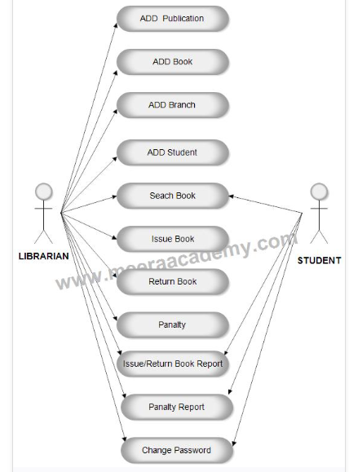

Figure 3.1: Use Case Diagram Library System

In the above library system project there are two users Librarian and Student. Both Librarian and Student can do all activities after login into the library management system.

Librarian Activity:
- Add Publication
- Add books
- Add Branch
- Add Student
- Issue Book
- Retu=rn Book
- Apply Penalty
- Change Password
- View Reports

Student Activity:
- Search Book
- Issue / Return Book Report
- Penalty Report
- Change Password

3.2 Analysis of the Existing System
The existing system of library management involves a lot of paperwork. The system involves a librarian who will have to check the stock card for the books available. In a situation where a borrower wants to borrow a book and the book is not available, the librarian will have to search in vain and this results in time wastage. During this process, there are lots of events happening there leading to time wastage.
  - Problems with the Existing System
There are lots of identified problems with the existing system. Some of these problems are:
    - Time Wastage: It takes a lot of time to get the books available in the paper format of the library system. In a situation whereby a borrower/librarian wants to search for a book that does not exist in the system and the user checks through the book and did not get it, the user has wasted enough time searching for a book that does not exist.
- Loss of Data: With the manual approach, hardcopy can get damaged or lost. A result of transferring data from one location to another may result in the loss of data. The present approach (system) is prone to theft. It can easily be stolen. Fire outbreaks can also affect it. When a house or the office in which the medical dictionary is kept gets burnt, then it affects it.
- Insertion of New Words and Deleting Obsolete Ones: in the present system takes a lot of time to edit. With the new system, it will only require the administrator of the system to search for the word with the mistake and edit it easily. A lot of months or even years can be spent creating a new version of the existing system.
- Size (Volume of the Book): Some of the present medical lexicons are very large and this results in the inability to handle them. As a result of this, it cannot be easily carried around. The present system is too big to be used in several places.

3.4 Description of the Proposed System
The proposed system is a computer-based medical lexicon (dictionary) that allows doctors, nurses, patients, medical students, and none medical users to be able to search for medical terminologies and get their equivalent meanings. It is used for searching for words, adding new medical terminologies, deleting existing words if it’s no more relevant, and also modify existing terminologies.
  - Advantages of the Proposed System
The proposed system has several advantages over the present system. The advantages will make the operation of the system to be performed in a simplified way compared to the present system. There are lots of merits attached to this system and they are:
- Easy Navigation: A user can easily navigate among the web pages and this will not make the user to be bored using the system.
- Immediate Response: It provides a form of an immediate response. The computer system is designed to respond almost immediately to questions or tasks.
- Facilitates Easy Learning: There is an improvement or enhancement in learning while using the proposed system.
- No Loss of Data: The present system consists of lots of paper and this can easily get lost. But with the proposed system, the data are saved and can be retrieved anytime it is needed.
- Ease of Usage: It is easy to use than the present system because all that is required in the proposed system is to supply the book needed and the result will be displayed.
- Accuracy: One of the proposed system are its flexibility and scalability as well as the access it provides to accurate information.
- Storage Capability: The computerized system has a very large storage capacity, very large computer installations are capable of storing billions of data that could be accessed by manual users at a time compared to the manual approach, which is tedious.
- Less Human Effort Requirement: With the application of a computer in a library, the human effort required is tremendously reduced to its minimal, this is because what men can do within five days can be done by the computer within a few seconds.
- Flexibility: The program is very flexible and will ease all modifications, for example, many books may be required in a large stage. This can easily be inserted.
- Fast Processing: It takes a very short time to process a medical lexicon by the use of the computer as opposed to a manual approach which resides on paper. Since fast processing speed is one of the advantages of the computer system, then it takes nanoseconds to process operations to the ensure efficiency of the proposed system.
CHAPTER FOUR
DESIGN, IMPLEMENTATION, AND DOCUMENTATION OF THE SYSTEM
  - Design of the System
The proposed system is designed in modules with each module working together to perform the electronic library system to enhance the performance of the existing system as earlier discussed in chapter three.
The ability to analyze and give focus to the system is explained in the following formats which are output design, input design, database design, and procedure design.
    - Output Design
The output and output to be extracted from the proposed system are shown below
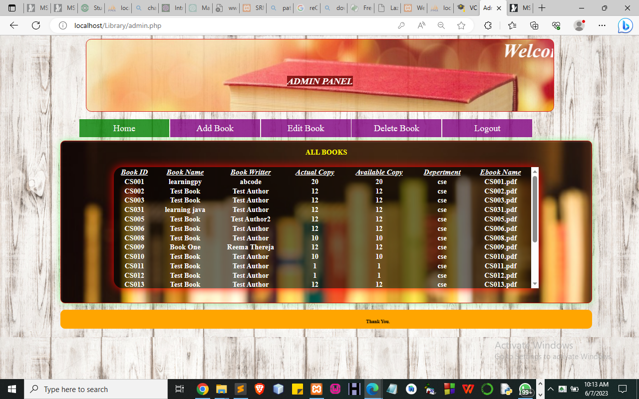
Figure 4.1: Admin dashboard
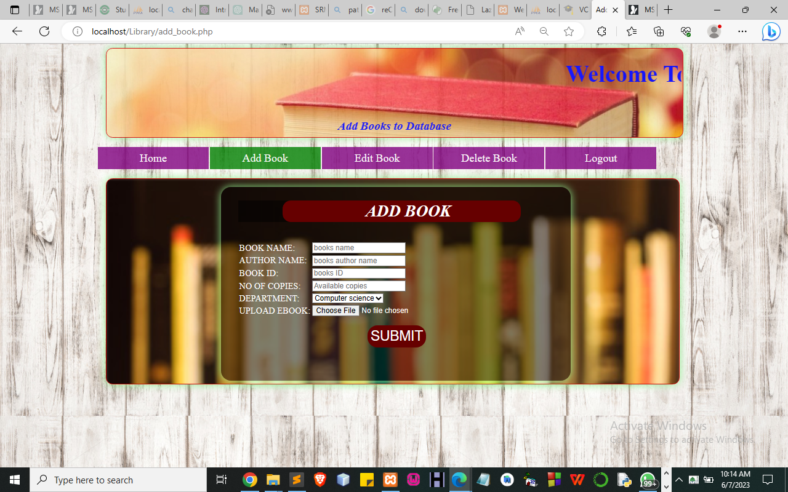
Figure 4.2: Add Books
This page displays a page to add books available on the system this system.
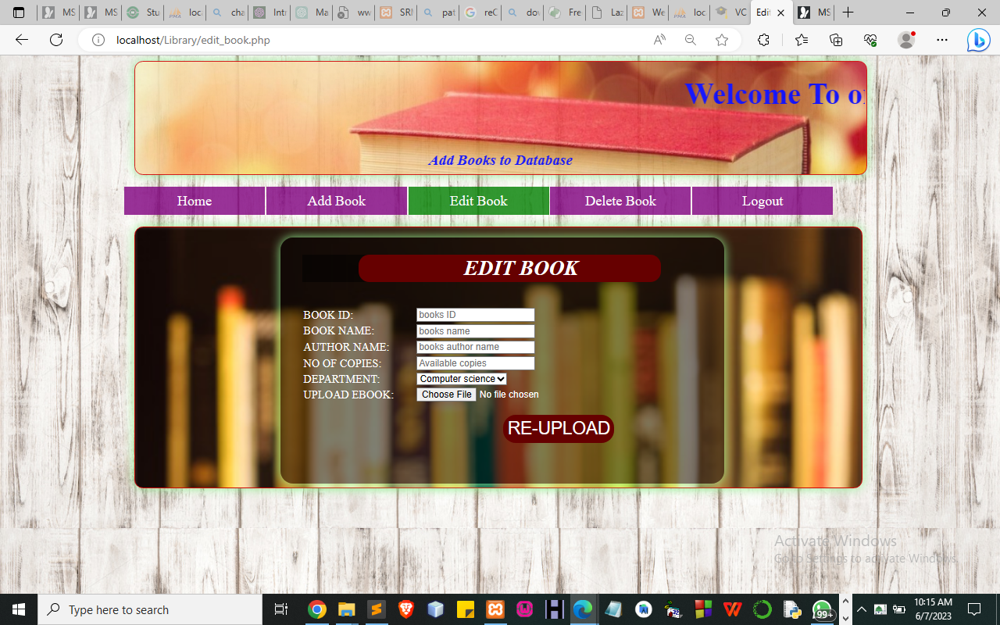
Figure 4.3: Edit Book

This allows users to edit books from the system

4.1.2 Input Design

It is also necessary to denote that data inputted in the computer for processing determines what the output will be. The inputs are use in collecting information the student through the keyboard. Inputs are necessary information needed for processing so as to produce the expected outputs; which are supplied through the keyboard.

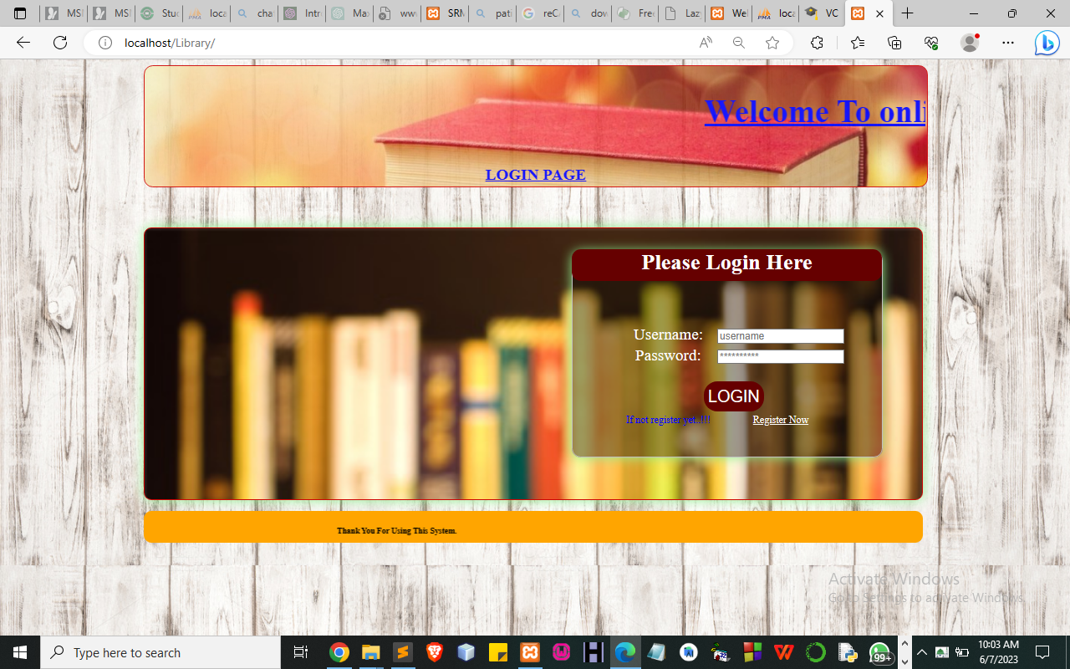
Figure 4.4: Login Page
This Page allows an authorized user to log into the system.
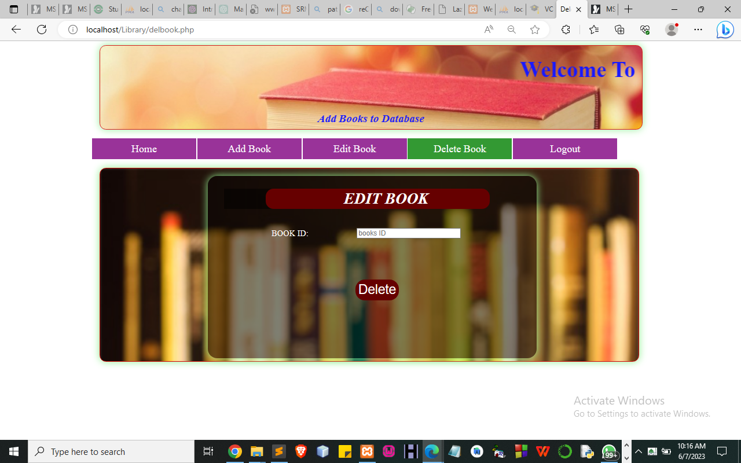
Figure 4.5: Delete Book
This Page allows user to delete a different book that is available on the system.
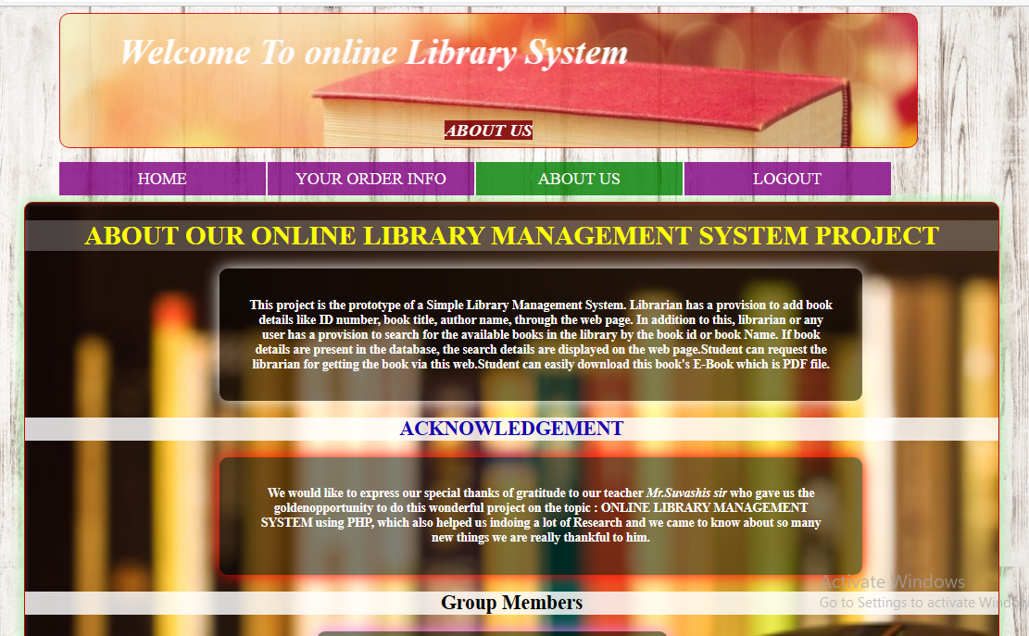
Figure 4.6: Contact Us
This is where the student/user can contact the administrator for more details
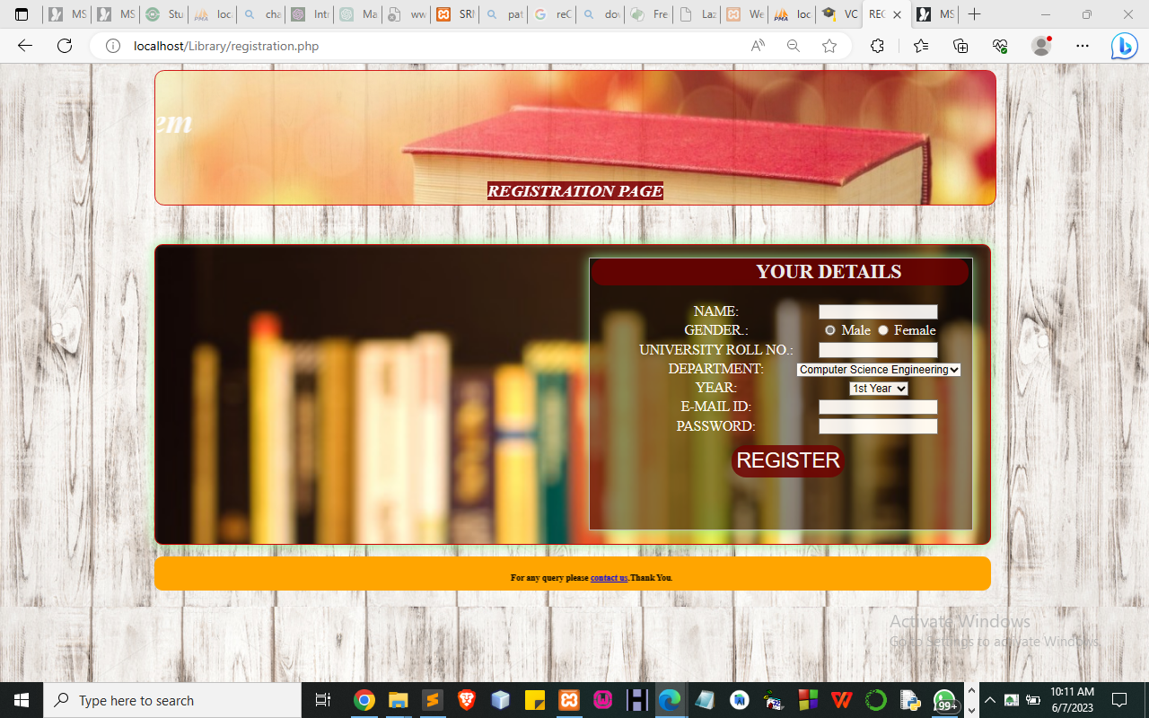
Figure 4.7: Sign Up
This Page allows students/users to their details and gain access to the system.

4.1.3 Database Design
A database table is used for storing information about the files. The database used for this application is MySQL database. The files and their respective modes of access, as well as the information they hold, are given below;
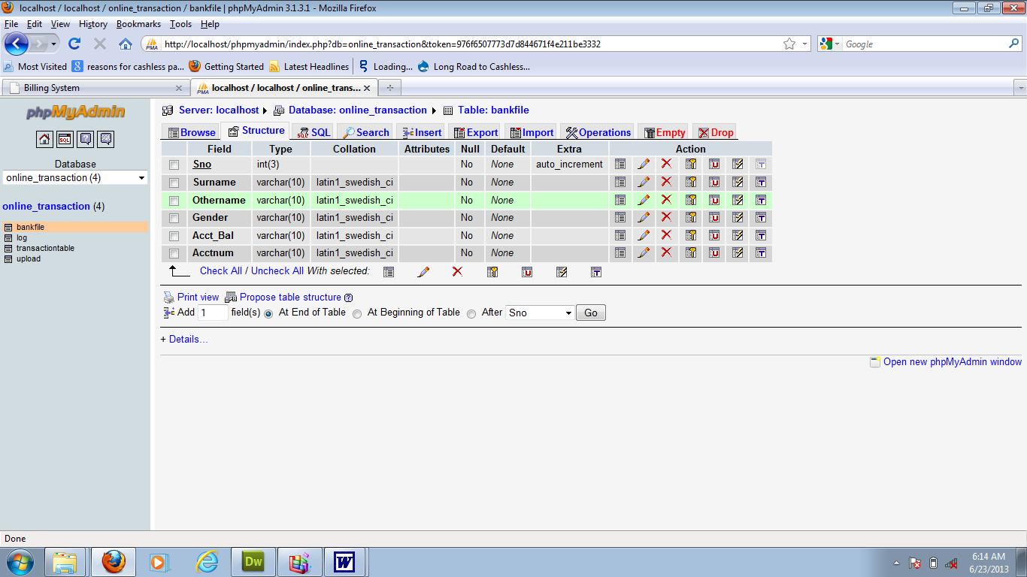
Table 4.1: Registration Structure

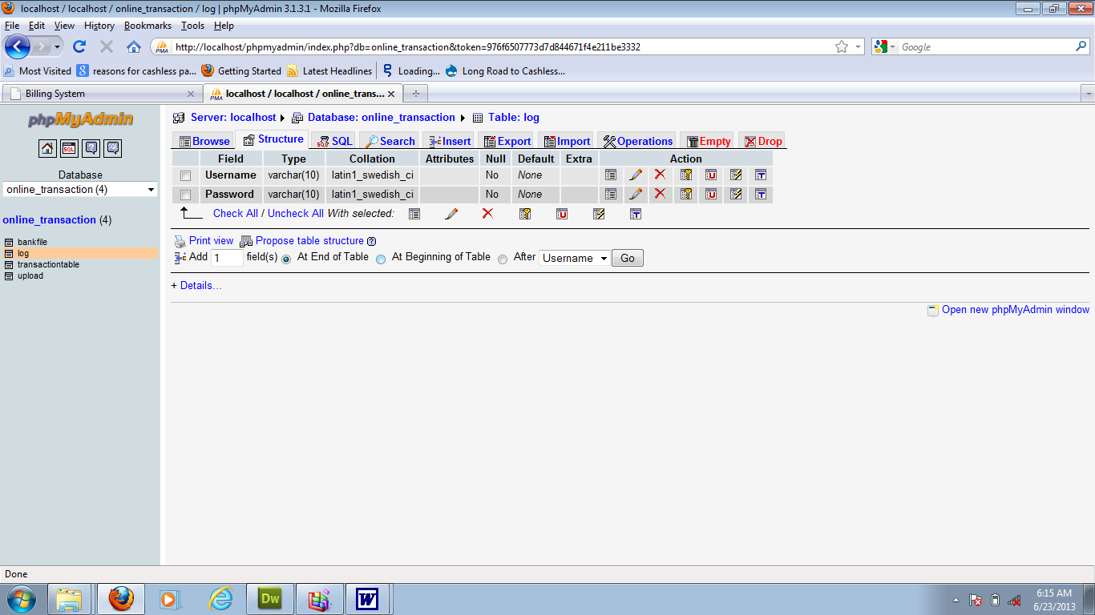
Table 4.2: Admin Login Table Structure

Table 4.3: Student Personal Data Table
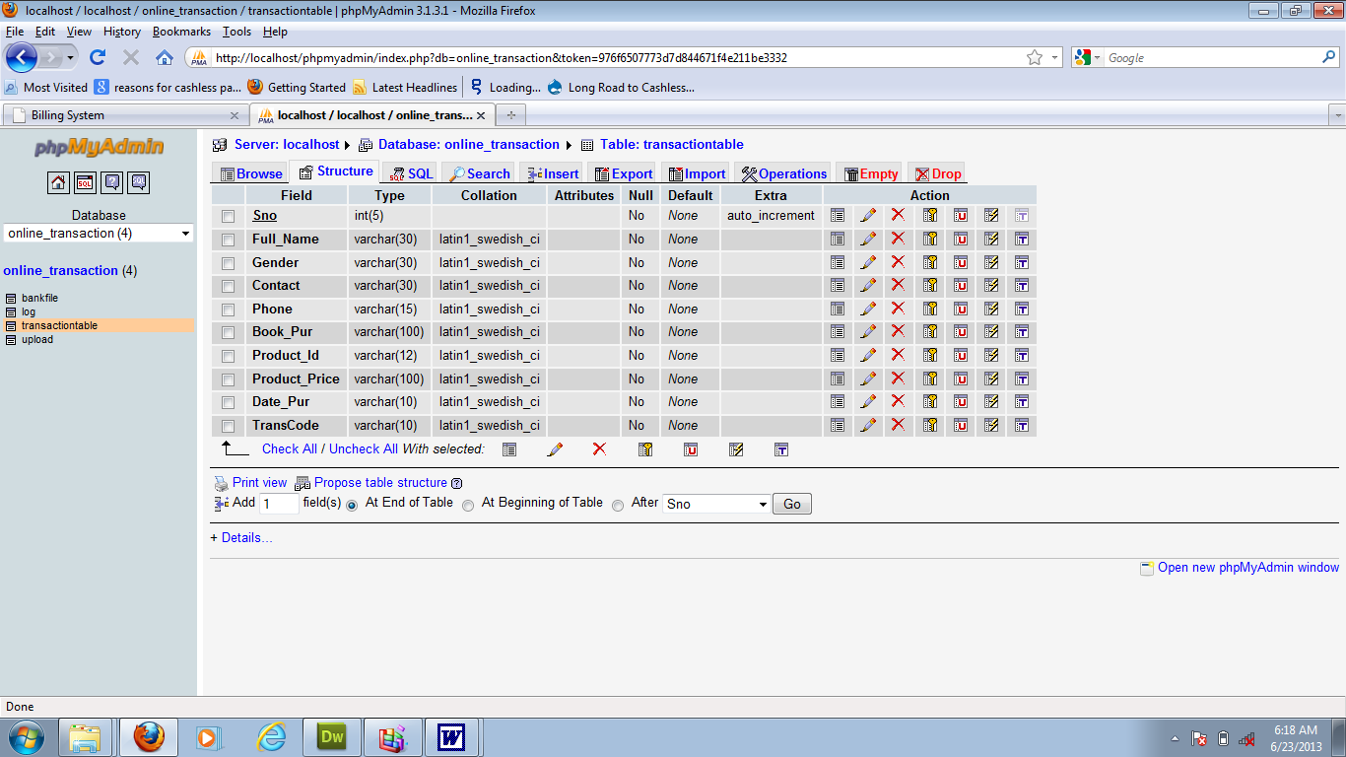

4.1.3 Procedure Design
Procedures are steps that verify the whole process. That is everything put together to produce the desired output. This involves the organization of the source document and ends with the output result.
Documents are sent to various departments to be filled by the employees and later returned to the personnel department which are analyzed to determine which record goes into the computer.
After selecting the necessary data, this serves as input to the computer system.

4.2 Implementation of the System
It is always good to develop new ideas, implement them on a computer, and eventually relish the satisfaction of achieving a successful result. The implementation process involves converting the system design into a complete and tested EDP that is fully operational and that can be used by the system users to meet their business needs. During the implementation phase, the hardware and the software must be implemented.
The implementation of a system can be explained in six steps:-
- Review design specification
- Code, test, and document programs
- Train users
- Perform system test
- Convert to the new system
- Evaluate and maintain the new system
4.2.1 Choice of Programming Language
The application is designed in Sublime web development package which involves the use of PHP server-side scripting language, MYSQL for database management and HTML (with other embedded functionalities) for the page design and layout settings. Hence, the program testing simply involves running it directly from a Mozilla Firefox web browser on a local host server provided by Apache 2.0 in WampServer 2.0 application.
In preparation for the installation of the new system, the method of changeover is given serious consideration to determine the success of the new system. A suitable changeover technique for this system is a pilot changeover. The pilot changeover is operated by applying the new system bit by bit until it covers the whole of the operations. The result obtained from using the pilot method on a small portion of the operations would be used in determining the suitability of the feed system for the rest of the operations. This method is similar to testing a small sample of a distribution, if the test yields a good result then the whole system becomes fully operational and the manual/existing system is eliminated.
4.2.2 Hardware Support
- Minimum of Microcomputer Pentium II- Intel 533 MHZ processor, 128 MB RAM, 3.5GB HDD, 3.5”FDD, 14” VGA Monitor Windows 2000 Enhanced keyboard, mouse, and pad.
- Scanner
- Printer
- HP DeskJet 3820c series
4.2.3 Software Support
  - Interface Design Language Windows Notepad for help interface design Hypertext Mark-up Language (HTML)
  - MY SQL Database Management Software
  - Programming PHP (Hypertext Pre-processor)
  - Operating system window 07 professional
  - Graphic software paint shop and choosing these two formats GIF (Graphic Image Format)
  - Scanner software, Mira scan
  - Web browser software MOZILLA

4.3 Program Documentation
4.3.1 Operating the System
Step 1: Boot your computer and click on the start button on the taskbar
Step 2: Launch the Wamp server
Step 3: Log in to your Application
Step 4: Click on Options
4.1 Click on Dashboard(to view operations)
4.2 Click on Detect(to Detect online Terrorism)
4.3 Click on Check (to check for website validation)
Step 5: Logout

4.3.2 Maintaining the System
The use of the term maintenance for software is different from other references to maintenance. Unlike the tires on your car, the software does not “wear out”. If this is the case, then why does software maintenance account for such a high percentage of the Total Cost of Ownership for software?
The software maintenance definition refers to changes for defect correction, performance improvements, or adaptations to a changed environment (enhancements). According to this definition, if we build defect-free software, that performs well, and contains user-controlled parameters to adjust processing rules in response to changing requirements, then most maintenance would not be necessary.
Why does this happen? There are many reasons but the most common reasons are time constraints and lack of experience. Adding validation logic takes time. So, people make assumptions about the quality of inbound data. Assumptions are also made about the volume of transactions and the impact on performance and the stability of the automated business processes. Finally, it is common for new software to be developed by younger developers who don’t understand the maintenance impacts of their designs.
The reality is that business requirements change and most of these assumptions are flawed. Transaction volumes increase, changing business processes require new transactions or new validation criteria, and software users will use the software incorrectly. The cost of software maintenance and the total cost of ownership can dramatically be reduced, if developers build software that adjusted to changes in transaction volumes; validated all inbound data, and provide user-configurable options for logic decision and data validation.

CHAPTER FIVE
SUMMARY, CONCLUSION, AND RECOMMENDATIONS
5.1 Summary
In summary, this comprehensive study explored the existing manual system in digital libraries and proposed a new system to address its limitations. The research methodology employed a mixed-methods approach, combining qualitative and quantitative data collection and analysis. The analysis of the existing manual system revealed several problems and limitations, including time-consuming processes, limited accessibility, difficulties in resource retrieval, and scalability challenges. These issues hindered the efficiency and user experience of the system. On the other hand, the proposed new system offered several advantages over the existing system. It incorporated automated processes for cataloging, indexing, and metadata management, resulting in time savings and improved efficiency. The new system also emphasized enhanced accessibility through web-based interfaces and mobile compatibility, enabling remote access to resources. Additionally, it introduced advanced search algorithms and personalized recommendations, improving the user experience and resource discovery. The new system demonstrated scalability and flexibility, allowing for the effective management and expansion of digital collections.
5.2 Conclusion
In conclusion, the study highlighted the limitations of the existing manual system in digital libraries and presented a comprehensive analysis of a proposed new system. The findings indicated that the new system offers significant advantages over the existing system, addressing key challenges and improving efficiency, accessibility, and user experience. By transitioning from the manual system to the proposed new system, digital libraries can streamline their operations, enhance user satisfaction, and facilitate better resource management. The automation of processes, improved accessibility, and advanced search functionalities contribute to a more efficient and user-centric digital library environment.

5.3 Recommendations
Based on the research findings, the following recommendations are suggested:
- Adoption of the New System: Digital libraries should consider implementing the proposed new system to overcome the limitations of the existing manual system. This would require the allocation of resources, including technological infrastructure, software development, and training for library staff.
- User-Centered Design: When implementing the new system, digital libraries should prioritize a user-centered design approach. This involves understanding the needs, preferences, and behaviors of the users to create intuitive interfaces, personalized experiences, and efficient search functionalities.
- Collaboration and Knowledge Sharing: Digital libraries should promote collaboration and knowledge sharing among institutions to collectively address challenges and share best practices in implementing and maintaining the new system. This could involve partnerships, conferences, and workshops aimed at fostering collaboration and innovation.
- Continuous Evaluation and Improvement: After implementing the new system, digital libraries should continuously evaluate their performance and gather user feedback to identify areas for improvement. This iterative process ensures that the system remains up-to-date, efficient, and aligned with evolving user needs.
- Long-term Sustainability: Digital libraries should develop strategies for the long-term sustainability of the new system. This includes establishing preservation plans, ensuring data security, and regularly updating the system to incorporate emerging technologies and standards.
References
Abbas, F., A., (2014) “Design and Implementation of an E-Library Search System” International Journal of Innovation and Applied Studies ISSN 2028-9324 Vol. 7 No. 4 Aug. 2014, pp. 1321-1329

Anupama. S.. (2016). Library Cataloguing (Theory). Library and Information Science at Department of Library and Information Science, University of Delhi. Retrieved from http://www.slideshare.net/anupamasaini23/theory-of-library cataloguing?qid=b2d3e11d c30a-4ad5-8365 3654cae30c66&v=default&b=&from_search=1Encyclopedia

Brad, K. (2001). The Associated Press Broadcast News Handbook. New York: McGraw-Hill.

Britannica (2016). library classification | library science. Encyclopædia Britannica Inc. Retrieved from http://www.britannica.com/science/library-classification

C, Kasimani and N, Rajendran Dr, "Use of Online Public Access Catalogue (OPAC) Services in District Central Library, Chennai, (Tamilnadu)" (2019). Library Philosophy and Practice (e-journal). 2016.

Carl, G. L. (1991). Dictionary of Symbols. Santa Barbara: Colleague of Santa Barbara Press.

Daniel A. S. (2006). Encyclopedia of Religion, Communication, and Media. New York: Oxford University Press.

Encyclopedia of New Media. Ed. by Steve Jones. Thousand Oaks: Sage, (2003).

Erik, B. (1988). International Encyclopedia of Communications. Ed. by. New York: Oxford University Press.

Erwin, K. T. & Brown, H. C. (1994). Handbook on Mass Media in the United States: The Industry and its Audiences.

Gerald R. Sherratt Library. (2014). Library Classification Systems. Southern Utah University. Retrieved from http://www.li.suu.edu/research-tips/LCclassification.html

Ismail, M. I., Yaakub, T. S. Z. T., & Napiah, M. K. M. (2015). Fear Factors in Cataloguing Arabic Books: USM Experience. Malaysia: Hamzah Sendut Library, Universiti Sains Malaysia, Penang, Malays. Retrieved from http://www.slideshare.net/mohdkamal7/fear factors-in-cataloging-arabic books?qid=b2d3e11d-c30a-4ad5-8365 3654cae30c66&v=default&b=&from_search=7

James, W. & Anne, H. (1997). A Dictionary of Communication and Media Studies. New York.

John, M. & Fitzroy, D. (2003). The Advertising Age Encyclopedia of Advertising.

Jorge, S. (2002). Encyclopedia of Communication and Information. Toronto: University of Toronto Press.
Kasimani C and Rajentran N.Dr.(2018) User Satisfaction of Public Library Resources and Services in Chennai City: A Study, International Journal of Review of Research multidisciplinary; Laxmi Publication, Vol.7, Issue No.12 (Sep-2018), pp.1-9.

Kasimani C, and Rajendran N, Dr.(2019), "User’s Satisfaction with Public Libraries: A Special Reference to District Central Library, Thiruvallur (Tamilnadu)" (2019). Library Philosophy and Practice (e-journal). 2386. https://digitalcommons.unl.edu/libphilprac/2386

Lincoln, D. (1989). The Broadcast Communications Dictionary. New York: Greenwood Press.

Lloyd J. J. & Steven C. S. (1998). The Copyright Permission and Libel Handbook: A Step-by-Step Guide for Writers, Editors, and Publishers.

Marcel, D. (2000). Encyclopedic Dictionary of Semiotics, Media, & Communications. Toronto: University of Toronto Press.

Michael, S. F. (1998). Language and Communication: A Cross-Cultural Encyclopedia.

Muhammad, N. M., (2016) “Cataloguing and Classification System for E-resources in Web-based Digital Libraries” Australian Journal of Humanities and Islamic Studies Research (ajhisr) vol.2, issue 1, Jan-16 to jul-16

Paul, B. (1998). Encyclopedia of Semiotics. Toronto: University of Toronto Press.

R.R. Bowker, (2002). Broadcasting & Cable Yearbook. New York: Oxford University Press.

Rajinder, K., & Joginder S., (2017) Use of OPAC in the University Library of GGIPU, Delhi, Indian Journal of Information Sources and Services ISSN: 2231-6094 Vol. 7 No. 1, 2017, pp. 16-20

Robert, G. (1997). From Talking Drums to the Internet: An Encyclopedia of Communications Technology.

Sangayya, .S. S. (2011). Electronic library and information services. United States: The \Industry and its Audiences.

Theresa, E. (1996). Encyclopedia of Rhetoric and Composition: Communication from Ancient Times to the Information Age. New York: Garland Publishing.

Source Code
<?php
include("dashboard.php");
session_start();
?>
<div class="inner_content">
<!-- /inner_content_w3_agile_info-->

<!-- breadcrumbs -->
<div class="w3l_agileits_breadcrumbs">
<div class="w3l_agileits_breadcrumbs_inner">
<ul>
<li><a href="main-page.html">Home</a><span>«</span></li>
<li>Dashboard <span>«</span></li>
<li>Transfer</li>
</ul>
</div>
</div>
<!-- //breadcrumbs -->

<div class="inner_content_w3_agile_info two_in">
<h2 class="w3_inner_tittle">Sending by Email</h2>

<!--/forms-->
<div class="forms-main_agileits">

<div class="graph-form agile_info_shadow">
<h3 class="w3_inner_tittle two">Send Files </h3>
<div class="form-body">
<form method="post" action="send_process.php" enctype="multipart/form-data">
<div class="form-group">
<label for="exampleInputFile">Select File</label>
<input type="file" id="File" name="file">
</div>
<div class="form-group">
<label for="inputEmail3" class="col-sm-2 control-label">Your Email</label>
<div class="col-sm-9">

<li class="dropdown head-dpdn">
<a href="#" class="dropdown-toggle" data-toggle="dropdown" aria-expanded="false"><i class="fa fa-tasks"></i></a>
<ul class="dropdown-menu">
</ul>
</li>
</ul>
</li>

<li class="second w3l_search">
<form action="#" method="post">
<input type="search" name="search" placeholder="Search here..." required="">
<button class="btn btn-default" type="submit"><i class="fa fa-search" aria-hidden="true"></i></button>
</form>
</li>
<li class="second full-screen">
<section class="full-top">
<button id="toggle"><i class="fa fa-arrows-alt" aria-hidden="true"></i></button>
</section>
</li>

</ul>
<!-- //nav -->

</div>
<?php
include("dashboard.php");
session_start();
?>
<div class="inner_content">
<!-- /inner_content_w3_agile_info-->

<!-- breadcrumbs -->
<div class="w3l_agileits_breadcrumbs">
<div class="w3l_agileits_breadcrumbs_inner">
<ul>
<li><a href="main-page.html">Home</a><span>«</span></li>
<li>Dashboard <span>«</span></li>
<li>Operation</li>

<input type="Text" name="fishkey" class="form-control" id="fishkey" placeholder="Key" required>
</div>
<button type="submit" class="btn btn-default">Encrypt in Blowfish</button>
</form>
<?php echo
@$_SESSION['redow5'];
echo
@$_SESSION['redow1'];
?>
</div>
</div>
<?php include("footer.php");?>

<?php
unset($_SESSION['redow1']);
unset($_SESSION['redow4']);
unset($_SESSION['redow5']);
?>

