CHAPTER ONE
  - INTRODUCTION
  - Background to the Study
Wireless communication technology became commercially available in the 1980’s. Since then, it has been like a snowball rolling downhill, ever increasing in the number of users and the speed at which the technology advances. When the cellular phone was first implemented, it was enormous in size by today’s standards. This reason is two-fold; the battery had to be large, and the circuits themselves were large (Muncuk, 2012). The circuits of that time used in electronic devices were made from off the shelf integrated circuits (IC), meaning that usually, every part of the circuit had its own package. These packages were also very large. These large circuit boards required large amounts of power, which meant bigger batteries. This reliance on power was a major contributor to the reason these phones were so big (Pakkirisami et al., 2022).
Through the years, technology has allowed the cellular phone to shrink not only in the size of the ICs, but also the batteries. New combinations of materials have made possible the ability to produce batteries that are not only smaller and last longer, but also can be recharged easily. However, as technology advanced which has made our phones smaller and easier to use, we still have one of the major problems: we must plug the dc applications into the wall to recharge the battery or the supercapacitors. Most people accept this as something that will never change, so they might as well accept it and carry around either extra batteries with them or a charger. Either way, it’s just something extra to weigh someone down. There has been research done in the area of shrinking the charger to make it easier to carry with the phone. One study, in particular, went on to find the lower limit of charge size (Schauwecker, 2016). But as small as the charger becomes, it still needs to be plugged into a wall outlet. How can something be called “wireless” when the object in question is required to be plugged into an outlet?
Now, think about this; what if it didn’t have to be that way? Most people don’t realize that energy is abundant all around us at all times. We are being strafed with energy waves every second of the day. Radio and television towers, satellites orbiting the earth, and even cellular phone antennas are constantly transmitting energy. What if there was a way, we could harvest the energy that is being transmitted and use it as a source of power? If it could be possible to gather the energy and store it, we could potentially use it to power other circuits. In the case of the cellular phone, this power could be used to recharge a battery that is constantly being depleted. The potential exists for cellular phones, and even more complicated devices, that is, pocket organizers, personal digital assistants (PDAs), and even notebook computers, to become completely wireless (Fatima and Warder, 2020). Of course, right now this is all theoretical. There are many complications to be dealt with. The first major obstacle is that it is not a trivial problem to capture energy from the air. We will use a concept called energy harvesting. Energy harvesting is the idea of gathering transmitted energy and either using it to power a circuit or storing it for later use (Nechibvute et al., 2017). The concept needs an efficient antenna along with a circuit capable of converting alternating-current (AC) voltage to direct-current (DC) voltage. The efficiency of an antenna, as discussed here, is related to the shape and impedance of the antenna and, the impedance of the circuit. If the two impedances aren’t matched then there is a reflection of the power back into the antenna meaning that the circuit was unable to receive all the available power. Matching of the impedances means that the impedance of the antenna is the complex conjugate of the impedance of the circuit. Figure 1 shows the block diagram of an RF energy harvesting circuit.
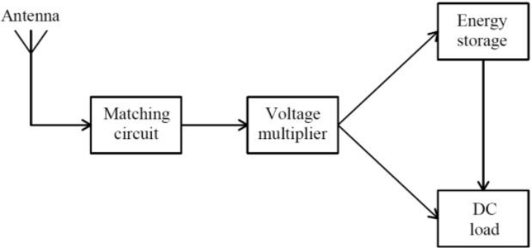
Figure 1.1: The block diagram of an RF energy harvesting system (Uzun, 2015)
The energy harvesting concept is also motivated by the need to address the issue of climate change and global warming. RF wireless power holds vast potential for replacing batteries or increasing their lifespan. Especially in critical situations, this much needed innovation would be most useful. Wireless ad-hoc networks would benefit the most from this innovation since these networks are battery-powered and are mostly deployed in critical environments such as military zones, hostile, hazardous, flooded areas and in emergency health care situations where it is almost impossible to replenish the batteries. The application of power harvesting technologies, devices and equipment can become self-sustaining on the energy required for operation, thereby obtaining an unlimited operating lifespan resulting in the demand for power maintenance becoming negligible (Sitan, 2016).
The disposal of battery waste is currently a critical problem. The bulk of these batteries are dumped in landfills, resulting in the pollution of the land and water directly below. It seems the most effective solution for reducing battery waste is to avoid using them. Applying the RF harvesting concept will assist in reducing the dependency on batteries, which will ultimately have a positive impact on the environment (Fan et al., 2019).
Moreover, the process of harnessing electromagnetic energy will not generate waste as it is a clean energy source. The target area to harvest RF energy is Ahmadu Bello University Zaria, Staff Secondary School. It is important to investigate the availability of sufficient RF energy in the target area before embarking on developing an RF energy harvester as this will reveal the number of ambient RF sources, frequencies that offer the highest energy levels and the extent of availability of the RF sources (Selvan et al., 2018).
RF energy is more available among of all other ambient energy like solar, water, wind, thermal etc. It is easy and continually available to scavenge RF power from surrounds like cellular base stations, Wi-Fi access points, television and radio broadcast stations. The power transmits from these sources are very high in KW range, but just a little amount of power is received by the antenna of the receiver. So, the wasted energy can be harvested to produce electricity which will energies the low power devices (Assimonis et al., 2016). It consists of a receiving antenna, impedance matching circuit, rectifying circuit followed by energy storage. Moreover, losses due to matching circuits and the nonlinearity properties of diode reduce the circuit performance. Also, the antenna distance, line of direction and the presents of obstacles between the antennas is also a big challenge to scavenge the RF power.

1.2 Statement of the Research Problem
Current developments in the design of mobile devices joined with improvements in the combination of wireless access and networks have made mobile devices exceptionally prevalent. These devices offer convenience and offer services including communication, computation, personal information management, and Internet access. Mobile devices such as personal digital assistants, laptops with wireless access and mobile cell phones are becoming pervasive. As the practicality and abilities of these mobile devices have surged, their energy consumption supplies also increase (Zeng et al., 2017). Mobile DC applications rely on a constant source of power to operate and this increased demand for power leads to the problem of battery depletion (Mouapi, 2022). Three issues arise with the use of mobile application devices:
- Firstly, a mobile application device battery needs constant charging and this is seen as a major problem in the absence of an electrical outlet or charging cables.
- Secondly, if the mobile device is being charged, this will pose an inconvenience to the user since the device cannot be used during that time.

.3 Aim and Objectives
The aim of this research is the Development of an Improved Radio Frequency Energy Harvesting System at 90 MHz using Cockroft-Walton Voltage Doubling and Maximum Ratio Combining Techniques.
The objectives are:
- To carry out an empirical study of various signal strength analysis with respect to distance using Kwara State Polytechnic Ilorin as testbed.
- To develop a seven-stage RF Energy Harvesting prototype using Cockcroft-Walton voltage doubling and Maximum Ratio Combining techniques
- To simulate the data collected from the RF Energy Harvesting prototype developed. and empirical study carried out.

CHAPTER TWO

2.1 LITERATURE REVIEW
In the years gone by recently, other than the excessive extraction of fossil fuels, the consistent development of the latest technologies and the constant requirement for electrical energy supply are powering the research for new and more efficient ways to harness energy from different and unique ambient sources of energy. Some of the solutions to this need have been renewable energy sources such as Photovoltaic solar Cell-Panels (PVs), Thermal-powered Electricity generators and wind power generators among others. These technologies are under regular updates and one branch of science specifically focuses to recover some energy at more little scale, which is called Energy Harvesting. RF energy-harvesting (Shastri, 2016). is the technology of converting the received RF-powered signals into the form of electricity. This method creates a sustainable solution to power energy-limited wireless designs and systems. Traditionally, energy-confined wireless systems, namely wireless sensor networks (WSNs), have a short operational span that majorly confines the network's performance. In comparison, an RF energy harvesting network possesses a wide-spanning sustainable supply of power via remote or a fixed transmitting radio network. The abilities and the possibilities of RF energy harvesting prompts the wireless devices to harness energy directly from the RF signals to be implemented by their information-process-protocol and transmitting systems. Subsequently, it has found its applications quickly in vast array of applications, such as WSNs, and wireless device-charging systems. With the exponentially emerging applications for the usages of energy harvesting or charging devices, the Wireless Energy authorities are also making great efforts towards establishing an international standard for the RF safety and harvesting techniques (Ali et al., 2019).
In this section, we look at how various authors were able to capture RF using an antenna. We take a look at the problems they were trying to solve, the methodologies used and the results they achieved. This thesis is based on a very simple concept, capture RF energy using an antenna, input it into a RF circuit and use this energy to power some other circuit, as a precursor to this thesis, as there have been many projects involving charge pumps. These projects range from tuning the charge pump to using results from existing charge pumps to drive other circuits. For the tuning projects, usually, the testing is done using a light emitting diode (LED), ( Sivaramakrishnan and Jegadishkumar, 2011). RF energy is transmitted to the circuit and the charge pump stores the energy in a large capacitor. When the amount of charge is large enough, the LED uses the stored energy to light for a moment. This is called a charge-and-fire system. In another research (Ramsaroop, 2017) carried out a research on an RF energy harvester used to charge a phone. The research used a charge pump with peak detector circuit to charge a capacitor. The study used a commercially available quarter wave whip antenna with a seven-stage voltage doubler with an output capacitor to harvest RF energy from a 915MHz signal transmitted from a dedicated transmitter. SPICE was used to carry out optimization of the circuit parameters. The software allows the user to input a range of values for a given parameter and then specifies the value of increment for each of the parameters, this way the user is be able to detect the range of values that will yield maximum output power (Kitazawa et al., 2012). The study showed that as number of stages increase, the output voltage also increases, but the voltage stabilized when the number of stages reached seven, any additional stage resulted in a decrease in the output voltage and this could be explained by the fact that the voltage gain becomes negligible as the number of stages reach six. Any additional stage will consume power without having any effect on the output voltage. The harvester was tested on two phones, the first was a Nokia 3570 which required a power of 1.26 Watts to charge the battery, and the second phone was a Motorola V60i which required a power of 2.36 Watts to charge the battery. The harvester was able to only power the phones for a short while and then failed to sustain the power levels required due to low energy output levels, but the harvester was able to recharge the batteries when the phones are off, the study was able to show that the harvester reduced the charging time of the mobile phone batteries by half.
  - Theoretical Background
This chapter deals with the theoretical information related to the work done in the thesis. This chapter provides insight into the background of the theoretical research which went in along with the Literature prior to the commencement of simulations and results. This chapter starts with a section dealing with energy harvesting followed by antennas and various types of antennas, RF power transfer, diodes for energy harvesting (Ali et al., 2017).

2.2.1 Overview of RF energy harvesting system
The basic structure of a radio frequency energy harvesting system consists of a receiving antenna, matching circuit, peak detector, and voltage elevator. Where electromagnetic waves are captured by the antenna, voltage is amplified using the matching circuit, signal is converted to a voltage value thanks to the peak detector, and finally this voltage output is adjusted using the voltage multiplier (Mnif et al., 2019). The whole system formed by receiving antenna, matching network, and rectifier is usually known as a rectenna or an Radio frequecy direct current (DC), which is able to harvest high-frequency energy in free space and convert it to DC power. The detail of each block is subsequently discussed in order to define specifications and limitations of the power conversion system. Further, a block of power management and another for energy storage could be integrated into the energy harvesting system 0(Ansari et al., 2015; Sivaramakrishnan and Jegadishkumar, 2011). The energy storage subsystem is responsible for storing all the captured energy and providing a constant output voltage.
RF energy harvesting technique needs, as mentioned in the previous section, an efficient antenna with a circuit capable of converting alternating current (AC) voltage to direct current voltage (Habash et al., 2009). The front end is a key component to ensure the successful operation of RFEH system. It has the duty of capturing electromagnetic waves, which will be used later to power the integrated system (Ansari et al., 2015; Sivaramakrishnan and Jegadishkumar, 2011).

CHAPTER THREE

3.0 MATERIALS AND METHODS

3.1 Introduction
In this chapter, the methods, materials and procedures employed for the successful completion of this research work are discussed and an improved RF energy harvesting circuit was developed. This research is primarily fully empirical, that is the data captured using handheld spectrum analyser were MTN 3G live network in Kwara State Polytechnic Ilorin. There are many variables in the system that changed the voltage that is developed such as resistors, capacitors, Receiving antenna, Schottky diodes and super capacitors.
3.2 Materials, Measurement of Received Signal Strength (RSS)
3.2.1 Methodology for objective 1
Fully empirical measurement was done and results were compared with the results obtained. The campus is geographically located at latitude (11.1526°) and longitude (7.65°) on the map of Zango Ilorin, Kwara State. A walk test measurement for the transmitted signal collection was conducted from MTN base station located inside the Demonstration Secondary School (DSS) of the Polyechnic. The field measurements from the base station transmitter were carried out along three different routes, designated as radio path i, ii and iii. The data collection tools consist of BK precision 2658A handheld spectrum analyser, a laptop and a global positioning system (GPS) distance meter. The spectrum analyser was used to capture received signal strength; the GPS distance meter was used to measure the transmitter-to-receiver (T-R) separation distances, while the readings stored on the spectrum analyser were transferred to a laptop for data analysis. The base station and mobile station antenna heights are 40m and 1.5m, respectively, while the base station transmits frequency is 900MHz. Table 3.1 shows the parameters of the base station under consideration as well as the gain and height of the mobile station used.
Table 3.1: Base and Mobile Station Parameters
BS Antenna  Height (m) | MS Antenna  Height (m) | BS Antenna  Gain (dBi) | MS Antenna  Gain (dBi) | BS EIRP  (dBm)
40 | 1.5 | 17 | 1.7 | 43

The coverage area of the MTN BS in the main campus is 200m radially, which means is a micro cell. Thus, the experimental data were taken at distances ranging from 100m to 1500m, within the coverage area of the BS, for each of the three radio paths. The measurements were conducted during day time for Twenty-three days in February 2023, 8am-5pm daily. For every route, received signal strength was measured at a reference distance of 10m from the base station and a subsequent interval of 100m up to 1500m. The non-line of sight (NLOS) links investigated for the three routes encompass divergent scenarios, for route ‘c’, for example, there is a large tree obstructing the path between A.B.U. central Mosque through area ‘A’ up to A.B.U. forest while for route ‘b’, the link from Faculty of Medicine main entrance to A.B.U. water works is hindered by a row of trees. On the other hand, NLOS for route ‘a’ is mostly experienced between Faculty of Science and Art with raw of trees from Staff School up to PG School of the University. Received signal strength, also known as power received (P_{rd}) values were recorded at various distances from each of the three routes.

This research adopts software approach; the method to be adopted for this research will be based simulation and prototype. The energy harvesting circuit will be created as a prototype model to deploy data. ADS simulation software will be used for the dimensioning and correct interpretation of the individual components of the circuit.
Various mathematical formulae will be applied to calculate the amount of power that could be generated from the prototype and the simulation circuit. The simulation software will demonstrate the behaviour of the different components and circuit layouts for effective RF energy harvesting.
The materials used for this research work include:
3.2.2 2658A BK precision handheld spectrum analyser
The 2658A BK spectrum analyser has a frequency range of 50 MHz - 8.5 GHz; thus, a 900 MHz can be measured comfortably. The analyser finds its application in the installation, maintenance, and troubleshooting of wireless communication systems such as Wide Band Code Division Multiple Access (W-CDMA/CDMA), Global System for Mobile communications (GSM), Wireless Local Area Network (WLAN), Worldwide Interoperability for Microwave Access (WiMAX) and Bluetooth. It can also be used in frequency response measurements of passive components such as RF cables, filters, and attenuators. Another important application is in the detection of signal interference and undesired emissions, antenna alignment, electric field strength measurement with dipole antennas optimized for typical frequencies used in wireless systems (M401-M406) and magnetic field strength measurement with magnetic field probe. In this research work, the analyser was used to capture signal strength from the base station under test. Plate I show the front panel of the 2658A BK spectrum analyser.
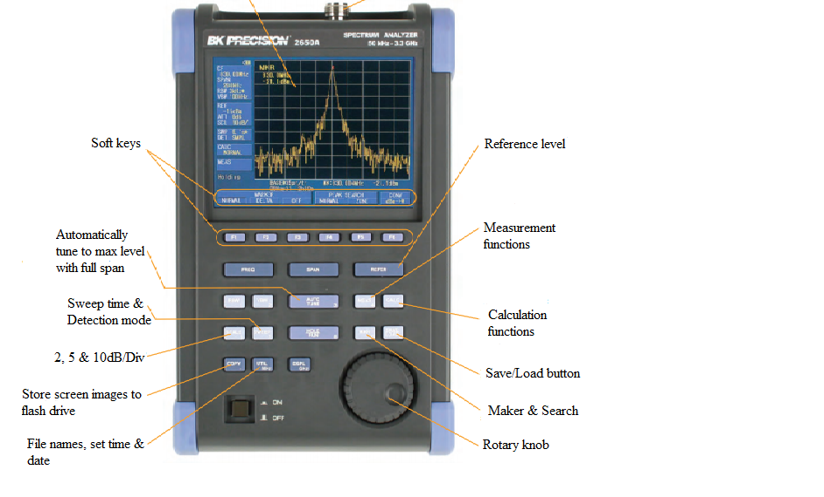

Plate I: 2658A BK precision handheld Spectrum Analyzer Front Panel

3.2.6 Measuring tape
Due to varying foliage length, measuring tape was used to quantify the length of foliage at each of the three paths taken, and the total foliage length was averagely determined. The appearance of the foliage medium in the path of the communication link has found to play a significant role on the quality of services for wireless communication. In this research work, foliage depth was experienced along the three paths followed.
3.2.7 Personal computer (PC)
After completing the measurements, the handheld spectrum analyser was then connected to an “HP Pavilion x360 Convertible 14-dy0” laptop through a Universal Serial Bus (USB) port and the data stored in the memory of the spectrum analyser was transferred to ADS 2015 and MATLAB software installed on the PC for further analysis.
3.2.8 Measurement set-up
A pictorial diagram of the Field measurement set-up used for the research work is shown in Figure 3.1. Measurer GPS distance meter Application was used to determine distance from the BS, 2658A BK precision handheld Spectrum Analyzer was used to capture signal strength from the BS. The analyser has a dipole antenna (options M401 – M406) connected to the RF input to enable the measurement of electric field strength. Users can choose antenna based on the frequency range under investigation. Each antenna’s resonance point is optimized for the frequency spectrum of a specific wireless standard: M401 is suitable for GSM 850/900, M403 for W-CDMA 1.7-2.3gHz and GSM 1800/1900, M404 for 2.4 GHz wireless LAN and Bluetooth and M406 for 5 GHz wireless LAN. Since the research work focused on 3G WCDMA technology at 2100MHz frequency, M401 antenna was used. The BS for MTN serving the University main campus is situated inside Demonstration Secondary School of the University. The BS accommodates both 3g and 3G technologies. A receiver antenna height of 1.5m was maintained throughout the measurement analysis and the measured data was saved on the spectrum analyser and later transferred to a computer for further analysis.
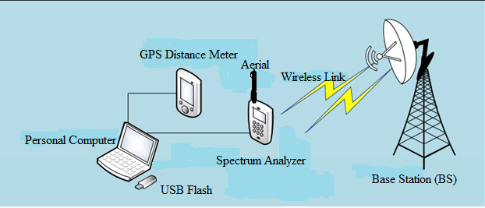

Figure 3.1: Equipment Set-up for the Field Measurement, modified from (Kasar et al., 2020)
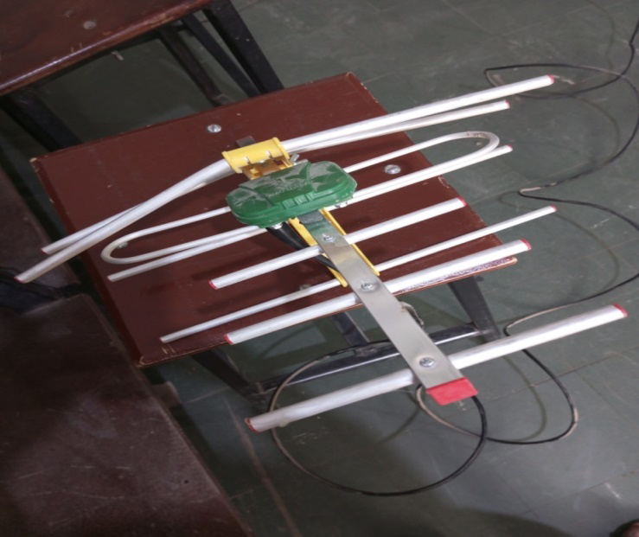

Plate IV: Yagi-Uda Array for signal Reception in RF energy harvesting circuit
The most straightforward option for the receiving antenna selection is to use an antenna that can be obtained commercially. Yagi-Uda antenna, or simply Yagi antenna, is a directional antenna consisting of two or more parallel resonant antenna elements in an end-fire array, these elements are most often metal rod acting as half-wave dipoles. Yagi-Uda antennas consist of a single driven element connected to a radio transmitter and/or receiver. The frequency range of Yagi-Uda antenna ranges between 3 MHz to 300 GHz. Frequencies ranging between 3Mhz to 300 GHz are categorized into VHF, LF, UHF, HF, SHF and EHF and this type of antenna above can be used for wireless communications and for maximum signal reception in radio frequency energy harvesting system where higher DC output voltage for DC applications is the utmost priority. Its a compact size and also it is must in lightweight, its offers wide bandwidth due to the use of folded dipole. Its lower cost because easy of handling and maintenance.

3.3 DC Output Voltage of the developed RF Energy Harvesting Circuit
Tektronix DMM digit Precision Multimeter, was used to measure the output voltage of the radio frequency energy harvesting prototyped developed to display the needed output voltage to power a low dc application device, by placing the two terminals of the multimeter to the terminals of the developed radio frequency energy harvesting prototype. It measures volts, ohms, and amps, with basic V dc accuracy of up to 80%, 10 A current ranges, and a wide ohm’s range. Tektronix DMM digit Precision Multimeter also measures frequency and period. The functions of a counter, capacitance meter, and thermometer are built in. The below RF circuit system developed to improve the meager harvested energy in the atmosphere to power dc applications; it can output a dc voltage of 8.063v with percentage improvement of 92.43% it consists of diodes which has the ability to rectifies the RF signal (AC current) and convert it to a dc signal and the capacitors provides a critical component for accumulating charge from low-energy ambient sources and discharging stored charge quickly and efficiently.
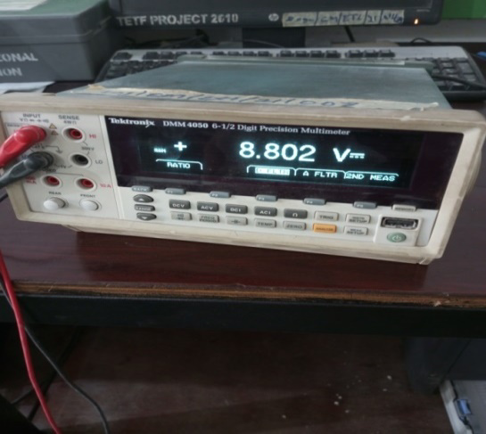
Plate V: Tektronix DMM digit Precision Multimeter showing the DC output of the RF energy harvesting of the prototype in A.B.U Zaria Telecom Lab.

3.4 Improved RF Energy Harvesting Circuit
3.4.1 Methodology for objective 2
The RF energy harvesting prototype was designed and developed to improve the dc output voltage to power dc applications. It consists of two storage capacitors (22µf each). However, the higher the value of the storage capacitor the longer the time it needs to harvest and store. This is shown in Plate VI. For devices to charge for a longer period, we have to use a super capacitor, two terminals (Red +ve and Black –ve) where the multimeter terminals were placed to measure the dc usable output voltage, a Vero board where all the components were soldered on, Nine Special Schottky diodes were used for rectifications, twelve capacitors of 103µf were used. However, it was discovered that the aim and objective this thesis was achieved because we were able harnessed Radio Frequency energy in our environment and it was converted to a usable dc voltage to power low dc application devices.
3.4.2 Methodology of designing the rectenna linearized analysis of voltage multiplier
The analytical model of a rectifying antenna is based on the linearization concept. The accurate techniques for determining the output results of rectifying circuits were given by the design. Figure 3.2 shows an RF harvester realized at 900 MHz V_{S} is the input voltage.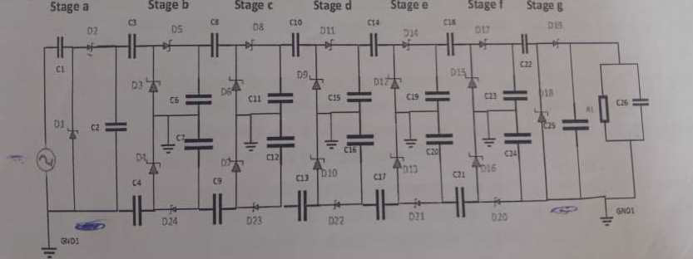
Figure 3.2: Radio frequency (RF) harvesting system using an HSMS-2858A at 900 MHz
The number of stages, as shown in Figure 3.1, in the system has the greatest effect on the output voltage. The capacitance, both in the stages and at the end of the circuit, affects the speed of the transient response and the stability of the output signal. The number of stages is essentially directly proportional to the amount of voltage obtained at the output of the system. Generally, the voltage of the output increases as the number of stages increases. The telecommunications reason behind cascading beyond twelve stages is, in practice, it’s not recommended adding more stages, because adding more stages slows the charging time of RF energy harvesting circuit. Because the resistors, capacitors and Schottky diodes forms the time constant, therefore the more the stages the slower the charging time. It does not slow the charging time alone but also reduces voltage regulation by increasing the output ripples. Output ripples are unwanted signals at the output level, once you’ve reached your optimal stage that you’ve gotten the desired results you stop adding stages, or else the result will be mixture of AC and DC signals and we are interested in DC voltage.
The original circuit, as shown in Figure 3.2, consists of the antenna and voltage multiplier. The main reason for choosing the seven-stages of voltage multiplier is that the parasitic effect of the capacitor of each stage was increased, which accumulates and leads to a decrease in voltage gain. The circuit connection was done in parallel for high output. In general, the diode impedance is RD, the capacitor impedance is -jXC, and the inductor impedance is jXL. XC1–XC14 is the reactance with a value of 103uF. XCL is the reactance with a value of 100 pF load capacitor.
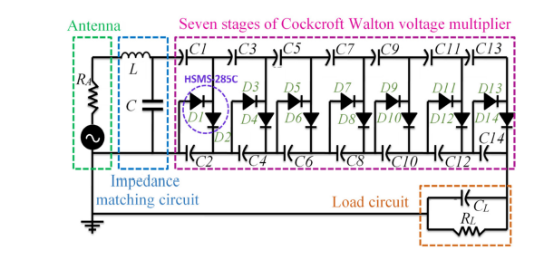
Figure 3.3: Rectenna design parameters in Cockcroft–Walton voltage multiplier circuit.
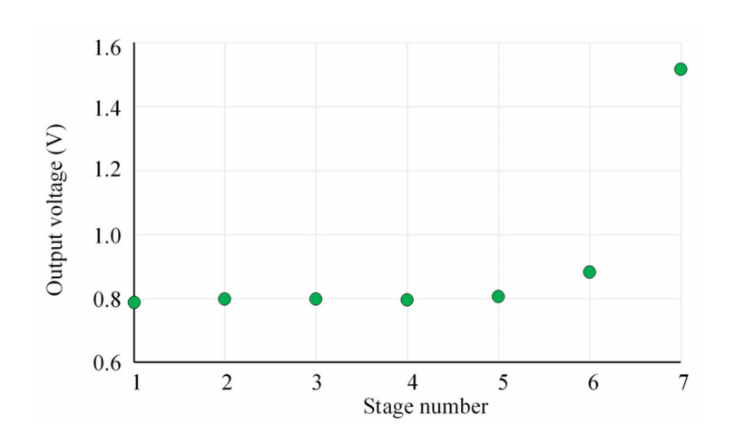
Figure 3.4: Verification result of Cockcroft–Walton voltage multiplier using ADS for indoor RF Energy harvesting.
For linear circuit elements, the rule is $V=I×Z$, where V, I and Z are all complex variables. Impedances are added in series and in parallel in the same way as resistors, i.e.,$Z_{series}=Z_{1}+Z_{2}, { Z}_{parallel}=Z_{1}∥Z_{2}=\left(Z_{1}×Z_{2}\right)÷\left(Z_{1}+Z_{2}\right)$
By applying Kirchhoff voltage law (KVL) and Kirchhoff current law (KCL) on the seven stages, equations (3.1) – (3.7) were derived.
$V_{2}=V_{S}+I_{S}\left({-jX}_{C}+Z_{O}\right) \left(3.1\right)$
$V_{4}=\frac{V_{2}\left({-jX}_{C}+Z_{D}\right)+{jX}_{C}V_{1}}{Z_{D}} \left(3.2\right)$

CHAPTER FOUR

4.0 RESULTS AND DISCUSSION

4.1 Results

In this chapter, the parameters used for all formulas introduced earlier in the methodology were tested with the prototype and simulated. ADS simulation software was used for this thesis. Output voltages are compared to each other for the harvesting circuit and output voltage. The field measurement shows the measured result to be 8.068V dc output voltage and a simulated result of the thesis using the Advanced Design System is 4.062V. The increase in the output voltage is due to the addition of stages and with maximum ratio combiner (MRC) in the circuit that operates as a detector for the circuit to confirm a good transformation of the power from the antenna to the voltage multiplier. The function of the voltage multiplier rectifier circuit is to increase the output voltage value.

CHAPTER FIVE

5.0 CONCLUSION AND RECOMMENDATION

5.1 Conclusion
This research work focused on improving output voltage of Radio Frequency Energy Harvesting system using Cockroft Walton doubling and maximum ratio combining Techniques. Since the effects of major parasitic elements on a wireless RF harvester performance are known, wireless RF harvesters capable of harvesting low ambient RF power levels can be realized. This study presents model for Cockcroft–Walton voltage multiplier for harvesting applications.

REFERENCES
Adam, I., Abd Malek, M. F., Mohd Yasin, M. N., & Rahim, H. A. (2015). RF energy harvesting with efficient matching technique for low power level application. ARPN Journal of Engineering and Applied Sciences, 10(18), 8318–8321.
Agrawal, S., Parihar, M. S., & Kondekar, P. N. (2018). Broadband Rectenna for Radio Frequency Energy Harvesting Application. IETE Journal of Research, 64(3), 347–353. https://doi.org/10.1080/03772063.2017.1356755
Ahn, C. J. (2011). Development of RF energy harvesting and charging circuits for low power mobile devices. Recent Researches in Circuits, Systems, Control and Signals - Proceedings of the 2nd International Conference on Circuits, Systems, Control, Signals, CSCS’11, December, 131–134.
Akter, N., Kabir, M. H., & Science, N. (2014). Design and Performance Analysis of 10-Stage Voltage Doublers RF Energy Harvesting Circuit for Wireless Sensor Network. April. https://doi.org/10.18005/JCEN0202004
Al-azawy, M. M. (2019). Analysis of Dickson Voltage Multiplier for RF Energy Harvesting. 2019 1st Global Power, Energy and Communication Conference (GPECOM), June, 10–14.
Alghaythi, M. L., O’Connell, R. M., Islam, N. E., Khan, M. M. S., & Guerrero, J. M. (2020). A High Step-Up Interleaved DC-DC Converter with Voltage Multiplier and Coupled Inductors for Renewable Energy Systems. IEEE Access, 8, 123165–123174. https://doi.org/10.1109/ACCESS.2020.3007137
Ali, E. M., Yahaya, N. Z., Nallagownden, P., & Alqasem, B. H. (2019). Enhanced Dickson voltage multiplier rectenna by developing analytical model for radio frequency harvesting applications. International Journal of RF and Microwave Computer-Aided Engineering, 29(1), 1–10. https://doi.org/10.1002/mmce.21657
Ali, E. M., Yahaya, N. Z., Perumal, N., & Zakariya, M. A. (2016). Development of Cockcroft ‐ Walton voltage multiplier for RF energy harvesting applications. 3(3), 47–51.
Ali, E. M., Yahaya, N. Z., Perumal, N., & Zakariya, M. A. (2017). Design of microstrip patch antenna at 900 MHz for charging mobile applications. Journal of Engineering and Applied Sciences, 12(4), 988–993. https://doi.org/10.3923/jeasci.2017.988.993
Ali, E. M., Yahaya, N. Z., Saraereh, O. A., Assaf, A. H. Al, Alqasem, B. H., Iqbal, S., Ibrahi- m, O., & Patel, A. V. (2021). Power conversion using analytical model of cockcroft‐walton voltage multiplier rectenna. Electronics (Switzerland), 10(8), 1–17. https:// doi. org/10.3390/electronics10080881
Altinel, D., & Kurt, G. K. (2017). Diversity Combining for RF Energy Harvesting. IEEE Vehicular Technology Conference, 2017-June. https://doi.org/10. 1109/VTC Spring. 2017.8108420
Amer, A. A. G., Sapuan, S. Z., Nasimuddin, N., Alphones, A., & Zinal, N. B. (2020). A comprehensive review of metasurface structures suitable for RF energy harvesting. IEEE Access, 8, 76433–76452. https://doi.org/10.1109/ACCESS.2020.2989516
Ansari, T. R., Khan, A., & Ansari, I. (2015). Wireless-Charging-of-Mobile-Battery-via-Optimization-of-RF-Energy-Harvesting-System.docx. 6(7).
Arrawatia, M., Baghini, M. S., & Kumar, G. (2011). RF energy harvesting system from cell towers in 900MHz band. 2011 National Conference on Communications, NCC 2011, 1–5. https://doi.org/10.1109/NCC.2011.5734733
Assimonis, S. D., Daskalakis, S. N., & Bletsas, A. (2016). Sensitive and Efficient RF Harvesting Supply for Batteryless Backscatter Sensor Networks. IEEE Transactions on Microwave Theory and Techniques, 64(4), 1327–1338. https://doi.org/ 10.1109/ TMTT. 2016.2533619
Bae, J., Yi, S. H., Choi, W., Koo, H., Hwang, K. C., Lee, K. Y., & Yang, Y. (2019). 5.8 GHz high-efficiency RF–DC converter based on common-ground multiple-stack structure. Sensors (Switzerland), 19(15), 1–13. https://doi.org/10.3390/s19153257
Bakkali, A., Pelegri-Sebastia, J., Sogorb, T., Llario, V., & Bou-Escriva, A. (2022). A Dual-Band Antenna for RF Energy Harvesting Systems in Wireless Sensor Networks. Journal of Sensor, 18(1) 5725836:1-5725836:8. https://doi.org/10.1155/2016/5725836
Ballo, A., Bottaro, M., Grasso, A. D., & Palumbo, G. (2020). Regulated charge pumps: A comparative study by means of verilog-AMS. Electronics (Switzerland), 9(6), 1–21. https://doi.org/10.3390/electronics9060998
Banerjee, J., & Banerjee, S. (2022). Radio frequency energy harvesting circuits design for the applications of low power electronics. International Journal of Electronics Letters, 10(1), 115–130. https://doi.org/10.1080/21681724.2020.1870719
Benkalfate, C., & Feham, M. (2019). UWB patch antenna design and realization in the bandwidth 780MHz to 4.22GHz. Networking and Internet Architecture. 18(2) https://doi.org/10.48550/arXiv.2207.001521, 1–10.
Brynhildsvoll, F. S. (2016). / Ambient RF-energy harvesting at 900 MHz. July.
Butt, M. M., Labs, N. B., & Krikidis, I. (2016). Mohamed , Mohsen Guizani Management in Wireless Cellular and Ad hoc Networks. January. https://doi.org/10.1007/978-3-319-27568-0
Cansiz, M., Altinel, D., & Karabulut, G. (2019). Efficiency in RF energy harvesting systems : A comprehensive review Ef fi ciency in RF energy harvesting systems : A comprehensive review. Energy, 17(4), 292–309. https://doi.org/10.1016/j.energy.2019.02.100
Chaour, I., Fakhfakh, A., & Kanoun, O. (2017). Enhanced passive RF-DC converter circuit efficiency for low RF energy harvesting. In Sensors (Switzerland) (17(3). https://doi.org /10.3390/s17030546
Chou, C. K. (2015). A need to provide explanations for observed biological effects of radiofrequency exposure. Electromagnetic Biology and Medicine, 34(3), 175–179. https://doi.org/10.3109/15368378.2015.1076439
Deme, A., Dajab, D., Bajoga, B., Mu, M., & Choji, D. (2013). Hata-Okumura Model Computer Analysis for Path Loss Determination at 900MHz for Maiduguri , Nigeria. 13(3), 1–10. https://doi.org/10.3390/s10030546
Divakaran, S. K., Das, D., & Nasimuddin, K. (2018). RF energy harvesting systems : An overview and design issues. October, 1–15. https://doi.org/10.1002/mmce.21633

Elalfy, A. M. (2007). Energy Harvesting using Optimized Piezoelectric Microcantilevers.
Environment, R. F., & Hardware, D. (2019). RF Energy Harvesting Wireless Communica- tions : https://doi.org/10.3390/s19133010
Estrada-l, J. J. (2018). Multiple Input Energy Harvesting Systems for Autonomous IoT End-Nodes. https://doi.org/10.3390/jlpea8010006
Estrada-López, J. J., Abuellil, A., Zeng, Z., & Sánchez-Sinencio, E. (2018). Multiple input energy harvesting systems for autonomous IoT end-nodes. Journal of Low Power Electronics and Applications, 8(1), 6. https://doi.org/10.3390/JLPEA8010006
Fatima, K., & Warder, S. (2020). International Journal of Antennas and Propagations, Quad-band 3D Rectenna Array for Ambient RF Energy Harvesting. Volume 2020 | Article ID 7169846 | https://doi.org/10.1155/2020/7169846
Fadel, L., Oyhenart, L., Bergès, R., Vigneras, V., & Taris, T. (2016). A concurrent 915/2440 MHz RF energy harvester. International Journal of Microwave and Wireless Technologies, 8(3), 405–413. https://doi.org/10.1017/S1759078716000179
Fan, S., Yuan, Z., Gou, W., Zhao, Y., Song, C., Huang, Y., Zhou, J., & Geng, L. (2019). A 2.45-GHz Rectifier-Booster Regulator With Impedance Matching Converters for Wireless Energy Harvesting. IEEE Transactions on Microwave Theory and Techniques, 67(9), 3833–3843. https://doi.org/10.1109/tmtt.2019.2910062
Flint, I., Lu, X., Privault, N., Niyato, D., & Wang, P. (2015). Performance Analysis of Ambi- ent RF Energy Harvesting with Repulsive Point Process Modeling. IEEE Transactions on Wireless Communications, 14(10), 5402–5416. https://doi. org/10.1109/ TWC. 2015 .2437973
Habash, R. W. Y., Elwood, J. M., Krewski, D., Lotz, W. G., McNamee, J. P., & Prato, F. S. (2009). Recent advances in research on radiofrequency fields and health: 2004-2007. Journal of Toxicology and Environmental Health - Part B: Critical Reviews, 12(4), 250–288. https://doi.org/10.1080/10937400903094125
Hamid, S. M., Nyakoe, N. G., & James, K. N. (2015). Energy Harvesting and Optimisation from Ambient RF Sources: A Review. Innovative Systems Design and Engineering, 6(10), 23–28.
Hridayeta, B., & Singhal, P. K. (2015). RF Energy Harvesting from Cell Phone in GSM900 Band. International Journal of Computer Applications, 14(10), 1–8. https:// doi.org/ 10 .5120/ijca2016909924
Jabbar, H., Member, S., Member, Y. S. S., & Jeong, T. T. (2010). 1 and Circuits for Charging RF Energy Harvesting System of Mobile Devices. 247–253.
Jia, P., & Yuan, Y. (2019). Analysis and implementation of LC series resonant converter with secondary side clamp diodes under DCM operation for high step-up applications. Journ- al of Power Electronics, 19(2), 363–379. https://doi.org/10.6113/JPE.2019.19.2.363
Jordana, J., Reverter, F., & Gasulla, M. (2015). Power efficiency maximization of an RF energy harvester by finetuning an L-matching network and the load. Procedia Engineering, 120, 655–658. https://doi.org/10.1016/j.proeng.2015.08.698

Kasar, Ö., Gözel, M. A., & Kahriman, M. (2020). Analysis of rectifier stage number and load resistance in an RF energy harvesting circuit. Microwave and Optical Technology Letters, 62(4), 1542–1547. https://doi.org/https://doi.org/10.1002/mop.32218
Kitazawa, S., Ban, H., & Kobayashi, K. (2012). Energy harvesting from ambient RF sources. 2012 IEEE MTT-S International Microwave Workshop Series on Innovative Wireless Power Transmission: Technologies, Systems, and Applications, IMWS-IWPT 2012 - Proceedings, 39–42. https://doi.org/10.1109/IMWS.2012.6215815
Krishnamoorthy, R., & Umapathy, K. (2017). Mobile Phone Charger Using RF Through GSM Network 1. 25(3), 600–602. https://doi.org/10.5829/idosi.mejsr.2017.600.602
Kundu (Datta), P., Acharjee, J., & Mandal, K. (2017). Design of an Efficient Rectifier Circuit for RF Energy Harvesting System. International Journal of Advanced Engineering and Management, 2(4), 94. https://doi.org/10.24999/ijoaem/02040024
Leon-gil, J. A., Cortes-loredo, A., Fabian-mijangos, A., Martinez-flores, J. J., Tovar-padilla, M., Cardona-castro, M. A., Morales-s, A., & Alvarez-quintana, J. (2018). Powering Wireless Sensor Networks. 1–13. https://doi.org/10.3390/s18030768
Leon-Gil, J. A., Cortes-Loredo, A., Fabian-Mijangos, A., Martinez-Flores, J. J., Tovar-Padilla, M., Cardona-Castro, M. A., Morales-Sánchez, A., & Alvarez-Quintana, J. (2018). Medium and short wave rf energy harvester for powering wireless sensor networks. Sensors (Switzerland), 18(3), 768. https://doi.org/10.3390/s18030768
Ludivine, F., Taris, T., & Vigneras, V. (2014). A concurrent 915 / 2440 MHz RF energy harvester. March 2017. https://doi.org/10.1017/S1759078716000179
Mandal, S., & Giri, S. K. (2011). Comparison of antennas for radio frequency energy harves- ting in 0.2-2.4 GHz range. In ICECT 2011-2011 3rd International Conference on Electronics Computer Technology (1). https://doi.org/ 10.1109/ ICEC TECH. 2011.5941567
Mathur, M., Agarwal, A., Singh, G., & Bhatnagar, S. K. (2016). A novel design module of RF energy harvesting for powering the low power electronics circuits. In ACM International Conference Proceeding Series https://doi.org/10.1145/2979779.2979847 12-13
Mnif, M. M., Mnif, H., & Loulou, M. (2019). An Efficient Dual Band 900MHz / 2.45GHz RF Energy Harvester. Mediterranean Microwave Symposium, https://doi.org/10.1 109 /MMS48040.2019.9157324. 2–6.
Monti, G., Congedo, F., De Donno, D., & Tarricone, L. (2012). Monopole-based rectenna for microwave energy harvesting of UHF RFID systems. Progress In Electromagnetics Research C, 31, 109–121. https://doi.org/10.2528/PIERC12061501
Mouapi, A. (2022). Radiofrequency Energy Harvesting Systems for Internet of Things Applications: A Comprehensive Overview of Design Issues. Sensors, 2 2(21), 8088. https://doi.org/10.3390/s22218088
Mouapi, A., Hakem, N., & Delisle, G. Y. (2018). A new approach to design of RF energy harvesting system to enslave wireless sensor networks. ICT Express, 4(4), 228–233. https://doi.org/10.1016/j.icte.2017.11.002

Mrnka, M., Vasina, P., Kufa, M., Hebelka, V., & Raida, Z. (2016). The RF Energy Harvesti- ng Antennas Operating in Commercially Deployed Frequency Bands: A Comparative Study. International Journal of Antennas and Propagation,1–11.https://doi.org/ 10.11 55/2016/7379624
Muncuk, U. (2012). Design Optimization and Implementation for RF Energy Harvesting Circuits.
Muncuk, U., Alemdar, K., Sarode, J. D., & Chowdhury, K. R. (2018). Multi-band Ambient RF Energy Harvesting Circuit Design for Enabling Battery-less Sensors and IoTs. IEEE Internet of Things Journal.
Nechibvute, A., Chawanda, A., Taruvinga, N., & Luhanga, P. (2017). Radio Frequency Ener- gy Harvesting Sources. Acta Electrotechnica et Informatica, 17(4), 19–27. https:// doi .org/10.15546/aeei-2017-0030
Okba, A., Charlot, S., Calmon, P. F., Takacs, A., & Aubert, H. (2016). Multiband rectenna for microwave applications. 2016 IEEE Wireless Power Transfer Conference, WPTC 1–4. https://doi.org/10.1109/WPT.2016.7498799
Pakkirisami Churchill, K. K., Ramiah, H., Chong, G., Chen, Y., Mak, P. I., & Martins, R. P. (2022). A Fully-Integrated Ambient RF Energy Harvesting System with 423-µW Output Power. Sensors, 22(12), 4415. https://doi.org/10.3390/s22124415
Panda, N., & M Deshmukh, S. (2016). Novel Technique for Wireless Power Transmission using ISM Band RF Energy Harvesting for Charging Application. International Journal of Engineering Trends and Technology, 39(2), 63–69. https://doi.org/ 10.14445/ 223153 81/ijett-v39p211
Papotto, G., Carrara, F., & Palmisano, G. (2011). A 90-nm CMOS threshold-compensated RF energy harvester. IEEE Journal of Solid-State Circuits, 46(9), 1985–1997. https://doi.org /10.1109/JSSC.2011.2157010
Ramsaroop, N. (2017). Investigating energy harvesting technology to wirelessly charge batteries of mobile devices. 19751797.
Sari, F., & Uzun, Y. (2019). A comparative study: voltage multipliers for rf energy harvesting system. 61(1), 12–23. https://doi.org/10.33769/aupse.469183
Schauwecker, B. (2016). Design of Processing Circuitry for an RF Energy Harvester.
Science, A. (2017). Demonstration of an Efficient Ambient Radio- frequency and Microwave Energy Harvesting System with High Sensitivity and DC Output Master of Science Author Signature : December.
Selvan, S., Zaman, M., Gobbi, R., & Wong, H. Y. (2018). Recent advances in the design and development of radio frequency-based energy harvester for powering wireless sensors: a review. Journal of Electromagnetic Waves and Applications, 32(16), 2110–2134. https://doi.org/10.1080/09205071.2018.1497548
Shahabuddin, A. A., Shalu, P. D., & Akter, N. (2018). Optimized Process Design of RF Energy Harvesting Circuit for Low Power Devices. 13(2), 849–854.
Shaikh, F. K., & Zeadally, S. (2016). Energy harvesting in wireless sensor networks: A comprehensive review. Renewable and Sustainable Energy Reviews, 55, 1041–1054. https://doi.org/10.1016/j.rser.2015.11.010
Shastri, A. (2016). Antennas and RF energy-harvesting devices for Office or Domestic environments. 176. https://kar.kent.ac.uk/59752
Sitan, I. (2016). Proposed Technologies for Solving Future 5G Heterogeneous Networks Challenges. International Journal of Computer Applications, 142 (10), 1–8. https:// doi .org/10.5120/ijca2016909924
Sivaramakrishnan, A., & Ganesan, K. (2011). 1 Introduction to RF Energy Harvesting. 253–254.
Sivaramakrishnan, A., & Jegadishkumar, K. J. (2011). A Highly Efficient Power Management System for Charging Mobile Phones using RF Energy Harvesting. 1(5), 21–30.
Sung, Y. T., Chang, K. E., & Liu, T. C. (2016). The effects of integrating mobile devices with teaching and learning on students’ learning performance: A meta-analysis and rese arch synthesis.Computers and Education, 94, 252–275.https://doi.org/ 10.1016/j. compe du..11.008
Toth, S., & Affairs, P. (2014). An Efficient RF Rectifier for Energy Harvesting Systems with Applications to Wireless Dosimetry. September.
Tran, H., Åkerberg, J., Björkman, M., & Tran, H. V. (2019). RF energy harvesting: an analysis of wireless sensor networks for reliable communication. Wireless Networks, 25(1), 185–199. https://doi.org/10.1007/s11276-017-1546-6
Tran, L. G., Cha, H. K., & Park, W. T. (2017). RF power harvesting : a review on designing methodologies and applications. Micro and Nano Systems Letters. https://doi.org/ 10.11 86/s40486-017-0051-0
Uzun, Y. (2015). Design of an efficient triple band RF energy harvester. Applied Computational Electromagnetics Society Journal, 30(12), 1286–1293.
Valenta, C. R., & Durgin, G. D. (2014). Harvesting wireless power: Survey of energy-harvester conversion efficiency in far-field, wireless power transfer systems. IEEE Microwave Magazine, 15(4), 108–120. https://doi.org/10.1109/MMM.2014.2309499
Zeng, M., Andrenko, A. S., Liu, X., Li, Z., & Tan, H.-Z. (2017). A compact fractal loop rectenna for RF energy harvesting. IEEE Antennas and Wireless Propagation Letters, 16, 2424–2427.

