CHAPTER THREE
RESEARCH METHODOLOGY AND ANALYSIS OF THE EXISTING SYSTEM
3.1 RESEARCH METHODOLOGY
Design of smart robotic sweeper starts with the design of simple and most effective chassis for the robot which is a very important part as it has to carry all the weight on the robot then electronics components which are to be used on the robot are decided these include the type of motor and its specification that are to be used to run the bot, the sensors to be used, the microcontroller, the motor drivers, the wheels and other electronic components to be used on the robot. After all, parts are procured assembling the components and finally testing and calibrating the device are done. Below is the working methodology of the robot:
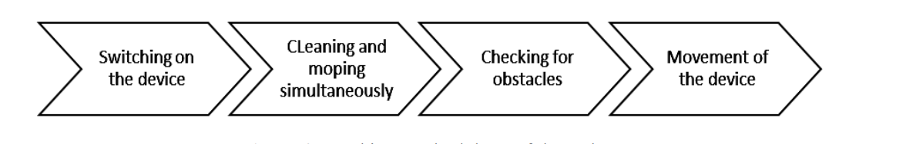
Figure 3.1 Working Methodology of the Robot.
Designing a smart robotic sweeper involves integrating various technologies to ensure efficient and autonomous cleaning capabilities. Here is a list of key technologies needed for a smart robotic sweeper:
- Sensors
  - LiDAR (Light Detection and Ranging): Provides 3D mapping and accurate distance measurements, enabling the robot to navigate and avoid obstacles.
  - Cameras: Capture visual information for object recognition, navigation, and mapping.
  - Ultrasonic Sensors: Assist in detecting and avoiding obstacles by sending and receiving ultrasonic waves.
- Navigation System:
  - Simultaneous Localization and Mapping (SLAM): Enables the robot to create a map of its environment in real-time while simultaneously determining its own position within that environment.
  - Wheel Encoders: Measure the rotation of the robot's wheels, aiding in distance and speed calculations for precise navigation.
- Actuators
  - Brush Motors: Power the sweeping mechanism for effective debris collection.
  - Drive Motors: Facilitate movement and navigation of the robot across different surfaces.
- Cleaning Mechanism
  - Modular Sweeping System: Allows the sweeper to adapt to different surfaces and efficiently collect various types of debris.
  - Suction System: Ensures effective debris collection and storage within the robot.
  - Machine Learning Algorithms: Improve the robot's performance over time by learning from its experiences and user preferences.
  - Human-Machine Interface: Provides a user-friendly way for manual control and programming.
- Power Management:
  - Battery Technology: Efficient and long-lasting batteries to support extended cleaning sessions.
- Connectivity
    - Wireless Communication: Enables communication between the robotic sweeper and external devices, facilitating remote control and data exchange.
3.2 ANALYSIS OF THE EXISTING SYSTEM
The traditional method of manual sweeping, though simple and widely adopted, poses several inherent challenges. The primary drawback is its labor-intensive nature, relying on human effort for the physical act of sweeping and collecting debris. This method is time-consuming, particularly in larger areas, and its effectiveness is influenced by the operator's skill, leading to inconsistencies in cleaning quality. Manual sweeping is also less efficient in navigating through tight spaces and corners, often resulting in overlooked areas. Additionally, the need for continuous physical exertion can lead to fatigue, impacting the overall productivity of the cleaning process.
3.3 PROBLEMS OF THE EXISTING PROBLEM
The followings are problems of the existing system
- Labor-Intensive: Manual sweeping relies heavily on human labor, making it inefficient for large areas or frequent cleaning requirements.
- Inconsistency: Cleaning quality varies based on the operator's skills and physical condition, leading to uneven cleanliness levels.
- Time-Consuming: The process is time-consuming, especially in larger spaces, which can hinder productivity.
- Limited Adaptability: Manual sweeping may struggle to adapt to diverse surfaces and efficiently collect various types of debris.
- Fatigue and Productivity: Continuous physical effort can lead to operator fatigue, reducing the overall productivity of the cleaning task.
3.4 DESCRIPTION OF THE PROPOSED SYSTEM
The proposed system involves the design and implementation of a Robotics Sweeper, a smart and autonomous cleaning solution. This robotic sweeper leverages advanced technologies, including sensors, intelligent control algorithms, and a versatile cleaning mechanism. Equipped with LiDAR, cameras, and ultrasonic sensors, the Robotics Sweeper can perceive its environment in real-time, allowing for precise navigation and obstacle avoidance. The modular and adjustable sweeping mechanism accommodates different surfaces, and a robust suction system efficiently collects and stores debris.
3.5 ADVANTAGES OF THE PROPOSED SYSTEM
- Autonomous Operation: The Robotics Sweeper operates autonomously, reducing the reliance on manual labor and enabling hands-free cleaning.
- Consistent Cleaning Quality: The intelligent control algorithms optimize cleaning routes, ensuring consistent and thorough cleaning performance across various surfaces.
- Time Efficiency: With efficient navigation and advanced cleaning mechanisms, the Robotics Sweeper significantly reduces cleaning time, enhancing overall productivity.
- Adaptability: The modular sweeping mechanism and advanced sensors allow the robot to adapt to different surfaces and efficiently collect various types of debris.
- Reduced Operator Fatigue: Automation minimizes the physical strain on operators, leading to reduced fatigue and maintaining consistent cleaning quality over time.

CHAPTER FOUR
DESIGN, IMPLEMENTATION AND DOCUMENTATION OF THE SYSTEM
4.1 DESIGN OF THE SYSTEM
The design of the robotic sweeper system incorporates a central processing unit, such as a microcontroller or single-board computer, which processes data from LIDAR and ultrasonic sensors for navigation and obstacle detection, IR sensors for edge detection, and wheel encoders for precise movement tracking, while brushless DC motors drive the wheels, servo motors control the sweeping mechanism, and a vacuum motor enhances debris collection.
4.1.1 OUTPUT DESIGN
The output design of the robotic sweeper system includes a user interface for monitoring the sweeper’s status and performance, visual indicators such as LED lights to signal operational states and alerts, and data logging capabilities to record cleaning metrics and system diagnostics for performance analysis and maintenance. Things taken into consideration in determining the output are represented below:
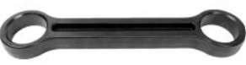
Figure 4.1: 34cm by 36cm chassis
The robotic sweeper system, housed within a 34cm by 36cm chassis, features a central processing unit (such as an Arduino or Raspberry Pi), sensors (LIDAR, ultrasonic, IR, and wheel encoders) for navigation and obstacle detection, actuators (brushless DC motors, servo motors, and a vacuum motor) for movement and debris collection, a rechargeable battery for power, communication modules (Wi-Fi and Bluetooth) for remote control, and software (including a Linux-based OS, Python, C/C++, ROS, OpenCV, and TensorFlow/PyTorch) for control algorithms and user interfaces, with comprehensive documentation and maintenance protocols to ensure optimal performance and longevity.
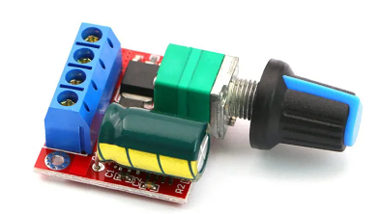
Figure 4.2: 12V 5A DC motor
The robotic sweeper system utilizes a 12V 5A DC motor to drive its wheels, providing sufficient power and torque for smooth and efficient movement across various surfaces while maintaining the system's overall compact design and operational efficiency.
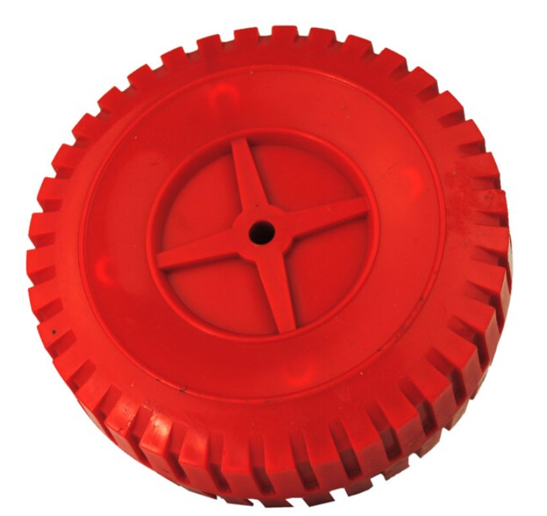
Figure 4.3: 5mm x 4 free wheel
The robotic sweeper system is equipped with 5mm x 4 free wheels, allowing for stable support and smooth, multidirectional movement, which enhances the maneuverability and overall performance of the system.
4.1.2 INPUT DESIGN
The input design of the robotic sweeper system includes sensors such as LIDAR for mapping and navigation, ultrasonic and IR sensors for obstacle and edge detection, wheel encoders for tracking movement, and user input interfaces for setting cleaning schedules and modes, ensuring comprehensive and precise control over the cleaning process.

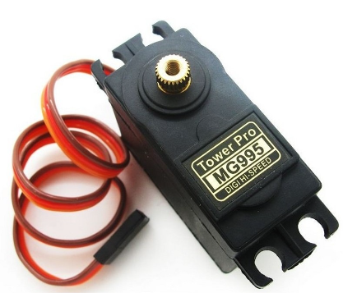
Figure 4.4: Mq99a steel servo motor
The robotic sweeper system incorporates the MQ99A steel servo motor, renowned for its robust construction and precise control capabilities. This servo motor enables accurate and efficient operation of the sweeping mechanism, enhancing the system's effectiveness in collecting debris and maintaining cleanliness across various surfaces.

Figure 4.5: Brush
The robotic sweeper system is equipped with a durable brush mechanism, designed to effectively sweep and collect debris from floors. This brush, typically made from high-quality materials such as nylon or polypropylene, ensures thorough cleaning performance while minimizing wear and tear, thus contributing to the system's longevity and efficiency in maintaining cleanliness.
4.1.3 PROCEDURE DESIGN
The procedure design for the robotic sweeper system involves initializing the hardware and software components, continuously collecting and processing sensor data for real-time navigation and obstacle detection, executing path planning algorithms to cover the cleaning area efficiently, controlling the actuators for movement and debris collection, and periodically logging performance metrics and system diagnostics for analysis and maintenance.
4.2 IMPLEMENTATION OF THE SYSTEM
The implementation of the robotic sweeper system involves integrating hardware components such as sensors, motors, and the central processing unit, developing software for sensor data processing, path planning, and control algorithms, and deploying the system for real-time operation and performance evaluation.
4.2.1 CHOICE OF PROGRAMMING LANGUAGE
The choice of programming language for the robotic sweeper system is Python due to its extensive libraries for robotics, ease of integration with hardware, and support for machine learning and computer vision algorithms.
4.2.2 HARDWARE REQUIREMENT
- entral Processing Unit (CPU): Raspberry Pi or Arduino
- Sensors:
  - LIDAR sensor for mapping and navigation
  - Ultrasonic sensors for obstacle detection
  - Infrared (IR) sensors for edge detection
  - Wheel encoders for movement tracking
- Motors:
  - Brushless DC motors for wheel movement
  - Servo motors for controlling the sweeping mechanism
  - Vacuum motor for debris collection
- Power Supply: Rechargeable battery pack
- Chassis: Durable frame to house all components
- Communication Modules: Wi-Fi or Bluetooth for remote control and monitoring
- Miscellaneous:
  - Bump sensors for collision detection
  - Dustbin for debris storage
  - Charging dock for automated recharging
4.2.3 SOFTWARE REQUIREMENT
- Operating System: Linux-based OS (e.g., Raspbian for Raspberry Pi)
- Programming Languages: Python for main control logic, C/C++ for low-level hardware interfacing (if using Arduino)
- Libraries and Frameworks:
  - ROS (Robot Operating System): For robot software development and communication
  - OpenCV: For computer vision tasks
  - TensorFlow/PyTorch: For machine learning and AI-based tasks (if applicable)
- Control Algorithms:
  - Navigation and path planning algorithms
  - Obstacle detection and avoidance algorithms
- Development Tools:
  - Integrated Development Environment (IDE) such as PyCharm or Visual Studio Code
  - Git for version control
4.3 DOCUMENTATION OF THE SYSTEM
4.3.1 PROGRAM DOCUMENTATION
The program documentation for the robotic sweeper system encompasses a comprehensive guide covering installation, configuration, usage, troubleshooting, and maintenance procedures. It includes detailed instructions for setting up hardware components, installing required software packages, configuring system settings, operating the system, diagnosing common issues, and performing routine maintenance tasks. Additionally, it provides thorough documentation of programming interfaces, user interfaces, and source code, facilitating understanding, usage, and further development of the system.
4.3.2 MAINTAINING OF THE SYSTEM
Maintaining the robotic sweeper system involves regular hardware inspections and upkeep, software updates to incorporate improvements and address issues, careful management of batteries to ensure reliable power supply, sensor calibration for accurate performance, user training and support to facilitate smooth operation, and ongoing performance monitoring for continuous optimization. This comprehensive approach ensures the system's longevity, reliability, and efficiency in maintaining clean environments.

CHAPTER FIVE
SUMMARY, CONCLUSION AND RECOMMENDATIONS
5.1 SUMMARY
The design and implementation of a Robotics Sweeper represent a significant advancement in the field of automated cleaning technology. The robotics sweeper is a cutting-edge device that combines artificial intelligence, sensor technology, and efficient mechanical design to autonomously navigate and clean various surfaces. The system incorporates a robust set of sensors for environmental awareness, allowing it to adapt to different spaces and obstacles. The integration of AI algorithms enables the sweeper to optimize cleaning patterns, ensuring thorough coverage while maximizing efficiency. The user-friendly interface facilitates easy operation and customization, making it a practical solution for both residential and commercial settings.
5.2 CONCLUSION
The Robotics Sweeper demonstrates the potential of robotics in revolutionizing mundane tasks such as cleaning. The successful design and implementation showcase the feasibility of incorporating intelligent systems into everyday appliances, enhancing their functionality and autonomy. The device not only simplifies the cleaning process but also contributes to resource efficiency by optimizing its movements and cleaning patterns. As technology continues to evolve, the Robotics Sweeper sets a precedent for future innovations in the realm of household automation, paving the way for smarter and more efficient solutions.

  - RECOMMENDATIONS
Based on this research, the following were recommended:
- Further improvements in navigation algorithms and sensor technologies can enhance the sweeper's ability to navigate complex environments with increased precision and reliability.
- Consider expanding compatibility with smart home ecosystems, allowing users to integrate the Robotics Sweeper seamlessly into their existing home automation setups.
- Explore the possibility of incorporating specialized cleaning modes for different surfaces or targeted cleaning tasks, providing users with more flexibility and customization options.
- Investigate ways to extend the battery life to enhance the device's autonomy and reduce the need for frequent recharging, improving overall user experience.
- Implement a system for regular software updates to ensure that the Robotics Sweeper remains up-to-date with the latest advancements in AI and robotics, ensuring optimal performance over time.
- Provide comprehensive user manuals, online resources, and customer support to assist users in maximizing the benefits of the Robotics Sweeper and troubleshooting any issues they may encounter.

REFERENCES
Adithya, R. P., Tejas, R., Varun, V. & Prashanth, B. N. (2018). Design and Development of Automatic Cleaning and Mopping, IOP Conference Series: Materials Science and Engineering. IOP Publishing. Pp. 23-24. doi:10.1088/1757-899X/577/1/012126 1
Asafa, T. B., Afonja, T. M. Olaniyan, A. & Alade, H. O. (2018). Development of a Vacuum Cleaner Robot, Alexandria Engineering Journal, Vol. 3, Issue: 3. Pp. 23-24.
Bala, S. H., Prajith, K. P., Siddharth, B. & Prashanth, B. N. (2020). Design and Analysis of Automatic Robotic Vacuum Cleaner, International Journal of Advanced Research in Engineering and Technology (IJARET), Vol. 11, Issue: 11. Pp. 728-736.
Changhong, L. (2022). Design of Sweeping Robot Based on Single Chip Microcomputer, Journal of Electronic Production. Vol. 8. Pp. 26-29.
Gajbhiye, V., Ahmad, N & Tufail M. S. (2018). Design and Application of D. C. Vacuum Cleaner using Axial Flow Fan, International Journal of Engineering and Techniques, Vol. 4. Pp. 467-474.
Joon K. & Kowalczyk, W. (2021). Design of Autonomous Mobile Robot for Cleaning in the Environment with Obstacles, International Journal of Advanced Research in Engineering and Technology (IJARET), Vol. 2, Issue: 2. Pp. 18-20.
Kumar, A. & Kumar, A. (2019). Fabrication of Portable Street Vacuum Cleaner, Proceedings of the 2nd International Conference on Computational & Experimental Methods in Mechanical Engineering (ICCEMME), IOP Conference Series: Materials Science and Engineering, Vol. 6. Pp. 691, 2019.
Long, T. (2023). Design of Sweeping Robot Based on STM32 Single Chip Microcomputer, Journal of Physics. Conference Series Publishing. Pp. 12-14. doi:10.1088/1742-6596/2456/1/012045 1
Prashanth, B. P., Karthik, V., Karthikeyan, S. & Raviteja, S. (2015). Design and Development of Drainage Inspection and Anti-clogging Robot, Applied Mechanics and Materials. Trans Tech Publications, Switzerland. Vol. 13. Pp. 978-982.
Rajesh, M. & Nagaraja, S. R., (2019). An Autonomous System of Mobile Robots for Search in Disaster Affected Sites, Proceedings of the 3rd International conference on Electronics, Communication and Aerospace Technology (ICECA). Pp. 1190-1194.
Saleem, A., Iqbal, A. & Hussain, A. (2019). Design and Implementation of an Intelligent Dust Cleaner Robot for Uneven and Nonstructural Environment, International Conference on Computing, Mathematics and Engineering Technologies – iCoMET. Vol. 2. Pp. 9-11.

