DESIGN AND IMPLEMENT OF COMPUTER BASE SCHEDULING SYSTEM FOR A TRANSPORT COMPANY

BY

SUNDAY OYINDAMOLA FAITH

HND/23/COM/FT/0126

BEING A RESEARCH PROJECT SUBMITTED TO THE DEPARTMENT OF COMPUTER SCIENCE, INSTITUTE OF INFORMATION COMMUNICATION TECHNOLOGY, KWARA STATE POLYTECHNIC, ILORIN
IN PARTIAL FULFILLMENT OF THE REQUIREMENT FOR THE AWARD OF HIGHER NATIONAL DIPLOMA (HND) IN COMPUTER SCIENCE

JUNE, 2025

APPROVAL PAGE
This is to certify that this project was carried out by HND/23/COM/FT/0126 has been read and approved by the Department of Computer Science, Kwara State Polytechnic Ilorin. In partial fulfillment of the requirements for the award of Higher National Diploma (HND) in Computer Science.

___________________ __________________

Mr. OLAJIDE A.T. Date

Project Supervisor

______________________ _________________

Mr. Oyedepo, F.S. Date
Head of Department

______________________ _________________
External Examiner Date

DEDICATION
This research project is dedicated to the Almighty God, the giver of life and taker of life that guide me throughout my program.

ACKNOWLEDGEMENTS
All Glory and adoration belong to him alone (God), Omniscience, and Omnipresent for his mercy over me throughout my undergraduate journey.
First and foremost, we would like to express my deepest gratitude to my project supervisor, in person of Mr. OLAJIDE A.T. for his unwavering support, insightful advice, and constructive feedback throughout the development of this project.
Also, to my lovely parents, indeed we are speechless to thank you today, I pray to the Almighty God to grant you both all your heart desires. May you both live long to eat the fruit of your labour.
Also, to the school management, Kwara State Polytechnic, Ilorin and entire Staff of Computer Science Department, starting from the Head of Department in person of Mr. Oyedepo, F.S. I appreciate you all.
To all my friends and family, i can’t mention all of you, we shall all meet in the field of success.
Thank you all.

ABSTRACT
Transport companies often face scheduling difficulties due to the complexity of managing multiple vehicles, routes, and time slots manually. These challenges lead to inefficiencies such as delays, double bookings, and resource mismanagement. This project focuses on the design and implementation of a computer-based scheduling system aimed at automating the scheduling process for a transport company. The system was developed using PHP for the front-end and MySQL for the back-end database. It allows administrators to manage transport schedules, allocate vehicles and drivers, and monitor operations efficiently. By automating the scheduling process, the system reduces human error, improves service delivery, and enhances operational efficiency. The system also supports reporting features that aid decision-making. The successful implementation demonstrates that integrating information technology into transport operations can greatly enhance reliability and productivity.

TABLE OF CONTENT
TITLE PAGE
CERTIFICATION
DEDICATION
ACKNOLEDGEMENT
TABLE OF CONTENT
ABSTRACT
CHAPTER ONE: GENERAL INTRODUCTION
1.1 BACKGROUND TO THE STUDY
1.2 STATEMENT OF THE PROBLEM
1.3 AIM AND OBJECTIVES OF THE STUDY
1.4 SIGNIFICANCE OF THE STUDY
1.5 SCOPE OF THE STUDY
1.6 ORGANIZATION OF THE STUDY
CHAPTER TWO: LITERATURE REVIEW
2.1 REVIEW OF RELATED PAST WORK
2.2 REVIEW OF GENERAL STUDY
2.3 INTELLIGENT TRANSPORT SYSTEMS
2.4 OVERVIEW OF REAL-TIME INFORMATION COST-EFFECTIVE
CHAPTER THREE:METHODOLOGY & ANALYSIS OF THE SYSTEM
3.1 METHOD OF COLLECTING DATA
3.2 ANALYSIS OF THE EXISTING SYSTEM
3.3 PROBLEM OF THE EXISTING SYSTEM
3.4 ANALYSIS OF THE PROPOSED SYSTEM
3.5 ADVANTAGE OF THE NEW SYSTEM OVER THE EXISTING SYSTEM
CHAPTER FOUR: DESIGN AND IMPLEMENTATION OF THE SYSTEM
4.1 DESIGN OF THE SYSTEM
4.1.1 OUTPUT DESIGN
4.1.2 INPUT DESIGN
4.1.3 DATABASE DESIGN
4.1.4 PROCEDURE DESIGN
4.2 SYSTEM IMPLEMENTATION
4.2.1 CHOICE OF PROGRAMMING LANGUAGE
4.2.2 HARDWARE SUPPORT
4.2.3 SOFTWARE SUPPORT
4.2.4 IMPLEMENTATION TECHNIQUES USED IN DETAILS
4.3 PROGRAM DOCUMENTATION
4.3.1 DOCUMENTATION OF THE SYSTEM
4.3.2 OPERATING THE SYSTEM
4.3.3 MAINTAINING THE SYSTEM
CHAPTER FIVE: SUMMARY, CONCLUSION AND RECOMMENDATION
5.1 SUMMARY
5.2 CONCLUSION
5.3 RECOMMENDATION
REFEPENCE
APPENDIX A: FLOWCHART
APPENDIX B: SOURCE CODE

CHAPTER ONE
GENERAL INTRODUCTION
1.1 BACKGROUND TO THE STUDY
Contemporary approach involves using the state of the art means of transportation to overcome those inherent problems of the ancient scheduling transport system. This modern means of transportation incorporates Internet facilities to provide access to the users at the remote areas.Transportation could simply be defined as the movement of people and goods from one location to another. Throughout history, the economic wealth and military power of people or nation have been closely tied to efficient methods of transportation. Transportation provides access to natural resources and promotes trade, allowing a nation to accumulate wealth and power. Transportation system and the routes they use have greatly influenced both how and where people live. Reliable transportation allows a population to expand throughout a country's territory and to live comfortably in remote areas far from factories and Transportation is vital to a nation's economy, so reducing the cost of transporting natural resources to production sites and moving finished goods to the market is one of the key factors in economic competition.Transportation is usually classified by the medium in which the movement occurs, such as land,air, water or pipeline. Within each of the three media, many different methods are used to move people and goods from place to place. Pipelines are used mainly for transportation of liquids or gases over long distances.(U.F. Eze,2018).
Sustenance in a highly competitive transport industry harbors on patronage. This patronage is dependent upon the type and quality of service offered to her customer; the watchwords are diversity and quality, both of which are interrelated and interdependent on each other. The question is how can an organization achieve this? Diverse emphasizes on the ability of the organization to offer various services to the customer while the quality relates to the efficiency and effectiveness of these services. This need is even enunciated in a transport company (ABC Transport) quarterly publication of August 2004 where the Assistant Manager of Cargo Operations wrote these steps; managing the spirit of innovation, performance and consolidation are necessary now that the competitors have taken advantage and dangerous positions, even ready to take advantage of our facilities and convert them to sustainable opportunities. With the advent of the Internet in Nigeria, there's being much major advancements in our Information Technology. Among the socio-economic effects, the Internet has spurred some forms for business transactions and exchange coined as Electronic Commerce. Though a recent development has already being internet banking system which many banks have initiated to enhance the service offered to their customers and also a medium of attracting new ones. So transport sector as an organization could integrate this technology like the banking sector, its services would definitely reap the bountiful opportunities and unique features it offers.
(G.N.Okeudo,2017)
1.2 STATEMENT OF THE PROBLEM
A scheduling situation in a transport company develops, when buses are expected to dispatch effectively. Scheduling needs the dispatch and general information about routes to generate optimal transportation resources schedules. Lack of management and scheduling modules has cause a big problem for most transport companies. As a result of these problems these transport companies have not been able to present charts and text reports for these companies. The major problem of this system is that most operations within the company is done manually, those who are interested in inquiring about the Bus Type, its Tickets Price, available seats, facility of the bus etc need to walk to the Booking office. Hence, this project work is developed to cater for these problems.
1.3 AIM AND OBJECTVES OF THE STUDY
The aim of this project is to design and implement a computer based scheduling system for a transport company and its objectives are:
i. To design an online platform, where people will book for space with ease and obtain receipt in respect of such.
ii. To develop an application that will allocate space for passengers.iii.to come up with a scheduling system that can generate optimal buses and driver schedules for a given dispatching scenario
1.4 SIGNIFICANCE OF THE STUDY
This study would spur up a greater desire for an improvement in business strategies and services rendered in a bid to further enhance the organizations' performance. It is important to customers because they can check availability of the bus tickets, and pay for the bus ticket online. E-ticket is different from the traditional paper ticket because e-ticket is safer, faster, reliable and maybe cheaper. The profit of any transportation company that uses this system will be increased because the online system a will attract more customers and no need to hire many staffs at the counter to sell bus ticket because ticket can be sold efficiently online. It should also assist the branch manager in calculating their daily collections and generating reports. In the long-term operation, the financial turnout from the sales of tickets is expected to increase as passengers satisfaction is almost guaranteed with the availability of accurate information, shorter queues and better services.
1.5 SCOPE OF THE STUDY
The scope of this study focus mainly on the design and implementation of computer based scheduling system for a transport company.
1.6 ORGANIZATION OF THE STUDY
For ease study and proper understanding of this project write-up, It is planned and organized into three chapters. The description of what each chapter contains is explained below:
Chapter one contains an Introduction to the whole write-up, the problem of the study, aim and objectives of the study, the significant of the study, the scope of the study, and organization of the report.
Chapter two contains the literature review of the study, computerization of the current state of the art.
Chapter three Presents data collection method employed, analysis of data and existing system, advantages of the proposed system, design and implementation, programming language used with reasons, hardware and software support.
Chapter four contains system design implementation and documentation, design of the system, output design, input design, file system, procedural design, and documentation of the new system.
Chapter five contains the summary. recommendation and conclusion.

CHAPTER TWO
LITERATURE REVIEW
2.1 REVIEWOF RELATED PAST WORK
Amadi (2016),“Contemporary Approach to Enhanced Road Transport System in Nigeria through the Application of it based (online) Bus Ticketing and Payment System"Contemporary approach involves using the state-of-the art means of transportation to overcome those inherent problems of the ancient road transport system. This modern means of transportation incorporates Internet facilities to provide access to the users at the remote areas. Transportation could simply be defined as the movement of people and goods from one location to another. Throughout history,the economic wealth and military power of people or nation have been closely tied to efficient methods of transportation. Transportation provides access to natural resources and promotes trade, allowing a nation to accumulate wealth and power. Transportation system and the routes they use have greatly influenced both how and where people live. Reliable transportation allows a population to expand throughout a country's territory and to live comfortably in remote areas far from factories and farms. Transportation is vital to a nation's economy so reducing the cost of transporting natural resources to production sites and moving finished goods to the market is one of the key factors in economic competition. Transportation is usually classified by the medium in which the movement occurs, such as land, air, water or pipeline. Within each of the three media, many different methods are used to move people and goods from place to place. Pipelines are used mainly for transportation of liquids or gases over long distances. Analysis phase is the step that is concern with first studying the existing system, then using the information gathered to define the requirements for a new system. Analysis follows the problem recognition and feasibility phases and must be completed before the design phase can begin.
Syed,(2016)"Online Bus Ticketing System" In today's tech era, IOT (Internet of things)has become much popular around the world. Almost all the devices, which are known as smart device, can connect to the internet and access data from any corner of the world. There was a time when people used to waste their valuable times just to get a piece of information. Now the technology is more advance then compare to any previous times. One of the blessings of technology is web application. It allows users to interact with the system from anywhere as long as they are connected to the internet. EZB SDN BHD is a bus service company located in the heart of Malaysia, Kuala Lumpur. Usually they do paper works for keep their customer's details and booking reservation records. If any customer need to reserve seat he or she need to call them or walk in to their counter which is consider as wasting their valuable times. Sometimes the web also keep busy and customers unable to reserve seats for them. Besides, EZB need to keep records of the payments made by customers in papers and quite impossible for them to keep track on payment issues. urrently EZB is planning to replace their old booking system with new system which is online based. So they want to implement an online web based bus ticketing system which will be easier for customers to book from home and abroad as well as for them to manage their overall business smoothly. Extreme Programming is one of the agile methodology for system development. Here changes in requirements while iteration is possible compare to others like (Scrum, RAD etc.). It improves the quality and responsiveness of system application. There are 5 phases in this agile methodology. They are: Planning: The first step we are going to take is planning. Here we the development team will involve customers or users to create the system requirements or user stories. Here the users of our system are Admin, Staff, Manage and the registered customers. We will convert their requirements into the iteration which is usually a small parts of the system functionalities. We will focus on dead line of the iteration so that we will be able to complete the requirements on time. According to our system we are having some features which will make users to access the system smoothly. Here we will describe what are going to implement in this bus ticketing system. We will integrate the features with the user's interaction to make it clearer
USERS LIST
a. User: Customer
Here customers can purchase the ticket or reserve their seats by accessing the system as a guest or as a member. With every purchasing or reservation the system will generate a reservation id or purchased id for both guest and members at a time. Once the payment is done customers won't be able to send the request through the system to refund the payment if they want to cancel their purchase. Customers can update their account details as for example: contact number, email address, mail address etc. If the customer is not registered members then the system will not have any account for the guest to update at any time they want. So the information as for example name, address, contact, and email they will provide while reservation need to make sure they don't change for any reasons. Registered Customers are able to cancel their booking although there will be no refund.
b. User: Staff
Employee is another user of this system. They will access the system for reservation and booking purposes. Every employee can login to the system by entering their individual username and password. Depending on customers preferences they will purchase the ticket on behalf of them or reserve the seats and send them an email as a confirmation or notification.
c. user: manager
Manager will be able to access the system to check the reports of booking or purchasing details of individual customers. He can cancel the booking on request. He will also check the employees Working hours completed. Manager will also be able to generate the sales report depending on months or years. He can also update the bus schedule.
d. User: Admin
Admin is the key users of this entire web system. He will register new staff, new manager and even new admin (if necessary) by entering their details into the system. He will also be able to manage the booking of the registered customers. Again, changing the user's credentials like username and password is another important function that only an admin will be allowed to do that. In a nutshell admin will be able to access each and every functionalities of the system. Besides admin can also delete users account.
DISCUSSION: Although the overall system will bring some advantages for EZB, some of the facts needed to be considered. As we said earlier the system is not going to available for 24*7and there will be a limited operation hours, EZB may lose some customers in future due to the booking time restriction. If the internet connection become down then the system will halt and no offline data can be accessed through it. Changing customers mind wont effect the system as there will be no refund after booking. The pros of the system we can consider here is like EZB can run the business smoothly as there will be no hustle regarding managing customers details, booking details, payments and so on. This system will increase the productivity of their business as well. For the future enhancement, there will be a scope for international customers also to book from home and abroad which will boost up their business profit and also make them renown

worldwide. Besides. they also need to provide hands on training to their staffs so that they will become more familiar to the system and also make it easy for them to book seats on behalf of customers. Restriction in PayPal money transfer is also an issue. So customers from abroad will face some difficulties on payment. Auto backup will be implemented in future as currently we designed the backup system manually. If the system crash then all the data will be erased so staff should take care for keeping the data safe by saving it every day after office hours.
Ahmed K. &Azman B. (2015),"“Mobile Based Bus Ticketing System in Iraq" Public transportation has been classified as an essential mode of travelling. In older days, human travels from one location to another takes months and years, with less support of technology and communication tools. Currently, with the effective and efficient mode of transportation, one could travel thousands of miles with hours and days and communicate across the globe within split of seconds. Public in many countries, especially in the third world, prefer to use buses and train services to travel from one location to another. “Electronic ticketing system is the ticketing system which uses self-service technology as a base of application helping the user to book a ticket by themselves". Recently, with the introduction and evolution of smart phones applications, the consumers' behavioural habits have changed in the goods and services purchasing power. Consumers' on-line purchases using mobile application had increasing globally, without boundaries. Consumers' or the public population, in current age, can purchase their transport ticket through mobile phone and pay on-line to book, validate and retrieve tickets using simple mobile applications (Ceipidor et al., 2013). The consumer's application and usage of mobile phones have expended tremendously from a single purpose usage, namely communication purposes, to multiple usage such as gaming, music, navigating and many more. Approximately, there are around 370 thousand mobile phone application that can be utilized by consumers and 425 thousand Android platform application available for Apple customers (Böhmer, Hecht, Schöning, Krüger, & Bauer, 2011). People start to spend more time on mobile devices than desktop and laptops (Meeker, 2015). Indeed, mobile devices (e.g., smart phone and tablet PC) are increasingly becoming an essential part of Iraqis' as the most effective and convenent communication tools not bounded by time and place (Jarad, 2014).

Nikitha P.&Adarsh K.(2017),“Android Bus Ticketing System" The Public transport system is a major source of income in developing countries like India. Ealier to reserve a ticket people had to waste a lot of time by standing in a long queue. As technology proliferated. automation is ingrained in our daily life. To book ticket instantly "The Online Bus Ticket Reservation System" came into existence. It is a web-based application that allows visitors to check the bus ticket availability, book the bus tickets and payment transactions are done through online. It provides facilities like reservation; cancellation of seats and various types of information's regarding buses ec. These types of reservation are suited for longer journeys. When passenger needs to travel within a city, online booking would long hectic procedure to book a ticket online and generate a ticket and show that to a conductor. Ascertaining the same situations in a mall to book movie tickets 'Book my show' Android application is used. The QR code will be generated as ticket; this is scanned at the entrance and allowed inside the theater. By this got an idea to develop a system to book tickets for passengers who travel within the city. The app is developed, passenger needs to login by providing necessary credentials. The user must enter the destination place and the number of passengers in the fields provided by the app and then the respective amount is been deducted directly through paytm account or bank account which is registered at the time of login and the ticket will be generated that will be unique. This will be scanned at entrance and valid passengers are allowed to get in and IR sensor will count the no of passengers, database is also managed. There are three parts in door opening system in bus. In below fig you are observing a special mechanism door is placed inside the bus, that door is called inlet door. Code scanner is placed at the center, there are 2 code scanners one is while entering the bus and another while alighting the bus.
Julian et al (2016) Information Systems Applied To Transport Improvement, Transport is one of the most relevant elements for the competitiveness of companies and cities. An inadequate transportation system generates high costs and low customer service levels, which ultimately produces a negative economic impact for both. This article presents an overview of the technology tools that are part of the Intelligent Transportation Systems (ITS) used to improve the performance and safety of transport, not only of cargo but also of passengers, in different modes such as air, maritime, rail and road. This article begins with a description of ITS, followed by the presentations of their benefits and, finally, it presents a review of the different tools for ITS.

Shoaibe & Morshed (2017) Transport Information System (TIS),In this paper, we present a GIS Based traveling information systems on a variety of transportation modes, Schedule status and transportation related information in the context of the available media of Bangladesh. The goal of this system is to go through an approach that will minimize travel time & cost on a variety of transportation modes using the available media that include telephone, SMS and the Internet. This system incorporates unbiased-ness (best output) and consistency (expected output)into its core operations. At present there is no such type of system exists in our country. But similar kind of system exists in other countries. Some research work has already done in the development of this system. The major focuses in building the web application are Generate Route Direction, View Specific Node and Edge Information GIS information about each node is stored into the database where we provide the approximate location of the node by giving the GPS coordinate point. Users can access this system through different available and flexible media. The comparison between the existing status of research and development of Traveler Information System and the system that we proposed indicate that yet we can enhance and improve the service through many different ways based on the availability and applications of current technology, equipments and resources. If we consider about the cost for the users if it is adapted by the city government then for web-based solution it will be free, for SMS based solution users will pay the same rate as the any other SMS push-pull services.
Ashour et al (2017) Design and Implementation of Transportation Management System. This paper proposes an effective method of transportation management system. This proposed system is designed to interconnect public transport vehicles and bus stations to “Central Room” to monitor the vehicles & traffic status. Based on the collected data and via analyzing road condition, estimated arrival times are computed and transmitted to all relevant stations. The main structure of proposed system consists of Bus unit, station unit and main control centre with servers. Bus and station unit can be hardware unit or mobile android unit. Monitoring Busses based on GPS and GPRS applications. The data transferred between Bus units, station units and the main servers are managed via GPRS/UMTS link. At the server (Central Room) and based on the collected data from buses and via analyzing road condition, accurate arrival times will be computed (Via Neural network (NN) / Kalman Filter (KF)) and transmitted to all relevant stations. In this paper, we proposed a modified technique to predict bus arrival time depending on the two algorithms (NN & KF) simultaneously to take advantage of historical data (NN) with current data (KF). Achieving these main features will cause major improvements in public transport convenience and safety. Field tests were performed under real traffic situations in order to test the system.
Janusz et al (2015) The Role Of Information Systems In Transport Logistics. The information can be a "good" or" phenomena" without which, the proper functioning of the company, would not be possible. In the era of today's solutions for the acquisition and transmission of information, information systems play an increasingly important role in the cnterprise's proccsses realization. This paper presents the role of the information system, it plays in the implementation of transport processes in the enterprise.
Maurizio et al (2016) A real-time information system for public transport in case of delays and service disruptions, Promoting the use of public transportation and Intelligent Transport Systems, as well as improving transit accessibility for all citizens, may help in decreasing traffic congestion and air pollution in urban areas. In general, poor information to customers is one of the main issues in public transportation services, which is an important reason for allocating substantial efforts to implement a powerful and easy to use and access information tool. This paper focuses on the design and development of a real time mobility information system for the management of unexpected events, delays and service disruptions concerning public transportation in the city of Milan. Exploiting the information on the status of urban mobility and on the location of citizens, commuters and tourists, the system is able to reschedule in real time their movements. The service proposed stems from the state of the art in the field of travel planners for public transportation, available for Milan. Peculiarly, we built a representation of the city transit based on a time-expanded graph that considers the interconnections among all the stops of the rides offered during the day. The structure distinguishes the physical stations and the get on/get off stops of each ride, representing them with two different types of nodes. Such structure allows, with regard to the main focus of the project, to mode a wide range of service disruptions, much more meaningful than those possible with approaches currently proposed by transit agencies. One of the most interesting point lies in the expressive capability in describing the different disruptions: with our model it is possible, for instance, to selectively inhibit getting on and/or off at a particular station, avoid specific rides, and model temporary deviations.

Eloísa et al (2021) Real-time information systems for public transport: user perspective. Public transport (PT) agencies are expected to provide passenger-oriented services. There is a need to understand the user's perception of information technologies, especially within specific socioeconomic and demographic groups. Because of this, and although public transportation agencies are integrating various systems, this work aims at assessing which type of real-time information (RTI) and display platform (DP) for PT are perceived as the most useful among different socioeconomic and demographic groups citizens. Surveys were disseminated in two different readiness level areas, to understand citizens preferences based on age, academic qualifications, public transportation usage, and access to such type of technologies. There was a total of 655 respondents, 196 in Portugal and 459 in Sweden. The most valued RTI were arrival/departure time (ADT) and trip planning (TP). Results suggest there are clear differences between the preferences of young and older users. While in Portugal, high percentage of young people prefer TP as RTI, in Sweden it was found that the percentage of respondents that prefer ADT or TP increases with the increase of age. With respect to DP, panels and apps are those with more votes. Results show in general, younger people prefer Apps and older people prefer RTI provided through panels. Moreover, the findings suggest that areas served with less technologies on information for public transport give more value of having access to RTI. These results are important to support public authorities on designing an integrated system with such technologies to be possibly implemented at a regional level.
2.2 REVIEW OF GENERAL STUDY
Okeudo (2012) Prepared a journal on a project titled “Contemporary Approach To Enhanced Road Transport System In Nigeria Through The Application Of IT-Based (Online)Bus Ticketing And Payment System" The world is trending towards IT based technologies and Nigeria as a country is not left behind. The nature of transport needs makes it a key player in any viable economy. Owing to the possibilities tat IT offers and the need for improved services (ticketing and otherwise) in the transport sector it is proper to look at what exists currently in the country and what steps could be taken based on current findings. This study looks at the existing ticketing systems, makes comparison with contemporary approaches to ticketing, draws information from other materials, journals, investigations and makes recommendations based on the findings. It further suggest a theoretical model for the Nigerian road transport system.
Ibrahim (2015)Prepared a journal on the project titled "Mobile-Based Bus Ticketing System In Iraq" The use of bus in traveling is a large growing business in Iraq and other countries. Hence, bus ticketing system deals with maintenance records of each passenger who had reserved a seat for a journey. Moreover, the ticketing system includes maintenance of schedule, fare and details of each bus traveling. However, there are many bus operations, which were operated manually. The manual or traditional system takes a lot of time and causes many errors of the operation. Due to this, lot of problems occur and they were facing many disputes with customers and each branch works separately. To solve the above problem, and further maintaining records of items, seat availability for customers, and the price of per seat, bill generation and with the emergence of mobile devices are rapidly increasing among users, bus travel companies a chance to improve their business' performance by adopted mobile-based application. A prototype of mobile bus ticketing system (MBTS) is developed by using agile software development approach and Unified Modeling Language (UML) for designing the MBTS. The prototype is evaluated on it usability to ensure the successful implementation of the MBTS in the real environment.
2.3 INTELLIGENT TRANSPORT SYSTEMS
During the last decade, a significant development of "smart" information technologies for vehicle routing management has emerged, based on technological advances in more accurate geographic information systems, new generation of computers with increased processing capabilities, and developments of better planning systems and techniques.
The Ministerio de Fomento en España, defines intelligent transport systems as a set of advanced applications inside information technology, electronics and communications that, from a social economic and environmental standpoint, are designed to improve transport mobility, safety and productivity, by optimizing the use of existing infrastructure, increasing energy efficiency and improving the capacity of the transport system. Intelligent Transport Systems aim to respond, from a multimodal perspective, to the transportation needs, applying ICT (Information and communication technologies)". Intelligent Transportation Systems are part of ICT, however Perego et al. argue that some authors use the term ITS and ICT for transport without distinction. Therefore, the reader interested in exploring this subject should take note of this clarification and perform their analysis using the two possible names. With the use of ITS, transport operations are performed optimally in terms of traffic flow (speed and time routes). Jarašūniene states that the integration of ITS allows the exchange and coordination of information, information acquisition and integration between vehicles and the road infrastructure, the exchange of information with private sectors (logistics service providers),and the exchange with non-transport related organizations, such as electronic payment institutions. Then, Intelligent Transportation Systems are the interconnection of different information systems aimed to capture, communicate, compute and assist decision making, allowing to properly manage the flow of vehicles and transportation means. For the proper management of a transport system, the integration of technologies such as the Internet, electronic data exchange, wireless communications, computer technology, programming, and technologics designed to capture and analyze the required information.
2.4 OVERVIEW OF REAL-TIME INFORMATION COST-EFFECTIVE
None of the four studies provide a detailed analysis of the wider economic benefits of real-time 2.4information (e.g. in terms of congestion, employment or productivity) so we cannot assess these benefits relative to costs.
A number of the studies attempted to identify the impact of real-time information systems on operators' revenues. But it is important to note that cost-effectiveness in terms of operator revenues and costs was not the focus of our review. A much wider evidence base is available that could inform assessments of possible effects on operator revenues and costs.
Things to Consider
i. Should real-time information systems be implemented universally? Given the evidence I suggests that effection ridership might depend on the type of transport network and route, it may be best to implement the systems selectively.
ii. What sort of technology should be used for real-time information systems? The limited evidence suggests there may be an association between technology adoption and ridership effects. However, there is a lack of evidence of what is the best technology to use for systems in terms of increasing ridership.
iii. How will transport operators be persuaded to adopt real-time information systems? Given the modest uplifts in ridership reported, and the substantial costs associated with real time information systems, operators may need to be incentivized to introduce systems.
iv. What kind of evidence will be used to inform decision making? Results are likely to be scheme specific. The existing evaluation evidence provides some guidance, but additional sources of evidence (e.g. bespoke surveys, ex-ante modeling, etc.) should play an important role in making decisions around real-time information in any specific context.

CHAPTER THREE
RESEACRH METHODOLOGY AND ANALYSIS OF THE SYSTEM
3.1 METHOD OF COLLECTING DATA
Method of data collection refers to the practices and techniques in research used to gather, process, and manipulate information that can then be used to test ideas and theories about social life. Types of methodologies include interview, textbooks and internet research. The main type of method employed in this system is observation on the way in which Transport Company operates and manages their booking records.
Data Flow Diagram

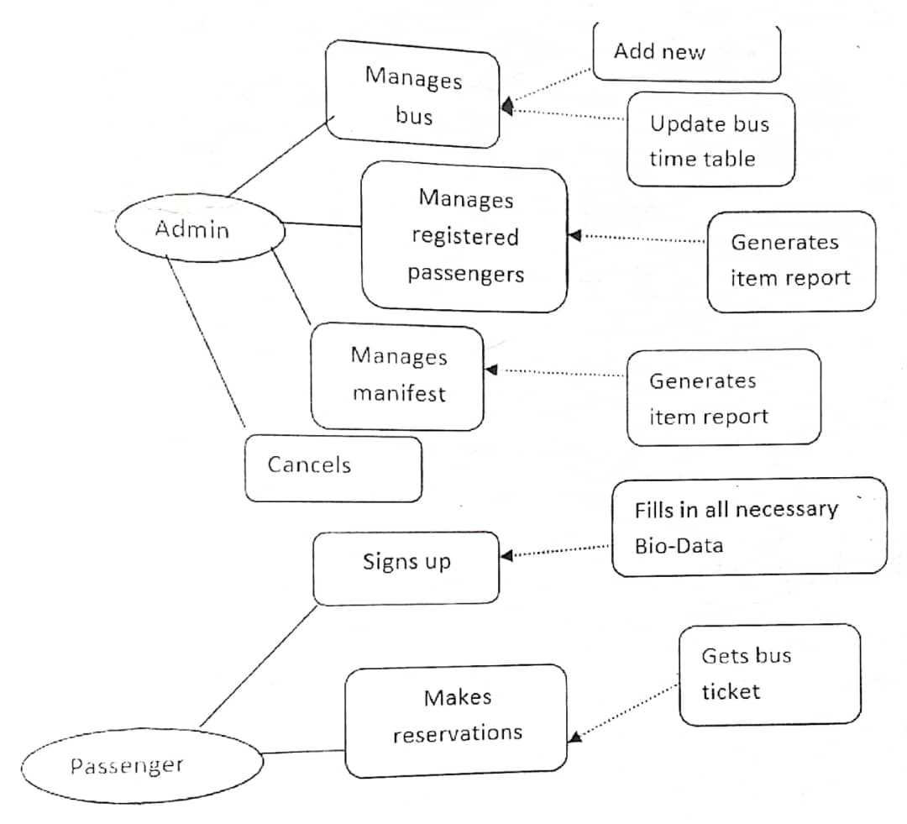
Figure: 3.1 Data flow Diagram

3.2 ANALYSIS OF THE EXISTING SYSTEM
Here the researcher made a fact finding and was able to identify procedures and operations mapped out for the existing system. To avoid queues and hassles associated with last minute immediate travel bookings at terminals, some passengers look forward to making reservations before the actual date of travel. There are two methods involved; Direct and Call-in reservation. With both reservation methods, the customer must first confirm the financial implications, if there are available seats; the passenger must now choose a seat. All of this requires the staff manually opening and checking documents and books each time to get the required indication while the customer and the other possibly in a queue exercise the virtue of patience same applies to those calling the terminus. Finally the passengers' data is required in order to issue the ticket and prepare manifest. Basic data contained in the ticket are: Name, Address Seat number, Cost of fare and Next of kin phone number. A scheduling (ticketing) officer handling more than one route repeats this process for every route and passenger. Routinelyeach day's operation starts with the scheduling officer drawing circles with numbers and crossing those seat numbers that have been reserved.
3.3 PROBLEME OF THE EXISTING SYSTEM
Due to the fact that most reservation systems are human-driven, it gives room for the following identified weakness:
i. Existing system is totally on book and thus a great amount of manual work has to be done. The amount of manual work increases exponentially with increase in bus services.
ii. Needs a lot of working staff and extra attention on all the records.
iii. There are various problems like keeping records of items, seats available, prices of per/seat and fixing bill generation on each bill.
iv. Finding out details regarding any information is very difficult, as the user has to go through all the books manually.
v. Major problem is the lack of security.

3.4 ANALYSIS OF THE PROPOSED SYSTEM
Computer based scheduling system for a transport company will have four factors that will interact with application. Firstly, passengers who will book the ticket, application will allow passenger to access, search and check bus ticket availability over the internet 24 hours a day, 7days a week online after. In addition passengers can book the bus ahead of time. Secondly, admin who will control and check whole the system, admin can add/edit/delete bus, route. destination and soon. However, admin can distribute accounts for the driver to allow them access to the system and for the guards as well. Thirdly, driver who will drive the bus, his privilege is less than the admin. Driver can only check his trip, the bus number that he will ride, beside that he can see the passenger's lists for a specific trip. Lastly, guard, his privilege same with the driver only check the trips and see the passenger's lists.
3.5 ADVANTAGES OF THE NEW SYSTEM OVER THE EXISTING SYSTEM
i. Convenient as it can be done by anyone and anywhere with an internet connection
ii. Customers can compare bus and rental car hire rates online without going to the company
iii. Saves the time and trouble to find a suitable travel agent
iv. Cheaper fares rates as some websites give lower rates for certain packages. Cheaper rates are aso used to attract potential customers.
v. The system having online payment functions. So that it will be easier for customers to pay online rather than going to the counter and pay by cash.

CHAPTER FOUR
IMPLEMENTATION AND DOCUMENTATION OF THE SYSTEM
4.1 DESIGN OF THE SYSTEM
Generally, all efforts are geared toward designing a system program that eliminates all the setbacks of the existing manual method. This new approach is simple, efficient and guaranteed.
The proposed is designed in order to meet the goal and objective of the organization. The design of the system is intended to solve the various problems contributed in the manual method of Bus Reservation System
4.1.1 OUTPUT DESIGN
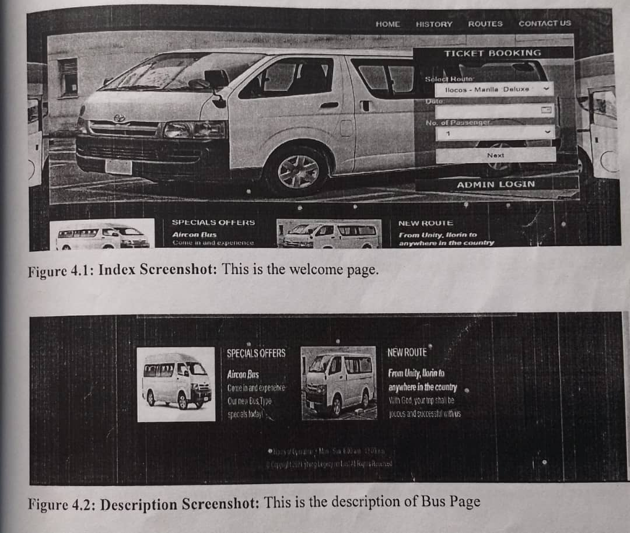
It refers to the report expected to be generated from files in database. The generated reports are lists of view, index page e.t.c.. Below are the snapshot of the output designs

Figure 4.1: Index Screenshot: This is the welcome page.

Figure 4.2: Description Screenshot: This is the description of Bus Page
4.1.2 INPUT DESIGN
Design is a way of mapping and arranging part into a whole, which satisfies the objective involved. The input design refers to the type of all data used to feed information into the database via the program and the format and the input used for the system. Below are the snapshots ofthe input designs
Administrator Login Panel
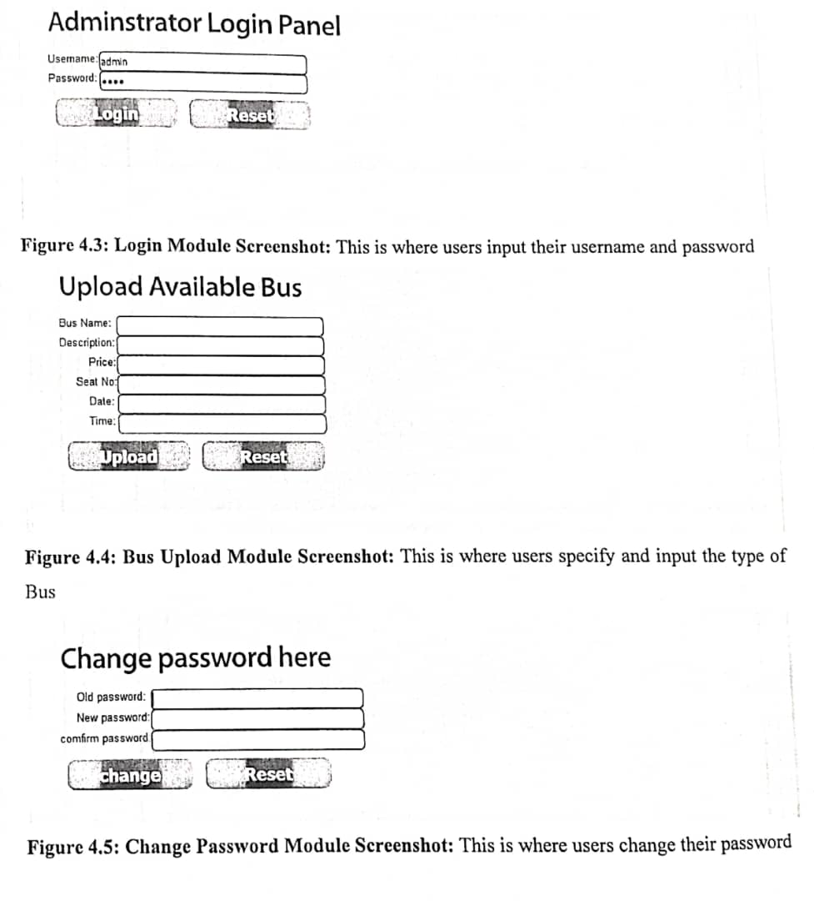
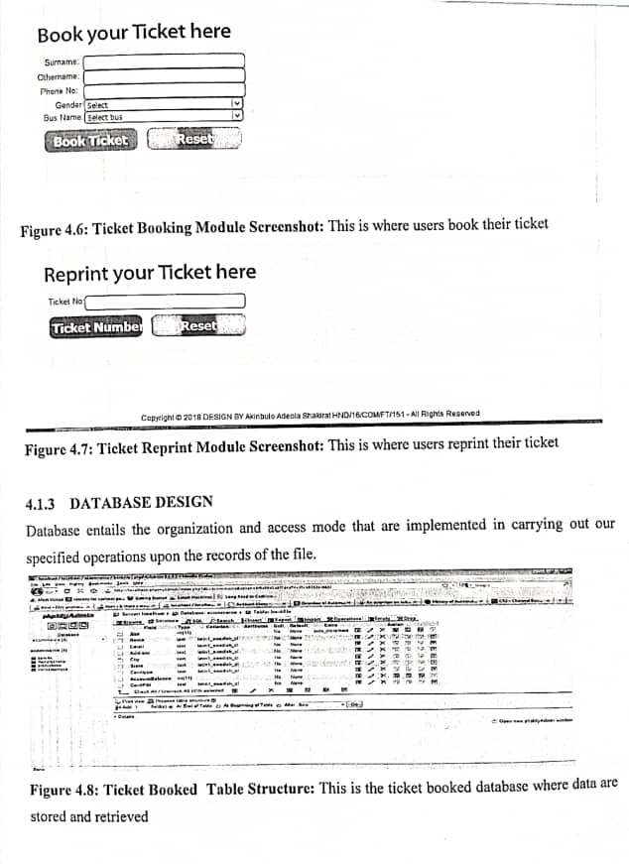
4.1.3 DATABASE DESIGN
Database entails the organization and access mode that are implemented in carrying out our specified operations upon the records of the file.
Figure 4.8: Ticket Booked Table Structure: This is the ticket booked database where data are stored and retrieved
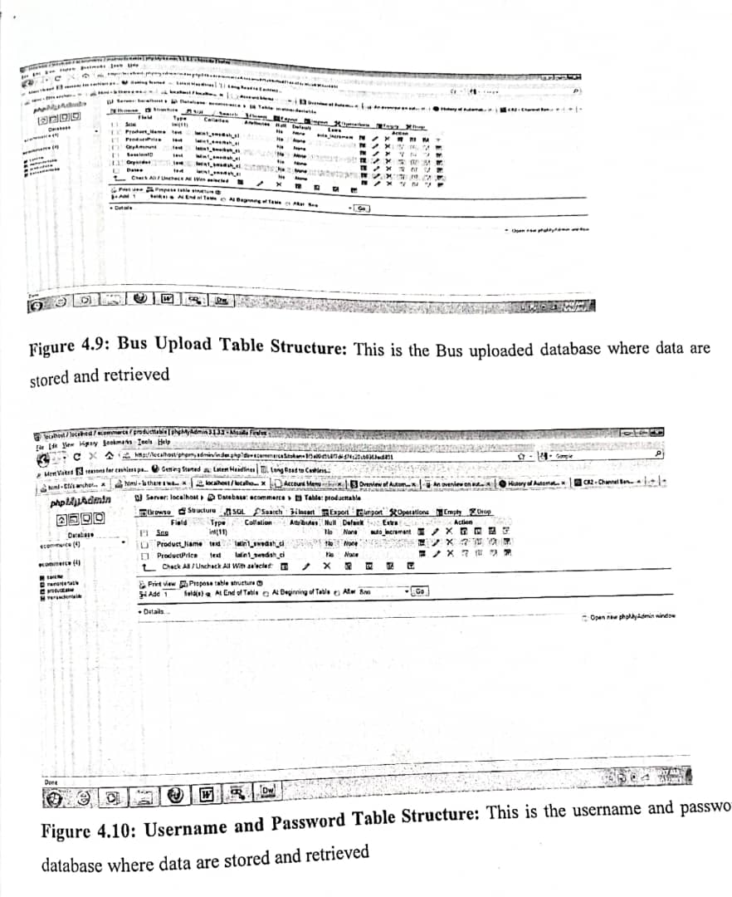
Figure 4.9: Bus Upload Table Structure: This is the Bus uploaded database where data are stored and retrieved

Figure 4.10: Username and Password Table Structure: This is the username and password database where data are stored and retrieved

4.1.3 PROCEDURE DESIGN
Procedures are steps which verify the whole process i.e which are everything put together to produce the desired output. This involves the organization of the source document and end with the output result.
Documents are sent to various departments to be filled by the employees and later returned to the personnel department which are analysed to determine which record goes into the computer. After selecting the necessary data, this serves as input to the computer system.
4.2 SYSTEM IMPLEMENTATION
It is always good to develop new ideas, to implement them on a computer and eventually to relish the satisfaction of achieving a successful result. The implementation process involves converting the system design into a complete and tested EDP that is fully operational and that can be used by the system users to meet their business needs. During implementation phase, the hardware and the software must be implemented.
Implementation of a system can be explained in six steps:-
1. Review design specification 2.Code,test and document programs
3. Train users
4. Perform system test 5. Convert to new system
6. Evaluate and maintain the new system
4.2.1 CHOICE OF PROGRAMMING LANGUAGE
The application is designed in Adobe CS4 Dreamweaver web development package which involves the use of PHP server-side scripting language, MYSQL for database management and HTML (with other embedded functionalities) for the page design and layout settings. Hence, the program testing simply involves running it directly from a Mozilla Firefox web browser on local host server provided by Apache 2.0 in WampServer 2.0 application.
4.2.2 HARDWARE SUPPORT
i. Minimum of Microcomputer Pentium II-Intel 533 MHZ processor, 128 MB RAM,i.3.5GB HDD, 3.5”FDD, 14” VGA Monitor Windows 2000 Enhanced keyboard, mouse and pad.
ii. Scanner
iii. Printer
iv. HP DeskJet 3820c series
4.2.3 SOFTWARE
i. Interface Design Language, windows Notepad for help interface design Hypertext Mark-up Language (HTML)
ii. MY SQL Database Management Software
iii. Programming PHP(Hypertext Pre-processor)
iv. Operating system window 07 professional V. Graphic software paint shop and choosing these two formats GIF (Graphic Image Format)
vi. Scanner software, Mira scan
vii. Web browser software MOZILLA
4.2.4 IMPLEMENTATION TECHNIQUE USED
In preparation for the installation of the new system, the method of changeover is given serious consideration to determine the success of the new system .Suitable changeover technique for this system is pilot changeover. The pilot changeover operates by applying the new system bit-by-bit until it covers the whole of the operations. The result obtained from using the pilot method on a small portion of the operations would be used in determining the suitability of the need system for the rest of the operations. This method is similar to testing small sample of a distribution if the test yields a good result then the whole system because fully operational and the manual/existing system is eliminated.
4.3 PROGRAM DOCUMENTATION
4.3.1 DOCUMENTATION OF THE SYSTEM
This is the detailed description of the proposed system. It important because it helps to design and implement a system that would allow shopping by getting into the company website on the internet from anywhere. It also helps to design and implement a website that will be more interactive and more information about company activities.
Moreover, it design and implements a system that will create a virtual community, which does not necessitate the use of offices and staff stationed around the world.
4.3.2 OPERATING THE SYSTEM
Step 1: Boot your computer and click on start button on task bar
Step 2: Launch wamp server
Step 3: Login to your Application
Step 4: Click on Options
4.1 Click Book Ticket (to book Ticket)
4.2 Click Reprint Ticket (to Reprint Ticket)
4.3 Click on Bus Upload (to Upload Bus)
4.4 Click on Change Password (to Change User Password)
Step 5: Logout
4.3.3 MAINTAINING THE SYSTEM
The use of the term maintenance for software is different from other references to maintenance. Unlike the tires on your car, software does not "wear out". If this is the case, then why does software maintenance account for such a high percentage of the Total Cost of Ownership for software?
The software maintenance definition refers to changes for defect correction, performance improvements, or adaptations to a changed environment (enhancements). According to this definition, if we build software that is defect-free, performs well, and contains user-controlled parameters to adjust processing rules in response to changing requirements then most maintenance would not be necessary.
Why does this happen? There are many reasons but the most common reasons are time constraints and lack of experience. Adding validation logic takes time. So, people make assumptions about the quality of in-bound data. Assumptions are also made about the volume of transactions and the impact on performance and the stability of the automated business processes. Finally, it is common for new software to be developed by younger developers who don't understand the maintenance impacts of their designs.
The reality is that business requirements change and most of these assumptions are flawed. Transaction volumes increase, changing business processes require new transactions or new validation criteria, and software users will use the software incorrectly. The cost of software maintenance and the total cost of ownership can dramatically be reduced if developers build software that adjusted to changes in transaction volumes; validated all inbound data and provide user-configurable options for decision logic and data validation.

CHAPTER FIVE
SUMMARY, CONCLUSION AND RECOMMENDATIONS
5.1 SUMMARY
Web-based Bus Ticketing Services introduce a new channel for passengers to book tickets by using the application through their mobile phones anywhere and anytime. As have been described in the introduction chapter, the aim of this study is to design a mobile based system for ticket booking of bus services. Moreover, the MBTS has been developed to facilitate passengers and give them a vital alternative to book ticket and/or check their tickets anywhere and anytime using their mobile phone via Internet. In addition MBTS will help the Admin and driver as well in them daily work to make their job more organized and easily to handle. The methodology for prototype development used in this research has three phases firstly, study and identify the problem of ticketing system to conduct the literature review that related to the ticketing system .Second phase is develop the prototype of MBTS by give the requirements, analysis, design, develop and then test the prototype. The third phase is the evaluation the MBTS prototype. The user evaluation was conducted to determine the users' perception on the usability aspects of the MBTS prototype. Thirty three participants were involved in the evaluation. The usability evaluation involved measures such as Usefulness, Ease of Use and Outcome/Future Use. The results indicate that all the users agreed that MBTS had good usability in terms of Usefulness, Ease of Use and Outcome/Future Use and all the measures were highly rated.
5.2 CONCLUSION
Transportation services have moved from the manual method to the one aided by new technology which gives comfort to travellers to make booking and reservations ahead of time rather than being in a queue waiting to get tickets. The ancillary infrastructure such as better internet services and rising level of awareness among the transportation sector towards this technology will promote the development and growth of the transport sector in Nigeria. Therefore, this system designed for luxurious bus owners integrate the new system of automation to the manual method is regarded as a value-added service in increasing revenue acquisition.

Before the use of the new system, proper training and orientation should be given to both Kwara State Polytechnic Staff and management. Due to the time and cost constraints, especially the scope of the design was limited to the
i. most basic capabilities.
ii. Numerous potentials of this system should not be neglected irrespective of its high overhead cost of implementation. Management should endeavour to join the moving tend of IT sector to enjoy the
iii. competitive advantage provided by the IT
5.3 RECOMMENDATION
Before the use of the new system, proper training and orientation should be given to both Kwara State Polytechnic Staff and management.
i. Due to the time and cost constraints, especially the scope of the design was limited to the most basic capabilities.
ii. Numerous potentials of this system should not be neglected irrespective of its high overhead cost of implementation.
iii. Management should Endeavour to join the moving tend of IT sector to enjoy the competitive advantage provided by the IT
iv staff should be acquainted with contemporary IT awareness and literacy.

REFERENCES
Ahmed K. & Azman B. (2015),"Mobile Based Bus Ticketing System in Iraq, European Journal of Computer Science and Information Technology Vol.3, No.5, pp.42-55, K https://www.eajournals.org
Amadi E.C (2011) Enhanced Road Transport System in Nigeria Through the Application of It-Based (Online) Bus Ticketing and Payment System, International Journal of Sustainable Development & World Policy
Arun & Lingeswaran (2014),“GPS based Automated public Transport Fare collection systems based in Distance Travelled by passenger using Smart card", issue 3, vol.2, 2014, pp.93-107
Ibrahim(2015)Prepared a journal on the project titled “Mobile-Based Bus Ticketing System In Iraq,European Journal of Computer Science and Information Technology Vol.3, No.5,pp.42-55,K https://www.eajournals.org
Nikitha P.&Adarsh K.(2017),“Android Bus Ticketing System, International Journal Of Electrical, Electronics And Data Communication, ISSN: 2320-2084 Volume-5,http://www.iraj.in
Okeudo (2012) Prepared a journal on a project titled “Contemporary Approach To Enhanced Road Transport System In Nigeria, International Journal of Sustainable Development &World Policy
Paul (2014)“Mobile enable bus tracking and ticketing system", IEEE transaction, vol.13,2014,pp.768775.
Prajash et al (2014), "RFID based Ticketing for public transport system", issue 5,vol.2, 2014,pp.58-97
Syed H.,(2016) “Online Bus Ticketing System, Uc2f1511 (Se) Documentation Ct015-3-2-Dmtd,https://www.researchgate.net/publication/307930993

